Screening for SCID - Literature Review
Prepared for National Screening Unit

Luke Williams
Dr Gary Jackson

December 2013

Introduction
The National Screening Unit (NSU) has commissioned Health Partners Consulting Group (‘Health Partners’) to provide an economic analysis of the cost-effectiveness of including testing for Severe Combined Immune Deficiency (SCID) in New Zealand as part of the Newborn Metabolic Screening Programme (NMSP). Specifically, the NSU requires:
- Assessment of the evidence of the economic impact of newborn screening for SCID in overseas jurisdictions
- An estimate of the incremental cost-effectiveness per life-year saved if newborn testing were introduced
- Analysis of the sensitivity of key variables driving the estimate of incremental cost-effectiveness.

The question to be addressed by the requested economic analysis can be expressed as:

Would adding newborn screening for SCID to the National Newborn Metabolic Screening programme be a cost-effective alternative to the current regime of opportunistic clinical diagnosis?

The analytical perspective to be taken in addressing this question has been agreed with the NSU as a public health funder perspective – that is, only costs borne by the health system, such as hospitalisations, are included. Costs borne by parents, such as travel expenses or loss of earnings, or employers, such as sick leave are not included. The rationale for adopting a public health funder perspective is:
- The decision to implement (or not) newborn screening for SCID will have an impact on the Vote Health (public health funding) and direct patient healthcare costs, and as such, these costs need to be included in the analysis
- Vote Health is separate from other public sector budgets; as such any patient benefits and/or costs that accrue beyond individual health outcomes are outside the scope of the NSU’s or Ministry of Health’s control
- This approach accords with other stated economic analysis perspectives undertaken in the New Zealand public health system, for example, PHARMAC and the National Health Committee (NHC). Adopting a similar approach will more easily enable prioritisation trade-offs between alternative public health system investment options.

This literature review contained in this report is the first component of the requested SCID newborn screening programme economic analysis. It is intended to inform what costs and benefits, with and without screening for SCID, should be included in the economic analysis, and begin developing the assumptions to be included in subsequent economic modelling. It summarises and builds on a recent extensive literature review published in 2012 for the UK National Screening Committee (see Bazian Ltd, 2012).

Economic evaluations of newborn screening for SCID
Four economic evaluations of newborn screening for SCID have been identified. Annex 1 outlines the key parameters and results of each of the identified economic evaluations.

McGhee et al (2005) undertook a preliminary analysis to ascertain whether a newborn screening test (then undeveloped) for SCID would be cost-effective. They assumed (all $ US 2000):
- an incidence rate of 1:50,000 births
- cost per test of $5
- test sensitivity of 0.99 and specificity of 0.996
- confirmatory testing cost of $460 and early transplant cost of $63k and $126k for late transplant (assumption that infection related discharge without screening equal to one additional charge on top of transplant)
- post-transplant survival of 95% for early-diagnosed cases and 75% for late-diagnosed cases
- life-long cost of $600,000 for treatment of intravenous immune globulin (IVIG) following transplantation.

Based on these assumptions, they estimated that newborn screening for SCID would result in a cost of less than $30k per life-year saved and $54k per QALY. Total incremental life-years saved being 760 and based on information provided in the study article, we estimate incremental QALYs to be 447.

Chan et al (2011) undertook a study employing Markov modelling techniques to assess whether universal newborn screening for T cell lymphocytopenia is cost-effective in enhancing quality of life and life expectancy for children with SCID. They assumed (all $ US 2005):

- an incidence rate of 1:75,000 births
- cost per test of $4.22
- test sensitivity of 0.99 and specificity of 0.99
- confirmatory testing cost of $250 and early transplant cost of $120k and $360k for late transplant (children aged 6 – 9 months)
- post-transplant survival of 100% for early-diagnosed cases and 43% for late-diagnosed cases
- life-long cost of $900k for treatment of intravenous immune globulin (IVIG) following transplantation ($1k per month – time horizon 70 years).

Based on these assumptions, they estimated that newborn screening for SCID would result in a cost around $25k per life-year saved and $28k per QALY. Total incremental life-years saved being 880 and incremental QALYs being 802.

Thompson and Glass (2012) have undertaken a cost-benefit study of newborn screening for SCID. They assumed (all $ US – year not reported):
- an incidence rate of 1:49,827 births
- cost per test of $7.10
- test sensitivity of 0.938 and specificity of 1.00
- confirmatory testing cost for true positives were not reported (might be captured in treatment costs reported below) but they estimated the cost of clinical care and diagnostic testing of false positives at $53k
- Early transplant cost of $100k and $450k for late transplant (based on Buckley, 2012)
- post-transplant survival of 91.4% for early-diagnosed cases and 62.5% for late-diagnosed cases
- Any costs associated with intravenous immune globulin (IVIG) following transplantation or other supports following treatment were not reported.

Thompson and Glass estimated the monetary value of life at $7.7M based on the average estimates used by three different Federal Agencies (Environmental Protection Agency; Food and Drug Administration; and Transportation Department).

Based on the assumptions above, Thompson and Glass estimate that 0.38 deaths would be averted per year (ie one infant every three years will not die because of early treatment afforded by newborn screening). At Thompson and Glass’s estimated monetary value of life, this equates to yearly benefits of $2.9M. They estimated total benefits at $3.4M and costs at $700k deriving a benefit/cost ratio of 4.93.

Pilliod et al (2011) provided a brief conference summary of their estimate of the cost-effectiveness of newborn screening for SCID. They only outlined some of the key assumptions that would have informed their modelling. Those outlined were:
- cost per test of $5.50
- test sensitivity of 0.84 and specificity of 0.97.

They estimated a cost of $87k (US) per QALY saved.

Decision-tree analysis
Figures 1 and 2 provide decision tree analysis of transition pathways for infants with and without newborn screening for SCID based on the four prior economic evaluation cited above. Based on the international literature reviewed below and consultation with New Zealand experts, transition probabilities will be estimated. Sensitivity analysis that varies key model assumptions and their associated transition probabilities will be used to assess impacts on the cost-effectiveness of newborn screening for SCID.

- Decision tree – no newborn screening (note births and prevalence rate not shown for simplicity)
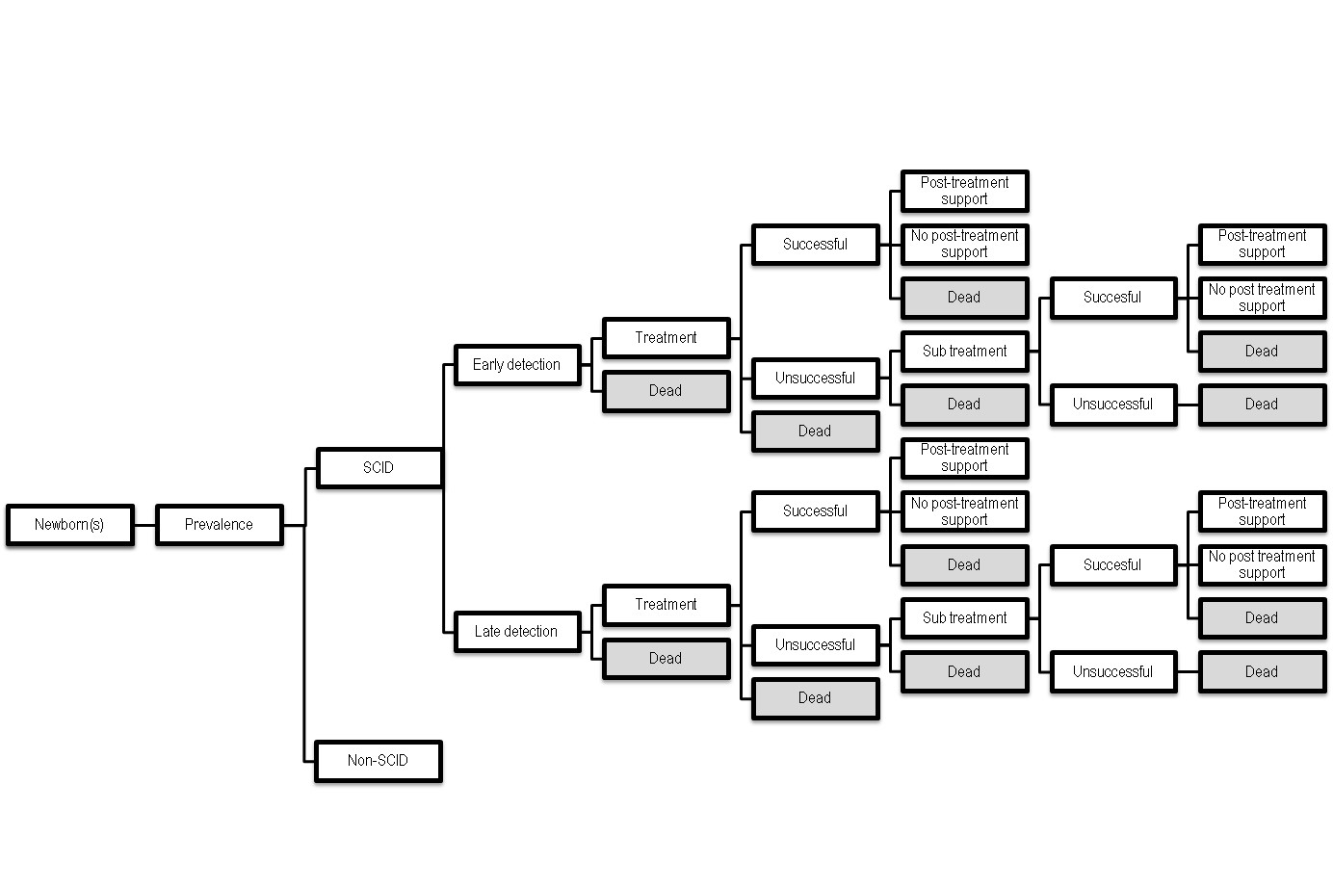

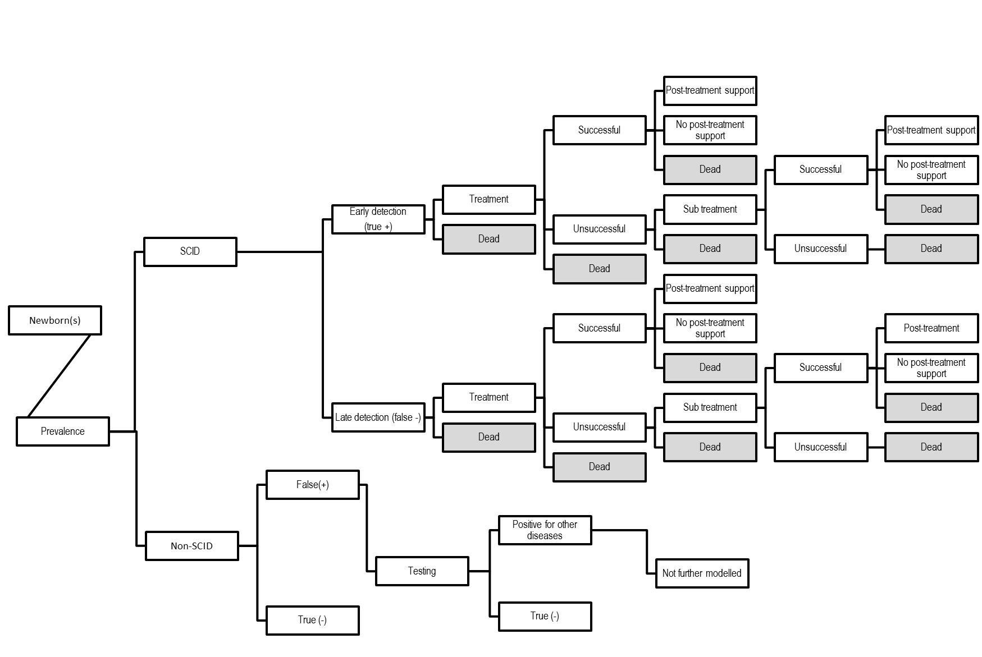
- Decision tree – with newborn screening (note births and incidence rate not shown for simplicity)

Specificity

Sensitivity

Demographics
Over the past 30 years, there have been on average 57,000 births per year in New Zealand, of which most were New Zealand citizens/residents. Between 2005 and 2008 there was a noticeable increase in the number of births (an increase of 11%), with 2008 having the greatest number of births of any year in the past 30 (~64,340). The number of births has since declined slightly but has remained above 61,000 as at 2012.

The recent elevated birth rate has been at the high-end of Statistics New Zealand population projections. The recent elevated birth rate is not unique to New Zealand; it has been evident in some other OECD countries (eg Australia and the United Kingdom).
1
We consider using 60,000 births per year as a reasonable base-case assumption with sensitivity of +/- 5,000 births used to determine the impact on incidence of SCID and associated costs and benefits.

- Annual live births in New Zealand 1973 to 2013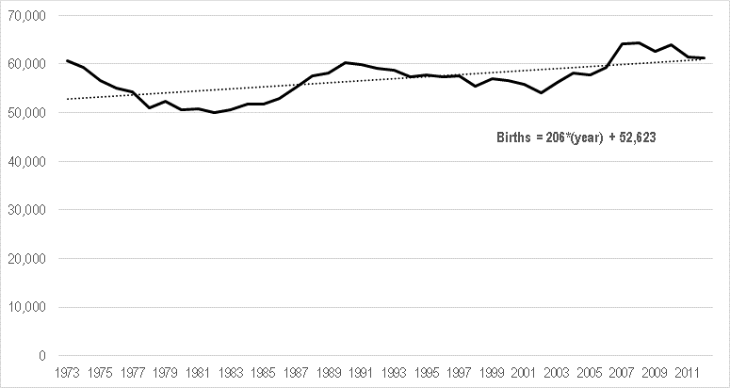
Source: Statistics New Zealand, Births VSB – Live births

SCID incidence
US data from SCID screening pilots suggest an incidence rate of 1:~69,000 births (Table 1). This incidence rate increases to 1:~48,000 when SCID variant cases (as classified in California) are included. It should be noted that incidence rates vary widely by state/district, ranging from 1:~34,000 in New York state to 1:~162,000 in Massachusetts. The incidence of non-SCID identified conditions is much higher than the incidence of SCID itself.

- Results from US SCID newborn screening programmes as of April 2011
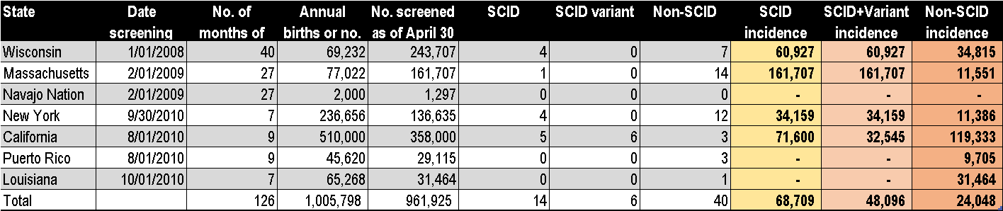
Source: Buckley (2012), ‘The long quest for neonatal screening for severe combined immunodeficiency’

Note the Californian pilot has more recently reported their results from the first two years of screening: 993,724 infants have been screened with a SCID incidence rate of 1:70,760 (14 cases) and a SCID variant incidence rate of 1:166,000 (6 cases) (Kwan et al, 2013).

The estimated UK incidence rate is 1:35,000 births (Gaspar, 2011). This estimate is based the number of SCID cases presented to the two UK centres for care of SCID from 2008 and 2009 (20 per year). It therefore does not account for children who may have been diagnosed after death at other UK centres or children who died and were undiagnosed (Bazien Ltd, 2012).

An Australian Paediatric Surveillance Unit study between May 1995 and 2001 estimated an Australian SCID incidence rate of 1:~55,555 births.

The incidence of SCID in New Zealand is unknown. Over the past 13 years, there have been 8 diagnosed cases of SCID identifiable in the national data collections. This equates to an incidence rate of 1:104,215 births. This incidence rate falls near the midpoint of the US range (~34,000 - ~162,000), although it is substantially lower than 4 of the 5 states/districts which have identified cases of SCID. It is possible some cases will have died undiagnosed.
2
We recommend that our modelling base case use New Zealand’s estimated incidence rate from known cases but include sensitivity analysis which uses the aggregate US incidence rate alongside max/min State/Territory and other international incidence rates to estimate the range of impacts on screening programme costs and benefits. This would imply a sensitivity parameter value range of 1:~32:000 to ~162,000.

Family history
While most cases of SCID do not have a family history associated with them, up to ~20% of SCID cases have been cited in the literature as having a family history of the disease (see for example Chan et al [2011). Family history is an important part of clinical diagnosis and the timeliness thereof. Economic evaluation of screening programme best practice recommends that the benefits of screening should be adjusted for the number of cases likely to be picked up early due to family history (Prosser et al, 2012).

Data provided to Health Partners suggests there have not been any SCID cases with associated family history enabling an early diagnosis in the past 13 years. We note that of the 8 cases of SCID diagnosed over the past 13 years one case is considered to be consanguineous, which represents 12.5% of all cases.
We suggest that the model base case assume that in the future that 10% of cases (mid-point of range cited in the literature) may have a family history of SCID associated with them and therefore should be diagnosed early in the non-screening scenario. We recommend that the model include a sensitivity analysis of the impact of family history on the cost-effectiveness of SCID screening, which varies the rate of family history association between 0%-20%.
3

Newborn SCID testing efficacy
Two methods of newborn screening tests for SCID are relevant to the Newborn Metabolic Screening Programme:
- Quantitative polymerase chain reaction for T-cell receptor excision circles (TRECs)
- Enzyme-linked immunosorbent assay, most commonly for interleukin 7 (IL-7).

The US SCID new born testing programme pilots have all used TREC assays to screen for SCID. Based on published information from the pilots, the TREC test has:
- A sensitivity of 100%
- A specificity of 99.96%
- A positive predicative value of 3.85% for SCID and 16.5% for all cases of T cell lymphopenia
- A negative predicative value of 100% (assumes no missed cases of SCID) (Bazian Ltd, 2012; Secretary’s Advisory Committee, 2011).

It has been widely noted that there have been no identified missed cases of SCID since screening has been introduced in the US pilot States/Districts.

The second testing method is a two-tiered approach. IL-7 testing (Tier 1) sensitivity has been estimated at 85% and specificity at 96.1% (Lipstein et al, 2010; McGhee et al, 2005). TREC testing (Tier 2) was then performed on infants with elevated IL-7 levels with estimated specificity of 92.3% and sensitivity approaching 100%.

Economic evaluations have assumed test sensitivity ranging from 84% to 99% and specificity ranging from 96% to 100%. The lower end test sensitivity and specificity assumptions are from the same study (Pilliod et al, 2011). The rationale for these more pessimistic assumptions is unclear particularly given they do not appear supported by empirical evidence (Grosse, 2012).
4
We recommend that:
- Quantitative polymerase chain reaction for T-cell receptor excision circles (TRECs) screening be used as the basis for cost-effectiveness modelling
- The empirical evidence of test efficacy from US pilot programme States/Districts as outlined above be used as the base-case for modelling – 100% sensitivity, 99.96 specificity
- Sensitivity analysis of test efficacy parameters be used to assess impact on the cost-effectiveness introducing SCID testing to the NMSP. Sensitivity 99-100%, specificity 99 -99.99%.

Screening costs
Screening costs include:
- Initial screening
- Confirmatory testing.

Initial screening
As per our recommendation to use quantitative polymerase chain reaction for T-cell receptor excision circles (TRECs) screening as the basis for cost-effectiveness modelling, initial screening costs will be estimated for the activities associated with this type of testing. Previous economic evaluations of SCID screening based on this mode of testing cite screening costs per test cited in the US literature range from $4 to $7 ($US – various financial years). It is unclear whether any of these cost estimates include establishment costs. In the US, establishment costs for screening have been estimated between $500k - $1M.

Confirmatory testing
Confirmatory testing includes further diagnostic testing and where appropriate, clinical evaluation. UK expert guidance on the recognition, diagnosis and management of primary immune deficiency diseases including SCID has been published (UK Primary Immunodeficiency Network, 2009; Bazian, 2012). It recommends that the following tests are performed for the diagnosis of SCID:
- Flow cytometry
- Assessment of the proliferative response of T cells in vitro mitogens and antigens
- Gene sequencing – although not required for HSCT, knowledge of mutation responsible for SCID is considered to inform treatment options eg myoablative conditioning.

Two US economic evaluations cite the cost of confirmatory testing as $250 and $461 respectively ($US) (Chan et al 2011; McGhee, 2005). Chan et al confirmatory testing cost assumption ($250 – US 2005) includes complete and differential blood counts and lymphocyte phenotyping.

McGhee et al based their confirmatory testing cost assumption ($461) on one specialist office visit ($125), flow cytometry ($74) and T-cell proliferation study ($262). These were established at the then (2000) Medicare rates. They considered this a conservative estimate given that T-cell proliferation studies are not always required for confirmatory testing.
5
Note we have approached LabPlus for an initial estimate of screening costs per test and establishment costs. This will be available in the new year.

Note we will follow-up with New Zealand experts regarding the cost of confirmatory testing. This cost information will primarily be used to estimate the opportunity cost of confirmatory testing for false positives identified by a newborn screening programme for SCID.

Treatment options, timing and evidence of effectiveness
There are three treatment options for “classical SCID”:
- Bone marrow transplant (eg HSCT)
- Enzyme replacement
- Gene therapy.

In the US pilot studies, ~80% of SCID patients have received HSCT while 20% are receiving enzyme replacement therapy, a treatment option for one type of SCID, Adenosine Diaminase Deficiency (ADA).

An important consideration is evidence regarding the outcomes after early versus late HSCT and survival after HSCT. Evidence suggests that early compared to late HSCT results in improved survival rates for children with primary immunodeficiency disorders (Buckley et al, 2011; Gennery et al, 2010; Railey et al). Early HSCT treatment generally defined as in the first 3.5 months of life.

Brown et al (2011) in the US compared survival in infants who were diagnosed early due to family history of SCID. They found that first presenting siblings (late diagnosis) survival rate after HSCT was 40% whereas early diagnosis in sibling cohort was 90%. They concluded “SCID babies diagnosed at birth have a significantly decreased number of infections, are transplanted earlier, and have dramatically improved survival outcome regardless of donor match, conditioning regimen, and SCID type”.

Buckley (2011) in the US summarised the long-term outcomes of 166 consecutive SCID infants given non-conditioned related donor bone marrow transplants at Duke Medical Centre over a 28 year period. The age of infants at time of transplantation ranged from newborn to 21 months. Of the 166 infants, 126 (76%) were alive 2 months to 28 years after transplantation, with none showing any evidence of susceptibility to opportunistic infections and most reported as in good general health. Of the 126 survivors, 125 have survived one or more years after transplantation, 110 are alive five or more years, and 83 have survived for ten or more years. Earlier transplantation in terms of age of infant was found to be positive and statistically significant in regard to survival outcomes: of the 48 infants transplanted during the first 3.5 months of life, 44 survived at time of the study (94%), compared to 82/188 (69%) who were transplanted after that age (p<0.001).

Chan et al (2010; 2011) have conducted two surveys to assess the health outcomes of infants with SCID. The first assessed outcomes based on parental responses (n = 126 families; 158 individual SCID cases) to a survey, which found that testing of infants at births had a statistically significant positive impact on survival, with 85% of those tested at birth surviving compared to only 58% of those not tested (p = 0.026). Overall survival was 61%, with over half (51%) of deaths occurring in diagnosed infants after receiving HSCT or enzyme replacement. However, overall survival rate of treated patients was 81.4%.

The average age of treatment was 34 weeks (median 28 weeks, n = 98). Those who were diagnosed due to positive family history of the disease had a mean duration of hospitalisation almost 7 weeks shorter than unsuspected cases (12.2 v 18.8 weeks). Those who were treated and survived (n = 78) were, on average, treated at 29 weeks of age. Those who were treated but died (n = 20) were on average treated at 57 weeks. There was a statistically significant difference between the mean age of 29 weeks in those that survived and 57 weeks in those who died (p = 0.038). They also found that there was a mean delay of 3.5 months from onset of symptoms to diagnosis, which they state provides a window of susceptibility for SCID infants to acquire serious infections. This may attributable to differences in observed survival outcomes.

The second survey undertaken by Chan et al (2011) surveyed physicians and families associated with 39 SCID cases. The results of the survey are shown in Table 2. Their findings suggest that earlier diagnosis is associated with earlier treatment and improved survival. They also found that infants with SCID diagnosed late had longer average hospitalisations before HSCT and during the post-HSCT phase (mean 30 days v. 14 days).

- Chan et al (2011) – age of clinical events in SCID patients from survey of physicians and families of SCID children (n = 39) (Months [mean +/- standard deviation])
 | Diagnosis | Treatment | Death
SCID infants identified early+ (n=7) | 1.0 +/- 0 | 3.7 +/- 4.3 | All alive
SCID infants identified late⁻ (n=39) | 9.0 +/- 7.6 | 9.6 +/- 5.4 | 17.6 +/- 10.4%
SCID infants w HSCT (n=23) | 6.9 +/- 5.0 | 9.8 +/- 5.5 | 17.3 +/- 7.5**
SCID infants w no HSCT$ (n=8) | 15.4 +/- 10.3 |  | 19.4 +/- 14.0
SCID infants w PEGADA^ (n=1) | 7 | 7 | 8
+ identified early is based on known family history of SCID, prior to manifestation of infections
- identified late is defined as confirmed with SCID after manifestation of infections
% 20 out of 32 SCID identified late died
** 10 out of 23 SCID patients transplanted died
$ all 8 SCID patients without HCT died
^ PEG-ADA specifically for SCID with adenosine deaminase deficiency
# SCID identified late resulted in longer hospital stays before and post-HCT (mean 30 days) than when identified early (mean 14 days)
Mitchell et al (2013) have recently conducted a retrospective study of 135 HSCT for primary immune-deficiency diseases between 1992 – 2008 at six Australian and New Zealand paediatric transplantation centres. Sixty-five patients were identified as SCID. They found a SCID-specific 5-year overall survival rate of 70%. The median time of diagnosis to transplantation was two months (range 0 – 163 months).

It is important to note that some infants may require more than transplantation given, for example, poor B or T cell function or resistance to engraftment. Buckley (2011 study discussed above) reports that 29% (49/166) of infants who had transplants required at least one subsequent ‘booster’ transplantation, of which 67% of infants survive (33/49). Similarly, Kane et al (2001) reported that approximately 23% (3/13) of studied SCID patients who received some form of bone marrow transplant required a subsequent transplantation. We note that 2 of the 8 identified SCID patients in New Zealand had HSCTs, one having 2 approximately 6-months apart. Their age at first transplant was 4 months. Unfortunately the double transplant patient later died.

Evidence relating to the effectiveness of enzyme replacement and gene therapy is more limited than that for transplantation (Bazian Ltd, 2012). Enzyme replacement therapy is used to treat infants with ADA-SCID, which in the US, have been estimated as representing ~20% of all infants with SCID. Enzyme replacement therapy is not curative but can provide life-saving treatment at time of treatment and if treatment is continued beyond 6-months, may provide clinical benefit for at least a decade (Gasper et al, 2009).

Gene therapy using viral vectors has been trialled for two types of SCID: x-linked SCID and ADA-SCID (Bazian Ltd, 2012). Trial results suggest that gene therapy can be an efficacious form of treatment but requires molecular diagnosis. Trials are undergoing. This form of treatment can be considered experimental and may have limited relevance in the New Zealand context currently. In the future, as the treatment is refined through clinical trials, the relevance will increase in New Zealand potentially improving the clinical benefit and cost-effectiveness of newborn screening for SCID. However, at this stage, HSCT will remain the core treatment option for the majority of SCID cases.
We assume all cases found via screening will receive early HSCT. We will assume a 90% survival with good outcome, 5% survival with poorer outcome, and 5% mortality. Sensitivity analysis 80% - 100% survival.
For unscreened patient we assume the current survival rate (12.5%). Sensitivity analysis 5-40%.
6

Health system costs associated with SCID excluding new born screening
Health system costs associated with SCID include:
- Primary care visits
- Community and specialist diagnostics
- Community pharmaceuticals
- Hospitalisations associated with complications of SCID (most notably severe infections)
- Specialist treatment costs, for example, HSCT
- Specialist follow-up following treatment
- Transport and accommodation assistance
- Disability costs such as institutionalised care and any community based services.

The literature primarily focuses on hospital and specialist costs associated with SCID, and in particular, any cost differentials between early and late diagnosis and treatment. At time of drafting, we have not identified any information on the costs of primary care and community diagnostics associated with SCID.

Kubiak et al (2012) have reported actual hospital charges from pre-diagnosis to post-transplant for SCID following retrospective chart review of five SCID cases diagnosed and treated at All Children’s Hospital Florida. They defined early diagnosis as occurring <3.5 months of life v. late >3.5 months of life. Only one case was identified as an early diagnosis (as a result of family history). The other four cases were diagnosed between 4.8 and 12.8 months of life, with only one receiving a successful transplant. They report that the total charge for the early diagnosed case was ~$607k v. a median charge of $1.9M for the late diagnosed cases – a late to early cost ratio of 3:1.

Buckley (2012) provides cost information from Duke University Medical Center from 1998 – 2006 comparing costs for infants (n = 74) with SCID who underwent transplantation before 3.5 months of age (n = 26) with those after 3.5 months of age (n = 48). The estimated cost ratio was 4.5:1 (after 3.5 months = $450k v. $100k for < 3.5 months of age). Buckley attributes the lower cost for infants undergoing transplantation early to:
- They are outpatients for the most part because they were not chemoablated
- Those treated late were often very sick when they presented, necessitating intensive care unit admissions, as well as prolonged hospitalisations.

Based on information from the National Minimum Data Set (NMDS) for the 8 identified cases of SCID in New Zealand over the past 13 years, we estimate an average cost per case of ~$220k (range: $3.4k - $403k). The average cost is estimated using the 2013/14 Inter-District Flow price of $4,655 and the cumulative caseweights associated with each identified case of SCID. The average per case cost is comprised of:
- Inpatient costs of $204k
- Outpatient costs of $7.8k
- ED costs of 0.4K
- Community pharmaceuticals of $1.6K
- Community labs of $0.03k
- Travel and accommodation costs of $5k

This includes all identified NMDS costs associated with each identified infant diagnosed with SCID excluding costs associated with birth. Note that the IDF price and caseweights used are based on the average of all costs and resources related to particular health sector services (eg ED) rather than being disease or case-specific. We will look to refine our cost estimate by discussing with Auckland DHB their estimate of the resource and cost associated with the identified cases of SCID in New Zealand over the past 13 years.

A further complication is that there has not been an ‘early’ transplantation in New Zealand in the past 13 years as defined by at 3.5 months of age or less (benchmark typically cited in the international literature). The literature cites significant cost differentials between early and late transplantations. An agreed base-case assumption regarding a New Zealand relevant cost differential between early and late transplantation will be needed to inform cost-effectiveness modelling.
7
Subject to more refined cost information to be sought in the new year, our assumption for the average cost of SCID cases in the absence a newborn screening programme is $220k based on the NZ cost estimates from the national data collections described above.
We recommend that early transplantation be defined as occurring within the first 3.5 months of an infant’s life as per generally cited definition in the international literature. We note that international evidence suggests a significant cost differential between early and late transplantation. Given there has been no specific cases of early transplantation in New Zealand, an agreed cost differential assumption will be required to inform modelling. As a first estimate we note the current IDF price for ARDRG A07Z Allogenic bone marrow transplantation as 15.1 cwts with up to 96 hours of ventilation. Approx cost $70,200

References
Bazian Ltd (2012). Screening for severe combined immunodeficiency: External review against programme appraisal criteria for the UK National Screening Committee (Version 3). London: UK National Screening Committee.

Brown, L., et al (2011). “Neonatal diagnosis of severe combined immunodeficiency leads to significantly improved survival outcome: the case for newborn screening”, Blood, 117(11), 3243-3246.

Buckley, R. (2011). “Transplantation of hematopoietic stem cells in human severe combined immunodeficiency: longterm outcomes”, Immunologic Research, 49(1-3), 25-43.

Buckley, R. (2012). “The long quest for neonatal screening for severe combined immunodeficiency”, The Journal of Allergy and Clinical Immunology, 129(3), 597-604.

Chan, A., et al (2011). “Early vs. delayed diagnosis of severe combined immunodeficiency: a family perspective survey”, Clinical Immunology, 138(1), 3-8.

Chan, K., Davis, J., Pai, S., Bonilla, F., Puck, J., & M. Apkon (2011). “A Markov model to analyse cost-effectiveness of screening for severe combined immunodeficiency”, Molecular Genetics and Metabolism, 104(3), 383-389.

Gaspar, B. (2011). Newborn screening for severe combined immunodeficiency: An appraisal against National Screening Committee Criteria. London: UK National Screening Committee.

Gennery, A., et al. (2010). “Transplantation of hematopoietic stem cells and long-term survival for primary immunodeficiencies in Europe: entering a new century, do we do better?”, The Journal of Allergy and Clinical Immunology, 126(3), 602-611.

Grosse, S. (2012). “Assessing the economic impact of newborn screening for SCID/T-cell lymphopenia through cost/cost-effectiveness analysis: methodological issues”, unpublished paper.

Kane, L., et al (2001). “Neonatal bone marrow transplantation for severe combined immunodeficiency”, Archives of Disease in Children, 85(2), F110-113.

Kubiak, C., et al (2012). “Financial impact of late diagnosis of severe combined immunodeficiency: Why it is fiscally sound for states to invest in the implementation of newborn screening”, The Journal of Allergy and Clinical Immunology, 129(2), AB247.

Kwan, A. et al (2013). “Newborn screening for severe combined immunodeficiency and T-cell lymphonpenia in California: Results of the first 2 years”, The Journal of Allergy and Clinical Immunology, 132(1), 140-150.

Lipstein, E., et al (2010). “Systematic evidence review of newborn screening and treatment of severe combined immunodeficiency”, Pediatrics, 126(5), e1226-1235.

McGhee, S., Stiehm, E.,& E. McCabe (2005). “Potential costs and benefits of newborn screening for severe combined immunodefiency”, Journal of Pediatrics, 147(5), 603-608.

Mitchell, R., et al (2013). “Outcomes of hematopoietic stem cell transplantation in primary immunodeficiency: a report from the Australian and New Zealand children’s haematology oncology group and the Australasian bone marrow transplant recipient registry”, Biology of Blood and Marrow Transplantation, 19(3), 338-343.

Pilliod, R., et al (2011). “Universal screening for severe combined immune deficiency: a cost-effectiveness analysis”, poster presentation at the annual meeting of the Society for Medical Decision Making, Chicago, October 2011.
Prosser, L., et al (2012). “Decision analysis, economic evaluation, and newborn screening: challenges and opportunities”, Genetics in Medicine, 14(8), 703-712.

Secretary’s Advisory Committee on Heritable Disorders in Newborns and Children (2011). Newborn Screening for Severe Combined Immunodeficiency Disorder. Rockville (MD): Health Resources and Services Administration.

Railey, M., Lokhnygina, Y. & R. Buckley (2009). “Long-term clinical outcome of patients with severe combined immunodeficiency who received related donor bone marrow transplants without pretransplant chemotherapy or post-transplant GVHD prophylaxis”, Journal of Pediatrics, 155(6), 834-840.

Thompson, J. & Glass, M. (2012). Guide to the newborn screening cost-benefit model for adding severe combined immunodeficiency. Unpublished. Available at: http://sboh.wa.gov/Portals/7/Doc/Meetings/2012/06-13/WSBOH-06-13-12-Tab07f.pdf

UK Primary Immunodeficiency Network (2009). Severe combined immunodeficiency: initial diagnosis and management. Newcastle upon Tyne, UK Primary Immunodeficiency Network.
Annex One: Summary of identified newborn screening for severe combined immunodeficiency cost-effectiveness studies (TBC)
Blank cells indicate not used/reported in study; highlighted cells indicate HPCG back calculation assumption from study reported data. Note page size A3
 | Base | Sensitivity | Base | Sensitivity | Base | Sensitivity | Base | Sensitivity
Study | A Markov model to analyze cost-effectiveness of screening for severe combined immunodeficiency (SCID) |  | Potential costs and benefits of newborn screening for SCID |  | Universal screening for SCID: a cost-effectiveness analysis (cited in Grosse 2012) |  | Guide to the Newborn Screening Cost-Benefit model for Adding SCID
Authors | Chan, K. et al |  | McGhee et al |  | Pilliod et al |  | Thompson & Glass
Year | 2011 |  | 2005 |  | 2011 |  | 2012
Study Type | CE/CU with Markov modelling |  | CU |  | CU |  | CB (hypothetical based on 90,000 births)
 | Universal TREC assay newborn screening for T lymphocytopenia to identify SCID compared to no screening
Perspective | Societal |  |  |  |  |  | Payer
 | Screening v. no screening
Time Horizon | 70 years |  |  |  |  |  | NR
$ | US 2005 |  | US 2000 |  |  |  | $US
Discount rate | 3% | - | 3% |  | 3% |  | NR
Number of births |  |  |  |  | 4M |  | 90k
Incidence (SCID) | 1/75,000 | 1/25,000-500,000 | 1/50,000 | 1/30,000-1,000,000 | NR |  | 1/49,827 | 1/37,000-71,000
% early ID - family history of SCID |  |  |  |  |  |  | 20.3% | 17.9%-28.9%
Test specificity | 0.99 | 0.85-1.00 | 0.96 | 0.9-1.0 | 0.97 |  | 1.000 | 0.9986-0.9886
Test sensitivity | 0.99 | 0.85-1.00 | 0.99 | 0.9-1.0 | 0.84 |  | 0.938 | 1.000 - 0.867
Probability of missed case |  |  | 50% | 0-80%
Cost per test | $ 4.22 | $0.5-$30 | $5 | $2-$65 | $5.50 |  | $7.10
Cost per test assumptions | Machine usage, labour and reagents (Myers et al, 2002) - incremental cost of introducing to existing screening programme |  | Incremental cost of introducing to existing screening programme
Confirmatory testing per patient | $250 | $50-$1,000 | $461 | $35-$1000 |  |  | NR
Confirmatory testing assumptions | Includes complete and differential blood counts and lymphocyte phenotyping |  | Includes office visit ($125), flow cytometry ($74), T-cell proliferation studies ($262). Est at Medicare rate. Considered a conservative assumption since proliferation studies not always needed.
Early HCT/BMT (equivalent) costs | $120,000 |  | $ 63,116 | $20,000-$1,000,000 |  |  | $100,000 | ~$70k-$450k
Early HCT/BMT Assumptions | Not differentiated by age so includes early and late diagnosed children who received HCT. Based on charges not costs. Converted charges to costs based on cost to charge ratio of 0.36. |  | Average charge of inpatient admission (1997) for ICD (9th ed) clinical modification code 279.2 ($169,213) adjusted by cost/charge ratio of 0.373 for DRGs 398 and 399 (immunity disorders with and without complications). Stated as likely over-estimating the cost of BMT |  |  |  | Based on Buckley (2012)
Late HCT/BMT costs | $360,000 |  | $ 126,232 | $0-$1,000,000 |  |  | $450,000 | $545k-$450k
Late HCT/BMT assumptions | Children 6-9mths who had HCT. |  | Assumption that infection related discharge without screening equal to one additional discharge on top of BMT ($63k *2) |  |  |  | Based on Buckley (2012)
Outpatient costs | $38
Outpatient assumptions | Average number of attendances from patient survey. Cost based on RVU for intermediate level 3 office visit * Center for Medicare services payment conversion factor.
Inpatient costs | Not reported
Inpatient cost assumption | Estimate based on average charges for patients with an immunity disorder during 2003 in HCUP-KIDs database; 0.39 cost/charge ratio applied.
IVIG cost | $1,070 |  | $598,000 | $400,000-$900,000
IVIG cost assumptions | Monthly - based on average cost per dose of the most common immunoglobin brands (www.primaryimmune.org) |  | Approximately $1,100 monthly
Non-medical costs | $66
Non-medical costs assumptions | Travel, waiting and caretime based on one parent losing 4hrs of work at av federal wage rate of $16.50/h
Transportation costs | $5
Transportation cost assumptions | Roundtrip per medical event
Ratio of cost between HCTlate & HCTearly | 3.0 | 0.5-10.0
Cost of false positives |  |  |  |  |  |  | $ 52,882
Treatment efficacy identifed late - HCT | 43% |  | 75%
Treatment efficacy identified late - HCT - assumptions | Based on survey data (see below) |  | Published literature (Buckley et al, 1999; Antoine et al, 2003)
Treatment efficacy identified early - HCT | 100% |  | 95%
Treatment efficacy identified early - HCT - assumptions | Based on survey data (see below) |  | Myers et al (2002)
Mortality - late |  |  |  |  |  |  | 0.375 | 0.604-0.26
Mortality - late assumptions |  |  |  |  |  |  | Probands - received transplant after 28 days of age
Mortality - early |  |  |  |  |  |  | 0.086 | 0.048-0.10
Mortality - early assumptions |  |  |  |  |  |  | Received transplant <= 28 days of age
Probability BMT fails (late transplant) |  |  | 28% | 0-60%
Probability BMT fails (early transplant) |  |  | 5% | 0-28%
Life expectancy following BMT w/o IVIG |  |  | 55 | 10-77
Life expectancy following BMT w IVIG |  |  | 45 | 10-77
Probability patient needs IVIG |  |  | 65% | 50%-100%
Uility values after HCT |  |  | 0.95 for successful BMT; 0.8 w IVIG
Uility value assumption | Based on average utilities published for children with cystic fibrosis, sickle cell anaemia, paediatric HIV-AIDS, medium chain acyl CoA dehydrogenase (MCAD) deficiency and leukaemia.
Monetary value of life |  |  |  |  |  |  | $7.7M | $9.1M-$6.1M
Results:
Cost - no screening | $ 8.89 |  |  |  |  |  | $ 7.61
Cost - screening | $ 14.33 |  |  |  |  |  | $ 10.13
Incremental cost | $ 5.44 |  | 5.98 |  |  |  | $ 2.52
Total cost * incremental cost | $22M |  | $24M |  | $75M |  | $ 227,122
Life years - no screening or Deaths (CB) | 28.684523 |  |  |  |  |  | 0.57
Life years - screening or Deaths (CB) | 28.684737 |  |  |  |  |  | 0.19
Incremental life-years or Deaths averted (CB) | 0.000214 |  |  |  |  |  | 0.38
Total life-years * incremental life-years | 880 |  | 760
QALYs - no screening | 28.684513
QALYs - screening | 28.684708
Incremental QALYs | 0.000195
Total QALYs | 802 |  | 447 |  | 856
ICER ($/life years saved) or Deaths Averted (CB) | $ 25,429 |  | $ 31,474 |  |  |  | $ 2,926,000
ICER ($/QALY saved) | $ 27,902 |  | $ 53,560 | $90,000 | $ 87,081
Total benefits (CB) |  |  |  |  |  |  | $ 3,390,760
CB ratio |  |  |  |  |  |  | 4.90 | 3.04-8.89

Lymphocyte counts – see Lipstein – comment on why not discussed. Cited sensitivity range 56%-86%; specificity 94%-100%.
14 out of 364 positive TREC tests

