**NSU Open Communication Policy (NSU 03)**

|  |  |
| --- | --- |
|  |  |

|  |  |
| --- | --- |
| IntroductionPurposePolicy OwnersScopePrinciplesPolicy Statement | People take part in screening in order to be reassured they are healthy, rather than with the expectation they are not. However, screening is not a comprehensive diagnosis.  It does not tell you whether you do have the condition. Instead, screening sorts people into two groups: people who have an increased chance of having the condition (positive screening result) and people who do not have an increased chance of having the condition (negative screening result).  People with a positive screening result will be offered a diagnostic test, which will give more information about whether they have the condition. People with a negative screening result will not be offered the diagnostic test. Depending on the type of screening, they may be invited to come back for further screening for example for a repeat cervical screen. All screening has the potential to cause harm. Screening tests carry a risk of false results.  This policy is based on the National Screening Unit (NSU) commitment to open, transparent, and timely communication with all consumers, their family and whanau. Effective communication for a consumer commences at the beginning of an episode of engagement in a screening programme and continues throughout the consumer health care journey. Open communication with consumers of NSU screening programmes include: informed consent; the right to effective communication; the right to be fully informed; the right to complain; and, the right to services of an appropriate standard.  The NSU values consumer trust in the performance and quality of screening service provision. This policy guides when ‘open disclosure’ is required and how it will be conducted.  This policy outlines the open disclosure process in accordance with the Code of Health and Disability Services Consumers’ Rights, and the principles set out in the Privacy Act 1993 and the rules set out in the Health Information Privacy Code 1994.  Open Disclosure  There is one open disclosure process outlined in the policy:   1. Open disclosure may be indicated at a time when an adverse event or a complaint identities harm has occurred within the NSU which involves administrative and support functions to the national screening programmes in its central agency role.   **NSU will lead the open disclosure process with a consumer (and with their representative) of the NSU screening service in accordance with the NSU open communication policy. NSU will request support from a related provider if indicated.**   1. NSU will support a screening provider’s communication process when open disclosure may be required at a time when the provider notifies NSU of an adverse event and or a complaint. Open disclosure will be conducted by the NSU service provider.The provider will lead the open disclosure process with a consumer (and with their representative) of the NSU screening service in accordance with the screening provider’s open communication or open disclosure policy. NSU will provide support to a provider if indicated.   ____________________________________________________________________  There is an ethical and legislated responsibility for health providers to maintain honest and open communication with consumers, their family and carers, especially if health care does not go to plan and when harm has occurred. The provider must ensure an ‘open disclosure’ process that is open, honest and timely as this is important to improving consumer safety and consumer recovery from harm. **Refer to Appendix One.**  Open disclosure occurs in many areas of the health system and this policy forms the basis for consistent and effective communication following a screening related an adverse event or a complaint where harm or possible harm has been identified. In creating an environment that acknowledges harm, we need to ensure system wide learning at the same time.  Health service organisations need to foster a culture where people feel supported and are encouraged to identify and report adverse events so that opportunities for system improvements can be identified and acted on. **Refer to Appendix Two.**  This includes the following:   * Providing an environment where consumers, their family and carers receive the information they need to understand what happened, can contribute information about the adverse event or a complaint and, where possible and appropriate, participate in the review; * Creating a culture where patients, their family and carers, clinicians and managers all feel supported; * Integrating the practice of open disclosure with investigative process to identify why adverse events occur; * Implementing the necessary changes in clinical care based systems from the lessons learned; * The mutually agreed outcome(s) are used to inform quality improvement opportunities and risk mitigation plans.   **__________________________________________________________________**   * National Screening Unit Group Manager * Clinical Director Screening   ________________________________________________________________   * This policy applies to all NSU staff and contractors * This policy applies to all NSU service providers.   ___________________________________________________________________  The NSU and screening programme providers will ensure a principle-based approach to the open disclosure process:   1. Open communication with consumers, their families and whanau that is culturally appropriate 2. Transparency is achieved so that open disclosure[1] and the discussion on the event or complaint is conducted in a transparent and open manner with consumer and with participating staff 3. Timely acknowledgement when actual or potential harm is identified must occur with the consumer and their support person as soon as possible 4. Fairness – staff, consumers and support people involved in complaints are entitled to fair treatment and with a ‘just culture’ approach 5. Systems approach is taken and not a blame, shame and name approach 6. Quality improvements actions are implemented to improve NSU and provider systems, processes and to reduce risk of recurrence 7. Monitoring of agreed corrective actions arising from harm will be conducted by the NSU and screening provider to measure progress to minimise the risk of recurrence 8. Lessons learned are shared with the sector to reduce the possibility of recurrence or ensure prevention 9. Support will be offered to all parties involved in an open disclosure process   **_______________________________________________________________**  All screening has the potential to cause harm. Screening tests carry a risk of false results.  A false-negative result is when a person who does have the condition is put into the group of people who have a lower chance of having the condition. False-negatives can provide false reassurance.  A false positive is when a person who does not have the condition is put into the group of people who have an increased chance of having the condition. False-positives can result in increased anxiety and referral for diagnostic tests.  The national screening programmes are delivered by many screening service providers. The NSU and national screening programme providers have a joint responsibility to ensure that all people who are part of the screening pathway receive high quality care where the risk of harm is minimised.  NSU expects all staff and screening providers to participate in open communication with consumers, and their family/ whanau/ support person(s), as part of their normal work place practice, and in accordance with the *Health and* *Disability Commissioner (Code of Health and Disability Services Consumers’ Rights) Regulations 1996,* including section 3 on provider compliance to give effects to the rights and comply with the duties set out in the Code.  NSU staff and screening providers are to ensure ‘open disclosure’ is provided whenever a consumer participating in a screening programme has:   * Suffered any harm while participating in a screening programme * Been exposed to possible harm resulting from a system error (mistake) that affected the consumer’s health outcome and may not be immediately apparent * Had their privacy breached, including information being mistakenly shared with the wrong person, including other health service providers or health professional * System and process-based acts or omission leading to harm for an individual   Consumers have the right to whanau support and health advocate at any stage during their care and in the open disclosure process, as well as the right to access Health & Disability Commissioner or Health & Disability Advocacy Service. |
|  | _______________________________________________________________ |

|  |  |  |  |  |  |  |  |  |  |  |  |  |  |  |  |  |  |  |  |  |  |  |  |  |  |  |  |  |
| --- | --- | --- | --- | --- | --- | --- | --- | --- | --- | --- | --- | --- | --- | --- | --- | --- | --- | --- | --- | --- | --- | --- | --- | --- | --- | --- | --- | --- |
| **Guidance**   |  |  | | --- | --- | |  |  |  DefinitionsProcess | The following points will assist in the interpretation and use of the NSU open communication policy.   * This policy is to inform the response actions and responsibilities of NSU staff and NSU screening providers to support ongoing open communication, and when indicated, support open disclosure process with an affected screening programme consumers * The policy does not outline the detail of the screening service provider response as the provider’s response actions will be guided and conducted according to the provider’s open communication (disclosure) policy and procedures * Open disclosure of harm or possible harm is not about attributing blame * Research on best practice has indicated that affected consumer values the following factors in the open disclosure process: * Acknowledgment, regret and empathy * Information; early, repeated and progressive * A care plan and discussion as to the extent of recovery from the harm event * Prevention of recurrence - what has been learnt and how it will prevent the occurrence of a similar situation * The Health and Disability Commissioner (HDC) document *Guidance on open disclosure policies* is a useful guide for all screening providers in preparing their open communication (disclosure) policy and is available on the HDC website * It may be appropriate for an early initial disclosure to occur, followed by a more detailed discussion with a consumer once the investigation into the adverse event or complaint is complete * Support and preparation of the staff who will conduct open disclosure is key to a satisfactory open disclosure process. This can be supported by an early debrief so the team can reflect on the situation which at times is emotionally charged * It is necessary to plan for enough dedicated time for all team members to prepare an open disclosure event and assign adequate time to meet with the consumer, whanau and support person.   ___________________________________________________________  The following definitions apply to this policy, unless otherwise stated.   |  |  | | --- | --- | | Word or phrase | Definition | | **Active Complaint** | A complaint that has been received by NSU or NSU provider or Health and Disability Commissioner (HDC); the investigation/ response is underway, and a final resolution has not been reached. | | **Closed Complaint** | A complaint that is either resolved to the satisfaction of the Complainant (as evidenced by no notification to the contrary) within 10 working days of receiving the complainant receiving the response  Or  A complaint where the Complainant has been referred to the Health and Disability Commissioner (HDC) and resolved to the satisfaction of the complainant with contribution from NSU and or the provider. | | **Complaint** | A complaint is any expression of dissatisfaction or unhappiness about a particular action, service or decision that is received from an external source, and that requires a response from NSU and or HSU provider. Complaints are managed in accordance with the Code of Health and Disability Services (Code of Health and Disability Consumers’ Rights) Regulations 1996. | | **Consumer** | It is the person who uses/receives health and disability services, or their representative. For the purposes of this policy a consumer includes a screening participant, client, or patient. | | **Just Culture** | A culture that recognises that individual practitioners should not be held accountable for system failings over which they have no control. A just culture also recognizes that many individual or active errors represent predictable interactions between human operators and the systems in which they work.  A just culture does not tolerate blameworthy behaviour such as conscious disregard of clear risks to patients or gross misconduct (e.g. falsifying a record, performing professional duties while intoxicated). | | **Open disclosure** | A timely and transparent approach to communicating with and supporting health consumers when an adverse event or a complaint is received. This included a factual explanation of what happened, an apology, and actions that deal with the actual and potential consequences of the event.  An important aspect of open disclosure is explaining to the consumer how the incident has been reviewed, and what systems will be put in place to make sure similar incidences will not happen again. | | **Representative** | A person to which the consumer has given their permission to make a complaint or represent them on their behalf:  Where the consumer is under 16 years, the parent or a guardian, or any person authorised in writing by the parent or guardian to act on behalf of the patient.  Where the consumer is deceased, the executor or administrator of the estate  Where the consumer is alive, over 16 and is unable to give consent, a person acting on the patient’s behalf. (This could be someone authorised in writing by the patient or family to act on behalf of the consumer). | | **Review** | A review is another name for a formal investigation process that is carried out by NSU or the screening provider to analyse an adverse event or a complaint. There are a variety of review methodologies such a root cause analysis (RCA) applied to conduct a review. The findings may lead to may lead to corrective actions and changes to organisation wide systems and processes. | | **Service** | The provision of assessment, treatment, care, support, teaching, research, promotion of independence, and other inputs provided to the consumer by the organisation. | | **SMART (mnemonic)** | **S** ~ specific  **M** ~ measurable  **A** ~ achievable/ assignable  **R** ~ relevant/ realistic  **T** ~ time bound | | **Unresolvable** | Where efforts to resolve the complaint to the complainant’s satisfaction have been exhausted. The complainant may be advised of the option of contacting the office of the Health and Disability Commission for independent review. |   ____________________________________________________________________  All screening providers contracted by NSU are required to have their own open communication or open disclosure policy and process.  There is one process aligned to the NSU policy;   1. NSU Open Disclosure Process - **refer toAppendix One**   ____________________________________________________________________ | |
| Related NSU Policies & StatementsReferences | | | NSU Adverse Event Management Policy (NSU 01)  NSU Complaint Management Policy (NSU 02)  NSU Quality Framework 2015  ________________________________________________________________  Ministry of Health, New Zealand Health and Disability Services Standards, NZS 8134:2008  Health & Disability Commissioner, Guidance on Open Disclosure Policies  Health & Disability Commissioner, Complaint Guidelines  Health and Disability Commissioner (Code of Health and Disability Services Consumers’ Rights) Regulations 1996  Health Quality Safety Commission National Adverse Event Policy 2017  Privacy Act 1993  Health Information Privacy Code 1994  Public Records Act 2005  Principles of the Treaty of Waitangi | |

Appendix One



**Appendix Two**

**Health Quality Safety Commission Guide to Partnering with consumer & whanau after an adverse event**

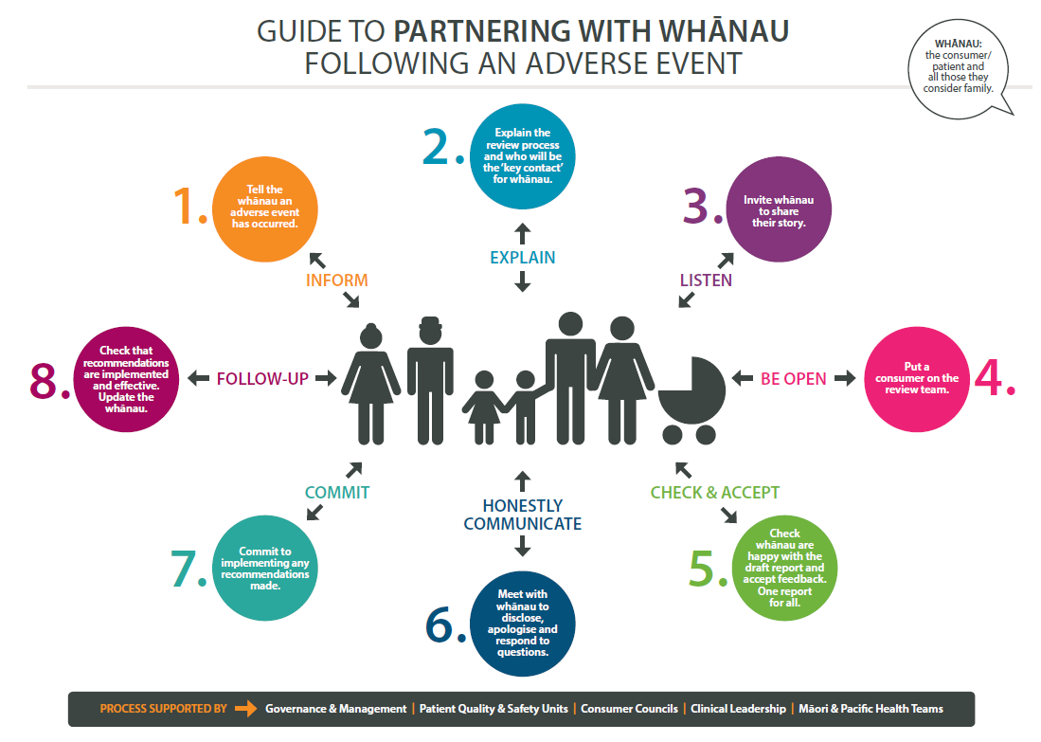

1.