|  |  |
| --- | --- |
|  | **NSU Adverse Event Management Policy (NSU 01)** |
| **Introduction** | This policy applies to adverse events that concern the national screening unit (NSU) in its central agency role of commissioning and supporting six national screening programmes in New Zealand.  The ongoing safety and quality of care provided to consumers is the primary objective of NSU.  There are two role options that NSU may adopt in response to an NSU screening programme related adverse event. The role depends upon where in the screening process the adverse event occurred, and the seriousness of impact caused by the adverse event.  The two roles for NSU are either to ‘support’ or to ‘lead’ a response to an adverse event as outlined below;   1. Adverse Event Management 2. An event has occurred involving one or more contracted NSU service providers.   **NSU will be informed of the event and investigation outcome/s will be reported to NSU within the specified timeline outlined in the provider service agreement. NSU may provide support to a provider investigation if indicated:** refer to *Appendix One*   1. The incident occurred within the NSU administrative and support functions to the national screening programmes in its central agency role.   **NSU will lead the investigation process and complete any / all recommendations arising from the investigation phase according to the process and specified timelines outlined in the *NSU Adverse Event Management Policy*:** refer to *Appendix Two*   1. 2. Serious Adverse Event 2. A serious adverse event has occurred involving one or more contracted NSU providers.   **NSU will be notified of the serious adverse event. The provider will lead the formal review process of the serious adverse event and complete any/ all recommendations arising from review. NSU may provide support to a provider investigation if indicated. The notification and review steps will be conducted according to the process and specified timelines:** refer to *Appendix Three*   1. The serious adverse event has occurred within the NSU administrative and support functions to the national screening programmes in its central agency role.   **NSU will inform the relevant stakeholders of the serious adverse event, lead the investigation process of the serious adverse event and complete any / all recommendations arising from the adverse event. The notification and investigations phase will be conducted according to the process and specified timelines outlined in the *NSU Adverse Event Management Policy*:** refer to *Appendix Four* |
|  |  |
| **Policy Owners** | * National Screening Unit Group Manager * Clinical Director Screening |
| **Scope** | * This policy applies to all NSU staff and contractors. * This policy applies to all NSU service providers. |
|  |  |
| **Principles** | National screening programmes are delivered by many screening service providers across six national screening programmes. The NSU and national screening programme providers have a joint responsibility to ensure that all people who are part of the screening pathway receive high quality care where harm is minimized.  The NSU and screening programme providers will ensure a principle-based approach to an incident and adverse event management process:   1. Open communication with consumers, their families and whanau in a culturally appropriate manner 2. Transparency is achieved so that open disclosure[1] and discussions of adverse events are conducted in a transparent and open manner with consumer participation 3. Timely investigation and reporting of screening programme related adverse events to ensure earlier identification of any wider system issues or risk of recurrence 4. Fairness – staff, consumers and support people involved in adverse events are entitled to fair treatment 5. Systems approach taken in reviewing adverse event and identifying improvements 6. Quality improvements actions are implemented to improve NSU and provider systems, processes and to minimise risk of recurrence 7. Monitoring of agreed corrective actions arising from adverse events will be conducted by the NSU to measure progress and the risk of recurrence 8. Lessons learned are shared with the sector to reduce the possibility of recurrence or ensure prevention 9. Support will be provided to staff following a serious event to manage and minimize the long-term impact that an event may have on them |
| **Policy Statement** | Adverse events must be notified and reviewed/investigated in compliance with the process and timeframes set out in the flowcharts attached to this policy.  All staff, contractors or providers are responsible for:   * notifying an adverse event as they identify them using the appropriate notification process including determining the severity of every reported adverse event using the Health Quality Safety Commission (HQSC) Severity Assessment Code (SAC) * participating in the review/investigation of incidents as required * participating in the implementation of recommendations made * encouraging colleagues to notify events that occur * participate in debriefing as or when required   Consumers/family/whanau/staff/health service providers will be informed of an adverse event. Consumer/s will be encouraged and assisted to report adverse events, to contribute to the review/investigation of an event that involves them and will be provided with a single point of contact within NSU or the NSU provider, as required. |
|  |  |
| **Guidance** | The following points will assist in the interpretation and use of the NSU Incident Management & Adverse Event Policy.   * This policy is to inform the response actions and responsibilities of NSU staff and contractors at the time an adverse event or incident has been identified * The term adverse event and incident are interchangeable. It should be noted the HQSC national adverse event policy was updated in 2017 and at that time the public health sector adopted the term ‘adverse event’ to replace the term incident. The term adverse event also aligns to *New Zealand Health & Disability Services (General) Standards* * The provider adverse event (incident) management policy must adhere to the *New Zealand Health & Disability Services (General) Standards*, *National Adverse Events Reporting Policy 2017* and *Health and Safety at Work Act 2015* * A severity assessment code aka SAC must be assigned for each adverse event. * The severity of an adverse event is determined using the HQSC severity assessment code rating and triage tool: refer to *Appendix Six* * This policy outlines what and when a service provider will notify to NSU if an incident or adverse event has occurred      * The policy does not outline how the service provider will conduct their response as the provider’s response actions will be guided and conducted according to the provider adverse event (incident) management policy and procedures * In the first instance the affected consumer/s name will not be required and only shared on a ‘need to know’ basis. Other consumer demographic information and NHI will be required to avoid duplication of effort or confusion throughout the investigation process * In accordance with the NSU Quality Framework an adverse event is a learning opportunity and is a valuable indicator in assessing the effectiveness of the NSU systems and processes      * The lessons learnt will be used to inform quality improvement activity for each programme and within NSU * All provider notifications to NSU will occur according to timeframes in the process outlined for either an adverse event or a serious adverse event; if the provider is uncertain, they can contact NSU to seek advice * If NSU or the provider is the lead for a SAE then they will also lead the external communication with media and notification HQSC * NSU will lead all communication with the Minister’s office regardless of who is leading the investigation of a screening programme related SAE * At the time of a SAE the lead organisation will conduct the open communication aka open disclosure with the affected person/s, family and whanau * To notify HQSC of a SAC 1 or SAC 2 event with reference to the HQSC website for their forms and process * A ‘no surprises’ approach will be adopted by all parties in support of prompt notification to NSU of a possible SAE i.e. a possible SAC 1 or 2 event, and throughout all communication surrounding the SAE * A ‘no surprises’ approach will also be applied for a SAC 3 or 4 adverse event if there could be public sensitivity or media interest surrounding the event; **if in doubt call NSU** * NSU provider SAC 3 and 4 adverse events will be reported to NSU in the regular contract relationship reporting mechanisms * If an adverse event involves the possibility of any of the following concerns; * a criminal act, * the use of illicit drugs / alcohol by an NSU or provider employee, * a deliberate unsafe act, * a deliberate patient harm,   Then the matter should be referred to the most senior manager role of the organisation where the event occurred. The management of an adverse event and any performance management processes must be clearly separated. An adverse event investigation cannot be conducted when an investigation process is underway for an alleged employee performance related matter. |
|  |  |
| **Exclusions** | * Consumer complaints not related to a screening adverse event   NB: Where a consumer complaint includes notification of a screening related adverse event then a SAC rating should be applied, and the adverse event should be reported and reviewed according to the NSU Adverse Event Management Policy   * Provider complaints about NSU staff or processes * Employee complaints or sensitive incidents not related to patient care or treatment (refer to the relevant Human Resources policy of the organisation) * Employee & Employer relationship issues |
| **Definitions** | The following definitions apply to this policy, unless otherwise stated.   |  |  | | --- | --- | | Word or phrase | Definition | | **Adverse Event** | An event with negative, unfavourable reactions or results that are unintended, unexpected, or unplanned.  In practice this is most often understood as an event which results in harm or has the potential to result in harm to a consumer.  The severity of harm or potential for harm is rated for each adverse event and assigned a severity assessment code aka SAC.  The preliminary SAC rating for an adverse event may alter after the initial investigation or formal review i.e. the SAC rating may increase or decrease according to the severity level of harm to the consumer. If the SAC alters to SAC 1 or 2 then a formal review process must occur. | | **Always Report and Review events** | The Always Report and Review list is a subset of adverse events that should be reported and managed in the same way as SAC 1 and 2 rated events, irrespective of whether there was harm to the consumer.  Always Report and Review events are events that can result in serious harm or death but are preventable with strong clinical and organisational systems.  Reporting Always Report and Review events can highlight weaknesses in how an organisation manages fundamental safety processes.  The Always Report and Review list is updated regularly by the Health Quality & Safety Commission. | | **Consumer** | For the purposes of this policy a consumer can also be a client, patient or resident. It is the person who uses/ receives health and disability services, or their representative. | | **Investigation** | Different levels of investigation of the adverse event may be undertaken generally aligned to the preliminary SAC rating of the incident for example for a SAC 3 or 4 event a desk-review or localised review within the organisation will be conducted that may lead to corrective actions and changes to localised systems and processes.  A formal review aka review is required for a SAC 1 or 2 event and ‘always report and review’ events.  The preliminary SAC rating may alter and can be adjusted either up or down in score according to the findings of the initial investigation or formal review. If the rate alters from SAC 3 or 4 to SAC 1 or 2 then a formal review must follow. | | **Near miss** | This is an event which, under different circumstances, could have caused harm to a consumer but did not, and which is indistinguishable from an adverse event in all but outcome. | | **Open communication** | A timely and transparent approach to communicating with and supporting health consumers when things go wrong. This included a factual explanation of what happened, an apology, and actions that deal with the actual and potential consequences of the event.  An important aspect of open disclosure is explaining to the consumer how the incident has been reviewed, and what systems will be put in place to make sure similar incidences will not happen again. | | **Representative** | A person to which the consumer has given their permission to make a complaint or represent them on their behalf:   * Where the consumer is under 16, the parent or guardian, or any person authorised in writing by the parent or guardian to act on behalf of the patient. * Where the consumer is deceased, the executor or administrator of the estate * Where the consumer is alive, over 16 and is unable to give consent, a person acting on the patient’s behalf. (This could be someone authorised in writing by the patient or family to act on behalf of the consumer). | | **Review** | A review is another name for a formal investigation process that is carried out by NSU or the service provider to analyse an adverse event (SAC 1 & 2), or an *Always Report and Review* event and develop recommendations based on the findings.  There are a variety of review methodologies such a root cause analysis (RCA) applied to conduct a review. The findings may lead to may lead to corrective actions and changes to organisation wide systems and processes.  On review the final SAC rating may alter and can be adjusted either up or down in score according to the findings of the review. | | **Serious Adverse Event** | An event during care or treatment that has resulted in an unanticipated death or major permanent loss of function not related to the natural course of an illness or underlying condition, pregnancy, or childbirth.  Major permanent loss of function is defined as sensory, motor, physiological, or intellectual impairment that as a result of an event during care, requires continues treatment or lifestyle change.  Permanent loss of function includes an increase in the level of disability where the consumer has a pre-existing disability or disabilities.  A serious adverse event will be rated either SAC1 or SAC 2.  An open communication process must be applied for a SAC 1 or 2 event. | | **Severity Assessment Code (SAC)** | The SAC is a numerical rating which assesses the severity of a patient adverse event and determines the level of reporting required and the type of review to be undertaken for the event.  HQSC publishes the SAC rating and triage tool with an examples table for use and guidance to all service providers.  *See Appendix Five for the SAC rating and triage tool for adverse event reporting* |  | | **SMART (mnemonic)** | **S** ~ specific  **M** ~ measurable  **A** ~ achievable/ assignable  **R** ~ relevant/ realistic  **T** ~ time bound | |

|  |  |
| --- | --- |
| **Process** | The policy outlines four processes that are aligned to the two roles for NSU are either ‘support’ or ‘lead’ a response to an adverse event;   1. Adverse Event Management 2. An event has occurred involving a (or more) contracted NSU service providers: refer to *Appendix One* 3. The incident occurred within the NSU administrative and support functions to the national screening programmes in its central agency role: refer to *Appendices Two & Five* 4. Serious Adverse Event 5. A serious adverse event occurred involving one or more contracted NSU providers: refer to *Appendix Three* 6. The serious adverse event has occurred within the NSU administrative and support functions to the national screening programmes in its central agency role: refer to *Appendices Four & Five*   The process flow charts are colour coded; **blue** for providers and **green** for NSU. |
| **Related** **Policies & Statements** | NSU Complaints Management Policy (NSU 02)  NSU Open Communication Policy (NSU 03)  NSU Quality Framework 2015 |
| **References** | Ministry of Health, New Zealand Health and Disability Services Standards, NZS 8134:2008  Health & Disability Commissioner, Guidance on Open Disclosure Policies  Health & Disability Commissioner, Complaint Guidelines  Health and Disability Commission (Code of Health and Disability Services Consumers’ Rights) Regulation 1996  Health Quality Safety Commission National Adverse Event Policy 2017  Privacy Act 1993  Health Information Privacy Code 1994  Public Records Act 2005  Principles of the Treaty of Waitangi |

**Appendix One**



**Appendix Two**



**Appendix Three**



**Appendix Four**



**Appendix Five**

**NSU Adverse Events Closure Checklist Record**

This checklist has been prepared for NSU staff only. Closure of a NSU adverse event investigation process is the responsibility of the assigned NSU Lead Investigator. The closure steps will occur following acceptance of the final adverse event report with a completed action plan that assigns responsibility for the completion of the agreed corrective actions.

|  |  |  |  |
| --- | --- | --- | --- |
| **#** | **Closure Elements** | **Yes /**  **No** | **Comments / requirements**  **(if No state the rationale** |
| 1. | Has the final SAC rating been confirmed? |  |  |
| 2. | Has the SAC 1 or 2 ‘adverse event brief part B report’ been sent to HQSC?  (preferably within the recommended 70 working days of notification to HQSC of the adverse event) |  |  |
| 3. | When the corrective actions have been assigned - Is there a plan for the NSU programme to monitor the progress of corrective actions? |  |  |
| 4. | Is there any follow up or additional monitoring required by the NSU?  - If yes, please state and by whom? |  |  |
| 5 | If necessary, has the NSU Risk Register been updated to reflect the outcome of the adverse event |  |  |
| 6. | Have lessons learned been communicated or documented for discussion and sharing? If not, who is assigned this task? |  |  |
| 7. | Are there any recommendations for changes in screening guidelines or policy and quality standards to be planned and implemented? |  |  |
| 8 | Has follow up education or training been completed? |  |  |
| 9. | Has the adverse event closure details been documented and updated in JiRA? |  |  |
| 10. | Are any further reports or updates required (e.g. for Minister’s Health Report, Director General)?  - If yes, please state requirement and who is this assigned task? |  |  |

**Appendix Six**– also available on HQSC website

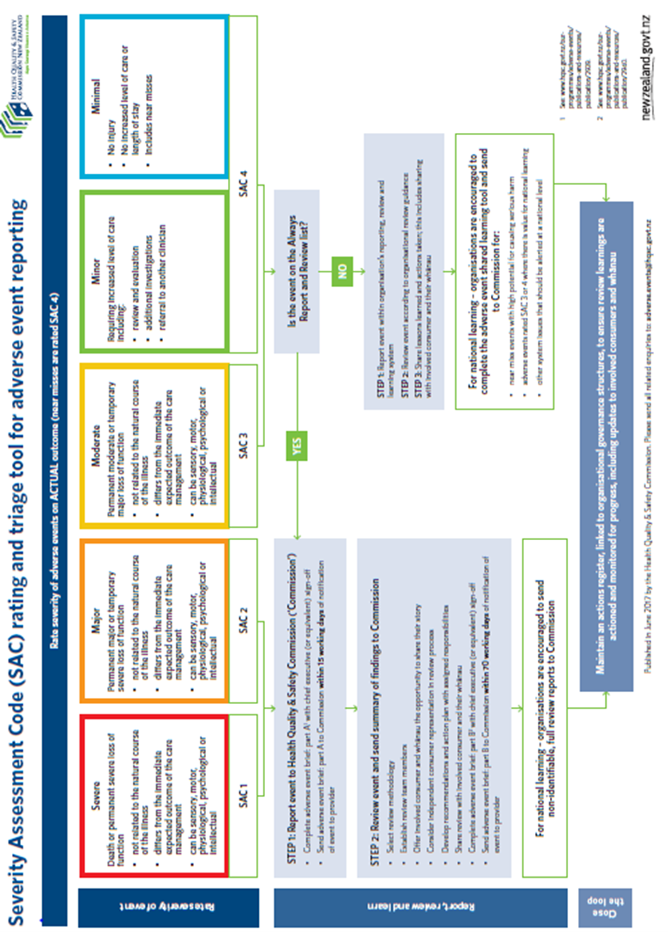

1.