Interval Cancers in the Bowel Screening Pilot
Preliminary Report: FIT negative

Citation: National Screening Unit. 2019. Interval Cancers in the Bowel Screening Pilot – Preliminary Report: FIT negative. Wellington: Ministry of Health.
Published in March 2019 by the Ministry of Health
PO Box 5013, Wellington 6140, New Zealand
ISBN 978-1-98-856849-2 (online)
HP 7031
This document is available at nsu.govt.nz
This work is licensed under the Creative Commons Attribution 4.0 International licence. In essence, you are free to: share ie, copy and redistribute the material in any medium or format; adapt ie, remix, transform and build upon the material. You must give appropriate credit, provide a link to the licence and indicate if changes were made.

Glossary
Definitive screen consists of a negative or positive faecal immunochemical test (FIT). Spoilt, expired or unreturned kits are excluded.
Faecal immunochemical test (FIT) is a test that can detect small amounts of blood in a bowel movement.
FIT result, negative is a test result below the pilot/programme threshold.
FIT result, positive is a test result that reaches or exceeds the pilot/programme threshold.
FIT threshold (pilot) is the set amount of blood in a sample that triggers a positive result. For the pilot, this was set at 75 nanograms (ng) of haemoglobin (Hb) per millilitre (mL) of buffer solution (15 µg Hb / g faeces).
Initial screen is the participant’s first definitive screening episode.
Interval cancer is a cancer that is diagnosed between a negative FIT result (normal) screen and the time the next screen would have occurred.
Sensitivity, programme (FIT + colonoscopy) is the proportion of cancers in the screened population that are identified through screening:
Screen-detected cancers
Screen-detected cancers + FIT interval cancers + colonoscopy interval cancers
Sensitivity, test (FIT) is the proportion of cancers in the screened population (excluding colonoscopy interval cancers) that are identified through screening:
Screen-detected cancers
Screen-detected cancers + FIT interval cancers
Subsequent screen/s is/are the screening episodes following a first successful (definitive) screening episode.
Target population (pilot) is the eligible population residing in the Waitemata DHB region between 50 and 74 years of age.

Contents
Glossary iii
Executive summary vii
Introduction vii
Methods vii
Results vii
International comparisons viii
1 Introduction 1
2 Methods 3
2.1 Screening cohort 3
2.2 Interval cancers definition 3
2.3 Matching between BSP and cancer registry data 4
2.4 Interval cancer rates 4
2.5 FIT sensitivity 5
2.6 Confidence interval calculations 5
3 Results 6
3.1 Initial and subsequent screens 6
3.2 Age at invite 6
3.3 Ethnicity 6
3.4 Sex 7
3.5 Figures and tables 7
4 International comparisons 13
Bibliography 14

List of Figures
Figure 1: Interval cancer rates for initial, subsequent and all screens, 2012–2015 7
Figure 2: FIT sensitivity for initial, subsequent and all screens, 2012–2015 8
Figure 3: Interval cancer rates by age at invite for initial, subsequent and all screens, 2012–2015 8
Figure 4: FIT sensitivity by age at invite for initial, subsequent and all screens, 2012–2015 9
Figure 5: Interval cancer rates by ethnicity for initial, subsequent and all screens, 2012–2015 10
Figure 6: FIT sensitivity by ethnicity for initial, subsequent and all screens, 2012–2015 10
Figure 7: Interval cancer rates by sex of participant for initial, subsequent and all screens, 2012–2015 11
Figure 8: FIT sensitivity by sex of participant for initial, subsequent and all screens, 2012–2015 12

List of Tables
Table 1: Case definition for colorectal cancers 3
Table 2: Interval cancer rates for initial, subsequent and all screens, 2012–2015 7
Table 3: FIT sensitivity for initial, subsequent screen and all screens, 2012–2015 8
Table 4: Interval cancer rates by age at invite for initial, subsequent and all screens, 2012–2015 9
Table 5: FIT sensitivity by age at invite for initial, subsequent and all screens, 2012–2015 9
Table 6: Interval cancer rates by ethnicity for initial, subsequent and all screens, 2012–2015 10
Table 7: FIT sensitivity by ethnicity for initial, subsequent and all screens, 2012–2015 11
Table 8: Interval cancers rates by sex of participant for initial, subsequent and all screens, 2012–2015 11
Table 9: FIT sensitivity by sex of participant for initial, subsequent and all screens, 2012–2015 12

Executive summary

Introduction
This report presents an analysis of interval cancers following a negative Faecal Immunochemical Test (FIT) occurring in participants screened in the first four years of the bowel screening pilot (BSP). The BSP was based in Waitemata District Health Board (DHB), and during this period, almost 136,000 screens were successfully completed, with over 44,000 of these a subsequent (repeat) screen. The numbers of both interval and screen detected cancers for this period were relatively small, and so caution is advised against drawing any strong conclusions from the analysis.

Overall interval cancer rates and sensitivity of the BSP will not be able to be calculated until sufficient time has elapsed from the last colonoscopy performed in the BSP for all potential interval cancers to be captured.

The findings in this report should not be used to predict FIT interval cancer rates and FIT sensitivity for the National Bowel Screening Programme (NBSP) due to differences between the pilot and the NBSP in the eligible age range and the threshold that triggers a positive screening result.

Methods
Data on participants screened in the BSP between 2012 and 2015 was matched to colorectal cancer diagnoses in the New Zealand Cancer Registry (NZCR), using the National Health Index number (NHI number). Interval cancer rates were calculated per 10,000 participants screened and were reported by type of screen (initial or subsequent), five-year age group, ethnicity, year of screen and the sex of the participant. Faecal immunochemical test (FIT) sensitivity (the proportion of cancers in the screened population detected by the screening programme) was calculated for the total BSP programme using the same breakdowns. Stage and site analysis will be performed at a later date, depending on the availability of data.

Results

Interval cancer rate
For the 2012–2015 screening period, 86 interval cancers were identified; a rate of 6.3 per 10,000 participants screened. The interval cancer rate was lower for participants undertaking their initial screen (first screen) at 5.9 per 10,000 participants screened compared with those having a subsequent screen (7.2 per 10,000 participants screened).

FIT sensitivity
For the 2012–2015 cohort, a total of 320 colorectal cancers were detected by screening. Overall, FIT sensitivity was 78.8%, with sensitivity higher in the initial screen (83.2%) compared with the subsequent screen (61.9%).

International comparisons
International comparisons are limited due to differences in bowel screening programme characteristics, such as eligible age, test type and methodology. However, the BSP results compared favourably with similar international bowel screening programmes. The Netherlands’ bowel screening programme had a comparable ratio of interval cancers to screen-detected cancers to the BSP. The Netherlands’ bowel screening programme also had a similar age range but lower threshold (10 µg Hb / g faeces).

Introduction
The goal of population-based cancer screening programmes is to reduce morbidity and mortality from cancer by finding cancers at an earlier, more treatable stage. Early detection can reduce the chances of dying from, and the impact of, colorectal cancer at both an individual and societal level. This is particularly pertinent in New Zealand, which has high rates of colorectal cancer compared with other Organisation for Economic Co-operation and Development (OECD) countries (Shaw et al 2008).

The bowel screening pilot (BSP) started screening Waitemata District Health Board (DHB) residents aged 50–74 years in January 2012 after an initial trial of 500 in November 2011. The purpose of the BSP was to test the feasibility of rolling out a National Bowel Screening Programme (the NBSP). In the first four years of the BSP, around 136,000 successful screening events were completed, with around 44,000 of these being a subsequent (repeat) screen.

Analysis of interval cancer rates, alongside regular programme monitoring reports, is an important part of monitoring the effectiveness of a cancer screening programme in meeting its goals. Reports on results from the BSP can be found on the Ministry of Health’s website at: www.health.govt.nz/our-work/preventative-health-wellness/ screening/bowel-screening-pilot/bowel-screening-pilot-monitoring-indicators

An interval cancer is a cancer that is diagnosed between a negative (normal) screen and the time the next screen would have occurred. In this report, this is a primary colorectal cancer that is diagnosed within two years of a negative faecal immunochemical test (FIT) result. Interval cancers following a negative colonoscopy are not included as sufficient time has not passed for a complete dataset to be compiled. These cancers will be analysed and reported separately, allowing overall programme sensitivity to be calculated.

The purpose of this report is to present information on interval cancers resulting from screens occurring during the first four years (2012–2015) of the BSP. This report presents interval cancer rates and FIT sensitivity. Interval cancers have been calculated per 10,000 individuals screened. FIT sensitivity has been calculated as the proportion of colorectal cancers diagnosed in screened individuals that were detected by the BSP (screen detected) for a given screening period. Sensitivity is inversely related to the number of interval cancers. The lower the proportion of interval cancers (false negatives), the higher the sensitivity of the test.

Interval cancers were analysed according to whether they occurred after an initial screen or a subsequent screen, by age, sex of participant, ethnicity and year of screen. It should be noted that the number of interval and screen detected cancers used for the analysis in this report are relatively small, and we advise readers against drawing any strong conclusions from the findings.

Equity is an essential component of a quality screening programme (National Screening Unit 2015). This includes access to quality monitoring by ethnicity. However, due to small initial numbers, analysis is currently limited. As the NBSP matures and larger numbers become available, more detailed analysis will be reported.

The NBSP is being implemented with a narrower eligible age range and a higher threshold for triggering a positive screening result. For this reason, the analysis in this report should not be used to predict FIT interval cancer rates and FIT sensitivity in the NBSP.

Methods

Screening cohort
This analysis was based on definitive screens that occurred during the first four years of the BSP. To participate in the BSP, individuals had to be between 50 and 74 years of age, be residing in the Waitemata DHB region, be eligible for publicly funded health care and not have had a colonoscopy in the five years before being invited into the BSP. Individuals already diagnosed with colorectal cancer were excluded.

The target age range was broad, and the haemoglobin (Hb) threshold was set low for the BSP because this was the first opportunity to obtain New Zealand data that would enable researchers to determine the different benefits and harms in different age groups at different thresholds. The BSP data helped inform the age range and threshold for the NBSP.

Participant age range and Hb threshold will impact on all monitoring indicators, including interval cancers rates. Though these results should not be generalised to the NBSP, they will provide a benchmark for future reports.

Interval cancers definition
For this analysis, interval cancers were defined as cases of primary invasive colorectal cancer diagnosed within 24 months after a negative FIT result.

Table 1: Case definition for colorectal cancers
ICD-O-2/3 | Term
C18.0 | Caecum
C18.1 | Appendix
C18.2 | Ascending colon; right colon
C18.3 | Hepatic flexure of colon
C18.4 | Transverse colon
C18.5 | Splenic flexure of colon
C18.6 | Descending colon; left colon
C18.7 | Sigmoid colon
C18.8 | Overlapping lesion of colon
C18.9 | Colon, NOS
C19.9 | Rectosigmoid junction
C20.9 | Rectum, NOS

Matching between BSP and cancer registry data
Data was extracted from the New Zealand Cancer Registry (NZCR) for individuals who were diagnosed with colorectal cancer between 1 January 2012 and 31 December 2017. The resulting list of National Health Index numbers (NHI numbers) were matched with the BSP population pool to ascertain whether any of these individuals had a screening history.

The date difference between the date of a negative FIT result and the date of cancer diagnosis as recorded in the NZCR was calculated.

Records were excluded if the cancer was:
- diagnosed more than 24 months after screening
- diagnosed within two years of a spoilt kit
- diagnosed after a declined colonoscopy
- a metastatic cancer from a primary other than colorectal.

Duplicates were removed, data entry and matching errors were resolved and a list of provisional interval cancers was produced. This list was sent to the BSP coordination centre for checking against their records. It was asked to flag whether they agreed or disagreed that the record was an interval cancer according to the provided definition. No interval cancer records were challenged.

Interval cancer rates
Interval cancers were analysed according to whether they occurred after an initial screen or a subsequent screen, by five-year age group, ethnicity and year of screen. The denominator used for rate calculations was the number of definitive screens in a given screening year by age group, ethnicity, sex of participant and whether the screen was an initial or subsequent screen. For comparisons by age group, ethnicity and sex of participant, interval cancer rates have been aggregated for 2012–2015 due to small numbers.

FIT sensitivity
FIT sensitivity is defined as the proportion of cancers in the screened population, detected by the FIT screening test. It is calculated by dividing the number of screen-detected cancers by the total number of cancers diagnosed in the participant population (screen-detected and interval cancers). In the BSP, FIT sensitivity was calculated by five-year age group, ethnicity, the sex of the participant and whether the screen was an initial or subsequent screen. Total sensitivity will be calculated when data on interval cancers following a negative colonoscopy is available.

Confidence interval calculations
Interval cancer rates and sensitivity percentages presented in this report are accompanied by 95% confidence intervals (CIs). These were calculated using Wilson’s method for a binomial distribution formula. The wider the CI, the less precise the estimate is to the true result. CIs can indicate whether there is a statistically significant difference in reported rates across groups.

Results

Initial and subsequent screens
For screens occurring between 2012 and 2015, a total of 86 interval cancers were identified, a rate of 6.3 (CI 95% 5.2 to 7.8) per 10,000 screens, 54 of them occurring after an initial screen and 32 occurring after a subsequent screen. The rate of interval cancers was highest in the subsequent screen at 7.2 (CI 95% 5.2 to 10.1) per 10,000 screens compared with 5.9 (CI 95% 4.6 to 7.6) per 10,000 in the initial screen (see Figure 1 and Table 2).

Overall FIT sensitivity was 78.8% (CI 95% 74.6 to 82.5), with the initial screen having a significantly higher sensitivity at 83.2% (CI 95% 78.8 to 86.9) than the subsequent screen at 61.9% (CI 95% 51.2 to 71.6) (see Figure 2 and Table 3).

Age at invite
The interval cancer rate for all screens increased with increasing age from 2.1 (CI 95% 1.0 to 4.2) per 10,000 screened in the 50–54 year age group to 20.8 (CI 95% 16.0 to 27.5) per 10,000 screened in the 70–74 year age group. This trend was also evident in both the initial and subsequent screens, with both rates for the 70–74 year age group significantly higher than those for all other age groups, at 19.0 (CI 95% 13.4 to 27.7) and 23.7 (CI 95% 16.3 to 36.0) respectively (see Figure 3 and Table 4).

Sensitivity was the lowest in the 70–74 year age group (not significant). There was no consistent trend in sensitivity by increasing age (see Figure 4).

Ethnicity
As shown in Figure 5 and Table 6, the highest rate of interval cancer was seen in the Pacific population, at 14.2 (CI 95% 7.3 to 30.2) per 10,000, all screens. The Asian population had the lowest rate at 2.2 (CI 95% 0.9 to 5.6) per 10,000 (all screens).

Figure 6 and Table 7 show that sensitivity was the lowest in the Pacific population at 57.1% (CI 95% 32.6 to 78.6) per 10,000, all screens, and highest in the Asian population at 90.2% (CI 95% 77.5 to 96.1) per 10,000, all screens.

Sex
Males had a slightly higher rate of interval cancers at 6.6 (CI 95% 5.0 to 8.9) for all screens compared with females at 6.1 (CI 95% 4.6 to 8.1) (see Figure 7 and Table 8).

FIT sensitivity was higher for males at 81.8% (CI 95% 76.2 to 86.3) for all screens than females at 75.1% (CI 95% 68.4 to 80.9) (see Figure 8 and Table 9).

Figures and tables
Note: Numbers of definitive screen may differ from the total shown in the tables due to unknown sex of the participant and the participant being aged 75 years or older.

Figure 1: Interval cancer rates for initial, subsequent and all screens, 2012–2015
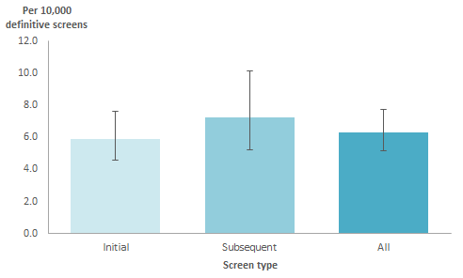

Table 2: Interval cancer rates for initial, subsequent and all screens, 2012–2015
Year | Initial screens |  |  |  | Subsequent screens |  |  |  | All screens
 | Interval cancers | Definitive screens | Rate/10,000 screened  (95% CI) |  | Interval cancers | Definitive screens | Rate/10,000 screened  (95% CI) |  | Interval cancers | Definitive screens | Rate/10,000 screened  (95% CI)
2012 | 16 | 26,461 | 6.0 | (3.8, 9.7) |  |  |  |  | 16 | 26,461 | 6.0 | (3.8, 9.7)
2013 | 25 | 37,381 | 6.7 | (4.6, 9.8) |  |  |  |  | 25 | 37,381 | 6.7 | (4.6, 9.8)
2014 | 6 | 15,272 | 3.9 | (1.9, 8.5) | 9 | 17,566 | 5.1 | (2.8, 9.7) | 15 | 32,838 | 4.6 | (2.8, 7.5)
2015 | 7 | 12,670 | 5.5 | (2.8, 11.3) | 23 | 26,573 | 8.7 | (5.9, 12.8) | 30 | 39,243 | 7.6 | (5.5, 10.8)
2012–2015 | 54 | 91,784 | 5.9 | (4.6, 7.6) | 32 | 44,139 | 7.2 | (5.2, 10.1) | 86 | 135,923 | 6.3 | (5.2, 7.8)

Figure 2: FIT sensitivity for initial, subsequent and all screens, 2012–2015
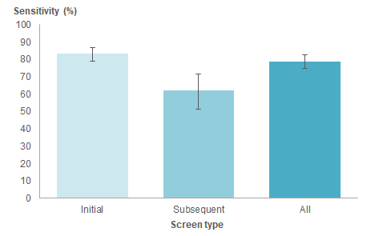

Table 3: FIT sensitivity for initial, subsequent screen and all screens, 2012–2015
Year | Initial screens |  |  |  | Subsequent screens |  |  |  | All screens
 | Interval cancers | Screen detected | Sensitivity  (95% CI) |  | Interval cancers | Screen detected | Sensitivity  (95% CI) |  | Interval cancers | Screen detected | Sensitivity  (95% CI)
2012 | 16 | 86 | 84.3 | (76, 90.1) |  |  |  |  | 16 | 86 | 84.3 | (76, 90.1)
2013 | 25 | 112 | 81.8 | (74.4, 87.3) |  |  |  |  | 25 | 112 | 81.8 | (74.4, 87.3)
2014 | 6 | 38 | 86.4 | (73.3, 93.6) | 9 | 23 | 71.9 | (54.6, 84.4) | 15 | 61 | 80.3 | (70, 87.7)
2015 | 7 | 32 | 82.1 | (67.3, 91) | 23 | 29 | 55.8 | (42.3, 68.4) | 30 | 61 | 67.0 | (56.9, 75.8)
2012–2015 | 54 | 268 | 83.2 | (78.8, 86.9) | 32 | 52 | 61.9 | (51.2, 71.6) | 86 | 320 | 78.8 | (74.6, 82.5)

Figure 3: Interval cancer rates by age at invite for initial, subsequent and all screens, 2012–2015
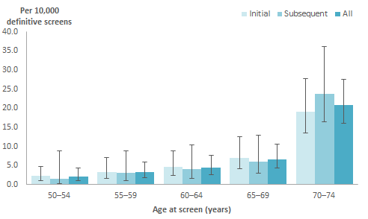

Table 4: Interval cancer rates by age at invite for initial, subsequent and all screens, 2012–2015
Age | Initial screens |  |  |  | Subsequent screens |  |  |  | All screens
 | Interval cancers | Definitive screens | Rate/10,000 screened  (95% CI) |  | Interval cancers | Definitive screens | Rate/10,000 screened  (95% CI) |  | Interval cancers | Definitive screens | Rate/10,000 screened  (95% CI)
50–54 | 6 | 27,546 | 2.2 | (1, 4.7) | 1 | 6,466 | 1.5 | (0.3, 8.7) | 7 | 34,012 | 2.1 | (1, 4.2)
55–59 | 6 | 18,643 | 3.2 | (1.5, 7) | 3 | 10,072 | 3.0 | (1.1, 8.7) | 9 | 28,715 | 3.1 | (1.7, 5.9)
60–64 | 8 | 17,757 | 4.5 | (2.3, 8.8) | 4 | 9,948 | 4.0 | (1.6, 10.3) | 12 | 27,705 | 4.3 | (2.5, 7.5)
65–69 | 11 | 15,693 | 7.0 | (4.1, 12.4) | 6 | 10,043 | 6.0 | (2.9, 12.9) | 17 | 25,736 | 6.6 | (4.2, 10.5)
70–74 | 23 | 12,131 | 19.0 | (13.4, 27.7) | 18 | 7,608 | 23.7 | (16.3, 36) | 41 | 19,739 | 20.8 | (16, 27.5)
Total | 54 | 91,784 | 5.9 | (4.6, 7.6) | 32 | 44,139 | 7.2 | (5.2, 10.1) | 86 | 135,923 | 6.3 | (5.2, 7.8)

Figure 4: FIT sensitivity by age at invite for initial, subsequent and all screens,
2012–2015
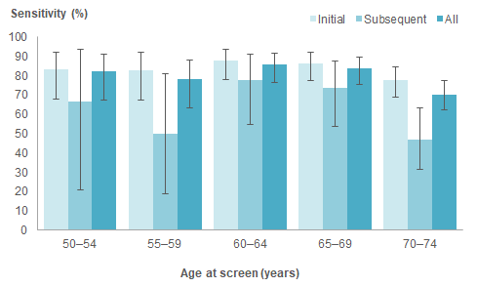

Table 5: FIT sensitivity by age at invite for initial, subsequent and all screens,
2012–2015
Age | Initial screens |  |  |  | Subsequent screens |  |  |  | All screens
 | Interval cancers | Screen detected | Sensitivity  (95% CI) |  | Interval cancers | Screen detected | Sensitivity  (95% CI) |  | Interval cancers | Screen detected | Sensitivity  (95% CI)
50–54 | 6 | 30 | 83.3 | (68.1, 92.1) | 1 | 2 | 66.7 | (20.8, 93.9) | 7 | 32 | 82.1 | (67.3, 91)
55–59 | 6 | 29 | 82.9 | (67.3, 91.9) | 3 | 3 | 50.0 | (18.8, 81.2) | 9 | 32 | 78.0 | (63.3, 88)
60–64 | 8 | 58 | 87.9 | (77.9, 93.7) | 4 | 14 | 77.8 | (54.8, 91) | 12 | 72 | 85.7 | (76.7, 91.6)
65–69 | 11 | 70 | 86.4 | (77.3, 92.2) | 6 | 17 | 73.9 | (53.5, 87.5) | 17 | 87 | 83.7 | (75.4, 89.5)
70–74 | 23 | 81 | 77.9 | (69, 84.8) | 18 | 16 | 47.1 | (31.5, 63.3) | 41 | 97 | 70.3 | (62.2, 77.3)
Total | 54 | 268 | 83.2 | (78.8, 86.9) | 32 | 52 | 61.9 | (51.2, 71.6) | 86 | 320 | 78.8 | (74.6, 82.5)

Figure 5: Interval cancer rates by ethnicity for initial, subsequent and all screens, 2012–2015
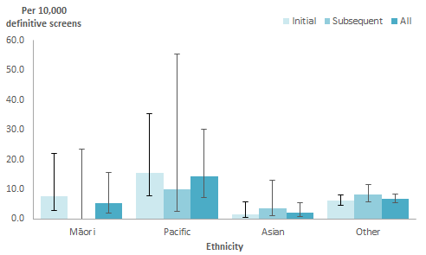

Table 6: Interval cancer rates by ethnicity for initial, subsequent and all screens,
2012–2015
Ethnicity | Initial screens |  |  |  | Subsequent screens |  |  |  | All screens
 | Interval cancers | Definitive screens | Rate/10,000 screened  (95% CI) |  | Interval cancers | Definitive screens | Rate/10,000 screened  (95% CI) |  | Interval cancers | Definitive screens | Rate/10,000 screened  (95% CI)
Māori | 3 | 3,941 | 7.6 | (2.9, 22.1) | 0 | 1,644 | 0.0 | (0, 23.3) | 3 | 5,585 | 5.4 | (2, 15.6)
Pacific | 5 | 3,219 | 15.5 | (7.6, 35.3) | 1 | 1,006 | 9.9 | (2.4, 55.4) | 6 | 4,225 | 14.2 | (7.3, 30.2)
Asian | 2 | 12,794 | 1.6 | (0.4, 5.7) | 2 | 5,567 | 3.6 | (1.1, 13) | 4 | 18,361 | 2.2 | (0.9, 5.6)
Other | 44 | 71,830 | 6.1 | (4.6, 8.2) | 29 | 35,922 | 8.1 | (5.7, 11.5) | 73 | 107,752 | 6.8 | (5.4, 8.5)
Total | 54 | 91,784 | 5.9 | (4.6, 7.6) | 32 | 44,139 | 7.2 | (5.2, 10.1) | 86 | 135,923 | 6.3 | (5.2, 7.8)

Figure 6: FIT sensitivity by ethnicity for initial, subsequent and all screens, 2012–2015
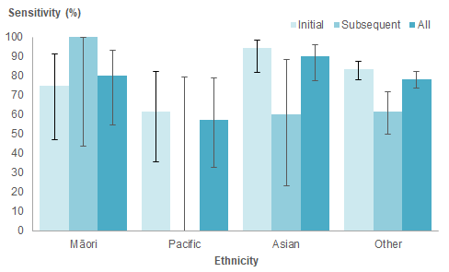
Table 7: FIT sensitivity by ethnicity for initial, subsequent and all screens, 2012–2015
Ethnicity | Initial screens |  |  |  | Subsequent screens |  |  |  | All screens
 | Interval cancers | Screen detected | Sensitivity  (95% CI) |  | Interval cancers | Screen detected | Sensitivity  (95% CI) |  | Interval cancers | Screen detected | Sensitivity  (95% CI)
Māori | 3 | 9 | 75.0 | (46.8, 91.1) | 0 | 3 | 100.0 | (43.9, 100) | 3 | 12 | 80.0 | (54.8, 93)
Pacific | 5 | 8 | 61.5 | (35.5, 82.3) | 1 | 0 | 0.0 | (0, 79.3) | 6 | 8 | 57.1 | (32.6, 78.6)
Asian | 2 | 34 | 94.4 | (81.9, 98.5) | 2 | 3 | 60.0 | (23.1, 88.2) | 4 | 37 | 90.2 | (77.5, 96.1)
Other | 44 | 217 | 83.1 | (78.1, 87.2) | 29 | 46 | 61.3 | (50, 71.5) | 73 | 263 | 78.3 | (73.6, 82.4)
Total | 54 | 268 | 83.2 | (78.8, 86.9) | 32 | 52 | 61.9 | (51.2, 71.6) | 86 | 320 | 78.8 | (74.6, 82.5)

Figure 7: Interval cancer rates by sex of participant for initial, subsequent and all screens, 2012–2015
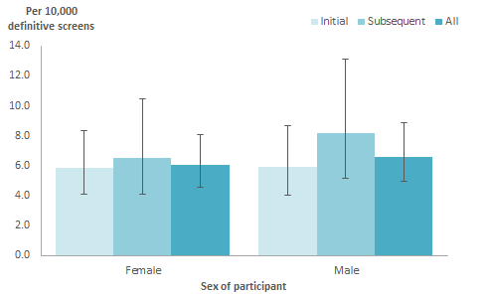

Table 8: Interval cancers rates by sex of participant for initial, subsequent and all screens, 2012–2015
Sex | Initial screens |  |  |  | Subsequent screens |  |  |  | All screens
 | Interval cancers | Definitive screens | Rate/10,000 screened  (95% CI) |  | Interval cancers | Definitive screens | Rate/10,000 screened  (95% CI) |  | Interval cancers | Definitive screens | Rate/10,000 screened  (95% CI)
Female | 29 | 49,537 | 5.9 | (4.1, 8.3) | 16 | 24,566 | 6.5 | (4.1, 10.5) | 45 | 74,103 | 6.1 | (4.6, 8.1)
Male | 25 | 42,245 | 5.9 | (4.1, 8.7) | 16 | 19,572 | 8.2 | (5.2, 13.1) | 41 | 61,817 | 6.6 | (5, 8.9)
Total | 54 | 91,784 | 5.9 | (4.6, 7.6) | 32 | 44,138 | 7.2 | (5.2, 10.1) | 86 | 135,922 | 6.3 | (5.2, 7.8)

Figure 8: FIT sensitivity by sex of participant for initial, subsequent and all screens, 2012–2015
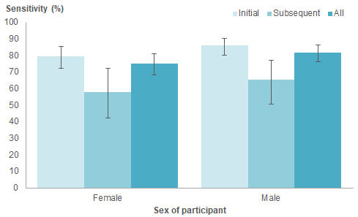

Table 9: FIT sensitivity by sex of participant for initial, subsequent and all screens, 2012–2015
Sex | Initial screens |  |  |  | Subsequent screens |  |  |  | All screens
 | Interval cancers | Screen detected | Sensitivity  (95% CI) |  | Interval cancers | Screen detected | Sensitivity  (95% CI) |  | Interval cancers | Screen detected | Sensitivity  (95% CI)
Female | 29 | 114 | 79.7 | (72.4, 85.5) | 16 | 22 | 57.9 | (42.2, 72.1) | 45 | 136 | 75.1 | (68.4, 80.9)
Male | 25 | 154 | 86.0 | (80.2, 90.4) | 16 | 30 | 65.2 | (50.8, 77.3) | 41 | 184 | 81.8 | (76.2, 86.3)
Total | 54 | 268 | 83.2 | (78.8, 86.9) | 32 | 52 | 61.9 | (51.2, 71.6) | 86 | 320 | 78.8 | (74.6, 82.5)

International comparisons
International comparisons of test sensitivity should be approached with caution because there are differences between programmes, including eligible age range, test type, methodology and length of time the programme ran (ie, proportion of screens that were an initial or subsequent test).

Internationally, two tests are commonly used: the guaiac faecal occult blood test (gFOBT) and the faecal immunochemical test (FIT), with many countries moving to FIT due to the higher test sensitivity compared with gFOBT.

An international meta-analysis reported that, for every gFOBT interval cancer identified, 1.2 screen-detected cancers were found, and for every FIT interval cancer, 2.6 screen-detected cancers were found (Wieten et al 2018).

Wieten et al included 17 studies reporting on FIT test interval cancers. Screening programmes included in this meta-analysis were diverse, with different age ranges, thresholds and number of screening rounds included. The median threshold of 20 µg Hb / g faeces was higher than the 15 µg Hb / g faeces (75 ng Hb / mL buffer) set for this pilot.

Overall, the BSP had a more favourable ratio of screen-detected cancers to FIT interval cancers than the average reported by Wieten et al. For every interval cancer, the BSP found 3.7 screen-detected cancers. This result was similar to the Netherlands pilot, a bowel screening programme with a similar age range but lower threshold (10 µg Hb / g faeces), which reported 3.3 screen-detected cancers for every FIT interval cancer (van der Vlugt et al 2017).

Bibliography
Australian Institute of Health and Welfare. 2014. Analysis of bowel cancer outcomes for the National Bowel Cancer Screening Programme: 2018. Cat. no. CAN 113. Canberra: AIHW.
Bill MD, Bramble MG, Rees CJ, et al. 2012. Comparison of screen-detected and interval cancers in the Bowel Cancer Screening Programme. British Journal of Cancer 107: 417–21.
Blom J, Törnberg S. 2017. Interval cancers in a guaiac-based colorectal cancer screening programme: consequences on sensitivity. J Med Screen 24(3): 146–52.
National Screening Unit. 2015. National Screening Unit Quality Framework 2015: Delivering screening programmes. Wellington: Ministry of Health.
Portillo I, Arana-Arri E, Idiggoras I, et al. 2017. Colorectal and interval cancers of the Colorectal Cancer Screening Programme in the Basque Country (Spain). World J Gastroenterol, April 21: 23(15): 2731–42. DOI: 10.3748/wjg.v23.i15.2731 (accessed 1 February 2019).
Shaw C, Cunningham R, Sarfati D. 2008. Next Steps towards a Feasibility Study for Colorectal Cancer Screening in New Zealand: Report for the Ministry of Health. Wellington: Department of Public Health, University of Otago. URL: www.health.govt.nz/system/files/documents/pages/next_steps_towards_a_feasibility_study_for_colorectal_cancer_screening_in_new_zealand_0.pdf (accessed 1 February 2019).
Steele RJ, Stanners G, Lang J, et al. 2016. Interval cancers in a national colorectal cancer screening programme. United European Gastroenterology Journal 4(4): 587–94. DOI: 10.1177/2050640615624294 (accessed 1 February 2019).
van der Vlugt M, Grobbee EJ, Bossuyt PMM, et al. 2017. Interval colorectal cancer incidence among subjects undergoing multiple rounds of fecal immunochemical testing. Gastroenterology 153: 4339–447.
Wieten E, Schreuders EH, Grobbee EJ, et al. 2018. Incidence of faecal occult blood test interval cancers in population-based colorectal cancer screening: a systematic review and meta-analysis. Gut. Published online first: 22 June 2018. DOI: 10.1136/gutjnl-2017-315340 (accessed 1 February 2019).

