Impact Analysis

Extending BreastScreen Aotearoa  
to include women aged 70–74 years



Citation: Ministry of Health. 2019. *Impact Analysis: Extending BreastScreen Aotearoa to include women aged 70–74 years*. Wellington: Ministry of Health.

Published in May 2019 by the Ministry of Health  
PO Box 5013, Wellington 6140, New Zealand

ISBN 978-1-98-856825-6 (online)  
HP 6984



This document is available at health.govt.nz

|  |  |
| --- | --- |
| **CCBY** | This work is licensed under the Creative Commons Attribution 4.0 International licence. In essence, you are free to: share ie, copy and redistribute the material in any medium or format; adapt ie, remix, transform and build upon the material. You must give appropriate credit, provide a link to the licence and indicate if changes were made. |

Contents

Introduction 1

Key findings from the impact analysis 1

Background 2

Purpose of this analysis 2

Methods 3

Limitation of the analysis 3

Current and future state overview 3

Section 1: Breast cancer in New Zealand 6

Overview of breast cancer in New Zealand 7

Overview of detection and treatment of breast cancer in New Zealand 9

Impact of age extension on breast cancer in New Zealand 11

Impact of age extension on women and their health 15

Section 2: BreastScreen Aotearoa service delivery 19

Overview of BreastScreen Aotearoa service delivery 20

Impact of age extension on BreastScreen Aotearoa service delivery 22

Section 3: The wider health system 27

Overview of breast cancer treatment and other services 28

Impact of age extension on breast cancer treatment services 29

Impact of age extension on other health services 32

Appendices 34

Appendix 1: Methodology 35

Appendix 2: Screening pathway 38

Appendix 3: Evidence for screening women aged 70 to 74 39

Appendix 4: Modelling the impacts on BreastScreen Aotearoa 41

Appendix 5: References 44

# Introduction

The National Screening Unit (NSU) undertook this impact analysis because recent evidence shows that there is a mortality benefit to providing regular organised breast screening to women aged 70–74 years for breast cancer.

The overall purpose of the analysis is to provide a summary of the impacts of extending the age range for the national breast screening programme, BreastScreen Aotearoa, to include women up to age 74. The audience for this analysis is primarily the Government and health professionals, but the analysis may be of interest to the general public. The analysis was completed in June 2018 and information in this report is the latest available at that time.

The analysis uses modelling and what we know about breast cancer and breast screening to provide a high-level summary of the impacts of a potential age extension on women, screening and treatment providers and the wider health sector. One of its aims is to help shape changes to the existing programme that provide the most benefits for New Zealanders.

## Key findings from the impact analysis

BreastScreen Aotearoa is a high quality national screening programme that has contributed to the reduction of breast cancer mortality in New Zealand but ongoing work is required to ensure the services are accessible for wāhine Māori and Pacific women.

Analysis of the impacts found that if we were to extend screening for women aged  
70–74:

|  |  |
| --- | --- |
|  | mortality from breast cancer might be reduced by at least one-third for these women (compared to women who are not screened) |
|  | treatment patterns would change, as more cancer would be found at an earlier stage, when the required treatment might be less intensive |
|  | more women would receive publicly funded screening mammograms (around 42,000 additional mammograms per year) |
|  | demand on screening, assessment, treatment and support services would increase (there are currently shortages of the specialist workforce required for breast screening, both in New Zealand and internationally) |
| C:\Users\JCOX~1.MOH\AppData\Local\Temp\notesBD2F6A\hospital2 blue.png | the challenges for BreastScreen Aotearoa would include ensuring the screening service is sustainable, high quality and equitable throughout the change. |

Screening services are nearing capacity; an age extension would be challenging and would be likely to have flow-on impacts on other health services. This represents a significant potential change for BreastScreen Aotearoa, and we would need to carefully plan, fund and manage it.

## Background

As a general principle, health systems offer population health screening to people who do not display symptoms of the condition being screened for (that is, people who are asymptomatic). The screening test identifies those who have an increased chance of having the condition (who receive a positive screening result) and those who do not have an increased chance of having the condition (who receive a negative screening result). The screening programme will offer people with a positive result further investigation, which will give them more information about whether they have the relevant condition. Where further investigation confirms the condition, the system offers treatment.

The majority of participants in any screening programme are healthy individuals, and potentially exposing this population to unnecessary harm is always a major consideration. Health systems put considerable infrastructure and resources in place to ensure the quality of screening programmes is as high as possible. Safety of participants is of paramount importance.

Screening mammography through an organised screening programme cannot prevent breast cancer, but international evidence has shown that it can reduce mortality from breast cancer. Mammographic screening can identify breast cancer at an early stage, thereby improving the probability of a positive outcome: survival after diagnosis and treatment is directly related to the stage at which the cancer is diagnosed.

BreastScreen Aotearoa is New Zealand’s publicly funded national biennial breast-screening programme. The Ministry of Health established the programme in December 1998 to provide screening for asymptomatic women aged 50–64 years. In July 2004, the eligible age range was extended to include women aged 45–69 years. Recently, Labour and New Zealand First agreed on a policy to progressively increase the age for free breast-screening to 74 years.

## Purpose of this analysis

Women aged 70–74 have not previously been eligible for BreastScreen Aotearoa because there was insufficient evidence that screening would reduce mortality for women in this age group.

Each country has a unique population; we need to interpret international evidence in the local context to ensure the findings are replicable. The previous age extension in 2004 effectively doubled the number of women eligible for the programme, and resulted in unintended negative impacts. One of the aims of this analysis is to help develop an implementation plan that will manage the potential negative impact on existing screening populations.

Consultation with women and the sector during the analysis was limited. However, the Breast Cancer Foundation New Zealand petition with 10,000 signatures presented to the House of Representatives on 4 May 2016 provides an indication that there is public support for extending the age range.

## Methods

This analysis is a high-level overview. It uses population modelling to provide a prediction of the impacts on breast cancer services, and summarises the likely impact on women’s health based on what we know about breast cancer in women aged 70–74 years. It also takes into account consultation with service providers on the likely impacts to their services. The analysis does not examine if women aged 70–74 years should have regular breast screening, and makes no recommendations.

## Limitation of the analysis

This analysis has limitations due to the difficulty inherent in interpreting breast cancer epidemiology. Specifically, the analysis does not include a determination of the potential number of lives that could be saved, analysis of whether benefits outweigh harms, a cost–benefit analysis or an analysis of the full impact on treatment patterns of offering breast screening to women aged 70–74 years. Previous international randomised controlled trials (RCTs) on breast cancer screening have not generally included women aged 70 years and over; therefore, the findings have not provided an evidence base for mortality reduction in this age group. It will be important to continue to monitor results from international programmes and trials, and to potentially review the mortality impact in New Zealand at least ten years after implementation of the potential extension.

## Current and future state overview

The next two pages provide an overview of the current state of BreastScreen Aotearoa and projections for what the future might look like.





# **Section 1:** Breast cancer in New Zealand

In 2016, the World Health Organization (WHO)’s International Agency for Research on Cancer (IARC) reviewed all published peer-reviewed scientific literature and concluded that:

**there is sufficient evidence that screening women aged  
70–74 years by mammography reduces breast cancer mortality. This evaluation is supported by observational studies of service mammography screening.**

This section looks at this finding in a New Zealand context and what it might mean for breast cancer in New Zealand.

The analysis found that, if we were to extend screening for women aged 70–74:

|  |  |
| --- | --- |
|  | there would be a temporary increase in the number of breast cancers found, but the overall number of breast cancers in New Zealand would not change significantly |
|  | mortality from breast cancer for women aged 70–74 years would reduce, and mortality from breast cancer for women aged 75 years and over might reduce |
| C:\Users\JCOX~1.MOH\AppData\Local\Temp\notesBD2F6A\iconmonstr-user-31-240.png | the benefits of screening would be likely to outweigh the risks for most women aged 70–74 |
| C:\Users\JCOX~1.MOH\AppData\Local\Temp\notesBD2F6A\hospital2 blue.png | screening and treatment pathways would need to manage higher rates of women with significant health conditions due to age |
| C:\Users\JCOX~1.MOH\AppData\Local\Temp\notesBD2F6A\iconmonstr-user-31-240.png | without maintaining an equity focus, the equity gap in mortality outcomes between wāhine Māori, Pacific women and non-Māori/non-Pacific women would increase. |

## Overview of breast cancer in New Zealand

|  |  |
| --- | --- |
| **Breast cancer is the most commonly diagnosed cancer for women in New Zealand** | In 2014, 3,272[1] new breast cancer cases were registered in New Zealand. Breast cancer registrations have been increasing as the population grows, but the age-standardised rate per 100,000 women shows that breast cancer registration rates are relatively stable in New Zealand. |

* All age-standardised rates in this analysis have been standardised to the WHO standard world population.

|  |  |
| --- | --- |
| **Wāhine Māori and Pacific women have significantly higher breast cancer incidence** | As the figure below shows, wāhine Māori have a significantly higher breast cancer registration rate than non-Māori/non-Pacific women (in 2014 the rates were 122.5 per 100,000 and 97.2 per 100,000, respectively). Pacific women also had a higher breast cancer registration rate compared to non-Māori/non-Pacific women (116.2 new registrations per 100,000 women in 2014). |

* A new algorithm for deriving cancer registration ethnicity was used from 2006 onwards.

|  |  |
| --- | --- |
| **Breast cancer is the second most common cause of cancer death** | After lung cancer, breast cancer is the most common cause of cancer death for women in New Zealand. In 2014, there were 607 deaths from breast cancer in New Zealand, including 68 wāhine Māori and 33 Pacific women. |

|  |  |
| --- | --- |
| **Mortality rates from breast cancer are higher for wāhine Māori and Pacific women** | Māori and Pacific men and women generally experience worse health outcomes than non-Māori and non-Pacific. Breast cancer outcomes reflect this disparity: more wāhine Māori and Pacific women die from breast cancer than non-Māori/non Pacific women.  In 2014, mortality from breast cancer was significantly higher for wāhine Māori compared to non-Māori/non-Pacific women (22.7 deaths per 100,000 and 15.5 deaths per 100,000, respectively). Mortality from breast cancer was also higher for Pacific women (25.5 deaths per 100,000 women).  Interpretation of Māori and Pacific data can be difficult due to small numbers, and should be undertaken with caution. |

## Overview of detection and treatment of breast cancer in New Zealand

|  |  |
| --- | --- |
| **In New Zealand Breast cancer can be found in a number of different ways** | Many health services are involved in identifying, treating and supporting women with breast cancer.  Any woman who has breast cancer symptoms is able to have her symptoms investigated for free with a doctor’s referral. This investigation is done through the woman’s district health board (DHB).  District health boards also provide free mammograms to women considered at increased risk of breast cancer. This is usually an annual mammogram, but may involve other breast imaging.  Women can also pay to have a mammogram through a private provider, or ask their doctor to do a physical examination. |

|  |  |
| --- | --- |
| **Women aged 45–69 years can have mammograms through BreastScreen Aotearoa** | Women aged 45–69 years can join BreastScreen Aotearoa, which invites them to have a screening mammogram every two years. The eligible age range is based on international evidence that women in this age group benefit from breast screening.  Screening mammography cannot prevent the development of breast cancer but provides an opportunity to detect a cancer earlier than it may have otherwise been found. Mammographic screen detected cancer improves the probability of a positive outcome from breast cancer as survival after diagnosis and treatment is directly related to the stage at which the cancer is diagnosed. |

|  |  |
| --- | --- |
| **Women diagnosed with breast cancer by BreastScreen Aotearoa are less likely to die from breast cancer** | *Cohort and Case Control Analyses of Breast Cancer Mortality: BreastScreen Aotearoa 1999–2011* (Morrell et al 2015) found that screening coverage of 70 percent or higher was associated with a reduction in breast cancer mortality of 30 percent or more for all women screened compared to women not screened. BreastScreen Aotearoa achieves this coverage target nationally, but not for wāhine Māori. The study found that wāhine Māori are likely to benefit from a similar reduction in breast cancer mortality if we can increase their participation in screening.  The study also found that among women who take part in regular breast screening through BreastScreen Aotearoa, there is an even greater reduction in the rate of breast cancer deaths. |

|  |  |
| --- | --- |
| **BreastScreen Aotearoa has never achieved the same screening coverage for wāhine Māori as it has for non-Māori/non-Pacific women** | An unintended consequence of the previous age extension in 2004 was the negative, long-term impact on screening coverage of the pre-existing eligible population, particularly for wāhine Māori, who experienced a 4.4 percent decrease in coverage.  It is a woman’s choice whether they want to enrol with BreastScreen Aotearoa. An unintended consequence is that women with fewer barriers to accessing screening services are advantaged. In times of significant programme change, resources and staff that would otherwise be focused on increasing accessibility are redeployed to meet increased demand.  It is important that we accompany any extension to the programme with steps to protect and increase Māori and Pacific coverage. |

Age extension implemented  
(1 July 2004)

|  |  |
| --- | --- |
| **Women diagnosed with breast cancer through screening tend to be diagnosed at an earlier stage** | Women diagnosed with breast cancer through BreastScreen Aotearoa tend to be diagnosed at an earlier stage compared with those diagnosed outside of the programme. Early diagnosis has significant benefits for women.  When breast cancer is detected at an earlier stage, women are less likely to require extensive axillary surgery (surgery on lymph nodes in the underarm) and less likely to require chemotherapy (Royal Australasian College of Surgeons 2017). In addition, early-stage small tumours are more amenable to treatment with breast-conserving surgery (complete local excision), which has some psychological and practical advantages over mastectomy. Section three further explores the impact of extending breast screening to women aged 70–74 years on breast cancer treatment. |

|  |  |
| --- | --- |
| **Screening has contributed to the standardisation of breast cancer management** | The introduction of breast screening has contributed to the standardisation of breast cancer management in New Zealand, which has had positive impacts on breast cancer outcomes: for example, more consistent clinical practice across screening and diagnostic services and the adoption of multidisciplinary meetings (MDMs) across breast services. |

|  |  |
| --- | --- |
| **All screening programmes can cause harm to participants** | Evaluating the harms of population screening is an important ongoing consideration. Screening programmes are only recommended when the benefits outweigh these harms. Screening can expose a large number of well people to risks; the recognised harms include overdiagnosis, false positive and false negative results, radiation exposure, discomfort and anxiety. In addition, for women aged 70–74 years, lower life expectancy and comorbidities[2] may reduce the benefits of screening for individuals.  There is international evidence from the RCTs that the benefits from breast screening outweigh the harms for women aged 50–69 years. This balance is less clear for other age groups. |

## Impact of age extension on breast cancer in New Zealand

|  |  |
| --- | --- |
| **Screening women aged 70–74 would result in a temporary increase in breast cancer registrations in New Zealand** | Offering breast screening to women aged 70–74 years would result in an initial increase in breast cancer registrations in the first four to six years. As cancers are found at earlier stages, the number of cancers diagnosed in women aged 75–79 years would decrease, as many would have been detected earlier through screening. The overall number of breast cancers diagnosed would not change significantly.  Breast cancer registrations were 88.8 per 100,000 in 1998, and increased to 95.4 per 100,000 in 1999, when the programme was implemented (Ministry of Health 2016). By 2004, breast cancer registrations had returned to pre-implementation levels (88.5 per 100,000).  Screening finds some breast cancers that would not otherwise have been found within a woman’s lifetime (overdiagnosis). However, the return to pre-implementation rates described above suggests that overdiagnosis is not a significant issue for BreastScreen Aotearoa. This analysis discusses overdiagnosis in more detail on page 16. |

|  |  |
| --- | --- |
| **There will be a shift in the number of breast cancer registrations for women aged 70–79 years** | Screening women aged 70–74 years will result in more breast cancers being found in this age group and fewer being found in the 75–79-year age group.  One effect of population screening is the reduction in cancers registered in the age group just outside the eligible age range: there is a delay before the cancers that develop after the age of screening grow enough to be felt. For BreastScreen Aotearoa, this is currently seen in the 70–74-year age group. The graph below illustrates this over a one-year period. The effect is recognised internationally, and is an important consideration in calculating screening effectiveness (Houssami and Miglioretti 2016). |

|  |  |
| --- | --- |
| **There would be a reduction in breast cancer mortality in the 70–74 age group** | Similar mortality reductions to those seen in women aged 65–69 years are assumed for women aged 70–74 years, dependent on coverage of 70 percent or higher. Estimates vary in the expected mortality reduction that screening could achieve for women aged 70–74 years, and are difficult to assess, as the evidence from RCTs for women aged 70–74 years is limited.  The most significant evidence for a mortality benefit from screening women aged 70–74 years is the IARC update to the handbook on breast cancer screening (2016): see Appendix 3. The updated handbook concludes there is sufficient evidence that screening women aged 70–74 years by mammography reduces breast cancer mortality. This benefit is likely to be due to improved life expectancy, rather than change in the disease, or diagnosis and treatment of breast cancer. |

|  |  |
| --- | --- |
| **Quantifying how many deaths could be prevented is complex** | In 2014, 63 women aged 70–74 years died from breast cancer in New Zealand (that is, an age-specific mortality rate of 76 deaths per 100,000 women). An age extension would introduce the potential to reduce mortality from breast cancer, but quantifying this is complex, and this impact analysis has not attempted to do so. Predictive models for mortality from breast cancer do exist, but require modelling programmes and expertise beyond the scope of this analysis.  The number of deaths from breast cancer start to decline after age 70; however, this is due to a decrease in the population in this age range. Age-specific mortality from breast cancer shows an increase in breast cancer deaths as women get older. |

|  |  |
| --- | --- |
|  | Trends in breast cancer mortality by age for wāhine Māori and Pacific women can be hard to determine due to small numbers; this analysis does not provide a breakdown by five-year age band for those groups. |

|  |  |  |  |  |  |  |  |  |  |  |  |  |  |
| --- | --- | --- | --- | --- | --- | --- | --- | --- | --- | --- | --- | --- | --- |
| **At a population level, there would be less mortality benefit for wāhine Māori and Pacific women** | On an individual level, some wāhine Māori and Pacific women aged 70–74 years would benefit from breast screening; however, there would be less potential benefit at a population level.  While life expectancy among wāhine Māori and Pacific women is improving, fewer wāhine Māori and Pacific women reach 70 years of age than non-Māori/non-Pacific women.   |  |  |  | | --- | --- | --- | |  | C:\Users\JCOX~1.MOH\AppData\Local\Temp\notesBD2F6A\~0402311.pngNumber of women alive at 70 per 100,000[3] | C:\Users\JCOX~1.MOH\AppData\Local\Temp\notesBD2F6A\~0402311.pngNumber of women alive at 75 per 100,000 | | Māori | 73,477 | 62,089 | | Pacific | 78,225 | 68,094 | | Non-Māori | 88,605 | 82,487 |   At a population level, there are fewer wāhine Māori and Pacific women alive to see a benefit from extension of the screening age, and those who are alive are more likely to have comorbidities that make treatment for breast cancer inappropriate or cause them to die before they are 75 years of age. Extending the age range would be likely to benefit non-Māori/non-Pacific women more, and so would contribute to an increase in the equity gap in breast cancer outcomes.  Wāhine Māori would experience a greater benefit from breast screening if participation of women aged 45–69 years was increased. Without prioritising an equity focus, the equity gap in mortality outcomes between wāhine Māori, Pacific women and non-Māori/non-Pacific women will increase. |

## Impact of age extension on women and their health

|  |  |
| --- | --- |
| **For most women aged 70–74, the benefit of breast screening would outweigh the risk of harm due to screening** | Women older than 74 years were not included in any of the international breast cancer screening trials, and there is limited evidence on the balance of benefits compared to harms of breast screening for women aged 70–74 years. The harms and benefits are sensitive to population characteristics and the update to the IARC handbook did not provide an analysis of the benefits and harms of screening women aged 70–74 years. This section contains a brief summary of what we might expect in New Zealand.  The harms of breast screening for women aged 70–74 years who have a life expectancy of at least ten years are unlikely to be significantly different from those for women aged 65–69 years. For most women the risk of harm would be outweighed by the benefit of breast screening as early detection of breast cancer with subsequent early treatment leads to a decrease in mortality from breast cancer. |

|  |  |
| --- | --- |
| **Screening women aged 70–74 years would mean some women aged 70–74 years experience discomfort, inconvenience and anxiety** | Extending the screening age would result in women having two or three additional mammograms in their lifetime. The majority of women being screened would have previous experience with breast screening, so we would not expect anxiety, inconvenience and discomfort related to breast screening to be higher than in other eligible age groups (as with all women, this assumes other factors remain unchanged; for example, significant life shocks, such as loss of a driver’s license or death of a spouse).  One of the potential benefits of screening women aged 70–74 years is reduced anxiety for women who find the free regular mammograms reassuring. |

|  |  |
| --- | --- |
| **Increasing the number of mammograms women have in their lifetime will expose them to additional low-dose radiation** | All women are exposed to a low dose of radiation during a mammogram, but digital mammography delivers a lower-dose radiation than film-based mammography (Hendrick et al 2010). BreastScreen Aotearoa has always achieved a low radiation dose by international standards, while maintaining high image quality. Therefore, the additional screening appointments should not put women at unnecessary risk.  The International Agency for Research on Cancer found that found that ‘there is sufficient evidence that the risk of radiation-induced cancer from mammography in women aged 50–74 years is substantially outweighed by the reduction in breast cancer mortality from mammography screening’ (IARC 2016). |

|  |  |
| --- | --- |
| **False positives and false negatives are less common in older women, but some women aged 70–74 would have a false positive and some a false negative result** | A screening mammogram by itself does not diagnose cancer but indicates if further investigations are needed. Mammograms do not find all cancers (known as a false negative result), and sometimes an abnormality is seen on the mammogram when cancer is not present (known as a false positive result).  Mammography is an effective screening tool for older women. Evidence shows that cancers are easier to detect on a mammogram with increasing age. Breast cancer is more common in older women, and as women age it is more likely that when an abnormality is detected through mammography it will be breast cancer.  False positives and false negatives are less common in older women, as their breast tissue is easier to read on mammograms than that of pre-menopausal women. |

|  |  |
| --- | --- |
| **Some women who attend breast screening would have breast cancer detected that may not have been detected in their lifetime (overdiagnosis)** | Overdiagnosis is defined as diagnosis of a breast cancer through screening that would not have progressed to a stage at which it would be found in a woman’s lifetime without screening (Cancer Australia 2014). There is evidence that breast screening programmes can result in overdiagnosis.  Measuring overdiagnosis is not straightforward; no consistent methodology has been agreed internationally. The rate of overdiagnosis in New Zealand has not been quantified.  This analysis assumes that the rate of overdiagnosis in women aged 70–74 years would be within the same range as that in other age groups. BreastScreen Aotearoa has taken the position that up to 1 in 10 of the cancers found by breast screening are overdiagnosed. This is likely to be an overestimate; EUROSCREEN found that the average estimate of overdiagnosis for screened women aged 50–79 years is closer to 6.5 percent (Paci et al 2014). For every 1,000 women aged 50–74 years screened in Australia every two years, around 8 (between 2 and 21) breast cancers may be categorised as overdiagnosed (Australian Institute of Health and Welfare 2017).  Overdiagnosis is hard to predict in women in women aged 70–74 years, as cancers in older women can be slower growing and women have fewer life years left in which the cancer may cause a problem. However, we do not expect that screening women aged 70–74 years would result in finding a large number of cancers that would not have otherwise been detected during women’s lifetimes. |

|  |  |
| --- | --- |
| **Some women will not live long enough to benefit from having breast cancer detected earlier** | As women live longer, the number of women who die before they can benefit from having breast cancer detected earlier will decrease. Clinical guidelines generally recommend against screening women if their life expectancy is less than 10 years (Houssami and Miglioretti 2016). This is because breast cancer left untreated results in death, on average, in approximately 10 years. Life expectancy for women in New Zealand is increasing. Statistics New Zealand calculate that a women at 70 years of age should on average live a further:   * 17.4 years for non-Māori women * 14.1 years for wāhine Māori * 14.6 years for Pacific women.   This suggests that women, including wāhine Māori and Pacific women, who reach 70 years of age have a life expectancy of at least 10 years. |

|  |  |
| --- | --- |
| **Older women are more likely to have health conditions that make screening and treatment more difficult (comorbidities)** | The greater the number and/or severity of comorbidities, the greater the impact on an individual’s ability to tolerate health interventions. In the context of breast screening, comorbidities can:   * impact a woman’s ability to access and participate in breast screening * make the assessment process, particularly needle biopsy, more difficult * delay or even prevent surgery * result in complications of surgery, chemotherapy and radiotherapy * prolong hospital stays * increase the risk of dying during or after surgery, in the case of severe comorbidities.   The comorbidities profiles of women aged 65–69 years and those aged 70–74 years are similar, but women in the 70–74-year age group appear to have a higher rate of more serious comorbidities. The rates and severity of comorbidities are higher in both age groups for wāhine Māori and Pacific women, compared to those for non-Māori/non-Pacific women. |
|  | We should note again that most women who have screen-detected breast cancer would have presented with breast cancer at a later stage if they had not been screened. Screening women aged 70–74 years could result in an increase in the number of women who are able to be treated, because screen-detected cancer often needs less intensive treatment. Additionally, screening could find breast cancer in some women at a younger age, when their comorbidities are less severe, meaning they may be more able to tolerate the anaesthetic and be a candidate for the less intensive treatment offered for early-stage cancer.  Overall, the rate of comorbidities for women aged 70–74 years does not seem to be a significant issue. The decision to undergo screening is an individual choice, and women need support in making this decision. The conversations that general practitioners have with their patients about screening will continue to be crucial. Developing guidance for both women and health practitioners about screening women with significant comorbidities may be helpful, and we could consider this as part of future work. |

|  |  |
| --- | --- |
| **Extending the age range for breast screening would have unintended consequences for some women** | Women who are already engaged with screening will benefit the most from a potential age extension. There may be some indirect benefit for other women; for example, standardising the clinical treatment of women aged 70–74 years with breast cancer.  There would be unintended negative consequences if resources were shifted away from women who are at a higher risk of breast cancer. This includes women of any age who have cancer symptoms and need to access symptomatic services. We also need to take into account the growing cohort of women who have been identified as having a genetic risk of breast cancer and who are reliant on high-risk screening services. |

# **Section 2:** BreastScreen Aotearoa service delivery

This section looks at the impact a potential age extension would have on service delivery.

Such an extension would represent a significant potential change; breast screening service providers would require substantial additional capacity (in terms of workforce, equipment and facilities).

The analysis found that, if we were to extend screening for women aged 70–74:

|  |  |
| --- | --- |
|  | at current breast screening coverage rates, there would be approximately 40,000 additional mammogram appointments and 1,600 additional assessment appointments per year |
|  | investment in national IT infrastructure supporting the programme would be necessary |
|  | growing capacity and capability within the specialist workforce would be essential |
|  | closing the equity gap would need to be an underlying principle for large-scale change |
|  | a progressive and carefully managed implementation would be important. |

## Overview of BreastScreen Aotearoa service delivery

|  |  |
| --- | --- |
| **BreastScreen Aotearoa provides screening and assessment services around the country** | Around 270,000 women access free breast screening through BreastScreen Aotearoa annually.  Eight providers are contracted to provide BreastScreen Aotearoa services in New Zealand. In addition to these providers, 11 screening support service providers are contracted to provide individualised support to help priority-group women access breast and cervical cancer screening services.  Mammographic screening is the only breast-screening method that has been shown to reduce mortality from breast cancer. BreastScreen Aotearoa uses digital mammography to screen for breast cancer.  Where a screening mammogram detects an abnormality that requires investigation, women receive multidisciplinary assessment services through BreastScreen Aotearoa. Assessment can include further mammogram pictures, clinical examination, ultrasound, biopsy and pathology services. A multidisciplinary team carries out such assessment, and includes a radiologist, surgeon, radiographer, breast nurse and pathologist.  If cancer is diagnosed, women are referred for treatment through their DHB or a private provider. |

|  |  |
| --- | --- |
| **High-quality screening and assessment services are provided nationally** | An organised approach to screening on a national basis is a proven way to reduce mortality from breast cancer. A reduction in mortality at a population level depends on high levels of coverage of the population, along with high-quality screening and follow-up services. Ad hoc screening is not organised or monitored and therefore cannot be proven to reduce mortality from breast cancer.  As screening programmes offer screening to a large number of asymptomatic people, a high quality programme is important, to ensure that the benefits of screening outweigh the potential harms. |

|  |  |
| --- | --- |
| **BreastScreen Aotearoa is committed to providing an equitable service to all women in New Zealand** | Improving participation of wāhine Māori and Pacific women is a key priority of the National Screening Unit. BreastScreen Aotearoa uses screening coverage data to monitor participation by ethnicity, assess the impact of activities to increase coverage and inform future planning. It works with providers on initiatives to close the equity gap between wāhine Māori and Pacific women and non-Māori/non-Pacific women.  Effective strategies include offering appointments outside work hours and on weekends; a day dedicated to screening priority-group women; community champions; a joined-up approach with other health services; involving local maraes, churches and community groups; and promoting mobile screening unit visits. These activities rely on providers having sufficient capacity, resources and commitment to support them, and are vulnerable to resource constraints.  Equitable coverage must be one of the underlying principles for large-scale programme change. An age extension could provide an opportunity to implement new innovations in service delivery that further support equitable breast cancer outcomes for wāhine Māori and Pacific women. |

|  |  |
| --- | --- |
| **The national screening programme is nearing capacity** | Programme monitoring and feedback from service providers indicate that there are existing workforce and facility shortages, and these are impacting on timeliness indicators. Work to improve service delivery and support systems to ensure they meet the needs of a growing screening programme is ongoing.  The information technology infrastructure supporting BreastScreen Aotearoa is nearing the end of its life. Increasing the number of women who undergo screening will put pressure on the system. Investment will be needed to ensure a sustainable and nationally consistent platform with centralised functionality to support the patient pathway and best practice.  We may need to consider changes to the service delivery model; for example, sharing resources across providers, expanding professional roles and supporting distance reading of mammograms. Implementing changes such as these will require sufficient time, funding and resources. We also need to weigh potential service delivery changes against best practice and the quality and safety of the programme. |

## Impact of age extension on BreastScreen Aotearoa service delivery

|  |  |
| --- | --- |
| **Screening services would need to provide appointments to more women** | Extending the age range for BreastScreen Aotearoa to include women aged 70–74 years would mean a 14.2 percent[4] increase in the number of women screened. At current coverage rates, this would mean approximately 42,000 additional mammogram appointments and 1,600 additional assessment appointments per year. |

**Number of additional screens per year if women aged 45−74 years were screened at equitable coverage, 2007−2029**

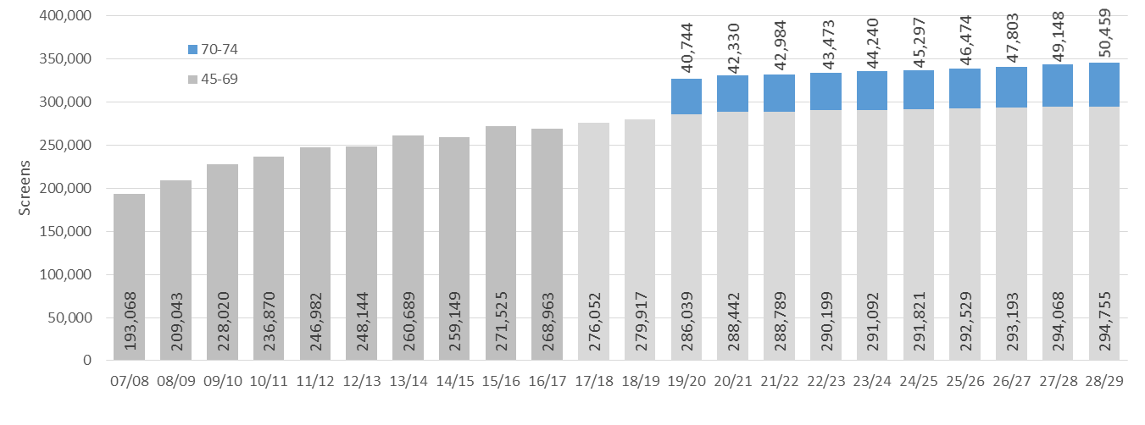

Note: The projection above is applied from 2019/20 onwards; this date was chosen for modelling purposes only.

|  |  |
| --- | --- |
| **Including women aged 70–74 years would increase the screening population beyond provider capacity** | Regionally, there is variation in the impact would have on screening, assessment and treatment capacity. The increase in the number of women aged 70–74 years who would undergo screening ranges between 2,000 and 8,000 per provider per year. The impact would depend on how the extension is introduced. A transition period would be required, for service providers to adjust workforce and facility capacity. |

|  |  |
| --- | --- |
| **The available specialist workforce required for breast screening is limited** | A quality breast screening service and an expert multidisciplinary team require specific mandatory key roles. The main concern is the medical radiation technologist (MRT) and radiologist workforces: BreastScreen Aotearoa is completely dependent on these highly specialised professionals.  Despite our best efforts, building expert workforce capacity remains a challenge, in New Zealand and internationally. Specialists require years of training to graduate and then must undertake further qualifications to subspecialise. A new consultant radiologist who has specialised in breast imaging, for example, will have been training and working for at least 15 years before applying to work in BreastScreen Aotearoa. Both MRTs and radiologists tend to work part time in BreastScreen Aotearoa and part time in general or symptomatic services. This allows them to keep their professional competencies up to date, and provides them with variety and experience.  If we were to extend the eligibility age range, we would need the following further capacity over the next 10 years. |

|  |  |  |  |  |  |
| --- | --- | --- | --- | --- | --- |
|  | C:\Users\JCOX~1.MOH\AppData\Local\Temp\notesBD2F6A\~0402311.png  Radiologists | C:\Users\JCOX~1.MOH\AppData\Local\Temp\notesBD2F6A\~0402311.png  MRTs | C:\Users\JCOX~1.MOH\AppData\Local\Temp\notesBD2F6A\~0402311.png  Pathologists | C:\Users\JCOX~1.MOH\AppData\Local\Temp\notesBD2F6A\~0402311.png  Surgeons | C:\Users\JCOX~1.MOH\AppData\Local\Temp\notesBD2F6A\~0402311.png  Other staff |
| BreastScreen Waitemata and Northland | ✓ | ✓ | ✓ | ✓ | ✓ |
| BreastScreen Auckland Limited | ✓ | ✓ | ✓ | 🗶 | ✓ |
| BreastScreen Counties Manukau | ✓ | ✓ | ✓ | ✓ | ✓ |
| BreastScreen Midland | ✓ | ✓ | 🗶 | ✓ | ✓ |
| BreastScreen Coast to Coast | ✓ | ✓ | 🗶 | 🗶 | ✓ |
| BreastScreen Central | ✓ | ✓ | - | ✓ | ✓ |
| BreastScreen South | ✓ | ✓ | 🗶 | 🗶 | ✓ |
| BreastScreen Otago Southland | ✓ | ✓ | 🗶 | ✓ | ✓ |

|  |  |  |
| --- | --- | --- |
| **Key**: | ✓ | Additional capacity required |
|  | 🗶 | Additional capacity not required |
|  | – | Information not available |

|  |  |
| --- | --- |
|  | The additional increase in capacity required by each provider ranges between:[5]   * 0.1 and 5 radiologists * 1.2 and 5.5 MRTs * 0.2 and 0.5 BreastScreen Aotearoa-accredited pathologists * 0.1 and 1.5 BreastScreen Aotearoa-accredited surgeons. |

|  |  |
| --- | --- |
| **There may not be enough radiologists and MRTs to meet population increases** | Currently, there is limited availability within the radiologist and MRT workforces to recruit for these roles. Regionally, there is great variety in workforce availability; some providers have significant issues filling existing vacancies.  An insufficient workforce will result in lengthy waitlists. It could also compromise activities that support priority women (wāhine Māori and Pacific women), like offering mammogram appointments outside of work hours. BreastScreen Aotearoa is investigating whether there are opportunities to improve international recruitment, make training pathways simpler and expand professional roles within BreastScreen Aotearoa. |

|  |  |
| --- | --- |
| **All providers will need to increase other staffing** | If we were to extend the age range for eligibility, all providers will need to increase numbers of support staff, including:   * breast care nurses * health promoters * data entry staff * managers * administration staff * data managers * reception staff * call centre staff.   A progressive implementation would be important, to enable recruiting and orientating new staff.  The availability of pathology services is not currently an issue. However, other programmes and services, such as the National Bowel Screening Programme and the Faster Cancer Treatment Tumour Streams, may affect this. |

|  |  |
| --- | --- |
| **We would need new or extended facilities to meet the demands of an increased population** | Currently, most providers have adequate screening and assessment sites. Age extension would require all service providers to extend their facilities or acquire new premises. This would require expenditure on new equipment, including mammogram machines, reading workstations and ultrasound machines. Providers would also be looking to replace equipment as part of expected maintenance over this period. Four service providers would need to consider purchasing an additional mobile unit to meet expected population increases.  If we were to extend the age of eligibility, we would need the following additional capacity over the next 10 years. |

|  |  |  |  |
| --- | --- | --- | --- |
|  | C:\Users\JCOX~1.MOH\AppData\Local\Temp\notesBD2F6A\~5695972.png  Facilities | C:\Users\JCOX~1.MOH\AppData\Local\Temp\notesBD2F6A\~1724842.png Mobiles | C:\Users\JCOX~1.MOH\AppData\Local\Temp\notesBD2F6A\iconmonstr-computer-1-240.png  Equipment |
| BreastScreen Waitemata and Northland | ✓ | 🗶 | ✓ |
| BreastScreen Auckland Limited | ✓ | ✓ | ✓ |
| BreastScreen Counties Manukau | ✓ | 🗶 | ✓ |
| BreastScreen Midland | ✓ | ✓ | ✓ |
| BreastScreen Coast to Coast | ✓ | ✓ | ✓ |
| BreastScreen Central | ✓ | 🗶 | ✓ |
| BreastScreen South | ✓ | 🗶 | ✓ |
| BreastScreen Otago Southland | ✓ | ✓ | ✓ |

|  |  |  |
| --- | --- | --- |
| **Key**: | ✓ | Additional capacity required |
|  | 🗶 | Additional capacity not required |

|  |  |
| --- | --- |
| **The previous BreastScreen Aotearoa extension had long-term impacts on screening coverage** | When BreastScreen Aotearoa was first established, it was acknowledged that a specialist workforce needed to be developed, which was why the eligible age range initially was limited to women aged 50–64 years. Work to increase the capacity of BreastScreen Aotearoa and the treatment pathway was more challenging than expected due to shortages of available workforce, including MRTs and radiologists, and the capacity of radiation oncology services.  The extension of the programme from 1 July 2004 to include women aged 45–69 made breast screening available to a further 216,000 women, in addition to the 328,000 already eligible for breast screening.  Providers did not have the capacity to immediately start screening all of the additional eligible women. Despite a planned staged roll-out, by May 2005, service providers had a backlog of approximately 20,000 newly enrolled women in the extended age range waiting for an appointment.  Service providers worked hard to clear the backlog while also extending screening and assessment facilities and purchasing additional mobile screening units. At the same time, there was a reconfiguration of services in the Auckland and Northland regions.  There was a negative impact on screening coverage over this period: coverage of the pre-existing eligible population reduced, particularly for wāhine Māori (there were percentage decreases of 4.4 for Māori, 2.3 for Pacific and 2.0 for other women).  It took more than four years for coverage to reach pre-extension rates, and national coverage did not reach the screening coverage target of 70 percent until 2012. Screening coverage for wāhine Māori has never met the target. |

|  |  |
| --- | --- |
| **We must continue to aim to achieve equitable outcomes for breast cancer mortality in New Zealand** | Capacity constraints limit the ability of BreastScreen Aotearoa both to achieve equity and to screen women aged 70–74 years. Age extension would require appropriate investment and time, to ensure sufficient capacity, and to support innovations to reach equitable coverage. Ultimately, the implementation of age extension should support efforts to achieve equitable outcomes for breast cancer mortality in New Zealand. |

|  |  |
| --- | --- |
| **A progressive implementation that allows sufficient time, funding and resources would give service providers a chance to recruit and expand facilities to meet the increase in demand** | There is a lot of regional variation in provider capacity; it may take longer for some providers to build capacity than others. Some providers may not be able to recruit sufficient staff to fill crucial roles. In this case, BreastScreen Aotearoa will need to consider if changes to the service delivery model are required. We need to carefully consider any changes, as the current programme reflects best practice, and quality and safety needs to be maintained. Emerging technologies may support changes to the delivery of the programme; it will be important for the NSU to work with service providers to identify where capacity can be shared across regions.  To achieve the best outcome for women of all ages, a progressive and carefully managed implementation of a potential age extension will be important. The scenario that has the least impact on the existing screening population is to invite women who are enrolled in the programme to continue screening after they turn 70 years of age. Even with this approach, we would need to significantly invest in the programme, and service providers would need time to increase capacity. |

# **Section 3:** The wider health system

This section looks at the impact extending the eligible age range for BreastScreen Aotearoa would have on treatment services and the wider health system.

BreastScreen Aotearoa is a part of a complex health system. Many health services are involved in identifying, treating and supporting women and men with breast cancer, including:

* DHBs
* primary health organisations
* general practitioners
* services for symptomatic women
* services for women at high risk of breast cancer
* genetic services
* private imaging and treatment providers
* patient support services
* Māori and Pacific health services
* palliative care services.

Extending free breast screening to women aged 70−74 years would impact a number of these services, especially treatment services. The ability of the programme to expand may also be impacted by changes in the wider health sector.

The analysis found that, if we were to extend screening for women aged 70–74:

|  |  |
| --- | --- |
|  | there would be an increase in early-stage screen-detected cancers and a corresponding decrease in late-stage cancers, resulting in a different range of treatment needs |
|  | in the first few years after the age range was fully extended, there would be an increase in women needing treatment for breast cancer. This would even out over time, but might result in pressure on surgery waitlists, and there would be regional variation in access to theatre time |
|  | there would likely be an increase in the proportion of women able to have breast conserving surgery and sentinel node biopsies, which would result in an increase in referrals to radiation oncology services |
|  | fewer women aged 70–74 years (and, probably, women aged 75–79 years) would need to access symptomatic services |
|  | primary care services would see an impact on the health of their populations; such services are crucial in providing support and information |
| C:\Users\JCOX~1.MOH\AppData\Local\Temp\notesBD2F6A\hospital2 blue.png | an increase in the population accessing screening services might put strain on services for women at high risk of breast cancer, where staff and equipment are shared. We need to ensure sufficient capacity to maintain high-risk and symptomatic services |
|  | private providers might see a change in the number of women aged 70–74 years accessing private mammography. |

## Overview of breast cancer treatment and other services

|  |  |
| --- | --- |
| **Breast cancer treatment services for most women start with surgery** | Breast surgery usually involves the breast and axilla (arm pit). Some women have breast conserving surgery (lumpectomy) while others will need or prefer a mastectomy. At the same time, surgery to assess the spread of disease to the axilla is performed. Plastic surgeons can perform breast reconstruction if a particular woman is a suitable candidate. Oncology services provide subsequent or adjuvant treatment; this may include chemotherapy, radiation therapy and/or oral medication. Specialists tailor this to each individual woman, depending on the type and extent of her breast cancer. District health boards or private treatment providers provide these treatment services. |

|  |  |
| --- | --- |
| **Screen detected breast cancer has different treatment patterns to non-screen detected cancer** | Currently, 67 percent of women diagnosed by BreastScreen Aotearoa will have breast conserving surgery, compared to 38 percent of women diagnosed outside BreastScreen Aotearoa. Women diagnosed by BreastScreen Aotearoa are significantly more likely to be candidates for sentinel node biopsy, which is a more limited form of axillary surgery associated with fewer complications. 75 percent of women diagnosed by BreastScreen Aotearoa will have sentinel node biopsy only, compared to 50 percent of women diagnosed outside BreastScreen Aotearoa. |

|  |  |
| --- | --- |
| **DHBs provide symptomatic services to all women and men who need them** | Women with symptoms or signs of breast cancer requiring investigation follow a different clinical pathway outside of the breast screening programme.  Additional imaging surveillance is also available for women considered at an increased risk of breast cancer. These women can access breast imaging services if they are referred by their doctor to the DHB. Women considered at high risk of breast cancer are those with:   * symptoms that may be related to breast cancer * two or more close relatives who developed breast cancer, including one or more who developed breast cancer before menopause or developed cancer in both breasts * a previous breast cancer * a previous biopsy of breast tissue showing an at-risk lesion.   The Ministry of Health funds DHBs to provide symptomatic services after a doctor’s referral to outpatient clinics or radiology departments. These services are separate to BreastScreen Aotearoa. |

|  |  |
| --- | --- |
| **Some women choose to have private mammograms or other imaging** | A number of private radiology providers in New Zealand provide mammography or other breast imaging services to women with a referral from their doctor. We do not know how many women attend private mammography services, but the August 2017 Royal Australasian College of Surgeons Quality Audit found that the majority of New Zealand patients (73.4 percent) were referred to public breast cancer treatment services (Royal Australasian College of Surgeons 2017). |

## Impact of age extension on breast cancer treatment services

|  |  |
| --- | --- |
| **More screen-detected cancers would be found, and treatment patterns would change** | Offering regular breast screening to women aged 70–74 years would result in approximately 350 additional surgical treatments per year for screen-detected cancers.[6] Screen-detected cancers are not additional cancers; the majority of them would present at some point in a woman’s lifetime. Even so, treatment services will see a change to treatment patterns, as screen-detected cancers often require less intensive treatment. |

|  |  |
| --- | --- |
| **Treatment options may be affected by increased rates of women with comorbidities** | As the population ages, the rate and severity of comorbidities increase. Women aged 70–74 years have higher rates of comorbidities than younger women. It is hard to predict how this would impact the treatment pathway, but the principle of support for women in making informed decisions about screening and treatment options remains crucial. |

|  |  |
| --- | --- |
| **The burden on treatment services would not likely be significant** | The expected increase in breast cancer incidence in the first few years after extension of the age range would not likely have a significant burden on treatment services. The most significant impact would be potential changes to treatment patterns due to increased detection of earlier-stage disease, which might result in a greater proportion of women in this age group requiring radiotherapy. |

|  |  |
| --- | --- |
| **The number of women having breast conserving surgery and sentinel node biopsies would increase** | We would expect an increase in the proportion of women aged 70–74 years having breast conserving surgery and sentinel node biopsies. Breast conserving surgery and sentinel node biopsy require less theatre time compared to mastectomy and axillary dissection. It is not clear at this stage how significant the reductions in theatre time could be for surgical services. |

|  |  |
| --- | --- |
| **The number of women who require chemotherapy may change** | The proportion of women aged 45 to 69 diagnosed in BreastScreen Aotearoa who are prescribed chemotherapy as adjuvant therapy is significantly lower than women in the same age range diagnosed outside the programme (29 percent compared to 56 percent). Prescription rates suggest that chemotherapy is much less likely to be provided to women aged 70 years and over but the evidence about chemotherapy treatment in this age group is limited by small numbers.  There are multiple clinical reasons for the reduction in referrals to chemotherapy for women aged 70 years and over, including that complications and side effects increase with age, as does the severity of co-morbidities. Women diagnosed within BreastScreen Aotearoa are significantly more likely to be hormone receptor positive making them candidates for hormone therapy. There is also a greater proportion of less aggressive disease, in which case women are less likely to require chemotherapy.  There are multiple clinical reasons for the reduction in referrals to chemotherapy for women aged 70 years and over, including that complications and side effects increase with age, as does the severity of co-morbidities. Women diagnosed within BreastScreen Aotearoa are significantly more likely to be hormone receptor positive making them candidates for hormone therapy. There is also a greater proportion of less aggressive disease, in which case women are less likely to require chemotherapy. |

|  |  |
| --- | --- |
| **Larger DHBs would more easily absorb increases in demand** | Regional cancer networks identified the following high-level potential impacts on treatment services.   * There would likely be an increase in post-treatment surveillance mammograms, which would require additional workforce and equipment capacity. These mammograms are usually provided annually until 10 years after surgery or 75 years of age, and DHBs fund them. * There would be some increase in screening MDMs and screening cases reviewed at treatment MDMs. Over time, there would be a reduction in the numbers of advanced breast cancers reviewed at treatment MDMs. Treatment services would need to plan for this change. * Women aged 70–74 years might need additional support to access treatment services and care coordination throughout the treatment pathway. * Surgical treatment and breast reconstruction patterns might change. Breast cancer treatment allows for a degree of patient choice, and older women may have different treatment and breast reconstruction preferences to women in other age groups. Services could consider seeking consumer feedback to better inform their understanding of patient preferences in this age group. * There is potential in the future for some populations to receive radiation oncology closer to home; this might impact overall on patients choosing mastectomy, with or without reconstruction, over breast conserving surgery and radiation therapy.   An age extension would require careful collaboration with DHBs. The ability of smaller DHBs to absorb increased demand might be limited by workforce and theatre availability.  Currently, there is regional variation in the availability of theatre time and reconstruction (plastic surgery) services. An age extension would increase pressure on these services, but this would be likely to level out over time. |

## Impact of age extension on other health services

|  |  |
| --- | --- |
| **Primary care services would see an impact on the health of their populations** | Primary care services would be integral to an age extension. Such services play a role in discussing with women whether continuing screening is right for them, as well as supporting women who are diagnosed with breast cancer.  There might also be flow-on effects to community support services and wrap-around services. For example, women aged 70–74 years might require additional support to access treatment services and care coordination throughout the treatment pathway. |

|  |  |
| --- | --- |
| **Fewer women would need symptomatic services** | Age extension would result in fewer women aged 70–74 years needing to access symptomatic services. Based on the experience after the age extension in 2004, we predict that there would also be a decrease in women aged 75–79 years requiring symptomatic services. |

|  |  |
| --- | --- |
| **Workforce and facility shortages would affect symptomatic services** | At many screening sites, symptomatic clinics and BreastScreen Aotearoa are co-located, and share equipment and resources. Increasing the screening population would put pressure on both workforce and equipment at these sites. We must ensure sufficient capacity to maintain high-risk and symptomatic services. Services need to continue investigating women with symptoms in a timely manner, and provide surveillance services for the cohort of women identified as being at high risk of breast cancer. |

|  |  |
| --- | --- |
| **There might be a change in the numbers of women who have private mammograms** | Private providers might see a change in the number of women aged 70–74 years accessing private mammography. It is difficult to determine what this impact would be. There may be opportunities to use private sector capacity to address public sector capacity constraints. |

|  |  |
| --- | --- |
| **New and changing screening programmes may impact on breast screening services** | The NSU is managing changes to other screening programmes, and is working with Health Workforce New Zealand to manage the impact of these changes on workforces. These changes may have an impact on DHBs and services. A number of the breast screening providers are involved in providing services for different screening programmes. |

|  |  |
| --- | --- |
| **Changes in the wider health sector may present opportunities to improve breast cancer outcomes** | Breast cancer outcomes in New Zealand will also be impacted by changes outside the screening pathway. The Faster Cancer Treatment programme is looking to improve timeliness for cancer treatments, including breast cancer treatment. The Ministry of Health is looking at how screen-detected cancers are included in the timeliness indicators. Treatment innovations and improvements as well as new technology will lead to further improvements in breast cancer outcomes. |

# Appendices

* Appendix 1: Methodology
* Appendix 2: Screening pathway
* Appendix 3: Evidence for screening women aged 70–74 years
* Appendix 5: Modelling the impacts on BreastScreen Aotearoa
* Appendix 5: References



## Appendix 1: Methodology

This impact analysis investigated breast screening for women aged 70–74 years in the local New Zealand context and the impact age extension could have on BreastScreen Aotearoa and priority group women (wāhine Māori and Pacific women, as well as women who have never been screened and who are under-screened).[7]

This impact analysis commenced prior to the October 2017 government coalition agreement, which included progressively increasing the age for free breast screening to age 74. Initially, the impact analysis was undertaken because of the publication of the IARC guidelines, which for the first time found evidence of the benefit of screening women aged 70–74 years.

For the purposes of this analysis, the NSU appointed a project team with subject matter experts from BreastScreen Aotearoa, Information Quality and Equity (IQE) and Cancer Services teams. Governance oversight was provided by a steering group chaired by the NSU Group Manager with membership comprising the NSU clinical director, BreastScreen Aotearoa clinical leader, BreastScreen Aotearoa manager, Information, Quality and Equity manager and manager of Cancer Services.

The BreastScreen Aotearoa Advisory Group, Māori Monitoring and Equity Group and National Screening Advisory Committee were consulted during the development of this impact analysis.

### Approach

The project modelled the current eligible population and the age-extension population over the 10-year period from 2019 using Statistics New Zealand population projections, and grouped the populations by BreastScreen Aotearoa service provider, DHB and ethnicity.

The project reviewed the potential impact on the health of New Zealanders using international evidence on the effect of screening women aged 70–74 years and evidence from the national breast screening programme and treatment service.

The project analysed the following scenarios to understand the potential impacts from different approaches.

* Status quo – assumed the eligible age range remained 45–69 years and the age extension was not introduced. This was the base scenario against which the analysis compared other scenarios.
* Equitable screening – assumed the eligible age range remained 45–69 years and the equity gap was closed, impacting on screening coverage, assessments and treatment. The analysis projected equitable screening at 72 percent coverage (national coverage) for all ethnicities unless regional coverage was higher than 72 percent; in these cases it calculated equitable coverage at the current coverage rate. BreastScreen Aotearoa aims for equitable screening coverage.
* Scenarios with different screening uptakes – assumed equitable coverage for women aged 45–69 years but different screening coverage rates for women aged 70–74 years. The analysis used the different coverage rates to understand how different uptake rates by women aged 70–74 years would impact the programme:
* screening women aged 70–74 years at current BreastScreen Aotearoa coverage rates (72 percent)
* screening women aged 70–74 years with reduced uptake (45 percent).

The project reviewed questionnaires sent to service providers and regional cancer networks to gain an understanding of capacity requirements (workforce, facilities and equipment) for providing breast screening, assessment and cancer treatment services to an increased population.

The project team asked the eight BreastScreen Aotearoa service providers to comment on their capacity to provide screening services based on four scenarios. To create a baseline, the analysis modelled two scenarios for women aged 45–69 years. It projected current coverage rates up to 2028/29, as well as the number of women BreastScreen Aotearoa would screen if there was no equity gap. Using equitable coverage as a baseline, the analysis modelled two further scenarios for women aged 70–74 years: low coverage (45 percent) and high coverage (72 percent). The low-coverage scenario was a simple representation of a limited number of women aged 70–74 years attending screening. This could be a result of a staggered implementation, or a long period of time to reach the coverage target for women aged 70–74 years. The high-coverage scenario represented the full impact the implementation of age extension could have.

The project reviewed the potential impact on equity, including:

* the capacity required to achieve and maintain equitable access along the breast screening and treatment pathways
* the impact extending the age range would have on the ability of BreastScreen Aotearoa to achieve and maintain equitable access.

The project reviewed the findings from the impact analysis and lessons learnt from the previous age extension in 2004 and documented implementation considerations.

### Assumptions

This impact analysis used the following assumptions.

* The benefits and harms of screening women aged 70–74 years are similar to those of screening women aged 65–69 years, provided life expectancy at 74 years of age is 10 years or longer. We will need to examine this further, including particularly for wāhine Māori and Pacific women.
* If the programme screened 70 percent of women aged 70–74 years, the reduction in mortality would be similar to that we achieve for women aged 65–69 years.
* The programme would apply the same biennial screening regime to women aged 70–74 years.
* Screening uptake by women aged 70–74 years would be similar to current uptake.
* The number of women aged 70–74 years recalled for assessment through screening would be similar to the equivalent number of women aged 65–69 years, with a slight upward trend. We will need to examine this further.
* There would be no significant changes to screening, assessment and treatment services within the time period modelled. 2D mammography would continue to be the primary breast screening tool, and no significant changes to screening technology would be introduced during the period covered in the impact analysis.
* The programme would achieve equitable coverage.

## Appendix 2: Screening pathway

Infographic showing the screening pathway

## Appendix 3: Evidence for screening women aged 70 to 74

The Ministry of Health regularly reviews international evidence regarding breast cancer screening programmes. In the past few years, researchers have published evidence that shows a mortality benefit to screening women aged 70–74 years for breast cancer.

The most significant evidence is the IARC update to the 2002 IARC handbook on breast-cancer screening (IARC 2016), which involved 29 independent experts from 16 countries. The group reviewed all published peer-reviewed scientific literature and concluded that there is sufficient evidence that mammography screening is effective in reducing breast cancer mortality for women aged 50–69 years, and that the benefit of reduced mortality extends to women screened at age 70–74 years. The IARC review does not provide an analysis of the benefits and harms of screening women aged  
70–74 years.

The IARC review did not produce an estimated absolute mortality reduction for women aged 70–74 years. The differences in comparisons and outcomes measures meant that pooling estimates of effectiveness was challenging. Mortality reduction estimates from the studies the review looked at (RCTs, observational studies and ecological studies) ranged from no effect to a 23 percent reduction in mortality (IARC 2016). Most studies focused on relative risk reduction compared to women in other age groups or unscreened women in the same age group. The IARC review did look briefly at cost–effectiveness and identified three studies demonstrating that screening women aged 70 and over could be cost-effective.

Most organised national breast screening programmes include women aged 50–69 years, but the upper age limit varies between countries. BreastScreen Australia recently extended their age criteria to invite women aged 69–74 years to screening. Prior to this decision an extensive review of the programme was undertaken, as well as a review of international evidence, an ecology study, a cost–benefit analysis and population modelling (National Breast and Ovarian Cancer Centre 2009a). The 2009 mortality (ecological) study undertaken by BreastScreen Australia found that data modelling showed a mortality reduction for women aged 70–74, but estimated effects were not statistically significant (National Breast and Ovarian Cancer Centre 2009b). The 2009 evaluation did recommend screening women aged 70–74 years based on ‘increasing life expectancy for women; the high incidence of breast cancer in this age group; and the similar or better Program performance for women aged 70–74 years compared to women aged 50–69 years in terms of sensitivity, recall and cancer detection rates’ (National Breast and Ovarian Cancer Centre 2009a).

The United Kingdom currently offers free triennial mammographic breast screening to women aged 50–70 years. Women aged 70 years and over are able to request screening every three years, but are not actively recruited. A cluster-randomised trial (the AgeX trial) is currently under way to assess the risks and benefits of extending the age range to women aged 47–49 years and women 70 and over; findings are expected in the mid-2020s.

The United States Preventive Service Task Force updated its recommendations on breast cancer screening in January 2016 to recommend biennial screening mammography for women aged 50–74 years. The United States does not have a national breast screening programme. The Canadian Task Force on Preventive Health Care is currently updating its recommendations, but its 2011 guidelines recommend screening women aged 70–74 every two to three years; currently, women aged 70 years and over are eligible for free screening in some, but not all provinces.

Other national breast screening programmes that screen women aged 70 years and over include those of France and the Netherlands, who screen up to age 74 years and 75 years respectively. Women aged 70 years and over are eligible for screening but not routinely invited in Iceland. The majority of European countries with breast cancer screening programmes do not include women aged 70 years and older.

## Appendix 4: Modelling the impacts on BreastScreen Aotearoa

### Scenario 1: Status quo

#### Population growth by age and year (women aged 45–69 years)

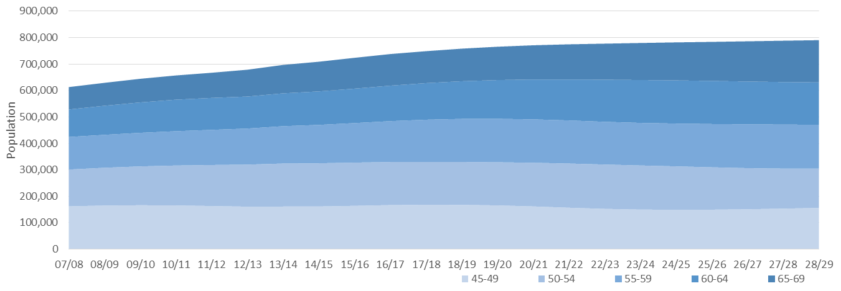

#### Screening appointments per year (women aged 45–69 years)

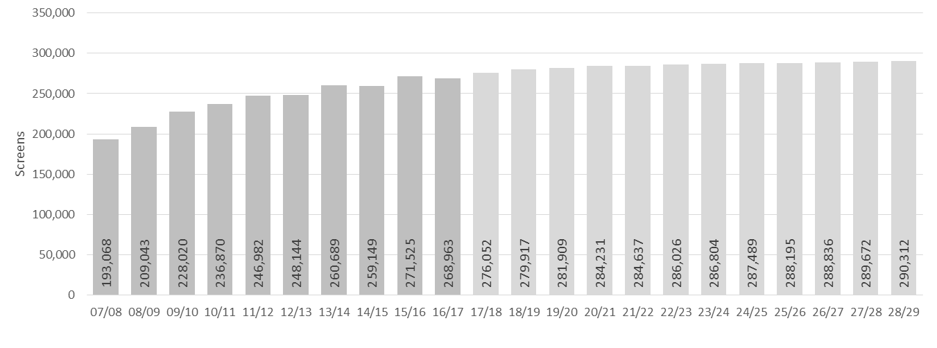

To meet population growth in women aged 45–69 years, in the next 10 years:

* seven providers will require additional radiologists (ranging between 0.1 and 1.3 FTE per provider)
* seven providers will require additional MRTs (ranging between 0.3 and 3.5 FTE per provider)
* two providers will require additional BreastScreen Aotearoa-accredited pathologists (ranging between 0.1 and 0.3 FTE per provider)
* three providers will require additional BreastScreen Aotearoa-accredited surgeons (ranging between 0.6 and 0.9 FTE per provider).

### Scenario 2a: Screening women aged 45–69 years with no equity gap

#### Screening appointments per year at equitable coverage (women aged 45–69 years)

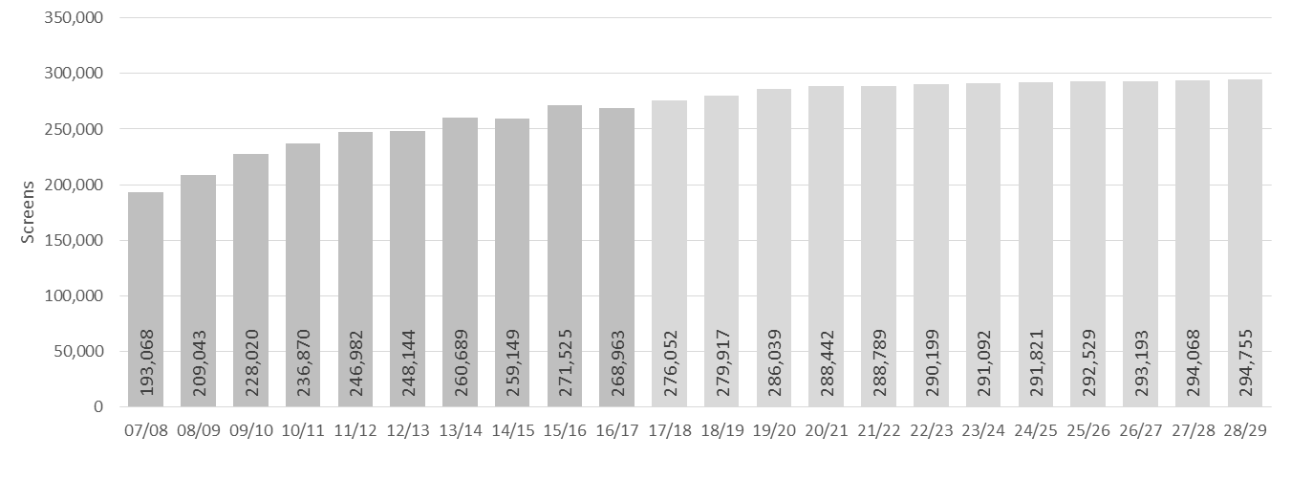

### Scenario 3: Immediate roll-out to all women aged 70–74 years

#### Population growth by age and year (women aged 45–74 years)

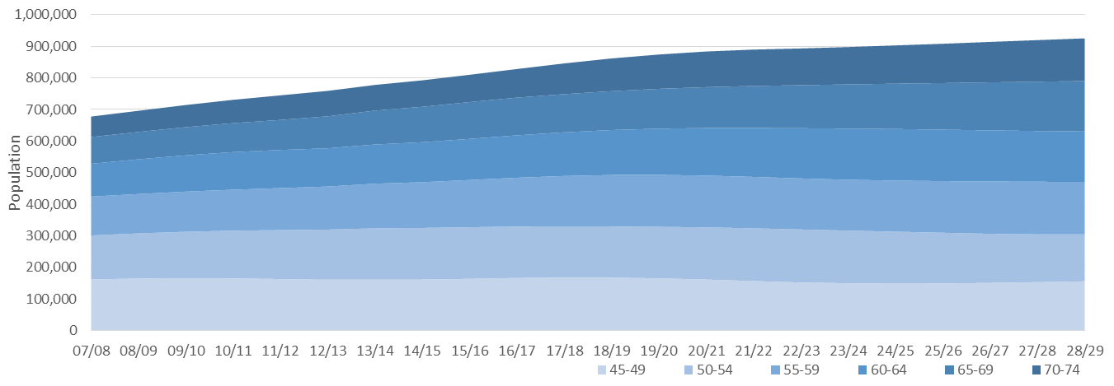

#### Screening appointments per year (women aged 45–74 years) with no equity gap

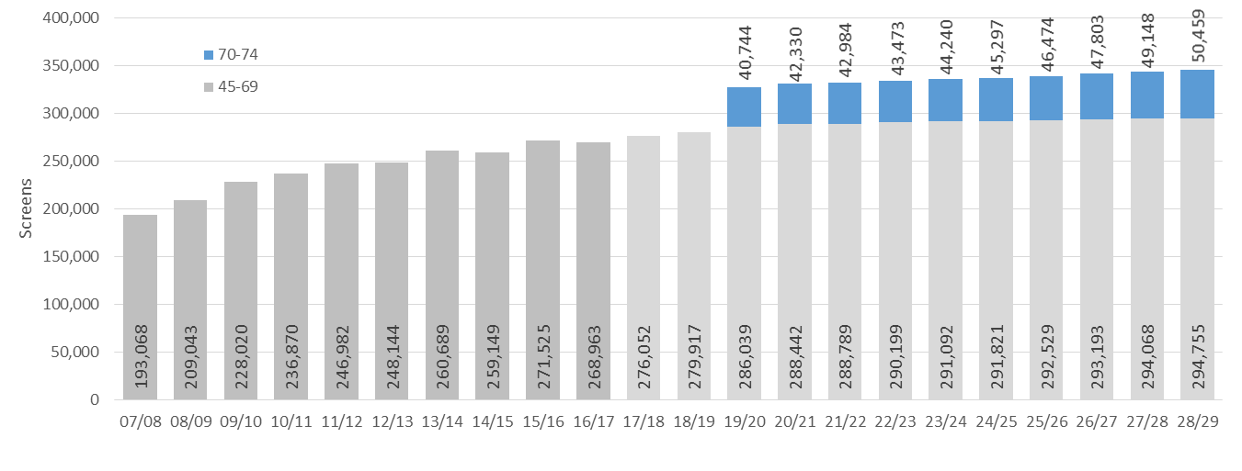

### Scenario 4: Progressive roll-out

#### Screening appointments per year (women aged 45–74 years) at equitable coverage

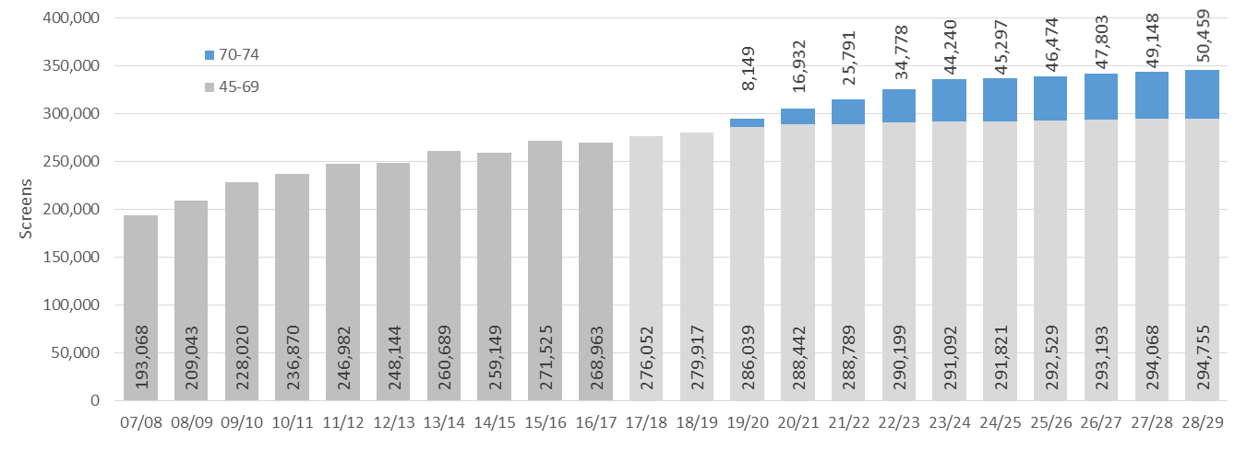

## Appendix 5: References

Australian Institute of Health and Welfare. 2017. *BreastScreen Australia monitoring report 2014–2015. Cancer series no. 106.* Cat. no. CAN 105. Canberra: AIHW.

Cancer Australia. 2014. *Overdiagnosis from mammographic screening*. URL: https://canceraustralia.gov.au/publications-and-resources/position-statements/overdiagnosis-mammographic-screening (accessed 8 September 2017).

Hendrick RE, Pisano ED, Averbukh A, et al. 2010. Comparison of acquisition parameters and breast dose in digital mammography and screen-film mammography in the American College of Radiology Imaging Network digital mammographic imaging screening trial. *American Journal of Roentgenology* 194(2): 362–9.

Houssami N, Miglioretti D (eds). 2016. *Breast Cancer Screening. An examination of scientific evidence*. Academic Press.

International Agency for Research on Cancer (IARC). 2016. *Handbook of Cancer Prevention: Breast cancer screening*. Volume 15. Lyon, France: IARC Press.

Ministry of Health. 2016. *Cancer: Historical Summary 1948–2013*. Wellington: Ministry of Health.

Morrell S, Taylor R, Roder D, et al. 2015. *The Cohort and Case Control Analyses of Breast Cancer Mortality: BreastScreen Aotearoa 1999–2011*. Wellington: Ministry of Health.

National Breast and Ovarian Cancer Centre. 2009a. *Screening Monograph No.4/2009 BreastScreen Australia Evaluation Mortality (Ecological) Study May 2009.* Australian Government Department of Health and Ageing.

National Breast and Ovarian Cancer Centre. 2009b. *Screening Monograph No.1/2009 BreastScreen Australia Evaluation Final Report June 2009*. Australian Government Department of Health and Ageing.

Paci E, EUROSCREEN Working Group. 2014. *European Breast Cancer Service Screening Outcomes: A First Balance Sheet of the Benefits and Harms*. http://cebp.aacrjournals.org/content/23/7/1159.full-text.pdf (accessed 21 September 2017).

Royal Australasian College of Surgeons. 2017. *BreastSurgANZ Quality Audit: BreastScreen Aotearoa Annual Report 2015*. North Adelaide: BreastSurgANZ.

1. Latest provisional data for both mortality and registrations available at the time of analysis.
2. Comorbidities are health conditions a patient has in addition to a specific primary disease.
3. New Zealand Period Life Tables: 2012-14. These are the median results produced for the New Zealand period life tables; uncertainty measures are available showing 95% credible intervals at www.stats.govt.nz
4. Note that this increase is slightly different to the increase in the total eligible population as it is based on screening coverage of 70%.
5. Because specialist workforces generally work part time for BreastScreen Aotearoa they are not measured in full-time equivalent (FTE).
6. The treatment projections are based on medians and may not reflect the full potential impact. Further work on these projections will be required during implementation planning.
7. Unscreened women are defined as women who have either never been screened or have not been screened for five years. Under-screened women are the groups of women whose participation is well below those of the total eligible population.