Equity and Performance Matrix
July 2019

Introduction
In Aotearoa New Zealand, people have differences in health that are not only avoidable but unfair and unjust. Equity recognises different people with different levels of advantage require different approaches and resources to get equitable health outcomes. While equity is an essential part of a functioning health system, by itself it does not provide the full picture. Health systems must also be performing to the expected levels.
Frequently the two measures of equity and performance are viewed one at a time and invariably overall performance against a performance target takes precedence as the headline measure while equity is relegated to a second tier measure. Bringing these two measures together in reporting has been a challenge. The Equity and Performance Matrix intertwines both measures so that one cannot be considered without the other, essentially elevating equity to a tier one measure.
Health services that are failing to meet performance targets are considered to be underperforming. Likewise health services that result in equity gaps for different populations must also considered to be underperforming. Both situations may occur simultaneously. In all these situations health services should take action to address these differences. The matrix provides a visual picture of any ‘equity gaps’ that exist as well as ‘how effectively’ health services are being delivered for a population against a defined target.

How the equity and performance matrix works
Any measure that has a target can be adapted to be incorporated into the matrix and the dimension of equity can also be adapted to help demonstrate a particular issues be it ethnicity, deprivation, sex, rurality etc. The key feature is the quadrant that the provider or service falls within.
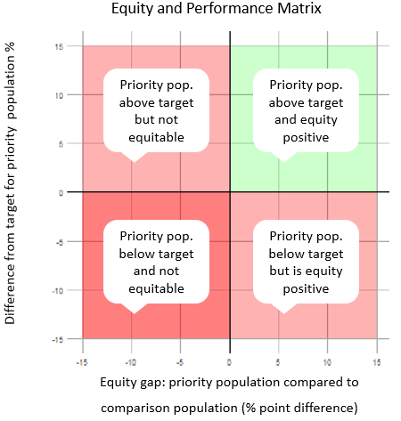

Definitions
Programme performance is measured for the population of interest and typically assess a services perofrmance against a given target service level, for example:
$$\frac{Māori participaiton}{Māori population}=programme performance (Māori)$$
The equity gap is measured by subtracting the programme performance for comparator population from the programme performance for the population of interst, for example:
Programme performance (%) (Māori)
-
Programme performance (%)
(non-Māori)
=
Equity gap

Setting targets
The performance target should already be established however equity gap targets may not have been formally established priority populations. In line with the policy direction of the Ministry of Health, legislation and Treaty obligation all programmes should target a zero equity gap in service delivery. It is possible to incorporate a phased approach for providers to achieve a zero equity gap, but caution should be used to ensure that there is rapid progression to the zero equity gap target and firm timeframes established. A positive equity gap may be desirable in the provision of services to achieve equitable outcomes. Below is an example of how equity and performance targets can set and used to measure service performance (based on a performance target of 70 percent):
Outstanding performer | ≥ 0 point equity difference AND ≥ 71% performance
Achieved | ≥ 0 point equity difference AND ≥ 70% performance
Partially Achieved | June 2020: ≥ -6 point equity difference AND 65 – 69% performance  June 2021: ≥ 0 point equity difference AND 65 – 69% performance
Not Achieved | June 2020: < -6 point equity difference OR < 65% performance  June 2021: < 0 point equity difference OR < 65% performance

Examples and interpretation
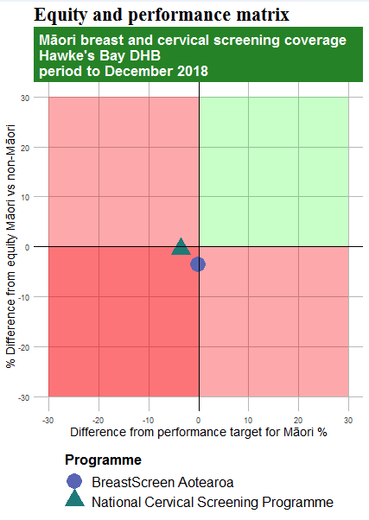 | 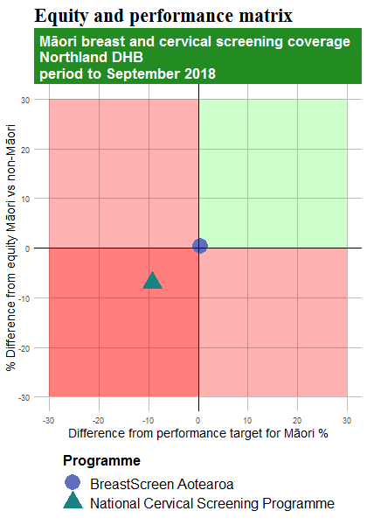
For breast screening, the programme is achieving target participation for the Māori population but there is a four point equity gap. For cervical screening the programme is not achieving target for Māori but is achieving equity with non-Māori. | For breast screening, the programme is achieving target participation for the Māori population and equity however for cervical screening programme is not achieving participation targets (10% below target) and there is a 7% equity gap.

Ministry of Health, 2019, Equity definition

