Review of Cervical Cancer Occurrences in relation to Screening History in New Zealand for the years 2013-2017

Prepared for the National Cervical Screening Programme
Final Report 29 August 2019

Department of Obstetrics & Gynaecology
University of Otago – Christchurch
Christchurch Women’s Hospital – Level 3
2 Riccarton Avenue
Private Bag 4711, Christchurch
Phone +64 3 364 4630 Fax: +64 3 364 4634
Email: peter.sykes@otago.ac.nz

Disclaimer
This document represents the advice and recommendations made to the Ministry of Health regarding the National Cervical Screening Programme by the independent review team based at the University of Otago, Christchurch.

The Review Team
This report was prepared by staff at the University of Otago, Christchurch, as part of an independent review with funding from the Ministry of Health.
The conduct of this review, data analysis and reporting of results has been undertaken solely by the review team.
The members of the review team are:
Associate Professor Peter Sykes, CGO, FRANZCOG, MBChB, is a Gynaecologic Oncologist with the Canterbury District Health Board and lead investigator of this Review.
Dr Jonathan Williman, BSc (Hons), PhD (Otago), is a consultant Biostatistician at the University of Otago, Christchurch.
Dr Carrie Innes, MSc, PhD (Otago), is a Research Fellow in the Department of Obstetrics and Gynaecology, University of Otago, Christchurch.
Dr Phil Hider, FAFPHM, FNZCPHM, MBChB, PhD (Otago), MMedSci (Newcastle), is a Public Health Physician in the Department of Population Health, University of Otago, Christchurch.

Contents
Disclaimer 2
The Review Team 3
List of Figures 7
List of Tables 8
Acknowledgments 10
Executive Summary 11
Recommendations from the Review 14
Introduction 16
Aims of the 2013-2017 Cervical Cancer Review 19
Methods 19
Sample Selection 19
Inclusion and exclusion criteria 19
Data 20
Collection and management 20
Data quality 20
Definitions 22
Date of diagnosis 22
Ethnicity 22
Deprivation and rurality 22
Screening history 23
Analysis 25
Results 26
Population 26
Review of available pathology information 26
Comparison of information in the NZCR and NCSP-R following review 26
Application of inclusion and exclusion criteria 27
Demographics of women with cancer 27
Incidence of cervical cancer 28
Age at diagnosis of cervical cancer 28
Histological type 28
FIGO staging 28
Ethnicity 29
Deprivation index 30
Residence at Time of Diagnosis 30
Rurality 30
Cancer Network Residence at diagnosis 31
Review of cervical screening adequacy 31
The accuracy of cervical cytology 32
Patients with prior screen detected abnormalities 33
Screening history in women with adenocarcinoma 33
Special Populations (women aged under 30 and over 70) 34
Women aged under 25 years 34
Women 25-29 years 34
Women aged over 70 years 34
Women aged between 70-79 years 35
Women aged over 80 years 35
Comparison of results from cervical screening programme reviews 2008-2012 and 2013-2017 36
Below is a summary of the main differences in the current review (2013-2017) compared with the previous review (2008-2012). Note: all numbers are presented as current review versus previous review. 36
Among women with confirmed cervical cancer: 36
Among women eligible for screening review 36
Number of women identified 37
Annual incidence 37
Annual incidence by year and ethnicity 37
Stage at diagnosis 38
Demographics for all cervical cancer diagnoses 38
Demographics among women eligible for screening history review 38
Age as a proportion of Māori and non-Māori women 38
Incidence rates by age and ethnicity 39
Incidence rates by deprivation and ethnicity 39
Diagnoses by rurality and ethnicity 39
Diagnoses by Cancer Network and ethnicity 39
Screening adequacy by demographics 39
Screening adequacy by histological type and stage 39
Screening adequacy and ethnicity 40
Screening history in 6-84 months period to diagnosis 40
Discussion 41
Tables and Figures for the 2013-2017 review of Cervical Cancer Occurrences 51
Appendix 1: Comparison of key results with previous review and audits 87
References 91
Supplementary Data 93

List of Figures
Figure 1-1 Application of inclusion and exclusion criteria to the full dataset as supplied by the NZCR and NCSP-R for selection of women eligible for the screening review 51
Figure 3-1 Annual age-standardised (WHO 2000-2025) incidence of cervical cancer cases per 100,000 female population by year 56
Figure 3-2 Age standardised (to Māori 2001 census) incidence of cervical cancer cases per 100,000 person-years by year of diagnosis (2008-2017) for Māori and non-Māori 58
Figure 3-3 Age specific incidence of cervical cancer cases per 100,000 person-years by age for Māori and non-Māori. 63
Figure 3-4 Age-standardised (to Māori 2001 census) incidence of cervical cancer per 100,000 persons-years by aggregated deprivation decile for Māori and non-Māori. 64
Figure 3-5 Age standardised (to Māori 2001 census) incidence of cervical cancer cases per 100,000 person-years by rurality for Māori and non-Māori. 66
Figure 3-6 Age standardised (to Māori 2001 census) incidence of cervical cancer cases per 100,000 person-years by Cancer Network for Māori and non-Māori. 68
Figure 3-7 Differences in histological type, stage by ethnicity for all women diagnosed with cervical cancer included in the review. 70
Figure 3-8 Deprivation index data expressed as aggregated deciles for cervical cancer cases by histological type and stage 73
Figure 4-1 Proportion of cervical cytology samples taken per month and associated cytological findings in the 60 months prior to diagnosis. 77
Figure 4-2 Screening adequacy by age at diagnosis 78

List of Tables
Table 1-1 Description of NZCR records Popn: 807 52
Table 1-2 ICD10 cancer codes for all NZCR records Popn: 807 52
Table 1-3 Women excluded from the review following review of histology reports Popn: 64 53
Table 1-4 Women excluded from the review for other reasons Popn: 119 53
Table 1-5 Mode of confirmation of cases included in the screening review Popn: 628 53
Table 2-1 Number of cases of cervical cancer as reported by NZCR, NCSP-R and following histological review by the review team 54
Table 2-2 Concordance of histology and date of diagnosis data between the NZCR and NCSP Popn: 747 54
Table 3-1 Annual incidence of confirmed cervical cancer per 100,000 female population across the review period, unadjusted or age-standardised to world standards (Segi, European, and WHO 2000-2025) 55
Table 3-2 Annual incidence of confirmed cervical cancer cases per 100,000 female population by year and ethnicity Popn: 747 57
Table 3-3 Demographics for all cervical cancer diagnoses by year (2013-2017) Popn: 747 59
Table 3-4 Tumour characteristics for all cervical cancer diagnoses by year (2013-2017 Popn: 747 60
Table 3-5 Age at diagnosis by ethnicity 60
Table 3-6 Demographics for all cervical cancer diagnoses eligible for the screening history review by year (2013-2017) Popn: 628 61
Table 3-7 Tumour characteristics for all cervical cancer diagnoses eligible for the screening history review by year (2013-2017) Popn: 628 62
Table 3-8 Women with cervical cancer by age and deprivation index, as a proportion of Māori and non-Māori populations Popn: 747 62
Table 3-9 Cervical cancer diagnoses by rurality and ethnicity Popn: 747 65
Table 3-10 Cancer Network regions by ethnicity Popn: 747 67
Table 3-11 Histological type and stage by ethnicity Popn: 747 69
Table 3-12 Histological type and stage by age at diagnosis Popn: 747 70
Table 3-13 Histological type and stage by ethnicity and age at diagnosis Popn: 747 71
Table 3-14 Histological type and aggregated NZ Deprivation Index decile Popn: 747 72
Table 3-15 Type and stage by rurality Popn: 747 74
Table 3-16 Type and stage by Regional Cancer Network Popn: 747 74
Table 4-1 Screening adequacy by patient demographics Popn: 628 76
Table 4-2 Screening adequacy by histological type and stage Popn: 628 79
Table 4-3 Screening adequacy by age and ethnicity Popn: 628 80
Table 4-4 Screening adequacy by year of diagnosis Popn: 628 81
Table 4-5 Screening adequacy by Regional Cancer Network Popn: 628 82
Table 4-6 Screening adequacy by rurality and ethnicity Popn: 628 83
Table 4-7 Screening history in the 6 to 84 months prior to diagnosis for all patients included in the Review Popn: 628 84
Table 4-8 Screening history in the 6 to 84 months prior to diagnosis by histological type and stage at diagnosis Popn: 628 85
Table 4-9 Cytological interpretation of high grade cervical cytology samples taken in the 0-36 months prior to the diagnosis of adenocarcinoma. 86
Table 5-1 Description of NZCR records comparing 2008-2012 and 2013-2017 87
Table 5-2 ICD10 cancer codes for all NZCR records comparing 2008-2012 and 2013-2017 87
Table 6-1 Number of cases of cervical cancer as reported by NZCR, NCSP-R comparing 2008-2012 and 2013-2017 88
Table 6-2 Number of cases of cervical cancer following histological review by the review team comparing 2008-2012 and 2013-2017 88
Table 6-3 Annual incidence of confirmed cervical cancer cases per 100,000 female population by year, unadjusted or age-standardised to world standards (Segi, European, and WHO 2000-2025) comparing 2008-2012 and 2013-2017 89
Table 6-4 Annual incidence of confirmed cervical cancer cases per 100,000 female population, age-standardised to the WHO 2000-2025 Standard Population (all ages) as reported in the NCSP Annual report 2015²¹ 89
Table 6-5 Key comparisons between the current review and previous audits and review 90

Acknowledgments
The review team would like to thank our advisors for providing feedback regarding the preparation of the final report.
Dr Gary Fentiman – Gynaecologic Oncologist
Dr Lynn Sadler – Senior Research Fellow in Obstetrics and Gynaecology, University of Auckland and Epidemiologist, Auckland District Health Board.
Dr Andrew Miller – Senior Lecturer in Anatomical Pathology, University of Otago, Christchurch and Anatomical Pathologist, Cantebury Health Laboratories, Christchurch.
Dr Melissa McLeod – Public health physician and Senior Research Fellow at Te Rōpū Rangahau Hauora a Eru Pōmare, University of Otago, Wellington.
The National Kaitiaki Group – the group appointed by the Minister of Health to protect Māori women’s cervical screening data.

Executive Summary
Summary of the University of Otago review of cervical cancer occurrences for the period between 1 January 2013 and 31 December 2017. This report was prepared for The National Cervical Screening Programme (NCSP).
- In this review, we examined information held by the NCSP Register (NCSP-R) and New Zealand Cancer Registry (NZCR), in order to determine the demographics and screening histories of New Zealand women with confirmed cervical cancer. The review did not include patient supplied information, a review of cytology specimens, or a population-based control.
- The Ministry of Health identified 809 records from 807 women from the NZCR as having or possibly having cervical cancer. Two women had two cancer diagnoses with different morphology, in these cases the earlier cancer diagnosis was kept and the later diagnosis excluded. Records were reviewed if they were coded as ICD-10 site code C530 (endocervix) n=0, C539 (cervix) n=776, or C578 (overlapping sites of the female genital tract) n= 31.
- NZCR records for these women were matched with NCSP-R records. An NZCR data extract and copies of the relevant pathology reports were forwarded to the review team.
- All available clinical information and histology reports contained within these records was reviewed by a medical practitioner (Associate Professor Peter Sykes) familiar with the management of women with cervical cancer.
- 64 records were excluded due to either a diagnosis outside the review timeframe (7), non-cervical cancer (35), histology not conclusive for invasive cancer (7), or no diagnostic histology and insufficient clinical information to confirm cervical cancer (15). Four women were added who had been identified in the NZCR during the 2008-2012 review but excluded from the earlier review due to their date of diagnosis being in 2013. Thus, 747 women were confirmed to have cancer of the cervix diagnosed within the review timeframe.
- As the NZCR may form the basis of future NCSP-R cervical cancer audits and reviews, it was noted that all confirmed cervical cancer cases in this review were coded in the NZCR as ICD10 C539.
- Of the 747 women, 75% of cervical cancers were squamous cell carcinoma (SCC), 18% were adenocarcinoma of endocervical type or not otherwise specified, 4% were adenosquamous carcinoma, and 4% were cervical cancers of other histological types.
- On average, there were 149 diagnoses of cervical cancer per year, resulting in a crude incidence of 6.37 per 100,000 female population per year and a standardised rate of 5.70 per 100,000 female population per year (using the World [WHO 2000-2025] Standard).
- Māori have a higher incidence of cervical cancer compared with non-Māori. The overall age-standardised (2001 Māori population) rates per 100,000 female population were 8.1 among Māori and 4.4 among non-Māori.
- Only 25% of records had FIGO stage recorded on the NZCR, however, following review of available pathology reports, it was determined that 26% of the 747 women had superficially invasive (microinvasive) cancers. For the 561 women with SCC, the proportion with superficially invasive cancers was higher (35%).
- Ethnicity data was retrieved from the NZCR and reported as total response ethnicity. Of the 747 women, 162 (22%) women identified as Māori, 49 (7%) women identified as Pacific island, and 91 (12%) women identified as Asian.
- 107 (14%) of the 747 women with confirmed cervical cancer were outside the 25-69 year screening age group at the date of their diagnosis and a further 12 (2%) had rare or non-HPV related cancer types.
- A review of screening history was performed on the remaining 628 women aged 25-69 years with HPV-related cancer types. Cervical cytology samples in the 6 months prior to diagnosis were considered to be part of the diagnostic process and therefore excluded. Of women with cervical cancer, eligible for screening history review, 74% had ever been screened, 50% had been screened in the 5 year interval prior to their diagnosis and 37% had been screened in the 3 year interval prior to their diagnosis.
- Using the definition of at least two cervical cytology samples, no more than 3 years apart, in the 6-84 months prior to diagnosis, only 12% of women aged 25-69 with cervical cancer had been adequately screened and only 23% had undergone five-yearly screens.
- For women with SCC, 70% had ever been screened, 45% had been screened in the 5 years prior to diagnosis, and 34% in the 3 years prior to diagnosis. Only 10% had been adequately screened.
- Of the 346 women who had been screened 6-84 months prior to diagnosis, 34% had had an abnormal screening test in that time period. Therefore, an opportunity for prevention or earlier diagnosis of cancer may have been missed. It is important to note that Māori and Pacific women were over-represented in this group of women. In particular, where a high grade abnormality was present prior to their diagnosis of cancer, the discrepancy was at its greatest – 40% of Māori women and 53% of Pacific women who were screened in the 6-84 months prior to diagnosis had had a high grade cervical cytology sample as opposed to 16% of European women who had been similarly screened.
- Compared with the 2008-2012 review:
  - There were fewer women in this review. While overall incidence rates, both unadjusted and age-standardised, were lower in absolute numbers, there was no evidence of a statistical decrease over time (2008 – 2017). There were more women in the 20-35 year age group (158 women in 2008-2012 review versus 182 women in the 2013-2017 review).
  - There was a decrease in the absolute numbers and incidence of adenocarcinoma and other non-squamous cancers, however, there was no decrease in the numbers or incidence of SCC or adenosquamous cancers.
  - Screening history by any definition of adequacy measured was lower among women 25-29 years.
  - There was less difference in the screening histories of Māori vs non-Māori women. However, Māori women still appear to have less access to regular and adequate cervical screening.

Recommendations from the Review
We recommend that:
    - The NCSP continue to aim to reduce the incidence of all cervical cancers, including superficially invasive tumours.
    - Emphasis continue to be placed on both enrolling (from the recommended age of commencement) and increasing regular participation in the screening programme.
    - Resources are provided to improve access to screening and treatment of cervical precancer for Māori women and, in particular, those who are more socially deprived (as defined by NZDep2013)¹. Intervention strategies should take into consideration both the practical and cultural needs of these women/wahine.
    - Resources should also be provided to improve access to screening and treatment of cervical precancer for Asian and Pacific women.
    - The sensitivity of the cervical screening test be improved. This will be achieved by the introduction of HPV-based primary screening.
    - Trends of cancer incidence and screening coverage in young women are carefully monitored (in view of the apparent increase in cervical cancer diagnosis in women under 35 years).
    - The NZCR inform the NCSP-R of any cervical cancer diagnosis.
    - The NZCR record the date of histological diagnosis of cancer (in addition to current SNOMED definition).
    - The NCSP-R enable data management to support future cervical cancer audits and reviews.
    - Superficially invasive tumours continue to be distinguished from other cancers for the purpose of cervical cancer review.
    - The decreasing incidence of non-squamous cancer of the cervix is further examined to determine whether there is an underlying reason for this decrease.
    - A system for ongoing audit and review of cervical cancer cases is established which utilises a consistent methodology. In doing so, the following points should be taken in consideration:
    - The NCSP-R should be matched with a population-based registry to allow the selection of control groups for case control studies. This will allow estimation of the protective effect of screening within different populations.
    - Clinical and demographic data should be collected which will confirm diagnosis, stage, method of diagnosis, residency status and ethnicity.
    - Clinical data would best be collected prospectively in conjunction with the three National gynaecological cancer treatment units.
    - HPV genotype status of cervical tumours should be recorded.
    - Review of negative screening tests in the screening period prior to the diagnosis of cancer should be undertaken.
    - Clinical case review of the management of patients with prior abnormal screening tests should be undertaken.

Introduction
This is the second of two cancer case reviews performed by the same team within the University of Otago which has enabled consistency of methodology. This brings the retrospective reviews up to date and it is the understanding of the review team that work is underway to establish an ongoing programme of cancer case reviews for women with cervical cancer. The 2008-2012 review was published in 2018² on the NCSP website and a synopsis in the NZMJ.³ The findings and recommendations are publicly available.
In synopsis the key findings of the 2008-2012 review included:
There were limitations of the methodology due to the lack of a population-based register and absence of clinical data, limited availability of cancer stage data, and discrepancies in date of diagnosis between the NZCR and the NCSP-R. The review reiterated the relatively high incidence of cervical cancer in Māori. Lack of regular screening was identified for the majority of women diagnosed with cancer but approximately one third had undergone screening in the last 3 years and about half had been screened within the last 5 years. Māori women with cervical cancer were less likely to have access to cervical screening than non-Māori. It was noted that 39% of women who had been screened in the 6-84 months prior to their cervical cancer diagnosis had had at least 1 abnormal cervical cytology sample indicating a possible lost opportunity for earlier diagnosis or cancer prevention. Māori were over-represented in the group, with 48% of Māori women who had been screened in the 6-84 months prior to their cervical cancer diagnosis having had at least 1 abnormal cervical cytology sample.
Due to the fact that both the 2008-2012 and 2013-2017 reviews were retrospective, few of the recommendations from the 2008-2012 review were able to be incorporated prior to this review. The methodology of the current review is essentially unchanged, however for this review NCSP-R histories have been made available in electronic form so avoiding the need for manual transcription of data. Pathology reports from the NZCR were provided in PDF format and were reviewed individually by an experienced gynaecological oncologist.
Prior to the two cancer case reviews performed by researchers from the University of Otago, two earlier audits of women with cervical cancer in New Zealand had been conducted. The first was performed following the ministerial inquiry into the under reporting of cervical abnormalities in the Gisborne region⁴ to determine if there was evidence of systemic failures leading to the under-reporting of cytological abnormalities.⁵ This was a formal external review that included women with histologically-proven cervical cancer between January 2000 and October 2002 and included 445 out of 562 (79%) women recorded as having cervical cancer by the NZCR. Exclusion criteria were: women in whom cervical cancer was not histologically proven, women over 80, and women who had not been resident in New Zealand for the four consecutive years prior to diagnosis. Clinical notes were reviewed for 376 women and this was accompanied by interviews of those women or their next of kin for 78% of women. This audit also included independent re-reading of negative screening cervical cytology samples among the included women. Cervical cytology samples were considered to be potentially part of the diagnostic process if performed within 6 months of the diagnosis and thus excluded from reviews of screening history. In this audit, screening histories were reviewed in relation to one screening interval (6-42 months prior to diagnosis), 2 screening intervals (6-84 months), and according to the audit’s definition of adequate screening (at least 2 screening tests in the last 2 screening cycles with no interval of greater than 3 years).
The key findings of the 2000-2002 audit were that: 77% of cancers were SCC, 67% of all women and 63% of those with SCC had had a cervical cytology sample in the 6-84 months prior to diagnosis, 49% of all women had had a cervical cytology sample in the 6-42 month interval prior to diagnosis, and 21% were considered adequately screened by the criteria of that audit. Indeed, the audit concluded that approximately 80% of women with cancer were inadequately screened. Ethnicity data on both the NZCR and the NCSP-R was considered inaccurate in 20% of Māori women. Māori women were on average younger at the time of diagnosis, had more advanced disease, and were less likely to have been screened in the prior 6-42 months. Cervical cytology sample re-reading showed that 18% of women with SCC had a cervical cytology sample reported as normal that was subsequently upgraded to high grade or possible high grade on the re-read. The recommendation from this audit was that priority should be given to improving the uptake and frequency of screening, with a special emphasis for Māori women.
The second audit was performed internally by staff within the NCSP. This audit included women recorded as being diagnosed with cervical cancer between January 2003 and December 2006.⁶ Data was extracted from both the NZCR and the NCSP-R but unlike the first audit, no further clinical information, (i.e. individual patient records) was available for review. This audit included 438 of 625 (70%) of potentially eligible women and excluded women with non-squamous cancers, and women over 80. As with the first audit, cervical cytology samples were considered to be part of the diagnostic process if they were performed within the 6 months prior to diagnosis. Screening history was reported as whether women were enrolled on the NCSP-R (qualified as any cervical cytology sample more than 6 months prior to diagnosis) and regularly screened (at least 5 yearly cervical cytology samples over their period of eligibility, dating back to 1990). Their key findings included that 69% of women were reported to have squamous cancers and 5% adenosquamous. 49% of women had never been screened and only 19% had been regularly screened.
As with the first audit, the second audit again concluded that ~80% of women with cervical cancer were inadequately screened. The recommendation being that improving coverage remains a priority, data linkage between the NZCR and NCSP-R was a useful form of monitoring, and further investigation of issues contributing to the development of cancer in women with a normal cervical cytology sample history is warranted.

Aims of the 2013-2017 Cervical Cancer Review
The aim of this review was to identify the demographics and screening histories of women diagnosed with cervical cancer in New Zealand from 2013-2017. This will help to enable the identification of factors associated with failure of prevention of cervical cancer and to help inform quality improvement initiatives by the NCSP.

Methods

Sample Selection
Case selection was conducted upon records supplied by the NZCR which were registered within the review timeframe of 1 January 2013 and 31 December 2017 as carrying a diagnosis of cervical cancer or possible cervical cancer. These records carried ICD-10 site codes of C530 (endocervix), C539 (cervix), C578 (overlapping sites of the female genital tract). In addition, four women were added who had been identified in the NZCR during the 2008-2012 review but excluded from the earlier review due to their date of diagnosis being in 2013.

Inclusion and exclusion criteria
Women included in this review were those that had a confirmed cervical cancer diagnosis within the review timeframe of 1 January 2013 and 31 December 2017. The identification of eligible women involved, in the first case, identifying a histology report which clearly describes a cancer arising from the cervix. Alternatively, if this information was not available, a diagnosis was inferred where there was at least a high grade cervical cytology sample (i.e., HSIL) or biopsy (i.e., CIN3) accompanied by documented clinical evidence of advanced cervical cancer. The exclusion criteria used in this review were as follows: women not confirmed as having cervical cancer (as defined in the section: “Data Quality” below), women with non-cervical cancer, women who following review were shown not to have cancer, and those whose date of histological diagnosis of cancer was outside of the review timeframe.
Women aged between 25 and 69 were considered eligible for the review of screening history. This age range was selected as it is in line with current NCSP monitoring, and accounts for the fact that screening histories for those under 25 and over 70 will be different and likely to skew results. Thus, women under 25 (n=14) and over 70 (n=93) were considered separately in this review. In addition, women with rare cervical cancer types unlikely to be prevented by cervical screening (i.e. clear cell, serous, small cell, and neuroendocrine tumours, sarcoma, lymphoma) were excluded for the review of screening history.⁷

Data

Collection and management
All women registered with the NZCR as having a diagnosis of either cervical cancer (with ICD-10 site codes of C530 endocervix, site C539 cervix) or possible cervical cancer (with an ICD-10 site code of C578 overlapping sites of female genital tract) between 1 January 2013 and 31 December 2017 were identified from the NZCR records. For each record, the following information was extracted from their respective sources: relevant screening history report from the NCSP-R, all relevant pathology and cytology reports, staging data, data provided to the NZCR from the National Minimum Data Set (NMDS) and data extracted from death certificates. This information was provided to the review team by the Ministry of Health.

Data quality
All pathology reports available from the NZCR were reviewed in conjunction with the corresponding NZCR and NCSP-R records (screening histories) by the review team to confirm histological diagnosis, date of diagnosis, and FIGO staging (where available). When this information was unavailable, staging information was inferred from available clinical information and histology reports (for example, tumour dimensions), to group confirmed diagnoses into two broad categories of either stage 1a (superficially invasive) or stage 1b and greater or unknown (FIGO pre-2018 definition).
A comparison of the information held in the NCSP-R and the NZCR was made and any discrepancies regarding: date of diagnosis, histological type, and stage were identified. Following review of pathology reports and available clinical information, the fidelity of data on the individual registers was assessed.
When considering discrepancies in the date of diagnosis, it is important to note that the NZCR uses an ICD 10 rule that uses the earliest date of diagnosis, even if not SNOMED cancer, when it is within 4 months before the SNOMED cancer diagnosis. So for the NZCR, if a woman is diagnosed with cervical cancer and had histology showing CIN 3 or high grade cytology 3 months earlier, the earlier date is taken. For most clinical purposes, the date of histological diagnosis of cancer is most commonly used. Therefore, use of the NZCR date of diagnosis may cause confusion if monitoring treatment of invasive cancer. In this review, we identify as significant a variance of greater than 31 days, as it is in line with the Ministry of Health Faster Cancer Treatment Times 31 day targets.⁸

Definitions

Date of diagnosis
The confirmed date of diagnosis was considered to be the earliest date of a pathology report carrying a histological diagnosis of cancer. In the small number of cases where histology was absent, cytology was utilised to confirm the diagnosis when presented in the presence of other supporting information suggestive of malignancy as described in the inclusion and exclusion criteria. In such a situation, the date of this cytology test was taken as the date of diagnosis of cancer.

Ethnicity
All ethnicity information for analysis is taken from the NZCR records. Up to three ethnicities were recorded for each individual, therefore ethnicity was grouped into the following level 1 categories and reported as total response as recommend by Statistics New Zealand^{9,10}; Māori, Pacific, Asian, , and European/Other (including NZ European). Due to small numbers and subsequent need to protect privacy, Middle Eastern Latin American or Africa (MELAA) cancer registration were included in the European/Other category. Cancer registrations were also analysed in the categories of Māori versus non-Māori ethnicity where records with any response for Māori were prioritised to Māori. In the Māori/non-Māori analysis, those with unknown ethnicity were excluded.

Deprivation and rurality
Deprivation was assessed using the New Zealand Index of Deprivation (NZDep2013), a small area classification that divides the population into ten evenly sized groups according to level of deprivation in the area surrounding their home, where 1 is least deprived and 10 is most deprived.¹ NZDep2013 deciles were aggregated where numbers were small.
Women’s addresses, as recorded on the NCSP-R at the time of diagnosis, were geocoded using the Statistics New Zealand Classification Coding System¹¹ to obtain meshblocks. Resulting meshblocks were linked to Area Concordance Files¹² containing NZ Index of deprivation and urban/rural classifications. Meshblocks and classifications from the 2013 census data were used.

Screening history
Consistent with previous reviews, any cervical cytology samples taken within 6 months of diagnosis were considered to be part of the diagnostic process and not screening cervical cytology samples.^{5,6} The number and proportion of women with the following screening histories were reported: those ever screened, those screened within the last 3 years, 5 years, and 7 years. In addition, we reported the proportion undergoing regular screening as defined in 2002 and 2006 audits.^{5,6}
Women are recommended to have three yearly screens from the age of 20 years. The following six definitions of screening adequacy have been used although it is recognised that other definitions have been employed elsewhere (for example, the NCSP-R monitors a regularity of screening indicator that defines adequacy as three yearly screens plus or minus 3 months).
For all definitions, cervical cytology samples that occurred less than six months prior to diagnosis were considered to be ‘diagnostic cervical cytology samples’ and therefore excluded. Time frames were defined in calendar time, so monthly and yearly intervals may not be represented by an exact number of days.
Ever screened
At least one cervical cytology sample recorded between 1 January 1990, when the NCSP-R was established, and six months immediately prior to diagnosis.
Cervical cytology sample in six to 84 months prior to diagnosis
At least one cervical cytology sample in the 6 to 84 months (7 years) immediately prior to diagnosis (i.e., two screening cycles).
Cervical cytology sample in six to 66 months prior to diagnosis
At least one cervical cytology sample in the 6 to 66 months (5.5 years) prior to diagnosis. This means at least one cervical cytology sample in the five years before the six months immediately prior to diagnosis.
Cervical cytology sample in six to 42 months prior to diagnosis
At least one cervical cytology sample in the 6 to 42 months (3.5 years) prior to diagnosis. This means at least one cervical cytology sample in the three years before the six months immediately prior to diagnosis.
Regular screening
As per the definition used by Lewis et al.⁶ regular screening is defined such that women must have undergone a cervical cytology sample within five years of becoming eligible for screening and then have had at least one cervical cytology sample every 5 years thereafter (until her 70th birthday or) to six months immediately prior to diagnosis. A woman was defined as having become eligible for screening from the establishment of the National Cervical Screening Programme (defined as 1 January 1990), or from the date of her 20th birthday if this occurred after 1 January 1990.
Adequate screening
Consistent with the 2000-2002 and 2008-2012 reviews^{2,3,5}, but different to the Regularity of Screening Indicator employed by the NCSP, adequate screening is defined as no interval of more than three calendar years between cervical cytology samples in the period 6 to 84 months (7 years) prior to diagnosis. To fulfil this criterion, a woman would have to have had at least two cervical cytology samples less than three years apart in the 6 to 84 months prior to diagnosis. Further, the interval between the start of the period and the first cervical cytology sample, and between the last cervical cytology sample and the end of the period, would also have to be less than three years.

Analysis
The number and proportion of eligible women was summarised by demographic (age, ethnicity, deprivation), pathological (histological type and stage), and geographical (rurality, cancer network region) characteristics, with cross-tabulations by year, Māori ethnicity, and pathology. Counts less than 5 have been suppressed at the request of the Ministry of Health for privacy reasons.
Cervical cancer incident rates by year, age, region, and Māori ethnicity, were calculated using the New Zealand estimated resident (ERP) female populations at June of each year obtained from Statistics New Zealand (via nz.stat or infoshare). Incidence rates by derivation and urban area were calculated using population counts based upon the 2013 census usually resident population and supplied by June Atkinson (University of Otago, Wellington). For international and subgroup comparisons rates were directly age-standardised, using 5-year age categories, to the World (WHO 2000-2025) Standard Population or the Maori 2001 female census population respectively. Rates are presented per 100,000 person-years, with 95% confidence intervals (CI) calculated using the Wilson method for unadjusted rates or via a gamma distribution for age standardised rates.¹³ The denominator dataset and reference populations used for each analysis are listed with the associated table or figure legend.
Screening history was presented in relation to key demographic factors as described previously. In order to determine if the failure of adequate treatment or monitoring of women with screen detected abnormalities contributed to diagnostic delay or cancer occurrences, women with previous screen detected abnormalities outside the 6 month diagnostic period were identified and subsequent colposcopy or cervical biopsy were recorded.

Results
The following section presents selected key findings of this review. Complete results of this review can be found later in this report in Sections 1-4 of the Presentation of Tables and Figures for the 2013-2017 review of Cervical Cancer Occurrences.

Population
The Ministry of Health identified 809 reports of cervical cancer diagnosed between 2013 and 2017 according to information available in the NZCR. Two women were found to have each been diagnosed with two cancers of different morphology, in which case the earlier cancer diagnosis was kept and the later diagnosis excluded. Among the remaining 807 reports, 776 had an ICD-10 diagnosis code of C539 (malignant neoplasm of cervix uteri, unspecified), and 31 a code of C578 (malignant neoplasm of overlapping sites of female genital organs). The Ministry of Health identified that, 794 of the 807 women had clinical details recorded in the NCSP-R.
Review of available pathology information
Following review of the pathology reports made available by the NZCR, only 743 women could be confirmed to have cervical cancer. This included 17 women who had no histology but could be confirmed on the basis of cytology and recorded clinical findings. Seven women were excluded as the date of first histological diagnosis was outside the review period, however, four women were added who had been identified in the NZCR during the 2008-2012 review but excluded from the earlier review due to their date of histological diagnosis being in 2013. 35 women had cancer but were excluded as it could not be confirmed as primary cervical. 15 women lacked histology or cytology that could confirm the diagnosis. None of the 31 women coded C578 could confidently be confirmed to have primary cervical cancer. A total of 747 women were therefore included in the review (see Figure 1-1 for a flow chart showing inclusions and exclusions).

Comparison of information in the NZCR and NCSP-R following review
Information in the NZCR was compared to that recorded in the NCSP-R for the 794 women for whom records were identified in both datasets. In 171 cases the date of diagnosis was discrepant by more than 31 days. It is important to note that the NZCR uses an ICD-10 rule that uses the earliest date of abnormal cytology/histology, even if not invasive cancer as defined by SNOMED, when it is within 4 months before the SNOMED cancer diagnosis. So for the NZCR, if a woman was diagnosed with cervical cancer and had histology showing CIN 3 or high grade cytology 3 months earlier, the earlier date was taken.

Application of inclusion and exclusion criteria
Figure 1-1 presents a flow diagram illustrating the application of the inclusion and exclusion criteria for the screening review.
Among the 807 women registered on the NZCR, 747 were confirmed to have a diagnosis of cervical cancer within the review time frame.
Women aged 25-69 with cervical cancer likely to be preventable by cervical screening were considered eligible for the review of screening history. Thus, 107 women outside this age group were excluded. In addition, 16 women with cancer types unlikely to be prevented by screening (pure neuroendocrine or non-HPV-related) were excluded. Four women were both outside the age range and had cancer types unlikely to be prevented by screening, thus 119 women were excluded from the screening review in total. This left a total of 628 eligible for the review of screening history.
The screening histories of women outside the specified age range will be considered separately.

Demographics of women with cancer
The demographics of women included in this review are presented in full in Section 3 of the Presentation of Tables and Figures for the 2013-2017 review of Cervical Cancer Occurrences later in this document. Below we present selected key results from the 747 women with confirmed cervical cancer included in the review timeframe.

Incidence of cervical cancer
Over the 5 year period from 2013 to 2017, the annual number of confirmed cases of cervical cancer varied from 133-170 (Table 3-2) with an average of 149 diagnoses of cervical cancer per year. Overall this represented a crude incidence rate of 6.37 (95% CI 5.93, 6.84) and a standardised (WHO 2000-2025 reference population) rate of 5.70 (95% CI 5.28, 6.14) per 100,000 female population (Table 3-1).

Age at diagnosis of cervical cancer
The median age at diagnosis was 45 years, with a peak of occurrences in the 40-44 year old bracket (Table 3-3 and Table 3-6). Among all women with cervical cancer, 2% of women were aged under 25 years (11% under 30) at diagnosis and 12% were over 70 years (Table 3-3).

Histological type
Data describing the various histological types and relevant demographics are described in Table 3-4 and Table 3-7. Among the common cancers, SCC (75%) was the most common, followed by adenocarcinoma (18%) and adenosquamous (4%). Other and non-HPV related cancers (including small cell) comprised 4% of all cervical cancers for the review period. In general, the proportion of cancers that were SCC was found to be lower in women aged 30–50 years at diagnosis (Table 3-12). However, this proportion is highest in those aged under 30 or over 80 (Table 3-12), and in those identifying as Māori (Table 3-11).

FIGO staging
FIGO staging was included in only 187 (25%) NZCR records. 41 (22%) of these were recorded as FIGO stage (pre 2018) 1a (superficially invasive) and the remaining 78% of women were recorded as stage 1b or greater. Following review of histology reports and clinical information by the review team, it was determined that 26% of the 747 women were definitively FIGO stage 1a and the remaining 74% of women were assumed to be stage 1b or greater.
Superficially invasive disease was found more commonly with SCC (30%) than with adenocarcinoma (15%) and was more common in younger women. For example, when considering SCC, 49% of women 20-39 years had superficially invasive disease at diagnosis compared to 25% in women 40-69 years (Table 3-12).

Ethnicity
Ethnicity was documented in the NZCR for 739/747 (99%) women. Among all women with cervical cancer, when using total response ethnicity, 66% were identified in the NZCR as New Zealand European, 22% were identified as Māori, 7% as Pacific Islander and 12% as Asian (Table 3-3). It should be noted that up to 3 ethnicities could be recorded when using total response ethnicity, hence individuals can be counted multiple times across multiple ethnicities.
The crude incidence for Māori exceeded that for non-Māori in all years covered by the review (Table 3-2). This same trend was accentuated when the incidence rate was age standardised using Māori 2001 population as the reference population (Table 3-2). The overall age-standardised (Māori 2001 population) rates per 100,000 female population were 8.1 (6.9 to 9.6) among Māori and 4.4 (4.0 to 4.8) among non-Māori.
The median age at diagnosis was the same for both Māori and non-Māori (45 years). However, the peak of cervical cancer occurrences was older in Māori (45-49 years) than non-Māori (40-44 years), as shown in Table 3-8. The peak incidence was also older in Māori (40-49 years) than in non-Māori (30-39 years) as shown in Figure 3-3. As the Māori population has a younger population than non-Māori, more women would be expected among the younger age-groups (Table 3-8). Incident rates for Māori women were higher than non-Māori for all age groups (Figure 3-3).
In this review, a higher proportion of Māori women had SCC than non-Māori women (81% vs 73%) (Table 3-11). However, across all histological types, a higher proportion of Māori had early stage disease than non-Māori women (29% vs 25%) (Table 3-11). Among those with SCC, 31% of Māori and 30% of non-Māori had superficially invasive disease (Table 3-11).
In general, Māori women with cancer resided in areas of greater deprivation than non-Māori. This is consistent with the general population, however, the greatest difference in cervical cancer incidence between Māori and non-Māori was seen in women residing in the areas of greatest deprivation (NZDep2013 deciles 9 and 10) (Table 3-8 and Figure 3-4).
The proportion of women amongst those residing in main urban areas was lower among Māori compared with non-Māori but higher in minor urban areas (Table 3-9). When considering rurality, the greatest difference in incidence between Māori and non-Māori was seen in women residing in minor urban areas (Figure 3-5).
As the number of women with either Pacific or Asian ethnicity were low in this dataset, further analysis beyond that presented in Section 3 was not performed.
For calculated incidence for Māori and non- Māori subpopulations see Supplementary Data.

Deprivation index
Data relating to cervical cancer and deprivation index are presented in Table 3-3, Table 3-6, Table 3-8, Table 3-14, and Figure 3-4. In this review, overall there was no clear association between cancer incidence and deprivation index. However, when considering only SCC, rates were highest in NZDep2013 index decile 9 and 10 areas (Figure 3-8 and Table 3-14). A high proportion of Māori women with cervical cancer were domiciled in deprivation index levels 9 and 10 (Table 3-8). This distribution is consistent with the overall population. As noted above, the greatest difference in cervical cancer incidence between Māori and non-Māori was seen in women residing in the areas of greatest deprivation (NZDep2013 deciles 9 and 10).

Residence at Time of Diagnosis

Rurality
The majority of cervical cancer diagnoses (68%) occurred among women residing in Main Urban Areas (Table 3-9).
As noted above, among Māori, the proportion from minor urban areas exceeds that of non-Māori (Table 3-9). There was no clear pattern between histological type and stage between Urban and Rural residence (Table 3-15).

Cancer Network Residence at diagnosis
The number of diagnoses varied from 152 (Midland) to 243 (Northern) between Cancer Networks. Cancer incidence across Cancer Networks was similar (Figure 3-6).

Review of cervical screening adequacy
For the purpose of the review of screening histories the following exclusion criteria were applied, as detailed in Section 2 Presentation of Tables and Figures for the 2013-2017 Review of Cervical Cancer Occurrences later in this document:
- Women aged 70 or over who are outside the screening age.
- Women under 25 years (due to having a limited period of time when eligible for screening and a limited number of screening tests when fully compliant with NCSP recommendations).
- Women with rare or non-HPV related cancer types that are unlikely to be preventable by screening.
- One woman in whom cervical cancer was diagnosed outside NZ.

Following application of these exclusion criteria, 628 eligible women confirmed to have cervical cancer aged 25 years or older and under 70 years were identified for whom regular screening as recommended by the NCSP had the potential to prevent the diagnosis of cervical cancer. Ethnicity was documented in the NZCR for 626/628 (99.7%) women. Of these women, 64% identified as European, 23% as Māori, 7% as Pacific Island, and 13% as Asian (Table 3-6).
As per previous reviews, in this review we considered that cervical cytology samples in the 6 months prior to diagnosis were likely to be part of the diagnostic process (see Figure 4-1), hence the decision to exclude them from the screening history review.
Of the 628 women who were diagnosed with cervical cancer between 2013-2017, 55% had a cervical cytology sample within the 6-84 months prior to diagnosis, 50% had had a cervical cytology sample in the 6-66 months (5 years) and 37% had a cervical cytology sample between 6-42 months (3 years) prior to diagnosis (Table 4-1). Amongst these 628 women, only 12% had an adequate screening history over the 84 months prior to diagnosis by the criteria used in the 2002 Review⁵ (adequate screening is defined such that there is no between-cervical cytology sample interval of three calendar years or more in 6 to less than 84 months prior to diagnosis). Based on the data provided in Table 4-1, Table 4-2, and Table 4-5, the following observations can be made for women with cervical cancer included in the review of screening histories:
- In general terms, older women were less likely to have been screened than younger women. 19% of women age 35-39 had been adequately screened compared with 3% of women aged 60-64. In the prior 6-42 months, 46% of women aged 25-29 had been screened compared to 23% of women aged 60-69.
- For women with cervical cancer, Māori women were less likely to have been adequately screened (10 vs 15%) than European women or screened 5 yearly (18% vs 30%). Pacific and Asian women were less likely than European or Māori women to have been screened by all measures.
- There was a trend towards women of higher deprivation being screened less often.
- The proportion of women with SCC who were screened at all time intervals was lower than for adenocarcinoma.
- Women with superficially invasive (stage 1A) cancers were more likely to have been screened at all time intervals (excluding the 0-6 months prior to diagnosis) than women with more advanced tumours.
- Comparing data between regions there appeared to be some variation in screening history by region. However the small numbers involved and demographic differences will likely influence these results.

The accuracy of cervical cytology
In total, 1127 cervical cytology samples were taken in the 3 years prior to diagnosis (i.e. 0-36 months) of which 1112 were satisfactory. Of these, 81% were abnormal with 839 (75%) high grade and 57 (5%) low grade abnormalities (Figure 4-1). 180 women also had high risk HPV genotype testing at some point prior to their diagnosis. Of the 169 women who had HPV testing in the 3 years prior to their diagnosis, 152 (90%) were high risk HPV genotype positive (see Supplementary Data).

Patients with prior screen detected abnormalities
In principle, women who had a screen detected abnormality more than 6 months prior to the diagnosis of cancer could potentially have had their cancer either diagnosed earlier or prevented. Of the 628 women included in the cervical cytology sample history review, 346 women had had at least one screen in the 6-84 months prior to their diagnosis. 116 of these women had had an abnormal cervical cytology sample. In 77 women, the abnormal cervical cytology sample had been high grade. This suggests that there was some element of the diagnostic or treatment pathway that failed and resulted in either the delayed diagnosis or failure of prevention in 18% of the entire cohort or 34% who had had a cervical cytology sample in that timeframe. It is important to note that Māori and Pacific women were over-represented in this group, and in particular, where a high grade abnormality was present prior to their diagnosis of cancer, the discrepancy was at its greatest – 40% of Māori women and 53% of Pacific women who were screened in that time period had had a high grade cervical cytology sample as opposed to 16% of European women who had been similarly screened. This suggests particular barriers for Māori and Pacific women in accessing diagnostic and treatment services. Further investigations of the factors that are associated with the failure of the screening and treatment pathway are under investigation in a detailed study of clinical information available in hospital records and the NCSP-R. This will be reported separately.

Screening history in women with adenocarcinoma
Cervical screening is known to offer greater protection for women against SCC than adenocarcinoma. In this cohort of women, 50% of women with SCC had had no screening in the 6-84 months prior to their diagnosis compared to 28% of women with adenocarcinoma. Furthermore, 57% of women with SCC who had been screened in the 6-84 months prior to their diagnosis had had only normal screens compared with 89% of women with adenocarcinoma. Failure of diagnosis or treatment following an abnormal cytology test appears to be a less common issue for women with adenocarcinoma than for women with SCC.

Special Populations (women aged under 30 and over 70)
Special consideration is given to women under 25 and over 70 years of age. These groups have different access to screening as per the NCSP guidelines for screening and as a result, the definitions for regular or adequate screening cannot apply to this group. We also consider women aged between 25 to 29 years separately as proposed changes to the screening programme may change access of this group to a history of regular screening. The relevant findings are presented below:

Women aged under 25 years
- Among all women with cervical cancer, 2% (14) were under 25.
- 86% (12/14) were diagnosed with SCC and 7% (1/14) adenocarcinoma.
- 36% (5/14) were of Māori ethnicity.
- Among women with SCC, 75% (9/12) were stage 1a and were likely to be diagnosed as a result of cervical screening.
- 13 of 14 women had a cervical cytology sample taken as part of the diagnostic process. (All had a cervical cytology sample taken, however, one did not have a cervical cytology sample taken within six months of diagnosis).
- 71% (10/14) of women had had a cervical cytology sample taken in the 6-42 months prior to diagnosis.
- 29% (4/14) had had at least 2 previous cervical cytology samples taken. (Excluding cervical cytology samples taken within 6 months of diagnosis).

Women 25-29 years
- Women in this age group represent 9% (69) of cervical cancers.
- 25% (17/69) were of Māori ethnicity.
- 84% (58/69) were diagnosed with SCC, and of these 53% (31/58) were Stage 1a.
- 46% (32/69) were screened in the 6-42 months prior to their diagnosis but only 10% (7/69) were adequately screened by the 2002 Review Standard.

Women aged over 70 years
- Represent 12% (93) of women with cervical cancer.
- Predominantly non-Māori with advanced disease.

Women aged between 70-79 years
Of the 53 women:
- 44 were non-Māori and six were Māori (3 unknown).
- 77% (41/53) of women in this age group were diagnosed with SCC.
- 46 (70%) had ever had a cervical cytology sample taken, however only 29 had a cervical cytology sample taken greater than 6 months prior to diagnosis.

Women aged over 80 years
- 40 women were diagnosed with cervical cancer over the age of 80.
- Of those, four were Māori.
- The predominant histological types were SCC (85%, 34/40). There were two women diagnosed with adenocarcinoma (5%), and two women diagnosed with adenosquamous (5%).
- 20 of the 40 (50%) women had had a prior screening test. (“Ever screened”, excluding in six months prior to diagnosis).

Comparison of results from cervical screening programme reviews 2008-2012 and 2013-2017

Below is a summary of the main differences in the current review (2013-2017) compared with the previous review (2008-2012). Note: all numbers are presented as current review versus previous review.

Among women with confirmed cervical cancer:
- There were fewer women with confirmed cervical cancer (747 versus 772). While overall 5-year incidence rates were lower, based on the overlap of confidence intervals, there was no evidence of a statistically significant decrease between the two periods.
- There was an increased proportion of superficially invasive (stage 1a) SCC in the current review (30% versus 26%).
- There was a decrease in the absolute numbers and incidence of adenocarcinoma, other, and non-HPV related cancers (186 versus 220), however, there was no decrease in the numbers or incidence of SCC (561 versus 552).
- There were more women in the 20-35 year age group (182 versus 158) but fewer women >35 years (565 versus 614)
- There were slightly fewer Māori women (162 versus 169) and fewer Pacific Island women (49 versus 72) but more Asian women (91 versus 57).
- There were more women from areas associated with less deprivation (NZDep2013 deciles 1 and 2) (154 versus 126).

Among women eligible for screening review
- Overall, screening histories were similar between the two reviews.
- As an exception, screening history by any measure of adequacy assessed was lower among women 25-29 years (e.g., adequate screening 10% versus 24% or in the prior 6 to 84 months 66% versus 80%). Additionally, screening history by any measure was slightly lower among women aged >55 years (e.g., adequate screening 7% versus 13% or in the prior 6-84 months 36% versus 42%).
- Screening history by any measure for Māori women slightly increased overall (e.g., adequate screening 10% versus 6% or in the prior 6-84 months 56% versus 45%). This was especially so among Māori women aged 40-49 years (e.g., adequate screening 16% versus 2% or in the prior 6-84 months 60% versus 36%) but has decreased for Māori women 25-29 years (e.g., screening in the prior 6-84 months 65% versus 100%).
- The number Asian women increased (82 versus 49) and by any measure were less well screened (e.g., adequate screening 9% versus 10% or in the prior 6-84 months 37% versus 51%).

Number of women identified
The number of women included in the NZCR was lower in the current review compared with the previous review (807 versus 852). Following review of histology reports, 747 were included in the current review compared with 772 women in the previous review and. In addition, there were fewer women aged 25-69 years who were eligible for inclusion in the current review of screening histories compared with the previous review (628 versus 644).
The decrease in the number of women in the current review was explained by a reduction in the number of adenocarcinomas (131 versus 150) and other rarer cancers (28 versus 50). The numbers of women diagnosed with SCC and adenosquamous tumours increased slightly (572 versus 587). These trends were true for both Māori and non-Māori.

Annual incidence
The annual incidence of cervical cancer either unadjusted or when standardised to world populations was lower for the current review compared with the previous review (unadjusted 6.37 versus 6.94 cases per 100,000 female population). While there was no reduction in the incidence of squamous carcinomas the incidence of non-squamous carcinomas dropped significantly (see Supplementary Data).

Annual incidence by year and ethnicity
Māori and non-Māori cervical cancer incidence rates fell in the current review period compared with the previous review period. The incidence rate in Māori women was 8.9 versus 9.9 per 100,000 while the age-standardised incidence rate among non-Māori was 4.4 versus 4.6 per 100,000 women. On closer examination of the annual incident rates, the incident rate for non-Māori was constant, while for Maori the incident rate fell slightly, thus reducing the difference between Māori and non-Māori (Figure 3-2). However based on an assessment of the confidence intervals for the results, changes were not statistically significance.

Stage at diagnosis
There was an increased proportion of superficially invasive cancer of all types. Most notably in SCC (30% versus 26%).

Demographics for all cervical cancer diagnoses
Some variations are evident between the two study periods in relation to the number of cases of cervical cancer diagnosed in each 5 year age band. Consistently in both audit periods, the age group associated with the highest number of incident cases was women aged 40—44 years. Most women in both audits identified within the categories of European/other or Māori ethnicities. Fewer women were recorded as Pacific (49 versus 72), while more women were recorded as Asian (91 versus 57). More women were associated with less deprived areas (NZDep2013 deciles 1 and 2) in the current review (154 versus 126).

Demographics among women eligible for screening history review
The number of women diagnosed with cervical cancer eligible for screening history review in all the 5 year bands were lower except among women aged 25-29 years (67 versus 50) and 30-34 years (98 versus 81). The number of Māori and Pacific Island women decreased (147 versus 159 and 43 versus 64 respectively), while the number of Asian women increased (82 versus 49). More women were associated with less deprived areas in the current review (128 versus 102).
The number of women with adenocarcinoma decreased (122 versus 132) and there was an increase in the number of women with stage 1a disease (182 versus 159).

Age as a proportion of Māori and non-Māori women
The proportions of each 5 year age bands that were Māori or non-Māori were similar between previous and current reviews, however, the number of non-Māori women at both extremes of age were lower in the current review and consequently the proportion of Māori in the 20-24, 75-79 and 80+ age bands were relatively higher in the current audit.

Incidence rates by age and ethnicity
Incidence rates appear generally similar between the current and previous review periods. Incidence rates for Māori aged 70-79 years are slightly higher in the current review, although it should be noted that confidence intervals overlap.

Incidence rates by deprivation and ethnicity
Annual incidence rates per 100,000 women of cervical cancer by deprivation and ethnicity appear similar between the current and previous review periods.

Diagnoses by rurality and ethnicity
There were no major differences in results by rurality and ethnicity between the current and previous review periods.

Diagnoses by Cancer Network and ethnicity
There were no major differences in results related to the cancer network regions and ethnicity between the current and previous review periods.

Screening adequacy by demographics
Screening adequacy among women in the two youngest 5 year age bands (25-29 years and 30-34 years) was lower in the current review period compared with the previous review period, (10% and 12% compared with 24% and 17%). Screening adequacy among women aged 55-59 years was also lower in the current review period (7% versus 17%). Results were similar by deprivation deciles, with small decreases in adequacy noted among the four lowest deciles in the current review period (16% and 15% compared with 19% and 18% for aggregated deciles 1-2 and 3-4, respectively).

Screening adequacy by histological type and stage
The percentage of women with cervical cancer that were adequately screened were generally similar between the previous review and current review periods in relation to histological type. Some differences were apparent in the percentage of women with adenosquamous disease adequately screened, 43% in the current review period compared with 21% in the previous review period, but small numbers limit any conclusions from these observations. The proportion of women with stage 1a disease that were adequately screened increased in current review period (14% compared with 8%) while the proportion adequately screened decreased among women with stage 1b+ disease (11% compared with 14%).

Screening adequacy and ethnicity
Screening adequacy among Māori women slightly increased in the current review period (10% versus 6%). Most of the increase in screening adequacy was among Māori women aged 40-49 years (16% versus 2%). By contrast, adequacy decreased among Māori women in the youngest age group (25-29 years 6% versus 15%), although it should be noted that numbers were low in this group in each review period (16 and 13 women, respectively). Among non-Māori women, screening adequacy was similar between the two study periods although a decrease in adequacy was evident among women aged 25-29 years (12% compared with 28%).

Screening history in 6-84 months period to diagnosis
Findings were generally similar between the current and previous review periods, however the results for some age groups were notably different. Among women aged 25-29 years, more women had not had a cervical cytology sample taken in the 6-84 months prior to diagnosis in the current review period (34% compared with 20%). By contrast, fewer women aged 30-34 years recorded no screening in the 6-84 months prior to diagnosis in the current review period (29% compared with 40%).
The number and percentage of Māori women that had had no screens in the previous 6-84 months was lower in the current review period compared with the previous review period (44% compared with 55%). Likewise, the number and proportion among Pacific Island women also decreased (55% compared with 69%). However, the number and proportion without screening in the previous 6-84 months increased among Asian women (63% compared with 49%).

Discussion
This is the second retrospective review of women with cervical cancer performed by the University of Otago team in close succession. A very similar methodology was utilised which made the results comparable. However, as the reviews are retrospective and were performed in close succession, there was little or no ability for policy change as a result of the first review to affect the outcome of the current review. The results are therefore similar and the recommendations are similar. Some differences are evident between the results of the reviews and these are discussed later in this section.
The methodology was based on the identification of women with cervical cancer by the NZCR and matching these data with the screening data in the NCSPR. The available histology reports and clinical information of all patients recorded on the NZCR was reviewed by an experienced gynaecological oncologist to confirm, if possible, the diagnosis and the date of diagnosis. A number of weaknesses are inherent in this methodology.
These weaknesses include:
- The audit cannot be performed until all cases are collated by the NZCR.
- Some cases of cervical cancer may not be identified as such on the NZCR and therefore would not be included in the review.
- The review was limited to the data available to the review team. There were particular issues with the availability of clinical data. For some women, we are unable to confirm the diagnosis, determine the stage at presentation, or determine the mode of diagnosis of cancer.
- As only data on women identified as having cancer was utilised, there is no ability to compare the screening histories of women with cancer to the screening histories of women without cancer. We can therefore make no determination of the effectiveness of screening in different populations.
- As no review of cytology was performed we are unable to determine the extent that under reporting of identifiable cervical abnormalities contributed to the occurrence of cancer in screened women.
Cervical cancer was most easily confirmed when patients recorded as having cervical cancer on the NZCR had a confirmatory biopsy record. For other women, further clinical information would have been helpful in determining the actual diagnosis. To minimise the number of exclusions, patients were included if they had abnormal cytology or histology consistent with, but not diagnostic of, cervical cancer and a recorded clinical history on the NZCR consistent with advanced cervical cancer.
Similar to the 2008-2012 review, a number of patients were excluded on review. None of the patients coded as C578 (overlapping sites of the female genital tract) were confirmed as having cervical cancer and no patients were identified as C530 (endocervix), suggesting that these patients do not need to be included in the review. Of the women coded C539 (cervix), approximately 5% could not be confirmed as having cervical cancer on the information made available to us. This proportion is slightly lower than those excluded in the previous audit. This method may slightly under-represent the number of women with cervical cancer. Further accuracy could be achieved by reviewing the clinical notes of the patients in question or closer communication between NZCR and clinical carers or, alternatively, the prospective registration of patients diagnosed with cervical cancer following multidisciplinary review.
As per SNOMED, the date of diagnosis recorded by the cancer registry dates back to abnormal cytology up to 4 months preceding the diagnosis. However, for the purpose of the review, the date of diagnosis was the date of first histological diagnosis of cancer. This leads to discrepancies in the date of diagnosis of up to 4 months. While, for most patients, the cancer may have been present at the earlier date, this is not certain for all women, and to some extent this date is arbitrary. Caution needs to be exercised when using the NZCR diagnosis date for audit of the management of women with invasive cervical cancer. For this reason, it would be an appropriate addition for the NZCR to record the date of histological diagnosis. As a result of this discrepancy, seven women with an NZCR diagnosis date within the review period had a histological diagnosis outside the period. To eliminate this bias, women identified from the NZCR as having a date of diagnosis in the 2008-2012 time period but who had a histological diagnosis in 2013 were included in this cohort (4 women).
In this review, it remains clear that a number of women who have a histological diagnosis of cancer are not coded as such on the NCSP-R. This often seems to be due to a SNOMED code recorded on the NCSP-R which is consistent with a high grade intraepithelial lesion but with a final diagnosis of invasive cancer recorded in the NZCR. Crosschecking of these diagnoses between the data sources would appear to be appropriate.
Having excluded unconfirmed cases, on average there were 149 diagnoses of cervical cancer per year resulting in a raw incidence of 6.37 per hundred thousand population per year and an age adjusted (WHO 2000-2025) incidence of 5.70. This is amongst the lowest in the world and is consistent with a highly successful screening programme. Unfortunately, however, the incidence of cervical cancer in Māori remains significantly higher than that of non-Māori. This is consistent with reduced access to screening and treatment of cervical precancer for Māori women.
The demographics of women in this review are similar to those of the 2008-12 review and other sources. The data were derived from the NZCR. This was reliably documented and methodologically consistent with the previous review. The demographics from the NCSP-R were not used. Women may move prior to their diagnosis with cervical cancer. Thus, there may be minor variations if the NCSP-R data was utilised.
The median age of women with cancer was 45 years with the peak age range being 40-45 years. Cervical cancer was rare in women under 25 years. 75% of cervical cancers were SCC and 18% adenocarcinoma. The remainder were adenosquamous cancers or a variety of rare histological types. FIGO stage was poorly reported but, on the basis of their histology report, 26% of cancers were superficially invasive. Women with superficially invasive disease have an excellent prognosis even with conservative surgery. The combination of a low incidence of cancer and a high proportion of superficially invasive cancers is associated with successful screening and a low mortality from cervical cancer. FIGO staging information was very poorly recorded in the NZCR over the review period. FIGO stage recording has decreased since the 2003-2006 audit where FIGO stage was recorded for 55% of cervical cancer cases (see Table 6-5).⁶ As clinical assessment is required to denote FIGO stage, it is clear that more access to clinical information is required to improve stage data. It is recommended that all patients with cervical cancer are managed in conjunction with a regional gynae-oncology multidisciplinary meeting (MDM). Sharing of information between MDMs and the NZCR would improve the recording of FIGO stage information in the NZCR. Improved stage data is important because screening downstages disease and prognosis correlates well with stage.
The occurrence of cervical cancer varied between regions but the reasons for these variations are likely to be complex and cannot be ascertained in this study. Overall, there was no clear association between deprivation index and the incidence of cervical cancer, but higher proportions of squamous cancers were associated with greater deprivation. Māori women with cervical cancer are over-represented within the lowest two deciles of deprivation and there was an apparent increase in incidence of cancer for Māori women in these most deprived deciles. Māori women continue to be socially and economically disadvantaged and, for disadvantaged Māori women, the risk of cervical cancer is increased. It seems likely this, at least in part, is due to increased barriers to screening and treatment of precancerous abnormalities.
A review of the screening history of women aged between 25 and 69 was undertaken. Younger and older women were excluded because the screening history of women outside the screening programme, and those who have just entered the programme, is not comparable to those of other age groups. Screening, however, does have an impact on women of these age groups. Young women with cancer often have superficially invasive cancers which are only picked up by screening. The risk of cancer in women over 70 years, who make up 12% of the group, will be influenced by their lifetime history of screening. We also excluded a small number of women with rare cancers for whom screening is unlikely to prevent the disease (including pure neuroendocrine tumours serous and clear cell tumours). The review of screening history included 84% of the entire cohort. It must be remembered the impact of the screening programme is different for the remaining 16% of women.
As per previous reviews, cervical cytology samples taken in the 6 months prior to the diagnosis, were excluded from consideration in the review of cervical screening history because of the high likelihood they were part of the diagnostic process (even if they were taken as a screening test for an asymptomatic woman). This is somewhat arbitrary and may underestimate screening activity for some women. Previously, we demonstrated an excess of tests in this period and that the majority of the results are abnormal. In the absence of further clinical information, this definition remains a standard. Some similar reviews exclude a shorter time frame.¹⁴
If, hypothetically, screening would prevent the vast majority of cancers, we can identify four major causes of screening failure. The first is lack of screening and in particular regular screening. The second is lack of sensitivity of the screening test, i.e., the test fails to detect a precancerous lesion that is present on a woman’s cervix. The third is failure of appropriate treatment of a precancerous abnormality that has been detected by the screening test. In addition, for some women, cervical cancer may not be preceded by a precancerous lesion detectable by the screening test.
As for all previous audits and reviews, the review of screening history clearly demonstrates that the vast majority of women with cervical cancer have not undergone regular or adequate screening. In this review, only 12% of women had undergone adequate screening as defined by no screening interval of greater than 3 years in the 6-84 months prior to the diagnosis. Similarly, only 23% of women had had regular smears less than 5 years apart back to 1990 or their age of 20. It is somewhat disappointing that there has been little substantive change to cervical cancer rates and cervical cytology coverage since 2005. Increasing the coverage and regularity of cervical cytology testing remains the most effective way of decreasing cervical cancer incidence. This implies that there should be an ongoing emphasis on improving 3- and 5-year screening. According to data available in NCSP 6-monthly reports, 3-year coverage remained fairly constant between 2010 and 2017 in women (25-69 years) at around 76%, but decreased by 5% (from 55% to 50%) in women aged 20-24 years and by 2% (from 67% to 65%) in women aged 25-29 years.^{15,16} It is apparent that renewed efforts and novel approaches are required to improve screening coverage.
Ideally, access to a population-based register (such as the NHI) would enable us to determine screening patterns in specific populations of women, so determining the apparent protective effect of different screening patterns in different groups of women. This approach has been used to determine screening policy in other countries.¹⁴
Māori women have a higher incidence of cervical cancer than non-Māori, have a higher proportion of squamous cancers, a lower proportion of superficially invasive disease, and a lower probability of screening prior to the diagnosis of cancer than non-Māori. All these support the fact that Māori women have reduced access to screening. According to data available in NCSP 6-monthly reports, 3-year coverage increased for Māori women by 8% (from 56% to 64%) between 2010 and 2017. However, coverage for Māori women is still lower than for European women (e.g., 3-year coverage of 64% for Māori women versus 81% for European women in 2017)¹⁶ and as such should remain a priority of the NCSP.
Regarding shorter screening intervals, 37% of women with cancer had had a cervical cytology sample taken in the 6-42 months (3 years) prior to their diagnosis and 50% had had a test in the 6-66 (5 years) months prior. While these rates are significant, these are well below the national 3 and 5 year coverage rates reported by the NCSP. For example, the 76.5% of eligible women aged 25-69 years had been screened in the three years prior to 31 December 2013.¹⁷ This infers significant protection against cancer from a single test but once again comparator groups are required to estimate the degree.
We expect that cancer is preceded by a precancerous lesion for a prolonged period of time, therefore in the majority of these women a lesion would have been present but not detected. As it is known that cervical cytology has a limited sensitivity we would expect in a well screened population many women with cancer would have been screened prior to their diagnosis. As the cytology tests have not been re-examined we are not able to determine the relative importance of the limitations of the test itself and limitations of the interpretation of the test by cytotechnologists and cytopathologists. While it cannot be excluded, there is no reason to suspect systematic under-reporting of abnormal cervical cytology.
The cervical cytology test has a limited sensitivity and cervical cancer is preceded by a long precancerous phase, thus, to provide optimal protection, cervical cytology tests need to be performed at regular intervals. Improving the frequency and regularity that women have tests and improving the sensitivity of the test would improve cancer protection. There is sound evidence that the HPV primary screening offers greater sensitivity in the detection of cervical precancers and the prevention of cervical cancer. The National Screening Unit has planned to change the NZ screening test from a cervical cytology based screening test to HPV primary screening. HPV primary screening would be more likely to detect abnormalities in the 5 years prior to diagnosis, thus its introduction would be likely to have a significant impact on the incidence of cancer provided coverage does not reduce. Further delays in the implementation of HPV primary screening will result in avoidable morbidity and mortality from cervical cancer for New Zealand women.
It is important to note that a proportion of women screened prior to the diagnosis of cancer will have had an abnormal test. In theory, for these women there has been a failure of the diagnostic or treatment pathway that has prevented their cancer from either being prevented or diagnosed earlier. In this population, one third of women screened in the 6-84 months prior to their diagnosis had had an abnormal screen. Māori women were over-represented in this group, 40% of Māori women and 53% of Pacific women who were screened in that time period had had a high grade cervical cytology. This suggests that barriers to effective diagnosis and treatment is an important cause of inequity. Further study into the factors associated with this treatment failure is being undertaken and will be presented separately.
Cervical screening is largely aimed at the prevention of SCC of the cervix which are preceded by CIN lesions that are easily detectable by cytology tests. Adenocarcinomas have a less well defined natural history and precancerous phase, thus the incidence of adenocarcinomas is normally not reduced by cervical cytology screening and are normally present in a greater proportion in screened populations. Some rarer cancers may not be impacted by screening at all. In this review, as expected, patients with adenocarcinoma were more likely to have been screened prior to their diagnosis. Adenocarcinomas were seen in a smaller proportion of Māori women compared with non-Māori.
There are some identifiable differences between the 2008-2012 and the 2013-2017 period. The most notable is that, despite a small rise in population, there was a reduction in the number of cervical cancer diagnoses, this was seen in the number of women identified on the NZCR, the number of women confirmed to have cervical cancer (772 vs 747), and the number included in the screening review. This results in a decreased raw and age-standardised incidence of cancer over the two periods. The reduction in incidence was seen in both Māori and non-Māori.
On closer scrutiny, it appears that the reduction is confined to women with adenocarcinoma or other rare tumour types. Squamous cancers do not appear to have reduced 552 (2008-12) vs 560 (2013-17). These trends were seen in Māori and non-Māori women. It is difficult to explain this reduction, and this trend has not been published by other registries. It may be a chance finding, it may be due to the cancer registration process, or it may reflect a true reduction in incidence.
Our findings suggest a significant decline in non-squamous cervical cancer incidence over the 2008 to 2017 period. However, there is no identifiable step change and the number of exclusions was less in our later cohort, so it seems unlikely this is a bias of this review methodology (see Supplementary Data). It is possible that the number of registrations have reduced, as following review at a multidisciplinary meeting, an increasing number of adenocarcinomas or other rare tumours have been identified to have a primary source outside the cervix. It is however possible that the reduction is due to an increase in the quality of cytological screening to detect glandular abnormalities. Compared with the 2008-2012 review, there has been very little change in the screening histories of women diagnosed with adenocarcinoma. Other jurisdictions have reported an increased identification of adenocarcinoma in situ but stable rates of adenocarcinoma.¹⁸⁻²⁰ Perhaps the increased detection of adenocarcinoma in situ will lead to a reduction in rates of adenocarcinoma, but this is yet to be reported by other registries. Regardless of the reason this is an interesting trend worthy of further inquiry.
There has been no reduction in the numbers of squamous cancers. However, there are some signals of improved performance of the screening programme between the time periods including the increased proportion of superficially invasive SCC (26% in 2008-2012 review versus 30% in 2013-2017 review). There are, however, some trends that may suggest that this is not so for all women. For example, there is an increase in the number of women under 40 with cancer as opposed to a reduction in the numbers of women age 40-69, and by some measures, younger women with cancer had less screening coverage than in the previous review period.
There was a non-statistical decrease in cervical cancer incidence for Māori women in this review period, however, in line with the total population, this fall was in non-squamous cancers. There were, however, some signs that screening coverage for Māori improved, the proportion of superficially invasive tumours increased and by most measures the proportion of Māori women with cervical cancer that had been screened at differing time intervals improved, suggesting improved coverage. As noted above, NCSP data indicates that 3-year coverage increased for Māori women by 8% between 2010 and 2017. However, Māori women continue to have lower 3-year coverage and a higher incidence of cancer than non-Māori women.
The increase in the number of Asian women in this cohort, and their low rate of adequate screening, draws attention to the importance of screening in Asian women.
In summary, this review has the same limitations as the 2008 to 2012 review. However, the results are consistent with a high quality screening programme. The number of cervical cancer cases has reduced but, because this reduction is due to a reduction in the numbers of non-squamous cancers, we are unsure if this can be attributed to improvements in the screening programme. The modifiable factors that are associated with the occurrence of cervical cancer include a lack of regular screening tests, the sensitivity of the screening test, and failure of the diagnostic and treatment pathway. Māori women particularly those living in the most deprived two deciles appear to be at greater risk than non-Māori. Care needs to be taken to ensure regular screening in younger women, as the occurrence in cancer in younger women may be increasing, associated with lower coverage.
Ongoing and renewed efforts to improve the regularity of screening, the introduction of a more sensitive screening test, and improvements in the screening and diagnostic pathway will further reduce the incidence of cervical cancer in New Zealand. In addition, attention must be given to improving access and quality across the screening pathway for Māori and Pacific women. Ongoing and more detailed review of cervical cancer occurrences generally, and the identification of intervention points to address inequities across the screening pathway for Māori and Pacific women, is recommended to ensure the ongoing high quality of the NCSP.

Tables and Figures for the 2013-2017 review of Cervical Cancer Occurrences

Identification of eligible cervical cancer cases
Information from the
New Zealand Cancer Registry
n = 809
Confirmed primary cervical cancer cases with a date of diagnosis between 2013-2017
N = 747
Primary cervical cancer cases eligible for the screening review:
n = 628
Histological confirmation of cancer: n = 611
Confirmed without histology: n = 17
Excluded = 66
Cancer non-cervical: n=35
No diagnostic histology & insufficient clinical information: n=15
Histology not conclusive for invasive cancer: n=7
Date of diagnosis outside review timeframe: n=7
Two cancers of different morphology (earlier cancer diagnosis kept & later excluded): n=2
Added = 4
Date of diagnosis outside 2008-2012 timeframe & transferred to 2013-2017 review
Excluded = 119
Age at diagnosis outside of range (25-69): n = 107
Cancer diagnosis was neuroendocrine or
non-HPV related: n = 16
(Note: four cases met both exclusion criteria, hence 119 were excluded and not 123)

Figure 1-1 Application of inclusion and exclusion criteria to the full dataset as supplied by the NZCR and NCSP-R for selection of women eligible for the screening review

Table 1-1 Description of NZCR records Popn: 807

NZCR Records | 2013–2017  n
Total number of cases received from the NZCR | 809
Total number of individual women* | 807
  - All cervical and related cancer incidences on the NZCR diagnosed 2013-2017, and the number of these with associated screening histories on the NCSP-R register. *Two women were found to have each been diagnosed with two cancers of different morphology, in which case the earlier cancer diagnosis was kept and the later diagnosis excluded.

Table 1-2 ICD10 cancer codes for all NZCR records Popn: 807

NZCR codes received in full dataset | ICD10 | 2013–2017  n
Malignant neoplasm of cervix uteri | C539 | 776
Malignant neoplasm of endocervix | C530 | 0
Malignant neoplasm of overlapping sites of female genital organs | C578 | 31
Total |  | 807

  - ICD10 cancer codes for all records received from the NZCR of cervical and related cancers. Cervical cancers include C539 and C530. The genital organs cancers (C578) were included in the dataset population also.

Table 1-3 Women excluded from the review following review of histology reports Popn: 64
Review of Cancer Registry records and corresponding histology reports revealed the following information.
Exclusion reason | C539 | C578 | Total
No diagnostic histology, insufficient clinical information on which to base a date of diagnosis | 15 | 0 | 15*
Histology not conclusive for invasive cancer | 6 | 1 | 7#
Cancer is not confirmed cervical | 5 | 30 | 35
Date of diagnosis outside of review timeframe | 7 | 0 | 7^
Total excluded | 33 | 31 | 64
*Typically metastatic tumours, diagnosis from a death certificate or the National Minimum Data Set. ^One recurrence from 2002. Six had a histological diagnosis in 2018. #Usually "suspicious for invasion" but not confirmed.

Table 1-4 Women excluded from the review for other reasons Popn: 119
Exclusion reason | Total
Age at diagnosis outside of range (25-69 years) | 107
Cancer diagnosis was rare or non-HPV related | 16
Total excluded | 119*
* Four women met both exclusion criteria, hence 119 were excluded and not 123

Table 1-5 Mode of confirmation of cases included in the screening review Popn: 628
This table describes the grounds on which 628 women were identified for inclusion in the screening review following review of available records.
Description of those included in screening review | n
Confirmed histological diagnosis of cervical cancer | 611
Cervical cancer confirmed on basis of clinical information and the presence of at least a high grade cytology but without a histology report available | 17
Total | 628

Concordance between NZCR and NCSP databases

Table 2-1 Number of cases of cervical cancer as reported by NZCR, NCSP-R and following histological review by the review team
Year | NZCR | NCSP-R | Confirmed cervical cancer diagnosed within review period | Screening history reviewed*
2013 | 161 | 159 | 152 | 122
2014 | 143 | 142 | 133 | 105
2015 | 149 | 146 | 136 | 117
2016 | 183 | 182 | 170 | 145
2017 | 168 | 165 | 156 | 139
Total | 804 | 794 | 747 | 628
  - * Women aged 25-69 years excluding rare cancers
  - Note, the total NZCR number excludes seven women who were out of range (diagnosed before or after the 2013-2017 review period) and includes four women from the 2008-2012 review who were out of range due to being diagnosed in 2013 and were transferred to the 2013-2017 review (807 – 7 + 4 = 804).

Table 2-2 Concordance of histology and date of diagnosis data between the NZCR and NCSP Popn: 747
Review of Cancer Registry records and corresponding histology reports revealed the following information.
 | Confirmed Histology Grade |  |  | Total
 | C | E | None* | n | %
All records | 727 | 16 | 4 | 747 | 100
Concordance with NZCR date of diagnosis
More than 3 days later | 1 | 0 | 0 | 1 | 0.1
Within +/-3 days | 430 | 10 | 4 | 444 | 59.4
3 days to 1 month (30 days) earlier | 128 | 3 | 0 | 131 | 17.5
1 month to 4 months (<122 days) earlier | 161 | 3 | 0 | 164 | 22.0
More than 4 months (122+ days) earlier | 7 | 0 | 0 | 7 | 0.9
Concordance with NCSP-R histology
Diagnostic event recorded | 624 | 14 | 0 | 638 | 85.4
Diagnostic event miscoded as lower grade | 68 | 1 | 0 | 69 | 9.2
Diagnostic event recorded on a later date | 4 | 1 | 0 | 5 | 0.7
Only non-diagnostic events recorded | 11 | 0 | 0 | 11 | 1.5
No histology recorded | 16 | 0 | 4 | 20 | 2.7
Not enrolled | 4 | 0 | 0 | 4 | 0.5
  - # SNOMED code C - Cancer of the cervix. ^SNOMED code E - Other primary epithelial malignancy (n = 9), Small cell carcinoma (n = 3), carcinosarcoma (n = 1), or miscellaneous primary tumour (n = 1). * None = No histological confirmation (Date of diagnosis based upon high grade cytology result).

Cancer and Patient Demographics

Notes: Individual counts under 5 are suppressed for privacy. As described previously, ethnicity as presented in the following tables is either prioritised for Māori and non-Māori or employs total response ethnicity. Please refer to the relevant table legends.
Table 3-1 Annual incidence of confirmed cervical cancer per 100,000 female population across the review period, unadjusted or age-standardised to world standards (Segi, European, and WHO 2000-2025)

Age adjustment | 2013–2017  Average annual incidence (95% CI)
Mean annual cases (population) | 149.4 (2,345,098)
Unadjusted rate per 100,000 women | 6.37 (5.93, 6.84)
Segi World Standard rate per 100,000 women | 5.13 (4.75, 5.54)
European rate per 100,000 women | 6.18 (5.74, 6.64)
World Health Organization (WHO 2000-2025) standard rate per 100,000 women | 5.70 (5.28, 6.14)

  - This table presents the estimated annual incidence of cervical cancer for all women for years 2013 to 2017. Rates were calculated using the 747 women divided by the sum of the estimated resident female New Zealand population at June of each year (11,725,490), and direct age-standardised to international reference populations.

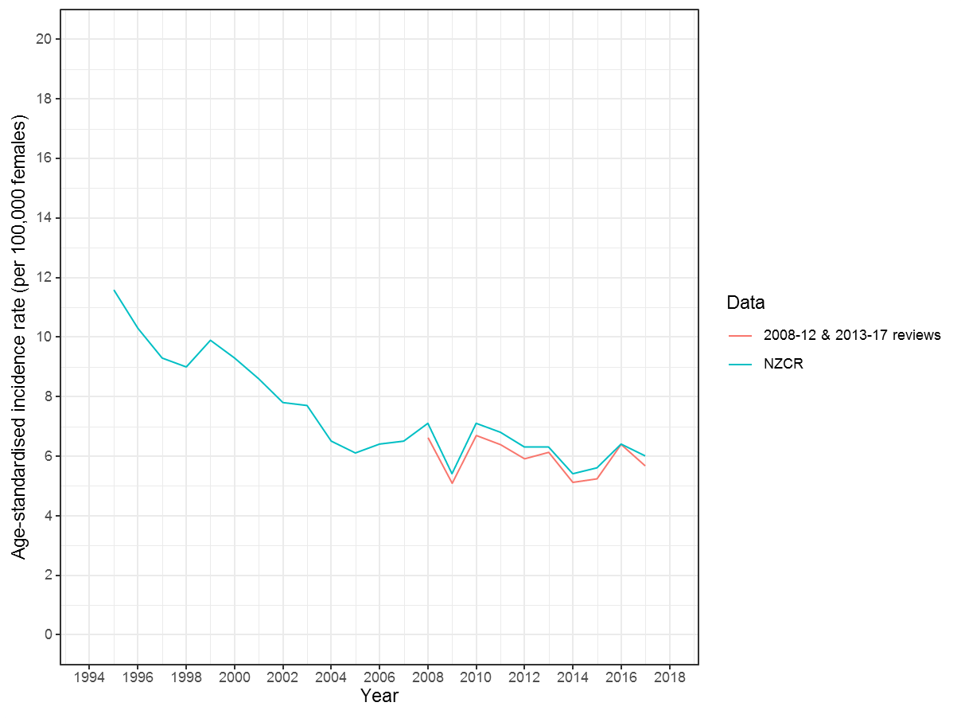
Figure 3-1 Annual age-standardised (WHO 2000-2025) incidence of cervical cancer cases per 100,000 female population by year
  - Rates were calculated according to the annual New Zealand June estimated resident population and direct age-standardised to the WHO 2000-2025 world standard population.

Table 3-2 Annual incidence of confirmed cervical cancer cases per 100,000 female population by year and ethnicity Popn: 747
Year | Total |  | Māori |  |  | Non- Māori
 | n | IR | n | IR | Age std IR | n | IR | Age std. IR*
 |  | (95% CI) |  |  | (95% CI) |  |  | (95% CI)
2013 | 152 | 6.7 (5.7, 7.8) | 33 | 9.3 | 8.0 (5.4 to 11.6) | 117 | 6.1 | 5.0 (4.0 to 6.2)
2014 | 133 | 5.8 (4.9, 6.9) | 32 | 8.8 | 8.0 (5.4 to 11.6) | 99 | 5.1 | 3.7 (2.9 to 4.8)
2015 | 136 | 5.8 (4.9, 6.9) | 33 | 8.9 | 8.8 (5.9 to 12.5) | 103 | 5.2 | 3.8 (3.0 to 4.8)
2016 | 170 | 7.1 (6.1, 8.3) | 33 | 8.8 | 8.6 (5.8 to 12.4) | 134 | 6.7 | 5.0 (4.1 to 6.1)
2017 | 156 | 6.4 (5.5, 7.5) | 31 | 8.1 | 7.4 (5.0 to 10.8) | 124 | 6.1 | 4.4 (3.6 to 5.5)
Total | 747 | 6.4 (5.9, 6.8) | 162 | 8.8 | 8.1 (6.9 to 9.6) | 577 | 5.8 | 4.4 (4.0 to 4.8)
  - IR = Unadjusted incidence rates per 100,000 females. Age std. IR = Incidence rates per 100,000 females age standardized to the 2001 Census Maori female population. Māori and non-Māori total do not include n=8 women with unknown ethnicity

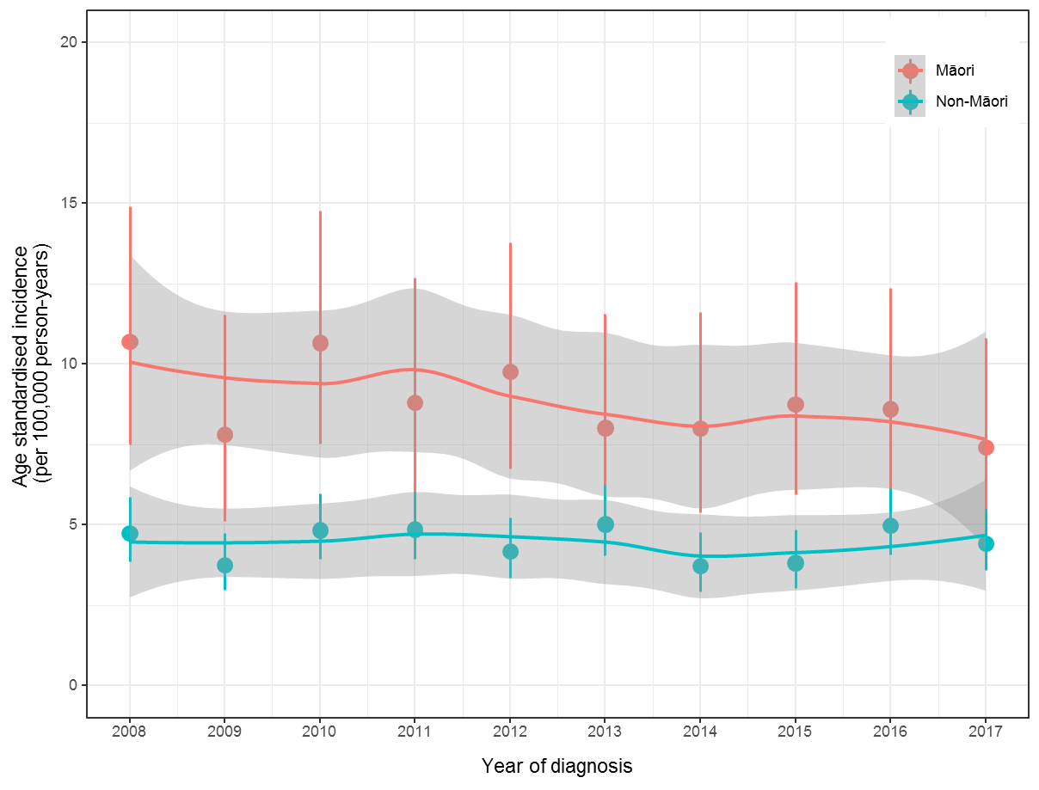
Figure 3-2 Age standardised (to Māori 2001 census) incidence of cervical cancer cases per 100,000 person-years by year of diagnosis (2008-2017) for Māori and non-Māori

Table 3-3 Demographics for all cervical cancer diagnoses by year (2013-2017) Popn: 747

 |  | 2013 | 2014 | 2015 | 2016 | 2017 | TOTAL
Total |  | 152 | 133 | 136 | 170 | 156 | 747
Age | 20-24 | 6 | <5 | <5 | <5 | <5 | 14
 | 25-29 | 22 | 14 | 12 | 14 | 7 | 69
 | 30-34 | 17 | 10 | 20 | 31 | 21 | 99
 | 35-39 | 17 | 17 | 13 | 20 | 14 | 81
 | 40-44 | 20 | 21 | 22 | 16 | 27 | 106
 | 45-49 | 11 | 14 | 15 | 21 | 16 | 77
 | 50-54 | 7 | 15 | 10 | 14 | 16 | 62
 | 55-59 | 13 | 6 | 14 | 16 | 13 | 62
 | 60-64 | 9 | 5 | 7 | 7 | 11 | 39
 | 65-69 | 8 | 5 | 5 | 11 | 16 | 45
 | 70+ | 22 | 23 | 16 | 20 | 12 | 93
Ethnicity | European/Other | 95 | 85 | 99 | 123 | 96 | 498
(Total | Māori | 33 | 32 | 33 | 33 | 31 | 162
response) | Pacific Island | 13 | 13 | <5 | 9 | 10 | 49
 | Asian | 17 | 12 | 17 | 19 | 26 | 91
Deprivation | 1 | 16 | 15 | 11 | 19 | 20 | 81
Index | 2 | 9 | 13 | 17 | 16 | 18 | 73
 | 3 | 15 | 12 | 6 | 11 | 13 | 57
 | 4 | 12 | 6 | 11 | 13 | 12 | 54
 | 5 | 14 | 9 | 9 | 18 | 19 | 69
 | 6 | 17 | 15 | 15 | 18 | 8 | 73
 | 7 | 22 | 12 | 14 | 24 | 18 | 90
 | 8 | 8 | 14 | 15 | 10 | 14 | 61
 | 9 | 12 | 14 | 15 | 18 | 14 | 73
 | 10 | 25 | 20 | 23 | 21 | 19 | 108
  - All confirmed cases of primary cervical cancer sorted by review year (2013-2017), age, ethnicity, histology and deprivation index. Deprivation Index data is taken from the 2013 census data. Note: Total response ethnicity is reported, therefore totals are greater than 747. n=8 women with no reported ethnicity are excluded from the table. N=8 women are excluded from the table due to a missing NZDep2013 Index score (two had an overseas address, two provided PO Box addresses only (in the NZCR and NCSP-R), and four resided in meshblocks without an associated 2013 NZDep2013 Index score).

Table 3-4 Tumour characteristics for all cervical cancer diagnoses by year (2013-2017 Popn: 747
 |  | 2013 | 2014 | 2015 | 2016 | 2017 | TOTAL
Type | SCC | 117 | 93 | 104 | 128 | 119 | 561
 | Adenocarcinoma | 26 | 31 | 21 | 25 | 28 | 131
 | Adenosquamous | 5 | <5 | 6 | 9 | <5 | 27
 | Other | <5 | <5 | <5 | <5 | <5 | 12
 | Non-HPV related | <5 | 5 | <5 | 5 | <5 | 16
Stage | 1a | 41 | 37 | 37 | 48 | 31 | 194
 | 1b+ | 111 | 96 | 99 | 122 | 125 | 553

Table 3-5 Age at diagnosis by ethnicity
 |  | Mean (years) | Median (years) | Range  (years)
 | Māori | 45.3 | 45.0 | 21–82
 | Non-Māori | 48.3 | 45.0 | 20–96
 | Total | 48.3 | 45.0 | 20–96

Table 3-6 Demographics for all cervical cancer diagnoses eligible for the screening history review by year (2013-2017) Popn: 628
 |  | 2013 | 2014 | 2015 | 2016 | 2017 | TOTAL
Total |  | 122 | 105 | 117 | 145 | 139 | 628
Age | 25-29 | 22 | 13 | 12 | 13 | 7 | 67
 | 30-34 | 17 | 10 | 20 | 31 | 20 | 98
 | 35-39 | 16 | 17 | 12 | 20 | 14 | 79
 | 40-44 | 20 | 21 | 22 | 14 | 26 | 103
 | 45-49 | 11 | 13 | 15 | 21 | 16 | 76
 | 50-54 | 7 | 15 | 10 | 14 | 16 | 62
 | 55-59 | 13 | 6 | 14 | 14 | 13 | 60
 | 60-64 | 9 | 5 | 7 | 7 | 11 | 39
 | 65-69 | 7 | 5 | 5 | 11 | 16 | 44
Ethnicity | European/Other | 74 | 63 | 83 | 105 | 82 | 407
(Total response) | Māori | 28 | 29 | 30 | 30 | 30 | 147
 | Pacific Island | 12 | 11 | <5 | 8 | 10 | 43
 | Asian | 15 | 10 | 16 | 16 | 25 | 82
Deprivation | 1 | 13 | 12 | 10 | 14 | 18 | 67
Index deciles | 2 | 8 | 8 | 14 | 14 | 17 | 61
 | 3 | 13 | 9 | 6 | 10 | 11 | 49
 | 4 | 10 | <5 | 9 | 12 | 11 | 46
 | 5 | 11 | 8 | 7 | 16 | 18 | 60
 | 6 | 12 | 14 | 15 | 15 | 6 | 62
 | 7 | 16 | 9 | 10 | 19 | 16 | 70
 | 8 | 7 | 11 | 12 | 8 | 13 | 51
 | 9 | 9 | 12 | 15 | 17 | 12 | 65
 | 10 | 22 | 15 | 19 | 19 | 16 | 91
  - Demographics for women diagnosed with cervical cancer and meeting eligibility criteria for the screening history review. These are sorted by year, age, ethnicity, histology, and deprivation index. Deprivation Index data is taken from the 2013 census data. Ethnicity data is from the NZCR records and uses total response ethnicity. n=2 women with no reported ethnicity are excluded from the table. N=6 women are excluded from the table due to a missing NZDep2013 Index score
  - Note: These data exclude non-HPV related cancers.

Table 3-7 Tumour characteristics for all cervical cancer diagnoses eligible for the screening history review by year (2013-2017) Popn: 628
 |  | 2013 | 2014 | 2015 | 2016 | 2017 | TOTAL
Type | SCC | 95 | 75 | 89 | 111 | 104 | 474
 | Adenocarcinoma | 23 | 27 | 20 | 24 | 28 | 122
 | Adenosquamous | <5 | <5 | 6 | 8 | <5 | 23
 | Other | <5 | <5 | <5 | <5 | <5 | 9
Stage | 1a | 38 | 34 | 37 | 45 | 28 | 182
 | 1b+ | 84 | 71 | 80 | 100 | 111 | 446

Table 3-8 Women with cervical cancer by age and deprivation index, as a proportion of Māori and non-Māori populations Popn: 747
 |  | Māori |  |  | Non-Māori
Age |  | n | % Māori | % age | n | % Non-Māori | % age
 | 20-24 | 5 | 3 | 38 | 8 | 1 | 62
 | 25-29 | 17 | 10 | 25 | 52 | 9 | 75
 | 30-34 | 22 | 14 | 22 | 77 | 13 | 78
 | 35-39 | 16 | 10 | 20 | 64 | 11 | 80
 | 40-44 | 19 | 12 | 18 | 87 | 15 | 82
 | 45-49 | 26 | 16 | 34 | 51 | 9 | 66
 | 50-54 | 20 | 12 | 32 | 42 | 7 | 68
 | 55-59 | 12 | 7 | 20 | 48 | 8 | 80
 | 60-64 | 10 | 6 | 26 | 29 | 5 | 74
 | 65-69 | 5 | 3 | 11 | 40 | 7 | 89
 | 70+ | 10 | 6 | 11 | 79 | 14 | 89
 | Total | 162 |  |  | 577
Deprivation | 1 | 6 | 4 | 7 | 75 | 13 | 93
Index | 2 | 5 | 3 | 7 | 68 | 12 | 93
 | 3 | 7 | 4 | 12 | 50 | 9 | 88
 | 4 | 8 | 5 | 15 | 45 | 8 | 85
 | 5 | 7 | 4 | 10 | 60 | 10 | 90
 | 6 | 11 | 7 | 15 | 62 | 11 | 85
 | 7 | 18 | 11 | 20 | 70 | 12 | 80
 | 8 | 18 | 11 | 30 | 42 | 7 | 70
 | 9 | 26 | 16 | 36 | 46 | 8 | 64
 | 10 | 55 | 34 | 51 | 52 | 9 | 49
 | Total | 161 |  |  | 570
  - Women diagnosed with cervical cancer within the review period by: ethnicity, age and deprivation index. Ethnicity data is taken from the NZCR records. Ethnicity is categorised as Māori or non-Māori, therefore any individuals with unknown ethnicity are excluded (n=8). Deprivation Index data is taken from the 2013 census data. An addition n=8 women are excluded due to unknown Deprivation Index.

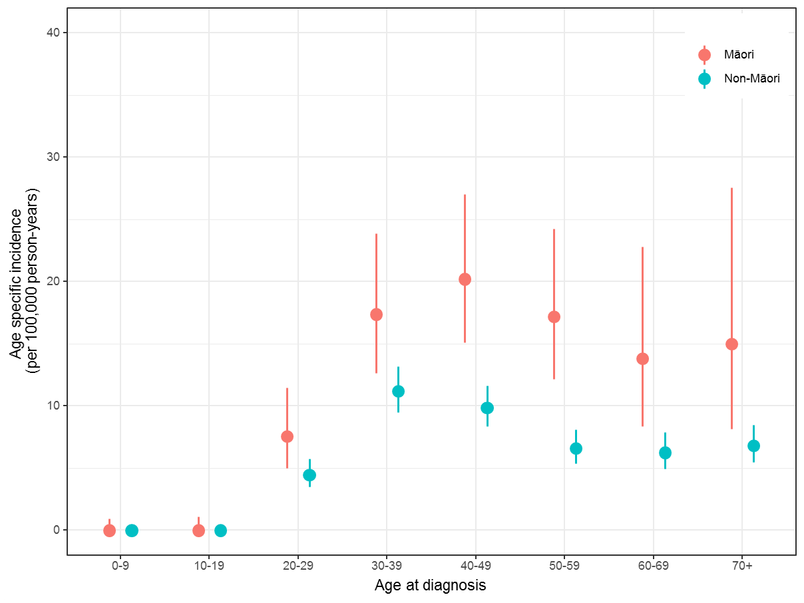
Figure 3-3 Age specific incidence of cervical cancer cases per 100,000 person-years by age for Māori and non-Māori.

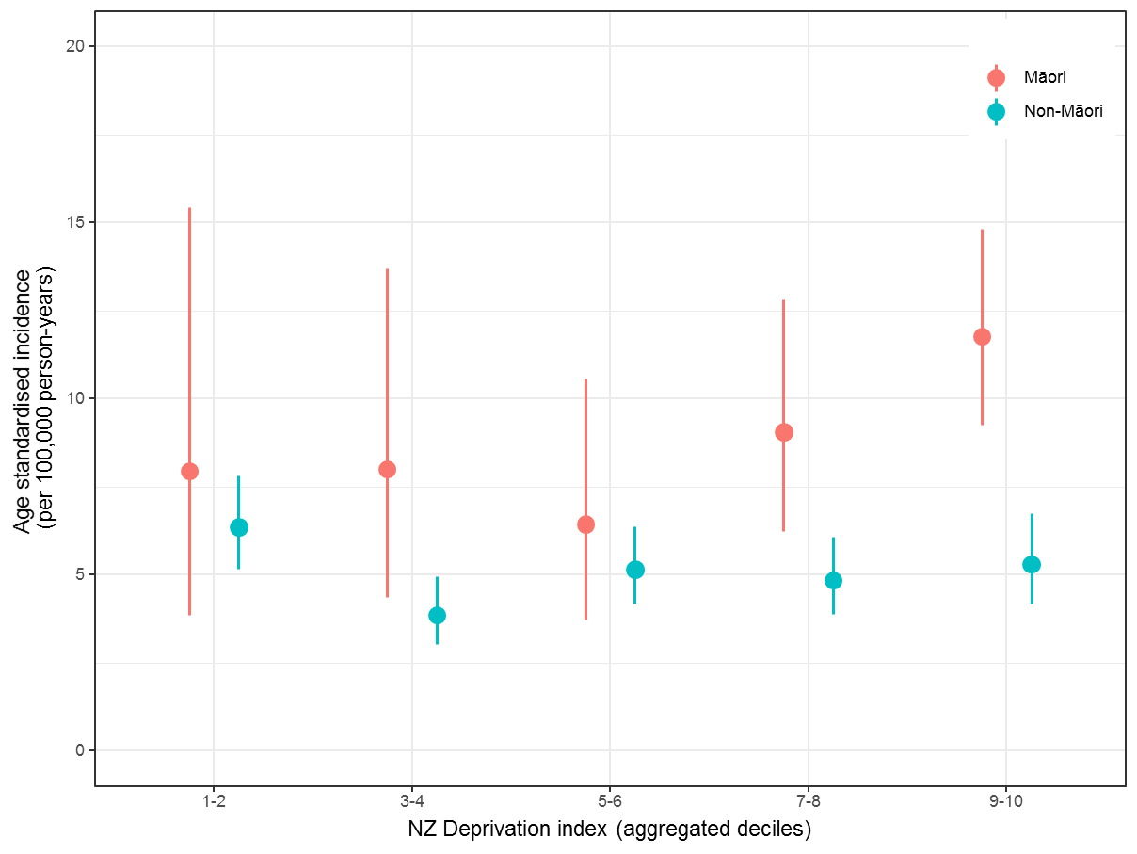
Figure 3-4 Age-standardised (to Māori 2001 census) incidence of cervical cancer per 100,000 persons-years by aggregated deprivation decile for Māori and non-Māori.

Table 3-9 Cervical cancer diagnoses by rurality and ethnicity Popn: 747

 | Māori |  | Non-Māori |  | Total
 | n | % Māori | n | % Non-Māori | n | % total
Main Urban Area | 97 | 60 | 411 | 72 | 510 | 69
Secondary Urban Area | 15 | 9 | 46 | 8 | 62 | 8
Minor Urban Area | 32 | 20 | 40 | 7 | 75 | 10
Rural Centre | 6 | 4 | 12 | 2 | 18 | 2
Other Rural | 12 | 7 | 64 | 11 | 78 | 10
Total | 162 | 100 | 573 | 100 | 743 | 100
  - All women diagnosed with cervical cancer within the review period by ethnicity and rurality. Ethnicity data is taken from NZCR records and is categorised as Māori or non-Māori. Rurality is based on census area units from the 2013 census data for the address recorded on NZCR at the time of diagnosis. Data in the Māori and non-Māori columns exclude those with unknown ethnicity (n = 8). An addition n=4 women are excluded due to unknown rurality.

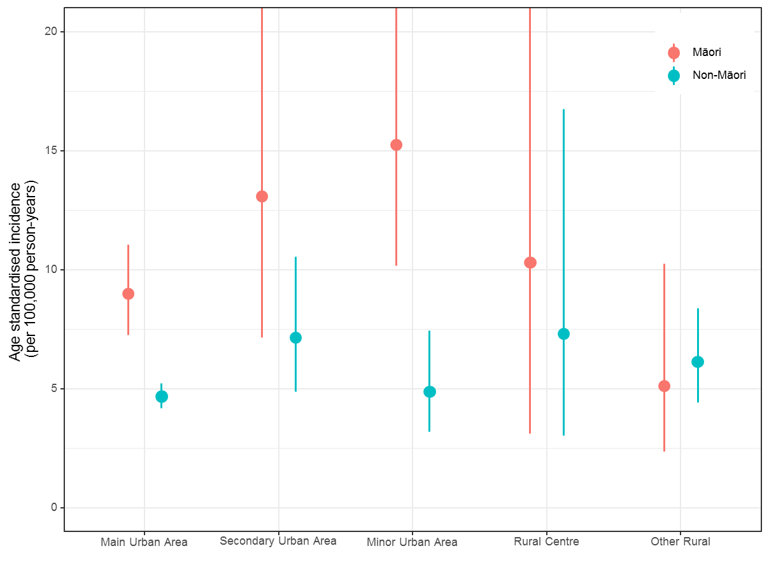
Figure 3-5 Age standardised (to Māori 2001 census) incidence of cervical cancer cases per 100,000 person-years by rurality for Māori and non-Māori.

Table 3-10 Cancer Network regions by ethnicity Popn: 747
Table 3-10a Confirmed cases by cancer network region as a proportion of Māori and non-Māori populations
 | Māori |  | Non-Māori |  | Total
Cancer Network | n | % Māori | n | % non-Māori | n | % total
Northern | 43 | 27 | 203 | 35 | 248 | 33
Midland | 53 | 33 | 92 | 16 | 150 | 20
Central | 45 | 28 | 116 | 20 | 161 | 22
Southern | 21 | 13 | 162 | 28 | 184 | 25
Total | 162 | 100 | 573 | 100 | 743 | 100
  - All women diagnosed with cervical cancer within the review period by Cancer Network Regions, ethnicity, histological type and stage. Data in the Māori and non-Māori columns exclude those with unknown ethnicity (n = 8). ). An addition n=4 women are excluded due to unknown Cancer Network.

Table 3-10b Cervical cancer cases by ethnicity as a proportion of cases within each Cancer Network region
 | Māori |  | Non- Māori
Cancer Network | n | % | n | %
Northern | 43 | 17 | 203 | 83
Midland | 53 | 37 | 92 | 63
Central | 45 | 28 | 116 | 72
Southern | 21 | 11 | 162 | 89
TOTAL | 162 | 22 | 573 | 78

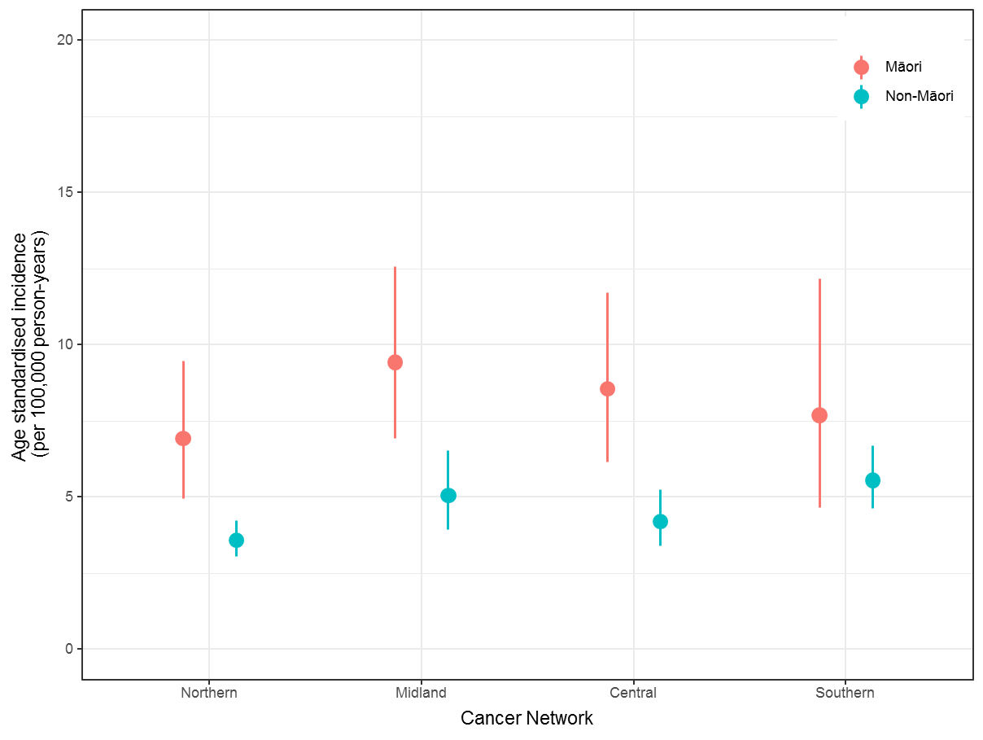
Figure 3-6 Age standardised (to Māori 2001 census) incidence of cervical cancer cases per 100,000 person-years by Cancer Network for Māori and non-Māori.

Table 3-11 Histological type and stage by ethnicity Popn: 747
 |  | Māori  n=162 |  | Non-Māori n=577 |  | All women  n=747
 |  | n | % | n | % | n | %
Histological type | SCC | 132 | 81 | 423 | 73 | 561 | 75
 | Adenocarcinoma | 21 | 13 | 110 | 19 | 131 | 18
 | Adenosquamous | 7 | 4 | 19 | 3 | 27 | 4
 | Other | <5 |  | 25 | 4 | 28 | 4
 | TOTAL | 162 | 100 | 577 | 100 | 747 | 100
Stage - all types | 1a | 47 | 29 | 146 | 25 | 194 | 26
 | 1b+ | 115 | 71 | 431 | 75 | 553 | 74
 | TOTAL | 162 | 100 | 577 | 100 | 747 | 100
Stage - SCC | 1a | 41 | 31 | 129 | 30 | 171 | 30
 | 1b+ | 91 | 69 | 294 | 70 | 390 | 70
 | TOTAL | 132 | 100 | 423 | 100 | 561 | 100
Stage - adenocarcinoma | 1a | <5 |  | 17 | 15 | 19 | 15
 | 1b+ | 19 | 90 | 93 | 85 | 112 | 85
 | TOTAL | 21 | 100 | 110 | 100 | 131 | 100
Stage - adenosquamous | 1a | <5 |  | <5 |  | <5
 | 1b+ | <5 |  | 19 | 100 | 24 | 89
 | TOTAL | 7 | 100 | 19 | 100 | 27 | 100
  - All women diagnosed with cervical cancer within the review period by histological type and stage, and ethnicity. The non-Māori ethnicity classification excludes any women with unknown ethnicity (n=8), but these women are included in the All Women column. (Note: rounding to whole numbers has been performed when presenting percentages)

Table 3-12 Histological type and stage by age at diagnosis Popn: 747
All women
Type / Age | 20-29 | 30-39 | 40-49 | 50-59 | 60-69 | 70+ | Total
SCC | 70 | 125 | 128 | 95 | 68 | 75 | 561
1a | 38 | 58 | 43 | 19 | 11 | <5 | 171
1b+ | 32 | 67 | 85 | 76 | 57 | 73 | 390
Adenocarcinoma | 10 | 42 | 39 | 21 | 11 | 8 | 131
1a | <5 | 8 | 7 | <5 | <5 | <5 | 19
1b+ | 8 | 34 | 32 | 20 | 10 | 8 | 112
Adenosquamous | <5 | 9 | 9 | 5 | <5 | <5 | 27
Other | <5 | <5 | 7 | <5 | 5 | <5 | 28
Total | 83 | 180 | 183 | 124 | 84 | 53 | 747
  - All women diagnosed with cervical cancer within the review period by histological type, stage and age at diagnosis. Staging data is presented in two categories covering both superficially invasive (microinvasive) cancer and greater.

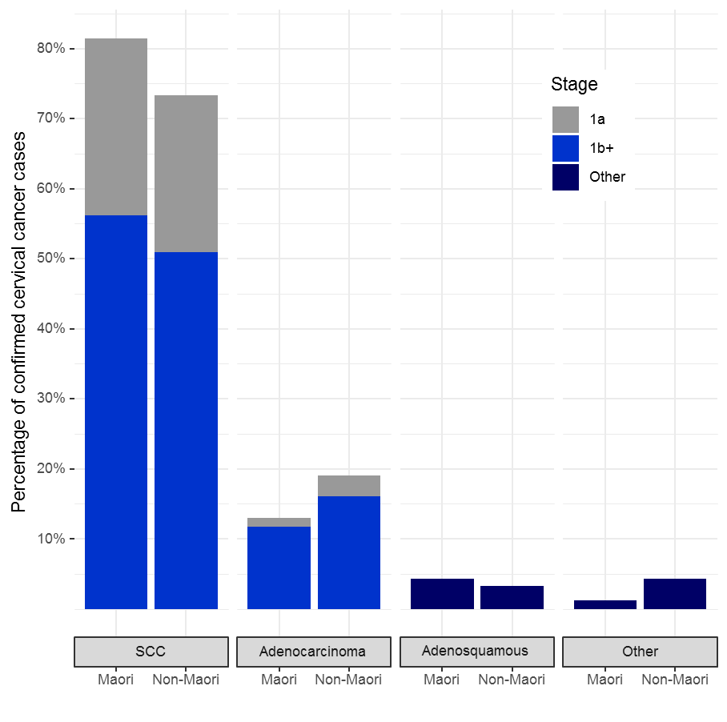
Figure 3-7 Differences in histological type, stage by ethnicity for all women diagnosed with cervical cancer included in the review.
Table 3-13 Histological type and stage by ethnicity and age at diagnosis Popn: 747
 | Māori
Type / Age | 20-29 | 30-39 | 40-49 | 50-59 | 60-69 | 70+ | Total
SCC 1a | 8 | 14 | 9 | 5 | <5 | <5 | 41
SCC 1b+ | 12 | 16 | 25 | 22 | 9 | 7 | 91
Non-squamous cell cancer | <5 | 8 | 11 | 5 | <5 | <5 | 30
Total | 22 | 38 | 45 | 32 | 15 | 10 | 162

 | Non-Māori
Type / Age | 20-29 | 30-39 | 40-49 | 50-59 | 60-69 | 70+ | Total
SCC 1a | 29 | 44 | 34 | 14 | 7 | <5 | 129
SCC 1b+ | 20 | 50 | 60 | 54 | 48 | 62 | 294
Non-squamous cell cancer | 11 | 47 | 44 | 22 | 14 | 16 | 154
Total | 60 | 141 | 138 | 90 | 69 | 79 | 577
  - All women diagnosed with cervical cancer within the review period by ethnicity, histological type, stage and age at diagnosis. Any women with unknown ethnicity was excluded (n=8). Staging data is presented in two categories covering both superficially invasive (microinvasive) cancer and greater. Due to small numbers non-squamous cell cancer types have been aggregated.

Table 3-14 Histological type and aggregated NZ Deprivation Index decile Popn: 747
 | NZ Deprivation index (Aggregated Deciles)
 | 1-2  (Least deprived) |  | 3-4 |  | 5-6 |  | 7-8 |  | 9-10  (Most deprived)
Type | n | % | n | % | n | % | n | % | n | %
SCC | 105 | 68 | 73 | 66 | 109 | 77 | 116 | 77 | 150 | 83
1a | 34 | 22 | 25 | 23 | 36 | 25 | 30 | 20 | 46 | 25
1b+ | 71 | 46 | 48 | 43 | 73 | 51 | 86 | 57 | 104 | 57
Adenocarcinoma | 35 | 23 | 25 | 23 | 24 | 17 | 26 | 17 | 21 | 12
1a | 6 | 4 | <5 |  | <5 |  | <5 |  | <5
1b+ | 29 | 19 | 21 | 19 | 20 | 14 | 24 | 16 | 18 | 10
Adenosquamous | 6 | 4 | 6 | 5 | <5 |  | 5 | 3 | 6 | 3
Other | 8 | 5 | 7 | 6 | 5 | 4 | <5 |  | <5
Total | 154 | 100 | 111 | 100 | 142 | 100 | 151 | 100 | 181 | 100
  - All women diagnosed with cervical cancer within the audit period by histological type and deprivation index by aggregated decile. Deprivation Index data is taken from the 2013 census. Women with unknown deprivation index are omitted from this table (n=13).

Figure 3-8 Deprivation index data expressed as aggregated deciles for cervical cancer cases by histological type and stage

Table 3-15 Type and stage by rurality Popn: 747
 | Rurality
 | Main urban |  | Secondary urban |  | Minor urban |  | Rural centre |  | Other rural
Type | n | % | n | % | n | % | n | % | n | %
SCC | 384 | 75 | 48 | 77 | 58 | 77 | 13 | 72 | 54 | 69
1a | 122 | 24 | 14 | 23 | 16 | 21 | <5 |  | 15 | 19
1b+ | 262 | 51 | 34 | 55 | 42 | 56 | 9 | 50 | 39 | 50
Non-squamous cell cancer | 126 | 25 | 14 | 23 | 17 | 23 | 5 | 28 | 24 | 31
Total | 510 | 100 | 62 | 100 | 75 | 100 | 18 | 100 | 78 | 100
  - All women diagnosed with cervical cancer within the review period by histological type and stage, and rurality. Rurality index is based on census unit data taken from the 2013 census data. Percentages expressed refer to the percentage of women in each rurality with the corresponding type and stage. Excludes women whose rurality is unknown (n=4). Due to small numbers non-squamous cell cancer types have been aggregated.

Table 3-16 Type and stage by Regional Cancer Network Popn: 747
 | Regional Cancer Network
 | Northern |  | Midland |  | Central |  | Southern
Type | n | % | n | % | n | % | n | %
SCC | 186 | 77 | 109 | 72 | 130 | 78 | 135 | 73
1a | 58 | 24 | 29 | 19 | 44 | 26 | 40 | 22
1b+ | 128 | 53 | 80 | 53 | 86 | 51 | 95 | 52
Adenocarcinoma | 43 | 18 | 28 | 18 | 23 | 14 | 37 | 20
1a | 5 | 2 | 5 | 3 | 6 | 4 | <5
1b+ | 38 | 16 | 23 | 15 | 17 | 10 | 34 | 18
Adenosquamous | 6 | 2 | 9 | 6 | 5 | 3 | 7 | 4
Other | 8 | 3 | 6 | 4 | 9 | 5 | 5 | 3
Total | 243 | 100 | 152 | 100 | 167 | 100 | 184 | 100
  - All women diagnosed with cervical cancer within the review period by Cancer Network and histological type and stage. This excludes one case which was diagnosed overseas.

Assessment of Screening Adequacy
All data in this section refers only to the 628 eligible women as determined by the application of the exclusion criteria described in Section 3.
The definitions outlined in the Screening History part of the Methods section were used to assess the frequency of a woman’s screening history in order to allow comparisons with previous reports.
For all definitions, cervical cytology samples that occurred less than six months prior to diagnosis were considered to be ‘diagnostic cervical cytology samples’ and therefore excluded. Time frames were defined in calendar time, so monthly and yearly intervals may not be represented by an exact number of days.

Table 4-1 Screening adequacy by patient demographics Popn: 628
 | Total | Ever screened |  | 6 to 84 months |  | 6 to 66 months |  | 6 to 42 months |  | Every five years |  | Adequately
 | N | n | % | n | % | n | % | n | % | n | % | n | %
Age
25-29 | 67 | 48 | 72 | 44 | 66 | 40 | 60 | 31 | 46 | 33 | 49 | 7 | 10
30-34 | 98 | 80 | 82 | 70 | 71 | 65 | 66 | 45 | 46 | 42 | 43 | 12 | 12
35-39 | 79 | 65 | 82 | 49 | 62 | 45 | 57 | 35 | 44 | 16 | 20 | 15 | 19
40-44 | 103 | 85 | 83 | 63 | 61 | 56 | 54 | 41 | 40 | 17 | 17 | 16 | 16
45-49 | 76 | 59 | 78 | 40 | 53 | 37 | 49 | 24 | 32 | 15 | 20 | 9 | 12
50-54 | 62 | 46 | 74 | 28 | 45 | 26 | 42 | 21 | 34 | 9 | 15 | 7 | 11
55-59 | 60 | 37 | 62 | 26 | 43 | 23 | 38 | 19 | 32 | <5 |  | <5
60-64 | 39 | 22 | 56 | 11 | 28 | 10 | 26 | 9 | 23 | <5 |  | <5
65-69 | 44 | 25 | 57 | 15 | 34 | 15 | 34 | 10 | 23 | 5 | 11 | 5 | 11
Total | 628 | 467 | 74 | 346 | 55 | 317 | 50 | 235 | 37 | 143 | 23 | 76 | 12
Ethnicity
European/Other | 407 | 322 | 79 | 245 | 60 | 227 | 56 | 168 | 41 | 124 | 30 | 61 | 15
Māori | 147 | 122 | 83 | 83 | 56 | 74 | 50 | 54 | 37 | 26 | 18 | 15 | 10
Pacific | 43 | 29 | 67 | 19 | 44 | 16 | 37 | 13 | 30 | <5 |  | <5
Asian | 82 | 37 | 45 | 30 | 37 | 29 | 35 | 25 | 30 | 5 | 6 | 7 | 9
Deprivation
(aggregated deciles)
1-2 | 128 | 100 | 78 | 83 | 65 | 76 | 59 | 55 | 43 | 37 | 29 | 21 | 16
3-4 | 95 | 69 | 73 | 57 | 60 | 53 | 56 | 43 | 45 | 26 | 27 | 14 | 15
5-6 | 122 | 91 | 75 | 61 | 50 | 55 | 45 | 36 | 30 | 33 | 27 | 15 | 12
7-8 | 121 | 85 | 70 | 66 | 55 | 56 | 46 | 43 | 36 | 22 | 18 | 10 | 8
9-10 | 156 | 120 | 77 | 78 | 50 | 76 | 49 | 57 | 37 | 24 | 15 | 16 | 10
Total | 622 | 465 | 75 | 345 | 55 | 316 | 51 | 234 | 38 | 142 | 23 | 76 | 12
  - Assessment of screening adequacy of screening for women with cervical cancer included in the screening review by 5-year age bracket, ethnicity, and deprivation index. This table describes the number of individuals who had at least one cervical cytology sample within 6-42, 6-66 and 6-84 months prior to diagnosis, those who were adequately screened and those who had ever had any screening. Ethnicity is total response. Women can fall into multiple ethnicity groups. N=8 women are excluded from the table due to no reported ethnicity (n=2) and missing NZDep2013 Index score (n=6).

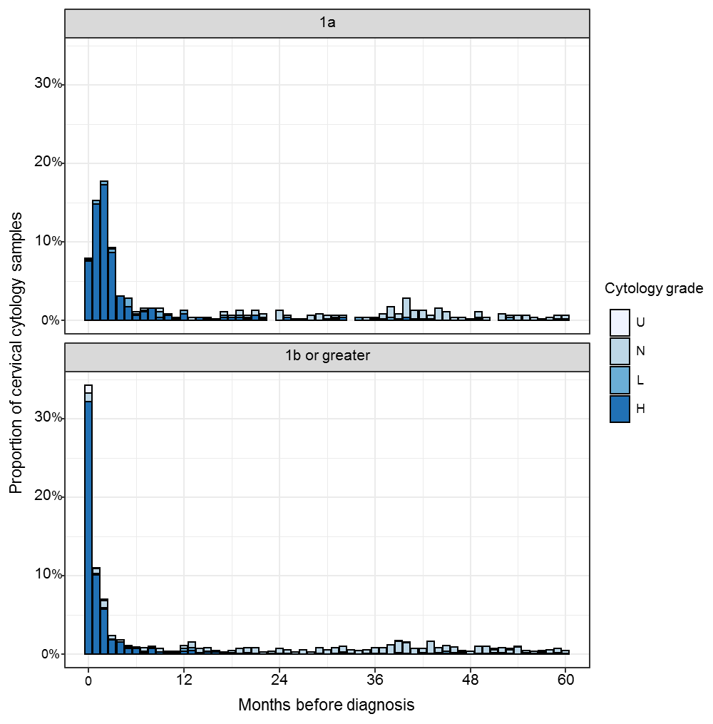
Figure 4-1 Proportion of cervical cytology samples taken per month and associated cytological findings in the 60 months prior to diagnosis.
  - This demonstrates the high proportion of abnormal cytological findings in the 6 months prior to diagnosis. Both the proportion of cervical cytology samples taken, and the incidence of high grade cytology plateaus beyond 6 months, hence cytology samples taken within the 6 months prior to diagnosis were considered to be part of the diagnostic process. Fewer than 17 cervical cytology samples were taken per month in 95% of months prior to cervical cancer diagnosis.

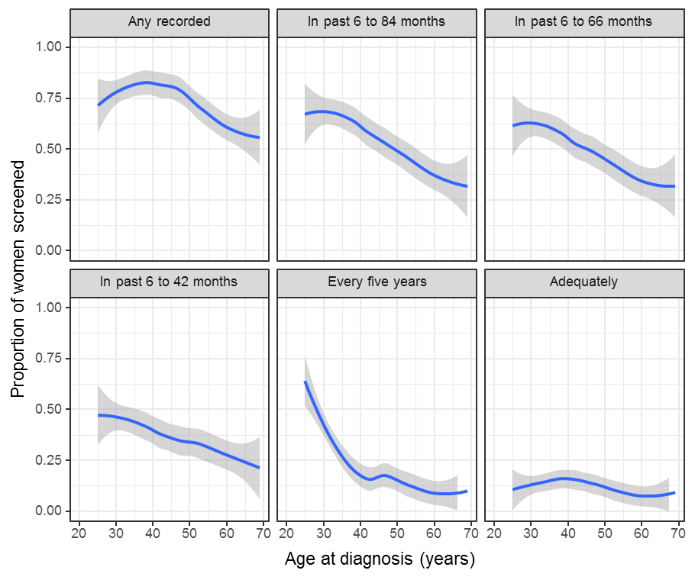
Figure 4-2 Screening adequacy by age at diagnosis
Table 4-2 Screening adequacy by histological type and stage Popn: 628

 | Total | Ever screened |  | 6 to 84 months |  | 6 to 66 months |  | 6 to 42 months |  | Every five years |  | Adequately screened
 | N | n | % | n | % | n | % | n | % | n | % | n | %
Type
SCC | 474 | 334 | 70 | 235 | 50 | 215 | 45 | 161 | 34 | 91 | 19 | 49 | 10
Adenocarcinoma | 122 | 105 | 86 | 88 | 72 | 80 | 66 | 55 | 45 | 44 | 36 | 17 | 14
Adenosquamous | 23 | 21 | 91 | 19 | 83 | 19 | 83 | 17 | 74 | 8 | 35 | 10 | 43
Stage
1a | 182 | 147 | 81 | 118 | 65 | 108 | 59 | 82 | 45 | 56 | 31 | 26 | 14
1b+ | 446 | 320 | 72 | 228 | 51 | 209 | 47 | 153 | 34 | 87 | 20 | 50 | 11
Total | 628 | 467 | 74 | 346 | 55 | 317 | 50 | 235 | 37 | 143 | 23 | 76 | 12
  - This table describes the number of all eligible women diagnosed with cervical cancer included in the screening review with at least one cervical cytology sample within 6-42, 6-66 and 6-84 months prior to diagnosis, those who were adequately screened and those who had ever had any screening by histological type and stage at the time of diagnosis. Due to the small number of ‘other’ cancers (n=9), these are not included in the Type section of the table, but are included in the Stage section.
  - Staging was grouped broadly into superficially invasive (microinvasive) or greater based on the available clinical information available on the NZCR and histological review by the review team.

Table 4-3 Screening adequacy by age and ethnicity Popn: 628
Table 4-3a Screening adequacy by age in 10 year age brackets (except for 25-29 years) for those women identified as Māori
Age | Total | Ever Screened |  | 6 to 84 months |  | 6 to 66 months |  | 6 to 42 months |  | Every five years |  | Adequately Screened
 | N | n | % | n | % | n | % | n | % | n | % | n | %
25 to 29 | 17 | 12 | 71 | 11 | 65 | 9 | 53 | 7 | 41 | 7 | 41 | <5
30 to 39 | 38 | 34 | 89 | 24 | 63 | 23 | 61 | 16 | 42 | 7 | 18 | <5
40 to 49 | 45 | 42 | 93 | 27 | 60 | 24 | 53 | 20 | 44 | 9 | 20 | 7 | 16
50 to 59 | 32 | 25 | 78 | 13 | 41 | 11 | 34 | 6 | 19 | <5 |  | <5
60 to 69 | 15 | 9 | 60 | 8 | 53 | 7 | 47 | 5 | 33 | <5 |  | <5
Total | 147 | 122 | 83 | 83 | 56 | 74 | 50 | 54 | 37 | 26 | 18 | 15 | 10

Table 4-3b Screening adequacy by age in 10 year age brackets (except for 25-29 years) for those women identified as non-Māori
Age | Total | Ever Screened |  | 6 to 84 months |  | 6 to 66 months |  | 6 to 42 months |  | Every five years |  | Adequately Screened
 | N | n | % | n | % | n | % | n | % | n | % | n | %
25 to 29 | 50 | 36 | 72 | 33 | 66 | 31 | 62 | 24 | 48 | 26 | 52 | 6 | 12
30 to 39 | 138 | 110 | 80 | 95 | 69 | 87 | 63 | 64 | 46 | 51 | 37 | 23 | 17
40 to 49 | 134 | 102 | 76 | 76 | 57 | 69 | 51 | 45 | 34 | 23 | 17 | 18 | 13
50 to 59 | 89 | 57 | 64 | 41 | 46 | 38 | 43 | 34 | 38 | 11 | 12 | 9 | 10
60 to 69 | 68 | 38 | 56 | 18 | 26 | 18 | 26 | 14 | 21 | 6 | 9 | 5 | 7
Total | 479 | 343 | 72 | 263 | 55 | 243 | 51 | 181 | 38 | 117 | 24 | 61 | 13
  - The number of individuals who had at least one cervical cytology sample within 6-42, 6-66 and 6-84 months prior to diagnosis, those who were adequately screened and those who had ever had any screening since the inception of the screening programme. Any women where ethnicity was unknown are excluded (n=2).

Table 4-4 Screening adequacy by year of diagnosis Popn: 628
Year | Total | Ever Screened |  | 6 to 84 months |  | 6 to 66 months |  | 6 to 42 months |  | Every five years |  | Adequately screened
 | N | n | % | n | % | n | % | n | % | n | % | n | %
2013 | 122 | 89 | 73 | 70 | 57 | 65 | 53 | 44 | 36 | 30 | 25 | 12 | 10
2014 | 105 | 81 | 77 | 57 | 54 | 53 | 50 | 41 | 39 | 20 | 19 | 13 | 12
2015 | 117 | 81 | 69 | 57 | 49 | 50 | 43 | 35 | 30 | 22 | 19 | 6 | 5
2016 | 145 | 113 | 78 | 83 | 57 | 75 | 52 | 60 | 41 | 39 | 27 | 23 | 16
2017 | 139 | 103 | 74 | 79 | 57 | 74 | 53 | 55 | 40 | 32 | 23 | 22 | 16
Total | 628 | 467 | 74 | 346 | 55 | 317 | 50 | 235 | 37 | 143 | 23 | 76 | 12

  - This table assesses screening adequacy by the year of diagnosis including the number of individuals who had at least one cervical cytology sample within 6-42, 6-66 and 6-84 months prior to diagnosis, those who were adequately screened, those who had ever been screened, and those who had ever had any screening since the inception of the screening programme.
Table 4-5 Screening adequacy by Regional Cancer Network Popn: 628
Māori
Region | Total | Since 1990 |  | 6 to 84 months |  | 6 to 66 months |  | 6 to 42 months |  | Every five years |  | Adequately  Screened
 | N | n | % | n | % | n | % | n | % | n | % | n | %
Northern | 36 | 30 | 83 | 21 | 58 | 18 | 50 | 13 | 36 | 5 | 14 | <5
Midland | 49 | 42 | 86 | 29 | 59 | 26 | 53 | 18 | 37 | 11 | 22 | 9 | 18
Central | 43 | 34 | 79 | 24 | 56 | 21 | 49 | 15 | 35 | 5 | 12 | <5
Southern | 19 | 16 | 84 | 9 | 47 | 9 | 47 | 8 | 42 | 5 | 26 | <5
Total | 147 | 122 | 83 | 83 | 56 | 74 | 50 | 54 | 37 | 26 | 18 | 15 | 10
Non-Māori
Region | Total | Since 1990 |  | 6 to 84 months |  | 6 to 66 months |  | 6 to 42 months |  | Every five years |  | Adequately  Screened
 | N | n | % | n | % | n | % | n | % | n | % | n | %
Northern | 165 | 106 | 64 | 82 | 50 | 77 | 47 | 60 | 36 | 33 | 20 | 23 | 14
Midland | 80 | 67 | 84 | 43 | 54 | 41 | 51 | 35 | 44 | 17 | 21 | 7 | 9
Central | 98 | 69 | 70 | 54 | 55 | 49 | 50 | 34 | 35 | 29 | 30 | 11 | 11
Southern | 135 | 101 | 75 | 84 | 62 | 76 | 56 | 52 | 39 | 38 | 28 | 20 | 15
Total | 478 | 343 | 72 | 263 | 55 | 243 | 51 | 181 | 38 | 117 | 24 | 61 | 13

Total
Region | Total | Since 1990 |  | 6 to 84 months |  | 6 to 66 months |  | 6 to 42 months |  | Every five years |  | Adequately  Screened
 | N | n | % | n | % | n | % | n | % | n | % | n | %
Northern | 201 | 136 | 68 | 103 | 51 | 95 | 47 | 73 | 36 | 38 | 19 | 25 | 12
Midland | 129 | 109 | 84 | 72 | 56 | 67 | 52 | 53 | 41 | 28 | 22 | 16 | 12
Central | 141 | 103 | 73 | 78 | 55 | 70 | 50 | 49 | 35 | 34 | 24 | 12 | 9
Southern | 156 | 119 | 76 | 93 | 60 | 85 | 54 | 60 | 38 | 43 | 28 | 23 | 15
Total | 627 | 467 | 74 | 346 | 55 | 317 | 50 | 235 | 37 | 143 | 23 | 76 | 12
  - Screening adequacy in relation to the Regional Cancer Network the woman resided in at the time of diagnosis and ethnicity. This table includes individuals who had at least one cervical cytology sample within 6-42, 6-66 and 6-84 months prior to diagnosis, those who were adequately screened and those who had ever had any screening since the inception of the screening programme. Women with unknown ethnicity (n = 2) are excluded from Māori and non-Māori categories, but included in total. N=1 woman with an overseas address is excluded.

Table 4-6 Screening adequacy by rurality and ethnicity Popn: 628
Māori
Region | Total | Since 1990 |  | 6 to 84 months |  | 6 to 66 months |  | 6 to 42 months |  | Every five years |  | Adequately Screened
 | N | n | % | n | % | n | % | n | % | n | % | n | %
Main Urban | 90 | 73 | 81 | 49 | 54 | 42 | 47 | 28 | 31 | 15 | 17 | 7 | 8
Secondary Urban | 14 | 11 | 79 | 6 | 43 | 6 | 43 | <5 |  | <5 |  | <5
Minor Urban | 29 | 26 | 90 | 18 | 62 | 18 | 62 | 16 | 55 | 7 | 24 | 5 | 17
Rural Centre | 5 | <5 |  | <5 |  | <5 |  | <5 |  | <5 |  | <5
Other Rural | 9 | 8 | 89 | 7 | 78 | 5 | 56 | 5 | 56 | <5 |  | <5
Total | 147 | 122 | 83 | 83 | 56 | 74 | 50 | 54 | 37 | 26 | 18 | 15 | 10
Non-Māori
Region | Total | Since 1990 |  | 6 to 84 months |  | 6 to 66 months |  | 6 to 42 months |  | Every five years |  | Adequately Screened
 | N | n | % | n | % | n | % | n | % | n | % | n | %
Main Urban | 344 | 246 | 72 | 185 | 54 | 170 | 49 | 126 | 37 | 78 | 23 | 42 | 12
Secondary Urban | 34 | 21 | 62 | 18 | 53 | 16 | 47 | 14 | 41 | 10 | 29 | 5 | 15
Minor Urban | 34 | 25 | 74 | 18 | 53 | 17 | 50 | 11 | 32 | 7 | 21 | 3
Rural Centre | 9 | 6 | 67 | 5 | 56 | 5 | 56 | 3 |  | 3 |  | 1
Other Rural | 54 | 44 | 81 | 36 | 67 | 34 | 63 | 26 | 48 | 18 | 33 | 10 | 19
Total | 475 | 342 | 72 | 262 | 55 | 242 | 51 | 180 | 38 | 116 | 24 | 61 | 13
Total
Region | Total | Since 1990 |  | 6 to 84 months |  | 6 to 66 months |  | 6 to 42 months |  | Every five years |  | Adequately Screened
 | N | n | % | n | % | n | % | n | % | n | % | n | %
Main Urban | 435 | 320 | 74 | 234 | 54 | 212 | 49 | 154 | 35 | 93 | 21 | 49 | 11
Secondary Urban | 48 | 32 | 67 | 24 | 50 | 22 | 46 | 17 | 35 | 10 | 21 | 6 | 12
Minor Urban | 63 | 51 | 81 | 36 | 57 | 35 | 56 | 27 | 43 | 14 | 22 | 8 | 13
Rural Centre | 14 | 10 | 71 | 8 | 57 | 8 | 57 | 5 | 36 | 4 | 29 | 1 | 7
Other Rural | 64 | 53 | 83 | 43 | 67 | 39 | 61 | 31 | 48 | 21 | 33 | 12 | 19
Total | 624 | 466 | 75 | 345 | 55 | 316 | 51 | 234 | 38 | 142 | 23 | 76 | 12
  - All women diagnosed with cervical cancer and eligible for screening review by rurality, histological type and stage. Rurality is based on census unit data taken from the 2013 census data. This includes individuals who had at least one cervical cytology sample within 6-42, 6-66 and 6-84 months prior to diagnosis, those who were adequately screened and those who had ever had any screening since the inception of the screening programme. Women with unknown ethnicity (n = 2) are excluded from Māori and non-Māori categories but included in the table for total women. Women with unknown rurality are excluded (n=4).

Table 4-7 Screening history in the 6 to 84 months prior to diagnosis for all patients included in the Review Popn: 628

 | Total | High grade |  | Two+ low grade |  | One low grade |  | One negative |  | Two+ negative |  | No screening
 | N | n | % | n | % | n | % | n | % | n | % | n | %
Age
25-29 | 67 | 9 | 13 | <5 |  | 8 | 12 | 11 | 16 | 14 | 21 | 23 | 34
30-34 | 98 | 15 | 15 | <5 |  | 7 | 7 | 24 | 24 | 23 | 23 | 28 | 29
35-39 | 79 | 9 | 11 | <5 |  | 3 |  | 18 | 23 | 18 | 23 | 30 | 38
40-44 | 103 | 12 | 12 | <5 |  | 5 | 5 | 20 | 19 | 25 | 24 | 40 | 39
45-49 | 76 | 11 | 14 | <5 |  | <5 |  | 13 | 17 | 13 | 17 | 36 | 47
50-54 | 62 | 8 | 13 | <5 |  | <5 |  | 6 | 10 | 11 | 18 | 34 | 55
55-59 | 60 | 8 | 13 | <5 |  | <5 |  | 9 | 15 | 7 | 12 | 34 | 57
60-64 | 39 | <5 |  | <5 |  | <5 |  | <5 |  | 6 | 15 | 28 | 72
65-69 | 44 | <5 |  | <5 |  | <5 |  | <5 |  | 6 | 14 | 29 | 66
Ethnicity
European & other | 407 | 39 | 10 | <5 |  | 26 | 6 | 76 | 19 | 100 | 25 | 162 | 40
Māori | 147 | 33 | 22 | <5 |  | 5 | 3 | 21 | 14 | 24 | 16 | 64 | 44
Pacific | 43 | 10 | 23 | <5 |  | <5 |  | 6 | 14 | <5 |  | 24 | 56
Asian | 82 | <5 |  | <5 |  | <5 |  | 11 | 13 | 10 | 12 | 52 | 63
Total | 628 | 77 | 12 | 6 | 1 | 33 | 5 | 107 | 17 | 123 | 20 | 282 | 45
  - Cervical cytology sample history in the 6 to 84 months prior to diagnosis for all eligible women diagnosed with cervical cancer, according to age and ethnicity. Cervical cytology sample history is defined as the highest of the following categories: at least one high grade cervical cytology sample, two or more low grade cervical cytology samples (but no high grade), one low grade cervical cytology sample (but no high grade), one negative cervical cytology sample, two or more negative cervical cytology samples, and no screening. Ethnicity is total response.

Table 4-8 Screening history in the 6 to 84 months prior to diagnosis by histological type and stage at diagnosis Popn: 628

 | Total | High grade |  | Two+ low grade |  | One low grade |  | One negative |  | Two+ negative |  | No screening
 | N | n | % | n | % | n | % | n | % | n | % | n | %
Type
SCC | 474 | 65 | 14 | 5 | 1 | 31 | 7 | 66 | 14 | 68 | 14 | 239 | 50
Adenocarcinoma | 122 | 9 | 7 | <5 |  | <5 |  | 35 | 29 | 43 | 35 | 34 | 28
Adenosquamous | 23 | <5 |  | <5 |  | <5 |  | <5 |  | 10 | 43 | <5
Stage
1a | 182 | 31 | 17 | <5 |  | 17 | 9 | 27 | 15 | 39 | 21 | 64 | 35
1b+ | 446 | 46 | 10 | <5 |  | 16 | 4 | 80 | 18 | 84 | 19 | 218 | 49
Total | 628 | 77 | 12 | 6 | 1 | 33 | 5 | 107 | 17 | 123 | 20 | 282 | 45

  - Cervical cytology sample history in the 6 to 84 months prior to diagnosis for all eligible women diagnosed with cervical cancer, according to histological type and stage at diagnosis. Cervical cytology sample history is defined as the highest of the following categories: at least one high grade cervical cytology sample, two or more low grade cervical cytology samples (but no high grade), one low grade cervical cytology sample (but no high grade), one negative cervical cytology sample, two or more negative cervical cytology samples, and no screening. Staging was grouped broadly into superficially invasive (microinvasive) or greater based on the available clinical information available on the NZCR and histological review by the review team. Due to the small number of ‘other’ cancers (n=9), these are not included in the Type section of the table, but are included in the Stage section.The No screening column includes one woman with a single unsatisfactory cervical cytology sample in the 6 to 84 months prior to diagnosis.
Table 4-9 Cytological interpretation of high grade cervical cytology samples taken in the 0-36 months prior to the diagnosis of adenocarcinoma.

Interpretation | Grade | Code | n
Endocervical adenocarcinoma | HG-G | AC1 | 15
Endometrial adenocarcinoma | HG-G | AC2 | 3
Extrauterine adeoncarcinoma | HG-G | AC3 | 0
Adenocarcinoma | HG-G | AC4 | 9
Malignant neoplasm | HG-G | AC5 | 1
Atypical endocervical cells | HG-G | AG1 | 10
Atypical endometrial cells | HG-G | AG2 | 3
Atypical glandular cells | HG-G | AG3 | 0
Atypical endocervical cells, neoplastic | HG-G | AG4 | 8
Atypical glandular cells, neoplastic | HG-G | AG5 | 6
Adenocarcinoma in-situ | HG-G | AIS | 55
Atypical squamous cells present, possible high grade | HG-S | ASH | 5
High grade intraepithelial lesion (CIN2 or CIN3) | HG-S | HS1 | 10
High grade intraepithelial lesion (suspect invasion) | HG-S | HS2 | 4
Squamous cell carcinoma | HG-S | SC | 2
 | Total Glandular |  | 110
 | Total Squamous |  | 21
 | Total Overall |  | 131

Appendix 1: Comparison of key results with previous review and audits

Description of data comparing 2008-2012 and 2013-2017

Table 5-1 Description of NZCR records comparing 2008-2012 and 2013-2017
All cervical and related cancer incidences on NZCR diagnosed 2008-2012 and 2013-2017.
NZCR Records | 2008–2012  n | 2013–2017  n
Total number of cases received from the NZCR | 854 | 809
Two of these were second cancer diagnoses and are excluded | 852 | 807

Table 5-2 ICD10 cancer codes for all NZCR records comparing 2008-2012 and 2013-2017
NZCR codes received in full dataset | ICD10 | 2008–2012  n* | 2013–2017  n
Malignant neoplasm of cervix uteri | C539 | 830 | 776
Malignant neoplasm of endocervix | C530 | 1 | 0
Malignant neoplasm of overlapping sites of female genital organs | C578 | 20 | 31
Total |  | 851 | 807
  - ICD10 cancer codes for all records received from NZCR of cervical and related cancers. Cervical cancers include C539 and C530. The genital organs cancers (C578) were included in the dataset population also.
  - * One women was listed in both the 2008-2012 and 2013-2017 NZCR data extracts. This women was considered to have Cancer-non-cervical diagnosed in 2012 but to have a diagnosis of Cervical cancer in 2015. She was thus excluded from the 2008-2012 numbers below (total = 852-1 = 851).

Cancer and Patient Demographics comparing 2008-2012 and 2013-2017

Table 6-1 Number of cases of cervical cancer as reported by NZCR, NCSP-R comparing 2008-2012 and 2013-2017
Review period | 2008–2012  n | 2013–2017  n
NZCR | 851 | 807
NCSP-R | 805 | 794
Review | 772 | 747

Table 6-2 Number of cases of cervical cancer following histological review by the review team comparing 2008-2012 and 2013-2017
Review records | 2008-2012  n | 2013-2017  n
Total individuals in range | 844 | 804
Excluding non-cervical | 34 | 35
Excluding Diagnosis unconfirmed | 38 | 22
Confirmed primary cervical Cancer | 772 | 747
Excluding Age outside range | 108 | 107
Excluding non-HPV cancers | 22 | 16
Plus women added from previous audit (were out of range) |  | 4
Included in review | 644 | 628
Confirmed histology | 623 | 611
Confirmed without histology | 21 | 17

Table 6-3 Annual incidence of confirmed cervical cancer cases per 100,000 female population by year, unadjusted or age-standardised to world standards (Segi, European, and WHO 2000-2025) comparing 2008-2012 and 2013-2017

Age adjustment | 2008–2012  Annual incident rate  (95% CI) | 2013–2017  Annual incident rate  (95% CI)
Mean annual cases (population) | 154.4 (2,218,122) | 149.4 (2,345,098)
Unadjusted | 6.96 (6.49, 7.47) | 6.37 (5.93, 6.84)
Segi World Standard | 5.57 (5.17, 6.00) | 5.13 (4.75, 5.54)
European | 6.75 (6.28, 7.25) | 6.18 (5.74, 6.64)
World Health Organization (WHO 2000-2025) standard | 6.14 (5.70, 6.61) | 5.70 (5.28, 6.14)

Table 6-4 Annual incidence of confirmed cervical cancer cases per 100,000 female population, age-standardised to the WHO 2000-2025 Standard Population (all ages) as reported in the NCSP Annual report 2015²¹

Year | Overall  N | Incidence | Māori  N | Incidence
2002 | 181 | 7.7 | 33 | 15.1
2003 | 178 | 7.7 | 33 | 13.5
2004 | 157 | 6.6 | 33 | 14.4
2005 | 154 | 6.1 | 25 | 10.1
2006 | 158 | 6.4 | 28 | 11.0
2007 | 163 | 6.5 | 34 | 12.9
2008 | 175 | 7.1 | 39 | 13.9
2009 | 142 | 5.5 | 30 | 10.7
2010 | 180 | 7.1 | 36 | 11.8
2011 | 169 | 6.7 | 37 | 12.3
2012 | 168 | 6.4 | 40 | 12.3
2013 | 159 | 6.3 | 39 | 12.7
2014 | 144 | 5.5 | 35 | 10.8
2015 | 142 | 5.4 | 29 | 9.1

Table 6-5 Key comparisons between the current review and previous audits and review
The following table summarises key direct comparisons that can be made between the current review and previous audits and review.
 | 2000-2002 | 2003-2006 | 2008-2012 | 2013-2017
Histological Type
SCC | 77% | 69% | 72% | 75%
Adenosquamous | 6% | 5% | 2% | 4%
Adenocarcinoma | 15% | 19% | 19% | 17%
FIGO Stage Recorded | 74% | 55% | 49% | 25%
Superficially Invasive (microinvasive) Disease at Diagnosis
SCC | 37% | 21% | 26% | 31%
Adenocarcinoma | —# | — | 19% | 15%
Screening history
Confirmed Cervical Cancer
Ever Screened | — | — | 70% | 74%
6-42 Months pre diagnosis | 49% | — | 37% | 38%
Regularly Screened^ | — | — | 17% | 23%
Adequately Screened† | 21% | — | 13% | 12%
SCC + Adenosquamous
Ever Screened | — | 51% | 66% | 71%
6-42 Months pre diagnosis | 43% | — | 33% | 36%
Regularly Screened^ | — | 19% | 16% | 20%
Adequately Screened† | 17% | — | 11% | 12%
Adenocarcinoma
Ever Screened | — | — | 89% | 86%
6-42 Months pre diagnosis | 74% | — | 55% | 46%
Regularly Screened^ | — | — | 23% | 36%
Adequately Screened† | 32% | — | 19% | 15%
Superficially Invasive (microinvasive)
Ever Screened | — | — | 79% | 80%
6-42 Months pre diagnosis | 54%‡ | — | 38% | 45%
Regularly Screened^ | — | 29% | 23% | 31%
Adequately Screened† | 22%‡ | — | 8% | 14%
Screening history in Māori Women
Proportion of women with cervical cancer who were Māori | 22% | — | 22% | 22%
Ever Screened | — | — | 73% | 83%
6-42 Months pre-diagnosis | 42% | — | 33% | 37%
Regular Screening^ | — | — | 11% | 18%
Adequately Screened | 20% | — | 6% | 10%
*2003-2006 review excluded non-squamous cancers in screening histology information. ^Regularly screened as defined in Definitions (page 22). †Adequately screened as defined in Definitions (page 22). ‡ Only included stage 1A for SCC. “— “ = not reported. # Reported as Stage 1 or 2+ but not reported for just Stage 1A.

References
1. Aitkinson J., Salmon C., Crampton P. NZDep2013 Index of Deprivation: University of Otago, Wellington, 2014. https://www.otago.ac.nz/wellington/departments/publichealth/research/hirp/otago020194.html.
2. Sykes P, Hider P, Dempster-Rivett K, et al. Review of Cervical Cancer Occurrences in relation to Screening History in New Zealand for the years 2008-2012. Wellington, New Zealand: Ministry of Health, 2018. https://www.nsu.govt.nz/system/files/resources/ncsp-2012-review-for-publication.pdf.
3. Hider P, Dempster-Rivett K, Williman J, et al. A review of cervical cancer occurrences in New Zealand 2008-2012. New Zealand Medical Journal 2018;131(1472):53-63.
4. Duffy A., Barrett D., Duggan M. Report of the Ministerial Inquiry into the Under-reporting of Cervical Smear Abnormalities in the Gisborne Region. Wellington: Ministry of Health 2001.
5. Ministry of Health. The New Zealand Cervical Cancer Audit: Screening of Women with Cervical Cancer 2000-2002. Wellington: Ministry of Health, 2004. http://www.moh.govt.nz/notebook/nbbooks.nsf/0/e83322df7ae45528cc256f5b0071d5a1/$FILE/cervicalcanceraudit-report.pdf.
6. Lewis H, Yeh L, Almendral B, et al. Monitoring the performance of New Zealand's National Cervical Screening Programme through data linkage. New Zealand Medical Journal 2009;122(1305):15-25.
7. Pirog EC, Kleter B, Olgac S, et al. Prevalence of human papillomavirus DNA in different histological subtypes of cervical adenocarcinoma. American Journal of Pathology 2000;157(4):1055-62.
8. New Zealand Ministry of Health. Faster Cancer Treatment 2016 [Available from: https://www.health.govt.nz/our-work/diseases-and-conditions/national-cancer-programme/cancer-initiatives/faster-cancer-treatment accessed 17 October 2016.
9. Statistics New Zealand. Understanding and Working with Ethnicity Data: A Technical Paper. Wellington: Statistics New Zealand, 2005. http://archive.stats.govt.nz/~/media/Statistics/surveys-and-methods/methods/class-stnd/ethnicity/Understanding%20and%20Working%20with%20Ethnicity%20Data.pdf.
10. Statistics New Zealand. Guidelines for Using Ethnicity Data: 2006 Census. Wellington: Statistics New Zealand, 2007. http://www.stats.govt.nz/~/media/Statistics/browse-categories/population/census-counts/review-measurement-ethnicity/guidelines-for-using-ethnicity.pdf.
11. Statistics New Zealand. Classification Coding System user guide, 2014. http://archive.stats.govt.nz/methods/classifications-and-standards/classification-related-stats-standards/download-the-classification-coding-system.aspx.
12. University of Otago Wellington. Socioeconomic Deprivation Indexes: NZDep and NZiDep, Department of Public Health Wellington, New Zealand: Department of Public Health, University of Otago Wellington; 2013 [Available from: https://www.otago.ac.nz/wellington/departments/publichealth/research/hirp/otago020194.html accessed 19 June 2016.
13. Fay MP, Feuer EJ. Confidence intervals for directly standardized rates: a method based on the gamma distribution. Stat Med 1997;16(7):791-801.
14. Sasieni P, Castanon A. NHSCSP Audit of invasive cervical cancer: Fourth National report 2009-2013 London: Centre for Cancer Prevention, Wolfson Institute of Preventive Medicine 2014.
15. Smith M, Walker R, Canfell K. National Cervical Screening Programme Monitoring Report 39, 1 January - 30 June 2013. New Zealand: Ministry of Health National Screening Unit, 2014.
16. Smith M, Rumlee L, Canfell K. National Cervical Screening Programme Monitoring Report 47. 1 January - 30 June 2017: National Cervical Screening Programme, 2018.
17. Smith M, Edwards S, Canfell K. National Cervical Screening Programme Annual Report 2013. New Zealand: National Screening Unit, 2016.
18. van der Horst J, Siebers AG, Bulten J, et al. Increasing incidence of invasive and in situ cervical adenocarcinoma in the Netherlands during 2004-2013. Cancer Med 2017;6(2):416-23.
19. Zhu C, Bassig BA, Zhang Y, et al. A birth cohort analysis of the incidence of adenocarcinoma of the uterine cervix in the USA. Eur J Cancer Prev 2015;24(3):240-4.
20. Castanon A, Landy R, Sasieni PD. Is cervical screening preventing adenocarcinoma and adenosquamous carcinoma of the cervix? Int J Cancer 2016;139(5):1040-5.
21. Smith M, Rumlee L, Canfell K. National Cervical Screening Programme Annual Report 2015. New Zealand: National Screening Unit, 2018.

Supplementary Data
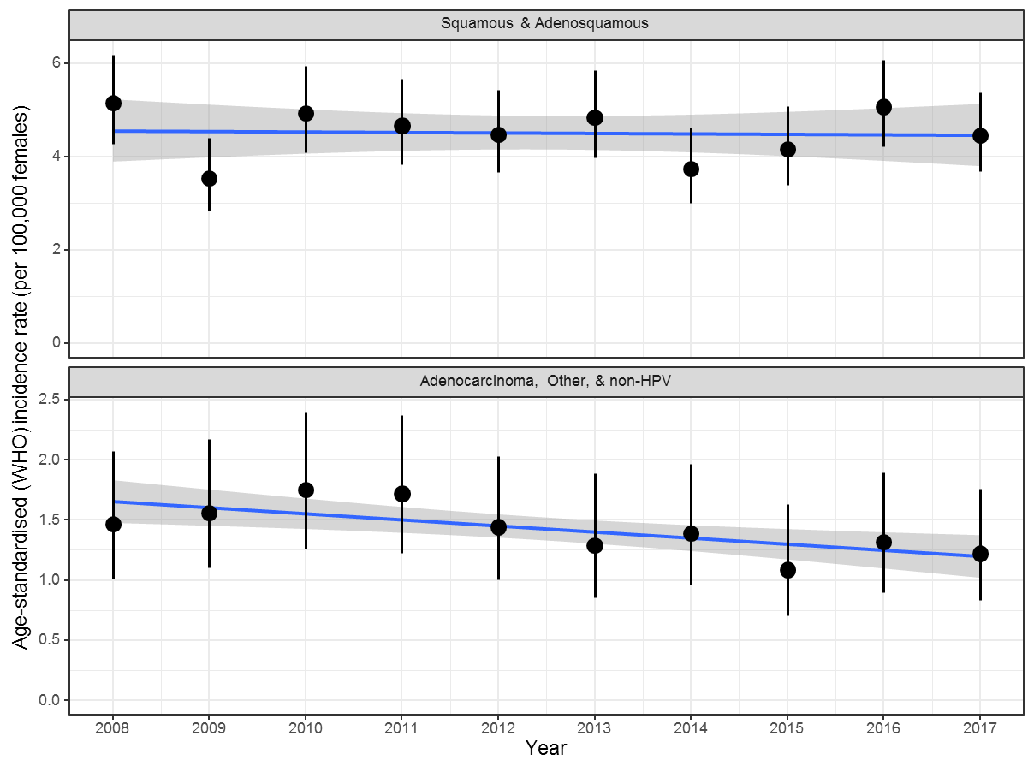
Supplementary Figure 1. Annual incidence of cervical cancer diagnosis by cancer type.

Supplementary Table 1 Aggregated list of morphology in confirmed cervical cancer registrations
Morphology in Cancer Registry | n
Squamous cell tumours and precursors | 562
Adenocarcinoma, endocervical or not otherwise specified | 116
Adenosquamous | 28
Adenocarcinoma, intestinal type | 10
Carcinoma, not otherwise specified | 5
Small cell neuroendocrine carcinoma, not otherwise specified | 5
Endometrioid adenocarcinoma, not otherwise specified | 4
Neuroendocrine carcinoma, not otherwise specified | 4
Adenosarcoma | 3
Carcinosarcoma, not otherwise specified | 2
Sarcoma, not otherwise specified | 2
Serous carcinoma | 2
Adenoid basal carcinoma | 1
Clear cell adenocarcinoma, not otherwise specified | 1
Embryonal rhabdomyosarcoma | 1
Lymphoepithelioma-like carcinoma | 1
TOTAL | 747

Supplementary Table 2 Incidence rates by year, age, NZDep2013 quintile, rurality, and Cancer Network for Māori and non-Māori
 |  | Maori |  |  |  | Non-Maori
Variable |  | n | IR raw | IR adj | 95% CI | n | IR raw | IR adj | 95% CI
Total | [2013,2017] | 162 | 8.8 | 8.1 | 6.9 to 9.6 | 577 | 5.8 | 4.4 | 4.0 to 4.8
Type | Squamous & Adenosquamous | 139 | 7.5 | 6.9 | 5.8 to 8.3 | 442 | 4.5 | 3.3 | 2.9 to 3.7
Type | Adenocarcinoma, Other, & non-HPV | 23 | 1.2 | 1.2 | 0.7 to 1.8 | 135 | 1.4 | 1.1 | 0.9 to 1.3
Year | 2013 | 33 | 9.3 | 8.0 | 5.4 to 11.6 | 117 | 6.1 | 5.0 | 4.0 to 6.2
Year | 2014 | 32 | 8.8 | 8.0 | 5.4 to 11.6 | 99 | 5.1 | 3.7 | 2.9 to 4.8
Year | 2015 | 33 | 8.9 | 8.8 | 5.9 to 12.5 | 103 | 5.2 | 3.8 | 3.0 to 4.8
Year | 2016 | 33 | 8.8 | 8.6 | 5.8 to 12.4 | 134 | 6.7 | 5.0 | 4.1 to 6.1
Year | 2017 | 31 | 8.1 | 7.4 | 5.0 to 10.8 | 124 | 6.1 | 4.4 | 3.6 to 5.5
Age | 0-9 | 0 | 0.0 |  | 0.0 to 1.0 | 0 | 0.0 |  | 0.0 to 0.3
Age | 10-19 | 0 | 0.0 |  | 0.0 to 1.1 | 0 | 0.0 |  | 0.0 to 0.3
Age | 20-29 | 22 | 7.6 |  | 5.0 to 11.5 | 60 | 4.5 |  | 3.5 to 5.8
Age | 30-39 | 38 | 17.4 |  | 12.7 to 23.8 | 141 | 11.2 |  | 9.5 to 13.2
Age | 40-49 | 45 | 20.2 |  | 15.1 to 27.0 | 138 | 9.9 |  | 8.3 to 11.6
Age | 50-59 | 32 | 17.2 |  | 12.2 to 24.3 | 90 | 6.6 |  | 5.4 to 8.1
Age | 60-69 | 15 | 13.8 |  | 8.4 to 22.8 | 69 | 6.3 |  | 4.9 to 7.9
Age | 70+ | 10 | 15.0 |  | 8.1 to 27.6 | 79 | 6.8 |  | 5.5 to 8.5
NZ_Dep | 1 | 11 | 42.6 | 39.7 | 19.4 to 77.2 | 143 | 35.3 | 31.8 | 25.8 to 39.1
NZ_Dep | 2 | 15 | 43.1 | 40.0 | 21.9 to 68.5 | 95 | 24.8 | 19.3 | 15.1 to 24.8
NZ_Dep | 3 | 18 | 36.3 | 32.2 | 18.6 to 52.8 | 122 | 34.0 | 25.8 | 20.9 to 31.9
NZ_Dep | 4 | 36 | 50.6 | 45.3 | 31.3 to 64.0 | 112 | 33.8 | 24.2 | 19.4 to 30.5
NZ_Dep | 5 | 81 | 63.1 | 58.9 | 46.3 to 74.2 | 98 | 36.7 | 26.5 | 20.9 to 33.7
UrbanArea | Main | 97 | 9.6 | 9.0 | 7.3 to 11.1 | 411 | 6.3 | 4.7 | 4.2 to 5.2
UrbanArea | Secondary | 15 | 14.4 | 13.1 | 7.2 to 22.5 | 46 | 9.5 | 7.2 | 4.9 to 10.5
UrbanArea | Minor | 32 | 16.4 | 15.3 | 10.2 to 22.2 | 40 | 6.3 | 4.9 | 3.2 to 7.5
UrbanArea | Rural Centre | 6 | 12.8 | 10.3 | 3.1 to 27.3 | 12 | 9.8 | 7.3 | 3.0 to 16.8
UrbanArea | Other Rural | 12 | 6.4 | 5.1 | 2.4 to 10.3 | 64 | 6.4 | 6.1 | 4.4 to 8.4
Cancer network | Northern | 44 | 7.2 | 6.9 | 5.0 to 9.5 | 198 | 5.1 | 3.6 | 3.1 to 4.2
Cancer network | Midland | 52 | 9.9 | 9.4 | 6.9 to 12.6 | 95 | 6.6 | 5.1 | 3.9 to 6.5
Cancer network | Central | 45 | 9.8 | 8.6 | 6.2 to 11.7 | 122 | 5.8 | 4.2 | 3.4 to 5.3
Cancer network | Southern | 21 | 8.4 | 7.7 | 4.7 to 12.2 | 161 | 6.5 | 5.6 | 4.6 to 6.7

Supplementary Table 3 Proportion of women with cervical cancer (n=747) who had had prior high risk HPV genotype testing
Time prior to diagnosis | Tested |  |  | High risk HPV positive |  |  |  | HR HPV (16/18)
 | n | % |  | n | % of tested | % Total |  | n
Within 3 years | 169 | 22.6% |  | 152 | 89.9% | 20.3% |  | 112
Within 5 years | 177 | 23.7% |  | 155 | 87.6% | 20.7% |  | 114
Any time | 180 | 24.1% |  | 158 | 87.8% | 21.2% |  | 114
Time prior to diagnosis | Tested |  |  | High risk HPV positive |  |  |  | HR HPV (16/18)
 | n | % |  | n | % of tested | % Total |  | n
6 months to 3.5 years | 54 | 7.2% |  | 44 | 81.5% | 5.9% |  | 29
6 months to 5.5 years | 61 | 8.2% |  | 47 | 77.0% | 6.3% |  | 31
Any time prior to 6 months | 64 | 8.6% |  | 54 | 84.4% | 7.2% |  | 32

Note: Percentages for high risk HPV types 16 and 18 have not been provided, as it was not clear when genotyping was or was not performed therefore a valid denominator could not be determined.

Note that the term ‘microinvasive carcinoma’ was used in the previous review to describe stage 1a lesions. The Lower Anogenital Squamous Terminology (LAST) Standardization Project for HPV-Associated Lesions: Background and Consensus Recommendations from the College of American Pathologists and the American Society for Colposcopy and Cervical Pathology now uses the term ‘superficially invasive’.

