BreastScreen Aotearoa
Workforce Development Strategy 2022 – 2032
Part 1 – Evidence for Change

This report (Report) has been produced independently by Fernhill Solutions Limited (Fernhill Solutions) on the request of Interim Health New Zealand (Client). The Report is to provide information for the Client and the wider Government as deemed appropriate by the Client. The views expressed in this Report are not necessarily the views of the Government or the Client.
The information, statements, statistics and commentary (together the ‘Information’) contained in this Report have been prepared by Fernhill Solutions from publicly available material and from discussions held with stakeholders. Fernhill Solutions does not express an opinion as to the accuracy or completeness of the information provided, the assumptions made by the parties that provided the information or any conclusions reached by those parties.
Fernhill Solutions has based this Report on information received or obtained, on the basis that such information is accurate and, where it is represented to Fernhill Solutions as such, complete. The Information contained in this Report has not been subject to an audit.

Contents
Background 4
Section 1 Introducing the strategy 5
The need for change 7
External drivers impacting the BSA workforce and screening rates 8
Equity and diversity in the workforce 9
The Action Plan 11
Section 2 Evidence for change 12
What we heard from key stakeholders 13
1. STRENGTHENING DIVERSITY AND INCLUSIVE PRACTICES ACROSS THE WORKFORCE 13
2. DEVELOPING RECRUITMENT AND RETENTION STRATEGIES 15
3. BUILDING FLEXIBLE, ATTRACTIVE AND SUSTAINABLE CAREER PATHWAYS 20
4. LOOKING TO THE WORKFORCE OF THE FUTURE 25
5. GOVERNANCE AND ENABLERS TO DRIVE CHANGE 26

Background
A growing population and changes proposed to BreastScreen Aotearoa’s service delivery are expected to increase demand for screening and assessment services over the next 10 years.
As the screening programme is nearing the capacity limits of current facilities, workforce and equipment, the Te Whatu Ora’s National Screening Unit (NSU) has recognised that it needs a clearly defined strategic vision for the development of the breast screening workforce - supported by a detailed action plan that fully describes and guides the initiatives required to achieve the future workforce needs of the BreastScreen Aotearoa programme.
In light of the challenges posed by the pandemic, developing workforce capability and capacity is now, more than ever, essential to ensure that women have equitable access to appropriate, mana-enhancing and timely screening services to reduce the severity and impacts of breast cancer which are disproportionately experienced by wāhine Māori and Pacific women.
Workforce strategies do not operate in a vacuum and BreastScreen Aotearoa exists within a complex environment whose influences are significant on both screening programme and workforce design. Each BreastScreen provider has a unique set of challenges to manage based on demographics, geographical challenges and professional needs.
History shows that workforce development initiatives need to be driven forward by a passionate, cross sector team who uphold and amplify the key principles of Te Tiriti o Waitangi. Without this, any current or future strategies will not create meaningful change.
Scope
The BreastScreen Aotearoa service includes a range of clinical and non-clinical roles. In creating this strategy, we’ve responded to the stories we heard, and feedback we received, from stakeholders across the sector and overlaid this with available research and data to amplify and address the roles and workforce characteristics of most concern. A number of the initiatives proposed in this strategy are intended to take a holistic effect across the workforce in its entirety.
The Support to Screening Service has been considered separately to this strategy and, therefore, is not addressed here.

Section 1 Introducing the strategy
The BreastScreen Aotearoa (BSA) workforce development strategy is a key driver of planning, building, enabling and equipping a workforce with the skills, behaviours and capabilities to meet present and future demand. At the heart of the BSA workforce development strategy is the need to build and sustain a professional, diverse and engaged workforce to ensure positive and mana-enhancing outcomes for wāhine in accessing and attending screening and, ultimately, a lower rate of breast cancer mortality.
The BSA workforce development strategy is driven by an overarching vision and goals that describe and bring to life the outcomes to be achieved. This is further supported by a detailed action plan which acts as the roadmap to drive change.
The vision…
The goals…
A sustainable and diverse breast screening workforce that is equipped and empowered to provide mana-enhancing services, and save women’s lives
Breast screening is a visible, attractive and flexible career pathway, enabled through best practice, Te Tiriti principles and long term planning.
Enablers (including governance, funding, IT, monitoring, quality assurance and data collection) are designed for long term sustainability and adaptability.

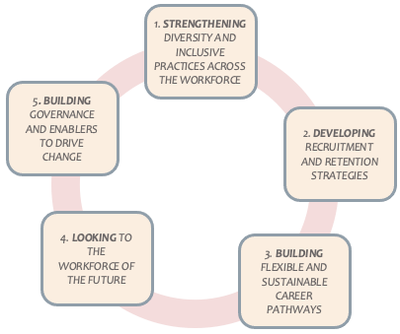

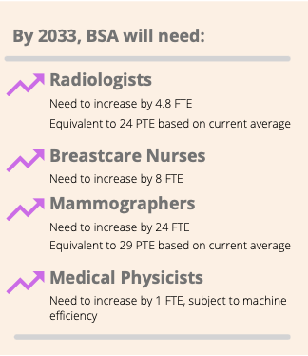
The need for change

The growing demand for breast screening services is creating a gap between workforce demand and supply which will need to be addressed over the next 10 years to ensure future population needs can be met.
In terms of future demand, the Breast Screening Projections 2023 – 2038 report produced for the National Screening Unit by Sense Partners reviewed the individual and cumulative impact on demand of a range of scenarios and concludes that meeting additional demand will mean new equipment and more workers across most BSA providers.
The numerical increases in workforce and equipment requirements appear modest in terms of FTE growth. However, given the specialist nature and costs of workforce and equipment, this resource expansion will require plans for training, recruitment and retention. This will be supported by equipment and facilities planning and sourcing in advance of any changes that are likely to increase demand for services, such as extending the upper age for screening to 74.
By 2033, screenings for:
Pacific women increase by 8,000

Māori women increase by 27,000

Asian women increase by 45,000

Combining population growth and equity targets
FTE growth has been calculated as growth from the current workforce base and doesn’t include an allowance for attrition or retirement rates over the next 10 years. As the BSA workforce has an older age profile, it’s likely that this will increase the requirement for additional workers over and above the predicted growth rate.
It should also be noted that the BSA workforce is predominantly part time and, therefore, one FTE will equate to a higher number of actual headcount workers.
Sense Partners calculated that by 2033 there would be a requirement for an additional 24 FTE mammographers and an additional 4.8 FTE radiologists.

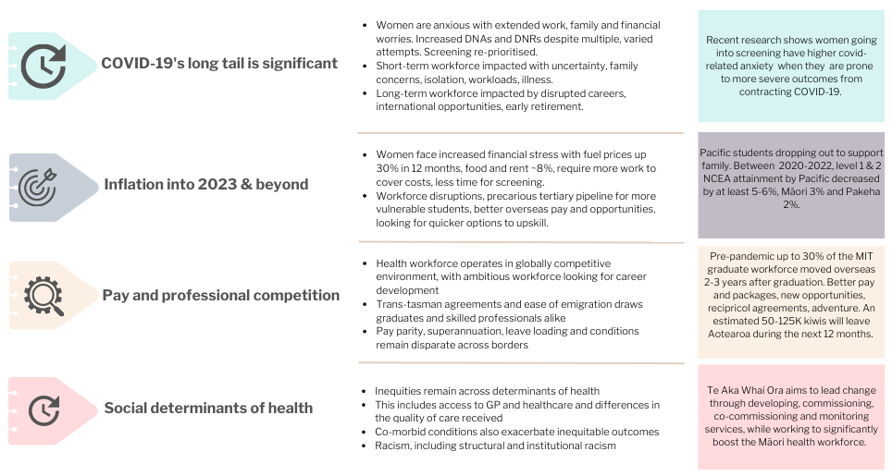
External drivers impacting the BSA workforce and screening rates

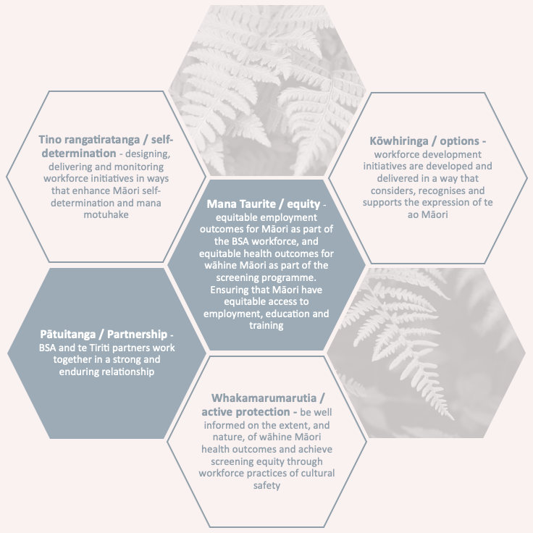
Equity and diversity in the workforce
Honouring Te Tiriti o Waitangi
This workforce development strategy recognises that honouring the special relationship with Māori under Te Tiriti o Waitangi is key to achieving the vision of the strategy, and fundamentally underpins pae ora (healthy futures) and equitable outcomes for Māori.
The strategy aims to strengthen, and put focus on, the important roles Māori already have in BreastScreen Aotearoa - as current and future members of the breast screening workforce, as providers of health services, as active participants in decision-making, and as priority users of the services. It is grounded in the guiding principles of Te Tiriti.
A Tiriti based system with shared values to guide workforce development, culture and behaviours will ultimately deliver better services to the wāhine of Aotearoa, and align with the goals of Te Whatu Ora and Te Aka Whai Ora.
Adapted from New Zealand Nursing Council
Building a diverse workforce

Achieving equitable outcomes in screening rates across Aotearoa relies largely on building equity and diversity into the workforce so that the workforce more accurately reflects the demographic of the population it serves. Both the Health and Disability Review, and Wai 2575 claim noted that the health system continues to underperform for Māori, and that the health and disability workforce has low Māori and Pacific representation, not only against population but particularly compared with need.
“Recruiting based on skills is a more equitable approach to employment. It removes economic and social barriers such as the prohibitive cost of tertiary education for many, and the historic barriers that resulted in the lower number of Māori who gain University Entrance.
Tertiary education is increasingly becoming a privilege only the middle to upper classes can afford. Given the barriers Māori face navigating the education system, a focus on skills will help to overcome these challenges.”
BERL; Nau Mai Te Ānamata | Tomorrow’s Skills (2022)
The medical benefits of a diverse workforce are well-known and evidence also suggests that a lack of cultural resonance between patients and health professionals may reduce patient satisfaction, access and adherence to treatments.. However, there has been an ongoing challenge in enabling career pathways that support a te ao Māori worldview.
Diversity is a key driver of innovation, fostering new ideas and ways of delivering services, and reflecting different needs in the community. This is evident in the BSA population recruitment teams, that engage directly with wāhine to invite them into the programme. For most BSA providers, recruiting staff with different cultural backgrounds is critical to successfully encouraging women into screening, particularly priority group women.
The established clinical career pathways into the BSA workforce follow a traditional, westernised, tertiary education model due to the existing prescribed registration pathways and the level of expertise and experience required. Attracting more Māori and Pacific students into these pathways, requires dedicated and sustained coordination across the school-university pipeline, and pro-equity approaches led by tertiary and polytechnic institutions.
COVID-19 has also changed the way young people view employment opportunities and careers. With low unemployment many young people, especially from lower socio-economic backgrounds, are looking for quick wins and ‘earn & learn’ options instead of long, educational pathways.
Building alternative training pipelines and career pathways for young people to access paid roles in the breast screening workforce, whilst simultaneously progressing their professional training and development, and being able to stay close to whānau and community support networks will help foster a home-grown and diverse workforce.

The Action Plan
Building a sustainable and diverse breast screening workforce that is equipped and empowered to provide mana-enhancing services, and save women’s lives
Goal | - Strengthening diversity and inclusive practices | - Developing recruitment and retention strategies | - Building flexible and sustainable career pathways | - Looking to the workforce of the future | - Building governance and enablers to drive change
Impact | A diverse, multi-cultural and multi-lingual clinical and non-clinical screening workforce to support all screening populations. | Attracting and retaining a healthy, diverse and well-designed workforce that supports ongoing personal and professional development. | Visible, attractive and flexible pathways into breast screening careers, which provide pro-equity opportunities and uphold the principles of Te Tiriti. | Frameworks and processes that support the sector to assess, evaluate and adopt innovative practices and technology. | Systems that support breast screening services are co-designed for long term sustainability and adaptability, to grow and develop with the services, and support the long term vision.
Actions | - Create and maintain an environment of cultural safety  - Ensure that BSA opt off strategy and tools are co-designed with a pro-equity approach  - Training and development of population recruitment teams  - Flexible and attractive career pathways  - Create and maintain effective workforce reporting and monitoring tools | - Recruitment initiatives  - International recruitment  - Recruitment incentives  - Retention initiatives  - Increase visibility of breast screening careers | - Develop stakeholder relationships  - Formalise role extension for mammographers  - Career pathways for mammographers  - Create opportunities for advanced practice for breastcare nurses  - Facilitate succession planning | - Create a framework for innovation  - Make best use of teleradiology  - Consider use of ultra-mobile units  - Keep informed on risk-based screening and AI technology  - Develop opt-off strategy  - Keep informed on health hubs | - Establish governance structure for workforce development  - Review National Process and Quality Standards  - Review funding for workforce development  - Establish workforce reporting  - Develop a change communication strategy  - Develop process evaluation framework

Section 2 Evidence for change

What we heard from key stakeholders
1. STRENGTHENING DIVERSITY AND INCLUSIVE PRACTICES ACROSS THE WORKFORCE
2. DEVELOPING RECRUITMENT AND RETENTION STRATEGIES
3. BUILDING FLEXIBLE AND SUSTAINABLE CAREER PATHWAYS
4. LOOKING TO THE WORKFORCE OF THE FUTURE
5. BUILDING GOVERNANCE AND ENABLERS TO DRIVE CHANGE
Hearing from the workforce and other key stakeholders and experts was critical in developing this strategy. Many hours of engagement, coupled with investigation of research literature, international practice and evaluations suggest strong evidence for change across the five goals.

STRENGTHENING DIVERSITY AND INCLUSIVE PRACTICES ACROSS THE WORKFORCE
We heard about the importance of teams that are resourced to deliver on the principles of te Tiriti to achieve equity targets and deliver mana-enhancing services. Equally, a diverse, multi-cultural and multi-lingual clinical and non-clinical screening workforce is needed to support all screening populations.
In general, the population recruitment teams (sometimes called recruitment and retention teams or equity teams) have high ethnic diversity, representing the cultures and languages of wāhine in their regions. These teams are making a real difference engaging with and reaching priority group women, striving to meet equity targets, and filling unoccupied or cancelled screening appointments. The also work closely with GPs, DHBs, iwi providers and Support to Screening providers to reach all possible wāhine. They are critical in building trust and removing barriers for wāhine entering screening.
However, they have suffered the impact of COVID-19, with increased workload on relatively low pay, and little room for career progression within BSA. There is strong competition for good call centre staff, and we heard team members have moved to new, better paying jobs outside of BSA. To achieve equity, these teams need support.
“Diversity within mammography? Everyone brings something different. It depends on the site. Culture is unique and individual, so you have to know how to negotiate the space and relationships.”
For the clinical and allied health workforce there is much lower ethnic diversity. This is representative of the broader health workforce, which is particularly low for Māori and Pacific representation compared to population and need. For many providers, increasing Māori staff was a long-term hope, given the lead time required through university, but they currently work with their existing staff to be culturally safe around clients.
“The team works during the day, they’ll get the list, they’ll email, phone, text … to try and do it. And send a referral to service providers. After that it’s after hours or weekend calling. The amount of work being done by those 2 people is huge. Currently paying them overtime to do after hours calling…. we need more support so I can hire more Māori and Pacific team people.”
We heard that improving diversity in the health workforce starts in school, and requires sustained school-university coordination, multiple pathways of opportunity into the health workforce, and pro-equity approaches led by school, tertiary and polytechnic institutions that challenge the “structures of opportunity in wider society”.
For example, deliberate policies, underpinned by theory, and enacted by Māori leadership with resourcing for Māori support staff have helped lift the percentage of Māori medical graduates from only 3-4% twenty years ago, to 20% today at Otago University.
Meeting the needs of the Asian population
The Asian population in New Zealand is a diverse group of ethnicities, cultures and languages. The most common cause of cancer death for Asians in NZ is lung cancer, followed by breast cancer and colorectal cancer. Currently, engagement with BSA screening is 59%.
The capacity modelling report shows that by 2033, with strong population growth, age extension and aiming for equitable engagement with the programme (72% of population), the number of screens for wāhine who identify with Asian ethnicity will grow to 80,000 per annum. Most of this growth will be in Auckland region. However, there is also expected to be a doubling of the Asian population in parts of the South Island.
An Asian Network report showed that racism and discrimination are important determinants of Asian health, particularly since the pandemic; and that funding for Asian-specific health projects remains challenging.
“I don’t know how they select students, but requirements are very high. So, this is difficult for some Māori students who tend to not do as well in high school. There is an interim science course, but the bar is set quite high.”
However, the availability of clinical placements is a limiting factor on entry into courses. For example, undergraduate MIT, which is a requirement for mammographers, is competitive and one university noted that of 150 applicants they only have placements for 40 in the course.
Demonstrating workforce cultural capability to enable a culturally safe environment is also essential to support wāhine entering screening for the first time, as well as influencing their decision to return. Providers felt that this was very important for ‘front of house’ staff - those recruiting women into the programme and welcoming women into the service for their screening appointments.
Being able to operate with this level of care, compassion and consideration of cultural and physical needs requires principles and values to be embedded within the workforce and organisation. Most providers trained their teams in cultural safety, including mammographers, but also felt this could be more consistent across the BSA workforce in general.
“Breast Care nurses are often the ones delivering news and supporting women through their journey. It would be fantastic to have more Māori Breast Care nurses, and more diversity in general, particularly with an ability to operate under Māori health models.”
From the workforce we heard a strong desire to achieve equity across population groups, but particularly for tangata whenua. There was frustration at not being able to achieve this in some regions which has been exacerbated by the continuing impact of COVID-19 on both the anxiety levels of wāhine and opportunities for them to engage with services. This is coupled with the impact of higher living costs and the practical barriers of time and cost to engage with screening services.
Reducing access barriers was important to lead providers, and although most could not offer financial incentives to attend (e.g. taxi vouchers), they tried to ensure wāhine were accessing services at a convenient time and location, to reduce travel and cost impacts.
This also included offering choice to wāhine Māori and Pacific women, in particular, to engage with services where they wanted. For example, some wāhine Māori were more comfortable accessing the mobile unit on a marae, whereas others wanted anonymity of another location.
We also heard of the importance of the screening environment and providing manaakitanga and wairuatanga both for staff, and wāhine and whānau. Suggestions included training for staff to support whānau to feel welcome and accommodated at screening clinics such as:
- Karakia before screening
- Whānau rooms
- Wāhine days
- Gown sizes that fit all women
- Kaiāwhina roles to welcome and navigate through screening process
- Practical support such as location of service delivery, childcare options, flexible hours of operation, and support with transport etc.
“There is little manaakitanga when you arrive at reception. From the moment you walk through the door it’s the whole picture of how they come in and how they’re greeted. Bringing down the anxiety level is half the battle.”

DEVELOPING RECRUITMENT AND RETENTION STRATEGIES
Cultural safety in the health workforce
The Medical Council of NZ, together with Te Oho Rata o Aotearoa (te ORA), released a report into the cultural safety and health equity of doctors practising in Aotearoa with the aim of achieving equity in healthcare through developing the practice of doctors and improving patient experience.
These findings can be applied to other sectors of the health workforce, including breast screening:
- Acknowledging systemic racism and privilege in the health system, with doctors reflecting on their own cultural views and biases to make positive change
- Removing structural barriers to engagement including short sessions, the focus on meeting immediate needs, and limited time to build relationships for re-engagement.
- Recognising wairuatanga to consider specific values and practices.
- Recognising the cultural loading that Māori doctors experience, including their out-of-work responsibilities to whānau, hapū, iwi and advisory roles
- Setting workforce goals to achieve equity
- Partnering with Māori in governance and strengthening participation
- Prioritising robust and consistent data collection to understand present state and track change
https://www.mcnz.org.nz/assets/Publications/Reports/f5c692d6b0/Cultural-Safety-Baseline-Data-Report-FINAL-September-2020.pdf
Good recruitment policies will ensure that well-trained staff − including Māori, Pacific and Asian practitioners - are attracted to an organisation. However, recruitment policies can only be effective when there is a pool of appropriately qualified workers to recruit from. Recruitment, therefore, relies on a well-functioning training and education system, and is closely linked to organisational development activities, in so far as healthy and well-designed work teams tend to attract staff.
Most providers we spoke to identified mammographers and radiologists as being the two mandatory roles that they had most difficulty recruiting and retaining. Both roles require significant training and expertise to undertake, with extra BSA requirements to ensure that quality standards are maintained.
The modelling report shows that by 2033, there will be a need for an additional 24 FTE mammographers, and 5 new FTE radiologists without even counting workforce attrition through retirement, maternity leave, international travel, and resignation.
Currently, most providers are recruiting in one form or another, which is both costly and time consuming. Some providers run a continual advert for radiographers / mammographers. We heard of three main barriers to recruitment:
- Availability – limited domestic pool of radiographers and radiologists meant recruiting workforce within Aotearoa quite often means taking staff from another provider.
- Immigration process –can be time consuming and was especially impacted by COVID-19. Several radiologists during this time changed their mind or were offered work elsewhere.
- Registration and supervision process – the process, particularly for international radiologists, can be obstructive and time consuming. For mammographers, they can be rapidly approved, but some international recruits may require an extensive supervision plan.
“To help ease that international process from a radiologist perspective it’s the medical council and the process there, especially in the middle of a pandemic. It was just a struggle to get people into the country and get them approved. Very slow.”
BreastScreen Aotearoa

Starting salary - $57k

5 weeks leave

3% Kiwisaver

Fair and equitable remuneration is important. We heard about the frustration of low remuneration within the New Zealand health workforce and the loss of homegrown health professionals to higher paying countries, particularly the UK and Australia. For radiologists, the highest New Zealand salary grade is currently lower than the lowest Australian salary grade.
BreastScreen
Queensland

Starting salary - $77k

4 weeks leave
17.5% leave loading

12.5% super

Higher salaries in Australia, combined with the ease with which health professionals can transfer to Australian roles, creates an appealing opportunity for our locally trained radiologists to re-locate.
However, this issue isn’t unique to the breast screening workforce and is a whole of health sector issue that places stress on an already stretched and frustrated system, with around 100,000 health workers currently involved in pay disputes.
Comparison of job adverts for mammographers, April 2022
Workforce retention is more than financial benefits. Until progress is made on establishing a homegrown workforce, a large segment of the BSA workforce continues to operate in a highly competitive global recruitment environment with attractive international remuneration and lifestyle packages. Reciprocal agreements make cross-border transitions, particularly trans-Tasman work, relatively easy and accessible for graduates and experienced staff alike.
However, we found that there are a range of other factors that contributed to workforce retention beyond pay, particularly for MITs. These include:
- Conditions of employment
- Fair and appropriate remuneration, based on qualifications (remuneration increases by one step after completing PGCert)
- Study support for PGCert (most providers paid for the PGCert but the pandemic placed pressure on their ability to enable time-off-work to study)
- Opportunities for career promotion or professional development
- Ability to undertake role extension, particularly for mammographers, and a consistent approach to role extension across all providers
- Innovative practices and access to work with new technology
- Clinical standards that support flexible work practice
- Flexibility at work, and the opportunity to work part-time within set hours
- Ability to work across modalities or retain general scope of practice to keep options open
- Opportunities to pursue other modalities such as breast sonography
- Opportunities for secondments to other locations
- Relocation costs and other incentives
In 2004, BSA funded relocation costs for a short period of time to boost recruitment. This includes $6K for mammographers, and $12K for radiologists. Some DHBs continue to provide small relocation costs however the amount has not changed much over 20 years.
Stakeholders also told us that it was difficult to recruit advanced practice mammographers from the UK when they discover that they can’t practice at that level in Aotearoa.
Breastcare nurses we spoke with had undertaken advanced study and often had at least five years’ experience. They work closely with wāhine across their screening and assessment journey, to support them and their whānau to make informed choices. Being supported in their ongoing professional development remained important:
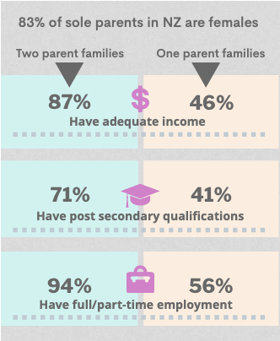
“This role needs nurses that have nursing skills and experiences from other areas of nursing and requires specialised training and education in the field of breast cancer nursing … It’s extremely important that the breast nurses are able to attend local and international conferences to keep updated with the current trends in Breast Cancer and treatments.”
Gender can impact career pathways and options. Due to the nature of screening - the trust required to recruit wāhine into the service and the close contact in delivering the service, the BSA workforce is predominantly female, and the mammography workforce is currently 100% female. Therefore, recruitment and retention are impacted more by family and childrearing choices than in gender balanced workforces. Research shows this continues to impact females more so than other genders (Hostetler et al 2007, Moen et al 2002).
We heard that although the workforce remains positive and works hard, COVID-19 continues to apply significant pressure in terms of home isolation and caring duties, and stress of increased workload.
This reflects a global survey of 5,000 women across 10 countries showing many women are burned out at having to manage pandemic-increased workloads and home responsibilities. 53% of women surveyed said their stress levels are higher than they were a year ago, and almost half feel burned out. One-third have taken time off work for their wellbeing and approximately 40% were looking for a new role due to burnout. For those who had already left, they cited “lack of opportunity to advance”.
Attracting a young and aspiring workforce. We heard that although international recruitment is a necessity at the moment, growing the domestic workforce for the longer term is essential. Historically it has been difficult to recruit younger graduates into the BSA workforce, particularly mammography. Reasons include visibility and perception of mammography as a career option, competition with other modalities and technology, and wanting to travel.
“Mammography isn’t an interesting career; there’s no variety and no technology advancement. It still uses old technology compared to new, ‘sexier’ tech like MRI. Therefore, mammographers often do split roles – 2 days on BSA then the rest of the time on other modalities.”
Although some providers have benefitted from closed borders and recruiting younger graduates, with the 2022 re-opening there is an expectation that similar patterns of travel as 2019 will resume. This shows that by their 4th year out of university, almost 30% of MIT graduates were working overseas pursuing more diverse opportunities and better rates of pay.
Interestingly, a 2016 report showed that most radiologists who trained in Aotearoa remain here. Nearly two-thirds of those surveyed were New Zealand medical graduates, and three-quarters had undertaken their radiology training here, mainly benefitting from increased training places. We heard that training spots for radiologists have increased from 20 to 25 per year. However, modelling completed by the Health Workforce directorate suggests that the number of training places will need to increase to 50 per annum over the next 10 years to reduce the reliance on overseas trained radiologists. Increasing funding for BSA fellowships in radiology will be required to grow a domestic workforce.
The importance of BSA fellowships. Radiologists we spoke with who had undertaken, or supervised, BSA fellowships for radiologists spoke highly of the programme and quality of training, noting modality training was part and parcel of being a radiologist and the length of time was not a hindrance.
Although scholarships that are partially funded by BSA are available, there are times that they are difficult to fill. Some clinical leads spoke of the misconception that BSA work is only screen reading, or not very people focused. To counter this, some clinical directors, who had the opportunity, ensured strong engagement with registrars who may consider BSA fellowships in the future.
Visibility of BSA workforce at a school-graduate level. We heard from all sections of the workforce that BSA work was relatively hidden as an option during their undergraduate training. Mammographers noted that they had a few weeks of introductory mammography during their undergraduate degree, but those who were interested in pursuing the career were often motivated by personal or whānau reasons, and/or a strong interest in women’s health.
“Students always come through for a day. They have a quota to do 10 mammograms for their logbook. That’s quite a lot – because a mammogram can take 15 minutes - and it would be more fun to show them some cool stuff - like a 2-hour procedure with needles and stuff.”
Within the existing structure, providers told us that there were two main ways that they try to raise awareness of mammography among MIT students - enabling a positive, visible and engaging undergraduate experience by welcoming students on-site for their clinical placement; or going into the universities to talk about mammography. This was undertaken in their own time. One lecturer we spoke with noted that during interviews for clinical placement, very few to no prospective students mentioned mammography as a pathway.
“Applicants have a friend or whānau or neighbour in the profession. The term radiographer is not so well known, and it’s hard to pinpoint what they do, how to get into the profession.”
Some nurses we spoke with had a similar experience and found out about the specialisation by chance, either seeing an advertisement or hearing via colleagues, but not via their nursing training or practice.
Attracting graduates into Aotearoa’s workforce. We know many health graduates move internationally for better pay and opportunities. Table 1 shows a comparison of graduate supports to encourage health graduates to move to regional locations, or specialise in mammography for example, and shows initiatives that could be considered in Aotearoa. Recruiting to more regional areas, or areas with high mobile unit usage remains problematic. Some providers make use of locum resources to fill MIT vacancies. This has both positives (enthusiasm, engagement) and negatives (transience).
“I’m happy to train new grads but they’re hard to recruit. I always say when they’re on placement, you can come back – but they never come back.”

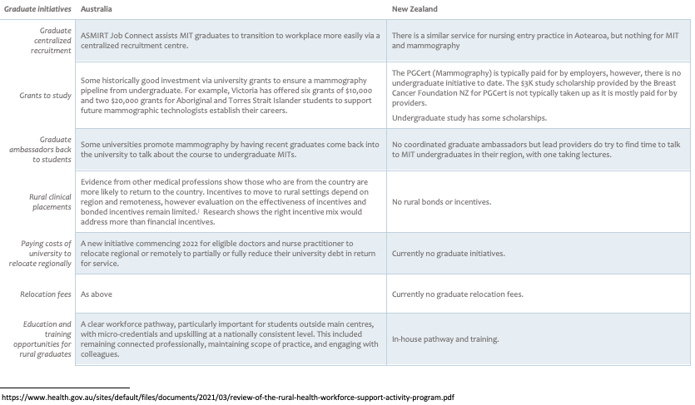
Table 1: Comparison of Graduate Supports

BUILDING FLEXIBLE, ATTRACTIVE AND SUSTAINABLE CAREER PATHWAYS
There are three main outcomes of enabling flexible and sustainable career pathways: it increases diversity, helps retain a valuable workforce, and it increases engagement and wellbeing at work. We heard that the main area where this could be valuable is the mammography workforce, with years of international experience available to inform an approach.
Diversifying entry into mammography. For domestic MIT graduates, there is typically one pathway into mammography (after graduating and receiving a practising certificate) and this is to be accepted into a role and undertake postgraduate study. With the two-year PGCert course being reduced to one year in 2023, some of the concerns we heard regarding length of study will be alleviated.
However, internationally there are other opportunities to enter mammography – both as an assistant practitioner, or via post-graduate training coming from another health-related field.
The assistant practitioner role is an initiative across the health workforce in the UK, similar to enrolled nurses in Aotearoa, in which quality training gives a limited scope of practice for those who do not wish to undertake a full degree qualification. It was part of a broader health workforce restructure aimed at tackling recruitment and retention challenges across the health workforce, and defining practice by skills and competencies, that could alleviate pressure on cancer services.
We heard that being innovative with the structure of a shorter, and focused, mammography-only vocational course could work for Aotearoa for both breast screening, and other health-related professions. However, care would have to be taken with scope of practice, and integration of the role within the workforce. Some expressed hesitation but were willing to consider something different.
“There are some mammographers who just do screening. If you had 2 to 4 people in your workforce that just did this, a higher proportion of the MIT team could be doing more advanced work. It works elsewhere so it’s definitely possible.”
We heard that such a pathway may support career pipeline options for Māori and Pacific students, for students who were unable to afford the time out of work to pursue years of full-time study, and for students who have childcare responsibilities, particularly sole parents.
Such a course has also been a career pathway in the UK for imaging assistants and other non-clinical staff to enter mammography while still being able to work.
Evidence from the UK looking at various assistant practitioner roles (from mammography to nursing and dementia care) highlighted the need for meticulous planning, and clear parameters to their scope of work within health settings, both to support the safety of assistant practitioners and give confidence to their work colleagues. Earlier evaluations across the assistant practitioner role found that:
Case Study 1: Role extension in Aotearoa
During our interviews, we spoke with many mammographers who were keenly interested in the UK model of role extension as an incentive to remain in their work. Some expressed disappointment that they couldn’t practice role extension in Aotearoa, and we heard of UK recruits who had declined NZ positions due to no advanced practice being available. As a lead provider in another part of the country noted:
“The team really does want role extension and to take more ownership of biopsies but there is a reluctance among the radiologists.”
Canterbury Breastcare (CBC), however, has a well-established role extension for mammographers and, since 2014, has trained a small number of mammographers to undertake stereotactic biopsy. The purpose of the extension was to improve workflow for radiologists and assist with staff retention.
This practice was originally set up by Clinical Director, Catherine Brown, who had come from the UK with its established advanced practice. By 2015, BSA had agreed to role extension as there was nothing in the quality standards to prevent well-supervised and well-trained mammographers from undertaking extra responsibilities.
“We set up protocols and guidelines. We ran a pilot with our MRTs and did an audit to make sure it stands up. We ran the proposals through the MRTB. As a Fellow, we were regularly here until 7pm, because you’d have a big assessment day, and you’d have to stay until all the biopsies are done. And now, some of those, the stereotactic biopsies, we get the radiographer starting them at 1pm, and concurrently we get going with some of the others, we’re finished off by 5pm.”
At CBC role extension is firmly established and continues to grow. There are plans to extend the practice to Dunedin and train a mammographer there in stereotactic biopsies. And in 2021, trained mammographers at CBC had commenced doing supervised vacuum incisions, performing simple incisions of a certain size to save hospital admissions.
However, despite almost ten years, role extension remains only single site-specific in Aotearoa.

- Assistant Practitioners were valuable to the registered workforce, enabling greater flexibility, while giving registered staff opportunities to extend their practice.
- Assistant Practitioners needed to be seen not as a “cost cutting” exercise but as beneficial to existing practices.
- Levels of supervision need to be clearly established and remunerated, both financial and time to undertake.
More recently, the UK introduced apprenticeship Associate Mammographer roles, which included a combination of 12-18 months supervised on-the-job limited practice and 20% study, giving a similar qualification to the Assistant Practitioner role. This role is funded nationally through a levy which is distributed across providers. A short case study celebrating one of the initial graduates (who started as a chaperone in the breast unit) noted the importance of mentoring, supervision, and organisational structure to the successful integration of the role.
Empowering mammographers to develop advanced practice (role extension). We heard from mammographers, radiologists, and students about the importance of having a career pathway, and how for mammographers this was limited with lack of academic pathways to be recognised as specialist radiographers, leading to advanced practice.
“Mammography is very demanding and in order to attract new grads, or staff from overseas, we need to be able to offer more in the way of career progression, wider range of skills and a salary scale to match.”
“There will be some who do not wish to extend their career, but we also need mammographers who are skilled and knowledgeable to screen and assess our clients.”
“Greater variety, interest and recognition definitely helps, as does some flexibility of hours that are available for staff to meet family and work/life balance, which seems even more important in our pandemic and post-pandemic world.”
Internationally, with UK leading the change over the past 20 years, mammographers have been able to:
- Upskill in interventional procedures such as stereotactic biopsies
- Upskill in breast ultrasound in a more recognised and consistent way
- Upskill in first screen readings of mammography (very common)
- Have opportunities to academically specialise and contribute to the research base
Leadership and higher research opportunities were also an important component of advanced practice.
We heard that in Aotearoa we have the only mammographers in Australasia who are undertaking advanced practice in stereotactic biopsies (see Case Study 1), but many others would be interested with the right training and supervision.
“I would love to see role extension happen. I do know some other departments where they are doing the biopsies themselves. But in our department no, we still have the radiologists present. And we don’t see that changing.”
Evidence from the UK shows that advanced practice has a long history in breast screening and diagnostic services to support demand, and increase workforce engagement and retention, with advanced practice first piloted in breast imaging in 1999-2001. Although the role has evolved, advanced partitioners demonstrate expertise in their scope of practice, and undertake specialised post graduate study. A systematic review of advanced practice noted four themes to enable success:
- Right multidisciplinary workforce balance to ensure teams functioned to their highest potential.
- Clarity of role to reduce ambiguity and define scope of practice.
- Remove barriers to training including financial barriers, location barriers, and radiologist engagement, and providing a career progression framework.
- Embed and sustain advanced practice at an organisational level.
Many studies found one of the main barriers to advanced practice is professional reticence. For example, radiologists being protective of their roles or not seeing a need to enable advanced practice. We heard in Aotearoa that for advance practice to succeed, the enthusiastic and willing engagement of radiologists to train and supervise, and relinquish some of their role at times, was critical to progress. Some radiologists did not see a role for advanced practice in BSA, whereas others enthusiastically engaged with its benefits – both in terms of workload and retention.
Is it successful in Aotearoa and why? Currently there are five mammographers practising role extension in Canterbury Breastcare (CBC). All were internal recruits, who had practised mammography for a minimum of five years. The training was in-house, led by radiologists, with established and approved training and supervision protocols.
For mammographers who practice role extension there is strong job satisfaction and unwillingness to leave their role – knowing that role extension was not available elsewhere. By mixing BSA screening and assessment with role extension they felt they had great variety of practice and engagement while maintaining quality standards. For radiologists there is time to perform other duties and reduce pressure on workflow.
There were also concerns too that need to be balanced. Radiologists did not want to lose their skills and needed to be able to train registrars, so they need to continue to undertake regular biopsies to maintain standards.
“A good mix is about 10%-15% of mammography staff undertaking advanced practice – we don’t want anyone to lose their skills. What it requires is a small, skilled team, with a core of 1 to 2 radiologists supervising training, and the others who are receptive and provide feedback.”
Role extension can become a reality. Practitioners told us that three key things need to happen to make role extension a reality in Aotearoa:
- Responsive to new ideas. In particular, radiologists seeing the value to both their work practice, and the work engagement of mammographers.
- Consistent, formalised study pathways. A modular approach to role extension training through educational institutions, with modules on biopsies, breast ultrasound, or image reading, for example.
- Recognised pay grades. Comparable pay grades to the work and responsibilities being undertaken.
Resourcing to ensure wellbeing. There was a strong ethos of care across the workforce, with lead providers and clinical directors working hard to maintain staff wellbeing under intense pressures of pandemic staffing, and negative media about their screening levels.
“We are a very small, specialised work force. We are extremely short staffed and need to look after the staff we have.”
Although many lead providers were aware of the impact on work-life balance of postgraduate study on their mammographers, they were unable to give any length of time away from their workload given the pressures of screening numbers and staff illness.
Given the strain of undertaking mammography on their bodies, other providers supported their mammography staff through free massages which were well received or a few hours every month for training or professional activities.
“At least 25 days you’re doing the same movement. In our department we get a little voucher to get a massage once a month – that’s quite helpful. We negotiate that every so often when prices go up as it’s quite expensive.”
The impact of retirement and succession planning for specialised workforce. Although much of the BSA workforce is also nearing retirement, it is difficult to quantify given limited BSA workforce data. The RANZCR workforce survey (2016) showed that although radiologists have extended their retirement age, a staggering one third are approaching retirement in the next ten years.
Similarly, since the removal of Medical Physicists from the DHBs in the early 2000s, there are only 6 private practising Medical Physicists in Aotearoa to ensure quality standards are being met across the BSA and other cancer programmes. However, they operate without consistent or government-funded succession planning (see Case Study 2).
Lack of workforce data at a national level is making a view of the retirement patterns difficult for Mammographers and Breastcare Nurses in particularly. However, anecdotally nearly every provider had a Mammographer nearing retirement or considering maternity, or other leave, in the next five years.
Case study 2: Limited Medical Physicist succession planning in Aotearoa poses significant risks
Succession planning is a difficult balance and remains unfunded by the Government. There are 6 diagnostic Medical Physicists in Aotearoa who operate privately to ensure the safe and effective operation of screening equipment. Some have reached or are nearing retirement age. However, without a secure, sustainable succession plan there is medium to long term risk to screening services.
Succession planning is fraught. There have been no new diagnostic Medical Physicists in Aotearoa since 2011. There are very few diagnostic imaging Medical Physicists who operate privately in Australia and United Kingdom, and no vacancies in the DHBs, and, therefore, no training schedule or clinical placements. This makes recruiting internationally difficult, as it requires a Medical Physicist with a mix of regional knowledge, entrepreneurship to build a customer base, and in particular, BSA specific training requirements.
One Medical Physicist who is looking to develop a succession plan for a graduate from the MSc Medical Physics programme is Susan who operates Gamma Health on the South Island. With no response from Health Workforce NZ, Susan started to develop her own plan, at her own expense.
Creating a succession pathway
There are only a few routes into becoming a Medical Physicist in Australia and New Zealand. The Australasian College of Physical Scientists and Engineers in Medicine (ACPSEM) runs the Training Education and Assessment team (TEAP) scheme which combines post-graduate study with full-time competency-based training and assessment in an accredited department. There are currently three disciplines:
- Radiation Oncology Medical Physics (ROMP) – mainly employed by DHBs with few vacancies (funding from Health Workforce NZ to train)
- Diagnostic Imaging Medical Physics (DIMP) – mainly private (no funding from Health Workforce NZ to train)
- Radiopharmaceutical Science (RPS)
A standard TEAP takes 3-5 years to complete after completing a specific degree.
Never done before with a private contractor
After contacting ACPSEM, Susan was told to set up a cooperative of specialists (which ended up being herself and two others who she had known through previous work), establish the contract, and apply to ACPSEM to be awarded a one-year provisional licence to train. All exams still go through the professional body. Her trainee will become a diagnostic registrar and commence his three-year training.
As this has never been done before the exact out-of-pocket costs remain unknown yet will be significant. Susan must pay the cooperative specialists for their training, factor in her own time as supervisor, and a registrar salary. This is the start of the costs for the three years training (excluding equipment). As a private contractor, contracted per machine, there are also travel costs and other expenses. This is another cost to training.
The BSA component is once again another quality standard for diagnostic Medical Physicist to achieve. To achieve certification the registrar would have to be fully qualified as a diagnostic Medical Physicist, despite knowing how to service the mammography machines from prior work. The screening work is identical to the work he has previously been undertaking, but he will need to be supervised.
Succession planning
In order to support succession planning for the BSA programme, there would be opportunities for Te Whatu Ora to fund or partially fund training places for registrars. Engaging to evaluate initiatives such as the one run by Gamma Health would help BSA understand costs and support required to ensure long-term planning for its screening services and minimise workforce gaps and risks that have huge significance to the BSA programme.

LOOKING TO THE WORKFORCE OF THE FUTURE
Traditional methods of determining workforce shortages tend to assume that the structure of the workforce is set, and don’t consider the potential impact of role substitution or extension, the introduction of new roles and how innovation and developing technologies may change work practices.
In future, the constraints on labour supply in New Zealand, and globally, will necessitate a much greater focus on improving the performance and productivity of the available workforce.
The use of AI and teleradiology. Some providers use teleradiology to access required radiologist resource. Teleradiology is currently only used for BSA screen reading, and only provided by New Zealand-based radiologists. Teleradiology was proving a good way of sharing workload for some providers, especially when covering pandemic-related workforce challenges.
Interestingly, some diagnostic radiology outside the BSA programme is being undertaken for international organisations, including in Australia and the UK, to enable 24-hour services for health systems. A recent ad called for NZ-based radiologists who had UK certification to work from home for a global radiologist company providing 24 hours service. No BSA screen reading by internationally based radiologists is permitted.
We also heard that although AI is progressing it still is not advanced or nuanced enough to be introduced into the screening programme. However, AI is expected to impact screen reading in the future but more likely in conjunction with other changes to mammography, for example risk-based screening or other forms of testing. Some radiologists did think AI could, in the short term, have an important role in workflow management including sorting, prioritising, report analysis and risk stratification.
Risk-based screening. We heard a little about risk-based screening, but most interviewees felt it was a long time away for Aotearoa given the levels of infrastructure and demands on the current system. There is a significant amount of literature on risk-based screening, yet approaches are variable internationally. For example, some used demographic risk-base and prior screening, others genetic risk-base. Risk-stratified screening options require investment in technology including MRI, tomosynthesis, and automated ultrasound as well as risk-based interventions. There remain challenges around social acceptability of risk-based screening across population.
Screening hubs. Some providers had thought about the value of community screening hubs where wāhine could attend a clinic and get all their screening completed in a day, including breast and cervical. This may be beneficial to those who have to travel long distances to access screening services.
“Perhaps the Māori Health Authority and Health NZ will support a combined screening approach and a focus on ‘Healthy Hubs’; including a possible move to put all screening on a two-yearly cycle, so people can come in and have everything done once. At present it is difficult to combine as the services as they are not set up the same and there is a bit of a piecemeal approach – if we could somehow line them up then screening may be more successful.”
Opt-off strategies. There were mixed feelings about the opt-off strategies. Some providers felt they were already doing everything possible to reach women, and worked closely across GPs, PHOs, iwi and other social service providers to try and capture all the women in their region. They were unsure where the information would be sourced, and how this would capture women who were not on GP roles. Many found value in the click PHO data matches, but as one provider noted, this did not account for wāhine who had moved, or whose details were incorrect.
“Opt off will be a less clunky tool but will it increase coverage? Unlikely. All the processes I’ve described to you…we find more women eventually. Currently 30-40% of contact information is wrong in the PHO lists we get.”
Age-extension and its impact. All providers were aware that age extension would increase their workload significantly and many had started to plan for this population increase.
Ultra-mobile units. We heard from the Breast Cancer Foundation of the potential piloting of ultra-mobile units to complement existing fixed and mobile screening services, extend reach, and deliver more equitable screening rates particularly for Māori, and rural locations. Piloting an ultra-mobile unit in Aotearoa could deliver a comprehensive evaluation of this kind of technology to reach equity targets, and also trial a workforce model that includes advanced practice mammographer, and real-time teleradiology. The use of teleradiology for immediate assessment and feedback has been shown to be efficient in US trials, with most women willing to wait up to 45 minutes for their results.

GOVERNANCE AND ENABLERS TO DRIVE CHANGE
Most providers that we spoke to weren’t aware of previous workforce development strategies, plans and initiatives over the last 20 years. Most thought that any initiatives that had been implemented over that period had likely been discontinued or shelved due to staff turnover.
Having strong, focused governance to drive BSA initiatives will help deliver change required for next ten years. We heard of several enablers that were critical to this change.
Adequate resourcing to ensure changes are made. We heard that to ensure safety and wellbeing of workforce while implementing any new developments, adequate resourcing was required within BSA at a governance level to drive change. This included aligning any changes with broader NSU initiatives to ensure Māori governance and partnership; and aligning core principles and vision to broader workforce development initiatives.
The impact of Te Whatu Ora and Te Aka Whai Ora on BSA is unknown. On 1 July 2022, the 20 existing DHBs were disestablished, and their functions merged into Health New Zealand, which will lead the day-to-day running of the health system for the whole country. Te Whatu Ora has also taken over the operational functions of the Ministry of Health, such as managing national contracts.
A new statutory entity, Te Aka Whai Ora, will develop strategy, policy, monitoring and commissioning to improve Māori Health outcomes.
Stakeholders that we spoke to didn’t have a comprehensive understanding of how these new organisations would impact on their day-to-day operations both in the short and longer term.
One of the key workstreams within Te Whatu Ora is the development of the NZ Health Charter, which will set out the shared values, standards, expectations and ways of working within the national health system. A key focus is on the wellbeing of staff and being safe in their work environment.
Governance and partnership with Māori. We heard that NSU could better resource, develop and align with te Tiriti and work is underway to achieve co-governance structures to challenge systemic racism and ensure all screening services deliver for Māori. And that, in turn, this is also applied to BSA and other screening services.
A step toward this approach was developing an NSU operating model that is underpinned by te Tiriti and equity. This includes co-design and development across the commissioning cycle (from service design through to monitoring and evaluation).
Quality standards are important, but they also need to be flexible. Stakeholders agree that the BSA National Policy and Quality Standards (NPQS) ensure a high standard of breast screening across Aotearoa.
However, lead providers have also found a tension between operating in accordance with the NPQS and ensuring a sustainable and well supported workforce that is able to meet demand.
“...with mammography, and in the screening programme, we are always auditing our own work. Sometimes it can be soul destroying.”
For radiologists, some wondered whether the extra requirements to be able to read BSA screens was a barrier to recruitment, whereas some radiologists we spoke with assured us that the high standards needed in screen reading were best practice, and necessary.
The NPQS should have the flexibility to support innovative resourcing models (including casual or locum workers, and working across regions) in BSA accredited roles, particularly the mammographer and radiologist roles.
Balancing client need with workforce flexibility. We heard from providers that one important way of reaching priority group women is to offer a more flexible approach to screening – including screening after hours, at weekends and at locations closer and more accessible for their target client cohort. However, this has an impact on the rostering of key BSA staff and there may not be the ability within current workforce capacity, and also within employment and rostering arrangements to accommodate such flexibility.
Collection and use of data. The impact of COVID-19 has been difficult to measure and communicate. It was felt immediately by lead providers as screening services were shut down completely during the first level 4 lockdown of 2020. This, and subsequent lockdowns and level changes through 2020 and 2021, meant a delay in screening for some women and created a sense of nervousness around attending screening appointments, especially for those priority group women who are also more vulnerable to COVID-19.
Providers told us that they were working hard to return to pre-pandemic screening levels and were focusing on encouraging priority group women back into the service.
Most providers now feel that they have ‘caught up’ on the backlog of screening to a certain extent. The exceptions are areas which were subject to more stringent, and longer, lockdowns, or had multiple challenges.
We also found that people’s perceptions and interpretation of the impact of COVID-19 differed, and this has created a lack of clarity around the terminology used. A range of terms such as ‘backlog’, ‘waitlist’ and ‘delays’ are used when talking about the impact of the pandemic and are often not fully defined, explained or quantified.
It’s difficult to accurately quantify or understand the workforce. The ways in which BSA services are resourced means that it’s hard for providers to accurately quantify their workforce in terms of FTE resource. Use of teleradiology, private subcontractors and DHB resources all add to the challenge.
There is no national workforce survey that considers demographics, cultural competencies, and qualifications. Sourcing workforce information for this report was time consuming and not always accurate, needing to be triple checked. Accurate oversight of the national workforce is critical to recruitment and retention practices, and long-term planning.
Some stakeholders suggested that alternative ways of measuring workforce capacity requirements should also be considered.
Providers noted that streamlining and making reporting more effective would benefit everyone, including NSU.
“It would be great to have one report for all screening services, because we are required to provide a lot of data (although not all providers offer all services). It would be more helpful to have something that asked us what things we were doing to achieve our targets and what are our equity plans. Currently it’s an auditing process, rather than a process that focuses on what’s going on. They just want us to provide data and it’s not consistent (e.g. some services, like bowel have delayed reporting).”

In this report, we respectfully use the terms ‘person’, ‘woman’, ‘women’ and ‘wāhine’ as representing all people with breasts who are entitled to mammographic screening. This includes transgender and non-binary people.
Shea Pita & Associates; Me aro ki te hā o Hinehuone – A National Evaluation of Breast and Cervical Screening Support Services (2021)
Gender analysis shows that 91% of sole parents receiving support are women, and more wāhine Māori receive support than Pākehā, impacting affordability of study, and balancing work and education.
Note the terminology “foundation degree” differs between the UK and Aotearoa
There is discussion around the use of terms “advanced practice” and “role extension”. Advanced practice in the UK is clearly structured pathway that is broader than role extension. However, role extension is a critical component of advanced practice.
The UK has a four-tier structure, including assistant practitioner, practitioner, advanced practitioner and consultant practitioner with qualifications and experience to clearly delineate roles.
At the time of reporting (2016) this was 10-15 years.
Curtis E, Wikaire E, Stokes K. and Reid, P.. Addressing indigenous health workforce inequities: A literature review exploring ‘best’ practice for recruitment into tertiary health programmes. International Journal for Equity in Health. (2012) 11:1, 13. Crampton P, Weaver N, and Howard A. Holding a mirror to society? Progression towards achieving better sociodemographic representation among the University of Otago’s health professional students. New Zealand Medical Journal (2018) 131:1476, 59-69. Crampton, P., Baxter, J., Bristowe, Z. Selection of Māori students into medicine: re-imaging merit. Exploring some of the sociological reasons that might explain the exclusion of Maori from the medical workforce, NZMJ (2021) 134: 1543, 59-68.
See Health and Disability System Review: Final Review (2020)
Crampton op. cit.
See Māori Strategic Framework 2022, available from https://www.otago.ac.nz/%20maori/otago667421.pdf
See www.thespinoff.co.nz/the-bulletin/11-05-2022/over-100000-health-workers-in-pay-disputes
Tertiary graduate destinations: Percentage of young, domestic bachelors-degree graduates in each destination one to eleven years after study by field of study 2018 radiography only data, available from https://www.educationcounts.govt.nz/statistics/life_after_study
RANZCR. Clinical radiology workforce census report New Zealand (2016). https://www.ranzcr.com/college/document-library/2016-clinical-radiology-workforce-census-report-new-zealand
In Australia the Charles Sturt University postgraduate alternate pathways into mammography ceased in 2021, once again reducing pathways to MIT only graduates.
Reflecting recommendations to help enable flexible career pathways in Te Mahere Whai Mahi Māori retrieved from www.mbie.govt.nz/dmsdocument/18759-te-mahere-whai-mahi-maori-maori-employment-action-plan-english
Pipi Barton, Ramai Lord, Lorraine Hetaraka Independently reviewed by: Professor Denise Wilson. Responding to Maori student nurse attrition rates: a summary of research and recommendations for the nursing pre-registration pipeline working group (2021).
This is only one part of a broader vision for tertiary education and Māori in Aotearoa. See, for example, Taumata Aronui (2022) Maori success and tertiary education : towards a comprehensive vision.
Henshall, C., Doherty, A., Green, H., Westcott, L. and Aveyard, H. The role of the assistant practitioner in the clinical setting: a focus group study. BMC Health Services Research (2018) 18, 695. Kessler, I. and Nath, V. Re-evaluating the assistant practitioner role in NHS England: Survey findings. Journal of Nursing Management (2019) 27:3, 625-632. Johnson, S. Scope of Practice of Assistant Practitioners (2012) Society of Radiologists.
See for example, https://qualifications.pearson.com/en/qualifications/new-apprenticeships/healthcare/mammography-associate.html
Case study: A trainee, mentor and service manager’s perspective on the mammography associate apprenticeship. https://www.nth.nhs.uk/news/a-trainee-mentor-and-service-managers-perspective-on-the-mammography-associate-apprenticeship/
Spacey, A., Hipperson, V., Gloster, A., and Mercer, C. The role of the advanced clinical practitioner in breast diagnosis: a systematic review of literature. Radiography (2021) 27:654-662. Culpan, G., Culpan, A. M., Docherty, P., and Denton, E. Radiographer reporting: A literature review to support cancer workforce planning in England Radiography (2021). W.B. Saunders Ltd. https://doi.org/10.1016/j.radi.2019.02.010 (radiography in general, not specific mammography).
Harkness, E., Astley, S. and Evans, D. Risk-based breast cancer screening strategies. Best practice and research clinical obstetrics and gynaecology. (2020) 65:3-17. Blouin-Bougie, J., Amara, N. Simard, J. Towards a population-based Breast Cancer Risk Stratification Approach? The needs and concerns of healthcare providers. Journal of Personalized Medicine (2021) 11: 6, 540.
For example, Te Rau Ora Workforce Development Outcomes Framework https://terauora.com/wp-content/uploads/2022/05/Te-Rau-Ora-Workforce-Development-Outcomes-Framework.pdf

