Breast density information

Introduction
Increased breast density is a known risk factor for breast cancer. Breast cancers can be masked by dense breast tissue, making them harder to diagnose on mammography. Breast density is not currently measured as part of the BreastScreen Aotearoa (BSA) programme.

Breast density
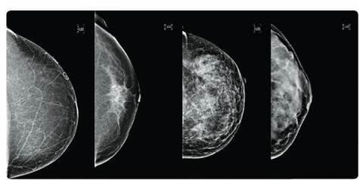
Breast density relates to the amount of fibroglandular (non-fatty) tissue in the breast as seen on a mammogram, not how the breasts look or feel. Some women have denser breast tissue (more fibroglandular tissue). The density of the breast can be influenced by genetics, age, weight, hormonal treatments, ethnicity and physical activity.
Fibroglandular (non-fatty) tissue looks white on mammograms. These images show a range of breast densities starting with a mostly fatty breast on the left and a very dense breast on the right.

Risk associated with dense breasts
Women with dense breasts have an increased risk of breast cancer. The risk is thought to be less than having a first degree relative who is diagnosed with breast cancer before menopause (which doubles the risk), or carrying a gene mutation (where the risk is up to eight times higher).
The risk of the masking effect of the dense breast tissue is less since the programme has become fully digital, lowering the chances of a breast cancer being missed.

Measuring breast density
Breast density can be measured on mammography, however, there are different ways used by radiologists (specialist doctors) to grade dense breasts. American advocacy groups have lobbied successfully for laws to be passed requiring reporting of breast density for every mammogram, despite difficulties in grading breast density, and a lack of evidence that extra monitoring of women with dense breasts will reduce deaths from breast cancer.

BSA has reviewed the evidence on breast density. For women with dense breasts who otherwise have an average risk of breast cancer, there is insufficient evidence to recommend additional imaging (such as ultrasound or MRI). The harms of extra imaging, such as causing anxiety, unnecessary needle biopsies, over-diagnosis and cost, are likely to outweigh the benefits. This is the reason breast density is not currently measured within the BSA programme, or many other population based screening programmes such as the UK, Europe and Australia (excluding Western Australia).

Recommendations for women with dense breasts
Women with dense breasts at an otherwise average risk of breast cancer can be managed within BSA by regular mammography every two years. It is recommended that women at high risk of breast cancer, for example those with very strong family history of breast cancer, or those with gene mutations, are referred for additional care outside the BSA programme. BSA recommends that any woman who notices any breast changes, or who has any concerns, see their GP for a breast check and further individual advice.

