Universal Newborn Hearing Screening and Early Intervention Programme (UNHSEIP)
Monitoring Report
January to December 2015
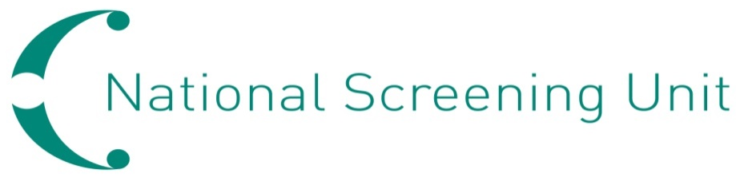

Copyright
The copyright owner of this publication is the Ministry of Health, which is part of the New Zealand Crown. The Ministry of Health permits the reproduction of material from this publication without prior notification, provided that all the following conditions are met:
- the content is not distorted or changed
- the information is not sold
- the material is not used to promote or endorse any product or service
- the material is not used in an inappropriate or misleading context having regard to the nature of the material
- any relevant disclaimers, qualifications or caveats included in the publication are reproduced
- the New Zealand Ministry of Health is acknowledged as the source.

Disclaimer
This publication reports on information provided to the Ministry of Health by district health boards (DHBs) and Ministry of Education Special Education. Its purpose is to inform discussion and assist the ongoing development of the Universal Newborn Hearing and Early Intervention Programme. All care has been taken in the production of this report, and the data was deemed to be accurate at the time of publication. However, the data may be subject to updates over time as further information is received. Before quoting or using this information, it is advisable to check the current status with the Ministry of Health.

Acknowledgements
Many people have assisted in the production of this report. In particular, we would like to acknowledge those who have collected this information at the DHBs and Ministry of Education early intervention education services, those who have entered the data, and those who have facilitated the analysis of the data.

Citation: Ministry of Health. 2016. Universal Newborn Hearing and
Early Intervention Programme: Monitoring Report January to December 2015.
Wellington: Ministry of Health.
Published in October 2016
by the Ministry of Health
PO Box 5013, Wellington 6140, New Zealand
ISBN 978-0-947515-73-7 (online)
HP 6503
This document is available at www.nsu.govt.nz

Contents
Executive summary vii
Introduction 1
The Universal Newborn Hearing Screening and Early Intervention Programme 1
Programme monitoring 1
Information included in this report 3
Data calculations 4
Data limitations 5
Screening and audiology monitoring indicators 6
1.1 Newborn hearing screening offers 6
1.2 Newborn hearing screening consents and declines 7
1.3 Newborn hearing screening coverage 9
1.5 Referral rate to audiology 17
1.6 Hearing surveillance rate 19
1.8 Positive predictive value of the screening test 22
2.2 Audiology assessment completed 23
2.3 Audiology assessment not attended 29
2.4 Hearing loss detected 30
Early Intervention education services indicators 33
3.1 Making initial contact with families/whānau 34
3.2 Commencement of Early Intervention education services 36
3.3 Continuation of Early Intervention education services 39
3.4 Outcome of early intervention 40
Hearing screening indicators not yet monitored 41
Appendices
Appendix 1 42
Appendix 2 43
Appendix 3 44
Appendix 4 46

List of Tables
Table 1: Summary of newborn hearing screening participation indicators by DHB, 1 January to 31 December 2015 ix
Table 2: Summary of newborn hearing screening coverage indicators by DHB, 1 January to 31 December 2015 x
Table 3: Summary of newborn hearing screening coverage indicators by ethnicity and deprivation quintile, 1 January to 31 December 2015 xi
Table 4: Summary of newborn hearing screening outcome indicators by DHB, 1 January to 31 December 2015 xii
Table 5: Summary of newborn hearing screening outcome indicators by ethnicity and deprivation quintile, 1 January to 31 December 2015 xiii
Table 6: Summary of newborn hearing screening audiology indicators by DHB, 1 January to 31 December 2015 xiv
Table 7: Summary of newborn hearing screening audiology indicators by ethnicity and deprivation, 1 January to 31 December 2015 xv
Table 8: Offer of newborn hearing screening by DHB, 1 January to 31 December 2015 6
Table 9: Consents for newborn hearing screening by DHB, 1 January to 31 December 2015 7
Table 10: Newborn hearing screening declines by DHB, 1 January to 31 December 2015 8
Table 11: Newborn hearing screens completed by 1 month of age by DHB, 1 January to 31 December 2015 9
Table 12: Newborn hearing screens completed by 1 month of age by ethnicity, 1 January to 31 December 2015 10
Table 13: Newborn hearing screens completed by 1 month of age by deprivation, 1 January to 31 December 2015 10
Table 14: Total newborn hearing screens completed for the period by DHB, 1 January to 31 December 2015 13
Table 15: Total newborn hearing screens completed for the period by ethnicity, 1 January to 31 December 2015 13
Table 16: Total newborn hearing screens completed for the period by deprivation 1 January to 31 December 2015 14
Table 17: Newborn hearing screens completed as percentage of consents by DHB, 1 January to 31 December 2015 15
Table 18: Newborn hearing screens completed as percentage of consents by ethnicity, 1 January to 31 December 2015 15
Table 19: Newborn hearing screens completed as percentage of consents by deprivation, 1 January to 31 December 2015 16
Table 20: Referrals to audiology from newborn hearing screening by DHB, 1 January to 31 December 2015 17
Table 21: Referrals to audiology from newborn hearing screening by ethnicity, 1 January to 31 December 2015 18
Table 22: Referrals to audiology from newborn hearing screening by deprivation, 1 January to 31 December 2015 18
Table 23: Breakdown of referrals to audiology from newborn hearing screening by type (unilateral or bilateral), 1 January to 31 December 2015 18
Table 24: Referrals for surveillance from newborn hearing screening by DHB, 1 January to 31 December 2015 19
Table 25: Referrals for surveillance from newborn hearing screening by ethnicity, 1 January to 31 December 2015 20
Table 26: Referrals for surveillance from newborn hearing screening by deprivation, 1 January to 31 December 2015 20
Table 27: Number and proportion of risk factors for babies referred for surveillance from newborn hearing screening, 1 January to 31 December 2015 21
Table 28: Positive predictive value of newborn hearing screening by type of audiology referral, 1 January to 31 December 2015 22
Table 29: Audiology assessment completion for babies referred from newborn hearing screening by timeframe and DHB, 1 January to 31 December 2015 24
Table 30: Audiology assessment completion for babies referred from newborn hearing screening by timeframe and ethnicity, 1 January to 31 December 2015 25
Table 31: Audiology assessment completion for babies referred from newborn hearing screening by timeframe and deprivation, 1 January to 31 December 2015 26
Table 32: Proportion of babies with confirmed PCHL following newborn hearing screening who have a diagnosis by 3 months of age, 1 January to 31 December 2015 27
Table 33: Total audiology assessments not attended for babies referred from newborn hearing screening by DHB, 1 January to 31 December 2015 29
Table 34: Total audiology assessments not attended for babies referred from newborn hearing screening by ethnicity, 1 January to 31 December 2015 30
Table 35: Total audiology assessments not attended for babies referred from newborn hearing screening by deprivation, 1 January to 31 December 2015 30
Table 36: Proportion of babies screened that had permanent congenital hearing loss detected by DHB, 1 January to 31 December 2015 31
Table 37: Proportion of babies screened that had permanent congenital hearing loss detected by ethnicity, 1 January to 31 December 2015 31
Table 38: Proportion of babies screened that had permanent congenital hearing loss detected by deprivation, 1 January to 31 December 2015 32
Table 39: Proportion of babies screened that had permanent congenital hearing loss detected by type of hearing loss, 1 January to 31 December 2015 32
Table 40: Referrals received by Ministry of Education districts, 1 January to 31 December 2015 33
Table 41: Referrals received by ethnicity of child, 1 January to 31 December 2015 34
Table 42: Time taken for first contact by ethnicity, 1 January to 31 December 2015 34
Table 43: Time taken for first contact by education district, 1 January to 31 December 2015 35
Table 44: First contact by time category, 1 January to 31 December 2015 35
Table 45: Time taken for commencement of services, 1 January to 31 December 2015 36
Table 46: Time taken for commencement of services by ethnicity, 1 January to 31 December 2015 36
Table 47: Time taken for commencement of services by Education District, 1 January to 31 December 2015 37
Table 48: Proportion of referrals where service received by 6 months of age, 1 January to 31 December 2015 37
Table 49: Proportion of referrals where services were received by 6 months of age by ethnicity, 1 January to 31 December 2015 38
Table 50: Proportion of referrals where child was aged >6 months, 1 January to 31 December 2015 38
Table 51: Referrals received by age at referral and ethnicity, 1 January to 31 December 2015 38
Table 52: Age of children at exit from early intervention education services, 1 January to 31 December 2015 39
Table 53: Audiology assessment completion by timeframe and DHB, 1 January to 31 December 2015 44
Table 54: Audiology assessment completion by timeframe and ethnicity, 1 January to 31 December 2015 44
Table 55: Audiology assessment completion by timeframe and deprivation, 1 January to 31 December 2015 45
Table 56: Number of babies screened that had permanent congenital hearing loss detected by type of hearing loss and DHB, 1 January to 31 December 2015 46

List of Figures
Figure 1: National screening coverage by 1 month of age and total, 2011–2015 11
Figure 2: Screening coverage by 1 month of age by ethnicity, 2011–2015 11
Figure 3: Screening coverage by 1 month of age by DHB, 2013–2015 12
Figure 4: Audiology completion by 3 months of age and total, 2011–2015 23
Figure 5: Audiology completion by 3 months of age by DHB, 2013–2015 25
Figure 6: Audiology completion by 3 months of age by ethnicity, 2011–2015 26
Figure 7: Audiology assessment duration for babies referred from newborn hearing screening, all DHBs, 1 January to 31 December 2015 28
Figure 8: Ministry of Education regions and districts 42
Figure 9: Ministry of Health District Health Board boundaries 43

Executive summary
Universal newborn hearing screening is the standard of care internationally, and in New Zealand. The early detection of hearing loss, and the application of appropriate medical and educational interventions, has been demonstrated to significantly improve the baby’s long-term language skills and cognitive ability.

In August 2010 the national implementation of the Universal Hearing Screening and Early Intervention Programme (UNHSEIP) was completed. All 20 district health boards (DHBs) offer screening to the families and whānau of newborn babies.

Throughout 2015, following the recommendations of the report Review of newborn hearing screening regimes and associated screening devices for the National Screening Unit, revised protocols and standardised screening equipment were implemented across all 20 DHBs. The move to aABR only screening and refined surveillance criteria, combined with new equipment, represented a significant change for the programme. Each DHB implemented the changes at a different time, linked to the timing of on-site training, which was provided at each DHB between March and September 2015.

The core goals of the programme, which are based on international best practice, are unchanged, and are described as ‘1–3–6’ goals:
1 = ≥95% babies to be screened by one month of age
3 = ≥90% audiology assessments completed by three months of age
6 = initiation of appropriate medical, audiological and early intervention education services by six months of age.

This monitoring report covers the babies screened in the 12 month period from 1 January 2015 to 31 December 2015. Audiology data for these babies up to 9 August 2016, when final data was extracted, is captured in this report.

The UNHSEIP Monitoring Framework 2009 was updated in 2015. Consistent with a maturing programme, the new framework shifts the focus of monitoring from the screening process to greater consideration of outcomes across the programme pathway and performance against international benchmarks. Some indicators in the revised framework are still under development, whilst others cannot be reported until additional data from the new newborn hearing information management system (NHIMS) and other sources is available.

Key points from January 2015 to December 2015
- The total number of offers reported by DHBs for 2015 was 57,814 out of 58,972 live births (98.0%).
- 95.6% of parents/guardians that were offered screening consented, and 97.7% of those that consented completed screening.
- 83.1% of babies born completed screening by 1 month of age and a total of 91.5% completed screening for the period. Completion rates were higher for Other and Asian babies than for Māori and Pacific babies, and for babies from areas of lower deprivation compared to high deprivation.
- The rate of referral to audiology for babies screened during the period was 2.4%. Northland and Hawke’s Bay DHBs had the highest rates.
- 2.2% of babies that passed screening were referred for surveillance due to the presence of a risk factor for development of hearing loss. Hawke’s Bay and Nelson Marlborough DHBs had the highest surveillance rates, and rates by ethnicity varied from 3.5% for Māori to 1.6% for Asian babies.
- The most common risk factor identified for babies referred for surveillance was family history (45.6% of babies referred, 1.0% of completed screens).
- The positive predictive value (PPV) of screening for 2015 was 14%.
- 873 (66.5%) out of 1,318 babies referred to audiology had assessments completed by the date of data extraction for this report. 56.4% of referrals had their assessments completed by three months of age. There were also 104 babies for whom the audiology outcome was DNA/lost contact/declined. Assessment completion rates were lower for Māori and Pacific babies, and for babies living in areas of greater deprivation.
- 86.0% of babies that had a confirmed diagnosis of permanent congenital hearing loss (PCHL) received that diagnosis by three months of age.
- 85.3% of completed audiology assessments were started and completed on the same day. These babies equated to 56.8% of all referrals to audiology for the period.
- Nationally, 2.2 babies per 1000 completed screens had PCHL diagnosed.
- Early intervention education services received referrals for 150 babies and children during the 2015 year. Of these, the families/whānau of 120 referrals (80%) were contacted within 10 working days.
- 91.3% of referrals to early intervention began receiving services within one month of referral, against a target of 90% or greater. The rates for all ethnicities except Asian and NZ European exceeded the target.
- 97.7% of referrals to early intervention began receiving services by six months of age, exceeding the target of 90% or greater. The target was met for all ethnicities.
- Just over half of all exits from early intervention services occurred before the child was three years of age. A portion of these exits may actually relate to instances of service change rather than complete withdrawal.
- In the Central North Education District, 95% of eligible children had language assessments completed within the recommended age period. Of these, 33% had a language level within six months of what that expected for their chronological age.

Table 1: Summary of newborn hearing screening participation indicators by DHB, 1 January to 31 December 2015
DHB of first screen | Offers | Consents | Declines | Live births | 1.1  Offers as % of births | 1.2a  Consents as % of offered¹ | 1.2b  Declines as % of offers
 | Number |  |  |  | Percentage
Northland | 2045 | 1734 | 78 | 2140 | 95.6 | 84.8 | 3.8
Waitemata | 6118 | 5773 | 98 | 7622 | 80.3 | 94.4 | 1.6
Auckland | 8015 | 7703 | 71 | 5937 | 135.0 | 96.1 | 0.9
Counties Manukau | 7043 | 7086 | 26 | 8253 | 85.3 | 100.6 | 0.4
Waikato | 5259 | 4728 | 52 | 5319 | 98.9 | 89.9 | 1.0
Lakes | 1508 | 1401 | 4 | 1520 | 99.2 | 92.9 | 0.3
Bay of Plenty | 2578 | 2387 | 129 | 2796 | 92.2 | 92.6 | 5.0
Tairāwhiti | 705 | 705 | 3 | 741 | 95.1 | 100.0 | 0.4
Taranaki | 1542 | 1480 | 17 | 1528 | 100.9 | 96.0 | 1.1
Hawke’s Bay | 1920 | 1816 | 28 | 2010 | 95.5 | 94.6 | 1.5
Whanganui | 808 | 777 | 5 | 816 | 99.0 | 96.2 | 0.6
MidCentral | 1968 | 1946 | 4 | 2131 | 92.4 | 98.9 | 0.2
Hutt Valley | 1980 | 1941 | 7 | 1979 | 100.1 | 98.0 | 0.4
Capital & Coast | 3680 | 3530 | 19 | 3561 | 103.3 | 95.9 | 0.5
Wairarapa | 444 | 435 | 3 | 462 | 96.1 | 98.0 | 0.7
Nelson Marlborough | 1529 | 1403 | 21 | 1426 | 107.2 | 91.7 | 1.4
West Coast | 325 | 302 | 17 | 358 | 90.8 | 92.9 | 5.2
Canterbury | 6245 | 6148 | 42 | 6262 | 99.7 | 98.4 | 0.7
South Canterbury | 633 | 611 | 2 | 667 | 94.9 | 96.5 | 0.3
Southern | 3469 | 3371 | 30 | 3444 | 100.7 | 97.2 | 0.9
Total | 57,814 | 55,277 | 656 | 58,972 | 98.0 | 95.6 | 1.1
1 The percentage consented and the percentage declined do not add to 100% (1.3% gap) due to offers and declines currently coming from a different data source than consents.

Table 2: Summary of newborn hearing screening coverage indicators by DHB, 1 January to 31 December 2015
DHB of birth | Screens completed by 1 month | Total screens completed | Consents | Live births | 1.3a  Complete by 1 month as % of births | 1.3b  Total complete as % of births | 1.3c  Complete as % of consented
 | Number |  |  |  | Percentage
Northland | 1078 | 1691 | 1739 | 2140 | 50.4 | 79.0 | 97.2
Waitemata | 5803 | 6825 | 6899 | 7622 | 76.1 | 89.5 | 98.9
Auckland | 5325 | 5578 | 5628 | 5937 | 89.7 | 94.0 | 99.1
Counties Manukau | 6675 | 7065 | 7963 | 8253 | 80.9 | 85.6 | 88.7
Waikato | 4090 | 4738 | 4771 | 5319 | 76.9 | 89.1 | 99.3
Lakes | 1287 | 1396 | 1397 | 1520 | 84.7 | 91.8 | 99.9
Bay of Plenty | 1757 | 2353 | 2395 | 2796 | 62.8 | 84.2 | 98.2
Tairāwhiti | 674 | 696 | 705 | 741 | 91.0 | 93.9 | 98.7
Taranaki | 1447 | 1463 | 1473 | 1528 | 94.7 | 95.7 | 99.3
Hawke’s Bay | 1574 | 1763 | 1803 | 2010 | 78.3 | 87.7 | 97.8
Whanganui | 733 | 754 | 760 | 816 | 89.8 | 92.4 | 99.2
MidCentral | 1403 | 1934 | 1967 | 2131 | 65.8 | 90.8 | 98.3
Hutt Valley | 1890 | 1898 | 1901 | 1979 | 95.5 | 95.9 | 99.8
Capital & Coast | 3480 | 3603 | 3609 | 3561 | 97.7 | 101.2 | 99.8
Wairarapa | 416 | 431 | 432 | 462 | 90.0 | 93.3 | 99.8
Nelson Marlborough | 1308 | 1392 | 1394 | 1426 | 91.7 | 97.6 | 99.9
West Coast | 264 | 287 | 292 | 358 | 73.7 | 80.2 | 98.3
Canterbury | 5956 | 6176 | 6179 | 6262 | 95.1 | 98.6 | 100.0
South Canterbury | 594 | 604 | 606 | 667 | 89.1 | 90.6 | 99.7
Southern | 3231 | 3335 | 3364 | 3444 | 93.8 | 96.8 | 99.1
Total | 48,985 | 53,982 | 55,277 | 58,972 | 83.1 | 91.5 | 97.7

Table 3: Summary of newborn hearing screening coverage indicators by ethnicity and deprivation quintile, 1 January to 31 December 2015
 | Screens completed by 1 month | Total screens completed | Consents | Live  births | 1.3a  Complete by 1 month as % of births | 1.3b  Total complete as % of births | 1.3c  Complete as % of consented
 | Number |  |  |  | Percentage
Ethnicity
Māori | 10,955 | 12,717 | 13,211 | 14,605 | 75.0 | 87.1 | 96.3
Pacific | 4841 | 5389 | 5826 | 6064 | 79.8 | 88.9 | 92.5
Asian | 8332 | 8807 | 8913 | 9226 | 90.3 | 95.5 | 98.8
Other | 24,857 | 27,069 | 27,327 | 29,077 | 85.5 | 93.1 | 99.1
Total | 48,985 | 53,982 | 55,277 | 58,972 | 83.1 | 91.5 | 97.7
NZ Dep 2013
Quintile 1 | 7864 | 8287 | 8346 | 8305 | 94.7 | 99.8 | 99.3
Quintile 2 | 8419 | 9085 | 9180 | 9407 | 89.5 | 96.6 | 99.0
Quintile 3 | 8944 | 9846 | 9939 | 10,662 | 83.9 | 92.3 | 99.1
Quintile 4 | 10,783 | 12,047 | 12,248 | 13,348 | 80.8 | 90.3 | 98.4
Quintile 5 | 12,899 | 14,636 | 15,483 | 17,250 | 74.8 | 84.8 | 94.5
Unknown | 76 | 81 | 81 | – | – | – | 100.0
Total | 48,985 | 53,982 | 55,277 | 58,972 | 83.1 | 91.5 | 97.7

Table 4: Summary of newborn hearing screening outcome indicators by DHB, 1 January to 31 December 2015
DHB of first screen | Total screens completed | Referred to audiology | Referred for surveillance | Screened and passed | 1.5  Referred as % of screens | 1.6a  Surveillance as % of passed screens
 | Number |  |  |  | Percentage
Northland | 1687 | 113 | 46 | 1574 | 6.7 | 2.9
Waitemata | 5714 | 102 | 148 | 5612 | 1.8 | 2.6
Auckland | 7641 | 126 | 121 | 7515 | 1.6 | 1.6
Counties Manukau | 6183 | 185 | 98 | 5998 | 3.0 | 1.6
Waikato | 4698 | 140 | 113 | 4558 | 3.0 | 2.5
Lakes | 1401 | 29 | 30 | 1372 | 2.1 | 2.2
Bay of Plenty | 2343 | 64 | 40 | 2279 | 2.7 | 1.8
Tairāwhiti | 698 | 9 | 19 | 689 | 1.3 | 2.8
Taranaki | 1470 | 35 | 42 | 1435 | 2.4 | 2.9
Hawke’s Bay | 1774 | 104 | 79 | 1670 | 5.9 | 4.7
Whanganui | 771 | 11 | 23 | 760 | 1.4 | 3.0
Mid Central | 1913 | 60 | 51 | 1853 | 3.1 | 2.8
Hutt Valley | 1938 | 69 | 44 | 1869 | 3.6 | 2.4
Capital & Coast | 3524 | 97 | 81 | 3427 | 2.8 | 2.4
Wairarapa | 434 | 6 | 8 | 428 | 1.4 | 1.9
Nelson Marlborough | 1401 | 14 | 62 | 1387 | 1.0 | 4.5
West Coast | 297 | 5 | 8 | 292 | 1.7 | 2.7
Canterbury | 6146 | 88 | 102 | 6058 | 1.4 | 1.7
South Canterbury | 609 | 19 | 9 | 590 | 3.1 | 1.5
Southern | 3340 | 42 | 56 | 3298 | 1.3 | 1.7
Total | 53,982 | 1318 | 1180 | 52,664 | 2.4 | 2.2

Table 5: Summary of newborn hearing screening outcome indicators by ethnicity and deprivation quintile, 1 January to 31 December 2015
 | Total screens completed | Total referred to audiology | Referred for surveillance | Screened and passed | 1.5a  Audiology referrals as % of completed screens | 1.6a  Surveillance as % of passed screens
 | Number |  |  |  | Percentage
Ethnicity
Māori | 12,717 | 465 | 392 | 12,252 | 3.7 | 3.2
Pacific | 5389 | 200 | 96 | 5189 | 3.7 | 1.9
Asian | 8807 | 151 | 115 | 8656 | 1.7 | 1.3
Other | 27,069 | 502 | 577 | 26,567 | 1.9 | 2.2
Total | 53,982 | 1318 | 1180 | 52,664 | 2.4 | 2.2
NZ Dep 2013 quintile
Quintile 1 | 8287 | 138 | 140 | 8149 | 1.7 | 1.7
Quintile 2 | 9085 | 171 | 196 | 8914 | 1.9 | 2.2
Quintile 3 | 9846 | 173 | 189 | 9673 | 1.8 | 2.0
Quintile 4 | 12,047 | 293 | 283 | 11,754 | 2.4 | 2.4
Quintile 5 | 14,636 | 541 | 369 | 14,095 | 3.7 | 2.6
Unknown | 81 | 2 | 3 | 79 | 2.5 | 3.8
Total | 53,982 | 1318 | 1180 | 52,664 | 2.4 | 2.2

Table 6: Summary of newborn hearing screening audiology indicators by DHB, 1 January to 31 December 2015
DHB of first screen | Total screens completed | Total referred to audiology | Audiology completed by 3 months | Total audiology completed | PCHL diagnosed by 3 months | Total PCHL diagnosed | Audiology DNA/lost contact/ declined | 2.2a  Audiology assessment completion by 3 months | 2.2b  PCHL diagnosed by 3 months | 2.3  Audiology DNA/lost contact/ declined | 2.4  Hearing loss detected
 | Number |  |  |  |  |  |  | Percentage |  |  | Per 1000
Northland | 1687 | 113 | 45 | 64 | 5 | 6 | 22 | 39.8 | 83.3 | 19.5 | 3.6
Waitemata | 5714 | 102 | 60 | 74 | 10 | 13 | – | 58.8 | 76.9 | 0.0 | 2.3
Auckland | 7641 | 126 | 86 | 91 | 9 | 11 | 1 | 68.3 | 81.8 | 0.8 | 1.4
Counties Manukau | 6183 | 185 | 67 | 93 | 7 | 10 | 1 | 36.2 | 70.0 | 0.5 | 1.6
Waikato | 4698 | 140 | 73 | 85 | 9 | 10 | 30 | 52.1 | 90.0 | 21.4 | 2.1
Lakes | 1401 | 29 | 15 | 18 | 1 | 2 | 5 | 51.7 | 50.0 | 17.2 | 1.4
Bay of Plenty | 2343 | 64 | 33 | 43 | 7 | 8 | 11 | 51.6 | 87.5 | 17.2 | 3.4
Tairāwhiti | 698 | 9 | 7 | 7 | 3 | 3 | – | 77.8 | 100.0 | 0.0 | 4.3
Taranaki | 1470 | 35 | 22 | 23 | 3 | 3 | 1 | 62.9 | 100.0 | 2.9 | 2.0
Hawke’s Bay | 1774 | 104 | 45 | 58 | 2 | 2 | 10 | 43.3 | 100.0 | 9.6 | 1.1
Whanganui | 771 | 11 | 8 | 9 | 1 | 1 | 1 | 72.7 | 100.0 | 9.1 | 1.3
MidCentral | 1913 | 60 | 23 | 34 | 4 | 4 | 9 | 38.3 | 100.0 | 15.0 | 2.1
Hutt Valley | 1938 | 69 | 65 | 65 | 8 | 8 | 2 | 94.2 | 100.0 | 2.9 | 4.1
Capital & Coast | 3524 | 97 | 68 | 75 | 6 | 7 | 8 | 70.1 | 85.7 | 8.2 | 2.0
Wairarapa | 434 | 6 | 6 | 6 | 2 | 2 | – | 100.0 | 100.0 | 0.0 | 4.6
Nelson Marlborough | 1401 | 14 | 11 | 11 | 2 | 2 | – | 78.6 | 100.0 | 0.0 | 1.4
West Coast | 297 | 5 | 2 | 2 | – | – | 1 | 40.0 | – | 20.0 | 0.0
Canterbury | 6146 | 88 | 69 | 78 | 20 | 24 | – | 78.4 | 83.3 | 0.0 | 3.9
South Canterbury | 609 | 19 | 17 | 17 | 2 | 2 | 1 | 89.5 | 100.0 | 5.3 | 3.3
Southern | 3340 | 42 | 22 | 24 | 3 | 3 | 1 | 52.4 | 100.0 | 2.4 | 0.9
Total | 53,982 | 1318 | 744 | 877 | 104 | 121 | 104 | 56.4 | 86.0 | 7.9 | 2.2

Table 7: Summary of newborn hearing screening audiology indicators by ethnicity and deprivation, 1 January to 31 December 2015
 | Total screens completed | Total referred to audiology | Audiology completed by 3 months | Total audiology completed | PCHL diagnosed by 3 months | Total PCHL diagnosed | Audiology DNA/lost contact/ declined | 2.2a  Audiology assessment completion by 3 months | 2.2b  PCHL diagnosed by 3 months | 2.3  Audiology DNA/lost contact/ declined | 2.4  Hearing loss detected
 | Number |  |  |  |  |  |  | Percentage |  |  | Per 1000
Ethnicity
Māori | 12,717 | 465 | 206 | 255 | 29 | 34 | 73 | 44.3 | 85.3 | 15.7 | 2.7
Pacific | 5389 | 200 | 90 | 115 | 11 | 14 | 8 | 45.0 | 78.6 | 4.0 | 2.6
Asian | 8807 | 151 | 102 | 115 | 20 | 25 | 1 | 67.5 | 80.0 | 0.7 | 2.8
Other | 27,069 | 502 | 346 | 392 | 44 | 48 | 22 | 68.9 | 91.7 | 4.4 | 1.8
Total | 53,982 | 1318 | 744 | 877 | 104 | 121 | 104 | 56.4 | 86.0 | 7.9 | 2.2
NZ Dep 2013
Quintile 1 | 8287 | 138 | 102 | 113 | 16 | 18 | 2 | 73.9 | 88.9 | 1.4 | 2.2
Quintile 2 | 9085 | 171 | 117 | 136 | 18 | 20 | 5 | 68.4 | 90.0 | 2.9 | 2.2
Quintile 3 | 9846 | 173 | 119 | 129 | 15 | 16 | 10 | 68.8 | 93.8 | 5.8 | 1.6
Quintile 4 | 12,047 | 293 | 175 | 203 | 34 | 40 | 25 | 59.7 | 85.0 | 8.5 | 3.3
Quintile 5 | 14,636 | 541 | 231 | 295 | 21 | 26 | 62 | 42.7 | 80.8 | 11.5 | 1.8
Unknown | 81 | 2 | – | 1 | – | 1 | – | 0.0 | 0.0 | 0.0 | 12.3
Total | 53,982 | 1318 | 744 | 877 | 104 | 121 | 104 | 56.4 | 86.0 | 7.9 | 2.2

Introduction

The Universal Newborn Hearing Screening and Early Intervention Programme
The early detection of hearing loss, and the application of appropriate medical and educational interventions, has been demonstrated to significantly improve the baby’s long-term language skills and cognitive ability.

New Zealand’s Universal Newborn Hearing Screening and Early Intervention Programme (UNHSEIP) was implemented over a three year period from 2007 to 2010. The UNHSEIP is jointly overseen by two Government agencies, the Ministries of Health and Education. The Ministry of Health has responsibility for screening, audiological diagnosis of hearing loss and medical interventions, and the Ministry of Education has responsibility for early intervention services. District Health Boards (DHBs) are the main providers of newborn hearing screening, follow-up audiology services and medical interventions.

Throughout 2015, following the recommendations of the report Review of newborn hearing screening regimes and associated screening devices for the National Screening Unit, revised protocols and standardised screening equipment were implemented across all 20 DHBs. The move to aABR only screening and refined surveillance criteria, combined with new equipment, represented a significant change for the programme. Each DHB implemented the changes at a different time, linked to the timing of on-site training, which was provided at each DHB between March and September 2015.

Newborn hearing screening must be offered to the family/whānau of all babies born in a DHB region, whether they are born in hospital or at home, within a framework of nationally consistent policies, standards and guidelines.

Programme monitoring
The aim of the UNHSEIP is early identification of newborns with hearing loss, so that they can access timely and appropriate interventions, inequalities are reduced and the outcomes for these children, their families and whānau, communities and society are improved. The core goals of the UNHSEIP are described as ‘1–3–6’ goals which are based on international benchmarks:
- ≥95% of babies to be screened by one month of age
- ≥90% of audiology assessments to be completed by three months of age
- initiation of appropriate medical and audiological services, and early intervention education services, by six months of age.

Monitoring is a core aspect of quality improvement activities, which are concerned with maximising the likelihood that the day-to-day operations of the screening programme will deliver the expected outcomes. Routine monitoring based on newborn hearing screening and audiology data is reported to the Ministry by DHBs on a quarterly basis.

The data presented in this report covers the following indicators from the UNHSEIP Monitoring Framework:
1.1 Newborn hearing screening offered
1.2 Newborn hearing screening consents and declines
1.3 Newborn hearing screening coverage
(a) Completed by one month [one month goal]
(b) Completed total
(c) Completed of those consented
1.5 Referral rate to audiology assessment
1.6 Hearing surveillance rate
(a) Referral for surveillance rate
(b) Distribution of risk factors
1.8 Positive predictive value of the screening test
2.2 Audiology assessment completion
(a) Audiology assessment completion rate [three month goal]
(b) PCHL diagnosed by three months
2.3 Audiology not attended
2.4 Hearing loss detected
3.1 Contact with families following referral to Early Intervention education services
3.2 Commencement of Early Intervention education services
3.3 Continuation of Early Intervention services
3.4 Outcome of Early Intervention services

Other indicators from the framework, for which data is not currently available, are listed below:
1.4 Newborn hearing screening did not attend and lost contacts – the number of babies that do not complete screening due to not attending or the service losing contact as a proportion of all babies whose parents/guardians consented to screening.
1.7 Second screening rates – the number of babies referred from first to second automated auditory brainstem response (aABR) screening as a proportion of all babies that completed first aABR screens relates to the new protocol.
2.5 Outcome of hearing surveillance:
(a) Hearing loss detected
(b) Referred for surveillance but not assessed
2.6 Cases not identified from screening
2.7 Age at first assistive hearing device [six month goal]

The remaining indicator in the framework is indicator 2.1 (audiology assessment timeliness). This is not a national monitoring indicator but is instead reported by DHBs to the NSU as part of regular reporting. Further details for indicators not covered by this report are given at the end of this report.

Information included in this report
The information included in this report relates to babies that commenced screening between 1 January 2015 and 31 December 2015.

Newborn hearing screening tests and audiology assessments
Newborn hearing screening and follow-up audiology information is captured by the Ministry of Health’s National Screening Unit (NSU) in two ways. Some DHBs collect and record information on paper forms, which are regularly submitted NSU and the data is entered into the NSU’s national hearing database. An increasing number of DHBs submit their data electronically which is then uploaded into the national database. Data for babies who started screening during the reporting period was extracted on 9 August 2016.

Additional information for monitoring was sourced from quarterly DHB contractual reporting. This information is used to monitor trends in the offer and decline of newborn hearing screening, as only information from babies with consent is recorded in the national database. In future this information will come from NHIMS.

Early Intervention education services
Information on Early Intervention education services is captured by the Ministry of Education’s Case Management System (CMS). Data for services provided during 2015 was extracted in August 2016. Ministry of Education services are divided into four regions (Northern, Central North, Central South and Southern) with 16 districts as shown on the map in Appendix 1. For comparison, DHB boundaries are shown in Appendix 2.

Ethnicity
Ethnicity data for the hearing screening and audiology indicators is grouped according to a prioritised system, which is commonly applied across the health sector. Prioritisation involves allocating each person to a single ethnic group, based on the ethnicities they have identified with, in the prioritised order of Māori, Pacific, Asian, Other and European. For example, if someone identifies as being New Zealand European and Māori, under the prioritised ethnic group method, they are classified as Māori for the purpose of the analysis. In contrast, ethnicity data for Early Intervention education services indicators is reported by total response ethnicity. Using the same example as above, the person would be counted twice under the total response method; once against New Zealand European and once against Māori. This means that children with more than one ethnic group are counted multiple times for early intervention education service indicators.

Neighbourhood deprivation
Deprivation data for screening and audiology indicators was sourced from the NHI database. The New Zealand deprivation index (NZ Dep) is the average level of deprivation of people living in an area at a particular point in time, relative to the whole of New Zealand. Deprivation refers to areas (based on New Zealand Census mesh blocks) rather than individuals. All reporting by NZ Dep is based on the 2013 New Zealand deprivation index decile associated with the residential address held in the NHI database for each baby at the time of data extraction.

In the deprivation index system used by the health sector, areas classified as decile 1 have the least deprivation and areas classified as decile 10 have the most deprivation. This is opposite to some other systems of classification, such as that used by education, where level 10 is the least disadvantaged and level 1 the most disadvantaged.

This report presents results by 2013 NZ Dep quintiles. Each quintile groups two deciles together and contains about 20% of small areas in New Zealand. The two quintiles at opposite ends of the scale are quintile 1 (deciles 1 and 2), which represents children living in the least deprived 20% of small areas (‘the least deprived areas’), and quintile 5 (deciles 9 and 10), which represents children living in the most deprived 20% of small areas (‘the most deprived areas’).

Births
The number of live births by DHB of residence was sourced from the National Maternity Collection, which combines information from live birth registrations from the Births, Deaths and Marriages (BDM) Register along with hospital discharge information and Lead Maternity Carer claims.

Data calculations

Reporting by DHB
Almost all screening and audiology indicators have been reported by the screening DHB as this DHB is responsible for ensuring screening is completed. The exceptions are indicators 1.1 and 1.3 (offer of screening and screening coverage) where the denominator is the number of births. As this data is only available by DHB of domicile at birth the numerator counts for these two indicators have also been calculated using DHB of birth. All remaining indicators (including audiology) are reported by the screening DHB location. For most babies (about 95%) this is the same as DHB of birth. In the past monitoring reports reported audiology indicators by the DHB that delivered the audiology assessment. The screening and audiology DHBs are usually the same. Exceptions to this are Waitemata and West Coast DHBs whose audiology is provided by Auckland and Canterbury DHBs respectively.

Gestational age
Where gestational age was not recorded, a gestational age of 40 weeks was allocated (1% of records, n=523). DHBs will continue to be encouraged to include the correct gestational age on data forms. For babies born at less than full term, age is corrected by the length of time pre-term for the purposes of calculating age at screen and age at audiology.

Confidence intervals
Rates and percentages presented in this report are accompanied by 95% confidence intervals (CI). CIs were calculated for all indicators using Wilson’s method for a binomial distribution formula. The 95% CI indicates that there is a 5% chance that the ‘true’ value lies outside the range of values contained by the CI. Therefore, the wider the CI, the less precise the estimate is to the true population parameter.

Data limitations

Accuracy of reporting
Where hand written screening forms are provided to the NSU, data is entered manually into the national database. Data is also imported into the database from DHBs electronically. The potential for errors in data entry is minimised by a two-step data checking process – one at data entry and the other during data processing. Each record must contain a value in 11 mandatory fields to be included in reporting. The NSU and screening providers have quality monitoring processes in place to maintain high data quality.

Audiology data
This report includes audiology information on 877 (66.5%) of the 1318 babies that were referred for audiology assessment. A further 104 babies were identified as ‘Did not attend’ (DNA), declined or moved. The percentage of audiology referrals with completed assessment information recorded in the database is consistent with previous monitoring reports. Audiology assessment information had not been recorded in the national database for the remaining babies by the date of data extraction for this report.

Numerator and denominator source differences
The data used for this report has come from different sources. Offers and declines data taken was from DHB contractual reporting and gives the count of offers and declines made during the 2015 year. Live births data relates to deliveries during the 2015 year. The screening and audiology data extracted from the national hearing database relates to babies that commenced screening during the 2015 year. There is a slight mismatch between these three cohorts. This mismatch leads to situations where a DHB may show as having offered screening to more than 100% of births, or as having more than 100% of births consenting to newborn hearing screening. The local over (and under) proportions should balance out at regional and national levels. All early intervention education services data was provided by the Ministry of Education.

Screening and audiology monitoring indicators

1.1 Newborn hearing screening offers
Indicator 1.1 | Target
The number of babies whose parents/guardians were offered screening as a proportion of live births. | 100%
Using the numbers reported by DHBs for 2015, the national rate of screening offers was 98.0%. This is higher than the rate reported for the 2014 period (96.5%), but is below the target. As shown in Table 8, rates by DHB ranged from 80.3% (Waitemata) to 135.0% (Auckland). Most DHBs had rates above 95%.
The number of babies offered screening within a reporting period comes from a different data source and can be greater than the number of live births attributed to the DHB for the same period, leading to the percentage offered being more than 100%. The local over (and under) proportions should balance out at regional and national levels. When the three Auckland region DHBs are combined the rate of offers to live births is 91.7%.
Table 8: Offer of newborn hearing screening by DHB, 1 January to 31 December 2015
DHB of birth | Offered screening  N | Live births  N | Percentage offered  % | 95% confidence interval¹
Northland | 2045 | 2140 | 95.6 | (94.6, 96.4)
Waitemata | 6118 | 7622 | 80.3 | (79.4, 81.1)
Auckland | 8015 | 5937 | 135.0
Counties Manukau | 7043 | 8253 | 85.3 | (84.6, 86.1)
Waikato | 5259 | 5319 | 98.9 | (98.6, 99.1)
Lakes | 1508 | 1520 | 99.2 | (98.6, 99.5)
Bay of Plenty | 2578 | 2796 | 92.2 | (91.2, 93.1)
Tairāwhiti | 705 | 741 | 95.1 | (93.3, 96.5)
Taranaki | 1542 | 1528 | 100.9
Hawke’s Bay | 1920 | 2010 | 95.5 | (94.5, 96.3)
Whanganui | 808 | 816 | 99.0 | (98.1, 99.5)
MidCentral | 1968 | 2131 | 92.4 | (91.1, 93.4)
Hutt Valley | 1980 | 1979 | 100.1
Capital & Coast | 3680 | 3561 | 103.3
Wairarapa | 444 | 462 | 96.1 | (93.9, 97.5)
Nelson Marlborough | 1529 | 1426 | 107.2
West Coast | 325 | 358 | 90.8 | (87.3, 93.4)
Canterbury | 6245 | 6262 | 99.7 | (99.6, 99.8)
South Canterbury | 633 | 667 | 94.9 | (93.0, 96.3)
Southern | 3469 | 3444 | 100.7
Total | 57,814 | 58,972 | 98.0 | (97.9, 98.1)
1 Confidence interval not able to be calculated due to denominator being less than the numerator.

1.2 Newborn hearing screening consents and declines

1.2a Newborn hearing screening consents
Indicator 1.2a | Target
The number of babies whose parents/guardians consented to screening as a proportion of those offered. | No target set

Nearly all families that were offered screening during 2015 accepted (95.6%). Offers data was sourced from DHB contractual reporting and gives the count of offers made during the 2015 year. Consents data was sourced from the national hearing database and relates to babies that commenced screening during the 2015 year. The slight mismatch between these cohorts has led to the situation where Counties Manukau has a result greater than 100%.

Table 9: Consents for newborn hearing screening by DHB, 1 January to 31 December 2015
DHB of screening | Consented  N | Offered  screening  N | Percentage consented  % | 95% confidence interval¹
Northland | 1734 | 2045 | 84.8 | (83.2, 86.3)
Waitemata | 5773 | 6118 | 94.4 | (93.8, 94.9)
Auckland | 7703 | 8015 | 96.1 | (95.7, 96.5)
Counties Manukau | 7086 | 7043 | 100.6
Waikato | 4728 | 5259 | 89.9 | (89.1, 90.7)
Lakes | 1401 | 1508 | 92.9 | (91.5, 94.1)
Bay of Plenty | 2387 | 2578 | 92.6 | (91.5, 93.5)
Tairāwhiti | 705 | 705 | 100.0 | (99.5, 100)
Taranaki | 1480 | 1542 | 96.0 | (94.9, 96.9)
Hawke’s Bay | 1816 | 1920 | 94.6 | (93.5, 95.5)
Whanganui | 777 | 808 | 96.2 | (94.6, 97.3)
MidCentral | 1946 | 1968 | 98.9 | (98.3, 99.3)
Hutt Valley | 1941 | 1980 | 98.0 | (97.3, 98.6)
Capital & Coast | 3530 | 3680 | 95.9 | (95.2, 96.5)
Wairarapa | 435 | 444 | 98.0 | (96.2, 98.9)
Nelson Marlborough | 1403 | 1529 | 91.7 | (90.3, 93.0)
West Coast | 302 | 325 | 92.9 | (89.6, 95.2)
Canterbury | 6148 | 6245 | 98.4 | (98.1, 98.7)
South Canterbury | 611 | 633 | 96.5 | (94.8, 97.7)
Southern | 3371 | 3469 | 97.2 | (96.6, 97.7)
Total | 55,277 | 57,814 | 95.6 | (95.4, 95.8)
1 Confidence interval not able to be calculated due to denominator being less than the numerator.

1.2b Newborn hearing screening declines
Indicator 1.2b | Target
The number of babies whose parents/guardians declined screening as a proportion of those offered. | No target set

For the 2015 period a small number of families that were offered screening declined (1.1%). Decline rates varied from 5% (West Coast and Bay of Plenty) to 0.2% (MidCentral). The percentage consented and the percentage declined do not add to 100% (3.3% gap) due to offers and declines currently coming from a different data source than consents.

Table 10: Newborn hearing screening declines by DHB, 1 January to 31 December 2015
DHB of screening | Declined  N | Offered  screening  N | Percentage declined  % | 95% confidence interval
Northland | 78 | 2045 | 3.8 | (3.1, 4.7)
Waitemata | 98 | 6118 | 1.6 | (1.3, 1.9)
Auckland | 71 | 8015 | 0.9 | (0.7, 1.1)
Counties Manukau | 26 | 7043 | 0.4 | (0.3, 0.5)
Waikato | 52 | 5259 | 1.0 | (0.8, 1.3)
Lakes | 4 | 1508 | 0.3 | (0.1, 0.7)
Bay of Plenty | 129 | 2578 | 5.0 | (4.2, 5.9)
Tairāwhiti | 3 | 705 | 0.4 | (0.1, 1.2)
Taranaki | 17 | 1542 | 1.1 | (0.7, 1.8)
Hawke’s Bay | 28 | 1920 | 1.5 | (1, 2.1.0)
Whanganui | 5 | 808 | 0.6 | (0.3, 1.4)
MidCentral | 4 | 1968 | 0.2 | (0.1, 0.5)
Hutt Valley | 7 | 1980 | 0.4 | (0.2, 0.7)
Capital & Coast | 19 | 3680 | 0.5 | (0.3, 0.8)
Wairarapa | 3 | 444 | 0.7 | (0.2, 2.0)
Nelson Marlborough | 21 | 1529 | 1.4 | (0.9, 2.1)
West Coast | 17 | 325 | 5.2 | (3.3, 8.2)
Canterbury | 42 | 6245 | 0.7 | (0.5, 0.9)
South Canterbury | 2 | 633 | 0.3 | (0.1, 1.1)
Southern | 30 | 3469 | 0.9 | (0.6, 1.2)
Total | 656 | 57,814 | 1.1 | (1.1, 1.2)

1.3 Newborn hearing screening coverage
Information on the number of screens completed was sourced from the national UNHSEIP database and information on live births was sourced from the National Maternity Collection. Both the numerator and the denominator have been calculated by DHB of birth to be more consistent.

1.3a Newborn hearing screening completed by one month of age
Indicator 1.3a | Target
The number of babies for whom screening is completed by 1 month of age as a proportion of live births. | ≥95%
Nationally, 83.1% of babies completed screening by one month against the target of greater than or equal to 95%. Three DHBs met the target (Hutt Valley, Capital & Coast, and Canterbury) and one was just slightly below (Taranaki) (see Table 11). Rates ranged from 50.4% (Northland) to 97.7% (Capital & Coast).
Table 11: Newborn hearing screens completed by 1 month of age by DHB, 1 January to 31 December 2015
DHB of birth | Completed by 1 month of age  N | Live births²  N | Percentage complete 1 month  % | 95% confidence interval
Northland | 1078 | 2140 | 50.4 | (48.3, 52.5)
Waitemata | 5803 | 7622 | 76.1 | (75.2, 77.1)
Auckland | 5325 | 5937 | 89.7 | (88.9, 90.4)
Counties Manukau | 6675 | 8253 | 80.9 | (80.0, 81.7)
Waikato | 4090 | 5319 | 76.9 | (75.7, 78.0)
Lakes | 1287 | 1520 | 84.7 | (82.8, 86.4)
Bay of Plenty | 1757 | 2796 | 62.8 | (61.0, 64.6)
Tairāwhiti | 674 | 741 | 91.0 | (88.7, 92.8)
Taranaki | 1447 | 1528 | 94.7 | (93.5, 95.7)
Hawke’s Bay | 1574 | 2010 | 78.3 | (76.5, 80.1)
Whanganui | 733 | 816 | 89.8 | (87.6, 91.7)
MidCentral | 1403 | 2131 | 65.8 | (63.8, 67.8)
Hutt Valley | 1890 | 1979 | 95.5 | (94.5, 96.3)
Capital & Coast | 3480 | 3561 | 97.7 | (97.2, 98.2)
Wairarapa | 416 | 462 | 90.0 | (87.0, 92.5)
Nelson Marlborough | 1308 | 1426 | 91.7 | (90.2, 93.0)
West Coast | 264 | 358 | 73.7 | (69.0, 78.0)
Canterbury | 5956 | 6262 | 95.1 | (94.6, 95.6)
South Canterbury | 594 | 667 | 89.1 | (86.5, 91.2)
Southern | 3231 | 3444 | 93.8 | (93.0, 94.6)
Total | 48,985 | 58,972 | 83.1 | (82.8, 83.4)
1 Sourced from UNHSEIP national database.
2 Sourced from National Maternity Collection.

Completion of screening by one month of age varied by ethnicity from 75.0% for Māori to 90.3% for Asian (see Table 12).

Table 12: Newborn hearing screens completed by 1 month of age by ethnicity, 1 January to 31 December 2015
Ethnicity | Completed by 1 month of age  N | Live births²  N | Percentage complete 1 month  % | 95% confidence interval
Māori | 10,955 | 14,605 | 75.0 | (74.3, 75.7)
Pacific | 4841 | 6064 | 79.8 | (78.8, 80.8)
Asian | 8332 | 9226 | 90.3 | (89.7, 90.9)
Other | 24,857 | 29,077 | 85.5 | (85.1, 85.9)
Total | 48,985 | 58,972 | 83.1 | (82.8, 83.4)
1 Sourced from UNHSEIP national database.
2 Sourced from National Maternity Collection.

Rates of completion by one month of age also varied by deprivation with the rate for the least deprived areas (quintile 1) being nearly 20 percentage points higher than the most deprived areas (quintile 5).

Table 13: Newborn hearing screens completed by 1 month of age by deprivation, 1 January to 31 December 2015
NZDep 2013 | Completed by 1 month of age  N | Live births²  N | Percentage complete 1 month  % | 95% confidence interval
Quintile 1 | 7864 | 8305 | 94.7 | (94.2, 95.2)
Quintile 2 | 8419 | 9407 | 89.5 | (88.9, 90.1)
Quintile 3 | 8,944 | 10,662 | 83.9 | (83.2, 84.6)
Quintile 4 | 10,783 | 13,348 | 80.8 | (80.1, 81.4)
Quintile 5 | 12,899 | 17,250 | 74.8 | (74.1, 75.4)
Unknown | 76 | – | –
Total | 48,985 | 58,972 | 83.1 | (82.8, 83.4)
1 Sourced from UNHSEIP national database.
2 Sourced from National Maternity Collection.

Nationally, the screening coverage rate by one month of age increased in 2013 and 2014 before dropping slightly in 2015 (see Figure 1). The total coverage rate time trend was similar with increases from 2011 to 2014 before falling slightly in 2015. Coverage by one month of age fell for all ethnic groups in 2015 after a good gain in 2014 (see Figure 2). The drop in coverage between 2014 and 2015 is reflected across most DHBs (see Figure 3). The largest decreases were seen in Waikato, Bay of Plenty, and South Canterbury DHBs. Several others increased (Whanganui and MidCentral) or held steady over the same period.

Figure 1: National screening coverage by 1 month of age and total, 2011–2015
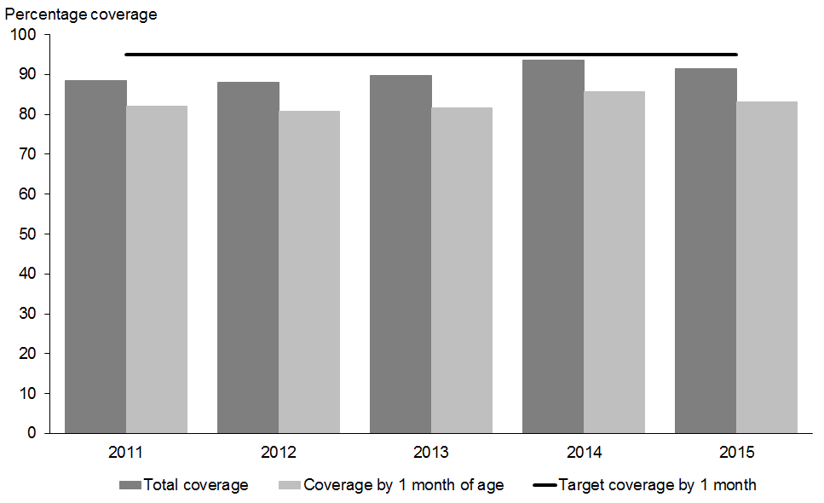

Figure 2: Screening coverage by 1 month of age by ethnicity, 2011–2015
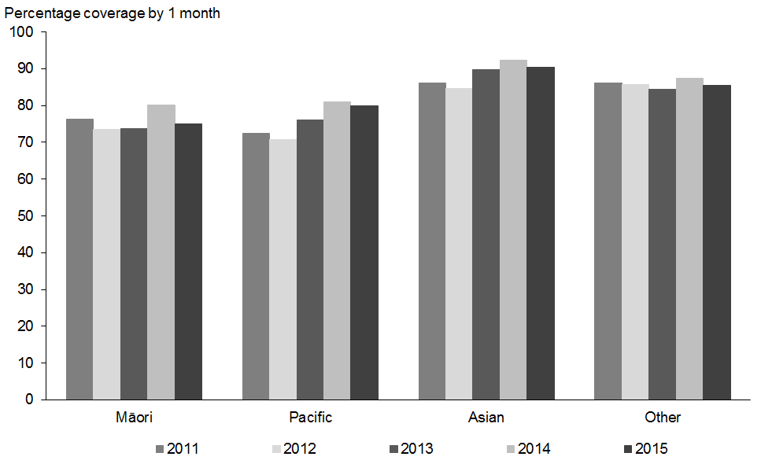

Figure 3: Screening coverage by 1 month of age by DHB, 2013–2015
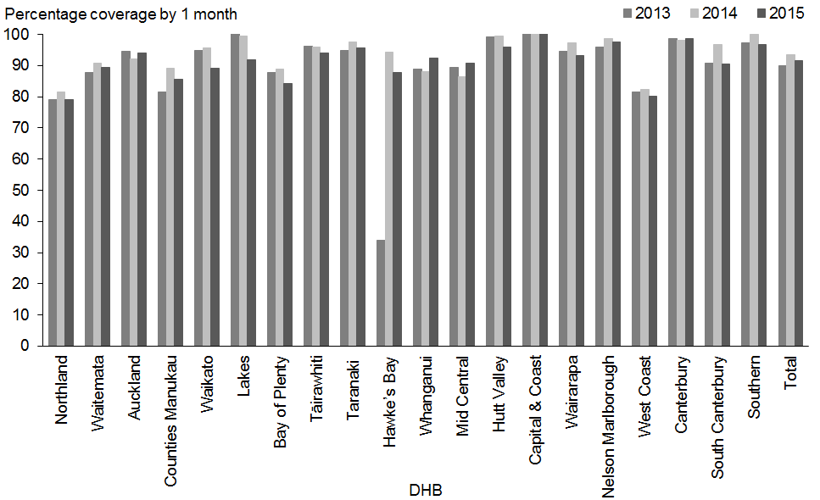

1.3b Total newborn hearing screens completed
Indicator 1.3b | Target
The number of babies for whom screening is completed as a proportion of live births. | No target set

In total, 53,982 babies completed newborn hearing screening during the period, compared with 58,972 live births. While these figures come from different data sources, this indicates that approximately 91.5% of babies born in this period completed screening.

Total screening completion rates by DHB ranged from 79% (Northland) to 101.2% (Capital & Coast). Seven DHBs had rates around 94% or above (see Table 14). Rates above 100% are due to the use of different data sources.

Table 14: Total newborn hearing screens completed for the period by DHB, 1 January to 31 December 2015
DHB of birth | Completed total¹  N | Live births²  N | Percentage complete within period  % | 95% confidence interval
Northland | 1691 | 2140 | 79.0 | (77.2, 80.7)
Waitemata | 6825 | 7622 | 89.5 | (88.8, 90.2)
Auckland | 5578 | 5937 | 94.0 | (93.3, 94.5)
Counties Manukau | 7065 | 8253 | 85.6 | (84.8, 86.3)
Waikato | 4738 | 5319 | 89.1 | (88.2, 89.9)
Lakes | 1396 | 1520 | 91.8 | (90.4, 93.1)
Bay of Plenty | 2353 | 2796 | 84.2 | (82.8, 85.5)
Tairāwhiti | 696 | 741 | 93.9 | (92.0, 95.4)
Taranaki | 1463 | 1528 | 95.7 | (94.6, 96.6)
Hawke’s Bay | 1763 | 2010 | 87.7 | (86.2, 89.1)
Whanganui | 754 | 816 | 92.4 | (90.4, 94.0)
MidCentral | 1934 | 2131 | 90.8 | (89.5, 91.9)
Hutt Valley | 1898 | 1979 | 95.9 | (94.9, 96.7)
Capital & Coast | 3603 | 3561 | 101.2
Wairarapa | 431 | 462 | 93.3 | (90.6, 95.2)
Nelson Marlborough | 1392 | 1426 | 97.6 | (96.7, 98.3)
West Coast | 287 | 358 | 80.2 | (75.7, 84.0)
Canterbury | 6176 | 6262 | 98.6 | (98.3, 98.9)
South Canterbury | 604 | 667 | 90.6 | (88.1, 92.5)
Southern | 3335 | 3444 | 96.8 | (96.2, 97.4)
Total | 53,982 | 58,972 | 91.5 | (91.3, 91.8)
1 Sourced from UNHSEIP national database.
2 Sourced from National Maternity Collection.

Tables 15 and 16 show a breakdown of total screening completion rates by ethnicity and deprivation respectively. As for completion by 1 month, the rate of completed screens for Māori and Pacific babies was lower than for Asian and Other, and the rate for the most deprived areas (quintile 5) was lower than the least deprived areas (quintile 1).

Table 15: Total newborn hearing screens completed for the period by ethnicity, 1 January to 31 December 2015
Ethnicity | Completed total¹  N | Live births²  N | Percentage complete within period  % | 95% confidence interval
Māori | 12,717 | 14,605 | 87.1 | (86.5, 87.6)
Pacific | 5389 | 6064 | 88.9 | (88.1, 89.6)
Asian | 8807 | 9226 | 95.5 | (95.0, 95.9)
Other | 27,069 | 29,077 | 93.1 | (92.8, 93.4)
Total | 53,982 | 58,972 | 91.5 | (91.3, 91.8)
1 Sourced from UNHSEIP national database.
2 Sourced from National Maternity Collection.

Table 16: Total newborn hearing screens completed for the period by deprivation 1 January to 31 December 2015
NZ Dep 2013 | Completed total¹  N | Live births²  N | Percentage complete within period  % | 95% confidence interval
Quintile 1 | 8287 | 8305 | 99.8 | (99.7, 99.9)
Quintile 2 | 9085 | 9407 | 96.6 | (96.2, 96.9)
Quintile 3 | 9846 | 10,662 | 92.3 | (91.8, 92.8)
Quintile 4 | 12,047 | 13,348 | 90.3 | (89.7, 90.7)
Quintile 5 | 14,636 | 17,250 | 84.8 | (84.3, 85.4)
Unknown | 81 | –
Total | 53,982 | 58,972 | 91.5 | (91.3, 91.8)
1 Sourced from UNHSEIP national database.
2 Sourced from National Maternity Collection.

1.3c Newborn hearing screens completed as a percentage of consents
Indicator 1.3c | Target
The number of babies for whom screening is completed as a proportion of those who have been consented. | 97%

Indicator 1.3(c) looks at the extent to which screening is completed for those parents/guardians who consented to have their baby’s hearing screened. For the 2015 period the national rate was 97.7% (see Table 17). Rates by DHB all exceeded the 97% target, with the exception of Counties Manukau (88.7%).

Table 17: Newborn hearing screens completed as percentage of consents by DHB, 1 January to 31 December 2015
DHB of birth | Completed total  N | Consented  N | Complete as percentage of consented  % | 95% confidence interval
Northland | 1691 | 1739 | 97.2 | (96.4, 98.0)
Waitemata | 6825 | 6899 | 98.9 | (98.7, 99.2)
Auckland | 5578 | 5628 | 99.1 | (98.8, 99.3)
Counties Manukau | 7065 | 7963 | 88.7 | (88.0, 89.4)
Waikato | 4738 | 4771 | 99.3 | (99.0, 99.5)
Lakes | 1396 | 1397 | 99.9 | (99.6, 100)
Bay of Plenty | 2353 | 2395 | 98.2 | (97.6, 98.7)
Tairāwhiti | 696 | 705 | 98.7 | (97.6, 99.4)
Taranaki | 1463 | 1473 | 99.3 | (98.8, 99.7)
Hawke’s Bay | 1763 | 1803 | 97.8 | (97.0, 98.4)
Whanganui | 754 | 760 | 99.2 | (98.3, 99.7)
MidCentral | 1934 | 1967 | 98.3 | (97.7, 98.8)
Hutt Valley | 1898 | 1901 | 99.8 | (99.5, 100)
Capital & Coast | 3603 | 3609 | 99.8 | (99.6, 99.9)
Wairarapa | 431 | 432 | 99.8 | (98.7, 100)
Nelson Marlborough | 1392 | 1394 | 99.9 | (99.5, 100)
West Coast | 287 | 292 | 98.3 | (96.0, 99.4)
Canterbury | 6176 | 6179 | 100.0 | (99.9, 100)
South Canterbury | 604 | 606 | 99.7 | (98.8, 100)
Southern | 3335 | 3364 | 99.1 | (98.8, 99.4)
Total | 53,982 | 55,277 | 97.7 | (97.5, 97.8)

Tables 18 and 19 provide breakdowns by ethnicity and deprivation. The rates for Māori (96.3%) and Pacific (92.5%) are lower than for Asian and Other (both approximately 99%). The difference in rates for babies from the least and most deprived areas was nearly 5%.

Table 18: Newborn hearing screens completed as percentage of consents by ethnicity, 1 January to 31 December 2015
Ethnicity | Completed total  N | Consented  N | Complete as percentage of consented  % | 95% confidence interval
Māori | 12,717 | 13,211 | 96.3 | (95.9, 96.6)
Pacific | 5389 | 5826 | 92.5 | (91.8, 93.2)
Asian | 8807 | 8913 | 98.8 | (98.6, 99.0)
Other | 27,069 | 27,327 | 99.1 | (98.9, 99.2)
Total | 53,982 | 55,277 | 97.7 | (97.5, 97.8)

Table 19: Newborn hearing screens completed as percentage of consents by deprivation, 1 January to 31 December 2015
NZ Dep 2013 | Completed total  N | Consented  N | Complete as percentage of consented  % | 95% confidence interval
Quintile 1 | 8287 | 8346 | 99.3 | (99.1, 99.5)
Quintile 2 | 9085 | 9180 | 99.0 | (98.7, 99.2)
Quintile 3 | 9846 | 9939 | 99.1 | (98.9, 99.2)
Quintile 4 | 12,047 | 12,248 | 98.4 | (98.1, 98.6)
Quintile 5 | 14,636 | 15,483 | 94.5 | (94.2, 94.9)
Unknown | 81 | 81 | 100.0 | (95.5, 100)
Total | 53,982 | 55,277 | 97.7 | (97.5, 97.8)

1.5 Referral rate to audiology

1.5 Referrals to audiology from screening test
Indicator 1.5 | Target
The number of babies that are referred from screening to audiology as a proportion of all completed screens. | <2%

The average rate of referral to audiology for the period was 2.4%. Northland DHB had the highest referral rate at 6.7%, followed by 5.9% at Hawke’s Bay. All other DHBs had rates between 0% and 3.6% (see Table 20). Rates for some DHBs are based on low numbers so care should be taken with interpretation.

Table 20: Referrals to audiology from newborn hearing screening by DHB, 1 January to 31 December 2015
DHB of screen | Referred to audiology  N | Completed screening  N | Percentage referred  % | 95% confidence interval
Northland | 113 | 1687 | 6.7 | (5.6, 8.0)
Waitemata | 102 | 5714 | 1.8 | (1.5, 2.2)
Auckland | 126 | 7641 | 1.6 | (1.4, 2.0)
Counties Manukau | 185 | 6183 | 3.0 | (2.6, 3.4)
Waikato | 140 | 4698 | 3.0 | (2.5, 3.5)
Lakes | 29 | 1401 | 2.1 | (1.4, 3.0)
Bay of Plenty | 64 | 2343 | 2.7 | (2.1, 3.5)
Tairāwhiti | 9 | 698 | 1.3 | (0.7, 2.4)
Taranaki | 35 | 1470 | 2.4 | (1.7, 3.3)
Hawke’s Bay | 104 | 1774 | 5.9 | (4.9, 7.1)
Whanganui | 11 | 771 | 1.4 | (0.8, 2.5)
MidCentral | 60 | 1913 | 3.1 | (2.4, 4.0)
Hutt Valley | 69 | 1938 | 3.6 | (2.8, 4.5)
Capital & Coast | 97 | 3524 | 2.8 | (2.3, 3.3)
Wairarapa | 6 | 434 | 1.4 | (0.6, 3.0)
Nelson Marlborough | 14 | 1401 | 1.0 | (0.6, 1.7)
West Coast | 5 | 297 | 1.7 | (0.7, 3.9)
Canterbury | 88 | 6146 | 1.4 | (1.2, 1.8)
South Canterbury | 19 | 609 | 3.1 | (2.0, 4.8)
Southern | 42 | 3340 | 1.3 | (0.9, 1.7)
Total | 1,318 | 53,982 | 2.4 | (2.3, 2.6)

Referral rates by ethnicity are shown in Table 21. Rates were highly variable, with much higher rates for Māori and Pacific (both 3.7%) compared to 1.5% for Asian and 1.9% for Other.

Table 21: Referrals to audiology from newborn hearing screening by ethnicity, 1 January to 31 December 2015
Ethnicity | Referred to audiology  N | Completed screening  N | Percentage referred  % | 95% confidence interval
Māori | 465 | 12,717 | 3.7 | (3.3, 4.0)
Pacific | 200 | 5389 | 3.7 | (3.2, 4.2)
Asian | 151 | 8807 | 1.7 | (1.5, 2.0)
Other | 502 | 27,069 | 1.9 | (1.7, 2.0)
Total | 1318 | 53,982 | 2.4 | (2.3, 2.6)

The results for referral rate by deprivation show an association between higher rates of referral to audiology with higher levels of deprivation (Table 22). Babies resident in the most deprived areas had a referral rate that was more than twice that of babies in the least deprived areas.

Table 22: Referrals to audiology from newborn hearing screening by deprivation, 1 January to 31 December 2015
NZ Dep 2013 | Referred to audiology  N | Completed screening  N | Percentage referred  % | 95% confidence interval
Quintile 1 | 138 | 8287 | 1.7 | (1.4, 2.0)
Quintile 2 | 171 | 9085 | 1.9 | (1.6, 2.2)
Quintile 3 | 173 | 9846 | 1.8 | (1.5, 2.0)
Quintile 4 | 293 | 12,047 | 2.4 | (2.2, 2.7)
Quintile 5 | 541 | 14,636 | 3.7 | (3.4, 4.0)
Unknown | 2 | 81 | 2.5 | (0.7, 8.6)
Total | 1318 | 53,982 | 2.4 | (2.3, 2.6)

Table 23 shows the split between audiology referrals that were unilateral (for one ear), bilateral (for both ears), or for incomplete screens. For the 2015 period the majority of the 1318 babies that were referred to audiology were unilateral referrals (52.0%), followed by bilateral referrals (33.9%).

Table 23: Breakdown of referrals to audiology from newborn hearing screening by type (unilateral or bilateral), 1 January to 31 December 2015
Total referrals | Unilateral |  | Bilateral |  | Incomplete
 | N | % | N | % | N | %
1318 | 685 | 52.0 | 447 | 33.9 | 186 | 14.1

1.6 Hearing surveillance rate

1.6a Proportion of babies that pass screening but are referred for surveillance
Indicator 1.6a | Target
The number of babies who were referred to hearing surveillance as a proportion of all babies that completed screening with a pass result. | No target set
DHBs began transitioning to the updated aABR only screening protocol during the 2015 year. The transitions occurred throughout April to September, which means the annual surveillance data is a mix of old and new protocols. Under the new protocol surveillance referrals are made in a more targeted way with the presence of some risk factors no longer resulting in audiology follow-up. These changes mean that fewer babies are referred for surveillance compared with the previous AOAE/AABR screening regime and targeted follow up policy.
Nationally, 1180 babies (2.2%) that passed screening were referred for surveillance due to the presence of one or more risk factors for delayed onset/progressive hearing loss. The surveillance rate varied across DHBs from 4.7% at Hawke’s Bay to 1.5% at South Canterbury (see Table 24). For reference, in 2014, nationally 2494 babies (4.6%) that passed screening were referred for targeted follow-up. The rate varied across DHBs from 10.5% at Hawke’s Bay to 2.4% at South Canterbury.
Table 24: Referrals for surveillance from newborn hearing screening by DHB, 1 January to 31 December 2015
DHB of screen | Referred for surveillance  N | Screened and passed  N | Percentage referred for surveillance  % | 95% confidence interval
Northland | 46 | 1574 | 2.9 | (2.2, 3.9)
Waitemata | 148 | 5612 | 2.6 | (2.2, 3.1)
Auckland | 121 | 7515 | 1.6 | (1.3, 1.9)
Counties Manukau | 98 | 5998 | 1.6 | (1.3, 2.0)
Waikato | 113 | 4558 | 2.5 | (2.1, 3.0)
Lakes | 30 | 1372 | 2.2 | (1.5, 3.1)
Bay of Plenty | 40 | 2279 | 1.8 | (1.3, 2.4)
Tairāwhiti | 19 | 689 | 2.8 | (1.8, 4.3)
Taranaki | 42 | 1435 | 2.9 | (2.2, 3.9)
Hawke’s Bay | 79 | 1670 | 4.7 | (3.8, 5.9)
Whanganui | 23 | 760 | 3.0 | (2.0, 4.5)
MidCentral | 51 | 1853 | 2.8 | (2.1, 3.6)
Hutt Valley | 44 | 1869 | 2.4 | (1.8, 3.1)
Capital & Coast | 81 | 3427 | 2.4 | (1.9, 2.9)
Wairarapa | 8 | 428 | 1.9 | (1.0, 3.6)
Nelson Marlborough | 62 | 1387 | 4.5 | (3.5, 5.7)
West Coast | 8 | 292 | 2.7 | (1.4, 5.3)
Canterbury | 102 | 6058 | 1.7 | (1.4, 2.0)
South Canterbury | 9 | 590 | 1.5 | (0.8, 2.9)
Southern | 56 | 3298 | 1.7 | (1.3, 2.2)
Total | 1180 | 52,664 | 2.2 | (2.1, 2.4)

Surveillance rates vary by ethnicity (see Table 25). The lowest surveillance rate was 1.3% for Asian. Rates for Pacific (1.9%) and Other (2.2%) were close to the national rate, but the rate for Māori was higher (3.2%).

Table 25: Referrals for surveillance from newborn hearing screening by ethnicity, 1 January to 31 December 2015
Ethnicity | Referred for surveillance  N | Screened and passed  N | Percentage referred for surveillance  % | 95% confidence interval
Māori | 392 | 12,252 | 3.2 | (2.9, 3.5)
Pacific | 96 | 5189 | 1.9 | (1.5, 2.3)
Asian | 115 | 8656 | 1.3 | (1.1, 1.6)
Other | 577 | 26,567 | 2.2 | (2.0, 2.4)
Total | 1180 | 52,664 | 2.2 | (2.1, 2.4)

Differences by deprivation were smaller but surveillance rates were higher for babies in more deprived areas (see Table 26).

Table 26: Referrals for surveillance from newborn hearing screening by deprivation, 1 January to 31 December 2015
NZ Dep 2013 | Referred for surveillance  N | Screened and passed  N | Percentage referred for surveillance  % | 95% confidence interval
Quintile 1 | 140 | 8149 | 1.7 | (1.5, 2.0)
Quintile 2 | 196 | 8914 | 2.2 | (1.9, 2.5)
Quintile 3 | 189 | 9673 | 2.0 | (1.7, 2.2)
Quintile 4 | 283 | 11,754 | 2.4 | (2.1, 2.7)
Quintile 5 | 369 | 14,095 | 2.6 | (2.4, 2.9)
Unknown | 3 | 79 | 3.8 | (1.3, 10.6)
Total | 1180 | 52,664 | 2.2 | (2.1, 2.4)

1.6b Distribution of risk factors among babies referred for hearing surveillance
Indicator 1.6b | Target
The distribution of risk factors for babies referred to hearing surveillance. | No target set

The most frequently reported risk factor for babies referred for surveillance in the 2015 period was family history (45.6%), followed by being in a neonatal intensive care unit (NICU) for longer than five days (15.8%), and needing ventilation (13.7%). Of all completed screens the family history risk factor was present for 1.0% of babies. Table 27 shows the full count of babies for each risk factor. Where a baby had more than one risk factor reported they have been counted more than once.

On implementation of the aABR only screening protocol and revised surveillance criteria, the risk factors of family history and NICU for more than five days were removed. Although the new protocols were not in place for the full year, there are reduced numbers of babies being referred for these risk factors in 2015 compared with 2014. For reference, in 2014, 1448 babies (2.6%) had the risk factor family history, and 538 babies (1%) NICU more than five days. Further reductions across the risk factors are likely to be demonstrated in 2016.

Table 27: Number and proportion of risk factors for babies referred for surveillance from newborn hearing screening, 1 January to 31 December 2015
Risk factor | Number with risk factor  N | Percentage referred with risk factor¹  % | Percentage of all screened¹  %
Family history | 538 | 45.6 | 1.0
NICU more than 5 days | 186 | 15.8 | 0.3
Ventilation | 162 | 13.7 | 0.3
Jaundice – requiring phototherapy | 116 | 9.8 | 0.2
Jaundice – all other levels | 57 | 4.8 | 0.1
Head/brain trauma | 68 | 5.8 | 0.1
Craniofacial anomalies | 67 | 5.7 | 0.1
Meningitis | 52 | 4.4 | 0.1
Congenital infection | 17 | 1.4 | 0.0
Ototoxic medications above therapeutic levels | 42 | 3.6 | 0.1
Syndrome | 27 | 2.3 | 0.1
Severe asphyxia (Sarnat stage 2/3, cooled) | 34 | 2.9 | 0.1
Other risk factor | 81 | 6.9 | 0.2
1 These percentage columns do not add to 100% because babies can have more than one risk factor. The total number of babies referred for surveillance was 1,180, and the total number of babies that completed screening was 53,982.

1.8 Positive predictive value of the screening test
Indicator 1.8 | Target
The proportion of babies who are referred from screening and on audiology assessment are diagnosed with permanent congenital hearing loss. | No target set.

Positive predictive value (PPV) is a measure of the performance of the screening test. Results for this indicator give the probability that a baby referred from screening actually has permanent congenital hearing loss (PCHL). A high PPV means that there are few unnecessary referrals to audiology. If PPV is low, many children with no hearing loss will be referred for assessment, with associated costs and anxiety for families.

Of the 1318 referrals to audiology from screening during 2015, completed audiology assessment data for 873 babies was available at the date of data extraction for this report. There were 121 true positives (refer result from screening followed by a diagnosis of PCHL at audiology) and 752 false positives (refer result from screening but no PCHL diagnosed at audiology) for these 873 babies. This equates to a PPV of 14% (see Table 28). Because audiology assessment for the remaining babies referred to audiology is not included in this calculation, this result is only indicative and should not be considered the full programme PPV.

Table 28: Positive predictive value of newborn hearing screening by type of audiology referral, 1 January to 31 December 2015
Type of referral to audiology | True positives (TP) | False positives (FP) | PPV
 | (Positive screen and PCHL on audiology) | (Positive screen but no PCHL on audiology) | TP/TP+FP
Bilateral | 72 | 274 | 0.21
Unilateral | 49 | 478 | 0.09
Incomplete screen | – | 4 | –
Total screening referrals | 121 | 756 | 0.14

2.2 Audiology assessment completed
Data for this indicator relates to babies who were referred from screening to audiology (ie, did not pass screening). Reporting for periods up to and including the 2013 year calculated completed assessments as a proportion of babies that commenced audiology. The revised indicator used for the 2014 report onwards instead calculates completed assessments as a proportion of referrals.

2.2a Proportion of babies referred from screening that complete audiology assessments
Indicator 2.2a | Target
The proportion of babies referred from screening who complete audiology assessment. | ≥90% by 3 months of age

A total of 1318 babies did not pass screening and were referred to audiology for the 2015 period. By the date of data extraction for this report 873 babies had completed audiology assessment (66.2%). This was made up of 744 (56.4%) babies that completed by the target time of three months of age, 116 (8.8%) that completed between three and six months of age, and 17 (1.3%) that were over six months of age when assessment was completed. There were also an additional 104 babies for whom the audiology outcome was DNA, lost contact, or declined.

The national result (56.4%) was well below the target of 90% of assessments being complete by three months of age but there has been a trend of improving performance since 2012, when only 35.6% of assessments were completed by three months of age (see Figure 4). Figure 4 also includes total audiology completion rates. These rates follow a similar trend with increases each year from 2012 onward.

Figure 4: Audiology completion by 3 months of age and total, 2011–2015
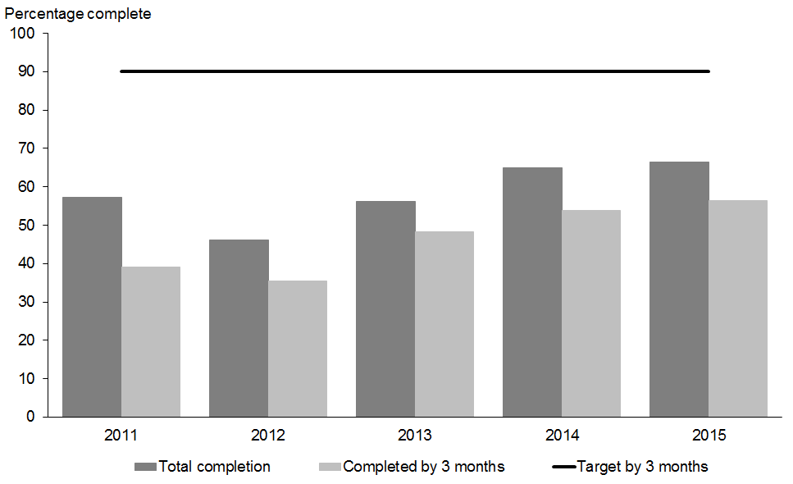

Table 29 shows performance at DHB level against the three-month target. Care should be taken when comparing DHB results due to the low numbers involved. These make the rates more unstable and lead to wide confidence intervals. Three DHBs met the 90% target (Wairarapa, Hutt Valley, and South Canterbury). A further five DHBs had rates above 70%. Appendix 3 contains further audiology completion tables showing the number and percentage completed later than three months and in total by DHB, ethnicity and NZ deprivation quintile.

Table 29: Audiology assessment completion for babies referred from newborn hearing screening by timeframe and DHB, 1 January to 31 December 2015
DHB of screen | Completed audiology by 3 months  N | Referred to audiology  N | Percentage complete by 3 months  % | 95% confidence interval
Northland | 45 | 113 | 39.8 | (31.3, 49.0)
Waitemata | 60 | 102 | 58.8 | (49.1, 67.9)
Auckland | 86 | 126 | 68.3 | (59.7, 75.7)
Counties Manukau | 67 | 185 | 36.2 | (29.6, 43.4)
Waikato | 73 | 140 | 52.1 | (43.9, 60.2)
Lakes | 15 | 29 | 51.7 | (34.4, 68.6)
Bay of Plenty | 33 | 64 | 51.6 | (39.6, 63.4)
Tairāwhiti | 7 | 9 | 77.8 | (45.3, 93.7)
Taranaki | 22 | 35 | 62.9 | (46.3, 76.8)
Hawke’s Bay | 45 | 104 | 43.3 | (34.2, 52.9)
Whanganui | 8 | 11 | 72.7 | (43.4, 90.3)
MidCentral | 23 | 60 | 38.3 | (27.1, 51.0)
Hutt Valley | 65 | 69 | 94.2 | (86.0, 97.7)
Capital & Coast | 68 | 97 | 70.1 | (60.4, 78.3)
Wairarapa | 6 | 6 | 100.0 | (61.0, 100)
Nelson Marlborough | 11 | 14 | 78.6 | (52.4, 92.4)
West Coast | 2 | 5 | 40.0 | (11.8, 76.9)
Canterbury | 69 | 88 | 78.4 | (68.7, 85.7)
South Canterbury | 17 | 19 | 89.5 | (68.6, 97.1)
Southern | 22 | 42 | 52.4 | (37.7, 66.6)
Total | 744 | 1318 | 56.4 | (53.8, 59.1)

Figure 5 shows DHB rates for audiology completion by three months for the past three years. Most DHB results vary year on year in keeping with the relatively low numbers involved which means rates are more changeable. The largest fluctuations relate to very small numbers of audiology referrals (for example, West Coast had only five referrals for 2015).

Figure 5: Audiology completion by 3 months of age by DHB, 2013–2015
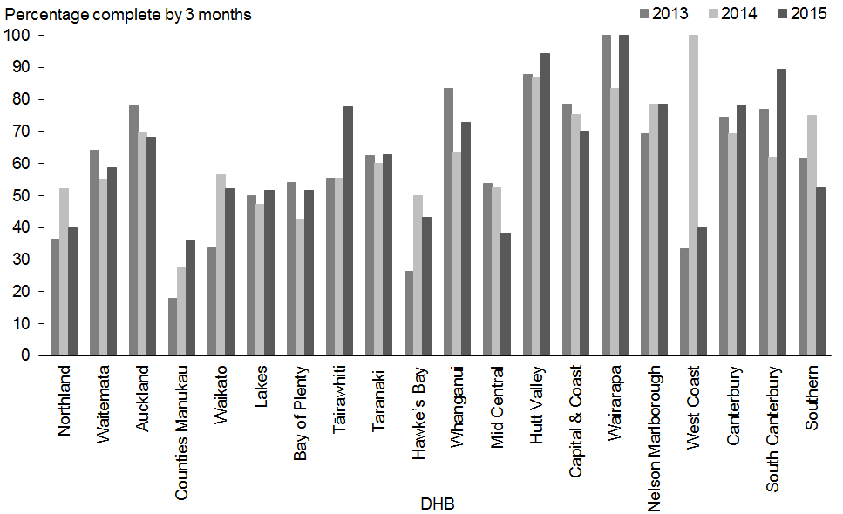

Audiology assessment completion by three months of age was below target for all ethnic groups (Table 30). The highest rate was 68.9% for Other, followed by 67.5% for Asian. Rates for Māori (44.3%) and Pacific (45.0%) were around half the 90% target.

Table 30: Audiology assessment completion for babies referred from newborn hearing screening by timeframe and ethnicity, 1 January to 31 December 2015
Ethnicity | Completed audiology by 3 months  N | Referred to audiology  N | Percentage complete by 3 months  % | 95% confidence interval
Māori | 206 | 465 | 44.3 | (39.9, 48.8)
Pacific | 90 | 200 | 45.0 | (38.3, 51.9)
Asian | 102 | 151 | 67.5 | (59.7, 74.5)
Other | 346 | 502 | 68.9 | (64.7, 72.8)
Total | 744 | 1318 | 56.4 | (53.8, 59.1)

Figure 6 shows the five-year time trend in audiology completion by three months of age by ethnicity. This demonstrates improvement in timely audiology completion for all ethnicities. Māori and Pacific rates have increased every year since 2012, while the rates for Asian and Other decreased or levelled off in 2015 after previous increases.

Figure 6: Audiology completion by 3 months of age by ethnicity, 2011–2015
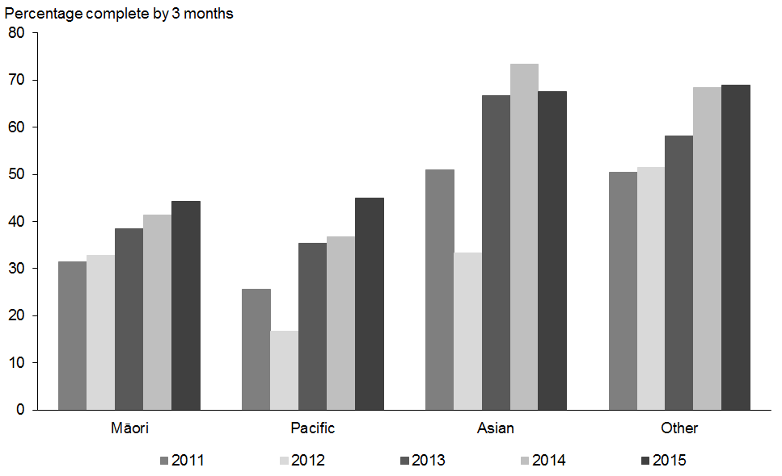

Variation in three-month completion rates by deprivation was also evident. Quintile 5, the most deprived, had a rate of 42.7% compared to a rate of 73.9% for quintile 1 (see Table 31).

Table 31: Audiology assessment completion for babies referred from newborn hearing screening by timeframe and deprivation, 1 January to 31 December 2015
NZ Dep 2013 | Completed audiology by 3 months  N | Referred to audiology  N | Percentage complete by 3 months  % | 95% confidence interval
Quintile 1 | 102 | 138 | 73.9 | (66.0, 80.5)
Quintile 2 | 117 | 171 | 68.4 | (61.1, 74.9)
Quintile 3 | 119 | 173 | 68.8 | (61.5, 75.2)
Quintile 4 | 175 | 293 | 59.7 | (54.0, 65.2)
Quintile 5 | 231 | 541 | 42.7 | (38.6, 46.9)
Unknown | – | 2 | 0.0 | (0.0, 65.8)
Total | 744 | 1318 | 56.4 | (53.8, 59.1)

2.2b Proportion of babies with confirmed PCHL who have a diagnosis by 3 months of age
Indicator 2.2b | Target
The proportion of babies with confirmed permanent congenital hearing loss that have a diagnosis by three months of (corrected) age. | No target set

Assessment completion timeliness is particularly important for the group of babies that have a diagnosis of PCHL. Of the 1318 babies referred to audiology during 2015, 121 had a confirmed diagnosis of PCHL. Of these 121 babies, 101 (86.0%) had hearing loss confirmed by the time they reached three months of age. The low numbers involved limit DHB rate comparisons but these have been included for information in Table 32.

Table 32: Proportion of babies with confirmed PCHL following newborn hearing screening who have a diagnosis by 3 months of age, 1 January to 31 December 2015
DHB of screen | Confirmed PCHL by 3 months  N | Total babies with confirmed PCHL  N | % PCHL confirmed by 3 months  % | 95% confidence interval
Northland | 5 | 6 | 83.3 | (43.6, 97.0)
Waitemata | 10 | 13 | 76.9 | (49.7, 91.8)
Auckland | 9 | 11 | 81.8 | (52.3, 94.9)
Counties Manukau | 7 | 10 | 70.0 | (39.7, 89.2)
Waikato | 9 | 10 | 90.0 | (59.6, 98.2)
Lakes | 1 | 2 | 50.0 | (9.5, 90.5)
Bay of Plenty | 7 | 8 | 87.5 | (52.9, 97.8)
Tairāwhiti | 3 | 3 | 100.0 | (43.9, 100)
Taranaki | 3 | 3 | 100.0 | (43.9, 100)
Hawke’s Bay | 2 | 2 | 100.0 | (34.2, 100)
Whanganui | 1 | 1 | 100.0 | (20.7, 100)
MidCentral | 4 | 4 | 100.0 | (51.0, 100)
Hutt Valley | 8 | 8 | 100.0 | (67.6, 100)
Capital & Coast | 6 | 7 | 85.7 | (48.7, 97.4)
Wairarapa | 2 | 2 | 100.0 | (34.2, 100)
Nelson Marlborough | 2 | 2 | 100.0 | (34.2, 100)
West Coast | – | – | – | –
Canterbury | 20 | 24 | 83.3 | (64.1, 93.3)
South Canterbury | 2 | 2 | 100.0 | (34.2, 100)
Southern | 3 | 3 | 100.0 | (43.9, 100)
Total | 104 | 121 | 86.0 | (78.6, 91.0)

2.2c Duration of audiology assessment
Indicator 2.2c | Target
The duration of audiology diagnosis from assessment to completion. | No target set

This indicator looks at the duration of audiology assessment from the date assessment starts to date of completion. The national median assessment duration was one day, meaning that for most babies assessment was completed on the same day it started (748 out of 873 completed assessments, or 85.3%). All DHBs had a median assessment duration of 1 day.

Figure 7 shows the frequency distribution of completed assessments by duration of assessment. The duration range covered by the graph excludes those completed on the same day they were started (ie, duration of one day) because the size of this group would mean that the other bars would not be visible on the graph. Each bar represents one week, with the exception of the ‘> 175 days’ category at far right. The labels used for each bar show the number of days.

Figure 7: Audiology assessment duration for babies referred from newborn hearing screening, all DHBs, 1 January to 31 December 2015
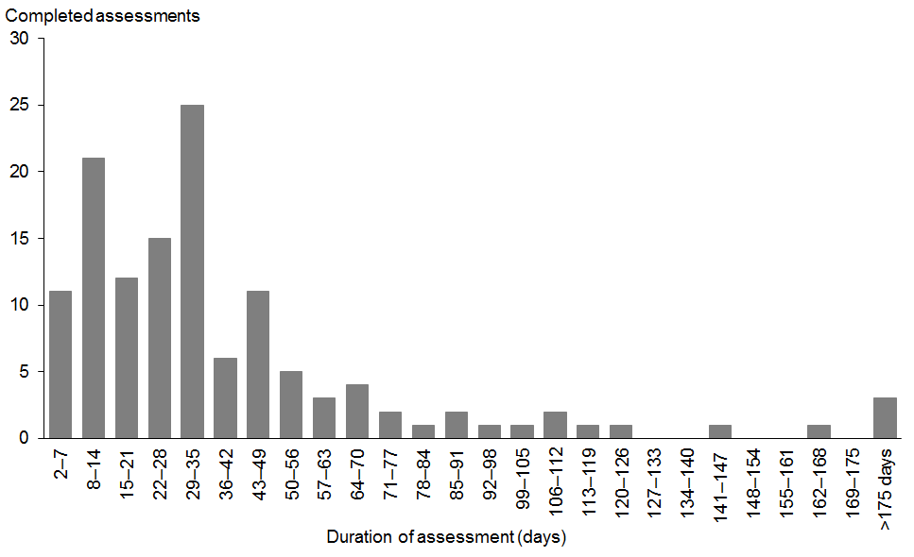
Note: A further 748 assessments were completed on the same day they were started.

2.3 Audiology assessment not attended
Indicator 2.3 | Target
The proportion of babies referred from screening who did not complete audiology assessments due to DNA, lost contact, declined or deceased. | No target set

Attendance at audiology assessments is a key factor in the success of the programme. Indicator 2.3 analyses the reasons recorded for audiology assessments that were not attended. It should be noted that DHB policies vary regarding the number of attempts that should be made to contact parents before the appointment is classified as ‘did not attend’ (DNA). As audiology data completeness increases it is expected that the reasons for non-attendance will be available for more assessments, and hence the counts reported will increase.

According to the data available from the national database at the time of reporting, 104 out of 1318 (7.9%) audiology referrals were classified as either DNA, lost contact or declined for the 2015 period (see Table 33). Included within the 104 were 20 assessments that were declined by the baby’s parents/guardians (1.5% of referrals).

Table 33: Total audiology assessments not attended for babies referred from newborn hearing screening by DHB, 1 January to 31 December 2015
DHB of screen | Total DNA, lost contact, declined  N | Total referred to audiology  N | Percentage not attended  % | 95% confidence interval
Northland | 22 | 113 | 19.5 | (13.2, 27.7)
Waitemata | – | 102 | 0.0 | (0.0, 3.6)
Auckland | 1 | 126 | 0.8 | (0.1, 4.4)
Counties Manukau | 1 | 185 | 0.5 | (0.1, 3.0)
Waikato | 30 | 140 | 21.4 | (15.4, 28.9)
Lakes | 5 | 29 | 17.2 | (7.6, 34.5)
Bay of Plenty | 11 | 64 | 17.2 | (9.9, 28.2)
Tairāwhiti | – | 9 | 0.0 | (0.0, 29.9)
Taranaki | 1 | 35 | 2.9 | (0.5, 14.5)
Hawke’s Bay | 10 | 104 | 9.6 | (5.3, 16.8)
Whanganui | 1 | 11 | 9.1 | (1.6, 37.7)
MidCentral | 9 | 60 | 15.0 | (8.1, 26.1)
Hutt Valley | 2 | 69 | 2.9 | (0.8, 10.0)
Capital & Coast | 8 | 97 | 8.2 | (4.2, 15.4)
Wairarapa | – | 6 | 0.0 | (0.0, 39.0)
Nelson Marlborough | – | 14 | 0.0 | (0.0, 21.5)
West Coast | 1 | 5 | 20.0 | (3.6, 62.4)
Canterbury | – | 88 | 0.0 | (0.0, 4.2)
South Canterbury | 1 | 19 | 5.3 | (0.9, 24.6)
Southern | 1 | 42 | 2.4 | (0.4, 12.3)
Total | 104 | 1318 | 7.9 | (6.6, 9.5)

Tables 34 and 35 provide breakdowns by ethnicity and deprivation. The numbers involved are low but the rate for Māori is higher than other ethnicities, as is the rate for babies from areas of higher deprivation.

Table 34: Total audiology assessments not attended for babies referred from newborn hearing screening by ethnicity, 1 January to 31 December 2015
Ethnicity | Total DNA, lost contact, declined  N | Total referred to audiology  N | Percentage not attended  % | 95% confidence interval
Māori | 73 | 465 | 15.7 | (12.7, 19.3)
Pacific | 8 | 200 | 4.0 | (2.0, 7.7)
Asian | 1 | 151 | 0.7 | (0.1, 3.7)
Other | 22 | 502 | 4.4 | (2.9, 6.5)
Total | 104 | 1318 | 7.9 | (6.6, 9.5)

Table 35: Total audiology assessments not attended for babies referred from newborn hearing screening by deprivation, 1 January to 31 December 2015
NZ Dep 2013 | Total DNA, lost contact, declined  N | Total referred to audiology  N | Percentage not attended  % | 95% confidence interval
Quintile 1 | 2 | 138 | 1.4 | (0.4, 5.1)
Quintile 2 | 5 | 171 | 2.9 | (1.3, 6.7)
Quintile 3 | 10 | 173 | 5.8 | (3.2, 10.3)
Quintile 4 | 25 | 293 | 8.5 | (5.8, 12.3)
Quintile 5 | 62 | 541 | 11.5 | (9.0, 14.4)
Unknown | – | 2 | 0.0 | (0.0, 65.8)
Total | 104 | 1318 | 7.9 | (6.6, 9.5)

2.4 Hearing loss detected
Indicator 2.4 | Target
The number of babies that have hearing loss detected as a proportion of all babies screened. | No target set

The detection of PCHL via newborn hearing screening is a key indicator of programme performance, and should be in line with international evidence on PCHL prevalence in comparable programmes. It is anticipated between one and two babies per 1000 screened will have moderate or more severe permanent congenital hearing loss identified. The national rate of PCHL for the 2015 period was close to the expected level with 2.2 babies per 1000 screens diagnosed with PCHL. A breakdown by DHBs has been provided but numbers are too low to make comparisons (Table 36).

Table 36: Proportion of babies screened that had permanent congenital hearing loss detected by DHB, 1 January to 31 December 2015
DHB of screen | Number of babies with confirmed PCHL |  |  | Total babies screened | Babies with confirmed PCHL per 1000 screened
 | Unilateral | Bilateral | Total |  | Unilateral | Bilateral | Total | 95% CI for total
Northland | 2 | 4 | 6 | 1691 | 1.2 | 2.4 | 3.5 | (1.7, 7.7)
Waitemata | 8 | 5 | 13 | 6825 | 1.2 | 0.7 | 1.9 | (1.1, 3.2)
Auckland | 8 | 3 | 11 | 5578 | 1.4 | 0.5 | 2.0 | (1.1, 3.5)
Counties Manukau | 5 | 5 | 10 | 7065 | 0.7 | 0.7 | 1.4 | (0.8, 2.6)
Waikato | 3 | 7 | 10 | 4738 | 0.6 | 1.5 | 2.1 | (1.2, 3.9)
Lakes | 1 | 1 | 2 | 1396 | 0.7 | 0.7 | 1.4 | (0.4, 5.2)
Bay of Plenty | 3 | 5 | 8 | 2353 | 1.3 | 2.1 | 3.4 | (1.8, 6.7)
Tairāwhiti | 1 | 2 | 3 | 696 | 1.4 | 2.9 | 4.3 | (1.5, 12.5)
Taranaki | 2 | 1 | 3 | 1463 | 1.4 | 0.7 | 2.1 | (0.7, 6.0)
Hawke’s Bay | 2 | – | 2 | 1763 | 1.1 | 0.0 | 1.1 | (0.3, 4.1)
Whanganui | – | 1 | 1 | 754 | 0.0 | 1.3 | 1.3 | (0.2, 7.5)
MidCentral | 2 | 2 | 4 | 1934 | 1.0 | 1.0 | 2.1 | (0.8, 5.3)
Hutt Valley | 4 | 4 | 8 | 1898 | 2.1 | 2.1 | 4.2 | (2.2, 8.2)
Capital & Coast | 4 | 3 | 7 | 3603 | 1.1 | 0.8 | 1.9 | (1.0, 4.0)
Wairarapa | 1 | 1 | 2 | 431 | 2.3 | 2.3 | 4.6 | (1.4, 16.6)
Nelson Marlborough | 1 | 1 | 2 | 1392 | 0.7 | 0.7 | 1.4 | (0.4, 5.2)
West Coast | – | – | – | 287 | 0.0 | 0.0 | 0.0 | (0.0, 13.2)
Canterbury | 8 | 16 | 24 | 6176 | 1.3 | 2.6 | 3.9 | (2.6, 5.7)
South Canterbury | 1 | 1 | 2 | 604 | 1.7 | 1.7 | 3.3 | (1.0, 11.9)
Southern | 1 | 2 | 3 | 3335 | 0.3 | 0.6 | 0.9 | (0.3, 2.6)
Total | 57 | 64 | 121 | 53,982 | 1.1 | 1.2 | 2.2 | (1.9, 2.7)

Rates of PCHL diagnosis by ethnicity ranged from 1.8 per 1000 for Other to 2.8 per 1000 babies screened for Asian (Table 37). Overlapping confidence intervals indicate that the difference in observed rates by ethnicity were not statistically significant. There was no consistent trend in rates of PCHL diagnoses by deprivation (see Table 38).

Table 37: Proportion of babies screened that had permanent congenital hearing loss detected by ethnicity, 1 January to 31 December 2015
Ethnicity | Number of babies with confirmed PCHL |  |  | Total babies screened | Babies with confirmed PCHL per 1000 screened
 | Unilateral | Bilateral | Total |  | Unilateral | Bilateral | Total | 95% CI for total
Māori | 15 | 19 | 34 | 12,717 | 1.2 | 1.5 | 2.7 | (1.9, 3.7)
Pacific | 8 | 6 | 14 | 5389 | 1.5 | 1.1 | 2.6 | (1.6, 4.3)
Asian | 14 | 11 | 25 | 8807 | 1.6 | 1.2 | 2.8 | (1.9, 4.2)
Other | 20 | 28 | 48 | 27,069 | 0.7 | 1.0 | 1.8 | (1.3, 2.3)
Total | 57 | 64 | 121 | 53,982 | 1.1 | 1.2 | 2.2 | (1.9, 2.7)

Table 38: Proportion of babies screened that had permanent congenital hearing loss detected by deprivation, 1 January to 31 December 2015
NZ Dep 2013 | Number of babies with confirmed PCHL |  |  | Total babies screened | Babies with confirmed PCHL per 1000 screened
 | Unilateral | Bilateral | Total |  | Unilateral | Bilateral | Total | 95% CI for total
Quintile 1 | 12 | 6 | 18 | 8287 | 1.4 | 0.7 | 2.2 | (1.4, 3.4)
Quintile 2 | 10 | 10 | 20 | 9085 | 1.1 | 1.1 | 2.2 | (1.4, 3.4)
Quintile 3 | 5 | 11 | 16 | 9846 | 0.5 | 1.1 | 1.6 | (1.0, 2.6)
Quintile 4 | 17 | 23 | 40 | 12,047 | 1.4 | 1.9 | 3.3 | (2.5, 4.5)
Quintile 5 | 12 | 14 | 26 | 14,636 | 0.8 | 1.0 | 1.8 | (1.2, 2.6)
Unknown | 1 | – | 1 | 81 | 12.3 | 0.0 | 12.3 | (3.1, 65.7)
Total | 57 | 64 | 121 | 53,982 | 1.1 | 1.2 | 2.2 | (1.9, 2.7)

Table 39 provides a count of PCHL diagnoses according to right and left ear results. Bilateral sensorineural hearing loss was the most common type of hearing loss identified with 7.8 babies diagnosed per 10,000 completed screens. This equated to 34.7% of PCHL diagnoses for the 2015 period.

Table 39: Proportion of babies screened that had permanent congenital hearing loss detected by type of hearing loss, 1 January to 31 December 2015
Right ear result | Left ear result | Number of babies | Number per 10,000 screens | % of babies with PCHL
Auditory neuropathy | Auditory neuropathy | 2 | 0.4 | 1.7
Auditory neuropathy | Normal | 3 | 0.6 | 2.5
Conductive permanent | Conductive permanent | 4 | 0.7 | 3.3
Conductive permanent | Conductive temporary | 2 | 0.4 | 1.7
Conductive permanent | Normal | 5 | 0.9 | 4.1
Conductive temporary | Auditory neuropathy | 2 | 0.4 | 1.7
Conductive temporary | Sensorineural | 3 | 0.6 | 2.5
Mixed | Mixed | 13 | 2.4 | 10.7
Normal | Auditory neuropathy | 5 | 0.9 | 4.1
Normal | Conductive permanent | 5 | 0.9 | 4.1
Normal | Mixed | 2 | 0.4 | 1.7
Normal | Sensorineural | 18 | 3.3 | 14.9
Sensorineural | Conductive permanent | 1 | 0.2 | 0.8
Sensorineural | Conductive temporary | 1 | 0.2 | 0.8
Sensorineural | Mixed | 2 | 0.4 | 1.7
Sensorineural | Normal | 11 | 2.0 | 9.1
Sensorineural | Sensorineural | 42 | 7.8 | 34.7
Total |  | 121 | 22.4 | 100.0

A further breakdown of PCHL diagnoses by DHB and type of hearing loss is included as Appendix 4.

Early Intervention education services indicators
The remaining indicators relate to Early Intervention education services provided to babies referred from newborn hearing screening. During the 2015 calendar year the Ministry of Education Special Education group recorded a total of 150 referrals across the 16 Ministry of Education districts, as shown in Table 40. A map showing the boundaries of these districts is given in Appendix 1.

Table 40: Referrals received by Ministry of Education districts, 1 January to 31 December 2015
Ministry of Education district | Referrals  N
Auckland City | 18
Bay of Plenty East | 4
Bay of Plenty West | 4
Canterbury | 19
Central Palmerston North | 3
Gisborne | 4
Greater Wellington | 10
Hawke’s Bay | 4
Manukau | 22
Nelson/Marlborough/Westland | 8
North West Auckland | 17
Otago | –
Southland | 2
Tai Tokerau (Northland) | 5
Taranaki | 6
Waikato | 24
Total | 150

Table 41 shows referrals received with ethnicity groups identified. Babies with more than one ethnicity are counted in more than one ethnicity group.

Table 41: Referrals received by ethnicity of child, 1 January to 31 December 2015
Ethnicity  (total response) | Referrals  N
Asian | 22
Māori | 45
NZ European | 58
Other | 13
Pasifika | 19
Unknown | 18
Total | 175

3.1 Making initial contact with families/whānau
Indicator 3.1 | Target
The number of working days taken for Early Intervention education services to make contact with the family/whānau. | ≥95% contacted within 10 working days

The earlier that contact is made with families/whānau the greater the opportunity to meet the international standard of intervention by six months. The target is for contact to be made within 10 working days for 95% or more of referrals. For the 2015 year, 120 out of 150 referrals (80%) were contacted within 10 days.

Table 42 shows a breakdown by ethnicity of the number of referrals where contact was made within 10 days. The rate for Pasifika exceeded the target but other ethnic groups were below.

Table 42: Time taken for first contact by ethnicity, 1 January to 31 December 2015
Ethnicity  (total response) | Contact within 10 days  N | Referrals  N | Within 10 days  % | 95% confidence interval
Asian | 16 | 22 | 72.7 | (51.8, 86.8)
Māori | 33 | 45 | 73.3 | (59.0, 84.0)
NZ European | 45 | 58 | 77.6 | (65.3, 86.4)
Other | 11 | 13 | 84.6 | (57.8, 95.7)
Pasifika | 18 | 19 | 94.7 | (75.4, 99.1)
Unknown | 15 | 18 | 83.3 | (60.8, 94.2)

Table 43 shows a breakdown by education district of referrals where contact was made within 10 days. Due to low numbers, percentage calculations are not shown.

Table 43: Time taken for first contact by education district, 1 January to 31 December 2015
Ministry of Education district | Contact within 10 days  N | Contact after 10 days  N
Auckland City | 14 | 4
Bay of Plenty East | 4 | 0
Bay of Plenty West | 4 | 0
Canterbury | 16 | 3
Central Palmerston North | 2 | 1
Gisborne | 1 | 3
Greater Wellington | 6 | 4
Hawke’s Bay | 3 | 1
Manukau | 21 | 1
Nelson/Marlborough/Westland | 7 | 1
North West Auckland | 14 | 3
Otago | 0 | 0
Southland | 2 | 0
Tai Tokerau (Northland) | 4 | 1
Taranaki | 5 | 1
Waikato | 17 | 7
Total | 120 | 30

Reasons given for instances of greater than 10 working day response time include incorrect coding of referrals (not initially identified as UNHS referral), unable to make contact with families, contact details received for families had changed, Adviser on Deaf Children on leave (only one advisor in district), and vacancies for Adviser on Deaf Children roles.

The majority of referrals are responded to within five working days, as shown in Table 44.

Table 44: First contact by time category, 1 January to 31 December 2015
Time for first contact (days) | Number of referrals  N | %
< 2 days | 63 | 42.0
3 to 5 days | 36 | 24.0
6 to 10 days | 21 | 14.0
11 to 20 days | 14 | 9.3
> 20 days | 16 | 10.7
Total | 150

3.2 Commencement of Early Intervention education services
Indicator 3.2 | Target
3.2a Proportion of children eligible for and referred to Early Intervention education services who began receiving a service within one month following receipt of referral. Number of months following receipt of referral that other families/whānau and children began receiving a service. | ≥90%
3.2b Proportion of children up to six months of age eligible for and referred to Early Intervention education services who began receiving a service by six months of age. | ≥90%
3.2c Proportion of children eligible for and referred to Early Intervention education services after six months of age. | No target set.

This indicator measures the timeliness with which all children diagnosed following screening are engaged in Early Intervention education services. The target is for at least 90% of children to begin receiving services within one month of referral. As Table 45 shows, this target was met for the 2015 period, with 91.3% of children referred to Early Intervention education services receiving a service within one month of referral.

Table 45: Time taken for commencement of services, 1 January to 31 December 2015
Time taken for service (months) | Number of referrals  N | %
< 1 month | 137 | 91.3
1 to 2 | 7 | 4.7
2 to 3 | 3 | 2.0
3 to 4 | 2 | 1.3
Not recorded | 1 | 0.7
Total | 150

Tables 46 and 47 provide further breakdowns by ethnicity and Ministry of Education District respectively. The observed rates for all ethnic groups except Asian and NZ European exceeded the 90% target. For all education districts the majority of referrals commenced services within one month.

Table 46: Time taken for commencement of services by ethnicity, 1 January to 31 December 2015
Ethnicity  (total response) | Commenced within 1 month |  |  |  | Later commencement
 | Service commenced <1 month | Referrals | % | 95% confidence interval | 1–2 months | 2–3 months | 3–4 months | Unknown
 | N | N |  |  | N | N | N | N
Asian | 19 | 22 | 86.4 | (66.7, 95.3) | 2 | 1 | – | –
Māori | 41 | 45 | 91.1 | (79.3, 96.5) | 2 | 1 | 1 | –
NZ European | 51 | 58 | 87.9 | (77.1, 94.0) | 3 | 1 | 2 | 1
Other | 12 | 13 | 92.3 | (66.7, 98.6) | 1 | – | – | –
Pasifika | 19 | 19 | 100.0 | (83.2, 100) | – | – | – | –
Unknown | 17 | 18 | 94.4 | (74.2, 99.0) | 1 | – | – | –

Table 47: Time taken for commencement of services by Education District, 1 January to 31 December 2015
Ministry of Education district | Time taken for service (months) | Number of referrals  N
Auckland City | <1 | 16
Auckland City | 1 to 2 | 2
Bay of Plenty East | <1 | 4
Bay of Plenty West | <1 | 4
Canterbury | <1 | 18
Canterbury | 1 to 2 | 1
Central (Palmerston North) | <1 | 2
Central (Palmerston North) | 1 to 2 | 1
Gisborne | <1 | 4
Greater Wellington | <1 | 9
Greater Wellington | 2 to 3 | 1
Hawkes Bay | <1 | 4
Manukau | <1 | 22
Nelson/Marlborough/Westland | <1 | 7
Nelson/Marlborough/Westland | 3 to 4 | 1
North West | <1 | 16
North West | 1 to 2 | 1
Southland | <1 | 2
Tai Tokerau | <1 | 5
Taranaki | <1 | 5
Taranaki | Not recorded | 1
Waikato | <1 | 19
Waikato | 1 to 2 | 2
Waikato | 2 to 3 | 2
Waikato | 3 to 4 | 1
Total |  | 150

The second part of this indicator measures the proportion of children that began receiving Early Intervention services by six months of age. The target is for at least 90% to begin by six months, this target was met for the 2015 year with 97.7% of children receiving first service by six months of age. The target was also met for all ethnic groups (see Table 49).

Table 48: Proportion of referrals where service received by 6 months of age, 1 January to 31 December 2015
Age when service first received (months) | Number of children  N | %
< 6 months | 84 | 97.7
6 to 10 months | 2 | 2.3

Table 49: Proportion of referrals where services were received by 6 months of age by ethnicity, 1 January to 31 December 2015
Ethnicity  (total response) | Services started  by 6 months  N | Aged <6 months at referral  N | % | 95% confidence interval
Asian | 13 | 13 | 100.0 | (77.2, 100)
Māori | 21 | 22 | 95.5 | (78.2, 99.2)
NZ European | 34 | 36 | 94.4 | (81.9, 98.5)
Other | 10 | 10 | 100.0 | (72.2, 100)
Pasifika | 11 | 12 | 91.7 | (64.6, 98.5)
Unknown | 8 | 8 | 100.0 | (67.6, 100)

The final part of this indicator measures the timeliness of referral. The required outcome is for referrals to be received before the child is six months of age. During the reporting period 150 referrals were recorded, of which 42.7% were received for children who were six months or older (see Table 50).

Table 50: Proportion of referrals where child was aged >6 months, 1 January to 31 December 2015
Age at referral (months) | Number of referrals  N | %
<6 | 86 | 57.3
6 to 10 | 16 | 10.7
11 to 15 | 9 | 6.0
16 to 20 | 5 | 3.3
21 to 25 | 9 | 6.0
26 to 30 | 7 | 4.7
31 to 35 | 3 | 2.0
36+ | 15 | 10.0
Total | 150

Table 51 provides a further breakdown by ethnicity and referral timeframe. Both Māori and NZ European ethnicities had a higher number of referrals at older age ranges (21 months and older).

Table 51: Referrals received by age at referral and ethnicity, 1 January to 31 December 2015
Ethnicity  (total response) | Referred before 6 months |  |  |  | Later referrals (grouped by month)
 | Referred <6 months | Referrals | % | 95% confidence interval | 6–10 | 11–15 | 16–20 | 21–25 | 26+
 | N | N |  |  | N | N | N | N | N
Asian | 13 | 22 | 59.1 | (38.7, 76.7) | 1 | 3 | – | 2 | 3
Māori | 22 | 45 | 48.9 | (35.0, 63.0) | 4 | 2 | 3 | 5 | 9
NZ European | 36 | 58 | 62.1 | (49.2, 73.4) | 5 | 3 | 4 | 1 | 9
Other | 10 | 13 | 76.9 | (49.7, 91.8) | 1 | 1 | – | – | 1
Pasifika | 12 | 19 | 63.2 | (41.0, 80.9) | 3 | – | – | 1 | 3
Unknown | 8 | 18 | 44.4 | (24.6, 66.3) | 4 | 1 | – | – | 5

3.3 Continuation of Early Intervention education services
Indicator 3.3 | Target
3.3a The proportion of children referred as a result of newborn hearing screening and eligible for the Early intervention education service who exited services prior to three years of age. | No target set
3.3b The proportion of children referred as a result of newborn hearing screening and eligible for the Early Intervention education service who exited services prior to five years of age. | No target set

During the 2015 reporting period 66 children exited early intervention education services. Of these, 36 children (54.5%) were aged less than three years and 30 children were aged between three and five years (45.5%).

Table 52: Age of children at exit from early intervention education services, 1 January to 31 December 2015
Age when service exited (years) | Number of children  N
< 3 years | 36
3 to 5 years | 30

Interpretation of these data needs to be done in a considered way as the reasons for withdrawal are varied. Some families may withdraw due to emigrating or because their child has age-appropriate development. The list below gives the reasons reported for withdrawals during 2015. In many cases the exit is actually a change in service as opposed to a complete withdrawal from services.

Rationale for exiting services:
- parent decision to close, service no longer required (n=20)
- case closed and reopened with a change of lead worker (n=11) – still receiving a service
- case closed and reopened, coded incorrectly not as newborn screening referral (n=11) – still receiving a service
- transition to school, code changed (n=13) – still receiving a service
- transition to other service provider (n=1) – still receiving a service
- deceased (n=5)
- family immigrated (n=4)
- contact lost with family (n=1).

3.4 Outcome of early intervention
Indicator 3.4 | Target
3.4a Proportion of children referred as a result of newborn hearing screening and eligible for the Early Intervention education service who received a language assessment between four years six months and five years of age. | No target set
3.4b Proportion of children referred as a result of newborn hearing screening and eligible for the Early Intervention education service whose language level was within six months of their chronological age at four years six months to five years of age. | No target set
3.4c Proportion of children referred as a result of newborn hearing screening and eligible for the Early Intervention service whose language level was delayed six months or more for their chronological age at four years six months to five years of age. | No target set

For the 2015 period reporting for this indicator coves the Ministry of Education Central North region only. Data for the Northern, Central South and Southern Ministry of Education regions should be available from the reporting period 2017 onwards.

During the 2015 year 19 children in the Central North region were eligible for assessment and 18 (95%) has assessment completed. Of these, six children (33%) presented with language levels within six months of their chronological age at four years six months to five years of age.

The remaining 12 children presented with a language level that was delayed six months or more for their chronological age at four years six months to five years of age. The reasons recorded for these delays are shown in the list below.

Rationale for language level delay that was six months or more for their chronological age at four years six months to five years of age:
- children presenting with additional disabilities to hearing loss (n=5)
- family initially declined service, delayed hearing aid and cochlear implant use (n=2)
- late diagnosis after screening (n=2)
- low family engagement and delayed and inconsistent use of hearing aid/cochlear implant, (n=3).

Hearing screening indicators not yet monitored
The indicators below are either under development or data is not currently available. Indicator 2.1 will be monitored by DHBs using data contained in NHIMS rather than in the annual national monitoring report.

Indicator | Target
1.4 Newborn hearing DNAs and lost contact  The number of babies that do not complete screening due to not attending or the service losing contact as a proportion of all babies whose parents/guardians consented to screening. | No target set
1.7 First refer rates  The number of babies referred from first to second aABR screening as a proportion of all babies that completed first aABR screens. | No target set
2.1 Audiology assessment commencement  2.1a The proportion of babies referred from screening who are offered audiology appointments dated within four weeks of referral.  2.1b The proportion of babies referred from screening who start audiology assessment within four weeks of referral, and in total for the reporting period. | 100%  No target set
2.5 Outcome of hearing surveillance  2.5a The proportion of babies with identified risk factor(s) that have permanent congenital hearing loss (PCHL) identified.  2.5b The proportion of babies who are referred for hearing surveillance that do not have an audiology assessment. | No target set  No target set
2.6 Cases not identified by screening  The number of cases of moderate or more severe hearing permanent hearing loss identified during the reporting period in children less than six years of age that were not referred from screening to audiology. | No target set
2.7 Age at first assistive device  The number of babies referred from screening diagnosed with PCHL who have an assistive hearing device fitted by six months of age as a proportion of all babies referred from screening diagnosed with PCHL. | No target set

Appendix 1
Figure 8: Ministry of Education regions and districts
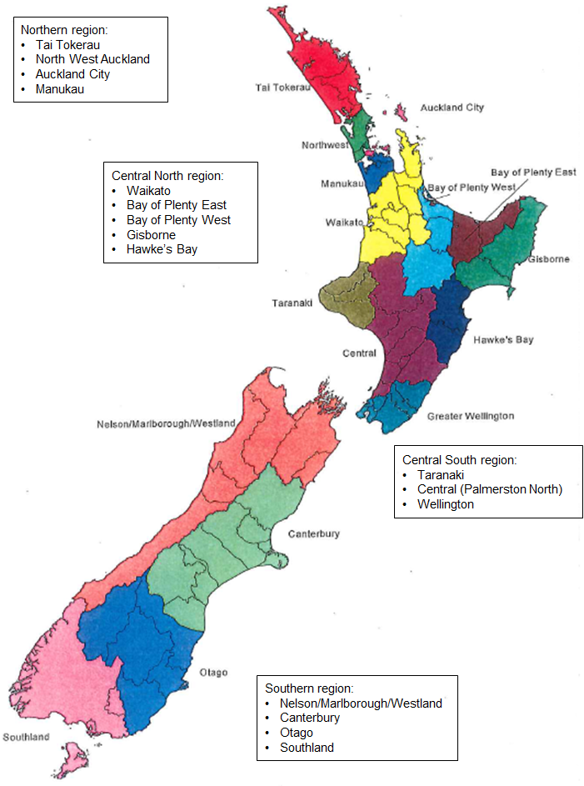

Appendix 2
Figure 9: Ministry of Health District Health Board boundaries
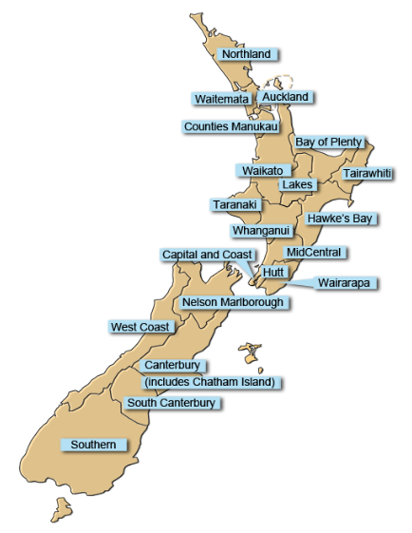

Appendix 3
Table 53: Audiology assessment completion by timeframe and DHB, 1 January to 31 December 2015
DHB of screen | Complete <3 months | Complete 3–6 months | Complete >6 months | Total referred to audiology | Complete <3 months | Complete 3–6 months | Complete >6 months | Total complete
 | N | N | N | N | % | % | % | %
Northland | 45 | 19 | – | 113 | 39.8 | 16.8 | 0.0 | 56.6
Waitemata | 60 | 12 | 2 | 102 | 58.8 | 11.8 | 2.0 | 72.5
Auckland | 86 | 4 | 1 | 126 | 68.3 | 3.2 | 0.8 | 72.2
Counties Manukau | 67 | 23 | 3 | 185 | 36.2 | 12.4 | 1.6 | 50.3
Waikato | 73 | 11 | 1 | 140 | 52.1 | 7.9 | 0.7 | 60.7
Lakes | 15 | 3 | – | 29 | 51.7 | 10.3 | 0.0 | 62.1
Bay of Plenty | 33 | 9 | 1 | 64 | 51.6 | 14.1 | 1.6 | 67.2
Tairāwhiti | 7 | – | – | 9 | 77.8 | 0.0 | 0.0 | 77.8
Taranaki | 22 | 1 | – | 35 | 62.9 | 2.9 | 0.0 | 65.7
Hawke’s Bay | 45 | 12 | 1 | 104 | 43.3 | 11.5 | 1.0 | 55.8
Whanganui | 8 | – | 1 | 11 | 72.7 | 0.0 | 9.1 | 81.8
MidCentral | 23 | 9 | 2 | 60 | 38.3 | 15.0 | 3.3 | 56.7
Hutt Valley | 65 | – | – | 69 | 94.2 | 0.0 | 0.0 | 94.2
Capital & Coast | 68 | 4 | 3 | 97 | 70.1 | 4.1 | 3.1 | 77.3
Wairarapa | 6 | – | – | 6 | 100.0 | 0.0 | 0.0 | 100.0
Nelson Marlborough | 11 | – | – | 14 | 78.6 | 0.0 | 0.0 | 78.6
West Coast | 2 | – | – | 5 | 40.0 | 0.0 | 0.0 | 40.0
Canterbury | 69 | 9 | – | 88 | 78.4 | 10.2 | 0.0 | 88.6
South Canterbury | 17 | – | – | 19 | 89.5 | 0.0 | 0.0 | 89.5
Southern | 22 | – | 2 | 42 | 52.4 | 0.0 | 4.8 | 57.1
Total | 744 | 116 | 17 | 1318 | 56.4 | 8.8 | 1.3 | 66.5

Table 54: Audiology assessment completion by timeframe and ethnicity, 1 January to 31 December 2015
Ethnicity | Complete <3 months | Complete 3–6 months | Complete >6 months | Total referred to audiology | Percentage complete <3 months | Percentage complete 3–6 months | Percentage complete >6 months | Total percentage complete
 | N | N | N | N | % | % | % | %
Māori | 206 | 46 | 3 | 465 | 44.3 | 9.9 | 0.6 | 54.8
Pacific | 90 | 21 | 4 | 200 | 45.0 | 10.5 | 2.0 | 57.5
Asian | 102 | 11 | 2 | 151 | 67.5 | 7.3 | 1.3 | 76.2
Other | 346 | 38 | 8 | 502 | 68.9 | 7.6 | 1.6 | 78.1
Total | 744 | 116 | 17 | 1318 | 56.4 | 8.8 | 1.3 | 66.5

Table 55: Audiology assessment completion by timeframe and deprivation, 1 January to 31 December 2015
NZ Dep 2013 | Complete <3 months | Complete 3–6 months | Complete >6 months | Total referred to audiology | Percentage complete <3 months | Percentage complete 3–6 months | Percentage complete >6 months | Total percentage complete
 | N | N | N | N | % | % | % | %
Quintile 1 | 102 | 8 | 3 | 138 | 73.9 | 5.8 | 2.2 | 81.9
Quintile 2 | 117 | 17 | 2 | 171 | 68.4 | 9.9 | 1.2 | 79.5
Quintile 3 | 119 | 9 | 1 | 173 | 68.8 | 5.2 | 0.6 | 74.6
Quintile 4 | 175 | 25 | 3 | 293 | 59.7 | 8.5 | 1.0 | 69.3
Quintile 5 | 231 | 57 | 7 | 541 | 42.7 | 10.5 | 1.3 | 54.5
Unknown | – | – | 1 | 2 | 0.0 | 0.0 | 50.0 | 50.0
Total | 744 | 116 | 17 | 1318 | 56.4 | 8.8 | 1.3 | 66.5

Appendix 4
Table 56: Number of babies screened that had permanent congenital hearing loss detected by type of hearing loss and DHB, 1 January to 31 December 2015
DHB of screening | Right ear result | Left ear result | Number of babies
Northland | Conductive permanent | Normal | 1
Northland | Normal | Sensorineural | 1
Northland | Sensorineural | Sensorineural | 4
Waitemata | Auditory neuropathy | Normal | 2
Waitemata | Conductive permanent | Conductive permanent | 1
Waitemata | Conductive temporary | Conductive permanent | 1
Waitemata | Normal | Auditory neuropathy | 2
Waitemata | Normal | Conductive permanent | 1
Waitemata | Sensorineural | Normal | 2
Waitemata | Sensorineural | Sensorineural | 4
Auckland | Conductive permanent | Conductive permanent | 1
Auckland | Conductive temporary | Conductive permanent | 1
Auckland | Normal | Auditory neuropathy | 1
Auckland | Normal | Conductive permanent | 1
Auckland | Normal | Sensorineural | 4
Auckland | Sensorineural | Normal | 1
Auckland | Sensorineural | Sensorineural | 2
Counties Manukau | Conductive permanent | Normal | 1
Counties Manukau | Mixed | Mixed | 1
Counties Manukau | Sensorineural | Conductive temporary | 1
Counties Manukau | Sensorineural | Normal | 3
Counties Manukau | Sensorineural | Sensorineural | 4
Waikato | Auditory neuropathy | Auditory neuropathy | 1
Waikato | Auditory neuropathy | Normal | 1
Waikato | Mixed | Sensorineural | 1
Waikato | Sensorineural | Normal | 2
Waikato | Sensorineural | Sensorineural | 5
Lakes | Mixed | Mixed | 1
Lakes | Normal | Conductive permanent | 1
Bay of Plenty | Mixed | Mixed | 2
Bay of Plenty | Mixed | Normal | 1
Bay of Plenty | Sensorineural | Conductive temporary | 1
Bay of Plenty | Sensorineural | Normal | 1
Bay of Plenty | Sensorineural | Sensorineural | 3
Tairāwhiti | Sensorineural | Normal | 1
Tairāwhiti | Sensorineural | Sensorineural | 2
Taranaki | Mixed | Sensorineural | 1
Taranaki | Normal | Sensorineural | 1
Taranaki | Sensorineural | Normal | 1
Hawke’s Bay | Normal | Sensorineural | 1
Hawke’s Bay | Sensorineural | Normal | 1
Whanganui | Sensorineural | Sensorineural | 1
Mid Central | Mixed | Mixed | 2
Mid Central | Normal | Conductive permanent | 2
Hutt Valley | Conductive permanent | Normal | 1
Hutt Valley | Normal | Sensorineural | 1
Hutt Valley | Sensorineural | Normal | 2
Hutt Valley | Sensorineural | Sensorineural | 4
Capital & Coast | Auditory neuropathy | Conductive temporary | 1
Capital & Coast | Conductive temporary | Sensorineural | 1
Capital & Coast | Normal | Sensorineural | 1
Capital & Coast | Sensorineural | Normal | 1
Capital & Coast | Sensorineural | Sensorineural | 3
Wairarapa | Auditory neuropathy | Normal | 1
Wairarapa | Sensorineural | Sensorineural | 1
Nelson Marlborough | Mixed | Mixed | 1
Nelson Marlborough | Sensorineural | Normal | 1
Canterbury | Auditory neuropathy | Auditory neuropathy | 1
Canterbury | Auditory neuropathy | Conductive temporary | 1
Canterbury | Conductive permanent | Conductive permanent | 2
Canterbury | Conductive permanent | Normal | 1
Canterbury | Conductive permanent | Sensorineural | 1
Canterbury | Mixed | Mixed | 6
Canterbury | Mixed | Normal | 1
Canterbury | Normal | Sensorineural | 2
Canterbury | Sensorineural | Conductive temporary | 1
Canterbury | Sensorineural | Normal | 2
Canterbury | Sensorineural | Sensorineural | 6
South Canterbury | Auditory neuropathy | Normal | 1
South Canterbury | Sensorineural | Sensorineural | 1
Southern | Conductive permanent | Normal | 1
Southern | Sensorineural | Sensorineural | 2
Total |  |  | 121

Young Futures. 2014. Review of Newborn Hearing Screening Regimes and Associated Screening Devices for the National Screening Unit. Ministry of Health, New Zealand, March 2014.
In this report permanent congenital hearing loss has been defined as a diagnosis that includes auditory neuropathy, sensorineural, conductive permanent, or mixed (combination of sensorineural and conductive) hearing loss.
Young Futures. 2014. Review of Newborn Hearing Screening Regimes and Associated Screening Devices for the National Screening Unit. Ministry of Health, New Zealand, March 2014.

