Newborn
Metabolic
Screening Programme

Annual Report
January to December 2016

Disclaimer
This publication reports on information provided to the Ministry of Health by the Auckland District Health Board. The purpose of this publication is to inform discussion and assist ongoing Newborn Metabolic Screening Programme development. All care has been taken in the production of this report, and the data was deemed to be accurate at the time of publication. However, the data may be subject to slight changes over time as further information is received. Before quoting or using this information, it is advisable to check the current status with the Ministry of Health.

Citation: Ministry of Health. 2017. Newborn Metabolic Screening Programme Annual Report 2016. Wellington: Ministry of Health.

Published in June 2017
by the Ministry of Health
PO Box 5013, Wellington 6140, New Zealand

ISBN 978-1-98-850262-5 (online)
HP 6632

This document is available at nsu.govt.nz

This work is licensed under the Creative Commons Attribution 4.0 International licence. In essence, you are free to: share i.e., copy and redistribute the material in any medium or format; adapt i.e., remix, transform and build upon the material. You must give appropriate credit, provide a link to the licence and indicate if changes were made.
Contents
Introduction 4
Background to the Programme 4
Data Summary 4
Executive Summary 5
Indicator 1: Coverage 6
Indicator 2: Timing of Sample Taking 12
Indicator 3: Quality of Blood Samples 14
Indicator 4: Sample Dispatch and Delivery 16
Indicator 5: Laboratory Testing Timeframes 18
Indicator 6: Timeliness of Reporting - Notification of Screen Positives 20
Indicator 7: Collection and Receipt of Second Samples 22
Indicator 8: Diagnosis and Commencement of Treatment 24
Indicator 9: Blood Spot Card Storage and Return 26
Appendix 1: List of Screened Conditions 27

Introduction
This annual report provides information on the performance of the Newborn Metabolic Screening Programme (NMSP) against the agreed set of national indicators. Regular analysis and reporting of NMSP data is a key tool in enabling continuous quality improvement of the programme.
This is the sixth annual report of the NMSP following the development of national indicators in 2010. The NMSP Monitoring Framework and monitoring reports are published on the National Screening Unit (NSU) website: www.nsu.govt.nz/health-professionals/newborn-metabolic-screening-programme/procedures-guidelines-and-reports-2

Background to the Programme
The aim of the NMSP is to reduce morbidity and mortality associated with specific congenital metabolic disorders by screening newborns to detect the conditions before life-threatening illness or developmental delays occur. Since 1969 almost all newborns in New Zealand have been screened by the programme. Currently the NMSP identifies about 50 newborns a year with a metabolic disorder and treatment is commenced.
A midwife, nurse, phlebotomist or doctor collects a blood sample from the newborn’s heel onto a blood spot card (a ‘Guthrie card’). Samples must be collected between 48 and 72 hours of age for optimal testing. Cards are sent urgently to LabPlus at Auckland District Health Board (ADHB) for analysis and reporting of results to appropriate clinicians. Blood spot samples are screened for the 24 metabolic disorders listed in Appendix A.
Since 2005, the NMSP has been overseen nationally by the NSU at the Ministry. A significant milestone for the programme was the introduction in 2006 of expanded newborn screening, adding fatty acid oxidation and more amino acid breakdown disorders to the screening panel.

Data Summary
Screening data is sourced from LabPlus at ADHB for all blood spot cards received in the 2016 calendar year. Birth data in the 2016 calendar year is sourced from the National Maternity Collection at the Ministry. Ethnicity data is prioritised in accordance with Statistics New Zealand’s prioritised ethnicity model which is standard across the health sector. When a newborn’s District Health Board (DHB) of domicile is unknown, it is set to ‘Unknown’.

Executive Summary
- 59,010 of the 59,640 babies born in 2016 were screened by the NMSP; a national coverage rate of 98.9%, which is in line with coverage rates since the programme began in 1969. However, there was variance at a local DHB level, with coverage rates ranging from 94.3% to 99.8%.
- In 2016 coverage varied by ethnic group, with 97.2% of Māori, 97.6% of Pacific, and 99.7% of newborns of all other ethnicities screened. From 2017 DHBs will be increasingly encouraged to match their birth data and babies screened data to ensure all consented babies are screened.
- The congenital disorders screened for by the NMSP are rare. In 2016 48 newborns were diagnosed with a screened disorder.
- The NMSP monitors timeframes along the screening pathway, from collection of blood spot samples through to clinical handover for care if needed, to ensure that newborns diagnosed with a screened condition are treated as soon as possible. While laboratory testing timeframes were uniformly high, as in previous years few of the general timeframe standards were met in 2016.
- Blood spot cards are expected to arrive at the laboratory within four days of sampling. In 2016 76% arrived in the timeframe. The national standard is 95%. This shortfall is a known and longstanding issue that, since 2015, has been the focus of quarterly ‘transit time’ reports to DHBs, to prompt a process quality improvement focus. The result has been a 10% lift in the four day transit rate, from 66% to 76% over the two years between 2014 and 2016. Also, higher volume maternity units are now shifting to using courier services, which is expected to improve transit rates further.
- A continuing success for the programme in 2016 was the impact of the new phone and text service between LabPlus and Lead Maternity Carers (LMCs), aimed at improving the turnaround time of requests for second samples. The rate of return within the expected 10-day timeframe has risen 35% over two years, from 38% in 2014 to 73% in 2016. This particular quality improvement was recognised by an ADHB Health Excellence Award presented to the LabPlus staff involved.
- In 2016 the NSU, in conjunction with the programme’s lead paediatricians and laboratory scientists, started a review of the monitoring indicators. It is expected that this revision will be completed in 2017, and that future annual reports will use the updated indicators.

Indicator 1: Coverage
Description: Monitoring the proportion of newborns in New Zealand who complete newborn metabolic screening.
Rationale: Newborn screening must be offered for all newborns. All newborns whose parent/guardians consent to screening should be screened.
Standard: 100% of newborns whose parents/guardians consent to screening are screened.
Interpretation: Coverage at 98.9% is in line with an average of 98.7% between 2007 and 2015. Coverage by DHB varied from 94.3% upward. Coverage by ethnicity varied from 97.2% for Māori, to 97.6% for Pacific and 99.7% for Other.
Comment: Overall programme coverage remained high, with one large DHB (Auckland) achieving more than 99.5% coverage. Tairawhiti DHB had the lowest coverage rate of 94.3%, though this is a 5.1% increase on its 2015 rate of 89.2%.
630 newborns were not screened by the NMSP in 2016. 351 (56%) of those were from four DHBs (Counties Manukau, Waikato, Capital Coast and Canterbury DHBs), with 147 from Waikato alone. It is not yet possible to distinguish between the few newborns who are unscreened due to parents/guardians withholding consent and those not screened because they are missed altogether. Some DHBs have begun to actively identify and follow up on their unscreened newborns. National Women’s Health at Auckland DHB now regularly matches birth and screened data. Waikato, Tairawhiti, and Taranaki DHBs have begun using the National Child Information Platform (NCHIP) application for the same purpose.
Coverage rates for Māori are lower than the general population at 13 DHBs, particularly so at Waikato, Tairawhiti, Capital Coast and Canterbury DHBs. This ought to improve with increased matching of birth and screening data to identify unscreened newborns.
As in previous years, there was some non-alignment of denominator data (birth volumes) with numerator data (newborns screened). Reasons include: the indicator reports DHB of domicile when many newborns (particularly in Auckland) are born and/or screened at a different DHB to where they live; and birth year and screened year can be different. Cross-matching and data cleansing to overcome these problems continues to improve, meaning that DHB coverage rates are in 2016 are likely to be more accurate than in the past.

Figure 1: Coverage over time
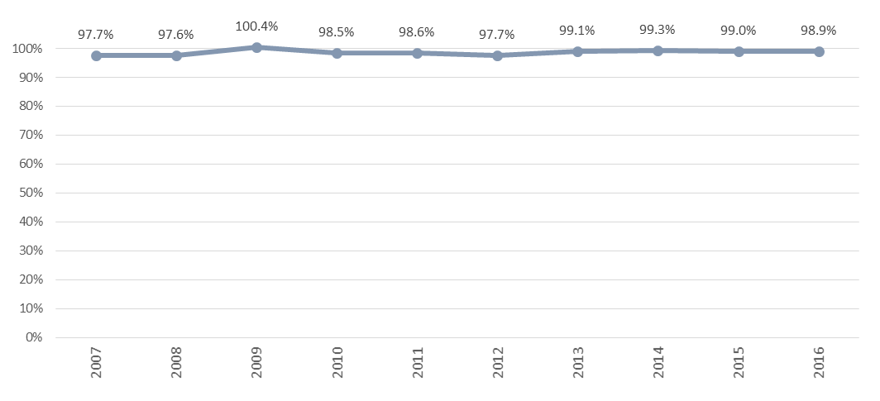

Table 1: Coverage over time
Year | Births | Newborns screened | Coverage
2007 | 64,040 | 65,121 | 97.7%
2008 | 65,333 | 63,794 | 97.6%
2009 | 63,285 | 63,516 | 100.4%
2010 | 64,699 | 63,727 | 98.5%
2011 | 62,733 | 61,859 | 98.6%
2012 | 62,842 | 61,422 | 97.7%
2013 | 59,707 | 59,192 | 99.1%
2014 | 59,097 | 58,673 | 99.3%
2015 | 59,058 | 58,463 | 99.0%
2016 | 59,640 | 59,010 | 98.9%

Figure 2: Coverage by DHB of domicile, January to December 2016
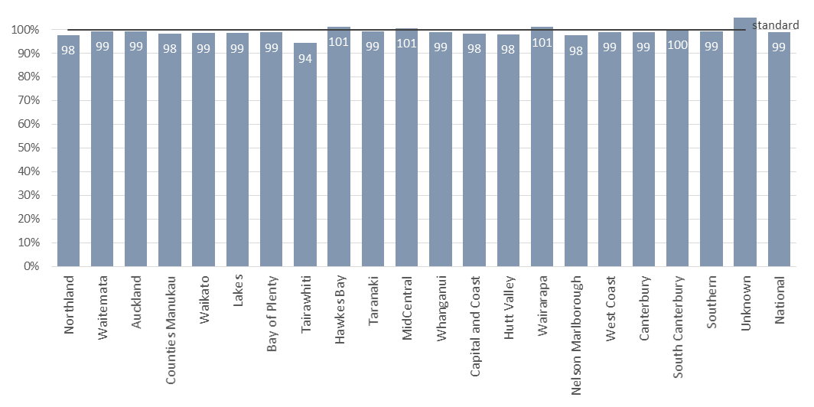
Table 2: Coverage by DHB of domicile, January to December 2016
DHB of Domicile | Births | Newborns Screened | Newborns Unscreened | Coverage
Northland | 2,266 | 2,214 | 52 | 97.7%
Waitemata | 7,978 | 7,927 | 51 | 99.4%
Auckland | 5,965 | 5,923 | 42 | 99.3%
Counties Manukau | 8,289 | 8,142 | 147 | 98.2%
Waikato | 5,377 | 5,298 | 79 | 98.5%
Lakes | 1,552 | 1,529 | 23 | 98.5%
Bay of Plenty | 2,880 | 2,847 | 33 | 98.9%
Tairawhiti | 791 | 746 | 45 | 94.3%
Hawkes Bay | 2,027 | 2,051 |  | *
Taranaki | 1,444 | 1,433 | 11 | 99.2%
MidCentral | 2,032 | 2,043 |  | *
Whanganui | 806 | 797 | 9 | 98.9%
Capital and Coast | 3,490 | 3,430 | 60 | 98.3%
Hutt Valley | 1,984 | 1,944 | 40 | 98.0%
Wairarapa | 396 | 400 |  | *
Nelson Marlborough | 1,556 | 1,518 | 38 | 97.6%
West Coast | 306 | 303 | 3 | 99.0%
Canterbury | 6,337 | 6,272 | 65 | 99.0%
South Canterbury | 657 | 656 | 1 | 99.8%
Southern | 3,343 | 3,320 | 23 | 99.3%
Unknown | 164 | 217 |  | *
National | 59,640 | 59,010 | 630 | 98.9%

*Percentages greater than 100% are suppressed because of a mismatch between numerator and denominator data due to such things as: newborns are not always born or screened in their DHB of domicile, year of birth and year of screening are not always the same.

Figure 3: Coverage by ethnicity, January to December 2016

Table 3: Coverage by ethnicity, January to December 2016
Ethnicity | Births | Newborns Screened | Coverage
Māori | 13,591 | 13,211 | 97.2%
Pacific | 5,684 | 5,546 | 97.6%
Other | 40,365 | 40,253 | 99.7%
Total | 59,640 | 59,010 | 98.9%

Figure 4: Coverage rate ratio* by DHB of domicile and ethnicity Māori / non-Māori, January to December 2016
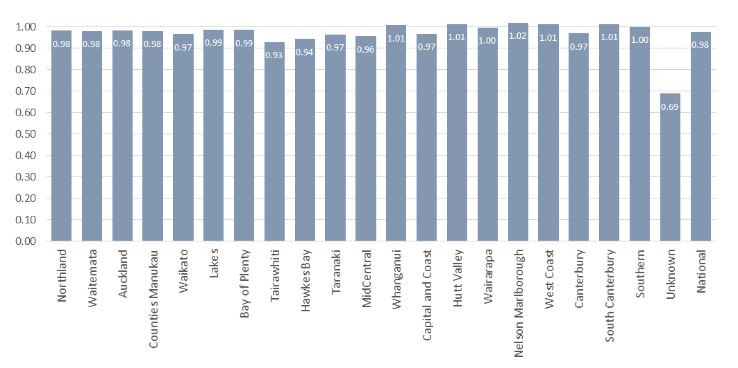
*A rate ratio is used here to focus on equity. It is calculated by dividing Māori coverage by non-Māori coverage. A ratio over 1 means higher coverage for Māori compared to non-Māori.

Table 4: Coverage by DHB of domicile and ethnicity
DHB of Domicile | Māori |  | Non-Māori |  | Total |  | Ratio
 | no. | % | no. | % | no. | %
Northland | 1,196 | 97% | 1,018 | 99% | 2,214 | 98% | 0.98
Waitemata | 1,072 | 98% | 6,855 | 100% | 7,927 | 99% | 0.98
Auckland | 634 | 98% | 5,289 | 100% | 5,923 | 99% | 0.98
Counties Manukau | 1,582 | 97% | 6,560 | 99% | 8,142 | 98% | 0.98
Waikato | 1,600 | 96% | 3,698 | 100% | 5,298 | 99% | 0.97
Lakes | 670 | 98% | 859 | 99% | 1,529 | 99% | 0.99
Bay of Plenty | 1,055 | 98% | 1,792 | 99% | 2,847 | 99% | 0.99
Tairawhiti | 477 | 92% | 269 | 99% | 746 | 94% | 0.93
Hawkes Bay | 864 | 98% | 1,187 | 104% | 2,051 | 101% | 0.94
Taranaki | 386 | 97% | 1,047 | 100% | 1,433 | 99% | 0.97
MidCentral | 628 | 98% | 1,415 | 102% | 2,043 | 101% | 0.96
Whanganui | 329 | 99% | 468 | 99% | 797 | 99% | 1.01
Capital and Coast | 480 | 96% | 2,950 | 99% | 3,430 | 98% | 0.97
Hutt Valley | 494 | 99% | 1,450 | 98% | 1,944 | 98% | 1.01
Wairarapa | 131 | 101% | 269 | 101% | 400 | 101% | 1.00
Nelson Marlborough | 303 | 99% | 1,215 | 97% | 1,518 | 98% | 1.02
West Coast | 46 | 100% | 257 | 99% | 303 | 99% | 1.01
Canterbury | 689 | 96% | 5,583 | 99% | 6,272 | 99% | 0.97
South Canterbury | 99 | 101% | 557 | 100% | 656 | 100% | 1.01
Southern | 429 | 99% | 2,891 | 99% | 3,320 | 99% | 1.00
Unknown | 47 | 100% | 170 | * | 217 | * | 0.69
National | 13,211 | 97% | 45,799 | 100% | 59,010 | 99% | 0.98

Indicator 2: Timing of Sample Taking
Description: Monitoring the age of newborns when the blood spot sample is taken.
Rationale: Timely sample collection leads to the best possible chance of a newborn with a screened condition receiving early diagnosis and treatment. However, the newborn must have been independent of their mother long enough for some biochemical markers to show an abnormality.
Standard: 95% of first samples are taken between 48-72 hours after birth.
Interpretation: Timeliness of sample taking varied from 64% to 90% between DHBs, with a national average of 78%, compared to 75% in 2015. 18% of samples were taken too late, and 1% too early.
Comment: Canterbury DHB continues to perform best. Counties Manukau, Waikato, Bay of Plenty and Lakes DHBs lag in meeting the standard due to the number of their samples being taken late. It is expected that this will progressively improve when DHBs review all their internal blood spot card processes and timeframes, including sample taking time, as is expected as part of the current roll-out of courier services to higher-volume maternity units.

Figure 5: Percentage of samples taken between 48 and 72 hours, January to December 2016
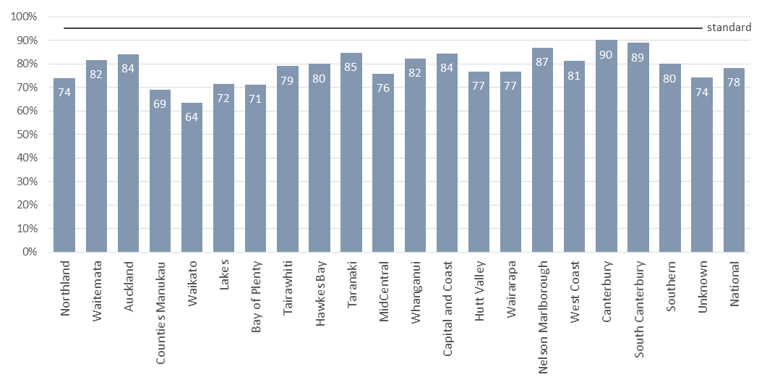
Table 5: Timing of sample taking, January to December 2016
DHB of Domicile | Less than 48 hours |  | 48 to 72 hours |  | More than 72 hours |  | Unknown |  | Total
 | no. | % | no. | % | no. | % | no. | % | no.
Northland | 25 | 1% | 1,637 | 74% | 500 | 23% | 52 | 2% | 2,214
Waitemata | 79 | 1% | 6,474 | 82% | 1,215 | 15% | 159 | 2% | 7,927
Auckland | 75 | 1% | 4,979 | 84% | 688 | 12% | 181 | 3% | 5,923
Counties Manukau | 93 | 1% | 5,629 | 69% | 2,125 | 26% | 295 | 4% | 8,142
Waikato | 64 | 1% | 3,371 | 64% | 1,688 | 32% | 175 | 3% | 5,298
Lakes | 14 | 1% | 1,095 | 72% | 365 | 24% | 55 | 4% | 1,529
Bay of Plenty | 22 | 1% | 2,027 | 71% | 710 | 25% | 88 | 3% | 2,847
Tairawhiti | 6 | 1% | 590 | 79% | 130 | 17% | 20 | 3% | 746
Hawkes Bay | 17 | 1% | 1,640 | 80% | 352 | 17% | 42 | 2% | 2,051
Taranaki | 16 | 1% | 1,215 | 85% | 168 | 12% | 34 | 2% | 1,433
MidCentral | 21 | 1% | 1,551 | 76% | 402 | 20% | 69 | 3% | 2,043
Whanganui | 7 | 1% | 656 | 82% | 120 | 15% | 14 | 2% | 797
Capital and Coast | 43 | 1% | 2,896 | 84% | 393 | 11% | 98 | 3% | 3,430
Hutt Valley | 17 | 1% | 1,492 | 77% | 381 | 20% | 54 | 3% | 1,944
Wairarapa | 4 | 1% | 307 | 77% | 69 | 17% | 20 | 5% | 400
Nelson Marlborough | 25 | 2% | 1,320 | 87% | 139 | 9% | 34 | 2% | 1,518
West Coast | 8 | 3% | 246 | 81% | 44 | 15% | 5 | 2% | 303
Canterbury | 68 | 1% | 5,654 | 90% | 382 | 6% | 168 | 3% | 6,272
South Canterbury | 10 | 2% | 583 | 89% | 56 | 9% | 7 | 1% | 656
Southern | 28 | 1% | 2,657 | 80% | 554 | 17% | 81 | 2% | 3,320
Unknown | 0 | 0% | 161 | 74% | 33 | 15% | 23 | 11% | 217
National | 642 | 1% | 46,180 | 78% | 10,514 | 18% | 1,674 | 3% | 59,010

Indicator 3: Quality of Blood Samples
Description: Monitoring the quality of blood spot samples received by the laboratory.
Rationale: Accurate testing of newborn metabolic screening samples is reliant on the quality of the sample. Unsatisfactory samples require a repeat sample which could have been avoided.
Standard: 99% of samples are of satisfactory quality.
Interpretation: The proportion of blood samples that were satisfactory ranged from 98.0% to 99.8% across DHBs, with a national average of 98.5%.
Comment: While only four DHBs met the standard (Taranaki, Wairarapa, Canterbury and South Canterbury), overall sample quality improved nationally in 2016, with 1.5% (892) of all samples being unsatisfactory as against 1.7% (1,021) in 2015. In 2017/18 DHBs with unusually high volumes of unsatisfactory samples will be asked to identify and address the causes.
Sample collection quality, such as insufficient blood on the card, remains the main reason for unsatisfactory samples. There was a 4% increase in transport related unsatisfactory samples between 2015 (5%) and 2016 (9%). This was due to an increase in samples that arrived at the laboratory damaged. Each unsatisfactory sample is followed up with a request for a second sample (Indicator 7) to reduce the risk to the babies affected.
Figure 6: Percentage of samples of a satisfactory quality, January to December 2016
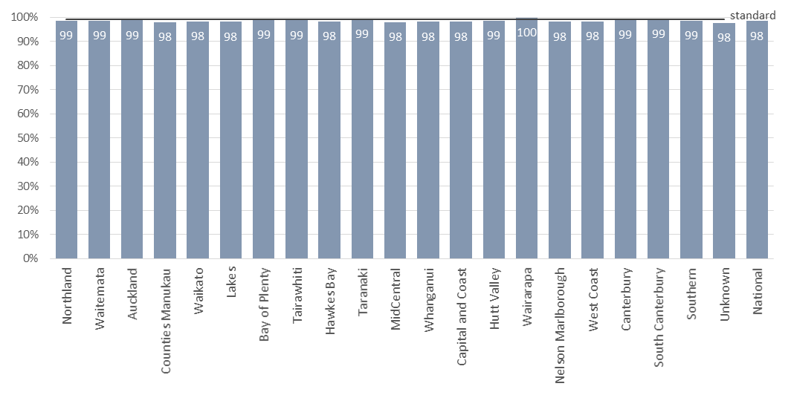
Table 6: Percentage of samples of a satisfactory quality, January to December 2016
DHB of Domicile | Satisfactory samples |  | Unsatisfactory samples |  | Total
 | no. | % | no. | % | no.
Northland | 2,181 | 98.5% | 33 | 1.5% | 2,214
Waitemata | 7,810 | 98.5% | 117 | 1.5% | 7,927
Auckland | 5,846 | 98.7% | 77 | 1.3% | 5,923
Counties Manukau | 7,985 | 98.1% | 157 | 1.9% | 8,142
Waikato | 5,208 | 98.3% | 90 | 1.7% | 5,298
Lakes | 1,500 | 98.1% | 29 | 1.9% | 1,529
Bay of Plenty | 2,814 | 98.8% | 33 | 1.2% | 2,847
Tairawhiti | 737 | 98.8% | 9 | 1.2% | 746
Hawkes Bay | 2,017 | 98.3% | 34 | 1.7% | 2,051
Taranaki | 1,422 | 99.2% | 11 | 0.8% | 1,433
MidCentral | 2,002 | 98.0% | 41 | 2.0% | 2,043
Whanganui | 782 | 98.1% | 15 | 1.9% | 797
Capital and Coast | 3,366 | 98.1% | 64 | 1.9% | 3,430
Hutt Valley | 1,917 | 98.6% | 27 | 1.4% | 1,944
Wairarapa | 399 | 99.8% | 1 | 0.3% | 400
Nelson Marlborough | 1,490 | 98.2% | 28 | 1.8% | 1,518
West Coast | 298 | 98.3% | 5 | 1.7% | 303
Canterbury | 6,207 | 99.0% | 65 | 1.0% | 6,272
South Canterbury | 652 | 99.4% | 4 | 0.6% | 656
Southern | 3,273 | 98.6% | 47 | 1.4% | 3,320
Unknown | 212 | 97.7% | 5 | 2.3% | 217
National | 58,118 | 98.5% | 892 | 1.5% | 59,010

Figure 7: Reason for unsatisfactory samples, January to December 2016
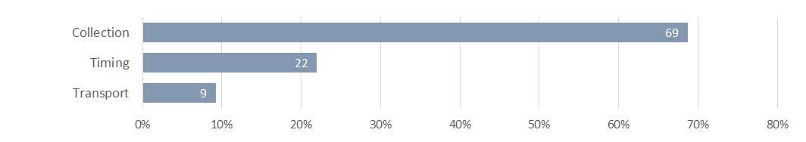

Collection: insufficient blood, incomplete demographics on the card, or the sample was contaminated.
Timing: samples were collected too early (before 48 hours of age).
Transport: took more than one month to arrive, blood was wet when folded, damaged in transit, or put wet into a plastic bag.

Table 6: Reason for unsatisfactory samples, January to December 2016
Reason | no. | %
Collection | 606 | 69%
Timing | 194 | 22%
Transport | 82 | 9%
Total | 882 | 100%

Indicator 4: Sample Dispatch and Delivery
Description: Monitoring the time between the sample being taken and receipt by the laboratory.
Rationale: To ensure early diagnosis and treatment, samples must be received by the laboratory as soon as possible after being taken.
Standard: 95% of samples are received at the laboratory within four (calendar) days of being taken.
Interpretation: Timeliness of sample dispatch and delivery varied widely between DHBs, ranging from 57% to 92% meeting the standard. While the national average of 76% is similar to the 74% in 2015, there was significant (9-10%) improvement in rates at Waitemata, Auckland, Counties Manukau and West Coast DHBs, offset by decreases at Lakes, Tairawhiti, MidCentral, Whanganui, Hutt Valley, Wairarapa and Nelson Marlborough DHBs.
Comment: As in 2015, this indicator remained the focus of considerable quality improvement work. The NSU continued to provide DHBs with quarterly ‘transit’ reports, for feedback on transit time turnaround. Variances in postal service provision remained an issue, compounded by unexpected natural events such as the Kaikoura earthquake in November 2016. These variables impact on DHBs’ ability to achieve the 95% standard, and the impacts vary significantly across the country.
Improving blood spot card transit times by taking a dedicated process improvement approach can make a real positive difference, as has been illustrated over recent years by improved transit times from National Women’s Health and Birthcare Auckland (ADHB) and Botany Downs Primary Birthing Unit (Counties Manukau DHB). Promotion of this approach, together with the progressive roll out of courier to replace FastPost of blood spot cards from main maternity units nationwide (commenced in late 2016), is expected to lead to improvement across all DHBs.
Figure 8: Percentage of samples received by the laboratory within four days of being taken, January to December 2016
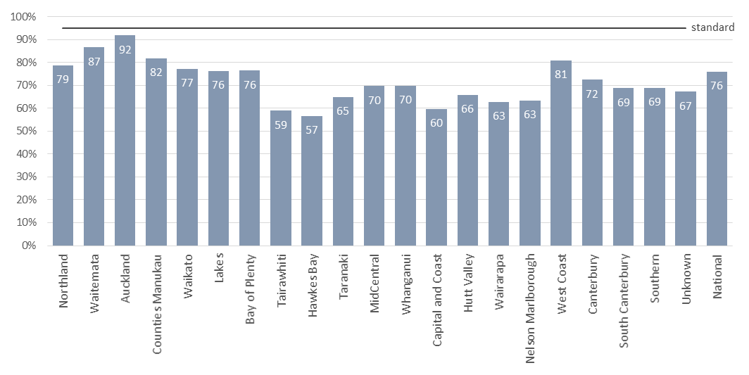
Table 7: Percentage of samples received by the laboratory within four days of being taken, January to December 2016
DHB of Domicile | Within 4 days |  | More than 4 days |  | Unknown |  | Total
 | no. | % | no. | % | no. | % | no.
Northland | 1,744 | 79% | 443 | 20% | 27 | 1% | 2,214
Waitemata | 6,861 | 87% | 984 | 12% | 82 | 1% | 7,927
Auckland | 5,438 | 92% | 413 | 7% | 72 | 1% | 5,923
Counties Manukau | 6,662 | 82% | 1,383 | 17% | 97 | 1% | 8,142
Waikato | 4,092 | 77% | 1,144 | 22% | 62 | 1% | 5,298
Lakes | 1,166 | 76% | 335 | 22% | 28 | 2% | 1,529
Bay of Plenty | 2,176 | 76% | 644 | 23% | 27 | 1% | 2,847
Tairawhiti | 440 | 59% | 297 | 40% | 9 | 1% | 746
Hawkes Bay | 1,163 | 57% | 868 | 42% | 20 | 1% | 2,051
Taranaki | 931 | 65% | 488 | 34% | 14 | 1% | 1,433
MidCentral | 1,425 | 70% | 588 | 29% | 30 | 1% | 2,043
Whanganui | 556 | 70% | 236 | 30% | 5 | 1% | 797
Capital and Coast | 2,049 | 60% | 1,348 | 39% | 33 | 1% | 3,430
Hutt Valley | 1,280 | 66% | 636 | 33% | 28 | 1% | 1,944
Wairarapa | 251 | 63% | 141 | 35% | 8 | 2% | 400
Nelson Marlborough | 961 | 63% | 542 | 36% | 15 | 1% | 1,518
West Coast | 245 | 81% | 56 | 18% | 2 | 1% | 303
Canterbury | 4,542 | 72% | 1,638 | 26% | 92 | 1% | 6,272
South Canterbury | 451 | 69% | 205 | 31% | 0 | 0% | 656
Southern | 2,288 | 69% | 987 | 30% | 45 | 1% | 3,320
Unknown | 146 | 67% | 63 | 29% | 8 | 4% | 217
National | 44,867 | 76% | 13,439 | 23% | 704 | 1% | 59,010

Indicator 5: Laboratory Testing Timeframes
Description: Monitoring the time taken by the laboratory to test for each of the screened disorders (turnaround time).
Rationale: Blood spot samples should be tested as soon as possible on receipt at the laboratory to ensure that screen positives can be acted on as quickly as possible.
Standard: 100% of samples have test results within the disorder specific number of working days from receipt by the laboratory.
Interpretation: The disorder specific testing timeframe was met for 2 of the 7 disorder groups, ranging from 98% to 100%.
Comment: Laboratory testing timeframes were not met for five of the seven disorder groups. Testing for congenital adrenal hyperplasia, galactosaemia and cystic fibrosis involves a further (second-tier) test to improve screening specificity. Occasionally there were assay failures with both the first and second-tier tests. In these cases the assays were repeated the next working day, unless the testing suggested there may be a clinical critical result, which was managed urgently. Delays in cystic fibrosis testing were due to second tier test turnaround times in the mutation analysis.
None of the test delays resulted in a delayed diagnosis.

Figure 9: Percentage of samples tested within disorder specific timeframes, January to December 2016
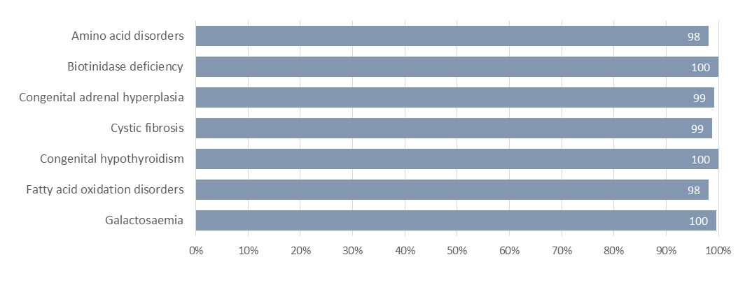

Table 8: Sample testing timeframes, January to December 2016
Disorder | Timeframe | Timeframe met |  | Timeframe not met |  | Total
 | (working days) | no. | % | no. | % | no.
Amino acid disorders | 2 | 57,880 | 98.1% | 1,130 | 1.9% | 59,010
Biotinidase deficiency | 5 | 58,988 | 100.0% | 22 | 0.0% | 59,010
Congenital adrenal hyperplasia | 2 | 58,546 | 99.2% | 464 | 0.8% | 59,010
Cystic fibrosis | 5 | 58,299 | 98.8% | 711 | 1.2% | 59,010
Congenital hypothyroidism | 5 | 58,987 | 100.0% | 23 | 0.0% | 59,010
Fatty acid oxidation disorders | 2 | 57,900 | 98.1% | 1,110 | 1.9% | 59,010
Galactosaemia | 2 | 58,764 | 99.6% | 246 | 0.4% | 59,010

Indicator 6: Timeliness of Reporting - Notification of Screen Positives
Description: This indicator monitors the timeliness of reporting of newborns with screen positive results by the laboratory.
Rationale: Early detection of screened disorders is dependent on timely referral of newborns with positive screening results for diagnostic testing.
Standard: 100% of screen positive results are notified to the newborn’s referring practitioner within the disorder specific number of calendar days.
Interpretation: Overall 59% of screen positives were notified within the standard timeframes; a 7% decline on 2015 (66%). There was wide variation in the timeliness of notification of screen positive results across the screened disorders, with disorder specific timeframes being met for 2 of the 7 disorder groups.
Comment: This indicator is being reviewed to improve accuracy and clinical utility. In 2016 all ‘clinical critical’ results were reported within the timeframes. A ‘clinical critical’ screening result is one which indicates a reasonable or high probability of a disorder that can present with severe illness in the early neonatal period, and where a delay of 1-2 days can affect the outcome.
Less severe cases warrant different indicator timeframes. Also, borderline newborn screening results are not reported until all results are available on the sample so the notification can include all results in one contact. For example, a borderline hypothyroid result may be available in two days, but if the sample also has a raised immune-reactive trypsin in the cystic fibrosis screen, it is sent for mutation analysis. The request for a second sample to confirm the thyroid result will be made after the cystic fibrosis mutation result is available.

Figure 10: Percentage of screen positives notified within the disorder specific timeframe, January to December 2016
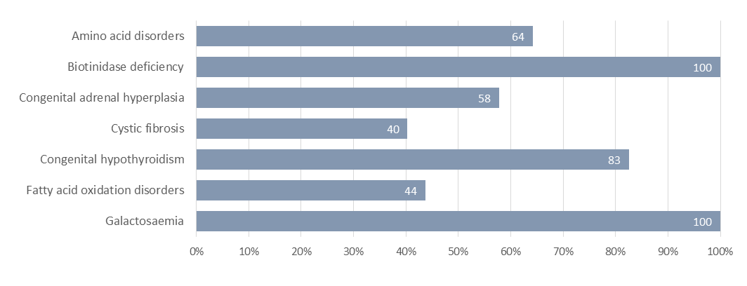
Table 9: Notification of screen positives, January to December 2016
Disorder | Timeframe* | Timeframe met |  | Timeframe not met |  | Total
 | (calendar days) | no. | % | no. | % | no.
Amino acid disorders | 3 | 92 | 66% | 48 | 34% | 140
Biotinidase deficiency | 9 | 5 | 100% | 0 | 0% | 5
Congenital adrenal hyperplasia | 3 | 53 | 54% | 46 | 46% | 99
Cystic fibrosis | 12 | 27 | 40% | 40 | 60% | 67
Congenital hypothyroidism | 4 | 51 | 77% | 15 | 23% | 66
Fatty acid oxidation disorders | 3 | 23 | 48% | 25 | 52% | 48
Galactosaemia | 3 | 3 | 100% | 0 | 0% | 3
Total |  | 254 | 59% | 174 | 41% | 428

* The validity of these timeframes are being reviewed to more accurately reflect clinical utility, for example not all screen positive cases were ‘clinical critical’.

Indicator 7: Collection and Receipt of Second Samples
Description: Monitoring the follow-up of requests for second blood spot samples when the original sample is either unsuitable for testing or gives a borderline result.
Rationale: If a second sample is required it means that a sample was not adequate, or results were borderline. Second samples should be taken as soon as possible so that the newborn can be treated early if they have a disorder.
Standard: 100% of second samples requested are received by the laboratory, or had other appropriate follow-up, or were declined by parents/guardians within ten calendar days of the request.
Interpretation: In 2016 73% of requests for second samples resulted in either a second sample arriving at the laboratory, or notification that the parents/guardians had declined the request, or that the newborn had been referred to a specialist, or had died. In the reporting period, a second sample was received, declined, or had other follow-up at some stage in 97% of the instances when a second sample was requested.
Comment: The time taken to receive a follow-up sample is influenced by: the time it takes to generate, send and receive the request; and the time it takes for the second sample to be collected (usually at the next scheduled LMC visit), sent to and received by the laboratory.
In line with the improvement in the quality of blood spot samples received at the laboratory (Indicator 3), there was a decline in the need to request second samples. In 2014 there were 1,352 requests, with 1,171 in 2015, and 988 in 2016. Also, in May 2015 a new protocol for follow-up samples was introduced along with phone and text requests from LabPlus to LMCs to supplement the usual paper reports per request, and regular reminders. Between 2014 and 2016 this resulted in a 35% improvement, from 38% to 73%, in the 10 day turnaround time of second samples. The LabPlus staff’s initiative with this quality improvement was recognised with an Auckland DHB Excellence Award in 2016.
Counties Manukau, Waikato and MidCentral DHBs had more than half of the 27 requests for second samples that drew no response in 2016. It is planned to systematically follow-up non-responses from LMCs in 2017/18.

Figure 11: Percentage of second samples received (or other appropriate follow-up occurred) within 10 days, January to December 2016
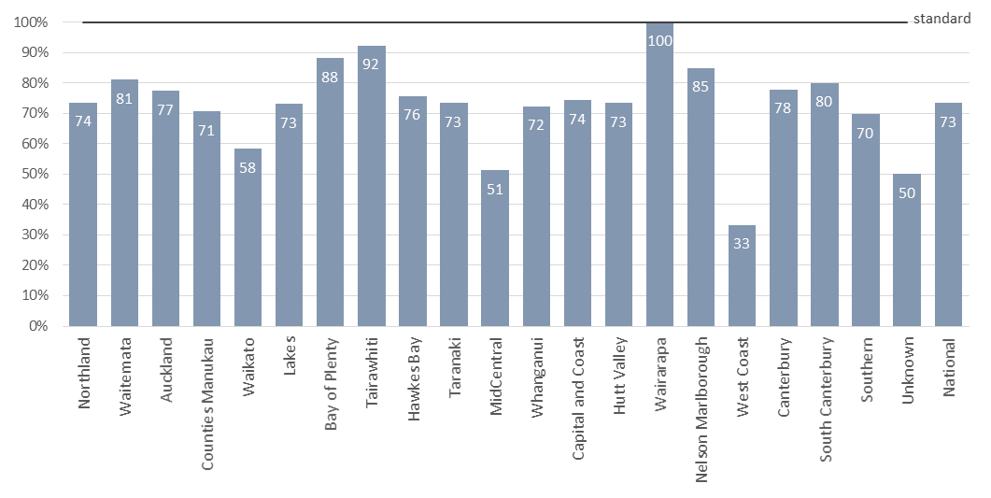
Table 10: Percentage of second samples received (or other appropriate follow-up occurred) within 10 days, January to December 2016
DHB of Domicile | Within 10 days |  | 10 days or more |  | Follow up complete |  | No follow up |  | Total
 | no. | % | no. | % | no. | % | no. | % | no.
Northland | 25 | 74% | 8 | 24% | 33 | 97% | 1 | 3% | 34
Waitemata | 107 | 81% | 23 | 17% | 130 | 98% | 2 | 2% | 132
Auckland | 65 | 77% | 18 | 21% | 83 | 99% | 1 | 1% | 84
Counties Manukau | 120 | 71% | 46 | 27% | 166 | 98% | 4 | 2% | 170
Waikato | 56 | 58% | 33 | 34% | 89 | 93% | 7 | 7% | 96
Lakes | 19 | 73% | 6 | 23% | 25 | 96% | 1 | 4% | 26
Bay of Plenty | 37 | 88% | 4 | 10% | 41 | 98% | 1 | 2% | 42
Tairawhiti | 12 | 92% | 1 | 8% | 13 | 100% | 0 | 0% | 13
Hawkes Bay | 31 | 76% | 8 | 20% | 39 | 95% | 2 | 5% | 41
Taranaki | 11 | 73% | 4 | 27% | 15 | 100% | 0 | 0% | 15
MidCentral | 20 | 51% | 16 | 41% | 36 | 92% | 3 | 8% | 39
Whanganui | 13 | 72% | 5 | 28% | 18 | 100% | 0 | 0% | 18
Capital and Coast | 52 | 74% | 18 | 26% | 70 | 100% | 0 | 0% | 70
Hutt | 22 | 73% | 8 | 27% | 30 | 100% | 0 | 0% | 30
Wairarapa | 2 | 100% | 0 | 0% | 2 | 100% | 0 | 0% | 2
Nelson Marlborough | 28 | 85% | 4 | 12% | 32 | 97% | 1 | 3% | 33
West Coast | 1 | 33% | 2 | 67% | 3 | 100% | 0 | 0% | 3
Canterbury | 60 | 78% | 15 | 19% | 75 | 97% | 2 | 3% | 77
South Canterbury | 4 | 80% | 0 | 0% | 4 | 80% | 1 | 20% | 5
Southern | 39 | 70% | 16 | 29% | 55 | 98% | 1 | 2% | 56
Unknown | 1 | 50% | 1 | 50% | 2 | 100% | 0 | 0% | 2
National | 725 | 73% | 236 | 24% | 961 | 97% | 27 | 3% | 988

Indicator 8: Diagnosis and Commencement of Treatment
Description: Monitoring the commencement of treatment for newborns diagnosed with a screened condition.
Rationale: The NMSP aims for early confirmed diagnosis and timely treatment to ensure that newborns with metabolic conditions have their development potential impacted as little as possible.
Standard: 100% of newborns who have a screen positive result and confirmed diagnosis have treatment commenced within the disorder specific time frame (age of newborn in days).
Interpretation: There was wide variation in timeliness of commencement of treatment for newborns diagnosed with a screened disorder. The disorder specific timeframe was met for 2 of the 6 disorders with cases.
Comment: Delays in treatment are caused by a combination of: later diagnosis of mild disease, difficulties obtaining diagnostic tests, or difficulty making a definitive diagnosis. Delayed diagnosis is far more likely when the disease is mild, for example where the initial test is marginally abnormal and confirmed with a second dried blood spot. Diagnosis may also be delayed due to diagnostic test processes, for example some laboratories do not do sweat tests for possible cystic fibrosis until the newborn is a month old. There were no known clinical consequences of delayed treatment for the 13 newborns in 2016 who did not receive treatment within their disorder specific timeframe.
As with Indicator 6, this indicator is being reviewed to improve accuracy and clinical utility.

Figure 12: Confirmed diagnosis commencement of treatment, January to December 2016
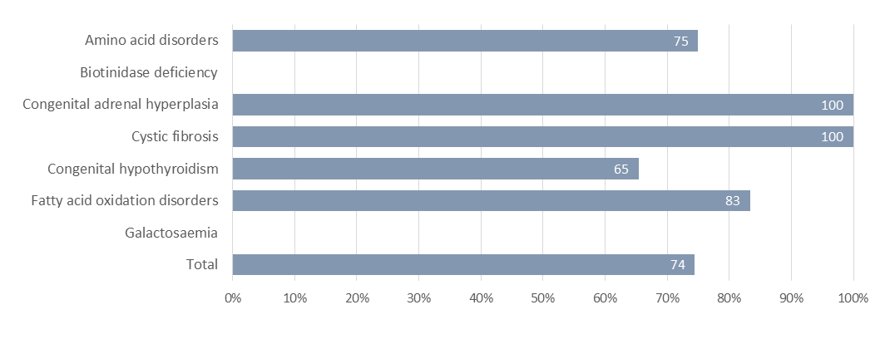

Table 11: Confirmed diagnosis commencement of treatment, January to December 2016
Disorder | Timeframe* | Timeframe met |  | Timeframe not met |  | Total
 | Age in Days | no. | % | no. | % | no.
Amino acid disorders | 10 | 3 | 50% | 3 | 50% | 6
Biotinidase deficiency | 14 | 0 | 0% | 1 | 100% | 1
Congenital adrenal hyperplasia | 10 | 1 | 100% | 0 | 0% | 1
Cystic fibrosis | 28 | 8 | 100% | 0 | 0% | 8
Congenital hypothyroidism | 10 | 18 | 69% | 8 | 31% | 26
Fatty acid oxidation disorders | 10 | 5 | 83% | 1 | 17% | 6
Galactosaemia | 10 | 0 |  | 0 |  | 0
Total |  | 35 | 73% | 13 | 27% | 48

* The validity of these timeframes are being reviewed to more accurately reflect clinical utility. There were no known clinical consequences of delayed treatment.

Indicator 9: Blood Spot Card Storage and Return
Description: Monitoring the return of blood spot card that are requested by parents/guardians or individuals.
Rationale: When requested, blood spot cards are to be returned securely and promptly.
Standard: 100% of blood spot cards requested are returned within 28 days of a valid request.
Interpretation: 100% of blood spot cards requested were returned within 28 days of a valid request. Last year the percentage was 99.7%.
Comment: All 607 requests for card returns were handled promptly within the 28 day standard.

Figure 13: Return of cards requested by parents / caregivers / individuals, January to December 2016
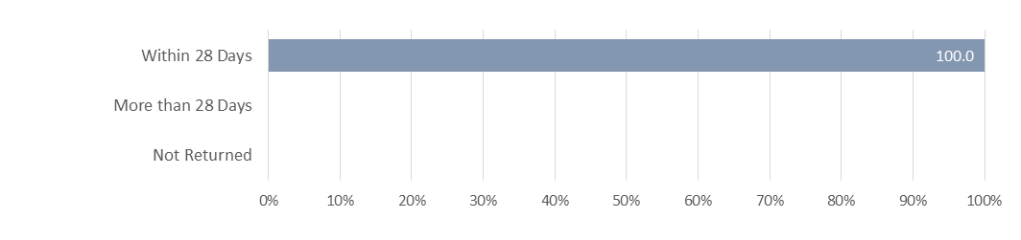

Table 12: Return of cards requested by parents / caregivers / individuals, January to December 2016
 | no. | %
Within 28 Days | 607 | 100.0%
More than 28 Days | 0 | 0.0%
Not Returned | 0 | 0.0%

Appendix 1: List of Screened Conditions

Amino Acid Disorders
Phenylketonuria
Maple syrup urine disease
Argininosuccinic aciduria (argininosuccinate lyase deficiency)
Citrullinaemia (argininosuccinate synthetase deficiency
Glutaric acidaemia type I (glutaryl-CoA dehydrogenase deficiency)
Homocystinuria (cystathionine beta-synthase deficiency)
Isovaleric acidaemia (isovaleryl-CoA dehydrogenase deficiency)
Methylmalonic acidurias (mutase deficiency, CblA, CblB, CblC, CblD defects)
Propionic acidaemia (propionyl-CoA carboxylase deficiency)
Tyrosinaemia (fumaryl acetoacetase deficiency, tyrosine aminotransferase deficiency)

Fatty acid oxidation disorders
CACT (carnitine acylcarnitine translocase deficiency
Carnitine transporter defect
CPT-I (carnitine palmitoyltransferase-I deficiency)
CPT-II (carnitine palmitoyltransferase-II deficiency)
LCHAD (3-hydroxy long-chain acyl-CoA dehydrogenase deficiency)
TFP (trifunctional protein deficiency)
MADD (multiple acyl-CoA dehydrogenase deficiency
MCAD (medium-chain acyl-CoA dehydrogenase deficiency)
VLCAD (very-long-chain acyl-CoA dehydrogenase deficiency)

Additional disorders
Congenital hypothyroidism (CH)
Congenital adrenal hyperplasia (CAH)
Cystic fibrosis (CF)
Biotinidase deficiency
Galactosaemia

