Newborn Metabolic Screening Programme
Annual Report

January to December 2017

Released 2018 health.govt.nz

Disclaimer
This publication reports on information provided to the Ministry of Health by the Auckland District Health Board. The purpose of this publication is to inform discussion and assist ongoing Newborn Metabolic Screening Programme development. All care has been taken in the production of this report, and the data was deemed to be accurate at the time of publication. However, the data may be subject to slight changes over time as further information is received. Before quoting or using this information, it is advisable to check the current status with the Ministry of Health.

Citation: Ministry of Health. 2018. Newborn Metabolic Screening Programme: Annual Report 2017. Wellington: Ministry of Health.

Published in June 2018 by the Ministry of Health
PO Box 5013, Wellington 6140, New Zealand

ISBN 978-1-98-853974-4 (online)
HP 6904

This document is available at nsu.govt.nz

This work is licensed under the Creative Commons Attribution 4.0 International licence. In essence, you are free to: share ie, copy and redistribute the material in any medium or format; adapt ie, remix, transform and build upon the material. You must give appropriate credit, provide a link to the licence and indicate if changes were made.

Contents

Introduction 1
Background to the Programme 1
Data summary 1
Executive summary 2
Indicator 1: Coverage 3
Indicator 2: Timing of sample taking 7
Indicator 3: Quality of blood samples 9
Indicator 4: Sample dispatch and delivery 11
Indicator 5: Collection and follow-up of second samples 13
Indicator 6: Laboratory turnaround time positive results 16
Indicator 7: Age of receipt into clinical care 18
Indicator 8: Positive predictive value of the screening test 19
Appendix 1: List of screened conditions 20
List of Figures
Figure 1: Coverage over time 4
Figure 2: Coverage by DHB of domicile, January to December 2017 4
Figure 3: Coverage rate ratio* by DHB of domicile and ethnicity Māori / non-Māori, January to December 2017 6
Figure 4: Percentage of samples taken between 48 and 72 hours, January to December 2017 7
Figure 5: Percentage of samples received by the laboratory within four days of being taken, January to December 2017 12
Figure 6: Percentage of second samples received (or other appropriate follow-up occurred) within 10 days, January to December 2017 14
Figure 7: Percentage of screen positives notified within the disorder specific timeframe, January to December 2017 17

List of Tables
Table 1: Coverage over time 4
Table 2: Coverage by DHB of domicile, January to December 2017 5
Table 3: Coverage by ethnicity, January to December 2017 5
Table 4: Coverage by DHB of domicile and ethnicity 6
Table 5: Timing of sample taking, January to December 2017 8
Table 6: Percentage of samples of a satisfactory quality, January to December 2017 10 Table 6: Reason for unsatisfactory samples, January to December 2017 10
Table 7: Percentage of samples received by the laboratory within four days of being taken, January to December 2017 12
Table 8: Percentage of second samples received (or other appropriate follow-up occurred) within 10 days, January to December 2017 15
Table 9: Notification of screen positives, January to December 2017 17
Table 10: Confirmed diagnosis commencement of treatment, January to December 2017 18
Table 11: Positive predictive value of the screening test, 2013–2017 19

Introduction

This annual report provides information on the performance of the Newborn Metabolic Screening Programme (NMSP) against the agreed set of national indicators. Regular analysis and reporting of NMSP data is a key tool in enabling continuous quality improvement of the programme.

This is the first annual report of the NMSP after the release of the new monitoring indicators document in February 2018 and the seventh annual report following the development of national indicators in 2010. The NMSP Monitoring Framework and monitoring reports are published on the National Screening Unit (NSU) website: www.nsu.govt.nz/health- professionals/newborn-metabolic-screening-programme/procedures-guidelines-and-reports-2

Background to the Programme
The aim of the NMSP is to reduce morbidity and mortality associated with specific congenital metabolic disorders by screening newborns to detect the conditions before life-threatening illness or developmental delays occur. Since 1969 almost all newborns in New Zealand have been screened by the programme. Currently the NMSP identifies about 50 newborns a year with a metabolic disorder and treatment is commenced.

A midwife, nurse, phlebotomist or doctor collects a blood sample from the newborn’s heel onto a blood spot card (a Guthrie card). Samples must be collected between 48 and 72 hours of age for optimal testing. Cards are sent urgently to LabPlus at Auckland District Health Board (ADHB) for analysis and reporting of results to appropriate clinicians. Blood spot samples are screened for the 25 metabolic disorders listed in Appendix A.

Since 2005, the NMSP has been overseen nationally by the NSU at the Ministry. A significant milestone for the programme was the introduction in 2006 of expanded newborn screening, adding fatty acid oxidation and more amino acid breakdown disorders to the screening panel. Screening for Severe Combined Immuno-deficiency (SCID) was added in December 2017.

Data summary
Screening data is sourced from LabPlus at ADHB for all blood spot cards received in the 2017 calendar year. Birth data in the 2017 calendar year is sourced from the National Maternity Collection at the Ministry. Ethnicity data is prioritised in accordance with Statistics New Zealand’s prioritised ethnicity model which is standard across the health sector. When a newborn’s District Health Board (DHB) of domicile is unknown, it is set to ‘Unknown’.

Executive summary

- Of the 59,517 babies born in 2017, 58,935 were screened by the NMSP; a national coverage rate of 99.0%, which is in line with coverage rates since the programme began in 1969. However, there was variance at a local DHB level, with coverage rates ranging from 94.3% (Tairāwhiti) to 101% (Nelson Marlborough).

- In 2017 coverage varied by ethnic group, with 98.0% of Māori, 98.1% of Pacific, and 99.6% of newborns of all other ethnicities screened. From 2017 DHBs have been increasingly encouraged to match their birth data and babies screened data to ensure all consented babies are screened.

- The congenital disorders screened for by the NMSP are rare. In 2017 41 newborns were diagnosed with a screened disorder compared to 48 in 2016.

- The NMSP monitors timeframes along the screening pathway, from collection of blood spot samples through to clinical handover for care if needed, to ensure that newborns diagnosed with a screened condition are treated as soon as possible. While laboratory testing timeframes were uniformly high, as in previous years few of the general timeframe standards were met in 2017.

- Blood spot cards are expected to arrive at the laboratory within four days of sampling. In 2017 79% arrived in the timeframe. The national standard is 95%. This shortfall is a known and longstanding issue that, since 2015, has been the focus of quarterly ‘transit time’ reports to DHBs, to prompt a process quality improvement focus. The result has been a 13% lift in the four day transit rate, from 66% to 79% over the two years between 2014 and 2017. Also, higher volume maternity units are now shifting to using courier services, which is expected to improve transit rates further.

- A phone and text service between LabPlus and Lead Maternity Carers (LMCs), aimed at improving the turnaround time of requests for second samples was introduced in 2016. The rate of return within the expected 10-day timeframe has risen 33% over two years, from 38% in 2014 to 71% in 2017. There has been a 2% drop in the return rate from 73% in 2016. It is planned to systematically follow-up non responses from LMCs in 2017/18.

- In 2016 the NSU, in conjunction with the programme’s lead paediatricians and laboratory scientists, started a review of the monitoring indicators. The revision was completed in February 2018, and this annual report will use the updated indicators.

Indicator 1: Coverage

Description: Monitoring the proportion of newborns in New Zealand who complete newborn metabolic screening.

Rationale: Newborn screening must be offered for all newborns. All newborns whose parent/guardians consent to screening should be screened.

Standard: 99% of babies born nationally and within each of Maori, Pacific, Asian and Other population groups are screened.

Interpretation: Coverage at 99.0% is in line with an average of 99.0% between 2007 and 2017. Coverage by DHB varied from 94.3% upward. Coverage by ethnicity varied from 98.0% for Māori and Pacific (98.1%), to 99.6% for Other.

Comment: Overall programme coverage remained high, with one large DHB (Nelson Marlborough) achieving more than 100% coverage. Tairāwhiti DHB had the lowest coverage rate of 94.3%.

In 2017, 582 newborns were not screened by the NMSP. Of those, 310 (54%) of those were from four DHBs (Counties Manukau, Bay of Plenty, Canterbury and Waitemata DHBs), with 127 from Counties Manukau alone. It is not yet possible to distinguish between the few newborns who are unscreened due to parents/guardians withholding consent and those not screened because they are missed altogether. Some DHBs have begun to actively identify and follow up on their unscreened newborns. National Women’s Health at Auckland DHB now regularly matches birth and screened data. Waikato, Tairawhiti, and Taranaki DHBs have begun using the National Child Information Platform (NCHIP) application for the same purpose.

Coverage rates for Māori are lower than the general population at 15 DHBs, particularly so at Tairāwhiti DHB. This ought to improve with increased matching of birth and screening data to identify unscreened newborns.

As in previous years, there was some non-alignment of denominator data (birth volumes) with numerator data (newborns screened). Reasons include: the indicator reports DHB of domicile when many newborns (particularly in Auckland) are born and/or screened at a different DHB to where they live; and birth year and screened year can be different. Cross-matching and data cleansing to overcome these problems continues to improve, meaning that DHB coverage rates are in 2017 are likely to be more accurate than in the past.

Figure 1: Coverage over time

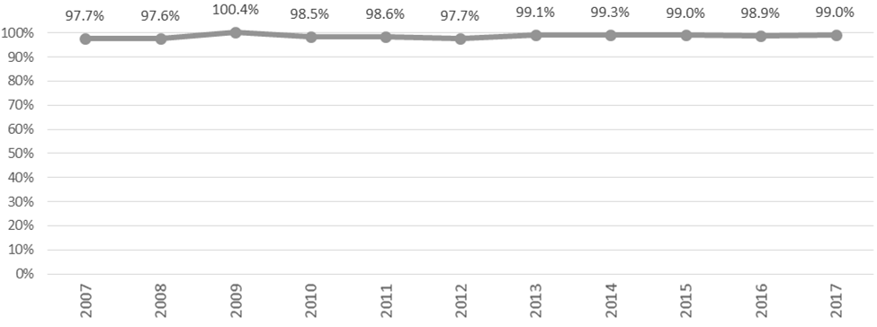

Table 1: Coverage over time

Year | Births | Babies screened | Coverage
2007 | 64,040 | 65,121 | 97.7%
2008 | 65,333 | 63,794 | 97.6%
2009 | 63,285 | 63,516 | 100.4%
2010 | 64,699 | 63,727 | 98.5%
2011 | 62,733 | 61,859 | 98.6%
2012 | 62,842 | 61,422 | 97.7%
2013 | 59,707 | 59,192 | 99.1%
2014 | 59,097 | 58,673 | 99.3%
2015 | 59,058 | 58,463 | 99.0%
2016 | 59,640 | 59,010 | 98.9%
2017 | 59,517 | 58,935 | 99.0%

Figure 2: Coverage by DHB of domicile, January to December 2017

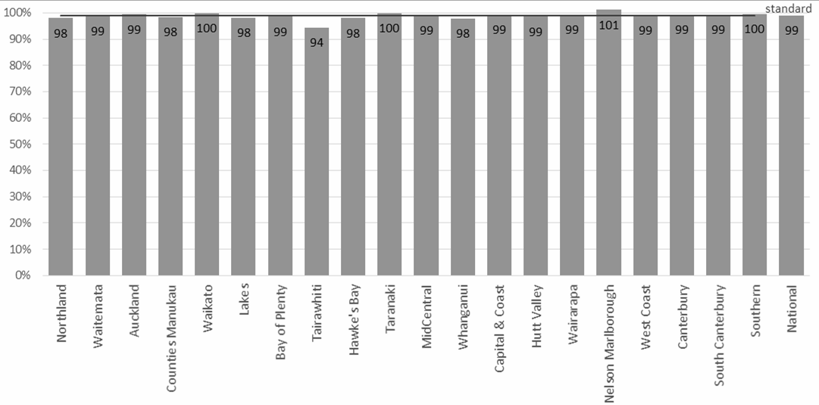

Table 2: Coverage by DHB of domicile, January to December 2017

DHB of domicile | Births | Newborns screened | Newborns unscreened | Coverage
Northland | 2,221 | 2,177 | 44 | 98.0%
Waitemata | 7,738 | 7,647 | 91 | 98.8%
Auckland | 5,671 | 5,636 | 35 | 99.4%
Counties Manukau | 8,340 | 8,213 | 127 | 98.5%
Waikato | 5,354 | 5,350 | 4 | 99.9%
Lakes | 1,552 | 1,523 | 29 | 98.1%
Bay of Plenty | 3,088 | 3,043 | 45 | 98.5%
Tairawhiti | 706 | 666 | 40 | 94.3%
Hawke’s Bay | 2,134 | 2,091 | 43 | 98.0%
Taranaki | 1,419 | 1,416 | 3 | 99.8%
MidCentral | 2,136 | 2,116 | 20 | 99.1%
Whanganui | 847 | 829 | 18 | 97.9%
Capital & Coast | 3,496 | 3,472 | 24 | 99.3%
Hutt Valley | 1,957 | 1,928 | 29 | 98.5%
Wairarapa | 510 | 506 | 4 | 99.2%
Nelson Marlborough | 1,418 | 1,434 |  | *
West Coast | 354 | 351 | 3 | 99.2%
Canterbury | 6,421 | 6,374 | 47 | 99.3%
South Canterbury | 633 | 628 | 5 | 99.2%
Southern | 3,445 | 3,430 | 15 | 99.6%
Unknown | 77 | 105 |  | *
National | 59,517 | 58,935 | 582 | 99.0%
* Percentages greater than 100% are suppressed because of a mismatch between numerator and denominator data due to such things as: newborns are not always born or screened in their DHB of domicile, year of birth and year of screening are not always the same.

Table 3: Coverage by ethnicity, January to December 2017

Ethnicity | Births | Babies screened | Coverage
Māori | 16,284 | 15,966 | 98.0%
Pacific | 6,002 | 5,886 | 98.1%
Other | 37,231 | 37,083 | 99.6%
Total | 59,517 | 58,935 | 99.0%

Figure 3: Coverage rate ratio* by DHB of domicile and ethnicity Māori / non-Māori, January to December 2017

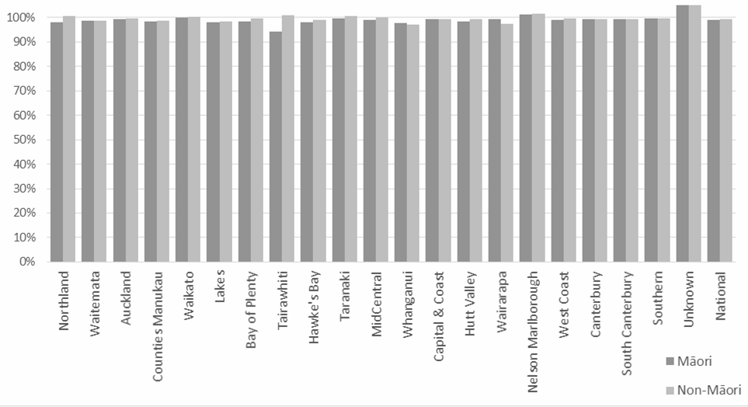
* A rate ratio is used here to focus on equity. It is calculated by dividing Māori coverage by non-Māori coverage.
A ratio over 1 means higher coverage for Māori compared to non-Māori.

Table 4: Coverage by DHB of domicile and ethnicity

DHB of domicile | Mā | ori | Non-Māori |  | Tot | al | Ratio
Northland | 1,239 | 98% | 938 | 101% | 2,177 | 98% | 0.98
Waitemata | 1,295 | 99% | 6,352 | 99% | 7,647 | 99% | 0.98
Auckland | 632 | 99% | 5,004 | 100% | 5,636 | 99% | 0.98
Counties Manukau | 1,876 | 98% | 6,337 | 99% | 8,213 | 98% | 0.98
Waikato | 2,083 | 100% | 3,267 | 100% | 5,350 | 100% | 0.97
Lakes | 846 | 98% | 677 | 98% | 1,523 | 98% | 0.99
Bay of Plenty | 1,285 | 99% | 1,758 | 100% | 3,043 | 99% | 0.99
Tairawhiti | 458 | 94% | 208 | 101% | 666 | 94% | 0.93
Hawkes Bay | 936 | 98% | 1,155 | 99% | 2,091 | 98% | 0.94
Taranaki | 483 | 100% | 933 | 101% | 1,416 | 100% | 0.97
MidCentral | 747 | 99% | 1,369 | 100% | 2,116 | 99% | 0.96
Whanganui | 396 | 98% | 433 | 97% | 829 | 98% | 1.01
Capital and Coast | 641 | 99% | 2,831 | 99% | 3,472 | 99% | 0.97
Hutt Valley | 522 | 99% | 1,406 | 99% | 1,928 | 99% | 1.01
Wairarapa | 180 | 99% | 326 | 98% | 506 | 99% | 1.00
Nelson Marlborough | 350 | 101% | 1,084 | 102% | 1,434 | 101% | 1.02
West Coast | 81 | 99% | 270 | 100% | 351 | 99% | 1.01
Canterbury | 1,106 | 99% | 5,268 | 99% | 6,374 | 99% | 0.97
South Canterbury | 129 | 99% | 499 | 99% | 628 | 99% | 1.01
Southern | 660 | 100% | 2,770 | 100% | 3,430 | 100% | 1.00
Unknown | 21 | 136% | 84 | 153% | 105 | 136% | 0.69
National | 15,966 | 99% | 42,969 | 99% | 58,935 | 99% | 0.98

Indicator 2:
Timing of sample taking
Description: Monitoring the proportion of babies screened who have a newborn metabolic screening sample taken between 48 and 72 hours of age.

Rationale: Prompt sample collection leads to the best possible chance of a baby with a screened condition receiving early diagnosis and treatment. Severe forms of some of the disorders can be fatal within seven to ten days, and many may not show any signs or symptoms of disease until irreversible damage has occurred. However, the baby must have been independent of their mother long enough for some biochemical markers to show an abnormality. The optimum window for sample collection is between 48 and 72 hours after birth.

Standard: 95% of first samples are taken between 48 and 72 hours after birth.

Interpretation: Timeliness of sample taking varied from 65% (Waikato) to 90% (Canterbury) between DHBs, with a national average of 79%, compared to 78% in 2016. 17% of samples were taken too late, and 1% too early.

Comment: Canterbury DHB continues to perform best. Counties Manukau, Waikato, Bay of Plenty and Lakes DHBs lag in meeting the standard due to the number of their samples being taken late. It is expected that this will progressively improve when DHBs review all their internal blood spot card processes and timeframes, including sample taking time, as is expected as part of the current roll-out of courier services to higher-volume maternity units.

Figure 4: Percentage of samples taken between 48 and 72 hours, January to December 2017

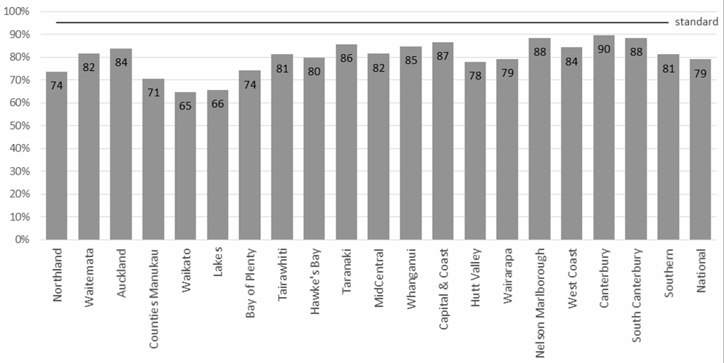

Table 5: Timing of sample taking, January to December 2017

own Total
DHB of domicile | Less than 48 hours |  | rs More than Unkn 72 hours
 | no. | % | no. % no. |  | % no. |  |  |  |  | % |  | no.
Northland | 30 | 1% | 1,603 74 | % 492 | 23% 52 |  |  |  |  | 2% |  | 2,177
Waitemata | 83 | 1% | 6,240 82 | % 1,175 | 15% 149 |  |  |  |  | 2% |  | 7,647
Auckland | 61 | 1% | 4,722 84 | % 653 | 12% 200 |  |  |  |  | 4% |  | 5,636
Counties Manukau | 62 | 1% | 5,799 71 | % 2,101 | 26% 251 |  |  |  |  | 3% |  | 8,213
Waikato | 44 | 1% | 3,469 65 | % 1,645 | 31% 192 |  |  |  |  | 4% |  | 5,350
Lakes | 11 | 1% | 1,002 66 | % 473 | 31% 37 |  |  |  |  | 2% |  | 1,523
Bay of Plenty | 27 | 1% | 2,258 74 | % 678 | 22% 80 |  |  |  |  | 3% |  | 3,043
Tairawhiti | 4 | 1% | 541 81 | % 112 | 17% 9 |  |  |  |  | 1% |  | 666
Hawke’s Bay | 21 | 1% | 1,669 80 | % 369 | 18% 32 |  |  |  |  | 2% |  | 2,091
Taranaki | 16 | 1% | 1,214 86 | % 153 | 11% 33 |  |  |  |  | 2% |  | 1,416
MidCentral | 36 | 2% | 1,726 82 | % 300 | 14% 54 |  |  |  |  | 3% |  | 2,116
Whanganui | 9 | 1% | 702 85 | % 103 | 12% 15 |  |  |  |  | 2% |  | 829
Capital & Coast | 37 | 1% | 3,010 87 | % 351 | 10% 74 |  |  |  |  | 2% |  | 3,472
Hutt Valley | 11 | 1% | 1,505 78 | % 367 | 19% 45 |  |  |  |  | 2% |  | 1,928
Wairarapa | 6 | 1% | 401 79 | % 83 | 16% 16 |  |  |  |  | 3% |  | 506
Nelson Marlborough | 18 | 1% | 1,268 88 | % 126 | 9% 22 |  |  |  |  | 2% |  | 1,434
West Coast | 4 | 1% | 296 84 | % 46 | 13% 5 |  |  |  |  | 1% |  | 351
Canterbury | 87 | 1% | 5,721 90 | % 396 | 6% 170 |  |  |  |  | 3% |  | 6,374
South Canterbury | 7 | 1% | 555 88 | % 55 | 9% 11 |  |  |  |  | 2% |  | 628
Southern | 36 | 1% | 2,788 81 | % 544 | 16% 62 |  |  |  |  | 2% |  | 3,430
Unknown | 1 | 1% | 80 76 | % 13 | 12% 11 |  |  |  |  | 10% |  | 105
National | 611 | 1% | 46,569 79 | % 10,235 | 17% 1,520 |  |  |  |  | 3% |  | 58,935

Indicator 3:
Quality of blood samples
Description: Monitoring the proportion of samples received by the laboratory that are of satisfactory quality.

Rationale: Accurate testing of newborn metabolic screening samples is reliant on the quality of the sample. Unsatisfactory samples require a repeat sample which could have been avoided.

Standard: 99% of samples are of satisfactory quality.

Interpretation: The proportion of blood samples that were satisfactory ranged from 98.0% to 99.6% across DHBs, with a national average of 98.7%.

Comment: While only three DHBs met the standard (Auckland, Tairāwhiti and Wairarapa), overall sample quality improved nationally in 2017, with 1.3% (743) of all samples being unsatisfactory as against 1.5% (892) in 2016. In 2017/18 DHBs with unusually high volumes of unsatisfactory samples will be asked to identify and address the causes.

Sample collection quality, such as insufficient blood on the card, remains the main reason for unsatisfactory samples. There was a 1% decrease in transport related unsatisfactory samples between 2016 (9%) and 2017 (8%). Each unsatisfactory sample is followed up with a request for a second sample (Indicator 5) to reduce the risk to the babies affected.

Table 6: Percentage of samples of a satisfactory quality, January to December 2017

Total
DHB of domicile | Satisfactory
 | no. | % | no. % |  |  | no.
Northland | 2,134 | 98.0% | 43 2.0% |  |  | 2,177
Waitemata | 7,543 | 98.6% | 104 1.4% |  |  | 7,647
Auckland | 5,579 | 99.0% | 57 1.0% |  |  | 5,636
Counties Manukau | 8,082 | 98.4% | 131 1.6% |  |  | 8,213
Waikato | 5,291 | 98.9% | 59 1.1% |  |  | 5,350
Lakes | 1,507 | 98.9% | 16 1.1% |  |  | 1,523
Bay of Plenty | 3,011 | 98.9% | 32 1.1% |  |  | 3,043
Tairawhiti | 661 | 99.2% | 5 0.8% |  |  | 666
Hawke’s Bay | 2,061 | 98.6% | 30 1.4% |  |  | 2,091
Taranaki | 1,401 | 98.9% | 15 1.1% |  |  | 1,416
MidCentral | 2,080 | 98.3% | 36 1.7% |  |  | 2,116
Whanganui | 819 | 98.8% | 10 1.2% |  |  | 829
Capital & Coast | 3,430 | 98.8% | 42 1.2% |  |  | 3,472
Hutt Valley | 1,906 | 98.9% | 22 1.1% |  |  | 1,928
Wairarapa | 504 | 99.6% | 2 0.4% |  |  | 506
Nelson Marlborough | 1,417 | 98.8% | 17 1.2% |  |  | 1,434
West Coast | 347 | 98.9% | 4 1.1% |  |  | 351
Canterbury | 6,304 | 98.9% | 70 1.1% |  |  | 6,374
South Canterbury | 619 | 98.6% | 9 1.4% |  |  | 628
Southern | 3,392 | 98.9% | 38 1.1% |  |  | 3,430
Unknown | 104 | 99.0% | 1 1.0% |  |  | 105
National | 58,192 | 98.7% | 743 1.3% |  |  | 58,935

Collection: insufficient blood, incomplete demographics on the card, or the sample was contaminated.

Timing: samples were collected too early (before 48 hours of age).

Transport: took more than one month to arrive, blood was wet when folded, damaged in transit, or put wet into a plastic bag.

Table 6: Reason for unsatisfactory samples, January to December 2017

Reason | no. | %
Collection | 508 | 68.4%
Timing | 175 | 23.6%
Transport | 58 | 7.8%
Error | 2 | 0.3%
Total | 743 | 100.0%

Indicator 4:
Sample dispatch and delivery
Description: Monitoring the time between the sample being taken and receipt by the laboratory.

Rationale: To ensure early diagnosis and treatment, samples must be received by the laboratory as soon as possible after being taken.

Standard: 95% of samples are received at the laboratory within four (calendar) days of being taken.

Interpretation: Timeliness of sample dispatch and delivery varied widely between DHBs, ranging from 58% to 91% meeting the standard. While the national average of 78% has slightly increased from the 76% in 2016, there was significant improvement in rates at Tairāwhiti and Hawke’s Bay (13%) and Capital and Coast (16%) DHBs, offset by decreases at South Canterbury (-11%) and Bay of Plenty (-5%) DHBs.

Comment: As in 2016, this indicator remained the focus of considerable quality improvement work. The NSU continued to provide DHBs with quarterly ‘transit’ reports, for feedback on transit time turnaround. Variances in postal service provision remained an issue, compounded by unexpected natural events such as the Kaikoura earthquake in November 2016. These variables impact on DHBs’ ability to achieve the 95% standard, and the impacts vary significantly across the country.

Improving blood spot card transit times by taking a dedicated process improvement approach can make a real positive difference, as has been illustrated over recent years by improved transit times from National Women’s Health and Birthcare Auckland (ADHB) and Botany Downs Primary Birthing Unit (Counties Manukau DHB). Promotion of this approach, together with the progressive roll out of courier to replace FastPost of blood spot cards from main maternity units nationwide (commenced in late 2016), is expected to lead to improvement across all DHBs.

Figure 5: Percentage of samples received by the laboratory within four days of being taken, January to December 2017

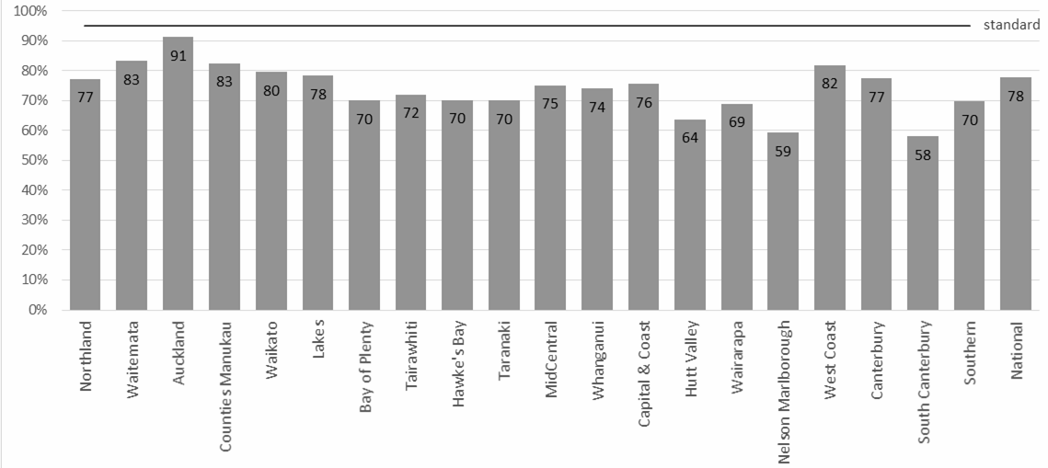

Table 7: Percentage of samples received by the laboratory within four days of being taken, January to December 2017

DHB of domicile | Within 4 days no. % |  | More than 4 days no. % |  | Unknown no. % |  | Total no.
Northland | 1,683 | 77% | 477 | 22% | 17 | 1% | 2,177
Waitemata | 6,364 | 83% | 1,215 | 16% | 68 | 1% | 7,647
Auckland | 5,141 | 91% | 418 | 7% | 77 | 1% | 5,636
Counties Manukau | 6,776 | 83% | 1,353 | 16% | 84 | 1% | 8,213
Waikato | 4,257 | 80% | 1,025 | 19% | 68 | 1% | 5,350
Lakes | 1,192 | 78% | 317 | 21% | 14 | 1% | 1,523
Bay of Plenty | 2,132 | 70% | 875 | 29% | 36 | 1% | 3,043
Tairawhiti | 479 | 72% | 184 | 28% | 3 | 0% | 666
Hawke’s Bay | 1,468 | 70% | 604 | 29% | 19 | 1% | 2,091
Taranaki | 992 | 70% | 413 | 29% | 11 | 1% | 1,416
MidCentral | 1,590 | 75% | 498 | 24% | 28 | 1% | 2,116
Whanganui | 613 | 74% | 209 | 25% | 7 | 1% | 829
Capital & Coast | 2,624 | 76% | 815 | 23% | 33 | 1% | 3,472
Hutt Valley | 1,229 | 64% | 680 | 35% | 19 | 1% | 1,928
Wairarapa | 349 | 69% | 150 | 30% | 7 | 1% | 506
Nelson Marlborough | 850 | 59% | 577 | 40% | 7 | 0% | 1,434
West Coast | 287 | 82% | 64 | 18% | 0 | 0% | 351
Canterbury | 4,934 | 77% | 1,341 | 21% | 99 | 2% | 6,374
South Canterbury | 364 | 58% | 261 | 42% | 3 | 0% | 628
Southern | 2,392 | 70% | 1,004 | 29% | 34 | 1% | 3,430
Unknown | 84 | 80% | 18 | 17% | 3 | 3% | 105
National | 45,800 | 78% | 12,498 | 21% | 637 | 1% | 58,935

Indicator 5: Collection and follow-up of second samples
Description: Monitoring the follow-up of requests for second blood spot samples when the original sample is either unsuitable for testing or gives a borderline result.

Rationale: If a second sample is required it means that a sample was not adequate, or results were borderline. Second samples should be taken as soon as possible so that the newborn can be treated early if they have a disorder.

Standard: 100% of second samples requested are received by the laboratory, or had other appropriate follow-up, or were declined by parents/guardians within ten calendar days of the request.

Interpretation: In 2017 71% of requests for second samples resulted in either a second sample arriving at the laboratory, or notification that the parents/guardians had declined the request, or that the newborn had been referred to a specialist, or had died. In the reporting period, a second sample was received, declined, or had other follow-up at some stage in 97% of the instances when a second sample was requested.

Comment: The time taken to receive a follow-up sample is influenced by: the time it takes to generate, send and receive the request; and the time it takes for the second sample to be collected (usually at the next scheduled LMC visit), sent to and received by the laboratory.

In line with the improvement in the quality of blood spot samples received at the laboratory (Indicator 3), there was a decline in the need to request second samples. In 2014 there were 1,352 requests, with 1,171 in 2015, 988 in 2016, and 998 in 2017. Also, in May 2015 a new protocol for follow-up samples was introduced along with phone and text requests from LabPlus to LMCs to supplement the usual paper reports per request, and regular reminders. Between 2014 and 2017 this resulted in a 33% improvement, from 38% to 71%, in the 10 day turnaround time of second samples. The LabPlus staff’s initiative with this quality improvement was recognised with an Auckland DHB Excellence Award in 2016.

There has been a 2% drop in the return rate from 73% in 2016. Waitemata, Counties Manukau and Waikato DHBs had more than half (23) of the 41 requests for second samples that drew no response in 2017. It is planned to systematically follow-up non-responses from LMCs in 2017/18.

Figure 6: Percentage of second samples received (or other appropriate follow-up occurred) within 10 days, January to December 2017

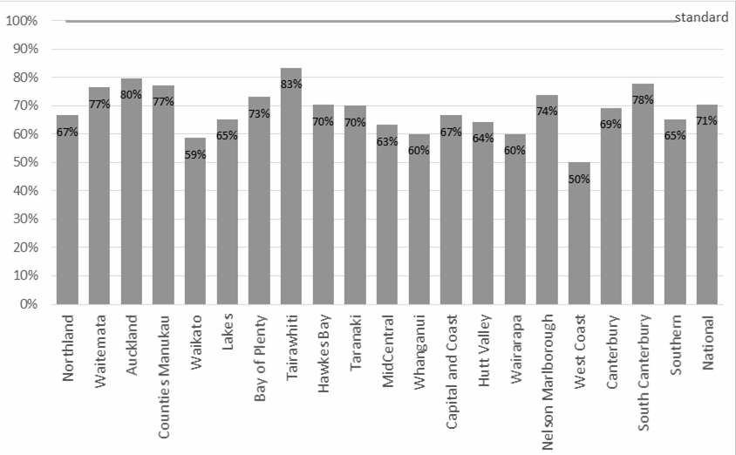

Table 8: Percentage of second samples received (or other appropriate follow-up occurred) within 10 days, January to December 2017

ow up Total
DHB of domicile | Within 10 days
 | no. | % | no. % | no. | % no. |  |  |  |  | % | no.
Northland | 34 | 67% | 14 27% 48 |  | 94% 3 |  |  |  |  | 6% | 51
Waitemata | 101 | 77% | 22 17% 123 |  | 93% 9 |  |  |  |  | 7% | 132
Auckland | 67 | 80% | 14 17% 81 |  | 96% 3 |  |  |  |  | 4% | 84
Counties Manukau | 129 | 77% | 34 20% 163 |  | 98% 4 |  |  |  |  | 2% | 167
Waikato | 44 | 59% | 21 28% 65 |  | 87% 10 |  |  |  |  | 13% | 75
Lakes | 15 | 65% | 5 22% 20 |  | 87% 3 |  |  |  |  | 13% | 23
Bay of Plenty | 38 | 73% | 13 25% 51 |  | 98% 1 |  |  |  |  | 2% | 52
Tairawhiti | 5 | 83% | 0 0% 5 |  | 83% 1 |  |  |  |  | 17% | 6
Hawke’s Bay | 26 | 70% | 11 30% 37 |  | 100% 0 |  |  |  |  | 0% | 37
Taranaki | 14 | 70% | 6 30% 20 |  | 100% 0 |  |  |  |  | 0% | 20
MidCentral | 31 | 63% | 17 35% 48 |  | 98% 1 |  |  |  |  | 2% | 49
Whanganui | 6 | 60% | 4 40% 10 |  | 100% 0 |  |  |  |  | 0% | 10
Capital & Coast | 36 | 67% | 18 33% 54 |  | 100% 0 |  |  |  |  | 0% | 54
Hutt Valley | 18 | 64% | 8 29% 26 |  | 93% 2 |  |  |  |  | 7% | 28
Wairarapa | 3 | 60% | 2 40% 5 |  | 100% 0 |  |  |  |  | 0% | 5
Nelson Marlborough | 17 | 74% | 6 26% 23 |  | 100% 0 |  |  |  |  | 0% | 23
West Coast | 4 | 50% | 4 50% 8 |  | 100% 0 |  |  |  |  | 0% | 8
Canterbury | 74 | 69% | 31 29% 105 |  | 98% 2 |  |  |  |  | 2% | 107
South Canterbury | 7 | 78% | 2 22% 9 |  | 100% 0 |  |  |  |  | 0% | 9
Southern | 32 | 65% | 15 31% 47 |  | 96% 2 |  |  |  |  | 4% | 49
Unknown | 3 | 33% | 6 67% 9 |  | 100% 0 |  |  |  |  | 0% | 9
National | 704 | 71% | 253 25% 957 |  | 96% 41 |  |  |  |  | 4% | 998

Indicator 6:
Laboratory turnaround time positive results
Description: This indicator monitors the timeliness of reporting of newborns with screen positive results by the laboratory.

Rationale: Early detection of screened disorders is dependent on timely referral of newborns with positive screening results for diagnostic testing.

Standard: 100% of screen positive results are notified to the newborn’s referring practitioner within the disorder specific number of calendar days.

Interpretation: Overall 82% of screen positives were notified in 2017 within the standard timeframes; an 23% increase on 2016 (59%). There was wide variation in the timeliness of notification of screen positive results across the screened disorders, with disorder specific timeframes being met for all of the 8 disorder groups.

Comment: This indicator is being reviewed to improve accuracy and clinical utility. In 2016 all ‘clinical critical’ results were reported within the timeframes. A ‘clinical critical’ screening result is one which indicates a reasonable or high probability of a disorder that can present with severe illness in the early neonatal period, and where a delay of 1-2 days can affect the outcome.

The ‘non clinical critical’ cases warrant different indicator timeframes. Also, borderline newborn screening results are not reported until all results are available on the sample so the notification can include all results in one contact. For example, a borderline hypothyroid result may be available in two days, but if the sample also has a raised immune-reactive trypsin in the cystic fibrosis screen, it is sent for mutation analysis. The request for a second sample to confirm the thyroid result will be made after the cystic fibrosis mutation result is available.

Figure 7: Percentage of screen positives notified within the disorder specific timeframe, January to December 2017

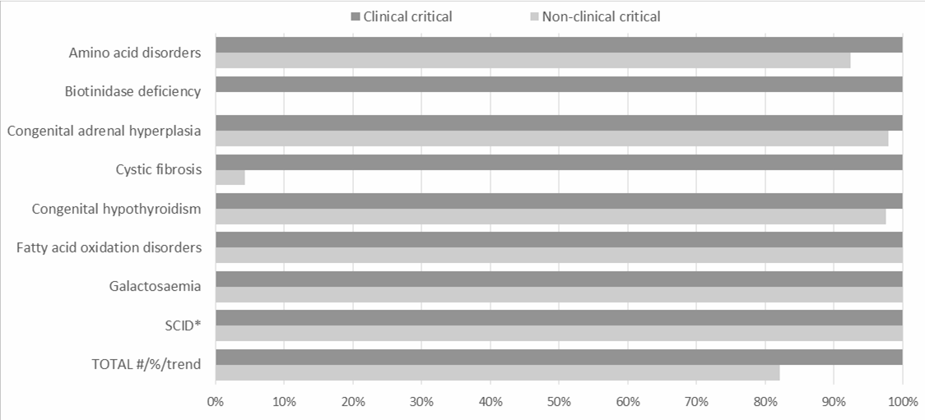

Table 9: Notification of screen positives, January to December 2017

Disorder | Timeframe (calendar days)  Clinical Non-  critical clinical |  | Timeframe met |  |  |  | Timeframe not m |  |  | et | Total no.  Clinical Non- critical clinical
 |  |  | Clinical critical  no. % |  | Non-clinical critical  no. % |  | Clinical critical  no. % |  | Non-clinical critical  no. %
Amino acid disorders | 2 | 7 | 2 | 100% | 73 | 92% | 0 | 0% | 6 | 8% | 2 | 79
Biotinidase deficiency | – | 7 | 0 | 100% | 0 | 0% | 0 | 0% | 0 | 0% | 0 | 0
Congenital adrenal hyperplasia | 2 | 7 | 1 | 100% | 95 | 98% | 0 | 0% | 2 | 2% | 1 | 97
Cystic fibrosis | – | 7 | 0 | 100% | 2 | 4% | 0 | 0% | 44 | 96% | 0 | 46
Congenital hypothyroidism | 4 | 7 | 9 | 100% | 41 | 98% | 0 | 0% | 1 | 2% | 9 | 42
Fatty acid oxidation disorders | 2 | 7 | 8 | 100% | 28 | 100% | 0 | 0% | 0 | 0% | 8 | 28
Galactosaemia | 2 | 7 | 0 | 100% | 4 | 100% | 0 | 0% | 0 | 0% | 0 | 4
SCID* | – | 7 | 0 | 100% | 1 | 100% | 0 | 0% | 0 | 0% | 0 | 1
Total # / % / trend | 20/20 | (100%,  no change) | 20 | 100% | 244 | 82% | 0 | 0% | 53 | 18% | 20 | 297
Note: SCID (Severe Combined Immuno-deficiency) testing was introduced in December 2017.
* The validity of these timeframes are being reviewed to more accurately reflect clinical utility, for example not all screen positive cases were ‘clinical critical’.

Indicator 7:
Age of receipt into clinical care
Description: Monitoring the commencement of treatment for newborns diagnosed with a screened condition.

Rationale: The NMSP aims for early confirmed diagnosis and timely treatment to ensure that newborns with metabolic conditions have their development potential impacted as little as possible.

Standard: 100% of newborns who have a screen positive result and confirmed diagnosis have treatment commenced within the disorder specific time frame (age of newborn in days).

Interpretation: There was wide variation in timeliness of commencement of treatment for newborns diagnosed with a screened disorder. The disorder specific timeframe was met for all of the eight disorders with cases.

Comment: Delays in treatment are caused by a combination of: later diagnosis of mild disease, difficulties obtaining diagnostic tests, or difficulty making a definitive diagnosis. Delayed diagnosis is far more likely when the disease is mild, for example where the initial test is marginally abnormal and confirmed with a second dried blood spot. Diagnosis may also be delayed due to diagnostic test processes, for example some laboratories do not do sweat tests for possible cystic fibrosis until the newborn is a month old.

Table 10: Confirmed diagnosis commencement of treatment, January to December 2017

Disorder | Timeframe (calendar days)  Clinical Non-  critical clinical |  | Timeframe met |  |  |  | Timeframe not met |  |  | Total no.  Clinical Non- critical clinical
 |  |  | Clinical critical  no. % |  | Non-clinical critical  no. % |  | Clinical critical  no. % |  | Non-clinical critical  no. %
Amino acid disorders | 10 | 28 | 1 | 100% | 0 |  | 0 | 0% | 0 | 1 | 0
Biotinidase deficiency | – | 28 | 0 |  | 0 |  | 0 | 0% | 0 | 0 | 0
Congenital adrenal hyperplasia | 10 | 28 | 1 | 100% | 0 |  | 0 | 0% | 0 | 1 | 0
Cystic fibrosis | – | 28 | 12 | 100% | 0 |  | 0 | 0% | 0 | 12 | 0
Congenital hypothyroidism | 10 | 28 | 9 | 100% | 11 | 100% | 0 | 0% | 0 | 9 | 11
Fatty acid oxidation disorders | 10 | 28 | 6 | 100% | 0 |  | 0 | 0% | 0 | 6 | 0
Galactosaemia | 10 | 28 | 0 |  | 0 |  | 0 | 0% | 0 | 0 | 0
SCID* | – | 14 | 1 | 100% | 0 |  | 0 | 0% | 0 | 1 | 0
Total |  |  | 30 | 100% | 11 |  | 0 | 0% | 0 | 30 | 11
* The validity of these timeframes are being reviewed to more accurately reflect clinical utility. There were no known clinical consequences of delayed treatment.

Indicator 8:
Positive predictive value of the screening test
Description: The probability of a baby having a positive diagnosis for a screened condition given a positive screening result for that condition.

Rationale: Positive predictive value (PPV) is a measure of the performance of the screening test. A low PPV means many babies without a screened condition will be referred for diagnostic testing, with associated costs and anxiety for families. Reporting of PPV helps to monitor potential harm of the programme due to identification of false positives through screening.

Standard: None. Interpretation: Comment:
Table 11: Positive predictive value of the screening test, 2013–2017

 | Babies screened | Positive tests | Cases  True False positive A positive B |  | Missed cases False True  negative C negative D |  | Sensitivity  % | Specificity  % | PPV %
AABD | 294,293 | 748 | 19 | 729 | 2 | 293,544 | 90.5 | 99.8 | 2.5
Galactosemia | 294,293 | 15 | 1 | 14 | 0 | 294,278 | 100 | 100 | 6.7
Biotinidase def | 294,293 | 8 | 1 | 7 | 0 | 294,285 | 100 | 100 | 12.5
CH | 294,293 | 276 | 154 | 122 | 1 | 294,016 | 99.4 | 100 | 55.8
CF | 294,293 | 258 | 60 | 198 | 0 | 294,035 | 100 | 99.9 | 23.3
CAH | 294,293 | 253 | 7 | 246 | 0 | 294,040 | 100 | 99.9 | 2.8
FAOD | 294,293 | 342 | 38 | 304 | 0 | 293,951 | 100 | 99.9 | 11.1
SCID | 3,843 | 0 | 0 | 0 | 0 | 3,843 |  | 100
Total |  | 1,900 | 280 | 1,620 | 3 | 290,490 | 98.9 | 99.4 | 14.7

Appendix 1:
List of screened conditions

Amino acid disorders

Phenylketonuria

Maple syrup urine disease

Argininosuccinic aciduria (argininosuccinate lyase deficiency) Citrullinaemia (argininosuccinate synthetase deficiency
Glutaric acidaemia type I (glutaryl-CoA dehydrogenase deficiency) Homocystinuria (cystathionine beta-synthase deficiency) Isovaleric acidaemia (isovaleryl-CoA dehydrogenase deficiency)
Methylmalonic acidurias (mutase deficiency, CblA, CblB, CblC, CblD defects) Propionic acidaemia (propionyl-CoA carboxylase deficiency)
Tyrosinaemia (fumaryl acetoacetase deficiency, tyrosine aminotransferase deficiency)

Fatty acid oxidation disorders

CACT (carnitine acylcarnitine translocase deficiency Carnitine transporter defect
CPT-I (carnitine palmitoyltransferase-I deficiency) CPT-II (carnitine palmitoyltransferase-II deficiency)
LCHAD (3-hydroxy long-chain acyl-CoA dehydrogenase deficiency) TFP (trifunctional protein deficiency)
MADD (multiple acyl-CoA dehydrogenase deficiency MCAD (medium-chain acyl-CoA dehydrogenase deficiency)
VLCAD (very-long-chain acyl-CoA dehydrogenase deficiency)

Additional disorders

Congenital hypothyroidism (CH) Congenital adrenal hyperplasia (CAH) Cystic fibrosis (CF)
Biotinidase deficiency Galactosaemia
Severe Combined Immuno-deficiency (SCID)

