Newborn Metabolic Screening Programme
  - Annual Report 2020
Released 2023
Acknowledgements
This report is the result of a partnership between the National Screening Unit and LabPlus (Te Toka Tumai Auckland).
The staff in the Clinicians Screening team and the Antenatal and Newborn Screening team in the National Screening Unit and Dr Dianne Webster, Keith Shore and Dr Natasha Heather of LabPlus have supported all stages of the development of the report and provided valuable feedback.
This publication reports on information Te Toka Tumai Auckland has provided to the National Screening Unit. The purpose of this publication is to inform discussion and assist the ongoing development of the Newborn Metabolic Screening Programme. All care has been taken in the production of this report, and the data was deemed to be accurate at the time of publication. However, the data may be subject to slight changes over time as further information is received. Before quoting or using this information, it is advisable to check the current status with the National Screening Unit.

Citation: National Screening Unit. 2022. Newborn Metabolic Screening Programme: Annual Report 2020. Wellington: National Screening Unit.
Published in April 2023 by National Screening Unit, PO Box 5013, Wellington 6140, New Zealand
ISBN 978-1-99-106705-0 (online)
This document is available at nsu.govt.nz
This work is licensed under the Creative Commons Attribution 4.0 International licence. In essence, you are free to: share ie, copy and redistribute the material in any medium or format; adapt ie, remix, transform and build upon the material. You must give appropriate credit, provide a link to the licence and indicate if changes were made.

Contents
Executive summary 5
Introduction 6
Background to the programme 6
Data summary 7
Indicator 1: Coverage 7
Indicator 2: Timing of sample taking 10
Indicator 3: Quality of blood samples 14
Indicator 4: Sample dispatch and delivery 17
Indicator 5: Receipt and follow-up of second samples 20
Indicator 6: Laboratory turnaround time for positive results 23
Indicator 7: Age of receipt into clinical care 26
Indicator 8: Positive predictive value of the screening test 28
Appendix 1: List of screened conditions 30
List of Figures
Figure 1: Percentage of samples taken between 48 and 72 hours, January to December 2020 11
Figure 2: Percentage of samples the laboratory received within four days of sample taking, January to December 2020 18
Figure 3: Percentage of second samples the laboratory received (or when other appropriate follow-up occurred) within 10 days, January to December 2020 21
Figure 4: Percentage of screen positives the laboratory notified within the disorder-specific timeframe, January to December 2020 25
List of Tables
Table 1: Coverage over time 8
Table 2: Coverage by ethnicity, January to December 2020 8
Table 3: Coverage by DHB of domicile and ethnicity, January to December 2020 9
Table 4: Timing of sample taking, January to December 2020 12
Table 5: Timing of sample taking by ethnicity, January to December 2020 13
Table 6: Percentage of samples of a satisfactory quality, January to December 2020 15
Table 7: Reason for unsatisfactory samples, January to December 2020 16
Table 8: Percentage of samples the laboratory received within four days of sample taking, January to December 2020. 19
Table 9: Percentage of second samples the laboratory received (or when other appropriate follow-up occurred) within 10 days, January to December 2020 22
Table 10: Notification of screen positives, January to December 2020 25
Table 11: Timeframe met for receipt into clinical care after confirmed diagnosis, January to December 2020 27
Table 12: Positive predictive value of the screening test, January 2016 to December 2020 29

Executive summary
- The Newborn Metabolic Screening Programme (NMSP) screened 57,930 of the 58,373 babies born in 2020. This represents a national coverage rate of 99.2 percent, which is comparable with coverage rates since the programme began in 1969. Coverage rates at a district health board (DHB) level range from 98.0 percent (Bay of Plenty) to 100 percent. Since 2017, DHBs have been increasingly encouraged to match their birth data with their data on babies screened to ensure all babies whose parents/guardians have given consent are screened.
- In 2020, national coverage varied by ethnic group: 97.8 percent of Māori newborns, 97.6 percent of Pacific newborns, 99.3 percent of Asian and 100 percent of newborns of all other ethnicities were screened.
- In 2020, 67 newborns were diagnosed with a screened disorder. This is slightly higher than in 2019 where 60 babies were diagnosed.
- Of the seven indicators with a national target, six were not met.
- Indicator 2: Timing of sample taking
- Indicator 3: Quality of blood samples
- Indicator 4: Sample dispatch and delivery
- Indicator 5: Receipt and follow-up of second samples
- Indicator 6: Laboratory turnaround time for positive results
- Indicator 7: Age of receipt into clinical care
- Blood spot cards are expected to arrive at the laboratory within four days of sampling. In 2020, 83 percent arrived in the indicator timeframe. The national standard is 95 percent. In 2019, the four-day transit time rate was 88 percent and the drop of 5 percent in 2020 was due to the impact of COVID. This shortfall is a known and long-standing issue that, since 2015, has been the focus of process quality improvement. The result has been significant increases, from 66 percent in 2014, in the four-day transit rate.
- In 2015 a new protocol was introduced by LabPlus which aimed to improve the time second samples were received at LabPlus. This included sending text messages, making extra phone calls and providing additional written reports to lead maternity carers (LMCs). The rate of return within the expected 10-day timeframe has risen from 38 percent in 2014 to 83 percent in 2020, up from 79 percent in 2019.

Introduction
This annual report provides information on the performance of the Newborn Metabolic Screening Programme (NMSP) against the agreed set of national indicators. Regular analysis and reporting of NMSP data is a key tool in enabling continuous quality improvement of the programme.

The NMSP Monitoring Framework and monitoring reports are published on the National Screening Unit (NSU) website: www.nsu.govt.nz/health-professionals/newborn-metabolic-screening-programme/procedures-guidelines-and-reports-2. The Newborn Metabolic Screening Programme monitoring indicators, dated February 2018, updates and replaces the indicators in the Newborn Metabolic Screening Programme Monitoring Framework, November 2010. This is available at: https://www.nsu.govt.nz/system/files/page/newborn-metabolic-screening-programme-monitoring-indicators-feb18.pdf.

Background to the programme
The aim of the NMSP is to reduce morbidity and mortality associated with specific congenital metabolic and some other disorders by screening newborns to detect the conditions before life-threatening illness or developmental delays occur. Since 1969, almost all newborns in New Zealand have been screened by the programme. Currently, the NMSP identifies about 60 to 70 newborns a year with a metabolic disorder.

To conduct the screening, a midwife, nurse, phlebotomist or doctor collects a blood sample from the newborns heel onto a blood spot card (a ‘Guthrie card’). The optimal collection time for samples is when the newborn is between 48 and 72 hours of age, however samples collected from 24 hours of age are now considered acceptable for screening completion. Cards are sent urgently to the laboratory, LabPlus at Auckland City Hospital, which analyses the samples and reports the results to appropriate clinicians. Blood spot samples are screened for the 23 conditions listed in Appendix 1.

Since 2005, the NSU at the Ministry of Health has overseen the NMSP nationally. A significant milestone for the programme came in 2006 when newborn screening was expanded to include fatty acid oxidation disorders and more amino acid breakdown disorders in the screening panel. Screening for severe combined immunodeficiency (SCID) was added in December 2017.

Data summary
Screening data is sourced from LabPlus at Auckland DHB for all blood spot cards received in the 2020 calendar year. Birth data in the 2020 calendar year is sourced from the National Maternity Collection at the Ministry of Health. Ethnicity data is prioritised following Statistics New Zealand’s HISO 10001:2017 ethnicity data protocol, which is the standard approach across the health sector. When a newborn’s DHB of domicile is unknown it is set to ‘Unknown’.

Note: Due to a mismatch between denominator data (babies born in the calendar year) and numerator data (screening performed in the calendar year) percentage calculations may exceed 100 percent.

Indicator 1: Coverage
Description: The proportion of babies born who complete newborn metabolic screening.

Rationale: Newborn screening must be offered for all babies. All babies whose parents/guardians have consented to screening should have completed screening.

Target: ≥99 percent of babies born nationally and within each of Māori, Pacific, Asian and Other population groups are screened.

Interpretation: National coverage is at 99.2 percent which is above target. Total coverage by DHB varied from 98.0 percent upward (Bay of Plenty and Counties Manukau). Coverage by ethnicity varied: 97.6 percent for Pacific newborns, 97.8 percent for Māori newborns, 99.3 percent for Asian newborns and 100 percent for Other newborns.

Comment: All 20 DHBs achieved at least 98 percent coverage in total. All but seven DHBs made the 99 percent target for total coverage; however, only two DHBs made the 99 percent target within each of the Māori, Pacific, Asian and Other population groups.

It is estimated that the NMSP did not screen approximately 443 newborns in 2020. It is not yet possible to distinguish between those unscreened who were offered screening and declined and those who were missed. Some DHBs have begun to actively identify and follow up on unscreened newborns, with the support of LabPlus, to ensure that an offer of screening has been made.

Coverage rates for Māori are lower than for non-Māori at 15 DHBs.

Table 1: Coverage over time
Year | Births | Babies screened | Coverage (%)
2010 | 64,699 | 63,727 | 98.5
2011 | 62,733 | 61,859 | 98.6
2012 | 62,842 | 61,422 | 97.7
2013 | 59,707 | 59,192 | 99.1
2014 | 59,097 | 58,673 | 99.3
2015 | 59,058 | 58,463 | 99.0
2016 | 59,640 | 59,010 | 98.9
2017 | 59,517 | 58,935 | 99.0
2018 | 58,163 | 57,880 | 99.5
2019 | 59,733 | 59,315 | 99.3
2020 | 58,373 | 57,930 | 99.2

Table 2: Coverage by ethnicity, January to December 2020
Ethnicity | Births | Babies screened | Coverage (%)
Māori | 14,908 | 14,582 | 97.8
Pacific | 6,029 | 5,884 | 97.6
Asian | 11,348 | 11,264 | 99.3
Other | 26,088 | 26,200 | 100*
Total | 58,373 | 57,930 | 99.2
* Due to a data mismatch between the denominator and numerator, percentages in this table may exceed 100%. Values greater than 100% are capped at 100.

Table 3: Coverage by DHB of domicile and ethnicity, January to December 2020
DHB of domicile | Māori (%) | Pacific (%) | Asian  (%) | Other (%) | Total  (%) | Ratio†
Northland | 98.8 | 92.7 | 98.2 | 98.5 | 98.5 | 0.97
Waitemata | 97.8 | 100* | 99.7 | 99.8 | 99.5 | 0.98
Auckland | 97.5 | 98.2 | 99.7 | 100* | 99.6 | 0.97
Counties Manukau | 97.6 | 96.0 | 98.7 | 100* | 98.0 | 0.96
Waikato | 97.6 | 96.3 | 99.4 | 100* | 99.0 | 0.97
Lakes | 97.6 | 97.1 | 98.8 | 100* | 98.7 | 0.97
Bay of Plenty | 96.2 | 93.7 | 99.4 | 99.5 | 98.0 | 0.95
Tairawhiti | 99.5 | 100* | 100* | 98.1 | 99.4 | 0.99
Hawke's Bay | 97.2 | 99.2 | 97.8 | 100* | 98.9 | 0.97
Taranaki | 96.1 | 100.0 | 99.1 | 99.1 | 98.3 | 0.95
MidCentral | 97.0 | 97.1 | 98.4 | 100.0 | 98.7 | 0.97
Whanganui | 97.1 | 100.0 | 100.0 | 100* | 99.0 | 0.98
Capital & Coast | 97.69 | 100.0 | 98.8 | 100.0 | 99.4 | 0.97
Hutt Valley | 97.2 | 99.5 | 99.2 | 100* | 99.4 | 0.97
Wairarapa | 100* | 100.0 | 89.3 | 99.7 | 99.4 | 0.99
Nelson Marlborough | 98.4 | 100.0 | 99.2 | 100.0 | 99.6 | 0.98
West Coast | 98.3 | 100.0 | 100.0 | 100* | 100* | 1.04
Canterbury | 100.0 | 98.5 | 99.8 | 100* | 100* | 1.01
South Canterbury | 100.0 | 100* | 100.0 | 100* | 100* | 1.01
Southern | 98.79 | 97.9 | 99.0 | 100* | 99.7 | 0.99
National | 97.81 | 97.6 | 99.3 | 100* | 99.2 | 0.98
* Due to a data mismatch between the denominator and numerator, percentages in this table may exceed 100%. Values greater than 100% are capped at 100.
† A rate ratio is used here to focus on equity. It is calculated by dividing Māori coverage by non-Māori coverage. A ratio over 1 means higher coverage for Māori compared with non-Māori.

Indicator 2: Timing of sample taking
Description: The proportion of babies screened who have a newborn metabolic screening sample taken between 48 and 72 hours of age.

Rationale: Prompt sample collection leads to the best possible chance of a baby with a screened condition receiving early diagnosis and treatment. Severe forms of some of the disorders can be fatal within seven to ten days, and many babies may not show any signs or symptoms of disease until irreversible damage has occurred. However, the baby must have been independent of their mother long enough for some biochemical markers to show an abnormality. The optimum window for sample collection is between 48 and 72 hours after birth.

Target: ≥95 percent of first samples are taken between 48 and 72 hours after birth.

Interpretation: Timeliness of sample taking varied between DHBs from 67 percent (Lakes DHB) to 90 percent (Canterbury and West Coast DHBs). The national average was 79 percent. Currently there are no DHBs meeting the target. Māori and Pacific ethnic groups have a higher proportion of samples taken after 72 hours than Asian and Other ethnic groups.

Comment: Canterbury and West Coast DHBs have the highest proportion of samples taken between 48 and 72 hours after birth (89.8 percent and 90.3 percent respectively). Lakes and Waikato DHBs had over 25 percent of samples taken after 72 hours after birth (28.3 percent and 25.7 percent respectively).
From late 2019 samples collected from 24hrs of age were considered acceptable for screening completion. Around 1% of samples were collected between 24 and 48 hours, which is similar to previous years. Table 4 shows a breakdown of the timing of sample taking.

Figure 1: Percentage of samples taken between 48 and 72 hours, January to December 2020
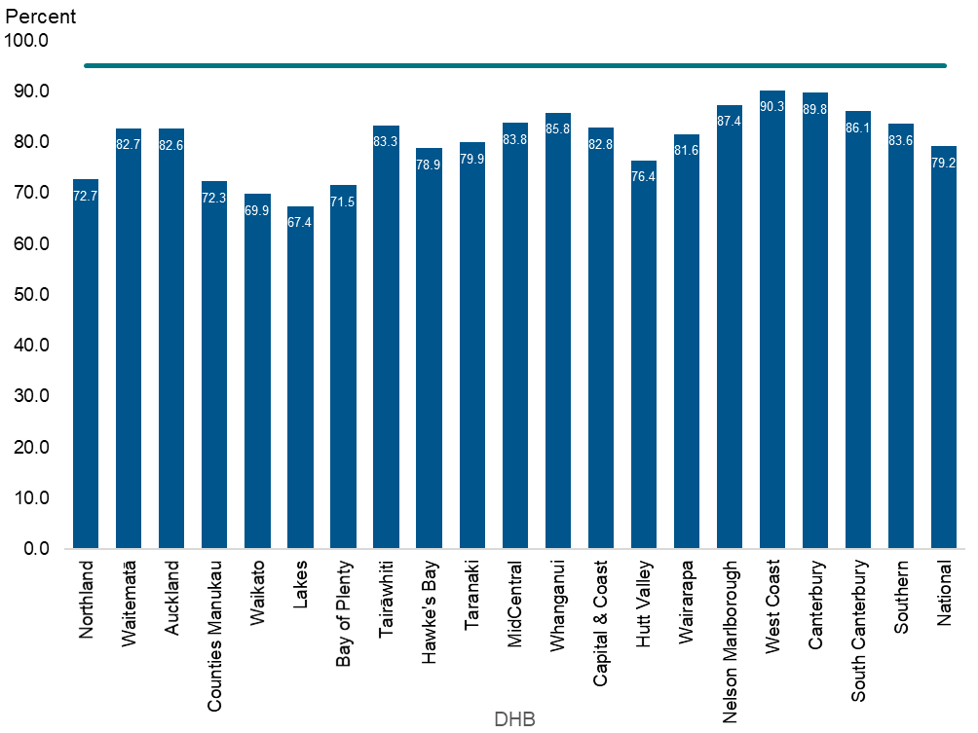

Table 4: Timing of sample taking, January to December 2020
DHB of domicile | 24 to 47 hours |  | 48 to 72 hours |  | More than 72 hours |  | Unknown |  | Total
 | No. | % | No. | % | No. | % | No. | % | No.
Northland | 25 | 1.1 | 1,710 | 72.7 | 559 | 23.8 | 52 | 2.2 | 2,353
Waitematā | 82 | 1.1 | 6,176 | 82.7 | 1,080 | 14.5 | 123 | 1.6 | 7,468
Auckland | 72 | 1.4 | 4,251 | 82.6 | 688 | 13.4 | 132 | 2.6 | 5,145
Counties Manukau | 156 | 1.9 | 5,999 | 72.3 | 1,876 | 22.6 | 256 | 3.1 | 8,296
Waikato | 72 | 1.3 | 3,853 | 69.9 | 1,418 | 25.7 | 168 | 3.0 | 5,516
Lakes | 18 | 1.3 | 957 | 67.4 | 401 | 28.3 | 42 | 3.0 | 1,419
Bay of Plenty | 26 | 0.8 | 2,204 | 71.5 | 763 | 24.8 | 85 | 2.8 | 3,081
Tairāwhiti | 11 | 1.6 | 588 | 83.3 | 98 | 13.9 | 8 | 1.1 | 706
Hawke's Bay | 25 | 1.2 | 1,634 | 78.9 | 368 | 17.8 | 44 | 2.1 | 2,072
Taranaki | 13 | 0.9 | 1,144 | 79.9 | 237 | 16.6 | 36 | 2.5 | 1,431
MidCentral | 31 | 1.5 | 1,785 | 83.8 | 243 | 11.4 | 64 | 3.0 | 2,129
Whanganui | 6 | 0.7 | 696 | 85.8 | 102 | 12.6 | 6 | 0.7 | 811
Capital & Coast | 53 | 1.7 | 2,564 | 82.8 | 396 | 12.8 | 78 | 2.5 | 3,096
Hutt Valley | 26 | 1.3 | 1,534 | 76.4 | 407 | 20.3 | 38 | 1.9 | 2,008
Wairarapa | 9 | 1.7 | 425 | 81.6 | 75 | 14.4 | 12 | 2.3 | 521
Nelson Marlborough | 12 | 0.8 | 1,250 | 87.4 | 150 | 10.5 | 18 | 1.3 | 1,431
West Coast | 4 | 1.3 | 269 | 90.3 | 21 | 7.0 | 4 | 1.3 | 298
Canterbury | 84 | 1.4 | 5,574 | 89.8 | 436 | 7.0 | 114 | 1.8 | 6,210
South Canterbury | 8 | 1.3 | 514 | 86.1 | 67 | 11.2 | 8 | 1.3 | 597
Southern | 45 | 1.4 | 2,749 | 83.6 | 436 | 13.3 | 57 | 1.7 | 3,289
Unknown | - | 0.0 | 33 | 62.3 | 10 | 18.9 | 10 | 18.9 | 53
National | 778 | 1.3 | 45,909 | 79.2 | 9,831 | 17.0 | 1,355 | 2.3 | 57,930
Table 5: Timing of sample taking by ethnicity, January to December 2020
Ethnicity | 24 to 47 hours |  | 48 to 72 hours |  | More than 72 hours |  | Unknown |  | Total
 | No. | % | No. | % | No. | % | No. | % | No.
Māori | 169 | 1.2 | 10,810 | 74.1 | 3,235 | 22.2 | 349 | 2.4 | 14,582
Pacific | 105 | 1.8 | 4,242 | 72.1 | 1,370 | 23.3 | 164 | 2.8 | 5,884
Asian | 179 | 1.6 | 9,291 | 82.5 | 1,518 | 13.5 | 268 | 2.4 | 11,264
Other | 324 | 1.2 | 21,566 | 82.3 | 3,708 | 14.2 | 574 | 2.2 | 26,200
National | 778 | 1.3 | 45,909 | 79.2 | 9,831 | 17.0 | 1,355 | 2.3 | 57,930

Indicator 3: Quality of blood samples
Description: The proportion of samples received by the laboratory that are of satisfactory quality.

Rationale: Accurate testing is reliant on a good quality blood spot sample. Unsatisfactory samples require a repeat sample which could have been avoided. This indicator measures the proportion of blood spot samples that require repeating due to a quality issue.

Target: ≥99 percent of blood spot samples received are of satisfactory quality.

Interpretation: The proportion of satisfactory blood samples ranged from 98.2 percent (MidCentral DHB) to 100 percent (West Coast DHB) across DHBs. The national average was 98.9 percent.

Comment: Overall sample quality declined slightly in 2020, with 1.1 percent (636) of all samples being unsatisfactory compared with 1.0 percent (604) in 2019.
Sample collection quality, for example due to, insufficient blood on the card, remains the main reason why samples were unsatisfactory, and the number has increased this year. The number of samples that were unsatisfactory due to being collected early has gone down predominantly due to samples collected from 24 hours now being acceptable samples. Each unsatisfactory sample is followed up with a request for a second sample (Indicator 5) to reduce the risk to the babies affected.

Table 6: Percentage of samples of a satisfactory quality, January to December 2020
DHB of domicile | Satisfactory |  | Unsatisfactory |  | Total
 | No. | % | No. | % | No.
Northland | 2,324 | 98.8 | 29 | 1.2 | 2,353
Waitemata | 7,395 | 99.0 | 73 | 1.0 | 7,468
Auckland | 5,104 | 99.2 | 41 | 0.8 | 5,145
Counties Manukau | 8,186 | 98.7 | 110 | 1.3 | 8,296
Waikato | 5,443 | 98.7 | 73 | 1.3 | 5,516
Lakes | 1,413 | 99.6 | 6 | 0.4 | 1,419
Bay of Plenty | 3,055 | 99.2 | 26 | 0.8 | 3,081
Tairawhiti | 702 | 99.4 | 4 | 0.6 | 706
Hawke's Bay | 2,047 | 98.8 | 25 | 1.2 | 2,072
Taranaki | 1,426 | 99.7 | 5 | 0.3 | 1,431
MidCentral | 2,091 | 98.2 | 38 | 1.8 | 2,129
Whanganui | 797 | 98.3 | 14 | 1.7 | 811
Capital & Coast | 3,056 | 98.7 | 40 | 1.3 | 3,096
Hutt Valley | 1,987 | 99.0 | 21 | 1.0 | 2,008
Wairarapa | 520 | 99.8 | 1 | 0.2 | 521
Nelson Marlborough | 1,422 | 99.4 | 9 | 0.6 | 1,431
West Coast | 298 | 100.0 | 0 | 0.0 | 298
Canterbury | 6,133 | 98.8 | 77 | 1.2 | 6,210
South Canterbury | 591 | 99.0 | 6 | 1.0 | 597
Southern | 3,253 | 98.9 | 36 | 1.1 | 3,289
Unknown | 51 | 96.2 | 2 | 3.8 | 53
National | 57,294 | 98.9 | 636 | 1.1 | 57,930

Table 7: Reason for unsatisfactory samples, January to December 2020
Reason* | Number | Percentage
Collection | 540 | 84.9
Timing | 55 | 8.6
Transport | 39 | 6.1
Other | 2 | 0.3
Total | 636 | 100.0
* Summary of main reasons:
- collection: insufficient blood or the sample was contaminated
- timing: sample was collected too early (before 24 hours of age).
- transport: sample took more than one month to arrive, blood was wet when sample card was folded, damaged in transit or sample was put wet into a plastic bag.
- other: any other reason for the sample being unsatisfactory.

Indicator 4: Sample dispatch and delivery
Description: The time taken for the sample to be received by the laboratory after being taken.

Rationale: Samples must be received by the laboratory as soon as possible after they are taken.

Target: ≥95 percent of samples are received by the laboratory within four calendar days of being taken.

Interpretation: Timeliness of sample dispatch and delivery varied widely between DHBs, ranging from 67 percent (Lakes DHB) to 91 percent (Auckland and Tairāwhiti DHBs) of samples received within four days. National timeliness has slightly decreased from 88 percent in 2019 to 83 percent in 2020.

Comment: Considerable quality improvement work has been undertaken, and is on-going, for this indicator since 2016. This has resulted in a 17 percent increase in the four-day transit rate, from 66 percent in 2014 to 83 percent in 2020, with a 4 percent drop from 2019. The NSU continues to provide DHBs with quarterly ‘transit time’ reports as feedback on transit time turnaround. To access the transit time reports, go to: https://minhealthnz.shinyapps.io/nsu-nmsp-transittime/.
COVID-19 is the primary reason for this drop in dispatch and delivery timeliness as courier delivery times increased, particularly during April and May 2020. The courier delivery delays were closely monitored by LabPlus throughout 2020 and priority stickers for courier envelops distributed.

Figure 2: Percentage of samples the laboratory received within four days of sample taking, January to December 2020
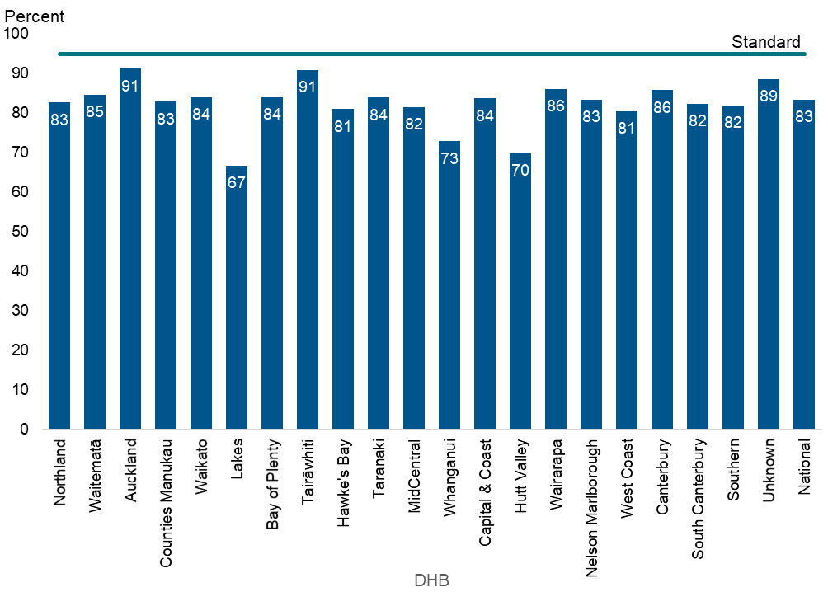

Table 8: Percentage of samples the laboratory received within four days of sample taking, January to December 2020
DHB of domicile | Within 4 days |  | Total
 | No. | % | No.
Northland | 1,945 | 83 | 2,353
Waitematā | 6,322 | 85 | 7,468
Auckland | 4,695 | 91 | 5,145
Counties Manukau | 6,878 | 83 | 8,296
Waikato | 4,637 | 84 | 5,516
Lakes | 948 | 67 | 1,419
Bay of Plenty | 2,588 | 84 | 3,081
Tairāwhiti | 642 | 91 | 706
Hawke's Bay | 1,679 | 81 | 2,072
Taranaki | 1,201 | 84 | 1,431
MidCentral | 1,737 | 82 | 2,129
Whanganui | 591 | 73 | 811
Capital & Coast | 2,593 | 84 | 3,096
Hutt Valley | 1,404 | 70 | 2,008
Wairarapa | 449 | 86 | 521
Nelson Marlborough | 1,194 | 83 | 1,431
West Coast | 240 | 81 | 298
Canterbury | 5,328 | 86 | 6,210
South Canterbury | 492 | 82 | 597
Southern | 2,694 | 82 | 3,289
Unknown | 47 | 89 | 53
National | 48,304 | 83 | 57,930

Indicator 5: Receipt and follow-up of second samples
Description: The proportion of second sample requests that had appropriate follow-up (timely receipt of second sample, decline notified or other appropriate follow-up).

Rationale: Second samples are requested if first samples give borderline results or are inadequate. Where requested, second samples should be taken as soon as possible.

Target: 100 percent of second samples requested are received by the laboratory, had other appropriate follow-up, or were declined by parents/guardians, within 10 calendar days of the request.

Interpretation: In 2020, 83 percent of requests for second samples resulted in one of the following within 10 days: a second sample arrived at the laboratory; or the laboratory received notification that the parents/guardians had declined the request, or that the newborn had been referred to a specialist, other appropriate follow-up had occurred, or that the newborn had died.

Comment: In the 2020 reporting period, a second sample was received, declined or had other follow-up in 99 percent of the instances when a second sample was requested. 83 percent of second samples were received by the laboratory, had other appropriate follow-up, or were declined by parents/guardians, within 10 calendar days of the request. 16 percent of samples or declines were received after 10 days, and an extra 1 percent were lost to follow-up and the task closed at 28 days.
The time taken to receive a follow-up sample is influenced by the time it takes to generate, send and receive the request; the time it takes to collect the second sample (usually at the next scheduled visit of the LMC) and send it to the laboratory; and for the laboratory to receive it.
In 2020, the timeliness of the receipt of second samples was also impacted by COVID-19 level 3-4 lockdowns. When the laboratory phoned LMCs to request repeat samples during level 3-4, in order to reduce unnecessary face-to-face contact and ensure it was safe for the baby, the laboratory asked the LMC to collect the next sample at their next scheduled visit instead of an extra earlier visit. Furthermore, pressure on courier services impacted card transit times and is also likely to have delayed the return of second cards to the laboratory during this time.

Despite an increase in the number of second sample requests (733 requests in 2019 to 803 requests in 2020) and the impacts on courier services, laboratory services, and face-to-face contact, the timeliness of receipt of second samples increased by 4 percent, from 79 percent in 2019 to 83 percent in 2020 of second samples received within 10 days.
May 2015 saw the introduction of a new protocol (which included sending text messages, making extra phone calls and providing written reports) for reminding LMCs when the laboratory did not receive follow-up samples. Between 2014 and 2020, the percentage of second samples received in 10 days or fewer has increased 45 percent.
Additionally, the total number of requests has declined significantly since 2014, when the laboratory made 1,352 second sample requests to 733 in 2019 , with a slight increase to 803 in 2020. This reduction is the result of stopping screening for 3MCC and carnitine uptake disorders and suspending screening for tyrosinemia; introducing second-tier tests in screening for some amino acid breakdown disorders; and improving sample quality.

Figure 3: Percentage of second samples the laboratory received (or when other appropriate follow-up occurred) within 10 days, January to December 2020
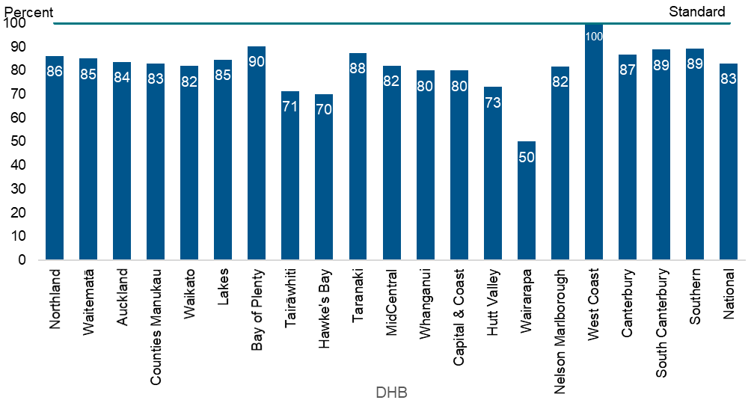

Table 9: Percentage of second samples the laboratory received (or when other appropriate follow-up occurred) within 10 days, January to December 2020
DHB of domicile | Within 10 days |  | Greater than 10 days |  | Grand Total | Target
 | no. | % | no. | % | no. | %
Northland | 31 | 86 | 5 | 14 | 36 | 100
Waitematā | 74 | 85 | 10 | 15 | 87 | 100
Auckland | 41 | 84 | 8 | 16 | 49 | 100
Counties Manukau | 108 | 83 | 20 | 17 | 130 | 100
Waikato | 68 | 82 | 15 | 18 | 83 | 100
Lakes | 11 | 85 | 2 | 15 | 13 | 100
Bay of Plenty | 28 | 90 | 2 | 10 | 31 | 100
Tairāwhiti | 5 | 71 | 2 | 29 | 7 | 100
Hawke's Bay | 21 | 70 | 8 | 30 | 30 | 100
Taranaki | 7 | 88 | 1 | 13 | 8 | 100
MidCentral | 32 | 82 | 7 | 18 | 39 | 100
Whanganui | 12 | 80 | 3 | 20 | 15 | 100
Capital & Coast | 40 | 80 | 10 | 20 | 50 | 100
Hutt Valley | 19 | 73 | 7 | 27 | 26 | 100
Wairarapa | 1 | 50 | 1 | 50 | 2 | 100
Nelson Marlborough | 9 | 82 | 2 | 18 | 11 | 100
West Coast | 1 | 100 | 0 | 0 | 1 | 100
Canterbury | 85 | 87 | 13 | 13 | 98 | 100
South Canterbury | 8 | 89 | 1 | 11 | 9 | 100
Southern | 42 | 89 | 5 | 11 | 47 | 100
Unknown | 24 | 77 | 6 | 23 | 31 | 100
National | 667 | 83 | 128 | 17 | 803 | 100

Indicator 6: Laboratory turnaround time for positive results
Description: The time from receipt of the sample in the laboratory to notification of the referring practitioner or specialist paediatrician of a screen positive result.

Rationale: Timely processing and notification of screen positive samples is essential to ensure early detection and treatment. This indicator is a measure of laboratory performance.

Target: 100 percent of babies with positive results are notified to their LMC / specialist paediatrician by the laboratory within the following timeframes:
Reason for report | Calendar days*
 | Clinical critical | Non-clinical critical
Amino acid disorders | 2 | 7
Biotinidase deficiency | - | 7
Congenital adrenal hyperplasia | 2 | 7
Cystic fibrosis | - | 7
Congenital hypothyroidism | 4 | 7
Fatty acid oxidation disorders | 2 | 7
Galactosaemia | 2 | 7
SCID | - | 7
* from receipt in lab to notification of screen positives
Interpretation: Overall, 86 percent of clinical critical screen positives, and 88 percent of non-clinical critical screen positives, were notified within the expected timeframes in 2020. Both are below the target of 100 percent. The timeliness of notification of screen positive results varied widely across the screened disorders, and caution should be used due to the relatively low numbers of results being reported.

Comment: In 2020, 25 of 29 ‘clinical critical’ results were reported within the timeframes. A ‘clinical critical’ screening result indicates a reasonable or high probability of a disorder that can present with severe illness in the early neonatal period, and where a delay of one to two days can affect the outcome. All clinical critical samples that did not meet timeframes were affected by weekends and public holidays, and there were no adverse clinical consequences from positives screens reported outside of timeframes.

The ‘non-clinical critical’ cases warrant different indicator timeframes. In 2020, 235 of 266 ‘non-clinical critical’ cases were reported within the timeframes. Borderline newborn screening results are not reported until all results are available on the sample so the notification can include all results in one contact. For example, a borderline hypothyroid result may be available in two days, but if the sample also has a raised immunoreactive trypsin in the cystic fibrosis screen, it is sent for mutation analysis. The laboratory will request a second sample to confirm the thyroid result after the cystic fibrosis mutation result is available.
There were no adverse clinical consequences from positive screens reported outside the timeframes.

Figure 4: Percentage of screen positives the laboratory notified within the disorder-specific timeframe, January to December 2020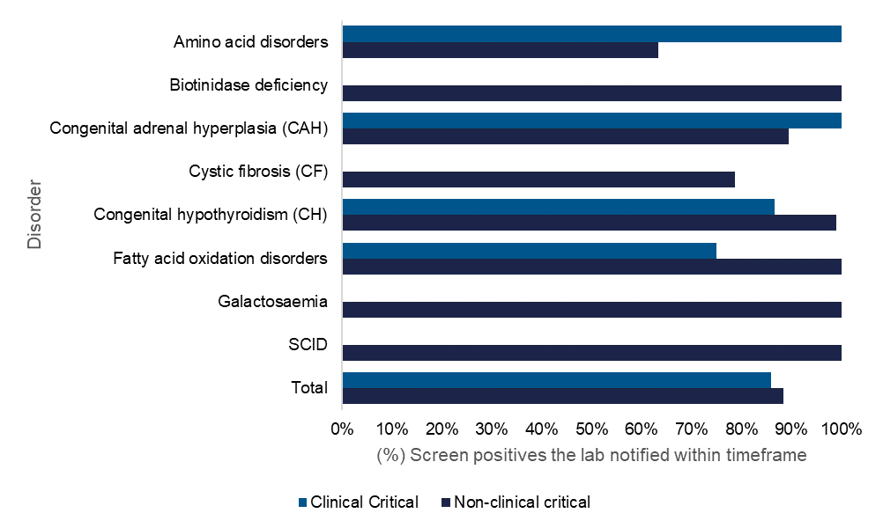

Table 10: Notification of screen positives, January to December 2020
Disorder | TAT met |  | TAT not met |  | Total
 | CC | NCC | CC | NCC | CC | NCC
Amino acid disorders | 3 | 31 | - | 18 | 3 | 49
Biotinidase deficiency | - | 7 | - | - | - | 7
Congenital adrenal hyperplasia | 3 | 17 | - | 2 | 3 | 19
Cystic fibrosis | - | 37 | - | 10 | - | 47
Congenital hypothyroidism | 13 | 102 | 2 | 1 | 15 | 103
Fatty acid oxidation disorders | 6 | 5 | 2 | - | 8 | 5
Galactosaemia | - | 11 | - | - | - | 11
SCID | - | 25 | - | - | - | 25
Total | 25 | 235 | 4 | 31 | 29 | 266
Percentage | 86% | 88% | 14% | 12%
TAT: Turn Around Time; CC: Clinical Critical; NCC: Not Clinical Critical

Indicator 7: Age of receipt into clinical care
Description: For babies with screened conditions, the age of the baby at transfer into clinical care.

Rationale: To ensure babies with congenital metabolic disorders have their development potential affected as little as possible, all babies with a screened condition must receive a confirmed diagnosis and timely commencement of treatment/active clinical management.

Target: 100 percent of babies who receive a screen positive result and are diagnosed with a screened condition receive active clinical management by the following timeframes:
Disorder | Age of baby in days
 | Clinical critical | Non-clinical critical
Amino acid disorders | 10 | 28
Biotinidase deficiency | - | 28
Congenital adrenal hyperplasia | 10 | 28
Cystic fibrosis | - | 28
Congenital hypothyroidism | 10 | 28
Fatty acid oxidation disorders | 10 | 28
Galactosaemia | 10 | 28
SCID | - | 14

Interpretation: The disorder-specific timeframe was met for 22 out of 23 cases identified as clinical critical. 42 of 44 non-clinical critical cases were received into clinical care within the specified timeframe.

Comment: The three cases that didn’t meet the timeframe were preterm babies for whom additional screening occurs at days 14 and 28, as congenital hypothyroidism is not detectable in these babies earlier. 95.5 percent of babies with disease detected following a positive newborn screen were received into clinical care within an acceptable timeframe.

Table 11: Timeframe met for receipt into clinical care after confirmed diagnosis, January to December 2020
Disorder | Timeframe |  | Timeframe met |  |  |  | Total |  | Total
 | CC | NCC | CC |  | NCC |  | CC | NCC
 | Timeframe |  | No. | % | No. | % | No. | No. | No.
Amino acid disorders | 10 | 28 | 1 | 100 | 1 | 100 | 1 | 1 | 2
Biotinidase deficiency | - | 28 | - | - | - | - | - | 1 | 1
Congenital adrenal hyperplasia | 10 | 28 | 3 | 100 | - | - | 3 | - | 3
Cystic fibrosis | - | 28 | - | - | 18 | 100 | - | 18 | 18
Congenital hypothyroidism | 10 | 28 | 13 | 92.9 | 22 | 91.7 | 14 | 24 | 38
Fatty acid oxidation disorders | 10 | 28 | 5 | 100 | - | - | 5 | - | 5
Galactosaemia | 10 | 28 | - |  | - | - | - | - | -
SCID | - | 14 | - | - | - | - | - | - | -
Total |  |  | 22 | 95.7 | 42 | 95.5 | 23 | 44 | 67
CC: Clinical Critical; NCC: Not Clinical Critical

Indicator 8: Positive predictive value of the screening test
Description: The probability of a baby having a positive diagnosis for a screened condition given a positive screening result for that condition.

Rationale: Positive predictive value (PPV) is a measure of the performance of the screening test. A low PPV means many babies without a screened condition will be referred for diagnostic testing, this brings associated costs and anxiety for families. Reporting of PPV helps to monitor the potential harm of the programme due to identification of false positives through screening.

Target: None.

Interpretation: The PPV for individual disorders is presented as five-year rolling data because the number of cases varies significantly year on year. Over all the tests, a baby with a positive screen is 20 percent likely to be affected with the screened disorder.

Comment: Five-year rolling data is slow to show the benefits of adding second-tier testing to the amino acid breakdown disorders and the improved protocols for some other disorders. The benefits should become evident in future reports. The overall PPV for 2020 is 21.8 percent.

Table 12: Positive predictive value of the screening test, January 2016 to December 2020
Disorder | Babies screened | Positive tests | False positive | True positive | False negative | True negative | Sens. % | Spec. % | PPV %
Amino acid disorders | 292,798 | 325 | 311 | 14 | 1 | 292,474 | 93.3 | 99.9 | 4.3
Biotinidase deficiency | 292,798 | 26 | 23 | 3 | 0 | 292,772 | 100.0 | 100.0 | 11.5
Congenital Adrenal Hyperplasia | 292,798 | 184 | 174 | 10 | 0 | 292,614 | 100.0 | 99.9 | 5.4
Cystic Fibrosis | 292,798 | 265 | 191 | 74 | 0 | 292,513 | 100.0 | 99.9 | 27.9
Congenital Hypothyroidism | 292,798 | 355 | 202 | 153 | 2 | 292,541 | 98.7 | 99.9 | 43.1
Fatty acid oxidation disorders | 292,798 | 113 | 80 | 33 | 0 | 292,685 | 100.0 | 100.0 | 29.2
Galactosaemia | 292,798 | 1 | 0 | 1 | 2 | 292,775 | 33.3 | 100.0 | 11.8
SCID* | 178,679 | 73 | 69 | 4 | 0 | 178,605 | 100.0 | 100.0 | 5.5
Total | 292,798 | 1342 | 1050 | 292 | 5 | 291,451 | 98.3 | 100.0 | 21.8
*SCID screening started December 2017

Appendix 1:

List of screened conditions
Amino acid disorders
Phenylketonuria
Maple syrup urine disease
Argininosuccinic aciduria (argininosuccinate lyase deficiency)
Citrullinaemia (argininosuccinate synthetase deficiency)
Glutaric acidaemia type I (glutaryl-CoA dehydrogenase deficiency)
Homocystinuria (cystathionine beta-synthase deficiency)
Isovaleric acidaemia (isovaleryl-CoA dehydrogenase deficiency)
Methylmalonic acidurias (mutase deficiency, CblA, CblB, CblC, CblD defects)
Propionic acidaemia (propionyl-CoA carboxylase deficiency)
Fatty acid oxidation disorders
CACT (carnitine acylcarnitine translocase deficiency)
CPT-I (carnitine palmitoyltransferase-I deficiency)
CPT-II (carnitine palmitoyltransferase-II deficiency)
LCHAD (3-hydroxy long-chain acyl-CoA dehydrogenase deficiency)
TFP (trifunctional protein deficiency)
MADD (multiple acyl-CoA dehydrogenase deficiency)
MCAD (medium-chain acyl-CoA dehydrogenase deficiency)
VLCAD (very-long-chain acyl-CoA dehydrogenase deficiency)
Additional disorders
Congenital hypothyroidism
Congenital adrenal hyperplasia
Cystic fibrosis
Biotinidase deficiency
Galactosaemia
Severe combined immunodeficiency (SCID)

