Newborn Metabolic Screening Programme
Annual Report
January to December 2019

Disclaimer
This publication reports on information Auckland District Health Board has provided to the Ministry of Health. The purpose of this publication is to inform discussion and assist the ongoing development of the Newborn Metabolic Screening Programme. All care has been taken in the production of this report, and the data was deemed to be accurate at the time of publication. However, the data may be subject to slight changes over time as further information is received. Before quoting or using this information, it is advisable to check the current status with the Ministry of Health.
Citation: Ministry of Health. 2022. Newborn Metabolic Screening Programme: Annual Report 2019. Wellington: Ministry of Health.
Published in April 2022 by the Ministry of Health
PO Box 5013, Wellington 6140, New Zealand
ISBN 978-1-99-110033-7 (online)
HP 8116
This document is available at nsu.govt.nz
This work is licensed under the Creative Commons Attribution 4.0 International licence. In essence, you are free to: share ie, copy and redistribute the material in any medium or format; adapt ie, remix, transform and build upon the material. You must give appropriate credit, provide a link to the licence and indicate if changes were made.

Contents
Executive summary v
Introduction 1
Background to the programme 1
Data summary 1
Indicator 1: Coverage 2
Indicator 2: Timing of sample taking 4
Indicator 3: Quality of blood samples 7
Indicator 4: Sample dispatch and delivery 9
Indicator 5: Receipt and follow-up of second samples 12
Indicator 6: Laboratory turnaround time for positive results 15
Indicator 7: Age of receipt into clinical care 18
Indicator 8: Positive predictive value of the screening test 20
Appendix 1: List of screened conditions 22

List of Figures
Figure 1: Percentage of samples taken between 48 and 72 hours, January to December 2019 5
Figure 2: Percentage of samples the laboratory received within four days of sample taking, January to December 2019 10
Figure 3: Percentage of second samples the laboratory received (or other appropriate follow-up occurred) within 10 days, January to December 2019 13
Figure 4: Percentage of screen positives the laboratory notified within the disorder-specific timeframe, January to December 2019 16

List of Tables
Table 1: Coverage over time 2
Table 2: Coverage by ethnicity, January to December 2019 3
Table 3: Coverage by district health board of domicile and ethnicity, January to December 2019 3
Table 4: Timing of sample taking, January to December 2019 6
Table 5: Timing of sample taking by ethnicity, January to December 2019 6
Table 6: Percentage of samples of a satisfactory quality, January to December 2019 8
Table 7: Reason for unsatisfactory samples, January to December 2019 8
Table 8: Percentage of samples the laboratory received within four days of sample taking, January to December 2019 11
Table 9: Percentage of second samples the laboratory received (or other appropriate follow-up occurred) within 10 days, January to December 2019 14
Table 10: Notification of screen positives, January to December 2019 17
Table 11: Timeframe met for receipt into clinical care after confirmed diagnosis, January to December 2019 19
Table 12: Positive predictive value of the screening test, January 2015 to December 2019 21

Executive summary
      - The Newborn Metabolic Screening Programme (NMSP) screened 59,315 of the 59,733 babies born in 2019. This represents a national coverage rate of 99.3 percent, which is comparable with coverage rates since the programme began in 1969. Coverage rates at a district health board (DHB) level ranged from 98.0 percent to 100 percent.
      - In 2019, coverage varied by ethnic group: 98.1 percent of Māori newborns, 97.5 percent of Pacific newborns and 100 percent of newborns of all other ethnicities were screened. Since 2017, the Ministry of Health has increasingly encouraged DHBs to match their birth data with their data on babies screened to ensure all babies whose parents/guardians have given consent are screened.
      - In 2019, 60 newborns were diagnosed with a screened disorder. This is comparable with previous years.
      - In 2018, the National Screening Unit, together with the programme’s lead paediatricians and laboratory scientists, completed a review of the monitoring indicators. This report contains the updated indicators.
      - Of the seven indicators with a national target, four were not met.
- Indicator 2: Timing of sample taking
- Indicator 4: Sample dispatch and delivery
- Indicator 5: Receipt and follow-up of second samples
- Indicator 6: Laboratory turnaround time for positive results.
      - Blood spot cards are expected to arrive at the laboratory, LabPLUS within Auckland DHB, within four days of sampling. In 2019, 88 percent arrived in the indicator timeframe. The national standard is 95 percent. This shortfall is a known and long-standing issue that, since 2015, has been the focus of process quality improvement, in particular the provision of quarterly ‘transit time’ reports to DHBs. The result has been a 22 percent increase in the four-day transit rate, from 66 percent in 2014 to 88 percent in 2019.
      - In 2015, LabPLUS introduced a new protocol that aimed to improve the time within which it receives second samples. This included sending text messages, making extra phone calls and providing additional written reports to lead maternity carers. The rate of return within the expected 10-day timeframe rose from 38 percent in 2014 to 79 percent in 2019.

Introduction
This annual report provides information on the performance of the Newborn Metabolic Screening Programme (NMSP) against the agreed set of national indicators. Regular analysis and reporting of NMSP data is a key tool in enabling continuous quality improvement of the programme.

The NMSP Monitoring Framework and monitoring reports are published on the National Screening Unit (NSU) website: www.nsu.govt.nz/health-professionals/newborn-metabolic-screening-programme/procedures-guidelines-and-reports-2. The NMSP monitoring indicators, dated February 2018, update and replace the indicators in the Newborn Metabolic Screening Programme Monitoring Framework, November 2010. They are available at https://www.nsu.govt.nz/system/files/page/newborn-metabolic-screening-programme-monitoring-indicators-feb18.pdf.

Background to the programme
The aim of the NMSP is to reduce morbidity and mortality associated with specific congenital metabolic disorders by screening newborns to detect the conditions before life-threatening illness or developmental delays occur. Since 1969, almost all newborns in New Zealand have been screened by the programme. Currently the NMSP identifies about 50 to 60 newborns a year with a metabolic disorder.

To conduct the screening, a midwife, nurse, phlebotomist or doctor collects a blood sample from the newborn’s heel onto a blood spot card (a ‘Guthrie card’). Samples must be collected when the newborn is between 48 and 72 hours of age for optimal testing. Cards are sent urgently to the laboratory, LabPLUS at Auckland District Health Board (DHB), which analyses the samples and reports the results to appropriate clinicians. Blood spot samples are screened for the 23 conditions listed in Appendix 1.

Since 2005, the NSU at the Ministry of Health has overseen the NMSP nationally. A significant milestone for the programme came in 2006 when newborn screening was expanded to include fatty acid oxidation disorders and more amino acid breakdown disorders in the screening panel. Screening for severe combined immunodeficiency (SCID) was added in December 2017.

Data summary
Screening data is sourced from LabPlus at Auckland DHB for all blood spot cards received in the 2019 calendar year. Birth data in the 2019 calendar year is sourced from the National Maternity Collection at the Ministry of Health. Ethnicity data is prioritised following Stats NZ’s HISO 10001:2017 ethnicity data protocol, which is the standard approach across the health sector. When a newborn’s DHB of domicile is unknown, it is set to ‘Unknown’.

Indicator 1: Coverage
Description: The proportion of babies born who complete newborn metabolic screening.
Rationale: Newborn screening must be offered for all babies. All babies whose parents/guardians have consented to screening should have completed screening.
Target: ≥99 percent of babies born nationally and within each of Māori, Pacific, Asian and Other population groups are screened.
Interpretation: National coverage is at 99.3 percent, which is above target. Total coverage by DHB varied from 98.0 percent upward. Coverage by ethnicity varied: 97.5 percent for Pacific newborns, 98.1 percent for Māori newborns, 99.5 percent for Asian newborns and 100 percent for Other newborns.
Comment: All 20 DHBs achieved at least 98 percent coverage in total. All but six DHBs made the 99 percent target for total coverage; however, only five DHBs made the 99 percent target within each of the Māori, Pacific and Other population groups.
We estimate that the NMSP did not screen approximately 400 newborns in 2019. It is not yet possible to distinguish between the few newborns who are unscreened because parents/guardians withhold consent and those not screened because they are missed. Some DHBs have begun to actively identify and follow up on unscreened newborns, with the support of LabPlus.
Coverage rates for Māori are lower than for non-Māori at 15 DHBs, as measured using a rate ratio. We expect these rates to improve with increased matching of birth and screening data.
Note: Due to a mismatch between denominator data (babies born in the calendar year) and numerator data (screening performed in the calendar year), percentage calculations may vary.

Table 1: Coverage over time
Year | Births | Babies screened | Coverage (%)
2010 | 64,699 | 63,727 | 98.5
2011 | 62,733 | 61,859 | 98.6
2012 | 62,842 | 61,422 | 97.7
2013 | 59,707 | 59,192 | 99.1
2014 | 59,097 | 58,673 | 99.3
2015 | 59,058 | 58,463 | 99.0
2016 | 59,640 | 59,010 | 98.9
2017 | 59,517 | 58,935 | 99.0
2018 | 58,163 | 57,880 | 99.5
2019 | 59,733 | 59,315 | 99.3

Table 2: Coverage by ethnicity, January to December 2019
Ethnicity | Births | Babies screened | Coverage (%)
Māori | 14,695 | 14,419 | 98.1
Pacific | 6,097 | 5,943 | 97.5
Asian | 11,619 | 11,560 | 99.5
Other | 27,322 | 27,393 | 100*
Total | 59,733 | 59,315 | 99.3
* Percentages greater than 100 percent (due to a mismatch between numerator and denominator data) are capped at 100 percent.

Table 3: Coverage by district health board of domicile and ethnicity, January to December 2019
DHB of domicile | Māori  (%) | Pacific  (%) | Asian  (%) | Other  (%) | Total  (%) | Ratio†
Northland | 96.8 | 100.0 | 97.9 | 98.9 | 98.0 | 0.97
Waitematā | 99.6 | 99.0 | 99.3 | 100* | 99.8 | 1.00
Auckland | 97.4 | 98.2 | 100 | 99.7 | 99.3 | 0.98
Counties Manukau | 96.8 | 96.2 | 99 | 100* | 98.0 | 0.98
Waikato | 98.1 | 97.2 | 98.9 | 99.7 | 99.0 | 0.99
Lakes | 96.8 | 98.0 | 100 | 99.6 | 98.2 | 0.97
Bay of Plenty | 97.9 | 95.4 | 99.4 | 100* | 99.2 | 0.98
Tairāwhiti | 96.2 | 94.7 | 100 | 100* | 98.1 | 0.95
Hawke’s Bay | 99.6 | 99.3 | 97.7 | 100* | 100* | 0.98
Taranaki | 98.7 | 100.0 | 100* | 100* | 100* | 0.98
MidCentral | 98.4 | 92.6 | 97.2 | 99.5 | 98.6 | 1.00
Whanganui | 97.3 | 92.7 | 100 | 100.0 | 98.5 | 0.98
Capital & Coast | 100* | 97.9 | 100 | 100* | 100* | 1.00
Hutt Valley | 98.8 | 100.0 | 99.5 | 100* | 99.8 | 0.99
Wairarapa | 100.0 | 100.0 | 100* | 99.0 | 99.6 | 1.01
Nelson Marlborough | 96.9 | 100* | 100* | 99.0 | 99.0 | 0.97
West Coast | 98.6 | 100.0 | 100 | 100* | 100* | 0.95
Canterbury | 98.5 | 98.8 | 99.5 | 100 | 99.6 | 0.99
South Canterbury | 99.0 | 100.0 | 98.5 | 100* | 99.8 | 0.99
Southern | 100* | 100.0 | 98.1 | 100* | 100.0 | 1.00
National | 98.1 | 97.5 | 99.5 | 100* | 99.3 | 0.98
* Percentages greater than 100 percent (due to a mismatch between numerator and denominator data) are capped at 100 percent.
† A rate ratio is used here to focus on equity. It is calculated by dividing Māori coverage by non-Māori coverage. A ratio over 1 means higher coverage for Māori compared with non-Māori.

Indicator 2: Timing of sample taking
Description: The proportion of babies screened who have a newborn metabolic screening sample taken between 48 and 72 hours of age.

Rationale: Prompt sample collection leads to the best possible chance of a baby with a screened condition receiving early diagnosis and treatment. Severe forms of some of the disorders can be fatal within seven to ten days, and many babies may not show any signs or symptoms of disease until irreversible damage has occurred. However, the baby must have been independent of their mother long enough for some biochemical markers to show an abnormality. The optimum window for sample collection is between 48 and 72 hours after birth.

Target: ≥95 percent of first samples are taken between 48 and 72 hours after birth.

Interpretation: Timeliness of sample taking varied between DHBs from 67 percent (Lakes) to 90 percent (Canterbury). The national average was 80 percent. Currently no DHBs are meeting the standard.

Comment: Canterbury and South Canterbury DHBs have the highest proportion of samples taken between 48 and 72 hours after birth, at 90 percent. One third of samples from Waikato and Lakes DHBs were taken outside the standard period (both at 33 percent).

Figure 1: Percentage of samples taken between 48 and 72 hours, January to December 2019
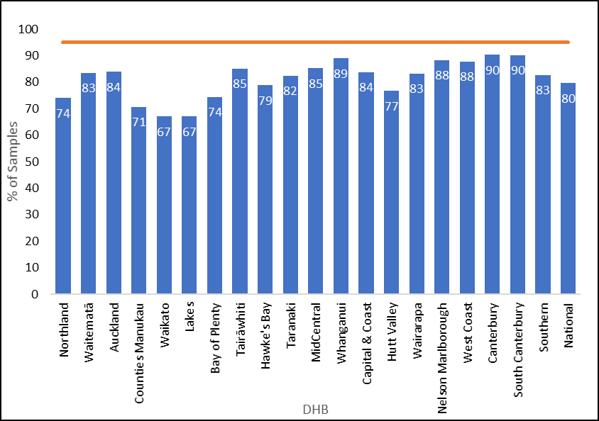

Table 4: Timing of sample taking, January to December 2019
DHB of domicile | Less than 48 hours |  | 48 to 72 hours |  | More than 72 hours |  | Unknown |  | Total
 | No. | % | No. | % | No. | % | No. | % | No.
Northland | 24 | 1 | 1,679 | 74 | 516 | 23 | 50 | 2 | 2,269
Waitematā | 81 | 1 | 6,512 | 83 | 1,104 | 14 | 108 | 1 | 7,805
Auckland | 69 | 1 | 4,662 | 84 | 654 | 12 | 175 | 3 | 5,560
Counties Manukau | 120 | 1 | 5,869 | 71 | 2,086 | 25 | 232 | 3 | 8,307
Waikato | 58 | 1 | 3,638 | 67 | 1,547 | 29 | 181 | 3 | 5,424
Lakes | 8 | 1 | 1,026 | 67 | 447 | 29 | 50 | 3 | 1,531
Bay of Plenty | 31 | 1 | 2,295 | 74 | 700 | 23 | 62 | 2 | 3,088
Tairāwhiti | 3 | 0 | 573 | 85 | 90 | 13 | 7 | 1 | 673
Hawke’s Bay | 25 | 1 | 1,605 | 79 | 351 | 17 | 55 | 3 | 2,036
Taranaki | 6 | 0 | 1,255 | 82 | 228 | 15 | 33 | 2 | 1,522
MidCentral | 16 | 1 | 1,841 | 85 | 233 | 11 | 71 | 3 | 2,161
Whanganui | 7 | 1 | 761 | 89 | 78 | 9 | 9 | 1 | 855
Capital & Coast | 49 | 2 | 2,699 | 84 | 397 | 12 | 79 | 2 | 3,224
Hutt Valley | 25 | 1 | 1,518 | 77 | 386 | 19 | 51 | 3 | 1,980
Wairarapa | 8 | 2 | 428 | 83 | 67 | 13 | 11 | 2 | 514
Nelson Marlborough | 10 | 1 | 1,277 | 88 | 137 | 9 | 23 | 2 | 1,447
West Coast | 5 | 1 | 314 | 88 | 35 | 10 | 4 | 1 | 358
Canterbury | 59 | 1 | 5,817 | 90 | 429 | 7 | 134 | 2 | 6,439
South Canterbury | 3 | 0 | 566 | 90 | 52 | 8 | 7 | 1 | 628
Southern | 34 | 1 | 2,847 | 83 | 481 | 14 | 83 | 2 | 3,445
Unknown | 1 | 2 | 36 | 73 | 8 | 16 | 4 | 8 | 49
National | 642 | 1 | 47,218 | 80 | 10,026 | 17 | 1,429 | 2 | 59,315

Table 5: Timing of sample taking by ethnicity, January to December 2019
Ethnicity | Less than 48 hours |  | 48 to 72 hours |  | More than 72 hours |  | Unknown |  | Total
 | No. | % | No. | % | No. | % | No. | % | No.
Māori | 163 | 1 | 10,789 | 75 | 3,114 | 22 | 353 | 2 | 14,419
Pacific | 71 | 1 | 4,299 | 72 | 1,420 | 24 | 153 | 3 | 5,943
Asian | 116 | 1 | 9547 | 82 | 1639 | 14 | 258 | 2 | 11,560
Other | 292 | 1 | 22,583 | 82 | 3853 | 14 | 665 | 2 | 27,393
National | 642 | 1 | 47,218 | 80 | 10,026 | 17 | 1,429 | 2 | 59,315

Indicator 3: Quality of blood samples
Description: The proportion of samples received by the laboratory that are of satisfactory quality.

Rationale: Accurate testing is reliant on a good quality blood spot sample. Unsatisfactory samples require a repeat sample which could have been avoided. This indicator measures the proportion of blood spot samples that require repeating due to a quality issue.

Target: ≥99 percent of blood spot samples received are of satisfactory quality.

Interpretation: The proportion of satisfactory blood samples ranged from 98.4 percent to 99.7 percent across DHBs. The national average was 99.0 percent.

Comment: Overall sample quality improved slightly in 2019, with 1.0 percent (604) of all samples being unsatisfactory, compared with 1.2 percent (698) in 2018.

Sample collection quality – for example, due to insufficient blood on the card – remains the main reason why samples were unsatisfactory. Each unsatisfactory sample is followed up with a request for a second sample (Indicator 5) to reduce the risk to the babies affected.

Table 6: Percentage of samples of a satisfactory quality, January to December 2019
DHB of domicile | Satisfactory |  | Unsatisfactory |  | Total
 | No. | % | No. | % | No.
Northland | 2,244 | 98.9 | 25 | 1.1 | 2,269
Waitematā | 7,729 | 99.0 | 76 | 1.0 | 7,805
Auckland | 5,503 | 99.0 | 57 | 1.0 | 5,560
Counties Manukau | 8,195 | 98.7 | 112 | 1.3 | 8,307
Waikato | 5,373 | 99.1 | 51 | 0.9 | 5,424
Lakes | 1,521 | 99.3 | 10 | 0.7 | 1,531
Bay of Plenty | 3,056 | 99.0 | 32 | 1.0 | 3,088
Tairāwhiti | 671 | 99.7 | 2 | 0.3 | 673
Hawke’s Bay | 2,012 | 98.8 | 24 | 1.2 | 2,036
Taranaki | 1,512 | 99.3 | 10 | 0.7 | 1,522
MidCentral | 2,127 | 98.4 | 34 | 1.6 | 2,161
Whanganui | 848 | 99.2 | 7 | 0.8 | 855
Capital & Coast | 3,197 | 99.2 | 27 | 0.8 | 3,224
Hutt Valley | 1,966 | 99.3 | 14 | 0.7 | 1,980
Wairarapa | 512 | 99.6 | 2 | 0.4 | 514
Nelson Marlborough | 1,434 | 99.1 | 13 | 0.9 | 1,447
West Coast | 356 | 99.4 | 2 | 0.6 | 358
Canterbury | 6,369 | 98.9 | 70 | 1.1 | 6,439
South Canterbury | 626 | 99.7 | 2 | 0.3 | 628
Southern | 3,412 | 99.0 | 33 | 1.0 | 3,445
Unknown | 48 | 98.0 | 1 | 2.0 | 49
National | 58,711 | 99.0 | 604 | 1.0 | 59,315

Table 7: Reason for unsatisfactory samples, January to December 2019
Reason* | Number | Percentage
Collection | 362 | 59.9
Timing | 222 | 36.8
Transport | 12 | 2.0
Other | 8 | 1.3
Total | 604 | 100.0
* Summary of main reasons:
- collection: insufficient blood or the sample was contaminated
- timing: sample was collected too early (before 48 hours of age). Note: not all samples collected before 48 hours are classed as unsatisfactory as some samples collected after 24 hours are analysed
- transport: sample took more than one month to arrive, blood was wet when folded, sample was damaged in transit or sample was put wet into a plastic bag
- other: any other reason for the sample being unsatisfactory.

Indicator 4: Sample dispatch and delivery
Description: The time taken for the sample to be received by the laboratory after being taken.

Rationale: Samples must be received by the laboratory as soon as possible after they are taken.

Target: ≥95 percent of samples are received by the laboratory within four calendar days of being taken.

Interpretation: Timeliness of sample dispatch and delivery varied widely between DHBs, ranging from 77 percent (Hutt Valley) to 93 percent (Auckland) of samples received within four days. National timeliness improved from 85 percent in 2018 to 88 percent in 2019.

Comment: As in 2016, 2017 and 2018, this indicator remained the focus of considerable quality improvement work in 2019. Quality improvements have included solely using courier services for sending samples to the laboratory and counting transit times from the ‘date of receipt’ in the laboratory (rather than from the date of registration – that is, the start of the test process). The NSU continues to provide DHBs with quarterly ‘transit time’ reports as feedback on transit time turnaround. To access the transit time reports, go to: https://minhealthnz.shinyapps.io/nsu-nmsp-transittime/. As a result, there has been a 22 percent increase in the four-day transit rate, from 66 percent in 2014 to 88 percent in 2019.

Figure 2: Percentage of samples the laboratory received within four days of sample taking, January to December 2019
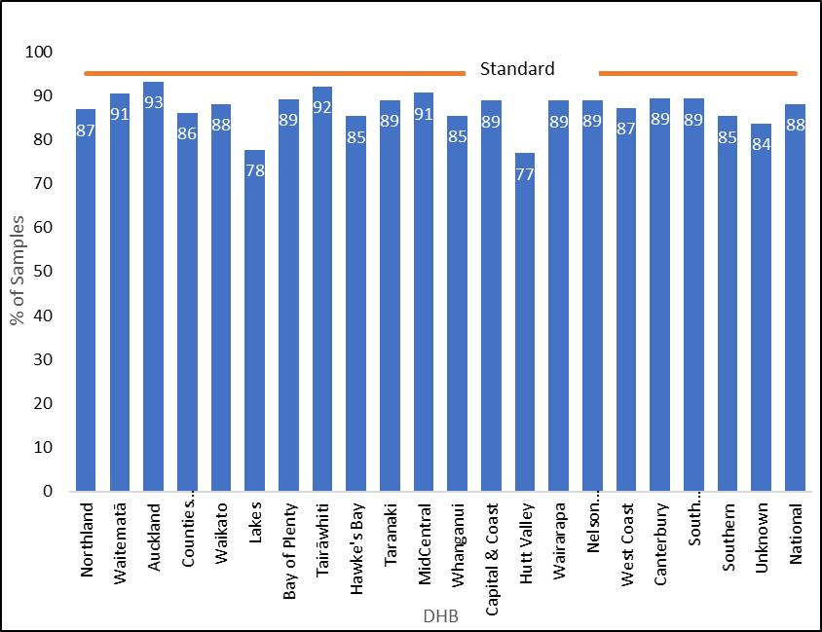

Table 8: Percentage of samples the laboratory received within four days of sample taking, January to December 2019
DHB of domicile | Within 4 days |  | Total
 | No. | % | No.
Northland | 1,971 | 87 | 2,269
Waitematā | 7,067 | 91 | 7,805
Auckland | 5,181 | 93 | 5,560
Counties Manukau | 7,154 | 86 | 8,307
Waikato | 4,777 | 88 | 5,424
Lakes | 1,190 | 78 | 1,531
Bay of Plenty | 2,755 | 89 | 3,088
Tairāwhiti | 620 | 92 | 673
Hawke’s Bay | 1,737 | 85 | 2,036
Taranaki | 1,354 | 89 | 1,522
MidCentral | 1,958 | 91 | 2,161
Whanganui | 731 | 85 | 855
Capital & Coast | 2,866 | 89 | 3,224
Hutt Valley | 1,523 | 77 | 1,980
Wairarapa | 457 | 89 | 514
Nelson Marlborough | 1,287 | 89 | 1,447
West Coast | 312 | 87 | 358
Canterbury | 5,755 | 89 | 6,439
South Canterbury | 561 | 89 | 628
Southern | 2,940 | 85 | 3,445
Unknown | 41 | 84 | 49
National | 52,237 | 88 | 59,315

Indicator 5: Receipt and follow-up of second samples
Description: The proportion of second sample requests that had appropriate follow-up (timely receipt of second sample, decline notified or other appropriate follow-up).

Rationale: Second samples are requested if first samples give borderline results or are inadequate. Where requested, second samples should be taken as soon as possible.

Target: 100 percent of second samples requested are received by the laboratory, had other appropriate follow-up, or were declined by parents/guardians, within 10 calendar days of the request.

Interpretation: In 2019, 79 percent of requests for second samples resulted in one of the following within 10 days: a second sample arrived at the laboratory; or the laboratory received notification that the parents/guardians had declined the request, that the newborn had been referred to a specialist or that the newborn had died. Both Wairarapa and West Coast DHBs achieved the target of 100 percent in 2019.

Comment: The time taken to receive a follow-up sample is influenced by the time it takes to generate, send and receive the request and the time it takes to collect the second sample (usually at the next scheduled visit of the lead maternity carer) and send it to the laboratory and for the laboratory to receive it.

May 2015 saw the introduction of a new protocol (which included sending text messages, making extra phone calls and providing additional written reports) for reminding lead maternity carers when the laboratory did not receive follow-up samples. Between 2014 and 2018, the percentage of second samples received in 10 days or fewer increased from 38 percent to 77 percent; it rose further in 2019 to 79 percent.

In the reporting period, a second sample was received, declined or had other follow-up at some stage in 99 percent of the instances when a second sample was requested. This includes instances where requests were followed up after 10 or more days.

Since 2014, when the laboratory made 1,352 second sample requests, the number of second sample requests has declined. The laboratory requested 1,171 second samples in 2015, 988 in 2016, 998 in 2017, 755 in 2018 and 733 in 2019. This reduction is the result of stopping screening for 3MCC and carnitine uptake disorders and suspending screening for tyrosinemia; introducing second-tier tests in screening for some amino acid breakdown disorders; and improving sample quality.

Figure 3: Percentage of second samples the laboratory received (or other appropriate follow-up occurred) within 10 days, January to December 2019

Table 9: Percentage of second samples the laboratory received (or other appropriate follow-up occurred) within 10 days, January to December 2019
DHB of domicile | Within 10 days |  | Greater than 10 days |  | Total | Target
 | No. | % | No. | % | No. | %
Northland | 18 | 62 | 11 | 38 | 29 | 100
Waitematā | 70 | 80 | 18 | 20 | 88 | 100
Auckland | 51 | 85 | 9 | 15 | 60 | 100
Counties Manukau | 95 | 73 | 36 | 27 | 131 | 100
Waikato | 45 | 75 | 15 | 25 | 60 | 100
Lakes | 13 | 81 | 3 | 19 | 16 | 100
Bay of Plenty | 33 | 94 | 2 | 65 | 35 | 100
Tairāwhiti | 3 | 75 | 1 | 25 | 4 | 100
Hawke’s Bay | 30 | 91 | 3 | 9 | 33 | 100
Taranaki | 8 | 62 | 5 | 38 | 13 | 100
MidCentral | 23 | 64 | 13 | 36 | 36 | 100
Whanganui | 8 | 89 | 1 | 11 | 9 | 100
Capital & Coast | 28 | 88 | 4 | 13 | 32 | 100
Hutt Valley | 17 | 85 | 3 | 15 | 20 | 100
Wairarapa | 4 | 100 | 0 | 0 | 4 | 100
Nelson Marlborough | 13 | 87 | 2 | 13 | 15 | 100
West Coast | 2 | 100 | 0 | 0 | 2 | 100
Canterbury | 70 | 86 | 11 | 14 | 81 | 100
South Canterbury | 3 | 75 | 1 | 255 | 4 | 100
Southern | 28 | 72 | 11 | 28 | 39 | 100
Unknown | 18 | 82 | 4 | 18 | 22 | 100
National | 580 | 79 | 153 | 21 | 733 | 100

Indicator 6: Laboratory turnaround time for positive results
Description: The time from receipt of the sample in the laboratory to notification of the referring practitioner or specialist paediatrician of a screen positive result.

Rationale: Timely processing and notification of screen positive samples is essential to ensure early detection and treatment. This indicator is a measure of laboratory performance.

Target: 100 percent of babies with positive results are notified to their lead maternity carer / specialist paediatrician by the laboratory within the following timeframes:

Reason for report | Calendar days  (from receipt in laboratory to notification of screen positives)
 | Clinical critical | Non-clinical critical
Amino acid disorders | 2 | 7
Biotinidase deficiency | – | 7
Congenital adrenal hyperplasia | 2 | 7
Cystic fibrosis | – | 7
Congenital hypothyroidism | 4 | 7
Fatty acid oxidation disorders | 2 | 7
Galactosaemia | 2 | 7
SCID | – | 7

Interpretation: Overall, 91 percent of clinical critical screen positives, and 82 percent of non-clinical critical screen positives, were notified within the expected timeframes in 2019. Both are below the target of 100 percent; however, both are improvements compared to 2018 figures. The timeliness of notification of screen positive results varied widely across the screened disorders, and caution should be used due to the relatively low numbers of disorders being reported.

Comment: In 2019, 31 of 34 ‘clinical critical’ results were reported within the timeframes. A ‘clinical critical’ screening result indicates a reasonable or high probability of a disorder that can present with severe illness in the early neonatal period, and where a delay of one to two days can affect the outcome. All ‘clinical critical’ samples that were not reported within the timeframes were affected by weekends and public holidays. A trial of processing samples on Friday afternoons/evenings, with the aim of reducing laboratory turnaround times for clinical critical results, began in late 2021. Any results and outcomes will not be evident until 2022.

The ‘non-clinical critical’ cases warrant different indicator timeframes. In 2019, 194 of 237 ‘non-clinical critical’ cases were reported within the timeframes. Borderline newborn screening results are not reported until all results are available on the sample so the notification can include all results in one contact. For example, a borderline hypothyroid result may be available in two days, but if the sample also has a raised immune-reactive trypsin in the cystic fibrosis screen, it is sent for mutation analysis. The laboratory will request a second sample to confirm the thyroid result after the cystic fibrosis mutation result is available.

There were no adverse clinical consequences from positive screens reported outside the timeframes.

Figure 4: Percentage of screen positives the laboratory notified within the disorder-specific timeframe, January to December 2019
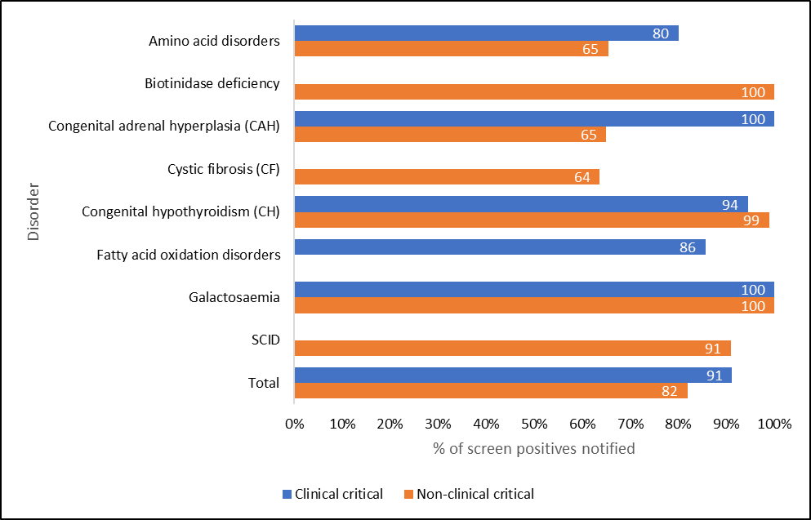

Table 10: Notification of screen positives, January to December 2019
Disorder | Timeframe |  | Timeframe met |  |  |  | Total
 | Clinical critical | Non-clinical critical | Clinical  critical |  | Non-clinical critical |  | Clinical critical | Non-clinical critical
 | Calendar days |  | No. | % | No. | % | No. | No.
Amino acid disorders | 2 | 7 | 4 | 80 | 17 | 65 | 5 | 26
Biotinidase deficiency | – | 7 | 0 | – | 8 | 100 | 0 | 8
Congenital adrenal hyperplasia | 2 | 7 | 3 | 100 | 13 | 65 | 3 | 20
Cystic fibrosis | – | 7 | 0 | – | 42 | 64 | 0 | 66
Congenital hypothyroidism | 4 | 7 | 17 | 94 | 92 | 99 | 18 | 93
Fatty acid oxidation disorders | 2 | 7 | 6 | 86 | 0 | – | 7 | 0
Galactosaemia | 2 | 7 | 1 | 100 | 2 | 100 | 1 | 2
SCID | – | 7 | 0 | – | 20 | 91 | 0 | 22
Total |  |  | 31 | 91 | 194 | 82 | 34 | 237

Indicator 7: Age of receipt into clinical care
Description: For babies with screened conditions, the age of the baby at transfer into clinical care.

Rationale: To ensure babies with congenital metabolic disorders have their development potential affected as little as possible, all babies with a screened condition must receive a confirmed diagnosis and timely commencement of treatment/active clinical management.

Target: 100 percent of babies who receive a screen positive result and are diagnosed with a screened condition receive active clinical management by the following timeframes:

Disorder | Age of baby in days –  clinical critical conditions | Age of baby in days –  non-clinical critical
Amino acid disorders | 10 | 28
Biotinidase deficiency | – | 28
Congenital adrenal hyperplasia | 10 | 28
Cystic fibrosis | – | 28
Congenital hypothyroidism | 10 | 28
Fatty acid oxidation disorders | 10 | 28
Galactosaemia | 10 | 28
SCID | – | 14

Interpretation: The disorder-specific timeframe was met for all 23 cases identified as clinical critical. Additionally, all 37 non-clinical critical cases were received into clinical care within the specified timeframe.

Comment: All babies with disease detected following a positive newborn screen were received into clinical care within an acceptable timeframe.

Table 11: Timeframe met for receipt into clinical care after confirmed diagnosis, January to December 2019
Disorder | Timeframe |  | Timeframe met |  |  |  | Total |  | Total
 | Clinical critical | Non-clinical critical | Clinical  critical |  | Non-clinical critical |  | Clinical critical | Non-clinical critical
 | Timeframe |  | No. | % | No. | % | No. | No. | No.
Amino acid disorders | 10 | 28 | 0 | – | 3 | 100 | 0 | 3 | 3
Biotinidase deficiency | – | 28 | – | – | 0 | – | – | 0 | 0
Congenital adrenal hyperplasia | 10 | 28 | 3 | 100 | – | – | 3 | – | 3
Cystic fibrosis | – | 28 | – | – | 16 | 100 | – | 16 | 16
Congenital hypothyroidism | 10 | 28 | 13 | 100 | 16 | 100 | 13 | 16 | 29
Fatty acid oxidation disorders | 10 | 28 | 6 | 100 | 0 | – | 6 | 0 | 6
Galactosaemia | 10 | 28 | 1 | 100 | – | – | 1 | – | 1
SCID | – | 14 | – | – | 2 | 100 | – | 2 | 2
Total |  |  | 23 | 100 | 37 | 100 | 23 | 37 | 60

Indicator 8: Positive predictive value of the screening test
Description: The probability of a baby having a positive diagnosis for a screened condition given a positive screening result for that condition.

Rationale: Positive predictive value (PPV) is a measure of the performance of the screening test. A low PPV means many babies without a screened condition will be referred for diagnostic testing; this brings associated costs and anxiety for families. Reporting of PPV helps to monitor the potential harm of the programme due to identification of false positives through screening.

Target: None.

Interpretation: The PPV for individual disorders is presented as five-year rolling data, because the number of cases varies significantly year on year. Over all the tests, a baby with a positive screen is 20 percent likely to be affected with the screened disorder.

Comment: Five-year rolling data is slow to show the benefits of adding second-tier testing to the amino acid breakdown disorders and the improved protocols for some other disorders. The benefits should become evident in future reports. The overall PPV for 2019 is 23 percent.

Table 12: Positive predictive value of the screening test, January 2015 to December 2019
2015–2019 | Babies screened | Positive tests | True positive | False positive | False negative | True negative | Sensitivity  % | Specificity  % | PPV  %
Amino acid disorders | 293,301 | 426 | 17 | 409 | 1 | 292,874 | 94.4 | 99.9 | 4.0
Biotinidase deficiency | 293,301 | 21 | 2 | 19 | 0 | 293,280 | 100 | 100 | 9.5
Congenital adrenal hyperplasia | 293,301 | 197 | 7 | 190 | 0 | 293,104 | 100 | 99.9 | 3.6
Cystic fibrosis | 293,301 | 267 | 70 | 197 | 0 | 293,014 | 100 | 99.9 | 26.2
Congenital hypothyroidism | 293,301 | 310 | 149 | 161 | 2 | 293,069 | 98.7 | 99.9 | 48.1
Fatty acid oxidation disorders | 293,301 | 172 | 35 | 137 | 0 | 293,129 | 100 | 100 | 20.3
Galactosaemia | 293,301 | 17 | 2 | 15 | 1 | 293,283 | 66.7 | 100 | 11.8
SCID | 120,716 | 48 | 4 | 44 | 0 | 120,667 | 100 | 100 | 8.3
Total | 293,301 | 1,458 | 286 | 1,172 | 4 | 291,839 | 98.6 | 99.6 | 19.6

Appendix 1: List of screened conditions
Amino acid disorders
Phenylketonuria
Maple syrup urine disease
Argininosuccinic aciduria (argininosuccinate lyase deficiency)
Citrullinaemia (argininosuccinate synthetase deficiency)
Glutaric acidaemia type I (glutaryl-CoA dehydrogenase deficiency)
Homocystinuria (cystathionine beta-synthase deficiency)
Isovaleric acidaemia (isovaleryl-CoA dehydrogenase deficiency)
Methylmalonic acidurias (mutase deficiency, CblA, CblB, CblC, CblD defects)
Propionic acidaemia (propionyl-CoA carboxylase deficiency)
Fatty acid oxidation disorders
CACT (carnitine acylcarnitine translocase deficiency)
CPT-I (carnitine palmitoyltransferase-I deficiency)
CPT-II (carnitine palmitoyltransferase-II deficiency)
LCHAD (3-hydroxy long-chain acyl-CoA dehydrogenase deficiency)
TFP (trifunctional protein deficiency)
MADD (multiple acyl-CoA dehydrogenase deficiency)
MCAD (medium-chain acyl-CoA dehydrogenase deficiency)
VLCAD (very-long-chain acyl-CoA dehydrogenase deficiency)
Additional disorders
Congenital hypothyroidism
Congenital adrenal hyperplasia
Cystic fibrosis
Biotinidase deficiency
Galactosaemia
Severe combined immunodeficiency (SCID)

