**NCSP New Zealand Lakes District Health Board Coverage Report**

For the period ending

30 September 2018

Citation: Ministry of Health. October 2018. *NCSP New Zealand District Health Board Coverage Report: period ending 30 September 2018*. Wellington: Ministry of Health.

Published in October 2018 by the  
Ministry of Health  
PO Box 5013, Wellington 6145, New Zealand

2422-9199 (online)

This document is available at [www.nsu.govt.nz](http://www.nsu.govt.nz)

Contents

Introduction 2

Technical notes 3

Lakes coverage 4

Lakes coverage by ethnicity in the three years ending 30 September 2018 4

Lakes coverage trends by ethnicity 5

DHB coverage comparisons 5

DHB coverage by ethnicity in the three years ending 30 September 2018 5

DHB coverage comparison trends by ethnicity 13

**List of tables**

Table 1: NCSP coverage (%) in the three years ending 30 September 2018 by ethnicity, women aged 25–69 years, Total Coverage 4

Table 2: NCSP number of screens and coverage (%) in women aged 25–69 years in the three years ending 30 September 2018 by District Health Board 12

Table 3: NCSP coverage (%) of women aged 25–69 years in the three years ending 30 September, 2016, 2017, 2018, by ethnicity and District Health Board 13

**List of figures**

Figure 1: NCSP coverage (%) in the three years ending 30 September 2018 by ethnicity, women aged 25–69 years, Total Coverage 4

Figure 2: NCSP coverage (%) of women aged 25–69 years in the three years ending 30 September 2018 by ethnicity, Total Coverage 5

Figure 3: NCSP coverage (%) of Māori women aged 25–69 years in the three years ending 30 September 2018 by District Health Board 5

Figure 4: NCSP coverage (%) of Pacific women aged 25–69 years in the three years ending 30 September 2018 by District Health Board 6

Figure 5: NCSP coverage (%) of Asian women aged 25–69 years in the three years ending 30 September 2018 by District Health Board 6

Figure 6: Overall NCSP coverage (%) of women aged 25–69 years in the three years ending 30 September 2018 by District Health Board 7

Figure 7: NCSP coverage (%) of Māori women aged 25–69 years in the three years ending 30 September 2018 8

Figure 8: NCSP coverage (%) of Pacific women aged 25–69 years in the three years ending 30 September 2018 9

Figure 9: NCSP coverage (%) of Asian women aged 25–69 years in the three years ending 30 September 2018 by District Health Board 10

Figure 10: Overall NCSP coverage (%) of women aged 25–69 years in the three years ending 30 September 2018 by District Health Board 11

# Introduction

Well-organised cervical cancer screening programmes can significantly reduce the incidence and mortality of the disease. The National Cervical Screening Programme (NCSP) was established in New Zealand in 1990, and since that time, the number of women who develop cervical cancer, and the number of women who die from it, has reduced by 60 percent. Having regular cervical smear tests continues to be a woman’s best protection against the development of invasive cervical cancer.

One of the main performance measures of NCSP is coverage. Coverage is defined as the proportion of women eligible for screening who have been screened in the previous three years. Our target is to reach 80 percent screening coverage for all eligible women. While we have met this target nationally for European/ Other women, coverage rates for Maori, and Asian women remain at under 70 percent.

The incidence of cervical cancer among Māori, Pacific and Asian women remains higher than that among European/Other ethnicities. One of the primary reasons for this is lower rates of screening coverage among these groups.

This NCSP District Health Board Coverage Report is intended to support those working in increasing coverage and improving equity in cervical screening. Tihei mauri ora!

# Technical notes

The data for the period ending 30 September 2018 was extracted from the Ministry of Health NCSP Datamart on 25 October 2018.

Screened women (the ‘numerator’) are included in the coverage calculations based on their age at the end of the monitoring period. This means that coverage for women aged 25-69 years includes women who were aged 22, 23 or 24 at the start of the monitoring period. Since February 2016 the ethnicity and domicile of a screened woman is that recorded on the Ministry of Health’s National Health Index (NHI). Prior to this date, demographic information was obtained from the NCSP Register. The impact of this change can be found in the comparison document re: December 2015 coverage: <https://www.nsu.govt.nz/health-professionals/national-cervical-screening-programme/cervical-screening-coverage>

Any time series data produced from February 2016 will use demographic information from the NHI across all time periods.

For both women screened and in the denominator, women have been prioritised to a single ethnicity using the following priority order: Māori, Pacific, Asian, European/Other. This means that if a woman chooses more than one category, and one of these is Māori, she is counted as Māori. The ethnicity recorded on the Ministry of Health’s National Health Index has been used for any screened woman with no ethnicity recorded on the Register.

The denominators used for calculating coverage are derived from Statistics New Zealand’s District Health Board (DHB) population projections 30 June 2017update based on the 2013 Census. The population projections have been adjusted for the prevalence of hysterectomy.

Additional detail on the methodology can be obtained via a request made to [screening@moh.govt.nz](mailto:screening@moh.govt.nz).

# Lakes coverage

## Lakes coverage by ethnicity in the three years ending 30 September 2018

Figure : NCSP coverage (%) in the three years ending 30 September 2018 by ethnicity, women aged 25–69 years, Total Coverage

Table 1: NCSP coverage (%) in the three years ending 30 September 2018 by ethnicity, women aged 25–69 years, Total Coverage



*\*For the total population the number of additional screens is the number required to move from the total population coverage to 80%. This may not be the same as the sum of additional screens required for each ethnic group to reach 80%.*

## Lakes coverage trends by ethnicity

Figure : NCSP coverage (%) of women aged 25–69 years in the three years ending 30 September 2018 by ethnicity, Total Coverage

# 

# DHB coverage comparisons

## DHB coverage by ethnicity in the three years ending 30 September 2018

Figure : NCSP coverage (%) of Māori women aged 25–69 years in the three years ending 30 September 2018 by District Health Board

Figure : NCSP coverage (%) of Pacific women aged 25–69 years in the three years ending 30 September 2018 by District Health Board

Figure : NCSP coverage (%) of Asian women aged 25–69 years in the three years ending 30 September 2018 by District Health Board

Figure : Overall NCSP coverage (%) of women aged 25–69 years in the three years ending 30 September 2018 by District Health Board

Figure : NCSP coverage (%) of Māori women aged 25–69 years in the three years ending 30 September 2018

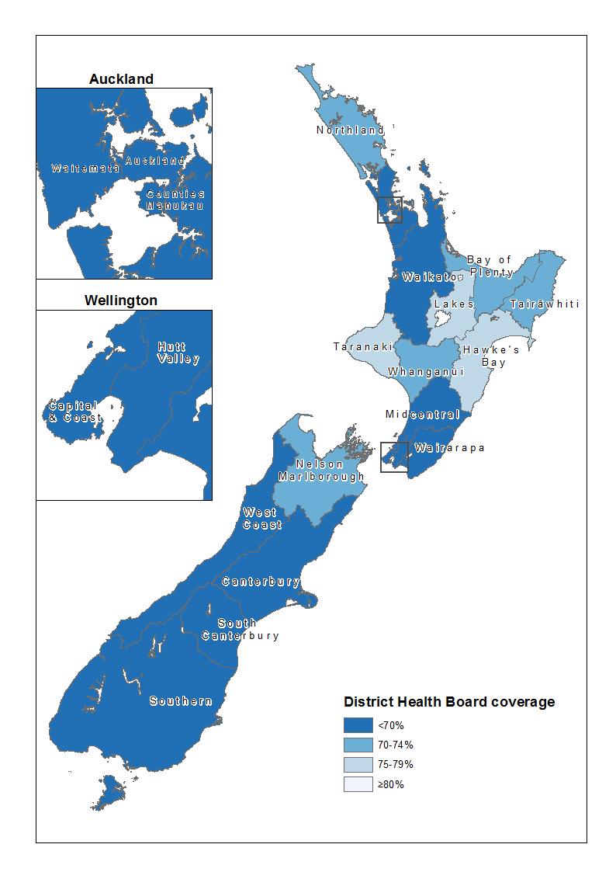

Figure : NCSP coverage (%) of Pacific women aged 25–69 years in the three years ending 30 September 2018

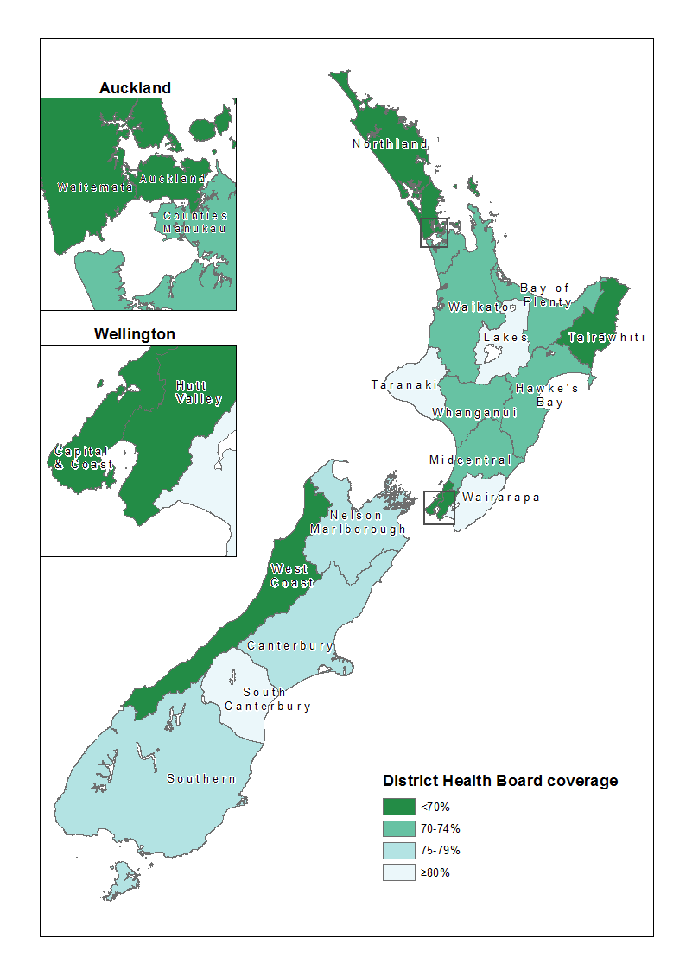

Figure : NCSP coverage (%) of Asian women aged 25–69 years in the three years ending 30 September 2018 by District Health Board

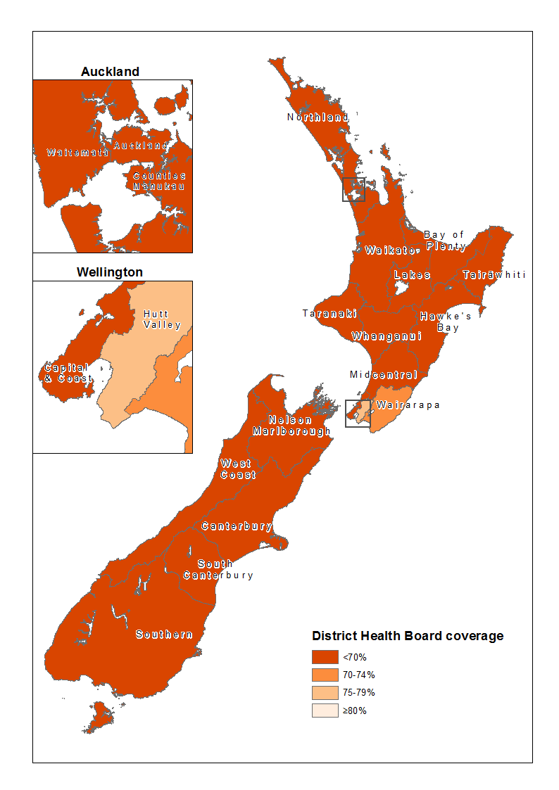

Figure : Overall NCSP coverage (%) of women aged 25–69 years in the three years ending 30 September 2018 by District Health Board

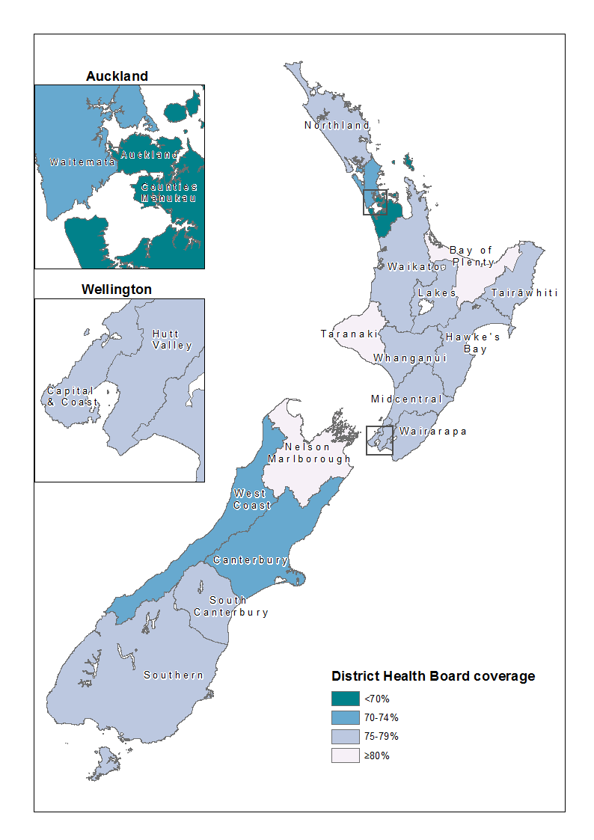

Table 2: NCSP number of screens and coverage (%) in women aged 25–69 years in the three years ending 30 September 2018 by District Health Board



## DHB coverage comparison trends by ethnicity

Table 3: NCSP coverage (%) of women aged 25–69 years in the three years ending 30 September, 2016, 2017, 2018, by ethnicity and District Health Board

