NCSP Annual Report
2016

Citation: Ministry of Health. 2019. NCSP Annual Report 2016. Wellington: Ministry of Health.
Published in August 2019 by the Ministry of Health
PO Box 5013, Wellington 6140, New Zealand
ISSN 2703-1772 (online)
HP 7179
This document is available at health.govt.nz
This work is licensed under the Creative Commons Attribution 4.0 International licence. In essence, you are free to: share ie, copy and redistribute the material in any medium or format; adapt ie, remix, transform and build upon the material. You must give appropriate credit, provide a link to the licence and indicate if changes were made.

Contents
Selected results 1
Cancer incidence to 31 December 2016 1
Cancer mortality to 31 December 2015 1
Related National Cervical Screening Programme reports 2
Cancer incidence to 31 December 2016 3
Definition 3
Target 3
Calculation 3
Results 4
Comments 5
Cancer mortality to 31 December 2015 12
Definition 12
Target 12
Calculation 12
Results 13
Comments 13
Appendices
Appendix A: Additional data tables 19
Appendix B: Population data 21
References 23

List of Tables
Table 1: Cervical cancer incidence, 1996–2016, by ethnicity 7
Table 2: Cervical cancer incidence (per 100,000 women), 2006–2016, by histological type 8
Table 3: Five-year average cervical cancer incidence (2012–2016), by age and ethnicity 11
Table 4: Cervical cancer mortality, 1998–2015, by ethnicity 16
Table 5: Average cervical cancer mortality (2011–2015), by age 18
Table 6: Incident cases by detailed morphology, 2016 19
Table 7: Extent of disease at time of diagnosis for incident cervical cancer cases, 2006–2016 20
Table 8: WHO standard population 21

List of Figures
Figure 1: Age-standardised cervical cancer incidence rates, 2010–2016, by ethnicity 5
Figure 2: Age-standardised cervical cancer incidence rates for Māori and all women, 1985–2016 6
Figure 3: Age-standardised cervical cancer incidence rates, 2006–2016, by histological type 8
Figure 4: Five-year average cervical cancer incidence rates (2012–2016), by age 9
Figure 5: Five-year average cervical cancer incidence rates (2012–2016), by age and ethnicity 9
Figure 6: Five-year average cervical cancer incidence rates (2012–2016), by age and histological type 10
Figure 7: Age-standardised cervical cancer mortality rates, 2009–2015, by ethnicity 14
Figure 8: Age-standardised cervical cancer mortality rates for Māori and all women, 1985–2015 15
Figure 9: Five-year average cervical cancer mortality rates (2011–2015), by age 17
Figure 10: Five-year average cervical cancer mortality rates (2011–2015), by age and ethnicity 17

Selected results

Cancer incidence to
31 December 2016
- In 2016, there were 170 new diagnoses of cervical cancer, including 32 new diagnoses in Māori women.
- This is equivalent to an age-standardised rate (ASR, using the WHO world standard population) of 6.3 new diagnoses per 100,000 women in the population and 9.7 per 100,000 for Māori women.
- Most cervical cancers were squamous cell carcinomas (127 cases; ASR 4.6 per 100,000 women), with a smaller proportion comprising adenocarcinomas (25 cases; ASR 1.1 per 100,000 women), adenosquamous (10 cases; ASR 0.4 per 100,000 women) or other cervical cancers (8 cases; ASR 0.3 per 100,000 women).
- Overall, between 1996 and 2016, cervical cancer incidence declined from 10.5 to 6.3 per 100,000 for women of all ethnicities and from 25.0 to 9.7 per 100,000 for Māori women.

Cancer mortality to
31 December 2015
- In 2015, there were 53 deaths due to cervical cancer, including 11 deaths in Māori women.
- This is equivalent to an age-standardised mortality rate of 1.6 per 100,000 women in the population and 3.6 per 100,000 for Māori women.
- Overall, between 1998 and 2015, cervical cancer mortality declined from 3.2 to 1.6 per 100,000 for women of all ethnicities and from 10.3 to 3.6 per 100,000 for Māori women.

Related National Cervical Screening Programme reports
Information on participation in screening and programme statistics (including cytology, HPV testing, colposcopy and histology reporting) for 2016 can be found in the published reports NCSP Six-monthly Monitoring Report 45, January–June 2016 and NCSP Six-monthly Monitoring Report 46, July–December 2016, available on the NCSP website at www.nsu.govt.nz/health-professionals/national-cervical-screening-programme/independent-monitoring-reports.

Cancer incidence to 31 December 2016

Definition
Cancer incidence is the annual rate of new registrations of invasive cervical cancer (per 100,000 women in the New Zealand estimated resident population), standardised to the WHO standard population according to Ahmad et al (2001).

Target
Incidence in the New Zealand population of no more than 14.8 per 100,000 women when age standardised to the WHO standard population (or no more than 7.5 per 100,000 when age standardised to the SEGI population).

Calculation
Registrations of cancer cases (by age, ethnicity and histological type) over the period 2007 to 2016 were obtained from the New Zealand Cancer Registry (data extracted 18 September 2018). Age-specific incidence rates were calculated for each calendar year, based on the estimated resident New Zealand female population in June of that year (mid-year estimates), using projections from the 2013 Census.

Age-specific rates were then weighted using the WHO standard population to derive age-standardised rates (details of the WHO standard population are provided in Appendix B: Population data. Ninety-five percent confidence intervals were calculated according to the methods in IARC Scientific Publication 95. Cancer Registrations: Principles & Methods (Chapter 11: Statistical Methods for Registries) (Boyle et al 2002). Incidence rates were calculated separately for either each ethnic group or each histological type. Five-year average rates were also calculated by five-year age group as the sum of all cases over the five-year period within that age group, divided by the sum of the estimated population within that age group in each of the five years contributing to the average.

Results
In 2016, there were 170 new diagnoses of cervical cancer, or an age-standardised rate of 6.3 new diagnoses per 100,000 women in the population (Table 1). Cervical cancer incidence rates overall, and for each of Māori (9.7), Pacific (7.7), Asian (5.8) and European/Other (4.9) women, are shown in Table 1, and with 95 percent confidence intervals in Figure 1a. Counts of actual numbers of cancer cases are also shown in Table 1. Rates could not be calculated for all four ethnicity groups before 2006 due to limitations in the availability of population data (although separate case numbers for 2005 only were available from previous Annual Monitoring Reports). Therefore, cases and rates presented for “Other women” in 1996 to 2004 relate to all non-Māori women. These data were sourced from Cancer: New Registrations and Deaths (Ministry of Health 2010a, b).

Overall, between 1996 and 2016, cervical cancer incidence has declined from 10.5 to 6.3 per 100,000 for women of all ethnicities and from 25.0 to 9 per 100,000 for Māori women (Table 1). Longer-term cancer incidence trends for Māori and all women by year can be seen in Figure 2.

As shown in Figure 1a, there is some variation in the incidence rates by ethnicity, however, the 95 percent confidence intervals are wide for some ethnicities. As case numbers are quite small for Pacific women and Asian women, an additional figure is included that compares rates in Māori women with rates in all women in New Zealand (Figure 1b), to supplement the detailed information in Figure 1a.

Cervical cancer incidence rates by histological type are shown in Figure 3 and Table 2. Squamous cell cancer remained the most commonly diagnosed type of cervical cancer over the period 2006–2016, at 127 cases (74.7 percent). There were 25 cases (14.7 percent) of adenocarcinoma and 10 cases (5.9 percent) of adenosquamous carcinoma. A more detailed breakdown by histological type of cases diagnosed in 2016 is shown in Table 6.

Five-year average age-specific cervical cancer incidence rates (2012–2016) are shown in Figure 4 and Table 3. Overall, there is a low incidence at younger ages, increasing by the age of 25–29 years to reach a peak in the five-years age groups 30–44 (13.2, 12.2 and 12.9 per 100,000 for all ethnicities for age groups 30–34, 35–39 and 40–44 respectively). A general decrease following a plateauing is seen for the remaining ages until the age of 75 years. Five-year average age-specific incidence rates are shown by ethnicity in Figure 5 and Table 3. Confidence intervals are generally wide so are not displayed on Figure 5 but are included in Table 3. There are small case numbers (five or less per year) in most age groups for Māori, Pacific and Asian women. Because of these factors, age-specific incidence rates by ethnicity must be interpreted cautiously.

Five-year average age-specific cervical cancer incidence rates (2012–2016) by histological type are shown in Figure 6. Squamous and adenocarcinoma histological types follow broadly similar patterns by age to each other, while the histological types defined in the other group (not squamous, adenocarcinoma or adenosquamous carcinoma) tended to increase with increasing age. The absolute rates varied, being highest for squamous cell cancer and generally lowest for adenosquamous cancer in virtually all age groups. In 2016, among cancer cases where extent of disease information is recorded, most new cases are localised to the cervix (Table 7).

Comments
In this report, incidence rates are age standardised using the WHO standard population (see Appendix B: Population data), consistent with the population used to produce standardised rates in Cancer: New Registrations and Deaths. Note that National Cervical Screening Programme Annual Monitoring Reports before that for 2008–2009 reported on rates that were standardised to the Segi population, and therefore these rates are not directly comparable.

Consistent with other statistical data, the rates of cervical cancer incidence are expressed per 100,000 women in the population. The population is not adjusted to take into account hysterectomy prevalence.

The distribution of new diagnoses by FIGO stage has not been included in this report due to 76.5 percent of newly diagnosed cases not having a FIGO stage recorded.

Figure 1: Age-standardised cervical cancer incidence rates, 2010–2016, by ethnicity
a) All ethnic groups
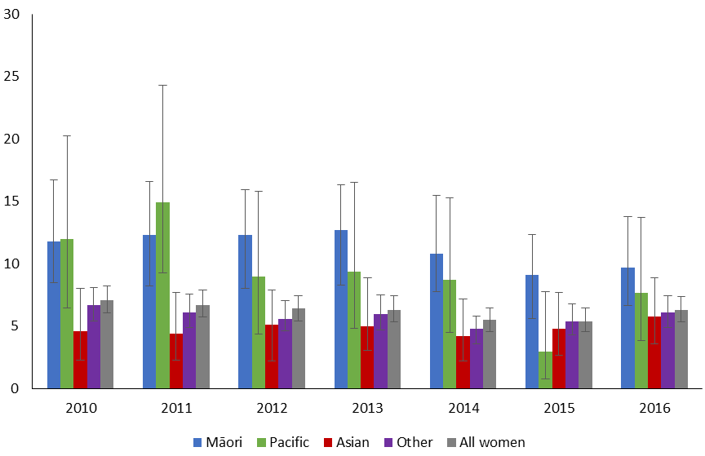
Vertical bars represent 95 percent confidence intervals.
b) Māori women, compared with all women
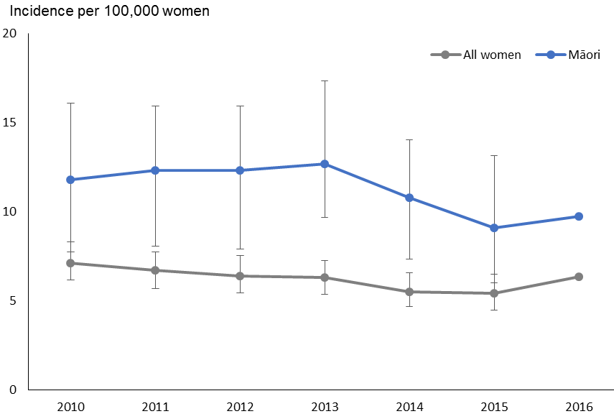
Vertical bars represent 95 percent confidence interval.

Figure 2: Age-standardised cervical cancer incidence rates for Māori* and all women, 1985–2016†
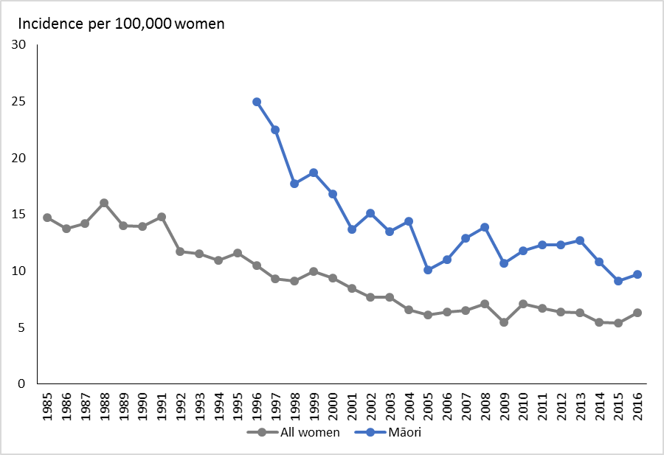
Rates are per 100,000 women, age-standardised to the WHO Standard Population (all ages).
* Age-standardised rates for Māori women were not available for years before 1996.
† Rates for 1996-2004 sourced from Cancer: New Registrations and Deaths, 2007 (Ministry of Health 2010b) and 2006 (Ministry of Health 2010a). Rates from 2005 are sourced from previous (Smith et al 2012) and the current NCSP annual monitoring report (see Table 1 footnote). Prior dates have been sourced directly from the New Zealand Ministry of Health.

Table 1: Cervical cancer incidence, 1996–2016, by ethnicity
Year | All women |  | Māori women |  | Pacific women |  | Asian women |  | Other women
 | N | Rate | N | Rate | N | Rate | N | Rate | N | Rate
1996 | 211 | 10.5 | 47 | 25 | n/a | n/a | n/a | n/a | 164 | 9
1997 | 205 | 9.3 | 51 | 22.5 | n/a | n/a | n/a | n/a | 154 | 7.6
1998 | 200 | 9.1 | 36 | 17.7 | n/a | n/a | n/a | n/a | 164 | 8.3
1999 | 220 | 10 | 43 | 18.7 | n/a | n/a | n/a | n/a | 177 | 8.9
2000 | 204 | 9.4 | 43 | 16.8 | n/a | n/a | n/a | n/a | 161 | 8.3
2001 | 189 | 8.5 | 33 | 13.7 | n/a | n/a | n/a | n/a | 156 | 8
2002 | 181 | 7.7 | 33 | 15.1 | n/a | n/a | n/a | n/a | 148 | 7.2
2003 | 178 | 7.7 | 33 | 13.5 | n/a | n/a | n/a | n/a | 145 | 7.1
2004 | 157 | 6.6 | 33 | 14.4 | n/a | n/a | n/a | n/a | 124 | 5.9
2005 | 154 | 6.1 | 25 | 10.1 | 17 | n/a | 15 | n/a | 97 | n/a
2006 | 158 | 6.4 | 28 | 11 | 10 | 8.4 | 15 | 7.6 | 105 | 6
2007 | 163 | 6.5 | 34 | 12.9 | 12 | 12.1 | 12 | 6.2 | 105 | 5.8
2008 | 175 | 7.1 | 39 | 13.9 | 12 | 10.5 | 13 | 5.6 | 111 | 6.3
2009 | 142 | 5.5 | 30 | 10.7 | 20 | 16.9 | 7 | 2.9 | 85 | 4.5
2010 | 180 | 7.1 | 36 | 11.8 | 14 | 12 | 12 | 4.6 | 118 | 6.7
2011 | 169 | 6.7 | 37 | 12.3 | 18 | 14.9 | 12 | 4.4 | 102 | 6.1
2012 | 168 | 6.4 | 40 | 12.3 | 11 | 9 | 13 | 5.1 | 104 | 5.6
2013 | 159 | 6.3 | 39 | 12.7 | 12 | 9.4 | 15 | 5 | 93 | 6
2014 | 144 | 5.5 | 35 | 10.8 | 12 | 8.7 | 13 | 4.2 | 84 | 4.8
2015 | 142 | 5.4 | 29 | 9.1 | 4 | 3 | 16 | 4.8 | 93 | 5.4
2016 | 170 | 6.3 | 32 | 9.7 | 11 | 7.7 | 21 | 5.8 | 106 | 4.9
† Cases and rates for 1997–2004 sourced from Cancer: New Registrations and Deaths, 2007 (Ministry of Health 2010b); cases and rates for 1996 sourced from Cancer: New Registrations and Deaths, 2006 (Ministry of Health 2010a). Cases and rates for 2005 sourced from a previous NCSP Annual Report (2008–2009) (Smith et al 2012).
§ Counts and rates for ‘European/Other women’ in 1996–2004 are combined for all non-Māori women, ie, they also include cases in Pacific and Asian women.
* Rates are per 100,000 women, age standardised to the WHO standard population (all ages).
NA = not available.

Figure 3: Age-standardised cervical cancer incidence rates, 2006–2016, by histological type
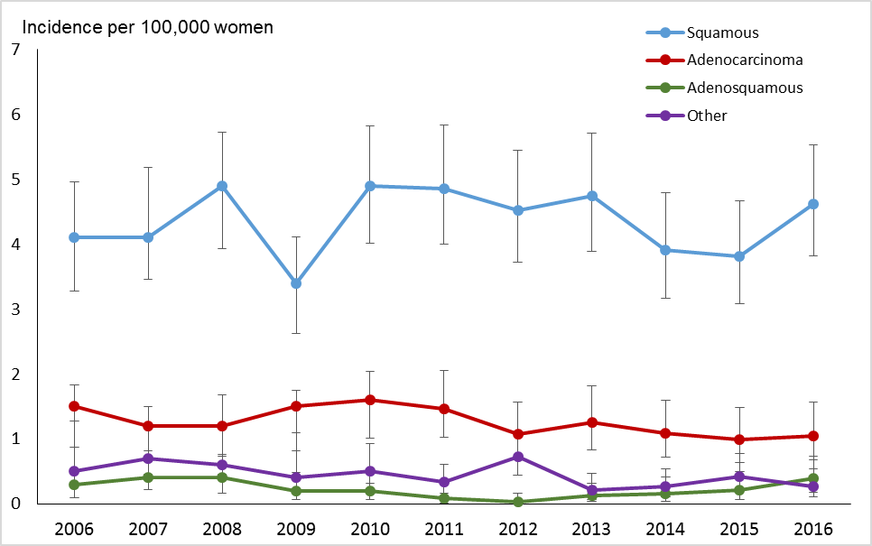
Vertical bars represent 95 percent confidence intervals.

Table 2: Cervical cancer incidence (per 100,000 women), 2006–2016, by histological type
Year | Squamous |  | Adenocarcinoma |  | Adenosquamous |  | Other
 | N | Rate | N | Rate | N | Rate | N | Rate
2006 | 100 | 4.1 | 36 | 1.5 | 7 | 0.3 | 15 | 0.5
2007 | 102 | 4.1 | 31 | 1.2 | 11 | 0.4 | 19 | 0.7
2008 | 121 | 4.9 | 30 | 1.2 | 8 | 0.4 | 16 | 0.6
2009 | 87 | 3.4 | 37 | 1.5 | 5 | 0.2 | 13 | 0.4
2010 | 123 | 4.9 | 38 | 1.6 | 5 | 0.2 | 14 | 0.5
2011 | 119 | 4.8 | 36 | 1.5 | 2 | 0.1 | 12 | 0.3
2012 | 117 | 4.5 | 27 | 1.0 | 1 | <0.1 | 23 | 0.8
2013 | 118 | 4.7 | 28 | 1.2 | 5 | 0.1 | 8 | 0.2
2014 | 103 | 4.0 | 29 | 1.1 | 4 | 0.2 | 8 | 0.2
2015 | 102 | 3.8 | 24 | 1.0 | 5 | 0.2 | 11 | 0.4
2016 | 127 | 4.6 | 25 | 1.1 | 10 | 0.4 | 8 | 0.3
* Per 100,000 women, age standardised to the WHO population (all ages).

Figure 4: Five-year average cervical cancer incidence rates (2012–2016), by age
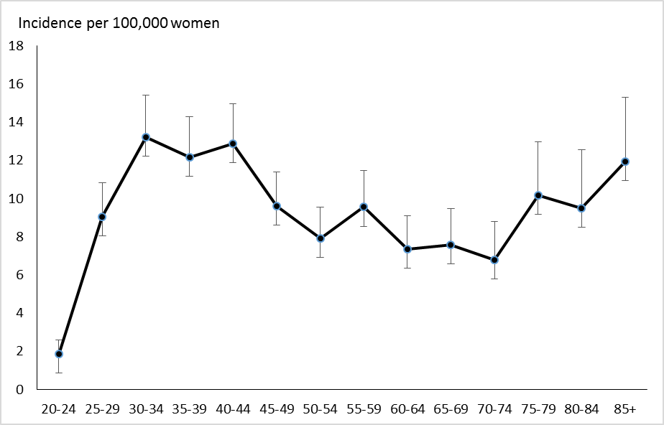
Vertical bars represent 95 percent confidence intervals.

Figure 5: Five-year average cervical cancer incidence rates (2012–2016), by age and ethnicity
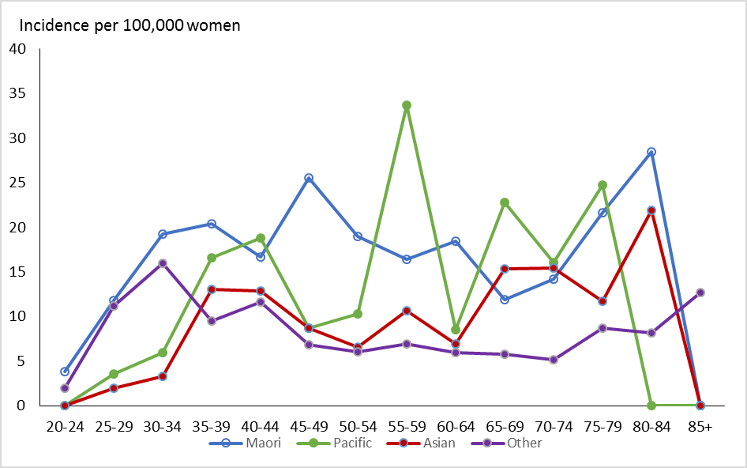
Note that no cases were observed in Pacific women aged 20–24 years and 80+ years or in Asian women aged 85+ years over this time period. See also Table 3.

Figure 6: Five-year average cervical cancer incidence rates (2012–2016), by age and histological type
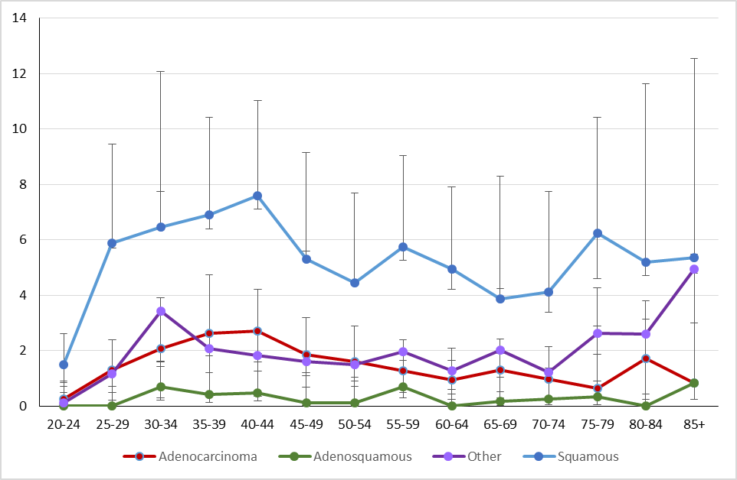
Vertical bars represent 95 percent confidence intervals.

Table 3: Five-year average cervical cancer incidence (2012–2016), by age and ethnicity
Age  (in years) | All women |  | Māori |  | Pacific |  | Asian |  | Other
 | Rate | 95% CI | Rate | 95% CI | Rate | 95% CI | Rate | 95% CI | Rate | 95% CI
20–24 | 1.9 | (1.1, 3.1) | 3.9 | (1.8, 3.9) | 0.0 | (0, 5.6) | 0.0 | (0, 3) | 2.0 | (1.1, 3.8)
25–29 | 9.0 | (7.2, 11.3) | 11.8 | (7.5, 11.8) | 3.5 | (1, 12.9) | 2.0 | (0.7, 5.7) | 11.2 | (8.7, 14.6)
30–34 | 13.2 | (11, 16) | 19.2 | (13.4, 19.2) | 6.0 | (2.2, 17.4) | 3.3 | (1.5, 7.7) | 15.9 | (12.9, 19.9)
35–39 | 12.2 | (10, 14.8) | 20.4 | (14.4, 20.4) | 16.6 | (9.3, 31.8) | 13.0 | (8.3, 21) | 9.5 | (7.2, 12.6)
40–44 | 12.9 | (10.8, 15.4) | 16.7 | (11.3, 16.7) | 18.8 | (11, 34.6) | 12.9 | (8.1, 21.2) | 11.6 | (9.3, 14.7)
45–49 | 9.6 | (7.8, 11.9) | 25.5 | (18.9, 25.5) | 8.7 | (3.7, 22) | 8.7 | (4.8, 16.4) | 6.8 | (5, 9.3)
50–54 | 7.9 | (6.3, 10) | 19.0 | (13, 19) | 10.3 | (4.5, 26.1) | 6.6 | (3.2, 14.2) | 6.0 | (4.4, 8.3)
55–59 | 9.5 | (7.6, 12) | 16.4 | (10.3, 16.4) | 33.7 | (21.9, 58.3) | 10.6 | (5.8, 20.5) | 7.0 | (5.1, 9.5)
60–64 | 7.3 | (5.6, 9.7) | 18.4 | (11.3, 18.4) | 8.5 | (2.7, 30.5) | 6.9 | (2.9, 17.6) | 5.9 | (4.2, 8.5)
65–69 | 7.6 | (5.7, 10.2) | 11.9 | (5.6, 11.9) | 22.8 | (11.3, 56.1) | 15.3 | (7.9, 32.6) | 5.8 | (4, 8.4)
70–74 | 6.8 | (4.8, 9.7) | 14.2 | (6.4, 14.2) | 16.0 | (5.9, 56.9) | 15.4 | (7.1, 38.5) | 5.2 | (3.3, 8.1)
75–79 | 10.2 | (7.3, 14.2) | 21.6 | (10.6, 21.6) | 24.7 | (10.4, 86.4) | 11.7 | (4, 42) | 8.7 | (5.9, 12.9)
80–84 | 9.5 | (6.5, 14.2) | 28.5 | (13.9, 28.5) | 0.0 | (0, 79) | 21.9 | (8.9, 77.1) | 8.2 | (5.3, 13)
85+ | 11.9 | (8.6, 16.9) | 0.0 | (0, 0) | 0.0 | (0, 120.5) | 0.0 | (0, 66.2) | 12.7 | (9.1, 17.9)
‘0.0’ indicates no cases recorded.

Cancer mortality to 31 December 2015

Definition
Cancer mortality is the annual rate of deaths due to invasive cervical cancer (per 100,000 women in the New Zealand estimated resident population), standardised to the WHO population.

Target
Mortality in the New Zealand population of no more than 2.8 per 100,000 women when age standardised to the WHO standard population (or no more than 2.5 per 100,000 women when age standardised to the SEGI population).

Calculation
Registrations of cervical cancer mortality (by age and ethnicity) over the period
2006–2014 were obtained from the New Zealand Cancer Registry (data extracted 1 December 2017).

Age-specific mortality rates were calculated for each calendar year, based on the estimated resident New Zealand female population in June of that year (mid-year estimates), using projections from the 2013 Census.

Age-specific rates were then weighted using the WHO standard population to derive age-standardised rates (details of the WHO standard population are provided in Appendix B: Population data). Ninety-five percent confidence intervals were calculated according to the methods in IARC Scientific Publication 95. Cancer Registrations: Principles & Methods (Chapter 11: Statistical Methods for Registries) (Boyle and Parkin 2002). Mortality rates were calculated separately for each ethnic group. Five-year average rates were also calculated by five-year age group as the sum of all cases over the five-year period within that age group, divided by the sum of the estimated population within that age group in each of the five years contributing to the average.

Results
The most recent mortality data available is for 2015. In 2015, there were 53 deaths due to cervical cancer, or an age-standardised rate of 1.6 cervical cancer deaths per 100,000 women in the population (Table 4 Cervical cancer mortality rates overall, and for each of Māori (3.6), Pacific (2.3), Asian (0.7) and European/Other (1.5) women, are shown in Table 4 and Figure 7a. Counts of deaths due to cervical cancer are also shown in Table 4. Rates could not be calculated for all four ethnicity groups prior to 2006 due to limitations in the availability of population data, however separate counts for deaths were available for 2005 from previous Annual Monitoring Reports (Smith et al 2012; Brewer et al 2008). Therefore rates and deaths reported for ‘Other women’ in 1998 to 2004 relate to all non-Māori women; these data were sourced from Cancer: New Registrations and Deaths (Ministry of Health 2010b).

Overall, between 1998 and 2015, cervical cancer mortality has declined from 3.2 to 1.6 per 100,000 for women of all ethnicities and from 10.3 to 3.6 per 100,000 for Māori women (Table 4). Longer-term cancer mortality trends for Māori and all women by year can be seen in Figure 8.

As shown in Figure 7a, there is some variation in the mortality rates by ethnicity (although the 95 percent confidence intervals are very wide). As for the incidence data, an additional figure is included that compares mortality rates in Māori women with rates in all women in New Zealand (Figure 7b), to supplement the more detailed ethnicity information in Figure 7a.

Average age-specific cervical cancer mortality rates (2011–2015) are shown for all women in Figure 9, and by ethnicity in Figure 10. As for incidence, the associated confidence intervals are wide, making ethnicity-specific trends by age more difficult to discern, but generally there appears to be a broad increase with age. Case numbers by age are generally small for Māori, Pacific and Asian women (total deaths across all ages over the five-year period were 58 for Māori women, 28 for Pacific women and 11 for Asian women).

Comments
In this report, mortality rates are standardised using the WHO standard population (see Appendix B: Population data), consistent with the population used to produce standardised rates in Cancer: New Registrations and Deaths. Note that National Cervical Screening Programme Annual Monitoring Reports prior to that for 2008–2009 reported on rates that were standardised to the Segi population, and therefore these rates are not directly comparable.

Consistent with other statistical data, the rates of cervical cancer incidence and mortality are expressed per 100,000 women in the population. The population is not adjusted to take into account hysterectomy prevalence.

Figure 7: Age-standardised cervical cancer mortality rates, 2009–2015, by ethnicity
a) All ethnic groups
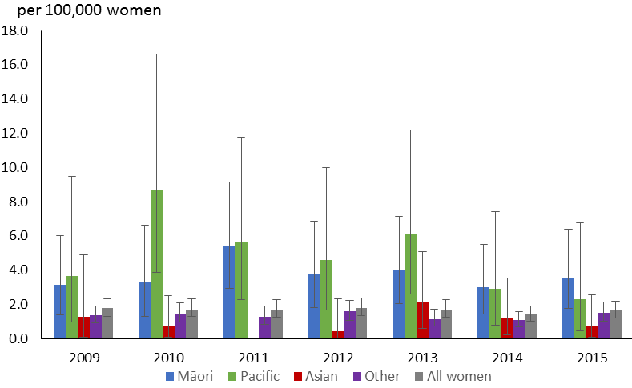
Vertical bars represent 95 percent confidence intervals.
Note: no deaths were recorded for Asian women in 2011.
b) Māori women, compared with all women
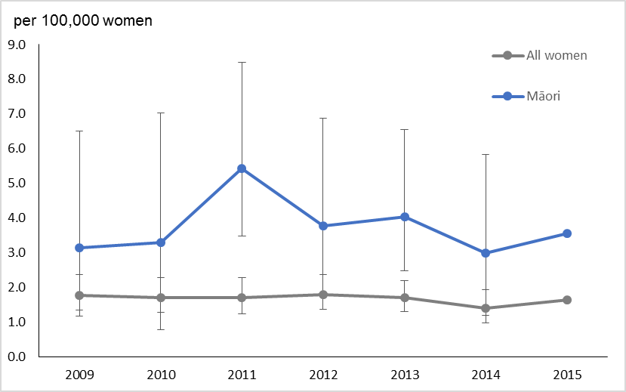
Vertical bars represent 95 percent confidence intervals.

Figure 8: Age-standardised cervical cancer mortality rates for Māori* and all women, 1985–2015†
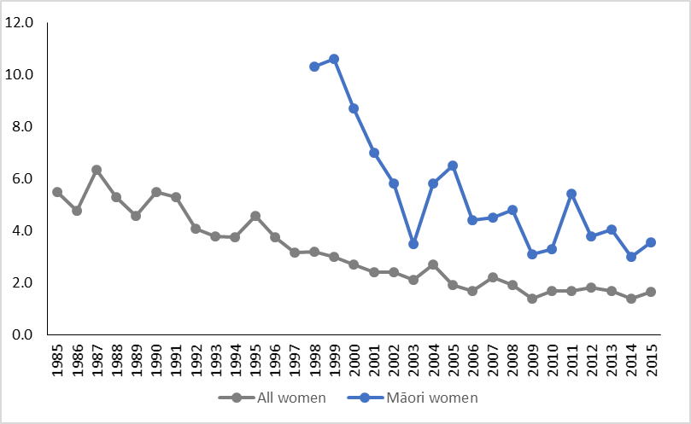
Rates are per 100,000 women, age-standardised to the WHO standard population (all ages).
* Age-standardised rates for Māori women were not available for years before 1996.
† Rates for 1996–2004 sourced from Cancer: New Registrations and Deaths, 2007 (Ministry of Health 2010b) and 2006 (Ministry of Health 2010a). Rates from 2005 are sourced from previous (Smith et al 2012) and the current NCSP annual monitoring report (see Table 4 footnote). Prior dates have been sourced directly from the New Zealand Ministry of Health.

Table 4: Cervical cancer mortality, 1998–2015, by ethnicity
Year† | All women |  | Māori |  | Pacific |  | Asian |  | European / Other women§
 | N | Rate* | N | Rate* | N | Rate* | N | Rate* | N | Rate*
1998 | 77 | 3.2 | 17 | 10.3 | 4 | NA | NA | NA | 60 | 2.7
1999 | 71 | 3.0 | 20 | 10.6 | 7 | NA | NA | NA | 51 | 2.3
2000 | 66 | 2.7 | 17 | 8.7 | 3 | NA | NA | NA | 49 | 2.1
2001 | 63 | 2.4 | 13 | 7.0 | 1 | NA | NA | NA | 50 | 2.0
2002 | 65 | 2.4 | 12 | 5.8 | 2 | NA | NA | NA | 53 | 2.1
2003 | 58 | 2.1 | 8 | 3.5 | 5 | NA | NA | NA | 50 | 2.0
2004 | 71 | 2.7 | 15 | 5.8 | 4 | NA | NA | NA | 56 | 2.2
2005 | 54 | 1.9 | 13 | 6.5 | 6 | NA | NA | NA | 35 | NA
2006 | 52 | 1.7 | 10 | 4.4 | 7 | 7 | 0 | 0.0 | 35 | 1.2
2007 | 65 | 2.2 | 11 | 4.5 | 8 | 8 | 4 | 2.9 | 42 | 1.7
2008 | 59 | 1.9 | 12 | 4.8 | 5 | 5.4 | 4 | 2.0 | 38 | 1.4
2009 | 44 | 1.4 | 9 | 3.1 | 4 | 3.7 | 2 | 1.3 | 29 | 1.0
2010 | 52 | 1.7 | 8 | 3.3 | 9 | 8.6 | 2 | 0.7 | 33 | 1.4
2011 | 53 | 1.7 | 14 | 5.3 | 7 | 5.8 | 0 | 0.0 | 32 | 1.3
2012 | 56 | 1.8 | 11 | 3.7 | 6 | 4.6 | 1 | 0.4 | 38 | 1.6
2013 | 54 | 1.7 | 12 | 4.0 | 8 | 6.1 | 5 | 2.1 | 29 | 1.1
2014 | 46 | 1.4 | 10 | 3.0 | 4 | 2.9 | 3 | 1.2 | 29 | 1.1
2015 | 53 | 1.6 | 11 | 3.6 | 3 | 2.30 | 2 | 0.7 | 37 | 1.5
† Deaths and rates for 1998–2004 sourced from Cancer: New Registrations and Deaths, 2007 (Ministry of Health 2010b). Deaths and rates for 2005 sourced from National Cervical Screening Programme Annual Monitoring Report 2008–2009 (Smith et al 2012). Separate data on deaths in Pacific women were sourced from National Cervical Screening Programme Annual Monitoring Report 2006 (Center for Public Health et al 2008).
§ Counts and rates for ‘European/ Other women’ in 1998–2004 are combined for all non-Māori women, ie, they also include deaths in Pacific and Asian women.
* Rates are per 100,000 women, age-standardised to the WHO standard population (all ages)
NA = not available.
‘–’ = no cases recorded.

Figure 9: Five-year average cervical cancer mortality rates (2011–2015), by age
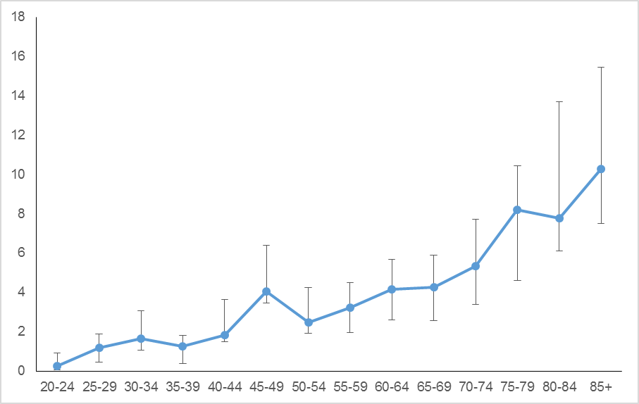
Vertical bars represent 95 percent confidence intervals. See also Table 5.

Figure 10: Five-year average cervical cancer mortality rates (2011–2015), by age and ethnicity
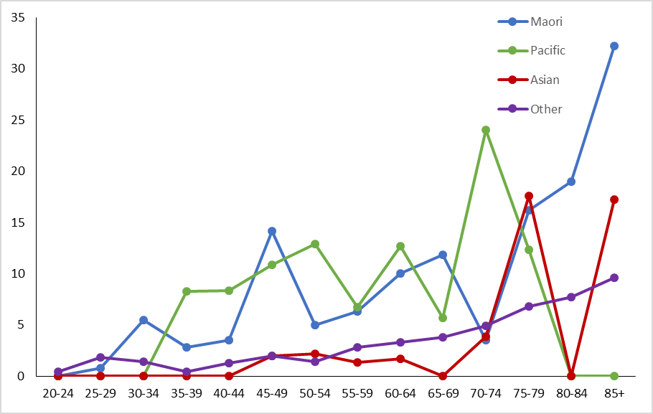
Note that no deaths were recorded in Māori women aged 20–24 years and 70–74, in Pacific women aged 20–34 or 75–84 years, in Asian women aged 20–34, 40–44, 55–59, 65–69 and 80–84 years over this time period. See also Table 5.

Table 5: Average cervical cancer mortality (2011–2015), by age
Age  (in years) | All women |  | Māori women
 | Rate | 95% CI | Rate | 95% CI
20–24 | 0.2 | (0.1, 0.9) | 0.0 | (0, 2.5)
25–29 | 1.2 | (0.4, 1.9) | 0.8 | (0.1, 4.5)
30–34 | 1.7 | (1.1, 3.1) | 5.5 | (2.6, 11.9)
35–39 | 1.2 | (0.4, 1.8) | 2.8 | (1, 8.1)
40–44 | 1.8 | (1.5, 3.6) | 3.5 | (1.4, 9)
45-49 | 4.1 | (3.4, 6.4) | 14.2 | (9.1, 22.9)
50–54 | 2.5 | (1.9, 4.3) | 5.0 | (2.2, 11.6)
55–59 | 3.2 | (1.9, 4.5) | 6.3 | (2.9, 14.6)
60–64 | 4.1 | (2.6, 5.7) | 10.1 | (5, 21.6)
65–69 | 4.2 | (2.6, 5.9) | 11.9 | (5.6, 27.2)
70–74 | 5.3 | (3.4, 7.7) | 3.5 | (0.7, 20)
75–79 | 8.2 | (4.6, 10.4) | 16.2 | (6.8, 46.3)
80–84 | 7.8 | (6.1, 13.7) | 19.0 | (7.3, 67.1)
85+ | 10.3 | (7.5, 15.4) | 32.3 | (15.1, 111.3)
‘0.0’ indicates no deaths recorded over the five-year period.

Appendix A:
Additional data tables
Table 6: Incident cases by detailed morphology, 2016
Morphology | Cases | % of all cervical cancers
Adenocarcinoma | 25 | 14.7
Adenocarcinoma, endocervical type | 3 | 1.8
Adenocarcinoma, not otherwise specified | 20 | 11.8
Endometrioid adenocarcinoma, not otherwise specified | 1 | 0.6
Mucinous adenocarcinoma | 1 | 0.6
Adenosquamous | 10 | 5.9
Adenosquamous carcinoma | 10 | 5.9
Other | 8 | 4.7
Adenoid basal carcinoma | 1 | 0.6
Adenosarcoma | 1 | 0.6
Large cell neuroendocrine carcinoma | 1 | 0.6
Neoplasm, malignant | 1 | 0.6
Neuroendocrine carcinoma, not otherwise specified | 1 | 0.6
Small cell carcinoma, not otherwise specified | 3 | 1.8
Squamous | 127 | 74.7
Basaloid squamous cell carcinoma | 2 | 1.2
Papillary squamous cell carcinoma | 1 | 0.6
Squamous cell carcinoma, keratinizing, not otherwise specified | 9 | 5.3
Squamous cell carcinoma, large cell, non-keratinizing, not otherwise specified | 9 | 5.3
Squamous cell carcinoma, microinvasive (superficially invasive) | 13 | 7.6
Squamous cell carcinoma, not otherwise specified | 93 | 54.7
Total | 170 | 100.0

Table 7: Extent of disease at time of diagnosis for incident cervical cancer cases, 2006–2016
Code | Description | 2006 |  | 2007 |  | 2008 |  | 2009 |  | 2010 |  | 2011 |  | 2012 |  | 2013 |  | 2014 |  | 2015 |  | 2016
 |  | N | % | N | % | N | % | N | % | N | % | N | % | N | % | N | % | N | % | N | % | N | %
B | Localised to organ of origin | 68 | 43.0 | 52 | 31.9 | 71 | 40.6 | 45 | 31.7 | 77 | 42.8 | 67 | 39.6 | 52 | 31.0 | 68 | 42.8 | 60 | 41.7 | 55 | 38.7 | 75 | 44.1
C | Invasion of adjacent tissue or organ | 6 | 3.8 | 6 | 3.7 | 14 | 8.0 | 20 | 14.1 | 21 | 11.7 | 19 | 11.2 | 18 | 10.7 | 35 | 22.0 | 16 | 11.1 | 16 | 11.3 | 23 | 13.5
D | Regional lymph nodes | 6 | 3.8 | 4 | 2.5 | 12 | 6.9 | 8 | 5.6 | 8 | 4.4 | 8 | 4.7 | 7 | 4.2 | 7 | 4.4 | 10 | 6.9 | 6 | 4.2 | 16 | 9.4
E | Distant | 19 | 12.0 | 22 | 13.5 | 16 | 9.1 | 17 | 12.0 | 22 | 12.2 | 21 | 12.4 | 28 | 16.7 | 18 | 11.3 | 13 | 9.0 | 11 | 7.7 | 17 | 10.0
F | Not known | 59 | 37.3 | 79 | 48.5 | 62 | 35.4 | 52 | 36.6 | 52 | 28.9 | 54 | 32.0 | 63 | 37.5 | 31 | 19.5 | 45 | 31.3 | 54 | 38.0 | 39 | 22.9
Total |  | 158 |  | 163 |  | 175 |  | 142 |  | 180 |  | 169 |  | 168 |  | 159 |  | 144 |  | 142 |  | 170

Appendix B:
Population data

WHO standard population
Rates for cervical cancer incidence and mortality were standardised using the WHO world standard population according to Ahmad et al (2001), as shown in Table 8.

Table 8: WHO standard population
Age group | N | Proportion
00–04 | 8,860 | 0.088569
05–09 | 8,690 | 0.08687
10–14 | 8,600 | 0.08597
15–19 | 8,470 | 0.08467
20–24 | 8,220 | 0.082171
25–29 | 7,930 | 0.079272
30–34 | 7,610 | 0.076073
35–39 | 7,150 | 0.071475
40–44 | 6,590 | 0.065877
45–49 | 6,040 | 0.060379
50–54 | 5,370 | 0.053681
55–59 | 4,550 | 0.045484
60–64 | 3,720 | 0.037187
65–69 | 2,960 | 0.02959
70–74 | 2,210 | 0.022092
75–79 | 1,520 | 0.015195
80–84 | 910 | 0.009097
85+ | 635 | 0.006348
Total | 100,035 | 1

New Zealand estimated resident population
The estimated data for New Zealand female population was based on data from Statistics New Zealand. Population figures for cancer incidence and mortality used mid-year estimates, based on projections from 2013 Census data for 2006–2014. Population estimates for 2005 were based on a linear interpolation between data from the 2001 Census and 2006 Census. Population data for 2005 were not available in the four required ethnic groups, and so ethnicity-specific estimates could not be calculated for 2005 for cancer incidence, cancer mortality or coverage.

References
Ahmad OB, Boschi-Pinto C, Lopez AD, et al. 2001. Age standardization of rates: A new WHO standard. Geneva: World Health Organization.
Boyle P, Parkin D. 2002. Chapter 11. Statistical methods for registries. IARC Scientific Publication 95 Cancer Registrations: Principles & Methods. Lyon, France: International Agency for Research on Cancer (IARC) Press.
Brewer N, McKenzie F, Wong KC, et al. 2008. National Cervical Screening Programme Annual Monitoring Report 2006. Wellington: Centre for Public Health Research, Massey University.
Ministry of Health. 2010a. Cancer: New registrations and deaths 2006. Wellington: Ministry of Health.
Ministry of Health. 2010b. Cancer: New registrations and deaths 2007. Wellington: Ministry of Health.
Smith M, Walker R, Canfell K. 2012. National Cervical Screening Programme Annual Report 2008–2009.

The equivalent overall incidence rate if age-standardised to the SEGI population is 5.6 per 100,000 women in the population.
The equivalent overall mortality rate if age-standardised to the SEGI population is 1.4 per 100,000 women in the population.

