National Cervical Screening Programme

Monitoring Report 47

1 January – 30 June 2017

Technical report 47

Prepared November
Revised March 2018
Finalised April 2018

By Megan Smith, Leanne Rumlee, and Karen Canfell
Cancer Research Division, Cancer Council NSW Australia, Sydney NSW Australia

Suggested citation:
Smith M, Rumlee L, Canfell K. National Cervical Screening Programme Monitoring Report Number 47 (1 January – 30 June 2017). National Screening Unit: Wellington, 2018.

Acknowledgements

This report was prepared by the authors in collaboration with the National Screening Unit (NSU), Ministry of Health, in particular Ivan Rowe, Senior Analyst, Sector Development, of the National Screening Unit.

We would like to acknowledge the contribution from Ronnie de Does, NCSP Register Central Team, for data extraction; John Newell, NSU, for developing the SQL queries from the extracted data to calculate and produce the IMR tables; and Simon Edwards, Robert Walker, Sarsha Yap and Dr Mark Clements for assistance with code development and importing data for analysis.

About the authors

The authors are based at Cancer Research Division at Cancer Council NSW, Sydney, Australia. They are part of a research group (led by Prof Karen Canfell) which has as its core research focus the epidemiology of cervical cancer, cervical screening and human papillomavirus (HPV) vaccination. This research group has established an extensive track record both in research publication and in successful completion of commissioned projects related to national cervical screening programmes in New Zealand, Australia and England. The group has extensive experience in the analysis of descriptive data from cervical cancer screening programmes. The team also has a range of related skills in the analysis of linked datasets, systematic review and meta-analysis, biostatistics, health economics, and advanced statistical modelling techniques.

Contents
1. Executive Summary 1
2. Background 12
3. Methods 13
Data used 13
Age 13
Hysterectomy-adjusted population 13
Ethnicity analysis 14
Calculating NCSP coverage 14
4. Biannual NCSP Monitoring Indicators 16
Indicator 1 – Coverage 16
Indicator 1.1 – Three-year coverage 17
Indicator 1.2 – Regularity of screening 32
Indicator 2 – First screening events 33
Indicator 3 – Withdrawal rates 39
Indicator 4 – Early re-screening 43
Indicator 5 – Laboratory indicators 49
Indicator 5.1 – Laboratory cytology reporting 50
Indicator 5.2 – Accuracy of cytology predicting HSIL 63
Indicator 5.3 – Accuracy of negative cytology reports 69
Indicator 5.4 – Histology Reporting 70
Indicator 5.5 - Laboratory turnaround times 77
Indicator 6 – Follow-up women high grade cytology, no histology 84
Indicator 7 – Colposcopy Indicators 98
Indicator 7.1 – Timeliness of colposcopic assessment – high grade cytology 99
Indicator 7.2 – Timeliness of colposcopic assessment – low grade cytology 106
Indicator 7.3 – Adequacy of documenting colposcopy assessment 112
Indicator 7.4 – Timeliness and appropriateness of treatment 118
Indicator 7.5 – Timely discharging of women after treatment 123
Indicator 8 – HPV tests 127
Indicator 8.1 – Triage of low grade cytology 128
Indicator 8.2 – HPV test volumes 142
Indicator 8.3 – HPV tests for follow-up of women with a historical high grade abnormality 153
Appendix A – Additional data 160
Indicator 1 - Coverage 160
Indicator 1.1 – Three-year coverage 160
Indicator 2 – First screening events 170
Indicator 3 – Withdrawal rates 173
Indicator 4 – Early re-screening 174
Indicator 5 – Laboratory indicators 176
Indicator 5.1 – Laboratory cytology reporting 176
Indicator 5.2 – Accuracy of cytology predicting HSIL 177
Indicator 5.4 – Histology Reporting 179
Indicator 5.5 – Laboratory turnaround time 180
Indicator 6 – Follow-up of women with high grade cytology 183
Indicator 7 – Colposcopy indicators 185
Indicator 7.1 – Timeliness of colposcopic assessment – high grade cytology 185
Indicator 7.2 – Timeliness of colposcopic assessment – low grade cytology 187
Indicator 7.3 – Adequacy of documenting colposcopic assessment 189
Indicator 7.5 – Timely discharge of women after treatment 192
Indicator 8 – HPV tests 194
Indicator 8.1 – Triage of low grade cytology 194
Indicator 8.2 – HPV test volumes 197
Indicator 8.3 –HPV tests for follow-up of women with a historical high grade abnormality 201
Appendix B – Bethesda 2001 New Zealand Modified 206
Appendix C – SNOMED categories for histological samples 208
Appendix D – Indicator Definitions Targets and Reporting Details 210
Positive predictive value calculations 210
Appendix E – DHB assignment for colposcopy clinics 211
Appendix F – Glossary 213
References 214

List of Tables

Table 1 - Satisfactory and unsatisfactory cytology reporting by laboratory (1 January – 30 June 2017) 57
Table 2 - Laboratory cytology reporting by general result (1 January – 30 June 2017) – percentage of satisfactory samples 57
Table 3 - Laboratory cytology reporting by type of cytological category (1 January – 30 June 2017) – counts 58
Table 4 - Laboratory cytology reporting by cytological category (1 January – 30 June 2017) – percentage of all satisfactory samples 58
Table 5 - Laboratory reporting of cytological category by five-year age group (1 January – 30 June 2017) – counts 59
Table 6 - Laboratory reporting of cytological category by five-year age group (1 January – 30 June 2017) – percentage of all satisfactory samples in women of that age group 60
Table 7 - Histology results reporting by SNOMED category 72
Table 8 - Histology results reporting by diagnostic category 73
Table 9 - Histology results by age – counts 74
Table 10 - Histology results by age – percentages 75
Table 11 - Women with a histology report within 90 and 180 days of a high grade cytology report, by DHB 91
Table 12 - Women with a histology report within 90 and 180 days of a high grade cytology report, by age 91
Table 13 - Women with a histology report within 90 days of a high grade cytology report, by DHB and ethnicity 92
Table 14 - Women with a histology report within 180 days of a high grade cytology report, by DHB and ethnicity 93
Table 15 - Women with high grade cytology who have follow-up within 90 and 180 days recorded on the NCSP Register, by urgency of referral and type of follow-up 93
Table 16 - Women without any follow-up test within 90 and 180 days of a high grade cytology report, by DHB 95
Table 17 - Women without any follow-up test within 180 days of a high grade cytology report, by ethnicity 95
Table 18 - Women with a high grade cytology report (suspicion of invasive disease), accepted referral and colposcopy visit, by ethnicity 104
Table 19 - Timeliness and appropriateness of treatment, by DHB 122
Table 20 - HPV triage test results following ASC-US cytology, by age and cytology laboratory 136
Table 21 - HPV triage test results following LSIL cytology, by age and cytology laboratory 137
Table 22 - Coverage by DHB (women 25-69 years screened in the three years prior to 30 June 2017, hysterectomy adjusted) 160
Table 23 - Coverage by ethnicity (women 25-69 years screened in the three years prior to 30 June 2017, hysterectomy adjusted) 160
Table 24 - Coverage by age (women 20-69 years screened in the three years prior to 30 June 2017, hysterectomy adjusted) 161
Table 25 - Coverage by DHB (women aged 25-69 years screened in the five years prior to 30 June 2017, hysterectomy adjusted) 161
Table 26 - Coverage by ethnicity – women aged 25-69 years screened in the five years prior to 30 June 2017, hysterectomy adjusted 162
Table 27 - Coverage by age (women 20-69 years screened in the five years prior to 30 June 2017, hysterectomy adjusted) 162
Table 28 - Women aged 25-69 years screened in the five years prior to 30 June 2017, by ethnicity and DHB (hysterectomy adjusted) 163
Table 29 - Women under 20 years of age, and aged 15-19 years, screened in the three years prior to 20 June 2017, by DHB. 164
Table 30 - Women screened under 20 years of age, as a proportion of all women screened in the three years to 30 June 2017, by DHB 165
Table 31 - Women screened under 20 years of age, and women aged 18-19 years when they were screened, in the three years to 30 June 2017, by DHB 166
Table 32 - Women (25-69 years) screened in the three years to 30 June 2017, as a percentage of the i) hysterectomy-adjustment NZ female population and ii) total NZ female population, by DHB 167
Table 33 - Trends in three-year coverage by DHB (women screened in the previous three years, as a percentage of the hysterectomy-adjusted female population) 168
Table 34 - Trends in three-year coverage by age (women screened in the previous three years, as a percentage of the hysterectomy-adjusted female population) 168
Table 35 - Trends in three-year coverage by ethnicity (women screened in the previous three years, as a percentage of the hysterectomy-adjusted female population) 169
Table 36 - Age distribution of first screening events for period 1 January – 30 June 2017 170
Table 37 - Women (aged 20-69 years) with first screening events as a proportion of i) total number of women with screening events, and ii) eligible women, by DHB, for period 1 January – 30 June 2017 171
Table 38 - Women (ages 20-69 years) with first screening events as a proportion of i) total number of women with screening events, and ii) eligible women, by ethnicity, for period 1 January – 30 June 2017 171
Table 39 - Median age of women with a first screening event, by ethnicity, for period 1 January – 30 June 2017 172
Table 40 - Number of women who withdrew from the NCSP Register 1 January – 30 June 2017 by age, and proportion of women who were enrolled at the start of the monitoring period who withdrew 173
Table 41 - Number of women (aged 20-69 years) who withdrew from the NCSP Register 1 January – 30 June 2017 by ethnicity, and proportion of women who were enrolled at the start of the monitoring period who withdrew 173
Table 42 - Early re-screening by five-year age group 174
Table 43 - Early re-screening by DHB 174
Table 44 - Early re-screening by ethnicity 175
Table 45 - Age-standardised percentage of satisfactory smears reported as HSIL, by laboratory 176
Table 46 - Positive predictive value of a report of HSIL + SC cytology by laboratory 177
Table 47 - Positive predictive value of a report of ASC-H cytology by laboratory 177
Table 48 - Positive predictive value of a report of ASC-H + HSIL + SC cytology by laboratory 178
Table 49 - Histology results reporting by diagnostic category excluding samples from partial or total hysterectomy specimens and where the result was negative/ benign. 179
Table 50 - Timeliness of cytology reporting by laboratory, 1 January – 30 June 2017 180
Table 51 - Timeliness of histology reporting by laboratory, 1 January – 30 June 2017 181
Table 52 - Timeliness of reporting for cytology with associated HPV testing by laboratory, 1 January – 30 June 2017 182
Table 53 - Women with a histology report within 90 days of a high grade cytology report, by DHB and age 183
Table 54 - Women with a histology report within 180 days of a high grade cytology report, by DHB and age 184
Table 55 - Women with high grade cytology (including cytological suspicion of invasive disease), by DHB 185
Table 56 - Women with a high grade cytology report (no suspicion of invasive disease), accepted referral and a colposcopy visit within 20 and 40 working days, by ethnicity 185
Table 57 - Women with a high grade cytology report (no suspicion of invasive disease), accepted referral and a colposcopy visit within 20 and 40 working days, by DHB 186
Table 58 - Women with cytological suspicion of invasive disease, by cytology result subcategory 186
Table 59 - Follow-up of women with persistent low grade cytology/ low grade cytology and positive hrHPV test, by DHB 187
Table 60 - Follow-up of women with persistent low grade cytology/ low grade cytology and positive hrHPV test, by ethnicity 188
Table 61 - Completion of colposcopic assessment fields, by DHB 189
Table 62 - Summary of colposcopic appearance findings, by DHB 190
Table 63 - Biopsies by colposcopic appearance and DHB 191
Table 64 - Follow-up of treated women with colposcopy and cytology in the period up to nine months post-treatment, and discharge of eligible women 192
Table 65 - Follow-up of treated women in the period up to nine months post-treatment 193
Table 66 - Triage testing of women with ASC-US cytology 194
Table 67 - Triage testing of women with LSIL cytology 195
Table 68 - Histological outcomes within 12 months in women with ASC-US cytology and positive HPV triage test 195
Table 69 - Histological outcomes within 12 months in women with LSIL cytology and positive HPV triage test 196
Table 70 - Volume of HPV test samples received during the monitoring period, by laboratory 197
Table 71 - Invalid HPV tests, by laboratory 197
Table 72 - Validity of HPV triage tests, by test technology 197
Table 73 - Volume of HPV test samples received during the monitoring period, by purpose and ethnicity 198
Table 74 - Volume of HPV test samples received during the monitoring period, by purpose and age 198
Table 75 - Volume of HPV test samples received during the monitoring period, by purpose and laboratory 199
Table 76 - HPV test samples collected at colposcopy, in relation to total colposcopies performed in the period, by DHB 200
Table 77 - Women eligible for and proportion who have received HPV testing for a historical high grade abnormality, by age at 30 June 2017 201
Table 78 - Women eligible for and proportion who have received historical HPV testing, by DHB 202
Table 79 - Women eligible for and proportion who have received historical HPV testing, by ethnicity 202
Table 80 - Women screened in the previous five years and proportion of women with historical round 1 and 2 tests recorded, by DHB 205
Table 81 - Definition used for positive predictive value calculations 210

List of Figures

Figure 1 - Three-year coverage by ethnicity (women 25-69 years screened in the three years prior to 30 June 2017, as a proportion of hysterectomy-adjusted female population) 22
Figure 2 - Three-year coverage by five-year age group (women 20-69 years screened in the three years prior to 30 June 2017, as a proportion of hysterectomy-adjusted female population) 22
Figure 3 - Three-year coverage by DHB (women 25-69 years screened in the three years prior to 30 June 2017, as a proportion of hysterectomy-adjusted female population) 23
Figure 4 - Three-year coverage in Māori women (women 25-69 years screened in the three years prior to 30 June 2017, as a proportion of hysterectomy-adjusted female population), by DHB 23
Figure 5 - Three-year coverage in Pacific women (women 25-69 years screened in the three years prior to 30 June 2017, as a proportion of hysterectomy-adjusted female population), by DHB 24
Figure 6 - Three-year coverage in Asian women (women 25-69 years screened in the three years prior to 30 June 2017, as a proportion of hysterectomy-adjusted female population), by DHB 24
Figure 7 - Three-year coverage in European/ Other women (women 25-69 years screened in the three years prior to 30 June 2017, as a proportion of hysterectomy-adjusted female population), by DHB 25
Figure 8 - Five-year coverage by DHB (women screened in the five years prior to 30 June 2017, as a proportion of hysterectomy-adjusted female population) 25
Figure 9 - Five-year coverage by five-year age-group (women screened in the five years prior to 30 June 2017, as proportion of hysterectomy-adjusted female population) 26
Figure 10 - Five-year coverage by ethnicity (women screened in the five years prior to 30 June 2017, as a proportion of hysterectomy-adjusted female population) 26
Figure 11 - Five-year coverage in Māori women (women 25-69 years screened in the five years prior to 30 June 2017, as a proportion of hysterectomy-adjusted female population), by DHB 27
Figure 12 - Five-year coverage in Pacific women (women 25-69 years screened in the five years prior to 30 June 2017, as a proportion of hysterectomy-adjusted female population), by DHB 27
Figure 13 - Five-year coverage in Asian women (women 25-69 years screened in the five years prior to 30 June 2017, as a proportion of hysterectomy-adjusted female population), by DHB 28
Figure 14 - Five-year coverage in European/ Other women (women 25-69 years screened in the five years prior to 30 June 2017, as a proportion of hysterectomy-adjusted female population), by DHB 28
Figure 15 - Number of women screened who were aged less than 20 years at the time of their cervical sample in the three years to 30 June 2017, by DHB 29
Figure 16 - Trends in three-year coverage by DHB (women aged 25-69 years screened in the previous three years, as a proportion of hysterectomy-adjusted female population) 29
Figure 17 - Trends in three-year coverage by age (women screened in the previous three years, as a proportion of hysterectomy-adjusted female population) 30
Figure 18 - Trends in three-year coverage by ethnicity (women aged 25-69 years screened in the previous three years, as a proportion of hysterectomy-adjusted female population) 30
Figure 19 - Trends in the number of women screened in the preceding three years who were aged less than 20 years at the time of their cervical sample, by DHB 31
Figure 20 - Trends in the percent of women aged less than 20 years at the time of their cervical sample who were aged 18 or 19 years, by DHB 31
Figure 21 - Women with first screening events during the monitoring period, by five-year age group (women aged 20-69 years at 30 June 2017) 35
Figure 22 - Women with first screening events as a proportion of all women screened in that age group during the monitoring period, by five-year age group (women aged 20-69 years at 30 June 2017) 35
Figure 23 - Proportion of population* in that age group with their first screening event during the monitoring period (women aged 20-69 years at 30 June 2017) 36
Figure 24 - Women with first screening events as a proportion of all women screened during the monitoring period, by DHB (women aged 20-69 years at 30 June 2017) 36
Figure 25 - Women with first screening events as a proportion of all women screened during the monitoring period, by ethnicity (women aged 20-69 years at 30 June 2017) 37
Figure 26 - Trends in the number of women with a first screening event, by age 37
Figure 27 - Trends in the number of women with a first screening event, by DHB 38
Figure 28 - Trends in the number of women with a first screening event, by ethnicity 38
Figure 29 - Number of women (aged 20-69 years) who withdrew from the NCSP Register by DHB, 1 January – 30 June 2017 41
Figure 30 - Number of women who withdrew from the NCSP Register by age, 1 January – 30 June 2017 41
Figure 31 - Number of women (aged 20-69 years) who withdrew from the NCSP Register by ethnicity, 1 January – 30 June 2017 42
Figure 32 - Proportion of women recommended to return at the routine interval (three years) who were re-screened early, by DHB 46
Figure 33 - Proportion of women recommended to return at the routine interval (three years) who were re-screened early, by five-year age group 46
Figure 34 - Proportion of women recommended to return at the routine interval (three years) who were re-screened early, by ethnicity 47
Figure 35 - Trends in the proportion of women recommended to return at the routine interval (three years) who were re-screened early, by DHB 47
Figure 36 - Trends in the proportion of women recommended to return at the routine interval (three years) who were re-screened early, by age 48
Figure 37 - Proportion of total LBC samples reported as unsatisfactory by laboratory, 1 January – 30 June 2017 55
Figure 38 - Proportion of total satisfactory samples reported as negative by laboratory, 1 January – 30 June 2017 55
Figure 39 - Proportion of total satisfactory samples reported as abnormalities by laboratory, 1 January – 30 June 2017 56
Figure 40 - Proportion of total satisfactory samples reported as HSIL by laboratory, 1 January – 30 June 2017 56
Figure 41 - Trends in the proportion of total satisfactory samples reported as HSIL (last four monitoring periods), by age 61
Figure 42 - Longer term trends in the proportion of total satisfactory samples reported as HSIL (to 1 January – 30 June 2017), selected age groups 61
Figure 43 - Trends in the proportion of total satisfactory samples reported as HSIL, by laboratory 62
Figure 44 - Positive predictive value for CIN 2+ in women with HSIL or SC cytology reports (cytology in 1 July to 31 December 2016), by laboratory 66
Figure 45 - Positive predictive value for CIN 2+ in women with other high grade cytology results (cytology in 1 July to 31 December 2016), by laboratory 66
Figure 46 - Trends in the positive predictive value for CIN 2+ in women with HSIL or SC cytology results, by laboratory 67
Figure 47 - Trends in the positive predictive value for CIN 2+ in women with ASC-H cytology results, by laboratory 67
Figure 48 - Trends in the positive predictive value for CIN 2+ in women with ASC-H, HSIL or SC cytology results, by laboratory 68
Figure 49 - Trends in histologically-confirmed HSIL as a percentage of all women with histology (Jul-Dec 2011 to 1 Jan – 30 Jun 2017) 76
Figure 50 - Proportion of cytology samples reported within seven working days by laboratory, 1 January – 30 June 2017 81
Figure 51 - Proportion of cytology samples reported within 15 working days by laboratory, 1 January – 30 June 2017 81
Figure 52 - Proportion of histology samples reported within ten working days by laboratory, 1 January – 30 June 2017 82
Figure 53 - Proportion of histology samples reported within 15 working days by laboratory, 1 January – 30 June 2017 82
Figure 54 - Proportion of cytology samples with associated HPV triage testing and of all cytology samples reported within 15 days by laboratory, 1 January – 30 June 2017 83
Figure 55 - Proportion of women with a histology report within 90 days, and within 180 days of their high grade cytology report, by DHB 90
Figure 56 - Proportion of women without any follow-up test within 90 days and within 180 days of a high grade cytology report, by DHB 94
Figure 57 - Proportion of women without any follow-up test within 90 days and within 180 days of a high grade cytology report, by ethnicity 94
Figure 58 – Trends in the proportion of women with high grade cytology who have follow-up within 90 days recorded on the NCSP Register, by DHB 96
Figure 59 – Trends in the proprtion of women with high grade cytology who have follow-up within 180 days recorded on the NCSP Register, by DHB 96
Figure 60 - Trends in the proportion of women with high grade cytology who have follow-up within 90 days recorded on the NCSP Register, by ethnicity 97
Figure 61 - Trends in the proportion of women with high grade cytology who have follow-up within 180 days recorded on the NCSP Register, by ethnicity 97
Figure 62 - Percentage of women with a high grade cytology (no suspicion of invasive disease) with a colposcopy visit within 20 and 40 working days, by ethnicity 104
Figure 63 - Percentage of women with a high grade cytology (no suspicion of invasive disease) with a colposcopy visit within 20 and 40 working days, by DHB 105
Figure 64 – Trends of the proportion of women with a high grade cytology report (no suspicion of invasive disease) seen within 4 weeks (20 working days), by ethnicity 105
Figure 65 - Follow-up recorded* for women with persistent LG cytology/ LG cytology and positive hrHPV test, by DHB 109
Figure 66 - Follow-up recorded* for women with persistent LG cytology/ LG cytology and positive hrHPV test, by ethnicity 109
Figure 67 - Women with persistent LG cytology/ LG cytology and positive hrHPV test and an accepted referral for colposcopy: percentage with a colposcopy visit recorded within 26 weeks of the date the referral was accepted, by DHB 110
Figure 68 - Women with persistent LG cytology or LG cytology and positive hrHPV test and an accepted referral for colposcopy: percentage with a colposcopy visit recorded within 26 weeks of the date the referral was accepted, by ethnicity 110
Figure 69 - Trends in the proportion of women with persistent LG cytology or LG cytology and positive hrHPV test and an accepted referral for colposcopy who have a colposcopy visit recorded within 26 weeks of the date the referral was accepted, by ethnicity 111
Figure 70 - Trends in proportion of women with persistent LG cytology or LG cytology and positive hrHPV test and an accepted referral for colposcopy who have a colposcopy visit recorded within 26 weeks of the date the referral was accepted, by DHB 111
Figure 71 - Completion of colposcopic assessment fields, by DHB 116
Figure 72 - Trends in the completion of all required colposcopic assessment fields, by DHB 116
Figure 73 - Trends in the number of colposcopies recorded on the NCSP Register, by DHB 117
Figure 74 - Proportion of women treated within eight weeks of histological confirmation of HSIL, by DHB 121
Figure 75 - Trends in the proportion of women treated within eight weeks of histological confirmation of HSIL, by DHB 121
Figure 76 - Percentage of women treated with colposcopy, and both colposcopy and cytology, within nine months post-treatment, by DHB 126
Figure 77 - Percentage of women discharged appropriately within 12 months of treatment, by DHB 126
Figure 78 - Proportion of women (aged 30 years or more) with low grade cytology who have a subsequent HPV test, by laboratory and cytology result 133
Figure 79 - Proportion of women (aged less than 30 years) with low grade cytology who have a subsequent HPV test, by laboratory and cytology result 133
Figure 80 - Proportion of HPV triage tests which are positive following ASC-US cytology (women aged 30 years or more), by cytology laboratory 134
Figure 81 - Proportion of HPV triage tests which are positive following LSIL cytology (women aged 30 years or more), by cytology laboratory 134
Figure 82 - Proportion of women with an HPV triage test who are HPV positive, by age and cytology result 135
Figure 83 – Triage-positive women with histologically-confirmed CIN 2+ within 12 months, as a percentage of all women with histology, by laboratory 138
Figure 84 – Triage-positive women with histologically-confirmed CIN 2+ within 12 months, as a percentage of all women who attended colposcopy, by laboratory 138
Figure 85 - Women with histologically-confirmed CIN 2+ within 12 months, as a percentage of all women who attended colposcopy, by laboratory and referral cytology 139
Figure 86 – Triage-positive women with histologically-confirmed CIN 2+ within 12 months, as a percentage of women with histology recorded, by age 139
Figure 87 – Triage-positive women with histologically-confirmed CIN 2+ within 12 months, as a percentage of women with colposcopy recorded, by age 140
Figure 88 – Trends in ASC-US triage-positive women with histologically-confirmed CIN 2+ within 12 months, as a percentage of women with colposcopy recorded, by laboratory 140
Figure 89 – Trends in LSIL triage-positive women with histologically-confirmed CIN 2+ within 12 months, as a percentage of women with colposcopy recorded, by laboratory 141
Figure 90 - Volume of HPV test samples received by laboratories during the monitoring period, by age 148
Figure 91 - Volume of HPV test samples received by laboratories during the monitoring period, by laboratory 148
Figure 92 - HPV test samples as a percentage of cytology test samples received during the monitoring period, by laboratory 149
Figure 93 - Volume of HPV test samples received during the monitoring period, by purpose 149
Figure 94 - HPV test samples received during the monitoring period, by purpose and age 150
Figure 95 - HPV test samples received during the monitoring period, by purpose and laboratory 150
Figure 96 - HPV test samples collected at colposcopy, in relation to total colposcopies performed in the period, by DHB 151
Figure 97 - Trends in volumes of HPV test samples received, by laboratory 151
Figure 98 - Trends in volumes of HPV test samples received, by purpose 152
Figure 99 - Proportion of eligible women with squamous high grade abnormality more than 3 years ago for whom an historical test is recorded on the NCSP Register, by age at 30 June 2017 157
Figure 100 - Proportion of eligible women with squamous high grade abnormality more than 3 years ago for whom an historical test is recorded on the NCSP Register, by DHB at 30 June 2017 157
Figure 101 - Proportion of eligible women with squamous high grade abnormality more than 3 years ago for whom an historical test is recorded on the NCSP Register, by ethnicity at 30 June 2017 158
Figure 102 – Trends in the proportion of eligible women with squamous high grade abnormality more than 3 years ago for whom a round 1 historical test is recorded on the NCSP Register, by DHB 158
Figure 103 - Trends in the proportion of eligible women with squamous high grade abnormality more than 3 years ago for whom a round 1 historical test is recorded on the NCSP Register, by ethnicity 159
Figure 104 - Trends in the proportion of eligible women with squamous high grade abnormality more than 3 years ago for whom a round 1 historical test is recorded on the NCSP Register, by age 159
Figure 105 - Number of women eligible for historical testing within a DHB versus the percentage with a Round 1 historical HPV test recorded 203
Figure 106 - Relationship between women screened in the previous five years and proportion of women with historical tests recorded, by DHB 203
Figure 107 - Relationship between women screened in the previous five years and proportion of women with historical tests recorded, by ethnicity 204

Executive Summary
Purpose | This report provides data on performance indicators of the National Cervical Screening Programme (NCSP) for the period 1 January to the 30 June 2017.
Key points on performance/trends

Indicator 1 | Coverage
Indicator 1.1 | Three-year coverage  Target: 80% of eligible women screened within the previous three years by 30 June 2017.  - Among an estimated 1,209,822 eligible women aged 25-69 years at the end of the monitoring period, 923,755 (76.4%) had a screening test in the previous three years.  - The coverage target was not met nationally (80% of women aged 25-69 years screened in the previous three years).  - The coverage target was met for specific five-year age groups between 45-54 years.  - Two of 20 DHBs met the coverage target.  - Nationally, coverage targets were met for European/ Other women (81.1% screened within the previous three years), but were not met for Māori, Pacific, or Asian women (64.0%, 74.3%, 67.2% respectively screened within the previous three years).  - Three-year coverage among women aged 25-69 years (76.4%) is similar to that reported in the previous monitoring report (76.8%). It has increased in Māori and Asian women and has decreased for Pacific and European/ Other women.  - Three-year coverage has decreased in 9 of the 10 age groups.  - Three-year coverage has decreased slightly in 13 of 20 DHBs.  - Five-year coverage among women aged 25-69 years (90.3%) is similar to that reported in the previous monitoring report (90.5%).  - Five-year coverage among women aged 25-69 years exceeded 80% in all DHBs, in Pacific and European/ Other women, and in women in all five-year age groups between 30-69 years.  Screens in women aged less than 20 years  Target: None  - In the three years to 30 June 2017, 6,076 women had a cervical sample taken when they were aged less than 20 years. This is fewer than in the previous monitoring period (6,434 women).  - This represents 0.6% of all women (of any age) who were screened in the three-year period (the same as the previous monitoring period).  - Most of these women (89.6%) were aged 18-19 years at the time of their cervical sample.
Indicator 1.2 | Regularity of screening  Target: Not yet defined  This indicator is not assessed in this report, instead it is assessed annually. This indicator was last assessed in Report 46 and will be next assessed in Report 48.
Indicator 2 | First screening events  Target: None  - There were 22,362 women who had their first screening event during the current monitoring period – an increase compared to the previous monitoring period.  - First screening events generally occur among young women (median age 26 years).  - Asian women appear to have their first screening event at a later age (median age of Asian women attending for their first screening event was 31 years).  - The proportion of women attending for screening who are attending for their first test is highest in Asian women.
Indicator 3 | Withdrawal rates  Target: Zero between ages 20-69 years  - There were 30 women aged between 20-69 years who withdrew from the NCSP Register during this six-month period. This is more than the number of women in this age range who withdrew during the previous monitoring period (26 women).
Indicator 4 | Early re-screening  Target: Not yet defined  Currently reporting on the percentage of women in routine screening (previous smear negative and recommended to return in 36 months (3 years) who returned for a smear within 30 months (2.5 years) of their index smear.  - 13.7% of a cohort of women with a recommendation to return at the routine interval had at least one cytology sample within 30 months of their index cytology sample.  - Early re-screening varies widely between DHBs, from 7.6% in Tairawhiti and Whanganui to 18.8% in Waitemata.  - Early re-screening occurs in all ethnic groups, but is most common among European/ Other (14.1%) and least common among Pacific women (9.8%).  - Early re-screening occurs in all age groups, but is most common in women aged 20-24 years at the end of the period (19.8%) and least common in women aged 65-69 years at the end of the period (9.6%).  - Early re-screening has decreased slightly overall since the previous report, from 14.3% to 13.7%.
Indicator 5 | Laboratory Indicators
Indicator 5.1 | Cytology reporting  Unsatisfactory cytology  Target: 0.1 - 3% for LBC  - The target for the percentage of LBC samples reported as unsatisfactory was met by four of the six laboratories, and was met nationally (1.4%).  - The rate of unsatisfactory LBC samples has remained similar to the previous report (1.6%).  Negative cytology  Target: No more than 96% of satisfactory cytology samples  - The target for the percent of samples reported as negative was met nationally and met by all six laboratories.  - Nationally, the percent of samples which are negative (93.3%) is similar to what was reported in the previous period (92.9%).  Abnormal cytology  Target: No more than 10% of satisfactory cytology samples  - The target for the percent of samples reported as abnormal was met nationally and by four of six laboratories.  - Nationally, the percent of samples which are abnormal (6.7%) is similar to what was reported in the previous period (7.1%).  HSIL cytology  Target: No less than 0.5% of satisfactory cytology samples  - The target for the percent of HSIL samples was met nationally and met by five of six laboratories.  - Nationally the percent of HSIL samples (0.8%) was lower then in the last monitoring report (1.0%). This rate has reduced in all ages; however, in women aged 20-24 years this rate is lower than has ever been previously reported.
Indicator 5.2 | Cytology positive predictive value  HSIL + SC  Target: 65% - 85% of HSIL+SC cytology samples should be histologically confirmed as high grade  - Three of six laboratories met the target range for HSIL + SC.  - Nationally, the positive predictive value of HSIL + SC was higher in this monitoring period (81.7%) than in the previous report (79.8%).  Other cytological abnormalities  Target: None  - Nationally, the positive predictive value of ASC-H has increased compared to the previous report (49.7% in this report, 41.2% in the previous report).  - Nationally, the positive predictive value of the combination of ASC-H + HSIL + SC has increased compared to the previous report (71.5% in this report, compared to 68.3% in the previous report).  - Nationally, the percent of glandular cytological abnormalities identified as histological high grade has increased since the previous report, from 44.9% to 46.1% (however this measure is generally based on a comparatively small number of samples; 180 samples with histology in the current report).
Indicator 5.3 | Accuracy of negative cytology reports  Among cytology slides within the 42 months preceding a histological diagnosis of high-grade/ invasive disease originally reported as negative, benign/ reactive or unsatisfactory:  Target: Not more than 10% identified as HS1, HS2, SC, AIS or AC1-AC5 (HSIL+) on review  This indicator is not assessed in this report. Data for this indicator is provided annually and this indicator was last assessed in Report 46 and will be next assessed in Report 48.
Indicator 5.4 | Histology reporting  Target: None  - 12,548 histology samples were taken during the current monitoring period. 447 (3.6%) of these were insufficient for diagnosis.  - Results for most severe histology from 10,643 women with samples which were sufficient for diagnosis are presented.  - 54.6% of women had histology samples which were negative/ benign. This reduced to 43.7% of women when negative/ benign hysterectomy samples (total hysterectomy and partial hysterectomy with cervical component) were excluded.  - 19.8% of women had CIN 2/3 or HSIL histology results.  - 62 (0.58%) women had histology results indicating adenocarcinoma in situ (AIS).  - 71 (0.67%) women had invasive squamous cell carcinoma (ISCC) histology results, 37 (0.35%) women had adenocarcinomas not arising from the endocervix and 5 (<0.05%) adenocarcinoma arising from the endocervix histology results. No women had adenosquamous carcinoma histology results.
Indicator 5.5 | Turnaround times  Cytology  Target: 90% within seven working days; 98% within 15 working days  - The seven-working-days target for cytology was met nationally (96.3%), and was met by all six laboratories.  - The 15-working-days target was met nationally (99.0%), and was also met in all six laboratories.  - Performance against the seven-working-days target is similar to that of the previous report (96.2% in the previous report and 96.3% in the current monitoring period).  - The overall percent of cytology samples reported within 15-working-days (99.0%) is similar to the previous monitoring period (98.9%).  Histology  Target: 90% within 10 working days; 98% within 15 working days  - Turnaround time target for histology was met nationally for reporting within 10 working days (93.6%).  - The target was not met for reporting within 15 working days (97.1%).  - Targets were met by 11 of 15 laboratories (10-working-day target) and four of 15 laboratories (15-working-day target).  - The overall proportion of histology samples reported within 15 days (97.1%) was higher to what was reported in the previous report (95.2%).  Low grade cytology with associated HPV triage testing  Target: 98% within 15 working days  - There were 2,687 cytology samples with associated HPV triage testing in the current monitoring period.  - The 15-working-days target for turnaround time for cytology with associated HPV triage testing was met nationally (98.5%).  - Three of the six laboratories met the target.
Indicator 6 | Follow-up of women with high grade cytology – histology  Histological follow-up  Target: 90% of women should have a histology report within 90 days of their high grade cytology report date; 99% should have a histology report within 180 days of their cytology report.  - Targets were not met nationally (for either 90 days or 180 days).  - 82.2% of women had a histology report within 90 days of their high grade cytology report; 89.6% of women had one within 180 days.  - Three DHBs met the target for histological follow-up within 90 days and no DHBs met the target for 180 days.  - Nationally, the proportion of women with histological follow-up within 90 days (from 81.5% to 82.2%) and 180 days (from 87.8% to 89.6%) has increased since the previous monitoring period.  - Compared to the previous monitoring period, the proportion of women with follow-up histology within 90 days has decreased for Māori women (from 78.0% to 74.3%), increased for Pacific (from 67.3% to 77.8%) and Asian women (from 78.5% to 80.6%) and remained similar for European/ Other women (from 84.0% to 84.4%).  - The proportion of women with follow-up histology within 180 days has decreased for Māori women and increased for Pacific, Asian and European/ Other women.  Women with no follow-up tests  Target: None  - Nationally, 175 (9.5%) women have no report of a follow-up test of any kind (colposcopy, subsequent cytology, histology or HPV test) within 90 days of their high grade cytology report, and 96 (5.2%) women have no follow-up test report within 180 days.  - Nationally, a decrease in the proportion of women with no record of a follow-up test report at 90 days (from 10.2% to 9.5%) and 180 days (from 6.5% to 5.2%) was observed in this report.  - Compared to the previous monitoring period, the proportion of women with no follow-up test recorded at 180 days has increased for Māori (from 7.8% to 8.6%) and decreased in Asian women (from 6.3% to 5.6%), Pacific women (from 13.3% to 6.7%) and European/ Other women (from 5.6% to 4.4%).
Indicator 7 | Colposcopy
Indicator 7.1 | Timeliness of colposcopic assessment – high grade cytology  Target: 95% or more of women who have evidence of clinical suspicion of invasive carcinoma, or a suspicion of invasive disease (TBS codes HS2, SC, AC1-AC5), receive colposcopy or a gynaecological assessment within 10 working days of receipt of referral. 95% or more of women who have other high-grade smear abnormalities (TBS codes ASH, HS1, AG1-AG5, AIS) receive colposcopy within 20 working days of receipt of referral.  - There were 1,840 women with high grade cytology results who were not already under specialist management (the same women reported on in Indicator 6).  - This comprised 70 women with high grade results indicating a suspicion of invasive disease and 1,770 women with other high grade results.  - Nationally, the proportion of women with accepted referrals recorded on the NCSP Register is higher compared to the previous report (increased from 86.7% to 88.0%).  Suspicion of Invasive Disease  - Among the 70 women with high grade cytology results indicating a suspicion of invasive disease, 40 (57.1%) had an accepted referral. Of the women with an accepted referral, 90.0% were seen within 10 working days of their referral being accepted. This is higher than in the previous report (78.0%).  - Among all 70 women with high grade cytology results indicating a suspicion of invasive disease, a colposcopy visit is recorded for 61 of these women (87.1%) up to 30 June 2017 (follow-up time of at least six and up to 12 months).  No Suspicion of Invasive Disease  - Among the 1,770 women with other high grade cytology results, 1,579 (89.2%) had an accepted referral. Of the women with an accepted referral, 69.6% were seen within 20 working days of their referral being accepted. This is higher than the proportion seen within 20 working days in the previous monitoring period (67.0%).  - Among all 1,770 women with other high grade cytology results, a colposcopy visit is recorded for 1,689 (95.4%) of these women up to 30 June 2017 (follow-up time of at least six and up to 12 months).
Indicator 7.2 | Timeliness of colposcopic assessment – low grade cytology  Target: 95% of women who have persistent low-grade abnormalities or a low-grade abnormality and positive HPV test, must receive a date for a colposcopy appointment within a period that does not exceed 26 weeks of the colposcopy unit accepting the referral from the sample taker.  - There were 3,738 women with persistent low grade cytology or low grade cytology and a positive hrHPV test collected (the 6-month period ending 12 months prior to the end of the current monitoring period, i.e. between 1 January – 30 June 2016).  - Subsequent accepted referrals are recorded for 3,105 (83.1%) of these women, and subsequent colposcopy (by 30 June 2017) for 3,347 (89.5%) of these women.  - Nationally, 81.4% of women attended for colposcopy within 26 weeks of their accepted referral. This is higher than in the previous monitoring report (68.8%).
Indicator 7.3 | Adequacy of reporting colposcopy  Target: 100% of medical notes will accurately record colposcopic findings including visibility of the squamocolumnar junction, presence or absence of a visible lesion, and colposcopic opinion regarding the nature of the abnormality.  - Based on 12,807 colposcopy visits recorded on the NCSP Register, no DHB nor the aggregate of colposcopy visits to private practice met the target of 100% completion of all recommended fields.  - All items (degree of visibility of the squamocolumnar junction, presence or absence of a lesion and colposcopic opinion regarding abnormality) were documented for 92.6% of colposcopy visits.  - The type of recommended follow-up was recorded for 95.5% of colposcopy visits, and the recommended timeframe for this follow-up was recorded for 94.8% of colposcopy visits.  - Colposcopic appearance was reported as abnormal in 52.7% of colposcopies, and inconclusive in 4.9% of colposcopies.  - Completion of most recommended fields is broadly similar to what was reported in the previous monitoring period.  - Overall completion is similar in this reporting period (92.6%) to the previous monitoring period (92.7%).  - The number of colposcopies recorded on the NCSP Register has decreased slightly by 4.8%.  - All DHBs were reporting colposcopy data electronically to the NCSP Register throughout the current monitoring period.
Indicator 7.4 | Timeliness and appropriateness of treatment  Target: 90% or more of women with HSIL should be treated within eight weeks of histological confirmation.  - 61.9% of 2,498 women with HSIL histology (CIN 2/3) during the period 1 July to 31 December 2016 have a record of treatment within eight weeks of their histology report.  - The proportion of women with histologically confirmed CIN 2/3 treated within eight weeks of their histology result being reported has decreased since the previous monitoring period (from 64.5% to 61.9%).  - No DHBs met the target.
Indicator 7.5 | Timeliness of discharge following treatment  Target: 90% or more of women treated for CIN 2/3 should have a colposcopy and cytology within the nine-month period post treatment.  - Based on NCSP Register records, 1,680 women were treated for high grade lesions in the period 1 January to 30 June 2016.  - 75.1% of women treated have a record of both colposcopy and cytology within the nine months after their treatment visit. 76.4% have a record of at least a colposcopy visit (with or without cytology) in the same time period.  - No DHBs met the target for follow-up within nine months post-treatment.  Target: 90% or more of women treated for CIN 2/3 should be discharged back to the sample taker as appropriate.  - There were 1,258 women who were eligible for appropriate discharge within 12 months of their treatment (74.9% of all women treated for CIN 2/3). Of these women, 1,057 (84.0%) were discharged to their sample taker within 12 months.  - Eleven DHBs met the target of discharging 90% or more women who were eligible for discharge within 12 months.
Indicator 8 | HPV testing
Indicator 8.1 | HPV triage of low grade cytology  Target: None set.  HPV triage  - Nationally, 97.7% of women aged 30 years or more with an eligible ASC-US cytology result, and 96.9% of women aged 30 years or more with an eligible LSIL cytology result are recorded as having a subsequent HPV triage test.  - Small numbers of HPV triage tests occur in women aged under 30 years (in 1.2% of women with an ASC-US result, and 0.6% of women with an LSIL result; 22 women in total).  - The proportion of women aged 30 years and over who were eligible for HPV triage of low grade cytology who subsequently received a triage test is higher than reported in the previous monitoring period for women with ASC-US results (97.7%, compared to 96.9% in the previous report) and for women with LSIL results (96.9%, compared to 97.1% in the previous report).  Positive triage tests  - Among women aged 30 years or more with a valid HPV triage test results, 24.8% of women with ASC-US results and 58.5% of women with LSIL results were positive for high risk HPV.  - Positivity for high risk HPV varied by laboratory (from 11.6% to 35.8% for ASC-US, and from 48.8% to 63.7% for LSIL).  - Positivity for high risk HPV generally decreased with increasing age.  - The proportion of women whose HPV tests were positive was similar to the previous monitoring period for ASC-US (24.8%, compared to 24.5% in the previous period), and increased slightly for LSIL (58.5%, compared to 57.7% in the previous period).  Histological outcomes in triage-positive women who attended colposcopy  - Among women with ASC-US cytology and a positive HPV triage test in six-month period one year prior to the current monitoring period, 89.4% of women have a record of colposcopy and 59.6% have a record of histology within 12 months of their triage test. The corresponding percentages for LSIL are 91.4% with colposcopy and 70.4% with histology within 12 months.  - Among women with colposcopy recorded within 12 months of a positive triage test, the proportion of women that had a CIN 2 or more severe outcome (CIN 2+) was 15.6% for women with ASC-US cytology and 17.8% for women with LSIL cytology. This corresponded to 45 of the women with ASC-US cytology and 140 of the women with LSIL cytology.  - Among women with histology recorded within 12 months of a triage test, 23.4% of women with ASC-US cytology and 23.1% of women with LSIL cytology had a histological outcome of CIN 2+.
Indicator 8.2 | HPV test volumes  Target: None set.  - 18,891 cervical samples were received nationally at laboratories for HPV testing during the current monitoring period.  - Nationally, 14.4% of HPV tests were taken for follow-up of women treated for confirmed high grade squamous abnormalities in the previous four years, 38.3% were taken to manage women with high grade squamous cytology or histology more than three years ago (historical testing), 4.3% were taken at colposcopy (potentially to assist in resolving discordant results), and 13.4% were taken for HPV triage of low grade cytology in women aged 30 years or more. The remaining 29.5% of HPV tests did not fit into any of the previously described categories, and so the reason for testing was unclear.  - The proportion of HPV tests which are invalid is very small (0.1%).  - Overall HPV test volumes have decreased by 4.7% since the previous monitoring period.
Indicator 8.3 | Historical HPV tests for follow-up of women with previous high grade abnormality  Target: None set.  - This analysis followed up 49,384 women who were eligible for historical HPV testing as at 1 October 2009 to ascertain how many women had received an HPV test for management of their historical (more than three years prior) high grade squamous abnormality.  - There were 32,066 women (64.9%) with a Round 1 historical HPV test recorded, and 25,746 women (52.1%) with a Round 2 historical HPV test recorded.  - The proportion of women who had received a historical HPV test varied by DHB, from 52.5% to 78.6% for Round 1 tests and from 36.5% to 70.5% for Round 2 tests.  - There was comparatively less variation by age in the proportion of women who had received a historical HPV test. For women aged 25 to 69 years this varied from 51.0% (25-29 years) to 67.4% (60-64 years) for Round 1 tests, and from 40.6% (25-29 years) to 55.6% (60-64 years) for Round 2 tests.  - The proportion of women who had received a historical HPV test varied somewhat by ethnicity, from 44.9% (Pacific women) to 67.2% (European/ Other women) for Round 1 tests and from 33.3% (Pacific women) to 54.9% (European/ Other women) for Round 2 tests.  - The proportion of eligible women with an HPV test recorded has increased since the previous report from 63.1% to 64.9% for Round 1 tests, and from 49.2% to 52.1% for Round 2 tests.

Background
An organised National Cervical Screening Programme (NCSP) was established in New Zealand in 1990, to reduce the number of women who develop cervical cancer and the number who die from it. The Programme recommends regular cervical screening at three-year intervals for women aged between 20 and 69 years who have ever been sexually active. Part 4A of the Health Act 1956, which came into effect in 2005, underpins the NCSP’s operations to ensure the co-ordination of a high quality screening programme for all women in New Zealand.

Ongoing systematic monitoring is a requirement of an organised screening programme. Such monitoring allows the performance of the Programme to be evaluated and corrective action to be taken as required. Monitoring is carried out through a set of key indicators which cover all aspects of the screening pathway, including participation by women, their clinical outcomes, NCSP provider performance and the Programme overall.

Monitoring reports were produced quarterly from December 2000 to June 2007 (Report 27); and six-monthly thereafter. The audience for these monitoring reports includes the general public, NCSP providers, and the Programme itself.

Technical information on the indicators are available from the Ministry of Health on request.

From Report 30 onwards, monitoring has been undertaken with the technical assistance of researchers based at the Cancer Research Division at Cancer Council NSW, Sydney, Australia. This has coincided with the use of a new reporting format, incorporating more explicit definitions and utilising data from the newly developed NCSP Register, so earlier reports are not fully comparable with Report 30 onwards.

The development of these reports has been ongoing, however it is anticipated that from Report 44 going forward, there will be minimal further changes to the indicators, since the NCSP is expected to transition to primary HPV screening in the near future.

NCSP biannual monitoring reports are reviewed by a multidisciplinary advisory and monitoring group, representing NCSP providers and consumers. The group may make recommendations to the NSU for follow-up actions.

Further information about the NCSP Advisory Group and the monitoring and performance of the NCSP is available on https://www.nsu.govt.nz/health-professionals/national-cervical-screening-programme/independent-monitoring-reports and on request from the NCSP:
Email: Ivan_Rowe@moh.govt.nz
Phone: (04) 816 3345, 021 711 432 or Fax: (04) 816 4484

- Methods

Data used

The analyses in this report are based on data extracted from the NCSP Register on 4 September 2017.

Age

Unless otherwise specified, age is defined as the woman’s age at the end of the monitoring period, i.e. the women’s age at 30 June 2017.

Hysterectomy-adjusted population

Measures such as coverage require an estimate of the population eligible for cervical screening. This is approximated by applying a hysterectomy-adjustment to the estimated New Zealand female population, to exclude women with a hysterectomy from the eligible population. This is an imperfect adjustor of the proportion of the population eligible for screening, since women with a hysterectomy may or may not require further cervical smears, depending on the type of hysterectomy that they received.

The hysterectomy-adjustment used in this report uses estimates of the hysterectomy prevalence (both total and partial) in the New Zealand population, modelled by Alistair Gray ¹, and are the adjustors recommended by the Health and Disability Intelligence Unit within the Ministry of Health. Hysterectomy incidence was estimated by fitting models to observed data on hysterectomies obtained from public and private hospital discharge data and estimates of the usually resident female population from Statistics New Zealand. The resulting estimates of hysterectomy incidence and survival in single-year age groups by calendar year were then used to estimate the prevalence of hysterectomy by five-year age group (among women aged 20-69 years) and calendar year (1988 to 2017). The 2017 estimates were employed in this monitoring report. A known limitation of these estimates of hysterectomy prevalence is that they do not take into account deaths or women who leave New Zealand after they have a hysterectomy (which would tend to result in an overestimate of hysterectomy prevalence), nor women who migrate to New Zealand who have previously had a hysterectomy (which would tend to underestimate hysterectomy prevalence). These limitations may be mitigated by the fact they are working in opposite directions, and that some women who emigrate from New Zealand do return later in their lives. Further information about the hysterectomy prevalence methodology can be found in the document ‘Methodology for estimating hysterectomy prevalence in women 20-69’ (14 September 2011) by A. Gray.¹

The hysterectomy prevalence data were applied to New Zealand population estimates from Statistics New Zealand (projection based on 2013 Census data) so that estimates of the number of women in the New Zealand population (by age and ethnicity) who had not had a hysterectomy prior to 30 June 2017 were obtained. Hysterectomy prevalence figures for the whole population (the denominator) were age-specific hysterectomy adjustments and were applied equally across each DHB and ethnicity grouping. These adjusted population estimates were then used as the denominator in the hysterectomy-adjusted calculations. The estimates used for the New Zealand female population were the female 2013 Census population, projected to 30 June 2017.

Ethnicity analysis

The analysis by ethnicity considered four groups – Māori, Pacific, Asian, or European/ Other, based on women’s prioritised ethnicity derived from level two ethnicity codes recorded on the NCSP Register. Women for whom ethnicity information was not available were included in the “European/ Other” ethnicity category. The data download used for the current analysis (NCSP Register data as at early September 2017) contained ethnicity codes for approximately 98.9% of women on the NCSP Register.

Ethnicity data in New Zealand is collected during encounters with the health system, such as registering with primary care, during an admission to hospital, or during surveys. The Ministry of Health has undertaken a number of activities to improve the quality of ethnicity data, including the development in 2004 of protocols for the collection and recording of ethnicity data.² Coding of ethnicity on the NCSP Register follows the classification used by the Ministry of Health.^{2, 3} The NCSP is continuing with work to improve the accuracy of ethnicity recording on the NCSP Register. This has included matching women’s NHIs for which there is no ethnicity on the register with the Ministry of Health’s NHI register to include ethnicities. This matching is done every three months.

Calculating NCSP coverage

The methods developed for calculating the indicators used to monitor the NCSP are reviewed and revised approximately every three years, consistent with other international programmes. In addition, revisions to calculations are made in accordance with changes to New Zealand statistics, such as the population census data and ethnicity recordings. These changes reflect Statistics New Zealand modifications to methods for estimating population statistics. Any changes to methods for numerators or denominators are discussed with and supported by the NCSP Advisory Group. These changes are then approved by the National Screening Unit.

In 2008 the NCSP Advisory Group agreed that NCSP report coverage for women aged 25-69 years at the end of the monitoring period. This includes women aged 22 and over at the beginning of the three-year period but excludes women aged 20 or 21 years at the beginning). This approach is consistent with practice in Australia and England. In England, until 2003, the target age range for screening was 20-64 years, but coverage was calculated for women aged 25-64 years, to ensure only women eligible throughout the period were included. Similarly, in Australia, women are eligible to start screening from 18 years, but coverage is measured among women aged 20-69 years. The difference between the starting ages (two years) is the same as the recommended screening interval in Australia.

The advantage of measuring coverage at ages 25-69 are that it provides a fairer estimate of coverage (by excluding women who are not eligible for the full three-year period) and allows international benchmarking with important peer group countries, including Australia and UK.

In addition to three-year coverage, (discussed above) we also report five-year coverage (as is also done internationally). The change in method is even more important here as women aged 20-24 all need to be excluded as they are not eligible for screening for the full five years prior to the end of the assessment period. Restricting the coverage estimate to the 25-69 age group rather than the 20-69 age group is even more advantageous with respect to the five-year coverage indicator than the three-year coverage indicator.

As with all indicators, coverage indicators and the statistics on which they are based continue to evolve and further changes in the construction of these indicators are to be expected in the future. Changes currently in progress include better methods for hysterectomy adjustment and ethnicity identifications.

Biannual NCSP Monitoring Indicators

Indicator 1 – Coverage

This indicator includes two sub-indicators – three-year coverage (Indicator 1.1) and regularity of screening (Indicator 1.2). Indicator 1.1 also describes participation at longer intervals (five-year coverage). These two sub-indicators complement each other, in that the first allows monitoring of women who are screened versus are not screened over various timeframes; whereas the second (regularity of screening) allows more detailed monitoring of the timeliness among women who have attended for screening.

This is a re-structure compared to reports prior to Report 44, where only three-year (and five-year) coverage were included in the biannual monitoring reports, and regularity of screening was included in the annual reports.

Indicator 1.1 – Three-year coverage
Definition | The proportion of all 25-69 year old women who have had a screening event (cytology sample, HPV sample or histology sample) taken in the three years prior to the end of the monitoring period. This definition restricts the measure of coverage to the five-year age groups who were eligible for the entire duration of the three-year period, i.e. women aged 25-69 years at the end of the monitoring period. Screening coverage in women aged 20-69 years is also presented, for comparability with previous reports.  The denominator (eligible population) for this indicator is adjusted for the estimated proportion of women who have had a total hysterectomy. Women who have withdrawn from or are not enrolled on the NCSP Register are excluded from the counts of women screened.  Screening of women aged less than 20 years at the time of their cervical sample is also reported by DHB.
Target | 80% of eligible women (aged 25-69 years at the end of the period) within three years.  This target applies nationally, but is also a target for each ethnicity group (80% for Māori, 80% for Asian, 80% for Pacific, 80% for European/ Other women).
Current Situation | Coverage  923,755 (76.4%) women aged 25-69 at the end of the current monitoring period (30 June 2017) had at least one cervical sample taken during the previous three years. This does not yet meet the target of 80%. 1,092,645 (90.3%) women aged 25-69 at the end of the current monitoring period had at least one cervical sample taken during the previous five years.  Three-yearly coverage varied by ethnicity. Coverage targets of 80% were not met for Māori, Pacific, or Asian women. Coverage in these groups for women aged 25-69 years was 64.0%, 74.3% and 67.2% respectively. The coverage target was achieved among European/ Other women (81.1% of eligible European/ Other women aged 25-69 screened) (Figure 1, Table 23).  Coverage for each of Māori, Pacific, Asian or European/ Other women was also explored at the DHB level. Three-yearly coverage for Māori women ranged from 53.6% (South Canterbury) to 73.3% (Wairarapa) (Figure 4). The target level of 80% of Māori women screened within the previous three years was not achieved in any DHB. Three-yearly coverage for Pacific women ranged from 55.8% (Northland) to all women in South Canterbury (Figure 5). The target level of 80% of Pacific women screened within the previous three years was achieved by three DHBs (Auckland, South Canterbury and Wairarapa). Three-yearly coverage in Asian women ranged from 51.3% (West Coast) to 80.0% (Hutt Valley) (Figure 6). The target level of 80% of Asian women screened within the previous three years was achieved in one DHB (Hutt Valley). Three-yearly coverage for European/ Other women ranged from 72.8% (West Coast) to 88.1% (Bay of Plenty) (Figure 7). The target level of 80% of European/ Other women screened within the previous three years was achieved in nine DHBs (Auckland, Bay of Plenty, Capital and Coast, Lakes, Nelson Marlborough, Southern, Taranaki, Waikato and Waitemata).  The target coverage of 80% of women screened at least once within three years was achieved in two out of the nine five-year age groups between 25 and 69 years. Among these women, the target was achieved for women between the five-year age groups between 45 and 54, but was not achieved for the five-year age groups between 25 and 44, and between 55 and 69 years. Among women aged 25-69 years at the end of the period, coverage was lowest for women aged 25-29 years (65.0%) and was highest for women aged 45-49 (81.0%) (Figure 2, Table 24). Coverage was also low for women aged 20-24 years (50.3%), however many women in this age group were not eligible for screening for the entire three-year period, and so the target is not applied to this age group.  Three-yearly coverage in women aged 25-69 years varied by DHB from 71.1% (West Coast) to 81.1% (Bay of Plenty). Two of the 20 DHBs achieved the 80% target for women aged 25-69 years at the end of the period (Figure 3, Table 22).  When compared to the findings for three-year coverage, five-year coverage had broadly similar patterns of variation by age, DHB, and ethnicity. For women aged 25-69 years at the end of the monitoring period, five-year coverage varied from 84.7% for West Coast to 95.0% for Capital & Coast (Figure 8, Table 25); by age from 78.9% for women aged 25-29 years to 95.7% for women aged 45-49 years (Figure 9, Table 27) and from 78.0% (Asian) to 95.1% (European/ Other) (Figure 10, Table 26). Five-yearly coverage for Māori women ranged from 66.3% (South Canterbury) to 91.0% (Hawke's Bay) (Figure 11, Table 28). Five-yearly coverage for Pacific women ranged from 68.0% (Northland) to all women (South Canterbury) (Figure 12, Table 28). Five-yearly coverage for Asian women ranged from 59.1% (West Coast) to 91.9% (Hutt Valley) (Figure 13, Table 28). Five-yearly coverage in European/ Other women ranged from 86.8% (West Coast) to all women (Auckland, Bay of Plenty and Capital & Coast) (Figure 14, Table 28). Coverage was estimated to be over 100% of the eligible population in some cases (Table 28); this is likely to be due to limitations in the estimates for population and hysterectomy prevalence.  Screens in women aged less than 20 years  A total of 6,076 women who were aged less than 20 years at the time of their cervical sample had a cervical sample taken in the three years to the 30 June 2017. This represents 0.6% of women who were screened at any age (Table 30).  The number of women aged less than 20 years at the time they were screened varied by DHB from 39 (Tairawhiti) to 1,100 (Canterbury), however some differences in counts are to be expected due to differences in population size and age structure between DHBs. In order to take differences in population size between DHBs into account, the number of women who were screened in the previous three years and aged 15-19 years at the time of their cervical sample in each DHB was divided by the estimated population of females aged 15-19 years in that DHB. Note that as the events occurred over a three-year period, and the population estimate is for a single year, this cannot be interpreted directly as the proportion of 15-19 year old females in each DHB who have been screened in the last three years. However, this does allow the variation in DHB populations to be partly accounted for, and thus can give an indication of where screening among women aged less than 20 years is more or less common. Estimates for this proportion ranged from 2.3% (Counties Manukau) to 6.6% (Canterbury). Some DHBs screen a relatively low number of women when they are younger than 20 years, but at a comparatively high rate, because their population is small (for example South Canterbury, Wairarapa, West Coast and Whanganui). Details of screens of women aged less than 20 years by DHB are presented in Figure 15, and Table 29 to Table 31.  Further exploratory analysis determined that a very high proportion of the women who were aged less than 20 years at the time of their cervical sample were aged 18-19 years at the time (89.6%; Table 31). This may represent opportunistic screening of women aged 18-19 years. This proportion varied from 84.0% in South Canterbury to 95.8% in Mid Central. Where this proportion is higher, it indicates that a larger proportion of screening in women aged less than 20 years may be attributable to opportunistic screening of women aged 18-19 years; as this proportion decreases, it indicates that more of the screening in women aged under 20 years is occurring in women aged under 18 years, and less may be attributed to opportunistic screening of women aged 18-19 years.
Trends | Coverage  Overall coverage in New Zealand among women aged 25-69 years is similar in the current monitoring report (76.4% within the last three years, and 90.3% within the last five years) compared to the previous monitoring report (76.8% within the last three years, and 90.5% within the last five years).  By ethnicity, coverage has been steadily declining over the last four monitoring periods for European/ Other women and more recently for Pacific women, while Māori and Asian women in general show increasing coverage over time. Over the last two monitoring periods the proportion of Asian women screened has increased from 66.6% in the previous period to 67.2% in the current period. Māori woman had coverage similar to the previous monitoring period with changes being no more than 0.5% while a decrease of 0.6% and 0.8% was seen in European/ Other and Pacific women, respectively (Figure 18, Table 35).  While coverage has decreased in 13 of the 20 DHBs compared to the previous monitoring period, the change has been relatively small (generally less than one percentage point). Two DHBs showed decreasing coverage over more than one monitoring period (Auckland and Waitemata). Trends over the last four monitoring periods by DHB are shown in Figure 16 and Table 33.  The proportion of women screened in the previous three years by age has decreased in 9 of the 10 age groups when compared to the proportions in the previous monitoring report. However, these decreases were quite small with a changed of less than one percentage point for all age groups and no more than 0.5% in six of the ten age groups. The coverage target of 80% was met for women in the five-year age groups between 45-54 years, with the age group 55-59 years dropping below the target in this report. Coverage in women outside this age range continued to not meet the target. Trends over the last four monitoring periods are shown in Figure 17 and Table 34.  Screens in women aged less than 20 years  The number of women screened who were aged under 20 years has decreased from 6,434 in the previous monitoring period to 6,076 in the current monitoring period, and the proportion of all women with screening events who were aged less than 20 years at the time of the event is similar (at 0.6% in both reports). The number of women screened who were aged less than 20 years at the time of their cervical sample has decreased in 18 of the 20 DHBs over the last two monitoring periods (Figure 19).  The proportion of these women who were aged 18-19 years has remained similar to the previous monitoring period (89.6%, compared to 89.3% previously), with an increase occurring in 7 of 20 DHBs (Figure 20). As in previous reports, it would appear that in New Zealand overall, screens in very young women are reducing, and when women aged less than 20 years are screened, it increasingly reflects opportunistic screening of 18-19 year olds.
Comments | The estimates for the number of women eligible for screening were updated in the July to December 2015 report (Report 44) to use projections based on the 2013 Census. While this should have resulted in more accurate estimates of coverage, this change means that differences compared to reports prior to report 44 should be interpreted with caution, as these may partially reflect differences in the population estimates.  As discussed in the Methods section of this report (Hysterectomy-adjusted population; Section 3), the hysterectomy prevalence used to make the adjustment includes all women with a hysterectomy, some of whom may still require cervical screening. These women will have been removed from the denominator, but may still appear in the numerator. As a result of these limitations, coverage must be interpreted with some caution. We explored the impact of the hysterectomy-adjustment on the results by calculating coverage as a proportion of the total New Zealand female population (i.e. regardless of whether they have had a hysterectomy or not). Results for this analysis appear in Table 32.  Counts of women screened used to estimate coverage (numerator) exclude women who are not enrolled on the NCSP Register, whereas the hysterectomy-adjusted population estimates (denominator) represent all women in New Zealand without a hysterectomy, regardless of whether they are enrolled on the NCSP Register. Therefore, the coverage estimates may be an underestimate of the actual coverage rates achieved, however the impact is likely to be very small.  Concerns about under- and over-counting of different ethnicity groups has led the Ministry to use the NHI for ethnicities as other Ministry collections do. This report relies on NCSP Register ethnicities; however regular matching is done with the NHI register for women on the NCSP Register who have no ethnicity recorded on the NCSP Register.  Coverage in women aged 20-24 years is likely to remain lower than for other ages and coverage in this age group should be interpreted with caution, as many women will have had a shorter period in which they were eligible for screening.

Figure 1 - Three-year coverage by ethnicity (women 25-69 years screened in the three years prior to 30 June 2017, as a proportion of hysterectomy-adjusted female population)
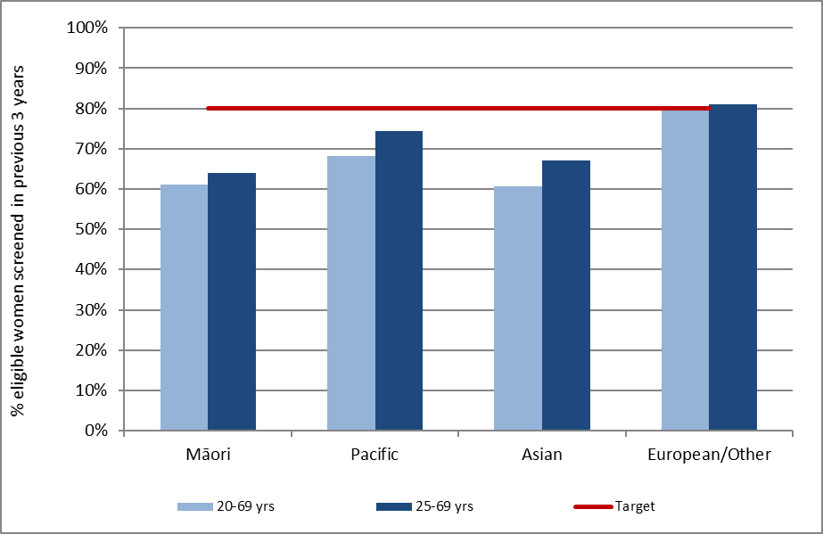
Note: Coverage calculated using population projection for 30 June 2017 based on 2013 Census data.
Target: 80% for ages 25-69 years, hysterectomy adjusted. See also Table 23.

Figure 2 - Three-year coverage by five-year age group (women 20-69 years screened in the three years prior to 30 June 2017, as a proportion of hysterectomy-adjusted female population)
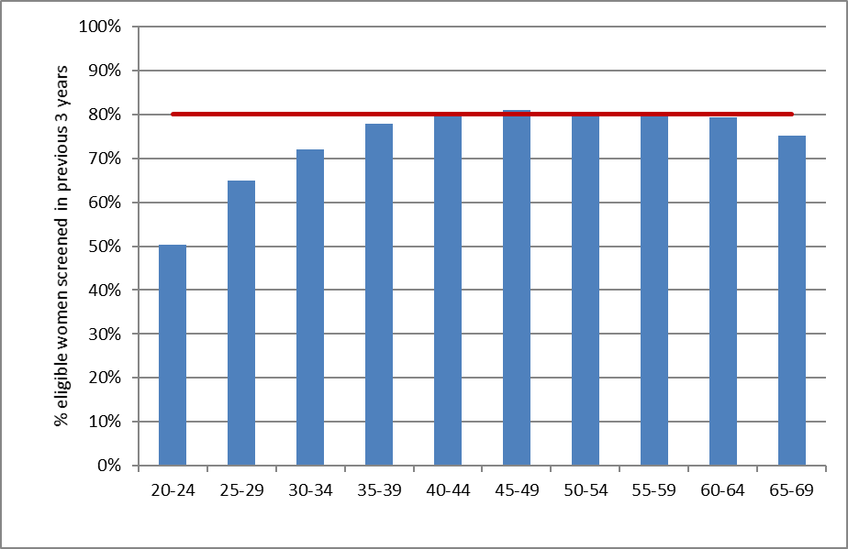
Note: Coverage calculated using population projection for 30 June 2017 based on 2013 Census data.
Target: 80% for ages 25-69 years, hysterectomy adjusted. See also Table 24.
Figure 3 - Three-year coverage by DHB (women 25-69 years screened in the three years prior to 30 June 2017, as a proportion of hysterectomy-adjusted female population)
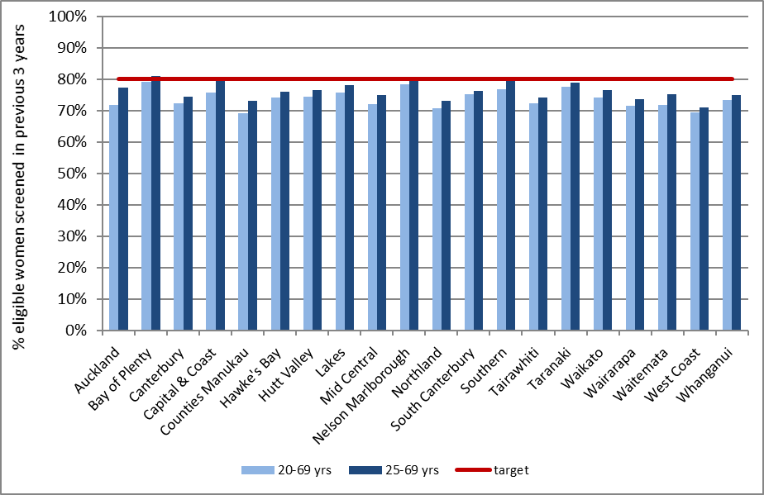
Note: Coverage calculated using population projection for 30 June 2017 based on 2013 Census data.
Target 80%, hysterectomy adjusted. See also Table 22.

Figure 4 - Three-year coverage in Māori women (women 25-69 years screened in the three years prior to 30 June 2017, as a proportion of hysterectomy-adjusted female population), by DHB
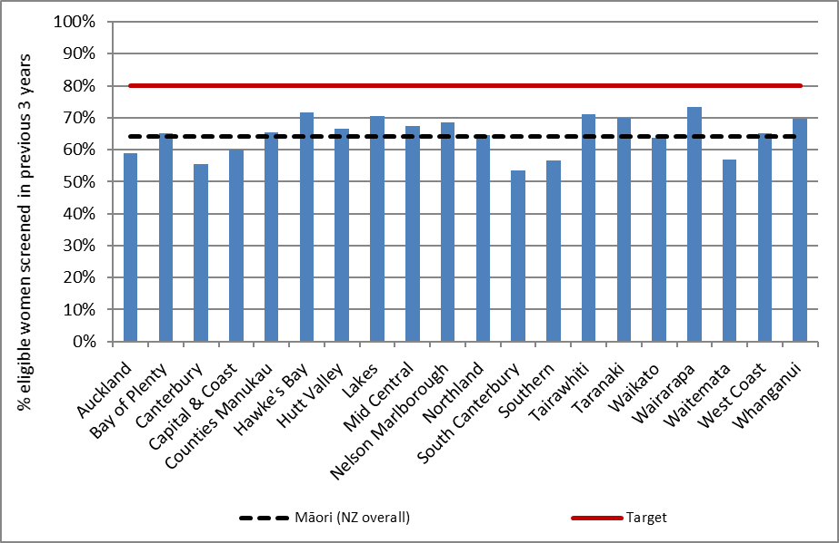
Note: Coverage calculated using population projection for 30 June 2017 based on 2013 Census data.
Target 80%, hysterectomy adjusted.
Figure 5 - Three-year coverage in Pacific women (women 25-69 years screened in the three years prior to 30 June 2017, as a proportion of hysterectomy-adjusted female population), by DHB
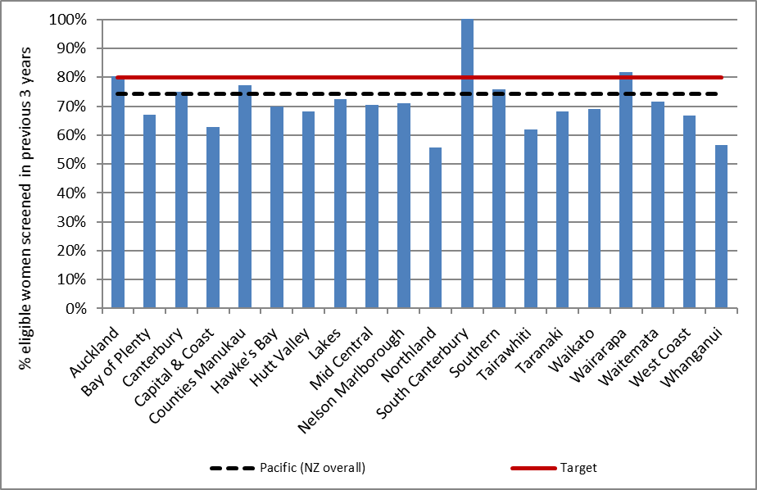
Note: Coverage calculated using population projection for 30 June 2017 based on 2013 Census data.
Target 80%, hysterectomy adjusted.

Figure 6 - Three-year coverage in Asian women (women 25-69 years screened in the three years prior to 30 June 2017, as a proportion of hysterectomy-adjusted female population), by DHB
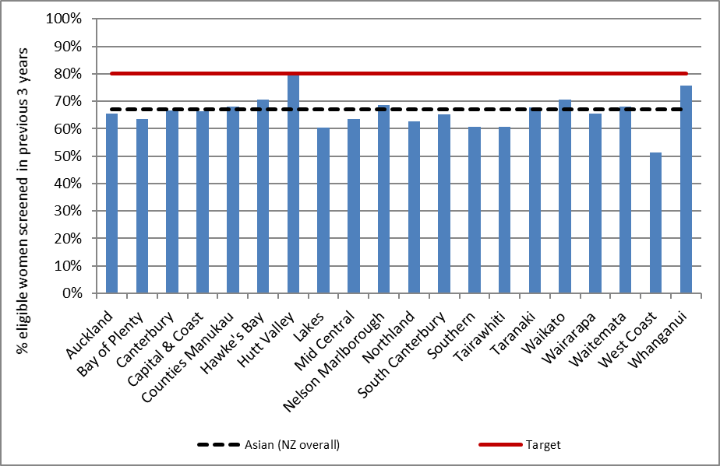
Note: Coverage calculated using population projection for 30 June 2017 based on 2013 Census data.
Target 80%, hysterectomy adjusted.
Figure 7 - Three-year coverage in European/ Other women (women 25-69 years screened in the three years prior to 30 June 2017, as a proportion of hysterectomy-adjusted female population), by DHB
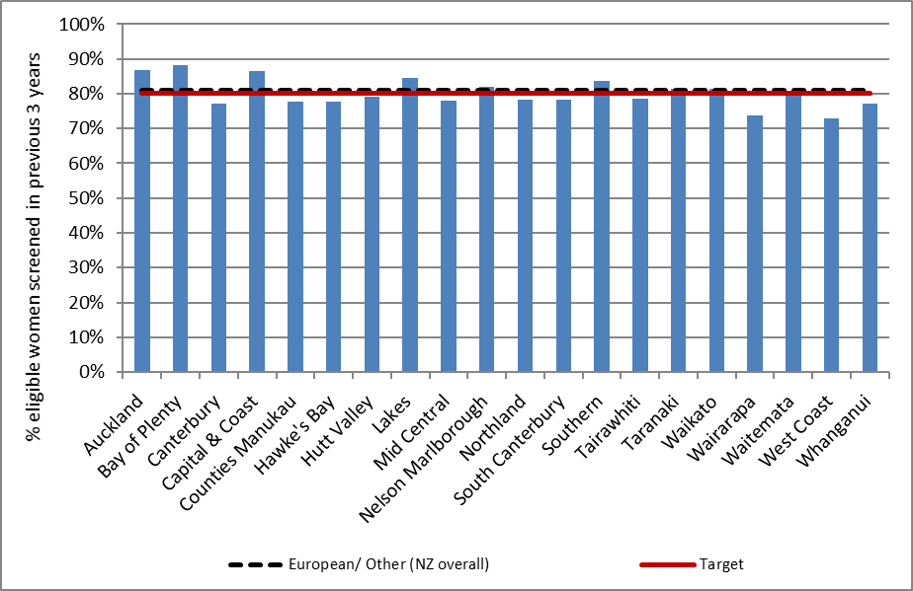
Note: Coverage calculated using population projection for 30 June 2017 based on 2013 Census data.
Target 80%, hysterectomy adjusted.

Figure 8 - Five-year coverage by DHB (women screened in the five years prior to 30 June 2017, as a proportion of hysterectomy-adjusted female population)
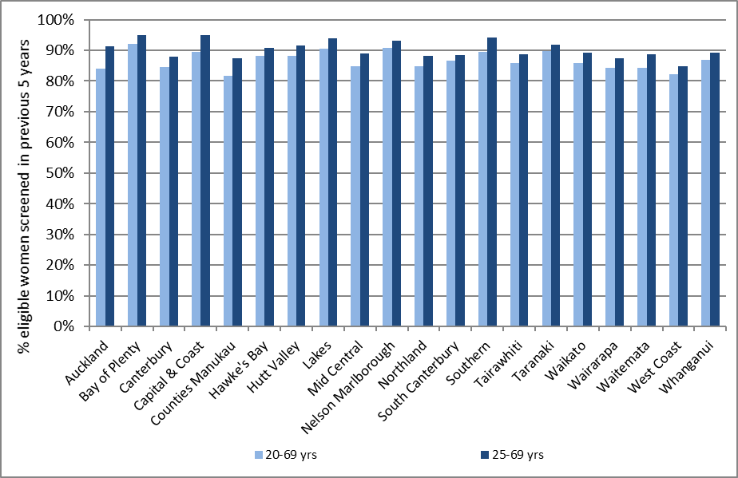
Note: Coverage calculated using population projection for 30 June 2017 based on 2013 Census data. See also Table 25.
Figure 9 - Five-year coverage by five-year age-group (women screened in the five years prior to 30 June 2017, as proportion of hysterectomy-adjusted female population)
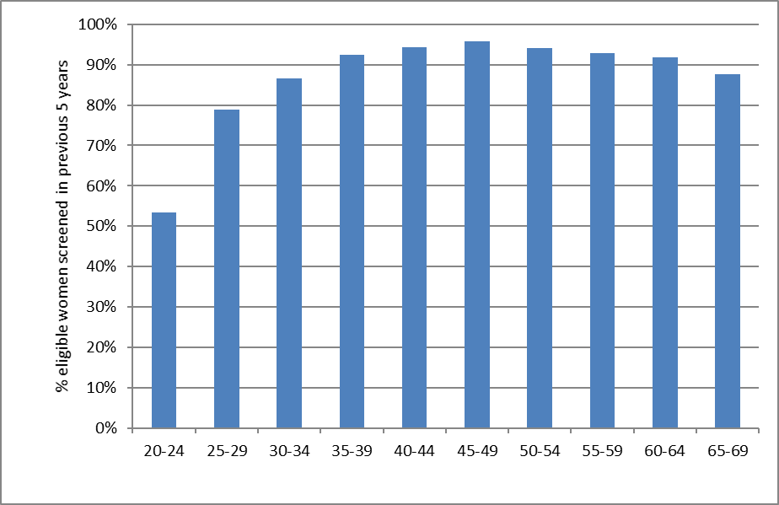
Note: Coverage calculated using population projection for 30 June 2017 based on 2013 Census data. See also Table 27.

Figure 10 - Five-year coverage by ethnicity (women screened in the five years prior to 30 June 2017, as a proportion of hysterectomy-adjusted female population)
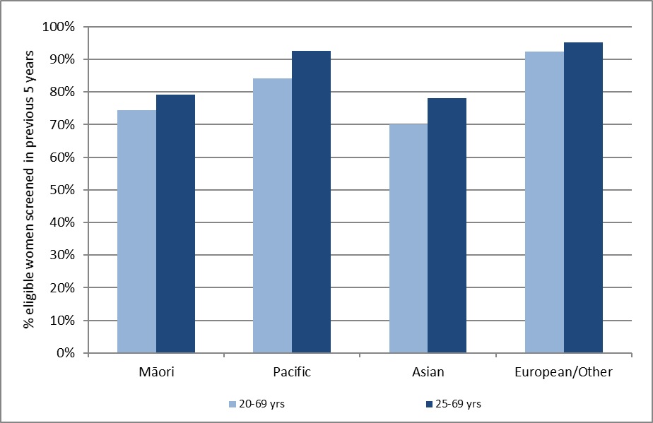
Note: Coverage calculated using population projection for based on 2013 Census data. See also Table 26.

Figure 11 - Five-year coverage in Māori women (women 25-69 years screened in the five years prior to 30 June 2017, as a proportion of hysterectomy-adjusted female population), by DHB
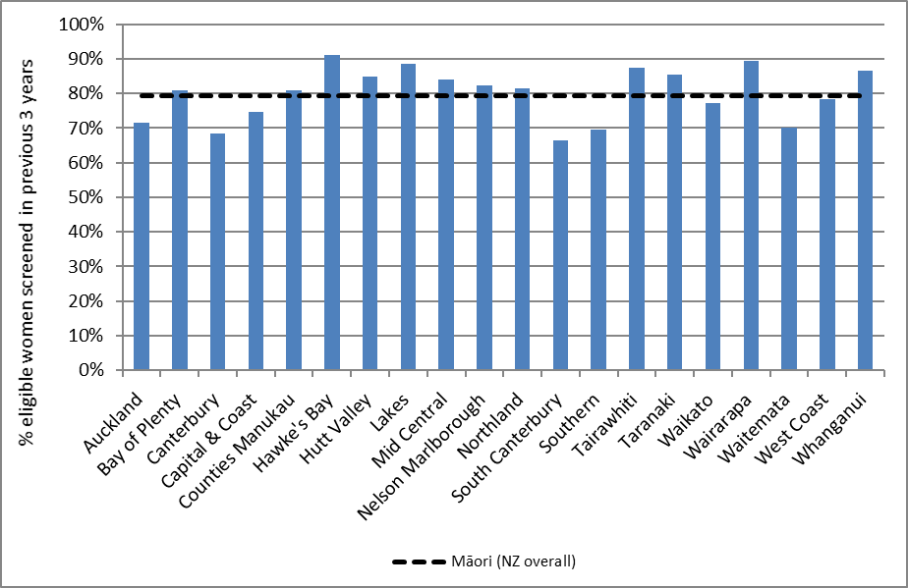
Note: Coverage calculated using population projection for 30 June 2017 based on 2013 Census data.

Figure 12 - Five-year coverage in Pacific women (women 25-69 years screened in the five years prior to 30 June 2017, as a proportion of hysterectomy-adjusted female population), by DHB
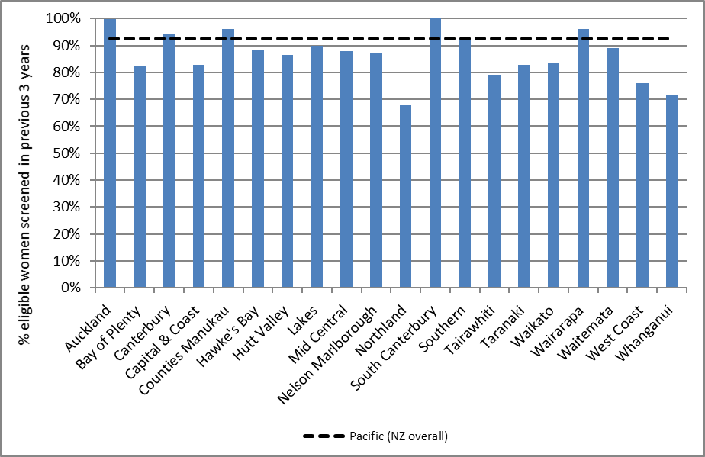
Note: Coverage calculated using population projection for 30 June 2017 based on 2013 Census data.

Figure 13 - Five-year coverage in Asian women (women 25-69 years screened in the five years prior to 30 June 2017, as a proportion of hysterectomy-adjusted female population), by DHB
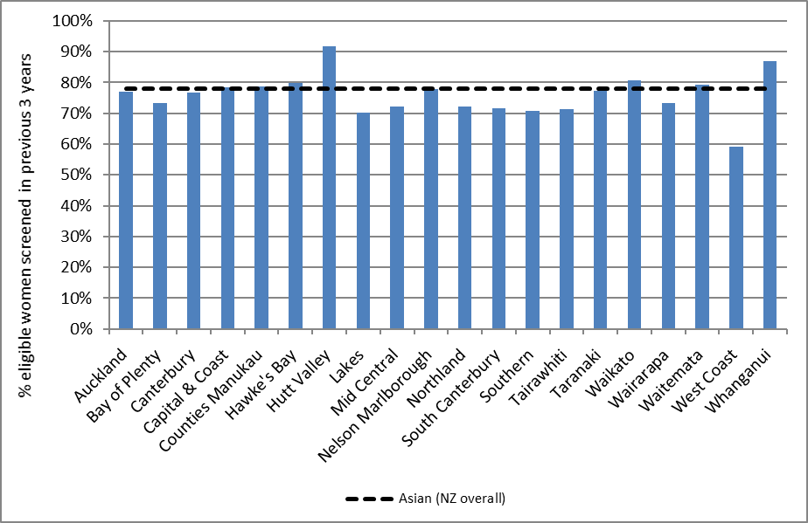
Note: Coverage calculated using population projection for 30 June 2017 based on 2013 Census data.

Figure 14 - Five-year coverage in European/ Other women (women 25-69 years screened in the five years prior to 30 June 2017, as a proportion of hysterectomy-adjusted female population), by DHB
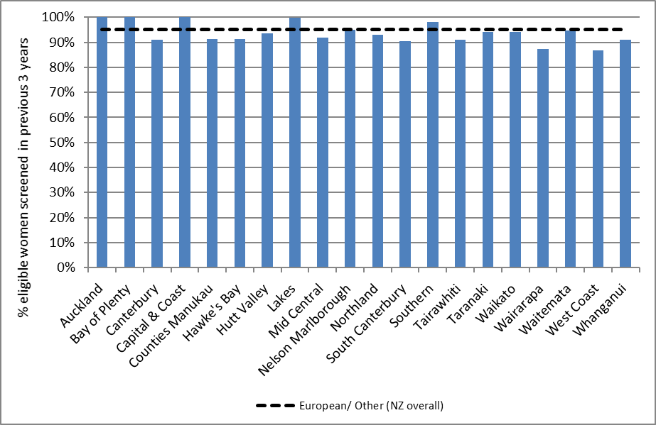
Note: Coverage calculated using population projection for 30 June 2017 based on 2013 Census data.

Figure 15 - Number of women screened who were aged less than 20 years at the time of their cervical sample in the three years to 30 June 2017, by DHB
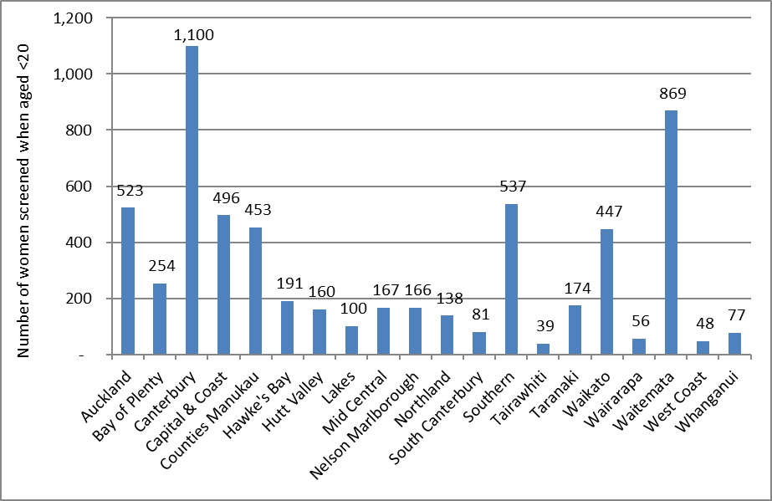
See also Table 29.

Figure 16 - Trends in three-year coverage by DHB (women aged 25-69 years screened in the previous three years, as a proportion of hysterectomy-adjusted female population)
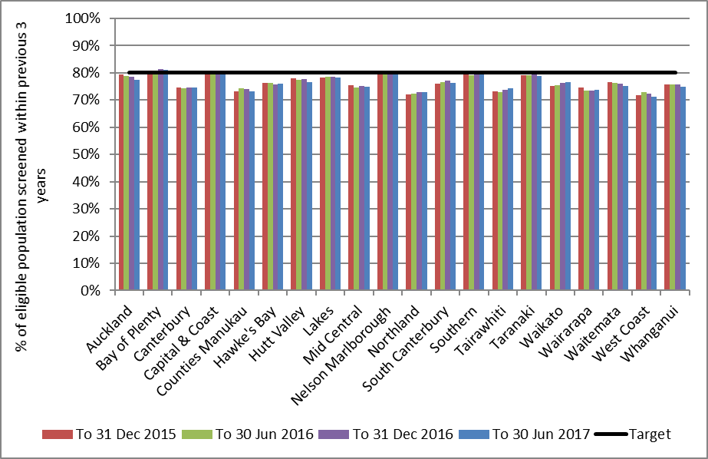
Note: Coverage calculated using population projection at the date shown based on 2013 Census data.
Target 80%. See also Table 33.
Figure 17 - Trends in three-year coverage by age (women screened in the previous three years, as a proportion of hysterectomy-adjusted female population)
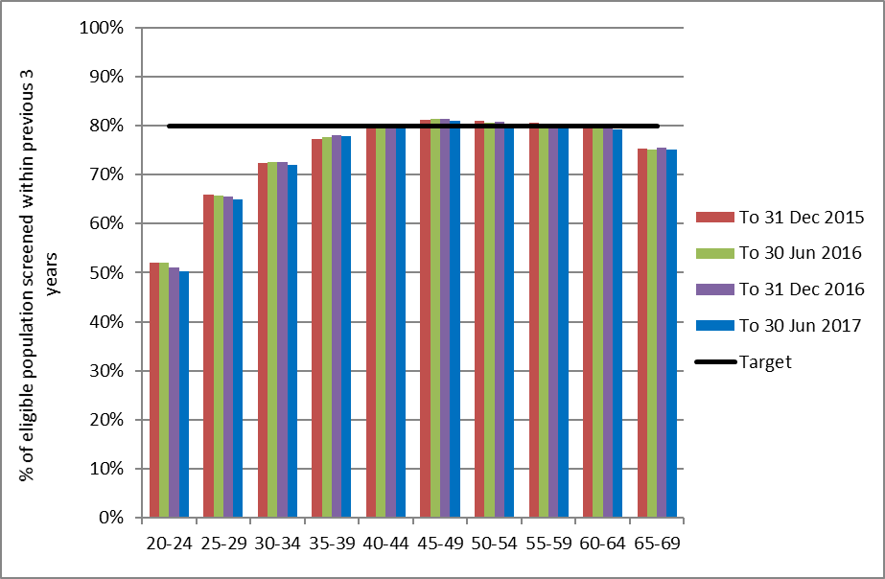
Note: Coverage calculated using population projection at the date shown based on 2013 Census data.
Target 80%. See also Table 34.

Figure 18 - Trends in three-year coverage by ethnicity (women aged 25-69 years screened in the previous three years, as a proportion of hysterectomy-adjusted female population)
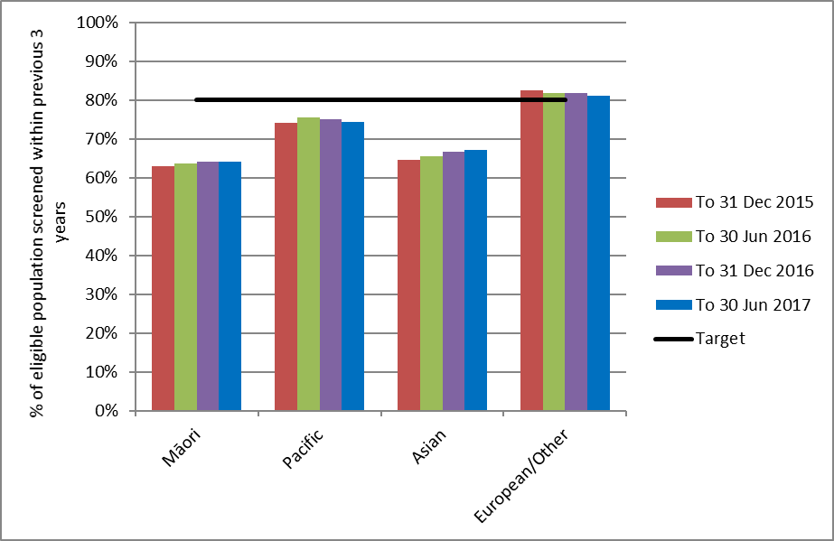
Note: Coverage calculated using population projection at the date shown based on 2013 Census data.
Target 80%. See also Table 35.
Figure 19 - Trends in the number of women screened in the preceding three years who were aged less than 20 years at the time of their cervical sample, by DHB
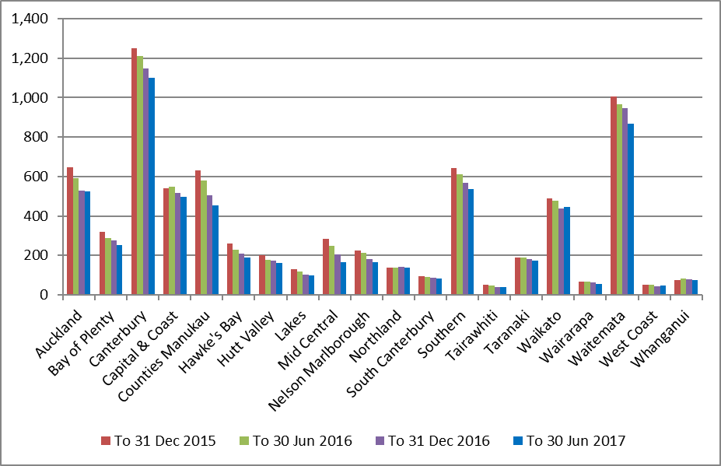
Note: Coverage calculated using population projection at the date shown based on 2013 Census data.
Target 80%. See also Table 29.

Figure 20 - Trends in the percent of women aged less than 20 years at the time of their cervical sample who were aged 18 or 19 years, by DHB
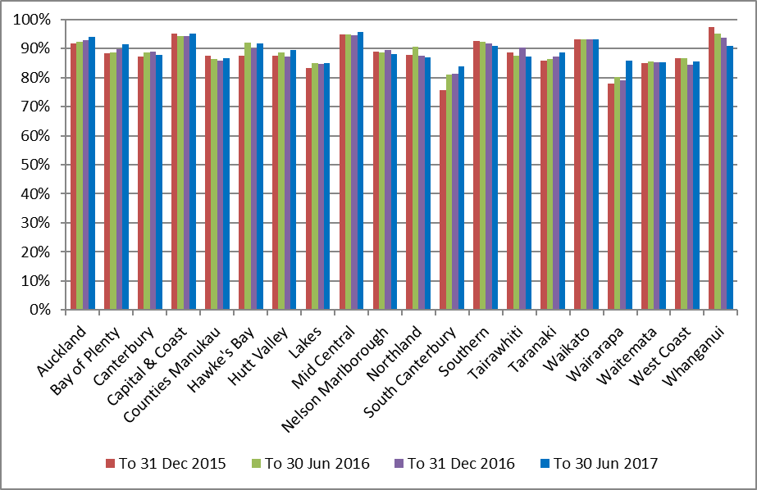

Indicator 1.2 – Regularity of screening

Definition | This indicator reports on the timeliness of attendance, both for women recommended to return at the routine time of three years, or at an earlier interval of 12 months (for example following a recent abnormality).  For women recommended to return at a three-year interval, on-time screening is defined as attending between 30-42 months of their previous test (that is, within +/- six months of their due date). Early and late screening are therefore respectively defined as women who attend either within 30 months (<2.5 years), or more than 42 months (>3.5 years) of their previous test. The timing of early re-screening in this context matches the definition used within Indicator 4 (the differences between early re-screening in this Indicator and in Indicator 4 are described in the Comments section).  For women recommended to return at a 12-month interval, on-time screening is defined as attending between 9-12 months of their previous test (that is, within +/- three months of their due date). Early and late screening are therefore respectively defined as women who attend either within 9 months, or more than 15 months of their previous test.
Target | Not yet defined, however aim to maximise on-time attendance.
Current Situation | This indicator is analysed annually to allow for the full year to be examined. Timeliness of screening was last reported for women who attended during 1 January to 31 December 2016 and was provided in Report 46. This indicator will next be reported for women attending during 2017 and will be provided again in Report 48.
Trends | -
Comments | -

Indicator 2 – First screening events
Definition | Women with no cervical (cytology, histology, or HPV) samples taken prior to the current monitoring period, who have had a cervical sample taken during the monitoring period (first event).  A woman’s age is defined as her age at the end of the current monitoring period (i.e. the women’s age at 30 June 2017).  This indicator is presented as the number of women by age, DHB and ethnicity. It is also presented as a proportion of all women in the eligible population (defined as the hysterectomy-adjusted population, aged 20-69 years), and as a proportion of all women with a cervical sample taken during this monitoring period (screening event), by DHB.
Target | There are no targets for first screening events
Current Situation | There were 22,362 women aged 20-69 years at the end of the period who had their first screening event in the period 1 January - 30 June 2017. This constituted 10.8% of the 207,696 women aged 20-69 years with a cervical sample taken in the period (screening event), and 1.6% of the eligible population. The median age (at the end of the monitoring period) of women with a first event recorded was 26 years.  The age group with the highest number of first screening events was women aged 20-24. 10,240 women aged 20-24 had their first screening event recorded on the register during this monitoring period, accounting for 45.8% of all women aged 20-69 years with first screening events (Figure 21, Table 36). First screening events then tended to decrease with increasing age. Women aged 20-24 years also had the highest proportion of women screened in their age group who were being screened for the first time (43.1%) (Figure 22), and the highest proportion of the eligible population at that age with a first screening event recorded in the current monitoring period (6.3%) (Figure 23).  The DHBs with the highest number of women aged 20-69 years with first screening events were Auckland (3,429) and Waitemata (3,042). The DHBs where women with first screening events, as a proportion of all women with screening events, were the highest in Auckland (14.0%) followed by Capital & Coast (12.8%) and Counties Manukau (12.7%). The DHBs where this proportion was lowest were West Coast (5.6%), Wairarapa (6.5%) and Taranaki (6.8%) (Figure 24, Table 37).  The ethnic group with the highest number of women with first screening events was European/ Other (12,328 women) (Figure 25, Table 38). The group with the highest proportion of their eligible population being screened for the first time was Asian women (2.9%), and the lowest was Maori women (1.2%) (Table 38). The proportion of women screened who were being screened for the first time was highest for Asian women (21.8%) (Figure 25, Table 38). This proportion is likely to be related to the median age of women with a first screening event, which is comparatively high for Asian women (31 years, compared with 21 years for Māori women, 25 years for Pacific women, and 23 years for European/ Other women) (Table 39).
Trends | The number of women with a first screening event recorded on the NCSP Register has decreased from 22,616 women in the previous period to 22,362 in the current period. Across the overall eligible population aged 20-69 years, the proportion of women with screening events that are their first screening event being recorded on the NCSP Register is slightly lower in this period (1.6%) compared to the previous period (1.7%).  Patterns by age, DHB, and ethnicity are broadly similar to those seen in the previous report. Trends by age show a slight drop in the number of first screens over time in most five-year age groups compared to the previous report. Notable drops seen in the 20-24 age group in the previous report have not continued in this report. Declines in the proportions of all screening events were seen in Pacific and Asian women and to a lesser extent in Māori women. European/ Other women remained at a similar rate to the previous report. As was the case in previous reports, the median age of a first screening event was older for Asian women than for Māori, Pacific and European/ Other women, and Asian women with a first screening events constituted a larger proportion of all women with a screening event.  Trends over the two years ending 30 June 2017 are shown in Figure 26 (by age), Figure 27 (by DHB), and Figure 28 (by ethnicity).
Comments | This indicator can only measure the number of women with their first screening event in New Zealand, recorded on the register since its introduction (1990). It does not capture screening events which occurred outside New Zealand, or among women who are not enrolled on the NCSP Register.  Some differences in counts and proportion of women with first screens among screened women between DHBs are to be expected due to differences in population size, immigration and age structure. Proportions have been provided to partially account for this, however they should be interpreted with caution. For example, a relatively low number of women with first screens as a proportion of all women screened could be due to either a lower number of women with first events, or a higher number of women with screening events. For example, the DHB with the highest coverage, Bay of Plenty, does not have a particularly high proportion of women with first events. If coverage remains high, then this proportion will inevitably decrease, as fewer women are available to be screened for the first time. Conversely, a relatively high number of women with first screens as a proportion of all women screened could be due to either a higher number of women with first events (due to increasing coverage), or a lower number of women with screening events (for example due to less frequent screening among women who have been screened at least once since the inception of the NCSP Register).

Figure 21 - Women with first screening events during the monitoring period, by five-year age group (women aged 20-69 years at 30 June 2017)
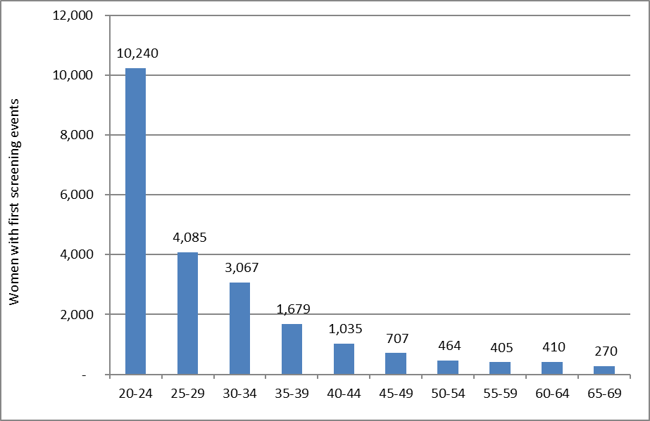

Figure 22 - Women with first screening events as a proportion of all women screened in that age group during the monitoring period, by five-year age group (women aged 20-69 years at 30 June 2017)
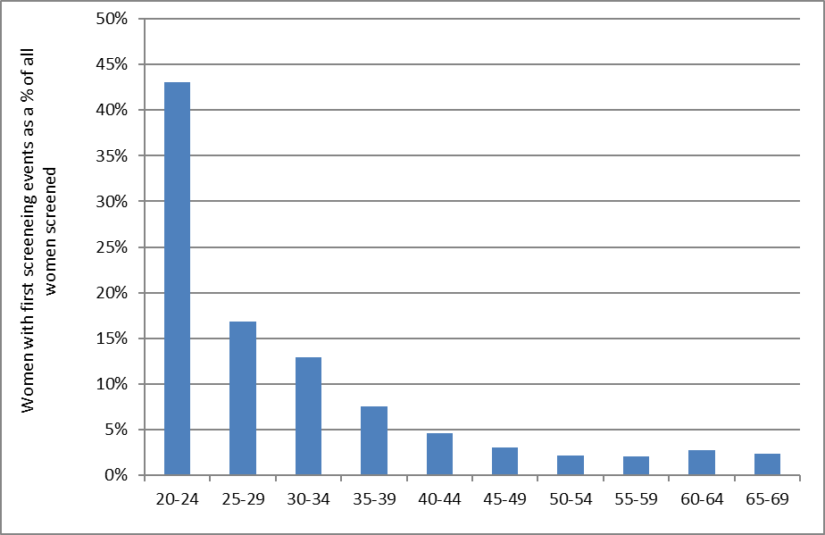

Figure 23 - Proportion of population* in that age group with their first screening event during the monitoring period (women aged 20-69 years at 30 June 2017)
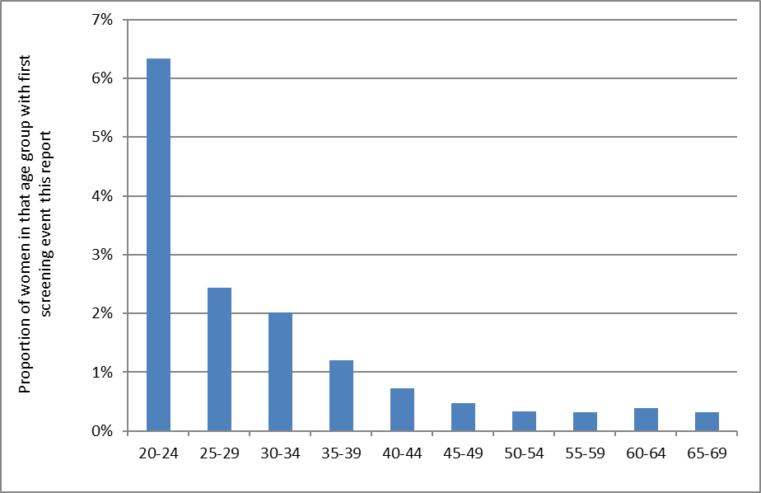
*Hysterectomy adjusted, 2013 Census data projected to 30 June 2017.

Figure 24 - Women with first screening events as a proportion of all women screened during the monitoring period, by DHB (women aged 20-69 years at 30 June 2017)
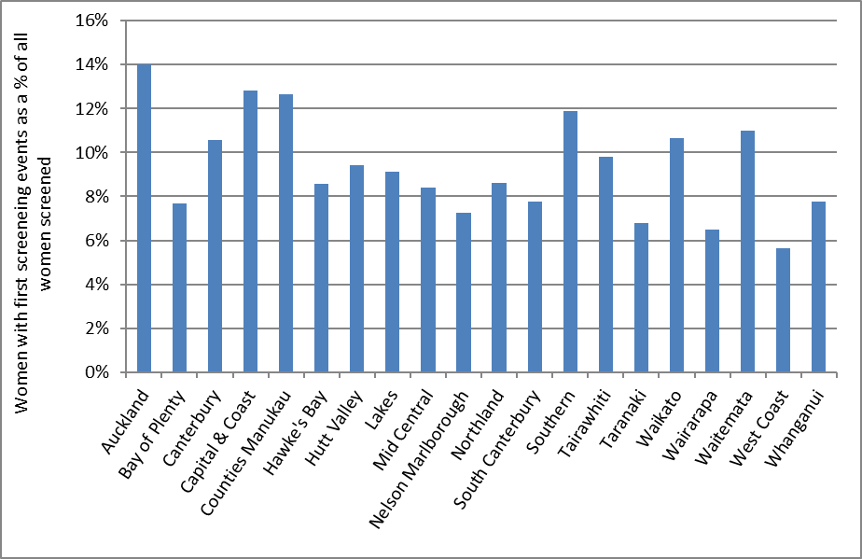

Figure 25 - Women with first screening events as a proportion of all women screened during the monitoring period, by ethnicity (women aged 20-69 years at 30 June 2017)
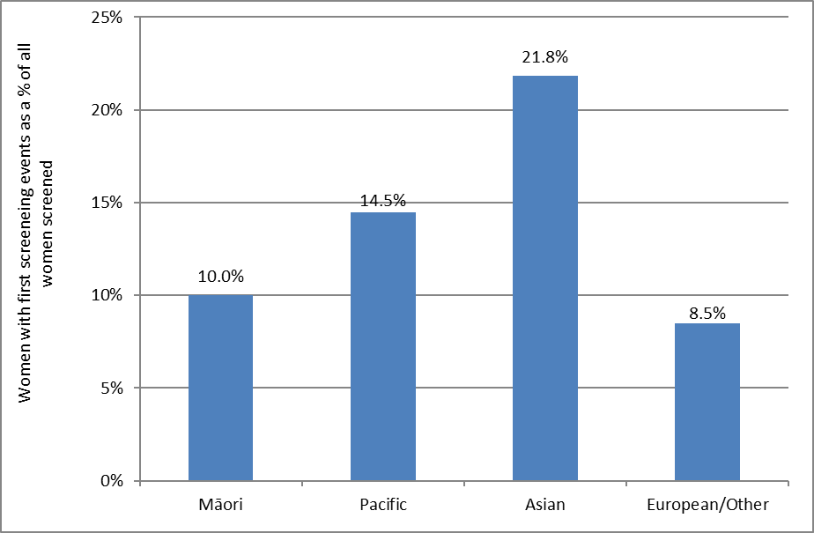

Figure 26 - Trends in the number of women with a first screening event, by age
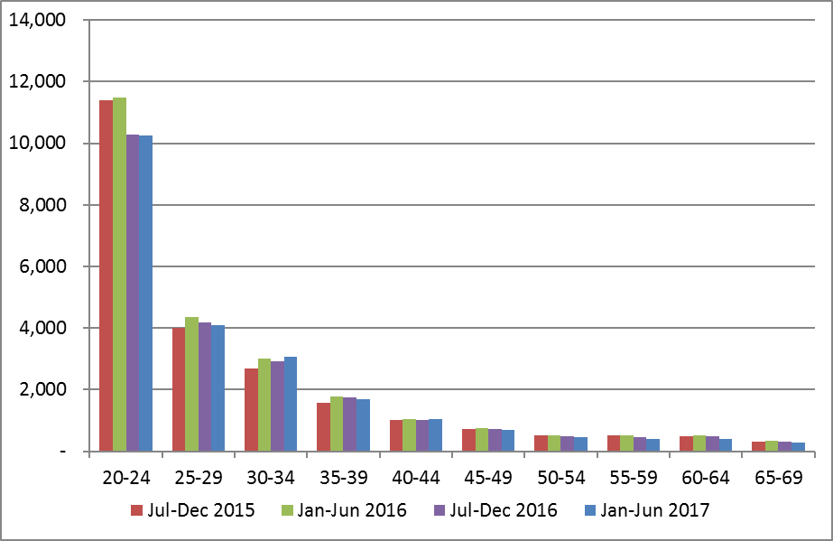

Figure 27 - Trends in the number of women with a first screening event, by DHB
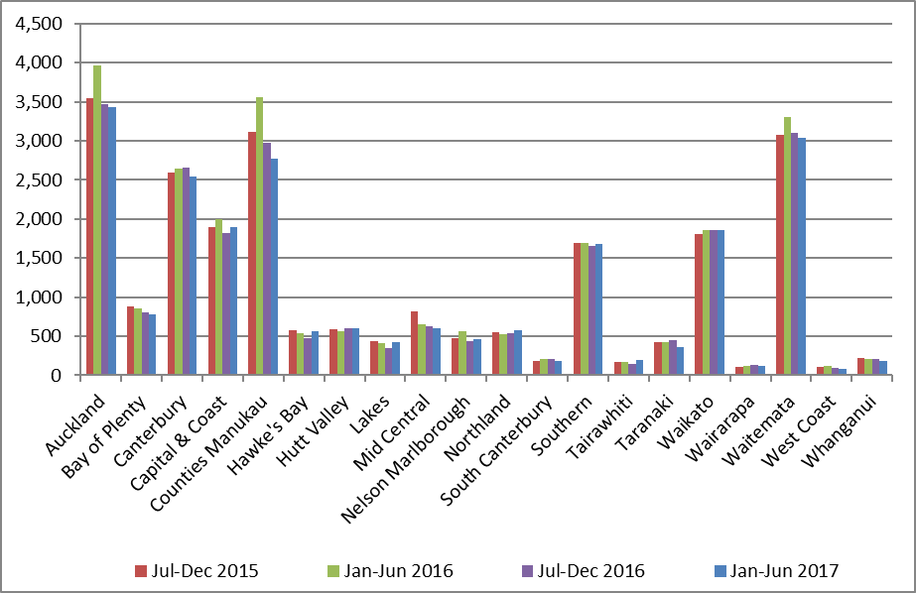

Figure 28 - Trends in the number of women with a first screening event, by ethnicity
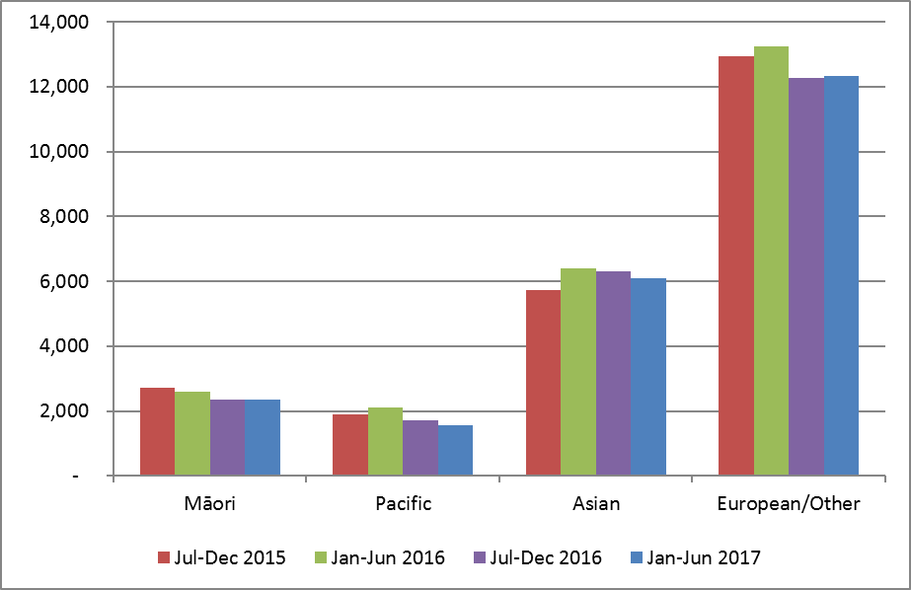

Indicator 3 – Withdrawal rates

Definition | The number of women, by age-group, DHB, and ethnicity not currently enrolled in the NCSP Register and whose enrolment ended during the monitoring period (withdrawals). Withdrawals relate to active withdrawals, where women specifically elect to be removed from the NCSP Register.  Withdrawals are also reported as a proportion of women who were enrolled on the NCSP Register at 31 December 2016 (i.e. just prior to the commencement of the current monitoring period). This is also reported by age group, DHB, and ethnicity.  Age is defined as a woman’s age at the end of the monitoring period (i.e. at 30 June 2017).
Target | Zero for ages 20-69 years.
Current Situation | At the end of the previous monitoring period, 1,579,775 women aged 20-69 years were enrolled on the NCSP Register. During the current monitoring period, 30 of these women (0.002%) withdrew from the NCSP Register.  In all DHBs, the number and proportion of women who withdrew was extremely small (maximum four women in the Auckland and Bay of Plenty DHB regions). No women withdrew in nine of the twenty DHB regions (Figure 29).  The number and proportion of women withdrawing was extremely small for all age groups, but were largest among women aged 45-49 years (7 women, 0.003% of those enrolled at the end of the previous monitoring period), 55-59 years (6 withdrawals, 0.003%) and 60-64 years (4 withdrawals, 0.003%). Women aged 20-24 years also had 0.003% of women enrolled prior to the start of the monitoring period withdrawal (2 women) (Figure 30, Table 40).  The number and proportion of women withdrawing was extremely small for all ethnic groups. Four Māori and four Asian women withdrew in the current monitoring period (both 0.002%), while 20 European/ Other women withdrew (0.002%). Two Pacific women (0.002%) withdrew during the current monitoring period (Figure 31, Table 41).
Trends | The number of women who withdrew in the current monitoring period (30 women) is higher than in the previous monitoring period (26 women) and has been increasing over the last three reports (since report 45; January – June 2016). The overall number of withdrawals and the withdrawals as a proportion of all women enrolled both continue to be extremely small.
Comments | The proportion of women choosing to withdraw from the NCSP Register is extremely small.  Withdrawals relate to active withdrawals, where women specifically elect to be removed from the NCSP Register. It does not include, for example, women who have moved overseas, or who have died during the period, and who therefore are not having tests recorded on the NCSP Register or who ask for no more communications but still participate in the Programme and have their results recorded on the NCSP Register.

Figure 29 - Number of women (aged 20-69 years) who withdrew from the NCSP Register by DHB, 1 January – 30 June 2017
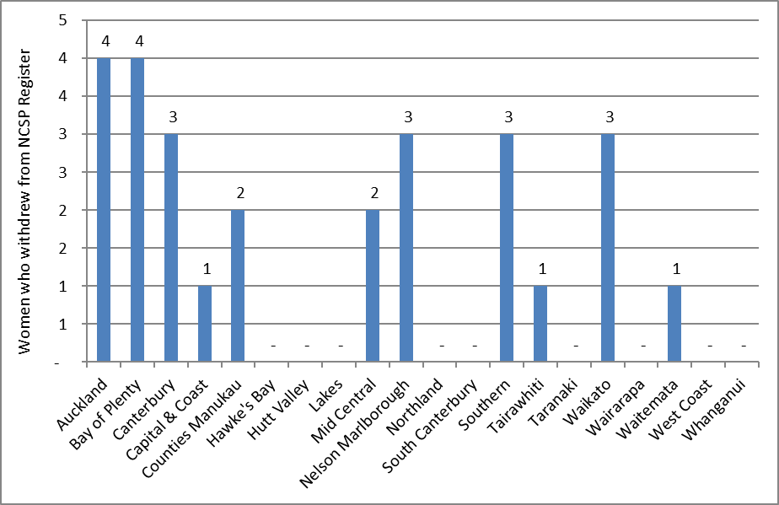
Excludes 3 women who withdrew whose DHB was not recorded.

Figure 30 - Number of women who withdrew from the NCSP Register by age, 1 January – 30 June 2017
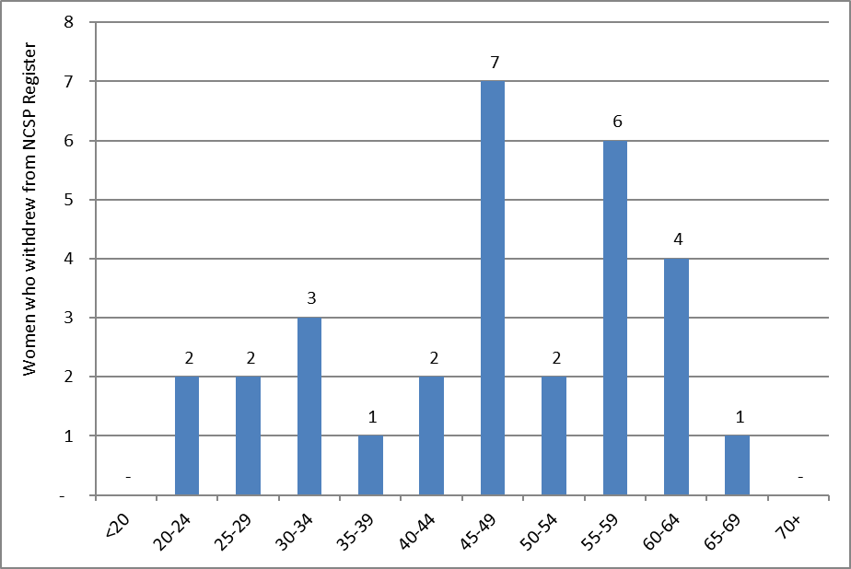

Figure 31 - Number of women (aged 20-69 years) who withdrew from the NCSP Register by ethnicity, 1 January – 30 June 2017
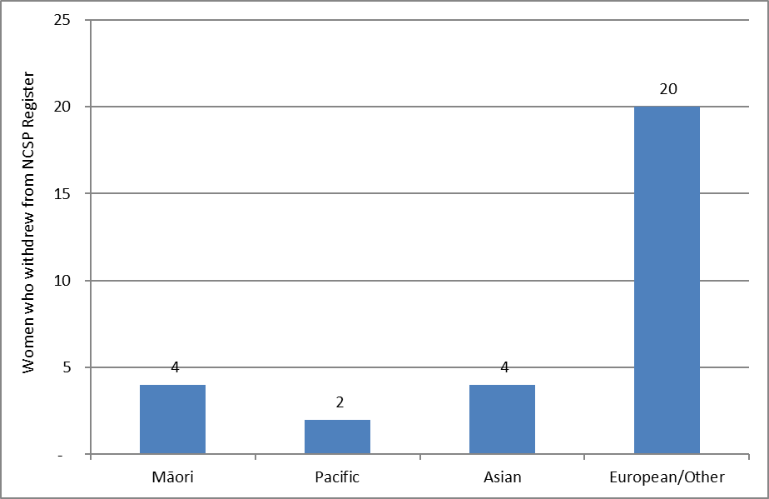

Indicator 4 – Early re-screening

Definition | The proportion of women who returned for a smear within 30 months (2.5 years) of their index smear is calculated for a cohort of women. The cohort comprises of women with an index smear taken between 1 August – 30 September 2014 (inclusive), who i) were aged 20-66 years at the time the smear was taken (and hence remained within the screening target age throughout the period); and ii) were given a recommendation to return at the regular interval of three years as a result of their smear in August/ September 2014 (NZ Modified Bethesda code R1). Using this method of calculating the measure allows follow-up to be considered over 30 months for every individual woman.  This measure excludes women who return early but are being followed according to Guidelines for Cervical Screening in New Zealand, for example, those with a recent report of an abnormality. It also excludes from the count of women screened early those whose “early” smear recommended urgent referral regardless of cytological findings, in view of the abnormal clinical history provided (NZ Modified Bethesda code R14).  In some cases, early re-screening may be the result of women being re-screened early in response to clinical symptoms, and this is appropriate.  For the purposes of analysis by age group, a woman’s age is defined as her age at the end of the current monitoring period (i.e. a women’s age at 30 June 2017).
Target | A target has not been set for this cohort-based calculation method.
Current Situation | There were 44,764 women who had a smear taken in August or September 2014, were aged between 20-66 years at the time of their smear, and were given a recommendation to return for their next smear at the routine interval of three years. Among these women, 6,114 (13.7%) had at least one subsequent smear in the following 30 months (6 months earlier than recommended).  There was wide variation in early re-screening by DHB. Early re-screening was most common in Waitemata (18.8%), Auckland and Bay of Plenty (16.5% and 16.4%, respectively), and was least common in Tairawhiti and Whanganui (both 7.6%) (Figure 32, Table 43).  There was also variability by age. Younger women (aged 20-24 years at the end of the period) were most likely to be re-screened early (19.8%) and older women (aged 60-64 and 65-69 years) were the least likely to be re-screened early (10.1% and 9.6%) (Figure 33, Table 42). Rates of early re-screening are quite similar across six five-year age groups from 25 to 54 years (between 13.7% and 16.4%).  Among the ethnic groups considered, European/ Other and Asian women were the most likely to be re-screened early (14.1% and 13.6%, respectively), while early re-screening was least common among Pacific women (9.8%) (Figure 34,  Table 44).
Trends | The level of early re-screening (13.7%) is slightly lower to what was reported in the previous monitoring period (14.3 %) and has been declining over a number of reporting periods.  The DHB with the highest levels of early re-screening since the last monitoring report remained similar, with Waitemata continuing to have the highest proportion of early rescreening. In most DHBs, early rescreening is decreasing; however early rescreening increased in the current report in 8 DHB’s with the highest increases occurring in Capital & Coast (from 9.8% to 11.0%), Mid Central (from 8.4% to 9.4%), Hawke’s Bay (from 12.1% to 12.8%) and West Coast (from 7.5% to 8.2%). The remaining DHBs did not have a percent increase that was greater than 0.5%. Trends over the two years ending 30 June 2017 by DHB are shown in Figure 35.  A reduction in the level of early re-screening was seen for eight of the ten five-year age groups between 20 and 69 years since the previous report. Increases were seen in two age groups however: in women aged 20-24 years (from 17.1% to 19.8%) and in women aged 40-44 years (from 14.7% to 15.1%). Trends over the two years ending 30 June 2017 by five-year age group are shown in Figure 36.  Small decreases in early re-screening were also seen in most ethnic groups with the greatest drops seen in Māori (from 14.0% to 12.3%) and Pacific women (from 10.9% to 9.8%) since the last monitoring period. Early rescreening in European/ Other women decreased to a lesser extent (from 14.8% to 14.1%) while there was a slight increase in Asian women (from 13.1% to 13.6%).
Comments | Early re-screening was assessed based on cytology recommendation codes, in order to exclude from the early re-screening group women with a negative smear for whom an earlier screening visit is appropriate. Thus, only women with a recommendation that their next screening visit be in three years were eligible for inclusion in the early re-screening group (that is, in both the numerator and the denominator). Women excluded from the early re-screening group would include those who just had their first smear or more than five years have elapsed since their previous smear (NCSP policy is to recommend a one-year follow-up), women with atrophic changes for whom a repeat after oestrogen is recommended, women with an abnormal history or clinical symptoms, and those already under specialist care.  In some cases, early re-screening may be the result of women being re-screened early in response to clinical symptoms, and this is appropriate. We have used the NZ Modified Bethesda recommendation code for urgent referral regardless of cytological findings (R14) to try and exclude some of these cases from the count of women re-screened early, but this probably does not exclude all screens performed in response to clinical symptoms.  There are some similarities between Indicator 4 and Indicator 1.2, although they examine different groups of women and the proportions reported answer somewhat different questions (as is described in more detail in the Definition and Comments section of Indicator 1.2). Indicator 1.2 addresses the question – “What proportion of women who are re-attending for routine screening in a particular time period are returning at least six months early?”, and does not take into account women who did not attend for screening; whereas Indicator 4 addresses the question – “What proportion of women recommended to return in three years for routine screening return at least six months early?”, and takes into account all women given a routine screening recommendation, whether they re-attend or not.

Figure 32 - Proportion of women recommended to return at the routine interval (three years) who were re-screened early, by DHB
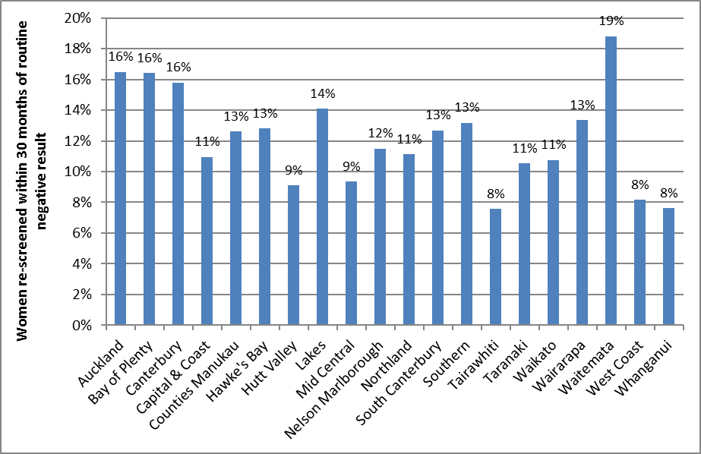

Figure 33 - Proportion of women recommended to return at the routine interval (three years) who were re-screened early, by five-year age group
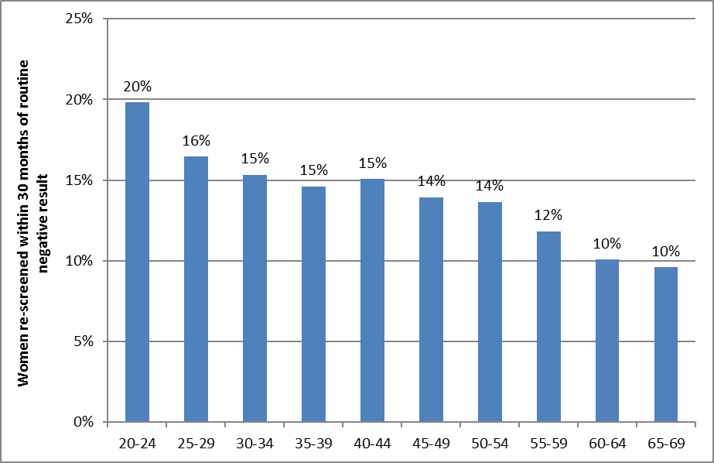

Figure 34 - Proportion of women recommended to return at the routine interval (three years) who were re-screened early, by ethnicity
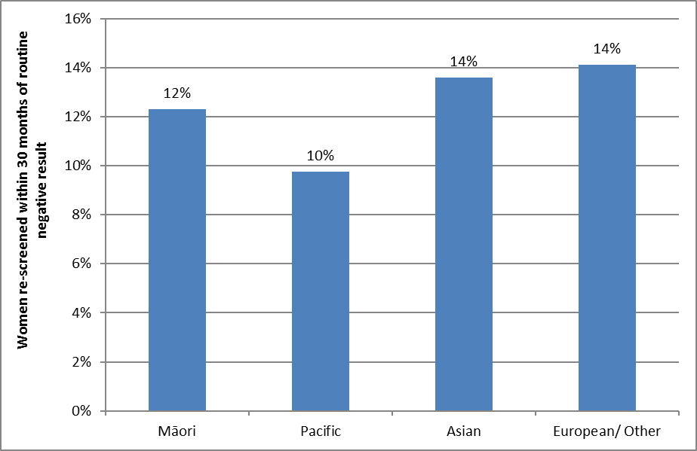

Figure 35 - Trends in the proportion of women recommended to return at the routine interval (three years) who were re-screened early, by DHB
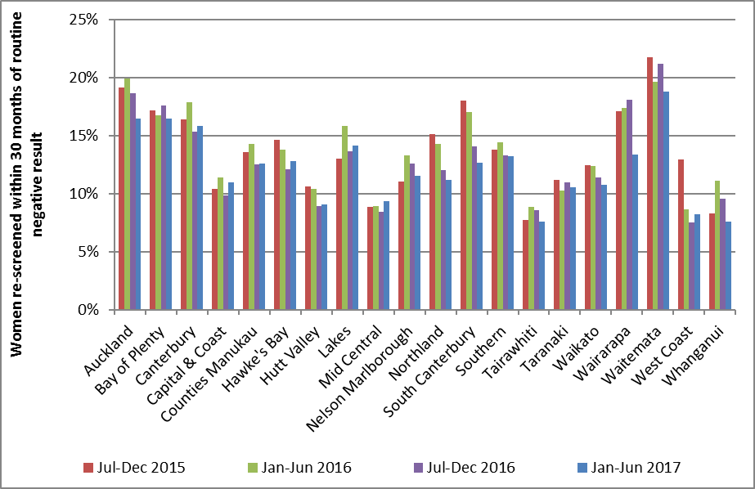

Figure 36 - Trends in the proportion of women recommended to return at the routine interval (three years) who were re-screened early, by age
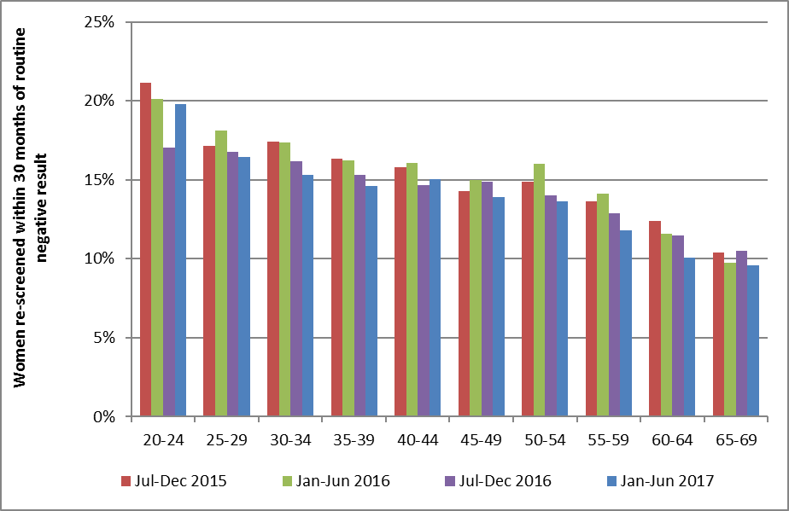

Indicator 5 – Laboratory indicators

The indicators include cytology, histology reports (encompassing cytology and histology reporting rates, positive predictive value of cytology predicting HSIL), laboratory turnaround times, the accuracy of negative cytology reports (future development), and unsatisfactory samples. Volumes of high risk HPV (hrHPV) tests according to NCSP guidelines are included in Indicator 8.

On 1 February 2015 Diagnostic Medlab Ltd. closed and Anatomical Pathology Services (owned by Auckland DHB) opened. This largely resulted in Diagnostic Medlab Ltd.’s work moving to Anatomical Pathology Services, therefore trends for Anatomical Pathology Services for periods prior to 1 February 2015 include results from Diagnostic Medlab Ltd. Also, Aotea Pathology Ltd. was taken over by Southern Community Laboratories in November 2015 and the cytology work was consolidated to Southern Community Laboratories Dunedin.

Indicator 5.1 – Laboratory cytology reporting

This includes the breakdown of cytology reporting by category for squamous and glandular abnormalities reported

- Negative  - ASC-US  - LSIL  - ASC-H  - HSIL | - SC  - AGC/ AIS  - Adenocarcinoma  - Malignant neoplasm  - Total abnormalities  - Unsatisfactory samples

Definition | Bethesda codes used are provided in Appendix B.  The Bethesda reporting system (TBS), introduced in New Zealand on 1 July 2005, is a New Zealand modification of the Bethesda 2001 cytology reporting system.  The NCSP Register collects cytology results of samples taken from the cervix and vagina.  Total samples include all cytology samples (satisfactory and unsatisfactory) taken during the monitoring period, including conventional, LBC, and combined samples.  Reporting rates for negative cytology, total abnormal cytology, and other reporting categories are as a percentage of all satisfactory cytology samples.
Target | 0.1 - 3.0% of LBC samples reported as unsatisfactory.  No more than 96% of satisfactory samples reported as negative.  No more than 10% of satisfactory samples reported as abnormal.  No less than 0.5% of satisfactory samples reported as HSIL (Bethesda HS1 or HS2).
Current Situation | Six laboratories reported on cytology taken during the current monitoring period, the same number as in the previous monitoring period. A total of 209,614 cytology samples were taken, almost all of which (>99.99%) were coded as liquid-based cytology (LBC) samples. The other 0.01% of cytology tests were either conventional cytology tests or have been miscoded).  Unsatisfactory cytology  3,003 cytology samples (1.4%) were unsatisfactory. These are reported in more detail in Table 1 and Figure 37.  The remaining satisfactory samples are reported on in more detail in Table 2 to Table 6.  The unsatisfactory rate for LBC is 1.4%, which is within the 0.1 - 3.0% target range for LBC samples. Four of the six laboratories had unsatisfactory rates within the target range; the other two laboratories had rates which exceeded the maximum target of 3.0%. Southern Community Laboratories had the lowest unsatisfactory percentage of 0.5% (Figure 37, Table 1).  Negative cytology reports  93.3% of satisfactory cytology results were negative, consistent with the target of no more than 96% (Table 2). The proportion of samples which were negative varied by laboratory from 67.7% (LabPLUS) to 95.6% (Southern Community Laboratories) (Figure 38). All six laboratories met the target of no more than 96%.  Abnormal cytology reports  Nationally, the proportion of satisfactory samples which were abnormal (6.7%) was consistent with the target of no more than 10% (Figure 39, Table 2). This varied by laboratory, from 4.4% (Southern Community Laboratories) to 32.3% (LabPLUS) (Figure 39). Two laboratories (LabPLUS and Canterbury Health Laboratories) exceeded the target (32.3% and 12.3%, respectively).  Abnormal cytology results were most common in younger women and LSIL was the most common abnormal result (Table 5, Table 6).  HSIL cytology reports  Overall, 0.8% of satisfactory cytology samples were HSIL, consistent with the target of at least 0.5% of samples (Table 4). Rates varied by laboratory from 0.4% (Anatomical Pathology Services) to 3.7% (LabPLUS). Five of the six laboratories met the HSIL target (Table 4, Figure 40).  Among women aged 20-69 years, rates of HSIL or worse were most common in women aged 25-29 years (Table 5, Table 6).  In the current report we additionally examined age-standardised rates of HSIL cytology reports. This was done to partially account for different rates which may arise in different laboratories due to differences in the age of the population whose cytology tests they process. The age-standardised HSIL rates were very similar to the crude rates, both nationally and within each laboratory, but tended to be slightly lower (Table 45).
Trends | Unsatisfactory cytology  Overall, the percentage of unsatisfactory LBC samples for the current monitoring period (1.4%) is similar to the 1.6% seen in the previous monitoring period. Two laboratories that exceeded the maximum target for unsatisfactory LBC samples in the previous report have lower rates in the current report (albeit still slightly higher than the target range).  Negative vs abnormal cytology reports  The proportion of satisfactory cytology samples which are negative for intraepithelial lesion or malignancy (93.3%) is similar to the previous monitoring period (92.9%), and correspondingly the proportion of cytology samples reported as abnormal (6.7%) is also similar as in the previous monitoring period (7.1%). All six laboratories have similar rates of negative cytology to the previous report and continued to meet the target for negative cytology. The same laboratories as previous reports had abnormal cytology rates above the target of 10% (Canterbury Health Laboratories and LabPLUS).  HSIL cytology reports  The proportion of satisfactory cytology samples reported as HSIL (0.8%) is lower to that reported in the previous monitoring report (1.0%). One of six laboratories that had met the target in the previous report did not meet the target of not less than 0.5% in this monitoring period (Anatomical Pathology Services).  Longer term trends in the proportion of satisfactory cytology samples reported as HSIL are shown in Figure 41 and Figure 42 (trends by age) and Figure 43 (trends by laboratory). Figure 41 and Figure 43 show trends over the last four monitoring report periods (two years), consistent with other trends presented in this report. Figure 42 shows longer term trends (1 July 2008 to 30 June 2017) in rates of HSIL cytology in women aged under 40 years, compared to the overall HSIL reporting rate in women of all ages. The younger age groups in this figure would be the first to be potentially affected by HPV vaccination (the oldest birth cohorts eligible for vaccination through the publicly funded programme would be aged up to 27 years at the time of the current monitoring period). HSIL rates in women aged less than 20 years are quite variable; this is likely to be because far fewer women of this age group attend for screening, since routine screening is not recommended for women aged less than 20 years. HSIL reporting rates in women aged 20-24 years had been increasing prior to 2013 and reached a high of 2.2% for the July-December 2012 period. (Report 38). HSIL rates then fell for four monitoring periods between January 2013 and December 2014. However, in the July-December 2015 monitoring period (Report 44) an increase was seen in virtually all age groups, including women aged 20-24 years (from 1.6% in the January to June 2015 report, report 43, to 2.0% in Report 44). A drop in HSIL rates has been observed in the last three monitoring reports including the current monitoring report in women aged 20-24 years (to 1.6%). Decreases have also been seen in the five-year age groups between 25-44 and 60-69 (Figure 41). However, in the 20-24 years age group, the rate in the current period is the lowest it has been since the latter half of 2008 (around the time that the HPV vaccination programme began). In all other age groups, the reduction in the current report brings rates back to levels similar to those seen prior to the increase observed in late 2015.
Comments | High rates of abnormal samples from LabPLUS are consistent with previous reports, and as discussed in previous monitoring reports, it is thought that the case-mix of this laboratory (i.e. a significant proportion of samples received from colposcopy clinics compared to other laboratories) is an underlying factor.  Workload catchments for laboratories may be regional or nationwide and may change because of laboratory service restructuring. As a result, it is not always straightforward to determine the catchment population for a laboratory. Rates of negative and abnormal results for individual laboratories therefore need to be interpreted with some care, to allow for this difference in workloads and case-mix.  The national Human Papillomavirus (HPV) Immunisation Programme was introduced in New Zealand in September 2008, and involves routine vaccination of girls 12-13 years and catch-up vaccination has previously been offered to young women born in 1990 or later. International and New Zealand data indicate that most high grade squamous cytology reports are associated with HPV types which are potentially preventable by vaccination (approximately 53% by first generation vaccines against HPV16/18; >70% with 9-valent vaccines),⁴⁻⁷ and that this is particularly true for younger women^{4, 8-10}. It is anticipated that data will also soon be available from New Zealand to further quantify the potential impact of the Human Papillomavirus Immunisation Programme in New Zealand. As vaccinated cohorts enter the screening programme, it is anticipated that the proportion of satisfactory cytology samples reported as HSIL will gradually reduce, and that this will occur in younger age groups first (the oldest birth cohorts eligible for vaccination through the publicly funded programme would be aged up to 27 years at the time of the current monitoring period, while the oldest birth cohorts offered vaccination at the target age of 12-13 years would be aged up to 21 years). Therefore, trends in the proportion of satisfactory cytology samples reported as HSIL by age are included in these monitoring reports, in order to monitor the impact of HPV vaccination over time. This proportion of satisfactory cytology samples reported as HSIL in the 20-24 years age group is in the current report the lowest it has been since the latter half of 2008 (around the time that the HPV vaccination programme began), and is consistent with an HPV vaccine effect. At the current time, it is not possible to present HSIL rates separately for vaccinated and unvaccinated women, because information relating to whether or not individual women have been vaccinated is not available on the NCSP Register. These data therefore need to be interpreted with some care, as they include results in all women, both vaccinated and unvaccinated.  In the current report we additionally examined age-standardised rates of HSIL cytology reports, in order to partially account for differences in the age of the population whose cytology tests each laboratory processes. This could be an additional factor in some laboratories having higher or lower HSIL reporting rates. As the target does not specifically relate to age-standardised rates, these results cannot be directly compared to the target; however, as the target was set in 2013, standardising was done using the 2013 Census population (females). As the age-standardised HSIL rates were very similar to the crude rates within each laboratory, differences in age distribution of cytology tests reported do not appear to be a factor in differences between laboratories in HSIL reporting rates.  Caution must be taken when comparing percentages of reporting from this monitoring period to the previous monitoring periods due to changes in the number of reporting laboratories. Differences in percentages from this and previous monitoring reports may be due to differences in laboratory caseloads between the periods.
Figure 37 - Proportion of total LBC samples reported as unsatisfactory by laboratory, 1 January – 30 June 2017
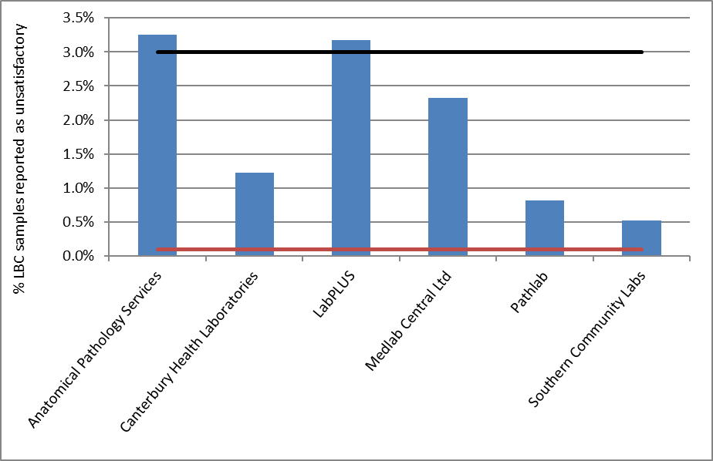
Target for LBC: 0.1-3.0% (Black line-upper target limit; red line=lower target limit)

Figure 38 - Proportion of total satisfactory samples reported as negative by laboratory, 1 January – 30 June 2017
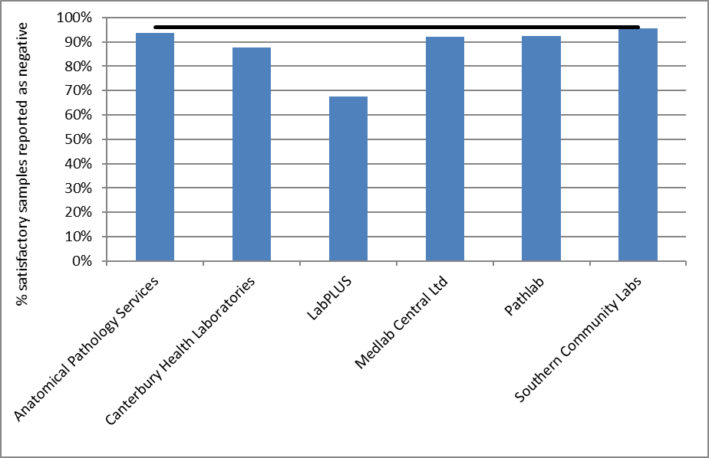
Note: Line shows negative target of no more than 96%

Figure 39 - Proportion of total satisfactory samples reported as abnormalities by laboratory, 1 January – 30 June 2017
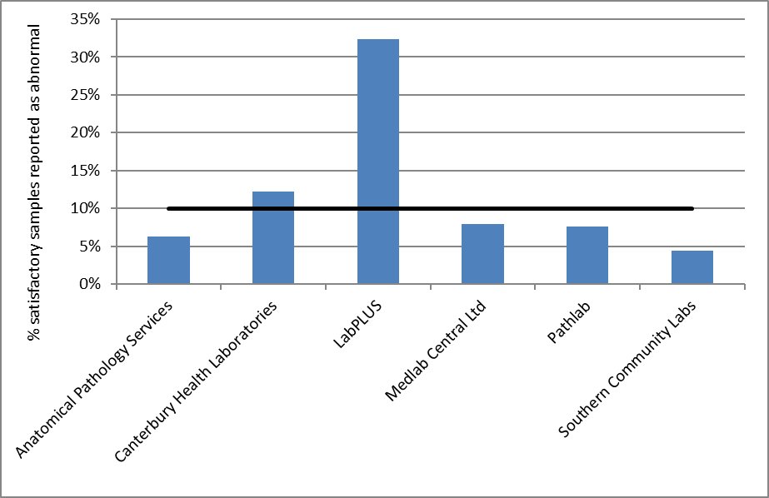
Note: Line shows abnormal target of no more than 10%

Figure 40 - Proportion of total satisfactory samples reported as HSIL by laboratory, 1 January – 30 June 2017
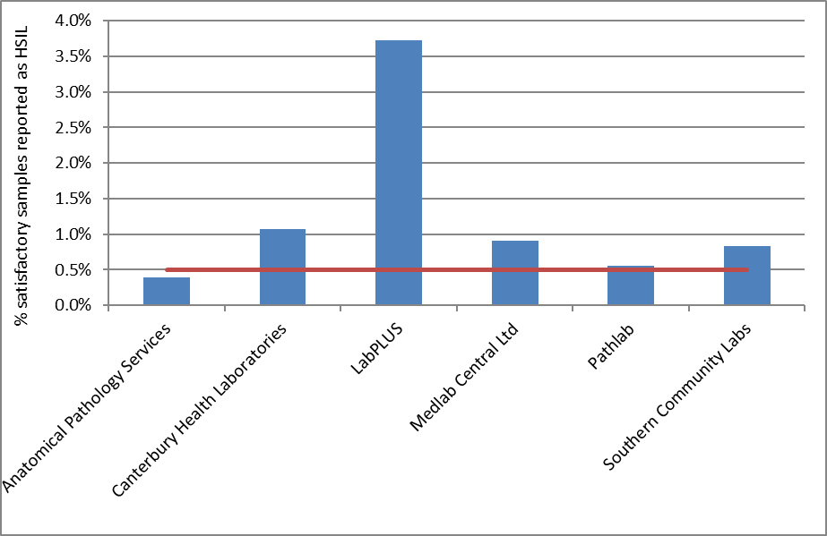
Note: Line shows HSIL target of no less than 0.5%

Table 1 - Satisfactory and unsatisfactory cytology reporting by laboratory (1 January – 30 June 2017)
 | All samples |  | Satisfactory |  | Unsatisfactory
Laboratory | N | N |  | % | N | %
Anatomical Pathology Services | 48,438 | 46,864 |  | 96.8 | 1,574 | 3.2
Canterbury Health Laboratories | 10,471 | 10,343 |  | 98.8 | 128 | 1.2
LabPLUS | 6,713 | 6,500 |  | 96.8 | 213 | 3.2
Medlab Central Ltd. | 14,587 | 14,248 |  | 97.7 | 339 | 2.3
Pathlab | 23,775 | 23,581 |  | 99.2 | 194 | 0.8
Southern Community Laboratories | 105,630 | 105,075 |  | 99.5 | 555 | 0.5
Total | 209,614 | 206,611 |  | 98.6 | 3,003 | 1.4
Target total unsatisfactory: 0.1%-3.0% reported as unsatisfactory

Table 2 - Laboratory cytology reporting by general result (1 January – 30 June 2017) – percentage of satisfactory samples
 | Negative |  | Abnormal
Laboratory | N | % |  | N | %
Anatomical Pathology Services | 43,947 | 93.8 |  | 2,917 | 6.2
Canterbury Health Laboratories | 9,075 | 87.7 |  | 1,268 | 12.3
LabPLUS | 4,400 | 67.7 |  | 2,100 | 32.3
Medlab Central Ltd. | 13,124 | 92.1 |  | 1,124 | 7.9
Pathlab | 21,796 | 92.4 |  | 1,785 | 7.6
Southern Community Laboratories | 100,455 | 95.6 |  | 4,620 | 4.4
Total | 192,797 | 93.3 |  | 13,814 | 6.7
Target total negative: ≤ 96% reported as negative
Target total abnormal: ≤ 10% reported as abnormal

Table 3 - Laboratory cytology reporting by type of cytological category (1 January – 30 June 2017) – counts
 | Result
Laboratory | Negative | ASC-US | LSIL | ASC-H | HSIL | Invasive SCC | AGC/AIS | Adeno-carcinoma | Malignant Neoplasm | Total
Anatomical Pathology Services | 43,947 | 816 | 1,746 | 117 | 183 | 3 | 44 | 6 | 2 | 46,864
Canterbury Health Laboratories | 9,075 | 431 | 558 | 162 | 111 | - | 5 | - | 1 | 10,343
LabPLUS | 4,400 | 690 | 833 | 305 | 242 | 1 | 23 | 2 | 4 | 6,500
Medlab Central Ltd. | 13,124 | 383 | 479 | 105 | 130 | 1 | 19 | 6 | 1 | 14,248
Pathlab | 21,796 | 593 | 928 | 104 | 130 | 7 | 22 | 1 | - | 23,581
Southern Community Laboratories | 100,455 | 726 | 2,654 | 241 | 872 | 14 | 92 | 21 | - | 105,075
Total | 192,797 | 3,639 | 7,198 | 1,034 | 1,668 | 26 | 205 | 36 | 8 | 206,611

Table 4 - Laboratory cytology reporting by cytological category (1 January – 30 June 2017) – percentage of all satisfactory samples
 | Result
Laboratory | Negative | ASC-US | LSIL | ASC-H | HSIL | Invasive SCC | AGC/AIS | Adeno-carcinoma | Malignant Neoplasm
Anatomical Pathology Services | 93.8 | 1.7 | 3.7 | 0.2 | 0.4 | 0.01 | 0.09 | 0.01 | <0.005
Canterbury Health Laboratories | 87.7 | 4.2 | 5.4 | 1.6 | 1.1 | - | 0.05 | - | 0.01
LabPLUS | 67.7 | 10.6 | 12.8 | 4.7 | 3.7 | 0.02 | 0.35 | 0.03 | 0.06
Medlab Central Ltd. | 92.1 | 2.7 | 3.4 | 0.7 | 0.9 | 0.01 | 0.13 | 0.04 | 0.01
Pathlab | 92.4 | 2.5 | 3.9 | 0.4 | 0.6 | 0.03 | 0.09 | <0.005 | -
Southern Community Laboratories | 95.6 | 0.7 | 2.5 | 0.2 | 0.8 | 0.01 | 0.09 | 0.02 | -
Total | 93.3 | 1.8 | 3.5 | 0.5 | 0.8 | 0.01 | 0.10 | 0.02 | <0.005
Target: HSIL ≥ 0.5% reported as HSIL

Table 5 - Laboratory reporting of cytological category by five-year age group (1 January – 30 June 2017) – counts
 | Cytology Result
Age Group | Negative | ASC-US | LSIL | ASC-H | HSIL | Invasive SCC | AGC/AIS | Adeno-carcinoma | Malignant Neoplasm |  | Total
<20 | 745 | 19 | 118 | 10 | 10 | - | - | - | - |  | 902
20-24 | 20,891 | 700 | 2,376 | 230 | 324 | - | 1 | - | - |  | 24,522
25-29 | 21,501 | 556 | 1,321 | 198 | 405 | - | 14 | - | - |  | 23,995
30-34 | 21,579 | 459 | 796 | 149 | 318 | 1 | 22 | 1 | - |  | 23,325
35-39 | 20,733 | 366 | 511 | 111 | 189 | - | 20 | - | - |  | 21,930
40-44 | 21,071 | 356 | 469 | 64 | 102 | 2 | 11 | 2 | - |  | 22,077
45-49 | 21,715 | 346 | 452 | 63 | 100 | 1 | 25 | - | 1 |  | 22,703
50-54 | 19,935 | 293 | 401 | 71 | 76 | 5 | 42 | 3 | 1 |  | 20,827
55-59 | 17,949 | 254 | 294 | 68 | 52 | 2 | 24 | 6 | 3 |  | 18,652
60-64 | 14,078 | 161 | 252 | 32 | 40 | 6 | 19 | 2 | - |  | 14,590
65-69 | 10,803 | 110 | 148 | 30 | 34 | 3 | 20 | 6 | - |  | 11,154
70+ | 1,796 | 17 | 59 | 8 | 18 | 6 | 7 | 16 | 3 |  | 1,930
Total | 192,796 | 3,637 | 7,197 | 1,034 | 1,668 | 26 | 205 | 36 | 8 |  | 206,607

Table 6 - Laboratory reporting of cytological category by five-year age group (1 January – 30 June 2017) – percentage of all satisfactory samples in women of that age group
 | Cytology Result
Age Group | Negative | ASC-US | LSIL | ASC-H | HSIL | Invasive SCC | AGC/AIS | Adeno-carcinoma | Malignant Neoplasm
<20 | 82.6 | 2.1 | 13.1 | 1.1 | 1.1 | - | - | - | -
20-24 | 85.2 | 2.9 | 9.7 | 0.9 | 1.3 | - | <0.005 | - | -
25-29 | 89.6 | 2.3 | 5.5 | 0.8 | 1.7 | - | 0.06 | - | -
30-34 | 92.5 | 2.0 | 3.4 | 0.6 | 1.4 | <0.005 | 0.09 | <0.005 | -
35-39 | 94.5 | 1.7 | 2.3 | 0.5 | 0.9 | - | 0.09 | - | -
40-44 | 95.4 | 1.6 | 2.1 | 0.3 | 0.5 | 0.01 | 0.05 | 0.01 | -
45-49 | 95.6 | 1.5 | 2.0 | 0.3 | 0.4 | <0.005 | 0.11 | - | <0.005
50-54 | 95.7 | 1.4 | 1.9 | 0.3 | 0.4 | 0.02 | 0.20 | 0.01 | <0.005
55-59 | 96.2 | 1.4 | 1.6 | 0.4 | 0.3 | 0.01 | 0.13 | 0.03 | 0.02
60-64 | 96.5 | 1.1 | 1.7 | 0.2 | 0.3 | 0.04 | 0.13 | 0.01 | -
65-69 | 96.9 | 1.0 | 1.3 | 0.3 | 0.3 | 0.03 | 0.18 | 0.05 | -
70+ | 93.1 | 0.9 | 3.1 | 0.4 | 0.9 | 0.31 | 0.36 | 0.83 | 0.16
Total | 93.3 | 1.8 | 3.5 | 0.5 | 0.8 | 0.01 | 0.10 | 0.02 | <0.005

Figure 41 - Trends in the proportion of total satisfactory samples reported as HSIL (last four monitoring periods), by age
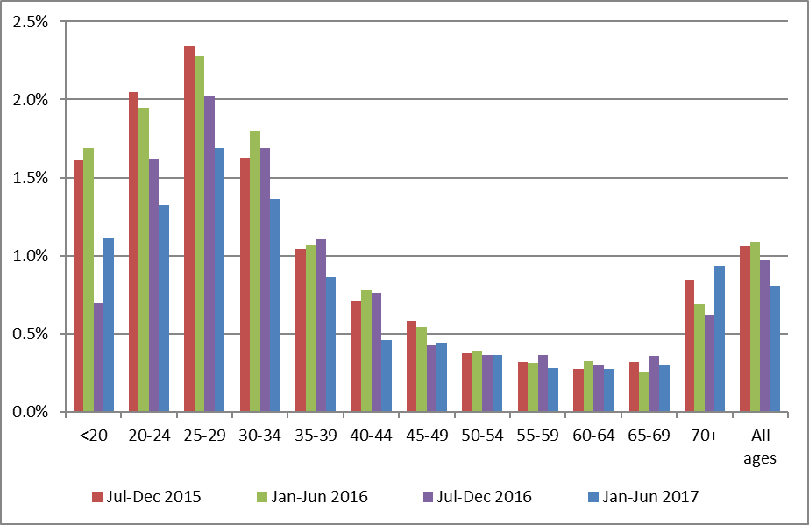
Note: women aged less than 20 years are not routinely screened

Figure 42 - Longer term trends in the proportion of total satisfactory samples reported as HSIL (to 1 January – 30 June 2017), selected age groups
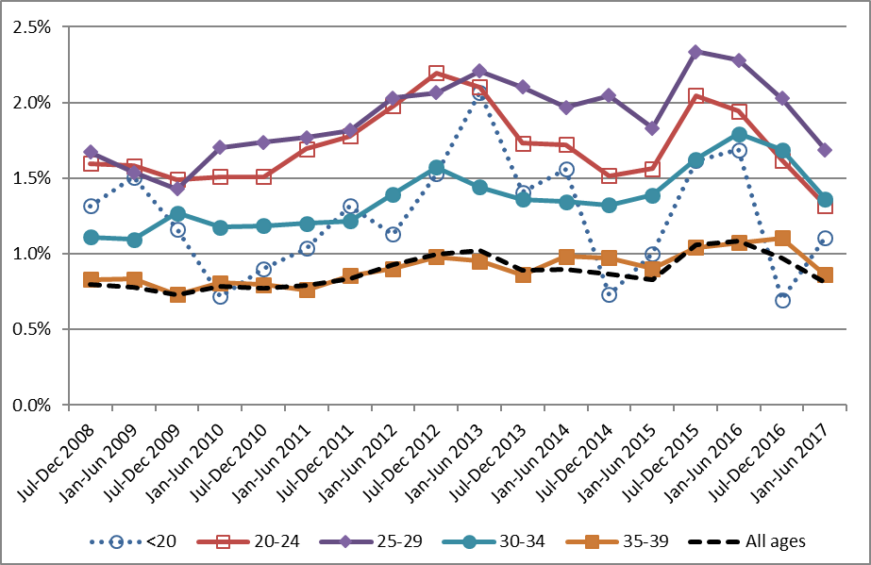
Note: women aged less than 20 years are not routinely screened

Figure 43 - Trends in the proportion of total satisfactory samples reported as HSIL, by laboratory
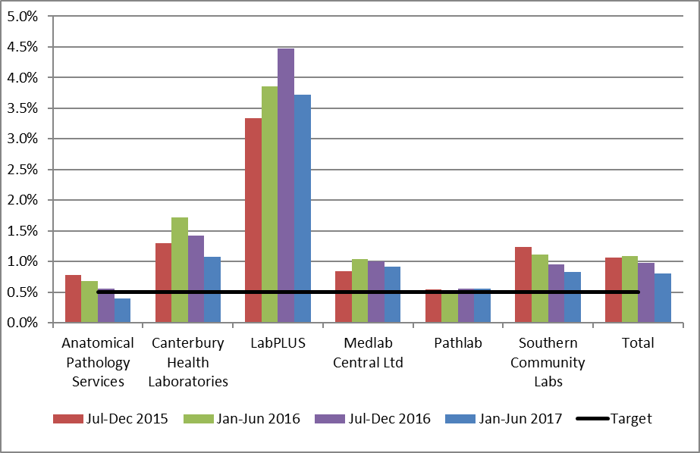
Note: Line shows HSIL target of no less than 0.5%.

Indicator 5.2 – Accuracy of cytology predicting HSIL

Definition | The accuracy of cytology predicting HSIL/ SC (positive predictive value – PPV) is defined as the probability of a high grade histological report (CIN 2/3 or higher) given an HSIL/ invasive squamous carcinoma cytology report.  Refer to Appendix D for detailed definitions of histological confirmation.  All satisfactory cytology samples collected in the six months prior to the current monitoring period (i.e. collected from 1 July - 31 December 2016 inclusive) were identified. Where a woman had multiple samples, or a report had multiple interpretation codes, the most serious cytology result category reported was used. If there were two cytology test results for a woman of the same grade, the earliest one was used. Histology samples taken up to five days prior to and up to six months after the cytology sample were then retrieved for women with a high grade cytology report. Where there were multiple histology reports for a woman in the period, the most serious abnormality category was used.
Target | Not less than 65% and not greater than 85%.
Current Situation | HSIL + SC  1,784 women with HSIL or SC cytology reports were identified. 130 of these women (7.3%) had no histology taken in the period from five days prior to six months after the cytology sample was taken. Among the remaining 1,654 for whom there was histology, 1,352 (81.7%) had their HSIL or SC cytology report confirmed as high grade by histology (Figure 44, Table 46).  By laboratory, the proportion of HSIL + SC being confirmed as high grade by histology ranged from 76.9% for Anatomical Pathology Services to 87.6% for Medlab Central Ltd. All six laboratories achieved the minimum target of at least 65% of cytological HSIL + SC being confirmed by histology. Three of the six laboratories exceeded the 85% upper target margin of HSIL + SC being histologically confirmed (Figure 44, Table 46).  Other cytological abnormalities  Similar calculations for positive predictive value were performed for ASC-H; glandular abnormalities (AG1-AG5, AIS, AC1-AC4); and the combination of ASC-H, HSIL and SC. There are no targets for these measures.  ASC-H  940 women with a cytology report of ASC-H were identified. 163 (17.3%) had no histology taken in the period from five days prior to six months after the cytology sample. Among the remaining 777 women, 386 (49.7%) were histologically confirmed as high grade. This proportion varied by laboratory, from 41.2% (Anatomical Pathology Services) to 61.4% (Medlab Central Ltd.) (Figure 45, Table 47).  ASC-H + HSIL + SC  A total of 2,724 women had a cytology report of ASC-H, HSIL or SC. 293 (10.8%) had no histology taken in the period from five days prior to six months after the cytology sample. Among the remaining 2,431 women, 1,738 (71.5%) were histologically confirmed as high grade. This proportion varied by laboratory, from 63.8% (Anatomical Pathology Services) to 78.4% (Medlab Central Ltd.) (Figure 45, Table 48).  Glandular abnormalities  There were 243 women with a glandular abnormality (AG1-AG5, AIS, AC1-AC4) identified. 63 women (25.9%) had no histology taken in the period from five days prior to six months after the cytology sample. Among the remaining 180 women, 83 (46.1%) were identified as having high grade histology. This was not analysed by laboratory, as the number of samples reported on by some laboratories were small.
Trends | HSIL + SC  Positive predictive value for HSIL and SC cytology has increased when compared to the previous monitoring report (79.8% in the previous period; 81.7% in the current period). As in the previous monitoring period, all six laboratories had greater than 65% of their HSIL + SC cytology results confirmed by histology. The number of laboratories with PPVs above the upper target of 85% has remained at three. The proportion of cytology reports with histology available following HSIL or SC results is similar (92.7% in the current report; 92.1% in the previous report). Trends in the positive predictive value for HSIL and SC cytology by laboratory are shown in Figure 46. Decreases in the positive predictive value for HSIL and SC cytology were evident for two laboratories, Canterbury Health Laboratories and Medlab Central. Three laboratories that previously had decreases in positive predictive value for HSIL and SC cytology over two or more consecutive monitoring periods (LabPLUS, Pathlab and Southern Community Laboratories) showed an increase in this monitoring period.  ASC-H  Positive predictive value for ASC-H cytology has increased, from 41.2% to 49.7%, however there is no target for this measure. The proportion of ASC-H cytology reports with histology available is similar in the current report compare to the previous monitoring report (82.7% in current report; 82.4% in previous report; Figure 47). Increases in the positive predictive value for ASC-H cytology were evident for all laboratories.  ASC-H + HSIL + SC  The positive predictive value for the combined group ASC-H, HSIL and SC has increased in the current report (to 71.5%, compared to 68.3% in the previous report). Note that there is no target for the positive predictive value of this combined group. Trends in the positive predictive value for the combined group ASC-H, HSIL and SC cytology by laboratory are shown in Figure 48. Increases in the positive predictive value for the combined group of ASC-H, HSIL and SC cytology were evident for all laboratories except Canterbury Health Laboratories.  Glandular abnormalities  The positive predictive value of glandular abnormalities increased (from 44.9% in the previous report to 46.1% in the current report). Compared to both ASC-H cytology, and the combined group of HSIL and SC cytology, there are far fewer glandular abnormalities, and an even smaller number with histology available. The proportion of glandular abnormalities with histology available (74.1%) is higher than that in the previous monitoring period (68.3%), however remains less than that for ASC-H (82.7%) and HSIL + SC (92.7%). As a result, the positive predictive value of glandular abnormalities is more prone to fluctuations than positive predictive values for other high grade abnormalities. Due to the small number of samples involved, glandular abnormalities were not analysed in further detail by laboratory.
Comments | This estimate does not take into account cytology predicting HSIL for which there is no histology available. Histology may be unavailable because the woman does not attend for follow-up colposcopy, or a biopsy may not be taken if the colposcopic impression is normal. When the monitoring period for this indicator is after all DHBs have started reporting in accordance the 2013 Colposcopy Standards (September 2017), it should be possible to better distinguish between these two possibilities. This can also be examined by calculating the probability of a high grade histological report (CIN 2/3 or higher) among all women attending colposcopy after a high grade cytology report (rather than only among the subset of women where a biopsy is taken). These results are presented in Figure 85, and compared with those for women with low grade cytology results with a positive HPV triage test.  The calculations also do not discriminate between cytology taken as a screening or diagnostic test. This may be a contributing factor for some laboratories with a PPV that is higher than the upper end of the target range, particularly where the colposcopically-directed cytology and corresponding histology are reported by the same laboratory as best management practice. Analysis separating community vs clinic derived cytology would provide a clearer picture of positive predictive value (and other reporting categories) in a screening setting.
Figure 44 - Positive predictive value for CIN 2+ in women with HSIL or SC cytology reports (cytology in 1 July to 31 December 2016), by laboratory
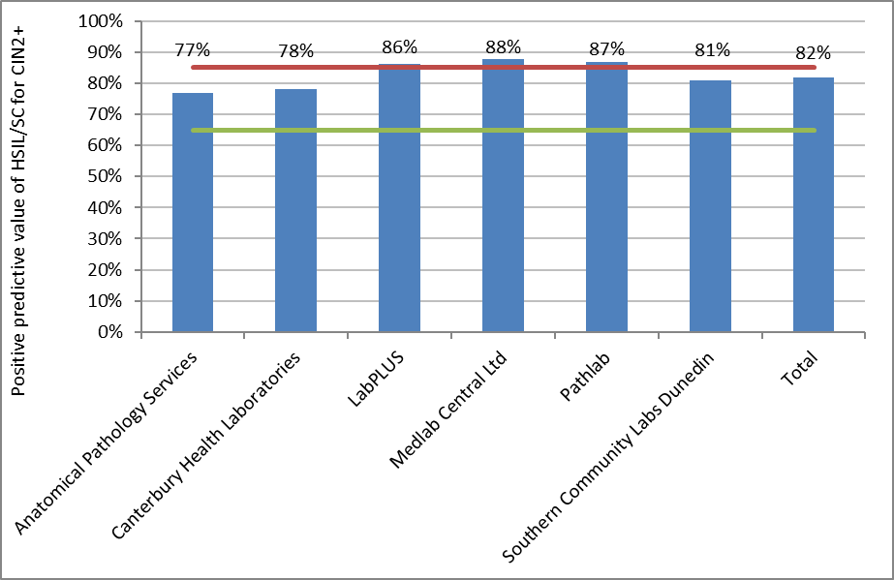Target: 65% - 85%.

Figure 45 - Positive predictive value for CIN 2+ in women with other high grade cytology results (cytology in 1 July to 31 December 2016), by laboratory
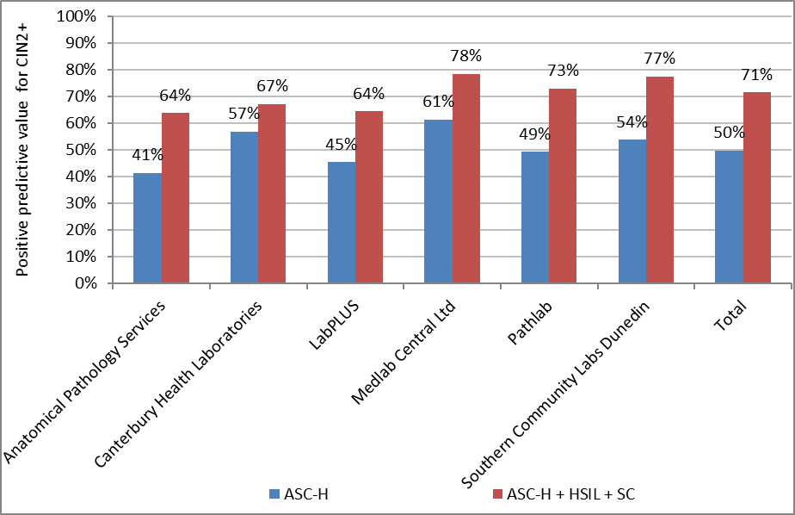
Figure 46 - Trends in the positive predictive value for CIN 2+ in women with HSIL or SC cytology results, by laboratory
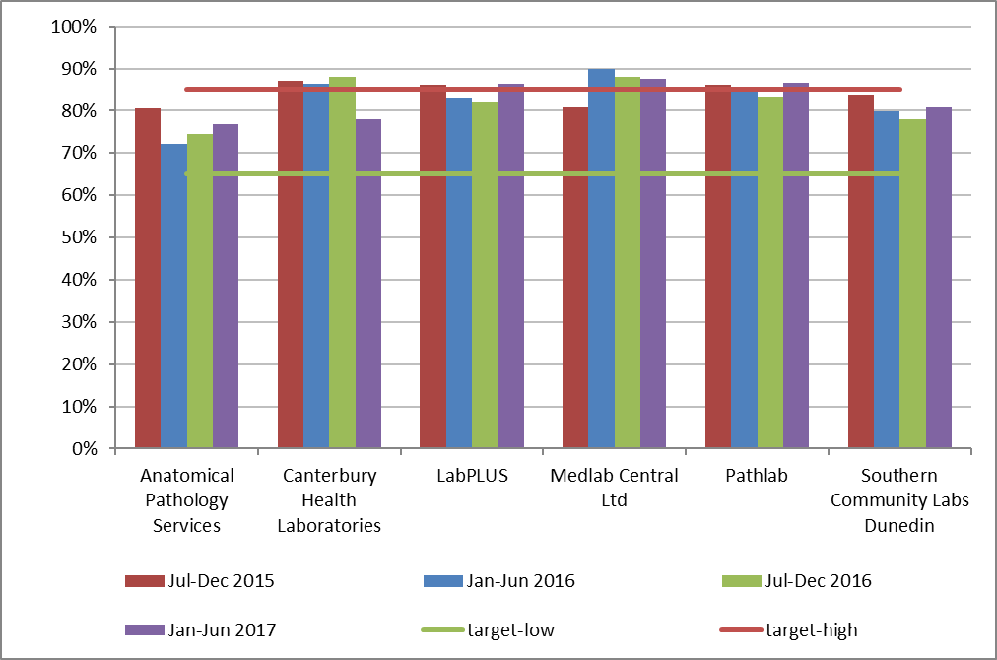
Time period relates to monitoring report period; cytology samples were collected in the period six months prior.

Figure 47 - Trends in the positive predictive value for CIN 2+ in women with ASC-H cytology results, by laboratory
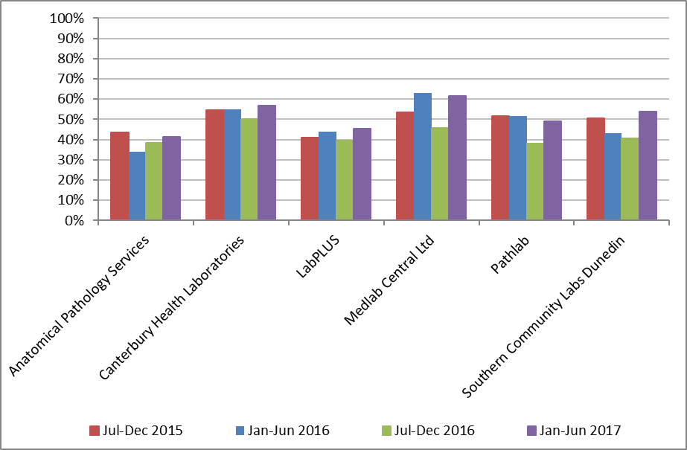

Figure 48 - Trends in the positive predictive value for CIN 2+ in women with ASC-H, HSIL or SC cytology results, by laboratory
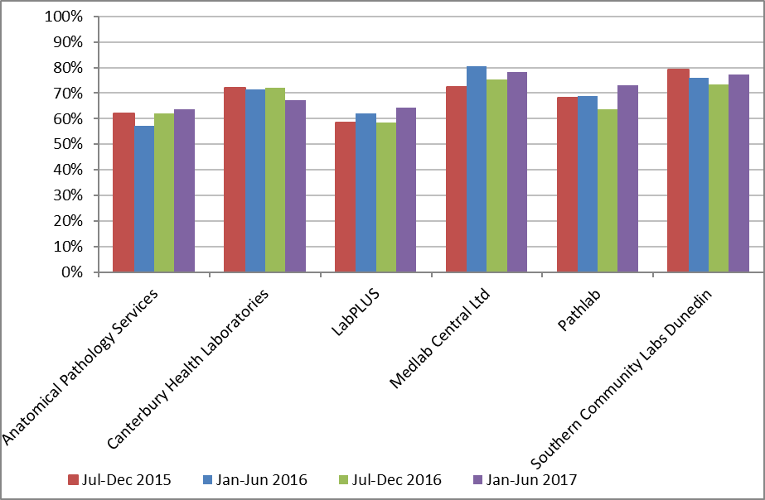
Time period relates to monitoring report period; cytology samples were collected in the period six months prior.

Indicator 5.3 – Accuracy of negative cytology reports

Definition | This indicator currently has two parts to its definition.  - For women with a histological diagnosis of CIN 2, CIN 3, invasive SCC, AIS or invasive endocervical adenocarcinoma, the proportion of cytology slides originally reported within the preceding 42 months as negative, benign/ reactive or unsatisfactory which on review are consistent with high grade or worse category (Standard 522).  - The ability of a laboratory to correctly identify a negative sample.  All cases with a high-grade/ invasive diagnosis on histology (CIN 2, CIN 3, invasive SCC, AIS or invasive endocervical adenocarcinoma) must have a review of any cytology slides that have been reported as negative, benign/ reactive or unsatisfactory in the previous 42 months. Any abnormality identified as high grade or worse on review of a previously reported negative or unsatisfactory cytology slide must be documented by the laboratory. Cumulative data must be forwarded to the National Screening Unit to help ensure the accuracy of submitted negative cytology reports.
Target | No more than 10% identified as HS1, HS2, SC, AIS or AC1-AC5 (HSIL+) on review.  Aim for less than 15%, but not more than 20% identified as ASC-H, HS1, HS2, SC, AG4-5, AIS or AC1-AC5 (ASC-H +) on review.
Current Situation | This indicator is analysed annually to allow for the full year to be examined. Data for women with a histological diagnosis of high-grade/ invasive disease in the period 1 January – 31 December 2016 were provided in Report 46. Data for women with a histological diagnosis of high-grade/ invasive disease in the period 1 January – 31 December 2017 will be provided in Report 48.
Trends | -
Comments | -

Indicator 5.4 – Histology Reporting

Definition | The NCSP Register collects histology results of samples taken from the cervix and vagina. Histology samples include diagnostic biopsies, treatment biopsies, cervical polyps and the cervical tissue of total hysterectomy specimens. All histology samples taken during the current monitoring period were retrieved. Where a histology sample had more than one SNOMED code, or a woman had more than one histology result, the most serious (highest) ranked code was used (see Appendix C).  Results are presented both according to the detailed SNOMED category, and by broader histology diagnostic category. The mapping between SNOMED codes and diagnostic category is detailed in Appendix C.  Two versions of SNOMED are used by laboratories (1986 and 1993) depending on the laboratory software. The NCSP Register accepts both versions and for statistical purposes maps the 1986 codes to the 1993 codes.  A woman’s age is defined as her age at the end of the monitoring period (i.e. a woman’s age at 30 June 2017).
Target | None
Current Situation | 12,548 histology samples were taken during the current monitoring period. 447 (3.6%) of these were insufficient for diagnosis. These samples were taken from 440 women, 74 (16.8%) of whom have a record of a subsequent sufficient histology test. The remaining 12,101 samples were taken from 10,643 women. Results for these women are reported on in Table 7 to Table 10. Table 7 shows histology results by SNOMED category, based on the most serious (highest) ranked result for each woman in the monitoring period. Table 8 to Table 10 and Table 49 show histology results by broader histology diagnostic category.  54.6% of women with histology tests had negative or benign histology results (Table 8). 19.8% of women had high grade squamous (CIN 2/3) histology results and 62 women (0.58%) had adenocarcinoma in situ. There were 71 women (0.67%) with invasive squamous cell carcinoma (ISCC) histology, 6 (0.06%) with microinvasive squamous cell carcinoma (SCC) histology and 42 (0.35%) with invasive adenocarcinoma; five (<0.05%) were adenocarcinomas arising from the endocervix and 37 (0.35%) were adenocarcinomas not arising from the endocervix. There were no cases with adenosquamous carcinoma.  The age group with the largest number of women with histology samples was women aged 25-29 years (1,434 women, Table 9). Among women aged 20-69 years, the age group with the lowest rate of women with results which were negative was women aged 20-24 years (26.9%, Table 10).  Histology samples were additionally analysed after excluding 2,057 women whose only histology result(s) originated from a hysterectomy (partial with cervical component or total hysterectomy) and were negative/ benign (non neoplastic) (Table 49). This represented approximately 35% of the women with negative/ benign histology. This reduced the proportion with a histology result being negative/ benign from 54.6% to 43.7% of all women with a histology sample. After excluding negative/ benign histology from hysterectomy samples, this resulted in 0.49% of women with histology having an invasive adenocarcinoma result, including with adenocarcinomas arising from the endocervix (0.06%) and women with adenocarcinomas not arising from the endocervix (0.43%). The most severe histological abnormality detected was HSIL (CIN 2/3) for 24.6% of women; ISCC for 0.83% of women; microinvasive SCC for 0.07% women; adenocarcinoma in situ for 0.72% of women (Table 49).
Trends | The proportion of women with negative or benign histology (54.6%) is higher to that reported for the previous period (53.3%). The proportion of women with HSIL histology is lower in the current period (19.8%) to what it was in the previous period (20.7%). There was a continued decrease in the percentage of HSIL histology in the 20-24 age group in this monitoring period compared to the previous report (Figure 49). This is consistent with a reduction of proportion of satisfactory cytology samples reported as HSIL in this age group (see Indicator 5.1) and with an HPV vaccine effect.  The proportions were similar to those in the previous period for women with ISCC (0.67% in this period and 0.60% in the last period); increased slightly for invasive adenocarcinoma not arising from the endocervix (0.25% to 0.35% in the current period); and decreased for adenocarcinoma arising from the endocervix (0.09 to <0.05 in the current period). The proportion slightly increased for women with adenocarcinoma in situ (0.58% in this period and 0.68% last period).
Comments | Histology samples include diagnostic biopsies, treatment biopsies, cervical polyps and the cervical tissue of total hysterectomy specimens. Histology samples may also include samples from non-cervical sites, where there is also a cervical component in the sample, for example endometrial samples. Also, pathologists are not always able to determine the site of origin particularly in small biopsies. “Adenocarcinoma not endocervical type” is the code that pathologists use for adenocarcinomas involving the cervix, but not primarily arising from the cervix. This means that the code category of endocervical adenocarcinoma of endocervical type will equate much more closely with data held on the Cancer Registry.  In the current report, a supplementary analysis was undertaken which excluded any samples which originated from a hysterectomy sample (partial or total) which were negative/ benign. These supplementary results may more closely reflect the results of histology which were collected in relation to the NCSP.
Table 7 - Histology results reporting by SNOMED category
SNOMED category | Women with that diagnosis
 | N | %
Negative/ normal | 3,140 | 29.5
Inflammation | 611 | 5.7
Microglandular hyperplasia | 15 | 0.14
Squamous metaplasia | 371 | 3.5
Polyp | 1,295 | 12.2
Other* | 375 | 3.5
Atypia | 40 | 0.38
Benign glandular atypia | 2 | <0.05
HPV | 664 | 6.2
Condyloma acuminatum | 4 | <0.05
CIN 1 (LSIL) or VAIN 1 | 1,760 | 16.5
Dysplasia/CIN NOS | 41 | 0.39
Glandular dysplasia | 1 | <0.05
CIN 2 (HSIL) or VAIN 2 | 866 | 8.1
HSIL not otherwise specified | 50 | 0.47
CIN 3 (HSIL) or VAIN 3 | 1,193 | 11.2
Adenocarcinoma in situ | 62 | 0.58
Microinvasive squamous cell carcinoma | 6 | 0.06
Invasive squamous cell carcinoma | 71 | 0.67
Adenocarcinoma (arising from the endocervix) | 5 | <0.05
Invasive adenocarcinoma (not arising from the endocervix) | 37 | 0.35
Adenosquamous carcinoma | - | -
Undifferentiated carcinoma | 5 | <0.05
Sarcoma | 2 | <0.05
Carcinosarcoma | 3 | <0.05
Choriocarcinoma | - | -
Miscellaneous primary tumour | - | -
Metastatic tumour | 12 | 0.11
Small cell carcinoma | - | -
Malignant tumour, small cell type | - | -
Melanoma | - | -
Other primary epithelial malignancy | 12 | 0.11
Total | 10,643 | 100.0
NOS = not otherwise specified; HSIL not otherwise specified = high grade squamous intraepithelial lesion, not otherwise specified/ CIN 2/3 (SNOMED code M67017; see Appendix C)
* Other morphologic abnormality, not dysplastic or malignant.

Table 8 - Histology results reporting by diagnostic category
Histology category | Women with that histology result
 | N | %
Negative/benign (non neoplastic) | 5,809 | 54.6
HPV | 668 | 6.3
CIN1 | 1,841 | 17.3
Glandular dysplasia | 1 | <0.05
CIN 2 | 866 | 8.1
HSIL not otherwise specified | 50 | 0.47
CIN 3 | 1,193 | 11.2
Adenocarcinoma in situ | 62 | 0.58
Microinvasive | 6 | 0.06
Invasive squamous cell carcinoma | 71 | 0.67
Adenocarcinoma (arising from the endocervix) | 5 | <0.05
Invasive adenocarcinoma (not arising from the endocervix) | 37 | 0.35
Adenosquamous carcinoma | - | -
Other cancer | 34 | 0.32
Total | 10,643 | 100.0
Details of mapping between SNOMED category and diagnostic category are included in Appendix C. HSIL not otherwise specified = high grade squamous intraepithelial lesion, not otherwise specified/ CIN 2/3 (SNOMED code M67017; see Appendix C).

Table 9 - Histology results by age – counts
 | Age group
Histology Diagnostic Category | <20 | 20-24 | 25-29 | 30-34 | 35-39 | 40-44 | 45-49 | 50-54 | 55-59 | 60-64 | 65-69 | 70+ | Total
Negative/benign (non neoplastic) | 13 | 353 | 397 | 472 | 572 | 808 | 947 | 780 | 578 | 368 | 254 | 267 | 5,809
HPV | - | 113 | 125 | 97 | 63 | 72 | 73 | 44 | 38 | 23 | 18 | 2 | 668
CIN1 | 9 | 428 | 381 | 278 | 187 | 165 | 139 | 102 | 73 | 39 | 28 | 12 | 1,841
Glandular dysplasia | - | - | - | - | - | - | 1 | - | - | - | - | - | 1
CIN 2 | 8 | 238 | 186 | 150 | 97 | 61 | 48 | 25 | 21 | 17 | 13 | 2 | 866
HSIL not otherwise specified | 1 | 7 | 11 | 14 | 5 | 4 | 2 | 1 | 1 | - | 2 | 2 | 50
CIN 3 | 2 | 169 | 313 | 264 | 153 | 111 | 50 | 47 | 33 | 25 | 19 | 7 | 1,193
Adenocarcinoma in situ | - | 3 | 14 | 15 | 13 | 2 | 5 | 3 | 1 | 2 | 2 | 2 | 62
Microinvasive | - | 1 | - | 4 | - | - | - | - | - | - | 1 | - | 6
Invasive squamous cell carcinoma | - | - | 5 | 6 | 5 | 6 | 8 | 9 | 9 | 4 | 4 | 15 | 71
Adenocarcinoma (arising from the endocervix) | - | - | - | 1 | - | 2 | - | - | - | - | 1 | 1 | 5
Invasive adenocarcinoma (not arising from the endocervix) | - | - | 1 | 3 | 5 | 2 | 1 | 2 | 4 | 6 | 5 | 8 | 37
Adenosquamous carcinoma | - | - | - | - | - | - | - | - | - | - | - | - | -
Other cancer | - | - | 1 | 2 | - | 5 | - | 3 | 8 | 5 | 4 | 6 | 34
Total | 33 | 1,312 | 1,434 | 1,306 | 1,100 | 1,238 | 1,274 | 1,016 | 766 | 489 | 351 | 324 | 10,643
HSIL not otherwise specified = high grade squamous intraepithelial lesion, not otherwise specified/ CIN 2/3 (SNOMED code M67017; see Appendix C)

Table 10 - Histology results by age – percentages
Histology Diagnostic Category | Age group
 | <20 | 20-24 | 25-29 | 30-34 | 35-39 | 40-44 | 45-49 | 50-54 | 55-59 | 60-64 | 65-69 | 70+
Negative/benign (non neoplastic) | 39.4 | 26.9 | 27.7 | 36.1 | 52.0 | 65.3 | 74.3 | 76.8 | 75.5 | 75.3 | 72.4 | 82.4
HPV | - | 8.6 | 8.7 | 7.4 | 5.7 | 5.8 | 5.7 | 4.3 | 5.0 | 4.7 | 5.1 | 0.6
CIN1 | 27.3 | 32.6 | 26.6 | 21.3 | 17.0 | 13.3 | 10.9 | 10.0 | 9.5 | 8.0 | 8.0 | 3.7
Glandular dysplasia | - | - | - | - | - | - | 0.08 | - | - | - | - | -
CIN 2 | 24.2 | 18.1 | 13.0 | 11.5 | 8.8 | 4.9 | 3.8 | 2.5 | 2.7 | 3.5 | 3.7 | 0.6
HSIL not otherwise specified | 3.0 | 0.53 | 0.77 | 1.07 | 0.45 | 0.32 | 0.16 | 0.10 | 0.13 | - | 0.57 | 0.6
CIN 3 | 6.1 | 12.9 | 21.8 | 20.2 | 13.9 | 9.0 | 3.9 | 4.6 | 4.3 | 5.1 | 5.4 | 2.2
Adenocarcinoma in situ | - | 0.23 | 1.0 | 1.1 | 1.18 | 0.16 | 0.39 | 0.30 | 0.13 | 0.41 | 0.57 | 0.62
Microinvasive | - | 0.08 | - | 0.31 | - | - | - | - | - | - | 0.3 | -
Invasive squamous cell carcinoma | - | - | 0.35 | 0.46 | 0.45 | 0.48 | 0.63 | 0.89 | 1.17 | 0.82 | 1.1 | 4.6
Adenocarcinoma (arising from the endocervix) | - | - | 0.07 | 0.23 | 0.45 | 0.16 | 0.08 | 0.20 | 0.52 | 1.23 | 1.4 | 2.47
Invasive adenocarcinoma (not arising from the endocervix) | - | - | - | 0.08 | - | 0.16 | - | - | - | - | 0.28 | 0.3
Adenosquamous carcinoma | - | - | - | - | - | - | - | - | - | - | - | -
Other cancer | - | - | 0.07 | 0.15 | - | 0.40 | - | 0.30 | 1.04 | 1.02 | 1.1 | 1.9
Total | 100.0 | 100.0 | 100.0 | 100.0 | 100.0 | 100.0 | 100.0 | 100.0 | 100.0 | 100.0 | 100.0 | 100.0
HSIL not otherwise specified = high grade squamous intraepithelial lesion, not otherwise specified/ CIN 2/3 (SNOMED code M67017; see Appendix C).

Figure 49 - Trends in histologically-confirmed HSIL as a percentage of all women with histology (Jul-Dec 2011 to 1 Jan – 30 Jun 2017)
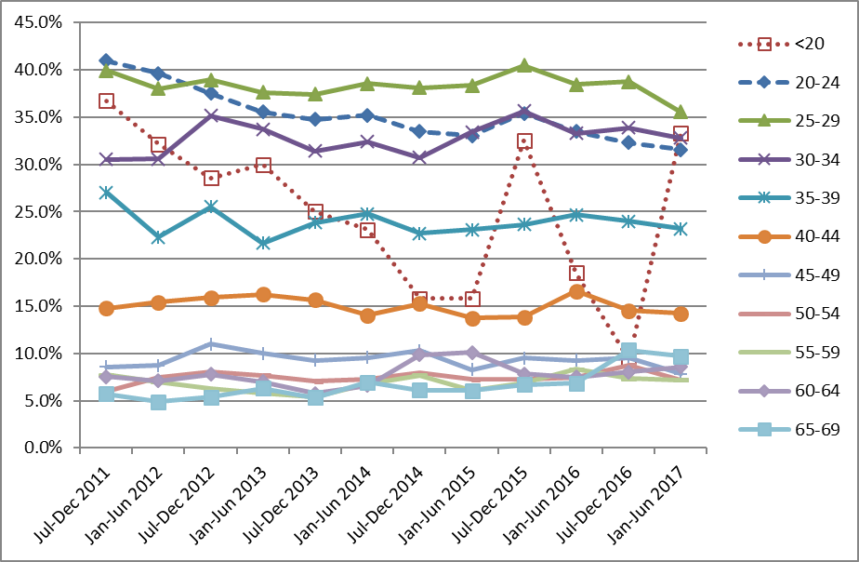

Indicator 5.5 - Laboratory turnaround times

Definition | Turnaround time is defined as the number of working days from the date a sample is received by a laboratory, and the date which it is reported to the sample taker or colposcopist. For the purposes of this measure, samples received and reported on the same day are defined as having a turnaround time of one day.
Target | Cytology  Laboratories are required to report 90% of final gynaecological cytology results to sample takers within seven working days of receipt of the sample and 98% within 15 working days (Standard 513¹¹).  Histology  Laboratories are required to report 90% of final histology results to referring colposcopists within ten working days of receipt of the sample and 98% of final histology results within 15 working days of receiving the sample (Standard 516¹¹).  Cytology with associated hrHPV testing  Laboratories are required to report 98% of final cytology test results (including those associated with HPV test) within 15 working days of receiving the sample. Here, the turnaround time is measured specifically for cytology where HPV testing is performed for low grade triage. Low grade triage is defined further in Indicator 8; here it relates to cytology samples received at the laboratory in the monitoring period (as opposed to samples collected in the period, in Indicator 8). It is restricted to triage testing of women aged 30 years or more. These samples form a subset of those considered in the overall measure of turnaround time for cytology. Note that since reporting of cytology with adjunctive hrHPV testing requires that both test results be reported together (hrHPV test results must not be issued independently when adjunct to a cytology request), the turnaround time of the hrHPV test should not exceed that of the accompanying cytology, except where the HPV test was added after cytology was already reported.
Current Situation | Cytology  Six laboratories received 208,843 cytology samples during the current monitoring period. Overall, 96.3% of cytology samples were reported on within seven working days, which meets the target of 90% (Table 50). Nationally, 99.0% were reported on within 15 working days, which meets the target of 98%.  All six laboratories met the target for 90% of cytology samples to be reported to sample takers in seven working days or less (Figure 50, Table 50).  All six laboratories met the target of 98% of samples reported within 15 working days (Figure 51, Table 50).  Histology  Fourteen laboratories received 12,535 histology samples in the current monitoring period. Overall 93.6% of samples were reported on within ten working days, which meets the target of 90%. Nationally 97.1% were reported on in 15 working days or less, which is below the target of 98% (Table 51). Eleven of the 14 laboratories met the target of 90% of final histology results to referring colposcopists within ten working days of receipt of the sample (Anatomical Pathology Services, Canterbury Health Laboratories, Medlab Central Ltd, Memorial Hospital Hastings Laboratory, Middlemore Hospital Laboratory, Nelson Hospital Laboratory, North Shore Hospital Laboratory, Northland Pathology Laboratory, Southern Community Labs Dunedin, Taranaki Medlab, Waikato Hospital Laboratory) (Figure 52). Four laboratories met the target of 98% of final histology results reported to the requestor within 15 working days of receiving the sample (Figure 53, Table 51). Seven of the remaining eleven laboratories had reported on at least 95% of samples within 15 days (Figure 53, Table 51).  Low grade cytology with associated HPV triage testing  Six laboratories received 2,687 cytology samples during the current monitoring period which were associated with HPV testing for the purpose of triage of low grade abnormalities. Overall, 98.5% of these cytology samples were reported on within 15 working days, which meets the target of 98%. The proportion of cytology samples with HPV triage tests reported on within 15 days ranged from 95.5% (Canterbury Health Laboratories) to 99.9% (Anatomical Pathology Services) (Figure 54, Table 52).  The target of 98% of tests reported within 15 working days was met by three of the six laboratories. Nationally, the proportion of cytology reported within 15 days for cytology associated with low grade triage HPV testing (98.5%) was similar to the cytology reported overall (99.0%). At most laboratories, the proportion of cytology tests reported within 15 working days was similar regardless of whether there is an associated HPV triage test (Figure 54). Canterbury Health Laboratories and Pathlab reported below the target level for cytology associated with low grade triage HPV testing (95.5% and 97.0%, respectively) but achieved the target for cytology overall (98.4% and 99.0%).
Trends | Cytology  The overall proportion of samples reported on within seven working days in the current report (96.3%) is similar to the proportion reported in the previous monitoring period (96.2%). All six laboratories meet the target in this monitoring period which is one additional laboratory compared to the previous reporting period. The proportion of samples reported on within 15 working days was similar to that reported in the previous monitoring period (99.0% compared to 98.9% in the previous monitoring period). All six laboratories met the target of reporting 98% of samples within 15 working days.  Histology  The proportion of histology samples reported on within ten working days has increased from 91.2% to 93.6%. Two additional laboratories achieved the ten-working-days target in this monitoring period compared to the last. The proportion of histology samples reported on within 15 working days is higher than reported in the previous report (97.1%, compared to 95.2% in the previous report). Two laboratories that achieved the target in the previous monitoring period fell below the 98% target and one that did not meet the target previously met the target in this report, resulting in a total of four laboratories meeting the target in this period. In the current period, seven of the 14 laboratories had reported on at least 95% of samples within 15 days, which is one fewer than achieved in the previous period.  Cytology with associated HPV triage testing  The proportion of cytology samples with an associated HPV triage test reported within 15 working days has remained similar to the previous report – from 98.7% to 98.5%.
Comments | Note that the total number of cytology samples reported on in this Indicator is different from that reported in Indicator 5.1, as the inclusion criteria for the current indicator was all cytology samples received by laboratories within the monitoring period, rather than cytology samples where the specimen was collected during the monitoring period, which is the criteria for Indicator 5.1.  The definition used by individual laboratories for turnaround time differs. For example, depending on the definition used by the laboratory, a turnaround time of one day can mean the results are reported within 24 hours, on the same day the sample is received, or on the day after the sample is received. Therefore, we have applied the same definition to all laboratories in these calculations, but because of the variation between laboratories in their internal definition, it has not been possible in this report to use a definition here which is consistent with what each individual laboratory uses.  Turnaround time performance may be underestimated due to limitations in the report date recorded on NCSP Register. When amended reports are sent to the NCSP Register, the report date in the NCSP Register is updated to reflect the date on which the report was re-transmitted after the amendments are made. The occurrence of these amended reports can therefore distort (and lengthen) turnaround time, as in these cases the report date recorded in the NCSP Register does not reflect the date on which results were first communicated to the sample taker or colposcopist. The extent of this cannot be directly determined from the NCSP Register, however audit results (which invariably find better turnaround time performance) suggest that it is a factor which should be considered in interpretation of these results.  There are some possible explanations why in some laboratories the turnaround time for cytology with associated HPV triage testing is longer than for other cytology. As the HPV triage test is performed in response to low grade cytology results in a subset of women (those aged 30 years or more without a recent cytological abnormality), the need for the HPV test is only apparent after the cytology result is available. Additionally, as HPV tests are generally performed in batches, laboratories with smaller HPV test volumes may take longer to accrue the required batch sizes, and therefore perform HPV tests less frequently.  Caution must be taken when comparing percentages of reporting from this monitoring period to previous monitoring periods due to changes in the number of reporting laboratories. Differences in percentages from this and previous monitoring reports may be due to differences in caseloads.
Figure 50 - Proportion of cytology samples reported within seven working days by laboratory, 1 January – 30 June 2017
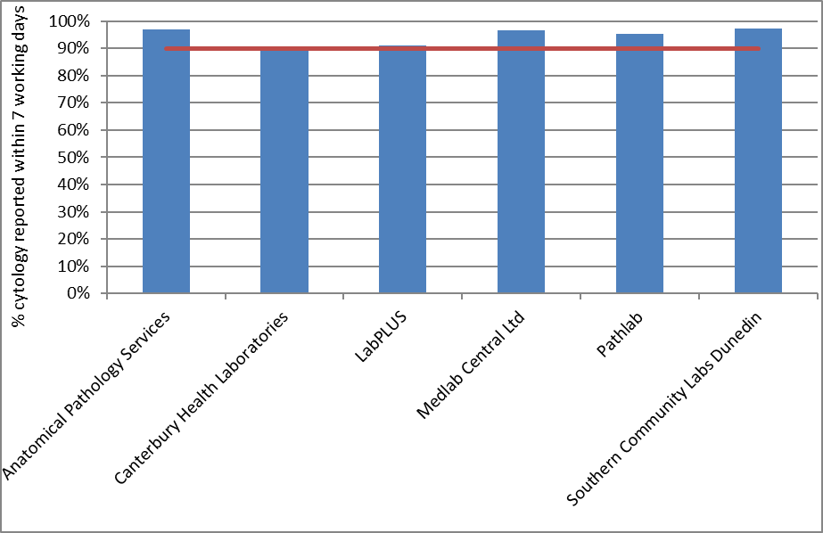
Target: 90% within seven working days (red line)

Figure 51 - Proportion of cytology samples reported within 15 working days by laboratory, 1 January – 30 June 2017
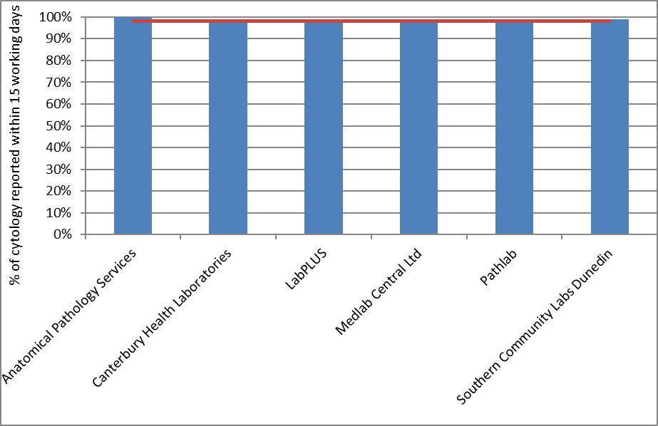
Target: 98% within 15 working days (red line)

Figure 52 - Proportion of histology samples reported within ten working days by laboratory, 1 January – 30 June 2017
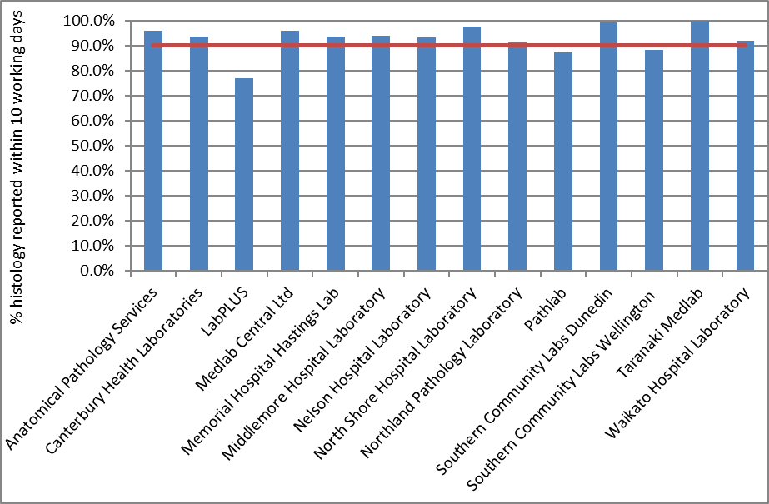
Target: 90% within ten working days (red line)

Figure 53 - Proportion of histology samples reported within 15 working days by laboratory, 1 January – 30 June 2017
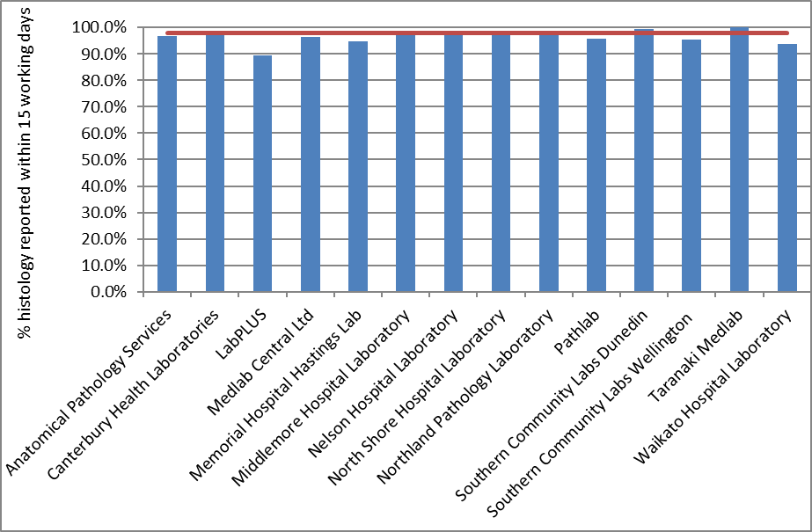
Target: 98% within 15 working days (red line)

Figure 54 - Proportion of cytology samples with associated HPV triage testing and of all cytology samples reported within 15 days by laboratory, 1 January – 30 June 2017
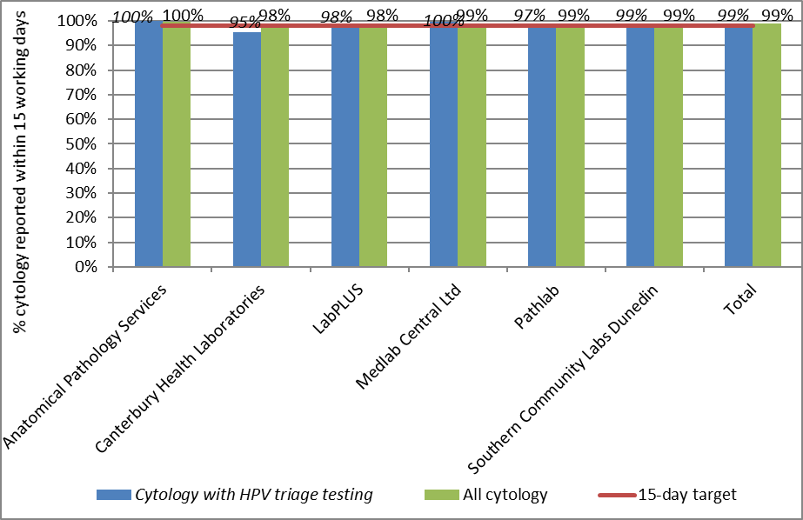
Target: 98% within 15 working days (red line)

Indicator 6 – Follow-up women high grade cytology, no histology

Definition | The proportion of women who have had a cervical sample showing a high grade cytology result for whom a histological report has been received by the NCSP Register. This proportion is a measure of the completeness of follow-up of women with high grade cytology.  Each woman with a high grade cytology result, relating to a cytology sample taken in the six months preceding the current monitoring period (i.e. sample taken in the period of 1 July - 31 December 2016), is followed for any histology samples taken on or after the date of the cytology sample. The period of time between the cytology and histology reports relating to these samples is calculated. The proportion of women with a histology report up to and including 90 days after their cytology report is calculated. Histology reports which occur prior to the cytology report are included, as long as the histology sample was not taken before the cytology sample, to allow for differences in turnaround times between cytology and histology.  Analyses were also performed which calculated the proportion of women with a high grade cytology result who have a histology report within 180 days of their cytology report.  For the purposes of this indicator, the following Bethesda 2001 (New Zealand modified; TBS 2001 NZ modified)¹² interpretation codes are included as high grade cytology: ASH, HS1, HS2, SC, AG1-AG5, AIS, AC1-AC5. Within this group, women are considered as having an urgent referral, due to suspicion of invasive disease if they have an interpretation code of HS2, SC, or AC1-AC5 and/ or a recommendation code of R10 or R14.  High grade cytology reports that indicated women were already under specialist management (TBS 2001 NZ modified recommendation code R13) are excluded. After these are excluded, follow-up of women who have more than one high grade cytology sample is based on the first cytology sample collected in the period.  Note that some women may be assessed at colposcopy but have no biopsy taken. The colposcopy visit data for this group of women (Indicator 7.1) will supplement this indicator. An exploratory analysis was also performed here which calculated the proportion of women with high grade cytology who had no follow-up test of any kind (including colposcopy, histology sample, HPV sample, or subsequent cytology sample) within 180 days.  Note that the Programme also attempts to facilitate the follow-up of all women with absent histology so that they may receive appropriate care where possible.  A woman’s age is defined as her age at the end of the current monitoring period (i.e. A woman’s age at 30 June 2017).
Target | 90% of women should have a histology report within 90 days of their cytology report date.  99% of women should have a histology report within 180 days of their cytology report.
Current Situation | There were 3,402 high grade cytology results relating to samples collected in the period 1 July - 31 December 2016; 1,559 of these cytology samples were collected at a colposcopy visit or the results indicated that a woman was already under specialist management. It was assumed that these results were already being followed up in the course of this management, and so the cytology tests were excluded from this measure. This left 1,843 cytology results, which related to 1,840 women. Histological follow-up for these 1,840 women is considered in this indicator. Where women had more than one high grade cytology result relating to a sample taken in the period, histological follow-up of the earliest cytology sample taken in the period was assessed.  Histological follow-up  Nationally, 1,512 women (82.2%) had a histology report within 90 days of their cytology report, and 1,649 (89.6%) had a histology report within 180 days. These were below the targets of 90% within 90 days and 99% within 180 days.  The proportion of women with a histology report varied by DHB from 57.1% (South Canterbury) to 93.3% (Wairarapa) within 90 days of their cytology report, and from 72.7% (West Coast) to 97.9% (Nelson Marlborough) within 180 days of their cytology report (Figure 55, Table 11). Three DHBs met the target for the proportion of women with histology within 90 days (Hutt Valley, Lakes, and Wairarapa with 91.1%, 90.6% and 93.3% of histology reported within 90 days of a high grade cytology report) however none met the target for 180 days. As shown in Table 11, some DHBs had a relatively small number of women with a high grade cytology result recorded in the period (including South Canterbury, Wairarapa and West Coast, with 7, 15 and 11, women with a high grade result respectively), and this should be taken into account when interpreting these results.  The proportion of women with a histology report also varied by age. Among women aged 20-69 years, the proportion varied from 59.4% (ages 60-64) to 88.3% (ages 20-24 years) within 90 days, and from 75.4% (ages 60-64 years) to 95.9% (ages 40-44 years) within 180 days (Table 12). The targets were not met in any age group.  There was some variation in the proportion of women with histological follow-up by ethnicity, however the targets were not met for any group of women. At 90 days, the proportion of women with histological follow-up ranged from 74.3% (Māori women) to 84.4% (European/ Other woman). By 180 days, however, the difference had narrowed, and the proportion with histology reports ranged from 85.5% (Māori women) to 90.7% (European/ Other women; Table 12). Further breakdown by DHB and ethnicity is also shown in Table 13 and Table 14, and breakdown by DHB and age is shown in Table 53 and Table 54.  Among women with an urgent referral, due to a suspicion of invasive disease, (N=70), a histology report was available within 90 days for 74.3% of women and within 180 days for 82.9% of women (Table 15). Among women where there was no suspicion of invasive disease (TBS 2001 NZ modified Bethesda codes ASH, HS1, AG1-AG5, AIS), 82.5% had a histology report available within 90 days and 89.9% within 180 days.  Women with no follow-up tests  When follow-up tests of any kind (colposcopy, histology, HPV test, or subsequent cytology test) were considered, there were 175 women (9.5%) who had no record of any subsequent follow-up within 90 days and 96 women (5.2%) who had no record of any subsequent follow-up within 180 days on the NCSP Register (Table 16).  This varied by DHB with no women without follow-up (South Canterbury, Wairarapa and Whanganui) to 31.3% (Tairawhiti) of women without follow-up of some kind by 90 days, and from no women (Lakes, Nelson Marlborough, South Canterbury, Wairarapa and Whanganui) to 18.8% (Tairawhiti) of women without follow-up of some kind by 180 days (Figure 56, Table 16). At 90 days, the number remaining without follow-up was ten or fewer in 12 DHBs and was a maximum of 25 women (11.6%) in Auckland. At 180 days, the number remaining without follow-up was ten or fewer in 17 DHBs, with a maximum of 17 women (7.9%) without follow-up in Auckland.  The proportion of women who had no record of any subsequent follow-up also varied by ethnicity, from 7.6% (European/ Other woman) to 17.8% (Māori woman) at 90 days and from 4.4% (European/ Other woman) to 8.6% (Māori women) at 180 days (Table 17, Figure 57).  Among women with an urgent referral, due to a suspicion of invasive disease, a follow-up test of some kind was available within 90 days for 87.1% of women and this did not change within 180 days (Table 15). At 180 days, there remained nine women (12.9%) for whom no follow-up tests were recorded. Among women where there was no suspicion of invasive disease, 90.6% had a follow-up test report available within 90 days and 95.1% within 180 days (Table 15). At 180 days, there remained 87 women (4.9%) for whom no follow-up tests were recorded.
Trends | Histological follow-up  The proportion of women with a histology report within 90 days has increased slightly since the previous monitoring period (from 81.5% to 82.2% in the current period). The proportion of women with a histology report within 180 days has also increased (from 87.8% in the previous period to 89.6% in the current period).  While the proportion of women with histological follow-up has increased overall, this still varies for individual DHBs (Figure 58, Figure 59). In six DHBs the proportion of women with histological follow-up has decreased at 90 days and at 180 days (Hawke's Bay, Mid Central, South Canterbury, Southern, Tairawhiti and West Coast). In nine DHBs, the proportion of women with histological follow-up increased at both 90 days and at 180 days (Bay of Plenty, Capital & Coast, Counties Manukau, Hutt Valley, Lakes, Nelson Marlborough, Northland, Taranaki and Wairarapa).  The proportion of women with follow-up histology at 90 days in the current monitoring period has increased for Pacific and Asian woman (Pacific women from 67.3% to 77.8% in the current monitoring period; Asian women from 78.5% to 80.6%) and remained similar for European/ Other women (from 84.0% to 84.4%). There has been a decrease in the proportion of Māori women with follow-up histology within 90 days over the last two monitoring periods (from 78.0% to 74.3% between the previous and current report). The proportion of women with follow-up histology at 180 days has increased for Pacific, Asian and European/ Other women (82.0% to 87.8% for Pacific; 86.9% to 89.3% for Asian woman; and from 88.8% to 90.7% for European/ Other women), and decreased slightly for Māori women (from 86.1% to 85.5%). The proportions of women with follow-up histology are quite variable within individual DHBs when broken down by DHB and ethnicity, as the number of women with high grade cytology generally becomes comparatively small when broken down in those categories (except in some cases such as for European/ Other women, and Māori women in a few DHBs). Trend charts for ethnicity can be seen in Figure 60 and Figure 61.  As in previous reports, the proportion of women with histological follow-up varies substantially by age, and is generally lower in women aged 50 years or more, than in women younger than 50 years. Increases in the proportion of women with histological follow-up were seen in six of the ten age groups at 90 days follow-up and seven age groups at 180 days. Decreases were seen in the five-year age groups between 25-29, 40-49 and 60-64 years at 90 days, and 35-39, 45-49 and 60-64 years at 180 days.  Women with no follow-up tests  The proportion of women with no record of a follow-up test has decreased when compared to the previous report at 90 days (from 10.2% to 9.5% in the current report), and has decreased at 180 days (from 6.5% to 5.2%).  Trends by DHB were complex, but the proportion of women with no follow-up test recorded at 180 days reduced in twelve of the 20 DHBs, and the reductions were greatest in Wairarapa, Nelson Marlborough and Lakes. Increases were observed in some other DHBs and was largest in Tairawhiti.  In the current monitoring period, the proportion of women for whom there was no follow-up test recorded has increased for Māori women at 90 days and at 180 days. For Māori women, there was an increase from 12.4% to 17.8% at 90 days, and from 7.8% to 8.6% at 180 days. For Asian women, there was a decrease from 10.5% to 9.2% at 90 days, and from 6.3% to 5.6% at 180 days. For European/ Other women the percent of women with no follow-up decreased from 8.2% to 7.6% at 90 days, and from 5.6% to 4.4% at 180 days. For Pacific women, the proportion with no follow-up test recorded decreased by 13.1% from 25.3% to 12.2% at 90 days, and from 13.3% to 6.7% at 180 days.
Comments | The proportion of women with a follow-up test of any kind provides useful additional information. While 17.8% of women with high grade cytology reports had no record of a histology report within 90 days, the proportion without a record of a follow-up test of any kind was much lower (9.5%). The same was also true at 180 days, where 10.4% of women with high grade cytology reports had no record of a histology report within 180 days, but the proportion without a record of a follow-up test of any kind was much lower (5.2%). Consistent with previous monitoring reports, many of the women with no follow-up histology recorded do have a record of some follow-up test. This provides reassurance that many women without histology have not been lost to follow-up.  The measure of whether or not there has been a follow-up test of any sort considers cytology, colposcopy, histology and HPV tests. Therefore, changes in women with a follow-up test of any kind may also reflect changes in the completeness of reporting colposcopy data to the NCSP Register. This will improve when the time period of the data used to report on this indicator is after all DHBs began electronically reporting 2013 Colposcopy Standards data to the Register.  Note that some women presenting with cancer may be referred directly to oncology and therefore not recorded on the NCSP Register. This may have contributed to the lower rates of follow-up recorded for women with an urgent referral, due to a suspicion of invasive disease.  Note that while all cytology results which indicated that a woman was under specialist management were excluded from the measure of follow-up, not all women who had these cytology results were. If all cytology results for a woman indicated that she was under specialist management, she was excluded. However, any woman with at least one high grade cytology result which did not indicate that she was under specialist management was included in the group in whom histological follow-up was measured. It was assumed that any high grade cytology result without this indication should have been followed up in some way, regardless of other cytology results in the period. All of the cytology tests selected for follow-up indicated that referral or further assessment was recommended.  The risk level for women with no recorded biopsy is difficult to ascertain because a lack of histology can be due to a number of reasons, including:  - examined but no biopsy taken,  - did not attend (DNA) or refusal to attend  - wait time issue  - died or left New Zealand  Risk is also related to the degree of abnormality including microinvasive/ invasive carcinoma. Women who do not or refuse to attend are at highest risk due to no colposcopic examination. Due to the significant risk for this group of women if not followed up, NCSP Portfolio Managers ensure that priority is given to follow-up of these women through DHBs.

Figure 55 - Proportion of women with a histology report within 90 days, and within 180 days of their high grade cytology report, by DHB
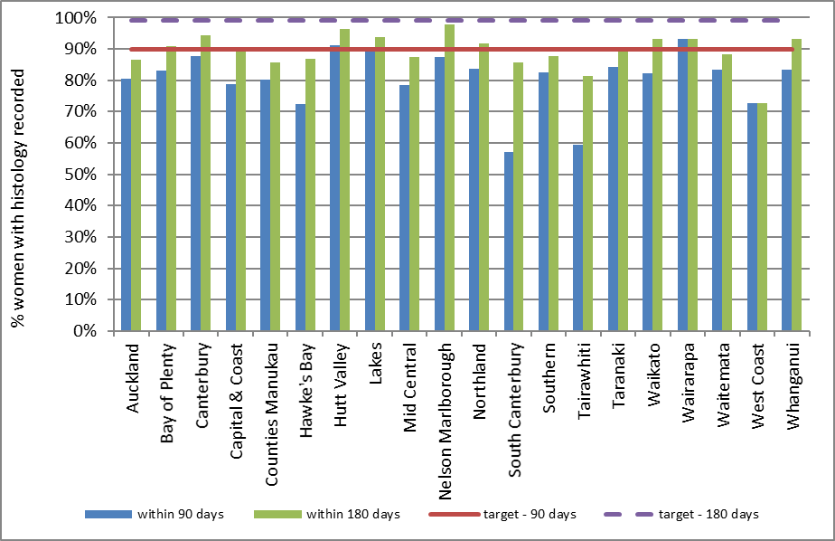
Target: 90% within 90 days; 99% within 180 days.

Table 11 - Women with a histology report within 90 and 180 days of a high grade cytology report, by DHB
DHB | High-grade cytology | Follow-up histology within 90 days |  | Follow-up histology within 180 days
 | N | N | % | N | %
Auckland | 215 | 173 | 80.5 | 186 | 86.5
Bay of Plenty | 65 | 54 | 83.1 | 59 | 90.8
Canterbury | 245 | 215 | 87.8 | 231 | 94.3
Capital & Coast | 123 | 97 | 78.9 | 110 | 89.4
Counties Manukau | 201 | 161 | 80.1 | 172 | 85.6
Hawke's Bay | 69 | 50 | 72.5 | 60 | 87.0
Hutt Valley | 56 | 51 | 91.1 | 54 | 96.4
Lakes | 32 | 29 | 90.6 | 30 | 93.8
Mid Central | 88 | 69 | 78.4 | 77 | 87.5
Nelson Marlborough | 48 | 42 | 87.5 | 47 | 97.9
Northland | 49 | 41 | 83.7 | 45 | 91.8
South Canterbury | 7 | 4 | 57.1 | 6 | 85.7
Southern | 114 | 94 | 82.5 | 100 | 87.7
Tairawhiti | 32 | 19 | 59.4 | 26 | 81.3
Taranaki | 64 | 54 | 84.4 | 57 | 89.1
Waikato | 146 | 120 | 82.2 | 136 | 93.2
Wairarapa | 15 | 14 | 93.3 | 14 | 93.3
Waitemata | 230 | 192 | 83.5 | 203 | 88.3
West Coast | 11 | 8 | 72.7 | 8 | 72.7
Whanganui | 30 | 25 | 83.3 | 28 | 93.3
Total | 1,840 | 1,512 | 82.2 | 1,649 | 89.6

Table 12 - Women with a histology report within 90 and 180 days of a high grade cytology report, by age
Age (years) | High grade cytology | Follow-Up histology Within 90 days |  | Follow-up histology  Within 180 days
 | N | N | % | N | %
<20 | 3 | 2 | 66.7 | 2 | 66.7
20-24 | 291 | 257 | 88.3 | 272 | 93.5
25-29 | 401 | 341 | 85.0 | 365 | 91.0
30-34 | 344 | 301 | 87.5 | 316 | 91.9
35-39 | 196 | 165 | 84.2 | 178 | 90.8
40-44 | 147 | 127 | 86.4 | 141 | 95.9
45-49 | 110 | 91 | 82.7 | 99 | 90.0
50-54 | 86 | 62 | 72.1 | 72 | 83.7
55-59 | 101 | 69 | 68.3 | 82 | 81.2
60-64 | 69 | 41 | 59.4 | 52 | 75.4
65-69 | 48 | 34 | 70.8 | 43 | 89.6
70+ | 44 | 22 | 50.0 | 27 | 61.4
Total | 1,840 | 1,512 | 82.2 | 1,649 | 89.6

Table 13 - Women with a histology report within 90 days of a high grade cytology report, by DHB and ethnicity
 | Māori |  | Pacific |  | Asian |  | European/ Other
DHB | N | % | N | % | N | % | N | %
Auckland | 11 | 73.3 | 19 | 82.6 | 39 | 81.3 | 104 | 80.6
Bay of Plenty | 13 | 81.3 | 2 | 100.0 | 1 | 100.0 | 38 | 82.6
Canterbury | 24 | 88.9 | 3 | 60.0 | 13 | 76.5 | 175 | 89.3
Capital & Coast | 5 | 50.0 | 7 | 100.0 | 9 | 69.2 | 76 | 81.7
Counties Manukau | 23 | 65.7 | 22 | 73.3 | 34 | 81.0 | 82 | 87.2
Hawke's Bay | 10 | 62.5 | - | - | 1 | 100.0 | 39 | 75.0
Hutt Valley | 4 | 100.0 | 1 | 100.0 | 6 | 85.7 | 40 | 90.9
Lakes | 10 | 83.3 | - | - | 1 | 100.0 | 18 | 94.7
Mid Central | 11 | 57.9 | - | - | 4 | 80.0 | 54 | 84.4
Nelson Marlborough | 6 | 100.0 | - | - | 1 | 50.0 | 35 | 87.5
Northland | 5 | 71.4 | - | - | - | - | 36 | 85.7
South Canterbury | - | - | - | - | - | - | 4 | 57.1
Southern | 6 | 85.7 | 1 | 100.0 | 1 | 25.0 | 86 | 84.3
Tairawhiti | 11 | 57.9 | 0 | 0.0 | 1 | 100.0 | 7 | 63.6
Taranaki | 11 | 68.8 | 1 | 100.0 | 1 | 100.0 | 41 | 89.1
Waikato | 25 | 86.2 | 2 | 66.7 | 5 | 71.4 | 88 | 82.2
Wairarapa | 4 | 100.0 | 2 | 100.0 | 1 | 100.0 | 7 | 87.5
Waitemata | 13 | 76.5 | 9 | 69.2 | 40 | 88.9 | 130 | 83.9
West Coast | 1 | 33.3 | - | - | - | - | 7 | 87.5
Whanganui | 7 | 100.0 | 1 | 100.0 | - | - | 17 | 77.3
Total | 200 | 74.3 | 70 | 77.8 | 158 | 80.6 | 1,084 | 84.4
‘ – ‘ indicates there were no women in this sub-category with a high grade cytology report

Table 14 - Women with a histology report within 180 days of a high grade cytology report, by DHB and ethnicity
 | Māori |  | Pacific |  | Asian |  | European/ Other
DHB | N | % | N | % | N | % | N | %
Auckland | 12 | 80.0 | 22 | 95.7 | 42 | 87.5 | 110 | 85.3
Bay of Plenty | 15 | 93.8 | 2 | 100.0 | 1 | 100.0 | 41 | 89.1
Canterbury | 26 | 96.3 | 5 | 100.0 | 15 | 88.2 | 185 | 94.4
Capital & Coast | 9 | 90.0 | 7 | 100.0 | 11 | 84.6 | 83 | 89.2
Counties Manukau | 28 | 80.0 | 24 | 80.0 | 36 | 85.7 | 84 | 89.4
Hawke's Bay | 13 | 81.3 | - | - | 1 | 100.0 | 46 | 88.5
Hutt Valley | 4 | 100.0 | 1 | 100.0 | 7 | 100.0 | 42 | 95.5
Lakes | 10 | 83.3 | - | - | 1 | 100.0 | 19 | 100.0
Mid Central | 14 | 73.7 | - | - | 5 | 100.0 | 58 | 90.6
Nelson Marlborough | 6 | 100.0 | - | - | 2 | 100.0 | 39 | 97.5
Northland | 6 | 85.7 | - | - | - | - | 39 | 92.9
South Canterbury | - | - | - | - | - | - | 6 | 85.7
Southern | 7 | 100.0 | 1 | 100.0 | 3 | 75.0 | 89 | 87.3
Tairawhiti | 14 | 73.7 | 0 | 0.0 | 1 | 100.0 | 11 | 100.0
Taranaki | 14 | 87.5 | 1 | 100.0 | 1 | 100.0 | 41 | 89.1
Waikato | 25 | 86.2 | 3 | 100.0 | 6 | 85.7 | 102 | 95.3
Wairarapa | 4 | 100.0 | 2 | 100.0 | 1 | 100.0 | 7 | 87.5
Waitemata | 15 | 88.2 | 10 | 76.9 | 42 | 93.3 | 136 | 87.7
West Coast | 1 | 33.3 | - | - | - | - | 7 | 87.5
Whanganui | 7 | 100.0 | 1 | 100.0 | - | - | 20 | 90.9
Total | 230 | 85.5 | 79 | 87.8 | 175 | 89.3 | 1,165 | 90.7
‘ – ‘ indicates there were no women in this sub-category with a high grade cytology report

Table 15 - Women with high grade cytology who have follow-up within 90 and 180 days recorded on the NCSP Register, by urgency of referral and type of follow-up
 | Urgent referral  (HS2, SC, AC1-AC5) |  | No suspicion of invasion (ASH, HS1, AG1-AG5, AIS)
 | N | % | N | %
Follow-up within 90 days
- histology | 52 | 74.3 | 1,460 | 82.5
- any follow-up | 61 | 87.1 | 1,604 | 90.6
- no follow-up | 9 | 12.9 | 166 | 9.4
Follow-up within 180 days
- histology | 58 | 82.9 | 1,591 | 89.9
- any follow-up | 61 | 87.1 | 1,683 | 95.1
- no follow-up | 9 | 12.9 | 87 | 4.9

Figure 56 - Proportion of women without any follow-up test within 90 days and within 180 days of a high grade cytology report, by DHB
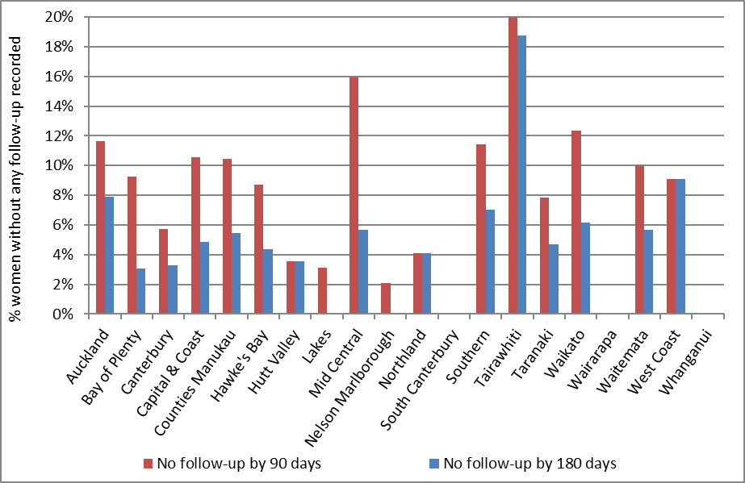
There were no women without follow-up recorded within 180 days in Lakes, Nelson Marlborough, South Canterbury, Wairarapa and Whanganui.

Figure 57 - Proportion of women without any follow-up test within 90 days and within 180 days of a high grade cytology report, by ethnicity
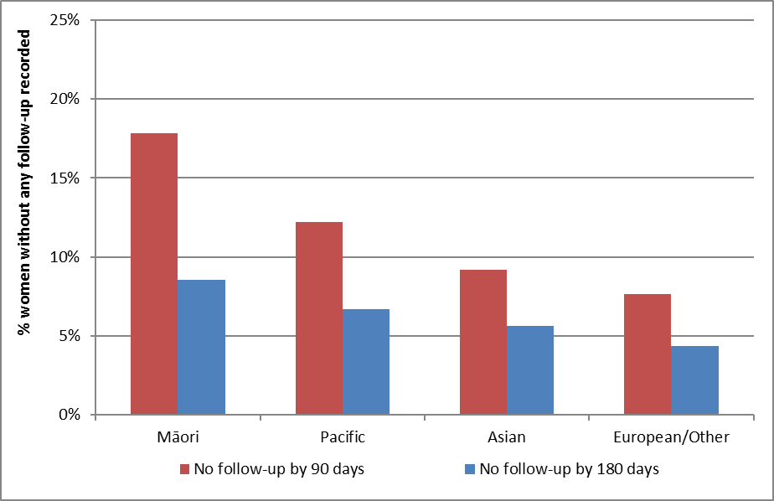

Table 16 - Women without any follow-up test within 90 and 180 days of a high grade cytology report, by DHB
 | High-grade cytology | Without a follow-up test by 90 days |  | Without a follow-up test by 180 days
DHB | N | N | % | N | %
Auckland | 215 | 25 | 11.6 | 17 | 7.9
Bay of Plenty | 65 | 6 | 9.2 | 2 | 3.1
Canterbury | 245 | 14 | 5.7 | 8 | 3.3
Capital & Coast | 123 | 13 | 10.6 | 6 | 4.9
Counties Manukau | 201 | 21 | 10.4 | 11 | 5.5
Hawke's Bay | 69 | 6 | 8.7 | 3 | 4.3
Hutt Valley | 56 | 2 | 3.6 | 2 | 3.6
Lakes | 32 | 1 | 3.1 | - | 0.0
Mid Central | 88 | 14 | 15.9 | 5 | 5.7
Nelson Marlborough | 48 | 1 | 2.1 | - | 0.0
Northland | 49 | 2 | 4.1 | 2 | 4.1
South Canterbury | 7 | - | - | - | 0.0
Southern | 114 | 13 | 11.4 | 8 | 7.0
Tairawhiti | 32 | 10 | 31.3 | 6 | 18.8
Taranaki | 64 | 5 | 7.8 | 3 | 4.7
Waikato | 146 | 18 | 12.3 | 9 | 6.2
Wairarapa | 15 | - | - | - | 0.0
Waitemata | 230 | 23 | 10.0 | 13 | 5.7
West Coast | 11 | 1 | 9.1 | 1 | 9.1
Whanganui | 30 | - | - | - | 0.0
Unspecified | - | - |  | -
Total | 1,840 | 175 | 9.5 | 96 | 5.2

Table 17 - Women without any follow-up test within 180 days of a high grade cytology report, by ethnicity
Ethnicity | High grade cytology | Without follow-up by 90 days |  | Without follow-up by 180 days
 | N | N | % | N | %
Māori | 269 | 48 | 17.8 | 23 | 8.6
Pacific | 90 | 11 | 12.2 | 6 | 6.7
Asian | 196 | 18 | 9.2 | 11 | 5.6
European/ Other | 1,285 | 98 | 7.6 | 56 | 4.4
Total | 1,840 | 175 | 9.5 | 96 | 5.2

Figure 58 – Trends in the proportion of women with high grade cytology who have follow-up within 90 days recorded on the NCSP Register, by DHB
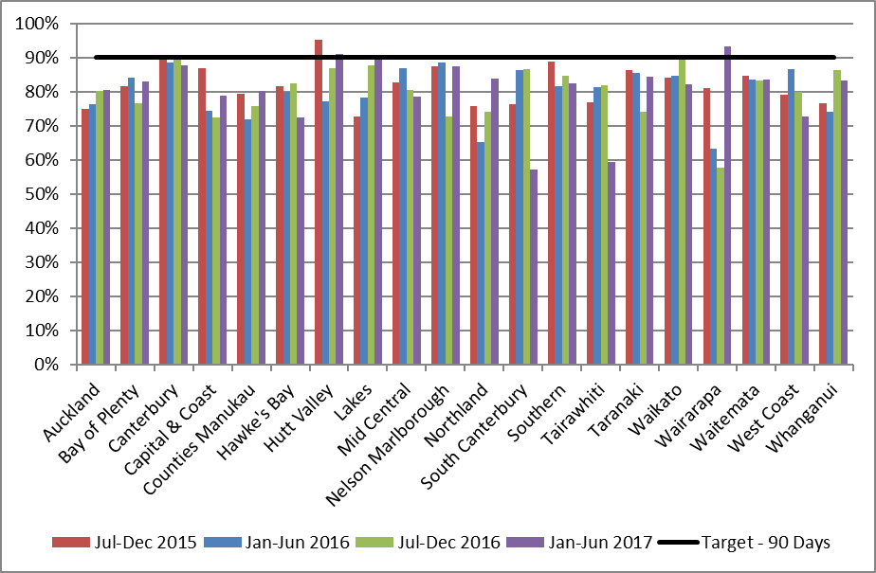

Figure 59 – Trends in the proportion of women with high grade cytology who have follow-up within 180 days recorded on the NCSP Register, by DHB
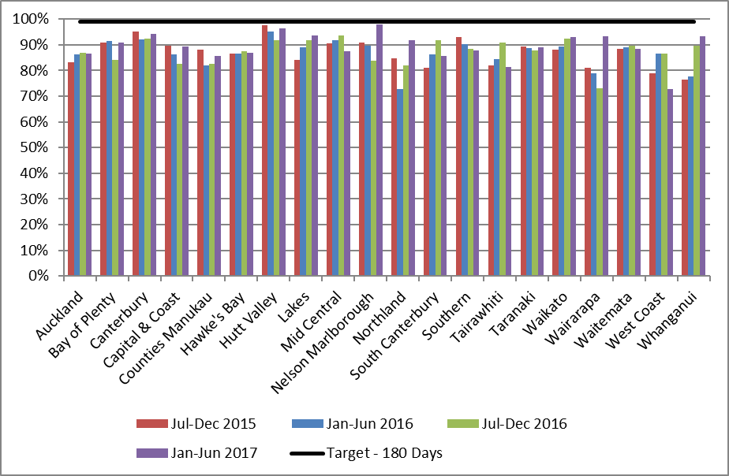

Figure 60 - Trends in the proportion of women with high grade cytology who have follow-up within 90 days recorded on the NCSP Register, by ethnicity
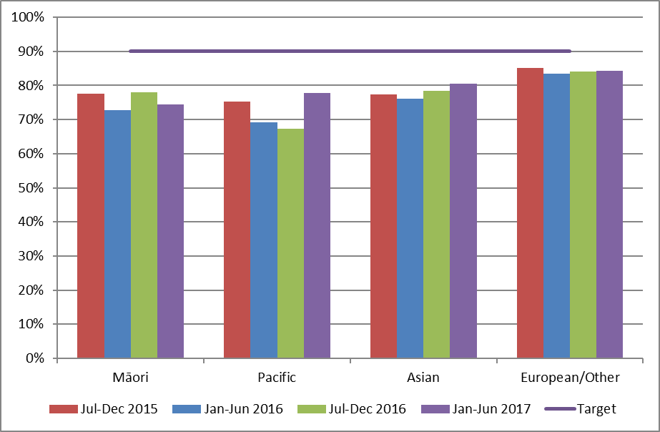

Figure 61 - Trends in the proportion of women with high grade cytology who have follow-up within 180 days recorded on the NCSP Register, by ethnicity
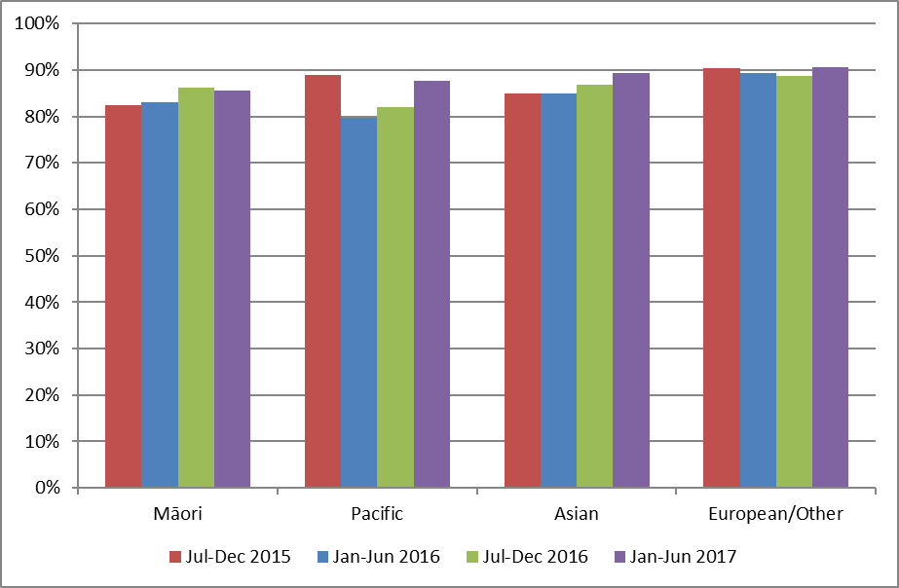

Indicator 7 – Colposcopy Indicators

These indicators report on colposcopy, against the 2013 NCSP Policies and Standards, Section 6. They include the following aspects:

- Timeliness of colposcopic assessment of high grade cytology results (Standard 602)

- Timeliness of colposcopic assessment of low grade cytology results (Standard 602)

- Adequacy of documenting colposcopy assessment (Standard 603)

- Timeliness of treatment (Standard 605)

- Timely discharging of women after treatment (Standard 608)

- Failure or refusal to attend appointments (Standard 609)

- Maintaining staff skill levels - minimum colposcopy volumes (Standard 611)

Some of these indicators (7.6 and 7.7) have not been developed. It is envisioned that all indicators will be reviewed as part of the planned transition to primary HPV screening, and so these may be included in future monitoring reports after the programme transitions.

Colposcopy data has been recorded on the NCSP Register for a relatively short time, compared to cytology and histology data. There is incomplete reporting of colposcopy data to the NCSP Register, and therefore results for these indicators may need to be interpreted with some caution. However, it was and is felt that colposcopy indicators were an important quality measure of the NCSP, and reporting on them should not be unduly delayed. This was also a recommendation of the 2011 Parliamentary Review into the NCSP¹³. It is anticipated that completeness of colposcopy data on the NCSP Register will continue to improve over time. The 2015 Parliamentary Review again emphasised that achieving complete recording of colposcopy data on the NCSP Register is essential ¹⁴.

Additionally, not all DHBs were yet reporting the full data required by Colposcopy Policies and Standards 2013 for the full time periods reported on in this monitoring period (as all indicators other than 7.3 can report on colposcopy which occurred earlier than the current monitoring period); the last three DHBs went live with the 2013 Standards in August 2016. This means that in many cases performance indicators are not directly compared to the targets or have had to rely on proxy data to measure performance. Where relevant, this is described in the sections relating to the individual indicators.

Indicator 7.1 – Timeliness of colposcopic assessment – high grade cytology

Definition | This indicator measures performance against Standard 602. It relates to the proportion of women seen at colposcopy within the recommended time period, from the time of the receipt of a referral from the sample taker for a high grade cytology.  One of the data items required to report against Standard 602 (appointment date) is a new data item required by the Colposcopy Policies and Standards 2013. It is not yet available from all DHBs, however, because although all have transitioned to reporting using 2013 Standards this field cannot be fully utilised due to a lack of completeness over the period required to report on this indicator in the current report. Therefore, this indicator relies on a proxy, the colposcopy visit date, and is not yet directly comparable to the standard. This approach was taken in agreement with the Ministry and NCSP Advisory Group. Timeliness is calculated using the time from the referral following the high grade cytology result being accepted by the colposcopy unit, to the time of the woman’s first colposcopic assessment at that colposcopy unit.  As in Indicator 6, high grade cytology results are included if the cytology sample was collected in the six months ending six months prior to the end of the current monitoring period (i.e. 1 July – 31 December 2016). High grade cytology is defined as that associated with any of the TBS codes ASH, HS1, HS2, SC, AG1-AG5, AIS, AC1-AC5. Where a woman has more than one high grade cytology result in the relevant time period, the result from the first high grade cytology sample collected is used. Timeliness of colposcopic assessment is calculated separately for those women with clinical suspicion of invasive carcinoma, or a suspicion of invasive disease (TBS codes HS2, SC, AC1-AC5 or recommendation codes R10 or R14); and for women with other high grade cytology results (TBS codes ASH, HS1, AG1-AG5, AIS), since the timeframes differ for these two groups.  Referrals and colposcopy visits for these women were retrieved from the NCSP Register. Referrals were retrieved where the date on which the referral was accepted occurred after the date the cytology sample was collected, and the referral was accepted no later than four weeks prior to the end of the current monitoring period. Colposcopy visits recorded on the NCSP Register were retrieved if they occurred after an accepted referral (to the same DHB) and no later than the end of the current monitoring period. The difference of four weeks between the two was to ensure that there were at least four weeks of data following every accepted referral which could be searched for colposcopy visits. In the current report, histology data are also used to supplement colposcopy data and help ascertain if a colposcopy visit occurred. Women with a histology sample collected after their cytology sample are assumed to have attended a colposcopy clinic for follow-up on the date the histology sample was collected, even if a colposcopy visit is not explicitly recorded on the NCSP Register.  Histology results have been used by the NCSP Register to follow up missing colposcopy visit data to improve the quality of colposcopy data on the Register. During the previous and current monitoring periods all DHBs adopted electronic reporting of the 2013 Standards, with the last three DHBs going live in August 2016. This has greatly improved the data on the Register and for public DHBs and future reports may be able to begin reporting directly against the 2013 Standards without using the current proxies. For private clinics, however, complete reporting against the 2013 Standards is taking more time with the majority still reporting against 2008 standards. Therefore, values reported for the private aggregate will need to continue to use histology proxies for a much longer period until complete 2013 Standard reporting occurs.  Results are reported by ethnicity and DHB. For women who attended colposcopy, DHB is assigned on the basis of the DHB of the colposcopy facility where they attended for colposcopy. The date on which the referral to that DHB was accepted is used to calculate timeliness. If there are multiple referrals for the same woman to that DHB, the date of the first accepted referral following the cytology sample is used. Women who attended colposcopy but had no relevant referral to that DHB recorded on the NCSP Register were excluded from the calculations of timeliness (since the time between the acceptance of the referral and the colposcopy visit could not be calculated). However, these women were reported on separately.  For women who did not attend colposcopy prior to the end of the current monitoring period, DHB is assigned based on the DHB of the facility which accepted the referral for that woman (where the referral was accepted no later than four weeks prior to the end of the current monitoring period). If there were multiple referrals for the same woman which occurred after the cytology sample, the most recently accepted referral within the timeframe was used.  For women who neither attended colposcopy nor had an accepted referral with any DHB, DHB is assigned on the basis of the health facility where their high grade cytology sample was collected.  Since cytology samples were collected in the six months prior to the current monitoring period, this allows a follow-up period of at least six months for all women (and up to 12 months for some women) where a woman can attend colposcopy and be assigned to a DHB, or alternately have a referral accepted by a DHB.  High grade cytology tests indicating that a woman was already under specialist management (TBS=R13) were excluded from this measure.
Target | Timeliness – high grade cytology indicating suspicion of invasive disease  95% or more of women who have evidence of clinical suspicion of invasive carcinoma, or a laboratory report indicating ‘features suspicious for invasion’, or ‘changes consistent with squamous cell carcinoma’ (TBS codes HS2, SC, AC1-AC5), or similar, must receive a date for a colposcopy appointment or a gynaecological assessment that is within 10 working days from when the colposcopy unit received the referral from the smear taker/ referrer.  Timeliness – high grade cytology (no suspicion of invasive disease)  95% or more of women who have high-grade smear abnormalities (but no suspicion of invasive disease; TBS codes ASH, HS1, AG1-AG5, AIS) must receive a date for a colposcopy appointment that is within 20 working days from when the colposcopy unit received the referral from the smear taker/ referrer.  The targets for this indicator rely on records of colposcopy appointments on the NCSP Register. It has not been possible to obtain appointment date from the NCSP Register for all women with a high grade cytology test in the six months prior to the current monitoring period, as this is a new data item in the Colposcopy Policies and Standards 2013. Therefore, as in recent reports, timeliness will be explored by looking at the time between an accepted referral and colposcopy visit, acknowledging that this is not directly comparable to the target.
Current Situation | In the period 1 July – 31 December 2016, there were 1,840 women with high grade cytology results who were not already under specialist management. There were 70 women who had results indicating suspicion of invasive disease, and the remaining 1,770 had other high grade cytology results. In total, accepted referrals were found for 1,619 (88.0%) of the 1,840 women (Table 55).  Timeliness – high grade cytology indicating suspicion of invasive disease  Accepted referrals for colposcopy were found for 40 (57.1%) of the 70 women who had high grade cytology indicating suspicion of invasive disease. For those with an accepted colposcopy referral recorded, referrals are broken down by the detailed cytological result in Table 58. Of these 40 women with a referral, 36 (90.0%) have a record of a colposcopy visit on the NCSP Register within ten working days of their referral, and 37 (92.5%) have a visit within 20 working days (Table 18).  Considering all 70 women with high grade cytology indicating suspicion of invasive disease, regardless of whether or not a referral to colposcopy was recorded, a total of 61 (87.1%) have a record of a colposcopy visit prior to 30 June 2017 representing a follow-up period of at least six and up to 12 months after their high grade cytology report.  Timeliness – high grade cytology (no suspicion of invasive disease)  Accepted referrals for colposcopy were found for 1,579 women (89.2%) of the 1,770 women who had high grade cytology not indicating suspicion of invasive disease. Among the women with accepted referrals, 1,099 (69.6%) were seen at colposcopy within 20 working days of their referral, and 1,406 (89.0%) were seen within 40 working days (Table 56). The proportion of women seen within 20 working days varied by ethnicity, from 56.4% (Māori women) to 74.3% (European/ Other women) (Figure 62, Table 56). This proportion also varied by DHB from 40.0% (West Coast) to 96.6% (Whanganui) (Figure 63, Table 57).  In total, 1,687 (95.3%) of the 1,770 women with high grade cytology (but no suspicion of invasive disease) relating to a sample collected in the period 1 July – 31 December 2016 have a record of a colposcopy visit prior to 30 June 2017 (representing a follow-up period of at least six and up to 12 months after their high grade cytology).
Trends | Nationally, the proportion of women with high grade cytology indicating suspicion of invasive disease and an accepted colposcopy referral who were seen within the target timeframe (10 working days) has increased from 78.0% to 90.0%. The percentage of women with high grade cytology indicating suspicion of invasive disease and an accepted colposcopy referral who were seen within 20 working days (92.5%) is also higher than that in the previous report (88.0%).  The proportion of women with high grade cytology (but no suspicion of invasive disease) and an accepted colposcopy referral who were seen within 20 working days has increased from 67.0% in the previous report to 69.6% in the current report. This trend was also representative when investigated by ethnicity, with an increase in all ethnic groups in this monitoring period in the proportion of women with high grade cytology and no suspicion of invasive disease seen within 20 working days (Figure 64). The proportion of all women with high grade results for whom an accepted referral was available on the NCSP Register is higher in the current report compared to the previous report (88.0% in the current report; 86.7% in Report 46).
Comments | Since this indicator relies on colposcopy data in the NCSP Register, any incompleteness in reporting of referrals and colposcopy visits as at the time of the data extract from the NCSP Register (early September 2017 for the current report) would lead to an underestimate of the number of women with referrals and/ or follow-up colposcopy visits. In order to help address this, in the current report, histology data are also used to help ascertain if a colposcopy visit occurred. Women with a histology sample collected after their cytology sample are assumed to have attended a colposcopy clinic for follow-up, even if a colposcopy visit is not explicitly recorded on the NCSP Register. Among the 1,748 women (with or without a referral) who had a colposcopy visit by the end of the current monitoring period, there were 155 (8.9%) women where the colposcopy visit was inferred by using the histology result proxy.  For women with high grade cytology indicating suspicion of invasive disease, the number referred for colposcopy is likely to be an underestimation of women with appropriate follow-up. Many women referred with suspicion of invasive disease are referred directly to gynae-oncology for a cone biopsy instead of colposcopy. Therefore, the proportion with colposcopy in this group does not fully reflect the level of performance.  Additional information about follow-up tests performed in women with high grade cytology is included in Indicator 6. The same 1,840 women (70 with suspicion of invasive disease, 1,770 with other high grade cytology) are included in both this measure and Indicator 6. In Indicator 6, it was found that 1,649 (89.6%) had histology within 180 days and 1,774 (94.8%) had a follow-up test of some sort within 180 days. While in this indicator, colposcopy and histology records indicate that 1,748 (95.0%) women had attended colposcopy prior to 30 June 2017 (i.e. in a period of at least 181 days and up to one year after their high grade cytology sample). Note that there may be some differences in results by DHB, however, since in Indicator 6 the DHB assigned to a woman is her own DHB (or, where this information is not available on the NCSP Register, the DHB of her responsible health facility, based on the clinic’s geographic location). In this indicator, women are assigned to a DHB based on either the DHB where they attended colposcopy, or the most recent DHB to which they have been referred (for women without colposcopy visits), or to the DHB of the health facility where the high grade cytology sample was collected (for women with no referral and no colposcopy visit). Additionally, only public clinics are assigned a DHB within Indicator 7.1; private clinics are separated out and reported on as a group.  Reasons why a woman may not attend colposcopy within the recommended timeframe include both capacity limitations within the clinic, and potentially factors related to the woman requiring follow-up. Currently there is incomplete information available on the NCSP Register about colposcopy appointments which are scheduled for women where the woman reschedules or does not attend. Therefore, in this indicator it is not possible to distinguish delays in attending colposcopy following high grade cytology which are due to capacity constraints which restrict the clinic’s ability to offer timely appointments, and delays which may be due to an individual woman’s need to reschedule an appointment or failure to attend. Factors which may lead a woman to delay a recommended visit include caring responsibilities, planned travel, competing prior commitments, illness, or menstruation.

Table 18 - Women with a high grade cytology report (suspicion of invasive disease), accepted referral and colposcopy visit, by ethnicity
Ethnicity | HG women (suspicion of invasion) | Urgent referrals received | Women seen within:
 |  |  | 10 working days |  | 20 working days
 | N | N | N | % | N | %
Māori | 7 | 6 | 5 | 83.3 | 6 | 100.0
Pacific | 5 | 2 | 1 | 50.0 | 1 | 50.0
Asian | 9 | 7 | 6 | 85.7 | 6 | 85.7
European/ Other | 49 | 25 | 24 | 96.0 | 24 | 96.0
Total | 70 | 40 | 36 | 90.0 | 37 | 92.5

Figure 62 - Percentage of women with a high grade cytology (no suspicion of invasive disease) with a colposcopy visit within 20 and 40 working days, by ethnicity
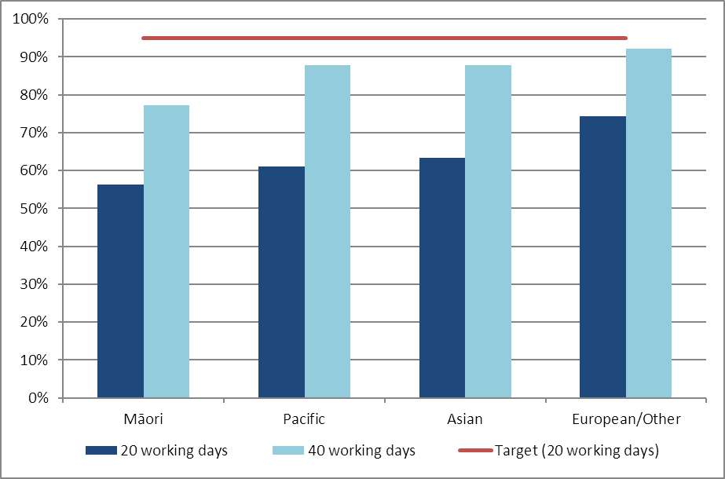
95% target relates to colposcopy visits within 20 working days

Figure 63 - Percentage of women with a high grade cytology (no suspicion of invasive disease) with a colposcopy visit within 20 and 40 working days, by DHB
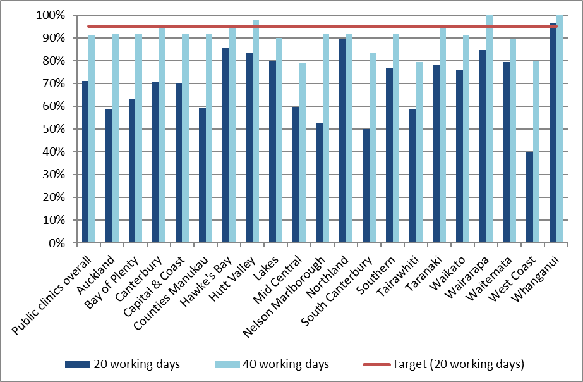
95% target relates to colposcopy visits within 20 working days

Figure 64 – Trends of the proportion of women with a high grade cytology report (no suspicion of invasive disease) seen within 4 weeks (20 working days), by ethnicity
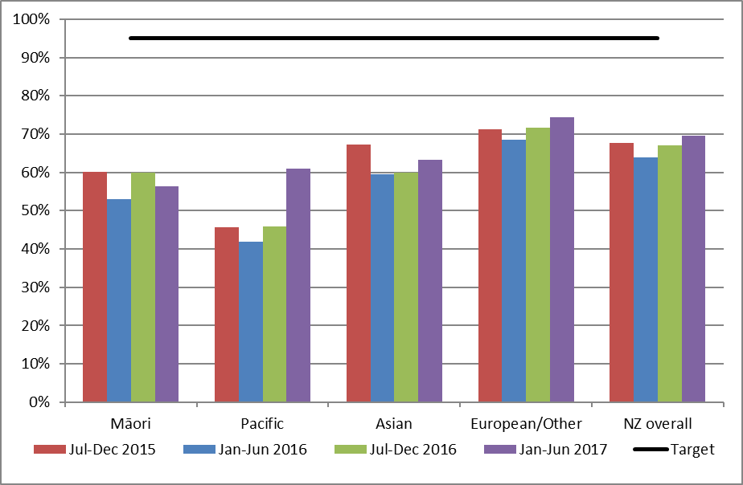
95% target relates to colposcopy visits within 20 working days

Indicator 7.2 – Timeliness of colposcopic assessment – low grade cytology

Definition | This indicator measures performance against Standard 602. It reports on the timeliness of colposcopic assessment of women with either persistent low grade cytology, or low grade cytology and concurrent positive hrHPV test.  One of the data items required to report against Standard 602 (appointment date) is a new data item required by the Colposcopy Policies and Standards 2013. Although all DHBs have transitioned to reporting using 2013 Standards, this field cannot be fully utilised due to a lack of completeness. In addition, this indicator considers colposcopy data from visits that occurred earlier than the current monitoring period. Therefore, because appointment date is not yet available to use, this indicator relies on a proxy, the colposcopy visit date, and is not directly comparable to the Standard. This approach was taken in agreement with the Ministry and NCSP Advisory Group.  Women were included in this measure if they had a cytology sample collected in the 6-month period ending 12 months prior to the end of the current monitoring period (1 January – 30 June 2016 for the current report) where the results were low grade (ASC-US or LSIL), and either a positive hrHPV test (within four weeks of the cytology result) or a previous low grade cytology result (within the previous five years). Women undergoing test-of-cure management for a recent treatment of a high grade squamous lesion (within the previous 4 years) were excluded.  Referrals and colposcopy visits for these women were retrieved from the NCSP Register. Referrals were retrieved where the date on which the referral was accepted occurred after the date the cytology sample was collected, and at least 26 weeks before the end of the current monitoring period (i.e. 26 weeks before 30 June 2017, to allow at least 26 weeks following the referral for colposcopy to occur). Colposcopy visits recorded on the NCSP Register were retrieved if they occurred after the cytology test and no later than the end of the current monitoring period. In addition to explicit colposcopy visit records, histology samples in the same timeframe were used as a proxy for a colposcopy visit, to supplement colposcopy visit data.  Results are reported by ethnicity and DHB. DHB is assigned in the same way as in Indicator 7.1. For women who attended colposcopy, DHB is assigned on the basis of the DHB of the colposcopy facility where they attended for colposcopy (or where the histology sample was collected if a visit is not explicitly recorded). If there are multiple referrals for the same woman to that DHB, the date of the first accepted referral following the cytology sample is used.  For women who did not attend colposcopy prior to the end of the current monitoring period, DHB is assigned based on the DHB of the facility which accepted the referral for that woman. If there were multiple referrals for the same woman which occurred after the cytology sample, the most recently accepted referral within the timeframe was used.  For women who neither attended colposcopy nor had an accepted referral with any DHB, DHB is assigned on the basis of the geographic region of the health facility where their low grade cytology sample was collected.  Since cytology samples were collected in the 6-month period ending 12 months prior to the end of the current monitoring period, this allows a follow-up period of at least twelve months for all women (and up to 18 months for some women) where a woman can attend colposcopy and be assigned to a DHB.
Target | 95% of women who have persistent low-grade abnormalities, or a low-grade abnormality and positive HPV test, must receive a date for a colposcopy appointment that does not exceed 26 weeks of receipt of the referral.  At present, this indicator reports on aspects of follow-up, but not specifically on timeliness in relation to the standard, as the date of the first scheduled colposcopic appointment is not yet available for all women with a low grade cytology test in the 6-month period 12-months prior to the end of the current monitoring period. In the interim, it reports on the number and percentage of women for whom a subsequent accepted referral and/ or a colposcopy visit are recorded, and the number and proportion of women who attended colposcopy within 26 weeks of an accepted referral.
Current situation | There were 3,738 women with either persistent low grade cytology or low grade cytology and a positive hrHPV test collected in the period 1 January – 30 June 2016. Nationally, subsequent accepted referrals are recorded for 3,105 (83.1%) of these women, and subsequent colposcopy for 3,347 (89.5%). The proportion of women for whom a subsequent referral and colposcopy visit are recorded are shown by DHB in Figure 65, and by ethnicity in Figure 66. The proportion of women for whom an accepted referral was recorded on the NCSP Register ranged from 84.2% (Wairarapa) to 97.6% (Lakes; Figure 65). The proportion of women with a subsequent colposcopy visit (which occurred by the end of the current monitoring period) recorded on the NCSP Register ranged from 80.6% (Hutt Valley) to 97.2% women (Tairawhiti; Figure 65). The proportion of women for whom an accepted referral was recorded on the NCSP Register ranged from 81.6% for European/ Other women to 90.0% for Maori women (Figure 66). The proportion of women with a subsequent colposcopy visit recorded on the NCSP Register ranged from 85.3% (Pacific women) to 90.1% (European/ Other women) (Figure 66).  An estimation of the timeliness of colposcopic assessment is provided by examining the time between when a referral is accepted for a colposcopy and when a woman attended for colposcopy. Nationally, 2,528 (81.4%) women attended for colposcopy within 26 weeks of their accepted referral (Table 59). By DHB, the proportion of women who attended for colposcopy within 26 weeks of their accepted referral ranged from 50.5% (Waikato) to all women (Wairarapa) (Figure 67, Table 59). By ethnicity, this figure ranged from 72.1% of Pacific women attending for colposcopy within 26 weeks of their accepted referral, to 83.5% of European/ Other women (Figure 68, Table 60)  Overall 2,874 women attended colposcopy following an accepted referral on the NCSP Register, and by the end of the current monitoring period. This is equivalent to 76.9% of all women with persistent low grade cytology or low grade cytology and a positive hrHPV test, and 92.6% of women who had an accepted referral following their low grade cytology.
Trends | Nationally, the proportion of women with colposcopy within 26 weeks has increased (81.4% in the current report, compared to 68.8% in the previous report), and it has also increased in every ethnic group with a minimum increase of 9.4% in Māori women (Figure 69). This was also reflected by DHB, with 13 out of 20 DHBs showing an increase in the proportion of women seen within 26 weeks since the previous report (Figure 70). Substantial decreases (greater than 10%) in the proportion seen within 26 weeks were still observed in three DHBs (Bay of Plenty, Capital & Coast and Hutt Valley). Conversely, a substantial increase (greater than 10%) in the proportion of women with colposcopy within 26 weeks compared to the previous report was seen in four DHBs (Counties Manukau, Southern, Waikato and Waitemata).
Comments | At present, this indicator reports on aspects of follow-up, but not specifically on timeliness in relation to the standard, as the date of the first scheduled colposcopic appointment is not yet available to use in the NCSP Register for all women referred. Therefore, the results for this indicator are not directly comparable to the target.  Since this indicator relies on colposcopy data in the NCSP Register, any incompleteness in reporting of referrals and colposcopy visits as at the time of the data extract from the NCSP Register (early September 2017 for the current report) would lead to an underestimate of the number of women with referrals and/ or follow-up colposcopy visits. In order to help address this, in the current report, histology data are also used to help ascertain if a colposcopy visit occurred. Women with a histology sample collected after their cytology sample are assumed to have attended a colposcopy clinic for follow-up, even if a colposcopy visit is not explicitly recorded on the NCSP Register.  As has been the case for previous monitoring periods, it is evident that referrals are incompletely recorded on the NCSP Register, as some women have a record of a colposcopy visit, but no record of an accepted referral.

Figure 65 - Follow-up recorded* for women with persistent LG cytology/ LG cytology and positive hrHPV test, by DHB
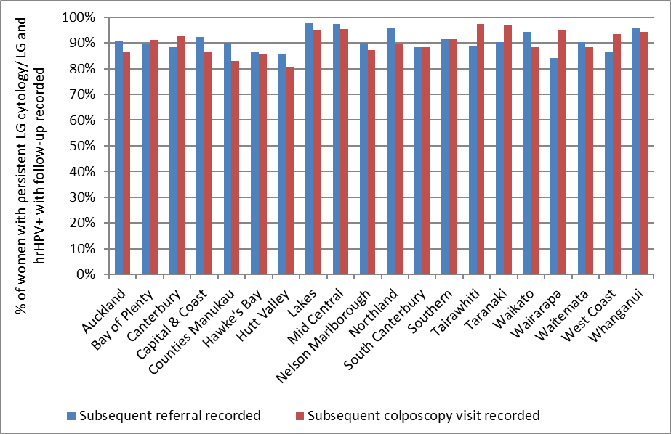
* For colposcopies ‘follow-up’ includes colposcopies recorded on the NCSP Register which occurred no later than the end of the current monitoring period, regardless of whether there is a referral or not. Referrals includes those recorded on the NCSP Register that were accepted no later than 26 weeks prior to the end of the current monitoring period. A colposcopy is assumed to have occurred if a histology sample is recorded in the relevant timeframe.

Figure 66 - Follow-up recorded* for women with persistent LG cytology/ LG cytology and positive hrHPV test, by ethnicity
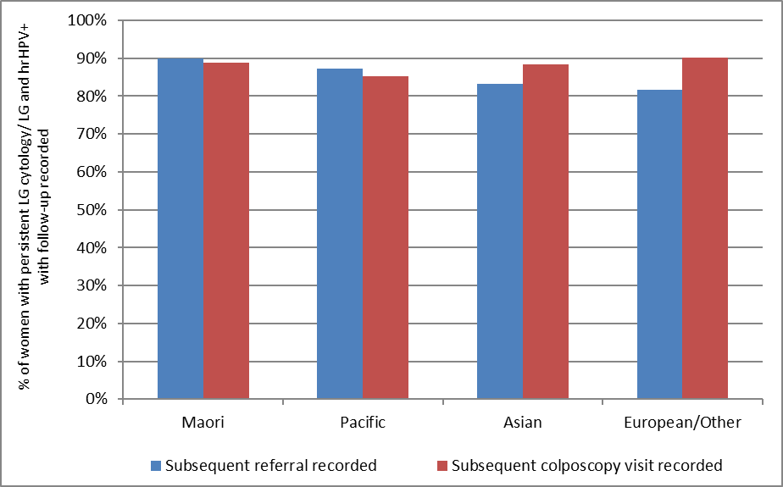
* For colposcopies ‘follow-up’ includes colposcopies recorded on the NCSP Register which occurred no later than the end of the current monitoring period, regardless of whether there is a referral or not. Referrals includes those recorded on the NCSP Register that were accepted no later than 26 weeks prior to the end of the current monitoring period. A colposcopy is assumed to have occurred if a histology sample is recorded in the relevant timeframe.
Figure 67 - Women with persistent LG cytology/ LG cytology and positive hrHPV test and an accepted referral for colposcopy: percentage with a colposcopy visit recorded within 26 weeks of the date the referral was accepted, by DHB
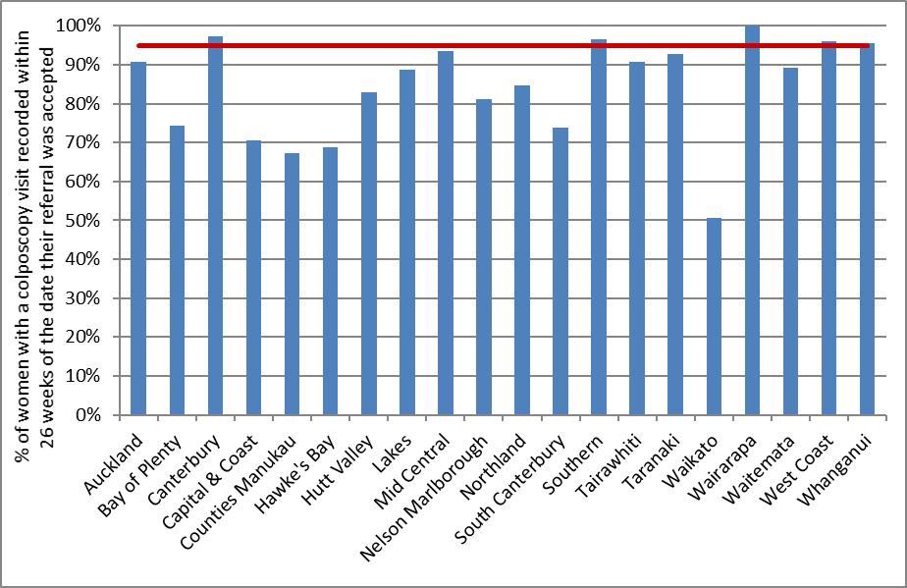

Figure 68 - Women with persistent LG cytology or LG cytology and positive hrHPV test and an accepted referral for colposcopy: percentage with a colposcopy visit recorded within 26 weeks of the date the referral was accepted, by ethnicity
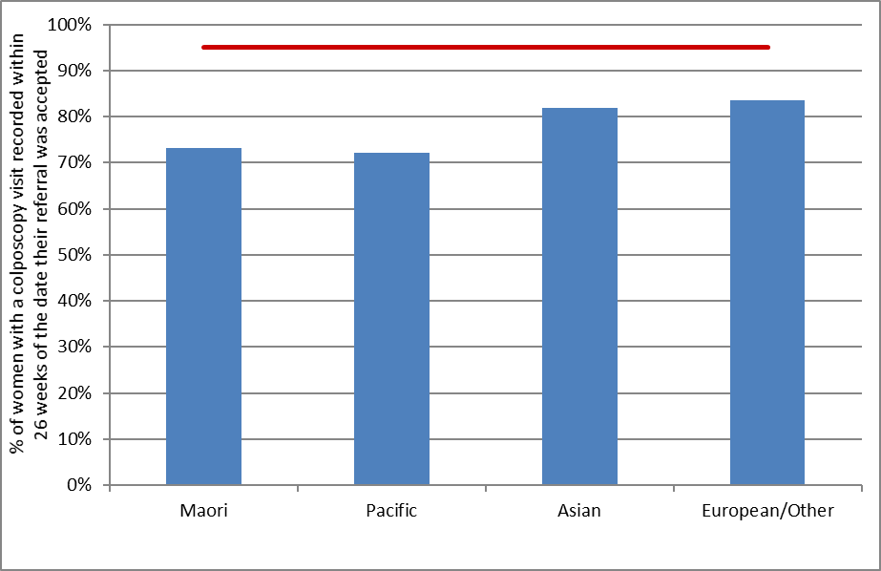

Figure 69 - Trends in the proportion of women with persistent LG cytology or LG cytology and positive hrHPV test and an accepted referral for colposcopy who have a colposcopy visit recorded within 26 weeks of the date the referral was accepted, by ethnicity
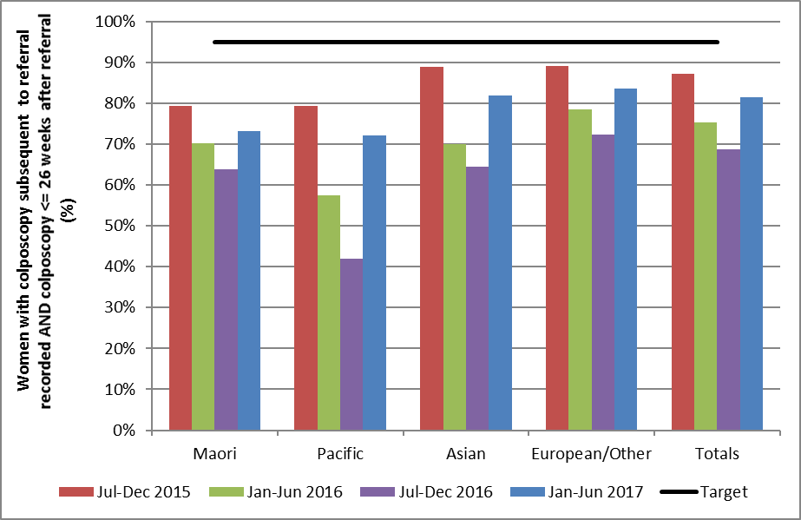

Figure 70 - Trends in proportion of women with persistent LG cytology or LG cytology and positive hrHPV test and an accepted referral for colposcopy who have a colposcopy visit recorded within 26 weeks of the date the referral was accepted, by DHB
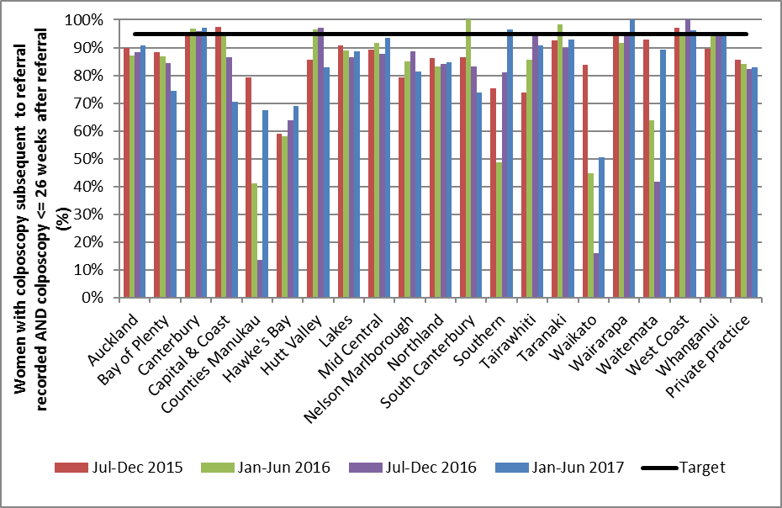

Indicator 7.3 – Adequacy of documenting colposcopy assessment

Definition | This indicator measures performance against Standard 603.  The proportion of colposcopies which occurred within the monitoring period with complete reporting of  - visibility of the squamo-columnar junction  - presence or absence of a visible lesion  - colposcopic opinion regarding the nature of the abnormality  - recommended management and follow-up  - timeframe recommended for follow-up  - items i), ii), and iii) completed  Results are reported by DHB, based on the DHB of the facility where colposcopy was performed.
Target | 100% of medical notes will accurately record colposcopic findings at first and any subsequent assessments, including:  - visibility of the squamo-columnar junction  - presence or absence of a visible lesion  - visibility of the limits of lesion  - colposcopic opinion regarding the nature of the abnormality and the requirement for treatment  - recommended management and follow-up  - timeframe recommended for follow-up.  Items i), ii), v), vi) and the first of the items in iv) can be assessed using data in the NCSP Register, and are reported on below. Item iii) and the second half of item iv) cannot currently be assessed as although all DHBs have transitioned to reporting using 2013 Standards these fields cannot be fully utilised due to a lack of completeness. For private clinics, however, complete reporting against the 2013 Standards is likely to take more time with the majority still reporting against 2008 standards. Therefore, values reported for the private aggregate will continue to use proxies for a much longer period until complete 2013 reporting occurs.  When calculating the completeness of recording of the colposcopic opinion regarding the nature of the abnormality, this was restricted to those colposcopy visits where the presence of a lesion was either noted (colposcopic appearance recorded as abnormal), or could not be ruled out (colposcopic appearance recorded as inconclusive).  When calculating the overall completeness of items i), ii), and iv), colposcopic opinion regarding the nature of the abnormality was only required where colposcopic appearance was recorded as either abnormal or inconclusive.
Current Situation | There were 12,807 colposcopy visits within the current monitoring period recorded on the NCSP Register. Documentation relating to these visits was analysed (Table 61).  Nationally, the visibility of the squamocolumnar junction was documented for 97.3% of visits; the presence or absence of a lesion was documented for all visits; and an opinion regarding the lesion grade was documented for 91.5% of visits where the presence of a lesion could not be ruled out. Additionally, the type of follow-up was documented for 95.5% of visits and the timeframe for follow-up was documented for 94.8% of visits. The visibility of the squamo-columnar junction, presence or absence of a visible lesion, and the colposcopic opinion regarding the nature of the abnormality (where relevant) were all documented for 92.6% of visits.  The colposcopic appearance was reported to be abnormal in 52.7% of colposcopies, and inconclusive in 4.9% of colposcopies (Table 62). Biopsies were taken at 91.4% of colposcopies when the colposcopic appearance was abnormal; 33.3% of colposcopies where the colposcopic appearance was reported as inconclusive, and 18.9% of colposcopies where colposcopic appearance was reported as normal (Table 63).  Documentation varied by DHB, as shown in Figure 71 and Table 61. Documentation of visibility of the squamocolumnar junction varied from 94.8% (Mid Central) to all cases in Tairawhiti. In all DHBs, all colposcopy reports documented the presence or absence of a lesion. Recording of the opinion regarding the abnormality grade (which was only assessed here if colposcopic appearance was recorded as abnormal or inconclusive), ranged from 80.9% (South Canterbury) to 96.2% (Waikato). Recording of the recommended type of follow-up ranged from 82.3% (Waitemata) to all cases (Tairawhiti) and recording of the recommended timeframe for follow-up ranged from 81.8% (Waitemata) to 99.7% (Taranaki). Complete documentation of the visibility of the squamo-columnar junction, presence or absence of a visible lesion, and the colposcopic opinion regarding the nature of the abnormality (where required) ranged from 86.3% (South Canterbury) to 95.7% (Waikato) (Figure 72, Table 61).  Abnormal colposcopic appearance ranged from 41.9% of colposcopies (Capital & Coast) to 61.6% of colposcopies (Canterbury). Inconclusive colposcopic appearance ranged from 2.1% of colposcopies (Waikato) to 11.1% of colposcopies (South Canterbury) (Table 62). The proportion of colposcopies where a biopsy was taken also varied by DHB. This proportion ranged from 81.8% of visits in South Canterbury, up to 97.2% (Northland) when the colposcopic appearance was abnormal, and from 6.1% (Whanganui) up to 34.8% (Wairarapa) when the colposcopic appearance was normal (Table 63).  Colposcopies performed in private practice accounted for 9.4% of all colposcopies recorded on the NCSP Register in New Zealand in the current monitoring period. The documentation rate varied according to the recorded section in private practice when compared with public clinics overall (Table 61); The proportion complete was higher in public clinics overall when compared to the private clinics overall for documenting visibility of the squamocolumnar junction (97.5% for public clinics overall; 95.6% for private practice) and follow-up timeframe (95.0% for public clinics; 93.4% for private practice). Documentation completion rate was higher in private clinics overall than for public clinics overall for lesion grade (94.2% for private practice and 91.2% for public clinics) and follow-up type (96.7% for private practice and 95.4% for public clinics). The completion rate for documenting the presence or absence of a lesion was 100% in both private and public clinics. The proportion of colposcopies with complete documentation of the visibility of the squamo-columnar junction, presence or absence of a visible lesion, and the colposcopic opinion regarding the nature of the abnormality was similar for private practice and for public clinics overall (92.6%).
Trends | For New Zealand as a whole, documentation of colposcopy visit items has remained fairly consistent over the last four monitoring periods. In the current period visibility of the squamocolumnar junction was documented for 97.3% of colposcopies, compared with between 97.4% and 97.7% for the previous three monitoring periods. The presence or absence of a lesion was documented for all visits in both the current and previous three periods. In the current period an opinion regarding the lesion grade was documented for 91.5% of visits where the presence of a lesion could not be ruled out, compared with between 91.5% and 92.0% for the previous three monitoring periods. Recording of recommended follow-up type was documented for 95.5% of visits in the current period, which is within the range seen for the previous three periods (92.2% - 96.5%). This was also the case for recommended timeframe for follow-up, which was recorded for 94.8% of visits in the current period compared with 91.6% - 95.9% in the previous three periods.  Trends in the completion of all required fields by DHB are shown in Figure 72.  Trends in the number of colposcopies recorded on the NCSP Register by DHB are shown in Figure 73. The number of colposcopies decreased in the current monitoring period in 14 of the 20 DHBs with an overall decrease in the number of colposcopies of 4.8%.
Comments | The current colposcopy standard was published in July 2013 (available at https://www.nsu.govt.nz/health-professionals/national-cervical-screening-programme/policies-and-standards).  This indicator is only able to assess adequacy of documentation where colposcopy visits have been entered onto the NCSP Register in accordance with the 2013 Colposcopy Standard. Therefore, it cannot provide an absolute estimate of adequacy if these data are incomplete on the NCSP Register (that is, if the colposcopy visit itself is not recorded on the NCSP Register). The data used in this analysis was extracted from the NCSP Register in mid-February 2017.  Missing colposcopy data from the latter part of 2015 (Report 44) for some DHBs led to an underestimate of the number of colposcopies in these DHBs during that previous monitoring period, and this likely explains the apparent increase in the volume of colposcopies recorded in Report 45 (1 January – 30 June 2016). This is observable in the trends chart seen in Figure 73.  Some items required by the standard, such as the recording of recommended follow-up type and timeframe, cannot necessarily be completed at the time of the colposcopy visit – for example because they will depend on results of histology tests or other reviews. For DHBs that electronically report data to the NCSP Register, the completeness of these fields is likely to lag behind that of other fields, because the colposcopy visit data will be loaded onto the NCSP Register soon after the visit and before this information is available. As more DHBs have moved to electronic reporting, this lag could explain the reduction in the percentage of colposcopies where these items are complete, compared to previous reports. Additionally, since there is a lag in reporting recommended type and timeframe for follow-up, these two items were removed from the calculation of ‘all items complete’ in Report 43 and this has remained the case in subsequent reports. These are often not the fields with the lowest completion rates however, and therefore removing them from the calculation made a relatively small difference to ‘all items complete’. In 18 out of the 20 DHBs, the field with the lowest completion rate is the documentation of the opinion regarding the nature of abnormality grade (only required where the presence of a lesion could not be ruled out). It is possible that the low completion rate for predicted abnormality grade could be because some clinics are incorrectly interpreting the requirement to document a predicted abnormality grade (which should be documented at the time of colposcopy) as a requirement to document the diagnosed abnormality grade, which can only be done after histology results are available.  Some items in the 2013 colposcopy standard are not included in the 2008 colposcopy visit form or on the NCSP Register, in particular the visibility of the limits of the lesion, the biopsy site, and an explicit colposcopic opinion regarding the need for treatment (although a recommended follow-up timeframe is recorded, and whether follow-up is recommended with a colposcopist, oncology services, or sample taker). It is also not possible to determine the reason for the visit from the colposcopy visit form, for example if this is a first visit or a follow-up visit; or whether it was prompted by a high grade cytology result, a low grade cytology result which is either persistent or accompanied by a positive high risk HPV test result, a request for referral regardless of cytology results, or another reason. As most private colposcopists were still reporting to the NCSP Register using the 2008 standard and due to the low completeness of the fields required to calculate the additional items for those DHBs using 2013 Standards, these items could not be taken into account in this indicator for the current report.
Figure 71 - Completion of colposcopic assessment fields, by DHB
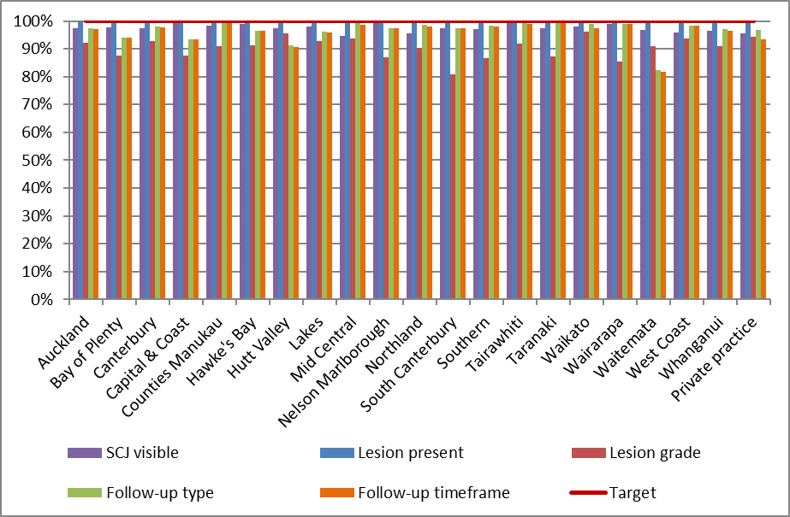

Figure 72 - Trends in the completion of all required colposcopic assessment fields, by DHB
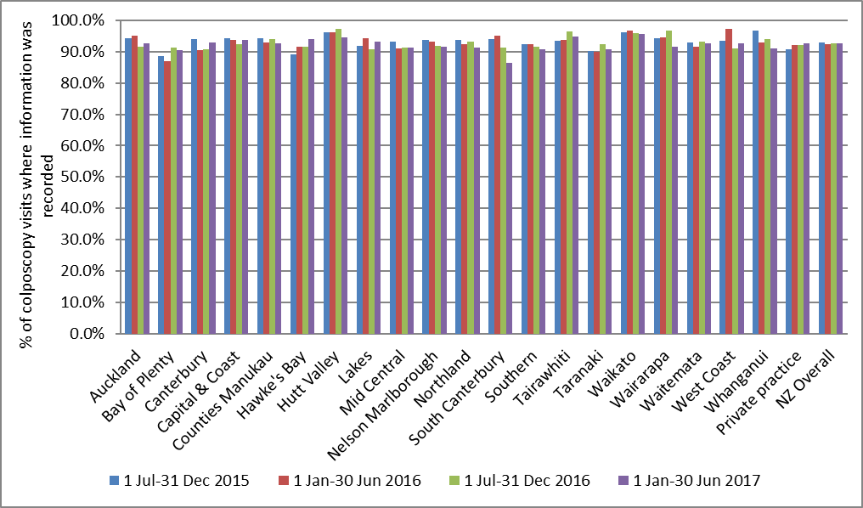
Note: Definition of ‘all fields completed’ changed from 1 January 2015 as two fields were no longer included in the calculation (follow-up type and timeframe)

Figure 73 - Trends in the number of colposcopies recorded on the NCSP Register, by DHB
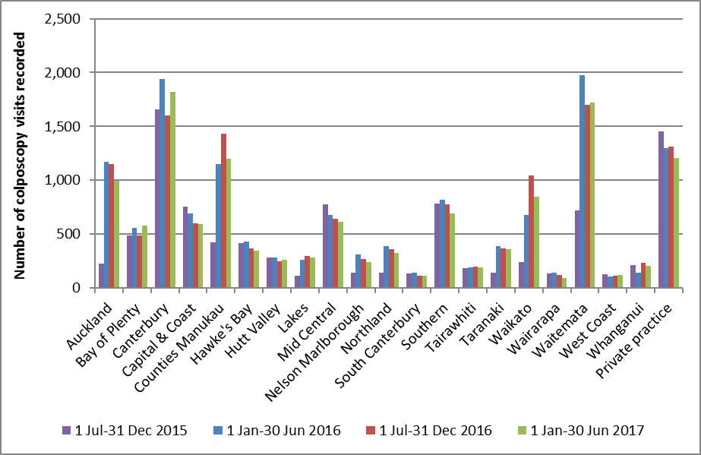
The apparent decrease in the number of colposcopies in 1 Jul-31 Dec 2015 compared to 1 Jan-30 Jun 2015 in several DHBs is because those DHBs were unable to electronically report colposcopy data to the NCSP Register after September 2015. Therefore, the values for the period 1 Jul-31 Dec 2015 above do not include colposcopies which occurred after September 2015 in the affected DHBs (Auckland, Counties Manukau, Lakes, Nelson Marlborough, Northland, Taranaki, Waikato and Waitemata).

Indicator 7.4 – Timeliness and appropriateness of treatment

Definition | This indicator measures performance against Standard 605.  It reports on the proportion of women with histological high grade squamous intraepithelial lesions (HSIL) who are treated within eight weeks of histological confirmation. Histological HSIL is defined as CIN 2, CIN 3, CIN 2/3 or HSIL not otherwise specified (SNOMED codes M74007, M74008, M80102, M80702 and M67017).  Histological LSIL is not routinely treated, as treatment is not recommended for women with low grade abnormalities in the 2013 Colposcopy Standards (consistent with 2008 NCSP Guidelines for Cervical Screening in New Zealand). The 2013 Colposcopy Standard recommends that the number of women who are treated with low-grade lesions (less than CIN 2 on histology) be minimised. Therefore, treatment of LSIL is included in this report for descriptive purposes and to examine the appropriateness (not timeliness) of treatment. This report describes the number and proportion of women with histological low grade squamous intraepithelial lesions (LSIL) who are treated. To ensure consistency in the follow-up time examined for each woman and in order to allow timely reporting, treatments are included if they occur within 26 weeks of histological confirmation. Histological LSIL is defined as CIN1 or CIN not otherwise specified (SNOMED codes M74006, M67016, M74000 and M67015). Women with histological LSIL who are treated but who also have a record of histological HSIL in the six-month period prior to their treatment are excluded, as their treatment in considered appropriate.  Women are included in this indicator if they have a histology sample where the result is HSIL or LSIL (as previously defined, above), and the sample was collected in the six-month period immediately prior to the current monitoring period (i.e. in the period 1 July - 31 December 2016). HSIL results must have been reported at least 8 weeks prior to the end of the current monitoring period, and LSIL results must have been reported at least 26 weeks prior to the end of the current monitoring period, in order to allow sufficient follow-up time for this indicator.  Treatment was defined as a colposcopy visit where there was a record of electrosurgical excision, laser ablation or excision, cold knife cone biopsy, or total hysterectomy. Colposcopy visits involving punch biopsies only are not included.  DHB is assigned based on the clinic where the histology sample was collected.
Target | 90% or more of women with HSIL are treated within 8 weeks of histological confirmation of CIN 2/3.  There is no explicit target relating to low grade lesions, but the standard recommends that the number of women who are treated with low-grade lesions (less than CIN 2 on histology) be minimised.
Current Situation | There were 2,498 women with a histological diagnosis of CIN 2/3 (associated with histology samples collected in the previous six months, and reported at least eight weeks prior to 30 June 2017). Of these women, 1,546 women (61.9%) were treated within eight weeks of HSIL being histologically confirmed. The proportion of women treated within eight weeks varied widely by DHB, from 50.0% (Wairarapa) to 85.4% of women (Whanganui). No DHBs met the target of at least 90% of women treated within eight weeks of histological confirmation of HSIL (Figure 74, Table 19).  There were 2,138 women with a histological diagnosis of LSIL (associated with histology samples collected in the previous six months, and reported at least 26 weeks prior to 30 June 2017). Treatment for histological LSIL is not routinely recommended in the 2013 Colposcopy Standards or the 2008 NCSP Guidelines for Cervical Screening in New Zealand¹⁵, and so timeliness of treatment is not examined or compared to a target for LSIL. However, for descriptive purposes and to examine appropriateness of treatment, follow-up records were retrieved for the 2,138 women with histological LSIL. Of these women, 143 (6.7%) women were subsequently treated within 26 weeks of LSIL being histologically confirmed and had no additional record of high grade histology in the six months preceding their treatment. The proportion of women subsequently treated varied widely by DHB, from no women (Nelson Marlborough, South Canterbury, Tairawhiti and Wairarapa) to 27.3% (Hawke's Bay) (Table 19). The DHB where the largest number of women were treated was Canterbury and Counties Manukau (26 women).
Trends | Nationally, the proportion of women with histological HSIL who were treated within eight weeks of histological confirmation is lower than the previous monitoring report; 64.5% in the previous report, 61.9% in the current report. The proportion of women with histological HSIL who were treated within eight weeks for the current report period decreased in 14 of the 20 DHBs when compared with the previous report period (Figure 75).  The proportion of women with histological LSIL who were subsequently treated (within 26 weeks of LSIL being histologically confirmed) has decreased, from 8.1% for the previous report to 6.7% in the current report.
Comments | Whether or not treatment has occurred is determined for this indicator via colposcopy data in the NCSP Register. Trends may reflect changes in the completeness of colposcopy data recording treatment within a DHB rather than necessarily true increases or decreases in the proportion of women treated. This incomplete recording of treatment potentially affects the results for treatments for both HSIL and LSIL. In some cases, treatment may have occurred in a different clinic to that where the original histology sample was collected. Facilities not explicitly defined as DHB (public) clinics are aggregated together as private practice. It is possible that women whose original HSIL (or LSIL) histology sample was collected outside a DHB clinic may in practice have been treated at a DHB clinic (or conversely a woman whose histology sample was collected at a DHB clinic may have been treated outside a DHB clinic). Note, however, that timeliness is assessed here by including any treatment visits, regardless of where they occurred.  The 2013 National Cervical Screening Programme Policies and Standards: ‘Section 6 – Providing a Colposcopy Service’ requires colposcopy clinics to provide information about the “decision to treat date”. At present, the “decision to treat date” is not available to use due to low completeness of this item on the NCSP Register. When this “decision to treat date” information is available for all DHBs for a full monitoring period, it will be used to calculate timeliness of treatment for women with histological HSIL.

Figure 74 - Proportion of women treated within eight weeks of histological confirmation of HSIL, by DHB
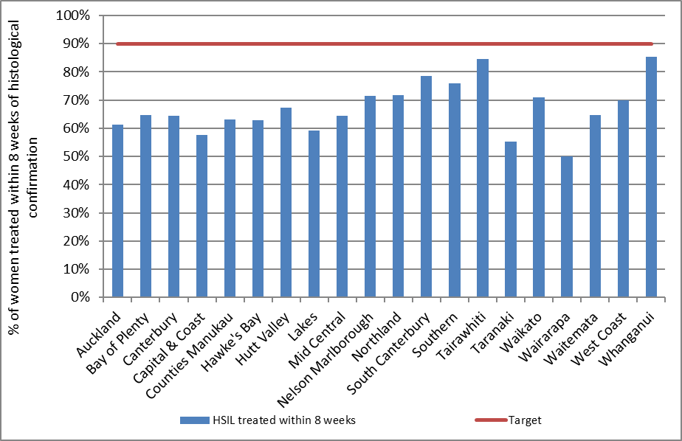
Date that histology results were reported to requesting clinician is used as the date of histological confirmation. DHB is assigned based on the clinic where the original HSIL histology sample was collected, however treatments will be included regardless of where they occurred.

Figure 75 - Trends in the proportion of women treated within eight weeks of histological confirmation of HSIL, by DHB
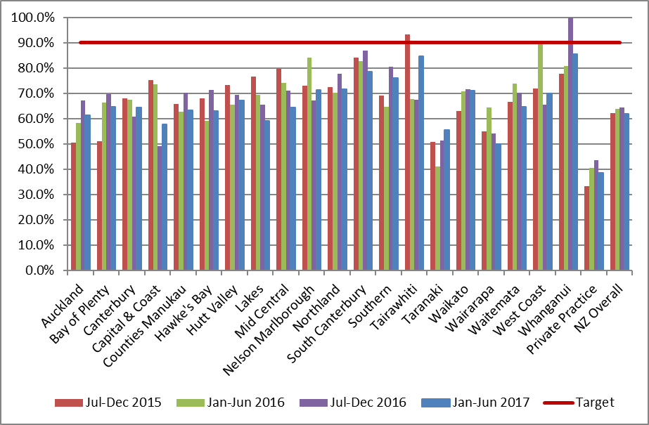

Table 19 - Timeliness and appropriateness of treatment, by DHB
DHB | Women with CIN 2/3 | Treated within 8 weeks |  | Women with histological LSIL* | Women subsequently treated†
 | N | N | % | N | N | %
Public clinics (overall) | 2,132 | 1,405 | 65.9 | 1,729 | 132 | 7.6
Auckland | 183 | 112 | 61.2 | 181 | 17 | 9.4
Bay of Plenty | 99 | 64 | 64.6 | 83 | 4 | 4.8
Canterbury | 336 | 216 | 64.3 | 345 | 26 | 7.5
Capital & Coast | 97 | 56 | 57.7 | 55 | 8 | 14.5
Counties Manukau | 258 | 163 | 63.2 | 405 | 26 | 6.4
Hawke's Bay | 81 | 51 | 63.0 | 11 | 3 | 27.3
Hutt Valley | 55 | 37 | 67.3 | 29 | 1 | 3.4
Lakes | 49 | 29 | 59.2 | 50 | 5 | 10.0
Mid Central | 121 | 78 | 64.5 | 62 | 6 | 9.7
Nelson Marlborough | 35 | 25 | 71.4 | 7 | - | -
Northland | 81 | 58 | 71.6 | 16 | 3 | 18.8
South Canterbury | 14 | 11 | 78.6 | 8 | - | -
Southern | 129 | 98 | 76.0 | 43 | 5 | 11.6
Tairawhiti | 39 | 33 | 84.6 | 30 | - | -
Taranaki | 65 | 36 | 55.4 | 68 | 6 | 8.8
Waikato | 193 | 137 | 71.0 | 69 | 1 | 1.4
Wairarapa | 16 | 8 | 50.0 | 6 | - | -
Waitemata | 213 | 138 | 64.8 | 197 | 16 | 8.1
West Coast | 20 | 14 | 70.0 | 31 | 2 | 6.5
Whanganui | 48 | 41 | 85.4 | 33 | 3 | 9.1
Private Practice | 366 | 141 | 38.5 | 409 | 11 | 2.7
Total | 2,498 | 1,546 | 61.9 | 2,138 | 143 | 6.7
DHB is assigned based on the clinic where the original HSIL histology sample was collected, however treatments will be included regardless of where they occurred.
* CIN1, CIN not otherwise specified (SNOMED codes M67015, M67016, M74000 and M74006). CIN1 is not routinely treated (consistent with 2008 NCSP Guidelines for Cervical Screening in New Zealand), so these results are not compared to a target. They appear here for descriptive purposes and to show how frequently the women with histologically confirmed LSIL were treated. † Includes women treated within 26 weeks of LSIL histology. Date that histology results were reported to requesting clinician is used as the date of histological confirmation.

Indicator 7.5 – Timely discharging of women after treatment

Definition | This indicator measures performance against Standard 608.  It reports on the proportion of women treated for a high grade lesion who:  - receive colposcopy within the period up to nine months after their treatment  - receive colposcopy and cytology within the period up to nine months after their treatment  - are discharged appropriately within 12 months of their treatment.  Treatment was defined as a colposcopy visit where there was a record of electrosurgical excision, laser ablation or excision, cold knife cone biopsy, or total hysterectomy. Colposcopy visits involving punch biopsies only are not included. Treatment was included if it was for a high grade lesion (CIN 2 or CIN 3), based on histology results for any histology specimen collected concurrent with or up to six months prior to treatment.  To allow for 12 months of follow-up information to be available, this indicator reports on women treated in the six-month period ending 12 months prior to the end of the current monitoring period (i.e. 1 January - 30 June 2016). Records for each woman treated in the six-month period ending 12 months prior to the end of current monitoring period were retrieved from the NCSP Register. Among these treated women, the number of women with a colposcopy visit, and with both a colposcopy visits and a cytology sample was calculated. Follow-up colposcopy visits were not restricted to only those within the same DHB as where initial treatment occurred; rather any colposcopy visit recorded on the NCSP Register for that woman was included. Follow-up visits were retrieved for the period up to nine months after the treatment visit.  Eligibility for discharge is not explicitly defined in the NCSP Colposcopy Standard, so based on advice from the NCSP Advisory Group, women were defined as eligible for discharge if they had a colposcopy visit and cytology test following their treatment, and their cytology result was negative.  Women were defined as having been discharged when their colposcopy report form recommended follow-up by their sample taker/ referring practitioner.  Results are reported by DHB, based on the DHB of the facility where the treatment colposcopy was performed. Therefore, for the purpose of this indicator, the DHB where treatment occurred was regarded as the DHB responsible for ensuring a treated woman was followed up. However, as previously described, the follow-up colposcopy visit need not have occurred within that DHB.
Target | 90% or more of women treated for CIN 2 or 3 should have a colposcopy and smear within the nine-month period post-treatment  90% or more of women treated for CIN 2 or 3 should be discharged back to the sample taker as appropriate.
Current Situation | There were 1,680 women treated for CIN 2 or CIN 3 lesions in the six-month period from 1 January - 30 June 2016. These women were followed up for 12 months from the date of their treatment visit.  Follow-up post treatment  There were 1,284 women (76.4%) with a follow-up colposcopy, and 1,261 women (75.1%) with both a follow-up colposcopy and a cytology sample in the nine month period after their treatment visit.  Figure 76 shows the percentage of treated women with a record of follow-up colposcopy, and both follow-up colposcopy and a cytology sample, in the period up to nine months post-treatment by DHB. Generally, the number of women with both cytology and colposcopy was very similar to the number of women with at least colposcopy (Table 65). The maximum number of women with colposcopy only and no record of a cytology sample in the timeframe was at most three in Canterbury, Counties Manukau and Mid Central.  Nationally, the percentage of women treated for high grade lesions with a record of colposcopy and cytology within the nine-month period post-treatment (75.1%) is below the target value of 90%.  No DHBs met the target of at least 90% of women receiving cytology and colposcopy within nine months post-treatment (Figure 76, Table 65) The percentage of treated women with a record of both follow-up colposcopy and a cytology sample in the period up to nine months post-treatment varied by DHB from 39.0% (Bay of Plenty) to 88.9% (Whanganui).  Women discharged appropriately  In total, 1,258 women (74.9% of those treated) were eligible to be discharged by 12 months after their treatment visit, and 1,057 of these women (84.0%) were discharged within 12 months of treatment (Table 64). Figure 77 shows how these percentages varied by DHB. The percentage of women eligible for discharge who were discharged within 12 months of treatment ranged from 20.0% (South Canterbury) to all eligible women (Tairawhiti, Wairarapa and West Coast) (Table 64). In some cases, the number of women eligible for discharge was small, so these results should be interpreted with caution (15 or fewer women in South Canterbury, Wairarapa, West Coast and Whanganui).  Eleven DHBs met the target of discharging 90% of women where appropriate within 12 months (Capital & Coast, Counties Manukau, Hawke's Bay, Lakes, Nelson Marlborough, Southern, Tairawhiti, Waikato, Wairarapa, West Coast and Whanganui).  In total (that is, without considering whether or not women met the criteria suggested by the NCSP Advisory Group to be eligible for discharge), 1,196 women were discharged within 12 months of being treated for a high grade lesion (71.2% of all women treated for a high grade lesion).
Trends | The proportion of women with follow-up has increased overall (from 75.4% to 76.4% for colposcopy, and from 74.3% to 75.1% for both cytology and colposcopy). No DHBs met the target of 90% of women having colposcopy and cytology within nine months of treatment, compared to one DHB in the previous report.  The proportion of women discharged appropriately to their sample taker by 12 months has increased slightly (83.5% in the previous report; 84.0% in the current report). The number of DHBs meeting the target of 90% increased from eight to eleven.
Comments | Since this indicator relies on colposcopy data in the NCSP Register, there is the possibility that incomplete reporting of colposcopy visits has led to an underestimate of the number of women with follow-up colposcopy visits and the number discharged in a given time period. The data used in this analysis was extracted from the NCSP Register in early-September 2017.  The target that 90% or more of women treated for CIN 2 or 3 should be discharged back to the sample taker as appropriate was assessed in this monitoring report, based on guidance from the NCSP Advisory Group as to when discharge would be appropriate. However, it should be noted that neither the 2008 NCSP Guidelines for Cervical Screening in New Zealand nor the 2013 Colposcopy Standards themselves provide explicit guidance for when discharge back to the sample taker is appropriate.  In some circumstances, women may be treated within one DHB, but referred to another DHB for follow-up. This information is not always recorded in the NCSP Register however, and for clarity in this report, women remain assigned to the DHB where their treatment was performed. However, this measure does take into account all follow-up visits which women attend, regardless of the DHB in which they occurred.

Figure 76 - Percentage of women treated with colposcopy, and both colposcopy and cytology, within nine months post-treatment, by DHB
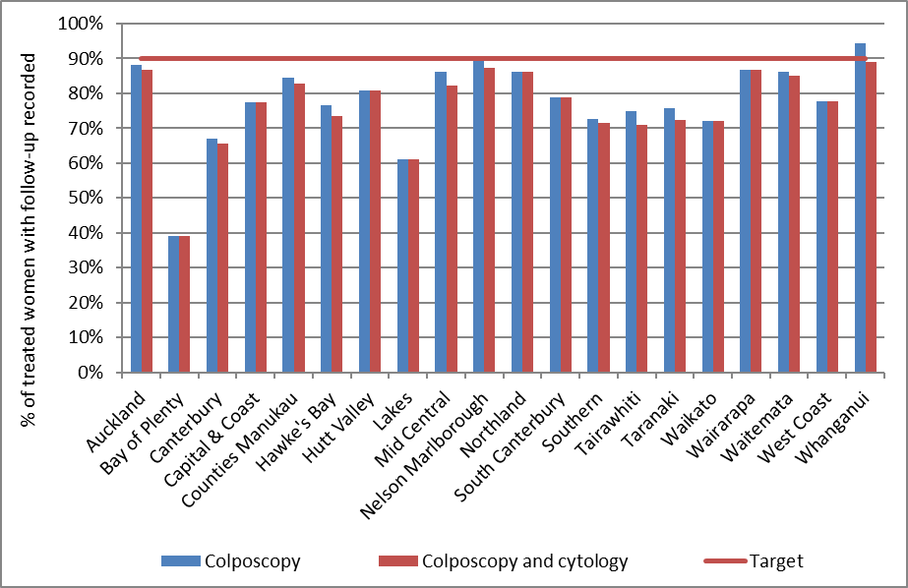

Figure 77 - Percentage of women discharged appropriately within 12 months of treatment, by DHB
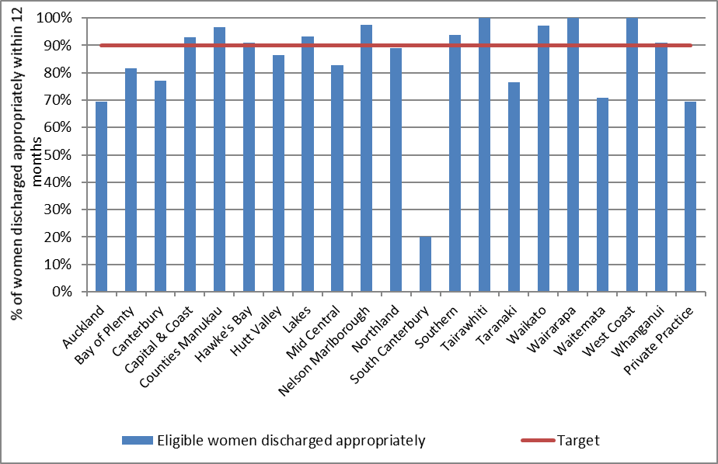

Indicator 8 – HPV tests

The indicators report on the use of HPV testing. At present, they incorporate the following indicators:

- Triage of low grade cytology

- HPV test volumes (including purpose for which the test was performed)

- HPV tests for follow-up of women with a historical high grade abnormality

Specific monitoring of the other uses of HPV testing is not yet included. These other purposes include:
- Management of women previously treated for CIN
- Management of women with a high grade squamous cytology result in the past followed by negative cytology
- Resolution of discordant cytology, colposcopy and histology

Indicator 8.1 – Triage of low grade cytology

Definition | For women with an ASC-US or LSIL (low grade) cytology result relating to a cervical sample taken in the monitoring period, and with no recent abnormal cytology (i.e. abnormal cytology results relating to specimens taken in the preceding five years), the following are reported on as follows:  - The number and proportion of women with a subsequent HPV triage test (by age group, and cytology laboratory)  - Women with positive HPV triage result, as a proportion of women with a valid HPV test (by age group, and cytology laboratory)  - Histological outcomes in women with a positive triage test, where this information is available within 12 months following a positive HPV triage test  Where a woman has two different low grade cytology results, relating to a sample or samples collected on the same date, she is grouped in accordance with the most serious result (i.e. LSIL).  A subsequent HPV triage test is defined as an HPV test where the sample was collected at the same time or after the cytology sample, and where there is a result available (including invalid results).  Women whose ASC-US or LSIL cytology test is associated with a recommendation code of R14 (refer regardless of cytology result) are excluded, as they may be symptomatic.  Women who are aged less than 30 years are excluded from this indicator if they have ever had either a high grade squamous cytology result (ASC-H, HSIL) or a high grade squamous histology result (CIN 2/3), as they may be having an HPV test in order to follow-up a previous high grade squamous abnormality (cytology or histology, i.e. historical testing or as a test-of-cure following treatment for CIN2/3).  If a laboratory which performed the cytology refers the HPV test to a different laboratory, measures are based on the laboratory which performed the cytology test.  Measures reported by age are based on the age of the women on the date that the cytology sample was collected.
Target | Targets have not yet been set.
Current Situation | There were 654 women aged less than 30 years and 1,356 women aged 30 years or more with an ASC-US cytology result relating to a sample collected in the current monitoring period, and who had no abnormal cytology results relating to samples taken in the previous five years. The corresponding figures for LSIL are 2,217 women aged less than 30 years and 1,404 women aged 30 years or more.  HPV triage  NCSP Guidelines (2008) recommend that women aged 30 years or more who have not had an abnormal cytology report in the previous five years are offered a HPV triage test following ASC-US or LSIL cytology. Among these eligible women, 97.7% of women aged 30 years or more with an ASC-US cytology result, and 96.9% of women aged 30 years or more with an LSIL cytology result are recorded as having a subsequent HPV test (Table 66, Table 67). These proportions ranged from 94.0% (Medlab Central Ltd.) to 99.0% (Anatomical Pathology Services) for ASC-US cytology results and from 90.1% (Medlab Central Ltd.) to 98.3% (Anatomical Pathology Services) for LSIL cytology results (Figure 78, Table 66, Table 67).  HPV triage is not included in the recommendations for women aged less than 30 years, and accordingly the proportions of women aged less than 30 years with a subsequent HPV test are very small. Subsequent HPV tests are recorded in the NCSP Register for 1.2% of women aged less than 30 years with ASC-US results, and 0.6% of women aged less than 30 years with LSIL results. These proportions ranged from 0.6% of women (Anatomical Pathology Services) to 1.9% (LabPLUS) for women with ASC-US results, and from no women (LabPLUS) to 1.5% (Canterbury Health Laboratories) for women with LSIL results (Figure 79, Table 66, Table 67).  Positive triage tests  Among women aged 30 years or more with a valid HPV triage test results, the proportion who were positive for high risk HPV (hrHPV) was 24.8% for women with ASC-US results, and 58.5% for women with LSIL results. These proportions varied by laboratory from 11.6% (LabPLUS) to 35.8% (Pathlab) for women with ASC-US cytology (Figure 80), and from 48.8% (Medlab Central Ltd) to 63.7% (Pathlab) for women with LSIL cytology (Figure 81).  The proportion of women whose HPV triage test was positive also varied by age. Among women aged 30-69 years, HPV positivity rates were highest for those aged 30-39 years for women with ASC-US cytology (30.5%), and for those with LSIL cytology (66.3%). HPV positivity rates generally decreased with increasing age, but were broadly similar for women in each of the 10-year age groups between 40 and 69 years. For women with ASC-US results, the positivity rates in the 10-year age groups between 40 and 69 years ranged between 20.8% and 22.6% (Figure 82, Table 20). For women with LSIL results, the positivity rates were between 51.5% and 52.7% for these 10-year age groups (Figure 82, Table 21).  Histological outcomes in triage-positive women who attended colposcopy  In order to allow sufficient time for women to have attended colposcopy following a positive triage test, histological outcomes were assessed in women with low grade cytology and a positive HPV triage test in the six-month period 1 January – 30 June 2016. In this period, there were 322 women with an ASC-US cytology result and positive HPV triage test, and 859 who had an LSIL cytology result and positive HPV triage test. 288 (89.4%) of the women with ASC-US who were triage-positive and 785 (91.4%) of the women with LSIL who were triage-positive had a record of colposcopy and/ or histology within the 12 months following their initial test results. Among the women with a record of colposcopy, 192 (66.7%) and 605 (77.1%) of the women with ASC-US and LSIL respectively have a histology record.  Histological outcomes in these women were initially considered in an analogous manner to Indicator 5.2 – that is, the number of women with CIN 2 or worse histology (CIN 2+; also see Appendix D), as a percentage of women who had a histology result available. The percentage of women with histology whose histology result was CIN 2+ was 23.4% for HPV triage-positive ASC-US and 23.1% for HPV triage-positive LSIL (Table 68, Table 69). These percentages varied by laboratory from 11.1% (Pathlab) to 36.8% (Medlab Central Ltd) for HPV triage-positive ASC-US and from 17.5% (Anatomical Pathology Services) to 34.1% (Medlab Central Ltd.) for HPV triage-positive LSIL (Figure 83). Note that these ranges excludes LabPLUS due to the very small numbers of triage-positive women (see Table 68 and Table 69).  We additionally considered histological outcomes as a percentage of women who attended colposcopy (rather than only those with a histology result), as some women may have no histology because colposcopic impression was normal. The corresponding percentages of women with CIN 2+ histology was 15.6% for HPV triage-positive ASC-US and 17.8% for HPV triage-positive LSIL (Table 68, Table 69). These percentages varied by laboratory from 5.8% (Pathlab) to 33.3% (Canterbury Health Laboratories) for HPV triage-positive ASC-US and from 13.1% (Anatomical Pathology Services) to 26.9% (Medlab Central Ltd.) for HPV triage-positive LSIL (Figure 84). These are also compared with the corresponding percentages of women who attended colposcopy within six months with CIN 2+ histology for women with ASC-H and HSIL cytology, by laboratory, in Figure 84.  Histological outcomes within 12 months in women with triage-positive test results are shown by age, as a percentage of women with histology recorded (Figure 86), and as a percentage of women with colposcopy recorded (Figure 87). Among women aged 30-69 years, the percentage of women with CIN 2+ histology within 12 months generally decreased with increasing age for HPV triage-positive ASC-US and LSIL. There were no cases of CIN 2+ among women aged 70+ years with ASC-US or LSIL and a positive HPV triage test.
Trends | HPV triage  The proportion of women aged 30 years or more with low grade cytology (and no recent abnormal cytology in the preceding five years) who received a subsequent HPV test is higher than in the previous report for women with ASC-US results (96.9% in the previous period compared to 97.7% in the current period), however remained stable for women with LSIL results (97.1% in the previous period compared to 96.9% in the current period). The proportion of women aged less than 30 years with a subsequent HPV test is similar to the previous monitoring period for ASC-US and for LSIL results (1.3% in the previous period compared to 1.2% in the current period for ASC-US; and similar in the previous and current period at 0.6% for LSIL).  Positive triage tests  The proportion of women aged 30 years or more who tested positive for a high risk HPV type was similar for ASC-US in both the previous and current report (24.5% in the previous report; 24.8% in the current report), and increased slightly for LSIL (57.7% in the previous report; 58.5% in the current report).  Histological outcomes in triage-positive women who attended colposcopy  89.4% of women with ASC-US cytology and a positive HPV triage test in the six-month reference period for the current report had a record of colposcopy and/ or histology within the 12 months following their test result, which has decreased since the previous report (91.9%). For the current report, 66.7% of these women with colposcopy also had a histology record, which is similar to the previous report (66.8%). Of these women with a histology record, the histology result was CIN 2+ for 23.4% of women in the current report, compared with 27.3% in the previous report. When histological CIN 2+ outcomes were considered as a proportion of women with colposcopy, rather than histology, the corresponding figures were 15.6% in the current report versus 18.2% in the previous report. The proportion of triage-positive ASC-US women who attended colposcopy with CIN 2+ histology decreased compared to the previous report at four of six laboratories (Figure 88; excludes LabPLUS).  For women with LSIL cytology and a positive HPV triage test in the reference period for the current report, 91.4% had a record of colposcopy and/ or histology within 12 months of their result, which is slightly higher to the 90.9% of women in the previous report. For the current report 77.1% of these women with colposcopy also had a histology record, compared with 76.8% for the previous report. Of these women with a histology record, the histology result was CIN 2+ for 23.1% of women in the current report, compared with 19.8% in the previous report. When histological CIN 2+ outcomes were considered as a proportion of women with colposcopy, rather than histology, the corresponding figures were 17.8% for the current report and 15.2% for the previous report. Trends in this proportion of LSIL triage-positive women who attended colposcopy with CIN 2+ histology are shown in Figure 89.
Comments | A small number of women aged less than 30 years with low grade results, no recent abnormalities (in the previous five years) and no record at any time of a previous high grade squamous abnormality (cytological or histological), have a record of a subsequent HPV test (22 women). This is the same number of women than in the previous report. It is uncertain whether these HPV tests were performed for the purpose of triage, or for other reasons. In this report, we excluded women aged less than 30 years from this indicator if they had ever had a previous high grade squamous abnormality (either ASC-H/ HSIL cytology, or CIN 2/3 histology). This was done in order to avoid potential inadvertent inclusion in this group of women being tested for HPV in concordance with the guidelines as part of “historical testing”. This could occur as a result of a previous high grade squamous abnormality (either ASC-H/ HSIL cytology, or CIN 2/3 histology) currently managed by annual cytology, which occurred more than five years earlier (since abnormalities within the previous five years are already taken into account). It is also possible that some women were aged 29 years at the time of their cytology sample, but 30 years at the time of the cytology result, although previous exploration has suggested that the extent of this is likely to be small.^{16, 17} Another possible explanation is that these women are being followed up for a previous high grade result but this is not recorded on the NCSP Register (for example because this occurred overseas). The HPV test may also have been ordered by a specialist. However note that inadvertent inclusion of HPV tests ordered by a specialist to resolve discordant results (or for historical testing) should be minimised since women were excluded from this indicator if they had any recent abnormalities (past five years, any abnormality grade); if they had ever had a high grade squamous abnormality (but no glandular abnormality) recorded on the NCSP Register; if the sample for HPV testing was collected on the same day as a recorded colposcopy visit for that woman; or if the sample for HPV testing was collected more than five weeks after the cytology sample.
Figure 78 - Proportion of women (aged 30 years or more) with low grade cytology who have a subsequent HPV test, by laboratory and cytology result
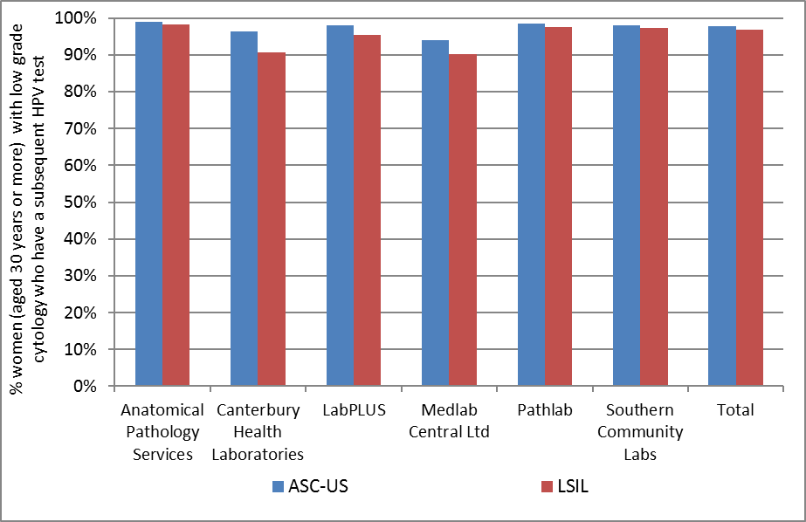
Excludes women with abnormal cytology in the five years preceding their low grade cytology sample

Figure 79 - Proportion of women (aged less than 30 years) with low grade cytology who have a subsequent HPV test, by laboratory and cytology result
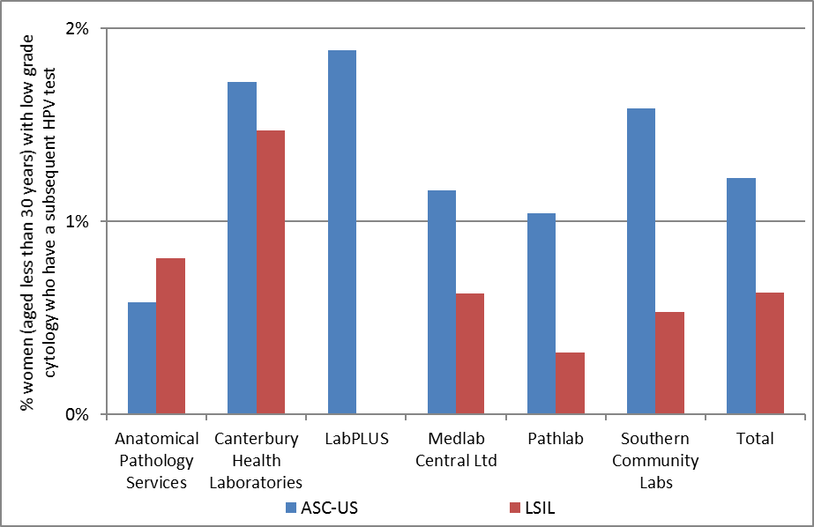
Excludes women with abnormal cytology in the five years preceding their low grade cytology sample and women who have ever had a high grade squamous abnormality (cytology or histology).
There were no women with cytology samples processed by LabPLUS who had an LSIL result.

Figure 80 - Proportion of HPV triage tests which are positive following ASC-US cytology (women aged 30 years or more), by cytology laboratory
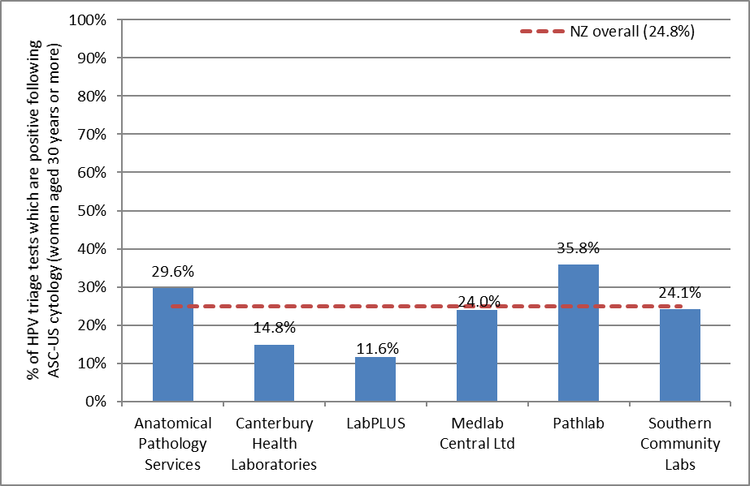

Figure 81 - Proportion of HPV triage tests which are positive following LSIL cytology (women aged 30 years or more), by cytology laboratory
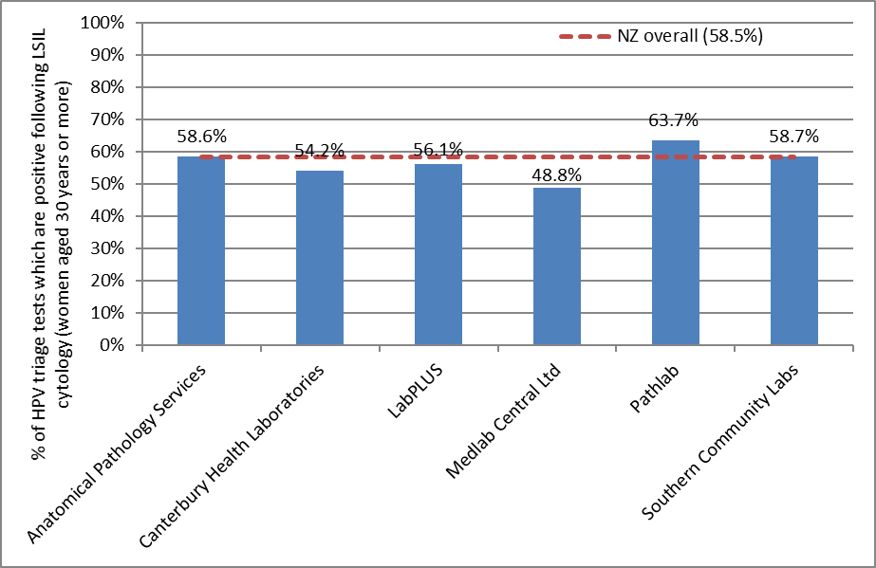

Figure 82 - Proportion of women with an HPV triage test who are HPV positive, by age and cytology result
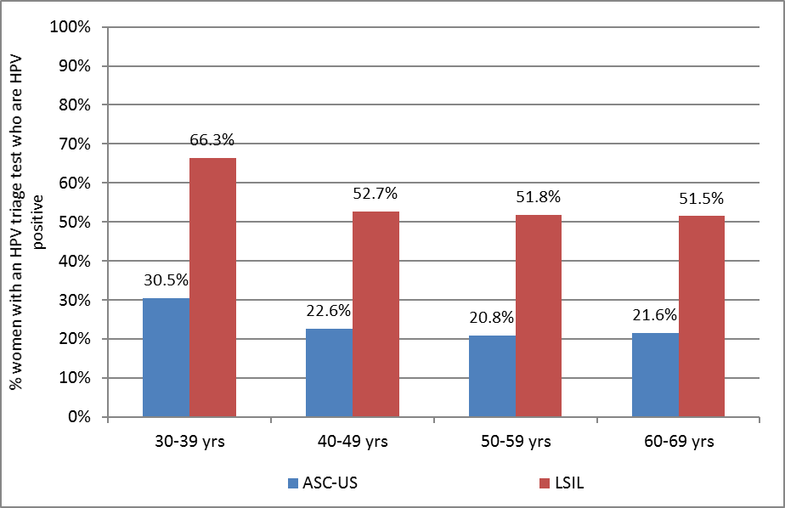
Note: Excludes results for women aged less than 30 years and aged 70 years or more, since these are based on very small numbers of women with valid HPV test results.

Table 20 - HPV triage test results following ASC-US cytology, by age and cytology laboratory
Laboratory | Women with valid HPV test results |  | Women with positive HPV test results (number and % within each age group)
 | <30yrs* | 30+ yrs | < 30yrs* |  | 30-39 yrs |  | 40-49 yrs |  | 50-59 yrs |  | 60-69 yrs |  | 70+ yrs
 | N | N | N | % | N | % | N | % | N | % | N | % | N | %
Anatomical Pathology Services | 1 | 287 | 0 | 0.0 | 42 | 37.5 | 22 | 25.9 | 16 | 24.2 | 5 | 20.8 | 0 | 0.0
Canterbury Health Laboratories | 1 | 162 | 1 | 100.0 | 10 | 20.4 | 9 | 14.5 | 5 | 13.9 | 0 | 0.0 | 0 | 0.0
LabPLUS | 1 | 155 | 0 | 0.0 | 7 | 13.0 | 6 | 11.1 | 3 | 10.0 | 1 | 6.3 | 1 | 100.0
Medlab Central Ltd. | 1 | 125 | 1 | 100.0 | 13 | 29.5 | 11 | 27.5 | 6 | 18.8 | 0 | 0.0 | 0 | 0.0
Pathlab | 1 | 243 | 1 | 100.0 | 33 | 45.8 | 24 | 34.3 | 19 | 30.2 | 11 | 31.4 | 0 | 0.0
Southern Community Laboratories | 3 | 353 | 1 | 33.3 | 36 | 27.3 | 21 | 20.8 | 15 | 18.8 | 13 | 32.5 | 0 | 0.0
Total | 8 | 1325 | 4 | 50.0 | 141 | 30.5 | 93 | 22.6 | 64 | 20.8 | 30 | 21.6 | 1 | 25.0
Excludes women with abnormal cytology in the five years preceding their low grade cytology sample.
* Additionally excludes women with any previous squamous high grade (cytology or histology)

Table 21 - HPV triage test results following LSIL cytology, by age and cytology laboratory
Laboratory | Women with valid HPV test results |  | Women with positive HPV test results (number and % within each age group)
 | < 30yrs* | 30+ yrs | < 30yrs* |  | 30-39 yrs |  |  | 40-49 yrs |  | 50-59 yrs |  |  | 60-69 yrs |  | 70+ yrs
 | N | N | N | % |  | N | % | N | % |  | N | % | N | % | N | %
Anatomical Pathology Services | 5 | 401 | 5 | 100.0 |  | 117 | 64.6 | 75 | 56.8 |  | 29 | 46.0 | 14 | 58.3 | 0 | 0.0
Canterbury Health Laboratories | 2 | 48 | 2 | 100.0 |  | 15 | 57.7 | 5 | 55.6 |  | 3 | 33.3 | 3 | 75.0 | 0 | 0.0
LabPLUS | 0 | 41 | - | - |  | 13 | 65.0 | 6 | 54.5 |  | 3 | 33.3 | 1 | 100.0 | 0 | 0.0
Medlab Central Ltd. | 1 | 82 | 1 | 100.0 |  | 15 | 46.9 | 12 | 50.0 |  | 10 | 62.5 | 3 | 33.3 | 0 | 0.0
Pathlab | 1 | 190 | 1 | 100.0 |  | 57 | 74.0 | 33 | 62.3 |  | 23 | 54.8 | 8 | 44.4 | 0 | 0.0
Southern Community Laboratories | 5 | 598 | 3 | 60.0 |  | 193 | 68.4 | 85 | 47.0 |  | 50 | 56.2 | 22 | 51.2 | 1 | 33.3
Total | 14 | 1360 | 12 | 85.7 |  | 410 | 66.3 | 216 | 52.7 |  | 118 | 51.8 | 51 | 51.5 | 1 | 20.0
Excludes women with abnormal cytology in the five years preceding their low grade cytology sample
* Additionally excludes women with any previous squamous high grade (cytology or histology)

Figure 83 – Triage-positive women with histologically-confirmed CIN 2+ within 12 months, as a percentage of all women with histology, by laboratory
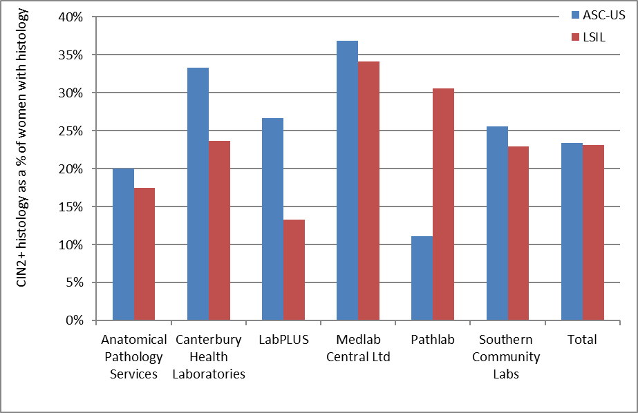
Note that LabPLUS results are based in very small numbers of triage-positive women (see Table 68 and Table 69).

Figure 84 – Triage-positive women with histologically-confirmed CIN 2+ within 12 months, as a percentage of all women who attended colposcopy, by laboratory
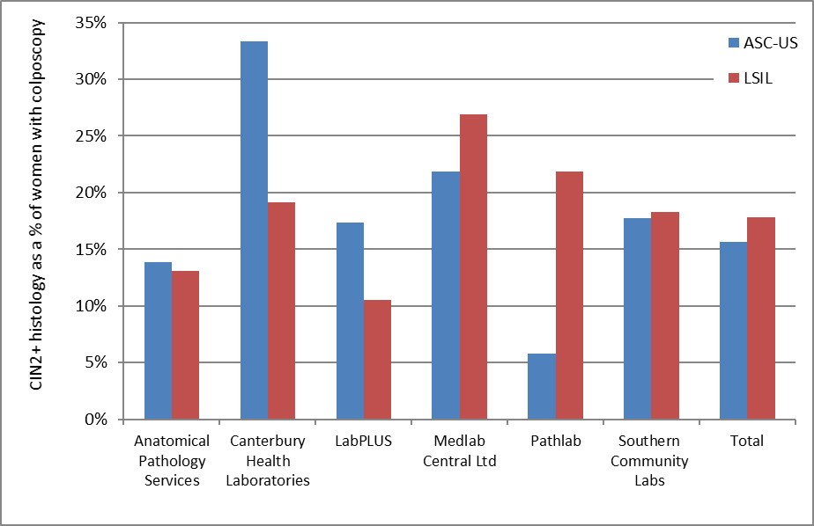
Note that LabPLUS results are based in very small numbers of triage-positive women (see Table 68 and Table 69).

Figure 85 - Women with histologically-confirmed CIN 2+ within 12 months, as a percentage of all women who attended colposcopy, by laboratory and referral cytology
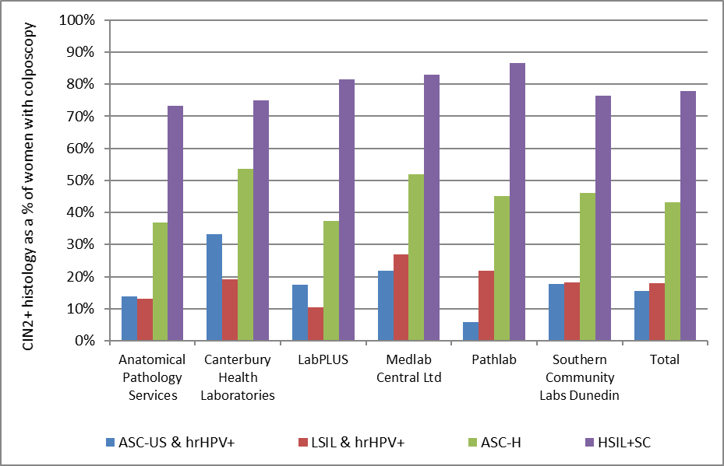

Figure 86 – Triage-positive women with histologically-confirmed CIN 2+ within 12 months, as a percentage of women with histology recorded, by age
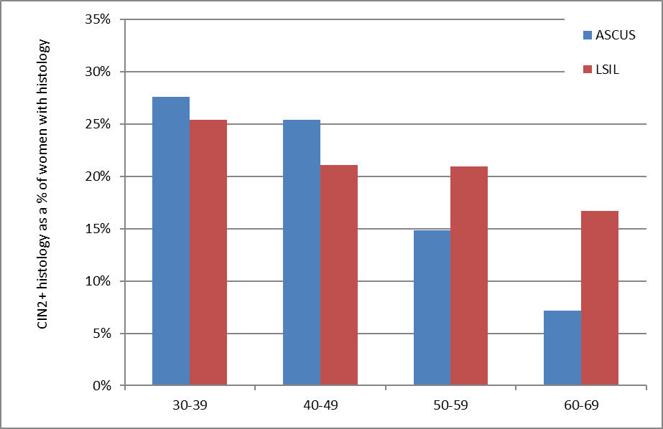

Figure 87 – Triage-positive women with histologically-confirmed CIN 2+ within 12 months, as a percentage of women with colposcopy recorded, by age
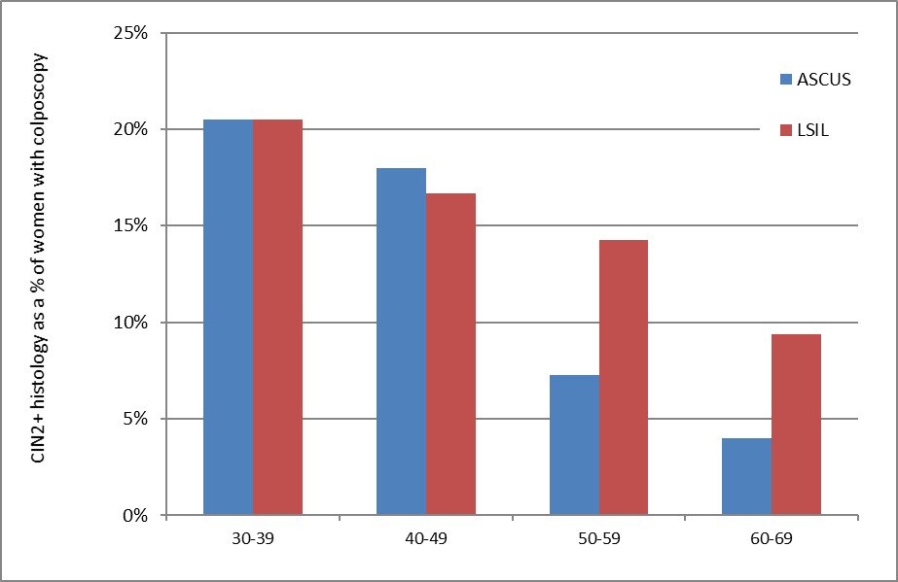

Figure 88 – Trends in ASC-US triage-positive women with histologically-confirmed CIN 2+ within 12 months, as a percentage of women with colposcopy recorded, by laboratory
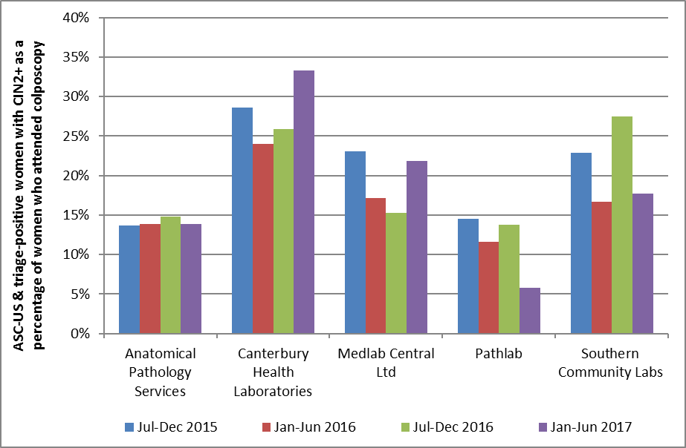
Time periods relate to monitoring report periods; results relate to samples collected in the 6-month period 12 months prior to the monitoring period, to allow for sufficient follow-up time for colposcopy/ histology. Note that this graph excludes LabPLUS due to the very small numbers of triage-positive women. See Table 68.

Figure 89 – Trends in LSIL triage-positive women with histologically-confirmed CIN 2+ within 12 months, as a percentage of women with colposcopy recorded, by laboratory
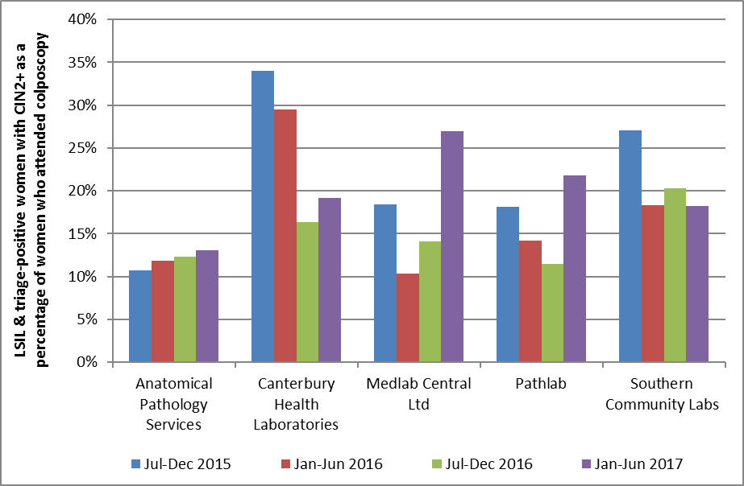
Time periods relate to monitoring report periods; results relate to samples collected in the 6-month period 12 months prior to the monitoring period, to allow for sufficient follow-up time for colposcopy/ histology. Note that this graph excludes LabPLUS due to the very small numbers of triage-positive women. See Table 69.

Indicator 8.2 – HPV test volumes

Definition | All HPV tests received by laboratories within the monitoring period were retrieved. This volume of HPV tests (performed for any purpose) is reported on by:  - Laboratory  - Ethnicity  - Age group  Purpose  Purpose is defined as one of the following categories:  - Post-treatment (women treated for high grade squamous lesions (specifically CIN 2/3) in the period six months to four years prior to the HPV sample date, to capture two rounds of testing)  - Historical (high grade squamous cytology (ASC-H/ HSIL) or histology (CIN 2/3) more than three years prior to the HPV test sample)  - Taken at colposcopy (HPV sample collected on the same date as a colposcopy visit or a histology sample in the same woman)  - HPV triage (as defined in Indicator 8.1, but restricted to women aged 30 years or more at the time of the cytology specimen, and where the low grade cytology (ASC-US or LSIL) was no more than six months prior to the HPV test)  - Other (tests which do not fit into any of the above categories)  These categories are defined hierarchically in the order shown; that is, a test cannot fit into more than one category, and tests are only considered for inclusion in a category if no previous categories in the list apply. The purpose of tests are not at its final stage of development and is an item that is under ongoing review.  Tests in the ‘Other’ category were explored further. The number of tests that fell into the ‘Other’ category was found to be relatively high in this report, but this analysis is nonetheless indicative of the appropriate purposes. It is also useful to report the extent of hrHPV tests for other purposes and the need to eliminate hrHPV tests for other purposes that are not within the NCSP guidelines. For this reason, the purpose of hrHPV tests are discussed in this report.  Rates of invalid HPV tests are also reported on.  Measures reported by age are based on the age of the women on the date that the HPV test sample was collected.
Target | Targets have not yet been set.
Current Situation | Overall volumes  There were 18,891 samples received by laboratories for HPV testing within the current monitoring period. These are reported on further in Table 70 to Table 76.  Virtually all (98.6%) samples for HPV testing were from women aged 20-69 years. The large majority of women (85.3%) were aged 30 years or more (Figure 90, Table 74).  The number of samples received by laboratories for HPV testing ranged from 929 (LabPLUS; 4.9% of all HPV tests) to 7,576 (Southern Community Labs; 40.1% of all HPV tests) (Figure 91, Table 70).  Figure 92 and Table 70 show for each laboratory the ratio of the number of HPV tests received, divided by the number of cytology tests received (expressed as a percentage). This measure provides some correction for the variation in workloads between different laboratories. It is likely, for example, that laboratories which process a larger volume of cytology tests would also undertake a larger volume of HPV tests. The ratio of HPV tests to cytology tests reported was on average 9.0% across New Zealand – that is, on average 9.0% of cytology tests are associated with an HPV test. This ratio varied by laboratory from 7.2% (Southern Community Laboratories; i.e. fewer HPV tests processed in relation to cytology tests processed than the national average) to 14.4% (Canterbury Health Laboratories; i.e. more HPV tests processed in relation to cytology tests processed than the national average).  The distribution of HPV tests by ethnicity is shown in Table 73.  The overall proportion of HPV tests with invalid results was 0.1% (Table 71). The proportion was small for both HPV test technologies reported (Table 72).  Purpose of HPV tests  These HPV tests were further analysed in order to ascertain the purpose for which they were performed. Nationally, it was calculated that 2,722 (14.4%) were for post-treatment management for women treated in the past four years; 7,244 (38.3%) were for follow-up management of women with high grade squamous cytology or histology more than three years previously (historical testing); 820 (4.3%) were on samples collected at a colposcopy visit which did not fit into a previous category (possibly for resolution of discordant results); and 2,536 (13.4%) were for triage of low grade cytology in women aged 30 years or more. There were 5,569 (29.5%) HPV tests that did not fit into any of the previously described categories (Figure 93).  Further breakdowns of HPV tests by purpose are presented by age (Figure 94), laboratory (Figure 95), and ethnicity (Table 73).  There were variations in HPV test purpose by age (Figure 94, Table 74). HPV triage (by the definition used here, and consistent with NCSP Guidelines) did not occur in women aged less than 30 years. In women aged less than 30 years, a comparatively larger proportion were taken for post-treatment management (31.8%) and other reasons where the purpose did not fit into the other categories (31.4%). Follow up of women with historical high grade squamous abnormalities (more than three years ago) was the most common reason that HPV tests were performed among women in the five-year age groups between 25 and 54 years. Tests which did not fit into the prescribed categories, and were therefore classified as ‘Other’, were the most common classification among women aged less than 24 years and 55 years and older.  HPV test purpose also varied by laboratory (Figure 95, Table 75). Among tests for which the purpose could be determined, the most common reason for HPV testing was historical testing in four of the six laboratories (Anatomical Pathology Services, Medlab Central Ltd., Pathlab and Southern Community Laboratories). Post-treatment management was most common HPV test reason for Canterbury Health Laboratories while it was HPV triage at LabPLUS. In all laboratories, however, tests for which the purpose was unclear were quite common, varying from 18.9% at Pathlab to 35.6% LabPLUS. The proportion of tests performed for post-treatment management varied from 11.3% (Pathlab) to 25.5% (Canterbury Health Laboratories), while the proportion performed to follow up women with historical high grade squamous abnormalities varied from 17.9% (LabPLUS) to 45.5% (Anatomical Pathology Services). The proportion of tests where the sample was collected at colposcopy but not for one of the previous purposes ranged from 1.4% (Anatomical Pathology Services) to 11.5% (LabPLUS). The proportion of tests performed for HPV triage ranged from 11.5% (Southern Community Laboratories) to 21.2% (LabPLUS).  Follow up of women with historical high grade squamous abnormalities (more than three years ago) was the most common reason that HPV tests were performed among Māori, Pacific and European/ Other women. Other tests for which an explicit reason could not be determined was the most common reason among Asian women (Table 73).  Tests in the ‘Other’ category were further explored. A proportion of the ‘Other’ tests (3.6%; 200 tests) were potentially tests performed for post-treatment management, because the same woman had CIN 2/3 histology recorded on the NCSP Register, however there was no explicit record of treatment available on the NCSP Register, potentially due to incomplete colposcopy data on the NCSP Register. Another 7.1% occurred after treatment, but did not meet the criteria for post-treatment management because they occurred within 6 months of treatment (2.0%; 109 tests), or after treatment of either a non-squamous high grade (1.5%; 84 tests), or a non-high grade (3.6%; 198 tests) or following treatment of cervical cancer (0.09%; 5 tests). A further 17.8% of the ‘Other’ HPV tests occurred after a previous abnormality but one which did not meet the criteria for historical testing either because it was non-squamous (7.9%; 439 tests), the high grade squamous cytology was less than three years ago (9.8%; 543 tests), or the histology diagnosis was cervical cancer (0.2%; 11 tests).  A larger proportion of the ‘Other’ tests (30.2%; 1,684 tests) occurred in women who did not have any specific high grade abnormality recorded on the NCSP Register, but who did have a record on the NCSP Register suggesting that they had a previous high grade abnormality (although the Register does not record whether it was a squamous abnormality or not; consequently, HPV testing is not indicated in these women by the NCSP guidelines). These records predominantly indicated prior high grade cytology (25.6%; 1,427 tests), but some suggested prior high grade histology (4.6%; 257 tests). Smaller proportions of HPV tests were associated with a low grade abnormality, including either a current low grade cytology result which did not meet the criteria for triage because the woman had another recent abnormality and triage was not required (2.2%; 121 tests), or a record suggesting a previous low grade cytology not explicitly recorded on the NCSP Register (3.2%; 177 tests). After this exploration, there remained 1,998 tests (35.9% of ‘Other’ tests; 10.6% of all HPV tests in the monitoring period) where purpose still could not be determined.  HPV tests at colposcopy  HPV tests taken at colposcopy were further explored, based on the DHB of the colposcopy clinic where the sample was taken, and whether or not it was a public or a private clinic. Nationally, more of the HPV tests which were taken at colposcopy came from public facilities (86.0%; 583 tests) than from private facilities (14.0%; 95 tests). As the number of HPV tests collected at a colposcopy clinic is potentially reflective of the number of colposcopies performed there, a rate of HPV tests at colposcopy which takes this variation into account was derived, in order to provide more information. The rate of HPV tests at colposcopy was calculated by dividing the number of HPV tests collected at colposcopy by the total number of colposcopies within that DHB or across private colposcopy clinics, expressed as a percentage. This rate can be broadly interpreted as the percentage of colposcopies (within a given DHB or sector) where an HPV test sample is collected. Across New Zealand, HPV test samples were collected in approximately 5.3% of colposcopies. In DHBs where HPV tests were collected at colposcopy, this value ranged from 0.9% (Hawke's Bay) to 23.0% (Lakes), and was 5.0% overall across all public DHB clinics (Figure 96, Table 76). In private practice, this rate was 7.9%. No HPV tests were taken at colposcopy in Tairawhiti, Taranaki, West Coast and Whanganui.
Trends | Fewer samples were received at laboratories for HPV testing in the current monitoring period (18,891) than in the previous monitoring report (19,822; a decrease of 4.7%). No laboratory experienced an increase in the number of samples received between the current monitoring period compared with the previous report period. Five of the six laboratories experienced a decrease in the number of tests and the remaining laboratory had no change. The laboratory with the largest percentage decrease in the number of tests received between the current and previous period was LabPLUS (from 1,191 to 929 tests; 22.0% decrease). Trends by laboratory can be seen in Figure 97.  The decrease in HPV test volumes was consistent across all test purpose categories however. The number of tests performed for each of the four guidelines categories (post-treatment, historical testing, HPV triage or tests at colposcopy) all decreased with the greatest relative decrease seen in HPV tests taken at colposcopy (decrease of 4.8% or 278 tests) (Figure 98). A decrease was also seen in the number of HPV tests in the ‘Other’ category of 8.7% (534 tests) and as a percent of all HPV tests from 30.8% to 29.5%. The proportion of tests in each of the other four categories was broadly similar to that seen in the previous report (from 13.9% to 14.4% for post-treatment management; from 37.9% to 38.3% for historical testing; from 13.0% to 13.4% for triage of low grade cytology, and remained similar at 4.3% for tests taken at colposcopy).  Variations in the purpose of HPV tests by age and ethnicity were broadly similar to that in previous reports.  The proportion of HPV tests which are invalid remains very small.
Comments | HPV volumes by laboratory will vary for a number of reasons, one of which being the general volume of work in that laboratory. In order to provide some correction for the variation in workloads between different laboratories, we calculated the ratio of HPV tests received to cytology tests reported on (Figure 92, Table 70). Other reasons for variations in the rate of HPV testing by laboratory (which are not taken into account in this ratio) may include differences in the population they serve, because HPV testing is performed in specific subgroups of women. For example, HPV triage testing is performed in women with low grade (ASC-US/ LSIL) cytology results (but without recent abnormalities), therefore laboratories reporting higher rates of low grade abnormalities may also have higher rates of triage testing. Conversely, laboratories reporting on a larger proportion of cytology from colposcopy clinics may be more likely to perform HPV tests arising from colposcopy (for example LabPLUS) but less likely to perform HPV triage testing, because women attending colposcopy have generally had a recent abnormality and therefore do not require triage. These issues may for example partly explain differences in the ratios between different labs. To understand in more detail, the reasons for the differences, an explicit exploration of the purpose for which the HPV test was performed has been examined here.  Exploration is ongoing into the potential reason for tests in the ‘Other’ category, as is the refinement of specifications for the analysis of purpose. Some possible explanations include follow-up of women previously treated for high grade squamous abnormalities where these abnormalities occurred outside New Zealand, prior to the woman being enrolled on the NCSP Register, or prior to the inception of the NCSP Register. The latter may potentially explain why the proportion of ‘Other’ tests is higher in older women than in younger women (except for ages less than 24). Synopses held on the NCSP Register of previous (self-reported) high grade abnormalities have been used in this report to explore this possibility further (although these synopses do not distinguish between squamous abnormalities and glandular abnormalities; HPV testing is currently only recommended for the management of women with previous squamous abnormalities). The proportion associated with a synopsis reflecting a previous high grade abnormality (cytological or historical) reported here (30.2%) is slightly less than that in the previous report (31.0%), and the number of tests in this category has also decreased since the previous report (from 1,892 to 1,684). In a June 2015 newsletter, the NCSP reminded laboratories that women with a previous glandular lesion, or a high grade synopsis code on their screening history but no confirmation that the previous abnormality was squamous, should remain on annual screening and HPV testing is not indicated for these women.

Figure 90 - Volume of HPV test samples received by laboratories during the monitoring period, by age
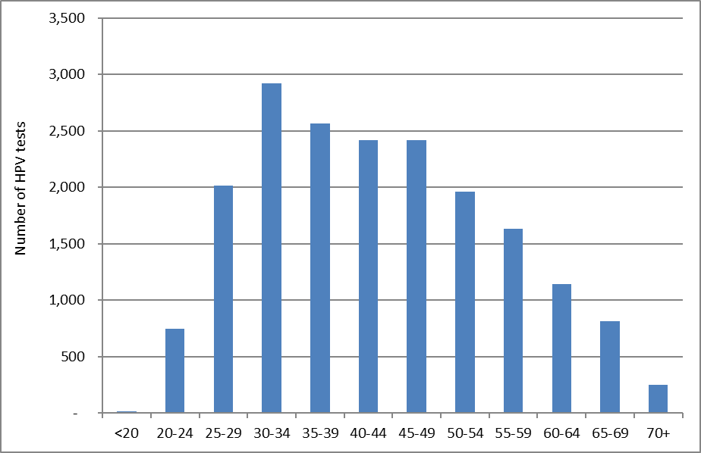

Figure 91 - Volume of HPV test samples received by laboratories during the monitoring period, by laboratory
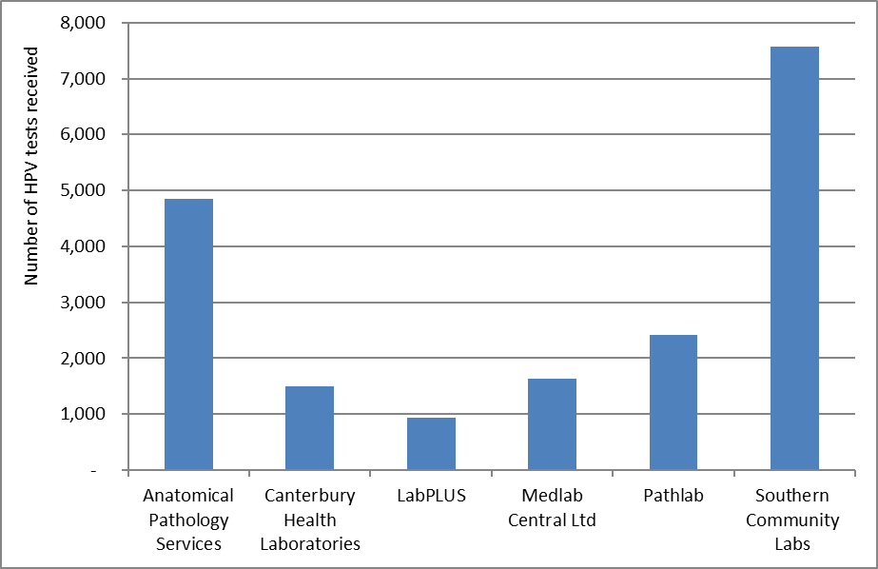

Figure 92 - HPV test samples as a percentage of cytology test samples received during the monitoring period, by laboratory
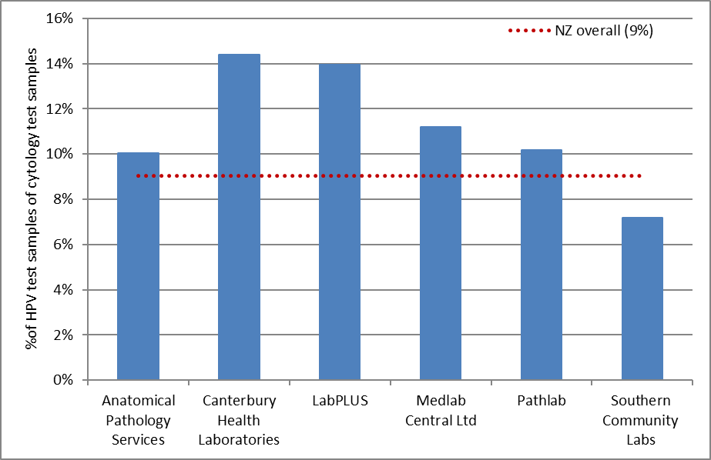
HPV tests/ colposcopy can be interpreted as the percentage of cytology tests which have an associated HPV test

Figure 93 - Volume of HPV test samples received during the monitoring period, by purpose
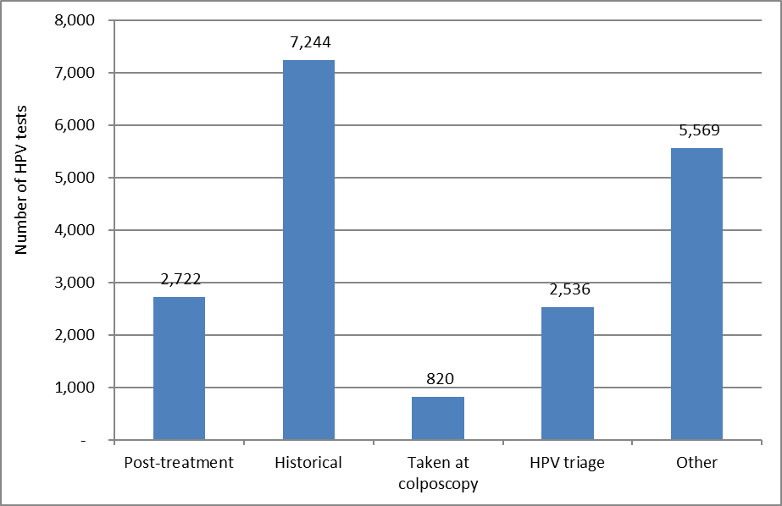

Figure 94 - HPV test samples received during the monitoring period, by purpose and age
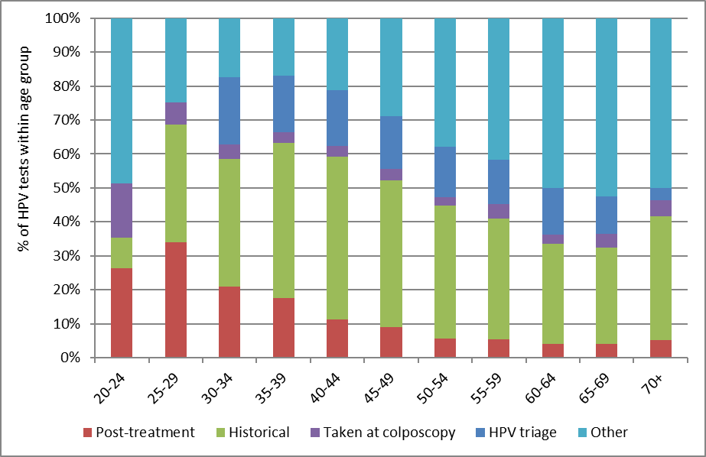

Figure 95 - HPV test samples received during the monitoring period, by purpose and laboratory
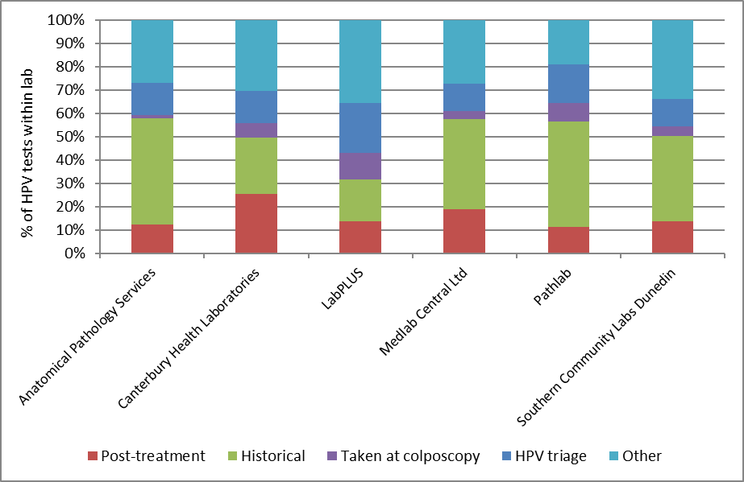

Figure 96 - HPV test samples collected at colposcopy, in relation to total colposcopies performed in the period, by DHB
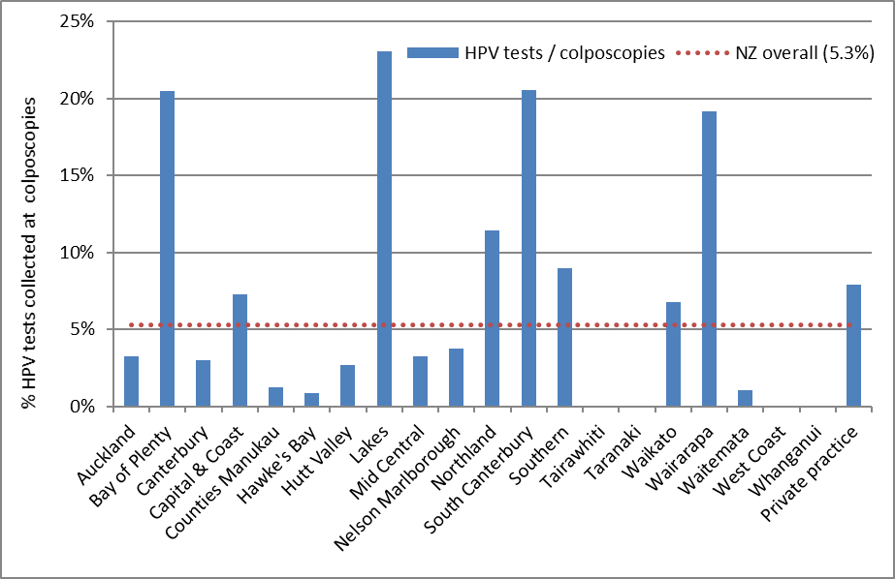
HPV tests/ colposcopy can be interpreted broadly as the percentage of colposcopies within this DHB/ sector where a sample is collected for HPV testing. No HPV tests at colposcopy in Tairawhiti, Taranaki, West Coast and Whanganui.

Figure 97 - Trends in volumes of HPV test samples received, by laboratory
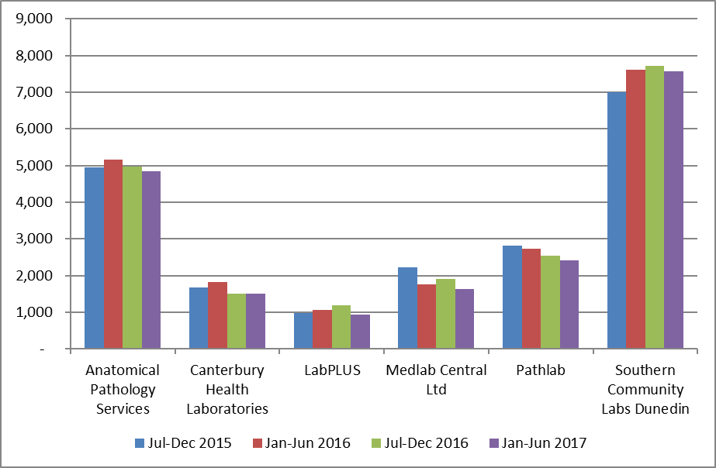

Figure 98 - Trends in volumes of HPV test samples received, by purpose
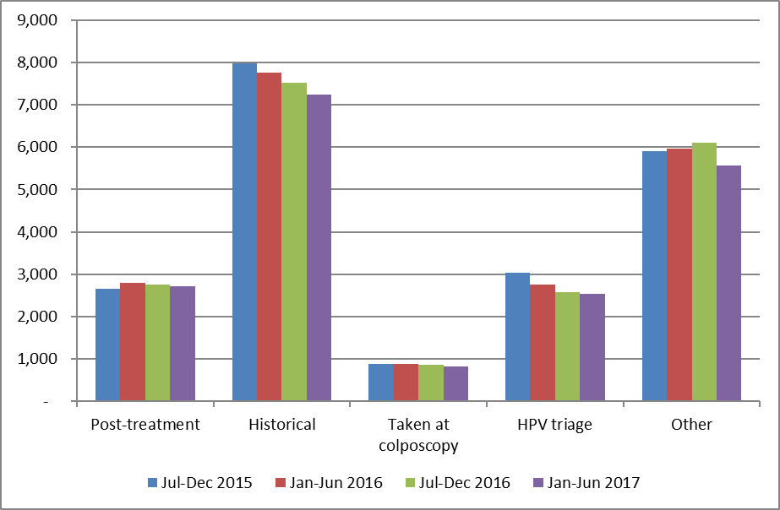

Indicator 8.3 – HPV tests for follow-up of women with a historical high grade abnormality

Definition | NCSP Guidelines for Cervical Screening in New Zealand state that women with a previous high grade squamous abnormality (ASC-H, HSIL, CIN 2/3) more than three years ago may benefit from two rounds of dual cytology and hrHPV testing (“historical testing”). If women test negative on both tests over two years, they can safely be screened according to the routine screening recommendations (cytology alone every three years until 70). HPV testing is not recommended for management of women with a historic non-squamous high grade abnormality.  The purpose of this indicator is to examine the extent to which historical testing is being used for women who are eligible for it, and the outcomes of these tests.  Predominantly, women who are eligible for historical testing will be those who were eligible for it at the time it was introduced (1 October 2009), because women with more recent high grade squamous abnormalities will be followed up with hrHPV testing in other ways (as part of standard post-treatment management and/ or use of hrHPV testing to assist in resolving discordant cytology and colposcopy/ histology). Therefore, at the current time, this indicator examines use of historical testing in the group of women who were eligible for it when it became available on 1 October 2009 (the date that testing for hrHPV was introduced in New Zealand within the NCSP). It does not include women who may have become eligible for historical testing after 1 October 2009. Women are considered to have been eligible for historical testing as at 1 October 2009 if:  - They had a high grade squamous abnormality (cytology or histology) more than three years prior to 1 October 2009, as per the definition of historical testing (i.e. prior to 1 October 2006) and  - They had no previous glandular abnormality (i.e. prior to 1 October 2009); and  - Between their historical high grade squamous abnormality and 1 October 2009, they had either no cytology OR only negative cytology OR three consecutive negative cytology tests as their most recent cytology results; and  - They were alive on 1 October 2009.  Women were excluded, however, if they had been treated for a high grade squamous abnormality within the three years prior to 1 October 2009, because this meant they met the criteria for post-treatment women, rather than historical testing.  Within the current report, Round 1 and Round 2 historical tests are only considered for women who were both eligible for historical testing on 1 October 2009 and who also remained eligible for it throughout the current monitoring period. Therefore, in the current report, women were excluded if:  - They were not still alive at the end of the current monitoring period (follow-up no longer possible); or  - They had a non-squamous high grade abnormality between becoming eligible (on 1 October 2009) and the end of the current monitoring period (no longer eligible for historical testing)  HPV tests in these women from 1 October 2009 were retrieved. HPV tests which appeared to have been carried out for other recommended uses of HPV testing (such as HPV triage of low grade cytology; HPV tests taken at colposcopy; or HPV tests performed to follow-up treatment of a high grade squamous abnormality within the previous three years) were excluded since they were not performed for the purpose of historical testing. After excluding those tests, the first HPV test in each woman was defined as her Round 1 historical test. A Round 2 historical test was defined as the first HPV test which occurred at least 9 months after a Round 1 historical test.  Measures reported by age are based on the age of the women at the end of the current monitoring period (i.e. a woman’s age at 30 June 2017). Measures reported by DHB are based on the geographic area relating to the woman’s residence (or if this information is not available, that of her responsible health provider).
Target | Targets have not yet been set.
Current Situation | Overall women eligible for historical testing  There were 50,504 women who, at 1 October 2009, were eligible for HPV testing to follow-up a historical squamous high grade abnormality (“historical testing”). Of these women, 49,384 are considered in the current report (the remaining women were excluded because they were no longer alive at the end of the current monitoring period, or were no longer eligible for historical testing because they had a non-squamous high grade abnormality since 1 October 2009). There were no women eligible for historical testing who were aged less than 25 years at the end of the current monitoring period; however, this is not unexpected, as women in this age group would have been aged less than 18 years old on 1 October 2009 and few women this age are screened or treated for high grade abnormalities (Table 77).  HPV tests performed for historical reasons  Overall, 32,066 (64.9%) of the women eligible for historical testing have a Round 1 historical test recorded on the NCSP Register. There were 25,746 women who also have a Round 2 historical test (52.1% of eligible women; 80.3% of those with a Round 1 test).  The proportion of women with historical tests varied by age. Among women aged 25 to 69 years at the end of the current monitoring period, the proportion of eligible women with a historical test varied from 51.0% (25-29 years) to 67.4% (60-64 years) for Round 1 tests, and from 40.6% (25-29 years) to 55.6% (60-64 years) for Round 2 tests (Figure 99, Table 77).  The proportion of eligible women with historical tests also varied by DHB, from 52.5% (Counties Manukau) to 78.6% (Nelson Marlborough) for Round 1 tests, and from 36.5% (Counties Manukau) to 70.5% (Nelson Marlborough) for Round 2 tests (Figure 100, Table 78). The number of women eligible for historical testing in a given DHB did not appear to have any relationship with the proportion who had received a historical test (Figure 105).  The proportion of eligible women with Round 1 historical tests ranged from 44.9% in Pacific women to 67.2% in European/ Other women (Figure 101, Table 79). For Round 2 tests, this proportion ranged from 33.3% in Pacific women to 54.9% in European/ Other women.  We explored whether the proportion of women with a historical HPV test was influenced by screening participation within the previous five years (since if women have not attended for any test, it would not be possible to initiate a historical test). The variation in the proportion of women with historical tests recorded did not appear to be fully explained by variations in screening participation, either by DHB (Figure 106, Table 80) or by ethnicity (Figure 107).
Trends | As this Indicator is reporting on the cumulative proportion of women who were eligible for HPV testing for the management of a historical high grade squamous lesion as at 1 October 2009, the proportion is generally expected to increase over time. It has done so in this report in every DHB (Figure 102) and ethnicity (Figure 103). An increase has been seen in every age group between this and the previous report except in women aged 25-29 (decreased from 51.8% to 51.0%) (Figure 104).
Comments | This indicator currently only considers women who had a high grade squamous abnormality more than three years prior to 1 October 2009. It is anticipated that women with more recent high grade squamous abnormalities will be followed up via standard post-treatment management which also includes hrHPV testing. It was intended that future monitoring reports would also incorporate reporting on the use of hrHPV tests for the purpose of post-treatment management as a separate sub-indicator within Indicator 8. However, development of additional indicators has been suspended prior to the programmes planned transition to primary HPV screening, as indicators will be reviewed as part of the transition process.  Planned future refinements include reporting on the proportion of the Round 1 and Round 2 historical tests where hrHPV was detected, and on how many women are able to be returned to routine screening after two rounds of negative cytology and hrHPV tests; considering women with a historical high grade squamous abnormality who became eligible for historical testing after 1 October 2009; and taking into account whether women have attended for any screening test, since women who have not attended for any testing could not be offered historical testing. This last point has been partially explored within the current report, by considering whether there was any relationship between the variations in women with Round 1 and Round 2 historical tests by DHB or ethnicity and the variations in screening participation within the previous five years by DHB or ethnicity. An extended period of five years was examined for screening participation (rather than three, which is the usual measure), since it corresponds more closely than three-year participation during which we searched for HPV tests in this group of women (i.e. from 1 October 2009 to the time of the data download from NCSP Register used within this report, early September 2017). However, as women with a previous abnormality are recommended to re-attend for screening more frequently than the routine interval, the variations in overall attendance by DHB or by ethnicity may differ from the variations by DHB or ethnicity in this subgroup of women who have had a previous abnormality.  It is possible that in some cases eligible women were offered historical HPV testing, but did not consent to the test. It has not been possible to take this into account within the current report. While this affects Round 1 tests, this should be less of an issue for Round 2 tests, because in June 2015 the NCSP requested that laboratories prompt sample takers to add on an HPV test where this is indicated by the Guidelines, but was not requested by the sample taker. Additionally, for women who had already consented to the Round 1 HPV test, separate consent was not required for a Round 2 HPV test.  It is also possible that the reason some women underwent Round 1 tests, but not Round 2 tests, is because their concurrent cytology result indicated that other management (for example colposcopy referral) was required. This might be explored when this indicator is further refined to report on the test results in women who have undergone historical testing.

Figure 99 - Proportion of eligible women with squamous high grade abnormality more than 3 years ago for whom an historical test is recorded on the NCSP Register, by age at 30 June 2017
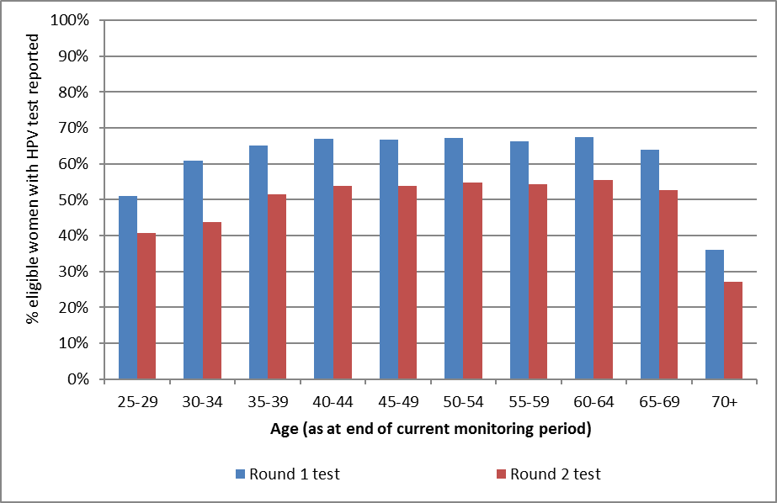
No women aged less than 25 years at the end of the current monitoring period were eligible for historical testing on 1 October 2009.

Figure 100 - Proportion of eligible women with squamous high grade abnormality more than 3 years ago for whom an historical test is recorded on the NCSP Register, by DHB at 30 June 2017
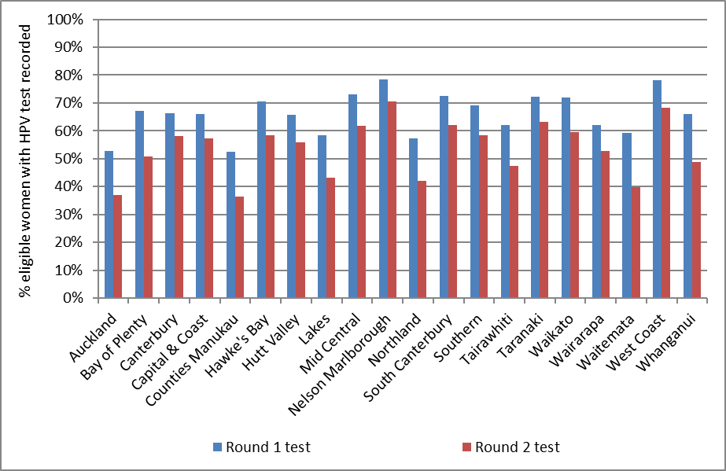

Figure 101 - Proportion of eligible women with squamous high grade abnormality more than 3 years ago for whom an historical test is recorded on the NCSP Register, by ethnicity at 30 June 2017
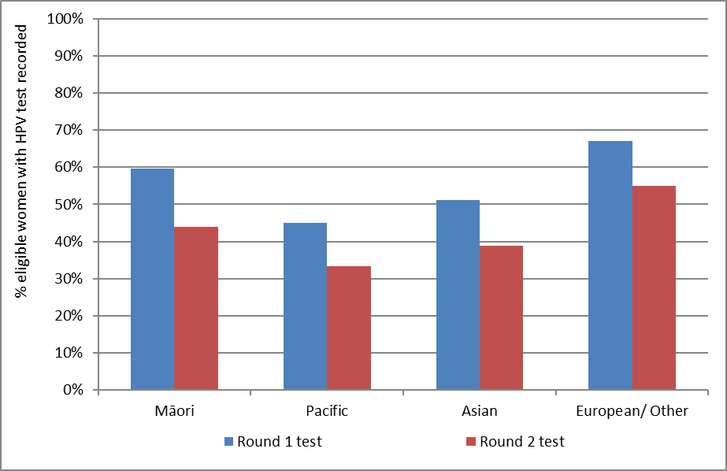

Figure 102 – Trends in the proportion of eligible women with squamous high grade abnormality more than 3 years ago for whom a round 1 historical test is recorded on the NCSP Register, by DHB
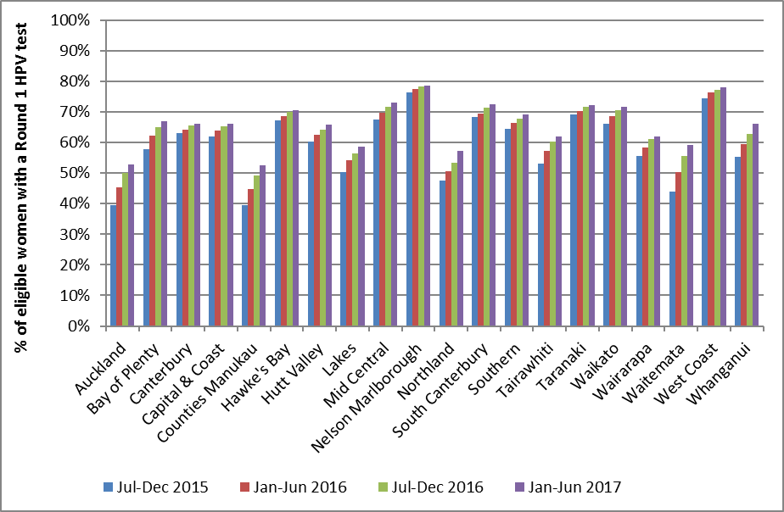

Figure 103 - Trends in the proportion of eligible women with squamous high grade abnormality more than 3 years ago for whom a round 1 historical test is recorded on the NCSP Register, by ethnicity
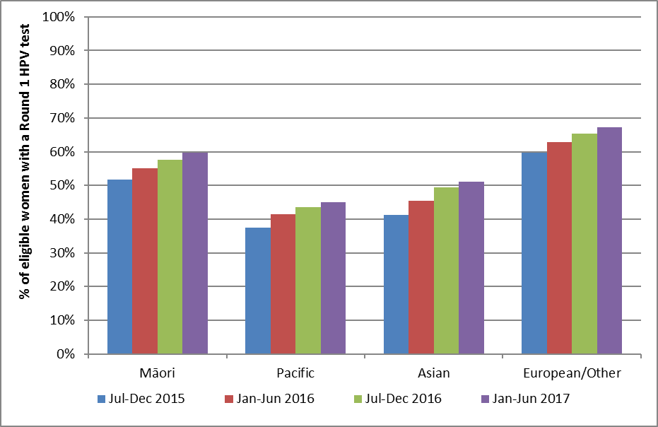

Figure 104 - Trends in the proportion of eligible women with squamous high grade abnormality more than 3 years ago for whom a round 1 historical test is recorded on the NCSP Register, by age
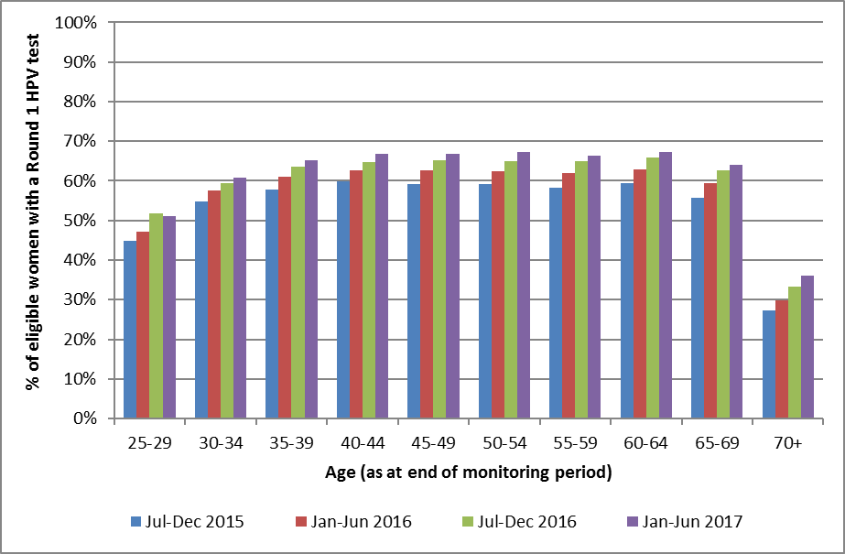
No women aged less than 25 years at the end of the current monitoring period were eligible for historical testing on 1 October 2009.

Appendix A – Additional data

Indicator 1 - Coverage

Indicator 1.1 – Three-year coverage
Table 22 - Coverage by DHB (women 25-69 years screened in the three years prior to 30 June 2017, hysterectomy adjusted)
DHB | Hysterectomy adjusted population |  | Women screened in the last 3 years
 | N | N | %
Auckland | 137,243 | 106,227 | 77.4
Bay of Plenty | 56,859 | 46,130 | 81.1
Canterbury | 138,940 | 103,528 | 74.5
Capital & Coast | 81,253 | 64,465 | 79.3
Counties Manukau | 137,181 | 100,480 | 73.2
Hawke's Bay | 40,702 | 30,892 | 75.9
Hutt Valley | 38,458 | 29,483 | 76.7
Lakes | 26,531 | 20,726 | 78.1
Mid Central | 42,593 | 31,888 | 74.9
Nelson Marlborough | 38,368 | 30,682 | 80.0
Northland | 42,364 | 30,933 | 73.0
South Canterbury | 15,019 | 11,449 | 76.2
Southern | 78,638 | 62,804 | 79.9
Tairawhiti | 11,945 | 8,870 | 74.3
Taranaki | 30,407 | 23,995 | 78.9
Waikato | 99,317 | 75,960 | 76.5
Wairarapa | 11,280 | 8,306 | 73.6
Waitemata | 158,606 | 119,211 | 75.2
West Coast | 8,851 | 6,295 | 71.1
Whanganui | 15,267 | 11,427 | 74.8
Total | 1,209,822 | 923,751 | 76.4
Excludes 4 women for whom DHB could not be determined

Table 23 - Coverage by ethnicity (women 25-69 years screened in the three years prior to 30 June 2017, hysterectomy adjusted)
Ethnicity | Hysterectomy adjusted population | Women screened in the last 3 years (ages 25-69 years)
 | (ages 25-69 years) | N | %
Māori | 160,223 | 102,544 | 64.0
Pacific | 68,539 | 50,901 | 74.3
Asian | 181,750 | 122,051 | 67.2
European/ Other | 799,310 | 648,259 | 81.1
Total | 1,209,822 | 923,755 | 76.4

Table 24 - Coverage by age (women 20-69 years screened in the three years prior to 30 June 2017, hysterectomy adjusted)
Age | Hysterectomy adjusted population | Women screened in the last 3 years
 | N | N | %
20-24 | 161,697 | 81,298 | 50.3
25-29 | 167,244 | 108,660 | 65.0
30-34 | 152,060 | 109,607 | 72.1
35-39 | 139,891 | 108,823 | 77.8
40-44 | 141,769 | 113,304 | 79.9
45-49 | 149,820 | 121,381 | 81.0
50-54 | 140,555 | 112,595 | 80.1
55-59 | 129,393 | 102,966 | 79.6
60-64 | 103,683 | 82,184 | 79.3
65-69 | 85,407 | 64,235 | 75.2
20-69 | 1,371,519 | 1,005,053 | 73.3

Table 25 - Coverage by DHB (women aged 25-69 years screened in the five years prior to 30 June 2017, hysterectomy adjusted)
DHB | Hysterectomy adjusted population | Women screened in the last 5 years
 | N | N | %
Auckland | 137,243 | 125,340 | 91.3
Bay of Plenty | 56,859 | 53,982 | 94.9
Canterbury | 138,940 | 122,224 | 88.0
Capital & Coast | 81,253 | 77,164 | 95.0
Counties Manukau | 137,181 | 119,817 | 87.3
Hawke's Bay | 40,702 | 36,904 | 90.7
Hutt Valley | 38,458 | 35,212 | 91.6
Lakes | 26,531 | 24,890 | 93.8
Mid Central | 42,593 | 37,890 | 89.0
Nelson Marlborough | 38,368 | 35,701 | 93.0
Northland | 42,364 | 37,349 | 88.2
South Canterbury | 15,019 | 13,275 | 88.4
Southern | 78,638 | 73,994 | 94.1
Tairawhiti | 11,945 | 10,583 | 88.6
Taranaki | 30,407 | 27,931 | 91.9
Waikato | 99,317 | 88,728 | 89.3
Wairarapa | 11,280 | 9,848 | 87.3
Waitemata | 158,606 | 140,672 | 88.7
West Coast | 8,851 | 7,495 | 84.7
Whanganui | 15,267 | 13,640 | 89.3
Total | 1,209,822 | 1,092,639 | 90.3
Excludes 6 women for whom DHB could not be determined

Table 26 - Coverage by ethnicity – women aged 25-69 years screened in the five years prior to 30 June 2017, hysterectomy adjusted
Ethnicity | Hysterectomy adjusted population | Women screened in the last 5 years
 | N | N | %
Māori | 160,223 | 127,013 | 79.3
Pacific | 68,539 | 63,528 | 92.7
Asian | 181,750 | 141,746 | 78.0
European/ Other | 799,310 | 760,358 | 95.1
Total | 1,209,822 | 1,092,645 | 90.3

Table 27 - Coverage by age (women 20-69 years screened in the five years prior to 30 June 2017, hysterectomy adjusted)
Age | Hysterectomy adjusted population | Women screened in the last 5 years
 |  | N | %
20-24 | 161,697 | 86,409 | 53.4
25-29 | 167,244 | 131,977 | 78.9
30-34 | 152,060 | 131,784 | 86.7
35-39 | 139,891 | 129,296 | 92.4
40-44 | 141,769 | 133,750 | 94.3
45-49 | 149,820 | 143,430 | 95.7
50-54 | 140,555 | 132,248 | 94.1
55-59 | 129,393 | 120,173 | 92.9
60-64 | 103,683 | 95,084 | 91.7
65-69 | 85,407 | 74,903 | 87.7
20-69 | 1,371,519 | 1,179,054 | 86.0

Table 28 - Women aged 25-69 years screened in the five years prior to 30 June 2017, by ethnicity and DHB (hysterectomy adjusted)
 | Māori |  | Pacific |  | Asian |  | European/ Other
DHB | N | % | N | % | N | % | N | %
Auckland | 7,039 | 71.6 | 12,399 | 99.9 | 33,961 | 77.0 | 71,941 | 101.5
Bay of Plenty | 10,010 | 80.9 | 690 | 82.2 | 2,805 | 73.4 | 40,477 | 101.6
Canterbury | 6,647 | 68.5 | 2,627 | 94.1 | 10,791 | 76.8 | 102,159 | 90.9
Capital & Coast | 5,994 | 74.8 | 4,308 | 82.7 | 9,356 | 78.6 | 57,506 | 102.5
Counties Manukau | 14,889 | 80.9 | 25,044 | 96.0 | 29,862 | 78.6 | 50,022 | 91.4
Hawke's Bay | 8,251 | 91.0 | 1,076 | 88.1 | 1,522 | 80.0 | 26,055 | 91.4
Hutt Valley | 4,658 | 85.0 | 2,303 | 86.4 | 4,156 | 91.9 | 24,095 | 93.4
Lakes | 7,244 | 88.6 | 510 | 89.9 | 1,493 | 70.2 | 15,643 | 99.9
Mid Central | 5,972 | 83.9 | 881 | 87.8 | 2,356 | 72.1 | 28,681 | 91.9
Nelson Marlborough | 2,677 | 82.3 | 416 | 87.2 | 1,416 | 77.8 | 31,192 | 95.0
Northland | 10,544 | 81.6 | 496 | 68.0 | 1,286 | 72.3 | 25,023 | 92.9
South Canterbury | 658 | 66.3 | 132 | 120.0 | 445 | 71.8 | 12,040 | 90.5
Southern | 4,484 | 69.6 | 1,110 | 92.7 | 3,285 | 70.7 | 65,115 | 98.1
Tairawhiti | 4,727 | 87.4 | 198 | 79.2 | 260 | 71.2 | 5,398 | 91.1
Taranaki | 3,844 | 85.5 | 239 | 82.7 | 1,132 | 77.2 | 22,716 | 94.0
Waikato | 15,174 | 77.2 | 2,106 | 83.6 | 7,448 | 80.8 | 64,000 | 94.2
Wairarapa | 1,423 | 89.4 | 174 | 96.1 | 257 | 73.4 | 7,994 | 87.3
Waitemata | 9,022 | 70.1 | 8,513 | 88.9 | 29,269 | 79.3 | 93,868 | 94.6
West Coast | 675 | 78.4 | 66 | 75.9 | 221 | 59.1 | 6,533 | 86.8
Whanganui | 3,081 | 86.4 | 240 | 71.9 | 424 | 86.9 | 9,895 | 90.9
NZ Overall | 127,013 | 79.3 | 63,528 | 92.7 | 141,745 | 78.0 | 760,353 | 95.1
Ethnicity-specific estimates for some DHBs exceed 100%. This is potentially due in part to limitations in the hysterectomy prevalence estimators which are used to adjust the eligible population.

Table 29 - Women under 20 years of age, and aged 15-19 years, screened in the three years prior to 30 June 2017, by DHB.
DHB | Number of women screened in last 3 years |  | % of population aged 15-19 years screened
 | aged 10-20 years | aged 15-19 years
Auckland | 523 | 523 | 3.4
Bay of Plenty | 254 | 254 | 3.8
Canterbury | 1,100 | 1,098 | 6.6
Capital & Coast | 496 | 496 | 4.7
Counties Manukau | 453 | 451 | 2.3
Hawke's Bay | 191 | 191 | 3.7
Hutt Valley | 160 | 159 | 3.5
Lakes | 100 | 97 | 2.9
Mid Central | 167 | 167 | 2.8
Nelson Marlborough | 166 | 166 | 4.2
Northland | 138 | 137 | 2.7
South Canterbury | 81 | 80 | 4.9
Southern | 537 | 537 | 4.7
Tairawhiti | 39 | 39 | 2.5
Taranaki | 174 | 173 | 5.0
Waikato | 447 | 444 | 3.3
Wairarapa | 56 | 55 | 4.5
Waitemata | 869 | 867 | 4.5
West Coast | 48 | 48 | 5.8
Whanganui | 77 | 77 | 4.1
Unspecified | - | - | -
Total | 6,076 | 6,059 | 4.0

Table 30 - Women screened under 20 years of age, as a proportion of all women screened in the three years to 30 June 2017, by DHB
DHB | Women screened in last 3 years |  | Proportion of women screened who were aged < 20 years (%)
 | aged < 20 years | all ages
Auckland | 523 | 117,262 | 0.4
Bay of Plenty | 254 | 51,244 | 0.5
Canterbury | 1,100 | 116,715 | 0.9
Capital & Coast | 496 | 73,587 | 0.7
Counties Manukau | 453 | 110,957 | 0.4
Hawke's Bay | 191 | 34,471 | 0.6
Hutt Valley | 160 | 32,543 | 0.5
Lakes | 100 | 22,883 | 0.4
Mid Central | 167 | 36,157 | 0.5
Nelson Marlborough | 166 | 33,713 | 0.5
Northland | 138 | 34,285 | 0.4
South Canterbury | 81 | 12,743 | 0.6
Southern | 537 | 72,083 | 0.7
Tairawhiti | 39 | 9,892 | 0.4
Taranaki | 174 | 26,781 | 0.6
Waikato | 447 | 85,752 | 0.5
Wairarapa | 56 | 9,283 | 0.6
Waitemata | 869 | 131,962 | 0.7
West Coast | 48 | 6,991 | 0.7
Whanganui | 77 | 12,834 | 0.6
Unspecified | - | - | -
Total | 6,076 | 1,032,138 | 0.6

Table 31 - Women screened under 20 years of age, and women aged 18-19 years when they were screened, in the three years to 30 June 2017, by DHB
DHB | Number of women screened in last 3 years
 | aged 10-19 years | aged 18-19 years | % aged 18-19 years
Auckland | 523 | 491 | 93.9
Bay of Plenty | 254 | 232 | 91.3
Canterbury | 1,100 | 965 | 87.7
Capital & Coast | 496 | 472 | 95.2
Counties Manukau | 453 | 392 | 86.5
Hawke's Bay | 191 | 175 | 91.6
Hutt Valley | 160 | 143 | 89.4
Lakes | 100 | 85 | 85.0
Mid Central | 167 | 160 | 95.8
Nelson Marlborough | 166 | 146 | 88.0
Northland | 138 | 120 | 87.0
South Canterbury | 81 | 68 | 84.0
Southern | 537 | 488 | 90.9
Tairawhiti | 39 | 34 | 87.2
Taranaki | 174 | 154 | 88.5
Waikato | 447 | 416 | 93.1
Wairarapa | 56 | 48 | 85.7
Waitemata | 869 | 742 | 85.4
West Coast | 48 | 41 | 85.4
Whanganui | 77 | 70 | 90.9
Unspecified | - | - | -
Total | 6,076 | 5,442 | 89.6

Table 32 - Women (25-69 years) screened in the three years to 30 June 2017, as a percentage of the i) hysterectomy-adjustment NZ female population and ii) total NZ female population, by DHB
DHB | Women screened in the last 3 years
 | (hysterectomy-adjusted) | (no hysterectomy adjustment)
Auckland | 77.4 | 70.0
Bay of Plenty | 81.1 | 71.2
Canterbury | 74.5 | 66.0
Capital & Coast | 79.3 | 71.1
Counties Manukau | 73.2 | 65.7
Hawke's Bay | 75.9 | 66.5
Hutt Valley | 76.7 | 68.2
Lakes | 78.1 | 68.9
Mid Central | 74.9 | 66.0
Nelson Marlborough | 80.0 | 69.7
Northland | 73.0 | 63.7
South Canterbury | 76.2 | 66.5
Southern | 79.9 | 70.5
Tairawhiti | 74.3 | 65.6
Taranaki | 78.9 | 69.7
Waikato | 76.5 | 67.8
Wairarapa | 73.6 | 64.1
Waitemata | 75.2 | 67.1
West Coast | 71.1 | 62.6
Whanganui | 74.8 | 65.5
Total | 76.4 | 67.8

Table 33 - Trends in three-year coverage by DHB (women screened in the previous three years, as a percentage of the hysterectomy-adjusted female population)
DHB | To 31 Dec 2015 | To 30 Jun 2016 | To 31 Dec 2016 | T0 30 Jun 2017
Auckland | 79.4% | 78.8% | 78.5% | 77.4%
Bay of Plenty | 80.1% | 80.5% | 81.3% | 81.1%
Canterbury | 74.6% | 74.4% | 74.6% | 74.5%
Capital & Coast | 80.5% | 80.5% | 80.1% | 79.3%
Counties Manukau | 73.3% | 74.2% | 74.0% | 73.2%
Hawke's Bay | 76.3% | 76.4% | 75.7% | 75.9%
Hutt Valley | 78.0% | 77.5% | 77.7% | 76.7%
Lakes | 78.2% | 78.4% | 78.5% | 78.1%
Mid Central | 75.6% | 74.7% | 75.1% | 74.9%
Nelson Marlborough | 80.6% | 80.2% | 79.9% | 80.0%
Northland | 72.0% | 72.4% | 73.0% | 73.0%
South Canterbury | 75.9% | 76.5% | 77.0% | 76.2%
Southern | 79.6% | 79.2% | 79.6% | 79.9%
Tairawhiti | 73.1% | 72.8% | 73.7% | 74.3%
Taranaki | 79.2% | 79.1% | 79.3% | 78.9%
Waikato | 75.1% | 75.3% | 76.2% | 76.5%
Wairarapa | 74.6% | 73.6% | 73.6% | 73.6%
Waitemata | 76.5% | 76.1% | 75.9% | 75.2%
West Coast | 71.8% | 73.0% | 72.3% | 71.1%
Whanganui | 75.8% | 75.6% | 75.8% | 74.8%
Total | 76.8% | 76.7% | 76.8% | 76.4%
Coverage calculated using population projection at the date shown based on 2013 Census data.

Table 34 - Trends in three-year coverage by age (women screened in the previous three years, as a percentage of the hysterectomy-adjusted female population)
Age | To 31 Dec 2015 | To 30 Jun 2016 | To 31 Dec 2016 | T0 30 Jun 2017
20-24 | 52.1% | 52.1% | 51.0% | 50.3%
25-29 | 66.0% | 65.8% | 65.5% | 65.0%
30-34 | 72.4% | 72.5% | 72.5% | 72.1%
35-39 | 77.3% | 77.8% | 78.0% | 77.8%
40-44 | 79.7% | 79.8% | 79.9% | 79.9%
45-49 | 81.2% | 81.3% | 81.4% | 81.0%
50-54 | 81.0% | 80.5% | 80.7% | 80.1%
55-59 | 80.7% | 80.0% | 80.1% | 79.6%
60-64 | 79.3% | 79.5% | 79.9% | 79.3%
65-69 | 75.2% | 75.2% | 75.5% | 75.2%
Total | 73.8% | 73.8% | 73.7% | 73.3%
Coverage calculated using population projection at the date shown based on 2013 Census data.

Table 35 - Trends in three-year coverage by ethnicity (women screened in the previous three years, as a percentage of the hysterectomy-adjusted female population)
Ethnicity | To 31 Dec 2015 | To 30 Jun 2016 | To 31 Dec 2016 | T0 30 Jun 2017
Māori | 63.0% | 63.6% | 64.1% | 64.0%
Pacific | 74.2% | 75.5% | 75.1% | 74.3%
Asian | 64.5% | 65.5% | 66.6% | 67.2%
European/ Other | 82.4% | 81.9% | 81.7% | 81.1%
Total | 76.8% | 76.7% | 76.8% | 76.4%
Coverage calculated using population projection at the date shown based on 2013 Census data.

Indicator 2 – First screening events
Table 36 - Age distribution of first screening events for period 1 January – 30 June 2017
Age | Women with first events | % of first events (ages 20-69 yrs) which occurred in that age group
20-24 | 10,240 | 45.8
25-29 | 4,085 | 18.3
30-34 | 3,067 | 13.7
35-39 | 1,679 | 7.5
40-44 | 1,035 | 4.6
45-49 | 707 | 3.2
50-54 | 464 | 2.1
55-59 | 405 | 1.8
60-64 | 410 | 1.8
65-69 | 270 | 1.2
20-69 yrs | 22,362 | 100.0
Percentage = number of first screens in age group divided by total number of first screens x 100

Table 37 - Women (aged 20-69 years) with first screening events as a proportion of i) total number of women with screening events, and ii) eligible women, by DHB, for period 1 January – 30 June 2017
DHB | Women with first events  N | As a proportion of women with a screening event |  | As a proportion of eligible population
 |  | N | % | N | %
Auckland | 3,429 | 24,475 | 14.0 | 159,954 | 2.1
Bay of Plenty | 784 | 10,202 | 7.7 | 62,589 | 1.3
Canterbury | 2,546 | 24,047 | 10.6 | 157,087 | 1.6
Capital & Coast | 1,900 | 14,838 | 12.8 | 95,225 | 2.0
Counties Manukau | 2,774 | 21,910 | 12.7 | 157,412 | 1.8
Hawke's Bay | 565 | 6,593 | 8.6 | 44,887 | 1.3
Hutt Valley | 602 | 6,384 | 9.4 | 42,783 | 1.4
Lakes | 419 | 4,582 | 9.1 | 29,391 | 1.4
Mid Central | 603 | 7,180 | 8.4 | 48,772 | 1.2
Nelson Marlborough | 459 | 6,311 | 7.3 | 41,627 | 1.1
Northland | 579 | 6,709 | 8.6 | 46,779 | 1.2
South Canterbury | 188 | 2,424 | 7.8 | 16,374 | 1.1
Southern | 1,683 | 14,156 | 11.9 | 91,255 | 1.8
Tairawhiti | 197 | 2,007 | 9.8 | 13,375 | 1.5
Taranaki | 360 | 5,289 | 6.8 | 33,471 | 1.1
Waikato | 1,853 | 17,386 | 10.7 | 112,800 | 1.6
Wairarapa | 115 | 1,769 | 6.5 | 12,456 | 0.9
Waitemata | 3,042 | 27,653 | 11.0 | 178,617 | 1.7
West Coast | 78 | 1,382 | 5.6 | 9,708 | 0.8
Whanganui | 186 | 2,399 | 7.8 | 16,957 | 1.1
Total | 22,362 | 207,696 | 10.8 | 1,371,519 | 1.6
Note: Proportions shown are women with first screening event within a DHB, divided by i) all women with a screening event within that DHB (first or subsequent events) and ii) the hysterectomy-adjusted 2013 Census population projected to 30 June 2017 for that DHB, as a percent. Total women screened and women with first events exclude those for whom DHB could not be ascertained.

Table 38 - Women (ages 20-69 years) with first screening events as a proportion of i) total number of women with screening events, and ii) eligible women, by ethnicity, for period 1 January – 30 June 2017
Ethnicity | Women with first events | As a proportion of women with a screening event^{i} |  | As a proportion of eligible population^{ii}
 |  | N | % | N | %
Māori | 2,364 | 23,602 | 10.0 | 190,896 | 1.2
Pacific | 1,561 | 10,799 | 14.5 | 82,485 | 1.9
Asian | 6,109 | 27,961 | 21.8 | 210,082 | 2.9
European/ Other | 12,328 | 145,334 | 8.5 | 888,056 | 1.4
Total | 22,362 | 207,696 | 10.8 | 1,371,519 | 1.6
Note: Proportions shown are women with first screening event in an ethnicity group, divided by i) all women with a screening event within that ethnicity group (first or subsequent events) and ii) the hysterectomy-adjusted 2013 Census population projected to 30 June 2017 for that ethnicity group, as a percent.

Table 39 - Median age of women with a first screening event, by ethnicity, for period 1 January – 30 June 2017
Ethnic Group | Median Age | Mean Age
Māori | 21 | 24.8
Pacific | 25 | 29.3
Asian | 31 | 34.0
European/ Other | 23 | 27.7

Indicator 3 – Withdrawal rates
Table 40 - Number of women who withdrew from the NCSP Register 1 January – 30 June 2017 by age, and proportion of women who were enrolled at the start of the monitoring period who withdrew
Age | Enrolled at start | Women withdrawn
 | N | N | %
<20 | 870 | - | 0
20-24 | 76,561 | 2 | 0.003
25-29 | 144,748 | 2 | 0.001
30-34 | 165,978 | 3 | 0.002
35-39 | 175,822 | 1 | 0.001
40-44 | 188,263 | 2 | 0.001
45-49 | 203,081 | 7 | 0.003
50-54 | 190,572 | 2 | 0.001
55-59 | 175,692 | 6 | 0.003
60-64 | 142,478 | 4 | 0.003
65-69 | 116,580 | 1 | 0.001
70+ | 255,466 | - | 0.000
Total (all ages) | 1,836,111 | 30 | 0.002
Total (20-69) | 1,579,775 | 30 | 0.002
* As a proportion of women enrolled at the start of the monitoring period

Table 41 - Number of women (aged 20-69 years) who withdrew from the NCSP Register 1 January – 30 June 2017 by ethnicity, and proportion of women who were enrolled at the start of the monitoring period who withdrew
Ethnicity | Enrolled at start | Women withdrawn
 | N | N | %
Māori | 195,189 | 4 | 0.002
Pacific | 99,444 | 2 | 0.002
Asian | 186,051 | 4 | 0.002
European/ Other | 1,099,091 | 20 | 0.002
Total | 1,579,775 | 30 | 0.002
* As a proportion of women enrolled at the start of the monitoring period

Indicator 4 – Early re-screening
Table 42 - Early re-screening by five-year age group
Age | Women recommended to return in 3 years | Women with >1 subsequent test
 |  | N | %
20-24 | 1,156 | 229 | 19.8
25-29 | 4,019 | 661 | 16.4
30-34 | 4,327 | 663 | 15.3
35-39 | 4,788 | 699 | 14.6
40-44 | 5,471 | 824 | 15.1
45-49 | 6,176 | 860 | 13.9
50-54 | 5,764 | 787 | 13.7
55-59 | 5,321 | 628 | 11.8
60-64 | 4,301 | 433 | 10.1
65-69 | 3,441 | 330 | 9.6
All ages | 44,764 | 6,114 | 13.7

Table 43 - Early re-screening by DHB
DHB | Women recommended to return in 3 years | Women with >1 subsequent test
 |  | N | %
Auckland | 4,838 | 798 | 16.5
Bay of Plenty | 2,325 | 382 | 16.4
Canterbury | 5,310 | 839 | 15.8
Capital & Coast | 3,230 | 354 | 11.0
Counties Manukau | 4,125 | 520 | 12.6
Hawke's Bay | 1,458 | 187 | 12.8
Hutt Valley | 1,584 | 144 | 9.1
Lakes | 957 | 135 | 14.1
Mid Central | 1,656 | 155 | 9.4
Nelson Marlborough | 1,712 | 197 | 11.5
Northland | 1,498 | 167 | 11.1
South Canterbury | 599 | 76 | 12.7
Southern | 3,299 | 435 | 13.2
Tairawhiti | 410 | 31 | 7.6
Taranaki | 1,235 | 130 | 10.5
Waikato | 3,635 | 391 | 10.8
Wairarapa | 404 | 54 | 13.4
Waitemata | 5,566 | 1,047 | 18.8
West Coast | 330 | 27 | 8.2
Whanganui | 591 | 45 | 7.6
Unspecified | 2 | - | 0.0
Total | 44,764 | 6,114 | 13.7

Table 44 - Early re-screening by ethnicity
Ethnicity | Women recommended to return in 3 years | Women with >1 subsequent test
 |  | N | %
Māori | 4,674 | 575 | 12.3
Pacific | 2,068 | 202 | 9.8
Asian | 5,255 | 714 | 13.6
European/ Other | 32,767 | 4,623 | 14.1
Total | 44,764 | 6,114 | 13.7

Indicator 5 – Laboratory indicators

Indicator 5.1 – Laboratory cytology reporting
Table 45 - Age-standardised percentage of satisfactory smears reported as HSIL, by laboratory
 | % satisfactory smears reported as HSIL
Laboratory | Age-standardised rate*  (20-69 years) | Crude rate
Anatomical Pathology Services | 0.35% | 0.39%
Canterbury Health Laboratories | 0.93% | 1.07%
LabPLUS | 3.31% | 3.72%
Medlab Central Ltd. | 0.87% | 0.91%
Pathlab | 0.52% | 0.55%
Southern Community Laboratories | 0.76% | 0.83%
Total | 0.74% | 0.81%
* Age-standardised to the NZ 2013 Census population (females, ages 20-69 years)

Indicator 5.2 – Accuracy of cytology predicting HSIL
Table 46 - Positive predictive value of a report of HSIL + SC cytology by laboratory
Laboratory | Histology available |  | HSIL confirmed by histology |  |  | No histology |  |  | Total reports
 | N | % | N | % | N |  | % | N
Anatomical Pathology Services | 225 | 91.5 | 173 | 76.9 | 21 |  | 8.5 | 246
Canterbury Health Laboratories | 123 | 93.9 | 96 | 78.0 | 8 |  | 6.1 | 131
LabPLUS | 226 | 93.4 | 195 | 86.3 | 16 |  | 6.6 | 242
Medlab Central Ltd. | 129 | 94.9 | 113 | 87.6 | 7 |  | 5.1 | 136
Pathlab | 113 | 94.2 | 98 | 86.7 | 7 |  | 5.8 | 120
Southern Community Laboratories | 838 | 92.2 | 677 | 80.8 | 71 |  | 7.8 | 909
Total | 1,654 | 92.7 | 1,352 | 81.7 | 130 |  | 7.3 | 1,784
Target: 65% - 85%

Table 47 - Positive predictive value of a report of ASC-H cytology by laboratory
Laboratory | Histology available |  | HSIL confirmed by histology |  | No histology |  | Total reports
 | N | % | N | % | N | % | N
Anatomical Pathology Services | 131 | 79.4 | 54 | 41.2 | 34 | 20.6 | 165
Canterbury Health Laboratories | 130 | 91.5 | 74 | 56.9 | 12 | 8.5 | 142
LabPLUS | 260 | 80.7 | 118 | 45.4 | 62 | 19.3 | 322
Medlab Central Ltd. | 70 | 79.5 | 43 | 61.4 | 18 | 20.5 | 88
Pathlab | 65 | 89.0 | 32 | 49.2 | 8 | 11.0 | 73
Southern Community Laboratories | 121 | 80.7 | 65 | 53.7 | 29 | 19.3 | 150
Total | 777 | 82.7 | 386 | 49.7 | 163 | 17.3 | 940

Table 48 - Positive predictive value of a report of ASC-H + HSIL + SC cytology by laboratory
Laboratory | Histology available |  | HSIL confirmed by histology |  | No histology |  | Total reports
 | N | % | N | % | N | % | N
Anatomical Pathology Services | 356 | 86.6 | 227 | 63.8 | 55 | 13.4 | 411
Canterbury Health Laboratories | 253 | 92.7 | 170 | 67.2 | 20 | 7.3 | 273
LabPLUS | 486 | 86.2 | 313 | 64.4 | 78 | 13.8 | 564
Medlab Central Ltd. | 199 | 88.8 | 156 | 78.4 | 25 | 11.2 | 224
Pathlab | 178 | 92.2 | 130 | 73.0 | 15 | 7.8 | 193
Southern Community Laboratories | 959 | 90.6 | 742 | 77.4 | 100 | 9.4 | 1,059
Total | 2,431 | 89.2 | 1,738 | 71.5 | 293 | 10.8 | 2,724

Indicator 5.4 – Histology Reporting
Table 49 - Histology results reporting by diagnostic category excluding samples from partial or total hysterectomy specimens and where the result was negative/ benign.
Histology category | Women with that histology result
 | N | %
Negative/benign (non neoplastic) | 3,752 | 43.7
HPV | 668 | 7.8
CIN1 | 1,841 | 21.4
Glandular dysplasia | 1 | <0.05
CIN 2 | 866 | 10.1
HSIL not otherwise specified | 50 | 0.58
CIN 3 | 1,193 | 13.9
Adenocarcinoma in situ | 62 | 0.72
Microinvasive | 6 | 0.07
Invasive squamous cell carcinoma | 71 | 0.83
Invasive adenocarcinoma (arising from the endocervix) | 5 | 0.06
Invasive adenocarcinoma (not arising from the endocervix) | 37 | 0.43
Adenosquamous carcinoma | - | -
Other cancer | 34 | 0.40
Total | 8,586 | 100.0
Details of mapping between SNOMED category and diagnostic category are included in Appendix C. HSIL not otherwise specified = high grade squamous intraepithelial lesion, not otherwise specified/ CIN 2/3 (SNOMED code M67017; see Appendix C). Results differ from those in Table 8 due to the exclusion of negative/benign results from partial/ total hysterectomy samples

Indicator 5.5 – Laboratory turnaround time
Table 50 - Timeliness of cytology reporting by laboratory, 1 January – 30 June 2017
Laboratory | Laboratory turnaround time - cytology
 | Within 7 days |  |  | 8-15 days |  |  | Total within 15 days |  | More than 15 days |  | Total
 | N | % | N |  | % | N |  | % | N | % |  | N
Anatomical Pathology Services | 46,748 | 97.0 | 1,358 |  | 2.8 | 48,106 |  | 99.8 | 103 | 0.2 |  | 48,209
Canterbury Health Laboratories | 9,428 | 90.6 | 813 |  | 7.8 | 10,241 |  | 98.4 | 170 | 1.6 |  | 10,411
LabPLUS | 6,057 | 91.0 | 486 |  | 7.3 | 6,543 |  | 98.3 | 116 | 1.7 |  | 6,659
Medlab Central Ltd. | 14,040 | 96.5 | 294 |  | 2.0 | 14,334 |  | 98.6 | 209 | 1.4 |  | 14,543
Pathlab | 22,635 | 95.3 | 898 |  | 3.8 | 23,533 |  | 99.0 | 230 | 1.0 |  | 23,763
Southern Community Laboratories | 102,269 | 97.2 | 1,767 |  | 1.7 | 104,036 |  | 98.8 | 1,222 | 1.2 |  | 105,258
Total | 201,177 | 96.3 | 5,616 |  | 2.7 | 206,793 |  | 99.0 | 2,050 | 1.0 |  | 208,843
Target: 90% within seven working days and 98% within 15 working days.
Note: total samples reported on for this Indicator is different from that reported in Indicator 5.1. Here, ‘total samples’ refers to all cytology samples received by laboratories within the monitoring period. Indicator 5.1 shows the total number of cytology samples taken during the period.

Table 51 - Timeliness of histology reporting by laboratory, 1 January – 30 June 2017
Laboratory | Laboratory turnaround time - histology
 | Within 10 days |  | 10-15 days |  |  | Total within 15 days |  |  | More than 15 days |  | Total
 | N | % |  | N | % |  | N | % | N | % |  | N
Anatomical Pathology Services | 1,340 | 96.1 |  | 10 | 0.7 |  | 1,350 | 96.8 | 45 | 3.2 |  | 1,395
Canterbury Health Laboratories | 1,508 | 93.7 |  | 64 | 4.0 |  | 1,572 | 97.6 | 38 | 2.4 |  | 1,610
LabPLUS | 664 | 76.9 |  | 110 | 12.7 |  | 774 | 89.6 | 90 | 10.4 |  | 864
Medlab Central Ltd. | 843 | 95.9 |  | 6 | 0.7 |  | 849 | 96.6 | 30 | 3.4 |  | 879
Memorial Hospital Hastings Laboratory | 71 | 93.4 |  | 1 | 1.3 |  | 72 | 94.7 | 4 | 5.3 |  | 76
Middlemore Hospital Laboratory | 1,107 | 93.9 |  | 52 | 4.4 |  | 1,159 | 98.3 | 20 | 1.7 |  | 1,179
Nelson Hospital Laboratory | 82 | 93.2 |  | 4 | 4.5 |  | 86 | 97.7 | 2 | 2.3 |  | 88
North Shore Hospital Laboratory | 1,060 | 97.4 |  | 15 | 1.4 |  | 1,075 | 98.8 | 13 | 1.2 |  | 1,088
Northland Pathology Laboratory | 240 | 91.3 |  | 17 | 6.5 |  | 257 | 97.7 | 6 | 2.3 |  | 263
Pathlab | 889 | 87.1 |  | 89 | 8.7 |  | 978 | 95.8 | 43 | 4.2 |  | 1,021
Southern Community Laboratories Dunedin | 2,604 | 99.1 |  | 6 | 0.2 |  | 2,610 | 99.3 | 18 | 0.7 |  | 2,628
Southern Community Laboratories Wellington | 778 | 88.3 |  | 62 | 7.0 |  | 840 | 95.3 | 41 | 4.7 |  | 881
Taranaki Medlab | 339 | 100.0 |  | - | 0.0 |  | 339 | 100.0 | - | 0.0 |  | 339
Waikato Hospital Laboratory | 206 | 92.0 |  | 4 | 1.8 |  | 210 | 93.8 | 14 | 6.3 |  | 224
Total | 11,731 | 93.6 |  | 440 | 3.5 |  | 12,171 | 97.1 | 364 | 2.9 |  | 12,535
Target: 90% within ten working days and 98% within 15 working days of receipt of the sample
Note: total histology samples reported on for this Indicator is different from that reported in Indicator 5.4. Indicator 5.5 includes all histology samples received by laboratories within the monitoring period, while 5.4 includes all histology samples taken within the monitoring period

Table 52 - Timeliness of reporting for cytology with associated HPV testing by laboratory, 1 January – 30 June 2017
Laboratory | Laboratory turnaround time - cytology with HPV testing
 | Within 15 days |  | More than 15 days |  |  | Total
 | N | % | N | % | N
Anatomical Pathology Services | 677 | 99.9 | 1 | 0.1 | 678
Canterbury Health Laboratories | 210 | 95.5 | 10 | 4.5 | 220
LabPLUS | 199 | 97.5 | 5 | 2.5 | 204
Medlab Central Ltd. | 209 | 99.5 | 1 | 0.5 | 210
Pathlab | 423 | 97.0 | 13 | 3.0 | 436
Southern Community Laboratories | 930 | 99.0 | 9 | 1.0 | 939
Total | 2,648 | 98.5 | 39 | 1.5 | 2,687

Indicator 6 – Follow-up of women with high grade cytology
Table 53 - Women with a histology report within 90 days of a high grade cytology report, by DHB and age
 | <20 |  | 20-24 |  |  | 25-29 |  | 30-34 |  |  | 35-39 |  | 40-44 |  | 45-49 |  | 50-54 |  |  | 55-59 |  | 60-64 |  | 65-69 |  | 70+ |  | Total
DHB | N | % |  | N | % | N | % |  | N | % | N | % | N | % | N | % |  | N | % | N | % | N | % | N | % | N | %
Auckland | - | - |  | 26 | 83.9 | 42 | 79.2 |  | 29 | 87.9 | 23 | 88.5 | 15 | 83.3 | 7 | 77.8 |  | 8 | 80.0 | 13 | 86.7 | 3 | 42.9 | 3 | 60.0 | 4 | 50.0 | 173
Bay of Plenty | - | - |  | 6 | 100.0 | 13 | 100.0 |  | 12 | 92.3 | 4 | 80.0 | 3 | 100.0 | 3 | 60.0 |  | 4 | 80.0 | 2 | 40.0 | 3 | 60.0 | 3 | 75.0 | 1 | 100.0 | 54
Canterbury | - | - |  | 44 | 95.7 | 46 | 93.9 |  | 41 | 89.1 | 28 | 84.8 | 19 | 90.5 | 15 | 88.2 |  | 7 | 70.0 | 8 | 80.0 | 3 | 42.9 | 2 | 100.0 | 2 | 50.0 | 215
Capital & Coast | - | - |  | 19 | 100.0 | 26 | 83.9 |  | 18 | 85.7 | 7 | 100.0 | 7 | 63.6 | 8 | 100.0 |  | 4 | 57.1 | 3 | 50.0 | 1 | 25.0 | 3 | 50.0 | 1 | 33.3 | 97
Counties Manukau | - | - |  | 27 | 81.8 | 32 | 76.2 |  | 31 | 86.1 | 22 | 78.6 | 11 | 84.6 | 10 | 90.9 |  | 4 | 80.0 | 10 | 55.6 | 6 | 85.7 | 6 | 100.0 | 2 | 100.0 | 161
Hawke's Bay | 1 | 100.0 |  | 6 | 75.0 | 16 | 84.2 |  | 11 | 100.0 | 2 | 50.0 | 3 | 75.0 | 3 | 75.0 |  | 1 | 50.0 | 2 | 50.0 | 3 | 42.9 | 1 | 50.0 | 1 | 33.3 | 50
Hutt Valley | - | - |  | 4 | 80.0 | 11 | 100.0 |  | 19 | 95.0 | 4 | 80.0 | 3 | 100.0 | 1 | 100.0 |  | 3 | 100.0 | 1 | 50.0 | 3 | 100.0 | 2 | 100.0 | 0 | 0.0 | 51
Lakes | - | - |  | 1 | 100.0 | 5 | 83.3 |  | 10 | 100.0 | 4 | 100.0 | 5 | 100.0 | 2 | 100.0 |  | 0 | 0.0 | 1 | 100.0 | 1 | 100.0 | 0 | 0.0 | - | - | 29
Mid Central | - | - |  | 14 | 82.4 | 12 | 66.7 |  | 13 | 86.7 | 12 | 80.0 | 5 | 62.5 | 1 | 100.0 |  | 4 | 100.0 | 5 | 83.3 | 0 | 0.0 | 2 | 100.0 | 1 | 100.0 | 69
Nelson Marlborough | - | - |  | 6 | 100.0 | 11 | 91.7 |  | 11 | 91.7 | 1 | 100.0 | 2 | 100.0 | 3 | 75.0 |  | 2 | 100.0 | 2 | 100.0 | 1 | 50.0 | 2 | 66.7 | 1 | 50.0 | 42
Northland | - | - |  | 5 | 100.0 | 14 | 93.3 |  | 5 | 83.3 | 8 | 100.0 | 1 | 50.0 | 3 | 60.0 |  | 2 | 50.0 | 2 | 66.7 | 1 | 100.0 | - | - | - | - | 41
South Canterbury | - | - |  | 1 | 100.0 | 0 | 0.0 |  | 0 | 0.0 | - | - | - | - | 2 | 100.0 |  | - | - | 0 | 0.0 | 1 | 100.0 | - | - | - | - | 4
Southern | - | - |  | 15 | 83.3 | 20 | 95.2 |  | 20 | 90.9 | 11 | 78.6 | 6 | 85.7 | 7 | 58.3 |  | 5 | 83.3 | 4 | 100.0 | 2 | 100.0 | 2 | 100.0 | 2 | 33.3 | 94
Tairawhiti | - | - |  | 3 | 60.0 | 4 | 40.0 |  | 3 | 50.0 | 4 | 80.0 | 1 | 100.0 | 1 | 100.0 |  | - | - | 1 | 50.0 | 1 | 100.0 | 1 | 100.0 | - | - | 19
Taranaki | 1 | 100.0 |  | 11 | 91.7 | 12 | 85.7 |  | 13 | 86.7 | 4 | 100.0 | 5 | 83.3 | 5 | 100.0 |  | 0 | 0.0 | - | - | 1 | 33.3 | 2 | 100.0 | - | - | 54
Waikato | - | - |  | 23 | 88.5 | 25 | 86.2 |  | 31 | 93.9 | 8 | 80.0 | 10 | 90.9 | 8 | 100.0 |  | 3 | 37.5 | 5 | 83.3 | 3 | 42.9 | 1 | 50.0 | 3 | 50.0 | 120
Wairarapa | - | - |  | 2 | 100.0 | 4 | 100.0 |  | 3 | 100.0 | 1 | 50.0 | - | - | 1 | 100.0 |  | 2 | 100.0 | - | - | 1 | 100.0 | - | - | - | - | 14
Waitemata | 0 | 0.0 |  | 39 | 88.6 | 39 | 90.7 |  | 23 | 74.2 | 17 | 85.0 | 29 | 96.7 | 11 | 78.6 |  | 12 | 85.7 | 7 | 63.6 | 7 | 87.5 | 4 | 57.1 | 4 | 57.1 | 192
West Coast | - | - |  | 1 | 100.0 | 1 | 100.0 |  | 3 | 75.0 | 2 | 100.0 | 1 | 100.0 | - | - |  | - | - | 0 | 0.0 | - | - | - | - | - | - | 8
Whanganui | - | - |  | 4 | 80.0 | 8 | 88.9 |  | 5 | 83.3 | 3 | 100.0 | 1 | 100.0 | - | - |  | 1 | 100.0 | 3 | 100.0 | 0 | 0.0 | 0 | 0.0 | - | - | 25
Total | 2 | 66.7 |  | 257 | 88.3 | 341 | 85.0 |  | 301 | 87.5 | 165 | 84.2 | 127 | 86.4 | 91 | 82.7 |  | 62 | 72.1 | 69 | 68.3 | 41 | 59.4 | 34 | 70.8 | 22 | 50.0 | 1,512
‘ – ‘ indicates there were no women in this sub-category with a high grade cytology report

Table 54 - Women with a histology report within 180 days of a high grade cytology report, by DHB and age
 | <20 |  | 20-24 |  | 25-29 |  | 30-34 |  | 35-39 |  | 40-44 |  | 45-49 |  | 50-54 |  | 55-59 |  | 60-64 |  | 65-69 |  | 70+ |  | Total
DHB | N | % | N | % | N | % | N | % | N | % | N | % | N | % | N | % | N | % | N | % | N | % | N | %
Auckland | - | - | 28 | 90.3 | 46 | 86.8 | 30 | 90.9 | 23 | 88.5 | 16 | 88.9 | 8 | 88.9 | 8 | 80.0 | 14 | 93.3 | 4 | 57.1 | 5 | 100.0 | 4 | 50.0 | 186
Bay of Plenty | - | - | 6 | 100.0 | 13 | 100.0 | 12 | 92.3 | 5 | 100.0 | 3 | 100.0 | 4 | 80.0 | 4 | 80.0 | 4 | 80.0 | 4 | 80.0 | 3 | 75.0 | 1 | 100.0 | 59
Canterbury | - | - | 46 | 100.0 | 46 | 93.9 | 44 | 95.7 | 31 | 93.9 | 21 | 100.0 | 15 | 88.2 | 9 | 90.0 | 9 | 90.0 | 5 | 71.4 | 2 | 100.0 | 3 | 75.0 | 231
Capital & Coast | - | - | 19 | 100.0 | 28 | 90.3 | 20 | 95.2 | 7 | 100.0 | 10 | 90.9 | 8 | 100.0 | 4 | 57.1 | 5 | 83.3 | 2 | 50.0 | 6 | 100.0 | 1 | 33.3 | 110
Counties Manukau | - | - | 29 | 87.9 | 35 | 83.3 | 31 | 86.1 | 22 | 78.6 | 12 | 92.3 | 11 | 100.0 | 5 | 100.0 | 13 | 72.2 | 6 | 85.7 | 6 | 100.0 | 2 | 100.0 | 172
Hawke's Bay | 1 | 100.0 | 6 | 75.0 | 18 | 94.7 | 11 | 100.0 | 4 | 100.0 | 4 | 100.0 | 3 | 75.0 | 1 | 50.0 | 3 | 75.0 | 6 | 85.7 | 2 | 100.0 | 1 | 33.3 | 60
Hutt Valley | - | - | 5 | 100.0 | 11 | 100.0 | 20 | 100.0 | 5 | 100.0 | 3 | 100.0 | 1 | 100.0 | 3 | 100.0 | 1 | 50.0 | 3 | 100.0 | 2 | 100.0 | 0 | 0.0 | 54
Lakes | - | - | 1 | 100.0 | 5 | 83.3 | 10 | 100.0 | 4 | 100.0 | 5 | 100.0 | 2 | 100.0 | 1 | 100.0 | 1 | 100.0 | 1 | 100.0 | 0 | 0.0 | - | - | 30
Mid Central | - | - | 16 | 94.1 | 13 | 72.2 | 14 | 93.3 | 13 | 86.7 | 8 | 100.0 | 1 | 100.0 | 4 | 100.0 | 5 | 83.3 | 0 | 0.0 | 2 | 100.0 | 1 | 100.0 | 77
Nelson Marlborough | - | - | 6 | 100.0 | 12 | 100.0 | 12 | 100.0 | 1 | 100.0 | 2 | 100.0 | 3 | 75.0 | 2 | 100.0 | 2 | 100.0 | 2 | 100.0 | 3 | 100.0 | 2 | 100.0 | 47
Northland | - | - | 5 | 100.0 | 14 | 93.3 | 6 | 100.0 | 8 | 100.0 | 2 | 100.0 | 4 | 80.0 | 3 | 75.0 | 2 | 66.7 | 1 | 100.0 | - | - | - | - | 45
South Canterbury | - | - | 1 | 100.0 | 1 | 100.0 | 1 | 100.0 | - | - | - | - | 2 | 100.0 | - | - | 0 | 0.0 | 1 | 100.0 | - | - | - | - | 6
Southern | - | - | 16 | 88.9 | 20 | 95.2 | 20 | 90.9 | 11 | 78.6 | 7 | 100.0 | 10 | 83.3 | 5 | 83.3 | 4 | 100.0 | 2 | 100.0 | 2 | 100.0 | 3 | 50.0 | 100
Tairawhiti | - | - | 3 | 60.0 | 8 | 80.0 | 4 | 66.7 | 5 | 100.0 | 1 | 100.0 | 1 | 100.0 | - | - | 2 | 100.0 | 1 | 100.0 | 1 | 100.0 | - | - | 26
Taranaki | 1 | 100.0 | 12 | 100.0 | 12 | 85.7 | 14 | 93.3 | 4 | 100.0 | 6 | 100.0 | 5 | 100.0 | 0 | 0.0 | - | - | 1 | 33.3 | 2 | 100.0 | - | - | 57
Waikato | - | - | 25 | 96.2 | 27 | 93.1 | 31 | 93.9 | 10 | 100.0 | 10 | 90.9 | 8 | 100.0 | 7 | 87.5 | 6 | 100.0 | 5 | 71.4 | 2 | 100.0 | 5 | 83.3 | 136
Wairarapa | - | - | 2 | 100.0 | 4 | 100.0 | 3 | 100.0 | 1 | 50.0 | - | - | 1 | 100.0 | 2 | 100.0 | - | - | 1 | 100.0 | - | - | - | - | 14
Waitemata | 0 | 0.0 | 40 | 90.9 | 42 | 97.7 | 24 | 77.4 | 19 | 95.0 | 29 | 96.7 | 12 | 85.7 | 13 | 92.9 | 8 | 72.7 | 7 | 87.5 | 5 | 71.4 | 4 | 57.1 | 203
West Coast | - | - | 1 | 100.0 | 1 | 100.0 | 3 | 75.0 | 2 | 100.0 | 1 | 100.0 | - | - | - | - | 0 | 0.0 | - | - | - | - | - | - | 8
Whanganui | - | - | 5 | 100.0 | 9 | 100.0 | 6 | 100.0 | 3 | 100.0 | 1 | 100.0 | - | - | 1 | 100.0 | 3 | 100.0 | 0 | 0.0 | 0 | 0.0 | - | - | 28
Total | 2 | 66.7 | 272 | 93.5 | 365 | 91.0 | 316 | 91.9 | 178 | 90.8 | 141 | 95.9 | 99 | 90.0 | 72 | 83.7 | 82 | 81.2 | 52 | 75.4 | 43 | 89.6 | 27 | 61.4 | 1,649
‘ – ‘ indicates there were no women in this sub-category with a high grade cytology report

Indicator 7 – Colposcopy indicators

Indicator 7.1 – Timeliness of colposcopic assessment – high grade cytology
Table 55 - Women with high grade cytology (including cytological suspicion of invasive disease), by DHB
DHB | HG women | HG women with referral recorded on the NCSP Register
 | N | N
Auckland | 160 | 140
Bay of Plenty | 53 | 50
Canterbury | 212 | 196
Capital & Coast | 93 | 85
Counties Manukau | 166 | 161
Hawke's Bay | 63 | 56
Hutt Valley | 46 | 43
Lakes | 32 | 32
Mid Central | 83 | 78
Nelson Marlborough | 40 | 36
Northland | 51 | 49
South Canterbury | 6 | 6
Southern | 97 | 87
Tairawhiti | 32 | 31
Taranaki | 55 | 53
Waikato | 126 | 119
Wairarapa | 13 | 13
Waitemata | 183 | 178
West Coast | 11 | 10
Whanganui | 29 | 29
Private practice | 289 | 167
Total | 1,840 | 1,619

Table 56 - Women with a high grade cytology report (no suspicion of invasive disease), accepted referral and a colposcopy visit within 20 and 40 working days, by ethnicity
Ethnicity | HG women | Accepted referrals recorded on NCSP Register | Women seen within 20 working days |  | Women seen within 40 working days
 | N | N | N | % | N | %
Māori | 262 | 250 | 141 | 56.4 | 193 | 77.2
Pacific | 85 | 82 | 50 | 61.0 | 72 | 87.8
Asian | 187 | 172 | 109 | 63.4 | 151 | 87.8
European/ Other | 1,236 | 1,075 | 799 | 74.3 | 990 | 92.1
Total | 1,770 | 1,579 | 1,099 | 69.6 | 1,406 | 89.0

Table 57 - Women with a high grade cytology report (no suspicion of invasive disease), accepted referral and a colposcopy visit within 20 and 40 working days, by DHB
DHB | HG women | Accepted referrals recorded on NCSP Register | Women seen within 20 working days |  | Women seen within 40 working  days
 | N | N | N | % |  | N | %
Public clinics overall | 1,493 | 1,418 | 1,008 | 71.1 |  | 1,297 | 91.5
Auckland | 147 | 134 | 79 | 59.0 |  | 123 | 91.8
Bay of Plenty | 51 | 49 | 31 | 63.3 |  | 45 | 91.8
Canterbury | 203 | 192 | 136 | 70.8 |  | 183 | 95.3
Capital & Coast | 90 | 84 | 59 | 70.2 |  | 77 | 91.7
Counties Manukau | 162 | 158 | 94 | 59.5 |  | 145 | 91.8
Hawke's Bay | 60 | 55 | 47 | 85.5 |  | 52 | 94.5
Hutt Valley | 43 | 42 | 35 | 83.3 |  | 41 | 97.6
Lakes | 30 | 30 | 24 | 80.0 |  | 27 | 90.0
Mid Central | 80 | 77 | 46 | 59.7 |  | 61 | 79.2
Nelson Marlborough | 40 | 36 | 19 | 52.8 |  | 33 | 91.7
Northland | 51 | 49 | 44 | 89.8 |  | 45 | 91.8
South Canterbury | 6 | 6 | 3 | 50.0 |  | 5 | 83.3
Southern | 96 | 86 | 66 | 76.7 |  | 79 | 91.9
Tairawhiti | 30 | 29 | 17 | 58.6 |  | 23 | 79.3
Taranaki | 53 | 51 | 40 | 78.4 |  | 48 | 94.1
Waikato | 119 | 112 | 85 | 75.9 |  | 102 | 91.1
Wairarapa | 13 | 13 | 11 | 84.6 |  | 13 | 100.0
Waitemata | 179 | 176 | 140 | 79.5 |  | 158 | 89.8
West Coast | 11 | 10 | 4 | 40.0 |  | 8 | 80.0
Whanganui | 29 | 29 | 28 | 96.6 |  | 29 | 100.0
Private Practice | 277 | 161 | 91 | 56.5 |  | 109 | 67.7
Total | 1,770 | 1,579 | 1,099 | 69.6 |  | 1,406 | 89.0

Table 58 - Women with cytological suspicion of invasive disease, by cytology result subcategory
Cytology result sub-category | Total women | Accepted referrals recorded on NCSP Register*
 | N | N
HS2 | 23 | 19
SC | 11 | 9
AC1-AC5 | 30 | 8
R10, R14 | 6 | 4
Total | 70 | 40
* Referral accepted date no later than four weeks prior to the end of the current monitoring period, in order to allow at least four weeks of follow-up time available.

Indicator 7.2 – Timeliness of colposcopic assessment – low grade cytology
Table 59 - Follow-up of women with persistent low grade cytology/ low grade cytology and positive hrHPV test, by DHB
DHB | LG women | Women with subsequent referral recorded |  |  | Women with subsequent colposcopy visit recorded |  |  |  | Women with colposcopy subsequent to referral recorded |  |  | Women with colposcopy subsequent to referral recorded AND referral:colposcopy interval <= 26 weeks
 | N | N | %* |  | N |  | % * | N |  | % † | N |  | % †
Auckland | 419 | 380 |  | 90.7 |  | 363 | 86.6 | 358 |  | 94.2 | 345 |  | 90.8
Bay of Plenty | 236 | 211 |  | 89.4 |  | 215 | 91.1 | 197 |  | 93.4 | 157 |  | 74.4
Canterbury | 248 | 219 |  | 88.3 |  | 230 | 92.7 | 213 |  | 97.3 | 213 |  | 97.3
Capital & Coast | 143 | 132 |  | 92.3 |  | 124 | 86.7 | 121 |  | 91.7 | 93 |  | 70.5
Counties Manukau | 388 | 349 |  | 89.9 |  | 322 | 83.0 | 306 |  | 87.7 | 235 |  | 67.3
Hawke's Bay | 89 | 77 |  | 86.5 |  | 76 | 85.4 | 72 |  | 93.5 | 53 |  | 68.8
Hutt Valley | 62 | 53 |  | 85.5 |  | 50 | 80.6 | 44 |  | 83.0 | 44 |  | 83.0
Lakes | 82 | 80 |  | 97.6 |  | 78 | 95.1 | 78 |  | 97.5 | 71 |  | 88.8
Mid Central | 111 | 108 |  | 97.3 |  | 106 | 95.5 | 105 |  | 97.2 | 101 |  | 93.5
Nelson Marlborough | 71 | 64 |  | 90.1 |  | 62 | 87.3 | 60 |  | 93.8 | 52 |  | 81.3
Northland | 68 | 65 |  | 95.6 |  | 61 | 89.7 | 60 |  | 92.3 | 55 |  | 84.6
South Canterbury | 26 | 23 |  | 88.5 |  | 23 | 88.5 | 22 |  | 95.7 | 17 |  | 73.9
Southern | 129 | 118 |  | 91.5 |  | 118 | 91.5 | 115 |  | 97.5 | 114 |  | 96.6
Tairawhiti | 36 | 32 |  | 88.9 |  | 35 | 97.2 | 31 |  | 96.9 | 29 |  | 90.6
Taranaki | 62 | 56 |  | 90.3 |  | 60 | 96.8 | 55 |  | 98.2 | 52 |  | 92.9
Waikato | 290 | 273 |  | 94.1 |  | 256 | 88.3 | 251 |  | 91.9 | 138 |  | 50.5
Wairarapa | 19 | 16 |  | 84.2 |  | 18 | 94.7 | 16 |  | 100.0 | 16 |  | 100.0
Waitemata | 484 | 437 |  | 90.3 |  | 427 | 88.2 | 407 |  | 93.1 | 390 |  | 89.2
West Coast | 30 | 26 |  | 86.7 |  | 28 | 93.3 | 25 |  | 96.2 | 25 |  | 96.2
Whanganui | 70 | 67 |  | 95.7 |  | 66 | 94.3 | 65 |  | 97.0 | 64 |  | 95.5
Private practice | 675 | 319 |  | 47.3 |  | 629 | 93.2 | 273 |  | 85.6 | 264 |  | 82.8
Total | 3,738 | 3,105 |  | 83.1 |  | 3,347 | 89.5 | 2,874 |  | 92.6 | 2,528 |  | 81.4
LG women = women with persistent LG/ who are LG & hrHPV positive
* Percentage of women with persistent LG/ who are LG & hrHPV positive; † percentage of women with a referral

Table 60 - Follow-up of women with persistent low grade cytology/ low grade cytology and positive hrHPV test, by ethnicity
Ethnicity | LG women | Women with subsequent referral recorded |  |  | Women with subsequent colposcopy visit recorded |  |  |  |  | Women with colposcopy subsequent to referral recorded |  | Women with colposcopy subsequent to referral recorded AND referral: colposcopy interval <= 26 weeks
 | N | N | %* |  |  | N |  | % * | N |  | % † |  | N | % †
Māori | 440 | 396 |  | 90.0 |  |  | 391 | 88.9 | 359 |  | 90.7 |  | 290 | 73.2
Pacific | 197 | 172 |  | 87.3 |  |  | 168 | 85.3 | 152 |  | 88.4 |  | 124 | 72.1
Asian | 399 | 332 |  | 83.2 |  |  | 353 | 88.5 | 301 |  | 90.7 |  | 272 | 81.9
European/ Other | 2,702 | 2,205 |  | 81.6 |  |  | 2,435 | 90.1 | 2,062 |  | 93.5 |  | 1,842 | 83.5
Total | 3,738 | 3,105 |  | 83.1 |  |  | 3,347 | 89.5 | 2,874 |  | 92.6 |  | 2,528 | 81.4
LG women = women with persistent LG/ who are LG & hrHPV positive
* Percentage of women with persistent LG/ who are LG & hrHPV positive; † percentage of women with a referral

Indicator 7.3 – Adequacy of documenting colposcopic assessment
Table 61 - Completion of colposcopic assessment fields, by DHB
DHB | Total colposcopies  N | % of colposcopies performed where items are completed
 |  | SCJ visibility^{(i)} | Presence/ absence lesion^{(ii)} | Opinion re abnormality grade^{(iii)} | Follow-up type | Follow-up timeframe | Items i, ii, & iii complete
Public clinics overall | 11,603 | 97.5 | 100.0 | 91.2 | 95.4 | 95.0 | 92.6
Auckland | 997 | 97.5 | 100.0 | 92.0 | 97.4 | 97.1 | 92.6
Bay of Plenty | 582 | 97.8 | 100.0 | 87.7 | 94.2 | 94.2 | 90.5
Canterbury | 1,817 | 97.5 | 100.0 | 92.7 | 98.1 | 97.8 | 93.0
Capital & Coast | 592 | 99.7 | 100.0 | 87.6 | 93.4 | 93.4 | 93.8
Counties Manukau | 1,202 | 98.2 | 100.0 | 90.9 | 99.4 | 99.2 | 92.6
Hawke's Bay | 345 | 98.8 | 100.0 | 91.2 | 96.5 | 96.5 | 93.9
Hutt Valley | 259 | 97.3 | 100.0 | 95.5 | 91.1 | 90.7 | 94.6
Lakes | 282 | 97.9 | 100.0 | 92.9 | 96.1 | 95.7 | 93.3
Mid Central | 614 | 94.8 | 100.0 | 93.6 | 99.3 | 98.7 | 91.2
Nelson Marlborough | 239 | 99.2 | 100.0 | 86.9 | 97.5 | 97.5 | 91.6
Northland | 325 | 95.7 | 100.0 | 90.4 | 98.8 | 98.2 | 91.4
South Canterbury | 117 | 97.4 | 100.0 | 80.9 | 97.4 | 97.4 | 86.3
Southern | 694 | 97.0 | 100.0 | 86.6 | 98.3 | 98.0 | 90.6
Tairawhiti | 192 | 100.0 | 100.0 | 91.9 | 100.0 | 99.0 | 94.8
Taranaki | 359 | 97.5 | 100.0 | 87.2 | 99.7 | 99.7 | 90.8
Waikato | 847 | 97.9 | 100.0 | 96.2 | 98.9 | 97.5 | 95.7
Wairarapa | 94 | 98.9 | 100.0 | 85.4 | 98.9 | 98.9 | 91.5
Waitemata | 1,722 | 96.9 | 100.0 | 91.1 | 82.3 | 81.8 | 92.6
West Coast | 122 | 95.9 | 100.0 | 93.8 | 98.4 | 98.4 | 92.6
Whanganui | 202 | 96.5 | 100.0 | 90.8 | 97.0 | 96.5 | 91.1
Private practice | 1,204 | 95.6 | 100.0 | 94.2 | 96.7 | 93.4 | 92.6
Total | 12,807 | 97.3 | 100.0 | 91.5 | 95.5 | 94.8 | 92.6

Table 62 - Summary of colposcopic appearance findings, by DHB
DHB | Total colposcopies | SCJ visible* | Colposcopic appearance (as % of colposcopies where items are completed)
 | N | N | Abnormal | Inconclusive
Public clinics overall | 11,603 | 11,313 | 52.8 | 5.1
Auckland | 997 | 972 | 59.1 | 5.1
Bay of Plenty | 582 | 569 | 52.7 | 7.4
Canterbury | 1,817 | 1,772 | 61.6 | 4.8
Capital & Coast | 592 | 590 | 41.9 | 5.9
Counties Manukau | 1,202 | 1,180 | 55.5 | 5.6
Hawke's Bay | 345 | 341 | 51.3 | 4.9
Hutt Valley | 259 | 252 | 56.8 | 2.7
Lakes | 282 | 276 | 60.3 | 4.6
Mid Central | 614 | 582 | 54.7 | 3.7
Nelson Marlborough | 239 | 237 | 49.8 | 7.5
Northland | 325 | 311 | 43.4 | 4.6
South Canterbury | 117 | 114 | 47.0 | 11.1
Southern | 694 | 673 | 42.9 | 6.6
Tairawhiti | 192 | 192 | 58.9 | 5.2
Taranaki | 359 | 350 | 45.7 | 6.7
Waikato | 847 | 829 | 53.4 | 2.1
Wairarapa | 94 | 93 | 43.6 | 7.4
Waitemata | 1,722 | 1,668 | 46.1 | 4.5
West Coast | 122 | 117 | 61.5 | 4.1
Whanganui | 202 | 195 | 54.0 | 5.4
Private practice | 1,204 | 1,151 | 51.6 | 3.2
Total | 12,807 | 12,464 | 52.7 | 4.9
* Field has been completed

Table 63 - Biopsies by colposcopic appearance and DHB
DHB | Colposcopic appearance
 | Abnormal |  |  |  | Inconclusive |  |  |  | Normal
 | Total | Biopsy taken |  |  | Total | Biopsy taken |  |  | Total | Biopsy taken
 | N | N | % |  | N | N | % |  | N | N | %
Public clinics overall | 6,122 | 5,692 | 93.0 |  | 589 | 185 | 31.4 |  | 4,892 | 900 | 18.4
Auckland | 589 | 541 | 91.9 |  | 51 | 16 | 31.4 |  | 357 | 42 | 11.8
Bay of Plenty | 307 | 270 | 87.9 |  | 43 | 8 | 18.6 |  | 232 | 24 | 10.3
Canterbury | 1,120 | 1,074 | 95.9 |  | 88 | 36 | 40.9 |  | 609 | 171 | 28.1
Capital & Coast | 248 | 229 | 92.3 |  | 35 | 11 | 31.4 |  | 309 | 81 | 26.2
Counties Manukau | 667 | 615 | 92.2 |  | 67 | 14 | 20.9 |  | 468 | 62 | 13.2
Hawke's Bay | 177 | 166 | 93.8 |  | 17 | 6 | 35.3 |  | 151 | 25 | 16.6
Hutt Valley | 147 | 138 | 93.9 |  | 7 | 2 | 28.6 |  | 105 | 23 | 21.9
Lakes | 170 | 153 | 90.0 |  | 13 | 4 | 30.8 |  | 99 | 16 | 16.2
Mid Central | 336 | 318 | 94.6 |  | 23 | 7 | 30.4 |  | 255 | 32 | 12.5
Nelson Marlborough | 119 | 111 | 93.3 |  | 18 | 8 | 44.4 |  | 102 | 18 | 17.6
Northland | 141 | 137 | 97.2 |  | 15 | 5 | 33.3 |  | 169 | 40 | 23.7
South Canterbury | 55 | 45 | 81.8 |  | 13 | 4 | 30.8 |  | 49 | 4 | 8.2
Southern | 298 | 285 | 95.6 |  | 46 | 24 | 52.2 |  | 350 | 97 | 27.7
Tairawhiti | 113 | 107 | 94.7 |  | 10 | 3 | 30.0 |  | 69 | 21 | 30.4
Taranaki | 164 | 151 | 92.1 |  | 24 | 4 | 16.7 |  | 171 | 28 | 16.4
Waikato | 452 | 436 | 96.5 |  | 18 | 3 | 16.7 |  | 377 | 45 | 11.9
Wairarapa | 41 | 37 | 90.2 |  | 7 | 3 | 42.9 |  | 46 | 16 | 34.8
Waitemata | 794 | 702 | 88.4 |  | 78 | 22 | 28.2 |  | 850 | 143 | 16.8
West Coast | 75 | 72 | 96.0 |  | 5 | 1 | 20.0 |  | 42 | 7 | 16.7
Whanganui | 109 | 105 | 96.3 |  | 11 | 4 | 36.4 |  | 82 | 5 | 6.1
Private practice | 621 | 468 | 75.4 |  | 38 | 24 | 63.2 |  | 545 | 130 | 23.9
Total | 6,743 | 6,160 | 91.4 |  | 627 | 209 | 33.3 |  | 5,437 | 1,030 | 18.9

Indicator 7.5 – Timely discharge of women after treatment
Table 64 - Follow-up of treated women with colposcopy and cytology in the period up to nine months post-treatment, and discharge of eligible women
 | Total treatments | Eligible for discharge* |  | Women discharged appropriately
DHB | N | N | % of women treated | N | % of eligible
Auckland | 142 | 88 | 62.0 | 61 | 69.3
Bay of Plenty | 59 | 38 | 64.4 | 31 | 81.6
Canterbury | 227 | 180 | 79.3 | 139 | 77.2
Capital & Coast | 53 | 42 | 79.2 | 39 | 92.9
Counties Manukau | 168 | 119 | 70.8 | 115 | 96.6
Hawke's Bay | 64 | 44 | 68.8 | 40 | 90.9
Hutt Valley | 42 | 37 | 88.1 | 32 | 86.5
Lakes | 18 | 15 | 83.3 | 14 | 93.3
Mid Central | 73 | 58 | 79.5 | 48 | 82.8
Nelson Marlborough | 47 | 38 | 80.9 | 37 | 97.4
Northland | 65 | 46 | 70.8 | 41 | 89.1
South Canterbury | 19 | 15 | 78.9 | 3 | 20.0
Southern | 158 | 132 | 83.5 | 124 | 93.9
Tairawhiti | 24 | 16 | 66.7 | 16 | 100.0
Taranaki | 58 | 47 | 81.0 | 36 | 76.6
Waikato | 140 | 113 | 80.7 | 110 | 97.3
Wairarapa | 15 | 12 | 80.0 | 12 | 100.0
Waitemata | 160 | 106 | 66.3 | 75 | 70.8
West Coast | 18 | 13 | 72.2 | 13 | 100.0
Whanganui | 18 | 11 | 61.1 | 10 | 90.9
Private Practice | 112 | 88 | 78.6 | 61 | 69.3
Total | 1,680 | 1,258 | 74.9 | 1,057 | 84.0
* Based on advice from the NCSP Advisory Group, women were defined as eligible for discharge if they had a cytology test following their treatment, and their cytology result was negative

Table 65 - Follow-up of treated women in the period up to nine months post-treatment
DHB | Total treatments | Colposcopy within 9 months post-treatment |  | Colposcopy & cytology within 9 months post-treatment
 | N | N | % | N | %
Auckland | 142 | 125 | 88.0 | 123 | 86.6
Bay of Plenty | 59 | 23 | 39.0 | 23 | 39.0
Canterbury | 227 | 152 | 67.0 | 149 | 65.6
Capital & Coast | 53 | 41 | 77.4 | 41 | 77.4
Counties Manukau | 168 | 142 | 84.5 | 139 | 82.7
Hawke's Bay | 64 | 49 | 76.6 | 47 | 73.4
Hutt Valley | 42 | 34 | 81.0 | 34 | 81.0
Lakes | 18 | 11 | 61.1 | 11 | 61.1
Mid Central | 73 | 63 | 86.3 | 60 | 82.2
Nelson Marlborough | 47 | 42 | 89.4 | 41 | 87.2
Northland | 65 | 56 | 86.2 | 56 | 86.2
South Canterbury | 19 | 15 | 78.9 | 15 | 78.9
Southern | 158 | 115 | 72.8 | 113 | 71.5
Tairawhiti | 24 | 18 | 75.0 | 17 | 70.8
Taranaki | 58 | 44 | 75.9 | 42 | 72.4
Waikato | 140 | 101 | 72.1 | 101 | 72.1
Wairarapa | 15 | 13 | 86.7 | 13 | 86.7
Waitemata | 160 | 138 | 86.3 | 136 | 85.0
West Coast | 18 | 14 | 77.8 | 14 | 77.8
Whanganui | 18 | 17 | 94.4 | 16 | 88.9
Private practice | 112 | 71 | 63.4 | 70 | 62.5
Total | 1,680 | 1,284 | 76.4 | 1,261 | 75.1

Indicator 8 – HPV tests

Indicator 8.1 – Triage of low grade cytology
Table 66 - Triage testing of women with ASC-US cytology
Laboratory | Total ASC-US results |  | Women with an HPV test
 | aged < 30yrs | aged 30+ yrs | aged < 30yrs |  | aged 30+ yrs
 | N | N | N | % | N | %
Anatomical Pathology Services | 172 | 290 | 1 | 0.6 | 287 | 99.0
Canterbury Health Laboratories | 58 | 168 | 1 | 1.7 | 162 | 96.4
LabPLUS | 53 | 158 | 1 | 1.9 | 155 | 98.1
Medlab Central Ltd. | 86 | 133 | 1 | 1.2 | 125 | 94.0
Pathlab | 96 | 247 | 1 | 1.0 | 243 | 98.4
Southern Community Laboratories | 189 | 360 | 3 | 1.6 | 353 | 98.1
Total | 654 | 1,356 | 8 | 1.2 | 1,325 | 97.7
* Where the laboratory which performed the cytology test differs from the laboratory which performed the HPV test, classification is according to the laboratory which performed the cytology test

Table 67 - Triage testing of women with LSIL cytology
Laboratory | Total LSIL results |  | Women with an HPV test
 | aged < 30yrs | aged 30+ yrs | aged < 30yrs |  | aged 30+ yrs
 | N | N | N | % | N | %
Anatomical Pathology Services | 617 | 408 | 5 | 0.8 | 401 | 98.3
Canterbury Health Laboratories | 136 | 53 | 2 | 1.5 | 48 | 90.6
LabPLUS | 53 | 43 | 0 | 0.0 | 41 | 95.3
Medlab Central Ltd. | 159 | 91 | 1 | 0.6 | 82 | 90.1
Pathlab | 313 | 195 | 1 | 0.3 | 190 | 97.4
Southern Community Laboratories | 939 | 614 | 5 | 0.5 | 598 | 97.4
Total | 2,217 | 1,404 | 14 | 0.6 | 1,360 | 96.9
* Where the laboratory which performed the cytology test differs from the laboratory which performed the HPV test, classification is according to the laboratory which performed the cytology test

Table 68 - Histological outcomes within 12 months in women with ASC-US cytology and positive HPV triage test
Laboratory | Women with ASC-US cytology & positive HPV triage test | Triage-positive women who attended colposcopy |  | Triage-positive women with histology recorded |  |  | Triage-positive women with CIN 2+ histology
 | N | N | %* |  | N | %* | N | %† | %‡
Anatomical Pathology Services | 110 | 101 | 91.8 |  | 70 | 63.6 | 14 | 13.9 | 20.0
Canterbury Health Laboratories | 19 | 18 | 94.7 |  | 18 | 94.7 | 6 | 33.3 | 33.3
LabPLUS | 26 | 23 | 88.5 |  | 15 | 57.7 | 4 | 17.4 | 26.7
Medlab Central Ltd. | 38 | 32 | 84.2 |  | 19 | 50.0 | 7 | 21.9 | 36.8
Pathlab | 60 | 52 | 86.7 |  | 27 | 45.0 | 3 | 5.8 | 11.1
Southern Community Laboratories | 69 | 62 | 89.9 |  | 43 | 62.3 | 11 | 17.7 | 25.6
Total | 322 | 288 | 89.4 |  | 192 | 59.6 | 45 | 15.6 | 23.4
* % of women with ASC-US cytology and positive triage test † expressed as a percentage of women with colposcopy ‡ expressed as a percentage of women with histology. Results are for ASC-US cytology collected in the 6-month period 12 months prior to the current monitoring period (i.e. in 1 January – 30 June 2016), to allow for sufficient follow-up time for colposcopy/ histology.
Table 69 - Histological outcomes within 12 months in women with LSIL cytology and positive HPV triage test
Laboratory | Women with LSIL cytology & positive HPV triage test | Triage-positive women who attended colposcopy |  | Triage-positive women with histology recorded |  | Triage-positive women with CIN 2+ histology
 | N | N | %* | N | %* | N | %† | %‡
Anatomical Pathology Services | 241 | 214 | 88.8 | 160 | 66.4 | 28 | 13.1 | 17.5
Canterbury Health Laboratories | 47 | 47 | 100.0 | 38 | 80.9 | 9 | 19.1 | 23.7
LabPLUS | 23 | 19 | 82.6 | 15 | 65.2 | 2 | 10.5 | 13.3
Medlab Central Ltd. | 54 | 52 | 96.3 | 41 | 75.9 | 14 | 26.9 | 34.1
Pathlab | 127 | 119 | 93.7 | 85 | 66.9 | 26 | 21.8 | 30.6
Southern Community Laboratories | 367 | 334 | 91.0 | 266 | 72.5 | 61 | 18.3 | 22.9
Total | 859 | 785 | 91.4 | 605 | 70.4 | 140 | 17.8 | 23.1
* % of women with LSIL cytology and positive triage test † expressed as a percentage of women with colposcopy ‡ expressed as a percentage of women with histology. Results are for ASC-US cytology collected in the 6-month period 12 months prior to the current monitoring period (i.e. in 1 January – 30 June 2016), to allow for sufficient follow-up time for colposcopy/ histology.

Indicator 8.2 – HPV test volumes
Table 70 - Volume of HPV test samples received during the monitoring period, by laboratory
 | HPV tests received |  | Ratio HPV tests: smears received (%)
Laboratory | N | % of  national total
Anatomical Pathology Services | 4,842 | 25.6 | 10.0
Canterbury Health Laboratories | 1,500 | 7.9 | 14.4
LabPLUS | 929 | 4.9 | 14.0
Medlab Central Ltd. | 1,629 | 8.6 | 11.2
Pathlab | 2,415 | 12.8 | 10.2
Southern Community Laboratories | 7,576 | 40.1 | 7.2
Total | 18,891 | 100.0 | 9.0

Table 71 - Invalid HPV tests, by laboratory
Laboratory | Total | Valid |  |  |  | Invalid
 | N |  | N | % | N |  | %
Anatomical Pathology Services | 4,842 |  | 4,839 | 99.9 | 3 |  | 0.1
Canterbury Health Laboratories | 1,500 |  | 1,499 | 99.9 | 1 |  | 0.1
LabPLUS | 929 |  | 929 | 100.0 | - |  | 0.0
Medlab Central Ltd. | 1,629 |  | 1,627 | 99.9 | 2 |  | 0.1
Pathlab | 2,415 |  | 2,406 | 99.6 | 9 |  | 0.4
Southern Community Laboratories | 7,576 |  | 7,574 | 100.0 | 2 |  | 0.0
Total | 18,891 |  | 18,874 | 99.9 | 17 |  | 0.1

Table 72 - Validity of HPV triage tests, by test technology
Test technology | Total HPV tests |  | Valid |  | Invalid
 | N | % | N | % | N | %
Abbott RealTime | 9,076 | 48.0 | 9,073 | >99.9 | 3 | <0.05
Roche COBAS 4800 | 9,815 | 52.0 | 9,801 | 99.9 | 14 | 0.1
Total | 18,891 | 100.0 | 18,874 | 99.9 | 17 | 0.1

Table 73 - Volume of HPV test samples received during the monitoring period, by purpose and ethnicity
 | Post-treatment |  |  | Historical |  | Taken at colposcopy |  |  | HPV triage |  | Other |  |  | Total
Ethnicity | N | % | N |  | % |  | N | % | N | % | N | % | N
Māori | 384 | 15.8 | 1,080 |  | 44.4 |  | 80 | 3.3 | 265 | 10.9 | 621 | 25.6 | 2,430
Pacific | 78 | 12.1 | 221 |  | 34.3 |  | 23 | 3.6 | 161 | 25.0 | 161 | 25.0 | 644
Asian | 253 | 17.8 | 368 |  | 25.9 |  | 66 | 4.6 | 356 | 25.0 | 379 | 26.7 | 1,422
European/ Other | 2,007 | 13.9 | 5,575 |  | 38.7 |  | 651 | 4.5 | 1,754 | 12.2 | 4,408 | 30.6 | 14,395
Total | 2,722 | 14.4 | 7,244 |  | 38.3 |  | 820 | 4.3 | 2,536 | 13.4 | 5,569 | 29.5 | 18,891

Table 74 - Volume of HPV test samples received during the monitoring period, by purpose and age
 | Post-treatment |  | Historical |  | Taken at colposcopy |  |  | HPV triage |  | Other |  |  | Total
Age | N | % | N | % |  | N | % | N | % |  | N | % | N
<20 | - | 0.0 | - | - |  | 3 | 27.3 | - | 0.0 |  | 8 | 72.7 | 11
20-24 | 196 | 26.3 | 67 | 9.0 |  | 120 | 16.1 | - | 0.0 |  | 362 | 48.6 | 745
25-29 | 686 | 34.0 | 696 | 34.5 |  | 134 | 6.7 | - | 0.0 |  | 499 | 24.8 | 2,015
30-34 | 612 | 21.0 | 1,100 | 37.7 |  | 122 | 4.2 | 577 | 19.8 |  | 509 | 17.4 | 2,920
35-39 | 451 | 17.6 | 1,171 | 45.6 |  | 84 | 3.3 | 426 | 16.6 |  | 435 | 16.9 | 2,567
40-44 | 273 | 11.3 | 1,158 | 47.9 |  | 80 | 3.3 | 397 | 16.4 |  | 512 | 21.2 | 2,420
45-49 | 218 | 9.0 | 1,044 | 43.2 |  | 82 | 3.4 | 376 | 15.6 |  | 698 | 28.9 | 2,418
50-54 | 108 | 5.5 | 769 | 39.2 |  | 48 | 2.4 | 292 | 14.9 |  | 743 | 37.9 | 1,960
55-59 | 86 | 5.3 | 581 | 35.6 |  | 69 | 4.2 | 214 | 13.1 |  | 680 | 41.7 | 1,630
60-64 | 46 | 4.0 | 336 | 29.4 |  | 33 | 2.9 | 156 | 13.7 |  | 571 | 50.0 | 1,142
65-69 | 33 | 4.1 | 231 | 28.4 |  | 33 | 4.1 | 89 | 10.9 |  | 427 | 52.5 | 813
70+ | 13 | 5.2 | 91 | 36.4 |  | 12 | 4.8 | 9 | 3.6 |  | 125 | 50.0 | 250
Total | 2,722 | 14.4 | 7,244 | 38.3 |  | 820 | 4.3 | 2,536 | 13.4 |  | 5,569 | 29.5 | 18,891

Table 75 - Volume of HPV test samples received during the monitoring period, by purpose and laboratory
 | Post-treatment |  | Historical |  | Taken at colposcopy |  | HPV triage |  |  | Other |  | Total
Laboratory | N | % | N | % | N | % | N | % | N |  | % | N
Anatomical Pathology Services | 599 | 12.4 | 2,204 | 45.5 | 69 | 1.4 | 667 | 13.8 | 1,303 |  | 26.9 | 4,842
Canterbury Health Laboratories | 382 | 25.5 | 363 | 24.2 | 91 | 6.1 | 206 | 13.7 | 458 |  | 30.5 | 1,500
LabPLUS | 128 | 13.8 | 166 | 17.9 | 107 | 11.5 | 197 | 21.2 | 331 |  | 35.6 | 929
Medlab Central Ltd. | 307 | 18.8 | 631 | 38.7 | 55 | 3.4 | 191 | 11.7 | 445 |  | 27.3 | 1,629
Pathlab | 273 | 11.3 | 1,094 | 45.3 | 191 | 7.9 | 400 | 16.6 | 457 |  | 18.9 | 2,415
Southern Community Laboratories | 1,033 | 13.6 | 2,786 | 36.8 | 307 | 4.1 | 875 | 11.5 | 2,575 |  | 34.0 | 7,576
Total | 2,722 | 14.4 | 7,244 | 38.3 | 820 | 4.3 | 2,536 | 13.4 | 5,569 |  | 29.5 | 18,891

Table 76 - HPV test samples collected at colposcopy, in relation to total colposcopies performed in the period, by DHB
Laboratory | HPV tests  N | Colposcopies  N | HPV tests / colposcopies  %
Public clinics overall | 583 | 11,603 | 5.0
Auckland | 32 | 997 | 3.2
Bay of Plenty | 119 | 582 | 20.4
Canterbury | 54 | 1,817 | 3.0
Capital & Coast | 43 | 592 | 7.3
Counties Manukau | 15 | 1,202 | 1.2
Hawke's Bay | 3 | 345 | 0.9
Hutt Valley | 7 | 259 | 2.7
Lakes | 65 | 282 | 23.0
Mid Central | 20 | 614 | 3.3
Nelson Marlborough | 9 | 239 | 3.8
Northland | 37 | 325 | 11.4
South Canterbury | 24 | 117 | 20.5
Southern | 62 | 694 | 8.9
Tairawhiti | - | 192 | -
Taranaki | - | 359 | -
Waikato | 57 | 847 | 6.7
Wairarapa | 18 | 94 | 19.1
Waitemata | 18 | 1,722 | 1.0
West Coast | - | 122 | -
Whanganui | - | 202 | -
Private practice | 95 | 1,204 | 7.9
Total | 678 | 12,807 | 5.3
HPV tests/ colposcopy can be interpreted broadly as the percentage of colposcopies within this DHB/ sector where a sample is collected for HPV testing. Consistent with the count of colposcopies column, the number of HPV tests here includes only HPV test samples where a colposcopy report record exists.

Indicator 8.3 –HPV tests for follow-up of women with a historical high grade abnormality
Table 77 - Women eligible for and proportion who have received HPV testing for a historical high grade abnormality, by age at 30 June 2017
Age group | Number of women eligible for testing as at 1 Oct 2009 |  | Round 1 test recorded |  | Round 2 test recorded
 | All | In current report* | N | % | N | %
<20 | - | - | - | 0.0 | - | 0.0
20-24 | - | - | - | 0.0 | - | 0.0
25-29 | 96 | 96 | 49 | 51.0 | 39 | 40.6
30-34 | 2,467 | 2,452 | 1,493 | 60.9 | 1,075 | 43.8
35-39 | 6,640 | 6,597 | 4,294 | 65.1 | 3,399 | 51.5
40-44 | 9,985 | 9,913 | 6,628 | 66.9 | 5,329 | 53.8
45-49 | 10,548 | 10,440 | 6,979 | 66.8 | 5,623 | 53.9
50-54 | 7,602 | 7,468 | 5,023 | 67.3 | 4,088 | 54.7
55-59 | 5,442 | 5,312 | 3,526 | 66.4 | 2,887 | 54.3
60-64 | 3,326 | 3,221 | 2,170 | 67.4 | 1,790 | 55.6
65-69 | 1,930 | 1,808 | 1,157 | 64.0 | 954 | 52.8
70+ | 2,468 | 2,077 | 747 | 36.0 | 562 | 27.1
Total | 50,504 | 49,384 | 32,066 | 64.9 | 25,746 | 52.1
* Women are not followed up in the current report if they are no longer alive at the end of the current monitoring period; or if they have since had a non-squamous high grade abnormality (no longer eligible for HPV testing to follow-up historical high grade abnormality).

Table 78 - Women eligible for and proportion who have received historical HPV testing, by DHB
DHB | Number of women eligible for historical testing as at 1 Oct 2009 |  | Round 1 test recorded |  | Round 2 test recorded
 | All | In current report* | N | % | N | %
Auckland | 4,074 | 4,012 | 2,118 | 52.8 | 1,485 | 37.0
Bay of Plenty | 3,000 | 2,923 | 1,962 | 67.1 | 1,481 | 50.7
Canterbury | 5,994 | 5,880 | 3,897 | 66.3 | 3,417 | 58.1
Capital & Coast | 2,839 | 2,801 | 1,852 | 66.1 | 1,601 | 57.2
Counties Manukau | 3,546 | 3,456 | 1,814 | 52.5 | 1,261 | 36.5
Hawke's Bay | 2,214 | 2,154 | 1,518 | 70.5 | 1,259 | 58.4
Hutt Valley | 1,538 | 1,503 | 989 | 65.8 | 838 | 55.8
Lakes | 1,615 | 1,580 | 925 | 58.5 | 684 | 43.3
Mid Central | 2,226 | 2,164 | 1,582 | 73.1 | 1,340 | 61.9
Nelson Marlborough | 1,894 | 1,851 | 1,454 | 78.6 | 1,305 | 70.5
Northland | 1,910 | 1,849 | 1,061 | 57.4 | 780 | 42.2
South Canterbury | 831 | 809 | 587 | 72.6 | 503 | 62.2
Southern | 4,754 | 4,659 | 3,226 | 69.2 | 2,724 | 58.5
Tairawhiti | 906 | 880 | 546 | 62.0 | 417 | 47.4
Taranaki | 2,229 | 2,167 | 1,566 | 72.3 | 1,372 | 63.3
Waikato | 3,998 | 3,913 | 2,810 | 71.8 | 2,325 | 59.4
Wairarapa | 497 | 484 | 300 | 62.0 | 256 | 52.9
Waitemata | 5,168 | 5,064 | 2,997 | 59.2 | 2,015 | 39.8
West Coast | 442 | 435 | 340 | 78.2 | 297 | 68.3
Whanganui | 816 | 789 | 522 | 66.2 | 386 | 48.9
Unspecified | 13 | 11 | - | 0.0 | - | 0.0
Total | 50,504 | 49,384 | 32,066 | 64.9 | 25,746 | 52.1
* Women are not followed up in the current report if they are no longer alive at the end of the current monitoring period; or if they have since had a non-squamous high grade abnormality (no longer eligible for historical HPV testing).

Table 79 - Women eligible for and proportion who have received historical HPV testing, by ethnicity
Ethnicity | Number of women eligible for historical testing as at 1 Oct 2009 |  | Round 1 test recorded |  |  | Round 2 test recorded
 | All | In current report* | N | % | N |  | %
Māori | 7,834 | 7,578 | 4,519 | 59.6 | 3,325 |  | 43.9
Pacific | 1,232 | 1,200 | 539 | 44.9 | 399 |  | 33.3
Asian | 1,688 | 1,672 | 854 | 51.1 | 651 |  | 38.9
European/ Other | 39,750 | 38,934 | 26,154 | 67.2 | 21,371 |  | 54.9
Total | 50,504 | 49,384 | 32,066 | 64.9 | 25,746 |  | 52.1
* Women are not followed up in the current report if they are no longer alive at the end of the current monitoring period; or if they have since had a non-squamous high grade abnormality (no longer eligible for historical HPV testing).

Figure 105 - Number of women eligible for historical testing within a DHB versus the percentage with a Round 1 historical HPV test recorded
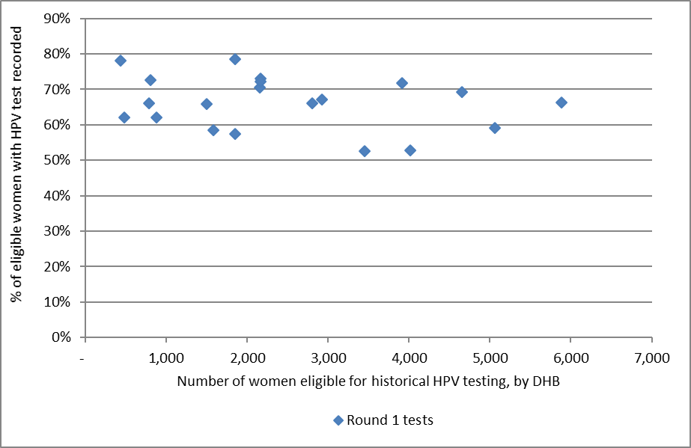
Each dot represents a DHB.
This chart does not suggest that there is any relationship between the number of women eligible for testing and percent of women who have been tested, therefore this does not seem a likely explanation for the variation in women tested in different DHBs.

Figure 106 - Relationship between women screened in the previous five years and proportion of women with historical tests recorded, by DHB
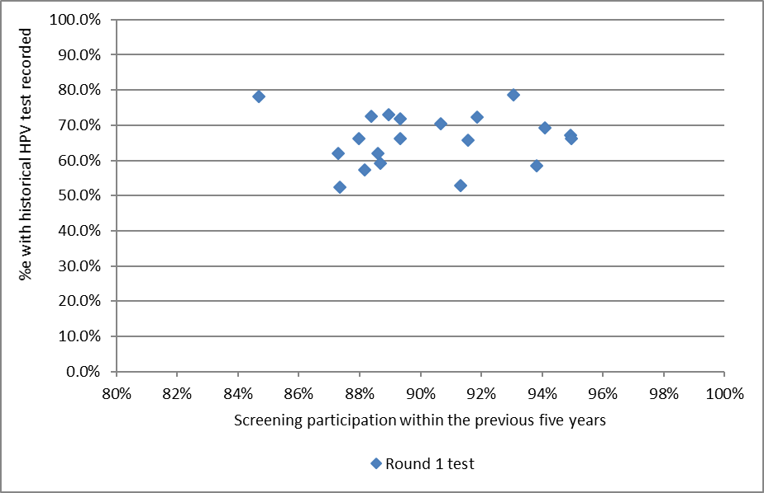
Each dot represents a DHB. See also Table 80
Figure 107 - Relationship between women screened in the previous five years and proportion of women with historical tests recorded, by ethnicity
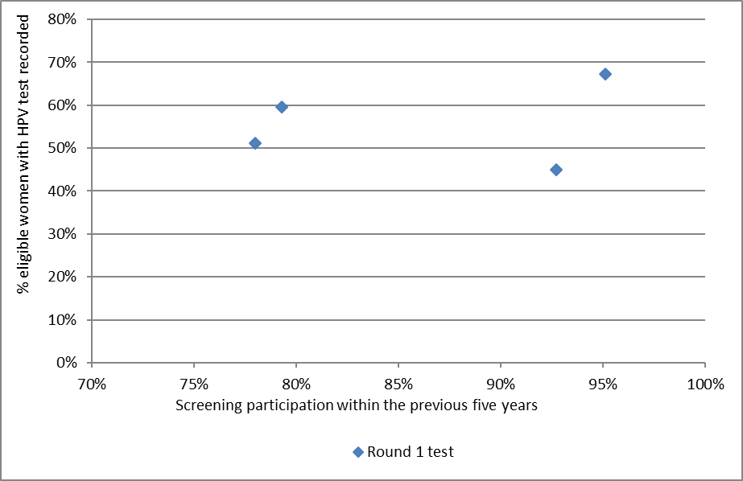
Each dot represents an ethnicity

Table 80 - Women screened in the previous five years and proportion of women with historical round 1 and 2 tests recorded, by DHB
DHB | Women screened in the last 5 years | Round 1 test recorded | Round 2 test recorded
 | % | % | %
Auckland | 91.3% | 52.8% | 37.0%
Bay of Plenty | 94.9% | 67.1% | 50.7%
Canterbury | 88.0% | 66.3% | 58.1%
Capital & Coast | 95.0% | 66.1% | 57.2%
Counties Manukau | 87.3% | 52.5% | 36.5%
Hawke's Bay | 90.7% | 70.5% | 58.4%
Hutt Valley | 91.6% | 65.8% | 55.8%
Lakes | 93.8% | 58.5% | 43.3%
Mid Central | 89.0% | 73.1% | 61.9%
Nelson Marlborough | 93.0% | 78.6% | 70.5%
Northland | 88.2% | 57.4% | 42.2%
South Canterbury | 88.4% | 72.6% | 62.2%
Southern | 94.1% | 69.2% | 58.5%
Tairawhiti | 88.6% | 62.0% | 47.4%
Taranaki | 91.9% | 72.3% | 63.3%
Waikato | 89.3% | 71.8% | 59.4%
Wairarapa | 87.3% | 62.0% | 52.9%
Waitemata | 88.7% | 59.2% | 39.8%
West Coast | 84.7% | 78.2% | 68.3%
Whanganui | 89.3% | 66.2% | 48.9%

Appendix B – Bethesda 2001 New Zealand Modified
TBS code | Descriptor

Specimen type
CPS | Conventional pap smear
LBC | Liquid based cytology
COM | Combined (conventional and liquid based)

Specimen site
T | Vault
R | Cervical
V | Vaginal

Adequacy
S1 | The specimen is satisfactory for evaluation (optional free text)
S2 | The specimen is satisfactory for evaluation (optional free text). No endocervical/ transformation zone component present
UA | The specimen is unsatisfactory for evaluation because of insufficient squamous cells
UB | The specimen is unsatisfactory for evaluation because of poor fixation/preservation
UC | The specimen is unsatisfactory for evaluation because foreign material obscures the cells
UD | The specimen is unsatisfactory for evaluation because inflammation obscures the cells
UE | The specimen is unsatisfactory for evaluation because blood obscures the cells
UF | The specimen is unsatisfactory for evaluation because of cytolysis/autolysis
UG | The specimen is unsatisfactory for evaluation because … (free text)

General
G1 | Negative for intraepithelial lesion or malignancy
G2 | Epithelial cell abnormality: See interpretation/result
G3 | Other: See interpretation/result

Interpretation
O1 | There are organisms consistent with Trichomonas species
O2 | There are fungal organisms morphologically consistent with Candida species
O3 | There is a shift in microbiological flora that may represent bacterial vaginosis
O4 | There are bacteria morphologically consistent with Actinomyces species
O5 | There are cellular changes consistent with Herpes simplex virus
OT1 | There are reactive cellular changes present (optional free text)
OT2 | There are endometrial cells present in a woman over the age of 40 years
OT3 | There are atrophic cellular changes present
ASL | There are atypical squamous cells of undetermined significance (ASC-US) present
ASH | There are atypical squamous cells present. A high grade squamous intraepithelial lesion cannot be excluded (ASC-H)
LS | There are abnormal squamous cells consistent with a low grade squamous intraepithelial lesion (LSIL; CIN1/HPV)
HS1 | There are abnormal squamous cells consistent with a high grade squamous intraepithelial lesion (HSIL). The features are consistent with CINII or CINIII
HS2 | There are abnormal squamous cells consistent with a high grade squamous intraepithelial lesion (HSIL) with features suspicious for invasion
SC | There are abnormal squamous cells showing changes consistent with squamous cell carcinoma
AG1 | There are atypical endocervical cells present
AG2 | There are atypical endometrial cells present
AG3 | There are atypical glandular cells present
AG4 | There are atypical endocervical cells favouring a neoplastic process
AG5 | There are atypical glandular cells favouring a neoplastic process
AIS | There are abnormal endocervical cells consistent with adenocarcinoma in-situ (AIS)
AC1 | There are abnormal glandular cells consistent with endocervical adenocarcinoma
AC2 | There are abnormal glandular cells consistent with endometrial adenocarcinoma
AC3 | There are abnormal glandular cells consistent with extrauterine adenocarcinoma
AC4 | There are abnormal glandular cells consistent with adenocarcinoma
AC5 | There are abnormal cells consistent with a malignant neoplasm

Recommendation
R1 | The next smear should be taken in three years, based on the information held on the NCSP Register
R2 | Please repeat the smear within three months
R3 | Please repeat the smear within three months of the end of pregnancy
R4 | Please repeat the smear in three months
R5 | Please repeat the smear in six months
R6 | Please repeat the smear in 12 months
R7 | Because a previous smear showed atypical squamous cells or low grade changes, please repeat the smear in 12 months
R8 | Annual smears are indicated because of previous high grade abnormality
R9 | Referral for specialist assessment is indicated
R10 | Urgent referral for specialist assessment is indicated
R11 | [not in use]
R12 | Please repeat the smear shortly after a course of oestrogen treatment
R13 | Under specialist care
R14 | In view of the abnormal clinical history provided, urgent referral for assessment is recommended regardless of cytological findings

Appendix C – SNOMED categories for histological samples
Adequacy of specimen |  | 1986 Code | 1993 Code
Insufficient or unsatisfactory material for diagnosis |  | M09000 | M09010
There is no code for satisfactory materials.
Site (topography) of specimen |  | 1986 Code | 1993 Code
Vagina |  | T81 | T82000
Cervix (includes endocervix and exocervix) |  | T83 | T83200
Summary diagnosis | Code stored on register | 1986 Code | 1993 Code | Diagnostic category | Rank*
There will be a maximum of four M codes transmitted to the register.
Negative result - normal tissue |  | M00100 | M60000 | Negative/benign | 1
Inflammation |  | M40000 | M40000 | Negative/benign | 2
Microglandular hyperplasia |  | M72480 | M72480 | Negative/benign | 3
Squamous Metaplasia |  | M73000 | M73000 | Negative/benign | 4
Polyp |  | M76800 | M76800 | Negative/benign | 5
Other (Morphologic abnormality, not dysplastic or malignant) |  | M01000 | M01000 | Negative/benign | 6
Atypia |  | M69700 | M67000 | CIN 1 | 7
Benign glandular atypia |  | M81400 | M67030 | Negative/benign | 8
HPV, koilocytosis, condyloma (NOS)  Condyloma acuminatum | M76700 | M76700  M76720 | M76700  M76720 | HPV | 9
CIN I (LSIL)  (VAIN I when used with T81/ T82000) |  | M74006 | M67016 | CIN 1 | 10
Dysplasia / CIN NOS |  | M74000 | M67015 | CIN 1 | 11
Glandular dysplasia |  | M81401 | M67031 | Glandular dysplasia | 12
CIN II (HSIL)  (VAIN II when used with T81/ T82000) |  | M74007 |  | CIN 2 | 13
HSIL NOS |  | M67017 | M67017 | HSIL | 14
CIN III (HSIL) |  | M74008 |  | CIN 3 | 17
(VAIN III when used with T81/ T82000)  Carcinoma in situ |  | M80102  M80702 | M80102  M80702 |  | 15  16
Adenocarcinoma in situ |  | M81402 | M81402 | Adenocarc. in situ | 18
Microinvasive squamous cell carcinoma |  | M80765 | M80763 | Micro-invasive | 19
Invasive squamous cell carcinoma |  | M80703 | M80703 | Invasive SCC | 20
Adenocarcinoma (endocervical type) |  | M83843 | M83843 | Adenocarcinoma (endocervical type) | 21
Adenosquamous carcinoma |  | M85603 | M85603 | Adenosquamous carcinoma | 22
Invasive adenocarcinoma (not endocervical type) |  | M81403 | M81403 | Invasive adenocarcinoma  (not endocervical type) | 23
Metastatic tumour |  | M80006 | M80006 | Other cancer | 29
Undifferentiated carcinoma |  | M80203 | M80203 | Other cancer | 24
Sarcoma |  | M88003 | M88003 | Other cancer | 25
Other codes accepted | Code stored on register | 1986 Code | 1993 Code | Diagnostic category | Rank
Carcinosarcoma | M88003 | M89803 | M89803 | Other cancer | 26
Choriocarcinoma | M80003 | M91003 | M91003 | Other cancer | 27
Miscellaneous primary tumour | M80003 | M80003 | M80003 | Other cancer | 28
Small cell carcinoma | M80003 | M80413 | M80413 | Other cancer | 30
Malignant tumour, Small cell type | M80003 | M80023 | M80023 | Other cancer | 31
Melanoma | M80003 | M87203 | M87203 | Other cancer | 32
Other primary epithelial malignancy | M80003 | M80103 | M80103 | Other cancer | 33

Appendix D – Indicator Definitions Targets and Reporting Details

Positive predictive value calculations
Table 81 - Definition used for positive predictive value calculations
Histology Diagnosis | G1 | Squamous (G2) |  |  |  |  | Glandular (G2) |  |  | Other (G3) | Total
 | G1 | ASL | LS | ASH | HS1/2 | SC | AG1-5 | AIS | AC1-4 | AC5
Negative |  |  |  | q | y | y | a | a | a
Squam-Atypia NOS |  |  |  | q | y | y | a | a | a
Squam-Low Grade/CIN1/HPV |  |  |  | q | y | y | a | a | a
Squam-High Grade/CIN 2-3 |  |  |  | p | x | x | b | b | b
Squam MI SCC |  |  |  | p | x | x | b | b | b
Squam-Invasive SCC |  |  |  | p | x | x | b | b | b
Gland-Benign Atypia |  |  |  | q | y | y | a | a | a
Gland-Dyplasia |  |  |  | p | x | x | b | b | b
Gland-AIS |  |  |  | p | x | x | b | b | b
Gland-Invasive Adeno |  |  |  | p | x | x | b | b | b
Other Malignant Neoplasm |  |  |  | p | x | x | b | b | b
PPV% (ASC-H)= sum(p) / (sum(p)+sum(q))
PPV% (HSIL)= sum(x) / (sum(x)+sum(y))
PPV% (ASC-H + HSIL + SC)= (sum(p) + sum(x))/ (sum(p)+sum(q) +sum(x) + sum(y)

Appendix E – DHB assignment for colposcopy clinics
Where results in Indicator 7 (colposcopy indicators) are provided by DHB, the clinics included in each DHB are as listed below. Assignment of individual facilities to specific DHBs was provided by the NCSP. All other colposcopy clinics were grouped together as “Private practice”.

DHB | Colposcopy clinics included*
Auckland | Ward 97 - Gynae Inpatient Auckland City Hospital  General Surgery – Auckland City Hospital  Colposcopy Clinic - Greenlane Clinical Centre  Gynae Outpatient Clinic – Greenlane Clinical Centre  Short Stay Surgical Unit – Greenlane Clinical Centre  Emergency Medicine – North Shore Hospital
Bay of Plenty | Whakatane Hospital (G)  Opotiki Hospital Outpatients’ Department  Tauranga Hospital (G)
Canterbury | Ashburton Hospital  Christchurch Hospital  Christchurch Sexual Health Centre  Christchurch Women's Hospital - Colposcopy  Christchurch Women's Hospital - Gynaecology
Capital & Coast | Colposcopy Clinic – Wellington Women’s Hospital Outpatients Department  Kenepuru Women's Outpatients’ Department  Women's Clinic – Wellington Regional Hospital
Counties Manukau | Manukau Super Clinic  Gynaecology Clinic – [Middlemore Hospital]  Colposcopy Clinic – Manukau Super Clinic
Hawke's Bay | Chatham Islands Health Centre  Outpatients Dept – Napier Health Centre  Villa 4, Gynaecology, Hawke’s Bay Hospital  Hawkes Bay Regional Hospital  Wairoa Cervical Screening  Wairoa Hospital
Hutt Valley | Women's Health Clinic – Hutt Hospital  Gynaecology Clinic - Hutt Hospital
Lakes | Rotorua Hospital (Gynae Dept)  Taupo Hospital
Mid Central | Colposcopy Clinic – Palmerston North Hospital  Gynaecology Clinic - Palmerston North Hospital  Gynaecology Clinic Horowhenua Hospital
Nelson Marlborough | Marlborough Maternity & Gynae  Nelson Outpatients Department
Northland | Colposcopy Clinic Whangarei Hospital  Kaitaia Hospital Colp Outpatients’ Department  Bay Of Islands Hospital Outpatients’ Department  Gynaecology Clinic Whangarei Hospital
South Canterbury | Timaru Hospital - Colp/Gynae
Southern | General Gynae Department – Dunedin Hospital  Dunedin Public Hospital  Dunedin Colposcopy Clinic  Southland Hospital Gynaecology
Tairawhiti | Gisborne Hospital
Taranaki | Taranaki Health Base Hospital - Outpatients Department  Hawera Outpatients
Waikato | Te Kuiti Hospital  Womens Outpatient Services – Waikato Hospital  Tokoroa Hospital - Bev Thorn
Wairarapa | Gynaecology Clinic – Wairarapa Hospital
Waitemata | Colposcopy Clinic- Waitakere Hospital  Gynaecology Clinic –North Shore Hospital  Colposcopy Clinic- North Shore Hospital  Peri-Operative Department - North Shore Hospital
West Coast | Greymouth Hospital  Gynaecology Clinic Greymouth
Whanganui | Wanganui Hospital  Gynaecology Clinic – Good Health Wanganui
* Assignment of specific facilities to a DHB was provided by the NCSP, in order to distinguish between DHB clinics and private practice, because the NCSP Register records geographic DHB and does not record public vs private clinic.

Appendix F – Glossary
Term | Definition
AGC | Atypical glandular cells
AIS | Adenocarcinoma in situ. High-grade changes to the glandular (endocervical) cells of the cervix
ASC-H | Atypical squamous cells of undetermined significance, cannot exclude high grade
ASC-US | Atypical squamous cells of undetermined significance
ASR | Age standardised rate
CI | Confidence interval
CIN | Cervical intra-epithelial neoplasia; CINI: low grade; CIN 2 or 3: high grade
CIS | Carcinoma in situ. An older classification of CIN 3. Abnormal cells that are confined to the surface epithelium of the cervix.
CPS | Conventional Pap (Papanicolaou) Smear
DHB | District Health Board
European/ Other | European women and women from non-Māori and non-Pacific ethnic groups
HPV | Human papillomavirus
HPV test | Testing for a high risk (oncogenic) subtype of human papillomavirus
hrHPV | A high risk (oncogenic) subtype of human papillomavirus
HSIL | High grade squamous intra-epithelial lesion
ISC | Invasive squamous carcinoma
LBC | Liquid based cytology
LSIL | Low grade squamous intra-epithelial lesion
NCSP | National Cervical Screening Programme
NHI | National Health Index
NILM | Negative for intraepithelial lesion or malignancy (a negative cytology report)
NSU | National Screening Unit of the Ministry of Health
NPV | Negative predictive value. The proportion of the screened population with negative test results who do not have the disease being tested for.
OR | Odds ratio
PCR | Polymerase chain reaction. A technique in molecular genetics used in many types of HPV testing
PPV | Positive predictive value. The proportion of the screened population with positive test results who have the disease being tested for.
RR | Relative risk
SC | Squamous cell carcinoma (TBS 2001)
SCC | Squamous cell carcinoma
SNOMED | Systematised Nomenclature of Medicine. A systematically organised collection of medical terminology including histopathological diagnoses.
TBS 2001 (New Zealand Modified) | The Bethesda System 2001 NZ Modified. A management system based on categorising the cytological interpretation of cellular abnormality as negative, low-grade or high-grade.
TZ | Transformation zone. The region of the cervix where the glandular precursor cells change to squamous cells

References
1. Gray A. Methodology for estimating hysterectomy prevalence in women 20-69. Wellington, New Zealand, 2011.
2. Ministry of Health. Ethnicity Data Protocols for the Health and Disability Sector. 2004. http://www.health.govt.nz/publication/ethnicity-data-protocols-health-and-disability-sector.
3. Ministry of Health. Asian Health Chart Book. 2006. http://www.health.govt.nz/publication/asian-health-chart-book-2006.
4. Simonella L, Lewis H, Smith M, Neal H, Bromhead C, Canfell K. The prevalence of type-specific oncogenic human papillomavirus infection in high grade cervical disease in New Zealand. BMC Infect Dis 2013; 13(114).
5. Smith JS, Lindsay L, Hoots B, et al. Human papillomavirus type distribution in invasive cervical cancer and high-grade cervical lesions: a meta-analysis update. Int J Cancer 2007; 121(3): 621-32.
6. Stevens MP, Garland SM, Tan JH, Quinn MA, Petersen RW, Tabrizi SN. HPV genotype prevalence in women with abnormal pap smears in Melbourne, Australia. J Med Virol 2009; 81(7): 1283-91.
7. Brestovac B, Harnett GB, Smith DW, Shellam GR, Frost FA. Human papillomavirus genotypes and their association with cervical neoplasia in a cohort of Western Australian women. J Med Virol 2005; 76(1): 106-10.
8. Porras C, Rodriguez AC, Hildesheim A, et al. Human papillomavirus types by age in cervical cancer precursors: predominance of human papillomavirus 16 in young women. Cancer Epidemiol Biomarkers Prev 2009; 18(3): 863-5.
9. Baandrup L, Munk C, Andersen KK, Junge J, Iftner T, Kjaer SK. HPV16 is associated with younger age in women with cervical intraepithelial neoplasia grade 2 and 3. Gynecol Oncol 2012; 124(2): 281-5.
10. Miyamoto J, Berkowitz Z, Unger E, et al. Vaccine-type HPV distribution in CIN3/AIS: 3 U.S. cancer registries, 1994-2005. International Papillomavirus Conference and Clinical Workshop; 2011 17-22/9/2011; Berlin, Germany; 2011.
11. National Cervical Screening Programme. NCSP Operational Policy and Quality Standards, Section 5.
12. National Cervical Screening Programme. Bethesda 2001 (NZ Modified) codes for Cytology Laboratories: Codes, descriptors and assessment of sample adequacy for cytology laboratories. Wellington, 2014.
13. Ministry of Health. Report of the Parliamentary Review Committee regarding the New Zealand Cervical Screening Programme Wellington: Ministry of Health, 2011.
14. Parliamentary Review Committee. Report of the Parliamentary Review Committee regarding the New Zealand Cervical Screening Programme, June 2015. Wellington, 2015.
15. National Screening Unit. Guidelines for Cervical Screening in New Zealand: Incorporating the management of women with abnormal cervical smears. Wellington: National Screening Unit, Ministry of Health, 2008.
16. Smith M, Walker R, Canfell K. National Cervical Screening Programme Monitoring Report Number 33. Wellington, 2012.
17. Smith M, Walker R, Canfell K. National Cervical Screening Programme Monitoring Report Number 34. Wellington, 2012.

