

|  |
| --- |
| National Cervical Screening Programme Incidence and Mortality Report  2018 to 2019 |
| Released 2022 |

Citation: Te Whatu Ora – Health New Zealand. 2022. *National Cervical Screening Programme Incidence and Mortality Report 2018 to 2019*. Wellington: Te Whatu Ora – Health New Zealand.

Published in August 2022 by Te Whatu Ora – Health New Zealand  
PO Box 5013, Wellington 6140, New Zealand

ISBN 978-1-99-117120-7 (online)



This document is available at [TeWhatuOra.govt.nz](https://www.tewhatuora.govt.nz/)

|  |  |
| --- | --- |
| **CCBY** | This work is licensed under the Creative Commons Attribution 4.0 International licence. In essence, you are free to: share ie, copy and redistribute the material in any medium or format; adapt ie, remix, transform and build upon the material. You must give appropriate credit, provide a link to the licence and indicate if changes were made. |

# Foreword

Ongoing, systematic monitoring against performance indicators is one of a range of monitoring systems the National Screening Unit (NSU) uses to ensure its programmes are working well.

The NCSP Incidence and Mortality report includes cervical cancer registrations to the New Zealand Cancer Registry to 2019 and mortality data to 2018. The previous report[1] 2017 was published in 2020.

Contents

Foreword 3

Executive summary 5

Selected results 5

Related National Cervical Screening Programme reports 6

Cancer Incidence to 31 December 2019 6

Definition 6

Calculation 6

Results 7

Comments 18

Cancer Mortality to 31 December 2018 19

Definition 19

Target 19

Calculation 19

Results 20

Comments 26

Appendix A: Additional data tables 27

Appendix B: Population data 29

References 30

**List of Figures**

Figure 1: Age-standardised cervical cancer incidence rates, 2011-2019, by ethnicity 8

Figure 2: Age-standardised cervical cancer incidence rates for Māori*, other, and all women, 1985–2019† 10

Figure 3: Age-standardised cervical cancer incidence rates, 2007-2019, by histological type 11

Figure 4: Five-year average cervical cancer incidence rates, by age 13

Figure 5: Five-year average cervical cancer incidence rates, 2015-2019, by age and ethnicity 15

Figure 6: Five-year average cervical cancer incidence rates, 2015-2019, by age and histological type 17

Figure 7: Age-standardised cervical cancer mortality rates, 2010–2018, by ethnicity 21

Figure 8: Age-standardised cervical cancer mortality rates for Māori*, other and all women, 1985–2018† 22

Figure 9: Five-year average cervical cancer mortality rates, 2014–2018, by age 24

Figure 10: Five-year average cervical cancer mortality rates, 2014–2018, by age and ethnicity 25

**List of Tables**

Table 1: Cervical cancer incidence, 1996-2019, by ethnicity 9

Table 2: Cervical cancer incidence (per 100,000 women), 2006–2019, by histological type 12

Table 3: Five-year average cervical cancer incidence, 2015-2019 by age and ethnicity 16

Table 4: Cervical cancer mortality, 1998-2018, by ethnicity 23

Table 5: Average cervical cancer mortality, 2014–2018, by age 25

Table 6: Incident cases by detailed morphology, 2019 27

Table 7: Extent of disease at time of diagnosis for incident cervical cancer cases, 2007–2019 28

Table 8: World Health Organization Standard Population 29

# Executive summary

## Selected results

### Cancer incidence to 31 December 2019

* In 2019, there were 186 new diagnoses of cervical cancer. In 2018, there were 187 new diagnoses of cervical cancer. In the year 2019 this is equivalent to an age-standardised rate (ASR, using the World Health Organization (WHO) World Standard Population) of 6.7 new diagnoses per 100,000 women in the population.
* In 2019, most cervical cancers were squamous cell carcinomas (134 cases; ASR 5.0 per 100,000 women), with a smaller proportion comprising adenocarcinomas (30 cases; ASR 1.1 per 100,000 women), adenosquamous carcinomas (6 cases; ASR 0.2 per 100,000 women), neuroendocrine carcinomas (2 cases, ASR 0.1 per 100,000 women) or other cervical cancers (14 cases; ASR 0.4 per 100,000 women).
* Overall, between 1996 and 2019 the age-standardised rate of cervical cancer incidence declined from 10.5 to 6.7 per 100,000 for women of all ethnicities, and from 25.0 to 7.8 per 100,000 for Māori women.

### Cancer mortality to 31 December 2018

* In 2018, there were 69 deaths due to cervical cancer. This is equivalent to an age-standardised mortality rate of 1.9 per 100,000 women in the population.
* In 2017, there were 51 deaths due to cervical cancer. This is equivalent to an age-standardised mortality rate of 1.5 per 100,000 women in the population.
* Overall, between 1998 and 2018 age-standardised cervical cancer mortality rates declined from 3.2 to 1.9 per 100,000 for women of all ethnicities, and from 10.3 to 4.5 per 100,000 for Māori women.

# Related National Cervical Screening Programme reports

Information on participation in screening and on programme statistics (including cytology, HPV testing, colposcopy, and histology reporting) can be found in the National Cervical Screening Programme (NCSP)’s published reports available on the NCSP website at <https://www.nsu.govt.nz/health-professionals/national-cervical-screening-programme/independent-monitoring-reports>.

# Cancer Incidence to 31 December 2019

## Definition

Cancer incidence is the annual rate of new registrations of invasive cervical cancer (per 100,000 women in the New Zealand estimated resident population), standardised to the WHO Standard Population according to Ahmad et al (2001).

## Calculation

Registrations of cancer cases (by age, ethnicity, and histological type) over the period 2008 to 2019 were obtained from the New Zealand Cancer Registry (data extracted 28 July 2021). Age-specific incidence rates were calculated for each calendar year, based on the estimated resident New Zealand female population in June of that year (mid-year estimates), using 2020 update projections from the 2018 Census. The analysis by ethnicity considered four groups – Māori, Pacific, Asian, or other, on women’s prioritised ethnicity derived from level two ethnicity codes in the Ministry of Health’s National Health Index (NHI). Women for whom ethnicity information was not available were included in the other ethnicity category.

Age-specific rates were then weighted using the WHO Standard Population to derive age-standardised rates (details of the WHO Standard Population are provided in Appendix B: Population data). 95 percent confidence intervals were calculated according to the methods in IARC Scientific Publication 95. Cancer Registrations: Principles and Methods (Chapter 11: Statistical Methods for Registries) (Boyle and Parkin 2002). Incidence rates were calculated separately for either each ethnic group, or for each histological type. Five-year average rates were also calculated by five-year age group as the sum of all cases over the five-year period within that age group, divided by the sum of the estimated mid-year population within that age group in each of the five years contributing to the average. Three-year moving averages for rates were calculated by finding the average of the current years rate and previous two years rates.

Note that throughout this report some of the breakdowns by ethnicity and histological type result in small counts. These small counts should be interpreted cautiously due to the instability of the results.

## Results

In 2019, there were 186 new diagnoses of cervical cancer, or an age-standardised rate of 6.7 new diagnoses per 100,000 women in the population[2]. Cervical cancer age-standardised incidence rates overall, and for each of Māori (7.8), Pacific (10.9), Asian (4.8), and other (7.1) women, are shown in Table 1 and with 95 percent confidence intervals in Figure 1a. Counts of actual numbers of cancer cases are also shown in Table 1.

Rates could not be calculated for all four ethnicity groups prior to 2006 due to limitations in the availability of population data (although separate case numbers for 2005 were only available from previous annual monitoring reports). Therefore, cases and rates presented for ‘Other women’ in 1996–2004 relate to all non-Māori women. This data was sourced from Cancer: New Registrations and Deaths (Ministry of Health 2010a and 2010b).

As Figure 1a shows, there is some variation in the age-standardised incidence rates by ethnicity; however, the 95 percent confidence intervals are wide for some ethnicities. There is a lot of volatility in the Pacific age-standardised incidence rates due to the small case counts. Figure 1b shows the 3-year moving average of the age-standardised incidence rates for the 4 ethnicity categories.

Figure 1: Age-standardised cervical cancer incidence rates, 2011-2019, by ethnicity

1. All ethnic groups

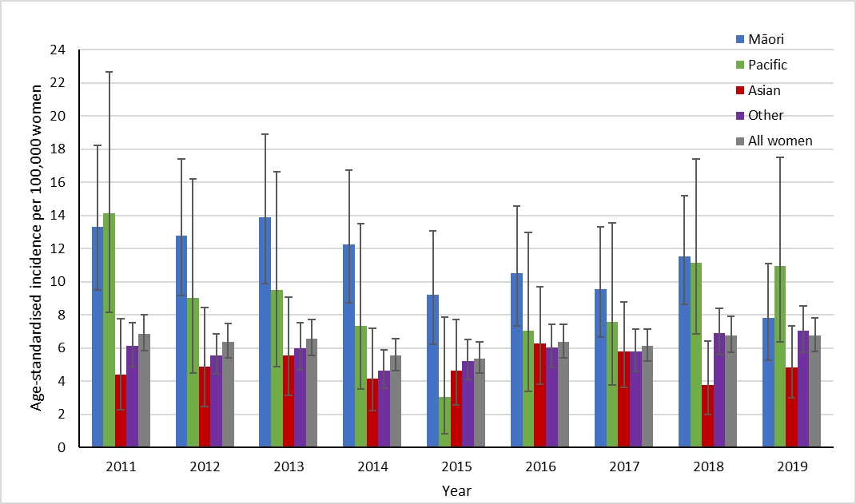

Vertical bars represent 95 percent confidence intervals. Other includes all non-Māori, Non-Pacific, and non-Asian.

1. 3-year moving average

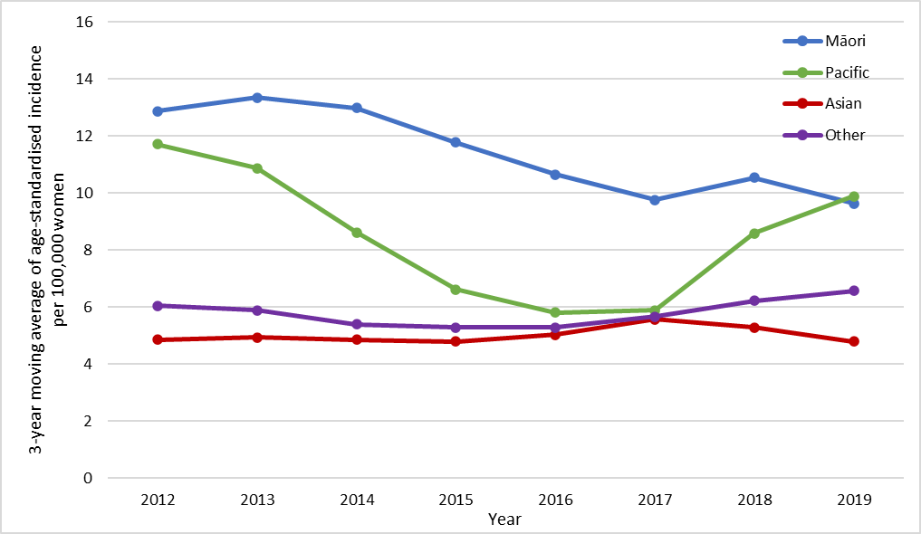

Other includes all non-Māori, Non-Pacific, and non-Asian.

Table 1: Cervical cancer incidence, 1996-2019, by ethnicity



† Cases and rates for 1997–2004 were sourced from *Cancer: New Registrations and Deaths 2007* (Ministry of Health 2010b)*;* cases and rates for 1996 were sourced from *Cancer: New Registrations and Deaths 2006* (Ministry of Health 2010a). Cases and rates for 2005 were sourced from a previous NCSP Annual Report (2008–2009) (Smith et al 2012)

§ Counts and rates for other women in 1996–2004 were combined for all non-Māori women; that is, they also include cases in Pacific and Asian women

* Rates are per 100,000 women, age-standardised to the WHO Standard Population (all ages)

n/a = not available

Overall, between 1996 and 2019, cervical cancer age-standardised incidence declined from 10.5 to 6.7 per 100,000 for women of all ethnicities, from 25.0 to 7.8 per 100,000 for Māori women, and from 9.0 to 7.1 per 100,000 for women of other ethnicity, shown in Table 1. The age-standardised rate for Maori in 2019 was the lowest recorded over the period 1985-2019. Longer-term cancer age-standardised incidence trends for Māori, other, all women by year can be seen in Figure 2.

Figure 2: Age-standardised cervical cancer incidence rates for Māori*, other, and all women, 1985–2019†

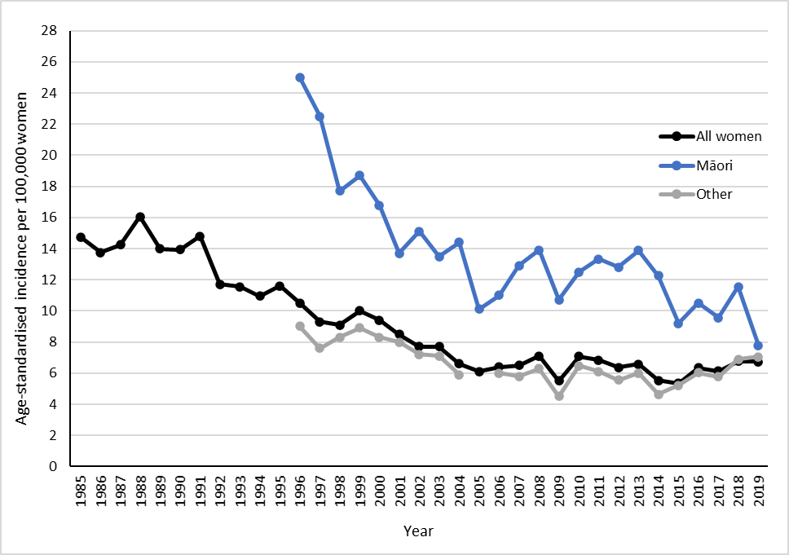

Rates are per 100,000 women, age-standardised to the WHO Standard Population (all ages).

* Aged-standardised rates for Māori women were not available for years prior to 1996.

† Rates for 1996–2004 were sourced from *Cancer: New Registrations and Deaths 2007* (Ministry of Health 2010b) and *2006* (Ministry of Health 2010a). Rates from 2005 were sourced from a previous (Smith et al 2012) and the current NCSP annual monitoring report (see footnote). Prior dates have been sourced directly from the Ministry of Health.

Figure 3 and Table 2 show cervical cancer age-standardised incidence rates by histological type. Squamous cell cancer remained the most diagnosed type of cervical cancer over the period 2007–2019. For example, in 2019 there were 134 cases (72.0% of cases) of Squamous, 30 cases (16.1% of cases) of adenocarcinoma, 6 cases (3.2% of cases) of adenosquamous carcinoma, 2 cases (1.1% of cases) of neuroendocrine carcinoma, and 14 Others (7.5% of cases). Table 6 (Appendix A) gives a more detailed breakdown by histological type of cases diagnosed in 2019.

Figure 3: Age-standardised cervical cancer incidence rates, 2007-2019, by histological type

Vertical bars represent 95 percent confidence intervals

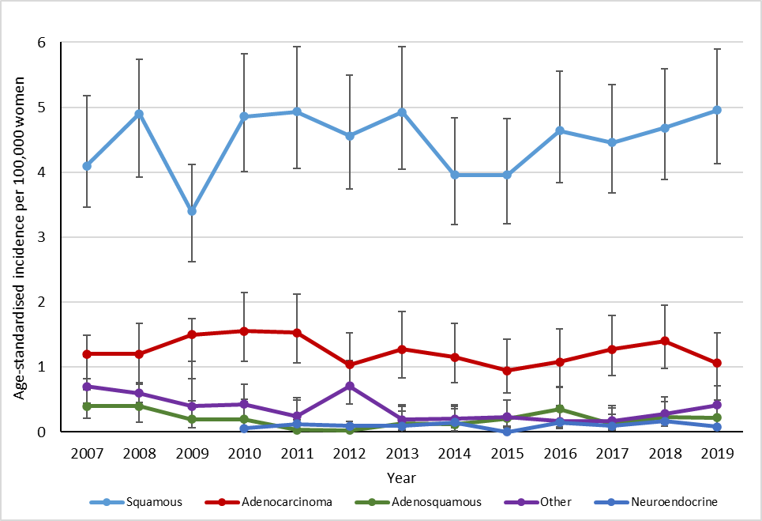

Table 2: Cervical cancer incidence (per 100,000 women), 2006–2019, by histological type



* Per 100,000 women, age-standardised to the WHO Standard Population (all ages)

Figure 4a and Table 3 show five-year average crude age-specific cervical cancer incidence rates (2015–2019). Overall, there was a low incidence at younger ages, increasing by the age of 25–29 years to reach a peak in the five-year age groups between 30 and 44 (15.8, 13.4 and 14.1 per 100,000 for all ethnicities for age groups 30–34, 35–39 and 40–44 respectively). A general decrease following a plateauing is seen for the remaining ages until the age of 80+. Figure 4b shows five-year average age-specific cervical cancer incidence rates in 2015 – 2019, compared to 2010–2014. The average age-specific incidence was lower for the 70-79 age groups between 2015-2019 than in the earlier period from 2010-2014.

Figure 4: Five-year average cervical cancer incidence rates, by age

1. 2015-2019

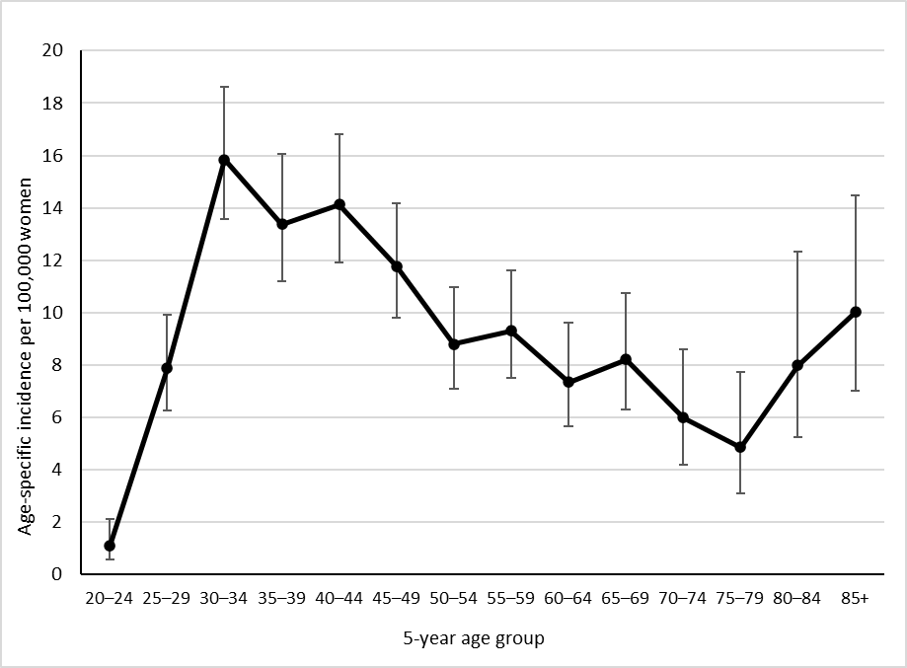

Vertical bars represent 95 percent confidence intervals

1. 2010-2014 and 2015-2019

Figure 5 and Table 3 show five-year average age-specific incidence rates by ethnicity. Confidence intervals are generally wide, so are not displayed in Figure 5, but are included in Table 3. There were small case numbers (five or fewer per year) in most age groups for Māori, Pacific, and Asian women. Because of these factors, age-specific incidence rates by ethnicity must be interpreted cautiously.

Figure 5: Five-year average cervical cancer incidence rates, 2015-2019, by age and ethnicity

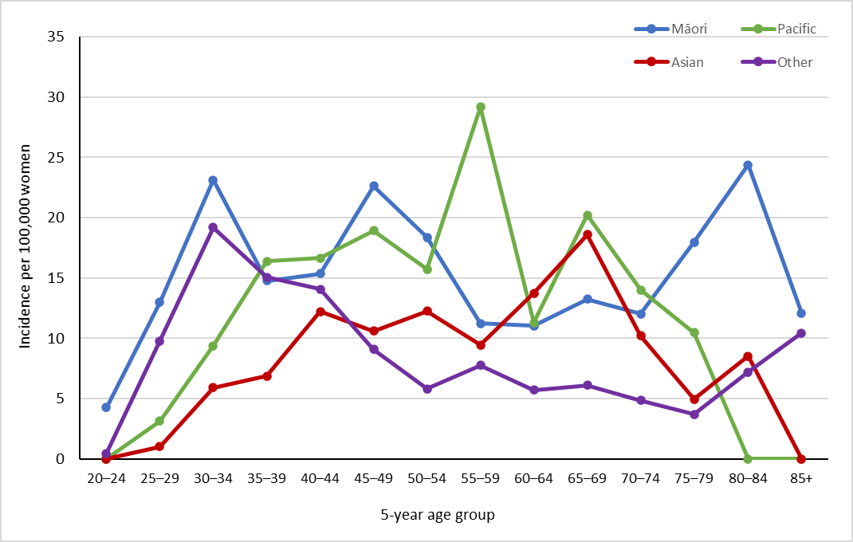

Note that no cases were observed among Pacific women aged 20–24 years, and 80+ years, or among Asian women aged 20-24 years, and 85+ years over this time period.

Table 3: Five-year average cervical cancer incidence, 2015-2019 by age and ethnicity



Figure 6 shows five-year average age-specific cervical cancer incidence rates for 2015-2019 by histological type. Squamous histological type increased to a peak in the five-year age group 30-34 and dropped before increasing again after the 75-79-year age group. Among cancer cases where extent of disease information was recorded, most new cases were localised to the cervix (Table 7 – Appendix A).

Figure 6: Five-year average cervical cancer incidence rates, 2015-2019, by age and histological type

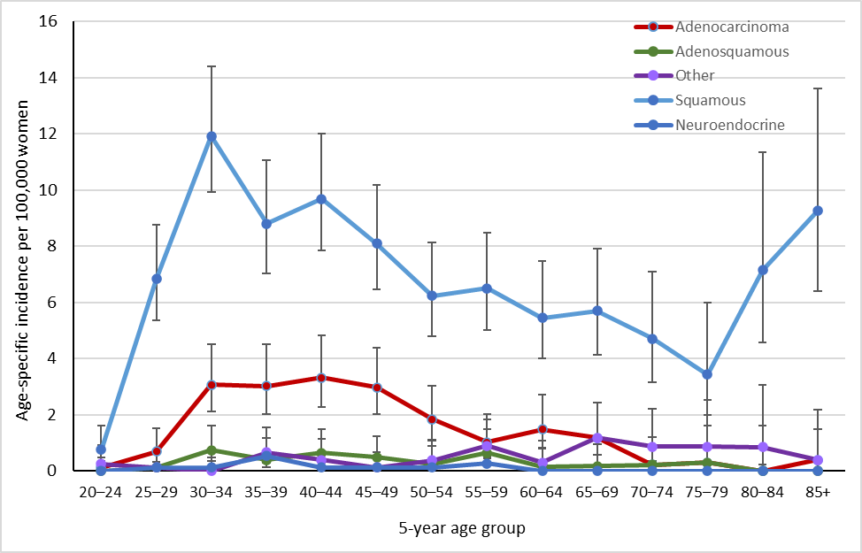

Vertical bars represent 95 percent confidence intervals

## Comments

In this report incidence rates are age-standardised using the WHO Standard Population (see **Error! Reference source not found.**), consistent with the population used to produce standardised rates in *Cancer: New Registrations and Deaths*. Note that NCSP annual monitoring reports prior to that for 2008–2009 reported on rates which were standardised to the Segi population, and therefore these rates are not directly comparable.

Consistent with other statistical data, the rates of cervical cancer incidence are expressed per 100,000 women in the population. The population is not adjusted to take into account hysterectomy prevalence.

# Cancer Mortality to 31 December 2018

## Definition

Cancer mortality is the annual rate of deaths due to invasive cervical cancer (per 100,000 women in the New Zealand estimated resident population), standardised to the WHO Standard Population.

## Target

Mortality in the New Zealand population of no more than 2.8 per 100,000 women when age-standardised to the WHO Standard Population (or no more than 2.5 per 100,000 women when age-standardised to the Segi population).

## Calculation

Registrations of cervical cancer mortality (by age and prioritised ethnicity) over the period 2009-2018 were obtained from the New Zealand Cancer Registry (data extracted 28 July 2021).

Age-specific mortality rates were calculated for each calendar year, based on the estimated resident New Zealand female population in June of that year (mid-year estimates), using 2020 update projections from the 2018 Census.

Age-specific rates were then weighted using the WHO Standard Population to derive age-standardised rates (details of the WHO Standard Population are provided in **Error! Reference source not found.**). 95 percent confidence intervals were calculated according to the methods in *IARC Scientific Publication 95. Cancer Registrations: Principles & Methods* (Chapter 11: Statistical Methods for Registries)(Boyle and Parkin 2002). Mortality rates were calculated separately for each ethnic group. Five-year average rates were also calculated by five-year age group as the sum of all cases over the five-year period within that age group, divided by the sum of the estimated population within that age group in each of the five years contributing to the average.

## Results

The most recent mortality data available is for 2018.

In 2018, there were 69 deaths due to cervical cancer, or an age-standardised rate of 1.9 cervical cancer deaths per 100,000 women in the population.[3] Table 4 and Figure 7a show cervical cancer mortality rates overall, and by ethnicity (these are 4.5 for Māori, 3.5 for Pacific, 0.7 for Asian and 1.6 for other women). Table 4 also shows counts of deaths due to cervical cancer.

In 2017, there were 51 deaths due to cervical cancer, or an age-standardised rate of 1.5 cervical cancer deaths per 100,000 women in the population.[4] Table 4 and Figure 7a show cervical cancer age-standardised mortality rates overall, and for by ethnicity (these are 2.8 for Māori, 0.7 for Pacific, 1.3 for Asian and 1.3 for other women). Table 4 also shows counts of deaths due to cervical cancer.

Rates could not be calculated for all four ethnicity groups prior to 2006 due to limitations in the availability of population data; however, separate counts for deaths were available for 2005 from previous annual monitoring reports (Brewer et al 2008; Smith et al 2012). Therefore rates and deaths reported for ‘Other women’ in 1998–2004 relate to all non-Māori women; this data was sourced from *Cancer: New Registrations and Deaths 2007* (Ministry of Health 2010b).

As **Error! Reference source not found.**7a shows, there is some variation in age-standardised mortality rates by ethnicity, however for Māori, Pacific, and Asian women the 95% confidence are relatively wide and trends in these numbers should be treated with caution as they are subject to large variation due to the small number of mortalities for these ethnicities. An additional figure is included that compares mortality rates in Māori women to rates in Other women in New Zealand (**Error! Reference source not found.**b), to supplement the more detailed ethnicity information in **Error! Reference source not found.**7a.

Figure 7: Age-standardised cervical cancer mortality rates, 2010–2018, by ethnicity

1. All ethnic groups

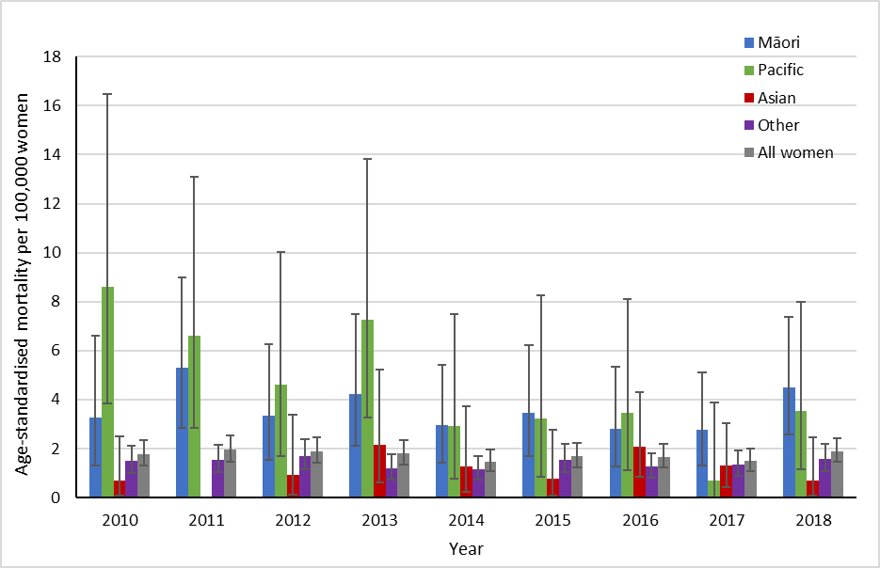

Vertical bars represent 95 percent confidence intervals. Note: no deaths were recorded for Asian women in 2011.

1. Māori women, compared to other/European women

Vertical bars represent 95 percent confidence intervals

Overall, between 1998 and 2018, cervical cancer age-standardised mortality rates declined from 3.2 to 1.9 per 100,000 for women of all ethnicities, from 10.3 to 4.5 per 100,000 for Māori women, and from 2.7 to 1.6 per 100,000 for other women (Table 4). Figure 8 shows longer-term cancer mortality trends for Māori, other, and all women by year.

Figure 8: Age-standardised cervical cancer mortality rates for Māori*, other and all women, 1985–2018†

Rates are per 100,000 women, age-standardised to the WHO Standard Population (all ages).

* Aged-standardised rates for Māori women were not available for years prior to 1996.

† Rates for 1996–2004 were sourced from Cancer: New Registrations and Deaths 2007 (Ministry of Health 2010b) and 2006 (Ministry of Health 2010a). Rates from 2005 were sourced from a previous (Smith et al 2012) and the current NCSP annual monitoring report (see Table 4 footnote). Prior dates have been sourced directly from the Ministry of Health.

Table 4: Cervical cancer mortality, 1998-2018, by ethnicity



† Deaths and rates for 1998–2004 were sourced from *Cancer: New Registrations and Deaths 2007* (Ministry of Health 2010b).Deaths and rates for 2005 were sourced from *National Cervical Screening Programme Annual Report 2008–2009* (Smith et al 2012).Separate data on deaths in Pacific women was sourced from *National Cervical Screening Programme Annual Monitoring Report 2006* (Brewer et al 2008)

§ Counts and rates for ‘Other women’ in 1998–2004 are combined for all non-Māori women; that is, they also include deaths in Pacific and Asian women

* Rates are per 100,000 women, age-standardised to the WHO Standard Population (all ages)

n/a = not available. ‘-’ = no cases recorded

Average age-specific cervical cancer mortality rates for 2014–2018 are shown for all women in Figure 9, and by ethnicity in Figure 10. As for incidence, the associated confidence intervals are wide, making ethnicity-specific trends by age more difficult to discern, but generally there appears to be a broad increase with age. Case numbers by age are generally small for Māori, Pacific and Asian women (total deaths across all ages over this five-year period were 56 for Māori women, 20 for Pacific women and 19 for Asian women).

Figure 9: Five-year average cervical cancer mortality rates, 2014–2018, by age

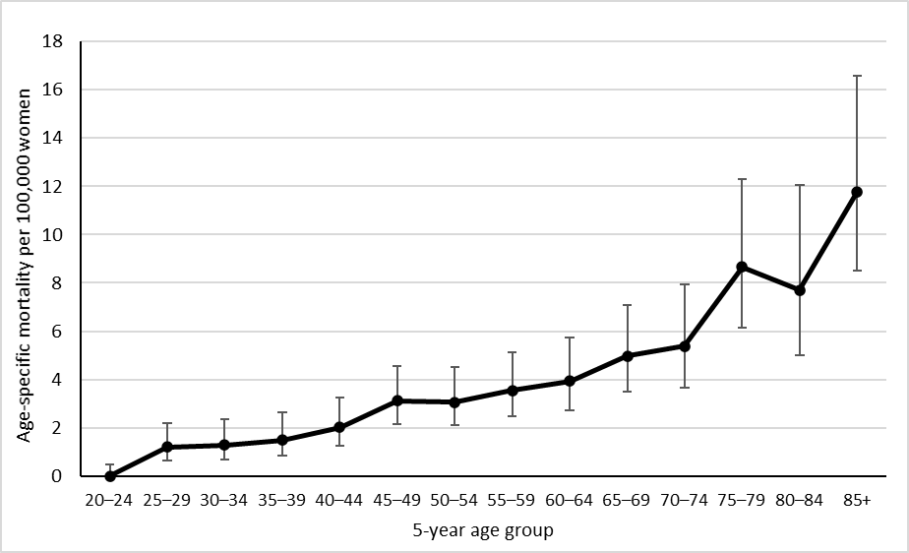

Vertical bars represent 95 percent confidence intervals. See also Table 5.

Figure 10: Five-year average cervical cancer mortality rates, 2014–2018, by age and ethnicity

Note that no deaths were recorded in Māori women aged 20–24 years and 85+ years, or Pacific women aged 20–34, 60-64, 70-74 and 85+ years or in Asian women aged 20–29, 35-39, and 85+ years over this time period. See also Table 5.

Table 5: Average cervical cancer mortality, 2014–2018, by age



‘0.0’ indicates no deaths recorded over the five-year period

## Comments

In this report, mortality rates are standardised using the WHO Standard Population (see **Error! Reference source not found.**), consistent with the population used to produce standardised rates in *Cancer: New Registrations and Deaths*. Note that NCSP annual monitoring reports prior to that for 2008–2009 reported on rates which were standardised to the Segi population, and therefore these rates are not directly comparable.

Consistent with other statistical data, the rates of cervical cancer incidence and mortality are expressed per 100,000 women in the population. The population is not adjusted to consider hysterectomy prevalence.

# Appendix A: Additional data tables

Table 6: Incident cases by detailed morphology, 2019



Table 7: Extent of disease at time of diagnosis for incident cervical cancer cases, 2007–2019



# Appendix B: Population data

***World Health Organization Standard Population***

Rates for cervical cancer incidence and mortality were standardised using the WHO World Standard Population according to Ahmad et al (2001), as Table 8 sets out.

Table 8: World Health Organization Standard Population



***New Zealand estimated resident population***

The estimated data for New Zealand female population was based on data from Statistics New Zealand. Population figures for cancer incidence and mortality used mid-year estimates, based on projections from 2018 Census data for 2006–2019. Population estimates for 2005 were based on a linear interpolation between data from the 2001 Census and 2006 Census. Population data for 2005 was not available in the four required ethnic groups, and so ethnicity-specific estimates could not be calculated for 2005 for cancer incidence, cancer mortality or coverage.

# References

Ahmad OB, Boschi-Pinto C, Lopez AD, et al. 2001. *Age Standardization of Rates: A new WHO standard*. Geneva: World Health Organization.

Boyle P, Parkin D. 2002. Chapter 11. Statistical methods for registries. *IARC Scientific Publication 95 Cancer Registrations: Principles and Methods*. Lyon: International Agency for Research on Cancer Press.

Brewer N, McKenzie F, Wong KC, et al. 2008. *National Cervical Screening Programme Annual Monitoring Report 2006*. Wellington: Centre for Public Health Research, Massey University.

Ministry of Health. 2010a. *Cancer: New Registrations and Deaths 2006*. Wellington: Ministry of Health.

Ministry of Health. 2010b. *Cancer: New Registrations and Deaths 2007*. Wellington: Ministry of Health.

Smith M, Walker R, Canfell K. 2012. *National Cervical Screening Programme Annual Report 2008–2009*. Wellington: National Screening Unit.

1. https://www.nsu.govt.nz/system/files/page/national-cervical-screening-programme-annual-report-2017-oct20.pdf
2. The equivalent overall incidence rate if age-standardised to the Segi population is 5.6 per 100,000 women in the population.
3. The equivalent overall mortality rate if age-standardised to the Segi population is 1.4 per 100,000 women in the population.
4. The equivalent overall mortality rate if age-standardised to the Segi population is 1.4 per 100,000 women in the population.