National Cervical Screening Programme Annual Report

2017

Citation: Ministry of Health. 2020. *National Cervical Screening Programme Annual Report 2017*. Wellington: Ministry of Health.

Published in October 2020 by the Ministry of Health  
PO Box 5013, Wellington 6140, New Zealand

ISBN 978-1-99-002944-8 (online)  
HP 7476



This document is available at [www.nsu.govt.nz](http://www.nsu.govt.nz)

|  |  |
| --- | --- |
| **CCBY** | This work is licensed under the Creative Commons Attribution 4.0 International licence. In essence, you are free to: share ie, copy and redistribute the material in any medium or format; adapt ie, remix, transform and build upon the material. You must give appropriate credit, provide a link to the licence and indicate if changes were made. |

Contents

Selected results 1

Cancer incidence to 31 December 2017 1

Cancer mortality to 31 December 2016 1

Related National Cervical Screening Programme reports 2

Cancer incidence to 31 December 2017 3

Definition 3

Target 3

Calculation 3

Results 4

Comments 5

Cancer mortality to 31 December 2016 12

Definition 12

Target 12

Calculation 12

Results 13

Comments 13

Appendix A: Additional data tables 19

Appendix B: Population data 21

World Health Organization Standard Population 21

New Zealand estimated resident population 22

References 23

List of Tables

Table 1: Cervical cancer incidence, 1996–2017, by ethnicity 7

Table 2: Cervical cancer incidence (per 100,000 women), 2007–2017, by histological type 8

Table 3: Five-year average cervical cancer incidence, 2013–2017, by age and ethnicity 11

Table 4: Cervical cancer mortality, 1998–2016, by ethnicity 16

Table 5: Average cervical cancer mortality, 2012–2016, by age 18

Table 6: Incident cases by detailed morphology, 2017 19

Table 7: Extent of disease at time of diagnosis for incident cervical cancer cases, 2007–2017 20

Table 8: World Health Organization Standard Population 21

List of Figures

Figure 1: Age-standardised cervical cancer incidence rates, 2011–2017, by ethnicity 5

Figure 2: Age-standardised cervical cancer incidence rates for Māori* and all women, 1985–2017† 6

Figure 3: Age-standardised cervical cancer incidence rates, 2007–2017, by histological type 8

Figure 4: Five-year average cervical cancer incidence rates, by age 9

Figure 5: Five-year average cervical cancer incidence rates, 2013–2017, by age and ethnicity 10

Figure 6: Five-year average cervical cancer incidence rates, 2013–2017, by age and histological type 10

Figure 7: Age-standardised cervical cancer mortality rates, 2010–2016, by ethnicity 14

Figure 8: Age-standardised cervical cancer mortality rates for Māori* and all women, 1985–2015† 15

Figure 9: Five-year average cervical cancer mortality rates, 2012–2016, by age 17

Figure 10: Five-year average cervical cancer mortality rates, 2012–2016, by age and ethnicity 17

# Selected results

## Cancer incidence to 31 December 2017

* In 2017 there were 168 new diagnoses of cervical cancer, including 34 new diagnoses in Māori women.
* This is equivalent to an age-standardised rate (ASR, using the World Health Organization (WHO) World Standard Population) of 6.1 new diagnoses per 100,000 women in the population, and 9.7 per 100,000 for Māori women.
* Most cervical cancers were squamous cell carcinomas (124 cases; ASR 4.4 per 100,000 women), with a smaller proportion comprising adenocarcinomas (34 cases; ASR 1.3 per 100,000 women), adenosquamous carcinomas (3 cases; ASR 0.1 per 100,000 women), neuroendocrine carcinomas (2 cases, ASR 0.1 per 100,000 women) or other cervical cancers (5 cases; ASR 0.2 per 100,000 women).
* Overall, between 1996 and 2017 cervical cancer incidence declined from 10.5 to 6.1 per 100,000 for women of all ethnicities, and from 25.0 to 9.7 per 100,000 for Māori women.

## Cancer mortality to 31 December 2016

* In 2016, there were 57 deaths due to cervical cancer, including 9 deaths in Māori women.
* This is equivalent to an age-standardised mortality rate of 1.7 per 100,000 women in the population, and 2.9 per 100,000 for Māori women.
* Overall, between 1998 and 2016 cervical cancer mortality declined from 3.2 to 1.7 per 100,000 for women of all ethnicities, and from 10.3 to 2.9 per 100,000 for Māori women.

# Related National Cervical Screening Programme reports

Information on participation in screening and on programme statistics (including cytology, HPV testing, colposcopy and histology reporting) for 2017 can be found in the National Cervical Screening Programme (NCSP)’s published reports *NCSP Six‑Monthly Monitoring Report 47, January to June 2017* and *NCSP Six-Monthly Monitoring Report 48, July to December 2017*, availableon the NCSP website at <https://www.nsu.govt.nz/health-professionals/national-cervical-screening-programme/independent-monitoring-reports>.

# Cancer incidence to 31 December 2017

## Definition

Cancer incidence is the annual rate of new registrations of invasive cervical cancer (per 100,000 women in the New Zealand estimated resident population), standardised to the WHO Standard Population according to Ahmad et al (2001).

## Target

Incidence in the New Zealand population of no more than 14.8 per 100,000 women when age-standardised to the WHO Standard Population (or no more than 7.5 per 100,000 when age standardised to the Segi population).

## Calculation

Registrations of cancer cases (by age, ethnicity, and histological type) over the period 2008 to 2017 were obtained from the New Zealand Cancer Registry (data extracted 18 February 2020). Age-specific incidence rates were calculated for each calendar year, based on the estimated resident New Zealand female population in June of that year (mid-year estimates), using projections from the 2013 Census.

Age-specific rates were then weighted using the WHO Standard Population to derive age-standardised rates (details of the WHO Standard Population are provided in Appendix B: Population data). 95 percent confidence intervals were calculated according to the methods in *IARC Scientific Publication 95. Cancer Registrations: Principles and Methods* (Chapter 11: Statistical Methods for Registries) (Boyle and Parkin 2002). Incidence rates were calculated separately for either each ethnic group, or for each histological type. Five-year average rates were also calculated by five-year age group as the sum of all cases over the five-year period within that age group, divided by the sum of the estimated population within that age group in each of the five years contributing to the average.

## Results

In 2017, there were 168 new diagnoses of cervical cancer, or an age-standardised rate of 6.1 new diagnoses per 100,000 women in the population[1] (Table 1). Cervical cancer incidence rates overall, and for each of Māori (9.7), Pacific (6.1), Asian (5.5) and European/Other (5.7) women, are shown in Table 1, and with 95 percent confidence intervals in Figure 1a. Counts of actual numbers of cancer cases are also shown in Table 1. Rates could not be calculated for all four ethnicity groups prior to 2006 due to limitations in the availability of population data (although separate case numbers for 2005 only were available from previous annual monitoring reports). Therefore, cases and rates presented for ‘Other women’ in 1996–2004 relate to all non-Māori women. This data was sourced from *Cancer: New Registrations and Deaths* (Ministry of Health 2010a and 2010b).

Overall, between 1996 and 2017 cervical cancer incidence declined from 10.5 to 6.1 per 100,000 for women of all ethnicities, and from 25.0 to 9.7 per 100,000 for Māori women (Table 1). Longer-term cancer incidence trends for Māori and all women by year can be seen in Figure 2.

As Figure 1a shows, there is some variation in the incidence rates by ethnicity; however, the 95 percent confidence intervals are wide for some ethnicities. As case numbers are quite small for Pacific women and Asian women, an additional figure is included that compares rates in Māori women to rates in all women in New Zealand (Figure 1b), to supplement the detailed information in Figure 1a.

Figure 3 and Table 2 show cervical cancer incidence rates by histological type. Squamous cell cancer remained the most commonly diagnosed type of cervical cancer over the period 2007–2017, at 124 cases (73.8 percent). There were 34 cases (20.2 percent) of adenocarcinoma, 3 cases (1.8 percent) of adenosquamous carcinoma and 2 cases (1.2 percent) of neuroendocrine carcinoma. Table 6 gives a more detailed breakdown by histological type of cases diagnosed in 2016.

Figure 4a and Table 3 show five-year average age-specific cervical cancer incidence rates (2013–2017). Overall, there was a low incidence at younger ages, increasing by the age of 25–29 years to reach a peak in the five-year age groups between 30 and 44 (13.5, 11.7 and 13.3 per 100,000 for all ethnicities for age groups 30–34, 35–39 and  
40–44 respectively). A general decrease following a plateauing is seen for the remaining ages until the age of 85+. Figure 4b shows five-year average age-specific cervical cancer incidence rates in 2013–2017 compared to 2008–2012. The average incidence was lower in all age groups in 2013–2017 than in 2008–2012, except for in the 25–29, 30–34 and 85+ age groups.

Figure 5 and Table 3 show five-year average age-specific incidence rates by ethnicity. Confidence intervals are generally wide, so are not displayed in Figure 5, but are included in Table 3. There were small case numbers (five or fewer per year) in most age groups for Māori, Pacific and Asian women. Because of these factors, age-specific incidence rates by ethnicity must be interpreted cautiously.

Figure 6 shows five-year average age-specific cervical cancer incidence rates for 2013–2017 by histological type. Squamous histological type increased to a peak in the five-year age group 30–34, and dropped before increasing again after the 70–74-year age group. The histological types defined in the ‘other’ group (not squamous, adenocarcinoma, adenosquamous or neuroendocrine carcinoma) tended to increase with increasing age. The absolute rates varied, being highest for squamous cell cancer and generally lowest for adenosquamous cancer in virtually all age groups. In 2017, among cancer cases where extent of disease information was recorded, most new cases were localised to the cervix (Table 7).

## Comments

In this report incidence rates are age-standardised using the WHO Standard Population (see Appendix B: Population data), consistent with the population used to produce standardised rates in *Cancer: New Registrations and Deaths*. Note that NCSP annual monitoring reports prior to that for 2008–2009 reported on rates which were standardised to the Segi population, and therefore these rates are not directly comparable.

Consistent with other statistical data, the rates of cervical cancer incidence are expressed per 100,000 women in the population. The population is not adjusted to take into account hysterectomy prevalence.

Figure 1: Age-standardised cervical cancer incidence rates, 2011–2017, by ethnicity

a) All ethnic groups

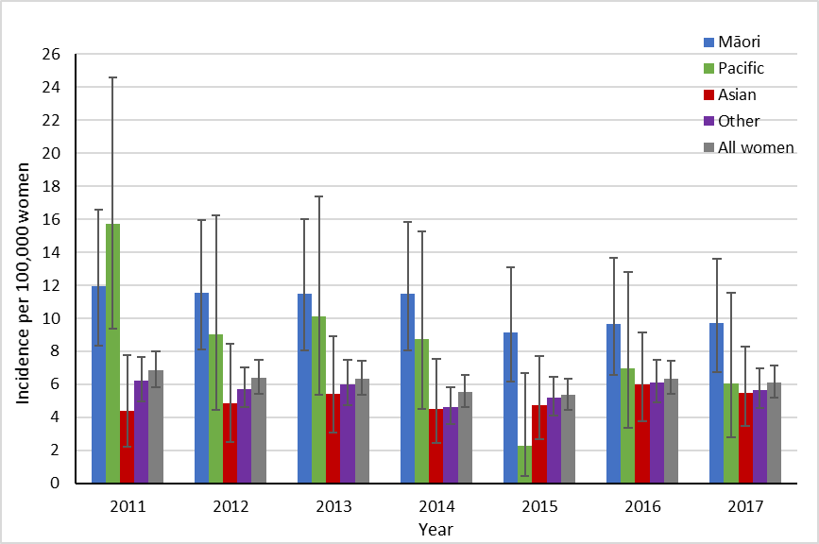

Vertical bars represent 95 percent confidence intervals.

b) Māori women, compared to all women

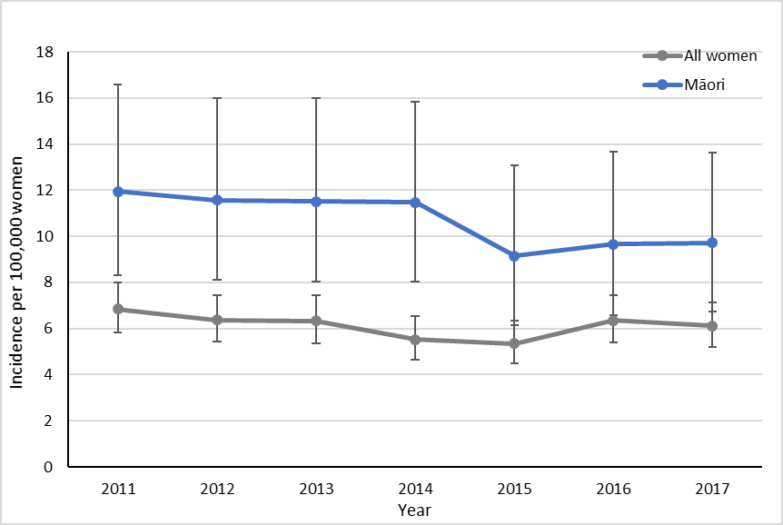

Vertical bars represent 95 percent confidence intervals.

Figure 2: Age-standardised cervical cancer incidence rates for Māori* and all women, 1985–2017†

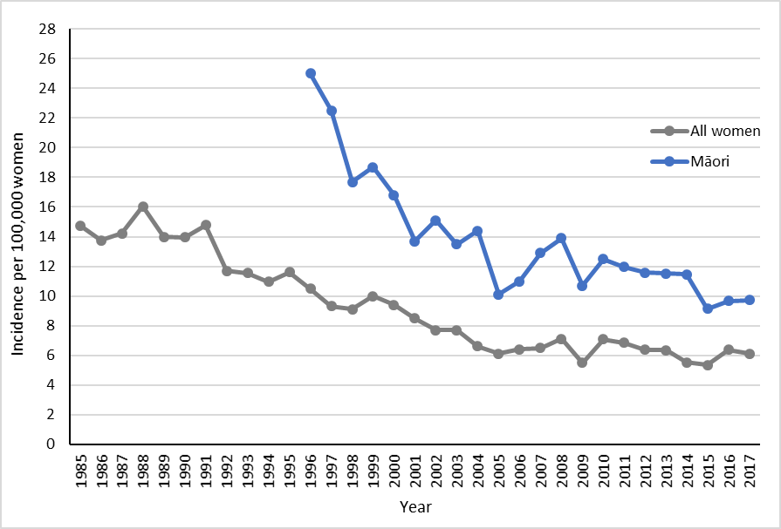

Rates are per 100,000 women, age-standardised to the WHO Standard Population (all ages).

* Age-standardised rates for Māori women were not available for years prior to 1996.

† Rates for 1996–2004 were sourced from *Cancer: New Registrations and Deaths 2007* (Ministry of Health 2010b) and *2006* (Ministry of Health 2010a). Rates from 2005 were sourced from a previous (Smith et al 2012) and the current NCSP annual monitoring report (see

Table 1 footnote). Prior dates have been sourced directly from the Ministry of Health.

Table 1: Cervical cancer incidence, 1996–2017, by ethnicity

Image of a table listing cancer rates for all women, Māori women, Pacific women, Asian women and other women for 1996-2017.

Cases and rates for 1997–2004 were sourced from *Cancer: New Registrations and Deaths 2007* (Ministry of Health 2010b)*;* cases and rates for 1996 were sourced from *Cancer: New Registrations and Deaths 2006* (Ministry of Health 2010a). Cases and rates for 2005 were sourced from a previous NCSP Annual Report (2008–2009) (Smith et al 2012).

Counts and rates for ‘European/Other women’ in 1996–2004 were combined for all non-Māori women; that is, they also include cases in Pacific and Asian women.

Rates are per 100,000 women, age-standardised to the WHO Standard Population (all ages).

n/a = not available

Figure 3: Age-standardised cervical cancer incidence rates, 2007–2017, by histological type

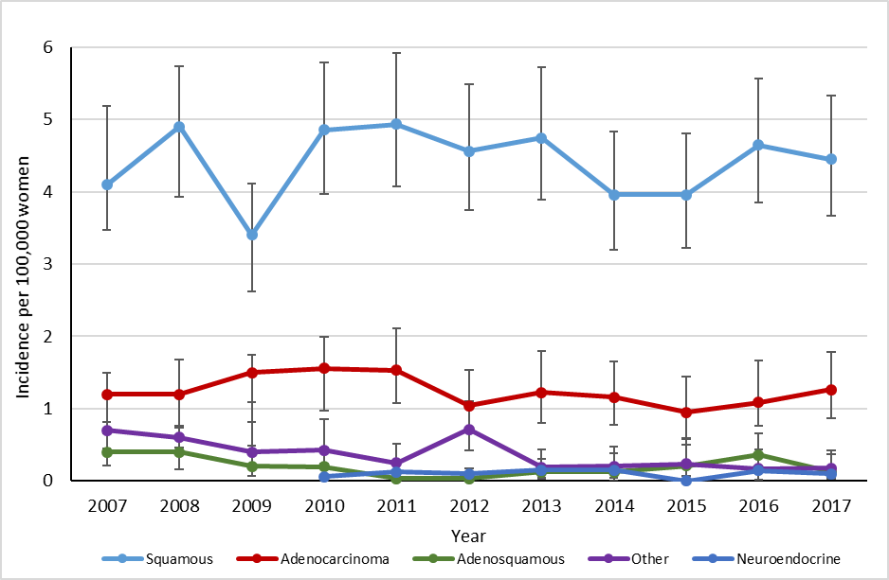

Vertical bars represent 95 percent confidence intervals.

Table 2: Cervical cancer incidence (per 100,000 women), 2007–2017, by histological type

This table shows the data from the graph above.

Per 100,000 women, age-standardised to the WHO Standard Population (all ages).

Figure 4: Five-year average cervical cancer incidence rates, by age

a) 2013–2017

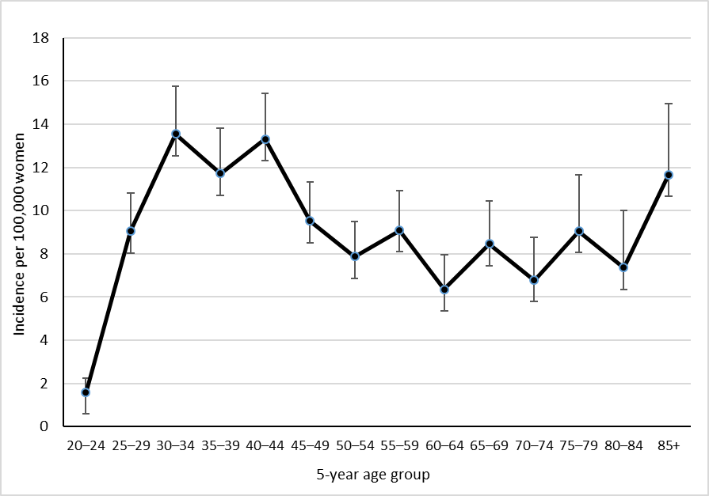

Vertical bars represent 95 percent confidence intervals

b) 2008–2012 versus 2013–2017

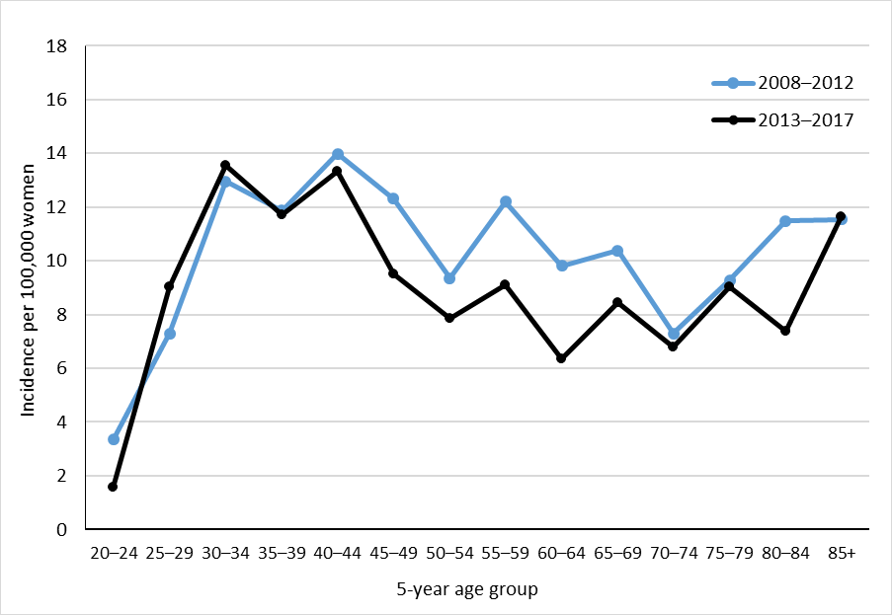

Figure 5: Five-year average cervical cancer incidence rates, 2013–2017, by age and ethnicity

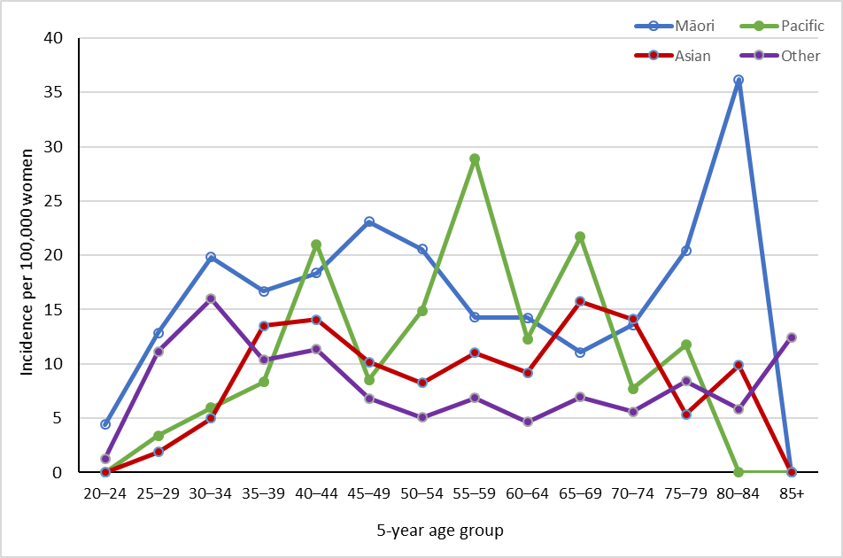

Note that no cases were observed in Pacific women aged 20–24 years, and 80+ years, or in Asian women aged 85+ years over this time period. See also Table 3.

Figure 6: Five-year average cervical cancer incidence rates, 2013–2017, by age and histological type

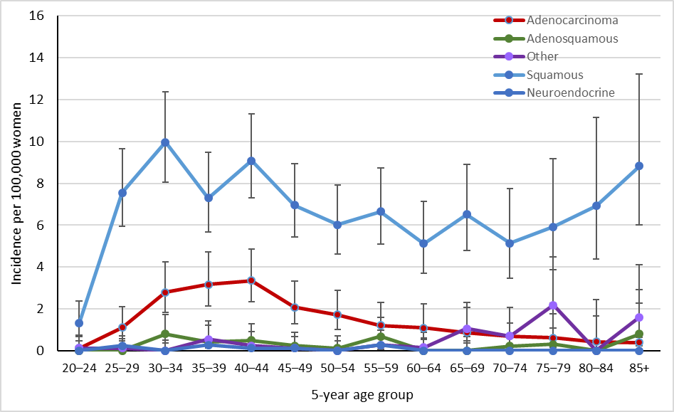

Vertical bars represent 95 percent confidence intervals.

Table 3: Five-year average cervical cancer incidence, 2013–2017, by age and ethnicity

This is the table of data for the graphs above.

‘0.0’ indicates no cases recorded.

# 

# Cancer mortality to 31 December 2016

## Definition

Cancer mortality is the annual rate of deaths due to invasive cervical cancer (per 100,000 women in the New Zealand estimated resident population), standardised to the WHO Standard Population.

## Target

Mortality in the New Zealand population of no more than 2.8 per 100,000 women when age-standardised to the WHO Standard Population (or no more than 2.5 per 100,000 women when age-standardised to the Segi population).

## Calculation

Registrations of cervical cancer mortality (by age and ethnicity) over the period  
2009–2016 were obtained from the New Zealand Cancer Registry (data extracted 5 February 2020).

Age-specific mortality rates were calculated for each calendar year, based on the estimated resident New Zealand female population in June of that year (mid-year estimates), using projections from the 2013 Census.

Age-specific rates were then weighted using the WHO Standard Population to derive age-standardised rates (details of the WHO Standard Population are provided in Appendix B: Population data). 95 percent confidence intervals were calculated according to the methods in *IARC Scientific Publication 95. Cancer Registrations: Principles & Methods* (Chapter 11: Statistical Methods for Registries) (Boyle and Parkin 2002). Mortality rates were calculated separately for each ethnic group. Five-year average rates were also calculated by five-year age group as the sum of all cases over the five-year period within that age group, divided by the sum of the estimated population within that age group in each of the five years contributing to the average.

## Results

The most recent mortality data available is for 2016. In 2016, there were 57 deaths due to cervical cancer, or an age-standardised rate of 1.7 cervical cancer deaths per 100,000 women in the population.[2] Table 4 and Figure 7a show cervical cancer mortality rates overall, and for each of Māori (2.9), Pacific (3.5), Asian (1.9) and European/Other (1.3) women. Table 4 also shows counts of deaths due to cervical cancer. Rates could not be calculated for all four ethnicity groups prior to 2006 due to limitations in the availability of population data; however, separate counts for deaths were available for 2005 from previous annual monitoring reports (Brewer et al 2008; Smith et al 2012). Therefore rates and deaths reported for ‘Other women’ in 1998–2004 relate to all non-Māori women; this data was sourced from *Cancer: New Registrations and Deaths 2007* (Ministry of Health 2010b).

Overall, between 1998 and 2016 cervical cancer mortality declined from 3.2 to 1.7 per 100,000 for women of all ethnicities, and from 10.3 to 2.9 per 100,000 for Māori women (Table 4). Figure 8 shows longer-term cancer mortality trends for Māori and all women by year.

As Figure 7a shows, there is some variation in mortality rates by ethnicity (although the 95 percent confidence intervals are very wide). As for the incidence data, an additional figure is included that compares mortality rates in Māori women to rates in all women in New Zealand (Figure 7b), to supplement the more detailed ethnicity information in Figure 7a.

Average age-specific cervical cancer mortality rates for 2012–2016 are shown for all women in Figure 9, and by ethnicity in Figure 10. As for incidence, the associated confidence intervals are wide, making ethnicity-specific trends by age more difficult to discern, but generally there appears to be a broad increase with age. Case numbers by age are generally small for Māori, Pacific and Asian women (total deaths across all ages over this five-year period were 52 for Māori women, 28 for Pacific women and 19 for Asian women).

## Comments

In this report, mortality rates are standardised using the WHO Standard Population (see Appendix B: Population data), consistent with the population used to produce standardised rates in *Cancer: New Registrations and Deaths*. Note that NCSP annual monitoring reports prior to that for 2008–2009 reported on rates which were standardised to the Segi population, and therefore these rates are not directly comparable.

Consistent with other statistical data, the rates of cervical cancer incidence and mortality are expressed per 100,000 women in the population. The population is not adjusted to consider hysterectomy prevalence.

Figure 7: Age-standardised cervical cancer mortality rates, 2010–2016, by ethnicity

a) All ethnic groups

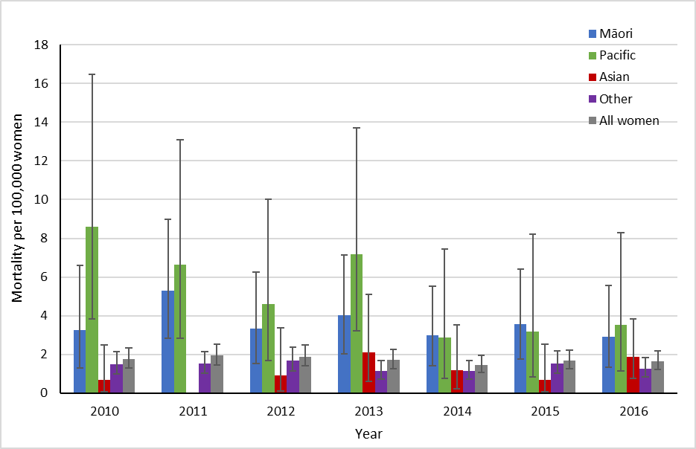

Vertical bars represent 95 percent confidence intervals. Note: no deaths were recorded for Asian women in 2011.

b) Māori women, compared to all women

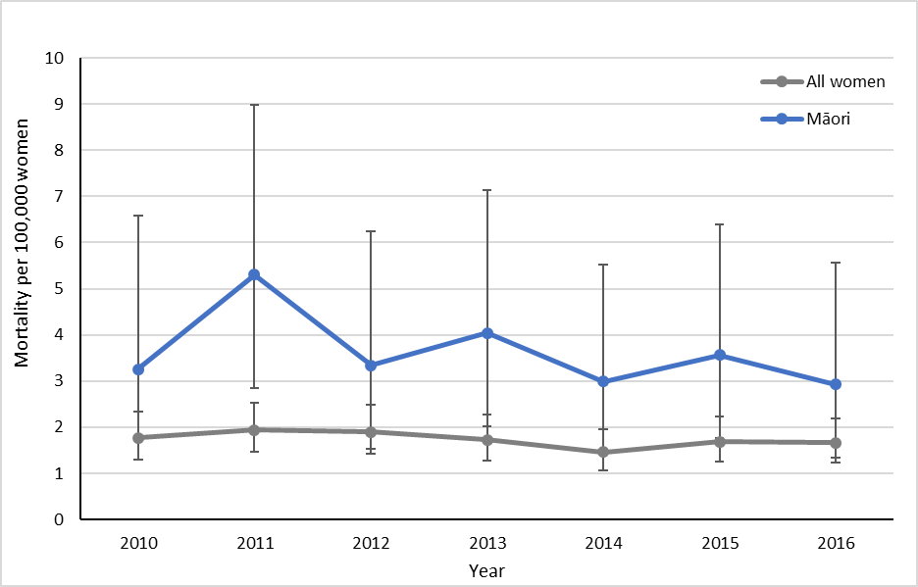

Vertical bars represent 95 percent confidence intervals.

Figure 8: Age-standardised cervical cancer mortality rates for Māori* and all women, 1985–2015†

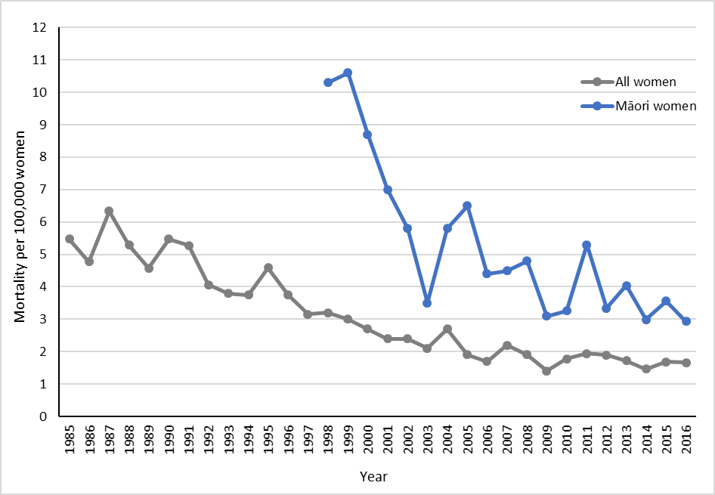

Rates are per 100,000 women, age-standardised to the WHO Standard Population (all ages).

* Age-standardised rates for Māori women were not available for years prior to 1996.

† Rates for 1996–2004 were sourced from *Cancer: New Registrations and Deaths 2007* (Ministry of Health 2010b) and *2006* (Ministry of Health 2010a). Rates from 2005 were sourced from a previous (Smith et al 2012) and the current NCSP annual monitoring report (see Table 4 footnote). Prior dates have been sourced directly from the Ministry of Health.

Table 4: Cervical cancer mortality, 1998–2016, by ethnicity

This table shows the data for the graphs above.

Deaths and rates for 1998–2004 were sourced from *Cancer: New Registrations and Deaths 2007* (Ministry of Health 2010b).Deaths and rates for 2005 were sourced from *National Cervical Screening Programme Annual Report 2008–2009* (Smith et al 2012).Separate data on deaths in Pacific women was sourced from *National Cervical Screening Programme Annual Monitoring Report 2006* (Brewer et al 2008).

Counts and rates for ‘European/Other women’ in 1998–2004 are combined for all non-Māori women; that is, they also include deaths in Pacific and Asian women.

Rates are per 100,000 women, age-standardised to the WHO Standard Population (all ages).

n/a = not available

Figure 9: Five-year average cervical cancer mortality rates, 2012–2016, by age

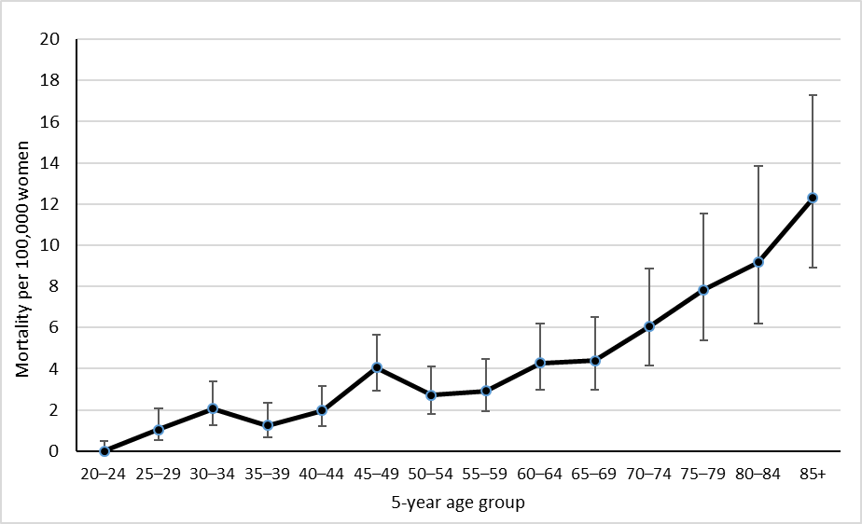

Vertical bars represent 95 percent confidence intervals. See also Table 5.

Figure 10: Five-year average cervical cancer mortality rates, 2012–2016, by age and ethnicity

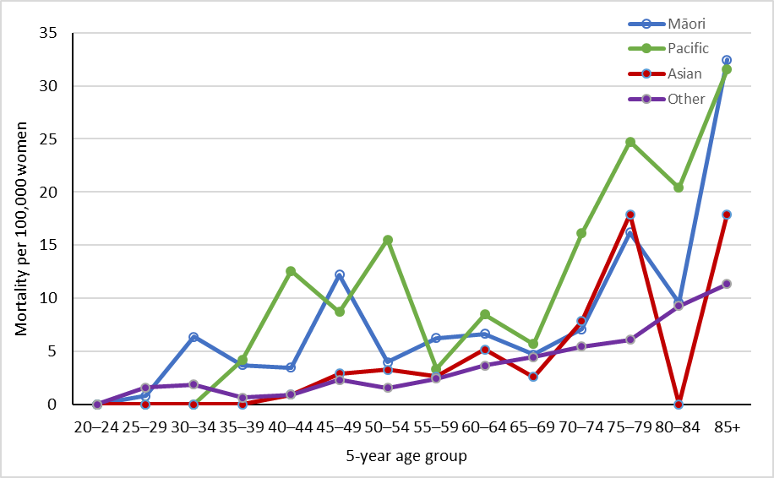

Note that no deaths were recorded in Māori women aged 20–24 years, in Pacific women aged 20–34 years, in Asian women aged 20–39 and 80–84 years, and in Other women aged 20–24 years over this time period. See also Table 5.

Table 5: Average cervical cancer mortality, 2012–2016, by age

This table shows the data from the graphs above.

‘0.0’ indicates no deaths recorded over the five-year period.

# Appendix A: Additional data tables

Table 6: Incident cases by detailed morphology, 2017

|  |  |  |
| --- | --- | --- |
| **Morphology** | **Cases** | **% of all cervical cancers** |
| **Sub-category** |
| **Adenocarcinoma** | **34** | **20.2%** |
| Adenocarcinoma, endocervical type | 3 | 1.8% |
| Adenocarcinoma, not otherwise specified | 28 | 16.7% |
| Endometrioid adenocarcinoma, not otherwise specified | 1 | 0.6% |
| Mucinous adenocarcinoma, endocervical type | 2 | 1.2% |
| **Adenosquamous** | **3** | **1.8%** |
| Adenosquamous carcinoma | 3 | 1.8% |
| **Other** | **5** | **3.0%** |
| Adenosarcoma | 1 | 0.6% |
| Carcinoma, not otherwise specified | 1 | 0.6% |
| Carcinoma, undifferentiated, not otherwise specified | 1 | 0.6% |
| Carcinosarcoma, not otherwise specified | 1 | 0.6% |
| Mesonephroma, malignant | 1 | 0.6% |
| **Squamous** | **124** | **73.8%** |
| Basaloid squamous cell carcinoma | 1 | 0.6% |
| Squamous cell carcinoma, keratinising, not otherwise specified | 7 | 4.2% |
| Squamous cell carcinoma, large cell, non-keratinising, not otherwise specified | 7 | 4.2% |
| Squamous cell carcinoma, microinvasive | 19 | 11.3% |
| Squamous cell carcinoma, not otherwise specified | 90 | 53.6% |
| **Neuroendocrine tumours** | **2** | **1.2%** |
| Small cell carcinoma, not otherwise specified | 1 | 0.6% |
| Small cell-large cell carcinoma | 1 | 0.6% |
| **Total** | **168** | **100.0%** |

Table 7: Extent of disease at time of diagnosis for incident cervical cancer cases, 2007–2017

This table shows that most cancers were limited to the organ of origin or of unknown extent at time of diagnosis.

# 

# Appendix B: Population data

## World Health Organization Standard Population

Rates for cervical cancer incidence and mortality were standardised using the WHO World Standard Population according to Ahmad et al (2001), as Table 8 sets out.

Table 8: World Health Organization Standard Population

This table shows the standard population distribution for each age group according to the World Health Organization.

## New Zealand estimated resident population

The estimated data for New Zealand female population was based on data from Statistics New Zealand. Population figures for cancer incidence and mortality used mid-year estimates, based on projections from 2013 Census data for 2006–2017. Population estimates for 2005 were based on a linear interpolation between data from the 2001 Census and 2006 Census. Population data for 2005 was not available in the four required ethnic groups, and so ethnicity-specific estimates could not be calculated for 2005 for cancer incidence, cancer mortality or coverage.

# References

Ahmad OB, Boschi-Pinto C, Lopez AD, et al. 2001. *Age Standardization of Rates: A new WHO standard*. Geneva: World Health Organization.

Boyle P, Parkin D. 2002. Chapter 11. Statistical methods for registries. *IARC Scientific Publication 95 Cancer Registrations: Principles and Methods*. Lyon: International Agency for Research on Cancer Press.

Brewer N, McKenzie F, Wong KC, et al. 2008. *National Cervical Screening Programme Annual Monitoring Report 2006*. Wellington: Centre for Public Health Research, Massey University.

Ministry of Health. 2010a. *Cancer: New Registrations and Deaths 2006*. Wellington: Ministry of Health.

Ministry of Health. 2010b. *Cancer: New Registrations and Deaths 2007*. Wellington: Ministry of Health.

Smith M, Walker R, Canfell K. 2012. *National Cervical Screening Programme Annual Report 2008–2009*. Wellington: National Screening Unit.

1. The equivalent overall incidence rate if age-standardised to the Segi population is 5.6 per 100,000 women in the population.
2. The equivalent overall mortality rate if age-standardised to the Segi population is 1.4 per 100,000 women in the population.