National Cervical Screening Programme

Annual Report 2015

Report prepared January 2018
Revised March 2018
Finalised April 2018

Report prepared by Megan Smith†, Leanne Rumlee† and Karen Canfell.
Cancer Research Division, Cancer Council NSW, Sydney NSW Australia

† Joint first authors

Contents

Selected Results 2
Related National Cervical Screening Programme reports 3
Cancer Incidence 4
Cancer Mortality 14
Appendix A – Additional data tables 21
Appendix B – Population data 23
References 24

Figures

Figure 1 – Age-standardised cervical cancer incidence rates, 2009 to 2015, by ethnicity 7
Figure 2 – Age-standardised cervical cancer incidence rates for Māori and all women, 1985-2015 8
Figure 3 – Age-standardised cervical cancer incidence rates, 2009 to 2015, by histological type 10
Figure 4 – Five-year average cervical cancer incidence rates (2011-2015), by age 11
Figure 5 – Five-year average cervical cancer incidence rates (2011-2015), by age and ethnicity 11
Figure 6 – Five-year average cervical cancer incidence rates (2011-2015), by age and histological type 12
Figure 7 – Age-standardised cervical cancer mortality rates, 2008 to 2014, by ethnicity 16
Figure 8 – Age-standardised cervical cancer mortality rates for Māori and all women, 1985-2015 17
Figure 9 – Five-year average cervical cancer mortality rates (2010-2014), by age 19
Figure 10 – Five-year average cervical cancer mortality rates (2010-2014), by age and ethnicity 19

Tables

Table 1 – Cervical cancer incidence, 1996 to 2015, by ethnicity 9
Table 2 – Cervical cancer incidence (per 100,000 women), 2006 to 2015, by histological type 10
Table 3 – Five-year average cervical cancer incidence (2011-2015), by age and ethnicity 13
Table 4 – Cervical cancer mortality, 1998 to 2014, by ethnicity 18
Table 5 – Average cervical cancer mortality (2010-2014), by age 20
Table 6 – Incident cases by detailed morphology, 2015 21
Table 7 - Extent of disease at time of diagnosis for incident cervical cancer cases, 2006-2014 22
Table 8 – WHO Standard Population 23

Acknowledgments
This report was prepared by the authors in collaboration with the National Screening Unit, Ministry of Health, and was reviewed by the National Cervical Screening Programme Advisory Group.
We would like to acknowledge the contribution from Ivan Rowe, Senior Analyst Service Development for extracting the cancer data to calculate and produce the annual report tables.

About the authors
The authors are based in the Cancer Research Division at Cancer Council NSW, Sydney, Australia. They are part of a research group (led by Prof Karen Canfell) which has as its core research focus in the epidemiology of cervical cancer, cervical screening and human papillomavirus (HPV) vaccination. This research group has established an extensive track record both in research publication and in successful completion of commissioned projects related to national cervical screening programs in New Zealand, Australia and England. The group has extensive experience in the analysis of descriptive data from cervical cancer screening programmes. The team also has a range of related skills in the analysis of linked datasets, systematic review and meta-analysis, biostatistics, health economics, and advanced statistical modelling techniques.

Selected Results

Cancer incidence
- In 2015 there were 142 new diagnoses of cervical cancer, including 29 new diagnoses in Māori women.
- This is equivalent to an age-standardised rate (ASR) of 5.4 new diagnoses per 100,000 women in the population, and 9.1 per 100,000 for Māori women.
- Most cervical cancers were squamous cell carcinomas (102 cases; ASR 3.8 per 100,000 women), with a smaller proportion comprising adenocarcinomas (24 cases; ASR 1.0 per 100,000 women), adenosquamous (5 cases; ASR 0.2 per 100,000 women) or other cervical cancers (11 cases; ASR 0.4 per 100,000 women).
- Overall, between 1996 and 2015 cervical cancer incidence has declined from 10.5 to 5.4 per 100,000 for women of all ethnicities, and from 25.0 to 9.1 per 100,000 for Māori women.

Cancer mortality
- In 2014, there were 46 deaths due to cervical cancer, including 10 deaths in Māori women.
- This is equivalent to an age-standardised mortality rate of 1.4 per 100,000 women in the population, and 3.0 per 100,000 for Māori women.
- Overall, between 1998 and 2014 cervical cancer mortality has declined from 3.2 to 1.4 per 100,000 for women of all ethnicities, and from 10.3 to 3.0 per 100,000 for Māori women.

Related National Cervical Screening Programme reports

Information on participation in screening and on programme statistics (including cytology, HPV testing, colposcopy and histology reporting) for 2015 can be found in the published reports NCSP Six-monthly Monitoring Report 43, January - June 2015 and NCSP Six-monthly Monitoring Report 44, July - December 2015, available on the NCSP website at https://www.nsu.govt.nz/health-professionals/national-cervical-screening-programme/independent-monitoring-reports.

Cancer Incidence

Definition
Cancer incidence is the annual rate of new registrations of invasive cervical cancer (per 100,000 women in the New Zealand estimated resident population), standardised to the WHO Standard Population according to Ahmad et al (1).

Target
Incidence of no more than the age-standardised SEGI population of 7.5 per 100,000 women or the age-standardised WHO standard population of 14.8 per 100,000 (modelled at the same time), in the New Zealand population.

Calculation
Registrations of cancer cases (by age, ethnicity, and histological type) over the period 2007 to 2015 were obtained from the New Zealand Cancer Registry (data extracted 1 December 2018).
Age-specific incidence rates were calculated for each calendar year, based on the estimated resident New Zealand female population in June of that year (mid-year estimates), using projections from the 2013 Census.
Age-specific rates were then weighted using the standard WHO population to derive age-standardised rates (details of the WHO Standard Population are provided in Appendix B – Population data). 95% confidence intervals were calculated according to the methods in IARC Scientific Publication 95. Cancer Registrations: Principles & Methods (Chapter 11: Statistical Methods for Registries)(2). Incidence rates were calculated separately for either each ethnic group, or for each histological type. Five-year average rates were also calculated by five-year age group as the sum of all cases over the five-year period within that age group, divided by the sum of the estimated population within that age group in each of the five years contributing to the average.

Results
In 2015, there were 142 new diagnoses of cervical cancer, or an age-standardised rate of 5.4 new diagnoses per 100,000 women in the population (Table 1). Cervical cancer incidence rates overall, and for each of Māori, Pacific, Asian and European/ Other women, are shown in Table 1, and with 95% confidence intervals in Figure 1a. Counts for incident cancer cases are also shown in Table 1. Rates could not be calculated for all four ethnicity groups prior to 2006 due to limitations in the availability of population data (although separate case numbers for 2005 only were available from previous Annual Monitoring Reports). Therefore, cases and rates presented for “Other women” in 1996 to 2004 relate to all non-Māori women. These data were sourced from Cancer: New Registrations and Deaths (3, 4).
Overall, between 1996 and 2015 cervical cancer incidence has declined from 10.5 to 5.4 per 100,000 for women of all ethnicities, and from 25.0 to 9.1 per 100,000 for Māori women (Table 1a). Longer term cancer incidence trends for Māori and all women by year can be seen in Figure 2.
As shown in Figure 1a, there is some variation in the incidence rates by ethnicity, however the 95% confidence intervals are wide for some ethnicities. As case numbers are quite small for Pacific women and Asian women, an additional figure is included which compares rates in Māori women to rates in all women in New Zealand (Figure 1b), to supplement the detailed information in Figure 1a.
Cervical cancer incidence rates by histological type are shown in Figure 3 and Table 2. Squamous cell cancer remained the most commonly diagnosed type of cervical cancer over the period 2006-2014. A more detailed breakdown by histological type of cases diagnosed in 2015 is shown in Table 6.
Five-year average age-specific cervical cancer incidence rates (2011-2015), are shown in Figure 4 and Table 3. Overall there is a low incidence at younger ages, increasing by the age of 25-29 years to reach a peak in the 5 years age groups between 30-44 (12.5, 11.8 and 12.7 per 100,000 for all ethnicities for age groups 30-34, 35-39 and 40-44 respectively). A general decrease following a plateauing is seen for the remaining ages until the age of 75. Five-year average age-specific incidence rates are shown by ethnicity in Figure 5 and Table 3. Confidence intervals are generally wide, so are not displayed on Figure 5, but are included in Table 3. There are small case numbers (five or less per year) in most age groups for Māori, Pacific and Asian women. Because of these factors, age-specific incidence rates by ethnicity must be interpreted cautiously.
Five-year average age-specific cervical cancer incidence rates (2011-2015), by histological type are shown in Figure 6. Squamous and adenocarcinoma histological types follow broadly similar patterns by age to each other, while the histological types defined in the other group (not squamous, adenocarcinoma, or adenosquamous carcinoma) tended to increase with increasing age. The absolute rates varied, being highest for squamous cell cancer, and generally lowest for adenosquamous cancer in virtually all age groups.
In 2015, among cancer cases where extent of disease information is recorded, most new cases are localised to the cervix (Table 7).

Comments
In this report incidence rates are standardised using the WHO Standard Population (see Appendix B – Population data), consistent with the population used to produce standardised rates in Cancer: New Registrations and Deaths. Note that National Cervical Screening Programme Annual Monitoring Reports prior to that for 2008-2009 reported on rates which were standardised to the Segi population, and therefore these rates are not directly comparable. The target for cancer incidence is also standardised to the Segi population and cannot be used as the target for the observed WHO standardised rate in this report. The WHO target is provided, however is in the process of being reevaluated for the 2016 report.
Consistent with other statistical data, the rates of cervical cancer incidence are expressed per 100,000 women in the population. The population is not adjusted to take into account hysterectomy prevalence.
The distribution of new diagnoses by FIGO stage has not been included in this report due to 71.8% of newly diagnosed cases not having a FIGO stage recorded.

Figure 1 – Age-standardised cervical cancer incidence rates, 2009 to 2015, by ethnicity
- All ethnic groups
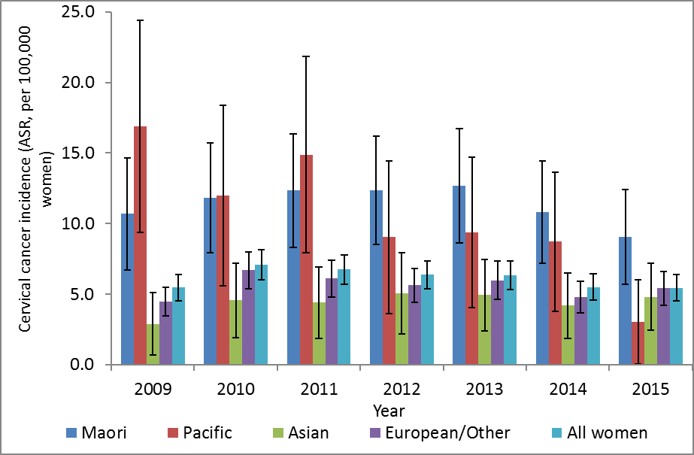Vertical bars represent 95% confidence intervals

- Māori women, compared to All women
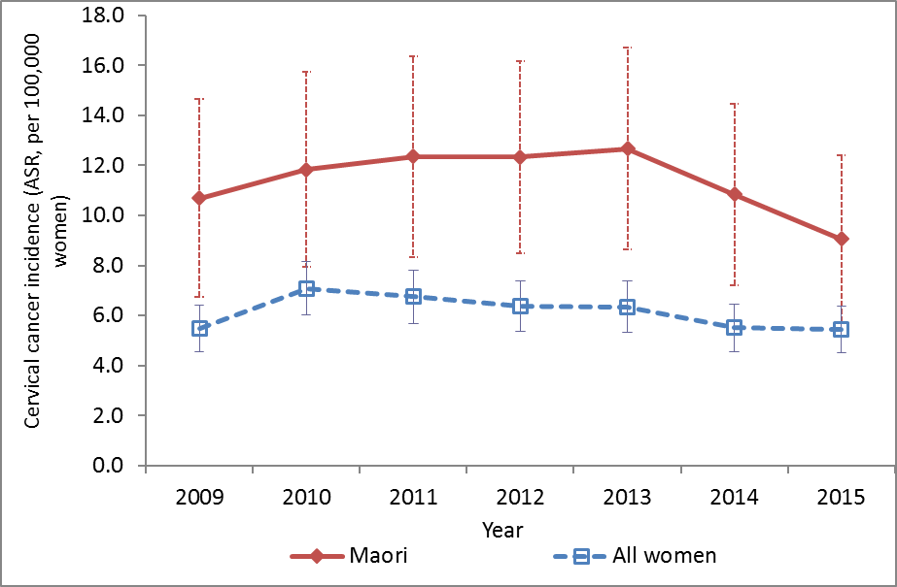
Vertical bars represent 95% confidence interval
Figure 2 – Age-standardised cervical cancer incidence rates for Māori* and all women, 1985-2015†
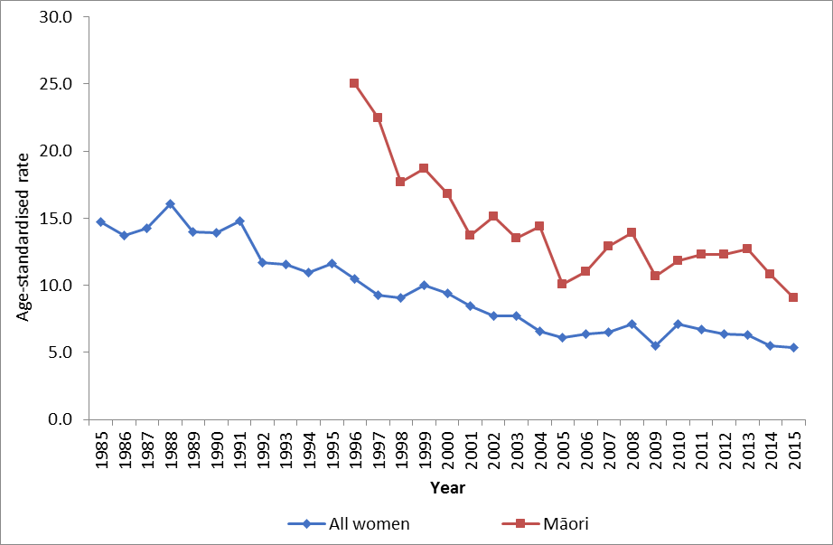
Rates are per 100,000 women, age-standardised to the WHO Standard Population (all ages).
* Aged-standardised rates for Māori women were not available for years prior to 1996.
† Rates for 1996-2004 sourced from Cancer: New Registrations and Deaths, 2007 (4) and 2006 (3). Rates from 2005 are sourced from previous (5) and the current NCSP annual monitoring report (see Table 1 footnote). Prior dates have been sourced directly from the New Zealand Ministry of Health.
Table 1 – Cervical cancer incidence, 1996 to 2015, by ethnicity
 | All women |  | Māori women |  | Pacific women |  | Asian women |  | European/Other women §
Year† | N | Rate* | N | Rate* | N | Rate* | N | Rate* | N | Rate*
1996 | 211 | 10.5 | 47 | 25.0 | NA | NA | NA | NA | 164 | 9.0
1997 | 205 | 9.3 | 51 | 22.5 | NA | NA | NA | NA | 154 | 7.6
1998 | 200 | 9.1 | 36 | 17.7 | NA | NA | NA | NA | 164 | 8.3
1999 | 220 | 10.0 | 43 | 18.7 | NA | NA | NA | NA | 177 | 8.9
2000 | 204 | 9.4 | 43 | 16.8 | NA | NA | NA | NA | 161 | 8.3
2001 | 189 | 8.5 | 33 | 13.7 | NA | NA | NA | NA | 156 | 8.0
2002 | 181 | 7.7 | 33 | 15.1 | NA | NA | NA | NA | 148 | 7.2
2003 | 178 | 7.7 | 33 | 13.5 | NA | NA | NA | NA | 145 | 7.1
2004 | 157 | 6.6 | 33 | 14.4 | NA | NA | NA | NA | 124 | 5.9
2005 | 154 | 6.1 | 25 | 10.1 | 17 | NA | 15 | NA | 97 | NA
2006 | 158 | 6.4 | 28 | 11.0 | 10 | 8.4 | 15 | 7.6 | 105 | 6.0
2007 | 163 | 6.5 | 34 | 12.9 | 12 | 12.1 | 12 | 6.2 | 105 | 5.8
2008 | 175 | 7.1 | 39 | 13.9 | 12 | 10.5 | 13 | 5.6 | 111 | 6.3
2009 | 142 | 5.5 | 30 | 10.7 | 20 | 16.9 | 7 | 2.9 | 85 | 4.5
2010 | 180 | 7.1 | 36 | 11.8 | 14 | 12.0 | 12 | 4.6 | 118 | 6.7
2011 | 169 | 6.7 | 37 | 12.3 | 18 | 14.9 | 12 | 4.4 | 102 | 6.1
2012 | 168 | 6.4 | 40 | 12.3 | 11 | 9.0 | 13 | 5.1 | 104 | 5.6
2013 | 159 | 6.3 | 39 | 12.7 | 12 | 9.4 | 15 | 5.0 | 93 | 6.0
2014 | 144 | 5.5 | 35 | 10.8 | 12 | 8.7 | 13 | 4.2 | 84 | 4.8
2015 | 142 | 5.4 | 29 | 9.1 | 4 | 3.0 | 16 | 4.8 | 93 | 5.4
† Cases and rates for 1997-2004 sourced from Cancer: New Registrations and Deaths, 2007 (4); cases and rates for 1996 sourced from Cancer: New Registrations and Deaths, 2006 (3). Cases and rates for 2005 sourced from a previous NCSP Annual Report (2008-2009) (5) § Counts and rates for “European/Other women” in 1996-2004 are combined for all non- Māori women i.e. they also include cases in Pacific and Asian women *Rates are per 100,000 women, age-standardised to the WHO Standard Population (all ages). NA = not available

Figure 3 – Age-standardised cervical cancer incidence rates, 2009 to 2015, by histological type
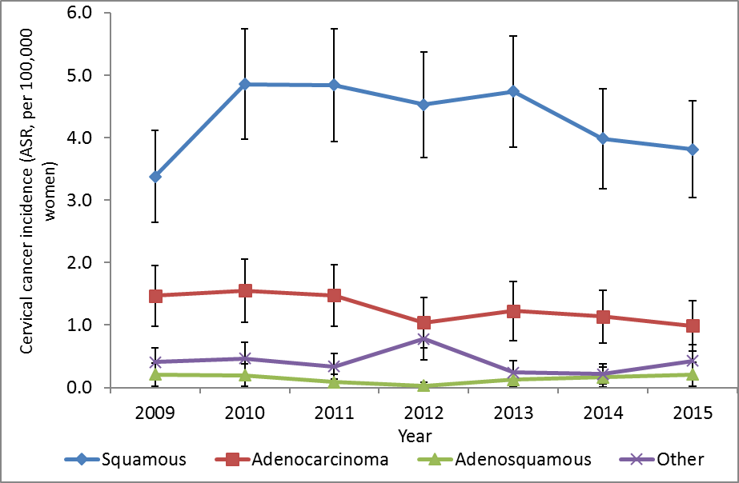
Vertical bars represent 95% confidence intervals

Table 2 – Cervical cancer incidence (per 100,000 women), 2006 to 2015, by histological type
 | Squamous |  | Adenocarcinoma |  | Adenosquamous |  | Other
Year | N | Rate* | N | Rate* | N | Rate* | N | Rate*
2006 | 100 | 4.1 | 36 | 1.5 | 7 | 0.3 | 15 | 0.5
2007 | 102 | 4.1 | 31 | 1.2 | 11 | 0.4 | 19 | 0.7
2008 | 121 | 4.9 | 30 | 1.2 | 8 | 0.4 | 16 | 0.6
2009 | 87 | 3.4 | 37 | 1.5 | 5 | 0.2 | 13 | 0.4
2010 | 123 | 4.9 | 38 | 1.6 | 5 | 0.2 | 14 | 0.5
2011 | 119 | 4.8 | 36 | 1.5 | 2 | 0.1 | 12 | 0.3
2012 | 117 | 4.5 | 27 | 1.0 | 1 | <0.1 | 23 | 0.8
2013 | 118 | 4.7 | 28 | 1.2 | 5 | 0.1 | 8 | 0.2
2014 | 103 | 4.0 | 29 | 1.1 | 4 | 0.2 | 8 | 0.2
2015 | 102 | 3.8 | 24 | 1.0 | 5 | 0.2 | 11 | 0.4
* Per 100,000 women, age-standardised to the WHO population (all ages)
Figure 4 – Five-year average cervical cancer incidence rates (2011-2015), by age
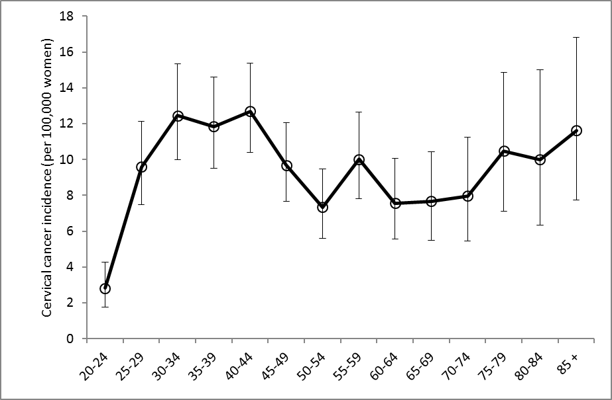
Vertical bars represent 95% confidence intervals

Figure 5 – Five-year average cervical cancer incidence rates (2011-2015), by age and ethnicity

Note that no cases were observed in Pacific women aged 20-24 years, and 80+ years, or in Asian women aged 85+ years over this time period. See also Table 3.
Figure 6 – Five-year average cervical cancer incidence rates (2011-2015), by age and histological type
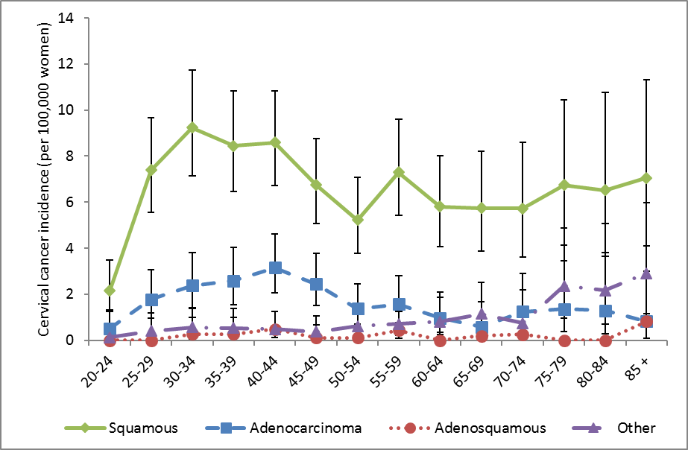
Vertical bars represent 95% confidence intervals
Table 3 – Five-year average cervical cancer incidence (2011-2015), by age and ethnicity
 | All women |  | Māori women |  | Pacific women |  | Asian women |  | European/ Other women
Age | Rate | (95%CI) | Rate | (95%CI) | Rate | (95%CI) | Rate | (95%CI) | Rate | (95%CI)
20-24 | 2.8 | (1.8 - 4.3) | 5.3 | (2.3 - 10.4) | . | - | 0.8 | (0.0 - 4.3) | 3.0 | (1.6 - 5.1)
25-29 | 9.6 | (7.5 - 12.1) | 9.9 | (5.1 - 17.3) | 5.7 | (1.2 - 16.5) | 2.1 | (0.4 - 6.2) | 12.6 | (9.4 - 16.5)
30-34 | 12.5 | (10.0 - 15.3) | 14.7 | (8.4 - 23.9) | 6.1 | (1.3 - 17.9) | 3.6 | (1.2 - 8.4) | 15.6 | (12.0 - 19.8)
35-39 | 11.8 | (9.5 - 14.6) | 24.7 | (16.3 - 35.9) | 12.6 | (4.6 - 27.5) | 11.1 | (5.7 - 19.4) | 9.0 | (6.5 - 12.1)
40-44 | 12.7 | (10.4 - 15.4) | 17.5 | (10.7 - 27.1) | 21.0 | (10.1 - 38.6) | 12.2 | (6.5 - 20.9) | 11.1 | (8.5 - 14.2)
45-49 | 9.7 | (7.7 - 12.1) | 26.7 | (17.7 - 38.5) | 13.4 | (4.9 - 29.1) | 8.1 | (3.5 – 16.0) | 6.5 | (4.6 – 9.0)
50-54 | 7.3 | (5.6 - 9.5) | 20.4 | (12.4 - 31.4) | 13.5 | (4.4 - 31.5) | 7.0 | (2.6 - 15.2) | 4.8 | (3.2 – 7.0)
55-59 | 10.0 | (7.8 - 12.6) | 22.4 | (13.0 - 35.8) | 31.6 | (14.5 – 60.0) | 11.4 | (4.9 - 22.4) | 6.9 | (4.8 - 9.5)
60-64 | 7.6 | (5.6 - 10.1) | 22.7 | (12.1 - 38.8) | 17.5 | (4.8 - 44.9) | 7.9 | (2.1 - 20.2) | 5.3 | (3.5 - 7.8)
65-69 | 7.7 | (5.5 - 10.4) | 17.7 | (7.1 - 36.5) | 29.8 | (9.7 - 69.6) | 6.0 | (0.7 - 21.6) | 6.0 | (3.9 - 8.8)
70-74 | 8.0 | (5.5 - 11.2) | 14.6 | (4.0 - 37.4) | 25.0 | (5.2 - 72.9) | 17.5 | (4.8 - 44.9) | 6.2 | (3.8 - 9.5)
75-79 | 10.5 | (7.1 - 14.9) | 11.5 | (1.4 - 41.6) | 38.8 | (8.0 - 113.4) | 13.4 | (1.6 - 48.3) | 9.4 | (6.0 – 14.0)
80-84 | 10.0 | (6.3 – 15.0) | 40.0 | (10.9 - 102.4) | . | - | 12.8 | (0.3 - 71.1) | 8.7 | (5.1 - 13.7)
85 + | 11.6 | (7.7 - 16.8) | 35.0 | (4.2 - 126.5) | . | - | . | - | 11.5 | (7.5 - 16.8)
‘-‘ indicates no cases recorded

Cancer Mortality

Definition
Cancer mortality is the annual rate of deaths due to invasive cervical cancer (per 100,000 women in the New Zealand estimated resident population), standardised to the WHO population.

Target
Mortality of no more than the age-standardised SEGI population of 2.5 per 100,000 women or age-standardised WHO standard population of 2.8 per 100,000 (modelled at the same time), in the New Zealand population.

Calculation
Registrations of cervical cancer mortality (by age and ethnicity) over the period 2006-2014 were obtained from the New Zealand Cancer Registry (data extracted 1 December 2017).
Age-specific mortality rates were calculated for each calendar year, based on the estimated resident New Zealand female population in June of that year (mid-year estimates), using projections from the 2013 Census.
Age-specific rates were then weighted using the standard WHO population to derive age-standardised rates (details of the WHO Standard Population are provided in Appendix B – Population data). 95% confidence intervals were calculated according to the methods in IARC Scientific Publication 95. Cancer Registrations: Principles & Methods (Chapter 11: Statistical Methods for Registries)(2). Mortality rates were calculated separately for each ethnic group. Five-year average rates were also calculated by five-year age group as the sum of all cases over the five-year period within that age group, divided by the sum of the estimated population within that age group in each of the five years contributing to the average.

Results
The most recent mortality data available is for 2014. In 2014, there were 46 deaths due to cervical cancer, or an age-standardised rate of 1.4 cervical cancer deaths per 100,000 women in the population (Table 4). Cervical cancer mortality rates overall, and for each of Māori, Pacific, Asian and European/ Other women, are shown in Table 4 and Figure 7a. Counts of deaths due to cervical cancer are also shown in Table 4. Rates could not be calculated for all four ethnicity groups prior to 2006 due to limitations in the availability of population data, however separate counts for deaths were available for 2005 from previous Annual Monitoring Reports (5, 6). Therefore rates and deaths reported for “Other women” in 1998 to 2004 relate to all non-Māori women; these data were sourced from Cancer: New Registrations and Deaths (4).
Overall, between 1998 and 2015 cervical cancer mortality has declined from 3.2 to 1.4 per 100,000 for women of all ethnicities, and from 10.3 to 3.0 per 100,000 for Māori women (Table 4). Longer term cancer mortality trends for Māori and all women by year can be seen in Figure 8.
As shown in Figure 7a, there is some variation in the mortality rates by ethnicity (although the 95% confidence intervals are very wide). As for the incidence data, an additional figure is included which compares mortality rates in Māori women to rates in all women in New Zealand (Figure 7b), to supplement the more detailed ethnicity information in Figure 7a.
Average age-specific cervical cancer mortality rates (2010-2014) are shown for all women in Figure 9, and by ethnicity in Figure 10. As for incidence, the associated confidence intervals are wide, making ethnicity-specific trends by age more difficult to discern, but generally there appears to be a broad increase with age. Case numbers by age are generally small for Māori, Pacific and Asian women (total deaths across all ages over the five year period were 55 for Māori women, 34 for Pacific women and eleven for Asian women).

Comments
In this report mortality rates are standardised using the WHO Standard Population (see Appendix B – Population data), consistent with the population used to produce standardised rates in Cancer: New Registrations and Deaths. Note that National Cervical Screening Programme Annual Monitoring Reports prior to that for 2008-2009 reported on rates which were standardised to the Segi population, and therefore these rates are not directly comparable. The target for cancer mortality is also standardised to the Segi population and cannot be used as the target for the observed WHO standardised rate in this report. The WHO target is provided, however is in the process of being reevaluated for the 2016 report.
Consistent with other statistical data, the rates of cervical cancer incidence and mortality are expressed per 100,000 women in the population. The population is not adjusted to take into account hysterectomy prevalence.

Figure 7 – Age-standardised cervical cancer mortality rates, 2008 to 2014, by ethnicity
- All ethnic groups
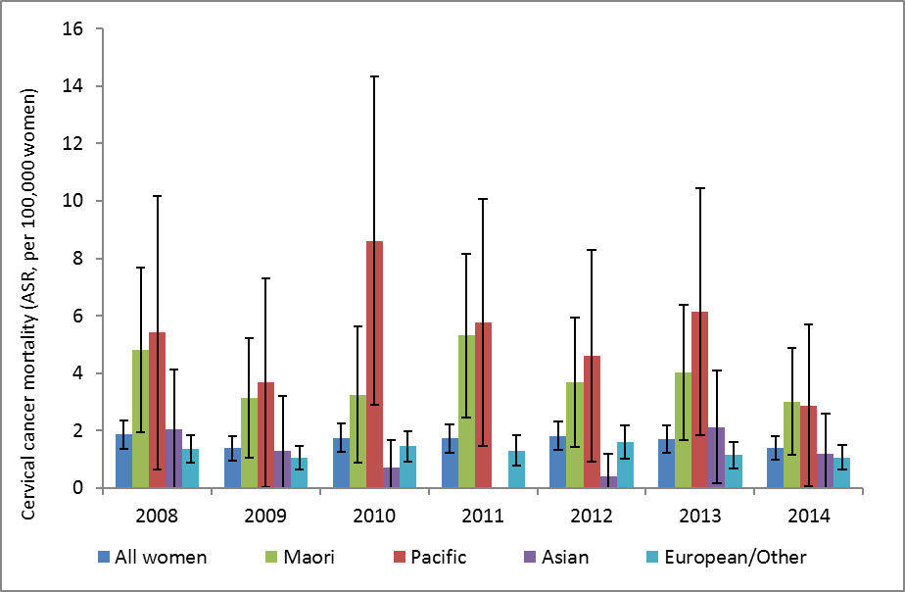
Vertical bars represent 95% confidence intervals. Note: no deaths were recorded for Asian women in 2011.
- Māori women, compared to All women
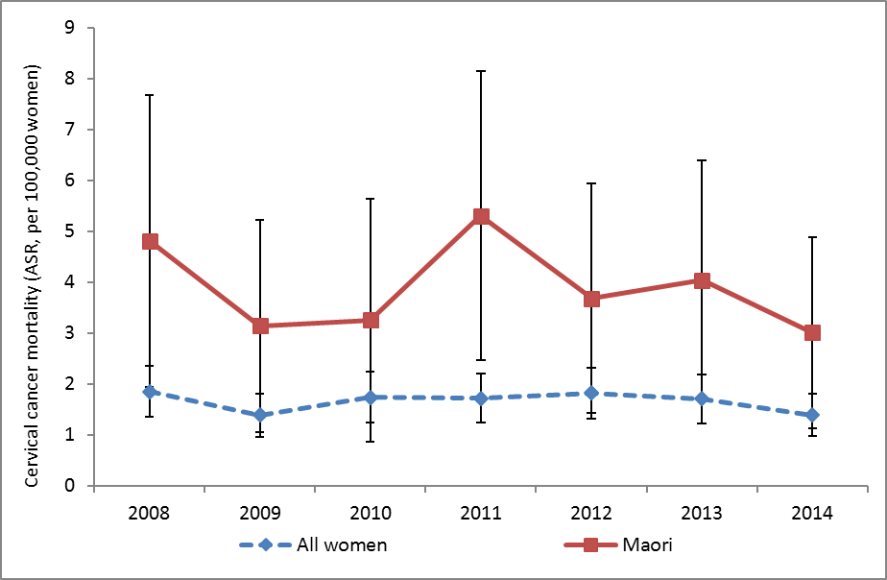
Vertical bars represent 95% confidence intervals
Figure 8 – Age-standardised cervical cancer mortality rates for Māori* and all women, 1985-2015†
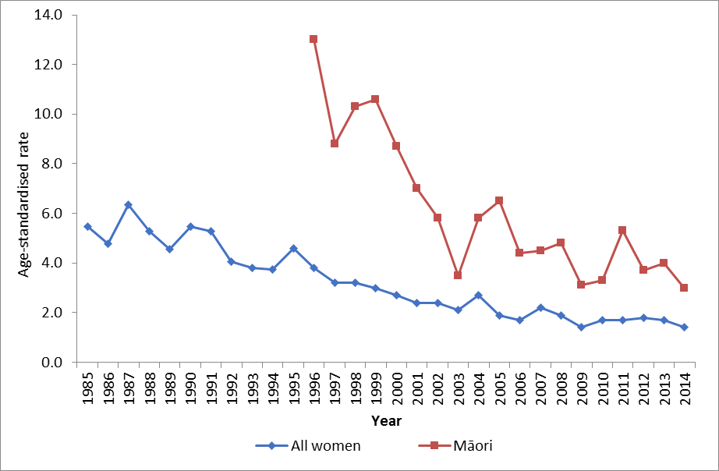
Rates are per 100,000 women, age-standardised to the WHO Standard Population (all ages).
* Aged-standardised rates for Māori women were not available for years prior to 1996.
† Rates for 1996-2004 sourced from Cancer: New Registrations and Deaths, 2007 (4) and 2006 (3). Rates from 2005 are sourced from previous (5) and the current NCSP annual monitoring report (see Table 4 footnote). Prior dates have been sourced directly from the New Zealand Ministry of Health.

Table 4 – Cervical cancer mortality, 1998 to 2014, by ethnicity
 | All women |  | Māori women |  | Pacific women |  | Asian women |  | European/ Other women §
Year† | N | Rate* | N | Rate* | N | Rate* | N | Rate* | N | Rate*
1998 | 77 | 3.2 | 17 | 10.3 | 4 | NA | NA | NA | 60 | 2.7
1999 | 71 | 3.0 | 20 | 10.6 | 7 | NA | NA | NA | 51 | 2.3
2000 | 66 | 2.7 | 17 | 8.7 | 3 | NA | NA | NA | 49 | 2.1
2001 | 63 | 2.4 | 13 | 7.0 | 1 | NA | NA | NA | 50 | 2.0
2002 | 65 | 2.4 | 12 | 5.8 | 2 | NA | NA | NA | 53 | 2.1
2003 | 58 | 2.1 | 8 | 3.5 | 5 | NA | NA | NA | 50 | 2.0
2004 | 71 | 2.7 | 15 | 5.8 | 4 | NA | NA | NA | 56 | 2.2
2005 | 54 | 1.9 | 13 | 6.5 | 6 | NA | - | - | 35 | NA
2006 | 52 | 1.7 | 10 | 4.4 | 7 | 7.0 | - | - | 35 | 1.2
2007 | 65 | 2.2 | 11 | 4.5 | 8 | 8.0 | 4 | 2.9 | 42 | 1.7
2008 | 59 | 1.9 | 12 | 4.8 | 5 | 5.4 | 4 | 2.0 | 38 | 1.4
2009 | 44 | 1.4 | 9 | 3.1 | 4 | 3.7 | 2 | 1.3 | 29 | 1.0
2010 | 52 | 1.7 | 8 | 3.3 | 9 | 8.6 | 2 | 0.7 | 33 | 1.4
2011 | 53 | 1.7 | 14 | 5.3 | 7 | 5.8 | - | - | 32 | 1.3
2012 | 56 | 1.8 | 11 | 3.7 | 6 | 4.6 | 1 | 0.4 | 38 | 1.6
2013 | 54 | 1.7 | 12 | 4.0 | 8 | 6.1 | 5 | 2.1 | 29 | 1.1
2014 | 46 | 1.4 | 10 | 3.0 | 4 | 2.9 | 3 | 1.2 | 29 | 1.1
† Deaths and rates for 1998-2004 sourced from Cancer: New Registrations and Deaths, 2007 (4). Deaths and rates for 2005 sourced from National Cervical Screening Programme Annual Monitoring Report 2008-2009 (5). Separate data on deaths in Pacific women were sourced from National Cervical Screening Programme Annual Monitoring Report 2006 (6). § Counts and rates for “European/ Other women” in 1998-2004 are combined for all non- Māori women i.e. they also include deaths in Pacific and Asian women * Rates are per 100,000 women, age-standardised to the WHO Standard Population (all ages) NA = not available. ‘-‘ = no cases recorded

Figure 9 – Five-year average cervical cancer mortality rates (2010-2014), by age
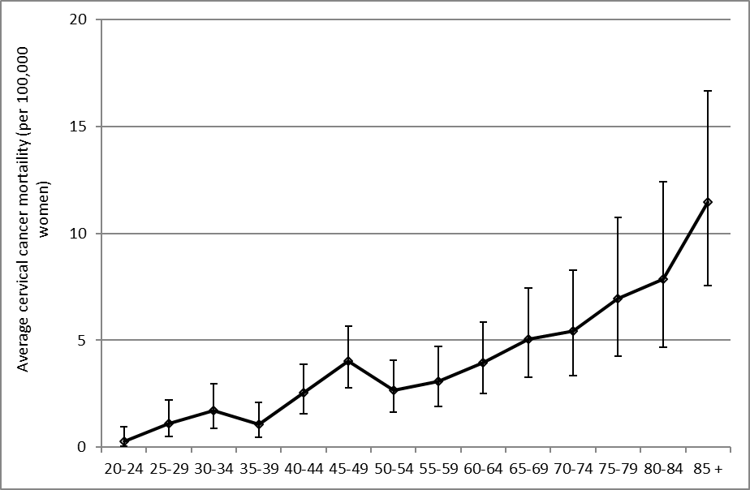Vertical bars represent 95% confidence intervals. See also Table 5.

Figure 10 – Five-year average cervical cancer mortality rates (2010-2014), by age and ethnicity
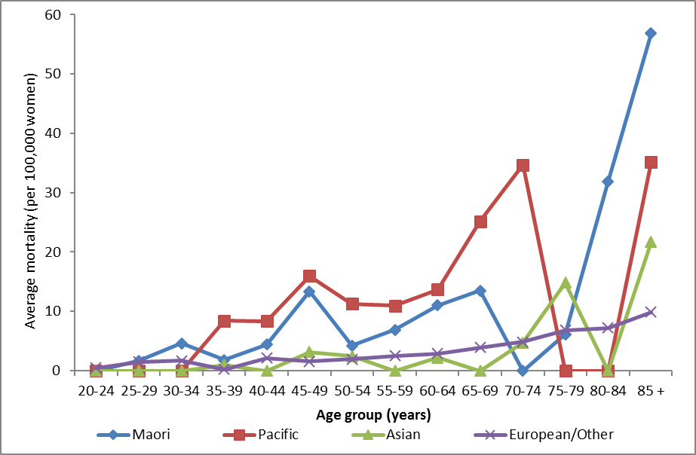
Note that no deaths were recorded in Māori women aged 20-24 years and 70-74, in Pacific women aged 20-34 or 75-84 years, in Asian women aged 20-34, 40-44, 55-59, 65-69 and 80-84 years over this time period. See also Table 5.
Table 5 – Average cervical cancer mortality (2010-2014), by age
 | All women |  | Māori women
Age | Rate | (95%CI) | Rate | (95%CI)
20-24 | 0.3 | (0.0 - 0.9) | - | (0.0 - 2.5)
25-29 | 1.1 | (0.5 - 2.2) | 1.7 | (0.2 - 6.1)
30-34 | 1.7 | (0.9 – 3.0) | 4.6 | (1.5 - 10.8)
35-39 | 1.1 | (0.5 - 2.1) | 1.8 | (0.2 - 6.5)
40-44 | 2.5 | (1.6 - 3.9) | 4.4 | (1.4 - 10.3)
45-49 | 4.0 | (2.8 - 5.7) | 13.4 | (7.3 - 22.4)
50-54 | 2.7 | (1.7 - 4.1) | 4.2 | (1.1 - 10.8)
55-59 | 3.1 | (1.9 - 4.7) | 6.9 | (2.2 - 16.1)
60-64 | 3.9 | (2.5 - 5.9) | 11.0 | (4.0 – 24.0)
65-69 | 5.0 | (3.3 - 7.4) | 13.5 | (4.4 - 31.5)
70-74 | 5.4 | (3.4 - 8.3) | - | (0.0 - 14.1)
75-79 | 7.0 | (4.3 - 10.7) | 6.1 | (0.2 - 34.1)
80-84 | 7.9 | (4.7 - 12.4) | 31.9 | (6.6 - 93.2)
85 + | 11.5 | (7.5 - 16.7) | 56.8 | (11.7 - 166)
‘-‘ indicates no deaths recorded over the five-year period

Appendix A – Additional data tables

Table 6 – Incident cases by detailed morphology, 2015
Morphology |  |  | Cases | % of all cervical cancers
 |  | Sub-category
Adenocarcinoma |  |  | 24 | 16.9
 |  | Adenocarcinoma, endocervical type | 2 | 1.4
 |  | Mucinous adenocarcinoma | 3 | 2.1
 |  | Adenocarcinoma, not otherwise specified | 19 | 13.4
Adenosquamous |  |  | 5 | 3.5
 |  | Adenosquamous carcinoma | 5 | 3.5
Squamous cell carcinoma |  |  | 102 | 71.8
 | Basaloid squamous cell carcinoma |  | 4 | 2.8
 |  | Papillary squamous cell carcinoma | 3 | 2.1
 |  | Squamous cell carcinoma, keratinizing, not otherwise specified | 8 | 5.6
 |  | Squamous cell carcinoma, large cell, non-keratinizing, not otherwise specified | 8 | 5.6
 |  | Squamous cell carcinoma, microinvasive | 9 | 6.3
 |  | Squamous cell carcinoma, not otherwise specified | 70 | 49.3
Other |  |  | 11 | 7.7
 |  | Carcinoma, not otherwise specified | 2 | 1.4
 |  | Carcinosarcoma, not otherwise specified | 1 | 0.7
 |  | Embryonal rhabdomyosarcoma, not otherwise specified | 1 | 0.7
 |  | Large cell neuroendocrine carcinoma | 1 | 0.7
 |  | Neoplasm, malignant | 5 | 3.5
 |  | Spindle cell carcinoma, not otherwise specified | 1 | 0.7
Total |  |  | 142 | 100

Table 7 - Extent of disease at time of diagnosis for incident cervical cancer cases, 2006-2014
Year
Code | Description | 2006 |  | 2007 |  | 2008 |  | 2009 |  |  | 2010 |  | 2011 |  | 2012 |  | 2013 |  | 2014 |  | 2015
 |  | N | % | N | % | N | % |  | N | % | N | % | N | % | N | % | N | % | N | % | N | %
B | Localised to organ of origin | 68 | 43.0 | 52 | 31.9 | 71 | 40.6 |  | 45 | 31.7 | 77 | 42.8 | 67 | 39.6 | 52 | 31.0 | 68 | 42.8 | 60 | 41.7 | 55 | 38.7
C | Invasion of adjacent tissue or organ | 6 | 3.8 | 6 | 3.7 | 14 | 8.0 |  | 20 | 14.1 | 21 | 11.7 | 19 | 11.2 | 18 | 10.7 | 35 | 22.0 | 16 | 11.1 | 16 | 11.3
D | Regional lymph nodes | 6 | 3.8 | 4 | 2.5 | 12 | 6.9 |  | 8 | 5.6 | 8 | 4.4 | 8 | 4.7 | 7 | 4.2 | 7 | 4.4 | 10 | 6.9 | 6 | 4.2
E | Distant | 19 | 12.0 | 22 | 13.5 | 16 | 9.1 |  | 17 | 12.0 | 22 | 12.2 | 21 | 12.4 | 28 | 16.7 | 18 | 11.3 | 13 | 9.0 | 11 | 7.7
F | Not known | 59 | 37.3 | 79 | 48.5 | 62 | 35.4 |  | 52 | 36.6 | 52 | 28.9 | 54 | 32.0 | 63 | 37.5 | 31 | 19.5 | 45 | 31.3 | 54 | 38.0
TOTAL |  | 158 | 100 | 163 | 100 | 175 | 100 |  | 142 | 100 | 180 | 100 | 169 | 100 | 168 | 100 | 159 | 100 | 144 | 100 | 142 | 100

Appendix B – Population data
WHO Standard Population
Rates for cervical cancer incidence and mortality were standardised using the WHO World Standard Population according to Ahmad et al (2001)(1), as shown in Table 8.

Table 8 – WHO Standard Population
Age group | N | Proportion
00-04 | 8,860 | 0.088569
05-09 | 8,690 | 0.08687
10-14 | 8,600 | 0.08597
15-19 | 8,470 | 0.08467
20-24 | 8,220 | 0.082171
25-29 | 7,930 | 0.079272
30-34 | 7,610 | 0.076073
35-39 | 7,150 | 0.071475
40-44 | 6,590 | 0.065877
45-49 | 6,040 | 0.060379
50-54 | 5,370 | 0.053681
55-59 | 4,550 | 0.045484
60-64 | 3,720 | 0.037187
65-69 | 2,960 | 0.02959
70-74 | 2,210 | 0.022092
75-79 | 1,520 | 0.015195
80-84 | 910 | 0.009097
85 + | 635 | 0.006348
Total | 100,035 | 1

New Zealand estimated resident population
The estimated data for New Zealand female population was based on data from Statistics New Zealand. Population figures for cancer incidence and mortality used mid-year estimates, based on projections from 2013 Census data for 2006-2014. Population estimates for 2005 were based on a linear interpolation between data from the 2001 Census and 2006 Census. Population data for 2005 were not available in the four required ethnic groups, and so ethnicity-specific estimates could not be calculated for 2005 for cancer incidence, cancer mortality, or coverage.

References

1. Ahmad OB, Boschi-Pinto C, Lopez AD, Murray CJL, Lozano R, Inoue M. Age standardization of rates: A new WHO standard. Geneva: World Health Organization; 2001.
2. Boyle P, Parkin D. Chapter 11. Statistical methods for registries. IARC Scientific Publication 95 Cancer Registrations: Principles & Methods. Lyon, France: International Agency for Research on Cancer (IARC) Press; 2002.
3. Ministry of Health. Cancer: New registrations and deaths 2006. Wellington: Ministry of Health2010.
4. Ministry of Health. Cancer: New registrations and deaths 2007. Wellington: Ministry of Health2010.
5. Smith M, Walker R, Canfell K. National Cervical Screening Programme Annual Report 2008-20092012.
6. Centre for Public Health R, Brewer N, McKenzie F, Wong KC, Ellison-Loschmann L. National Cervical Screening Programme Annual Monitoring Report 2006. Wellington, New Zealand: Centre for Public Health Research, Massey University, NZ2008.

