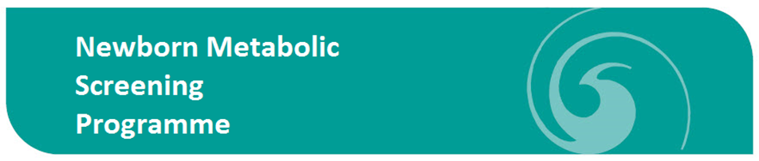 Insert DHB Logo
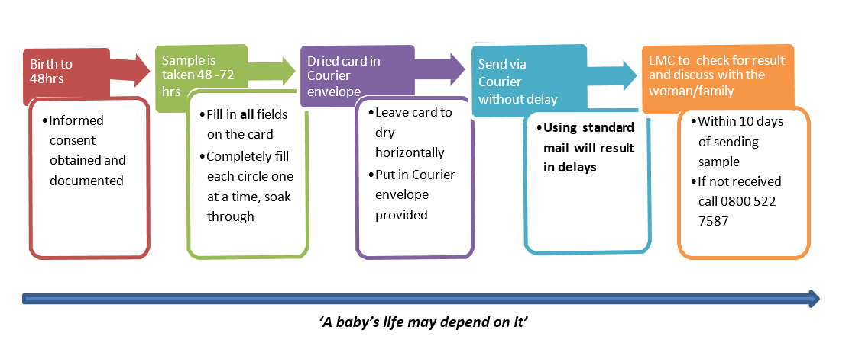
Working together to improve Newborn Metabolic Screening

Use this box to describe your DHB/facility specific instruction

