National Cervical Screening Programme

Monitoring Report 46

1 July - 31 December 2016

Technical report 46

Prepared June 2017
Revised November 2017
Finalised November 2017

By Megan Smith, Leanne Rumlee, and Karen Canfell
Cancer Research Division, Cancer Council NSW Australia, Sydney NSW Australia

Suggested citation:
Smith M, Rumlee L, Canfell K. National Cervical Screening Programme Monitoring Report Number 46 (1 July - 31 December 2016). National Screening Unit: Wellington, 2017.

Acknowledgements

This report was prepared by the authors in collaboration with the National Screening Unit (NSU), Ministry of Health, in particular Ivan Rowe, Senior Analyst, Sector Development, of the National Screening Unit.

We would like to acknowledge the contribution from Ronnie de Does, NCSP Register Central Team, for data extraction; John Newell, NSU, for developing the SQL queries from the extracted data to calculate and produce the IMR tables; and Simon Edwards, Robert Walker, Sarsha Yap and Dr Mark Clements for assistance with code development and importing data for analysis.

About the authors

The authors are based at Cancer Research Division at Cancer Council NSW, Sydney, Australia. They are part of a research group (led by Prof Karen Canfell) which has as its core research focus the epidemiology of cervical cancer, cervical screening and human papillomavirus (HPV) vaccination. This research group has established an extensive track record both in research publication and in successful completion of commissioned projects related to national cervical screening programs in New Zealand, Australia and England. The group has extensive experience in the analysis of descriptive data from cervical cancer screening programmes. The team also has a range of related skills in the analysis of linked datasets, systematic review and meta-analysis, biostatistics, health economics, and advanced statistical modelling techniques.

Contents
1. Executive Summary 1
2. Background 12
3. Methods 13
Data used 13
Age 13
Hysterectomy-adjusted population 13
Ethnicity analysis 14
Calculating NCSP coverage 14
4. Biannual NCSP Monitoring Indicators 16
Indicator 1 – Coverage 16
Indicator 1.1 – Three-year coverage 17
Indicator 1.2 – Regularity of screening 32
Indicator 2 – First screening events 44
Indicator 3 – Withdrawal rates 50
Indicator 4 – Early re-screening 54
Indicator 5 – Laboratory indicators 60
Indicator 5.1 – Laboratory cytology reporting 61
Indicator 5.2 – Accuracy of cytology predicting HSIL 73
Indicator 5.3 – Accuracy of negative cytology reports 78
Indicator 5.4 – Histology Reporting 82
Indicator 5.5 - Laboratory turnaround times 89
Indicator 6 – Follow-up women high grade cytology, no histology 96
Indicator 7 – Colposcopy indicators 107
Indicator 7.1 – Timeliness of colposcopic assessment – high grade cytology 108
Indicator 7.2 – Timeliness of colposcopic assessment – low grade cytology 115
Indicator 7.3 – Adequacy of documenting colposcopy assessment 121
Indicator 7.4 – Timeliness and appropriateness of treatment 127
Indicator 7.5 – Timely discharging of women after treatment 132
Indicator 8 – HPV tests 136
Indicator 8.1 – Triage of low grade cytology 137
Indicator 8.2 – HPV test volumes 151
Indicator 8.3 – HPV tests for follow-up of women with a historical high grade abnormality 162
Appendix A – Additional data 169
Indicator 1 - Coverage 169
Indicator 1.1 – Three-year coverage 169
Indicator 1.2 – Regularity of screening 179
Indicator 2 – First screening events 183
Indicator 3 – Withdrawal rates 185
Indicator 4 – Early re-screening 186
Indicator 5 – Laboratory indicators 188
Indicator 5.1 – Laboratory cytology reporting 188
Indicator 5.2 – Accuracy of cytology predicting HSIL 189
Indicator 5.4 – Histology Reporting 191
Indicator 5.5 – Laboratory turnaround time 192
Indicator 6 – Follow-up of women with high grade cytology 195
Indicator 7 – Colposcopy indicators 197
Indicator 7.1 – Timeliness of colposcopic assessment – high grade cytology 197
Indicator 7.2 – Timeliness of colposcopic assessment – low grade cytology 199
Indicator 7.3 – Adequacy of documenting colposcopic assessment 201
Indicator 7.5 – Timely discharge of women after treatment 204
Indicator 8 – HPV tests 206
Indicator 8.1 – Triage of low grade cytology 206
Indicator 8.2 – HPV test volumes 209
Indicator 8.3 –HPV tests for follow-up of women with a historical high grade abnormality 213
Appendix B – Bethesda 2001 New Zealand Modified 218
Appendix C – SNOMED categories for histological samples 220
Appendix D – Indicator Definitions Targets and Reporting Details 221
Positive predictive value calculations 221
Appendix E – DHB assignment for colposcopy clinics 222
Appendix F – Glossary 224
References 225

List of Tables

Table 1 - Satisfactory and unsatisfactory cytology reporting by laboratory (1 July – 31 December 2016) 67
Table 2 - Laboratory cytology reporting by general result (1 July – 31 December 2016) – percentage of satisfactory samples 67
Table 3 - Laboratory cytology reporting by type of cytology sample (1 July – 31 December 2016) – counts 68
Table 4 - Laboratory cytology reporting by cytological category (1 July – 31 December 2016) – percentage of all satisfactory samples 68
Table 5 - Laboratory reporting of cytological category by five-year age group (1 July – 31 December 2016) – counts 69
Table 6 - Laboratory reporting of cytological category by five-year age group (1 July – 31 December 2016) – percentage of all satisfactory samples in women of that age group 70
Table 7 - Histology results reporting by SNOMED category 84
Table 8 - Histology results reporting by diagnostic category 85
Table 9 - Histology results by age – counts 86
Table 10 - Histology results by age – percentages 87
Table 11 - Women with a histology report within 90 and 180 days of a high grade cytology report, by DHB 102
Table 12 - Women with a histology report within 90 and 180 days of a high grade cytology report, by age 103
Table 13 - Women with a histology report within 90 days of a high grade cytology report, by DHB and ethnicity 103
Table 14 - Women with a histology report within 180 days of a high grade cytology report, by DHB and ethnicity 104
Table 15 - Women with high grade cytology who have follow-up within 90 and 180 days recorded on the NCSP Register, by urgency of referral and type of follow-up 104
Table 16 - Women without any follow-up test within 90 and 180 days of a high grade cytology report, by DHB 106
Table 17 - Women without any follow-up test within 180 days of a high grade cytology report, by ethnicity 106
Table 18 - Women with a high grade cytology report (suspicion of invasive disease), accepted referral and colposcopy visit, by ethnicity 113
Table 19 - Timeliness and appropriateness of treatment, by DHB 131
Table 20 - HPV triage test results following ASC-US cytology, by age and cytology laboratory 145
Table 21 - HPV triage test results following LSIL cytology, by age and cytology laboratory 146
Table 22 - Coverage by DHB (women 25-69 years screened in the three years prior to 31 December 2016, hysterectomy adjusted) 169
Table 23 - Coverage by ethnicity (women 25-69 years screened in the three years prior to 31 December 2016, hysterectomy adjusted) 169
Table 24 - Coverage by age (women 20-69 years screened in the three years prior to 31 December 2016, hysterectomy adjusted) 170
Table 25 - Coverage by DHB (women aged 25-69 years screened in the five years prior to 31 December 2016, hysterectomy adjusted) 170
Table 26 - Coverage by ethnicity – women aged 25-69 years screened in the five years prior to 31 December 2016, hysterectomy adjusted 171
Table 27 - Coverage by age (women 20-69 years screened in the five years prior to 31 December 2016, hysterectomy adjusted) 171
Table 28 - Women aged 25-69 years screened in the five years prior to 31 December 2016, by ethnicity and DHB (hysterectomy adjusted) 172
Table 29 - Women under 20 years of age, and aged 15-19 years, screened in the three years prior to 31 December 2016, by DHB. 173
Table 30 - Women screened under 20 years of age, as a proportion of all women screened in the three years to 31 December 2016, by DHB 174
Table 31 - Women screened under 20 years of age, and women aged 18-19 years when they were screened, in the three years to 31 December 2016, by DHB 175
Table 32 - Women (25-69 years) screened in the three years to 31 December 2016, as a percentage of the i) hysterectomy-adjustment NZ female population and ii) total NZ female population, by DHB 176
Table 33 - Trends in three-year coverage by DHB (women screened in the previous three years, as a percentage of the hysterectomy-adjusted female population) 177
Table 34 - Trends in three-year coverage by age (women screened in the previous three years, as a percentage of the hysterectomy-adjusted female population) 177
Table 35 - Trends in three-year coverage by ethnicity (women screened in the previous three years, as a percentage of the hysterectomy-adjusted female population) 178
Table 36 - Routine (3-yearly) repeat screening interval (number of cytology tests), by ethnicity, 2012-2016 179
Table 37 - Routine (3-yearly) repeat screening interval (number of cytology tests), by age, 2012-2016 180
Table 38 - 12 month repeat screening interval (number of cytology tests), by ethnicity, 2012-2016 181
Table 39 - 12 month repeat screening interval (number of cytology tests), by age, 2012-2016 182
Table 40 - Age distribution of first screening events for period 1 July – 31 December 2016 183
Table 41 - Women (aged 20-69 years) with first screening events as a proportion of i) total number of women with screening events, and ii) eligible women, by DHB, for period 1 July – 31 December 2016 183
Table 42 - Women (ages 20-69 years) with first screening events as a proportion of i) total number of women with screening events, and ii) eligible women, by ethnicity, for period 1 July – 31 December 2016 184
Table 43 - Median age of women with a first screening event, by ethnicity, for period 1 July – 31 December 2016 184
Table 44 - Number of women who withdrew from the NCSP Register 1 July – 31 December 2016 by age, and proportion of women who were enrolled at the start of the monitoring period who withdrew 185
Table 45 - Number of women (aged 20-69 years) who withdrew from the NCSP Register 1 July – 31 December 2016 by ethnicity, and proportion of women who were enrolled at the start of the monitoring period who withdrew 185
Table 46 - Early re-screening by five-year age group 186
Table 47 - Early re-screening by DHB 186
Table 48 - Early re-screening by ethnicity 187
Table 49 - Age-standardised percentage of satisfactory smears reported as HSIL, by laboratory 188
Table 50 - Positive predictive value of a report of HSIL + SC cytology by laboratory 189
Table 51 - Positive predictive value of a report of ASC-H cytology by laboratory 189
Table 52 - Positive predictive value of a report of ASC-H + HSIL + SC cytology by laboratory 190
Table 53 - Histology results reporting by diagnostic category with the exclusion of women with partial or total hysterectomy as the only reason for the histology sample for Negative/ benign (non neoplastic) samples only. 191
Table 54 - Timeliness of cytology reporting by laboratory, 1 July – 31 December 2016 192
Table 55 - Timeliness of histology reporting by laboratory, 1 July - 1 July – 31 December 2016 193
Table 56 - Timeliness of reporting for cytology with associated HPV testing by laboratory, 1 July – 31 December 2016 194
Table 57 - Women with a histology report within 90 days of a high grade cytology report, by DHB and age 195
Table 58 - Women with a histology report within 180 days of a high grade cytology report, by DHB and age 196
Table 59 - Women with high grade cytology (including cytological suspicion of invasive disease), by DHB 197
Table 60 - Women with a high grade cytology report (no suspicion of invasive disease), accepted referral and a colposcopy visit within 40 working days, by ethnicity 197
Table 61 - Women with a high grade cytology report (no suspicion of invasive disease), accepted referral and a colposcopy visit within 40 working days, by DHB 198
Table 62 - Women with cytological suspicion of invasive disease, by cytology result subcategory 198
Table 63 - Follow-up of women with persistent low grade cytology/ low grade cytology and positive hrHPV test, by DHB 199
Table 64 - Follow-up of women with persistent low grade cytology/ low grade cytology and positive hrHPV test, by ethnicity 200
Table 65 - Completion of colposcopic assessment fields, by DHB 201
Table 66 - Summary of colposcopic appearance findings, by DHB 202
Table 67 - Biopsies by colposcopic appearance and DHB 203
Table 68 - Follow-up of treated women with colposcopy and cytology in the period up to nine months post-treatment, and discharge of eligible women 204
Table 69 - Follow-up of treated women in the period up to nine months post-treatment 205
Table 70 - Triage testing of women with ASC-US cytology 206
Table 71 - Triage testing of women with LSIL cytology 207
Table 72 - Histological outcomes within 12 months in women with ASC-US cytology and positive HPV triage test 207
Table 73 - Histological outcomes within 12 months in women with LSIL cytology and positive HPV triage test 208
Table 74 - Volume of HPV test samples received during the monitoring period, by laboratory 209
Table 75 - Invalid HPV tests, by laboratory 209
Table 76 - Validity of HPV triage tests, by test technology 209
Table 77 - Volume of HPV test samples received during the monitoring period, by purpose and ethnicity 210
Table 78 - Volume of HPV test samples received during the monitoring period, by purpose and age 210
Table 79 - Volume of HPV test samples received during the monitoring period, by purpose and laboratory 211
Table 80 - HPV test samples collected at colposcopy, in relation to total colposcopies performed in the period, by DHB 212
Table 81 - Women eligible for and proportion who have received HPV testing for a historical high grade abnormality, by age at 31 December 2016 213
Table 82 - Women eligible for and proportion who have received historical HPV testing, by DHB 214
Table 83 - Women eligible for and proportion who have received historical HPV testing, by ethnicity 214
Table 84 - Women screened in the previous five years and proportion of women with historical round 1 and 2 tests recorded, by DHB 217
Table 85 - Definition used for positive predictive value calculations 221

List of Figures

Figure 1 - Three-year coverage by DHB (women screened in the three years prior to 31 December 2016, as a proportion of hysterectomy-adjusted female population) 22
Figure 2 - Three-year coverage (women screened in the three years prior to 31 December 2016, as a proportion of hysterectomy-adjusted female population), by ethnicity 22
Figure 3 - Three-year coverage by five-year age group (women 20-69 years screened in the three years prior to 31 December 2016, as a proportion of hysterectomy-adjusted female population) 23
Figure 4 - Three-year coverage in Māori women (women 25-69 years screened in the three years prior to 31 December 2016, as a proportion of hysterectomy-adjusted female population), by DHB 23
Figure 5 - Three-year coverage in Pacific women (women 25-69 years screened in the three years prior to 31 December 2016, as a proportion of hysterectomy-adjusted female population), by DHB 24
Figure 6 - Three-year coverage in Asian women (women 25-69 years screened in the three years prior to 31 December 2016, as a proportion of hysterectomy-adjusted female population), by DHB 24
Figure 7 - Three-year coverage in European/ Other women (women 25-69 years screened in the three years prior to 31 December 2016, as a proportion of hysterectomy-adjusted female population), by DHB 25
Figure 8 - Five-year coverage by DHB (women screened in the five years prior to 31 December 2016, as a proportion of hysterectomy-adjusted female population) 25
Figure 9 - Five-year coverage by five-year age-group (women screened in the five years prior to 31 December 2016, as proportion of hysterectomy-adjusted female population) 26
Figure 10 - Five-year coverage by ethnicity (women screened in the five years prior to 31 December 2016, as a proportion of hysterectomy-adjusted female population) 26
Figure 11 - Five-year coverage in Māori women (women 25-69 years screened in the five years prior to 31 December 2016, as a proportion of hysterectomy-adjusted female population), by DHB 27
Figure 12 - Five-year coverage in Pacific women (women 25-69 years screened in the five years prior to 31 December 2016, as a proportion of hysterectomy-adjusted female population), by DHB 27
Figure 13 - Five-year coverage in Asian women (women 25-69 years screened in the five years prior to 31 December 2016, as a proportion of hysterectomy-adjusted female population), by DHB 28
Figure 14 - Five-year coverage in European/ Other women (women 25-69 years screened in the five years prior to 31 December 2016, as a proportion of hysterectomy-adjusted female population), by DHB 28
Figure 15 - Number of women screened who were aged less than 20 years at the time of their cervical sample in the three years to 31 December 2016, by DHB 29
Figure 16 - Trends in three-year coverage by DHB (women aged 25-69 years screened in the previous three years, as a proportion of hysterectomy-adjusted female population) 29
Figure 17 - Trends in three-year coverage by age (women screened in the previous three years, as a proportion of hysterectomy-adjusted female population) 30
Figure 18 - Trends in three-year coverage by ethnicity (women aged 25-69 years screened in the previous three years, as a proportion of hysterectomy-adjusted female population) 30
Figure 19 - Trends in the number of women screened in the preceding three years who were aged less than 20 years at the time of their cervical sample, by DHB 31
Figure 20 - Trends in the percent of women aged less than 20 years at the time of their cervical sample who were aged 18 or 19 years, by DHB 31
Figure 21 - Timeliness of re-attendance in 2016 following a routine (3-year) repeat screening recommendation 37
Figure 22 - Timeliness of re-attendance in 2016 following a routine (3-year) repeat screening recommendation, by ethnicity 37
Figure 23 - Timeliness of re-attendance in 2016 following a routine (3-year) repeat screening recommendation, by age 38
Figure 24 - Timeliness of re-attendance in 2016 following a 12-month repeat screening recommendation 38
Figure 25 - Timeliness of re-attendance in 2016 following a 12-month repeat screening recommendation, by ethnicity 39
Figure 26 - Timeliness of re-attendance in 2016 following a 12-month repeat screening recommendation, by age 39
Figure 27 - Trends in the timeliness of re-attendance following a routine (3-year) repeat screening recommendation 40
Figure 28 - Timeliness of re-attendance following a routine (3-year) repeat screening recommendation (percent), 2012-2016, by ethnicity 41
Figure 29 - Timeliness of re-attendance following a routine (3-year) repeat screening recommendation (percent), 2012-2016, by age 41
Figure 30 - Trends in the timeliness of re-attendance following a 12-month repeat screening recommendation 42
Figure 31 - Timeliness of re-attendance following a 12-month repeat screening recommendation (percent), 2012-2016, by ethnicity 43
Figure 32 - Timeliness of re-attendance following a 12-month repeat screening recommendation (percent), 2012-2016, by age 43
Figure 33 - Women with first screening events during the monitoring period, by five-year age group (women aged 20-69 years at 31 December 2016) 46
Figure 34 - Women with first screening events as a proportion of all women screened in that age group during the monitoring period, by five-year age group (women aged 20-69 years at 31 December 2016) 46
Figure 35 - Proportion of population* in that age group with their first screening event during the monitoring period (women aged 20-69 years at 31 December 2016) 47
Figure 36 - Women with first screening events as a proportion of all women screened during the monitoring period, by DHB (women aged 20-69 years at 31 December 2016) 47
Figure 37 - Women with first screening events as a proportion of all women screened during the monitoring period, by ethnicity (women aged 20-69 years at 31 December 2016) 48
Figure 38 - Trends in the number of women with a first screening event, by age 48
Figure 39 - Trends in the number of women with a first screening event, by DHB 49
Figure 40 - Trends in the number of women with a first screening event, by ethnicity 49
Figure 41 - Number of women (aged 20-69 years) who withdrew from the NCSP Register by DHB, 1 July – 31 December 2016 52
Figure 42 - Number of women who withdrew from the NCSP Register by age, 1 July – 31 December 2016 52
Figure 43 - Number of women (aged 20-69 years) who withdrew from the NCSP Register by ethnicity, 1 July – 31 December 2016 53
Figure 44 - Proportion of women recommended to return at the routine interval (three years) who were re-screened early, by DHB 57
Figure 45 - Proportion of women recommended to return at the routine interval (three years) who were re-screened early, by five-year age group 57
Figure 46 - Proportion of women recommended to return at the routine interval (three years) who were re-screened early, by ethnicity 58
Figure 47 - Trends in the proportion of women recommended to return at the routine interval (three years) who were re-screened early, by DHB 58
Figure 48 - Trends in the proportion of women recommended to return at the routine interval (three years) who were re-screened early, by age 59
Figure 49 - Proportion of total LBC samples reported as unsatisfactory by laboratory, 1 July – 31 December 2016 65
Figure 50 - Proportion of total satisfactory samples reported as negative by laboratory, 1 July – 31 December 2016 65
Figure 51 - Proportion of total satisfactory samples reported as abnormalities by laboratory, 1 July – 31 December 2016 66
Figure 52 - Proportion of total satisfactory samples reported as HSIL by laboratory, 1 July – 31 December 2016 66
Figure 53 - Trends in the proportion of total satisfactory samples reported as HSIL (last four monitoring periods), by age 71
Figure 54 - Longer term trends in the proportion of total satisfactory samples reported as HSIL (to 1 July – 31 December 2016), selected age groups 71
Figure 55 - Trends in the proportion of total satisfactory samples reported as HSIL, by laboratory 72
Figure 56 - Positive predictive value for CIN2+ in women with HSIL or SC cytology reports (cytology in 1 January – 30 June 2016), by laboratory 76
Figure 57 - Positive predictive value for CIN2+ in women with other high grade cytology results (cytology in 1 January – 30 June 2016), by laboratory 76
Figure 58 - Trends in the positive predictive value for CIN2+ in women with HSIL or SC cytology results, by laboratory 77
Figure 59 - Trends in the positive predictive value for CIN2+ in women with ASC-H, HSIL or SC cytology results, by laboratory 77
Figure 60 - Proportion of cytology slides within the 42 months preceding a high grade/ invasive histological diagnosis, originally reported as negative, which on review are consistent with a high grade abnormality 80
Figure 61 – Trends in the proportion of cytology slides within the 42 months preceding a high grade/ invasive histological diagnosis, originally reported as negative, which on review are consistent with HSIL or worse abnormality 80
Figure 62 – Trends in the proportion of cytology slides within the 42 months preceding a high grade/ invasive histological diagnosis, originally reported as negative, which on review are consistent with ASC-H or worse abnormality 81
Figure 63 - Trends in histologically-confirmed HSIL as a percentage of all women with histology (to 1 July 2011 – 31 December 2016) 88
Figure 64 - Proportion of cytology samples reported within seven working days by laboratory, 1 July – 31 December 2016 93
Figure 65 - Proportion of cytology samples reported within 15 working days by laboratory, 1 July – 31 December 2016 93
Figure 66 - Proportion of histology samples reported within ten working days by laboratory, 1 July – 31 December 2016 94
Figure 67 - Proportion of histology samples reported within 15 working days by laboratory, 1 July – 31 December 2016 94
Figure 68 - Proportion of cytology samples with associated HPV triage testing and of all cytology samples reported within 15 days by laboratory, 1 July – 31 December 2016 95
Figure 69 - Proportion of women with a histology report within 90 days, and within 180 days of their high grade cytology report, by DHB 102
Figure 70 - Proportion of women without any follow-up test within 90 days and within 180 days of a high grade cytology report, by DHB 105
Figure 71 - Proportion of women without any follow-up test within 90 days and within 180 days of a high grade cytology report, by ethnicity 105
Figure 72 - Percentage of women with a high grade cytology (no suspicion of invasive disease) with a colposcopy visit within 20 and 40 working days, by ethnicity 113
Figure 73 - Percentage of women with a high grade cytology (no suspicion of invasive disease) with a colposcopy visit within 20 and 40 working days, by DHB 114
Figure 74 - Trends of the proportion of women with a high grade cytology report (no suspicion of invasive disease) seen within 4 weeks (20 working days), by ethnicity 114
Figure 75 - Follow-up recorded* for women with persistent LG cytology/ LG cytology and positive hrHPV test, by DHB 118
Figure 76 - Follow-up recorded* for women with persistent LG cytology/ LG cytology and positive hrHPV test, by ethnicity 118
Figure 77 - Women with persistent LG cytology/ LG cytology and positive hrHPV test and an accepted referral for colposcopy: percentage with a colposcopy visit recorded within 26 weeks of the date the referral was accepted, by DHB 119
Figure 78 - Women with persistent LG cytology or LG cytology and positive hrHPV test and an accepted referral for colposcopy: percentage with a colposcopy visit recorded within 26 weeks of the date the referral was accepted, by ethnicity 119
Figure 79 - Trends in the proportion of women with persistent LG cytology or LG cytology and positive hrHPV test and an accepted referral for colposcopy who have a colposcopy visit recorded within 26 weeks of the date the referral was accepted, by ethnicity 120
Figure 80 - Trends in proportion of women with persistent LG cytology or LG cytology and positive hrHPV test and an accepted referral for colposcopy who have a colposcopy visit recorded within 26 weeks of the date the referral was accepted, by DHB 120
Figure 81 - Completion of colposcopic assessment fields, by DHB 125
Figure 82 - Trends in the completion of all required colposcopic assessment fields, by DHB 125
Figure 83 - Trends in the number of colposcopies recorded on the NCSP Register, by DHB 126
Figure 84 - Proportion of women treated within eight weeks of histological confirmation of HSIL 130
Figure 85 - Trends in the proportion of women treated within eight weeks of histological confirmation of HSIL, by DHB 130
Figure 86 - Percentage of women treated with colposcopy, and both colposcopy and cytology, within nine months post-treatment 135
Figure 87 - Percentage of women discharged appropriately within 12 months of treatment 135
Figure 88 - Proportion of women (aged 30 years or more) with low grade cytology who have a subsequent HPV test, by laboratory and cytology result 142
Figure 89 - Proportion of women (aged less than 30 years) with low grade cytology who have a subsequent HPV test, by laboratory and cytology result 142
Figure 90 - Proportion of HPV triage tests which are positive following ASC-US cytology (women aged 30 years or more), by cytology laboratory 143
Figure 91 - Proportion of HPV triage tests which are positive following LSIL cytology (women aged 30 years or more), by cytology laboratory 143
Figure 92 - Proportion of women with an HPV triage test who are HPV positive, by age and cytology result 144
Figure 93 - Triage-positive women with histologically-confirmed CIN2+ within 12 months, as a percentage of all women with histology, by laboratory 147
Figure 94 - Triage-positive women with histologically-confirmed CIN2+ within 12 months, as a percentage of all women who attended colposcopy, by laboratory 147
Figure 95 - Women with histologically-confirmed CIN2+ within 12 months, as a percentage of all women who attended colposcopy, by laboratory and referral cytology 148
Figure 96 - Triage-positive women with histologically-confirmed CIN2+ within 12 months, as a percentage of women with histology recorded, by age 148
Figure 97 - Triage-positive women with histologically-confirmed CIN2+ within 12 months, as a percentage of women with colposcopy recorded, by age 149
Figure 98 - Trends in ASC-US triage-positive women with histologically-confirmed CIN2+ within 12 months, as a percentage of women with colposcopy recorded, by laboratory 149
Figure 99 - Trends in LSIL triage-positive women with histologically-confirmed CIN2+ within 12 months, as a percentage of women with colposcopy recorded, by laboratory 150
Figure 100 - Volume of HPV test samples received by laboratories during the monitoring period, by age 157
Figure 101 - Volume of HPV test samples received by laboratories during the monitoring period, by laboratory 157
Figure 102 - HPV test samples as a percentage of cytology test samples received during the monitoring period, by laboratory 158
Figure 103 - Volume of HPV test samples received during the monitoring period, by purpose 158
Figure 104 - HPV test samples received during the monitoring period, by purpose and age 159
Figure 105 - HPV test samples received during the monitoring period, by purpose and laboratory 159
Figure 106 - HPV test samples collected at colposcopy, in relation to total colposcopies performed in the period, by DHB 160
Figure 107 - Trends in volumes of HPV test samples received, by laboratory 160
Figure 108 - Trends in volumes of HPV test samples received, by purpose 161
Figure 109 - Proportion of eligible women with squamous high grade abnormality more than 3 years ago for whom an historical test is recorded on the NCSP Register, by age at 31 December 2016 166
Figure 110 - Proportion of eligible women with squamous high grade abnormality more than 3 years ago for whom an historical test is recorded on the NCSP Register, by DHB 166
Figure 111 - Proportion of eligible women with squamous high grade abnormality more than 3 years ago for whom an historical test is recorded on the NCSP Register, by ethnicity 167
Figure 112 - Trends in the proportion of eligible women with squamous high grade abnormality more than 3 years ago for whom a round 1 historical test is recorded on the NCSP Register, by DHB 167
Figure 113 - Trends in the proportion of eligible women with squamous high grade abnormality more than 3 years ago for whom a round 1 historical test is recorded on the NCSP Register, by ethnicity 168
Figure 114 - Trends in the proportion of eligible women with squamous high grade abnormality more than 3 years ago for whom a round 1 historical test is recorded on the NCSP Register, by age 168
Figure 115 - Number of women eligible for historical testing within a DHB versus the percentage with a Round 1 historical HPV test recorded 215
Figure 116 - Relationship between women screened in the previous five years and proportion of women with historical tests recorded, by DHB 215
Figure 117 - Relationship between women screened in the previous five years and proportion of women with historical tests recorded, by ethnicity 216

Executive Summary
Purpose | This report provides data on performance indicators of the National Cervical Screening Programme (NCSP) for the period 1 July to the 31 December 2016.
Key points on performance/trends

Indicator 1 | Coverage
Indicator 1.1 | Three-year coverage  Target: 80% of eligible women screened within the previous three years.  - Among an estimated 1,201,088 eligible women aged 25-69 years at the end of the monitoring period, 922,119 (76.8%) had a screening test in the previous three years.  - The coverage target was not met nationally (80% of women aged 25-69 years screened in the previous three years).  - The coverage target was met for specific five-year age groups between 45-59 years.  - Two of 20 DHBs met the coverage target.  - Nationally, coverage targets were met for European/ Other women (81.7% screened within the previous three years), but were not met for Māori, Pacific, or Asian women (64.1%, 75.1%, 66.6% respectively screened within the previous three years).  - Three-year coverage among women aged 25-69 years (76.8%) is similar to that reported in the previous monitoring report (76.7%). It has increased in Māori and Asian women, and has decreased for Pacific and European/ Other women.  - Three-year coverage has increased in some age groups, with small increases in women aged 30 to 69 years.  - Three-year coverage has decreased slightly in 7 of 20 DHBs.  - Five-year coverage among women aged 25-69 years (90.5%) is similar to that reported in the previous monitoring report (90.3%).  - Five-year coverage among women aged 25-69 years exceeded 80% in all DHBs, in Pacific and European/ Other women, and in women in all five-year age groups between 30-69 years.  Screens in women aged less than 20 years  Target: None  - In the three years to 31 December 2016, 6,434 women had a cervical sample taken when they were aged less than 20 years. This is fewer than in the previous monitoring period (6,924 women).  - This represents 0.6% of all women (of any age) who were screened in the three-year period (the same as the previous monitoring period).  - Most of these women (89.3%) were aged 18-19 years at the time of their cervical sample.
Indicator 1.2 | Regularity of screening  Target: Not yet defined  Routine screening (3-year recall)  - Among women attending for screening in 2016 following a 3-year recall recommendation, 62.2% were attending on-time; 14.9% more than six months early; and 22.9% more than six months late.  - Over the period 2012 to 2016, the proportion of women who were screened on-time increased in all ethnic groups and all age groups. This predominantly reflected a reduction in early re-screening.  - The proportion re-attending more than six months late for their routine screen was consistently higher in Māori and Pacific women than in Asian and European/ Other women, and was consistently highest in women aged 30-39 years.  12-month re-screening  - Among women attending for screening in 2016 following a 12-month repeat recommendation, 42.1% were attending on-time; 2.9% more than three months early; and 55.0% more than three months late.  - Over the period 2012 to 2016, the proportion of women who were re-attending on-time and the proportion who were re-attending more than three months early decreased. There was a corresponding increase in the proportion of women who were re-attending more than 15 months after a recommendation to return in 12 months.  - In 2016, the majority of women who were re-attending after a recommendation to return in 12 months were re-attending more than three months later than recommended. This was the case for all ethnic groups, and all age groups other than women aged 60-69 years who were more likely to attend on-time.  - The proportion who were re-attending more than 15 months after a recommendation to return in 12 months was consistently higher in Māori and Pacific women than in Asian and European/ Other women, and was consistently highest in women aged 30-39 years.
Indicator 2 | First screening events  Target: None  - There were 22,616 women who had their first screening event during the current monitoring period – an increase compared to the previous monitoring period.  - First screening events generally occur among young women (median age 26 years).  - Asian women appear to have their first screening event at a later age (median age of Asian women with a first screening event was 31 years).  - The proportion of women attending for screening who are attending for their first test is highest in Asian women.
Indicator 3 | Withdrawal rates  Target: Zero between ages 20-69 years  - There were 26 women aged between 20-69 years who withdrew from the NCSP Register during this six-month period. This is more than the number of women in this age range who withdrew during the previous monitoring period (22 women).
Indicator 4 | Early re-screening  Target: Not yet defined  Currently reporting on the percentage of women in routine screening (previous smear negative and recommended to return in 36 months (3 years) who returned for a smear within 30 months (2.5 years) of their index smear.  - 14.3% of a cohort of women with a recommendation to return at the routine interval had at least one cytology sample within 30 months of their index cytology sample.  - Early re-screening varies widely between DHBs, from 7.5% in West Coast to 21.2% in Waitemata.  - Early re-screening occurs in all ethnic groups, but is most common among European/ Other (14.8%) and least common among Pacific women (10.9%).  - Early re-screening occurs in all age groups, but is most common in women aged 20-24 years at the end of the period (17.1%) and least common in women aged 65-69 years at the end of the period (10.5%).  - Early re-screening has decreased since the previous report, from 15.3% to 14.3%.
Indicator 5 | Laboratory Indicators
Indicator 5.1 | Cytology reporting  Unsatisfactory cytology  Target: 0.1 - 3% for LBC  - The target for the percentage of LBC samples reported as unsatisfactory was met by four of the six laboratories, and was met nationally (1.6%).  - The rate of unsatisfactory LBC samples has remained similar to the previous report (1.2%).  Negative cytology  Target: No more than 96% of satisfactory cytology samples  - The target for the percent of samples reported as negative was met nationally and met by all six laboratories.  - Nationally, the percent of samples which are negative (92.9%) is similar to that reported in the previous period (92.7%).  Abnormal cytology  Target: No more than 10% of satisfactory cytology samples  - The target for the percent of samples reported as abnormal was met nationally and by four of six laboratories.  - Nationally, the percent of samples which are abnormal (7.1%) is similar to that reported in the previous period (7.3%).  HSIL cytology  Target: No less than 0.5% of satisfactory cytology samples  - The target for the percent of HSIL samples was met nationally and met by all six laboratories.  - Nationally the percent of HSIL samples (1.0%) remained similar to that reported in the last monitoring report (1.1%).
Indicator 5.2 | Cytology positive predictive value  HSIL + SC  Target: 65% - 85% of HSIL+SC cytology samples should be histologically confirmed as high grade  - Four of six laboratories met the target range for HSIL + SC.  - Nationally, the positive predictive value of HSIL + SC was slightly lower for this monitoring period (79.8%) than in the previous report (80.4%).  Other cytological abnormalities  Target: None  - Nationally, the positive predictive value of ASC-H has decreased compared to the previous report (41.2% in this report, 45.6% in the previous report).  - Nationally, the positive predictive value of the combination of ASC-H + HSIL + SC has decreased compared to the previous report (68.3% in this report, compared to 69.4% in the previous report).  - Nationally, the percent of glandular cytological abnormalities identified as histological high grade has increased since the previous report, from 39.2% to 44.9% (however this measure is generally based on a comparatively small number of samples; 185 samples with histology in the current report).
Indicator 5.3 | Accuracy of negative cytology reports  Among cytology slides within the 42 months preceding a histological diagnosis of high-grade/invasive disease originally reported as negative, benign/reactive or unsatisfactory:  Target: Not more than 10% identified as HS1, HS2, SC, AIS or AC1-5 (HSIL+) on review  - Nationally, 2.9% of slides originally reported as negative, benign/reactive or unsatisfactory were consistent with HSIL+ on review.  - All laboratories met the target.  Target: Not more than 20% identified as ASC-H, HS1, HS2, SC, AG4-5, AIS or AC1-5 (ASC-H+) on review; aim for less than 15%  - Nationally, 5.1% of slides originally reported as negative, benign/reactive or unsatisfactory were consistent with ASC-H+ on review.  - All laboratories met the target of less than 20% and achieved rates of less than 15%.
Indicator 5.4 | Histology reporting  Target: None  - 13,974 histology samples were taken during the current monitoring period. 512 (3.7%) of these were insufficient for diagnosis.  - Results for most severe histology from 11,662 women with samples which were sufficient for diagnosis are presented.  - 53.3% of women had histology samples which were negative/ benign. This reduced to 42.9% of women when hysterectomy samples were excluded.  - 20.7% of women had CIN2/3 or HSIL histology results.  - 79 (0.68%) women had histology results indicating adenocarcinoma in situ (AIS).  - 70 (0.60%) women had ISCC histology results, 29 (0.25%) women had invasive adenocarcinoma (not endocervical type) and 10 (0.09%) adenocarcinoma of the endocervical type histology results, and 2 (<0.05%) had adenosquamous carcinoma histology results.
Indicator 5.5 | Turnaround times  Cytology  Target: 90% within seven working days; 98% within 15 working days  - The seven-working-days target for cytology was met nationally (96.2%), and was met by five of six laboratories.  - The 15-working-days target was met nationally (98.9%), and was also met by five of the six laboratories.  - Performance against the seven-working-days target is higher to that of the previous report (95.1% in the previous report and 96.2% in the current monitoring period).  - The overall percent of cytology samples reported within 15-working-days (98.9%) is similar to than in the previous monitoring period (98.6%).  Histology  Target: 90% within 10 working days; 98% within 15 working days  - Turnaround time target for histology was met nationally for reporting within 10 working days (91.2%).  - The target was not met for reporting within 15 working days (95.2%).  - Targets were met by 9 of 15 laboratories (10-working-day target) and five of 15 laboratories (15-working-day target).  - The overall proportion of histology samples reported within 15 days (95.2%) was similar to that of the previous report (95.5%).  Low grade cytology with associated HPV triage testing  Target: 98% within 15 working days  - There were 2,681 cytology samples with associated HPV triage testing in the current monitoring period.  - The 15-working-days target for turnaround time for cytology with associated HPV triage testing was met nationally (98.7%).  - Four of the six laboratories met the target.
Indicator 6 | Follow-up of women with high grade cytology – histology  Histological follow-up  Target: 90% of women should have a histology report within 90 days of their high grade cytology report date; 99% should have a histology report within 180 days of their cytology report.  - Targets were not met nationally (for either 90 days or 180 days).  - 81.5% of women had a histology report within 90 days of their high grade cytology report; 87.8% of women had one within 180 days.  - One DHB met the target for histological follow-up within 90 days and no DHB met the target for 180 days.  - Nationally, the proportion of women with histological follow-up within 90 days has increased since the previous monitoring period (from 80.4% to 81.5%), while the proportion with follow-up within 180 days has remained similar (from 87.6% to 87.8%).  - Compared to the previous monitoring period, the proportion of women with follow-up histology within 90 days has decreased for Pacific women (from 69.1% to 67.3%) and increased for Māori (from 72.7% to 78.0%), Asian (from 76.1% to 78.5%) and European/ Other women (from 83.4% to 84.0%).  - The proportion of women with follow-up histology within 180 days increased for Māori, Pacific and Asian women and decreased slightly in European/ Other women.  Any follow-up tests  Target: None  - Nationally, 237 (10.2%) women have no follow-up test report (colposcopy, subsequent cytology, histology or HPV test) within 90 days of their high grade cytology report, and 152 (6.5%) women have no follow-up test report within 180 days.  - Nationally, the proportion of women with no record of a follow-up test report at 90 days (at 10.2%) is similar to that in the previous monitoring period, but has increased at 180 days (from 5.8% to 6.5%).  - Compared to the previous monitoring period, the proportion of women with no follow-up test recorded at 180 days has decreased for Māori (from 8.6% to 7.8%), Asian women (from 7.1% to 6.3%) and Pacific women (from 14.6% to 13.3%), but increased for European/ Other women (from 4.4% to 5.6%).
Indicator 7 | Colposcopy
Indicator 7.1 | Timeliness of colpscopic assessment – high grade cytology  Target: 95% or more of women who have evidence of clinical suspicion of invasive carcinoma, or a suspicion of invasive disease (TBS codes HS2, SC, AC1-AC5), receive colposcopy or a gynaecological assessment within 10 working days of receipt of referral. 95% or more of women who have other high-grade smear abnormalities (TBS codes ASH, HS1, AG1-5, AIS) receive colposcopy within 20 working days of receipt of referral.  - There were 2,332 women with high grade cytology results who were not already under specialist management (the same women reported on in Indicator 6).  - This comprised 88 women with high grade results indicating a suspicion of invasive disease and 2,244 women with other high grade results.  - Nationally, the proportion of women with accepted referrals recorded on the NCSP Register is lower compared to the previous report (decreased from 87.8% to 86.7%).  Suspicion of Invasive Disease  - Among the 88 women with high grade cytology results indicating a suspicion of invasive disease, 50 (56.8%) had an accepted referral. Of the women with an accepted referral, 78.0% were seen within 10 working days of their referral being accepted. This is higher than in the previous report(63.8%).  - A colposcopy visit is recorded for 80 of these women (90.9%) up to 31 December 2016 (follow-up time of at least six and up to 12 months).  No Suspicion of Invasive Disease  - Among the 2,244 women with other high grade cytology results, 1,973 (87.9%) had an accepted referral. Of the women with an accepted referral, 67.0% were seen within 20 working days of their referral being accepted. This is higher than the proportion seen within 20 working days in the previous monitoring period (63.9%).  - A colposcopy visit is recorded for 2,103 (93.7%) of these women up to 31 December 2016 (follow-up time of at least six and up to 12 months).
Indicator 7.2 | Timeliness of colposcopic assessment – low grade cytology  Target: 95% of women who have persistent low-grade abnormalities or a low-grade abnormality and positive HPV test, must receive a date for a colposcopy appointment within a period that does not exceed 26 weeks of the colposcopy unit accepting the referral from the smear-taker.  - There were 3,994 women with persistent low grade cytology or low grade cytology and a positive hrHPV test collected the 6-month period ending 12 months prior to the end of the current monitoring period (i.e. between 1 July – 31 December 2015).  - Subsequent accepted referrals are recorded for 3,255 (81.5%) of these women, and subsequent colposcopy (by 31 December 2016) for 3,582 (89.7%) of these women.  - Nationally, 68.8% of women attended for colposcopy within 26 weeks of their accepted referral. This is lower than in the previous monitoring report (75.2%).
Indicator 7.3 | Adequacy of reporting colposcopy  Target: 100% of medical notes will accurately record colposcopic findings including visibility of the squamocolumnar junction, presence or absence of a visible lesion, and colposcopic opinion regarding the nature of the abnormality.  - Based on 13,447 colposcopy visits recorded on the NCSP Register, no DHB nor the aggregate of colposcopy visits to private practice met the target of 100% completion of all recommended fields.  - All items were documented for 92.7% of colposcopy visits (measuring the degree of visibility of the squamocolumnar junction,,presence or absence of a lesion and colposcopic opinion regarding abnormality )  - The type of recommended follow-up was recorded for 94.8% of colposcopy visits, and the recommended timeframe for this follow-up was recorded for 94.0% of colposcopy visits.  - Colposcopic appearance was reported as abnormal in 55.4% of colposcopies, and inconclusive in 4.8% of colposcopies.  - Completion of most recommended fields is broadly similar to what was reported in the previous monitoring period.  - Overall completion is similar in this reporting period (92.7%) to what it was in the previous monitoring period (92.4%).  - The number of colposcopies recorded on the NCSP Register has remained relatively stable with a small decrease of 2.1%  - The number of DHBs reporting colposcopy data electronically to the NCSP Register increased from 17 to all DHBs (as at 31 August 2016) during the current monitoring period.
Indicator 7.4 | Timeliness and appropriateness of treatment  Target: 90% or more of women with HSIL should be treated within eight weeks of histological confirmation.  - 64.5% of 2,606 women with HSIL histology (CIN2/3) during the period 1 January to 30 June 2016 have a record of treatment within eight weeks of their histology report.  - The proportion of women with histologically confirmed CIN2/3 treated within eight weeks of their histology result being reported has increased slightly since the previous monitoring period (from 64.0% to 64.5%).  - One DHB met the target.
Indicator 7.5 | Timeliness of discharge following treatment  Target: 90% or more of women treated for CIN2/3 should have a colposcopy and cytology within the nine-month period post treatment.  - Based on NCSP Register records, 1,634 women were treated for high grade lesions in the period 1 July to 31 December 2015.  - 74.3% of women treated have a record of both colposcopy and cytology within the nine months after their treatment visit. 75.4% have a record of at least a colposcopy visit (with or without cytology) in the same time period.  - One DHB met the target for follow-up within nine months post-treatment.  Target: 90% or more of women treated for CIN2/3 should be discharged back to the smear-taker as appropriate.  - There were 1,253 women who who were eligible for appropriate discharge within 12 months of their treatment (76.7% of all women treated for CIN2/3). Of these women, 1,046 (83.5%) were discharged to their smear-taker within 12 months.  - Eight DHBs met the target of discharging 90% or more women who were eligible for discharge within 12 months.
Indicator 8 | HPV testing
Indicator 8.1 | HPV triage of low grade cytology  Target: None set.  HPV triage  - Nationally, 96.9% of women aged 30 years or more with an eligible ASC-US cytology result, and 97.1% of women aged 30 years or more with an eligible LSIL cytology result are recorded as having a subsequent HPV triage test.  - Small numbers of HPV triage tests occur in women aged under 30 years (in 1.3% of women with an ASC-US result, and 0.6% of women with an LSIL result; 22 women in total).  - The proportion of women aged 30 years and over who were eligible for HPV triage of low grade cytology who subsequently received a triage test is more than that in the previous monitoring period for women with ASC-US results (96.9%, compared to 94.1% in the previous report) and for women with LSIL results (97.1%, compared to 95.0% in the previous report).  Positive triage tests  - Among women aged 30 years or more with valid HPV triage test results, 24.5% of women with ASC-US results and 57.7% of women with LSIL results were positive for high risk HPV.  - Positivity for high risk HPV varied by laboratory (from 16.2 % to 36.0% for ASC-US, and from 48.9% to 64.4% for LSIL).  - Positivity for high risk HPV generally decreased with increasing age.  - The proportion of women whose HPV tests were positive was higher in the current monitoring period for ASC-US (24.5%, compared to 22.8% in the previous period), and marginally higher for LSIL (57.7%, compared to 57.2% in the previous period).  Histological outcomes in triage-positive women who attended colposcopy  - Among women with ASC-US cytology and a positive HPV triage test in six-month period one year prior to the current monitoring report, 91.9% of women have a record of colposcopy and 61.3% have a record of histology within 12 months of their triage test. The corresponding percentages for LSIL are 90.9% with colposcopy and 69.8% with histology within 12 months.  - Among women with colposcopy recorded within 12 months of a positive triage test, the proportion of women that had a outcome of CIN 2 or more severe (CIN2+) was 18.2% for women with ASC-US cytology and 15.2% for women with LSIL cytology.  - Among women with histology recorded within 12 months of a triage test, 27.3% of women with ASC-US cytology and 19.8% of women with LSIL cytology had a histological outcome of CIN2+.
Indicator 8.2 | HPV test volumes  Target: None set.  - 19,822 cervical samples were received nationally at laboratories for HPV testing during the current monitoring period.  - Nationally, 13.9% of HPV tests were taken for follow-up of women treated for confirmed high grade squamous abnormalities in the previous four years, 37.9% were taken to manage women with high grade squamous cytology or histology more than three years ago (historical testing), 4.3% were taken at colposcopy (potentially to assist in resolving discordant results), and 13.0% were taken for HPV triage of low grade cytology in women aged 30 years or more.  - The proportion of HPV tests which are invalid is very small (0.2%).  - Overall HPV test volumes have decreased by 1.6% since the previous monitoring period.
Indicator 8.3 | Historical HPV tests for follow-up of women with previous high grade abnormality  Target: None set.  - This analysis followed up 49,478 women who were eligible for historical HPV testing as at 1 October 2009 to ascertain how many women had received an HPV test for management of their historical (more than three years prior) high grade squamous abnormality.  - There were 31,236 women (63.1%) with a Round 1 historical HPV test recorded, and 24,321 women (49.2%) with a Round 2 historical HPV test recorded.  - The proportion of women who had received a historical HPV test varied by DHB, from 49.3% to 78.4% for Round 1 tests and from 31.6% to 69.5% for Round 2 tests.  - There was comparatively less variation by age in the proportion of women who had received a historical HPV test. For women aged 25 to 69 years this varied from 51.8% (25-29 years) to 65.8% (60-64 years) for Round 1 tests, and from 36.2% (25-29 years) to 52.5% (60-64 years) for Round 2 tests.  - The proportion of women who had received a historical HPV test varied somewhat by ethnicity, from 43.5% (Pacific women) to 65.4% (European/ Other women) for Round 1 tests and from 30.4% (Pacific women) to 51.9% (European/ Other women) for Round 2 tests.  - The proportion of eligible women with an HPV test recorded has increased since the previous report from 60.6% to 63.1% for Round 1 tests, and from 46.1% to 49.2% for Round 2 tests.

Background
An organised National Cervical Screening Programme (NCSP) was established in New Zealand in 1990, to reduce the number of women who develop cervical cancer and the number who die from it. The Programme recommends regular cervical screening at three-year intervals for women aged between 20 and 69 years who have ever been sexually active. Part 4A of the Health Act 1956, which came into effect in 2005, underpins the NCSP’s operations to ensure the co-ordination of a high quality screening programme for all women in New Zealand.

Ongoing systematic monitoring is a requirement of an organised screening programme. Such monitoring allows the performance of the Programme to be evaluated and corrective action to be taken as required. Monitoring is carried out through a set of key indicators which cover all aspects of the screening pathway, including participation by women, their clinical outcomes, NCSP provider performance and the Programme overall.

Monitoring reports were produced quarterly from December 2000 to June 2007 (Report 27); and six-monthly thereafter. The audience for these monitoring reports includes the general public, NCSP providers, and the Programme itself.

Technical information on the indicators are available from the Ministry of Health on request.

From Report 30 onwards, monitoring has been undertaken with the technical assistance of researchers based at the Cancer Research Division at Cancer Council NSW, Sydney, Australia. This has coincided with the use of a new reporting format, incorporating more explicit definitions and utilising data from the newly developed NCSP Register, so earlier reports are not fully comparable with Report 30 onwards.

The development of these reports has been ongoing, however it is anticipated that from Report 44 going forward, there will be minimal further changes to the indicators, since the NCSP is expected to transition to primary HPV screening in the near future.

NCSP biannual monitoring reports are reviewed by a multidisciplinary advisory and monitoring group, representing NCSP providers and consumers. The group may make recommendations to the NSU for follow-up actions.

Further information about the NCSP Advisory Group and the monitoring and performance of the NCSP is available on https://www.nsu.govt.nz/health-professionals/national-cervical-screening-programme/independent-monitoring-reports and on request from the NCSP:
Email: Ivan_Rowe@moh.govt.nz
Phone: (04) 816 3345, 021 711 432 Fax: (04) 816 4484

- Methods

Data used

The analyses in this report are based on data extracted from the NCSP Register on 18 February 2017.

Age

Unless otherwise specified, age is defined as the woman’s age at the end of the monitoring period, i.e. the women’s age at 31 December 2016.

Hysterectomy-adjusted population

Measures such as coverage require an estimate of the population eligible for cervical screening. This is approximated by applying a hysterectomy-adjustment to the estimated New Zealand female population, to exclude women with a hysterectomy from the eligible population. This is an imperfect adjustor of the proportion of the population eligible for screening, since women with a hysterectomy may or may not require further cervical smears, depending on the type of hysterectomy that they received.

The hysterectomy-adjustment used in this report uses estimates of the hysterectomy prevalence (both total and partial) in the New Zealand population, modelled by Alistair Gray ¹, and are the adjustors recommended by the Health and Disability Intelligence Unit within the Ministry of Health. Hysterectomy incidence was estimated by fitting models to observed data on hysterectomies obtained from public and private hospital discharge data and estimates of the usually resident female population from Statistics New Zealand. The resulting estimates of hysterectomy incidence and survival in single-year age groups by calendar year were then used to estimate the prevalence of hysterectomy by five-year age group (among women aged 20-69 years) and calendar year (1988 to 2017). The 2016 estimates were employed in this monitoring report. A known limitation of these estimates of hysterectomy prevalence is that they do not take into account deaths or women who leave New Zealand after they have a hysterectomy (which would tend to result in an overestimate of hysterectomy prevalence), nor women who migrate to New Zealand who have previously had a hysterectomy (which would tend to underestimate hysterectomy prevalence). These limitations may be mitigated by the fact they are working in opposite directions, and that some women who emigrate from New Zealand do return later in their lives. Further information about the hysterectomy prevalence methodology can be found in the document ‘Methodology for estimating hysterectomy prevalence in women 20-69’ (14 September 2011) by A. Gray.¹

The hysterectomy prevalence data were applied to New Zealand population estimates from Statistics New Zealand so that estimates of the number of women in the New Zealand population (by age and ethnicity) who had not had a hysterectomy prior to were obtained. Hysterectomy prevalence figures for the whole population (the denominator) were not available by DHB or ethnicity, so age-specific hysterectomy adjustments were applied equally across each DHB and ethnicity grouping. These adjusted population estimates were then used as the denominator in the hysterectomy-adjusted calculations. The estimates used for the New Zealand female population were the female 2013 Census population, projected to 31 December 2016.

Ethnicity analysis

The analysis by ethnicity considered four groups – Māori, Pacific, Asian, or European/ Other, based on women’s prioritised ethnicity derived from level two ethnicity codes recorded on the NCSP Register. Women for whom ethnicity information was not available were included in the “European/ Other” ethnicity category. The data download used for the current analysis (NCSP Register data as at mid-February 2017) contained ethnicity codes for approximately 98.9% of women on the NCSP Register.

Ethnicity data in New Zealand is collected during encounters with the health system, such as registering with primary care, during an admission to hospital, or during surveys. The Ministry of Health has undertaken a number of activities to improve the quality of ethnicity data, including the development in 2004 of protocols for the collection and recording of ethnicity data.² Coding of ethnicity on the NCSP Register follows the classification used by the Ministry of Health.^{2, 3} The NCSP is continuing with work to improve the accuracy of ethnicity recording on the NCSP Register. This has included matching women’s NHIs for which there is no ethnicity on the register with the Ministry of Health’s NHI register to include ethnicities. This matching is done every three months.

Calculating NCSP coverage

The methods developed for calculating the indicators used to monitor the NCSP are reviewed and revised approximately every three years, consistent with other international programmes. In addition, revisions to calculations are made in accordance with changes to New Zealand statistics, such as the population census data and ethnicity recordings. These changes reflect Statistics New Zealand modifications to methods for estimating population statistics. Any changes to methods for numerators or denominators are discussed with and supported by the NCSP Advisory Group. These changes are then approved by the National Screening Unit.

In 2008 the NCSP Advisory Group agreed that NCSP report coverage for women aged 25-69 years at the end of the monitoring period. This includes women aged 22 and over at the beginning of the three-year period but excludes women aged 20 or 21 years at the beginning. This approach is consistent with best practice in Australia and England. In England, until 2003, the target age range for screening was 20-64 years, but coverage was calculated for women aged 25-64 years, to ensure only women eligible throughout the period were included. Similarly, in Australia, women are eligible to start screening from 18 years, but coverage is measured among women aged 20-69 years. The difference between the starting ages (two years) is the same as the recommended screening interval in Australia.

The advantage of measuring coverage at ages 25-69 are that it provides a fairer estimate of coverage (by excluding women who are not eligible for the full three-year period) and allows international benchmarking with important peer group countries, including Australia and UK.

In addition to three-year coverage, (discussed above) we also report five-year coverage (as is also done internationally). The change in method is even more important here as women aged 20-24 all need to be excluded as they are not eligible for screening for the full five years prior to the end of the assessment period. Restricting the coverage estimate to the 25-69 age group rather than the 20-69 age group is even more advantageous with respect to the five-year coverage indicator than the three-year coverage indicator.

As with all indicators, coverage indicators and the statistics on which they are based continue to evolve and further changes in the construction of these indicators are to be expected in the future. Changes currently in progress include better methods for hysterectomy adjustment and ethnicity identifications.

Biannual NCSP Monitoring Indicators

Indicator 1 – Coverage

This indicator includes two sub-indicators – three-year coverage (Indicator 1.1) and regularity of screening (Indicator 1.2). Indicator 1.1 also describes participation at longer intervals (five-year coverage). These two sub-indicators complement each other, in that the first allows monitoring of women who are screened versus are not screened over various timeframes; whereas the second (regularity of screening) allows more detailed monitoring of the timeliness among women who have attended for screening.

This is a re-structure compared reports prior to Report 44, where only three-year (and five-year) coverage were included in the biannual monitoring reports, and regularity of screening was included in the annual reports.

Indicator 1.1 – Three-year coverage
Definition | The proportion of all 25-69 year old women who have had a screening event (cytology sample, HPV sample or histology sample) taken in the three years prior to the end of the monitoring period. This definition restricts the measure of coverage to the five-year age groups who were eligible for the entire duration of the three-year period, i.e. women aged 25-69 years at the end of the monitoring period. Screening coverage in women aged 20-69 years is also presented, for comparability with previous reports.  The denominator (eligible population) for this indicator is adjusted for the estimated proportion of women who have had a total hysterectomy. Women who have withdrawn from or are not enrolled on the NCSP Register are excluded from the counts of women screened.  Screening of women aged less than 20 years at the time of their cervical sample is also reported by DHB.
Target | 80% of eligible women (aged 25-69 years at the end of the period) within three years.  This target applies nationally, but is also a target for each ethnicity group (80% for Māori, 80% for Asian, 80% for Pacific, 80% for European/ Other).
Current Situation | Coverage  As at 31 December 2016, 922,119 (76.8%) women aged 25-69 at the end of the current monitoring period had at least one cervical sample taken during the previous three years. This does not yet meet the target of 80%. 1,087,226 (90.5%) women aged 25-69 at the end of the current monitoring period had at least one cervical sample taken during the previous five years.  Three-yearly coverage varied by ethnicity. Coverage targets of 80% were not met for Māori, Pacific, or Asian women. Coverage in these groups for women aged 25-69 years was 64.1%, 75.1% and 66.6% respectively. The coverage target was achieved among European/ Other women (81.7% of women aged 25-69 screened) (Figure 2, Table 23).  Coverage for each of Māori, Pacific, Asian or European/ Other women was also explored at the DHB level. Three-yearly coverage for Māori women ranged from 51.7% (South Canterbury) to 72.8% (Hawke's Bay) (Figure 4). The target level of 80% of Māori women screened within the previous three years was not achieved in any DHB. Three-yearly coverage for Pacific women ranged from 55.2% (Whanganui) to all women in South Canterbury (Figure 5). The target level of 80% of Pacific women screened within the previous three years was achieved by three DHBs (Auckland, South Canterbury and Wairarapa). Three-yearly coverage in Asian women ranged from 52.9% (West Coast) to 78.7% (Hutt Valley) (Figure 6). The target level of 80% of Asian women screened within the previous three years was not achieved in any DHB. Three-yearly coverage for European/ Other women ranged from 74.1% (Wairarapa) to 88.4% (Auckland and Bay of Plenty) (Figure 7). The target level of 80% of European/ Other women screened within the previous three years was achieved in 10 DHBs (Auckland, Bay of Plenty, Capital & Coast, Hutt Valley, Lakes, Nelson Marlborough, Southern, Taranaki, Waikato, Waitemata).  The target coverage of 80% of women screened at least once within three years was achieved in three out of the nine five-year age groups between 25 and 69 years. Among these women, the target was achieved for women between the five-year age groups of 45 to 59 years, but was not achieved for the five-year age groups between 25-44 and 60-69 years. Among women aged 25-69 years at the end of the period, coverage was lowest for women aged 25-29 years (65.5%) and was highest for women aged 45-49 (81.4%) (Figure 3, Table 24). Coverage was also low for women aged 20-24 years (51.0%), however many women in this age group were not eligible for screening for the entire three-year period, and so the target is not applied to this age group.  Three-yearly coverage in women aged 25-69 years varied by DHB from 72.3% (West Coast) to 81.3% (Bay of Plenty). Two of the 20 DHBs achieved the 80% target for women aged 25-69 years at the end of the period (Figure 1, Table 22).  When compared to the findings for three-year coverage, five-year coverage had similar patterns of variation by age, DHB, and ethnicity. For women aged 25-69 years at the end of the monitoring period, five-year coverage varied from 85.0% for West Coast to 95.6% in Capital & Coast (Figure 8, Table 25); by age from 79.5% for women aged 25-29 years to 95.7% for women aged 45-49 years (Figure 9, Table 27); and from 77.1% (Asian) to 95.6% (European/ Other) (Figure 10, Table 26). Five-yearly coverage for Māori women ranged from 61.9% (South Canterbury) to 91.3% (Hawke's Bay) (Figure 11, Table 28). Five-yearly coverage for Pacific women ranged from 68.1% (Northland) to all women (Auckland and South Canterbury) (Figure 12, Table 28). Five-yearly coverage for Asian women ranged from 60.3% (West Coast) to 89.1% (Hutt Valley) (Figure 13, Table 28). Five-yearly coverage in European/ Other women ranged from 87.0% (West Coast) to all women (Auckland, Bay of Plenty, Capital & Coast and Lakes) (Figure 14, Table 28). Coverage was estimated to be over 100% of the eligible population in some cases (Table 28); this is likely to be due to limitations in the estimates for hysterectomy prevalence.  Screens in women aged less than 20 years  A total of 6,434 women who were aged less than 20 years at the time of their cervical sample had a cervical sample taken in the three years to the 31 December 2016. This represents 0.6% of women who were screened at any age (Table 30).  The number of women aged less than 20 years at the time they were screened varied by DHB from 41 (Tairawhiti) to 1,146 (Canterbury), however some differences in counts are to be expected due to differences in population size and age structure between DHBs. In order to take differences in population size between DHBs into account, the number of women who were screened in the previous three years and aged 15-19 years at the time of their cervical sample in each DHB was divided by the estimated population of females aged 15-19 years in that DHB. Note that as the events occurred over a three-year period, and the population estimate is for a single year, this cannot be interpreted directly as the proportion of 15-19 year old females in each DHB who have been screened in the last three years. However, this does allow the variation in DHB populations to be partly accounted for, and thus can give an indication of where screening among women aged less than 20 years is more or less common. Estimates for this proportion ranged from 2.6% (Counties Manukau and Tairawhiti) to 6.8% (Canterbury). Some DHBs screen a relatively low number of women when they are younger than 20 years, but at a comparatively high rate, because their population is small (for example South Canterbury, Wairarapa, West Coast and Whanganui). Details of screens of women aged less than 20 years by DHB are presented in Figure 15, and Table 29 to Table 31.  Further exploratory analysis determined that a very high proportion of the women who were aged less than 20 years at the time of their cervical sample were aged 18-19 years at the time (89.3%; Table 31). This may represent opportunistic screening of women aged 18-19 years. This proportion varied from 79.0% in Wairarapa to 94.7% in Mid Central. Where this proportion is higher, it indicates that a larger proportion of screening in women aged less than 20 years may be attributable to opportunistic screening of women aged 18-19 years; as this proportion decreases, it indicates that more of the screening in women aged under 20 years is occurring in women aged under 18 years, and less may be attributed to opportunistic screening of women aged 18-19 years.
Trends | Coverage  Overall coverage in New Zealand among women aged 25-69 years is similar in the current monitoring report (76.8% within the last three years, and 90.5% within the last five years) compared to the previous monitoring report (76.7% within the last three years, and 90.3% within the last five years).  For women screened in the last three years, coverage has been relatively stable in many DHBs compared to the previous monitoring period, with the change generally being less than one percentage point. No DHB showed a decreasing coverage over more than one monitoring period. Trends over the last four monitoring periods by DHB are shown in Figure 16 and Table 33.  The proportion of women screened in the previous three years by age continues to be similar to the proportions in the previous monitoring report. The coverage target of 80% was met for women in the five-year age groups between 45-59 years, but not for women outside this age range. Coverage has changed by less than one percentage point for all except one age group (20-24 years). Trends over the last four monitoring periods are shown in Figure 17 and Table 34.  By ethnicity, coverage has been relatively unchanged over the last four monitoring periods for European/ Other women, while Māori, Pacific and Asian women in general show increasing coverage over time. Over the last two monitoring periods the proportion of Asian women screened has increased by 1.1% (from 65.5% in the previous period to 66.6% in the current period). Māori, Pacific and European/ Other woman had coverage similar to the previous monitoring period with changes being no more than 0.5% (Figure 18, Table 35).  Screens in women aged less than 20 years  The number of women screened who were aged under 20 years has decreased from 6,924 in the previous monitoring period to 6,434 in the current monitoring period, and the proportion of all women with screening events who were aged less than 20 years at the time of the event is slightly less (at 0.7% in the previous report to 0.6% in the current monitoring report). The number of women screened who were aged less than 20 years at the time of their cervical sample has decreased in 19 of the 20 DHBs over the last two monitoring periods (Figure 19).  The proportion of these women who were aged 18-19 years has remained similar to the previous monitoring period (89.3%, compared to 89.5% previously), with an increase occurring in 7 of 20 DHBs (Figure 20). As in previous reports, it would appear that in New Zealand overall screens in very young women are reducing, and when women aged less than 20 years are screened, it increasingly reflects opportunistic screening of 18-19 year olds.
Comments | The estimates for the number of women eligible for screening were updated in the July to December 2015 report (Report 44) to use projections based on the 2013 Census. While this should have resulted in more accurate estimates of coverage, this change means that differences compared to reports prior to report 44 should be interpreted with caution, as these may partially reflect differences in the population estimates.  As discussed in the Methods section of this report (Hysterectomy-adjusted population; Section 3), the hysterectomy prevalence used to make the adjustment includes all women with a hysterectomy, some of whom may still require cervical screening. These women will have been removed from the denominator, but may still appear in the numerator. As a result of these limitations, coverage must be interpreted with some caution. We explored the impact of the hysterectomy-adjustment on the results by calculating coverage as a proportion of the total New Zealand female population (i.e. regardless of whether they have had a hysterectomy or not). Results for this analysis appear in Table 32.  Counts of women screened used to estimate coverage (numerator) exclude women who are not enrolled on the NCSP Register, whereas the hysterectomy-adjusted population estimates (denominator) represent all women in New Zealand without a hysterectomy, regardless of whether they are enrolled on the NCSP Register. Therefore, the coverage estimates may be an underestimate of the actual coverage rates achieved, however the impact is likely to be very small.  Concerns about under- and over-counting of different ethnicity groups is leading the Ministry to use the NHI for ethnicities as other Ministry collections do. In the interim this report relies on NCSP Register ethnicities; however regular matching is done with the NHI register for women on the NCSP Register who have no ethnicity recorded on the NCSP Register.  Coverage in women aged 20-24 years is likely to remain lower than for other ages and coverage in this age group should be interpreted with caution, as many women will have had a shorter period in which they were eligible for screening.

Figure 1 - Three-year coverage by DHB (women screened in the three years prior to 31 December 2016, as a proportion of hysterectomy-adjusted female population)
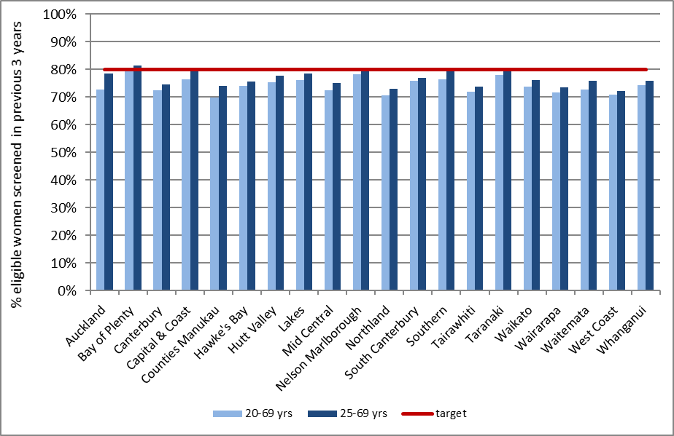
Note: Coverage calculated using population projection for 31 December 2016 based on 2013 Census data.
Target 80%, hysterectomy adjusted. See also Table 22.

Figure 2 - Three-year coverage (women screened in the three years prior to 31 December 2016, as a proportion of hysterectomy-adjusted female population), by ethnicity
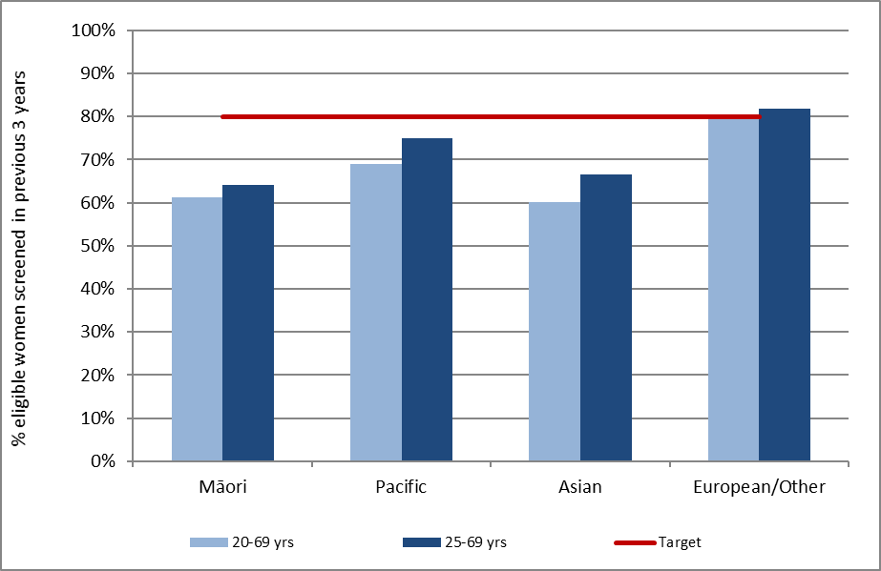
Note: Coverage calculated using population projection for 31 December 2016 based on 2013 Census data. Target: 80% for ages 25-69 years, hysterectomy adjusted. See also Table 23.
Figure 3 - Three-year coverage by five-year age group (women 20-69 years screened in the three years prior to 31 December 2016, as a proportion of hysterectomy-adjusted female population)
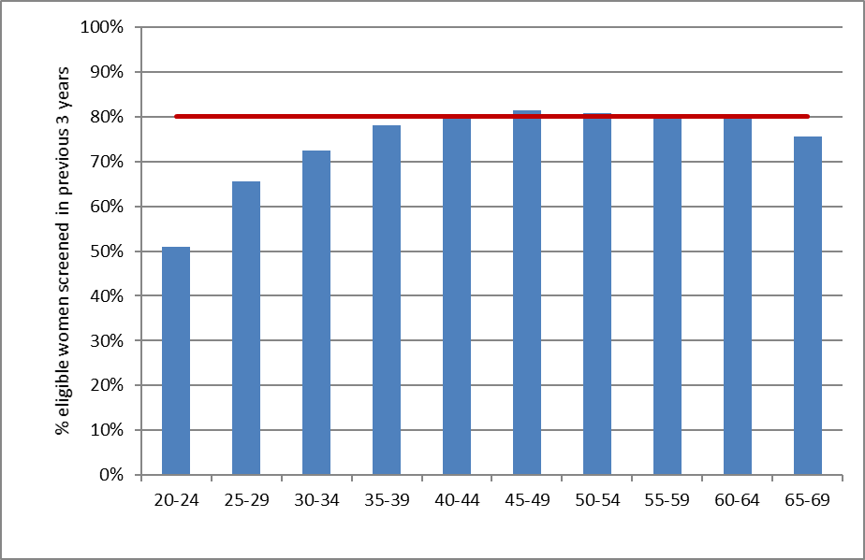
Note: Coverage calculated using population projection for 31 December 2016 based on 2013 Census data.
Target: 80% for ages 25-69 years, hysterectomy adjusted. See also Table 24.

Figure 4 - Three-year coverage in Māori women (women 25-69 years screened in the three years prior to 31 December 2016, as a proportion of hysterectomy-adjusted female population), by DHB
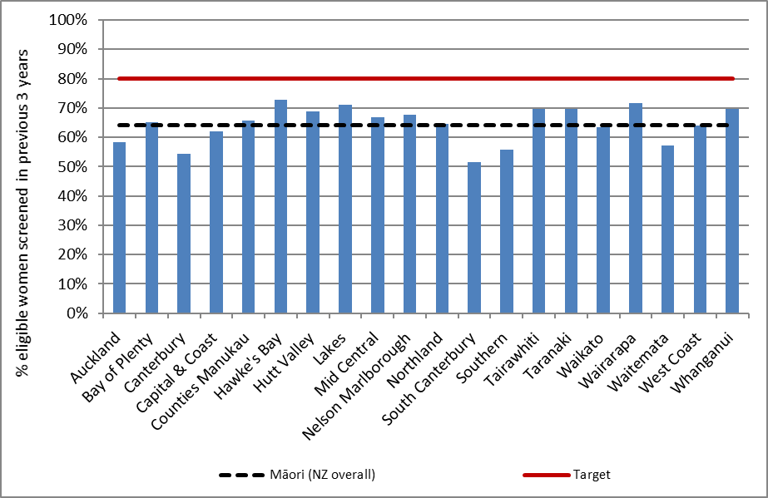
Note: Coverage calculated using population projection for 31 December 2016 based on 2013 Census data.
Target 80%, hysterectomy adjusted.
Figure 5 - Three-year coverage in Pacific women (women 25-69 years screened in the three years prior to 31 December 2016, as a proportion of hysterectomy-adjusted female population), by DHB
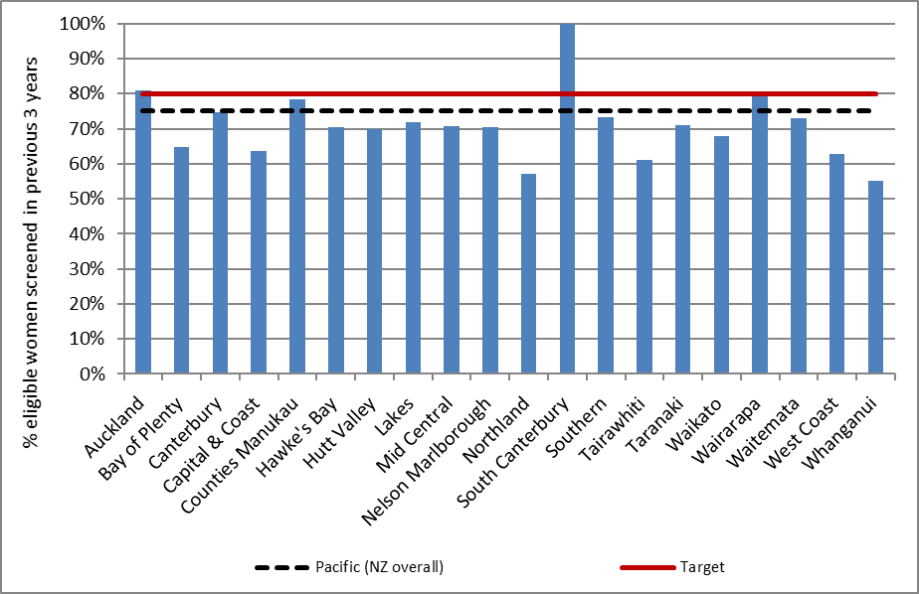
Note: Coverage calculated using population projection for 31 December 2016 based on 2013 Census data.
Target 80%, hysterectomy adjusted.

Figure 6 - Three-year coverage in Asian women (women 25-69 years screened in the three years prior to 31 December 2016, as a proportion of hysterectomy-adjusted female population), by DHB
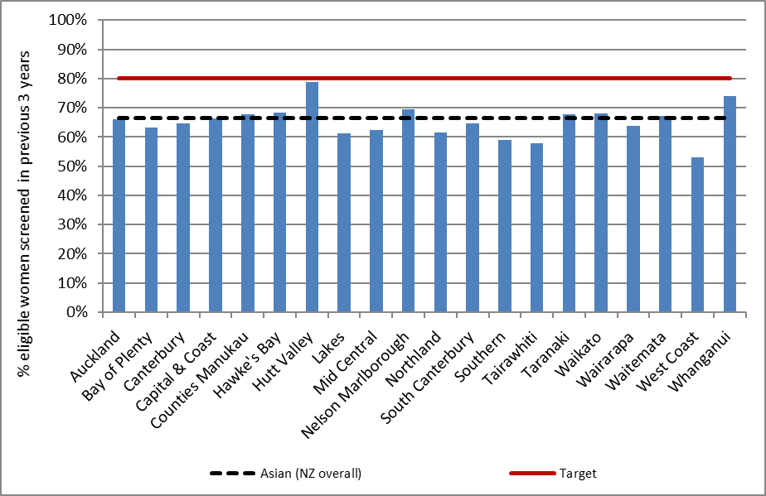
Note: Coverage calculated using population projection for 31 December 2016 based on 2013 Census data.
Target 80%, hysterectomy adjusted.

Figure 7 - Three-year coverage in European/ Other women (women 25-69 years screened in the three years prior to 31 December 2016, as a proportion of hysterectomy-adjusted female population), by DHB
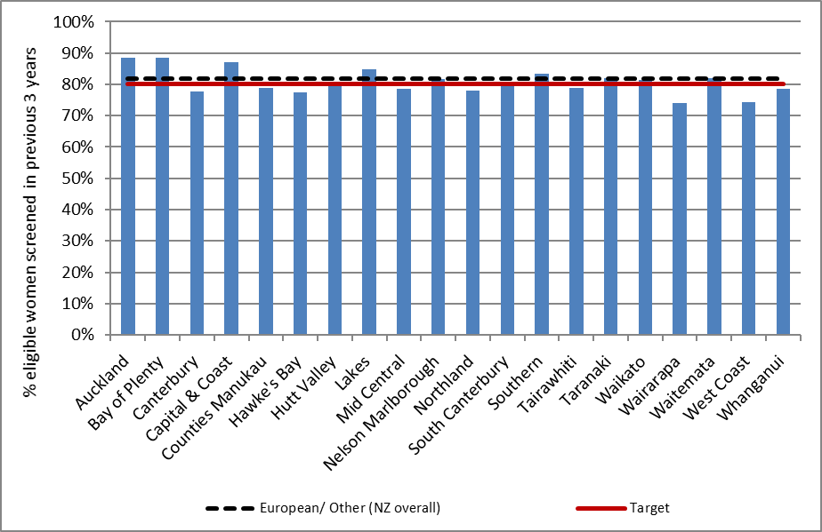
Note: Coverage calculated using population projection for 31 December 2016 based on 2013 Census data.
Target 80%, hysterectomy adjusted.

Figure 8 - Five-year coverage by DHB (women screened in the five years prior to 31 December 2016, as a proportion of hysterectomy-adjusted female population)
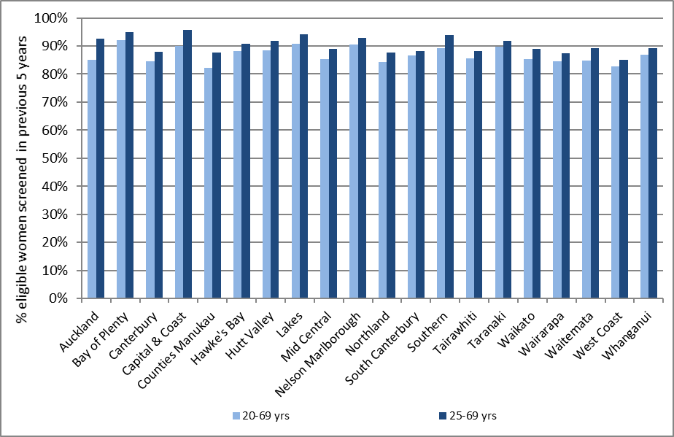
Note: Coverage calculated using population projection for 31 December 2016 based on 2013 Census data.
See also Table 25.

Figure 9 - Five-year coverage by five-year age-group (women screened in the five years prior to 31 December 2016, as proportion of hysterectomy-adjusted female population)
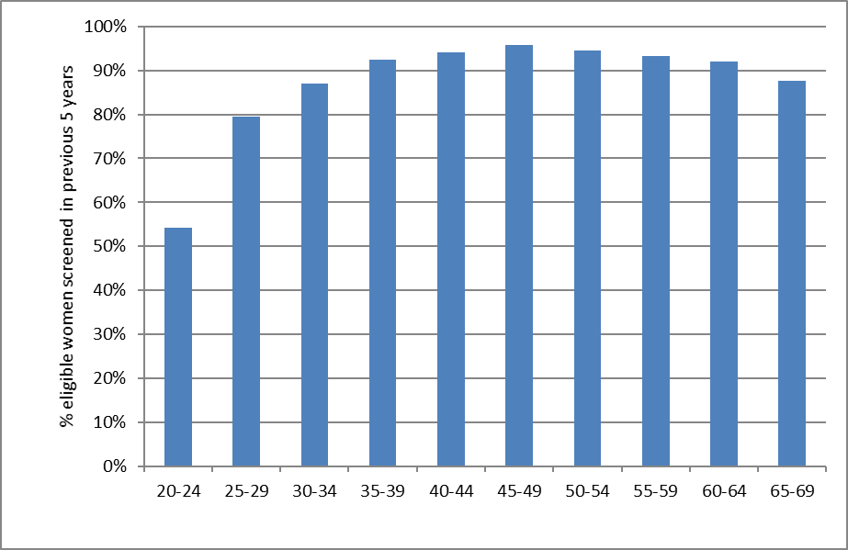
Note: Coverage calculated using population projection for 31 December 2016 based on 2013 Census data. See also Table 27.

Figure 10 - Five-year coverage by ethnicity (women screened in the five years prior to 31 December 2016, as a proportion of hysterectomy-adjusted female population)
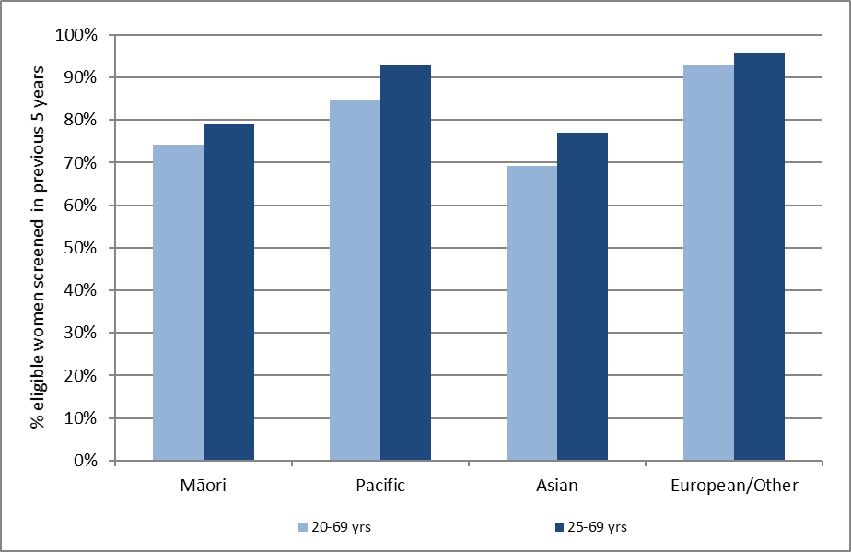
Note: Coverage calculated using population projection for 31 December 2016 based on 2013 Census data.
See also Table 26.

Figure 11 - Five-year coverage in Māori women (women 25-69 years screened in the five years prior to 31 December 2016, as a proportion of hysterectomy-adjusted female population), by DHB
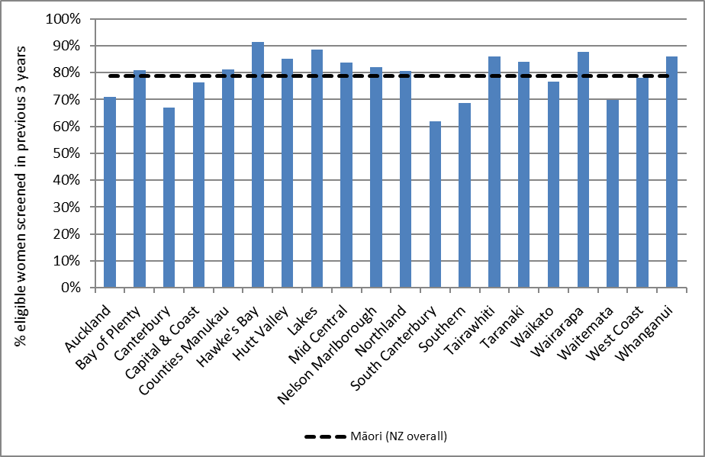
Note: Coverage calculated using population projection for 31 December 2016 based on 2013 Census data.

Figure 12 - Five-year coverage in Pacific women (women 25-69 years screened in the five years prior to 31 December 2016, as a proportion of hysterectomy-adjusted female population), by DHB
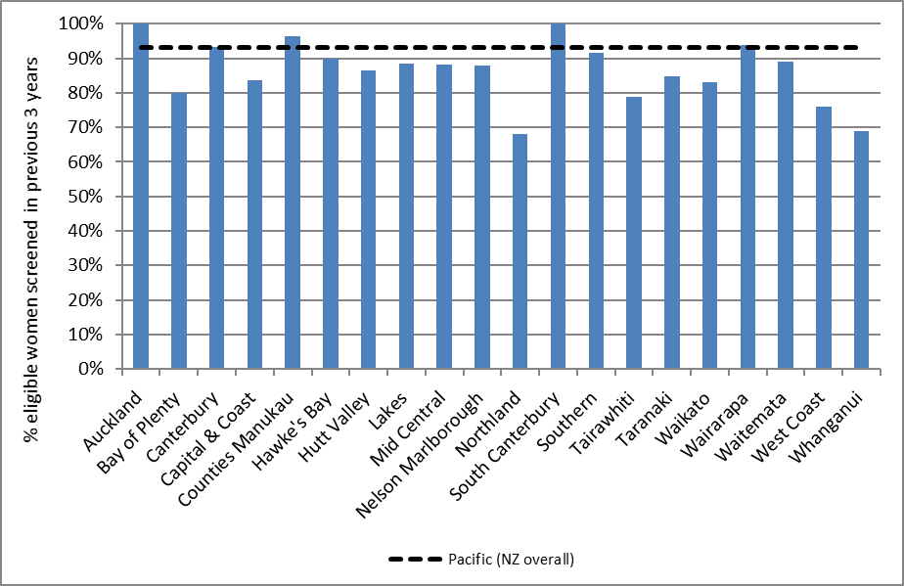
Note: Coverage calculated using population projection for 31 December 2016 based on 2013 Census data.

Figure 13 - Five-year coverage in Asian women (women 25-69 years screened in the five years prior to 31 December 2016, as a proportion of hysterectomy-adjusted female population), by DHB
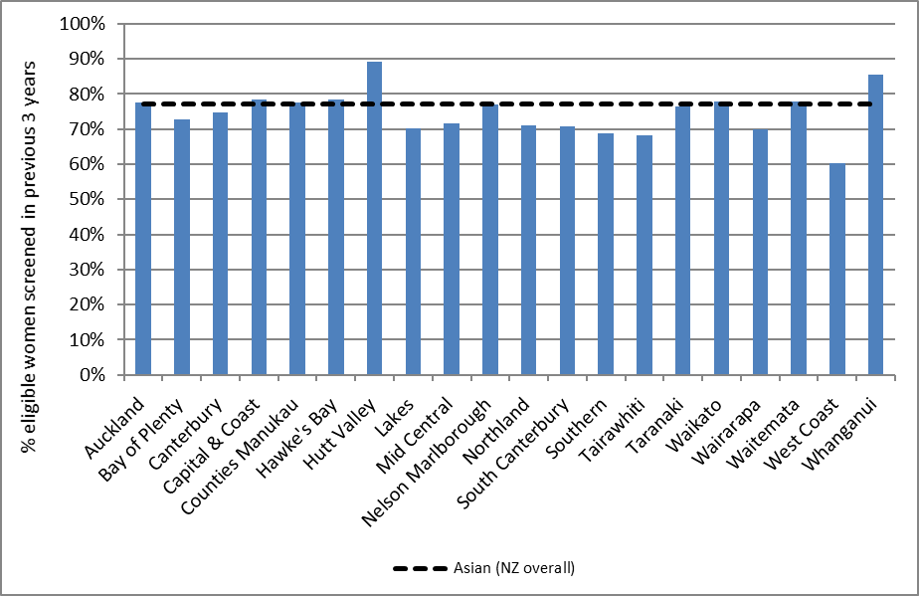
Note: Coverage calculated using population projection for 31 December 2016 based on 2013 Census data.

Figure 14 - Five-year coverage in European/ Other women (women 25-69 years screened in the five years prior to 31 December 2016, as a proportion of hysterectomy-adjusted female population), by DHB
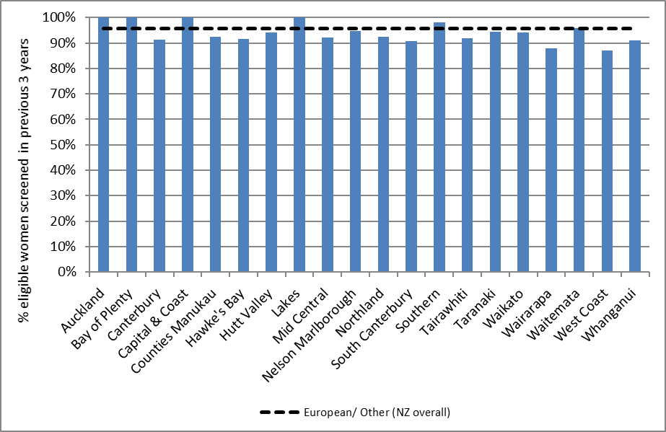
Note: Coverage calculated using population projection for 31 December 2016 based on 2013 Census data.

Figure 15 - Number of women screened who were aged less than 20 years at the time of their cervical sample in the three years to 31 December 2016, by DHB
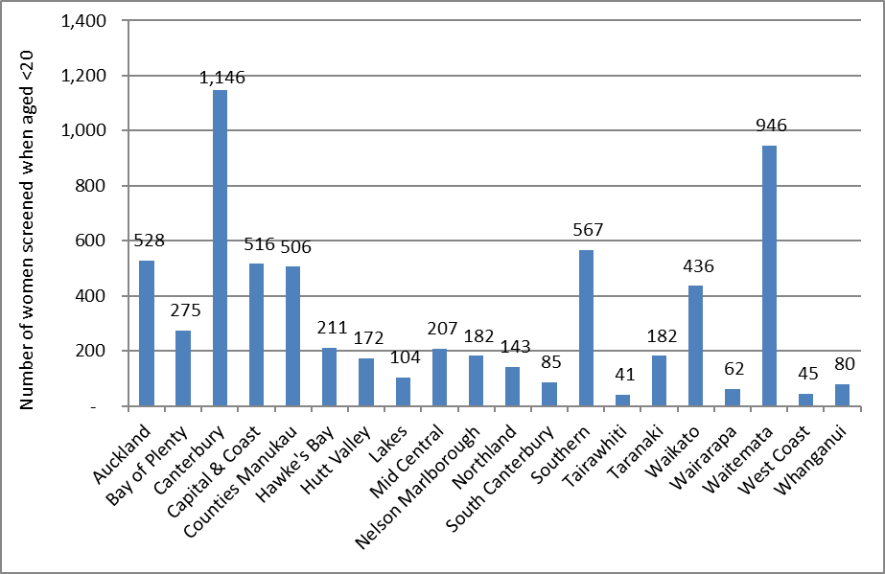
See also Table 29.

Figure 16 - Trends in three-year coverage by DHB (women aged 25-69 years screened in the previous three years, as a proportion of hysterectomy-adjusted female population)
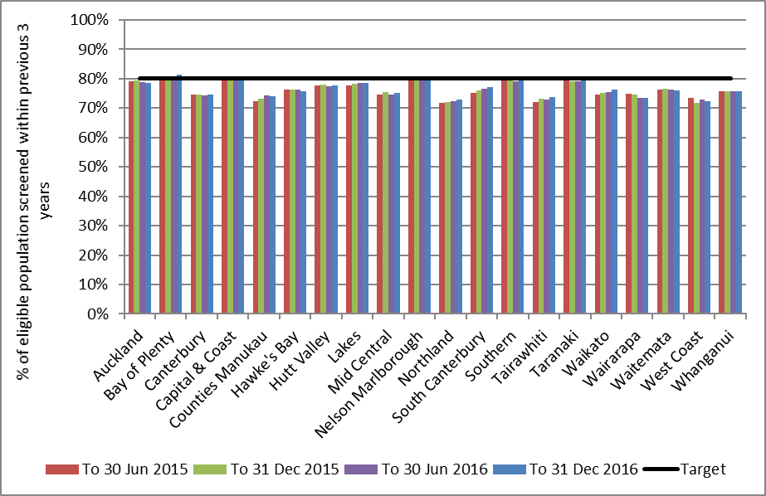
Note: Coverage calculated using population projection at the date shown based on 2013 Census data.
Target 80%. See also Table 33.

Figure 17 - Trends in three-year coverage by age (women screened in the previous three years, as a proportion of hysterectomy-adjusted female population)
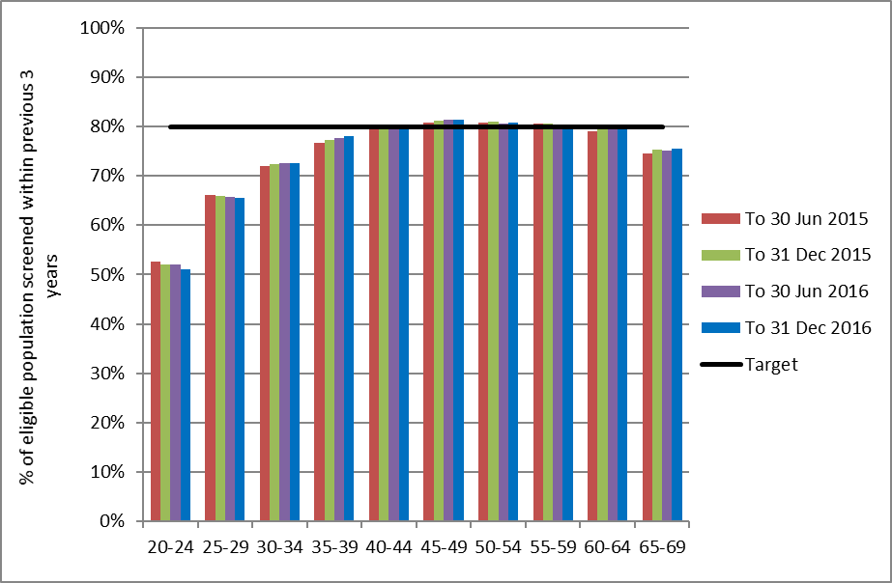
Note: Coverage calculated using population projection at the date shown based on 2013 Census data.
Target 80%. See also Table 34.

Figure 18 - Trends in three-year coverage by ethnicity (women aged 25-69 years screened in the previous three years, as a proportion of hysterectomy-adjusted female population)
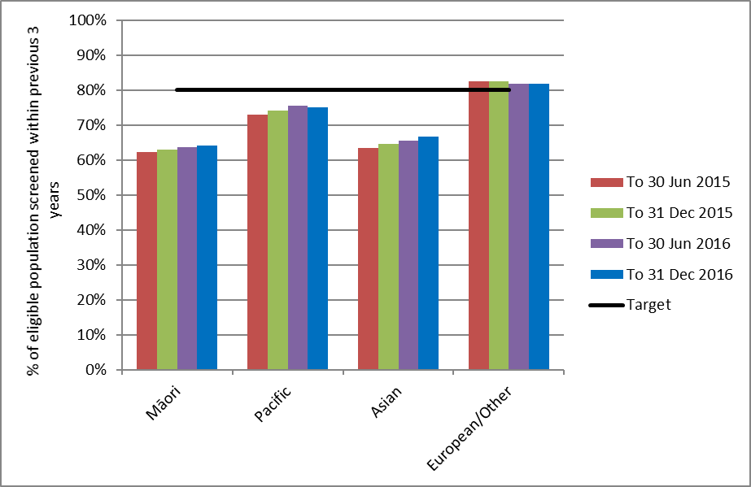
Note: Coverage calculated using population projection at the date shown based on 2013 Census data.
Target 80%. See also Table 35.

Figure 19 - Trends in the number of women screened in the preceding three years who were aged less than 20 years at the time of their cervical sample, by DHB
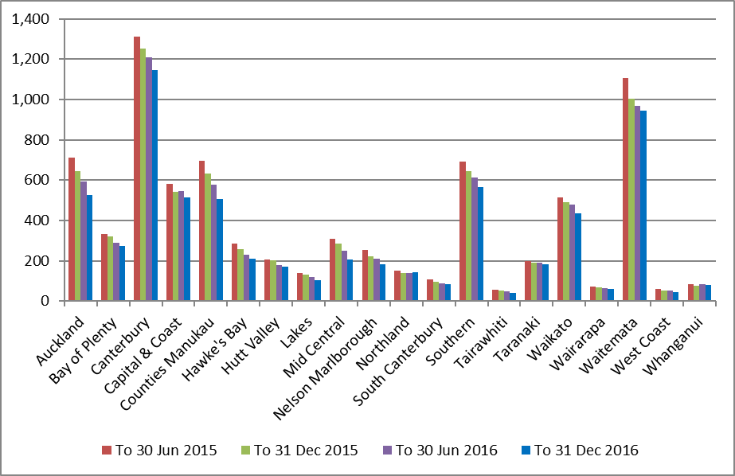
Note: Coverage calculated using population projection at the date shown based on 2013 Census data.
Target 80%. See also Table 29.

Figure 20 - Trends in the percent of women aged less than 20 years at the time of their cervical sample who were aged 18 or 19 years, by DHB
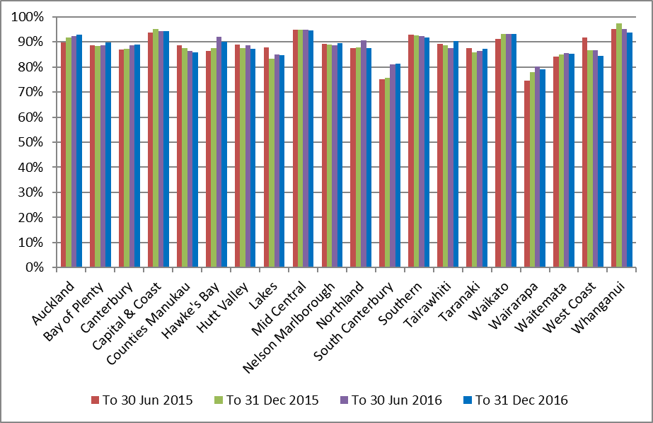
Note: Coverage calculated using population projection at the date shown based on 2013 Census data.
Target 80%. See also Table 31.

Indicator 1.2 – Regularity of screening

Definition | This indicator reports on the timeliness of attendance, both for women recommended to return at the routine time of three years, or at an earlier interval of 12 months (for example following a recent abnormality).  For women recommended to return at a three-year interval, on-time screening is defined as attending between 30-42 months of their previous test (that is, within +/- six months of their due date). Early and late screening are therefore respectively defined as women who attend either within 30 months (<2.5 years), or more than 42 months (>3.5 years) of their previous test. The timing of early re-screening in this context matches the definition used within Indicator 4 (the differences between early re-screening in this Indicator and in Indicator 4 are described in the Comments section).  For women recommended to return at a 12-month interval, on-time screening is defined as attending between 9-12 months of their previous test (that is, within +/- three months of their due date). Early and late screening are therefore respectively defined as women who attend either within 9 months, or more than 15 months of their previous test.  The measure is calculated by constructing a reference cohort consisting of satisfactory cytology samples (“reference samples”) collected from women aged 20-69 years in the five years prior to the end of the current monitoring period (31 December 2016).  The most recent satisfactory cytology sample from these women prior to the reference sample was identified on the NCSP Register. The recommendation code of these prior samples was used to classify the reference samples as either early, on-time, or late. Only reference samples where the prior sample indicated an expected screening interval or either three years (recommendation code R1 or B2B0) or 12 months (recommendation code R6, R7, R8, B2B7, B2B7A, or B2B7H) were included. Reference samples where no prior satisfactory cytology sample was identified on the register with a collection date of 1 January 2000 or later, or where the prior sample had any other recommendation code, were excluded from the analysis. These women were either under specialist management, had an expected screening interval of less than 12 months, or there was insufficient information to infer an expected screening interval. Reference samples collected at colposcopy were also excluded as these may have arisen in relation to symptoms or other clinical indications.  Results are presented based on the quarter of the year the reference cytology sample was collected. Therefore, a result for the first quarter of 2015 reports the percentage of women who attended for screening within that quarter who were attending either early, on-time or late in relation to the recommendation associated with their prior cytology test (i.e. the total of these three categories in each quarter sums to 100%).  For this measure age relates to the woman’s age on the date of her reference cytology sample (i.e. the attendance which is classified as either early, on-time or late).
Target | Not yet defined, however aim to maximise on-time attendance.
Current Situation | In total over the period 2012 to 2016, satisfactory cytology samples were collected from 1,197,972 women aged 20-69 years (based on their age at the time of the sample). Of these, 1,069,582 women met all inclusion criteria and 1,714,183 cytology samples collected from these women are included as reference cytology samples for analysis in this report. This section will focus on the results for the 12 months prior to the end of the current monitoring period (31 December 2016), while trends over the past five years are described in the Trends section.  Routine screening (3-year recall)  Among women attending for screening in 2016 following a 3-year recall recommendation, 62.2% were attending on-time; 14.9% more than six months early; and 22.9% more than six months late (Figure 21).  By ethnicity  The proportion of women re-attending in 2016 who were on-time was highest for Asian women (63.8%), and lowest in Māori women (52.9%). The proportion of women returning for routine screening who were re-attending early was highest for Asian women (15.8%) and lowest for Pacific women (10.8%). The proportion of women screened who were re-attending later than recommended was highest for Pacific women (34.5%), and lowest for Asian women (20.5%) (Figure 22). Details of the number of re-attendances in each category are shown in Table 36.  By age  The proportion of women attending for screening in 2016 who were re-attending on-time was highest for women aged 60-69 years (73.4%) and lowest for women aged 20-29 years (52.6%). The opposite pattern was observed for the proportion of women who were re-attending early, which ranged from 9.9% (60-69 years) to 24.8% (20-29 years). The proportion of women screened who were re-attending later than recommended was highest for women aged 30-39 years (29.2%) and lowest for women aged 60-69 years (16.7%) (Figure 23). Details of the number of re-attendances in each category are shown in Table 37.  12-month re-screening  Among women attending for screening in 2016 following a 12-month repeat recommendation, 42.1% were attending on-time; 2.9% more than three months early; and 55.0% more than three months late (Figure 24).  By ethnicity  The proportion of women re-attending in 2016 who were on-time was highest for European/ Other women (44.8%), and lowest in Pacific women (31.8%). The proportion of women returning for 12-month repeat screening who were re-attending early was very small in all groups, but was highest for European/ Other women (3.2%) and lowest for Pacific women (1.8%). The proportion of women screened who were re-attending later than recommended was relatively high in all groups, but was highest for Pacific women (66.4%), and lowest for European/ Other women (52.0%) (Figure 25). Details of the number of re-attendances in each category are shown in Table 38.  By age  The proportion of women attending for screening in 2016 following a 12-month repeat recommendation who were re-attending on-time was highest for women aged 60-69 years (49.9%) and lowest for women aged 30-39 years (36.6%). Very few women were re-attending early; this ranged from 2.2% (50-59 years) to 3.6% (20-29 years). The proportion of women screened who were re-attending later than recommended was highest for women aged 30-39 years (60.6%) and lowest for women aged 60-69 years (47.8%) (Figure 26). Details of the number of re-attendances in each category are shown in Table 39.
Trends | Routine screening (3-year recall)  Over the period 2012 to 2016, the proportion of women who were screened on-time increased from 57.5% to 62.2%. This predominantly reflected a reduction in the proportion of women who were being screened early (which fell from 21.7% to 14.9%). There was comparatively little variation in the proportion of women who were returning late (ranged from 21.1% to 22.9%) (Figure 27).  By ethnicity  Over the period 2012 to 2016, the proportion of women who were screened on-time increased in all ethnic groups, with the increase being largest in Asian followed by European/ Other women (increase of 7.8% and 4.7%, respectively). In these groups, this predominantly reflected a reduction in the proportion of women who were being screened early, as this attendance fell. There was comparatively little variation in the proportion of women who were returning late in Asian and European/ Other women, however Māori and Pacific women had larger increases in women being screened late which is reflected in the lower on-time screening prevalence increases. The proportion returning late was consistently higher in Māori and Pacific women over time than in Asian and European/ Other women (Figure 28).  By age  Over the period 2012 to 2016, the proportion of women who were screened on-time increased in all age groups, with the increase being largest in women aged 20-29 years (an increase of 7.0%). For women in the five-year age groups between 30 and 69 years the increases in on-time screening was fairly similar ranging from 3.5% to 4.1% (Figure 29). In all groups, there was a substantial reduction in the proportion of women who were being screened early, however there was also a small increase in the proportion of women who were returning late. The proportion of women returning late was consistently highest for women aged 30-39 years, and consistently lowest for women aged 60-69 years over time.  12-month re-screening  Over the period 2012 to 2016, the proportion of women who were re-attending on-time for 12-month follow-up decreased from 46.2% to 42.1%, as did the proportion who were re-attending more than three months early (decreased from 3.7% to 2.9%). There was a corresponding increase in the proportion of women who were re-attending more than 15 months after a recommendation to return in 12 months, which increased from 50.1% to 55.0%. This meant that in 2016, the majority of women who were re-attending after a recommendation to return in 12 months were re-attending more than three months later than recommended (Figure 30).  By ethnicity  Over the period 2012 to 2016, the proportion of women who were re-attending on-time for 12-month follow-up decreased somewhat in all ethnic groups, as did the proportion who were re-attending early. The proportion of women who were re-attending at more than 15 months after a recommendation to return at 12 months increased in all ethnic groups, however the increase was much larger in Māori women (6.1%) than in Pacific, Asian and European/ Other women (4.3%, 3.5% and 4.4% increase respectively). The proportion of women returning less than nine months after a recommendation to return in 12 months was very small and similar in all groups, however the proportion returning on-time was consistently higher in Asian and European/ Other women than in Māori and Pacific women. Conversely, the proportion who were re-attending more than 15 months after a recommendation to return in 12 months was consistently higher in Māori and Pacific women than in Asian and European/ Other women. By 2016, in all ethnic groups, the majority of women who were re-attending after a recommendation to return in 12 months were re-attending more than three months later than recommended (Figure 31).  By age  Over the period 2012 to 2016, the proportion of women who were re-attending on-time for 12-month follow-up had a notable decrease in all age groups other than women aged 20-29 years. The proportion of women who were re-attending early decreased in all age groups. The proportion of women who were re-attending at more than 15 months after a recommendation to return at 12 months increased in all age groups, but the increase was smallest in women aged 20-29 years (2.2% increase over 2012 to 2016), whereas it ranged from 4.1% to 8.9% in women in older age groups. The proportion of women returning less than nine months after a recommendation to return in 12 months was very small and broadly similar in all age groups, however the proportion returning on-time was consistently highest in women aged 60-69 years and lowest in women age 30-39 years over time. Conversely, the proportion who were re-attending more than 15 months after a recommendation to return in 12 months was consistently highest in women aged 30-39 years and lowest in women 60-69 years. By 2016, in all age groups other than those aged 60-69 years, the majority of women who were re-attending after a recommendation to return in 12 months were re-attending more than three months later than recommended (Figure 32).
Comments | This indicator is reported on every second reporting period to allow for the full year to be examined. It has been included in the biannual monitoring report since Report 44 (July – December 2015). Earlier versions of regularity of screening were included in the NCSP Annual Reports for 2012 and 2013, however this indicator has been moved to the biannual reports for easier comparison with other screening-related indicators. The NCSP Annual Reports now contain cancer (incidence and mortality) data only, and all screening-related indicators are in biannual reports.  This indicator reports on regularity of screening among women who have attended for screening; however it does not capture women who have not attended for screening at all. Indicator 1.1, Coverage, is able to provide some insight into the overall proportion of women who have not attended (for example, those not screened in the previous five years).  Indicators 1.2 and 4 both examine women recommended to return at the routine interval of three years who return early. The difference between these indicators are the women observed (cohorts) and how proportions are calculated. Indicator 4 identifies women with a cytology test taken in a specific earlier time period (between 1 February – 31 March 2014 in the current report) with a recommendation that the next test should be taken at the usual screening interval of three years (“routine screening”). Women with a subsequent cytology test taken within 30 months (i.e. at least six months early) are then identified – that is, this is a prospective investigation of all women within an historical cohort, including those who have re-attended, and those who have not. As described above, Indicator 1.2 identifies cytology tests within specific time periods (e.g. October - December 2016), then identifies the recommendation associated with the immediately preceding cytology test in each woman (whenever that occurred), and assesses whether the woman was returning early, on-time, or late. The proportion reported is women attending in the given time period who are attending for routine screening at least six months early, as a proportion of all women re-attending for routine screening in the same time period. That is, Indicator 1.2 is a proportion of women attending in the relevant time period (and does not take into account women not attending for screening), and it addresses the question – “What proportion of women who are re-attending for routine screening in a particular time period are returning at least six months early?”. Indicator 4 takes into account all women who were given the recommendation to return at the routine interval, regardless of whether they return or not. It addresses the question – “What proportion of women recommended to return in three years for routine screening return at least six months early?”

Figure 21 - Timeliness of re-attendance in 2016 following a routine (3-year) repeat screening recommendation
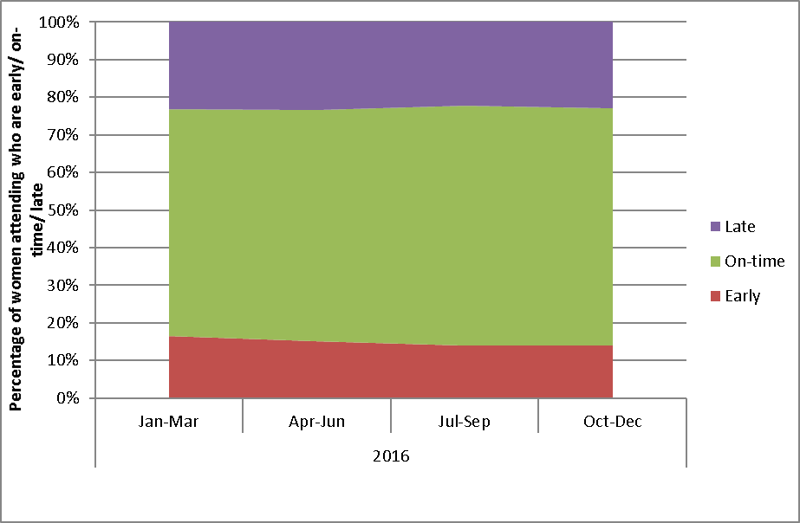

Figure 22 - Timeliness of re-attendance in 2016 following a routine (3-year) repeat screening recommendation, by ethnicity
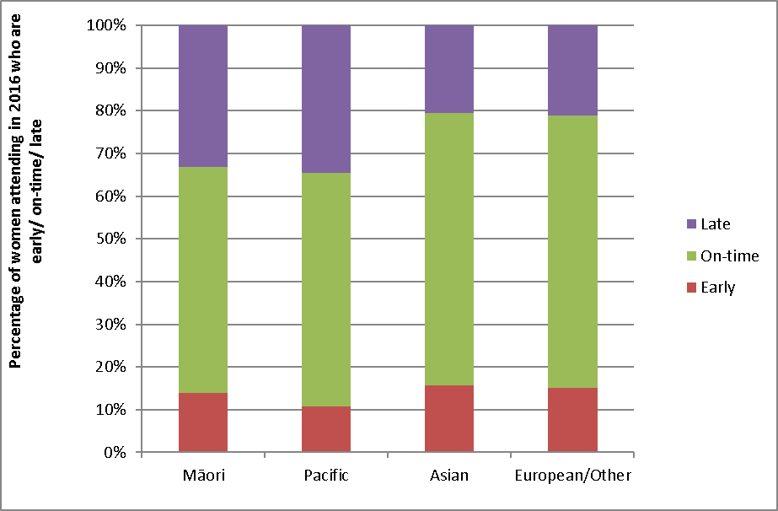

Figure 23 - Timeliness of re-attendance in 2016 following a routine (3-year) repeat screening recommendation, by age
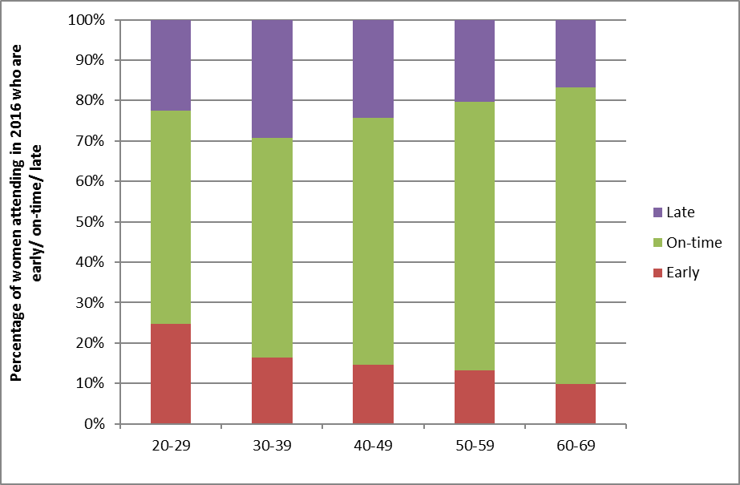

Figure 24 - Timeliness of re-attendance in 2016 following a 12-month repeat screening recommendation
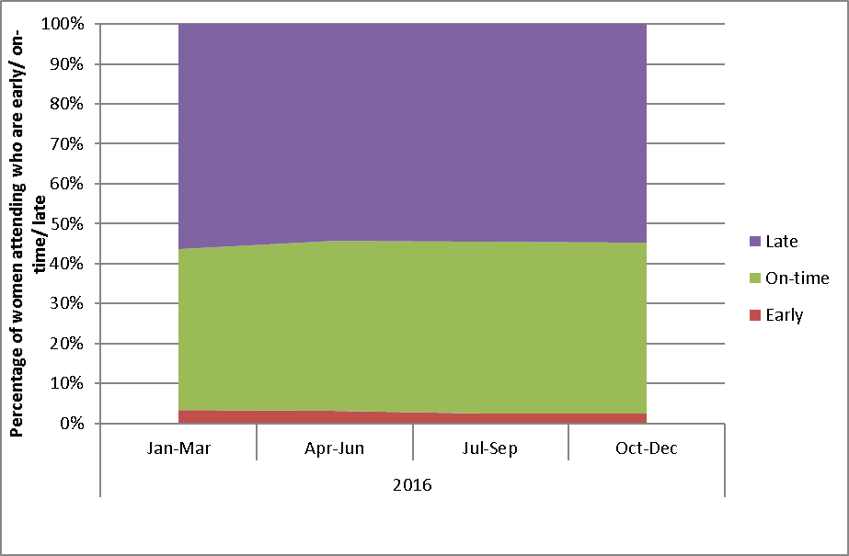

Figure 25 - Timeliness of re-attendance in 2016 following a 12-month repeat screening recommendation, by ethnicity
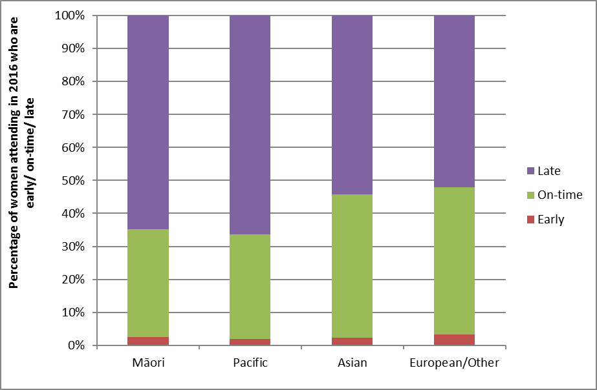

Figure 26 - Timeliness of re-attendance in 2016 following a 12-month repeat screening recommendation, by age
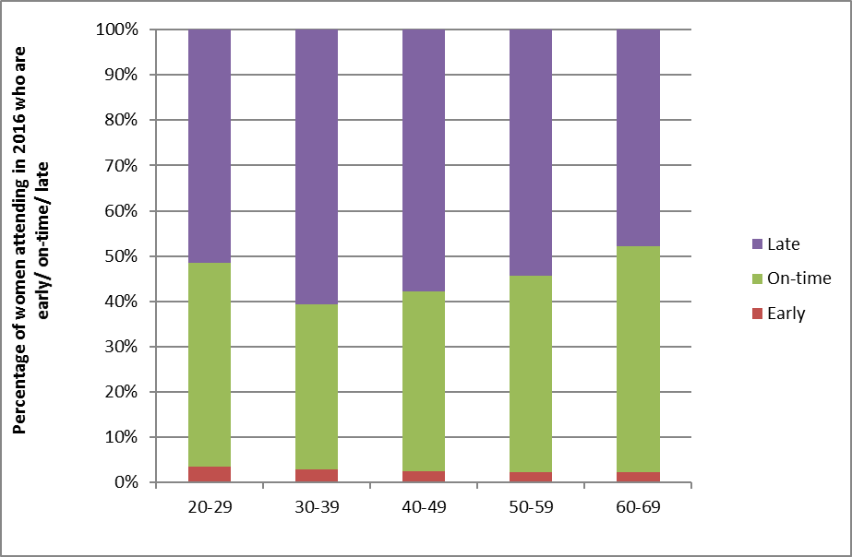

Figure 27 - Trends in the timeliness of re-attendance following a routine (3-year) repeat screening recommendation
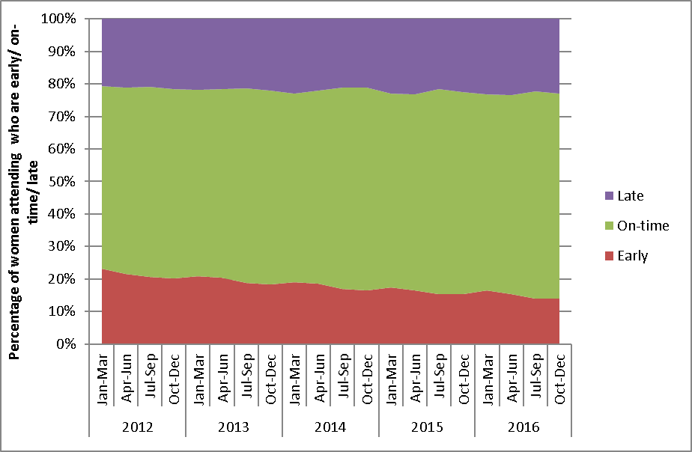

Figure 28 - Timeliness of re-attendance following a routine (3-year) repeat screening recommendation (percent), 2012-2016, by ethnicity
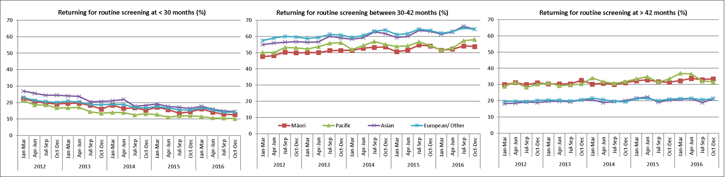

Figure 29 - Timeliness of re-attendance following a routine (3-year) repeat screening recommendation (percent), 2012-2016, by age
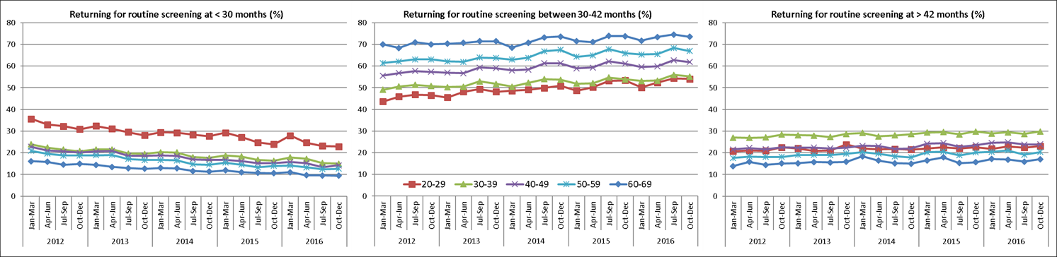

Figure 30 - Trends in the timeliness of re-attendance following a 12-month repeat screening recommendation
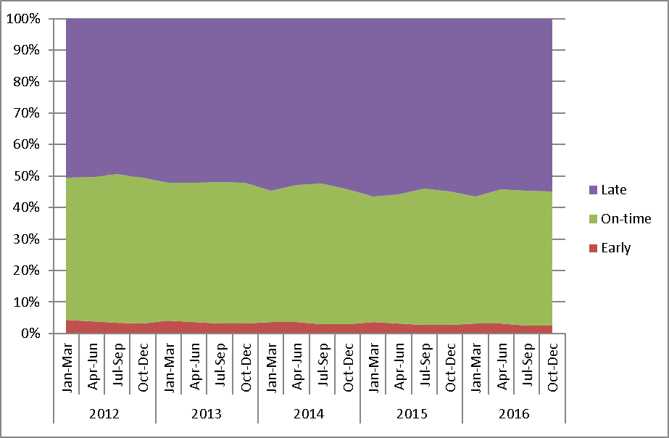
Figure 31 - Timeliness of re-attendance following a 12-month repeat screening recommendation (percent), 2012-2016, by ethnicity
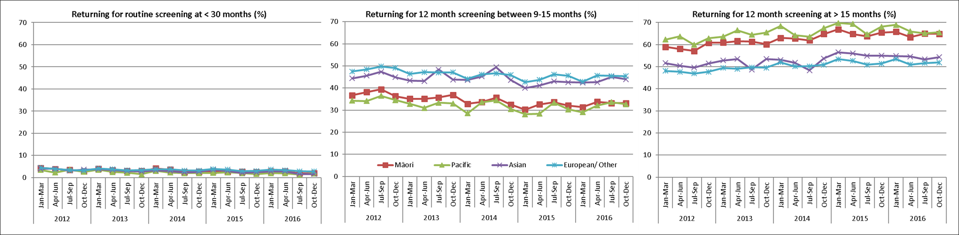

Figure 32 - Timeliness of re-attendance following a 12-month repeat screening recommendation (percent), 2012-2016, by age
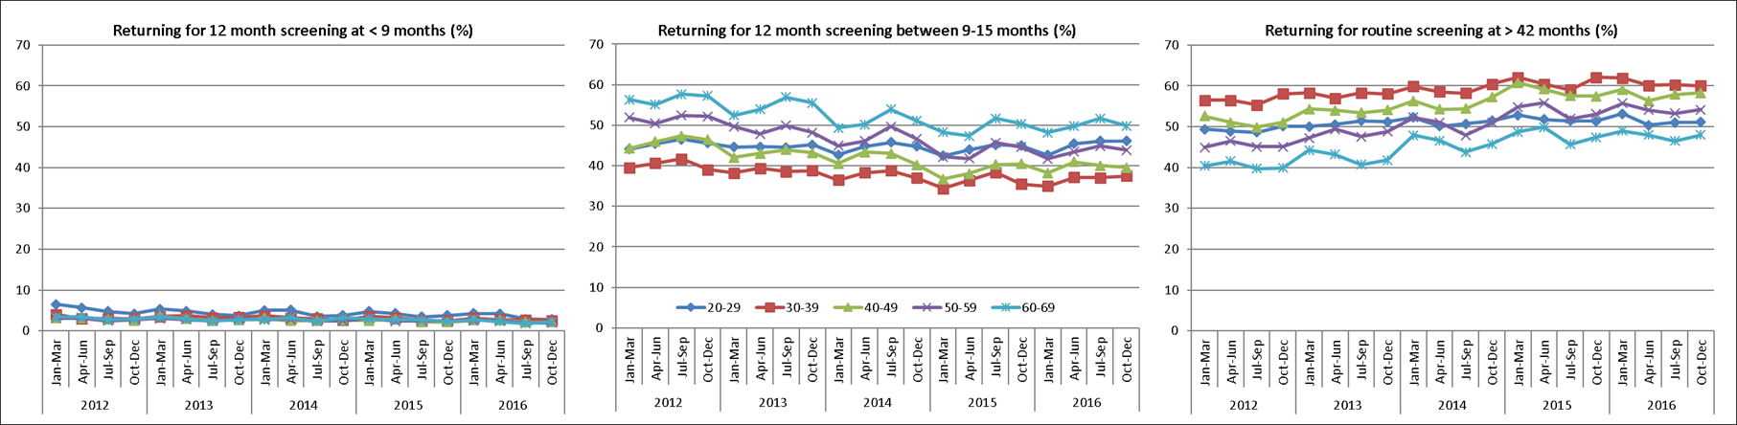

Indicator 2 – First screening events
Definition | Women with no cervical (cytology, histology, or HPV) samples taken prior to the current monitoring period, who have had a cervical sample taken during the monitoring period (first event).  A woman’s age is defined as her age at the end of the current monitoring period (i.e. the women’s age at 31 December 2016).  This indicator is presented as the number of women by age, DHB and ethnicity. It is also presented as a proportion of all women in the eligible population (defined as the hysterectomy-adjusted population, aged 20-69 years), and as a proportion of all women with a cervical sample taken during this monitoring period (screening event), by DHB.
Target | There are no targets for first screening events
Current Situation | There were 22,616 women aged 20-69 years at the end of the period who had their first screening event in the period 1 July - 31 December 2016. This constituted 11.0% of the 205,874 women aged 20-69 years with a cervical sample taken in the period (screening event), and 1.7% of the eligible population. The median age (at the end of the monitoring period) of women with a first event recorded was 26 years.  The age group with the highest number of first screening events was women aged 20-24. 10,285 women aged 20-24 had their first screening event recorded on the register during this monitoring period, accounting for 45.5% of all women aged 20-69 years with first screening events (Figure 33, Table 40). First screening events then tended to decrease with increasing age. Women aged 20-24 years also had the highest proportion of women screened in their age group who were being screened for the first time (44.0%) (Figure 34), and the highest proportion of the eligible population at that age with a first screening event recorded in the current monitoring period (6.4%) (Figure 35).  The DHBs with the highest number of women aged 20-69 years with first screening events were Auckland (3,475) and Waitemata (3,106). The DHBs where women with first screening events, as a proportion of all women with screening events, were the highest in Auckland (14.3%) followed by Counties Manukau (13.2%) and Capital & Coast (12.7%). The DHBs where this proportion was lowest were Wairarapa (6.8%), Hawke's Bay and Nelson Marlborough (both with 7.3%) (Figure 36, Table 41).  The ethnic group with the highest number of women with first screening events was European/ Other (12,264) (Table 42). The group with the highest proportion of their eligible population being screened for the first time was Asian (3.1%), and the lowest was Maori (1.2%) (Table 42). The proportion of women screened who were being screened for the first time was highest for Asian (23.2%) (Figure 37, Table 42). This proportion is likely to be related to the median age of women with a first screening event, which for Asian women is comparatively high (31 years, compared with 22 years for Māori women, 25 years for Pacific women, and 23 years for European/ Other women) (Table 43).
Trends | The number of women with a first screening event recorded on the NCSP Register has decreased from 24,346 women in the previous period to 22,616 in the current period. Across the overall eligible population aged 20-69 years, the proportion of women with screening events that are their first screening event being recorded on the NCSP Register is slightly lower in this period (1.7%) compared to the previous period (1.8%).  Patterns by age, DHB, and ethnicity are broadly similar to those seen in the previous report. Trends by age show a slight drop in the number of first screens over time in most five-year age groups, but a more noteable drop in women aged 20-24 years. Small declines were seen in all ethnic groups. As was the case in previous reports, the median age of a first screening event was older for Asian women than for Māori, Pacific and European/ Other women, and Asian women with a first screening events constituted a larger proportion of all women with a screening event.  Trends over the two years ending 31 December 2016 are shown in Figure 38 (by age), Figure 39 (by DHB), and Figure 40 (by ethnicity).
Comments | This indicator can only measure the number of women with their first screening event in New Zealand, recorded on the register since its introduction (1990). It does not capture screening events which occurred outside New Zealand, or among women who are not enrolled on the NCSP Register.  Some differences in counts and proportion of women with first screens among screened women between DHBs are to be expected due to differences in population size, immigration and age structure. Proportions have been provided to partially account for this, however they should be interpreted with caution. For example, a relatively low number of women with first screens as a proportion of all women screened could be due to either a lower number of women with first events, or a higher number of women with screening events. For example, the DHB with the highest coverage, Bay of Plenty, does not have a particularly high proportion of women with first events. If coverage remains high, then this proportion will inevitably decrease, as fewer women are available to be screened for the first time. Conversely, a relatively high number of women with first screens as a proportion of all women screened could be due to either a higher number of women with first events (due to increasing coverage), or a lower number of women with screening events (for example due to less frequent screening among women who have been screened at least once since the inception of the NCSP Register).

Figure 33 - Women with first screening events during the monitoring period, by five-year age group (women aged 20-69 years at 31 December 2016)
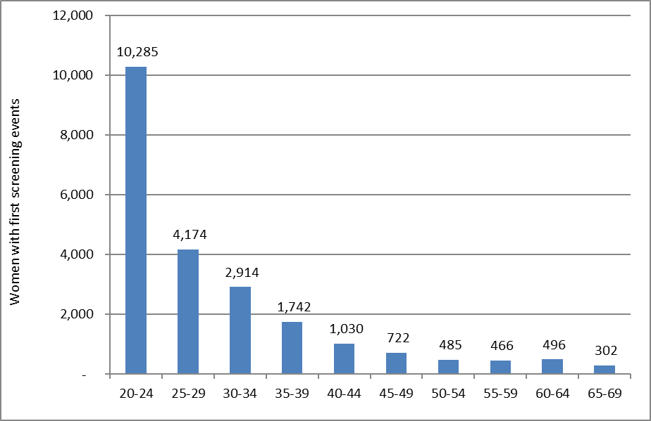

Figure 34 - Women with first screening events as a proportion of all women screened in that age group during the monitoring period, by five-year age group (women aged 20-69 years at 31 December 2016)
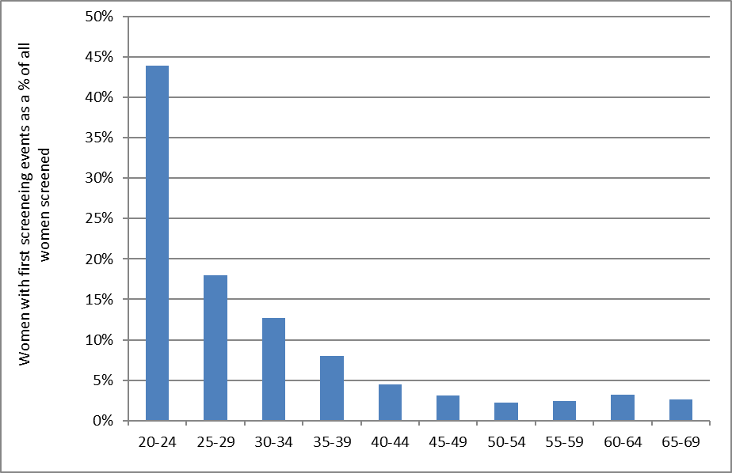

Figure 35 - Proportion of population* in that age group with their first screening event during the monitoring period (women aged 20-69 years at 31 December 2016)
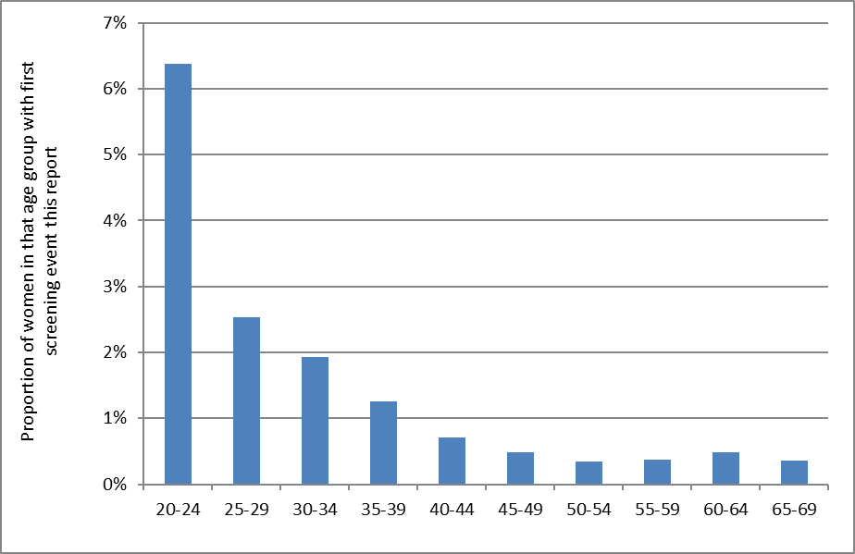
*Hysterectomy adjusted, 2013 Census data projected to 31 December 2016

Figure 36 - Women with first screening events as a proportion of all women screened during the monitoring period, by DHB (women aged 20-69 years at 31 December 2016)
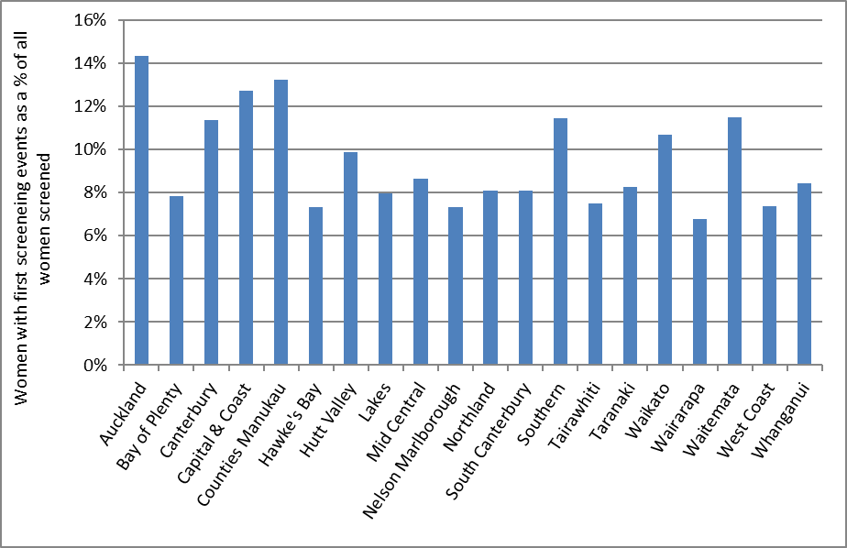

Figure 37 - Women with first screening events as a proportion of all women screened during the monitoring period, by ethnicity (women aged 20-69 years at 31 December 2016)
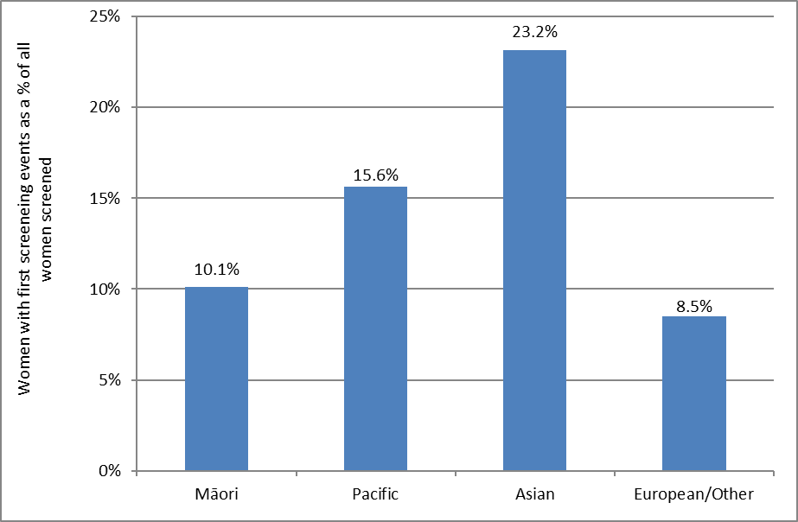

Figure 38 - Trends in the number of women with a first screening event, by age
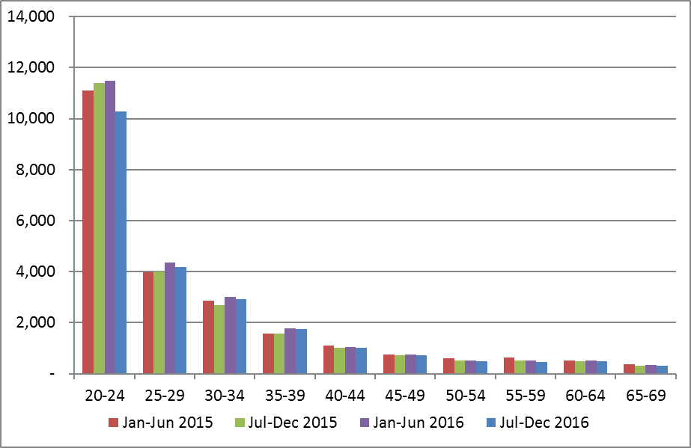

Figure 39 - Trends in the number of women with a first screening event, by DHB
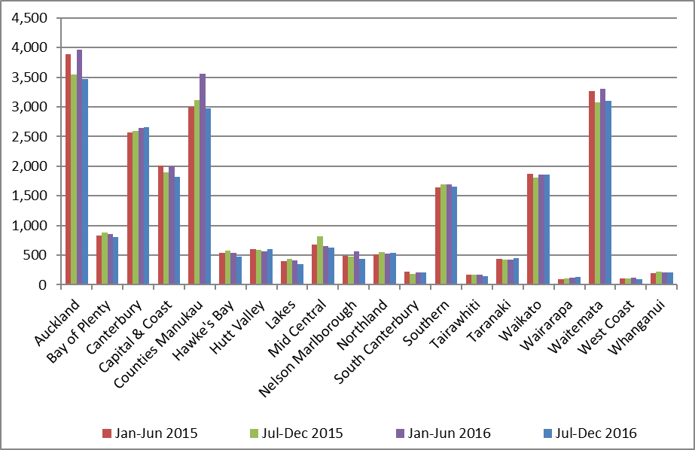

Figure 40 - Trends in the number of women with a first screening event, by ethnicity
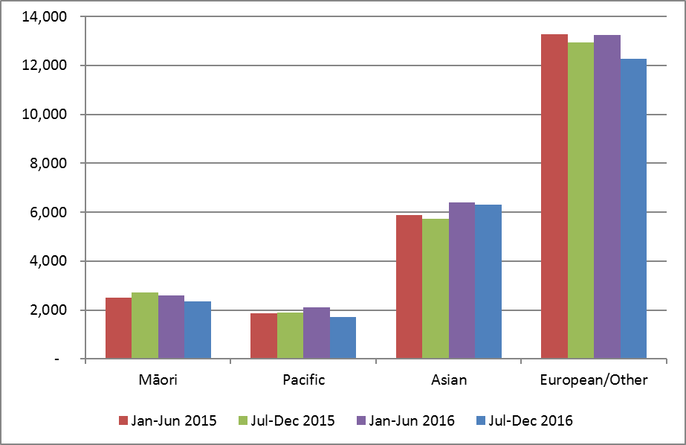

Indicator 3 – Withdrawal rates

Definition | The number of women, by age-group, DHB, and ethnicity not currently enrolled in the NCSP Register and whose enrolment ended during the monitoring period (withdrawals). Withdrawals relate to active withdrawals, where women specifically elect to be removed from the NCSP Register.  Withdrawals are also reported as a proportion of women who were enrolled on the NCSP Register at 30 June 2016 (i.e. just prior to the commencement of the current monitoring period). This also is reported by age group, DHB, and ethnicity.  Age is defined as a woman’s age at the end of the monitoring period (i.e. as at 31 December 2016).
Target | Zero for ages 20-69 years.
Current Situation | At the end of the previous monitoring period, 1,566,955 women aged 20-69 years were enrolled on the NCSP Register. During the current monitoring period, 26 of these women (0.002%) withdrew from the NCSP Register.  In all DHBs, the number and proportion of women who withdrew was extremely small (maximum five women in the Auckland DHB region). No women withdrew in seven of the twenty DHB regions (Figure 41).  The age groups with the largest numbers and proportions of women who withdrew were women aged 20-24 years (4 women, 0.005% of those enrolled at the end of the previous monitoring period) in addition to women aged 25-29 and 55-59 years (5 withdrawals or 0.003% and 4 withdrawals or 0.002%, respectively) (Figure 42, Table 44).  The number and proportion of women withdrawing was extremely small for all ethnic groups. Three Māori women withdrew in the current monitoring period (0.002%), as well as six Asian women (0.003%), and 17 European/ Other women (0.002%). No Pacific women withdrew during the current monitoring period (Figure 43, Table 45).
Trends | The number of women who withdrew in the current monitoring period (26 women) is higher than in the previous monitoring period (22 women). The overall number of withdrawals and the withdrawals as a proportion of all women enrolled both continue to be extremely small.
Comments | The proportion of women choosing to withdraw from the NCSP Register is extremely small.  Withdrawals relate to active withdrawals, where women specifically elect to be removed from the NCSP Register. It does not include, for example, women who have moved overseas, or who have died during the period, and who therefore are not having tests recorded on the NCSP Register or who ask for no more communications but still participate in the Programme and have their results recorded on the NCSP Register.

Figure 41 - Number of women (aged 20-69 years) who withdrew from the NCSP Register by DHB, 1 July – 31 December 2016
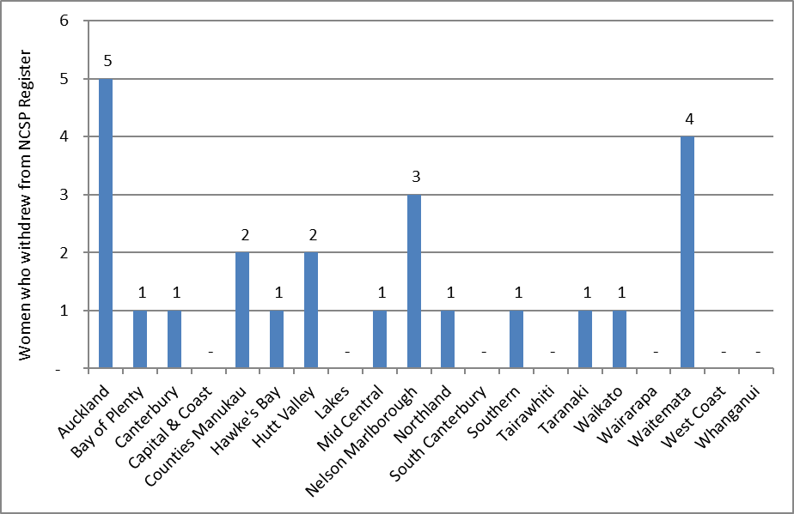
Excludes 2 women who withdrew whose DHB was not recorded

Figure 42 - Number of women who withdrew from the NCSP Register by age, 1 July – 31 December 2016
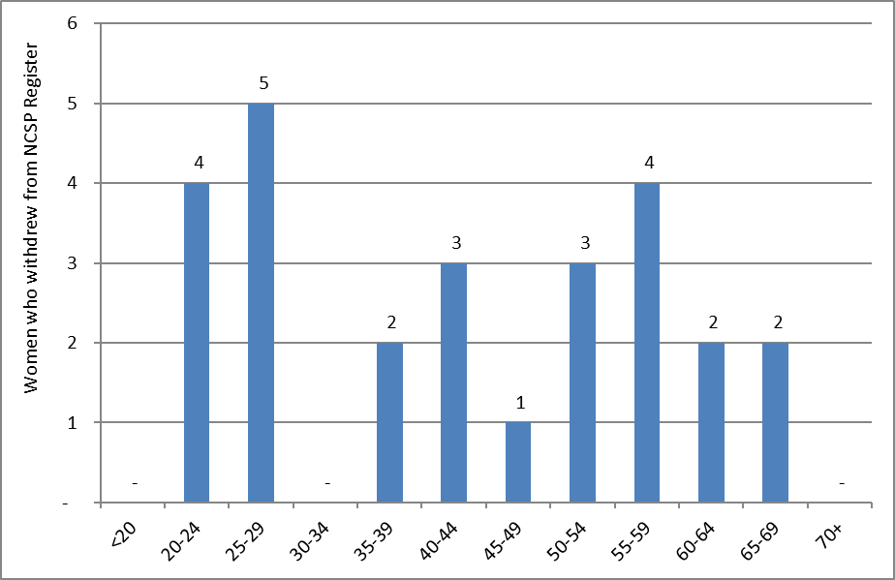

Figure 43 - Number of women (aged 20-69 years) who withdrew from the NCSP Register by ethnicity, 1 July – 31 December 2016
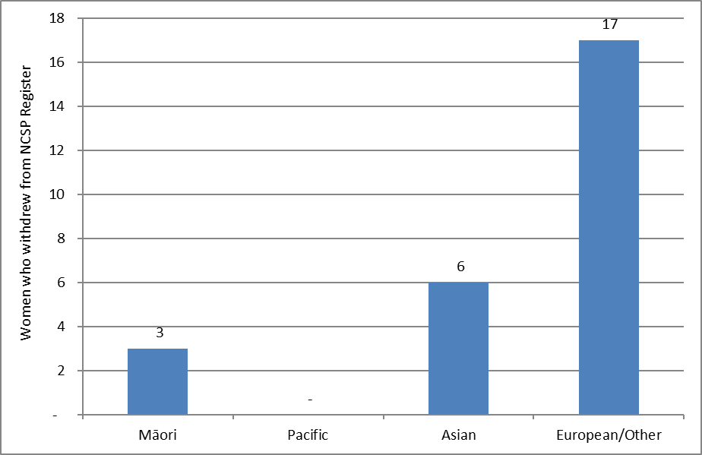

Indicator 4 – Early re-screening

Definition | The proportion of women who returned for a smear within 30 months (2.5 years) of their index smear is calculated for a cohort of women. The cohort comprises of women with an index smear taken between 1 February 2014 – 31 March 2014 (inclusive), who i) were aged 20-66 years at the time the smear was taken (and hence remained within the screening target age throughout the period); and ii) were given a recommendation to return at the regular interval of three years as a result of their smear in February/March 2014 (NZ Modified Bethesda code R1). Using this method of calculating the measure allows follow-up to be considered over 30 months for every individual woman.  This measure excludes women who return early but are being followed according to Guidelines for Cervical Screening in New Zealand, for example, those with a recent report of an abnormality. It also excludes from the count of women screened early those whose “early” smear recommended urgent referral regardless of cytological findings, in view of the abnormal clinical history provided (NZ Modified Bethesda code R14).  In some cases, early re-screening may be the result of women being re-screened early in response to clinical symptoms, and this is appropriate.  For the purposes of analysis by age group, a woman’s age is defined as her age at the end of the current monitoring period (i.e. a women’s age at 31 December 2016).
Target | A target has not been set for this cohort-based calculation method.
Current Situation | There were 44,070 women who had a smear taken in February or March 2014, were aged between 20-66 years at the time of their smear, and were given a recommendation to return for their next smear at the routine interval of three years. Among these women, 6,309 (14.3%) had at least one subsequent smear in the following 30 months (6 months earlier than recommended).  There was wide variation in early re-screening by DHB. Early re-screening was most common in Waitemata (21.2%) and Auckland (18.7%), and was least common in West Coast (7.5%) and Mid Central (8.4%) (Figure 44, Table 47).  There was also variability by age. Younger women (aged 20-24 years at the end of the period) were most likely to be re-screened early (17.1%), and older women (aged 65-69 years) were the least likely to be re-screened early (10.5%) (Figure 45, Table 46). Rates of early re-screening are quite similar across six five-year age groups from 25 to 54 years (between 14.0% and 16.8%).  Among the ethnic groups considered, European/ Other and Māori women were the most likely to be re-screened early (14.8% and 14.0% respectively), while early re-screening was least common among Pacific women (10.9%) (Figure 46, Table 48).
Trends | The level of early re-screening (14.3%) is lower to that seen for the previous monitoring period (15.3%).  The DHBs with the lowest and highest levels of early re-screening since the last monitoring report remained similar. In most DHBs, early rescreening is decreasing; however early rescreening increased in the current report in Waitemata (from 19.6% to 21.2%), Bay of Plenty (from 16.7% to 17.6%), Taranaki (from 10.2% to 10.9%) and Wairarapa (from 17.4% to 18.1%). Trends over the two years ending 31 December 2016 by DHB are shown in Figure 47.  A reduction in the level of early re-screening was seen for nine of the ten five-year age groups between 20 and 69 years since the previous report. Women aged 20-24 years saw the largest percentage point reduction (3.1 percentage points from 20.1% to 17.1%). Women aged 65-69 years saw the only increase in early re-screening; 0.7 percentage points, from 9.8% to 10.5%. Trends over the two years ending 31 December 2016 by five-year age group are shown in Figure 48.  Small decreases in early re-screening was also seen in all ethnic groups since the last monitoring period.
Comments | Early re-screening was assessed based on cytology recommendation codes, in order to exclude from the early re-screening group women with a negative smear for whom an earlier screening visit is appropriate. Thus, only women with a recommendation that their next screening visit be in three years were eligible for inclusion in the early re-screening group (that is, in both the numerator and the denominator). Women excluded from the early re-screening group would include those who had just had their first smear or more than five years have elapsed since their previous smear (NCSP policy is to recommend a one-year follow-up), women with atrophic changes for whom a repeat after oestrogen is recommended, women with an abnormal history or clinical symptoms, and those already under specialist care.  In some cases, early re-screening may be the result of women being re-screened early in response to clinical symptoms, and this is appropriate. We have used the NZ Modified Bethesda recommendation code for urgent referral regardless of cytological findings (R14) to try and exclude some of these cases from the count of women re-screened early, but this probably does not exclude all screens performed in response to clinical symptoms.  There are some similarities between Indicator 4 and Indictaor 1.2, although they examine different groups of women and the proportions reported answer somewhat different questions (as is described in more detail in the Comments section of Indicator 1.2). Indicator 1.2 addresses the question – “What proportion of women who are re-attending for routine screening in a particular time period are returning at least six months early?”, and does not take into account women who did not attend for screening; whereas Indicator 4 addresses the question – “What proportion of women recommended to return in three years for routine screening return at least six months early?”, and takes into account all women given a routine screening recommendation, whether they re-attend or not.

Figure 44 - Proportion of women recommended to return at the routine interval (three years) who were re-screened early, by DHB
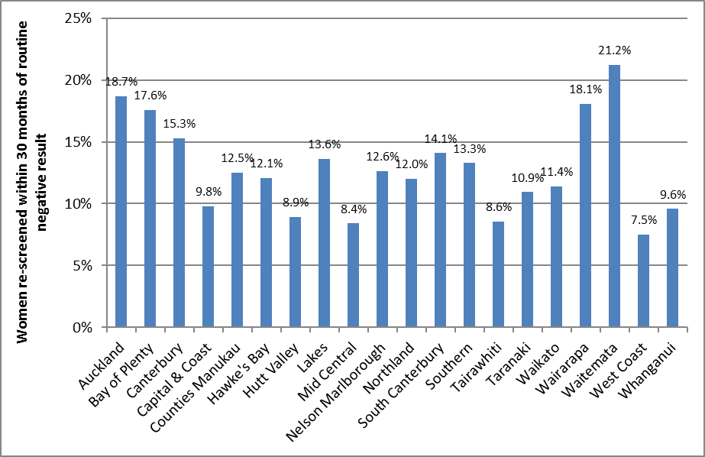

Figure 45 - Proportion of women recommended to return at the routine interval (three years) who were re-screened early, by five-year age group
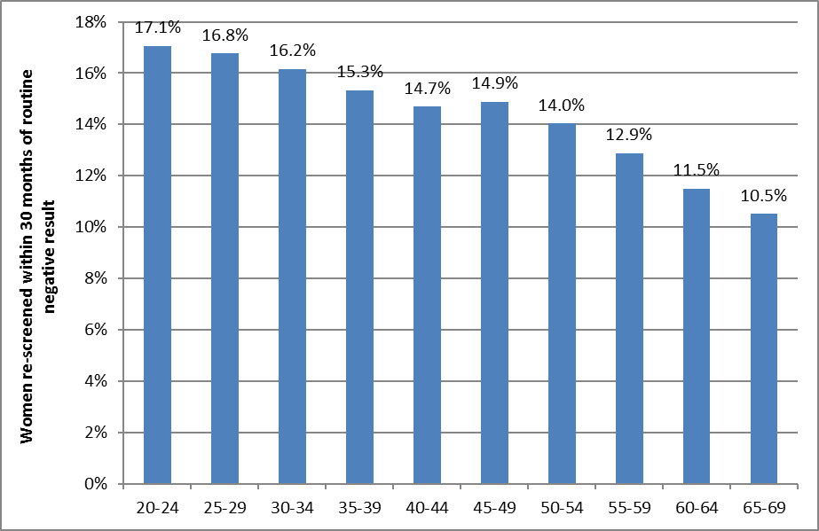

Figure 46 - Proportion of women recommended to return at the routine interval (three years) who were re-screened early, by ethnicity
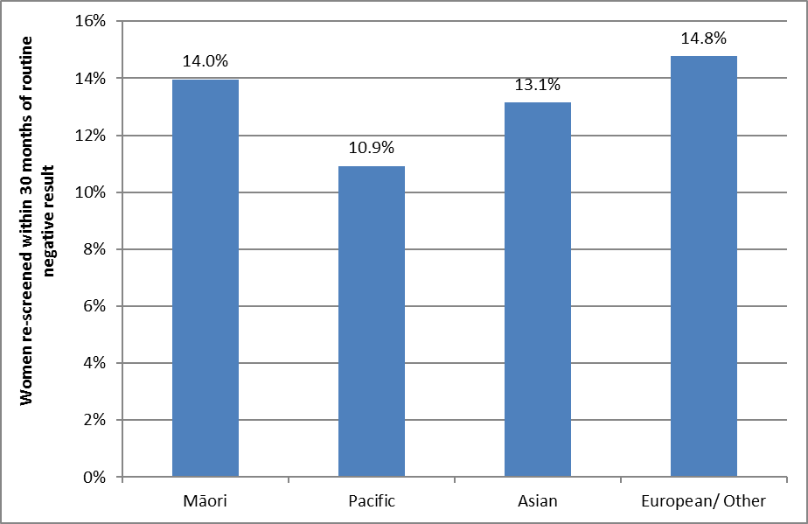

Figure 47 - Trends in the proportion of women recommended to return at the routine interval (three years) who were re-screened early, by DHB
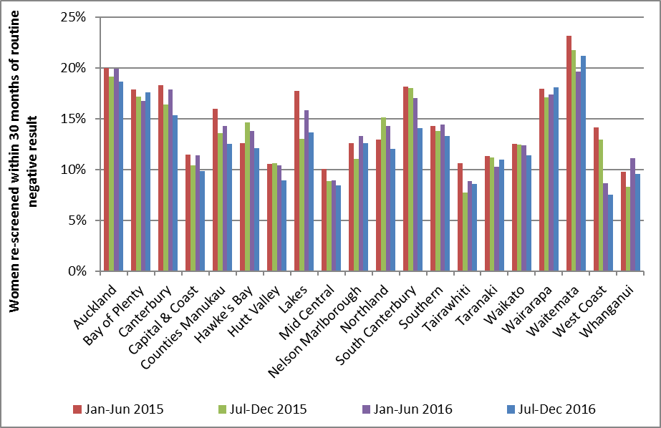

Figure 48 - Trends in the proportion of women recommended to return at the routine interval (three years) who were re-screened early, by age
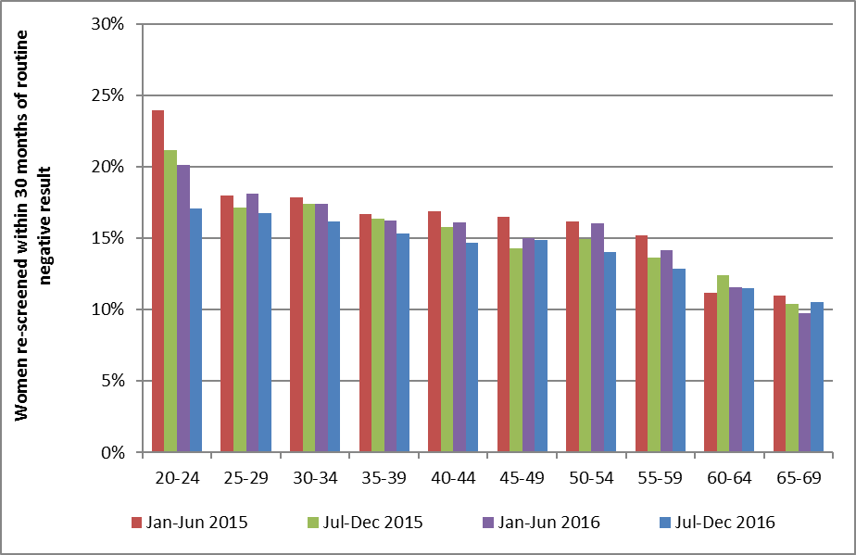

Indicator 5 – Laboratory indicators

The indicators include cytology, histology reports (encompassing cytology and histology reporting rates, positive predictive value of cytology predicting HSIL), laboratory turnaround times, the accuracy of negative cytology reports (future development), and unsatisfactory samples. Volumes of high risk HPV (hrHPV) tests according to NCSP guidelines are included in Indicator 8.

On 1 February 2015 Diagnostic Medlab Ltd. closed and Anatomical Pathology Services (owned by Auckland DHB) opened. This largely resulted in Diagnostic Medlab Ltd.’s work moving to Anatomical Pathology Services, therefore trends for Anatomical Pathology Services for periods prior to 1 Feb 2015 include results from Diagnostic Medlab Ltd. Also Aotea Pathology Ltd. was taken over by Southern Community Laboratories in November 2015 and the cytology work was consolidated to Southern Community Laboratories Dunedin.

Indicator 5.1 – Laboratory cytology reporting

This includes the breakdown of cytology reporting by category for squamous and glandular abnormalities reported

- Negative  - ASC-US  - LSIL  - ASC-H  - HSIL | - SC  - AGC/AIS  - Adenocarcinoma  - Malignant neoplasm  - Total abnormalities  - Unsatisfactory samples

Definition | Bethesda codes used are provided in Appendix B.  The Bethesda reporting system (TBS), introduced in New Zealand on 1 July 2005, is a New Zealand modification of the Bethesda 2001 cytology reporting system.  The NCSP Register collects cytology results of samples taken from the cervix and vagina.  Total samples include all cytology samples (satisfactory and unsatisfactory) taken during the monitoring period, including conventional, LBC, and combined samples.  Reporting rates for negative cytology, total abnormal cytology, and other reporting categories are as a percentage of all satisfactory cytology samples.
Target | 0.1 - 3.0% of LBC samples reported as unsatisfactory  No more than 96% of satisfactory samples reported as negative  No more than 10% of satisfactory samples reported as abnormal  No less than 0.5% of satisfactory samples reported as HSIL (Bethesda HS1 or HS2)
Current Situation | Six laboratories reported on cytology taken during the current monitoring period, the same number as in the previous monitoring period. A total of 207,966 cytology samples were taken, almost all of which (>99.99%) were coded as liquid-based cytology (LBC) samples (other samples may have been miscoded).  Unsatisfactory cytology  3,234 cytology samples (1.6%) were unsatisfactory. These are reported in more detail in Table 1 and Figure 49. The remaining satisfactory samples are reported on in more detail in Table 2 to Table 6.  The unsatisfactory rate for LBC is 1.6%, which is within the 0.1 - 3.0% target range for LBC samples. Four of the six laboratories had unsatisfactory rates within the target range; the other two laboratories had rates which exceeded the maximum target of 3.0%. Southern Community Laboratories had the lowest unsatisfactory percentage of 0.5% (Figure 49, Table 1).  Negative cytology reports  92.9% of satisfactory cytology results were negative, consistent with the target of no more than 96% (Table 2). The proportion of samples which were negative varied by laboratory from 65.1% (LabPLUS) to 95.7% (Southern Community Laboratories) (Figure 50). All six laboratories met the target of no more than 96%.  Abnormal cytology reports  The proportion of satisfactory samples which were abnormal (7.1%) was also consistent with the target of no more than 10% (Table 2). This varied by laboratory however, from 4.3% (Southern Community Laboratories) to 34.9% (LabPLUS) (Figure 51). Two laboratories (LabPLUS and Canterbury Health Laboratories) exceeded the target (34.9% and 12.2%, respectively).  Abnormal cytology results were most common in younger women (Table 5, Table 6).  HSIL cytology reports  Overall, 1.0% of satisfactory cytology samples were HSIL, consistent with the target of at least 0.5% of samples (Table 4). Rates varied by laboratory from 0.6% (Anatomical Pathology Services and PathLab) to 4.5% (LabPLUS). All six laboratories met the HSIL target (Figure 52).  Among women aged 20-69 years, rates of HSIL or worse were most common in women aged 25-29 years (Table 5, Table 6).  In the current report we additionally examined age-standardised rates of HSIL cytology reports. This was done to partially account for different rates which may arise in different laboratories due to differences in the age of the population whose cytology tests they process. The age-standardised HSIL rates were very similar to the crude rates, both nationally and within each laboratory, but tended to be slightly lower (Table 49).
Trends | Unsatisfactory cytology  Overall, the percentage of unsatisfactory LBC samples for the current monitoring period (1.6%) is similar to the 1.2% seen in the previous monitoring period. Two laboratories that previously met the target exceeded the maximum target for unsatisfactory LBC samples in this report.  Negative vs abnormal cytology reports  The proportion of satisfactory cytology samples which are negative for intraepithelial lesion or malignancy (92.9%) and is similar to the previous monitoring period (92.7%), and correspondingly the proportion of cytology samples reported as abnormal (7.1%) is also similar as in the previous monitoring period (7.3%). All six laboratories have similar rates of negative cytology to the previous report and continued to meet the target for negative cytology. The same laboratories as previous reports had abnormal cytology rates above the target of 10% (Canterbury Health Laboratories and LabPLUS).  HSIL cytology reports  The proportion of satisfactory cytology samples reported as HSIL (1.0%) is similar to that reported in the previous monitoring report (1.1%). All six laboratories met the target of not less than 0.5% as in the previous monitoring period.  Longer term trends in the proportion of satisfactory cytology samples reported as HSIL are shown in Figure 53 and Figure 54 (trends by age) and Figure 55 (trends by laboratory). Figure 53 and Figure 55 show trends over the last four monitoring report periods (two years), consistent with other trends presented in this report. Figure 54 shows longer term trends (1 July 2008 to 31 December 2016) in rates of HSIL cytology in women aged under 40 years, compared to the overall HSIL reporting rate in women of all ages. The younger age groups in this figure would be the first to be potentially affected by HPV vaccination (the oldest birth cohorts eligible for vaccination through the publicly funded program would be aged up to 26 years at the time of the current monitoring period). HSIL rates in women aged less than 20 years are quite variable; this is likely to be because far fewer women of this age group attend for screening, since routine screening is not recommended for women aged less than 20 years. HSIL reporting rates in women aged 20-24 years had been increasing prior to 2013 and reached a high of 2.2% for the July-December 2012 period (Report 38). HSIL rates then fell for four monitoring periods between January 2013 and December 2014. However, in the July-December 2015 monitoring period (Report 44) an increase was seen in virtually all age groups, including women aged 20-24 years (from 1.6% in the January to June 2015 report, report 43, to 2.0% in Report 44). A drop in HSIL rates has been observed in the last two monitoring reports including the current monitoring report in this age group (to 1.6%). Decreases have also been seen in age groups less than 20, 20-24, 30-34, 45-49 and 70+ (Figure 53).
Comments | High rates of abnormal samples from LabPLUS are consistent with previous reports, and as discussed in previous monitoring reports, it is thought that the case-mix of this laboratory (i.e. a significant proportion of samples received from colposcopy clinics compared to other laboratories) is an underlying factor.  Workload catchments for laboratories may be regional or nationwide and are changing because of laboratory service restructuring. As a result, it is not always straightforward to determine the catchment population for a laboratory. Rates of negative and abnormal results for individual laboratories therefore need to be interpreted with some care, to allow for this difference in workloads and case-mix.  The national Human Papillomavirus (HPV) Immunisation Programme was introduced in New Zealand in September 2008, and involves routine vaccination of girls 12-13 years and catch-up vaccination has previously been offered to young women born in 1990 or later. International and New Zealand data indicate that many high grade squamous cytology reports are associated with HPV types which are potentially preventable by vaccination⁴⁻⁷, and that this is particularly true for younger women^{4, 8-10}. It is anticipated that data will also soon be available from New Zealand to further quantify the potential impact of the Human Papillomavirus Immunisation Programme in New Zealand. As vaccinated cohorts enter the screening programme, it is anticipated that the proportion of satisfactory cytology samples reported as HSIL will gradually reduce, and that this will occur in younger age groups first (the oldest birth cohorts eligible for vaccination through the publicly funded program would be aged up to 26 years at the time of the current monitoring period, while the oldest birth cohorts offered vaccination at the target age of 12-13 years would be aged up to 20 years). Therefore, trends in the proportion of satisfactory cytology samples reported as HSIL by age are included in these monitoring reports, in order to monitor the impact of HPV vaccination over time. At the current time, it is not possible to present HSIL rates separately for vaccinated and unvaccinated women, because information relating to whether or not individual women have been vaccinated is not available on the NCSP Register. These data therefore need to be interpreted with some care, as they include results in all women, both vaccinated and unvaccinated.  In the current report we additionally examined age-standardised rates of HSIL cytology reports, in order to partially account for differences in the age of the population whose cytology tests each laboratory processes. This could be an additional factor in some laboratories having higher or lower HSIL reporting rates. As the target does not specifically relate to age-standardised rates, these results cannot be directly compared to the target; however, as the target was set in 2013, standardising was done using the 2013 Census population (females). As the age-standardised HSIL rates were very similar to the crude rates within each laboratory, differences in age distribution of cytology tests reported do not appear to be a factor in differences between laboratories in HSIL reporting rates.  Caution must be taken when comparing percentages of reporting from this monitoring period to the previous monitoring periods due to changes in the number of reporting laboratories. Differences in percentages from this and previous monitoring reports may be due to differences in laboratory caseloads between the periods.
Figure 49 - Proportion of total LBC samples reported as unsatisfactory by laboratory, 1 July – 31 December 2016
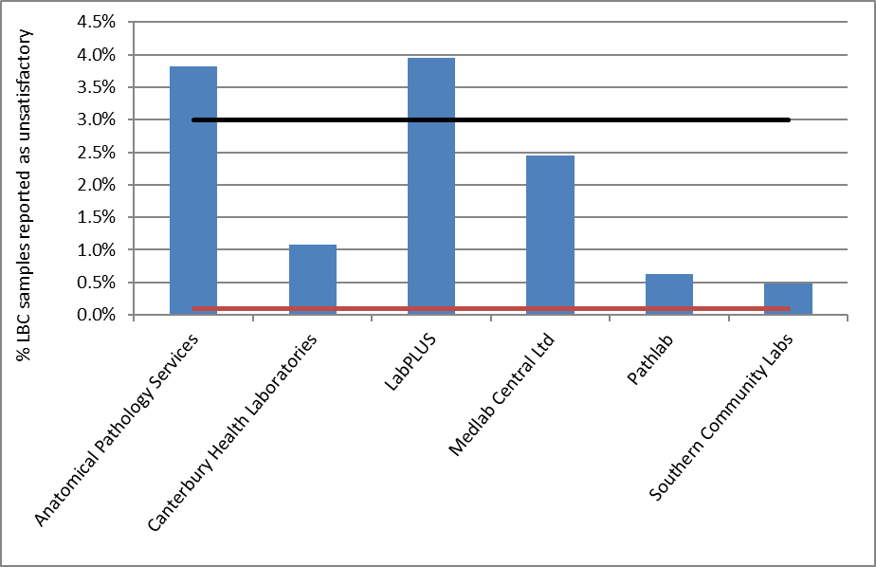
Target for LBC: 0.1-3.0% (Black line-upper target limit; red line=lower target limit)

Figure 50 - Proportion of total satisfactory samples reported as negative by laboratory, 1 July – 31 December 2016
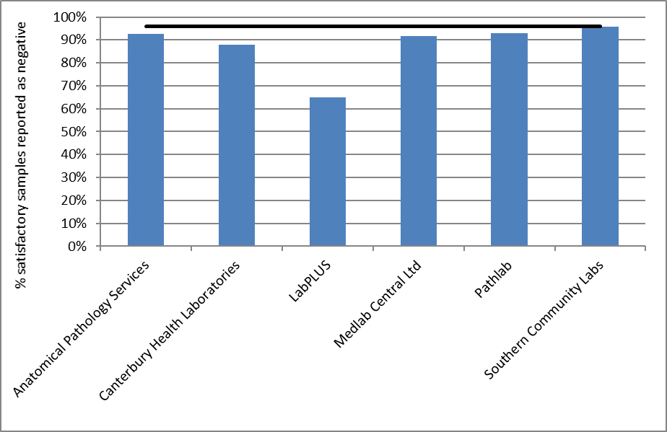
Note: Line shows negative target of no more than 96%

Figure 51 - Proportion of total satisfactory samples reported as abnormalities by laboratory, 1 July – 31 December 2016
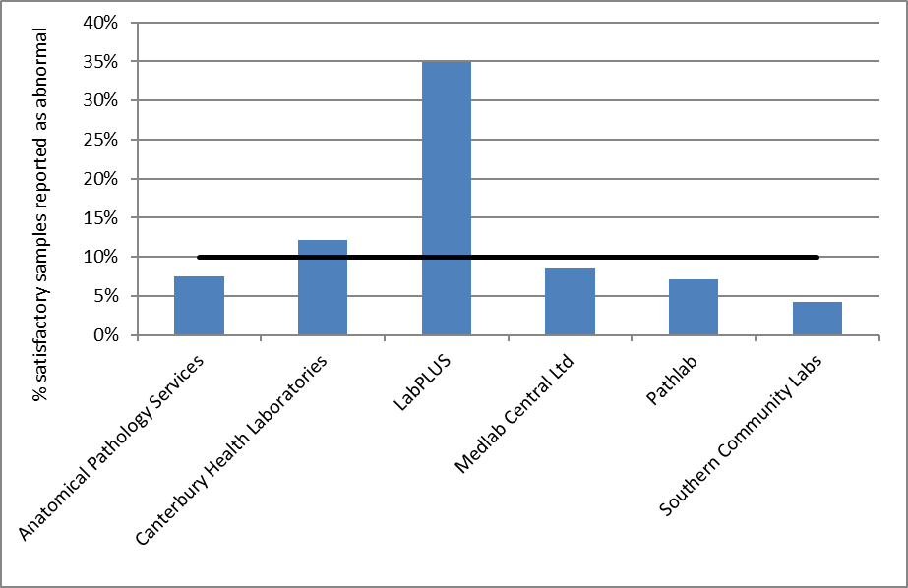
Note: Line shows abnormal target no more than 10%

Figure 52 - Proportion of total satisfactory samples reported as HSIL by laboratory, 1 July – 31 December 2016
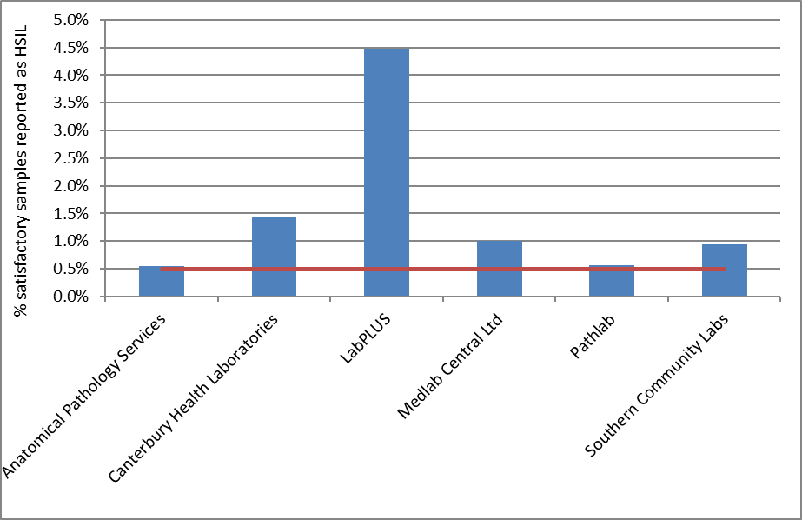
Note: Line shows HSIL target no less than 0.5%

Table 1 - Satisfactory and unsatisfactory cytology reporting by laboratory (1 July – 31 December 2016)
 | All samples |  | Satisfactory |  | Unsatisfactory
Laboratory | N | N |  | % | N | %
Anatomical Pathology Services | 47,499 | 45,687 |  | 96.2 | 1,812 | 3.8
Canterbury Health Laboratories | 10,233 | 10,122 |  | 98.9 | 111 | 1.1
LabPLUS | 7,791 | 7,483 |  | 96.0 | 308 | 4.0
Medlab Central Ltd. | 14,708 | 14,347 |  | 97.5 | 361 | 2.5
Pathlab | 23,298 | 23,152 |  | 99.4 | 146 | 0.6
Southern Community Laboratories | 104,437 | 103,941 |  | 99.5 | 496 | 0.5
Total | 207,966 | 204,732 |  | 98.4 | 3,234 | 1.6

Table 2 - Laboratory cytology reporting by general result (1 July – 31 December 2016) – percentage of satisfactory samples
 | Negative |  | Abnormal
Laboratory | N | % |  | N | %
Anatomical Pathology Services | 42,259 | 92.5 |  | 3,428 | 7.5
Canterbury Health Laboratories | 8,889 | 87.8 |  | 1,233 | 12.2
LabPLUS | 4,870 | 65.1 |  | 2,613 | 34.9
Medlab Central Ltd. | 13,133 | 91.5 |  | 1,214 | 8.5
Pathlab | 21,504 | 92.9 |  | 1,648 | 7.1
Southern Community Laboratories | 99,488 | 95.7 |  | 4,453 | 4.3
Total | 190,143 | 92.9 |  | 14,589 | 7.1
Target total negative: ≤ 96% reported as negative
Target total abnormal: ≤ 10% reported as abnormal

Table 3 - Laboratory cytology reporting by type of cytology sample (1 July – 31 December 2016) – counts
 | Result
Laboratory | Negative | ASC-US | LSIL | ASC-H | HSIL | Invasive SCC | AGC/AIS | Adeno-carcinoma | Malignant Neoplasm | Total
Anatomical Pathology Services | 42,259 | 1,138 | 1,788 | 183 | 253 | 2 | 50 | 14 | - | 45,687
Canterbury Health Laboratories | 8,889 | 385 | 522 | 166 | 144 | - | 10 | 3 | 3 | 10,122
LabPLUS | 4,870 | 802 | 1,041 | 407 | 335 | 1 | 15 | 8 | 4 | 7,483
Medlab Central Ltd. | 13,133 | 418 | 531 | 105 | 144 | 2 | 9 | 5 | - | 14,347
Pathlab | 21,504 | 493 | 893 | 107 | 130 | 2 | 20 | 2 | 1 | 23,152
Southern Community Laboratories | 99,488 | 516 | 2,650 | 189 | 985 | 9 | 87 | 16 | 1 | 103,941
Total | 190,143 | 3,752 | 7,425 | 1,157 | 1,991 | 16 | 191 | 48 | 9 | 204,732

Table 4 - Laboratory cytology reporting by cytological category (1 July – 31 December 2016) – percentage of all satisfactory samples
 | Result
Laboratory | Negative | ASC-US | LSIL | ASC-H | HSIL | Invasive SCC | AGC/AIS | Adeno-carcinoma | Malignant Neoplasm
Anatomical Pathology Services | 92.5 | 2.5 | 3.9 | 0.4 | 0.6 | <0.005 | 0.11 | 0.03 | -
Canterbury Health Laboratories | 87.8 | 3.8 | 5.2 | 1.6 | 1.4 | - | 0.10 | 0.03 | 0.03
LabPLUS | 65.1 | 10.7 | 13.9 | 5.4 | 4.5 | 0.01 | 0.20 | 0.11 | 0.05
Medlab Central Ltd. | 91.5 | 2.9 | 3.7 | 0.7 | 1.0 | 0.01 | 0.06 | 0.03 | -
Pathlab | 92.9 | 2.1 | 3.9 | 0.5 | 0.6 | 0.01 | 0.09 | 0.01 | <0.005
Southern Community Laboratories | 95.7 | 0.5 | 2.5 | 0.2 | 0.9 | 0.01 | 0.08 | 0.02 | <0.005
Total | 92.9 | 1.8 | 3.6 | 0.6 | 1.0 | 0.01 | 0.09 | 0.02 | <0.005
Target: HSIL ≥ 0.5% reported as HSIL

Table 5 - Laboratory reporting of cytological category by five-year age group (1 July – 31 December 2016) – counts
 | Cytology Result
Age Group | Negative | ASC-US | LSIL | ASC-H | HSIL | Invasive SCC | AGC/AIS | Adeno-carcinoma | Malignant Neoplasm |  | Total
<20 | 705 | 32 | 107 | 11 | 6 | - | - | - | - |  | 861
20-24 | 20,465 | 676 | 2,453 | 259 | 393 | - | 7 | - | - |  | 24,253
25-29 | 20,374 | 551 | 1,277 | 218 | 464 | - | 15 | 1 | 1 |  | 22,901
30-34 | 20,831 | 480 | 807 | 176 | 383 | 1 | 21 | 1 | 1 |  | 22,701
35-39 | 20,139 | 357 | 620 | 108 | 237 | - | 13 | 2 | - |  | 21,476
40-44 | 21,323 | 359 | 506 | 90 | 171 | 1 | 11 | 1 | 1 |  | 22,463
45-49 | 21,525 | 389 | 461 | 65 | 96 | 3 | 22 | 3 | - |  | 22,564
50-54 | 20,180 | 333 | 437 | 65 | 77 | 1 | 24 | 8 | - |  | 21,125
55-59 | 17,800 | 245 | 326 | 59 | 67 | 3 | 24 | 6 | 2 |  | 18,532
60-64 | 14,308 | 168 | 218 | 54 | 45 | 3 | 25 | 2 | 1 |  | 14,824
65-69 | 10,733 | 126 | 151 | 41 | 40 | - | 16 | 3 | 2 |  | 11,112
70+ | 1,760 | 36 | 62 | 11 | 12 | 4 | 13 | 21 | 1 |  | 1,920
Total | 190,143 | 3,752 | 7,425 | 1,157 | 1,991 | 16 | 191 | 48 | 9 |  | 204,732

Table 6 - Laboratory reporting of cytological category by five-year age group (1 July – 31 December 2016) – percentage of all satisfactory samples in women of that age group
 | Cytology Result
Age Group | Negative | ASC-US | LSIL | ASC-H | HSIL | Invasive SCC | AGC/AIS | Adeno-carcinoma | Malignant Neoplasm
<20 | 81.9 | 3.7 | 12.4 | 1.3 | 0.7 | - | - | - | -
20-24 | 84.4 | 2.8 | 10.1 | 1.1 | 1.6 | - | 0.03 | - | -
25-29 | 89.0 | 2.4 | 5.6 | 1.0 | 2.0 | - | 0.07 | <0.005 | <0.005
30-34 | 91.8 | 2.1 | 3.6 | 0.8 | 1.7 | <0.005 | 0.09 | <0.005 | <0.005
35-39 | 93.8 | 1.7 | 2.9 | 0.5 | 1.1 | - | 0.06 | 0.01 | -
40-44 | 94.9 | 1.6 | 2.3 | 0.4 | 0.8 | <0.005 | 0.05 | <0.005 | <0.005
45-49 | 95.4 | 1.7 | 2.0 | 0.3 | 0.4 | 0.01 | 0.10 | 0.01 | -
50-54 | 95.5 | 1.6 | 2.1 | 0.3 | 0.4 | <0.005 | 0.11 | 0.04 | -
55-59 | 96.1 | 1.3 | 1.8 | 0.3 | 0.4 | 0.02 | 0.13 | 0.03 | 0.01
60-64 | 96.5 | 1.1 | 1.5 | 0.4 | 0.3 | 0.02 | 0.17 | 0.01 | 0.01
65-69 | 96.6 | 1.1 | 1.4 | 0.4 | 0.4 | - | 0.14 | 0.03 | 0.02
70+ | 91.7 | 1.9 | 3.2 | 0.6 | 0.6 | 0.21 | 0.68 | 1.09 | 0.05
Total | 92.9 | 1.8 | 3.6 | 0.6 | 1.0 | 0.01 | 0.09 | 0.02 | <0.005

Figure 53 - Trends in the proportion of total satisfactory samples reported as HSIL (last four monitoring periods), by age
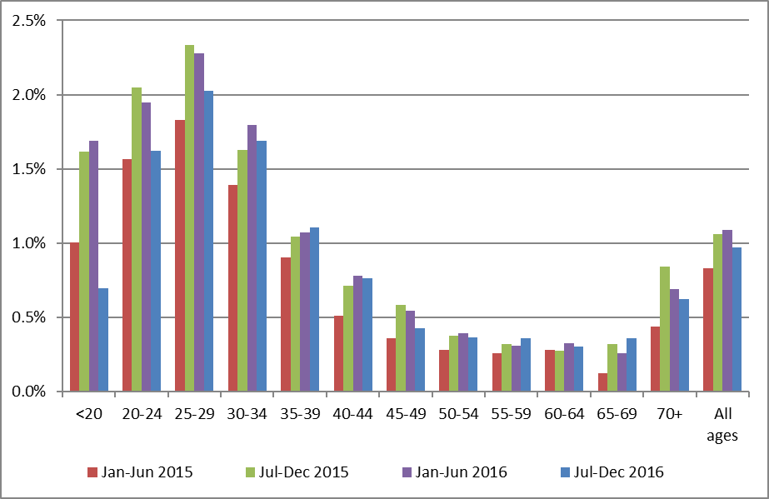
Note: women aged less than 20 years are not routinely screened

Figure 54 - Longer term trends in the proportion of total satisfactory samples reported as HSIL (to 1 July – 31 December 2016), selected age groups
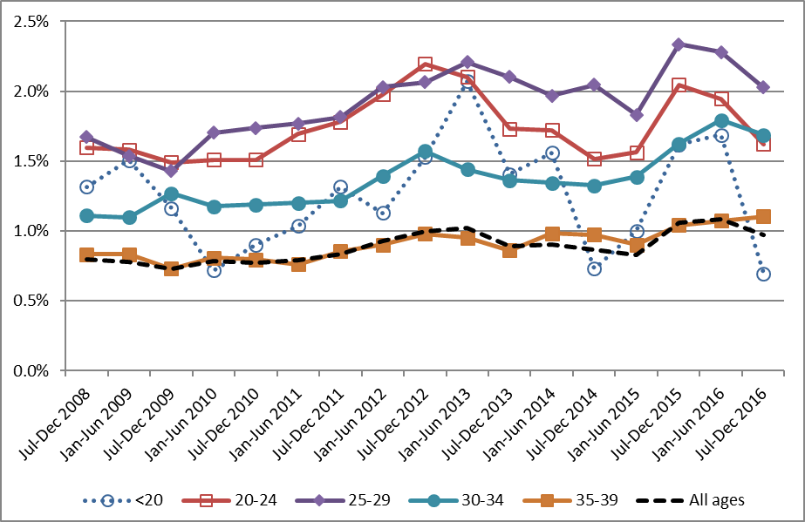
Note: women aged less than 20 years are not routinely screened

Figure 55 - Trends in the proportion of total satisfactory samples reported as HSIL, by laboratory
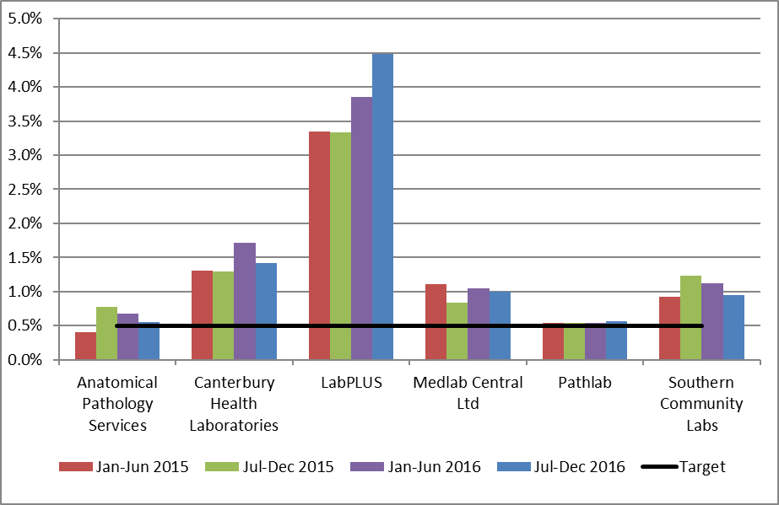
Note: Line shows HSIL target of no less than 0.5%. Cytology prior to 1 Feb 2015 was reported on by Diagnostic Medlab Ltd., not Anatomical Pathology Services, however the catchment was very similar between the two laboratories.

Indicator 5.2 – Accuracy of cytology predicting HSIL

Definition | The accuracy of cytology predicting HSIL/SC (positive predictive value – PPV) is defined as the probability of a high grade histological report (CIN2/3 or higher) given an HSIL/invasive squamous carcinoma cytology report.  Refer to Appendix D for detailed definitions of histological confirmation.  All satisfactory cytology samples collected in the six months prior to the current monitoring period (i.e. collected from 1 January – 30 June 2016 inclusive) were identified. Where a woman had multiple samples or a report had multiple interpretation codes, the most serious cytology result category reported was used. If there were two cytology test results for a woman of the same grade, the earliest one was used. Histology samples taken up to five days prior to and up to six months after the cytology sample were then retrieved for women with a high grade cytology report. Where there were multiple histology reports for a woman in the period, the most serious abnormality category was used.
Target | Not less than 65% and not greater than 85%.
Current Situation | HSIL + SC  2,102 women with HSIL or SC cytology reports were identified. 167 of these women (7.9%) had no histology taken in the period from five days prior to six months after the cytology sample was taken. Among the remaining 1,935 for whom there was histology, 1,544 (79.8%) had their HSIL or SC cytology report confirmed as high grade by histology (Figure 56, Table 50).  By laboratory, the proportion of HSIL + SC being confirmed as high grade by histology ranged from 74.6% for Anatomical Pathology Services to 88.1% for Medlab Central Ltd.. All six laboratories achieved the minimum target of at least 65% of cytological HSIL + SC being confirmed by histology. Two of the six laboratories exceeded the 85% upper target margin of HSIL + SC being histologically confirmed (Figure 56, Table 50).  Other cytological abnormalities  Similar calculations for positive predictive value were performed for ASC-H; glandular abnormalities (AG1-AG5, AIS, AC1-AC4); and the combination of ASC-H, HSIL and SC. There are no targets for these measures.  ASC-H  995 women with a cytology report of ASC-H were identified. 175 (17.6%) had no histology taken in the period from five days prior to six months after the cytology sample. Among the remaining 820 women, 338 (41.2%) were histologically confirmed as high grade. This proportion varied by laboratory, from 37.9% (PathLab) to 50.0% (Canterbury Health Laboratories) (Figure 57, Table 51).  ASC-H + HSIL + SC  A total of 3,097 women had a cytology report of ASC-H, HSIL or SC. 342 (11.0%) had no histology taken in the period from five days prior to six months after the cytology sample. Among the remaining 2,755 women, 1,882 (68.3%) were histologically confirmed as high grade. This proportion varied by laboratory, from 58.6% (LabPLUS) to 75.3% (Medlab Central Ltd.) (Figure 57, Table 52).  Glandular abnormalities  There were 271 women with a glandular abnormality (AG1-AG5, AIS, AC1-AC4) identified. 86 women (31.7%) had no histology taken in the period from five days prior to six months after the cytology sample. Among the remaining 185 women, 83 (44.9%) were identified as having high grade histology. This was not analysed further, as the number of samples reported on by some laboratories was small.
Trends | HSIL + SC  Positive predictive value for HSIL and SC cytology has slightly decreased when compared to the previous monitoring report (80.4% in the previous period; 79.8% in the current period). As in the previous monitoring period, all laboratories had greater than 65% of their HSIL + SC cytology results confirmed by histology. The number of laboratories with PPVs above the upper target of 85% has remained at two. The proportion of cytology reports with histology available following HSIL or SC results is slightly lower (92.1% in the current report; 93.0% in the previous report). Trends in the positive predictive value for HSIL and SC cytology by laboratory are shown in Figure 58. Decreases in the positive predictive value for HSIL and SC cytology were evident for all laboratories except Anatomical Pathology Services and Canterbury Health Laboratories. The positive predictive value for HSIL and SC cytology have decreased for two consecutive monitoring periods or more in LabPLUS, Pathlab and Southern Community Laboratories Dunedin; however in LabPLUS and Pathlab the decreases were from a starting point of above the upper target of 85%, and so have brought them inside the target range.  ASC-H  Positive predictive value for ASC-H cytology has decreased, from 45.6% to 41.2%, however there is no target for this measure. The proportion of ASC-H cytology reports with histology available has increased in the current report compare to the previous monitoring report (82.4% in current report; 81.4% in previous report). Decreases in the positive predictive value for ASC-H cytology were evident for all laboratories except Anatomical Pathology Services.  ASC-H + HSIL + SC  The positive predictive value for the combined group ASC-H, HSIL and SC has decreased in the current report (to 68.3%, compared to (69.4% in the previous report). Note that there are no targets for the positive predictive value of this combined group. Trends in the positive predictive value for the combined group ASC-H, HSIL and SC cytology by laboratory are shown in Figure 59. Decreases in the positive predictive value for the combined group of ASC-H, HSIL and SC cytology were evident for all laboratories except Anatomical Pathology Services and Canterbury Health Laboratories.  Glandular abnormalities  The positive predictive value of glandular abnormalities increased (from 39.2% in the previous report to 44.9% in the current report). Compared to both ASC-H cytology, and the combined group of HSIL and SC cytology, there are far fewer glandular abnormalities, and an even smaller number with histology available. The proportion of glandular abnormalities with histology available (68.3%) is higher than that in the previous monitoring period (64.9%), and remains less than that for ASC-H (82.4%) and HSIL + SC (92.1%). As a result, the positive predictive value of glandular abnormalities is more prone to fluctuations than positive predictive values for other high grade abnormalities. Due to the small number of samples involved, glandular abnormalities were not analysed in further detail by laboratory.
Comments | This estimate does not take into account cytology predicting HSIL for which there is no histology available. Histology may be unavailable because the woman does not attend for follow-up colposcopy, or a biopsy may not be taken if the colposcopic impression is normal. When more colposcopy data is available on the NCSP Register, it may be possible to better distinguish between these two possibilities.  The calculations also do not discriminate between cytology taken as a screening or diagnostic test. This may be a contributing factor for some laboratories with a PPV which is higher than the upper end of the target range, particularly where the colposcopically-directed cytology and corresponding histology are reported by the same laboratory as best management practice. Analysis separating community vs clinic derived cytology would provide a clearer picture of positive predictive value (and other reporting categories) in a screening setting.

Figure 56 - Positive predictive value for CIN2+ in women with HSIL or SC cytology reports (cytology in 1 January – 30 June 2016), by laboratory
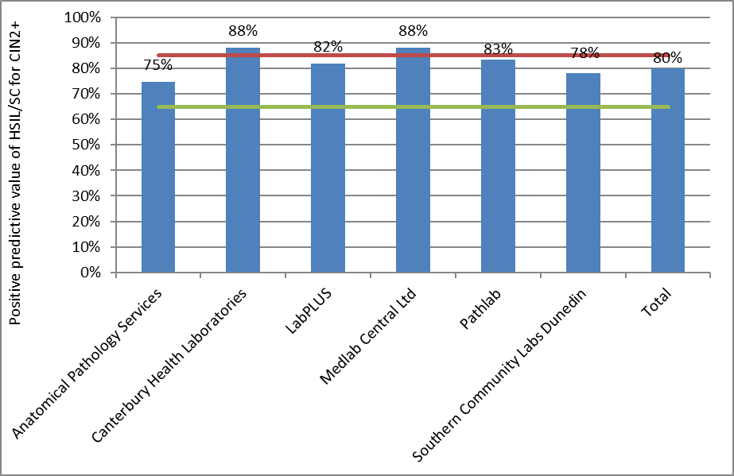
Target: 65% - 85%.

Figure 57 - Positive predictive value for CIN2+ in women with other high grade cytology results (cytology in 1 January – 30 June 2016), by laboratory
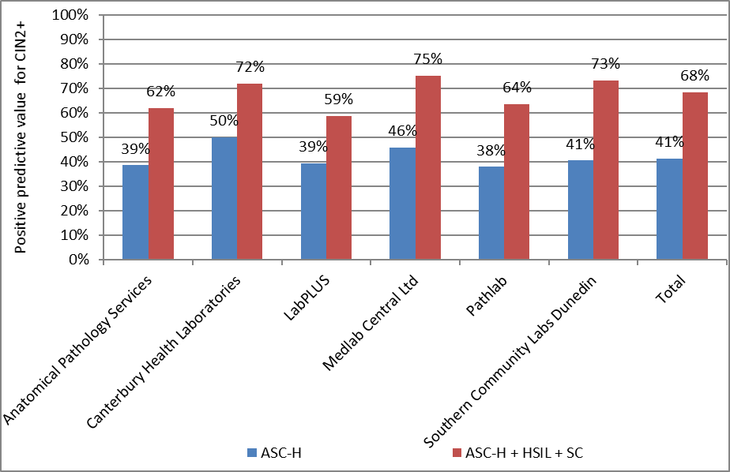

Figure 58 - Trends in the positive predictive value for CIN2+ in women with HSIL or SC cytology results, by laboratory
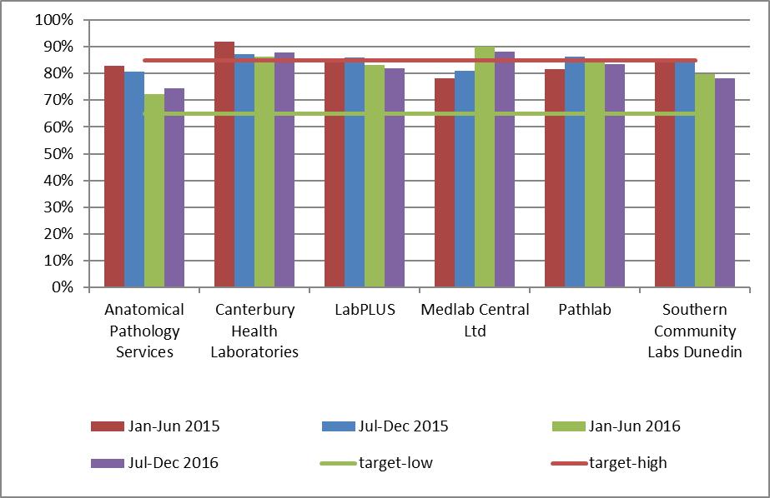
Time period relates to monitoring report period; cytology samples were collected in the period six months prior. Cytology prior to 1 Feb 2015 (included in results for Jan-Jun 2015 and Jul-Dec 2015) was reported on by Diagnostic Medlab Ltd., not Anatomical Pathology Services, however the catchment was very similar between the two laboratories.

Figure 59 - Trends in the positive predictive value for CIN2+ in women with ASC-H, HSIL or SC cytology results, by laboratory
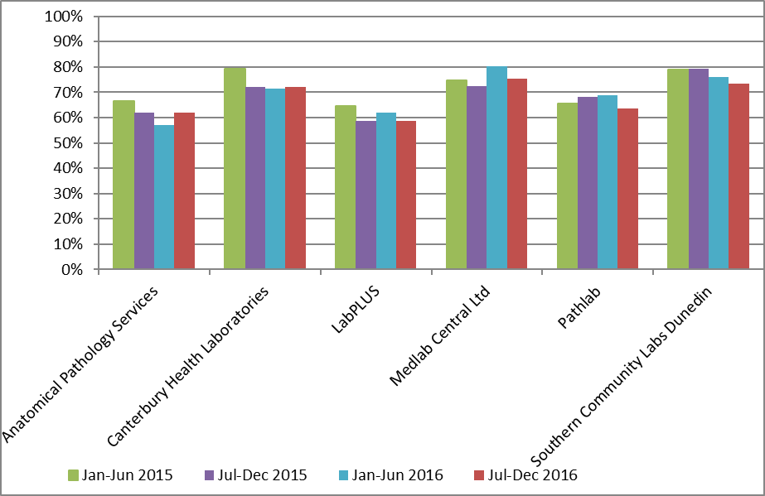
Time period relates to monitoring report period; cytology samples were collected in the period six months prior. Cytology prior to 1 Feb 2015 (included in results for Jan-Jun 2015 and Jul-Dec 2015) was reported on by Diagnostic Medlab Ltd., not Anatomical Pathology Services, however the catchment was very similar between the two laboratories.

Indicator 5.3 – Accuracy of negative cytology reports

Definition | This indicator currently has two parts to its definition.  - For women with a histological diagnosis of CIN2, CIN3, invasive SCC, AIS or invasive endocervical adenocarcinoma, the proportion of cytology slides originally reported within the preceding 42 months as negative, benign/reactive or unsatisfactory which on review are consistent with high grade or worse category (Standard 522).  - The ability of a laboratory to correctly identify a negative sample.  All cases with a high-grade/invasive diagnosis on histology (CIN2, CIN3, invasive SCC, AIS or invasive endocervical adenocarcinoma) must have a review of any cytology slides that have been reported as negative, benign/reactive or unsatisfactory in the previous 42 months. Any abnormality identified as high grade or worse on review of a previously reported negative or unsatisfactory cytology slide must be documented by the laboratory. Cumulative data must be forwarded to the National Screening Unit to help ensure the accuracy of submitted negative cytology reports.
Target | No more than 10% identified as HS1, HS2, SC, AIS or AC1-5 (HSIL+) on review.  Aim for less than 15%, but not more than 20% identified as ASC-H, HS1, HS2, SC, AG4-5, AIS or AC1-5 (ASC-H +) on review.
Current Situation | Data required for this measure were not available directly from the NCSP Register for the current reporting period, but was provided by the National Screening Unit and does not identify laboratories.  Data were provided for women with a histological diagnosis of high-grade/invasive disease in the period 1 January – 31 December 2016, for whom the previous cervical smear, within the 42 months prior, was negative. Nationally, 2.9% of these previous smears were consistent with HSIL+ on review, and 5.1% were consistent with ASC-H+ on review (Figure 60).  These results varied by laboratory, from 0% to 5.8% for HSIL+ and from 2.2% to 10.0% for ASC-H+ (Figure 60). No laboratory exceeded the targets, and all achieved the additional aim of less than 15% for ASC-H+.
Trends | Overall the proportion of slides that were consistent with a high grade or worse abnormality decreased from 2013 to 2014, but this proportion has been increasing from 2014 to 2016. Between this report and the previous report the proportion of negative slides which on review were consistent with HSIL+ increased from 2.7% to 2.9%, but decreased from 5.3% to 5.1% for ASC-H+. Trends by laboratory are shown in Figure 61 (HSIL+) and Figure 62 (ASC-H+).
Comments | Laboratories are not identified for this indicator. One laboratory no longer reports on cervical cancer cytology and has been removed. Laboratory numbers have been modified to account for this change.

Figure 60 - Proportion of cytology slides within the 42 months preceding a high grade/ invasive histological diagnosis, originally reported as negative, which on review are consistent with a high grade abnormality
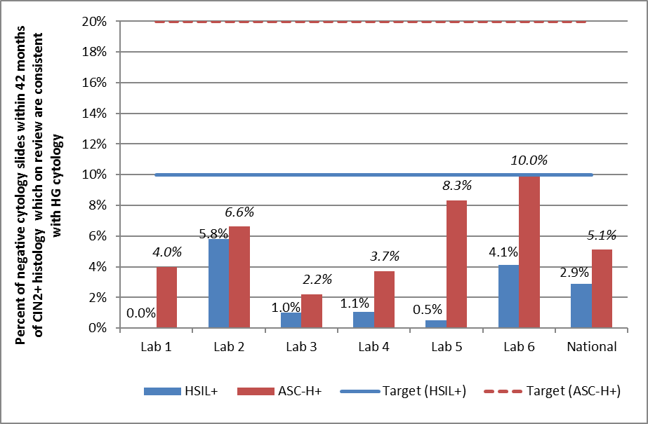
HSIL+ includes cytology interpretation codes HS1, HS2, SC, AIS or AC1-5; ASC-H+ includes cytology interpretation codes ASH, HS1, HS2, SC, AIS, AC1-5 or AG4-5 (see Appendix B – Bethesda 2001 New Zealand Modified). Lab 6 no longer reports on cervical cytology.

Figure 61 – Trends in the proportion of cytology slides within the 42 months preceding a high grade/ invasive histological diagnosis, originally reported as negative, which on review are consistent with HSIL or worse abnormality
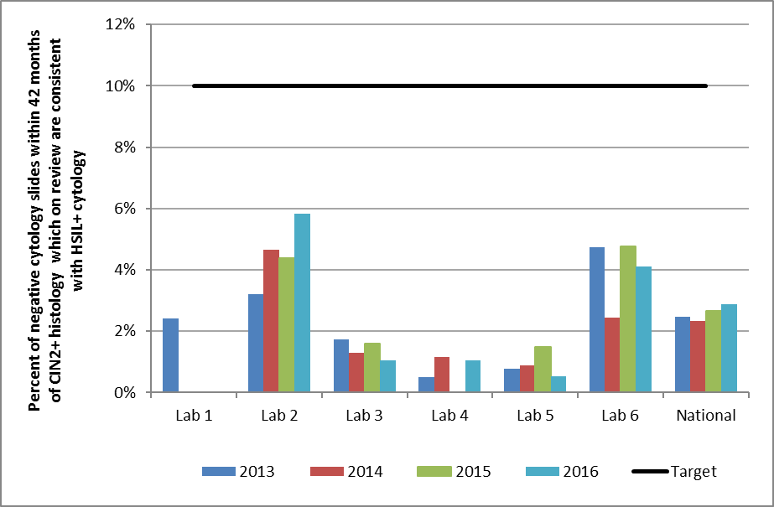
HSIL+ includes cytology interpretation codes HS1, HS2, SC, AIS or AC1-5; (see Appendix B – Bethesda 2001 New Zealand Modified ).

Figure 62 – Trends in the proportion of cytology slides within the 42 months preceding a high grade/ invasive histological diagnosis, originally reported as negative, which on review are consistent with ASC-H or worse abnormality
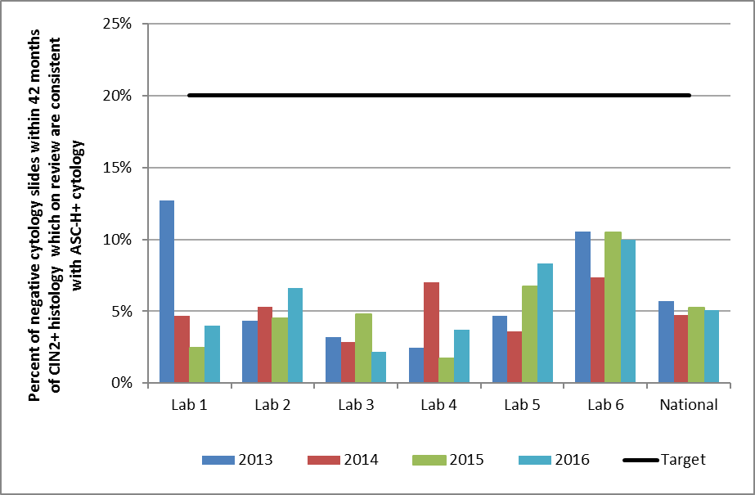
ASC-H+ includes cytology interpretation codes ASH, HS1, HS2, SC, AIS AC1-5 or AG4-5 (see Appendix B – Bethesda 2001 New Zealand Modified ).

Indicator 5.4 – Histology Reporting

Definition | The NCSP Register collects histology results of samples taken from the cervix and vagina. Histology samples include diagnostic biopsies, treatment biopsies, cervical polyps and the cervical tissue of total hysterectomy specimens. All histology samples taken during the current monitoring period were retrieved. Where a histology sample had more than one SNOMED code, or a woman had more than one histology result, the most serious (highest) ranked code was used (see Appendix C).  Results are presented both according to the detailed SNOMED category, and by broader histology diagnostic category. The mapping between SNOMED codes and diagnostic category is detailed in Appendix C.  Two versions of SNOMED are used by laboratories (1986 and 1993) depending on the laboratory software. The NCSP Register accepts both versions and for statistical purposes maps the 1986 codes to the 1993 codes.  A woman’s age is defined as her age at the end of the monitoring period (i.e. a woman’s age at 31 December 2016).
Target | None
Current Situation | 13,974 histology samples were taken during the current monitoring period. 512 (3.7%) of these were insufficient for diagnosis. These samples were taken from 506 women, 110 (21.7%) of whom have a record of a subsequent sufficient histology test. The remaining 13,462 samples were taken from 11,662 women. Results for these women are reported on in detail in Table 7 to Table 10. Table 7 shows histology results by detailed SNOMED category, based on the most serious (highest) ranked result for each woman in the monitoring period. Table 8 to Table 10 and Table 53 show histology results by broader histology diagnostic category.  53.3% of women with histology tests had negative or benign histology results (Table 8). 20.7% of women had high grade squamous (CIN2/3) histology results. There were 70 women (0.60%) women with invasive squamous cell carcinoma (ISCC) histology; 5 (<0.05%) with microinvasive SCC histology; 39 (0.33%) with invasive adenocarcinoma (10 were adenocarcinomas of the endocervical type and 29 were not of the endocervical type); 79 (0.68%) with adenocarcinoma in situ; and 2 (<0.05%) with adenosquamous carcinoma.  The age group with the largest number of women with histology samples was women aged 25-29 years (1,556 women, Table 9). Among women aged 20-69 years, the age group with the lowest rate of women with results which were negative or HPV only was women aged 25-29 years (34.2%, Table 10).  Histology samples were additionally analysed after excluding 2,177 women whose histology result was negative/ benign (non neoplastic) and only originated from a hysterectomy (partial or total) (Table 53). This reduced the proportion with a histology result being negative/ benign to 42.6% of all women with a histology sample. After excluding negative/ benign histology from hysterectomy samples, this resulted in 0.41% of women with histology having an invasive adenocarcinoma result, including with adenocarcinomas of the endocervical type (0.11%) and women with adenocarcinomas not of the endocervical type (0.31%). The most severe histological abnormality detected was HSIL (CIN 2/3) for 25.4% of women; ISCC for 0.74% of women; microinvasive SCC for 0.05% women; adenocarcinoma in situ for 0.83% of women (Table 53).
Trends | The proportion of women with negative or benign histology (53.3%) is similar to that reported for the previous period (53.2%). The proportion of women with HSIL histology is lower in the current period (20.7%) to what it was in the previous period (21.5%). There was a continued decrease in the percentage of HSIL histology in the younger age groups (less than 20 and the 20-24 years) in this monitoring period compared to the previous report (Figure 63).  The proportions were slightly higher to those in the previous period for women with ISCC (0.60% this period and 0.49% last period); were lower for invasive adenocarcinoma not of the endocervical type (0.33% to 0.25% in the current period); and remained similar for adenocarcinoma of the endocervical type (0.08% to 0.09% in the current period). The proportion was also similar for women with adenocarcinoma in situ (0.68% in this period and 0.60% last period).
Comments | Histology samples include diagnostic biopsies, treatment biopsies, cervical polyps and the cervical tissue of total hysterectomy specimens. Histology samples may also include samples from non-cervical sites, where there is also a cervical component in the sample, for example endometrial samples. Also, pathologists are not always able to determine the site of origin particularly in small biopsies. These are likely to be contributing to the higher number of women with adenocarcinoma histology on the NCSP Register compared to the Cancer Registry.  In the current report, a supplementary analysis was undertaken which excluded any samples which originated from a hysterectomy sample (partial or total), overwhelming majority of which were negative/ benign. These supplementary results may more closely reflect the results of histology which were collected in relation to the NCSP.
Table 7 - Histology results reporting by SNOMED category
SNOMED category | Women with that diagnosis
 | N | %
Negative/normal | 3,313 | 28.4
Inflammation | 683 | 5.9
Microglandular hyperplasia | 18 | 0.15
Squamous metaplasia | 379 | 3.2
Polyp | 1,356 | 11.6
Other* | 470 | 4.0
Atypia | 63 | 0.54
Benign glandular atypia | 2 | <0.05
HPV | 799 | 6.9
Condyloma acuminatum | 3 | <0.05
CIN 1 (LSIL) or VAIN 1 | 1,890 | 16.2
Dysplasia/CIN NOS | 44 | 0.38
Glandular dysplasia | - | -
CIN 2 (HSIL) or VAIN 2 | 992 | 8.5
HSIL not otherwise specified | 61 | 0.52
CIN 3 (HSIL) or VAIN 3 | 1,359 | 11.7
Adenocarcinoma in situ | 79 | 0.68
Microinvasive squamous cell carcinoma | 5 | <0.05
Invasive squamous cell carcinoma | 70 | 0.60
Invasive adenocarcinoma (endocervical type) | 10 | 0.09
Invasive adenocarcinoma (not endocervical type) | 29 | 0.25
Adenosquamous carcinoma | 2 | <0.05
Undifferentiated carcinoma | 2 | <0.05
Sarcoma | 2 | <0.05
Carcinosarcoma | 1 | <0.05
Choriocarcinoma | - | -
Miscellaneous primary tumour | - | -
Metastatic tumour | 14 | 0.12
Small cell carcinoma | 2 | <0.05
Malignant tumour, small cell type | - | -
Melanoma | 2 | <0.05
Other primary epithelial malignancy | 12 | 0.10
Total | 11,662 | 100.0
NOS = not otherwise specified; HSIL not otherwise specified = high grade squamous intraepithelial lesion, not otherwise specified/ CIN2/3 (SNOMED code M67017; see Appendix C)
* Other morphologic abnormality, not dysplastic or malignant.
Table 8 - Histology results reporting by diagnostic category
Histology category | Women with that histology result
 | N | %
Negative/benign (non neoplastic) | 6,221 | 53.3
HPV | 802 | 6.9
CIN1 | 1,997 | 17.1
Glandular dysplasia | - | -
CIN2 | 992 | 8.5
HSIL not otherwise specified | 61 | 0.52
CIN3 | 1,359 | 11.7
Adenocarcinoma in situ | 79 | 0.68
Microinvasive | 5 | <0.05
Invasive squamous cell carcinoma | 70 | 0.60
Invasive adenocarcinoma (endocervical type) | 10 | 0.09
Invasive adenocarcinoma (not endocervical type) | 29 | 0.25
Adenosquamous carcinoma | 2 | <0.05
Other cancer | 35 | 0.30
Total | 11,662 | 100.0
Details of mapping between SNOMED category and diagnostic category are included in Appendix C. HSIL not otherwise specified = high grade squamous intraepithelial lesion, not otherwise specified/ CIN 2/3 (SNOMED code M67017; see Appendix C).

Table 9 - Histology results by age – counts
 | Age group
Histology Diagnostic Category | <20 | 20-24 | 25-29 | 30-34 | 35-39 | 40-44 | 45-49 | 50-54 | 55-59 | 60-64 | 65-69 | 70+ | Total
Negative/benign (non neoplastic) | 14 | 370 | 405 | 458 | 562 | 880 | 1,077 | 886 | 607 | 374 | 309 | 279 | 6,221
HPV | 2 | 133 | 127 | 122 | 85 | 91 | 91 | 71 | 39 | 19 | 18 | 4 | 802
CIN1 | 13 | 432 | 400 | 308 | 246 | 190 | 157 | 102 | 67 | 54 | 17 | 11 | 1,997
Glandular dysplasia | - | - | - | - | - | - | - | - | - | - | - | - | -
CIN2 | 2 | 235 | 217 | 174 | 109 | 84 | 63 | 44 | 27 | 18 | 17 | 2 | 992
HSIL not otherwise specified | - | 12 | 19 | 18 | 3 | 3 | 2 | 1 | 1 | 1 | 1 | - | 61
CIN3 | 1 | 202 | 367 | 282 | 178 | 115 | 77 | 58 | 30 | 21 | 23 | 5 | 1,359
Adenocarcinoma in situ | - | 6 | 16 | 17 | 13 | 15 | 8 | 2 | - | 1 | 1 | - | 79
Microinvasive | - | - | - | 2 | 2 | - | - | - | - | - | - | 1 | 5
Invasive squamous cell carcinoma | - | - | 4 | 13 | 3 | 6 | 8 | 9 | 8 | 3 | 5 | 11 | 70
Invasive adenocarcinoma (endocervical type) | - | - | - | 4 | 3 | 4 | 1 | 1 | 4 | 3 | 2 | 7 | 29
Invasive adenocarcinoma (not endocervical type) | - | - | - | - | 5 | 1 | 1 | - | 1 | - | - | 2 | 10
Adenosquamous carcinoma | - | - | - | 1 | - | - | - | - | 1 | - | - | - | 2
Other cancer | - | 1 | 1 | 1 | - | 3 | - | 2 | 7 | 4 | 3 | 13 | 35
Total | 32 | 1,391 | 1,556 | 1,400 | 1,209 | 1,392 | 1,485 | 1,176 | 792 | 498 | 396 | 335 | 11,662
HSIL not otherwise specified = high grade squamous intraepithelial lesion, not otherwise specified/ CIN 2/3 (SNOMED code M67017; see Appendix C)

Table 10 - Histology results by age – percentages
Histology Diagnostic Category | Age group
 | <20 | 20-24 | 25-29 | 30-34 | 35-39 | 40-44 | 45-49 | 50-54 | 55-59 | 60-64 | 65-69 | 70+
Negative/benign  (non neoplastic) | 43.8 | 26.6 | 26.0 | 32.7 | 46.5 | 63.2 | 72.5 | 75.3 | 76.6 | 75.1 | 78.0 | 83.3
HPV | 6.3 | 9.6 | 8.2 | 8.7 | 7.0 | 6.5 | 6.1 | 6.0 | 4.9 | 3.8 | 4.5 | 1.2
CIN1 | 40.6 | 31.1 | 25.7 | 22.0 | 20.3 | 13.6 | 10.6 | 8.7 | 8.5 | 10.8 | 4.3 | 3.3
Glandular dysplasia | - | - | - | - | - | - | - | - | - | - | - | -
CIN2 | 6.3 | 16.9 | 13.9 | 12.4 | 9.0 | 6.0 | 4.2 | 3.7 | 3.4 | 3.6 | 4.3 | 0.6
HSIL not otherwise specified | - | 0.86 | 1.22 | 1.29 | 0.25 | 0.22 | 0.13 | 0.09 | 0.13 | 0.20 | 0.25 | -
CIN3 | 3.1 | 14.5 | 23.6 | 20.1 | 14.7 | 8.3 | 5.2 | 4.9 | 3.8 | 4.2 | 5.8 | 1.5
Adenocarcinoma in situ | - | 0.43 | 1.0 | 1.2 | 1.08 | 1.08 | 0.54 | 0.17 | - | 0.20 | 0.25 | -
Microinvasive | - | - | - | 0.14 | 0.17 | - | - | - | - | - | - | 0.3
Invasive squamous cell carcinoma | - | - | 0.26 | 0.93 | 0.25 | 0.43 | 0.54 | 0.77 | 1.01 | 0.60 | 1.3 | 3.3
Invasive adenocarcinoma (endocervical type) | - | - | - | 0.29 | 0.25 | 0.29 | 0.07 | 0.09 | 0.51 | 0.60 | 0.5 | 2.09
Invasive adenocarcinoma  (not endocervical type) | - | - | - | - | 0.41 | 0.07 | 0.07 | - | 0.13 | - | - | 0.6
Adenosquamous carcinoma | - | - | - | 0.07 | - | - | - | - | 0.13 | - | - | -
Other cancer | - | 0.07 | 0.06 | 0.07 | - | 0.22 | - | 0.17 | 0.88 | 0.80 | 0.8 | 3.9
Total | 100.0 | 100.0 | 100.0 | 100.0 | 100.0 | 100.0 | 100.0 | 100.0 | 100.0 | 100.0 | 100.0 | 100.0
HSIL not otherwise specified = high grade squamous intraepithelial lesion, not otherwise specified/ CIN 2/3 (SNOMED code M67017; see Appendix C).

Figure 63 - Trends in histologically-confirmed HSIL as a percentage of all women with histology (to 1 July 2011 – 31 December 2016)
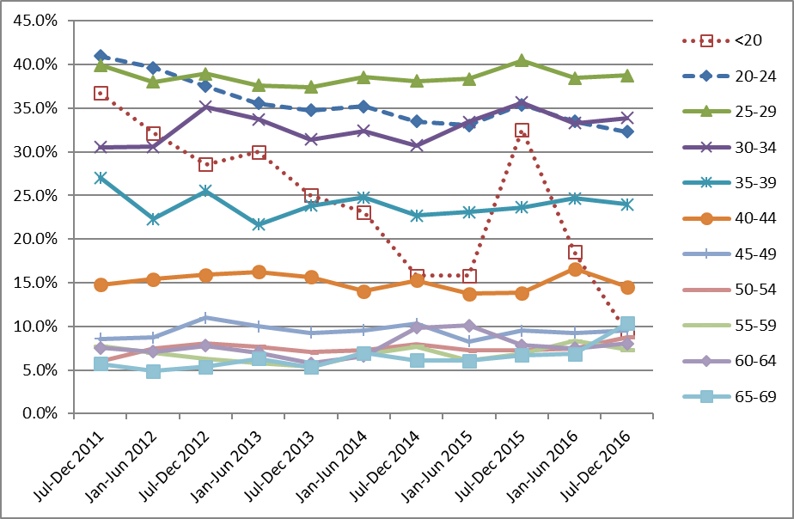

Indicator 5.5 - Laboratory turnaround times

Definition | Turnaround time is defined as the number of working days from the date a sample is received by a laboratory, and the date which it is reported to the smear-taker or colposcopist. For the purposes of this measure, samples received and reported on the same day are defined as having a turnaround time of one day.
Target | Cytology  Laboratories are required to report 90% of final gynaecological cytology results to sample taker within seven working days of receipt of the sample and 98% within 15 working days (Standard 513¹¹).  Histology  Laboratories are required to report 90% of final histology results to referring colposcopists within ten working days of receipt of the sample and 98% of final histology results within 15 working days of receiving the sample (Standard 516¹¹).  Cytology with associated hrHPV testing  Laboratories are required to report 98% of final cytology test results (including those associated with HPV test) within 15 working days of receiving the sample. Here, the turnaround time is measured specifically for cytology where HPV testing is performed for low grade triage. Low grade triage is defined further in Indicator 8; here it relates to cytology samples received at the laboratory in the monitoring period (as opposed to samples collected in the period, in Indicator 8). It is restricted to triage testing of women aged 30 years or more. These samples form a subset of those considered in the overall measure of turnaround time for cytology. Note that since reporting of cytology with adjunctive hrHPV testing requires that both test results be reported together (hrHPV test results must not be issued independently when adjunct to a cytology request), the turnaround time of the hrHPV test should not exceed that of the accompanying cytology, except where the HPV test was added after cytology was already reported.
Current Situation | Cytology  Six laboratories received 208,935 cytology samples during the current monitoring period. Overall, 96.2% of cytology samples were reported on within seven working days, which meets the target of 90% (Table 54). Nationally, 98.9% were reported on within 15 working days, which meets the target of 98%.  Five of the six laboratories met the target for 90% of cytology samples to be reported to sample taker in seven working days or less (Anatomical Pathology Services, Canterbury Health Laboratories, Medlab Central Ltd., Pathlab, Southern Community Laboratories). The remaining laboratory, LabPLUS, had reported 89.9% within seven working days. (Figure 64, Table 54).  Five laboratories met the target of 98% of samples reported within 15 working days (Anatomical Pathology Services, Canterbury Health Laboratories, Medlab Central Ltd, Pathlab, Southern Community Laboratories) (Figure 65, Table 54). The remaining laboratory (LabPLUS) had reported on 97.4% of cytology samples within 15 working days.  Histology  Fourteen laboratories received 14,014 histology samples in the current monitoring period. Overall 91.2% of samples were reported on within ten working days, which meets the target of 90%. Nationally 95.2% were reported on in 15 working days or less, which is below the target of 98% (Table 55). Nine of the 14 laboratories met the target of 90% of final histology results to referring colposcopists within ten working days of receipt of the sample (Anatomical Pathology Services, Canterbury Health Laboratories, Medlab Central Ltd., Middlemore Hospital Laboratory, Nelson Hospital Laboratory, North Shore Hospital Laboratory, Northland Pathology Laboratory, Southern Community Laboratories, Taranaki Medlab) (Figure 66, Table 55). Five laboratories met the target of 98% of final histology results within 15 working days of receiving the sample (Figure 67, Table 55). Three of the remaining eight laboratories had reported on at least 95% of samples within 15 days.  Low grade cytology with associated HPV triage testing  Six laboratories received 2,681 cytology samples during the current monitoring period which were associated with HPV testing for the purpose of triage of low grade abnormalities. Overall, 98.7% of these cytology samples were reported on within 15 working days, which meets the target of 98%. The proportion of cytology samples with HPV triage tests reported on within 15 days ranged from 95.3% (Canterbury Health Laboratories) to 99.8% (Anatomical Pathology Services) (Figure 68, Table 56).  The target of 98% of tests reported within 15 working days was met by four of the six laboratories. Nationally, the proportion of cytology reported within 15 days for cytology associated with low grade triage HPV testing (98.7%) was similar to the cytology reported overall (98.9%). At most laboratories, the proportion of cytology tests reported within 15 working days was similar regardless of whether there is an associated HPV triage test (Figure 68). Canterbury Health Laboratories reported below the target level for cytology associated with low grade triage HPV testing (95.3%) but achieved the target for cytology overall (99.0%).
Trends | Cytology  The overall proportion of samples reported on within seven working days is higher in the current report (96.2%) than in the previous monitoring period (95.1%). Five laboratories meet the target in this monitoring period which is one additional laboratory compared to the previous reporting period. The proportion of samples reported on within 15 working days was similar to that reported in the previous monitoring period (98.9%, compared to 98.6%) in the previous monitoring period). Five laboratories met the target of reporting 98% of samples within 15 working days, including all of the four who met the target in the previous monitoring period. All six laboratories had reported on at least 95% of samples within 15 working days in the current monitoring period, as was also the case in the previous monitoring period.  Histology  The proportion of histology samples reported on within ten working days has increased from 90.6%, to 91.2%. One additional laboratory achieved the ten-working-days target in this monitoring period compared to the last. The proportion of histology samples reported on within 15 working days is similar to the previous report (95.2%, compared to 95.5% in the previous report). One laboratory that achieved the target in the previous monitoring period fell below the 98% target, resulting in a total of five laboratories meeting the target in this period that also met the target in the previous monitoring period. In the current period, eight of the 14 laboratories had reported on at least 95% of samples within 15 days, which is two fewer than achieved in the previous period.  Cytology with associated HPV triage testing  The proportion of cytology samples with an associated HPV triage test reported within 15 working days has remained similar to the previous report – from 98.9% to 98.7%.
Comments | Note that the total number of cytology samples reported on in this Indicator is different from that reported in Indicator 5.1, as the inclusion criteria for the current indicator was all cytology samples received by laboratories within the monitoring period, rather than cytology samples where the specimen was collected during the monitoring period, which is the criteria for Indicator 5.1.  Two laboratories reporting histology (Capital & Coast DHB and Hutt Hospital laboratories) combined and became Southern Community Laboratories Wellington on 1 November 2015, therefore data for these two laboratories have been combined in the current report, and the number of laboratories reporting histology had decreased from 15 to 14.  Turnaround time performance may be an underestimate due to limitations in the report date recorded on NCSP Register. The definition used by individual laboratories for turnaround time differs. For example, depending on the definition used by the laboratory, a turnaround time of one day can mean the results are reported within 24 hours, on the same day the sample is received, or on the day after the sample is received. Therefore, we have applied the same definition to all laboratories in these calculations, but because of the variation between laboratories in their internal definition, it has not been possible in this report to use a definition here which is consistent with what each individual laboratory uses.  When errors are detected in the NCSP Register, the report date in the NCSP Register is updated to reflect the date on which the report was re-transmitted after the error was resolved. The occurrence of these errors can therefore distort (and lengthen) turnaround time, as in these cases the report date recorded in the NCSP Register does not reflect the date on which results were first communicated to the smear-taker or colposcopist. The extent of this cannot be directly determined from the NCSP Register, however audit results (which invariably find better turnaround time performance) suggest that it is a factor which should be considered in interpretation of these results.  There are some possible explanations why in some laboratories the turnaround time for cytology with associated HPV triage testing is longer than for other cytology. As the HPV triage test is performed in response to low grade cytology results in a subset of women (those aged 30 years or more without a recent cytological abnormality), the need for the HPV test is only apparent after the cytology result is available. Additionally, as HPV tests are generally performed in batches, laboratories with smaller HPV test volumes may take longer to accrue the required batch sizes, and therefore perform HPV tests less frequently.  Caution must be taken when comparing percentages of reporting from this monitoring period to the previous monitoring periods due to changes in the number of reporting laboratories. Differences in percentages from this and previous monitoring reports may be due to differences in caseloads.
Figure 64 - Proportion of cytology samples reported within seven working days by laboratory, 1 July – 31 December 2016
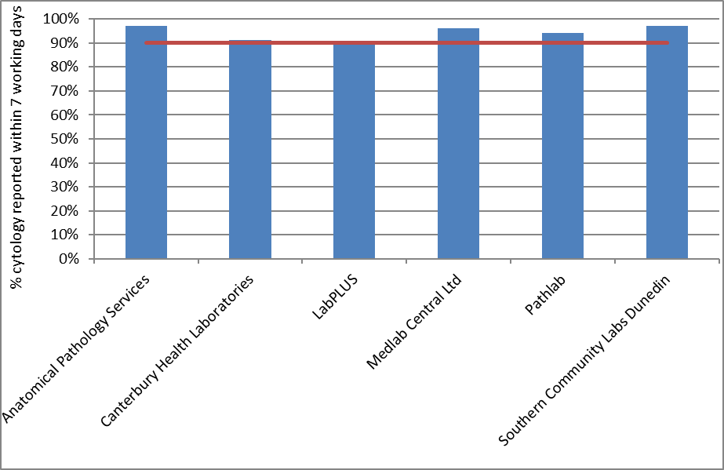
Target: 90% within seven working days (red line)

Figure 65 - Proportion of cytology samples reported within 15 working days by laboratory, 1 July – 31 December 2016
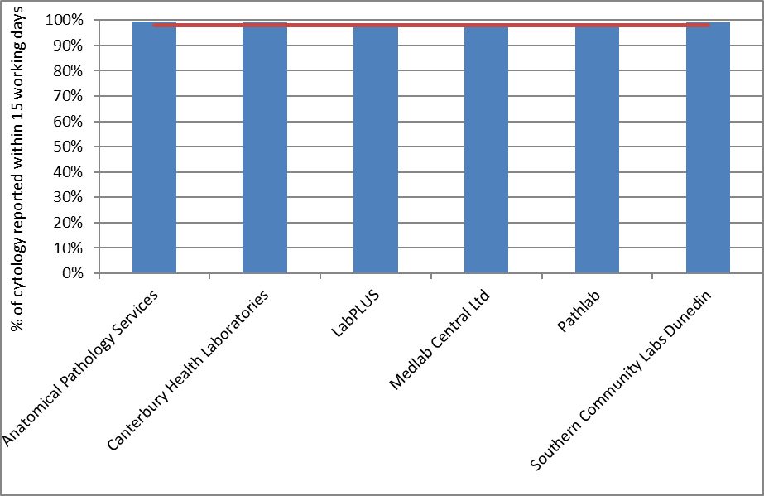
Target: 98% within 15 working days (red line)

Figure 66 - Proportion of histology samples reported within ten working days by laboratory, 1 July – 31 December 2016
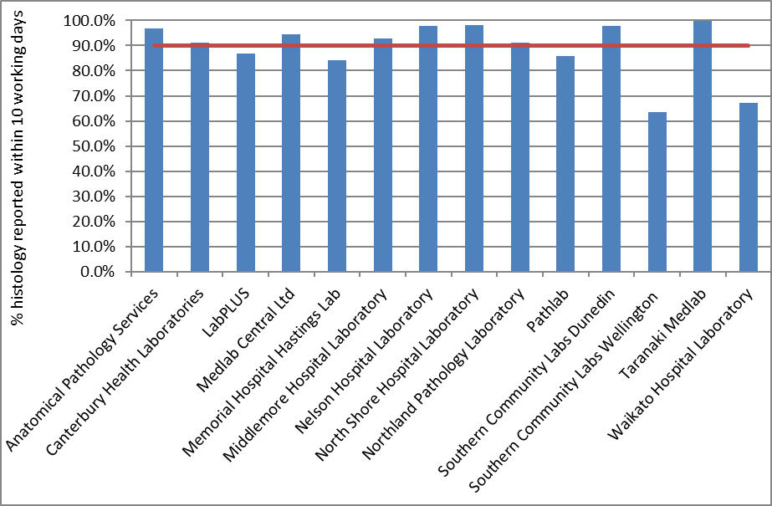
Target: 90% within ten working days (red line)

Figure 67 - Proportion of histology samples reported within 15 working days by laboratory, 1 July – 31 December 2016
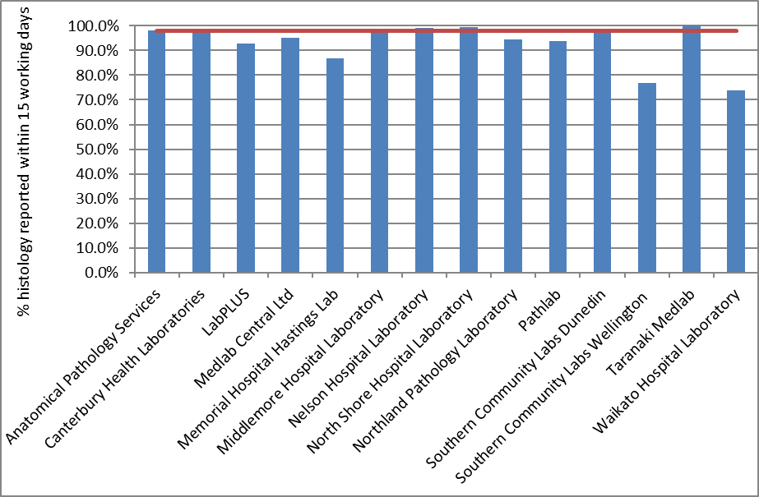
Target: 98% within 15 working days (red line)

Figure 68 - Proportion of cytology samples with associated HPV triage testing and of all cytology samples reported within 15 days by laboratory, 1 July – 31 December 2016
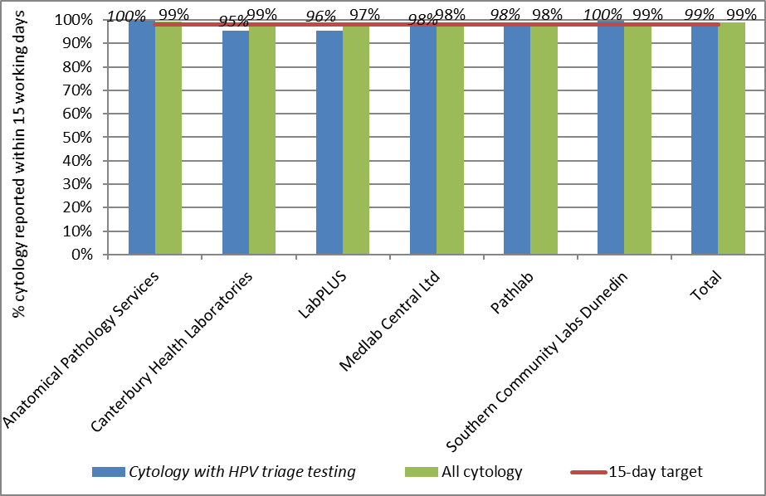
Target: 98% within 15 working days (red line)

Indicator 6 – Follow-up women high grade cytology, no histology

Definition | The proportion of women who have had a cervical sample showing a high grade cytology result for whom a histological report has been received by the NCSP Register. This proportion is a measure of the completeness of follow-up of women with high grade cytology.  Each woman with a high grade cytology result, relating to a cytology sample taken in the six months preceding the current monitoring period (i.e. sample taken in the period of 1 January – 30 June 2016), is followed for any histology samples taken on or after the date of the cytology sample. The period of time between the cytology and histology reports relating to these samples is calculated. The proportion of women with a histology report up to and including 90 days after their cytology report is calculated. Histology reports which occur prior to the cytology report are included, as long as the histology sample was not taken before the cytology sample, to allow for differences in turnaround times between cytology and histology.  Analyses were also performed which calculated the proportion of women with a high grade cytology result who have a histology report within 180 days of their cytology report.  For the purposes of this indicator, the following Bethesda 2001 New Zealand modified (2005) interpretation codes are included as high grade cytology: ASH, HS1, HS2, SC, AG1-AG5, AIS, AC1-AC5. Within this group, women are considered as having an urgent referral, due to suspicion of invasive disease if they have an interpretation code of HS2, SC, or AC1-5 and/or a recommendation code of R10 or R14.  High grade cytology reports which indicated that women were already under specialist management (TBS 2001 NZ modified 2005 recommendation code R13) are excluded. After these are excluded, follow-up of women who have more than one high grade cytology sample is based on the first cytology sample collected in the period.  Note that some women may be assessed at colposcopy but have no biopsy taken. The colposcopy visit data for this group of women (Indicator 7.1) will supplement this indicator. An exploratory analysis was also performed here which calculated the proportion of women with high grade cytology who had no follow-up test of any kind (including colposcopy, histology sample, HPV sample, or subsequent cytology sample) within 180 days.  Note that the Programme also attempts to facilitate the follow-up of all women with absent histology so that they may receive appropriate care where possible.  A woman’s age is defined as her age at the end of the current monitoring period (i.e. A woman’s age at 31 December 2016).
Target | 90% of women should have a histology report within 90 days of their cytology report date.  99% of women should have a histology report within 180 days of their cytology report.
Current Situation | There were 3,897 high grade cytology results relating to samples collected in the period 1 January – 30 June 2016; 1,561 of these cytology samples were collected at a colposcopy visit or the results indicated that a woman was already under specialist management. It was assumed that these results were already being followed up in the course of this management, and so the cytology tests were excluded from this measure. This left 2,336 cytology results, which related to 2,332 women. Histological follow-up for these 2,332 women is considered in this indicator. Where women had more than one high grade cytology result relating to a sample taken in the period, histological follow-up of the earliest cytology sample taken in the period was assessed.  Histological follow-up  Nationally, 1,900 women (81.5%) had a histology report within 90 days of their cytology report, and 2,047 (87.8%) had a histology report within 180 days. These were below the targets of 90% within 90 days and 99% within 180 days.  The proportion of women with a histology report varied by DHB from 57.7% (Wairarapa) to 90.2% (Waikato) within 90 days of their cytology report, and from 73.1% (Wairarapa) to 93.5% (Mid Central) within 180 days of their cytology report (Figure 69, Table 11). One DHB met the target for the proportion of women with histology within 90 days (Waikato, with 90.2% of histology reported within 90 days of a high grade cytology report) however none met the target for 180 days. As shown in Table 11, some DHBs had a relatively small number of women with a high grade cytology result recorded in the period (including Tairawhiti and Wairarapa, with 22 and 26 women respectively with a high grade result), and this should be taken into account when interpreting these results.  The proportion of women with a histology report also varied by age. Among women aged 20-69 years, the proportion varied from 65.4% (ages 60-64) to 87.0% (ages 40-44 years) within 90 days, and from to 75.0% (ages 50-54 years) to 94.1% (ages 40-44 years) within 180 days (Table 12). The targets were not met in any age group.  There was some variation in the proportion of women with histological follow-up by ethnicity, however the targets were not met for any group of women. At 90 days, the proportion of women with histological follow-up ranged from 67.3% (Pacific women) to 84.0% (European/ Other woman). By 180 days, however, the difference had narrowed, and the proportion with histology reports ranged from 82.0% (Pacific women) to 88.8% (European/ Other women; Table 13, Table 14). Further breakdown by DHB and ethnicity is also shown in Table 13 and Table 14, and breakdown by DHB and age is shown in Table 57 and Table 58.  Among women with an urgent referral, due to a suspicion of invasive disease (N=88), a histology report was available within 90 days for 84.1% of women and within 180 days for 88.6% of women (Table 15). Among women where there was no suspicion of invasive disease (NZ modified Bethesda 2001 codes ASH, HS1, AG1-5, AIS), 81.4% had a histology report available within 90 days and 87.7% within 180 days.  Women with no follow-up tests  When follow-up tests of any kind (colposcopy, histology, HPV test, or subsequent cytology test) were considered, there were 237 women (10.2%) who had no record of any subsequent follow-up within 90 days and 152 women (6.5%) who had no record of any subsequent follow-up within 180 days on the NCSP Register (Table 16).  This varied by DHB from 3.4% (Whanganui) to 19.2% (Wairarapa) of women without follow-up of some kind by 90 days, and from no women (Tairawhiti) to 19.2% (Wairarapa) of women without follow-up of some kind by 180 days (Figure 70, Table 16). At 90 days, the number remaining without follow-up was ten or fewer in 13 DHBs and was a maximum of 44 women (16.0%) in Counties Manukau. At 180 days, the number remaining without follow-up was ten or fewer in 15 DHBs, with a maximum of 30 women (10.9%) without follow-up in Counties Manukau.  The proportion of women who had no record of any subsequent follow-up also varied by ethnicity, from 8.2% (European/ Other woman) to 25.3% (Pacific woman) at 90 days and from 5.6% (European/ Other woman) to 13.3% (Pacific women) at 180 days (Table 17, Figure 71).  Among women with an urgent referral, due to a suspicion of invasive disease, a follow-up test of some kind was available within 90 days for 88.6% of women and within 180 days for 90.9% of women (Table 15). At 180 days, there remained 8 women (9.1%) for whom no follow-up tests were recorded. Among women where there was no suspicion of invasive disease (NZ modified Bethesda 2001 codes ASH, HS1, AG1-5, AIS), 89.9% had a follow-up test report available within 90 days and 93.6% within 180 days (Table 15). At 180 days, there remained 144 women (6.4%) for whom no follow-up tests were recorded.
Trends | Histological follow-up  The proportion of women with a histology report within 90 days has increased slightly since the previous monitoring period (from 80.4% to 81.5% in the current period). The proportion of women with a histology report within 180 days has remained similar (87.6% in the previous period; 87.8% in the current period).  While the proportion of women with histological follow-up has improved overall, this still varies for individual DHBs. In five DHBs the proportion of women with histological follow-up has decreased at 90 days and at 180 days (Bay of Plenty, Capital & Coast, Nelson Marlborough, Taranaki and Wairarapa). In ten DHBs, the proportion of women with histological follow-up increased at both 90 days and at 180 days (Auckland, Canterbury, Counties Manukau, Hawke's Bay, Lakes, Northland, South Canterbury, Tairawhiti, Waikato and Whanganui).  The proportion of women with follow-up histology at 90 days in the current monitoring period has increased for Māori, Asian and European/ Other woman (Asian women from 76.1%, to 78.5%; Māori from 72.7% to 78.0%; and European/ Other women from 83.4% to 84.0%). There has been a decrease in the proportion of Pacific women with follow-up histology within 90 days for the last two monitoring periods (from 75.2% in Report 44, to 69.1% in the previous monitoring period, and to 67.3% in the current monitoring period). The proportion of women with follow-up histology at 180 days has increased for Māori, Pacific and Asian women (from 83.2% to 86.1% for Māori; 79.7% to 82.0% for Pacific; and 85.0% to 86.9% for Asian woman), and decreased for European/ Other women (from 89.4% to 88.8%). The proportions of women with follow-up histology are quite variable within individual DHBs and when broken down by DHB and ethnicity, as the number of women with high grade cytology generally becomes comparatively small when broken down in those categories (except in some cases such as for European/ Other women, and Māori women in a few DHBs).  As in previous reports, the proportion of women with histological follow-up varies substantially by age, and is generally lower in women aged 50 years or more, than in women younger than 50 years. Increases in the proportion of women with histological follow-up were seen in six of the ten age groups at 90 days follow-up, and five age groups at 180 days. Decreases were seen in the five-year age groups between 30 to 39 and 50 to 59 at 90 days, and between 25 to 39 and 50 to 59 years at 180 days.  Women with no follow-up tests  The proportion of women with no record of a follow-up test has remained similar to that in the previous report at 90 days (10.2% in both reports), and has increased at 180 days (from 5.8% to 6.5%).  Trends by DHB were complex, but the proportion of women with no follow-up test recorded at 180 days reduced in eight of the 20 DHBs, and the reductions were greatest in Tairawhiti, Northland and South Canterbury. Increases were observed in some other DHBs and were largest in Wairarapa, Bay of Plenty and Lakes.  In the current monitoring period, the proportion of women for whom there was no follow-up test recorded has increased for Pacific and European/ Other women at 90 days, and for European/ Other women at 180 days. For Māori women there was a decrease from 17.9% to 12.4% at 90 days, and from 8.6% to 7.8% at 180 days. For Asian women there was a decrease from 11.9% to 10.5% at 90 days, and from 7.1% to 6.3% at 180 days. For European/ Other women the percent of women with no follow-up increased slightly from 7.4% to 8.2% at 90 days, and from 4.4% to 5.6% at 180 days. For Pacific women the proportion with no follow-up test recorded increased from 23.6% to 25.3% at 90 days, but decreased from 14.6% to 13.3% at 180 days.
Comments | The proportion of women with a follow-up test of any kind provides useful additional information. While 18.5% of women with high grade cytology reports had no record of a histology report within 90 days, the proportion without a record of a follow-up test of any kind was much lower (10.2%). The same was also true at 180 days, where 12.2% of women with high grade cytology reports had no record of a histology report within 180 days, but the proportion without a record of a follow-up test of any kind was much lower (6.5%). Consistent with previous monitoring reports, many of the women with no follow-up histology recorded do have a record of some follow-up test. This provides reassurance that many women without histology have not been lost to follow-up.  The measure of whether or not there has been a follow-up test of any sort considers cytology, colposcopy, histology and HPV tests. Therefore, changes in women with a follow-up of any kind of test may also reflect changes in the completeness of reporting on the NCSP Register for some tests. In particular, it may reflect changes in reporting of colposcopy visits on the Register over time (whereas it is expected that the completeness of laboratory-based tests is not likely to have changed).  Note that some women presenting with cancer may be referred directly to oncology and therefore not recorded on the NCSP Register. This may have contributed to the lower rates of follow-up recorded for women with an urgent referral, due to a suspicion of invasive disease.  Note that while all cytology results which indicated that a woman was under specialist management were excluded from the measure of follow-up, not all women who had these cytology results were. If all cytology results for a woman indicated that she was under specialist management, she was excluded. However, any woman with at least one high grade cytology result which did not indicate that she was under specialist management was included in the group in whom histological follow-up was measured. It was assumed that any high grade cytology result without this indication should have been followed up in some way, regardless of other cytology results in the period. All of the cytology tests selected for follow-up indicated that referral or further assessment was recommended.  The risk level for women with no recorded biopsy is difficult to ascertain because a lack of histology can be due to a number of reasons, including:  - examined but no biopsy taken,  - did not attend (DNA) or refusal to attend  - wait time issue  - died or left New Zealand  Risk is also related to the degree of abnormality including microinvasive/ invasive carcinoma. Women who do not or refuse to attend are at highest risk due to no colposcopic examination. Due to the significant risk for this group of women if not followed up, NCSP Portfolio Managers ensure that priority is given to follow-up of these women through DHBs.

Figure 69 - Proportion of women with a histology report within 90 days, and within 180 days of their high grade cytology report, by DHB
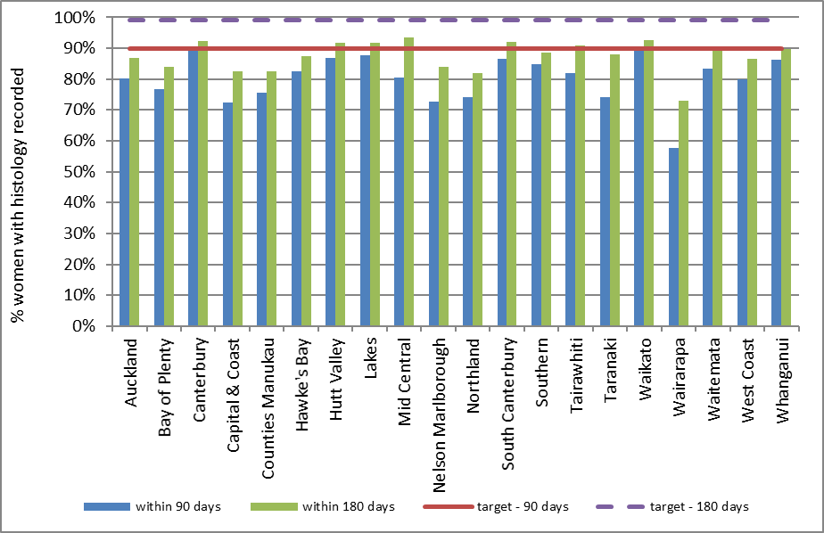
Target: 90% within 90 days; 99% within 180 days.

Table 11 - Women with a histology report within 90 and 180 days of a high grade cytology report, by DHB
DHB | High-grade cytology | Follow-up histology within 90 days |  | Follow-up histology within 180 days
 | N | N | % | N | %
Auckland | 273 | 219 | 80.2 | 237 | 86.8
Bay of Plenty | 94 | 72 | 76.6 | 79 | 84.0
Canterbury | 303 | 272 | 89.8 | 280 | 92.4
Capital & Coast | 148 | 107 | 72.3 | 122 | 82.4
Counties Manukau | 275 | 208 | 75.6 | 227 | 82.5
Hawke's Bay | 80 | 66 | 82.5 | 70 | 87.5
Hutt Valley | 61 | 53 | 86.9 | 56 | 91.8
Lakes | 49 | 43 | 87.8 | 45 | 91.8
Mid Central | 77 | 62 | 80.5 | 72 | 93.5
Nelson Marlborough | 62 | 45 | 72.6 | 52 | 83.9
Northland | 89 | 66 | 74.2 | 73 | 82.0
South Canterbury | 37 | 32 | 86.5 | 34 | 91.9
Southern | 157 | 33 | 84.7 | 139 | 88.5
Tairawhiti | 22 | 18 | 81.8 | 20 | 90.9
Taranaki | 58 | 43 | 74.1 | 51 | 87.9
Waikato | 174 | 157 | 90.2 | 161 | 92.5
Wairarapa | 26 | 15 | 57.7 | 19 | 73.1
Waitemata | 288 | 240 | 83.3 | 258 | 89.6
West Coast | 30 | 24 | 80.0 | 26 | 86.7
Whanganui | 29 | 25 | 86.2 | 26 | 89.7
Total | 2,332 | 1,900 | 81.5 | 2,047 | 87.8

Table 12 - Women with a histology report within 90 and 180 days of a high grade cytology report, by age
Age (years) | High grade cytology | Follow-Up histology Within 90 days |  | Follow-up histology  Within 180 days
 | N | N | % | N | %
<20 | 9 | 5 | 55.6 | 5 | 55.6
20-24 | 379 | 319 | 84.2 | 342 | 90.2
25-29 | 524 | 453 | 86.5 | 471 | 89.9
30-34 | 401 | 344 | 85.8 | 364 | 90.8
35-39 | 248 | 204 | 82.3 | 226 | 91.1
40-44 | 185 | 161 | 87.0 | 174 | 94.1
45-49 | 142 | 119 | 83.8 | 132 | 93.0
50-54 | 124 | 87 | 70.2 | 93 | 75.0
55-59 | 121 | 80 | 66.1 | 91 | 75.2
60-64 | 81 | 53 | 65.4 | 64 | 79.0
65-69 | 68 | 48 | 70.6 | 53 | 77.9
70+ | 50 | 27 | 54.0 | 32 | 64.0
Total | 2,332 | 1,900 | 81.5 | 2,047 | 87.8

Table 13 - Women with a histology report within 90 days of a high grade cytology report, by DHB and ethnicity
 | Māori |  | Pacific |  | Asian |  | European/ Other
DHB | N | % | N | % | N | % | N | %
Auckland | 13 | 76.5 | 18 | 64.3 | 43 | 82.7 | 145 | 82.4
Bay of Plenty | 11 | 73.3 | 1 | 50.0 | 7 | 87.5 | 53 | 76.8
Canterbury | 25 | 80.6 | 7 | 70.0 | 15 | 83.3 | 225 | 92.2
Capital & Coast | 10 | 90.9 | 6 | 75.0 | 10 | 66.7 | 81 | 71.1
Counties Manukau | 43 | 71.7 | 39 | 68.4 | 38 | 67.9 | 88 | 86.3
Hawke's Bay | 24 | 85.7 | 1 | 50.0 | 2 | 66.7 | 39 | 83.0
Hutt Valley | 8 | 80.0 | 4 | 80.0 | 3 | 100.0 | 38 | 88.4
Lakes | 17 | 94.4 | 0 | 0.0 | 0 | 0.0 | 26 | 92.9
Mid Central | 15 | 83.3 | 2 | 100.0 | 4 | 100.0 | 41 | 77.4
Nelson Marlborough | 3 | 75.0 | 0 | 0.0 | 3 | 100.0 | 39 | 73.6
Northland | 18 | 75.0 | 1 | 50.0 | 3 | 100.0 | 44 | 73.3
South Canterbury | 1 | 100.0 | - | - | 0 | 0.0 | 31 | 88.6
Southern | 11 | 78.6 | 2 | 100.0 | 4 | 66.7 | 116 | 85.9
Tairawhiti | 8 | 72.7 | 1 | 100.0 | - | - | 9 | 90.0
Taranaki | 9 | 75.0 | - | - | 3 | 75.0 | 31 | 73.8
Waikato | 29 | 96.7 | 4 | 80.0 | 9 | 100.0 | 115 | 88.5
Wairarapa | 3 | 42.9 | 0 | 0.0 | - | - | 12 | 66.7
Waitemata | 17 | 60.7 | 15 | 71.4 | 39 | 81.3 | 169 | 88.5
West Coast | 1 | 50.0 | - | - | 2 | 100.0 | 21 | 80.8
Whanganui | 4 | 80.0 | - | - | 1 | 100.0 | 20 | 87.0
Total | 270 | 78.0 | 101 | 67.3 | 186 | 78.5 | 1,343 | 84.0
‘ – ‘ indicates there were no women in this sub-category with a high grade cytology report

Table 14 - Women with a histology report within 180 days of a high grade cytology report, by DHB and ethnicity
 | Māori |  | Pacific |  | Asian |  | European/ Other
DHB | N | % | N | % | N | % | N | %
Auckland | 13 | 76.5 | 24 | 85.7 | 46 | 88.5 | 154 | 87.5
Bay of Plenty | 13 | 86.7 | 2 | 100.0 | 7 | 87.5 | 57 | 82.6
Canterbury | 25 | 80.6 | 7 | 70.0 | 18 | 100.0 | 230 | 94.3
Capital & Coast | 11 | 100.0 | 7 | 87.5 | 11 | 73.3 | 93 | 81.6
Counties Manukau | 48 | 80.0 | 45 | 78.9 | 42 | 75.0 | 92 | 90.2
Hawke's Bay | 25 | 89.3 | 1 | 50.0 | 3 | 100.0 | 41 | 87.2
Hutt Valley | 9 | 90.0 | 4 | 80.0 | 3 | 100.0 | 40 | 93.0
Lakes | 17 | 94.4 | 1 | 50.0 | 0 | 0.0 | 27 | 96.4
Mid Central | 17 | 94.4 | 2 | 100.0 | 4 | 100.0 | 49 | 92.5
Nelson Marlborough | 3 | 75.0 | 2 | 100.0 | 3 | 100.0 | 44 | 83.0
Northland | 20 | 83.3 | 2 | 100.0 | 3 | 100.0 | 48 | 80.0
South Canterbury | 1 | 100.0 | - | - | 1 | 100.0 | 32 | 91.4
Southern | 13 | 92.9 | 2 | 100.0 | 5 | 83.3 | 119 | 88.1
Tairawhiti | 9 | 81.8 | 1 | 100.0 | - | - | 10 | 100.0
Taranaki | 11 | 91.7 | - | - | 4 | 100.0 | 36 | 85.7
Waikato | 30 | 100.0 | 5 | 100.0 | 9 | 100.0 | 117 | 90.0
Wairarapa | 4 | 57.1 | 1 | 100.0 | - | - | 14 | 77.8
Waitemata | 22 | 78.6 | 17 | 81.0 | 44 | 91.7 | 175 | 91.6
West Coast | 2 | 100.0 | - | - | 2 | 100.0 | 22 | 84.6
Whanganui | 5 | 100.0 | - | - | 1 | 100.0 | 20 | 87.0
Total | 298 | 86.1 | 123 | 82.0 | 206 | 86.9 | 1,420 | 88.8
‘ – ‘ indicates there were no women in this sub-category with a high grade cytology report

Table 15 - Women with high grade cytology who have follow-up within 90 and 180 days recorded on the NCSP Register, by urgency of referral and type of follow-up
 | Urgent referral  (HS2, SC, AC1-5) |  | No suspicion of invasion (ASH, HS1, AG1-5, AIS)
 | N | % | N | %
Follow-up within 90 days
- histology | 74 | 84.1 | 1,826 | 81.4
- any follow-up | 78 | 88.6 | 2,017 | 89.9
- no follow-up | 10 | 11.4 | 227 | 10.1
Follow-up within 180 days
- histology | 78 | 88.6 | 1,969 | 87.7
- any follow-up | 80 | 90.9 | 2,100 | 93.6
- no follow-up | 8 | 9.1 | 144 | 6.4

Figure 70 - Proportion of women without any follow-up test within 90 days and within 180 days of a high grade cytology report, by DHB
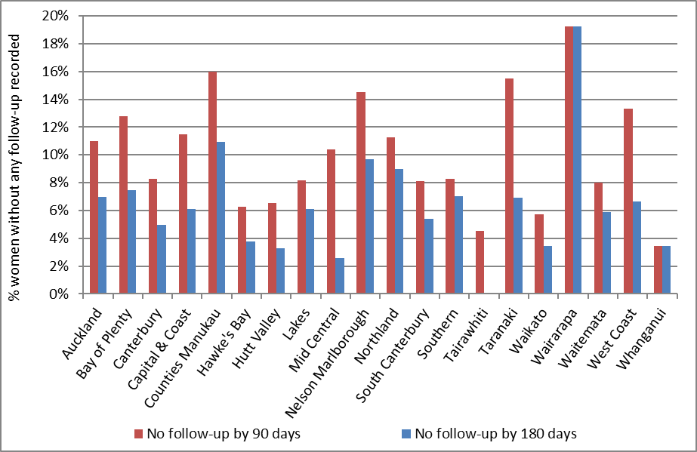
There were no women without follow-up recorded within 180 days in Tairawhiti.

Figure 71 - Proportion of women without any follow-up test within 90 days and within 180 days of a high grade cytology report, by ethnicity
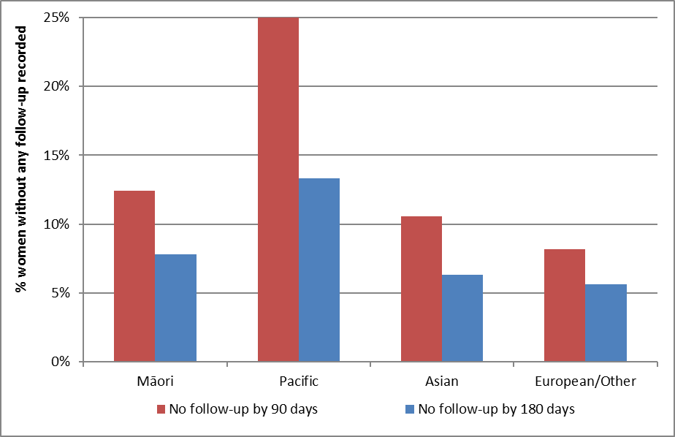

Table 16 - Women without any follow-up test within 90 and 180 days of a high grade cytology report, by DHB
 | High-grade cytology | Without a follow-up test by 90 days |  | Without a follow-up test by 180 days
DHB | N | N | % | N | %
Auckland | 273 | 30 | 11.0 | 19 | 7.0
Bay of Plenty | 94 | 12 | 12.8 | 7 | 7.4
Canterbury | 303 | 25 | 8.3 | 15 | 5.0
Capital & Coast | 148 | 17 | 11.5 | 9 | 6.1
Counties Manukau | 275 | 44 | 16.0 | 30 | 10.9
Hawke's Bay | 80 | 5 | 6.3 | 3 | 3.8
Hutt Valley | 61 | 4 | 6.6 | 2 | 3.3
Lakes | 49 | 4 | 8.2 | 3 | 6.1
Mid Central | 77 | 8 | 10.4 | 2 | 2.6
Nelson Marlborough | 62 | 9 | 14.5 | 6 | 9.7
Northland | 89 | 10 | 11.2 | 8 | 9.0
South Canterbury | 37 | 3 | 8.1 | 2 | 5.4
Southern | 157 | 13 | 8.3 | 11 | 7.0
Tairawhiti | 22 | 1 | 4.5 | - | 0.0
Taranaki | 58 | 9 | 15.5 | 4 | 6.9
Waikato | 174 | 10 | 5.7 | 6 | 3.4
Wairarapa | 26 | 5 | 19.2 | 5 | 19.2
Waitemata | 288 | 23 | 8.0 | 17 | 5.9
West Coast | 30 | 4 | 13.3 | 2 | 6.7
Whanganui | 29 | 1 | 3.4 | 1 | 3.4
Unspecified | - | - | 0.0 | - | 0.0
Total | 2,332 | 237 | 10.2 | 152 | 6.5

Table 17 - Women without any follow-up test within 180 days of a high grade cytology report, by ethnicity
Ethnicity | High grade cytology | Without follow-up by 90 days |  | Without follow-up by 180 days
 | N | N | % | N | %
Māori | 346 | 43 | 12.4 | 27 | 7.8
Pacific | 150 | 38 | 25.3 | 20 | 13.3
Asian | 237 | 25 | 10.5 | 15 | 6.3
European/ Other | 1,599 | 131 | 8.2 | 90 | 5.6
Total | 2,332 | 237 | 10.2 | 152 | 6.5

Indicator 7 – Colposcopy indicators

These indicators report on colposcopy, against the 2013 NCSP Policies and Standards, Section 6. They include the following aspects:

- Timeliness of colposcopic assessment of high grade cytology results (Standard 602)

- Timeliness of colposcopic assessment of low grade cytology results (Standard 602)

- Adequacy of documenting colposcopy assessment (Standard 603)

- Timeliness of treatment (Standard 605)

- Timely discharging of women after treatment (Standard 608)

- Failure or refusal to attend appointments (Standard 609)

- Maintaining staff skill levels - minimum colposcopy volumes (Standard 611)

Some of these indicators (7.6 and 7.7) have not been developed. It is envisioned that all indicators will be reviewed as part of the planned transition to primary HPV screening, and so these may be included in future monitoring reports after the program transitions.

Colposcopy data has been recorded on the NCSP Register for a relatively short time, compared to cytology and histology data. There is incomplete reporting of colposcopy data to the NCSP Register, and therefore results for these indicators may need to be interpreted with some caution. However, it was and is felt that colposcopy indicators were an important quality measure of the NCSP, and reporting on them should not be unduly delayed. This was also a recommendation of the 2011 Parliamentary Review into the NCSP¹². It is anticipated that completeness of colposcopy data on the NCSP Register will continue to improve over time. The 2015 Parliamentary Review again emphasised that achieving complete recording of colposcopy data on the NCSP Register is essential ¹³.

Additionally, not all DHBs were yet reporting the full data required by Colposcopy Policies and Standards 2013 for the full time periods reported on in this monitoring period, with the last three DHBs going live with the 2013 Standards in August 2016. This means that in many cases performance indicators are not directly compared to the targets or have had to rely on proxy data to measure performance. Where relevant, this is described in the sections relating to the individual indicators.

Indicator 7.1 – Timeliness of colposcopic assessment – high grade cytology

Definition | This indicator measures performance against Standard 602. One of the data items required to report against Standard 602 (appointment date) is a new data item required by the Colposcopy Policies and Standards 2013; however, it is not yet available from all DHBs, because some are still transitioning to reporting using 2013 standards. Therefore this indicator relies on a proxy, the colposcopy visit date, and is not yet directly comparable to the standard. This approach was taken in agreement with the Ministry and NCSP Advisory Group.  It relates to the proportion of women seen at colposcopy within the recommended time period, from the time of the receipt of a referral from the smear-taker for a high grade cytology. This is calculated as the time from the referral following the high grade cytology result being accepted by the colposcopy unit, to the time of the woman’s first colposcopic assessment at that colposcopy unit.  As in Indicator 6, high grade cytology results are included if the cytology sample was collected in the six months ending six months prior to the end of the current monitoring period (i.e. 1 January – 30 June 2016). High grade cytology is defined as that associated with any of the TBS codes ASH, HS1, HS2, SC, AG1-5, AIS, AC1-5. Where a woman has more than one high grade cytology result in the relevant time period, the result from the first high grade cytology sample collected is used. Timeliness of colposcopic assessment is calculated separately for those women with clinical suspicion of invasive carcinoma, or a suspicion of invasive disease (TBS codes HS2, SC, AC1-AC5 or recommendation codes R10 or R14); and for women with other high grade cytology results (TBS codes ASH, HS1, AG1-5, AIS), since the targets differ for these two groups.  Referrals and colposcopy visits for these women were retrieved from the NCSP Register. Referrals were retrieved where the date on which the referral was accepted occurred after the date the cytology sample was collected, and the referral was accepted no later than four weeks prior to the end of the current monitoring period. Colposcopy visits recorded on the NCSP Register were retrieved if they occurred after an accepted referral (to the same DHB) and no later than the end of the current monitoring period. The difference of four weeks between the two was to ensure that there were at least four weeks of data following every accepted referral which could be searched for colposcopy visits. In the current report, histology data are also used to supplement colposcopy data and help ascertain if a colposcopy visit occurred. Women with a histology sample collected after their cytology sample are assumed to have attended a colposcopy clinic for follow-up, even if a colposcopy visit is not explicitly recorded on the NCSP Register.  Histology results have been used to follow-up colposcopy visits by the NCSP Register to improve the quality of colposcopy data on the Register. During the previous and current monitoring periods all DHBs adopted electronic reporting of the 2013 Standards and this has greatly improved the data on the Register for those DHBs, with the last three DHBs going live in August 2016. For public DHBs, future reports will be able to begin reporting against the 2013 Standards without using the current proxies.  Results are reported by ethnicity and DHB. For women who attended colposcopy, DHB is assigned on the basis of the DHB of the colposcopy facility where she attended for colposcopy. The date on which the referral to that DHB was accepted is used to calculate timeliness. If there are multiple referrals for the same woman to that DHB, the date of the first accepted referral following the cytology sample is used. Women who attended colposcopy but had no relevant referral to that DHB recorded on the NCSP Register were excluded from the calculations of timeliness (since the time between the acceptance of the referral and the colposcopy visit could not be calculated). However, these women were reported on separately.  For women who did not attend colposcopy prior to the end of the current monitoring period, DHB is assigned based on the DHB of the facility which accepted the referral for that woman (where the referral was accepted no later than four weeks prior to the end of the current monitoring period). If there were multiple referrals for the same woman which occurred after the cytology sample, the most recently accepted referral within the timeframe was used.  For women who neither attended colposcopy nor had an accepted referral with any DHB, DHB is assigned on the basis of the health facility where their high grade cytology sample was collected.  Since cytology samples were collected in the six months prior to the current monitoring period, this allows a follow-up period of at least six months for all women (and up to 12 months for some women) where a woman can attend colposcopy and be assigned to a DHB, or alternately have a referral accepted by a DHB.  High grade cytology tests indicating that a woman was already under specialist management (TBS=R13) were excluded from this measure.
Target | 95% or more of women who have evidence of clinical suspicion of invasive carcinoma, or a laboratory report indicating ‘features suspicious for invasion’, or ‘changes consistent with squamous cell carcinoma’ (TBS codes HS2, SC, AC1-AC5), or similar, must receive a date for a colposcopy appointment or a gynaecological assessment that is within 10 working days of receipt of the referral.  95% or more of women who have high-grade smear abnormalities (but no suspicion of invasive disease) must receive a date for a colposcopy appointment that is within 20 working days of receipt of the referral.  The targets for this indicator rely on records of colposcopy appointments on the NCSP Register. It has not been possible to obtain appointment date from the NCSP Register for all women with a high grade cytology test in the six months prior to the current monitoring period, as this is a new data item in the Colposcopy Policies and Standards 2013. Therefore, as in recent reports, timeliness will be explored by looking at the time between an accepted referral and colposcopy visit, acknowledging that this is not directly comparable to the target.
Current Situation | In the period 1 January – 30 June 2016, there were 2,332 women with high grade cytology results who were not already under specialist management. There were 88 women who had results indicating suspicion of invasive disease, and the remaining 2,244 had other high grade cytology results. In total, accepted referrals were found for 2,023 (86.7%) of the 2,332 women (Table 59).  Timeliness – high grade cytology indicating suspicion of invasive disease  Accepted referrals for colposcopy were found for 50 (56.8%) of the 88 women who had high grade cytology indicating suspicion of invasive disease. For those with an accepted colposcopy referral recorded, referrals are broken down by the detailed cytological result in Table 62. Of these 50 women with a referral, 39 (78.0%) have a record of a colposcopy visit on the NCSP Register within ten working days of their referral, and 44 (88.0%) have a visit within 20 working days (Table 18).  Considering all 88 women with high grade cytology indicating suspicion of invasive disease, regardless of whether or not a referral to colposcopy was recorded, a total of 80 (90.9%) have a record of a colposcopy visit prior to 31 December 2016 representing a follow-up period of at least six and up to 12 months after their high grade cytology report.  Timeliness – high grade cytology (no suspicion of invasive disease)  Accepted referrals for colposcopy were found for 1,973 women (87.9%) of the 2,244 women who had high grade cytology not indicating suspicion of invasive disease. Referrals for these women are expected at colposcopy. Among the women with accepted referrals, 1,321 (67.0%) were seen within 20 working days of their referral, and 1,759 (89.2%) were seen within 40 working days (Table 60). The proportion of women seen within 20 working days varied by ethnicity, from 45.8% (Pacific women) to 71.7% (European/ Other women) (Figure 72, Table 60). This proportion also varied by DHB from 24.6% (Counties Manukau) to 90.5% (Wairarapa) (Figure 73, Table 61).  In total, 2,103 (93.7%) of the 2,244 women with high grade cytology (but no suspicion of invasive disease) relating to a sample collected in the period 1 January – 30 June 2016 have a record of a colposcopy visit prior to 31 December 2016 (representing a follow-up period of at least six and up to 12 months after their high grade cytology).
Trends | Nationally, the proportion of women with high grade cytology indicating suspicion of invasive disease and an accepted colposcopy referral who were seen within the target timeframe (10 working days) has increased from 63.8% to 78.0%. The percentage of women with high grade cytology indicating suspicion of invasive disease and an accepted colposcopy referral who were seen within 20 working days (88.0%) is also higher than that in the previous report (72.3%).  The proportion of women with high grade cytology (but no suspicion of invasive disease) and an accepted colposcopy referral who were seen within 20 working days has increased from 63.9% in the previous report to 67.0% in the current report. This trend was also representative when investigated by ethnicity with all ethnic groups seeing some sort of increase in the proportion of women seen with high grade cytology and no suspicion of invasive disease during this monitoring period (Figure 74). The proportion of all women with high grade results for whom an accepted referral was available on the NCSP Register is lower in the current report compared to the previous report (86.7% in the current report; 87.8% in Report 45).
Comments | Since this indicator relies on colposcopy data in the NCSP Register, incomplete reporting of referrals and colposcopy visits as at the time of the data extract from the NCSP Register (mid-February 2017 for the current report) has led to an underestimate of the number of women with referrals and/or follow-up colposcopy visits in a given time period. In order to help address this, in the current report, histology data are also used to help ascertain if a colposcopy visit occurred. Women with a histology sample collected after their cytology sample are assumed to have attended a colposcopy clinic for follow-up, even if a colposcopy visit is not explicitly recorded on the NCSP Register.  For women with high grade cytology indicating suspicion of invasive disease the number referred for colposcopy is likely to be an underestimation of women with appropriate follow-up. Many women referred with suspicion of invasive disease are referred directly to gynae-oncology for a cone biopsy instead of colopscopy. Therefore the proportion with colposcopy in this group does not fully reflect the level of performance.  Additional information about follow-up tests performed in women with high grade cytology is included in Indicator 6. The same 2,332 women (88 with suspicion of invasive disease, 2,244 with other high grade cytology) are included in both this measure and Indicator 6. In Indicator 6, it was found that 2,180 (93.5%) had a follow-up test of some sort within 180 days. Here, colposcopy and histology records indicate that 2,183 (93.6%) women had attended colposcopy prior to 31 December 2016 (i.e. in a period of at least 181 days and up to one year after their high grade cytology sample). Note that there may be some differences in results by DHB, however, since in Indicator 6 the DHB assigned to a woman is her own DHB (or, where this information is not available on the NCSP Register, the DHB of her responsible health facility, based on the clinic’s geographic location). In this indicator, women are assigned to a DHB based on either the DHB where they attended colposcopy, or the most recent DHB to which they have been referred (for women without colposcopy visits), or to the DHB of the health facility where the high grade cytology sample was collected (for women with no referral and no colposcopy visit). Additionally, only public clinics are assigned a DHB within Indicator 7.1; private clinics are separated out and reported on as a group.  Reasons why a woman may not attend colposcopy within the recommended timeframe include both capacity limitations within the clinic, and potentially factors related to the woman requiring follow-up. Currently there is incomplete information available on the NCSP Register about colposcopy appointments which are scheduled for women where the woman reschedules or does not attend. Therefore in this indicator it is not possible to distinguish delays in attending colposcopy following high grade cytology which are due to capacity constraints which restrict the clinic’s ability to offer timely appointments, and delays which may be due to an individual woman’s need to reschedule an appointment or failure to attend. Factors which may lead a woman to delay a recommended visit include caring responsibilities, planned travel, competing prior commitments, illness, or menstruation.

Table 18 - Women with a high grade cytology report (suspicion of invasive disease), accepted referral and colposcopy visit, by ethnicity
Ethnicity | HG women (suspicion of invasion) | Urgent referrals received | Women seen within:
 |  |  | 10 working days |  | 20 working days
 | N | N | N | % | N | %
Māori | 13 | 8 | 6 | 75.0 | 7 | 87.5
Pacific | 9 | 5 | 4 | 80.0 | 4 | 80.0
Asian | 11 | 6 | 5 | 83.3 | 5 | 83.3
European/ Other | 55 | 31 | 24 | 77.4 | 28 | 90.3
Total | 88 | 50 | 39 | 78.0 | 44 | 88.0

Figure 72 - Percentage of women with a high grade cytology (no suspicion of invasive disease) with a colposcopy visit within 20 and 40 working days, by ethnicity
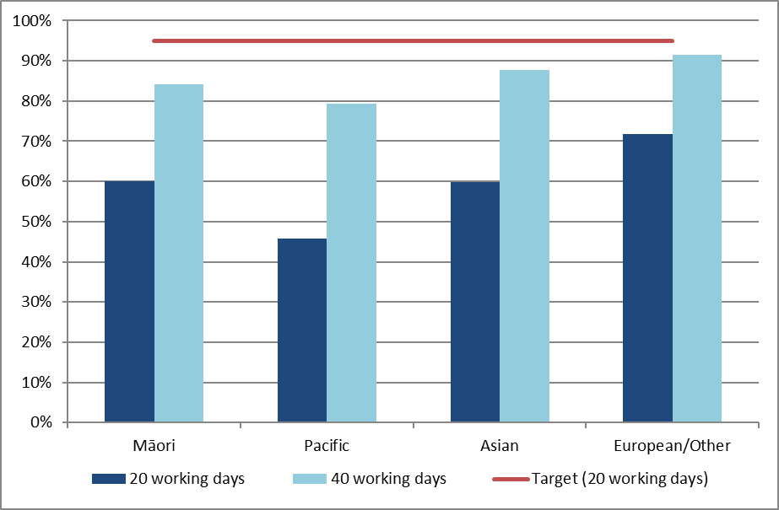
95% target relates to colposcopy visits within 20 working days

Figure 73 - Percentage of women with a high grade cytology (no suspicion of invasive disease) with a colposcopy visit within 20 and 40 working days, by DHB
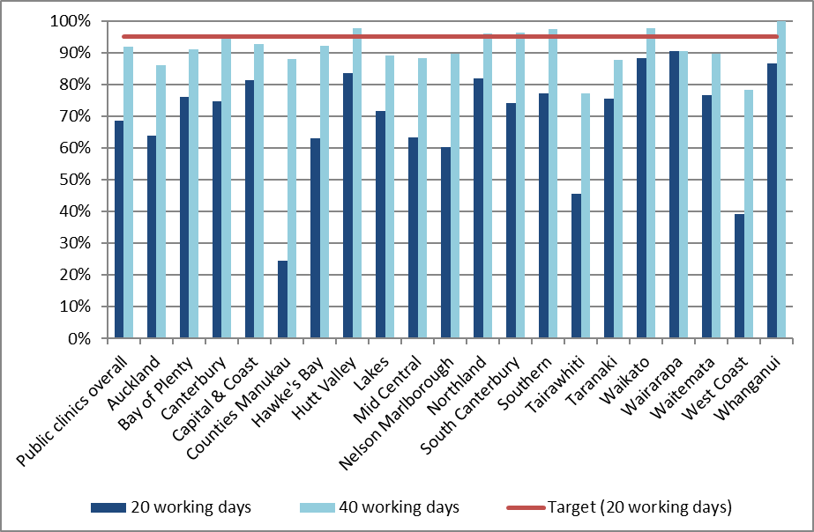
95% target relates to colposcopy visits within 20 working days

Figure 74 - Trends of the proportion of women with a high grade cytology report (no suspicion of invasive disease) seen within 4 weeks (20 working days), by ethnicity
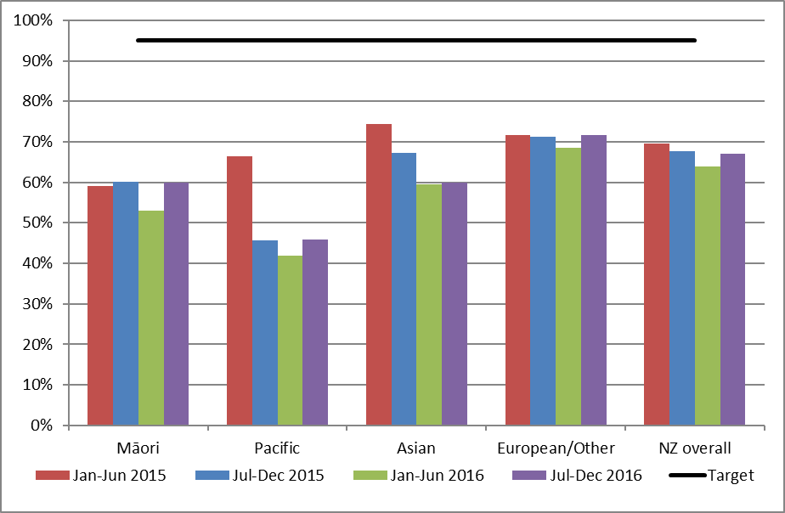
95% target relates to colposcopy visits within 20 working days

Indicator 7.2 – Timeliness of colposcopic assessment – low grade cytology

Definition | This indicator measures performance against Standard 602. One of the data items required to report against Standard 602 (appointment date) is a new data item required by the Colposcopy Policies and Standards 2013. However, it is not yet available from all DHBs, because (as at the beginning of the current monitoring period) some are still transitioning to reporting using 2013 standards. In addition, this indicator considers colposcopy data even earlier than the current monitoring period. Therefore, because appointment date is not yet available, this indicator relies on a proxy, the colposcopy visit date, and is not directly comparable to the Standard. This approach was taken in agreement with the Ministry and NCSP Advisory Group.  This indicator reports on the timeliness of colposcopic assessment of women with either persistent low grade cytology, or low grade cytology and concurrent positive hrHPV test.  Women were included in this measure if they had a cytology sample collected in the 6-month period ending 12 months prior to the end of the current monitoring period (1 July – 31 December 2015 for the current report) where the results were low grade (ASC-US or LSIL), and either a positive hrHPV test (within four weeks of the cytology result) or a previous low grade cytology result (within the previous five years).  Referrals and colposcopy visits for these women were retrieved from the NCSP Register. Referrals were retrieved where the date on which the referral was accepted occurred after the date the cytology sample was collected, and at least 26 weeks before the end of the current monitoring period (i.e. 26 weeks before 31 December 2016, to allow at least 26 weeks following the referral for colposcopy to occur). Colposcopy visits recorded on the NCSP Register were retrieved if they occurred after the cytology test and no later than the end of the current monitoring period. In addition to explicit colposcopy visit records, histology samples in the same timeframe were used as a proxy for a colposcopy visit, to supplement colposcopy visit data.  Results are reported by ethnicity and DHB. DHB is assigned in the same way as in Indicator 7.1. For women who attended colposcopy, DHB is assigned on the basis of the DHB of the colposcopy facility where she attended for colposcopy (or where the histology sample was collected if a visit is not explicitly recorded). If there are multiple referrals for the same woman to that DHB, the date of the first accepted referral following the cytology sample is used.  For women who did not attend colposcopy prior to the end of the current monitoring period, DHB is assigned based on the DHB of the facility which accepted the referral for that woman. If there were multiple referrals for the same woman which occurred after the cytology sample, the most recently accepted referral within the timeframe was used.  For women who neither attended colposcopy nor had an accepted referral with any DHB, DHB is assigned on the basis of the geographic region of health facility where their low grade cytology sample was collected.  Since cytology samples were collected in the 6-month period ending 12-months prior to the end of the current monitoring period, this allows a follow-up period of at least twelve months for all women (and up to 18 months for some women) where a woman can attend colposcopy and be assigned to a DHB.  At present, this indicator reports on aspects of follow-up, but not specifically on timeliness in relation to the standard, as the date of the first scheduled colposcopic appointment is not yet available for all women with a low grade cytology test in the 6-month period 12-months prior to the end of the current monitoring period. In the interim, it reports on the number and percentage of women for whom a subsequent accepted referral and/ or a colposcopy visit are recorded, and the number and proportion of women who attended colposcopy within 26 weeks of an accepted referral.
Target | 95% of women who have persistent low-grade abnormalities, or a low-grade abnormality and positive HPV test, must receive a date for a colposcopy appointment that does not exceed 26 weeks of receipt of the referral.
Current situation | There were 3,994 women with either persistent low grade cytology or low grade cytology and a positive hrHPV test collected in the period 1 July – 31 December 2015. Nationally, subsequent accepted referrals are recorded for 3,255 (81.5%) of these women, and subsequent colposcopy for 3,582 (89.7%). The proportion of women for whom a subsequent referral and colposcopy visit are recorded are shown by DHB in Figure 75, and by ethnicity in Figure 76. The proportion of women for whom an accepted referral was recorded on the NCSP Register ranged from 72.7% (Bay of Plenty) to 98.1% (Whanganui) (Figure 75). The proportion of women with a subsequent colposcopy visit (which occurred by the end of the current monitoring period) recorded on the NCSP Register ranged from 79.7% (Waikato) to all women (Wairarapa) (Figure 75). The proportion of women for whom an accepted referral was recorded on the NCSP Register ranged from 79.6% for European/ Other women to 88.9% for Māori women (Figure 76). The proportion of women with a subsequent colposcopy visit recorded on the NCSP Register ranged from 85.3% (Pacific women) to 90.8% (Asian women) (Figure 76).  An estimation of the timeliness of colposcopic assessment is provided by examining the time between when a referral is accepted for a colposcopy and when a woman attended for colposcopy. Nationally, 2,238 (68.8%) women attended for colposcopy within 26 weeks of their accepted referral (Table 63). By DHB, the proportion of women who attended for colposcopy within 26 weeks of their accepted referral ranged from 13.6% (Counties Manukau) to all women (West Coast) (Figure 77, Table 63). By ethnicity, this figure ranged from 42.0% of Pacific women attending for colposcopy within 26 weeks of their accepted referral, to 72.4% of European/ Other women (Figure 78, Table 64)  Overall 3,023 women attended colposcopy following an accepted referral on the NCSP Register, and by the end of the current monitoring period. This is equivalent to 75.7% of all women with persistent low grade cytology or low grade cytology and a positive hrHPV test, and 92.9% of women who had an accepted referral following their low grade cytology.
Trends | Nationally, the proportion of women with colposcopy within 26 weeks has decreased (68.8% in the current report, compared to 75.2% in the previous report), and it has also decreased in every ethnic group for the last two periods (Figure 80). This was also reflected by DHB, with 11 out of 20 DHBs showing a decline in the proportion of women seen within 26 weeks since the previous report (Figure 79). Substantial decreases (greater than 10%) in the proportion seen within 26 weeks were observed in four DHBs (Counties Manukau, South Canterbury, Waikato and Waitemata). Conversely, a substantial increase (greater than 10%) in the proportion of women with coloscopy within 26 weeks compared to the previous report was seen in one DHB (Southern).
Comments | At present, this indicator reports on aspects of follow-up, but not specifically on timeliness in relation to the standard, as the date of the first scheduled colposcopic appointment is not yet available in the NCSP Register for all women referred.Therefore the results for this indicator are not directly comparable to the target. In the interim, this indicator is a descriptive measure of how many women have a referral and/ or a colposcopy visit recorded on the NCSP Register, and of the time taken between an accepted referral and first colposcopy visit.  As has been the case for previous monitoring periods, it is evident that referrals are incompletely recorded on the NCSP Register, as some women have a record of a colposcopy visit, but no record of an accepted referral.

Figure 75 - Follow-up recorded* for women with persistent LG cytology/ LG cytology and positive hrHPV test, by DHB
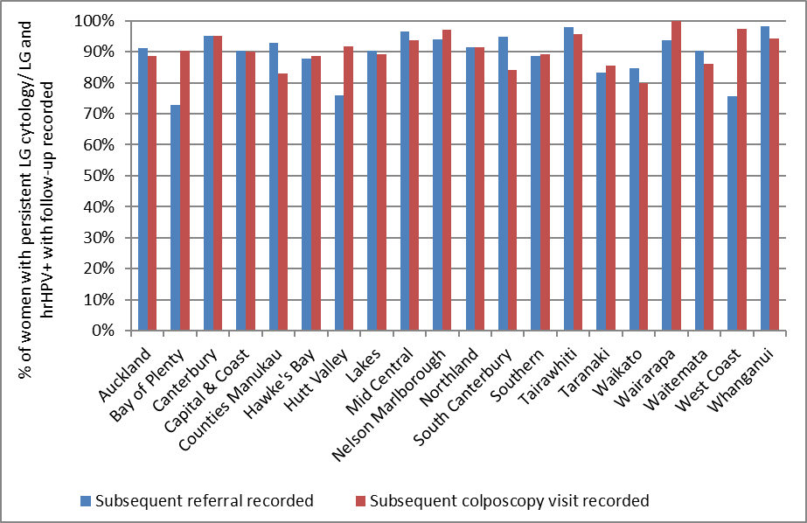
* For colposcopies ‘follow-up’ includes colposcopies recorded on the NCSP Register which occurred no later than the end of the current monitoring period, regardless of whether there is a referral or not. Referrals includes those recorded on the NCSP Register that were accepted no later than 26 weeks prior to the end of the current monitoring period. A colposcopy is assumed to have occurred if a histology sample is recorded in the relevant timeframe.

Figure 76 - Follow-up recorded* for women with persistent LG cytology/ LG cytology and positive hrHPV test, by ethnicity
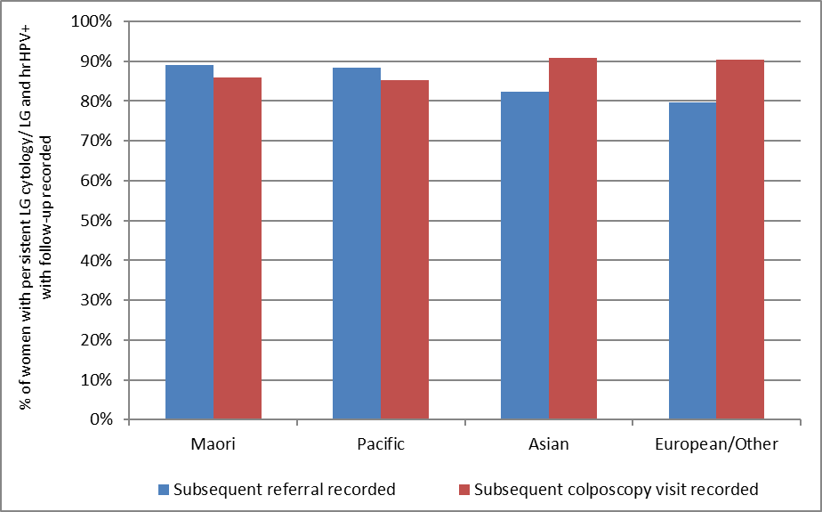
* For colposcopies ‘follow-up’ includes colposcopies recorded on the NCSP Register which occurred no later than the end of the current monitoring period, regardless of whether there is a referral or not. Referrals includes those recorded on the NCSP Register that were accepted no later than 26 weeks prior to the end of the current monitoring period. A colposcopy is assumed to have occurred if a histology sample is recorded in the relevant timeframe.

Figure 77 - Women with persistent LG cytology/ LG cytology and positive hrHPV test and an accepted referral for colposcopy: percentage with a colposcopy visit recorded within 26 weeks of the date the referral was accepted, by DHB
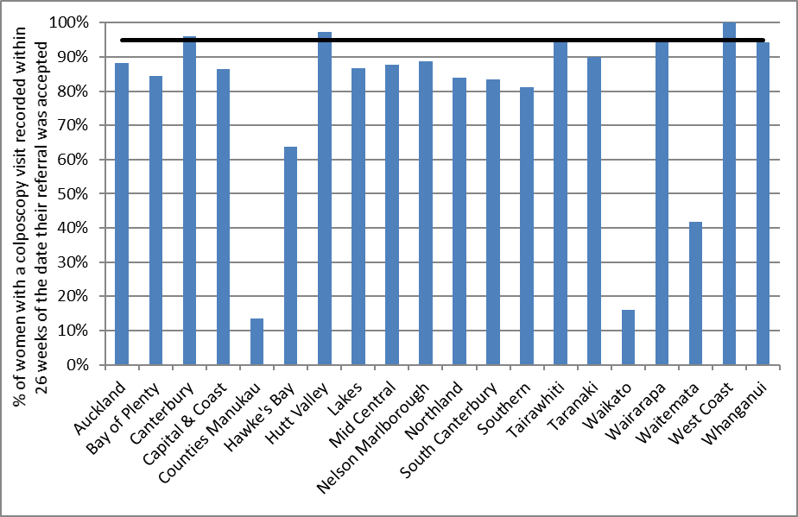

Figure 78 - Women with persistent LG cytology or LG cytology and positive hrHPV test and an accepted referral for colposcopy: percentage with a colposcopy visit recorded within 26 weeks of the date the referral was accepted, by ethnicity
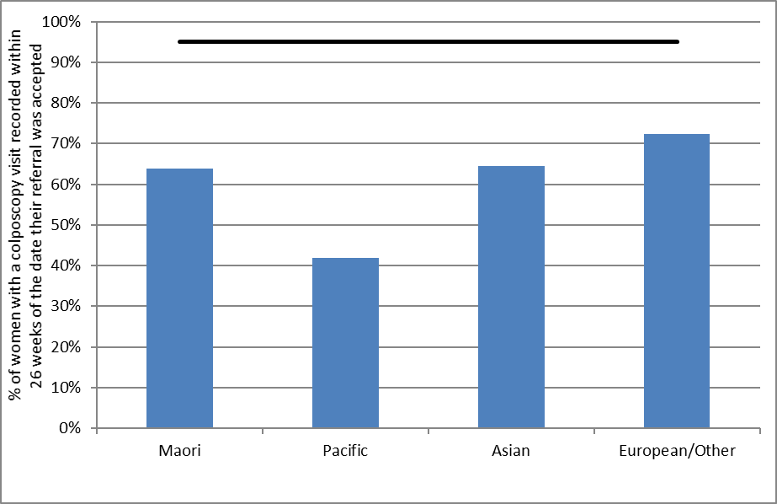
Figure 79 - Trends in the proportion of women with persistent LG cytology or LG cytology and positive hrHPV test and an accepted referral for colposcopy who have a colposcopy visit recorded within 26 weeks of the date the referral was accepted, by ethnicity
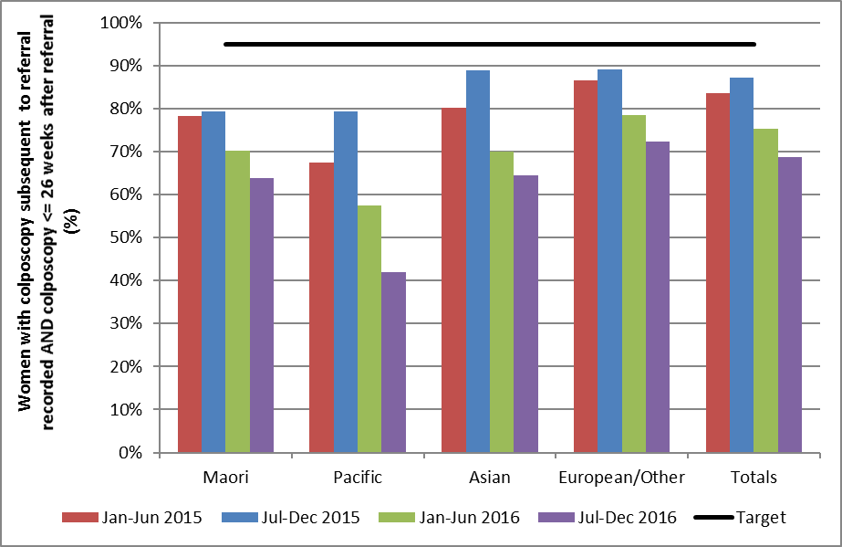

Figure 80 - Trends in proportion of women with persistent LG cytology or LG cytology and positive hrHPV test and an accepted referral for colposcopy who have a colposcopy visit recorded within 26 weeks of the date the referral was accepted, by DHB
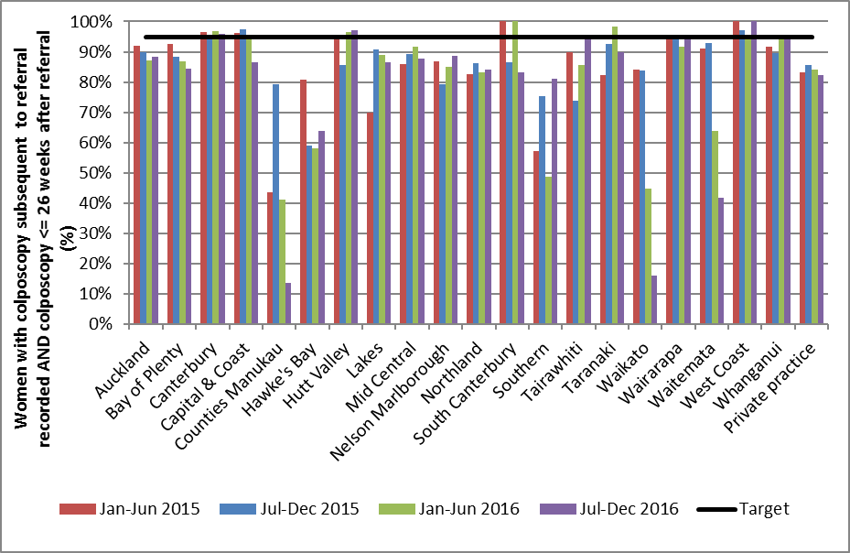

Indicator 7.3 – Adequacy of documenting colposcopy assessment

Definition | This indicator measures performance against Standard 603.  The proportion of colposcopies which occurred within the monitoring period with complete reporting of  - visibility of the squamo-columnar junction  - presence or absence of a visible lesion  - colposcopic opinion regarding the nature of the abnormality  - recommended management and follow-up  - timeframe recommended for follow-up  - items i), ii), and iii) completed  Results are reported by DHB, based on the DHB of the facility where colposcopy was performed.
Target | 100% of medical notes will accurately record colposcopic findings at first and any subsequent assessments, including:  - visibility of the squamo-columnar junction  - presence or absence of a visible lesion  - visibility of the limits of lesion  - colposcopic opinion regarding the nature of the abnormality and the requirement for treatment  - recommended management and follow-up  - timeframe recommended for follow-up.  Items i), ii), v), vi) and the first of the items in iv) can be assessed using data in the NCSP Register, and are reported on below. Item iii) and the second half of item iv) cannot currently be assessed until all DHB clinics report in accordance with the 2013 Colposcopy Standards, which had not occurred by the beginning of the current monitoring period.  When calculating the completeness of recording of the colposcopic opinion regarding the nature of the abnormality, this was restricted to those colposcopy visits where the presence of a lesion was either noted (colposcopic appearance recorded as abnormal), or could not be ruled out (colposcopic appearance recorded as inconclusive).  When calculating the overall completeness of items i), ii), and iii), colposcopic opinion regarding the nature of the abnormality was only required where colposcopic appearance was recorded as either abnormal or inconclusive.
Current Situation | There were 13,447 colposcopy visits within the current monitoring period recorded on the NCSP Register. Documentation relating to these visits was analysed (Table 65).  Nationally, the visibility of the squamocolumnar junction was documented for 97.4% of visits; the presence or absence of a lesion was documented for all visits; and an opinion regarding the lesion grade was documented for 92.0% of visits where the presence of a lesion could not be ruled out. Additionally, the type of follow-up was documented for 94.8% of visits and the timeframe for follow-up was documented for 94.0% of visits. The visibility of the squamo-columnar junction, presence or absence of a visible lesion, and the colposcopic opinion regarding the nature of the abnormality (where relevant) were all documented for 92.7% of visits.  The colposcopic appearance was reported to be abnormal in 55.4% of colposcopies, and inconclusive in 4.8% of colposcopies (Table 66). Biopsies were taken at 91.5% of colposcopies when the colposcopic appearance was abnormal; 31.1% of colposcopies where the colposcopic appearance was reported as inconclusive, and 19.2% of colposcopies where colposcopic appearance was reported as normal (Table 67).  Documentation varied by DHB, as shown in Figure 81 and Table 65. Documentation of visibility of the squamocolumnar junction varied from 94.1% (Mid Central) to all cases in Tairawhiti. In all DHBs, all colposcopy reports documented the presence or absence of a lesion. Recording of the opinion regarding the abnormality grade (which was only assessed here if colposcopic appearance was recorded as abnormal or inconclusive), ranged from 86.2% (Capital & Coast) to 97.6% (Hutt Valley). Recording of the recommended type of follow-up ranged from 81.0% (Capital & Coast) to 99.5% (Counties Manukau) and recording of the recommended timeframe for follow-up ranged from 80.8% (Capital & Coast) to 99.2% (Counties Manukau). Complete documentation of the visibility of the squamo-columnar junction, presence or absence of a visible lesion, and the colposcopic opinion regarding the nature of the abnormality (where required) ranged from 90.7% (Lakes) to 97.2% (Hutt Valley) (Figure 81, Table 65).  Abnormal colposcopic appearance ranged from 37.2% of colposcopies (Wairarapa) to 74.1% of colposcopies (Whanganui). Inconclusive colposcopic appearance ranged from 1.6% of colposcopies (Hutt Valley) to 7.2% of colposcopies (Capital & Coast) (Table 66). The proportion of colposcopies where a biopsy was taken also varied by DHB. This proportion ranged from 87.7% of visits in (Waitemata), up to 97.9% (Mid Central) when the colposcopic appearance was abnormal, and from 7.4% (Waikato) up to 37.8% (Wairarapa) when the colposcopic appearance was normal (Table 67).  Colposcopies performed in private practice accounted for 9.8% of all colposcopies recorded on the NCSP Register in New Zealand in the current monitoring period. The documentation rate was similar to, or slightly lower, in private practice compared with public clinics overall, with the exception of follow-up type which was higher in private practice compared to public clinics (Table 65); visibility of the squamocolumnar junction (96.1% for private practice and 97.5% for public clinics overall), presence or absence of a lesion (100.0% in both private and public), lesion grade (92.5% for private practice and 92.0% for public clinics), follow-up type (97.2% for private practice and 94.5% for public clinics) and follow-up timeframe (93.7% for private practice and 94.1% for public clinics). The proportion of colposcopies with complete documentation of the visibility of the squamo-columnar junction, presence or absence of a visible lesion, and the colposcopic opinion regarding the nature of the abnormality was 92.1% for private practice and 92.7% for public clinics overall.
Trends | For New Zealand as a whole, documentation of colposcopy visit items has remained fairly consistent over the last four monitoring periods. In the current period visibility of the squamocolumnar junction was documented for 97.4% of colposcopies compared with between 97.0% and 97.7% for the previous three monitoring periods. The presence or absence of a lesion was documented for all visits in both the current and previous three periods. In the current period an opinion regarding the lesion grade was documented for 92.0% of visits where the presence of a lesion could not be ruled out, compared with between 91.5% and 92.0% for the previous three monitoring periods. Recording of recommended follow-up type was documented for 94.8% of visits in the current period, which is within the range seen for the previous three periods (92.2% - 99.2%). This was also the case for recommended timeframe for follow-up, which was recorded for 94.0% of visits in the current period compared with 91.6% - 98.4% in the previous three periods.  Trends in the completion of all required fields are shown in Figure 82.  Trends in the number of colposcopies recorded on the NCSP Register are shown in Figure 83. The number of colposcopies decreased in the current monitoring period in fourteen of the 20 DHBs with an overall decrease in the number of colposcopies of 2.1%.
Comments | This measure is only able to assess adequacy of documentation where colposcopy visits have been entered onto the NCSP Register in accordance with the 2013 Colposcopy Standard. Therefore, it cannot provide an absolute estimate of adequacy if these data are incomplete on the NCSP Register. The data used in this analysis was extracted from the NCSP Register in mid-February 2017.  Missing colposcopy data from the latter part of 2015 (Report 44) for some DHBs led to an underestimate of the number of colposcopies in these DHBs during the previous monitoring period, and this likely explains the apparent increase in the volume of colposcopies recorded in Report 45 (1 January – 30 June 2016). This is observable in the trends chart seen in Figure 83.  Some items required by the standard, such as the recording of recommended follow-up type and timeframe, cannot necessarily be completed at the time of the colposcopy visit – for example because they will depend on results of histology tests or other reviews. For DHBs that electronically report data to the NCSP Register, the completeness of these fields is likely to lag behind that of other fields, because the colposcopy visit data will be loaded onto the NCSP Register soon after the visit and before this information is available. As more DHBs have moved to electronic reporting, this lag could explain the reduction in the percentage of colposcopies where these items are complete, compared to previous reports. Additionally, since there is a lag in reporting recommended type and timeframe for follow-up, these two items were removed from the calculation of ‘all items complete’ in Report 43 and this has remained the case in subsequent reports. These are often not the fields with the lowest completion rates however, and therefore removing them from the calculation made a relatively small difference to ‘all items complete’. In 16 out of the 20 DHBs, the field with the lowest completion rate is the documentation of the opinion regarding the nature of abnormality grade (only required where the presence of a lesion could not be ruled out). It is possible that the low completion rate for predicted abnormality grade could be because some clinics are incorrectly interpreting the requirement to document a predicted abnormality grade (which should be documented at the time of colposcopy) as a requirement to document the diagnosed abnormality grade, which can only be done after histology results are available.  Some items in the 2013 colposcopy standard are not included in the 2008 colposcopy visit form or on the NCSP Register, in particular the visibility of the limits of the lesion, the biopsy site, and an explicit colposcopic opinion regarding the need for treatment (although a recommended follow-up timeframe is recorded, and whether follow-up is recommended with a colposcopist, oncology services, or smear-taker). It is also not possible to determine the reason for the visit from the colposcopy visit form, for example if this is a first visit or a follow-up visit; or whether it was prompted by a high grade cytology result, a low grade cytology result which is either persistent or accompanied by a positive high risk HPV test result, a request for referral regardless of cytology results, or another reason. As some DHBs and most private colposcopists were still reporting to the NCSP Register using the 2008 standard at the start the current monitoring period, these items could not be taken into account in this indicator for the current report.  The current colposcopy standard was published in July 2013 (available at https://www.nsu.govt.nz/health-professionals/national-cervical-screening-programme/policies-and-standards). When a sufficient number of DHBs have transitioned to the updated standard for a whole monitoring period, items from the updated standard will be included in these monitoring reports.
Figure 81 - Completion of colposcopic assessment fields, by DHB
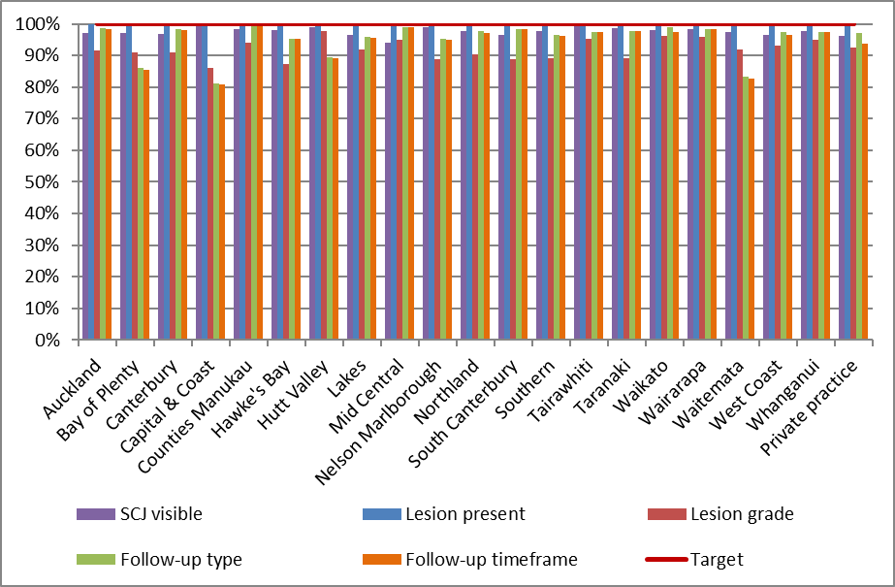

Figure 82 - Trends in the completion of all required colposcopic assessment fields, by DHB
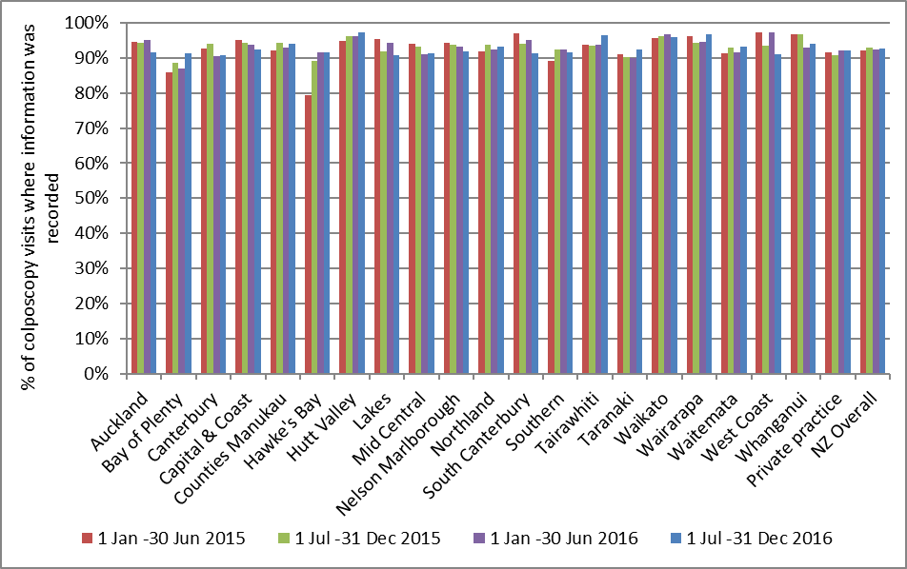
Note: Definition of ‘all fields completed’ changed from 1 January 2015 as two fields were no longer included in the calculation (follow-up type and timeframe)

Figure 83 - Trends in the number of colposcopies recorded on the NCSP Register, by DHB
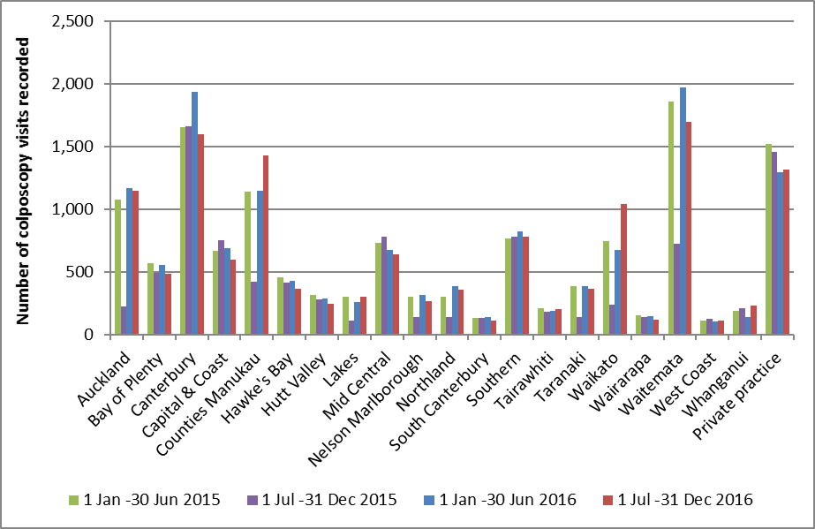
The apparent decrease in the number of colposcopies in 1 Jul-31 Dec 2015 compared to 1 Jan-30 Jun 2015 in several DHBs is because those DHBs were unable to electronically report colposcopy data to the NCSP Register after September 2015. Therefore the values for the period 1 Jul-31 Dec 2015 above do not include colposcopies which occurred after September 2015 in the affected DHBs (Auckland, Counties Manukau, Lakes, Nelson Marlborough, Northland, Taranaki, Waikato and Waitemata).

Indicator 7.4 – Timeliness and appropriateness of treatment

Definition | This indicator measures performance against Standard 605.  It reports on the proportion of women with histological high grade squamous intraepithelial lesions (HSIL) who are treated within eight weeks of histological confirmation. Histological HSIL is defined as CIN2, CIN3, CIN2/3 or HSIL not otherwise specified (SNOMED codes M74007, M74008, M80102, M80702 and M67017).  Histological LSIL is not routinely treated, as treatment is not recommended for women with low grade abnormalities in the 2013 Colposcopy Standards (consistent with 2008 NCSP Guidelines for Cervical Screening in New Zealand). The 2013 Colposcopy Standard recommends that the number of women who are treated with low-grade lesions (less than CIN2 on histology) be minimised. Therefore treatment of LSIL is included in this report for descriptive purposes and to examine the appropriateness (not timeliness) of treatment. This report describes the number and proportion of women with histological low grade squamous intraepithelial lesions (LSIL) who are treated. To ensure consistency in the follow-up time examined for each woman and in order to allow timely reporting, treatments are included if they occur within 26 weeks of histological confirmation. Histological LSIL is defined as CIN1 or CIN not otherwise specified (SNOMED codes M74006, M67016, M74000 and M67015). Women with histological LSIL who are treated but who also have a record of histological HSIL in the six-month period prior to their treatment are excluded, as their treatment in considered appropriate.  Women are included in this indicator if they have a histology sample where the result is HSIL or LSIL (as previously defined, above), and the sample was collected in the six-month period immediately prior to the current monitoring period (i.e. in the period 1 January – 30 June 2016). HSIL results must have been reported at least 8 weeks prior to the end of the current monitoring period, and LSIL results must have been reported at least 26 weeks prior to the end of the current monitoring period, in order to allow sufficient follow-up time for this indicator.  Treatment was defined as a colposcopy visit where there was a record of electrosurgical excision, laser ablation or excision, cold knife cone biopsy, or total hysterectomy. Colposcopy visits involving punch biopsies only are not included.  DHB is assigned based on the clinic where the histology sample was collected.
Target | 90% or more of women with HSIL are treated within 8 weeks of histological confirmation of CIN2/3.  There is no explicit target relating to low grade lesions, but the standard recommends that the number of women who are treated with low-grade lesions (less than CIN2 on histology) be minimised.
Current Situation | There were 2,606 women with a histological diagnosis of CIN2/3 (associated with histology samples collected in the previous six months, and reported at least eight weeks prior to 31 December 2016). Of these women, 1,680 women (64.5%) were treated within eight weeks of HSIL being histologically confirmed. The proportion of women treated within eight weeks varied widely by DHB, from 49.0% (Capital & Coast) to all women (Whanganui). One DHB met the target of at least 90% of women treated within eight weeks of histological confirmation of HSIL (Figure 84, Table 19).  There were 2,088 women with a histological diagnosis of LSIL (associated with histology samples collected in the previous six months, and reported at least 26 weeks prior to 31 December 2016). Treatment for histological LSIL is not routinely recommended in the 2013 Colposcopy Standards or the 2008 NCSP Guidelines for Cervical Screening in New Zealand¹⁴, and so timeliness of treatment is not examined or compared to a target for LSIL. However, for descriptive purposes and to examine appropriateness of treatment, follow-up records were retrieved for the 2,088 women with histological LSIL. Of these women, 169 (8.1%) were subsequently treated within 26 weeks of LSIL being histologically confirmed and had no additional record of high grade histology in the six months preceding their treatment. The proportion of women subsequently treated varied widely by DHB, from no women (South Canterbury, Tairawhiti, Wairarapa, and West Coast) to 21.8% (Capital & Coast) (Table 19). The DHB where the largest number of women were treated was Counties Manukau (37 women).
Trends | Nationally, the proportion of women with histological HSIL who were treated within eight weeks of histological confirmation is higher than the previous monitoring report; 64.0% in the previous report, 64.5% in the current report. The proportion of women with histological HSIL who were treated within eight weeks for the current report period increased in 11 of the 20 DHBs compared with the previous report period (Figure 85).  The proportion of women with histological LSIL who were subsequently treated (within 26 weeks of LSIL being histologically confirmed) has increased, from 6.6% for the previous report to 8.1% in the current report.
Comments | Whether or not treatment has occurred is determined for this indicator via colposcopy data in the NCSP Register. Colposcopy visit details are slowly improving with more and more DHBs adopting electronic reporting to the Register in place of manual colposcopy visit forms; however, these data are still potentially incomplete and consequently may underestimate timeliness of treatment. Similarly, trends may also reflect changes in the completeness of colposcopy data recording treatment within a DHB rather than necessarily true increases or decreases in the proportion of women treated. This incomplete recording of treatment potentially affects the results for treatments for both HSIL and LSIL. In some cases, treatment may have occurred in a different clinic to that where the original histology sample was collected. Facilities not explicitly defined as DHB (public) clinics are aggregated together as private practice. It is possible that women whose original HSIL (or LSIL) histology sample was collected outside a DHB clinic may in practice have been treated at a DHB clinic (or conversely a woman whose histology sample was collected at a DHB clinic may have been treated outside a DHB clinic). Note, however, that timeliness is assessed here by including any treatment visits, regardless of where they occurred.  The 2013 National Cervical Screening Programme Policies and Standards: ‘Section 6 – Providing a Colposcopy Service’ requires colposcopy clinics to provide information about the “decision to treat date”. At present, the “decision to treat date” is not available on the NCSP Register except where colposcopy is reported against the current Standards. When this “decision to treat date” information is available for all DHBs for a full monitoring period, it will be used to calculate timeliness of treatment for women with histological HSIL.

Figure 84 - Proportion of women treated within eight weeks of histological confirmation of HSIL
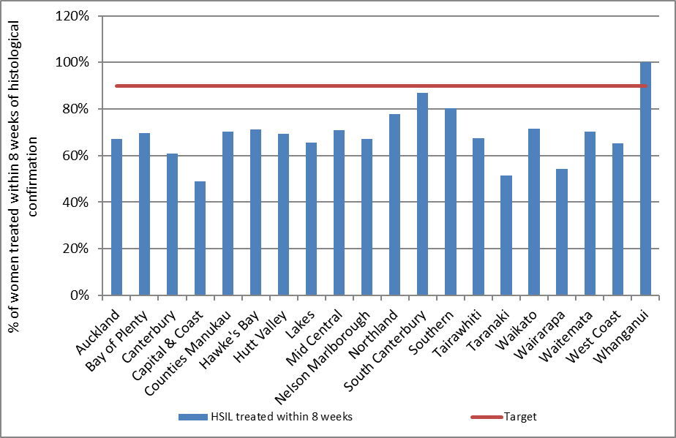
Date that histology results were reported to requesting clinician is used as the date of histological confirmation. DHB is assigned based on the clinic where the original HSIL histology sample was collected, however treatments will be included regardless of where they occurred.

Figure 85 - Trends in the proportion of women treated within eight weeks of histological confirmation of HSIL, by DHB
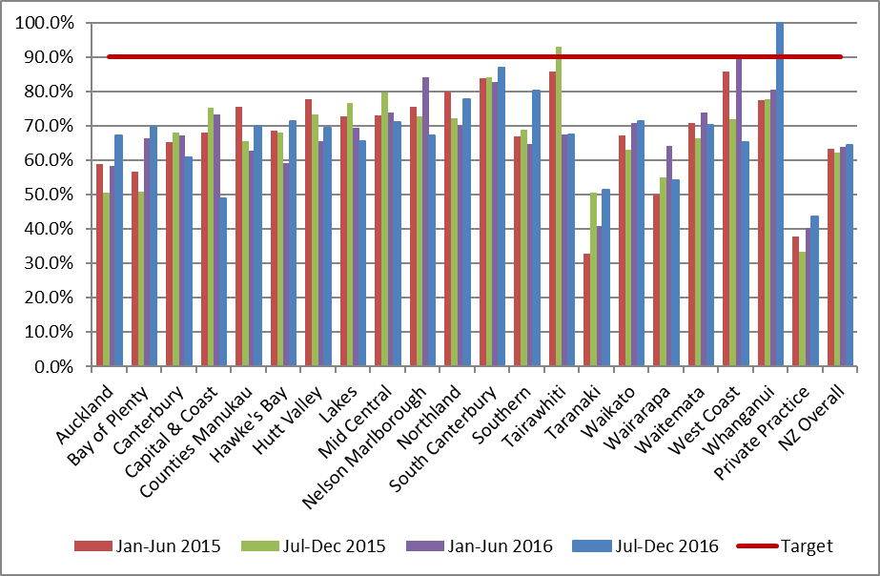

Table 19 - Timeliness and appropriateness of treatment, by DHB
DHB | Women with histological HSIL | Treated within 8 weeks |  | Women with histological LSIL* | Women subsequently treated†
 | N | N | % | N | N | %
Public clinics (overall) | 2,232 | 1,517 | 68.0 | 1,679 | 154 | 9.2
Auckland | 183 | 123 | 67.2 | 203 | 22 | 10.8
Bay of Plenty | 89 | 62 | 69.7 | 98 | 8 | 8.2
Canterbury | 387 | 235 | 60.7 | 407 | 29 | 7.1
Capital & Coast | 104 | 51 | 49.0 | 55 | 12 | 21.8
Counties Manukau | 241 | 169 | 70.1 | 298 | 37 | 12.4
Hawke's Bay | 87 | 62 | 71.3 | 22 | 2 | 9.1
Hutt Valley | 62 | 43 | 69.4 | 41 | 3 | 7.3
Lakes | 32 | 21 | 65.6 | 50 | 5 | 10.0
Mid Central | 107 | 76 | 71.0 | 55 | 5 | 9.1
Nelson Marlborough | 55 | 37 | 67.3 | 18 | 1 | 5.6
Northland | 94 | 73 | 77.7 | 16 | 1 | 6.3
South Canterbury | 23 | 20 | 87.0 | 11 | - | -
Southern | 163 | 131 | 80.4 | 44 | 2 | 4.5
Tairawhiti | 40 | 27 | 67.5 | 20 | - | -
Taranaki | 76 | 39 | 51.3 | 58 | 7 | 12.1
Waikato | 186 | 133 | 71.5 | 47 | 3 | 6.4
Wairarapa | 24 | 13 | 54.2 | 6 | - | -
Waitemata | 228 | 160 | 70.2 | 192 | 16 | 8.3
West Coast | 26 | 17 | 65.4 | 22 | - | -
Whanganui | 25 | 25 | 100.0 | 16 | 1 | 6.3
Private Practice | 374 | 163 | 43.6 | 409 | 15 | 3.7
Total | 2,606 | 1,680 | 64.5 | 2,088 | 169 | 8.1
DHB is assigned based on the clinic where the original HSIL histology sample was collected, however treatments will be included regardless of where they occurred.* CIN1, CIN not otherwise specified (SNOMED codes M67015, M67016, M74000 and M74006). CIN1 is not routinely treated (consistent with 2008 NCSP Guidelines for Cervical Screening in New Zealand), so these results are not compared to a target. They appear here for descriptive purposes and to show how frequently women with histologically confirmed LSIL were treated. † Includes women treated within 26 weeks of LSIL histology. Date that histology results were reported to requesting clinician is used as the date of histological confirmation. Excludes women treated following histological LSIL who additionally had HSIL histology in the 6 months preceding their treatment.

Indicator 7.5 – Timely discharging of women after treatment

Definition | This indicator measures performance against Standard 608.  The proportion of women treated for a high grade lesion who:  - receive colposcopy within the period up to nine months after their treatment  - receive colposcopy and cytology within the period up to nine months after their treatment  - are discharged appropriately within 12 months of their treatment.  Treatment was defined as a colposcopy visit where there was a record of electrosurgical excision, laser ablation or excision, cold knife cone biopsy, or total hysterectomy. Colposcopy visits involving punch biopsies only are not included. Treatment was included if it was for a high grade lesion (CIN2 or CIN3), based on histology results for any histology specimen collected concurrent with or up to six months prior to treatment.  To allow for 12 months of follow-up information to be available, this indicator reports on women treated in the six-month period ending 12 months prior to the end of current monitoring period (i.e. 1 July – 31 December 2015). Records for each woman treated in the six-month period ending 12 months prior to the end of current monitoring period were retrieved from the NCSP Register. Among these treated women, the number of women with a colposcopy visit, and with both a colposcopy visits and a cytology sample was calculated. Follow-up colposcopy visits were not restricted to only those within the same DHB as where initial treatment occurred; rather any colposcopy visit recorded on the NCSP Register for that woman was included. Follow-up visits were retrieved for the period up to nine months after the treatment visit.  Eligibility for discharge is not explicitly defined in the NCSP Colposcopy Standard, so based on advice from the NCSP Advisory Group, women were defined as eligible for discharge if they had a colposcopy visit and cytology test following their treatment, and their cytology result was negative.  Women were defined as having been discharged when their colposcopy report form recommended follow-up by their smear-taker/ referring practitioner.  Results are reported by DHB, based on the DHB of the facility where the treatment colposcopy was performed. Therefore, for the purpose of this indicator, the DHB where treatment occurred was regarded as the DHB responsible for ensuring a treated woman was followed up. However, as previously described, the follow-up colposcopy visit need not have occurred within that DHB.
Target | 90% or more of women treated for CIN 2 or 3 should have a colposcopy and smear within the nine-month period post-treatment.  90% or more of women treated for CIN 2 or 3 should be discharged back to the smear-taker as appropriate.
Current Situation | There were 1,634 women treated for CIN2 or CIN3 lesions in the six-month period from 1 July – 31 December 2015. These women were followed up for 12 months from the date of their treatment visit.  Follow-up post treatment  There were 1,232 women (75.4%) with a follow-up colposcopy, and 1,214 women (74.3%) with both a follow-up colposcopy and a cytology sample in the nine month period after their treatment visit.  Figure 86 shows the percentage of treated women with a record of follow-up colposcopy, and both follow-up colposcopy and a cytology sample, in the period up to nine months post-treatment by DHB. Generally, the number of women with both cytology and colposcopy was very similar to the number of women with at least colposcopy (Table 69). The maximum number of women with colposcopy only and no record of a cytology sample in the timeframe was at most four in Waikato.  Nationally, the percentage of women treated for high grade lesions with a record of colposcopy and cytology within the nine-month period post-treatment (74.3%) is below the target value of 90%.  One DHB (Auckland) met the target of at least 90% of women receiving cytology and colposcopy within nine months post-treatment (Figure 86, Table 69). The percentage of treated women with a record of both follow-up colposcopy and a cytology sample in the period up to nine months post-treatment varied by DHB from 34.9% (Bay of Plenty) to 92.1% (Auckland).  Women discharged appropriately  In total, 1,253 women (76.7% of those treated) were eligible to be discharged by 12 months after their treatment visit, and 1,046 of these women (83.5%) were discharged within 12 months of treatment (Table 68). Figure 87 shows how these percentages varied by DHB. The percentage of women eligible for discharge who were discharged within 12 months of treatment ranged from 43.8% (South Canterbury) to all eligible women (Hawke's Bay) (Table 68). In some cases, the number of women eligible for discharge was small, so these results should be interpreted with caution (16 or fewer women in South Canterbury, Tairawhiti and Wairarapa).  Eight DHBs met the target of discharging 90% of women where appropriate within 12 months (Capital & Coast, Counties Manukau, Hawke's Bay, Hutt Valley, Mid Central, Nelson Marlborough, Southern and Waikato).  In total (that is, without considering whether or not women met the criteria suggested by the NCSP Advisory Group to be eligible for discharge), 1,176 women were discharged within 12 months of being treated for a high grade lesion (72.0% of all women treated for a high grade lesion).
Trends | The proportion of women with follow-up has decreased slightly overall (from 76.2% to 75.4% for colposcopy, and from 74.9% to 74.3% for both cytology and colposcopy). One DHB met the target of 90% of women having colposcopy and cytology within nine months of treatment, compared to two DHBs in the previous report.  The proportion of women discharged appropriately to their smear-taker by 12 months has increased (82.9% in the previous report; 83.5% in the current report). The number of DHBs meeting the target of 90% increased from five to eight.
Comments | Since this indicator relies on colposcopy data in the NCSP Register, there is the possibility that incomplete reporting of colposcopy visits has led to an underestimate of the number of women with follow-up colposcopy visits and the number discharged in a given time period. The data used in this analysis was extracted from the NCSP Register in mid-February 2017.  The target that 90% or more of women treated for CIN 2 or 3 should be discharged back to the smear-taker as appropriate was assessed in this monitoring report, based on guidance from the NCSP Advisory Group as to when discharge would be appropriate. However, it should be noted that neither the 2008 NCSP Guidelines for Cervical Screening in New Zealand nor the 2013 Colposcopy Standards themselves provide explicit guidance for when discharge back to the smear-taker is appropriate.  In some circumstances, women may be treated within one DHB, but referred to another DHB for follow-up. This information is not always recorded in the NCSP Register however, and for clarity in this report, women remain assigned to the DHB where their treatment was performed. However, this measure does take into account all follow-up visits which women attend, regardless of the DHB in which they occurred.
Figure 86 - Percentage of women treated with colposcopy, and both colposcopy and cytology, within nine months post-treatment
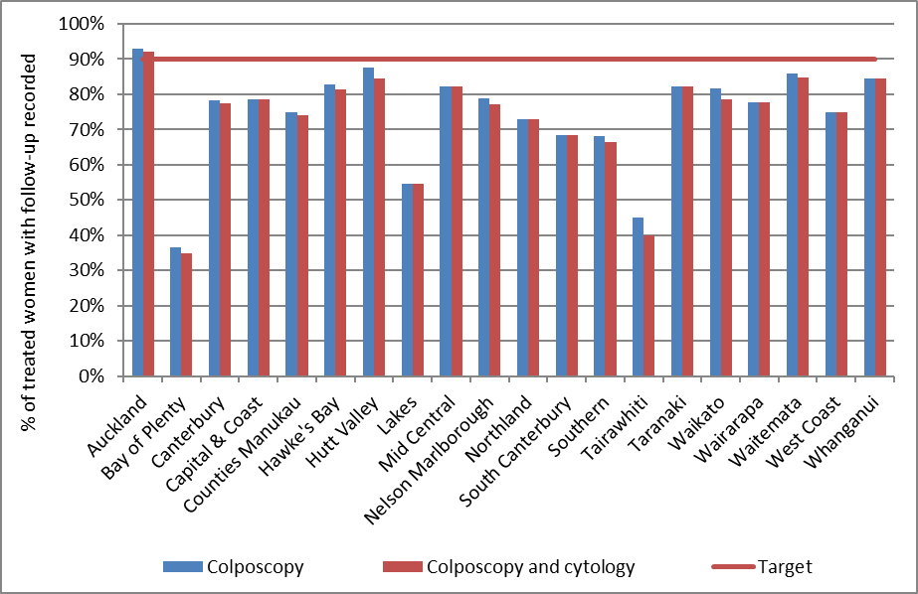

Figure 87 - Percentage of women discharged appropriately within 12 months of treatment
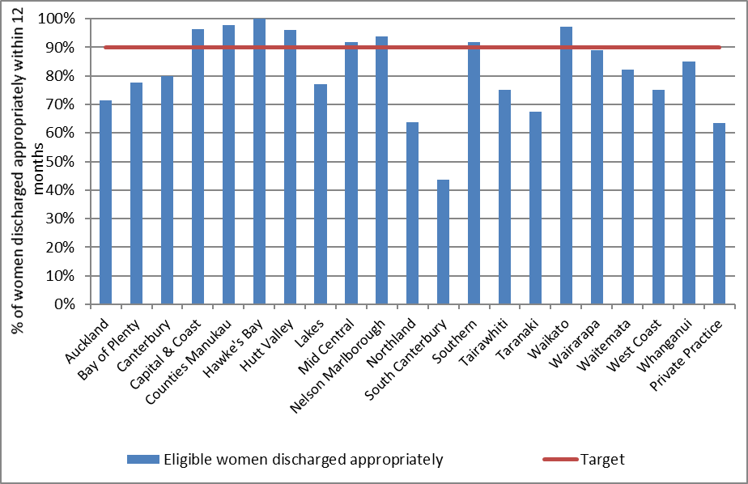

Indicator 8 – HPV tests

The indicators report on the use of HPV testing. At present, they incorporate the following indicators:

- Triage of low grade cytology

- HPV test volumes (including purpose for which the test was performed)

- HPV tests for follow-up of women with a historical high grade abnormality

Specific monitoring of the other uses of HPV testing is not yet included. These other purposes include:
- Management of women previously treated for CIN
- Management of women with a high grade squamous cytology result in the past followed by negative cytology
- Resolution of discordant cytology, colposcopy and histology

Indicator 8.1 – Triage of low grade cytology

Definition | For women with an ASC-US or LSIL (low grade) cytology result relating to a cervical sample taken in the monitoring period, and with no recent abnormal cytology (i.e. abnormal cytology results relating to specimens taken in the preceding five years), the following are reported on as follows:  - The number and proportion of women with a subsequent HPV triage test (by age group, and cytology laboratory)  - Women with positive HPV triage result, as a proportion of women with a valid HPV test (by age group, and cytology laboratory)  - Histological outcomes in women where this information is available within 12 months following a positive HPV triage test  Where a woman has two different low grade cytology results, relating to a sample or samples collected on the same date, she is grouped in accordance with the most serious result (i.e. LSIL).  A subsequent HPV triage test is defined as an HPV test where the sample was collected at the same time or after the cytology sample, and where there is a result available (including invalid results).  Women whose ASC-US or LSIL cytology test is associated with a recommendation code of R14 (refer regardless of cytology result) are excluded, as they may be symptomatic.  Women who are aged less than 30 years are excluded from this indicator if they have ever had either a high grade squamous cytology result (ASC-H, HSIL) or a high grade squamous histology result (CIN2/3), as they may be having an HPV test in order to follow-up a previous high grade squamous abnormality (cytology or histology, i.e. historical testing).  If a laboratory which performed the cytology refers the HPV test to a different laboratory, measures are based on the laboratory which performed the cytology test.  Measures reported by age are based on the age of the women on the date that the cytology sample was collected.
Target | Targets have not yet been set.
Current Situation | There were 638 women aged less than 30 years and 1,367 women aged 30 years or more with an ASC-US cytology result relating to a sample collected in the current monitoring period, and who had no abnormal cytology results relating to samples taken in the previous five years. The corresponding figures for LSIL are 2,181 women aged less than 30 years and 1,430 women aged 30 years or more.  HPV triage  NCSP Guidelines (2008) recommend that women aged 30 years or more who have not had an abnormal cytology report in the previous five years are offered a HPV triage test following ASC-US or LSIL cytology. Among these eligible women, 96.9% of women aged 30 years or more with an ASC-US cytology result, and 97.1% of women aged 30 years or more with an LSIL cytology result are recorded as having a subsequent HPV test (Table 70, Table 71). These proportions ranged from 92.4% (Medlab Central Ltd.) to 98.7% (Canterbury Health Laboratories) for ASC-US cytology results and from 87.7% (Medlab Central Ltd.) to 100% (Canterbury Health Laboratories) for LSIL cytology results (Figure 88, Table 70, Table 71).  HPV triage is not included in the recommendations for women aged less than 30 years, and accordingly the proportions of women aged less than 30 years with a subsequent HPV test are very small. Subsequent HPV tests are recorded in the NCSP Register for 1.3% of women aged less than 30 years with ASC-US results, and 0.6% of women aged less than 30 years with LSIL results. These proportions ranged from no women (Medlab Central Ltd. and Pathlab) to 4.2% (Canterbury Health Laboratories) for women with ASC-US results, and from 0.4% (Pathlab) to 1.8% (Medlab Central Ltd) for women with LSIL results (Figure 89, Table 70, Table 71).  Positive triage tests  Among women aged 30 years or more with a valid HPV triage test results, the proportion who were positive for high risk HPV (hrHPV) was 24.5% for women with ASC-US results, and 57.7% for women with LSIL results. These proportions varied by laboratory from 16.2% (Canterbury Health Laboratories) to 36.0% (Southern Community Laboratories) for women with ASC-US cytology (Figure 90), and from 48.9% (LabPLUS) to 64.4% (Pathlab) for women with LSIL cytology (Figure 91).  The proportion of women whose HPV triage test was positive also varied by age. Among women aged 30-69 years, HPV positivity rates were highest for those aged 30-39 years (35.2% for women with ASC-US cytology, and 61.9% for those with LSIL cytology). For women with ASC-US results, the positivity rates for each of the 10-year age groups between 40 and 69 years were similar (between 18.0% and 23.8%; Figure 92, Table 20). For women with LSIL results, the positivity rates were between 53.1% and 55.0% for these 10-year age groups (Figure 92, Table 21).  Histological outcomes in triage-positive women who attended colposcopy  In order to allow sufficient time for women to have attended colposcopy following a positive triage test, histological outcomes were assessed in women with low grade cytology and a positive HPV triage test in the six-month period 1 July – 31 December 2015. In this period, there were 406 women with an ASC-US cytology result and positive HPV triage test, and 897 who had an LSIL cytology result and positive HPV triage test. 373 (91.9%) of the women with ASC-US who were triage-positive and 815 (90.9%) of the women with LSIL who were triage-positive had a record of colposcopy and/or histology within the 12 months following their initial test results. Among the women with a record of colposcopy, 249 (66.8%) and 626 (76.8%) of the women with ASC-US and LSIL respectively have a histology record.  Histological outcomes in these women were initially considered in an analogous manner to Indicator 5.2 – that is, the number of women with CIN 2 or worse histology (CIN 2+; also see Appendix D), as a percentage of women who had a histology result available. The percentage of women with histology whose histology result was CIN 2+ was 27.3% for HPV triage-positive ASC-US and 19.8% for HPV triage-positive LSIL (Table 72, Table 73). These percentages varied by laboratory from 20.3% (Anatomical Pathology Services) to 36.7% (Southern Community laboratories) for HPV triage-positive ASC-US and from 12.0% (Aotea Pathology Ltd) to 25.3% (Southern Community Laboratories) for HPV triage-positive LSIL (Figure 93). Note that these ranges excludes LabPLUS due to the very small numbers of triage-positive women (see Table 72 and Table 73).  We additionally considered histological outcomes as a percentage of women who attended colposcopy (rather than only those with a histology result). This was done in order to take into account women with colposcopy who do not have histology taken because colposcopy does not identify any disease. Omitting these women can lead to inflated estimates of the positive predictive value or yield from triage-positive low grade cytology. The corresponding percentages of women with CIN 2+ histology were 18.2% for HPV triage-positive ASC-US and 15.2% for HPV triage-positive LSIL (Table 72, Table 73). These percentages varied by laboratory from 13.8% (Pathlab) to 27.5% (Southern Community Laboratories Dunedin) for HPV triage-positive ASC-US and from 10.3% (Aotea Pathology Ltd) to 20.3% (Southern Community Laboratories) for HPV triage-positive LSIL (Figure 94). These are also compared with the corresponding percentages of women who attended colposcopy within six months with CIN 2+ histology for women with ASC-H and HSIL cytology, by laboratory, in Figure 94.  Histological outcomes within 12 months in women with triage-positive test results are shown by age, as a percentage of women with histology recorded (Figure 96), and as a percentage of women with colposcopy recorded (Figure 97). Among women aged 30-69 years, the percentage of women with CIN2+ histology within 12 months generally decreased with increasing age for HPV triage-positive ASC-US. For HPV triage-positive LSIL this pattern was less clear; the percentage of triage-positive women with CIN2+ histology was similar for women aged 30-39 and 40-49. There were no cases of CIN2+ among the 45 women aged 60-69 years with a positive HPV triage test.
Trends | HPV triage  The proportion of women aged 30 years or more with low grade cytology (and no recent abnormal cytology in the preceding five years) who received a subsequent HPV test is higher than in the previous report for women with ASC-US results (94.1% in the previous period compared to 96.9% in the current period), and also for women with LSIL results (95.0% in the previous period compared to 97.1% in the current period). The proportion of women aged less than 30 years with a subsequent HPV test is slightly lower than the previous monitoring period for ASC-US and similar for LSIL results (1.8% in the previous period compared to 1.3% in the current period for ASC-US; 0.9% in the previous period compared to 0.6% in the current period for LSIL).  Positive triage tests  The proportion of women aged 30 years or more who tested positive for a high risk HPV type increased for ASC-US (22.8% in the previous report; 24.5% in the current report), and also for LSIL (57.2% in the previous report; 57.7% in the current report.  Histological outcomes in triage-positive women who attended colposcopy  91.9% of women with ASC-US cytology and a positive HPV triage test in the six-month reference period for the current report had a record of colposcopy and/or histology within the 12 months following their test result, similar to the result for the previous report (91.9%). For the current report 66.8% of these women with colposcopy also had a histology record, compared with 70.9% for the previous report. Of these women with a histology record, the histology result was CIN 2+ for 27.3% of women in the current report, compared with 20.2% in the previous report. When histological outcomes were considered as a proportion of women with colposcopy, rather than histology, the corresponding figures were 18.2% in the current report versus 14.3% in the previous report. The proportion of triage-positive ASC-US women who attended colposcopy with CIN 2+ histology increased compared to the previous report in five of six laboratories (Figure 98; excludes LabPLUS).  For women with LSIL cytology and a positive HPV triage test in the reference period for the current report, 90.9% had a record of colposcopy and/or histology within 12 months of their result, which was very similar to the 90.2% of women in the previous report. For the current report 76.8% of these women with colposcopy also had a histology record, compared with 75.2% for the previous report. Of these women with a histology record, the histology result was CIN 2+ for 19.8% of women in the current report, compared with 19.4% in the previous report. When histological outcomes were considered as a proportion of women with colposcopy, rather than histology, the corresponding figures were 15.2% for the current report and 14.6% for the previous report. Trends in this proportion of LSIL triage-positive women who attended colposcopy with CIN 2+ histology are shown in Figure 99.
Comments | A small number of women aged less than 30 years with low grade results, no recent abnormalities (in the previous five years) and no record of any previous high grade squamous abnormality (cytological or histological), have a record of a subsequent HPV test (22 women). This is less than in the previous report (35 women). It is uncertain whether these HPV tests were performed for the purpose of triage, or for other reasons. In this report, we excluded women aged less than 30 years from this indicator if they had ever had a previous high grade squamous abnormality (either ASC-H/ HSIL cytology, or CIN2/3 histology). This was done in order to avoid potential inadvertent inclusion in this group of women being tested for HPV in concordance with the guidelines as part of “historical testing”. This could occur as a result of a previous high grade squamous abnormality (either ASC-H/ HSIL cytology, or CIN2/3 histology) currently managed by annual cytology, which occurred more than five years earlier (since abnormalities within the previous five years are already taken into account). It is also possible that some women were aged 29 years at the time of their cytology sample, but 30 years at the time of the cytology result, although previous exploration has suggested that the extent of this is likely to be small^{15, 16}. Another possible explanation is that these women are being followed up for a previous high grade result but this is not recorded on the NCSP Register (for example because this occurred overseas). The HPV test may also have been ordered by a specialist. However note that inadvertent inclusion of HPV tests ordered by a specialist to resolve discordant results (or for historical testing) should be minimised since women were excluded from this indicator if they had any recent abnormalities (past five years, any abnormality grade); if they had ever had a high grade squamous abnormality (but no glandular abnormality) recorded on the NCSP Register; if the sample for HPV testing was collected on the same day as a recorded colposcopy visit for that woman; or if the sample for HPV testing was collected more than five weeks after the cytology sample.  Aotea Pathology Ltd. was taken over by Southern Community Laboratories in November 2015. Results in this section relating to ASC-US and LSIL cytology collected in the current monitoring period (1 July – 31 December 2016) were processed by Southern Community Laboratories, and are reported accordingly; however, results relating to histological outcomes in women with ASC-US and LSIL cytology who were hrHPV triage positive were collected in the period 12 months prior to the current monitoring period (i.e. in 1 July – 31 December 2015). These tests were processed by Aotea Pathology Ltd., and are likewise reported accordingly.
Figure 88 - Proportion of women (aged 30 years or more) with low grade cytology who have a subsequent HPV test, by laboratory and cytology result
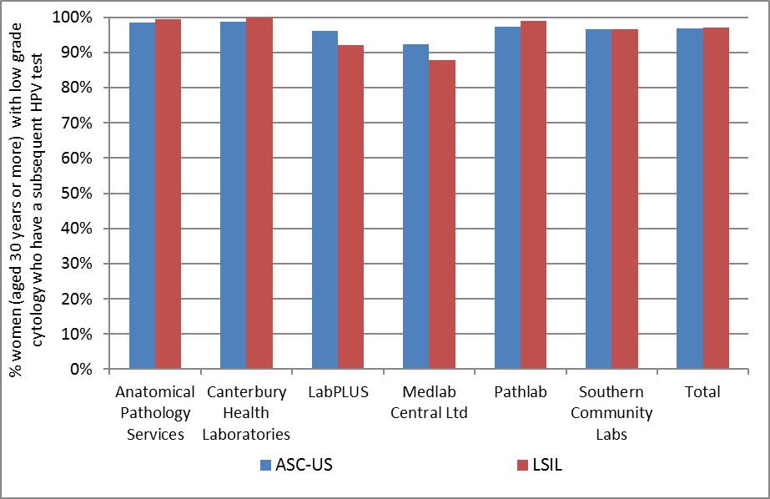
Excludes women with abnormal cytology in the five years preceding their low grade cytology sample

Figure 89 - Proportion of women (aged less than 30 years) with low grade cytology who have a subsequent HPV test, by laboratory and cytology result
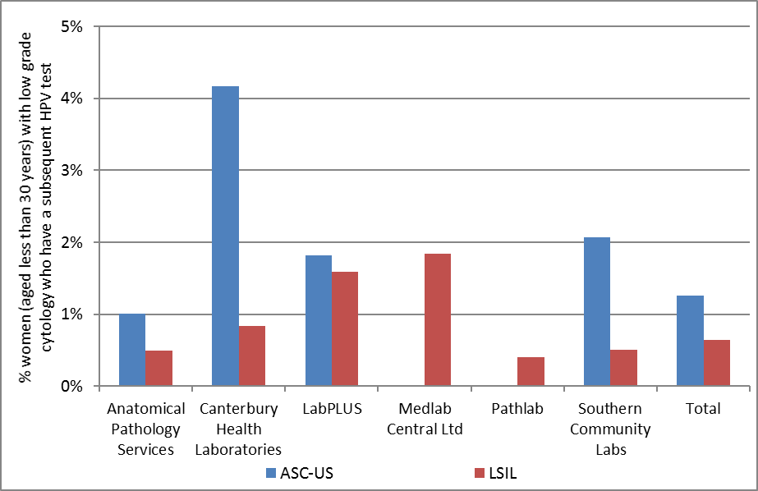
Excludes women with abnormal cytology in the five years preceding their low grade cytology sample, and also women who have ever had a high grade squamous abnormality (cytology or histology)

Figure 90 - Proportion of HPV triage tests which are positive following ASC-US cytology (women aged 30 years or more), by cytology laboratory
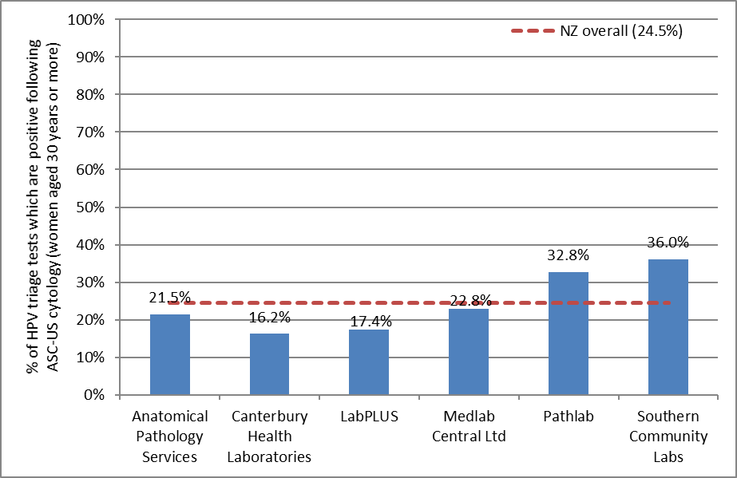

Figure 91 - Proportion of HPV triage tests which are positive following LSIL cytology (women aged 30 years or more), by cytology laboratory
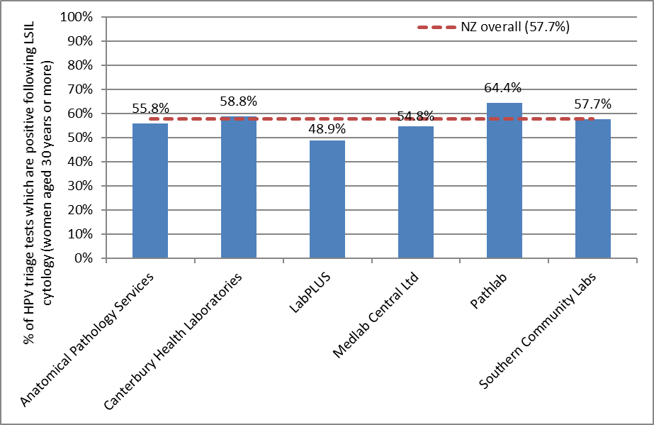

Figure 92 - Proportion of women with an HPV triage test who are HPV positive, by age and cytology result
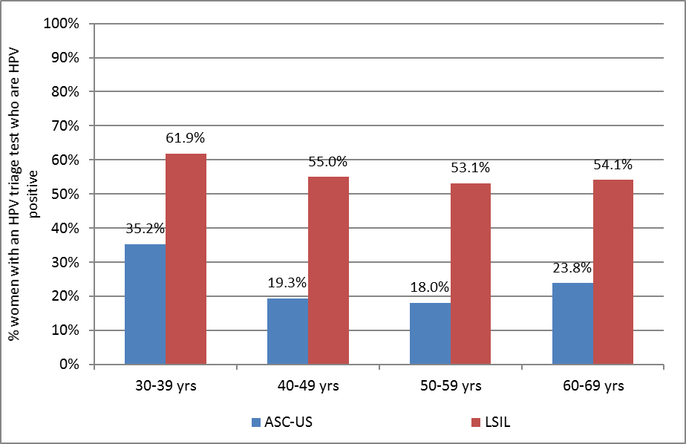
Note: Excludes results for women aged less than 30 years and aged 70 years or more, since these are based on very small numbers of women with valid HPV test results.

Table 20 - HPV triage test results following ASC-US cytology, by age and cytology laboratory
Laboratory | Women with valid HPV test results |  | Women with positive HPV test results (number and % within each age group)
 | <30yrs* | 30+ yrs | < 30yrs* |  | 30-39 yrs |  | 40-49 yrs |  | 50-59 yrs |  | 60-69 yrs |  | 70+ yrs
 | N | N | N | % | N | % | N | % | N | % | N | % | N | %
Anatomical Pathology Services | 2 | 465 | 0 | 0.0 | 54 | 35.5 | 26 | 17.8 | 13 | 11.3 | 7 | 15.6 | 0 | 0.0
Canterbury Health Laboratories | 2 | 148 | 2 | 100.0 | 16 | 27.6 | 3 | 6.7 | 1 | 3.3 | 4 | 26.7 | 0 | 0.0
LabPLUS | 1 | 144 | 0 | 0.0 | 11 | 21.6 | 3 | 8.6 | 8 | 20.5 | 3 | 20.0 | 0 | 0.0
Medlab Central Ltd. | 0 | 171 | 0 | 0.0 | 21 | 42.0 | 11 | 19.0 | 4 | 9.8 | 3 | 14.3 | 0 | 0.0
Pathlab | 0 | 174 | 0 | 0.0 | 24 | 45.3 | 14 | 28.0 | 10 | 28.6 | 9 | 27.3 | 0 | 0.0
Southern Community Laboratories | 3 | 222 | 2 | 66.7 | 28 | 38.4 | 20 | 30.8 | 22 | 35.5 | 10 | 45.5 | 0 | 0.0
Total | 8 | 1324 | 4 | 50.0 | 154 | 35.2 | 77 | 19.3 | 58 | 18.0 | 36 | 23.8 | 0 | 0.0
Excludes women with abnormal cytology in the five years preceding their low grade cytology sample.
* Additionally excludes women with any previous squamous high grade (cytology or histology)
Table 21 - HPV triage test results following LSIL cytology, by age and cytology laboratory
Laboratory | Women with valid HPV test results |  | Women with positive HPV test results (number and % within each age group)
 | < 30yrs* | 30+ yrs | < 30yrs* |  | 30-39 yrs |  |  | 40-49 yrs |  | 50-59 yrs |  |  | 60-69 yrs |  | 70+ yrs
 | N | N | N | % |  | N | % | N | % |  | N | % | N | % | N | %
Anatomical Pathology Services | 3 | 428 | 3 | 100.0 |  | 118 | 58.1 | 61 | 51.3 |  | 43 | 53.8 | 13 | 59.1 | 4 | 100.0
Canterbury Health Laboratories | 1 | 68 | 1 | 100.0 |  | 20 | 62.5 | 12 | 57.1 |  | 4 | 44.4 | 4 | 66.7 | 0 | 0.0
LabPLUS | 1 | 47 | 1 | 100.0 |  | 11 | 61.1 | 8 | 42.1 |  | 3 | 42.9 | 1 | 33.3 | 0 | 0.0
Medlab Central Ltd. | 3 | 93 | 3 | 100.0 |  | 22 | 61.1 | 16 | 51.6 |  | 11 | 57.9 | 2 | 33.3 | 0 | 0.0
Pathlab | 1 | 208 | 1 | 100.0 |  | 60 | 65.9 | 37 | 68.5 |  | 33 | 62.3 | 4 | 40.0 | 0 | 0.0
Southern Community Laboratories | 5 | 541 | 4 | 80.0 |  | 150 | 63.6 | 88 | 55.0 |  | 51 | 48.6 | 22 | 57.9 | 1 | 50.0
Total | 14 | 1385 | 13 | 92.9 |  | 381 | 61.9 | 222 | 55.0 |  | 145 | 53.1 | 46 | 54.1 | 5 | 71.4
Excludes women with abnormal cytology in the five years preceding their low grade cytology sample
* Additionally excludes women with any previous squamous high grade (cytology or histology)

Figure 93 - Triage-positive women with histologically-confirmed CIN2+ within 12 months, as a percentage of all women with histology, by laboratory
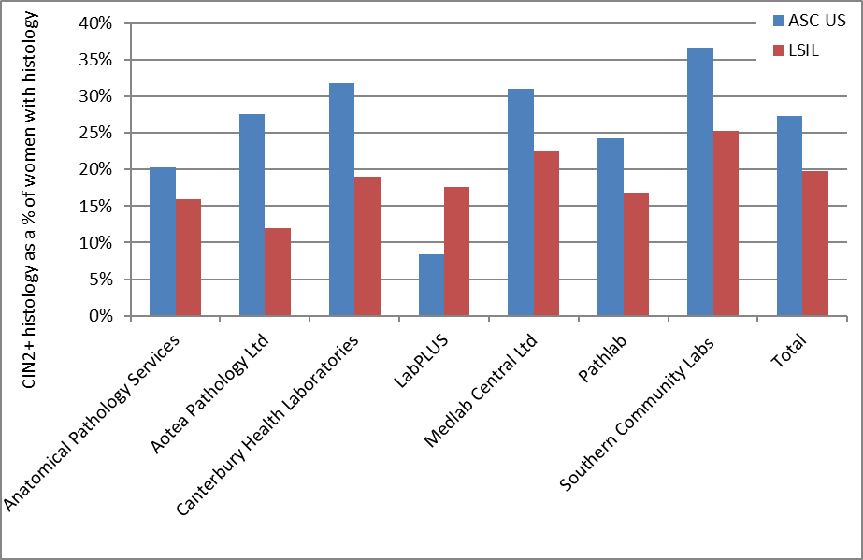
There were no women with cytology samples processed by LabPLUS who had an LSIL result resulting in histologically-confirmed CIN2+ for this monitoring period. Note that LabPLUS results are based in very small numbers of triage-positive women (see Table 72 and Table 73).

Figure 94 - Triage-positive women with histologically-confirmed CIN2+ within 12 months, as a percentage of all women who attended colposcopy, by laboratory
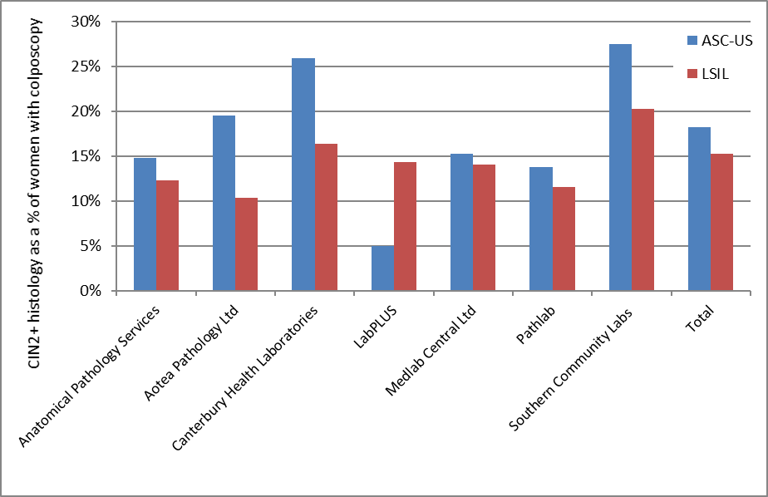
Note that LabPLUS results are based in very small numbers of triage-positive women (see Table 72 and Table 73).

Figure 95 - Women with histologically-confirmed CIN2+ within 12 months, as a percentage of all women who attended colposcopy, by laboratory and referral cytology
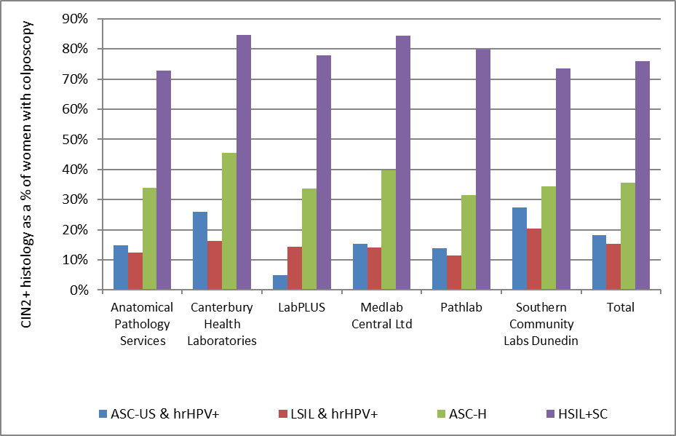

Figure 96 - Triage-positive women with histologically-confirmed CIN2+ within 12 months, as a percentage of women with histology recorded, by age
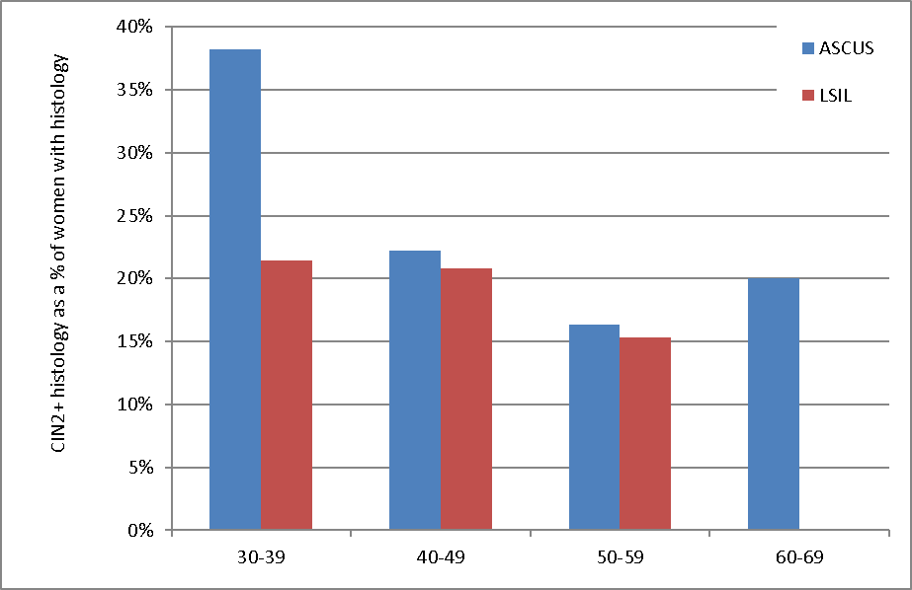

Figure 97 - Triage-positive women with histologically-confirmed CIN2+ within 12 months, as a percentage of women with colposcopy recorded, by age
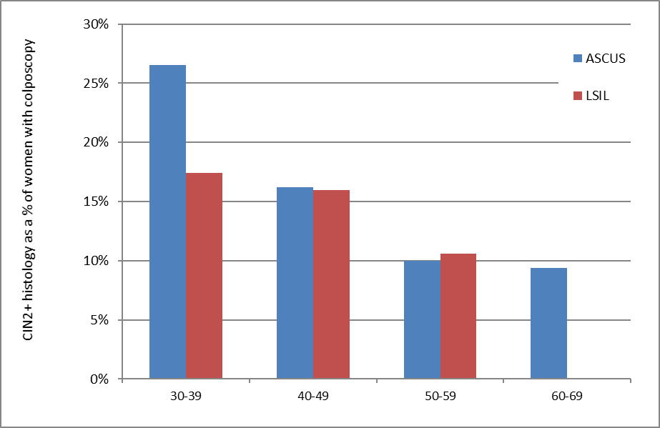

Figure 98 - Trends in ASC-US triage-positive women with histologically-confirmed CIN2+ within 12 months, as a percentage of women with colposcopy recorded, by laboratory
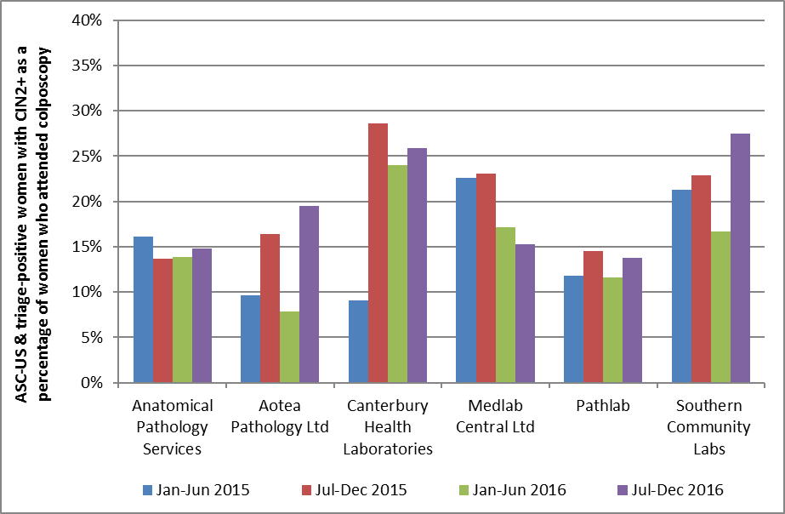
Time periods relate to monitoring report periods; results relate to samples collected in the 6-month period 12 months prior to the monitoring period, to allow for sufficient follow-up time for colposcopy/ histology. Note that this graph excludes LabPLUS due to the very small numbers of triage-positive women. See Table 72.

Figure 99 - Trends in LSIL triage-positive women with histologically-confirmed CIN2+ within 12 months, as a percentage of women with colposcopy recorded, by laboratory
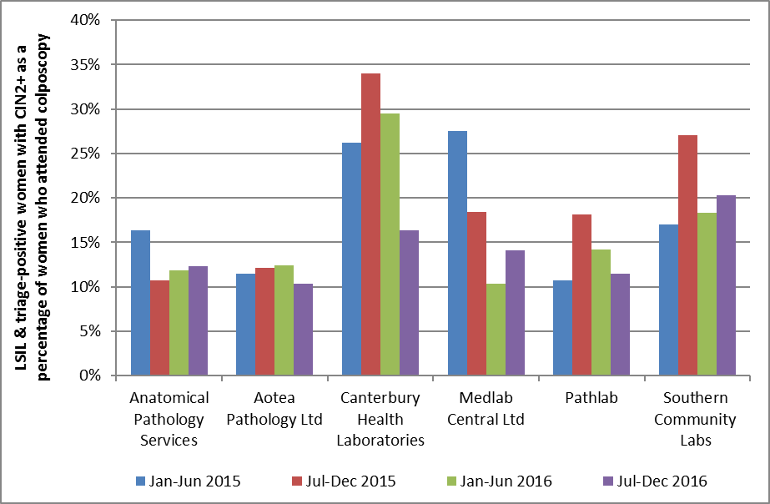
Time periods relate to monitoring report periods; results relate to samples collected in the 6-month period 12 months prior to the monitoring period, to allow for sufficient follow-up time for colposcopy/ histology. Note that this graph excludes LabPLUS due to the very small numbers of triage-positive women. See Table 73.

Indicator 8.2 – HPV test volumes

Definition | All HPV tests received by laboratories within the monitoring period were retrieved. This volume of HPV tests (performed for any purpose) is reported on by:  - Laboratory  - Ethnicity  - Age group  - Purpose (under development)  Purpose is defined as one of the following categories:  - Post-treatment (women treated for high grade squamous lesions (specifically CIN2/3) in the period six months to four years prior to the HPV sample date, to capture two rounds of testing)  - Historical (high grade squamous cytology (ASC-H/ HSIL) or histology (CIN2/3) more than three years prior to the HPV test sample)  - Taken at colposcopy (HPV sample collected on the same date as a colposcopy visit or a histology sample in the same woman)  - HPV triage (as defined in Indicator 8.1, but restricted to women aged 30 years or more at the time of the cytology specimen, and where the low grade cytology (ASC-US or LSIL) was no more than six months prior to the HPV test)  - Other (tests which do not fit into any of the above categories)  These categories are defined hierarchically in the order shown; that is, a test cannot fit into more than one category, and tests are only considered for inclusion in a category if no previous categories in the list apply.  As this indicator is still being developed, tests in the ‘Other’ category were explored further. The number of tests that fell into the ‘Other’ category was found to be relatively high in this report, but this analysis is nonetheless indicative of the appropriate purposes. It is also useful to report the extent of HrHPV tests for other purposes and the need to eliminate hrHPV tests for other purposes that are not within the NCSP guidelines. For this reason the purpose of hrHPV tests are discussed in this report.  Rates of invalid HPV tests are also reported on.  Measures reported by age are based on the age of the women on the date that the HPV test sample was collected.
Target | Targets have not yet been set.
Current Situation | Overall volumes  There were 19,822 samples received by laboratories for HPV testing within the current monitoring period. These are reported on further in Table 74 to Table 79.  Virtually all (98.5%) samples for HPV testing were from women aged 20-69 years. The large majority of women (86.0%) were aged 30 years or more (Figure 100, Table 78).  The number of samples received by laboratories for HPV testing ranged from 1,191 (LabPLUS; 6.0% of all HPV tests) to 7,714 (Southern Community Laboratories; 38.9% of all HPV tests) (Figure 101, Table 74).  Figure 102 and Table 74 also show for each laboratory the ratio of the number of HPV tests received, divided by the number of cytology tests reported (expressed as a percentage). This measure provides some correction for the variation in workloads between different laboratories. It is likely, for example, that laboratories which process a larger volume of cytology tests would also undertake a larger volume of HPV tests. The ratio of HPV tests to cytology tests reported was on average 9.5% across New Zealand – that is, on average 9.5% of cytology tests are associated with an HPV test. This ratio varied by laboratory from 7.3% (Southern Community Laboratories; i.e. fewer HPV tests processed in relation to cytology tests processed than the national average) to 15.1% (LabPLUS; i.e. more HPV tests processed in relation to cytology tests processed than the national average).  The distribution of HPV tests by ethnicity is shown in Table 77.  The overall proportion of HPV tests with invalid results was 0.2% (Table 75). The proportion was small for both HPV test technologies reported (Table 76).  Purpose of HPV tests  These HPV tests were further analysed in order to ascertain the purpose for which they were performed. Nationally, it was calculated that 2,756 (13.9%) were for post-treatment management for women treated in the past four years; 7,522 (37.9%) were for follow-up management of women with high grade squamous cytology or histology more than three years previously (historical testing); 861 (4.3%) were on samples collected at a colposcopy visit which did not fit into a previous category (possibly for resolution of discordant results); and 2,580 (13.0%) were for triage of low grade cytology in women aged 30 years or more. There were 6,103 (30.8%) HPV tests that did not fit into any of the previously described categories (Figure 103).  Further breakdowns of HPV tests by purpose are presented by age (Figure 104), laboratory (Figure 105), and ethnicity (Table 77).  There were variations in HPV test purpose by age (Figure 104, Table 78). HPV triage (by the definition used here, and consistent with NCSP Guidelines) did not occur in women aged less than 30 years. In women aged less than 30 years, a comparatively larger proportion were taken post-treatment management (32.4%) and other reasons where the purpose did not fit into other categories (33.1%). Follow up of women with historical high grade squamous abnormalities (more than three years ago) was the most common reason that HPV tests were performed among women in the five-year age groups between 30 and 54 years. Tests which did not fit into the prescribed categories, and were therefore classified as ‘Other’, were the most common classification among women aged less than 24 years and 55 years and older. Post-treatment management was most common purpose for HPV tests in women aged between 25-29 years.  HPV test purpose also varied by laboratory (Figure 105, Table 79). Among tests for which the purpose could be determined, the most common reason for HPV testing was historical testing in all laboratories. In all laboratories, however, tests for which the purpose was unclear were quite common, varying from 20.0% at Pathlab to 40.9% at LabPLUS. The proportion of tests performed for post-treatment management varied from 9.9% (Pathlab) to 23.7% (Canterbury Health Laboratories), while the proportion performed to follow up women with historical high grade squamous abnormalities varied from 18.2% (LabPLUS) to 48.0% (Pathlab). The proportion of tests where the sample was collected at colposcopy but not for one of the previous purposes ranged from 1.4% (Anatomical Pathology Services) to 11.3% (LabPLUS). The proportion of tests performed for HPV triage ranged from 9.3% (Southern Community Laboratories) to 17.5% (Anatomical Pathology Services).  Follow up of women with historical high grade squamous abnormalities (more than three years ago) was the most common reason that HPV tests were performed among Māori, Pacific and European/ Other women. HPV triage was the most common reason among Asian women (Table 77).  Tests in the ‘Other’ category were further explored. A proportion of the ‘Other’ tests (3.3%; 201 tests) were potentially tests performed for post-treatment management, because the same woman had CIN 2/3 histology recorded on the NCSP Register, however there was no explicit record of treatment available on the NCSP Register, potentially due to incomplete colposcopy data on the NCSP Register. Another 6.6% occurred after treatment, but did not meet the criteria for post-treatment management because they occurred within 6 months of treatment (2.5%; 153 tests), or after treatment of either a non-squamous high grade (1.2%; 76 tests), or a non-high grade (2.8%; 171 tests) or following treatment of cervical cancer (0.02%, 1 test). A further 18.7% of the ‘Other’ HPV tests occurred after a previous abnormality but one which did not meet the criteria for historical testing either because it was non-squamous (8.7%; 528 tests), the high grade squamous cytology was less than three years ago (9.9%; 603 tests), or the histology diagnosis was not high grade but cervical cancer, (0.2%; 12 tests).  A larger proportion of the ‘Other’ tests (31.0%; 1,892 tests) occurred in women who did not have any specific high grade abnormality recorded on the NCSP Register, but who did have a record on the NCSP Register suggesting that they had a previous high grade abnormality (although the Register does not record whether it was a squamous abnormality or not; consequently, HPV testing is not indicated in these women by the NCSP guidelines). These records predominantly indicated prior high grade cytology (25.1%; 1,529 tests), but some suggested prior high grade histology (5.9%; 363 tests). Smaller proportions of HPV tests were associated with a low grade abnormality, including either a current low grade cytology result which did not meet the criteria for triage because the woman had another recent abnormality and triage was not required (2.0%; 125 tests), or a record suggesting a previous low grade cytology not explicitly recorded on the NCSP Register (3.3%; 201 tests). After this exploration, there remained 2,140 tests (35.1% of ‘Other’ tests; 10.8% of all HPV tests in the monitoring period) where purpose still could not be determined.  HPV tests at colposcopy  HPV tests taken at colposcopy were further explored, based on the DHB of the colposcopy clinic where the sample was taken, and whether or not it was a public or a private clinic. Nationally, more of the HPV tests which were taken at colposcopy came from public facilities (653 tests; 89.2%) than from private facilities (79 tests; 10.8%). As the number of HPV tests collected at a colposcopy clinic is potentially reflective of the number of colposcopies performed there, a rate of HPV tests at colposcopy which takes this variation into account was derived, in order to provide more information. The rate of HPV tests at colposcopy was calculated by dividing the number of HPV tests collected at colposcopy by the total number of colposcopies within that DHB or across private colposcopy clinics, expressed as a percentage. This rate can be broadly interpreted as the percentage of colposcopies (within a given DHB or sector) where an HPV test sample is collected. Across New Zealand, HPV test samples were collected in approximately 5.4% of colposcopies. In DHBs where HPV tests were collected at colposcopy, this value ranged from 0.3% (Hawke's Bay) to 32.7% (Lakes), and was 5.4% overall across all public DHB clinics (Figure 106, Table 80). In private practice, this rate was 6.0%. No HPV tests were taken at colposcopy in Hutt Valley, Taranaki, Wairarapa and Whanganui.
Trends | Slightly fewer samples were received at laboratories for HPV testing in the current monitoring period (19,822) than in the previous monitoring report (20,143; a decrease of 1.6%). The laboratory with the greatest percentage increase in the number of samples received between the current monitoring period compared with the previous report period was LabPLUS (from 1,065 to 1,191 tests; 11.8% increase). The laboratory with the largest percentage decrease in the number of tests received between the current and previous period was Canterbury Health Laboratories (from 1,828 to 1,500 tests; 17.9% decrease). Trends by laboratory can be seen in Figure 107.  The decrease in HPV test volumes was not consistent across all test purpose categories however. The number of tests performed for each of the four guidelines categories (post-treatment, historical testing, HPV triage or tests at colposcopy) all decreased, while the number of tests which did not fit into any of these categories (‘Other’ tests) increased by 2.2%. Consequently the poroprtion of HPV tests in the ‘Other’ category increased from 29.6% of all HPV tests to 30.8% of all HPV tests. The proportion of tests in each of the other four categories was broadly similar to that seen in the previous report (from 13.8% to 13.9% for post-treatment management; from 38.5% to 37.9% for historical testing; from 13.6% to 13.0% for triage of low grade cytology, and from 4.4% to 4.3% for tests taken at colposcopy).  The number of HPV tests which are performed for other test where the reason can not be determined has been increasing over the last four monitoring periods while HPV triage and tests for historical management has seen a more recent decreasing trend (Figure 108).  Variations in the purpose of HPV tests by age and ethnicity were broadly similar to that in previous reports. Women aged 20-24 showed an increasing trend in HPV tests done for other reasons that did not fit into any of the other categories. There was also decreasing trends in HPV triage in women of all ethnic categories.  The proportion of HPV tests which are invalid remains very small.
Comments | HPV volumes by laboratory will vary for a number of reasons, one of which being the general volume of work in that laboratory. In order to provide some correction for the variation in workloads between different laboratories, we calculated the ratio of HPV tests received to cytology tests reported on (Figure 102, Table 74). Other reasons for variations in the rate of HPV testing by laboratory (which are not taken into account in this ratio) may include differences in the population they serve, because HPV testing is performed in specific subgroups of women. For example, HPV triage testing is performed in women with low grade (ASC-US/LSIL) cytology results (but without recent abnormalities), therefore laboratories reporting higher rates of low grade abnormalities may also have higher rates of triage testing. Conversely, laboratories reporting on a larger proportion of cytology from colposcopy clinics may be less likely to perform HPV triage testing, because women attending colposcopy have generally had a recent abnormality and therefore do not require triage. These issues may for example partly explain differences in the ratios in Canterbury Health Laboratories (where rates of low grade cytology results are comparatively higher) and LabPLUS (where a larger proportion of cytology comes from colposcopy clinics). To understand in more detail, the reasons for the differences, an explicit exploration of the purpose for which the HPV test was performed has been examined here.  Exploration is ongoing into the potential reason for tests in the ‘Other’ category, as is the refinement of specifications for the analysis of purpose. Some possible explanations include follow-up of women previously treated for high grade squamous abnormalities where these abnormalities occurred outside New Zealand, prior to the woman being enrolled on the NCSP Register, or prior to the inception of the NCSP Register. The latter may potentially explain why the proportion of ‘Other’ tests is higher in older women than in younger women (except for ages less than 20). Synopses held on the NCSP Register of previous (self-reported) high grade abnormalities have been used in this report to explore this possibility further (although these synopses do not distinguish between squamous abnormalities and glandular abnormalities; HPV testing is currently only recommended for the management of women with previous squamous abnormalities). The proportion associated with a synopsis reflecting a previous high grade abnormality (cytological or historical) reported here (31.0%) is less than that in the previous report (32.1%), and the number of tests in this category has also decreased since the previous report (from 1,915 to 1,892). In a June 2015 newsletter, the NCSP reminded laboratories that women with a previous glandular lesion, or a high grade synopsis code on their screening history but no confirmation that the previous abnormality was squamous, should remain on annual screening and HPV testing is not indicated for these women.

Figure 100 - Volume of HPV test samples received by laboratories during the monitoring period, by age
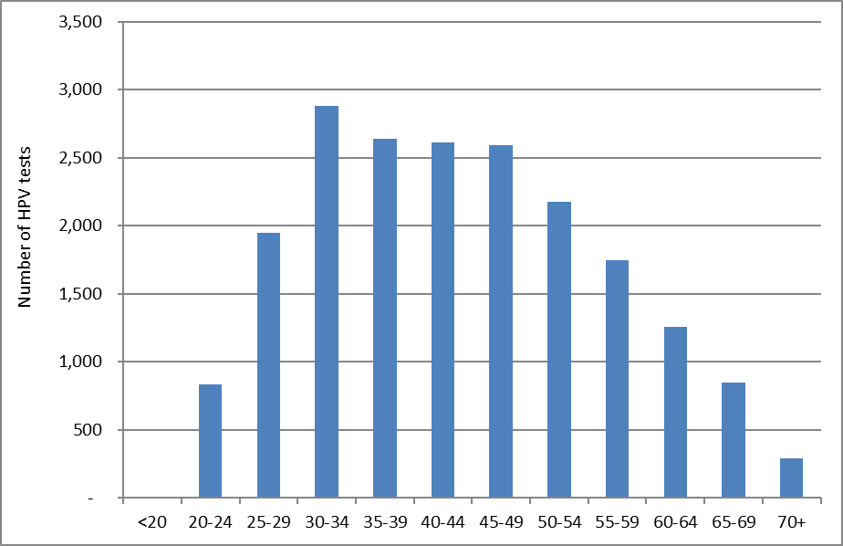

Figure 101 - Volume of HPV test samples received by laboratories during the monitoring period, by laboratory
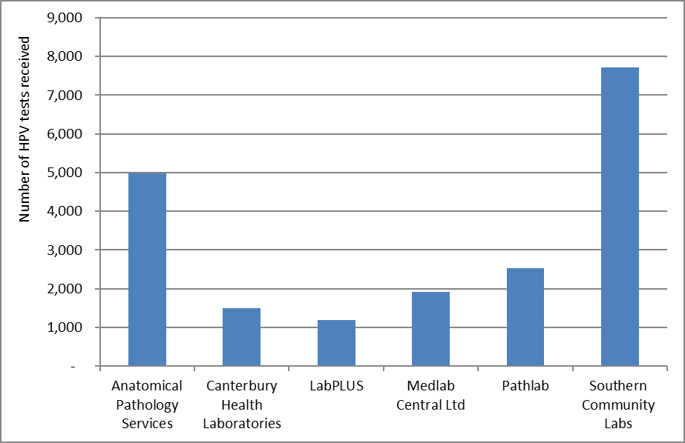

Figure 102 - HPV test samples as a percentage of cytology test samples received during the monitoring period, by laboratory
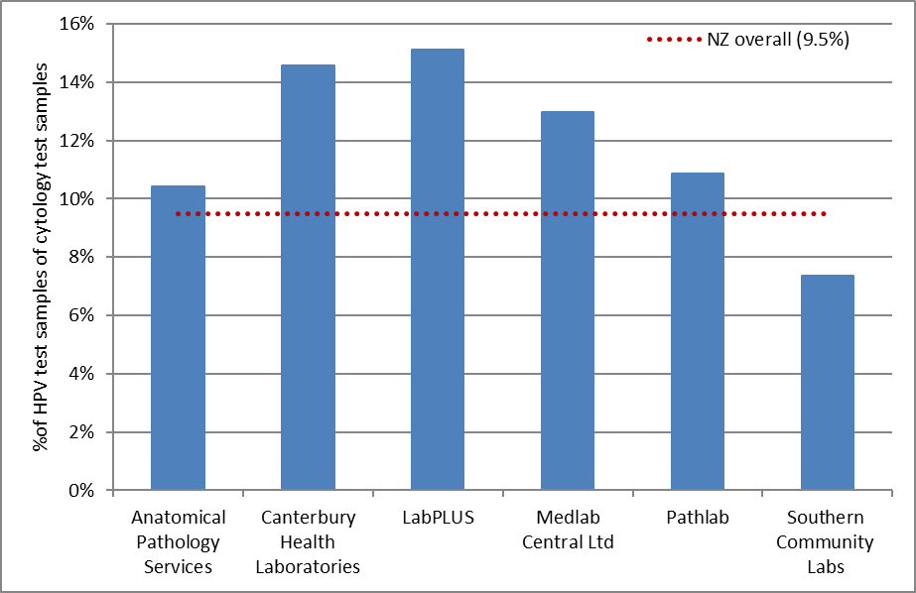
HPV tests/ colposcopy can be interpreted as the percentage of cytology tests which have an associated HPV test

Figure 103 - Volume of HPV test samples received during the monitoring period, by purpose
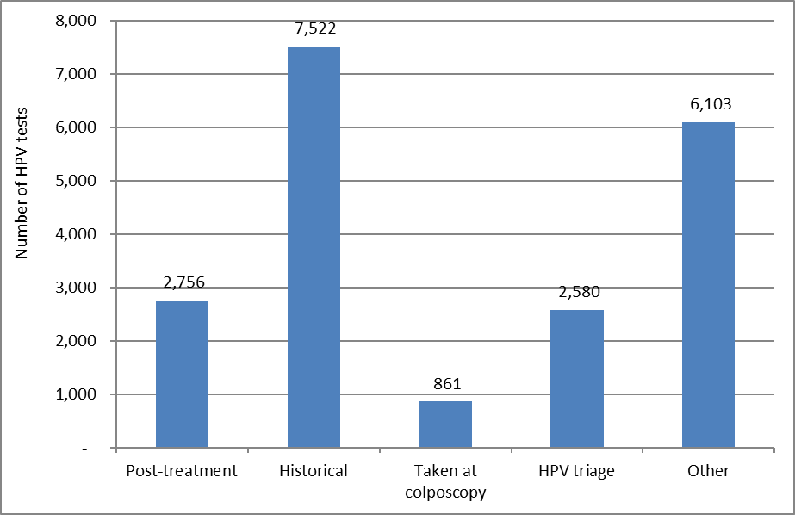

Figure 104 - HPV test samples received during the monitoring period, by purpose and age
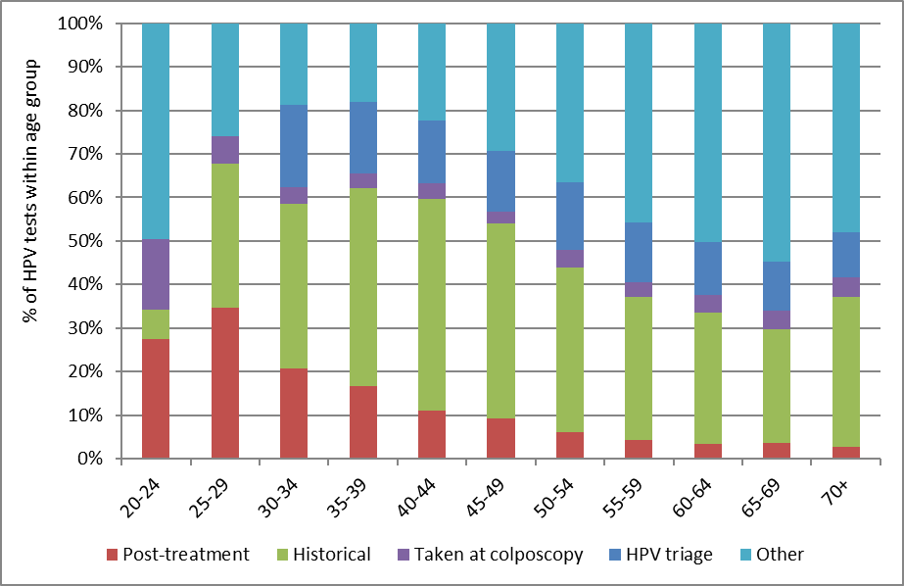

Figure 105 - HPV test samples received during the monitoring period, by purpose and laboratory
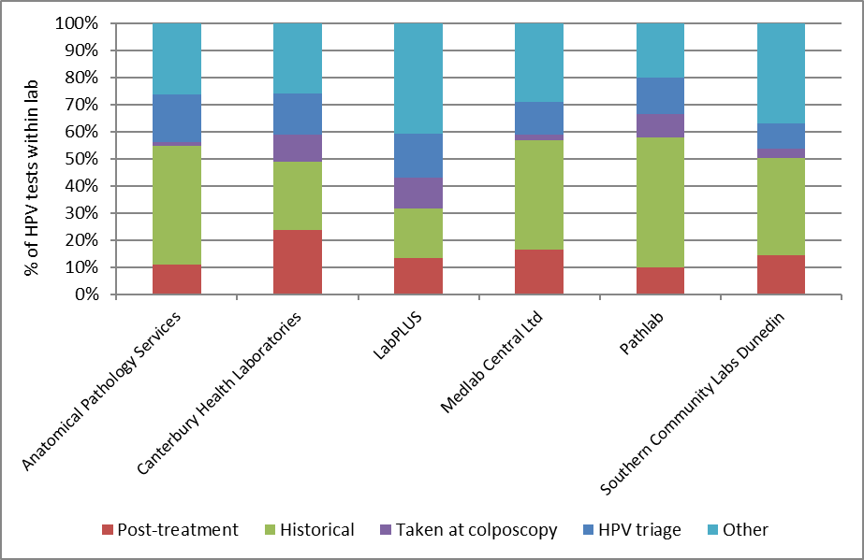

Figure 106 - HPV test samples collected at colposcopy, in relation to total colposcopies performed in the period, by DHB
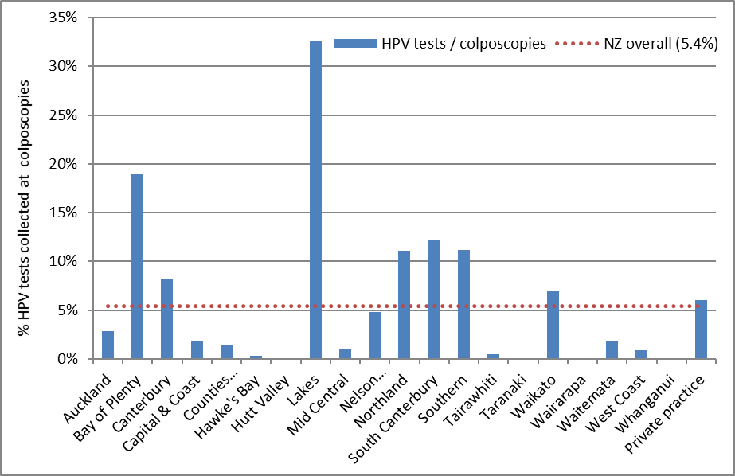
HPV tests/ colposcopy can be interpreted broadly as the percentage of colposcopies within this DHB/ sector where a sample is collected for HPV testing. No HPV tests at colposcopy in Hutt Valley, Taranaki, Wairarapa and Whanganui.

Figure 107 - Trends in volumes of HPV test samples received, by laboratory
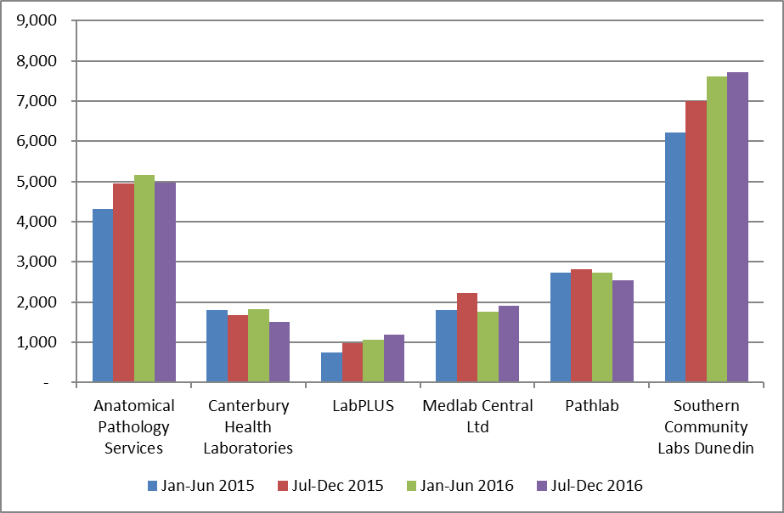

Figure 108 - Trends in volumes of HPV test samples received, by purpose
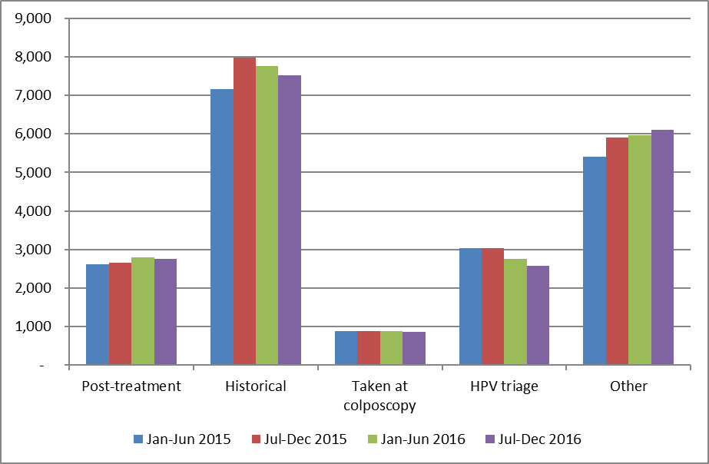

Indicator 8.3 – HPV tests for follow-up of women with a historical high grade abnormality

Definition | NCSP Guidelines for Cervical Screening in New Zealand state that women with a previous high grade squamous abnormality (ASC-H, HSIL, CIN2/3) more than three years ago may benefit from two rounds of dual cytology and hrHPV testing (“historical testing”). If women test negative on both tests over two years, they can safely be screened according to the routine screening recommendations (cytology alone every three years until 70). HPV testing is not recommended for management of women with a historic non-squamous high grade abnormality.  The purpose of this indicator is to examine the extent to which historical testing is being used for women who are eligible for it.  Predominantly, women who are eligible for historical testing will be those who were eligible for it at the time it was introduced (1 October 2009), because women with more recent high grade squamous abnormalities will be followed up with hrHPV testing in other ways (as part of standard post-treatment management and/ or use of hrHPV testing to assist in resolving discordant cytology and colposcopy/histology). Therefore, at the current time, this indicator examines use of historical testing in the group of women who were eligible for it when it became available on 1 October 2009 (the date that testing for hrHPV was introduced in New Zealand within the NCSP). It does not include women who may have become eligible for historical testing after 1 October 2009 (however it is expected that this would be a relatively small proportion of those eligible).  Women are considered to have been eligible for historical testing as at 1 October 2009 if:  - They had a high grade squamous abnormality (cytology or histology) more than three years prior to 1 October 2009, as per the definition of historical testing (i.e. prior to 1 October 2006) and  - They had no previous glandular abnormality (i.e. prior to 1 October 2009); and  - Between their historical high grade squamous abnormality and 1 October 2009, they had either no cytology OR only negative cytology OR three consecutive negative cytology tests as their most recent cytology results; and  - They were alive on 1 October 2009.  Women were excluded, however, if they had been treated for a high grade squamous abnormality within the three years prior to 1 October 2009, because this meant they met the criteria for post-treatment women, rather than historical testing.  Within the current report, Round 1 and Round 2 historical tests are only considered for women who were both eligible for historical testing on 1 October 2009 and who also remained eligible for it throughout the current monitoring period. Therefore, in the current report, women were excluded if:  - They were not still alive at the end of the current monitoring period (follow-up no longer possible); or  - They had a non-squamous high grade abnormality between becoming eligible (on 1 October 2009) and the end of the current monitoring period (no longer eligible for historical testing)  HPV tests in these women from 1 October 2009 were retrieved. HPV tests which appeared to have been carried out for other recommended uses of HPV testing (such as HPV triage of low grade cytology; HPV tests taken at colposcopy; or HPV tests performed to follow-up treatment of a high grade squamous abnormality within the previous three years) were excluded since they were not performed for the purpose of historical testing. After excluding those tests, the first HPV test in each woman was defined as her Round 1 historical test. A Round 2 historical test was defined as the first HPV test which occurred at least 9 months after a Round 1 historical test.  Measures reported by age are based on the age of the women at the end of the current monitoring period (i.e. a woman’s age at 31 December 2016). Measures reported by DHB are based on the geographic area relating to the woman’s residence (or if this information is not available, that of her responsible health provider).
Target | Targets have not yet been set.
Current Situation | Overall women eligible for historical testing  There were 50,504 women who, as at 1 October 2009, were eligible for HPV testing to follow-up a historical squamous high grade abnormality (“historical testing”). Of these women, 49,478 are considered in the current report (the remaining women were excluded because they were no longer alive at the end of the current monitoring period, or were no longer eligible for historical testing because they had a non-squamous high grade abnormality since 1 October 2009). There were no women eligible for historical testing who were aged less than 25 years at the end of the current monitoring period; however, this is not unexpected, as women in this age group would have been aged less than 18 years old on 1 October 2009 and few women this age are screened or treated for high grade abnormalities (Table 81).  HPV tests performed for historical reasons  Overall, 31,236 (63.1%) of the women eligible for historical testing as at 1 October 2009 have a Round 1 historical test recorded on the NCSP Register. There were 24,321 women who also have a Round 2 historical test (49.2% of eligible women; 77.9% of those with a Round 1 test).  The proportion of women with historical tests varied by age. Among women aged 25 to 69 years at the end of the current monitoring period, the proportion of eligible women with a historical test varied from 51.8% (25-29 years) to 65.8% (60-64 years) for Round 1 tests, and from 36.2% (25-29 years) to 52.5% (60-64 years) for Round 2 tests (Figure 109, Table 81).  The proportion of eligible women with historical tests also varied by DHB, from 49.3% (Counties Manukau) to 78.4% (Nelson Marlborough) for Round 1 tests, and from 31.6% (Counties Manukau) to 69.5% (Nelson Marlborough) for Round 2 tests (Figure 110, Table 82). The number of women eligible for historical testing in a given DHB did not appear to have any relationship with the proportion who had received a historical test (Figure 115).  The proportion of eligible women with Round 1 historical tests ranged from 43.5% in Pacific women to 65.4% in European/ Other women (Figure 111, Table 83). For Round 2 tests, this proportion ranged from 30.4% in Pacific women to 51.9% in European/ Other women.  We explored whether the proportion of women with a historical HPV test was influenced by screening participation within the previous five years (since if women have not attended for any test, it would not be possible to initiate a historical test). The variation in the proportion of women with historical tests recorded did not appear to be fully explained by variations in screening participation, either by DHB (Figure 116, Table 84) or by ethnicity (Figure 117).
Trends | As this Indicator is reporting on the cumulative proportion among the group of women who were eligible for hrHPV testing for the management of a historical high grade squamous lesion as at 1 October 2009, the proportion is generally expected to increase over time. It has done so in this report in every DHB (Figure 112), ethnicity (Figure 113) and every age group (Figure 114).
Comments | This indicator currently only considers women who had a high grade squamous abnormality more than three years prior to 1 October 2009. It is anticipated that women with more recent high grade squamous abnormalities will be followed up via standard post-treatment management which also includes hrHPV testing, or via use of hrHPV testing to resolve discordant test result. It was intended that future monitoring reports would also incorporate reporting on the use of hrHPV tests for the purpose of post-treatment management as a separate sub-indicator within Indicator 8. however, development of additional indicators has been suspended prior to the program’s planned transition to primary HPV screening, as indicators will be reviewed as part of the transition process.  Planned future refinements of this indicator include reporting on the proportion of the Round 1 and Round 2 historical tests where hrHPV was detected, and on how many women are able to be returned to routine screening after two rounds of negative cytology and hrHPV tests; considering women with a historical high grade squamous abnormality who became eligible for historical testing after 1 October 2009; and taking into account whether women have attended for any screening test, since women who have not attended for any testing could not be offered historical testing. This last point has been partially explored within the current report, by considering whether there was any relationship between the variations in women with Round 1 and Round 2 historical tests by DHB or ethnicity and the variations in screening participation within the previous five years by DHB or ethnicity (from Indicator 1.1). An extended period of five years was examined, since it corresponds more closely than three-year participation to the period during which we searched for HPV tests in this group of women (ie since 1 October 2009 and the time of the data download from NCSP Register used within this report, mid February 2017). However, as women with a previous abnormality are recommended to re-attend for screening more frequently than the routine interval, the variations in overall attendance by DHB or by ethnicity may differ from the variations by DHB or ethnicity in this subgroup of women who have had a previous abnormality.  It is possible that in some cases eligible women were offered historical HPV testing, but did not consent to the test. It has not been possible to take this into account within the current report. While this affects Round 1 tests, this should be less of an issue for Round 2 tests, because in June 2015 the NCSP requested that laboratories prompt sample taker to add on an HPV test where this is indicated by the Guidelines, but was not requested by the smear-taker. Additionally, for women who had already consented to the Round 1 HPV test, separate consent was not required for a Round 2 HPV test.  It is also possible that the reason some women underwent Round 1 tests, but not Round 2 tests, is because their concurrent cytology result indicated that other management (for example colposcopy referral) was required. This might be explored when this indicator is further refined to report on the test results in women who have undergone historical testing.

Figure 109 - Proportion of eligible women with squamous high grade abnormality more than 3 years ago for whom an historical test is recorded on the NCSP Register, by age at 31 December 2016
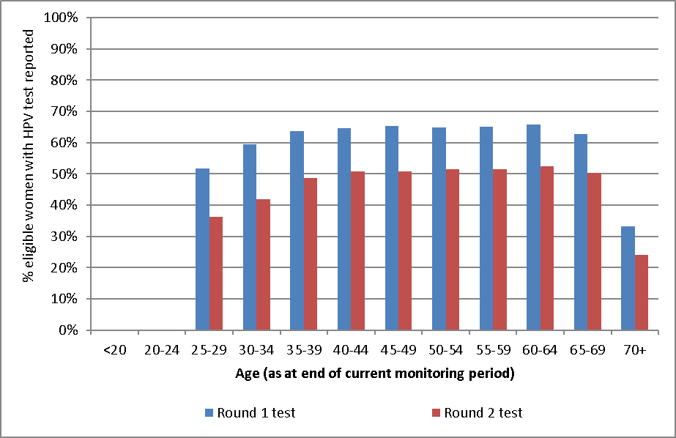
No women aged less than 25 years at the end of the current monitoring period were eligible for historical testing.

Figure 110 - Proportion of eligible women with squamous high grade abnormality more than 3 years ago for whom an historical test is recorded on the NCSP Register, by DHB
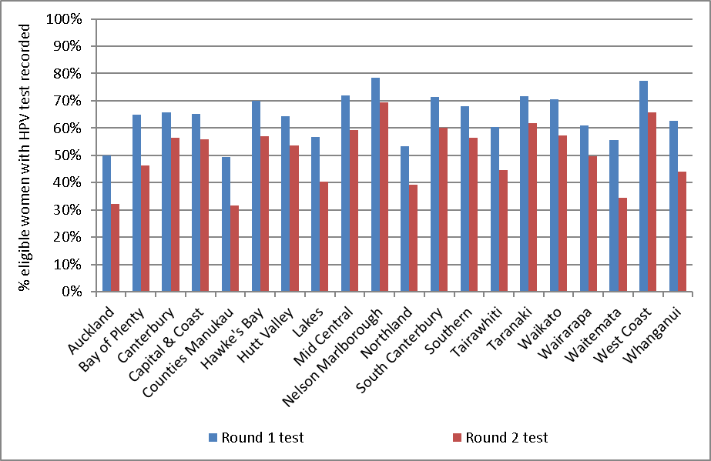

Figure 111 - Proportion of eligible women with squamous high grade abnormality more than 3 years ago for whom an historical test is recorded on the NCSP Register, by ethnicity
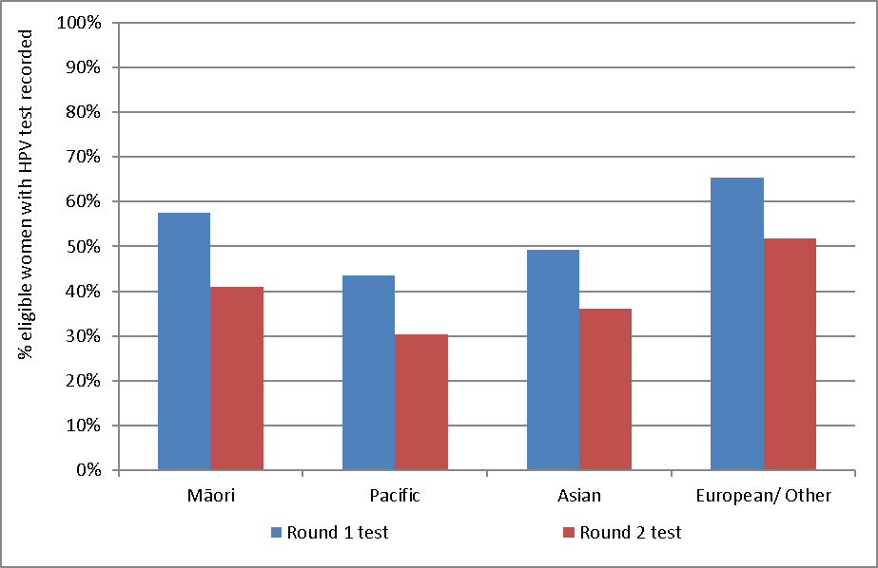

Figure 112 - Trends in the proportion of eligible women with squamous high grade abnormality more than 3 years ago for whom a round 1 historical test is recorded on the NCSP Register, by DHB
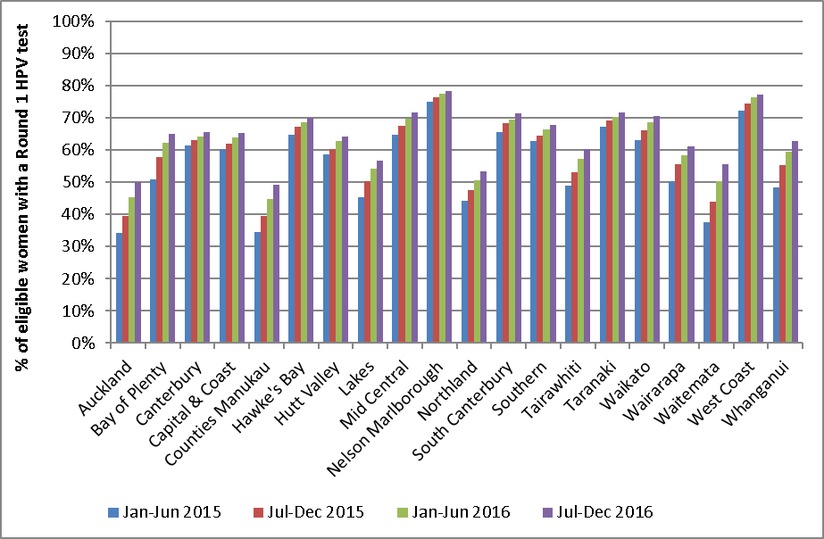

Figure 113 - Trends in the proportion of eligible women with squamous high grade abnormality more than 3 years ago for whom a round 1 historical test is recorded on the NCSP Register, by ethnicity
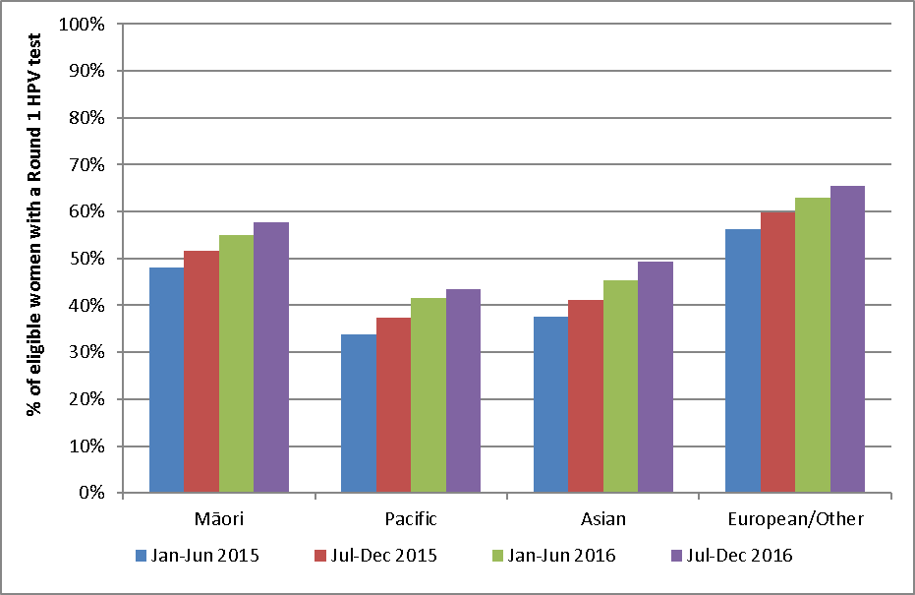

Figure 114 - Trends in the proportion of eligible women with squamous high grade abnormality more than 3 years ago for whom a round 1 historical test is recorded on the NCSP Register, by age
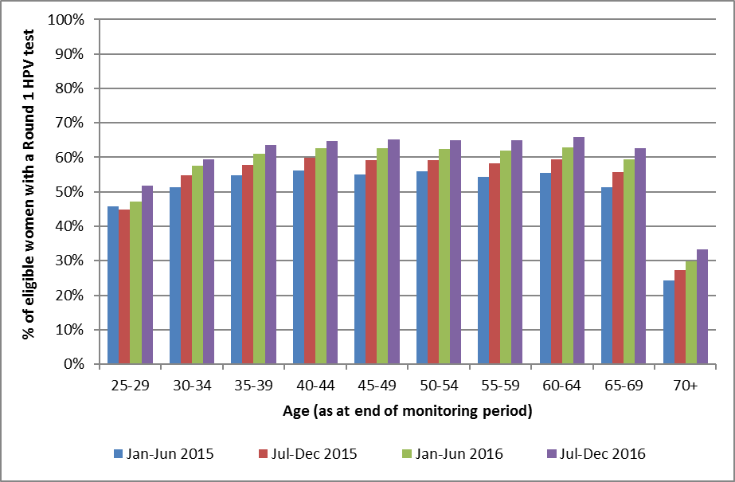
No women aged less than 25 years at the end of the current monitoring period were eligible for historical testing.

Appendix A – Additional data

Indicator 1 - Coverage

Indicator 1.1 – Three-year coverage
Table 22 - Coverage by DHB (women 25-69 years screened in the three years prior to 31 December 2016, hysterectomy adjusted)
DHB | Hysterectomy adjusted population |  | Women screened in the last 3 years
 | N | N | %
Auckland | 135,729 | 106,492 | 78.5
Bay of Plenty | 56,499 | 45,936 | 81.3
Canterbury | 137,855 | 102,870 | 74.6
Capital & Coast | 80,794 | 64,693 | 80.1
Counties Manukau | 135,645 | 100,342 | 74.0
Hawke's Bay | 40,552 | 30,704 | 75.7
Hutt Valley | 38,296 | 29,771 | 77.7
Lakes | 26,463 | 20,762 | 78.5
Mid Central | 42,470 | 31,887 | 75.1
Nelson Marlborough | 38,265 | 30,568 | 79.9
Northland | 42,123 | 30,747 | 73.0
South Canterbury | 14,951 | 11,519 | 77.0
Southern | 78,428 | 62,463 | 79.6
Tairawhiti | 11,878 | 8,752 | 73.7
Taranaki | 30,288 | 24,020 | 79.3
Waikato | 98,671 | 75,222 | 76.2
Wairarapa | 11,202 | 8,240 | 73.6
Waitemata | 156,947 | 119,200 | 75.9
West Coast | 8,794 | 6,354 | 72.3
Whanganui | 15,238 | 11,550 | 75.8
Total | 1,201,088 | 922,092 | 76.8
Excludes 27 women for whom DHB could not be determined

Table 23 - Coverage by ethnicity (women 25-69 years screened in the three years prior to 31 December 2016, hysterectomy adjusted)
Ethnicity | Hysterectomy adjusted population | Women screened in the last 3 years (ages 25-69 years)
 | (ages 25-69 years) | N | %
Māori | 158,942 | 101,839 | 64.1
Pacific | 67,670 | 50,797 | 75.1
Asian | 178,358 | 118,803 | 66.6
European/ Other | 796,118 | 650,680 | 81.7
Total | 1,201,088 | 922,119 | 76.8

Table 24 - Coverage by age (women 20-69 years screened in the three years prior to 31 December 2016, hysterectomy adjusted)
Age | Hysterectomy adjusted population | Women screened in the last 3 years
 | N | N | %
20-24 | 161,384 | 82,348 | 51.0
25-29 | 164,780 | 107,935 | 65.5
30-34 | 150,469 | 109,138 | 72.5
35-39 | 139,008 | 108,439 | 78.0
40-44 | 144,101 | 115,101 | 79.9
45-49 | 149,203 | 121,451 | 81.4
50-54 | 140,753 | 113,599 | 80.7
55-59 | 126,533 | 101,396 | 80.1
60-64 | 101,413 | 81,034 | 79.9
65-69 | 84,828 | 64,026 | 75.5
20-69 | 1,362,472 | 1,004,467 | 73.7

Table 25 - Coverage by DHB (women aged 25-69 years screened in the five years prior to 31 December 2016, hysterectomy adjusted)
DHB | Hysterectomy adjusted population | Women screened in the last 5 years
 | N | N | %
Auckland | 135,729 | 125,519 | 92.5
Bay of Plenty | 56,499 | 53,566 | 94.8
Canterbury | 137,855 | 121,175 | 87.9
Capital & Coast | 80,794 | 77,271 | 95.6
Counties Manukau | 135,645 | 118,870 | 87.6
Hawke's Bay | 40,552 | 36,830 | 90.8
Hutt Valley | 38,296 | 35,128 | 91.7
Lakes | 26,463 | 24,888 | 94.0
Mid Central | 42,470 | 37,834 | 89.1
Nelson Marlborough | 38,265 | 35,506 | 92.8
Northland | 42,123 | 36,889 | 87.6
South Canterbury | 14,951 | 13,192 | 88.2
Southern | 78,428 | 73,623 | 93.9
Tairawhiti | 11,878 | 10,479 | 88.2
Taranaki | 30,288 | 27,847 | 91.9
Waikato | 98,671 | 87,737 | 88.9
Wairarapa | 11,202 | 9,792 | 87.4
Waitemata | 156,947 | 139,991 | 89.2
West Coast | 8,794 | 7,471 | 85.0
Whanganui | 15,238 | 13,587 | 89.2
Total | 1,201,088 | 1,087,195 | 90.5
Excludes 31 women for whom DHB could not be determined

Table 26 - Coverage by ethnicity – women aged 25-69 years screened in the five years prior to 31 December 2016, hysterectomy adjusted
Ethnicity | Hysterectomy adjusted population | Women screened in the last 5 years
 | N | N | %
Māori | 158,942 | 125,391 | 78.9
Pacific | 67,670 | 62,988 | 93.1
Asian | 178,358 | 137,478 | 77.1
European/ Other | 796,118 | 761,369 | 95.6
Total | 1,201,088 | 1,087,226 | 90.5

Table 27 - Coverage by age (women 20-69 years screened in the five years prior to 31 December 2016, hysterectomy adjusted)
Age | Hysterectomy adjusted population | Women screened in the last 5 years
 |  | N | %
20-24 | 161,384 | 87,524 | 54.2
25-29 | 164,780 | 130,990 | 79.5
30-34 | 150,469 | 130,876 | 87.0
35-39 | 139,008 | 128,363 | 92.3
40-44 | 144,101 | 135,530 | 94.1
45-49 | 149,203 | 142,835 | 95.7
50-54 | 140,753 | 132,987 | 94.5
55-59 | 126,533 | 117,883 | 93.2
60-64 | 101,413 | 93,375 | 92.1
65-69 | 84,828 | 74,387 | 87.7
20-69 | 1,362,472 | 1,174,750 | 86.2

Table 28 - Women aged 25-69 years screened in the five years prior to 31 December 2016, by ethnicity and DHB (hysterectomy adjusted)
 | Māori |  | Pacific |  | Asian |  | European/ Other
DHB | N | % | N | % | N | % | N | %
Auckland | 6,918 | 70.9 | 12,493 | 101.1 | 33,539 | 77.5 | 72,569 | 103.2
Bay of Plenty | 9,945 | 80.8 | 664 | 80.1 | 2,711 | 72.9 | 40,246 | 101.5
Canterbury | 6,414 | 67.0 | 2,563 | 93.3 | 10,288 | 74.6 | 101,910 | 91.2
Capital & Coast | 6,037 | 76.2 | 4,315 | 83.6 | 9,200 | 78.4 | 57,719 | 103.1
Counties Manukau | 14,816 | 81.1 | 24,788 | 96.5 | 28,864 | 77.5 | 50,402 | 92.6
Hawke's Bay | 8,219 | 91.3 | 1,071 | 89.8 | 1,467 | 78.5 | 26,073 | 91.5
Hutt Valley | 4,660 | 85.2 | 2,282 | 86.3 | 3,994 | 89.1 | 24,192 | 94.1
Lakes | 7,217 | 88.5 | 497 | 88.4 | 1,461 | 70.2 | 15,713 | 100.3
Mid Central | 5,905 | 83.7 | 876 | 88.3 | 2,311 | 71.5 | 28,742 | 92.2
Nelson Marlborough | 2,651 | 82.1 | 412 | 88.0 | 1,371 | 77.0 | 31,072 | 94.8
Northland | 10,331 | 80.7 | 484 | 68.1 | 1,238 | 71.1 | 24,836 | 92.5
South Canterbury | 613 | 61.9 | 125 | 115.7 | 424 | 70.8 | 12,030 | 90.8
Southern | 4,382 | 68.7 | 1,072 | 91.5 | 3,142 | 68.7 | 65,027 | 98.1
Tairawhiti | 4,626 | 86.1 | 198 | 78.9 | 246 | 68.3 | 5,409 | 91.8
Taranaki | 3,762 | 84.0 | 240 | 84.8 | 1,097 | 76.5 | 22,748 | 94.4
Waikato | 14,891 | 76.6 | 2,049 | 83.1 | 7,074 | 77.9 | 63,723 | 94.1
Wairarapa | 1,391 | 87.6 | 167 | 93.8 | 240 | 70.0 | 7,994 | 87.9
Waitemata | 8,908 | 69.9 | 8,400 | 88.9 | 28,172 | 77.9 | 94,511 | 95.9
West Coast | 664 | 78.1 | 63 | 75.9 | 219 | 60.3 | 6,525 | 87.0
Whanganui | 3,038 | 85.9 | 227 | 68.8 | 411 | 85.4 | 9,911 | 91.0
NZ Overall | 125,388 | 78.9 | 62,986 | 93.1 | 137,469 | 77.1 | 761,352 | 95.6
Ethnicity-specific estimates for some DHBs exceed 100%. This is potentially due in part to limitations in the hysterectomy prevalence estimators which are used to adjust the eligible population.

Table 29 - Women under 20 years of age, and aged 15-19 years, screened in the three years prior to 31 December 2016, by DHB.
DHB | Number of women screened in last 3 years |  | % of population aged 15-19 years screened
 | aged 10-20 years | aged 15-19 years
Auckland | 528 | 528 | 3.4
Bay of Plenty | 275 | 274 | 4.1
Canterbury | 1,146 | 1,145 | 6.8
Capital & Coast | 516 | 516 | 4.8
Counties Manukau | 506 | 504 | 2.6
Hawke's Bay | 211 | 210 | 4.1
Hutt Valley | 172 | 172 | 3.8
Lakes | 104 | 102 | 3.0
Mid Central | 207 | 207 | 3.4
Nelson Marlborough | 182 | 182 | 4.5
Northland | 143 | 141 | 2.8
South Canterbury | 85 | 84 | 5.1
Southern | 567 | 567 | 4.9
Tairawhiti | 41 | 41 | 2.6
Taranaki | 182 | 181 | 5.1
Waikato | 436 | 433 | 3.2
Wairarapa | 62 | 61 | 4.9
Waitemata | 946 | 944 | 4.8
West Coast | 45 | 45 | 5.4
Whanganui | 80 | 80 | 4.2
Unspecified | - | - | -
Total | 6,434 | 6,417 | 4.2

Table 30 - Women screened under 20 years of age, as a proportion of all women screened in the three years to 31 December 2016, by DHB
DHB | Women screened in last 3 years |  | Proportion of women screened who were aged < 20 years (%)
 | aged < 20 years | all ages
Auckland | 528 | 117,434 | 0.4
Bay of Plenty | 275 | 51,163 | 0.5
Canterbury | 1,146 | 116,065 | 1.0
Capital & Coast | 516 | 73,734 | 0.7
Counties Manukau | 506 | 110,971 | 0.5
Hawke's Bay | 211 | 34,241 | 0.6
Hutt Valley | 172 | 32,882 | 0.5
Lakes | 104 | 22,928 | 0.5
Mid Central | 207 | 36,324 | 0.6
Nelson Marlborough | 182 | 33,644 | 0.5
Northland | 143 | 33,953 | 0.4
South Canterbury | 85 | 12,816 | 0.7
Southern | 567 | 71,634 | 0.8
Tairawhiti | 41 | 9,760 | 0.4
Taranaki | 182 | 26,849 | 0.7
Waikato | 436 | 84,997 | 0.5
Wairarapa | 62 | 9,208 | 0.7
Waitemata | 946 | 131,950 | 0.7
West Coast | 45 | 7,085 | 0.6
Whanganui | 80 | 12,954 | 0.6
Unspecified | - | - | -
Total | 6,434 | 1,030,592 | 0.6

Table 31 - Women screened under 20 years of age, and women aged 18-19 years when they were screened, in the three years to 31 December 2016, by DHB
DHB | Number of women screened in last 3 years
 | aged 10-19 years | aged 18-19 years | % aged 18-19 years
Auckland | 528 | 490 | 92.8
Bay of Plenty | 275 | 247 | 89.8
Canterbury | 1,146 | 1,019 | 88.9
Capital & Coast | 516 | 486 | 94.2
Counties Manukau | 506 | 434 | 85.8
Hawke's Bay | 211 | 190 | 90.0
Hutt Valley | 172 | 150 | 87.2
Lakes | 104 | 88 | 84.6
Mid Central | 207 | 196 | 94.7
Nelson Marlborough | 182 | 163 | 89.6
Northland | 143 | 125 | 87.4
South Canterbury | 85 | 69 | 81.2
Southern | 567 | 520 | 91.7
Tairawhiti | 41 | 37 | 90.2
Taranaki | 182 | 159 | 87.4
Waikato | 436 | 406 | 93.1
Wairarapa | 62 | 49 | 79.0
Waitemata | 946 | 806 | 85.2
West Coast | 45 | 38 | 84.4
Whanganui | 80 | 75 | 93.8
Unspecified | - | - | -
Total | 6,434 | 5,747 | 89.3

Table 32 - Women (25-69 years) screened in the three years to 31 December 2016, as a percentage of the i) hysterectomy-adjustment NZ female population and ii) total NZ female population, by DHB
DHB | Women screened in the last 3 years
 | (hysterectomy-adjusted) | (no hysterectomy adjustment)
Auckland | 78.5 | 70.8
Bay of Plenty | 81.3 | 71.1
Canterbury | 74.6 | 66.0
Capital & Coast | 80.1 | 71.6
Counties Manukau | 74.0 | 66.2
Hawke's Bay | 75.7 | 66.2
Hutt Valley | 77.7 | 69.0
Lakes | 78.5 | 69.0
Mid Central | 75.1 | 66.0
Nelson Marlborough | 79.9 | 69.4
Northland | 73.0 | 63.5
South Canterbury | 77.0 | 67.0
Southern | 79.6 | 70.1
Tairawhiti | 73.7 | 64.9
Taranaki | 79.3 | 69.9
Waikato | 76.2 | 67.4
Wairarapa | 73.6 | 63.8
Waitemata | 75.9 | 67.6
West Coast | 72.3 | 63.3
Whanganui | 75.8 | 66.1
Total | 76.8 | 68.0

Table 33 - Trends in three-year coverage by DHB (women screened in the previous three years, as a percentage of the hysterectomy-adjusted female population)
DHB | To 30 Jun 2015 | To 31 Dec 2015 | To 30 Jun 2016 | To 31 Dec 2016
Auckland | 79.1% | 79.4% | 78.8% | 78.5%
Bay of Plenty | 79.5% | 80.1% | 80.5% | 81.3%
Canterbury | 74.5% | 74.6% | 74.4% | 74.6%
Capital & Coast | 80.5% | 80.5% | 80.5% | 80.1%
Counties Manukau | 72.5% | 73.3% | 74.2% | 74.0%
Hawke's Bay | 76.4% | 76.3% | 76.4% | 75.7%
Hutt Valley | 77.6% | 78.0% | 77.5% | 77.7%
Lakes | 77.8% | 78.2% | 78.4% | 78.5%
Mid Central | 74.6% | 75.6% | 74.7% | 75.1%
Nelson Marlborough | 80.6% | 80.6% | 80.2% | 79.9%
Northland | 71.9% | 72.0% | 72.4% | 73.0%
South Canterbury | 75.2% | 75.9% | 76.5% | 77.0%
Southern | 79.6% | 79.6% | 79.2% | 79.6%
Tairawhiti | 72.0% | 73.1% | 72.8% | 73.7%
Taranaki | 79.5% | 79.2% | 79.1% | 79.3%
Waikato | 74.7% | 75.1% | 75.3% | 76.2%
Wairarapa | 74.8% | 74.6% | 73.6% | 73.6%
Waitemata | 76.3% | 76.5% | 76.1% | 75.9%
West Coast | 73.5% | 71.8% | 73.0% | 72.3%
Whanganui | 75.7% | 75.8% | 75.6% | 75.8%
Total | 76.5% | 76.8% | 76.7% | 76.8%
Coverage calculated using population projection at the date shown based on 2013 Census data.

Table 34 - Trends in three-year coverage by age (women screened in the previous three years, as a percentage of the hysterectomy-adjusted female population)
Age | To 30 Jun 2015 | To 31 Dec 2015 | To 30 Jun 2016 | To 31 Dec 2016
20-24 | 52.7% | 52.1% | 52.1% | 51.0%
25-29 | 66.0% | 66.0% | 65.8% | 65.5%
30-34 | 72.0% | 72.4% | 72.5% | 72.5%
35-39 | 76.7% | 77.3% | 77.8% | 78.0%
40-44 | 79.3% | 79.7% | 79.8% | 79.9%
45-49 | 80.8% | 81.2% | 81.3% | 81.4%
50-54 | 80.8% | 81.0% | 80.5% | 80.7%
55-59 | 80.6% | 80.7% | 80.0% | 80.1%
60-64 | 79.1% | 79.3% | 79.5% | 79.9%
65-69 | 74.5% | 75.2% | 75.2% | 75.5%
Total | 73.6% | 73.8% | 73.8% | 73.7%
Coverage calculated using population projection at the date shown based on 2013 Census data.

Table 35 - Trends in three-year coverage by ethnicity (women screened in the previous three years, as a percentage of the hysterectomy-adjusted female population)
Ethnicity | To 30 Jun 2015 | To 31 Dec 2015 | To 30 Jun 2016 | To 31 Dec 2016
Māori | 62.2% | 63.0% | 63.6% | 64.1%
Pacific | 73.0% | 74.2% | 75.5% | 75.1%
Asian | 63.5% | 64.5% | 65.5% | 66.6%
European/ Other | 82.4% | 82.4% | 81.9% | 81.7%
Total | 76.5% | 76.8% | 76.7% | 76.8%
Coverage calculated using population projection at the date shown based on 2013 Census data.

Indicator 1.2 – Regularity of screening
Table 36 - Routine (3-yearly) repeat screening interval (number of cytology tests), by ethnicity, 2012-2016
 | Māori women |  |  | Pacific women |  |  | Asian women |  |  | European/ Other women
Quarter | Early | On-time | Late | Early | On-time | Late | Early | On-time | Late | Early | On-time | Late
Jan-Mar 2012 | 1,086 | 2,322 | 1,462 | 443 | 1,055 | 608 | 1,213 | 2,473 | 816 | 9,493 | 23,618 | 8,020
Apr-Jun 2012 | 1,098 | 2,557 | 1,658 | 437 | 1,173 | 736 | 1,258 | 2,755 | 909 | 9,090 | 25,143 | 8,415
Jul-Sep 2012 | 1,056 | 2,693 | 1,604 | 418 | 1,198 | 637 | 1,176 | 2,726 | 926 | 8,745 | 25,511 | 8,287
Oct-Dec 2012 | 946 | 2,471 | 1,536 | 331 | 1,042 | 594 | 1,057 | 2,452 | 813 | 8,149 | 24,179 | 8,203
Jan-Mar 2013 | 953 | 2,446 | 1,488 | 351 | 1,094 | 647 | 1,108 | 2,595 | 903 | 8,172 | 22,964 | 7,994
Apr-Jun 2013 | 1,051 | 2,687 | 1,629 | 393 | 1,231 | 670 | 1,237 | 2,954 | 1,028 | 8,827 | 25,640 | 8,775
Jul-Sep 2013 | 985 | 2,751 | 1,634 | 374 | 1,442 | 769 | 1,139 | 3,340 | 1,075 | 8,275 | 26,866 | 8,714
Oct-Dec 2013 | 786 | 2,511 | 1,594 | 290 | 1,204 | 650 | 974 | 2,780 | 962 | 7,538 | 24,657 | 8,335
Jan-Mar 2014 | 976 | 2,712 | 1,597 | 326 | 1,213 | 796 | 1,060 | 2,940 | 1,038 | 7,723 | 24,157 | 8,803
Apr-Jun 2014 | 911 | 2,913 | 1,700 | 339 | 1,320 | 770 | 1,199 | 3,243 | 1,030 | 8,039 | 25,998 | 8,869
Jul-Sep 2014 | 955 | 3,030 | 1,707 | 312 | 1,428 | 770 | 1,036 | 3,650 | 1,128 | 7,563 | 27,973 | 8,703
Oct-Dec 2014 | 823 | 2,860 | 1,660 | 330 | 1,384 | 798 | 938 | 3,177 | 1,032 | 7,012 | 26,851 | 8,091
Jan-Mar 2015 | 945 | 2,789 | 1,784 | 310 | 1,315 | 818 | 1,057 | 3,277 | 1,189 | 7,602 | 26,413 | 9,188
Apr-Jun 2015 | 957 | 3,139 | 1,999 | 314 | 1,535 | 984 | 1,131 | 3,838 | 1,422 | 7,769 | 28,640 | 9,957
Jul-Sep 2015 | 859 | 3,465 | 2,005 | 317 | 1,515 | 843 | 1,013 | 3,759 | 1,128 | 7,064 | 29,348 | 9,116
Oct-Dec 2015 | 857 | 3,217 | 1,868 | 331 | 1,492 | 917 | 928 | 3,570 | 1,149 | 6,772 | 27,911 | 9,184
Jan-Mar 2016 | 927 | 2,967 | 1,861 | 311 | 1,394 | 999 | 1,024 | 3,538 | 1,198 | 7,187 | 26,665 | 9,159
Apr-Jun 2016 | 876 | 3,230 | 2,087 | 314 | 1,550 | 1,069 | 1,025 | 4,027 | 1,364 | 7,036 | 28,483 | 9,661
Jul-Sep 2016 | 777 | 3,267 | 1,990 | 278 | 1,519 | 852 | 969 | 4,334 | 1,230 | 6,332 | 29,355 | 9,264
Oct-Dec 2016 | 656 | 2,781 | 1,731 | 232 | 1,316 | 717 | 776 | 3,449 | 1,132 | 5,699 | 25,671 | 8,493

Table 37 - Routine (3-yearly) repeat screening interval (number of cytology tests), by age, 2012-2016
 | 20-29 |  |  | 30-39 |  |  | 40-49 |  |  | 50-59 |  |  | 60-69
Quarter | Early | On-time | Late | Early | On-time | Late | Early | On-time | Late | Early | On-time | Late | Early | On-time | Late
Jan-Mar 2012 | 2,286 | 2,799 | 1,327 | 2,874 | 5,909 | 3,248 | 3,334 | 8,116 | 3,156 | 2,549 | 7,463 | 2,148 | 1,192 | 5,181 | 1,027
Apr-Jun 2012 | 2,011 | 2,791 | 1,280 | 2,702 | 6,107 | 3,252 | 3,269 | 8,852 | 3,462 | 2,590 | 8,222 | 2,415 | 1,311 | 5,656 | 1,309
Jul-Sep 2012 | 1,901 | 2,759 | 1,235 | 2,566 | 6,129 | 3,240 | 3,233 | 9,043 | 3,393 | 2,511 | 8,432 | 2,412 | 1,184 | 5,765 | 1,174
Oct-Dec 2012 | 1,722 | 2,598 | 1,257 | 2,268 | 5,551 | 3,109 | 2,901 | 8,277 | 3,250 | 2,377 | 7,996 | 2,294 | 1,215 | 5,722 | 1,236
Jan-Mar 2013 | 1,932 | 2,719 | 1,318 | 2,433 | 5,685 | 3,180 | 2,857 | 7,874 | 3,088 | 2,269 | 7,494 | 2,295 | 1,093 | 5,327 | 1,151
Apr-Jun 2013 | 1,833 | 2,838 | 1,226 | 2,588 | 6,072 | 3,355 | 3,316 | 8,989 | 3,552 | 2,584 | 8,419 | 2,586 | 1,187 | 6,194 | 1,383
Jul-Sep 2013 | 1,804 | 3,010 | 1,279 | 2,367 | 6,369 | 3,284 | 3,007 | 9,565 | 3,554 | 2,443 | 9,102 | 2,693 | 1,152 | 6,353 | 1,382
Oct-Dec 2013 | 1,522 | 2,615 | 1,295 | 2,117 | 5,613 | 3,110 | 2,674 | 8,479 | 3,209 | 2,201 | 8,394 | 2,581 | 1,074 | 6,051 | 1,346
Jan-Mar 2014 | 1,773 | 2,926 | 1,322 | 2,352 | 5,863 | 3,389 | 2,742 | 8,477 | 3,394 | 2,145 | 8,110 | 2,614 | 1,073 | 5,646 | 1,515
Apr-Jun 2014 | 1,748 | 2,929 | 1,290 | 2,423 | 6,269 | 3,304 | 2,865 | 9,032 | 3,567 | 2,311 | 8,951 | 2,750 | 1,141 | 6,293 | 1,458
Jul-Sep 2014 | 1,708 | 3,005 | 1,308 | 2,165 | 6,487 | 3,369 | 2,729 | 9,829 | 3,486 | 2,173 | 9,864 | 2,714 | 1,091 | 6,896 | 1,431
Oct-Dec 2014 | 1,521 | 2,793 | 1,178 | 1,982 | 6,019 | 3,211 | 2,518 | 9,208 | 3,301 | 2,032 | 9,449 | 2,506 | 1,050 | 6,803 | 1,385
Jan-Mar 2015 | 1,834 | 3,052 | 1,380 | 2,289 | 6,346 | 3,591 | 2,572 | 9,022 | 3,697 | 2,151 | 8,959 | 2,827 | 1,068 | 6,415 | 1,484
Apr-Jun 2015 | 1,707 | 3,155 | 1,415 | 2,380 | 6,775 | 3,842 | 2,719 | 10,000 | 4,130 | 2,239 | 9,982 | 3,151 | 1,126 | 7,240 | 1,824
Jul-Sep 2015 | 1,513 | 3,244 | 1,343 | 2,132 | 6,935 | 3,614 | 2,495 | 10,211 | 3,730 | 2,057 | 10,461 | 2,911 | 1,056 | 7,236 | 1,494
Oct-Dec 2015 | 1,448 | 3,230 | 1,367 | 1,931 | 6,366 | 3,522 | 2,419 | 9,677 | 3,725 | 2,055 | 9,710 | 2,976 | 1,035 | 7,207 | 1,528
Jan-Mar 2016 | 1,804 | 3,233 | 1,412 | 2,296 | 6,803 | 3,699 | 2,393 | 9,045 | 3,732 | 1,956 | 8,995 | 2,823 | 1,000 | 6,488 | 1,551
Apr-Jun 2016 | 1,568 | 3,324 | 1,454 | 2,197 | 6,800 | 3,764 | 2,468 | 9,683 | 4,014 | 2,029 | 9,961 | 3,216 | 989 | 7,522 | 1,733
Jul-Sep 2016 | 1,395 | 3,266 | 1,349 | 1,911 | 6,999 | 3,595 | 2,165 | 10,102 | 3,830 | 1,906 | 10,470 | 2,932 | 979 | 7,638 | 1,630
Oct-Dec 2016 | 1,201 | 2,839 | 1,214 | 1,617 | 5,935 | 3,207 | 1,957 | 8,516 | 3,298 | 1,705 | 9,045 | 2,755 | 883 | 6,882 | 1,599

Table 38 - 12 month repeat screening interval (number of cytology tests), by ethnicity, 2012-2016
 | Māori women |  |  | Pacific women |  |  | Asian women |  |  | European/ Other women
Quarter | Early | On-time | Late | Early | On-time | Late | Early | On-time | Late | Early | On-time | Late
Jan-Mar 2012 | 187 | 1,563 | 2,510 | 61 | 607 | 1,101 | 112 | 1,272 | 1,479 | 1,060 | 11,316 | 11,450
Apr-Jun 2012 | 169 | 1,675 | 2,549 | 42 | 631 | 1,178 | 128 | 1,452 | 1,608 | 906 | 11,217 | 11,030
Jul-Sep 2012 | 161 | 1,843 | 2,670 | 64 | 641 | 1,051 | 106 | 1,609 | 1,686 | 805 | 11,937 | 11,256
Oct-Dec 2012 | 119 | 1,501 | 2,514 | 43 | 567 | 1,033 | 108 | 1,339 | 1,536 | 719 | 10,998 | 10,663
Jan-Mar 2013 | 163 | 1,441 | 2,495 | 59 | 543 | 1,051 | 112 | 1,289 | 1,568 | 872 | 9,886 | 10,531
Apr-Jun 2013 | 136 | 1,467 | 2,571 | 46 | 558 | 1,198 | 114 | 1,430 | 1,773 | 868 | 10,708 | 11,115
Jul-Sep 2013 | 130 | 1,535 | 2,636 | 42 | 632 | 1,221 | 103 | 1,686 | 1,696 | 731 | 10,571 | 11,171
Oct-Dec 2013 | 117 | 1,447 | 2,357 | 24 | 531 | 1,052 | 83 | 1,340 | 1,636 | 703 | 9,833 | 10,341
Jan-Mar 2014 | 166 | 1,318 | 2,527 | 53 | 493 | 1,181 | 101 | 1,358 | 1,652 | 781 | 9,034 | 10,636
Apr-Jun 2014 | 146 | 1,363 | 2,540 | 38 | 569 | 1,088 | 96 | 1,465 | 1,679 | 762 | 9,350 | 10,142
Jul-Sep 2014 | 98 | 1,406 | 2,446 | 33 | 563 | 1,039 | 80 | 1,732 | 1,693 | 649 | 9,567 | 10,295
Oct-Dec 2014 | 102 | 1,239 | 2,469 | 34 | 506 | 1,118 | 82 | 1,380 | 1,700 | 620 | 8,797 | 9,761
Jan-Mar 2015 | 116 | 1,196 | 2,644 | 35 | 474 | 1,175 | 120 | 1,361 | 1,923 | 777 | 8,502 | 10,642
Apr-Jun 2015 | 105 | 1,317 | 2,618 | 43 | 525 | 1,281 | 109 | 1,529 | 2,084 | 707 | 8,622 | 10,381
Jul-Sep 2015 | 109 | 1,397 | 2,650 | 35 | 569 | 1,101 | 71 | 1,490 | 1,901 | 577 | 8,936 | 9,858
Oct-Dec 2015 | 101 | 1,310 | 2,671 | 31 | 574 | 1,291 | 79 | 1,435 | 1,851 | 568 | 8,474 | 9,543
Jan-Mar 2016 | 116 | 1,264 | 2,651 | 38 | 544 | 1,290 | 91 | 1,443 | 1,863 | 674 | 7,962 | 9,932
Apr-Jun 2016 | 116 | 1,361 | 2,556 | 37 | 608 | 1,250 | 99 | 1,518 | 1,946 | 634 | 8,493 | 9,481
Jul-Sep 2016 | 74 | 1,271 | 2,490 | 23 | 585 | 1,134 | 61 | 1,677 | 1,987 | 513 | 8,229 | 9,345
Oct-Dec 2016 | 68 | 1,147 | 2,246 | 27 | 473 | 949 | 52 | 1,395 | 1,723 | 448 | 7,391 | 8,444

Table 39 - 12 month repeat screening interval (number of cytology tests), by age, 2012-2016
 | 20-29 |  |  | 30-39 |  |  | 40-49 |  |  | 50-59 |  |  | 60-69
Quarter | Early | On-time | Late | Early | On-time | Late | Early | On-time | Late | Early | On-time | Late | Early | On-time | Late
Jan-Mar 2012 | 602 | 4,074 | 4,558 | 329 | 3,239 | 4,632 | 248 | 3,437 | 4,084 | 161 | 2,654 | 2,294 | 80 | 1,354 | 972
Apr-Jun 2012 | 525 | 4,201 | 4,519 | 230 | 3,145 | 4,375 | 239 | 3,559 | 3,952 | 165 | 2,667 | 2,461 | 86 | 1,403 | 1,058
Jul-Sep 2012 | 466 | 4,512 | 4,721 | 244 | 3,355 | 4,451 | 220 | 3,790 | 3,989 | 135 | 2,840 | 2,445 | 71 | 1,533 | 1,057
Oct-Dec 2012 | 375 | 4,058 | 4,460 | 216 | 2,888 | 4,289 | 185 | 3,370 | 3,708 | 140 | 2,631 | 2,273 | 73 | 1,458 | 1,016
Jan-Mar 2013 | 490 | 4,087 | 4,586 | 257 | 2,768 | 4,225 | 243 | 2,830 | 3,661 | 138 | 2,253 | 2,143 | 78 | 1,221 | 1,030
Apr-Jun 2013 | 454 | 4,196 | 4,744 | 280 | 3,004 | 4,353 | 213 | 3,129 | 3,927 | 142 | 2,447 | 2,522 | 75 | 1,387 | 1,111
Jul-Sep 2013 | 394 | 4,350 | 5,030 | 238 | 2,895 | 4,372 | 186 | 3,169 | 3,852 | 127 | 2,541 | 2,418 | 61 | 1,469 | 1,052
Oct-Dec 2013 | 326 | 4,029 | 4,569 | 217 | 2,594 | 3,882 | 176 | 2,865 | 3,586 | 141 | 2,274 | 2,303 | 67 | 1,389 | 1,046
Jan-Mar 2014 | 467 | 3,973 | 4,865 | 253 | 2,505 | 4,118 | 194 | 2,548 | 3,539 | 124 | 2,023 | 2,354 | 63 | 1,154 | 1,120
Apr-Jun 2014 | 458 | 4,043 | 4,530 | 218 | 2,629 | 4,018 | 157 | 2,769 | 3,464 | 128 | 2,063 | 2,283 | 81 | 1,243 | 1,154
Jul-Sep 2014 | 330 | 4,296 | 4,756 | 205 | 2,677 | 4,016 | 160 | 2,749 | 3,477 | 109 | 2,251 | 2,172 | 56 | 1,295 | 1,052
Oct-Dec 2014 | 336 | 3,958 | 4,547 | 166 | 2,352 | 3,841 | 151 | 2,325 | 3,309 | 109 | 2,072 | 2,262 | 76 | 1,215 | 1,089
Jan-Mar 2015 | 457 | 4,095 | 5,095 | 239 | 2,329 | 4,197 | 153 | 2,189 | 3,626 | 129 | 1,785 | 2,320 | 70 | 1,135 | 1,146
Apr-Jun 2015 | 399 | 4,102 | 4,830 | 221 | 2,488 | 4,136 | 170 | 2,351 | 3,653 | 106 | 1,877 | 2,508 | 68 | 1,175 | 1,237
Jul-Sep 2015 | 326 | 4,276 | 4,868 | 169 | 2,549 | 3,922 | 129 | 2,376 | 3,391 | 107 | 2,014 | 2,289 | 61 | 1,177 | 1,040
Oct-Dec 2015 | 344 | 4,133 | 4,725 | 160 | 2,298 | 4,019 | 120 | 2,266 | 3,221 | 101 | 1,915 | 2,279 | 54 | 1,181 | 1,112
Jan-Mar 2016 | 406 | 4,065 | 5,075 | 206 | 2,313 | 4,098 | 145 | 2,102 | 3,253 | 100 | 1,664 | 2,224 | 62 | 1,069 | 1,086
Apr-Jun 2016 | 387 | 4,185 | 4,643 | 186 | 2,479 | 4,012 | 154 | 2,314 | 3,181 | 104 | 1,792 | 2,231 | 55 | 1,210 | 1,166
Jul-Sep 2016 | 259 | 4,133 | 4,574 | 178 | 2,456 | 3,997 | 118 | 2,235 | 3,230 | 76 | 1,786 | 2,119 | 40 | 1,152 | 1,036
Oct-Dec 2016 | 223 | 3,682 | 4,081 | 150 | 2,177 | 3,489 | 105 | 1,919 | 2,827 | 71 | 1,593 | 1,969 | 46 | 1,035 | 996

Indicator 2 – First screening events
Table 40 - Age distribution of first screening events for period 1 July – 31 December 2016
Age | Women with first events | % of first events (ages 20-69 yrs) which occurred in that age group
20-24 | 10,285 | 45.5
25-29 | 4,174 | 18.5
30-34 | 2,914 | 12.9
35-39 | 1,742 | 7.7
40-44 | 1,030 | 4.6
45-49 | 722 | 3.2
50-54 | 485 | 2.1
55-59 | 466 | 2.1
60-64 | 496 | 2.2
65-69 | 302 | 1.3
20-69 yrs | 22,616 | 100.0
Percentage = number of first screens in age group divided by total number of first screens x 100

Table 41 - Women (aged 20-69 years) with first screening events as a proportion of i) total number of women with screening events, and ii) eligible women, by DHB, for period 1 July – 31 December 2016
DHB | Women with first events  N | As a proportion of women with a screening event |  | As a proportion of eligible population
 |  | N | % | N | %
Auckland | 3,475 | 24,244 | 14.3 | 158,440 | 2.2
Bay of Plenty | 800 | 10,179 | 7.9 | 62,219 | 1.3
Canterbury | 2,657 | 23,338 | 11.4 | 155,922 | 1.7
Capital & Coast | 1,823 | 14,325 | 12.7 | 94,775 | 1.9
Counties Manukau | 2,972 | 22,449 | 13.2 | 155,716 | 1.9
Hawke's Bay | 469 | 6,394 | 7.3 | 44,758 | 1.0
Hutt Valley | 604 | 6,120 | 9.9 | 42,641 | 1.4
Lakes | 347 | 4,365 | 7.9 | 29,323 | 1.2
Mid Central | 629 | 7,276 | 8.6 | 48,629 | 1.3
Nelson Marlborough | 440 | 5,989 | 7.3 | 41,539 | 1.1
Northland | 532 | 6,571 | 8.1 | 46,534 | 1.1
South Canterbury | 202 | 2,492 | 8.1 | 16,298 | 1.2
Southern | 1,656 | 14,485 | 11.4 | 91,036 | 1.8
Tairawhiti | 149 | 1,987 | 7.5 | 13,298 | 1.1
Taranaki | 453 | 5,489 | 8.3 | 33,392 | 1.4
Waikato | 1,864 | 17,408 | 10.7 | 112,224 | 1.7
Wairarapa | 126 | 1,854 | 6.8 | 12,355 | 1.0
Waitemata | 3,106 | 27,050 | 11.5 | 176,768 | 1.8
West Coast | 97 | 1,316 | 7.4 | 9,663 | 1.0
Whanganui | 214 | 2,541 | 8.4 | 16,942 | 1.3
Total | 22,615 | 205,872 | 11.0 | 1,362,472 | 1.7
Note: Proportions shown are women with first screening event within a DHB, divided by i) all women with a screening event within that DHB (first or subsequent events) and ii) the hysterectomy-adjusted 2013 Census population projected to 31 December 2016 for that DHB, as a percent. Total women screened and women with first events exclude those for whom DHB could not be ascertained.

Table 42 - Women (ages 20-69 years) with first screening events as a proportion of i) total number of women with screening events, and ii) eligible women, by ethnicity, for period 1 July – 31 December 2016
Ethnicity | Women with first events | As a proportion of women with a screening event^{i} |  | As a proportion of eligible population^{ii}
 |  | N | % | N | %
Māori | 2,350 | 23,265 | 10.1 | 189,505 | 1.2
Pacific | 1,702 | 10,889 | 15.6 | 81,523 | 2.1
Asian | 6,300 | 27,184 | 23.2 | 206,275 | 3.1
European/ Other | 12,264 | 144,536 | 8.5 | 885,169 | 1.4
Total | 22,616 | 205,874 | 11.0 | 1,362,472 | 1.7
Note: Proportions shown are women with first screening event in an ethnicity group, divided by i) all women with a screening event within that ethnicity group (first or subsequent events) and ii) the hysterectomy-adjusted 2013 Census population projected to 31 December 2016 for that ethnicity group, as a percent.

Table 43 - Median age of women with a first screening event, by ethnicity, for period 1 July – 31 December 2016
Ethnic Group | Median Age | Mean Age
Māori | 22 | 24.8
Pacific | 25 | 29.4
Asian | 31 | 34.8
European/ Other | 23 | 27.7

Indicator 3 – Withdrawal rates
Table 44 - Number of women who withdrew from the NCSP Register 1 July – 31 December 2016 by age, and proportion of women who were enrolled at the start of the monitoring period who withdrew
Age | Enrolled at start | Women withdrawn
 | N | N | %
<20 | 976 | - | 0
20-24 | 77,492 | 4 | 0.005
25-29 | 143,668 | 5 | 0.003
30-34 | 165,176 | - | 0.000
35-39 | 174,154 | 2 | 0.001
40-44 | 190,050 | 3 | 0.002
45-49 | 200,914 | 1 | 0.000
50-54 | 190,243 | 3 | 0.002
55-59 | 171,454 | 4 | 0.002
60-64 | 139,115 | 2 | 0.001
65-69 | 114,689 | 2 | 0.002
70+ | 244,706 | - | 0.000
Total (all ages) | 1,812,637 | 26 | 0.001
Total (20-69) | 1,566,955 | 26 | 0.002
* As a proportion of women enrolled at the start of the monitoring period

Table 45 - Number of women (aged 20-69 years) who withdrew from the NCSP Register 1 July – 31 December 2016 by ethnicity, and proportion of women who were enrolled at the start of the monitoring period who withdrew
Ethnicity | Enrolled at start | Women withdrawn
 | N | N | %
Māori | 192,345 | 3 | 0.002
Pacific | 97,937 | - | 0.000
Asian | 179,892 | 6 | 0.003
European/ Other | 1,096,781 | 17 | 0.002
Total | 1,566,955 | 26 | 0.002
* As a proportion of women enrolled at the start of the monitoring period

Indicator 4 – Early re-screening
Table 46 - Early re-screening by five-year age group
Age | Women recommended to return in 3 years | Women with >1 subsequent test
 |  | N | %
20-24 | 1,137 | 194 | 17.1
25-29 | 4,058 | 680 | 16.8
30-34 | 4,423 | 715 | 16.2
35-39 | 5,006 | 767 | 15.3
40-44 | 5,610 | 824 | 14.7
45-49 | 6,063 | 902 | 14.9
50-54 | 5,738 | 805 | 14.0
55-59 | 5,023 | 647 | 12.9
60-64 | 3,852 | 443 | 11.5
65-69 | 3,160 | 332 | 10.5
All ages | 44,070 | 6,309 | 14.3

Table 47 - Early re-screening by DHB
DHB | Women recommended to return in 3 years | Women with >1 subsequent test
 |  | N | %
Auckland | 4,911 | 917 | 18.7
Bay of Plenty | 2,105 | 370 | 17.6
Canterbury | 5,031 | 770 | 15.3
Capital & Coast | 3,364 | 330 | 9.8
Counties Manukau | 4,490 | 562 | 12.5
Hawke's Bay | 1,408 | 170 | 12.1
Hutt Valley | 1,605 | 143 | 8.9
Lakes | 1,049 | 143 | 13.6
Mid Central | 1,463 | 123 | 8.4
Nelson Marlborough | 1,506 | 190 | 12.6
Northland | 1,465 | 176 | 12.0
South Canterbury | 518 | 73 | 14.1
Southern | 3,017 | 401 | 13.3
Tairawhiti | 385 | 33 | 8.6
Taranaki | 1,198 | 131 | 10.9
Waikato | 3,523 | 401 | 11.4
Wairarapa | 354 | 64 | 18.1
Waitemata | 5,840 | 1,238 | 21.2
West Coast | 333 | 25 | 7.5
Whanganui | 501 | 48 | 9.6
Unspecified | 4 | 1 | 25.0
Total | 44,070 | 6,309 | 14.3

Table 48 - Early re-screening by ethnicity
Ethnicity | Women recommended to return in 3 years | Women with >1 subsequent test
 |  | N | %
Māori | 4,613 | 644 | 14.0
Pacific | 2,162 | 236 | 10.9
Asian | 4,869 | 640 | 13.1
European/ Other | 32,426 | 4,789 | 14.8
Total | 44,070 | 6,309 | 14.3

Indicator 5 – Laboratory indicators

Indicator 5.1 – Laboratory cytology reporting
Table 49 - Age-standardised percentage of satisfactory smears reported as HSIL, by laboratory
 | % satisfactory smears reported as HSIL
Laboratory | Age-standardised rate*  (20-69 years) | Crude rate
Anatomical Pathology Services | 0.52% | 0.55%
Canterbury Health Laboratories | 1.26% | 1.42%
LabPLUS | 3.87% | 4.48%
Medlab Central Ltd. | 0.97% | 1.00%
Pathlab | 0.54% | 0.56%
Southern Community Laboratories | 0.89% | 0.95%
Total | 0.91% | 0.97%
* Age-standardised to the NZ 2013 Census population (females, ages 20-69 years)

Indicator 5.2 – Accuracy of cytology predicting HSIL

Table 50 - Positive predictive value of a report of HSIL + SC cytology by laboratory
Laboratory | Histology available |  | HSIL confirmed by histology |  |  | No histology |  |  | Total reports
 | N | % | N | % | N |  | % | N
Anatomical Pathology Services | 287 | 92.0 | 214 | 74.6 | 25 |  | 8.0 | 312
Canterbury Health Laboratories | 158 | 93.5 | 139 | 88.0 | 11 |  | 6.5 | 169
LabPLUS | 215 | 94.3 | 176 | 81.9 | 13 |  | 5.7 | 228
Medlab Central Ltd. | 135 | 94.4 | 119 | 88.1 | 8 |  | 5.6 | 143
Pathlab | 114 | 94.2 | 95 | 83.3 | 7 |  | 5.8 | 121
Southern Community Laboratories | 1,026 | 90.9 | 801 | 78.1 | 103 |  | 9.1 | 1,129
Total | 1,935 | 92.1 | 1,544 | 79.8 | 167 |  | 7.9 | 2,102
Target: 65% - 85%

Table 51 - Positive predictive value of a report of ASC-H cytology by laboratory
Laboratory | Histology available |  | HSIL confirmed by histology |  | No histology |  | Total reports
 | N | % | N | % | N | % | N
Anatomical Pathology Services | 153 | 80.1 | 59 | 38.6 | 38 | 19.9 | 191
Canterbury Health Laboratories | 114 | 88.4 | 57 | 50.0 | 15 | 11.6 | 129
LabPLUS | 259 | 83.8 | 102 | 39.4 | 50 | 16.2 | 309
Medlab Central Ltd. | 59 | 83.1 | 27 | 45.8 | 12 | 16.9 | 71
Pathlab | 87 | 78.4 | 33 | 37.9 | 24 | 21.6 | 111
Southern Community Laboratories | 148 | 80.4 | 60 | 40.5 | 36 | 19.6 | 184
Total | 820 | 82.4 | 338 | 41.2 | 175 | 17.6 | 995

Table 52 - Positive predictive value of a report of ASC-H + HSIL + SC cytology by laboratory
Laboratory | Histology available |  | HSIL confirmed by histology |  | No histology |  | Total reports
 | N | % | N | % | N | % | N
Anatomical Pathology Services | 440 | 87.5 | 273 | 62.0 | 63 | 12.5 | 503
Canterbury Health Laboratories | 272 | 91.3 | 196 | 72.1 | 26 | 8.7 | 298
LabPLUS | 474 | 88.3 | 278 | 58.6 | 63 | 11.7 | 537
Medlab Central Ltd. | 194 | 90.7 | 146 | 75.3 | 20 | 9.3 | 214
Pathlab | 201 | 86.6 | 128 | 63.7 | 31 | 13.4 | 232
Southern Community Laboratories | 1,174 | 89.4 | 861 | 73.3 | 139 | 10.6 | 1,313
Total | 2,755 | 89.0 | 1,882 | 68.3 | 342 | 11.0 | 3,097

Indicator 5.4 – Histology Reporting
Table 53 - Histology results reporting by diagnostic category with the exclusion of women with partial or total hysterectomy as the only reason for the histology sample for Negative/ benign (non neoplastic) samples only.
Histology category | Women with that histology result
 | N | %
Negative/benign (non neoplastic) | 4,044 | 42.6
HPV | 802 | 8.5
CIN1 | 1,997 | 21.1
Glandular dysplasia | - | -
CIN2 | 992 | 10.5
HSIL not otherwise specified | 61 | 0.64
CIN3 | 1,359 | 14.3
Adenocarcinoma in situ | 79 | 0.83
Microinvasive | 5 | 0.05
Invasive squamous cell carcinoma | 70 | 0.74
Invasive adenocarcinoma (endocervical type) | 10 | 0.11
Invasive adenocarcinoma (not endocervical type) | 29 | 0.31
Adenosquamous carcinoma | 2 | <0.05
Other cancer | 35 | 0.37
Total | 9,485 | 100.0
Details of mapping between SNOMED category and diagnostic category are included in Appendix C. HSIL not otherwise specified = high grade squamous intraepithelial lesion, not otherwise specified/ CIN 2/3 (SNOMED code M67017; see Appendix C).

Indicator 5.5 – Laboratory turnaround time
Table 54 - Timeliness of cytology reporting by laboratory, 1 July – 31 December 2016
Laboratory | Laboratory turnaround time - cytology
 | Within 7 days |  |  | 8-15 days |  |  | Total within 15 days |  | More than 15 days |  | Total
 | N | % | N |  | % | N |  | % | N | % |  | N
Anatomical Pathology Services | 46,296 | 97.1 | 1,118 |  | 2.3 | 47,414 |  | 99.4 | 264 | 0.6 |  | 47,678
Canterbury Health Laboratories | 9,413 | 91.4 | 787 |  | 7.6 | 10,200 |  | 99.0 | 102 | 1.0 |  | 10,302
LabPLUS | 7,079 | 89.9 | 591 |  | 7.5 | 7,670 |  | 97.4 | 207 | 2.6 |  | 7,877
Medlab Central Ltd. | 14,176 | 96.0 | 322 |  | 2.2 | 14,498 |  | 98.2 | 263 | 1.8 |  | 14,761
Pathlab | 21,912 | 94.0 | 974 |  | 4.2 | 22,886 |  | 98.2 | 420 | 1.8 |  | 23,306
Southern Community Laboratories | 102,146 | 97.3 | 1,808 |  | 1.7 | 103,954 |  | 99.0 | 1,057 | 1.0 |  | 105,011
Total | 201,022 | 96.2 | 5,600 |  | 2.7 | 206,622 |  | 98.9 | 2,313 | 1.1 |  | 208,935
Target: 90% within seven working days and 98% within 15 working days.
Note: total samples reported on for this Indicator is different from that reported in Indicator 5.1. Here, ‘total samples’ refers to all cytology samples received by laboratories within the monitoring period. Indicator 5.1 shows the total number of cytology samples taken during the period.

Table 55 - Timeliness of histology reporting by laboratory, 1 July - 1 July – 31 December 2016
Laboratory | Laboratory turnaround time - histology
 | Within 10 days |  | 10-15 days |  |  | Total within 15 days |  |  | More than 15 days |  | Total
 | N | % |  | N | % |  | N | % | N | % |  | N
Anatomical Pathology Services | 1,495 | 97.0 |  | 19 | 1.2 |  | 1,514 | 98.2 | 28 | 1.8 |  | 1,542
Canterbury Health Laboratories | 1,495 | 91.3 |  | 95 | 5.8 |  | 1,590 | 97.1 | 48 | 2.9 |  | 1,638
LabPLUS | 931 | 86.9 |  | 63 | 5.9 |  | 994 | 92.8 | 77 | 7.2 |  | 1,071
Medlab Central Ltd. | 923 | 94.6 |  | 7 | 0.7 |  | 930 | 95.3 | 46 | 4.7 |  | 976
Memorial Hospital Hastings Laboratory | 63 | 84.0 |  | 2 | 2.7 |  | 65 | 86.7 | 10 | 13.3 |  | 75
Middlemore Hospital Laboratory | 1,407 | 92.7 |  | 73 | 4.8 |  | 1,480 | 97.6 | 37 | 2.4 |  | 1,517
Nelson Hospital Laboratory | 95 | 97.9 |  | 1 | 1.0 |  | 96 | 99.0 | 1 | 1.0 |  | 97
North Shore Hospital Laboratory | 1,209 | 98.1 |  | 16 | 1.3 |  | 1,225 | 99.4 | 8 | 0.6 |  | 1,233
Northland Pathology Laboratory | 248 | 91.2 |  | 9 | 3.3 |  | 257 | 94.5 | 15 | 5.5 |  | 272
Pathlab | 952 | 85.7 |  | 91 | 8.2 |  | 1,043 | 93.9 | 68 | 6.1 |  | 1,111
Southern Community Laboratories Dunedin | 2,812 | 97.7 |  | 24 | 0.8 |  | 2,836 | 98.5 | 42 | 1.5 |  | 2,878
Southern Community Laboratories Wellington | 692 | 63.5 |  | 144 | 13.2 |  | 836 | 76.7 | 254 | 23.3 |  | 1,090
Taranaki Medlab | 367 | 99.7 |  | 1 | 0.3 |  | 368 | 100.0 | - | 0.0 |  | 368
Waikato Hospital Laboratory | 98 | 67.1 |  | 10 | 6.8 |  | 108 | 74.0 | 38 | 26.0 |  | 146
Total | 12,787 | 91.2 |  | 555 | 4.0 |  | 13,342 | 95.2 | 672 | 4.8 |  | 14,014
Target: 90% within ten working days and 98% within 15 working days of receipt of the sample
Note: total histology samples reported on for this Indicator is different from that reported in Indicator 5.4. Indicator 5.5 includes all histology samples received by laboratories within the monitoring period, while 5.4 includes all histology samples taken within the monitoring period

Table 56 - Timeliness of reporting for cytology with associated HPV testing by laboratory, 1 July – 31 December 2016
Laboratory | Laboratory turnaround time - cytology with HPV testing
 | Within 15 days |  | More than 15 days |  |  | Total
 | N | % | N | % | N
Anatomical Pathology Services | 882 | 99.8 | 2 | 0.2 | 884
Canterbury Health Laboratories | 201 | 95.3 | 10 | 4.7 | 211
LabPLUS | 192 | 95.5 | 9 | 4.5 | 201
Medlab Central Ltd. | 260 | 98.1 | 5 | 1.9 | 265
Pathlab | 372 | 98.2 | 7 | 1.8 | 379
Southern Community Laboratories | 738 | 99.6 | 3 | 0.4 | 741
Total | 2,645 | 98.7 | 36 | 1.3 | 2,681

Indicator 6 – Follow-up of women with high grade cytology
Table 57 - Women with a histology report within 90 days of a high grade cytology report, by DHB and age
 | <20 |  | 20-24 |  | 25-29 |  | 30-34 |  |  | 35-39 |  | 40-44 |  | 45-49 |  | 50-54 |  |  | 55-59 |  | 60-64 |  | 65-69 |  | 70+ |  | Total
DHB | N | % | N | % | N | % |  | N | % | N | % | N | % | N | % |  | N | % | N | % | N | % | N | % | N | %
Auckland | 1 | 100.0 | 31 | 79.5 | 51 | 86.4 |  | 46 | 86.8 | 28 | 75.7 | 15 | 75.0 | 11 | 84.6 |  | 15 | 78.9 | 4 | 57.1 | 7 | 70.0 | 8 | 80.0 | 2 | 40.0 | 219
Bay of Plenty | - | - | 9 | 81.8 | 15 | 83.3 |  | 12 | 100.0 | 9 | 81.8 | 5 | 71.4 | 5 | 83.3 |  | 3 | 50.0 | 3 | 100.0 | 2 | 28.6 | 7 | 87.5 | 2 | 40.0 | 72
Canterbury | 2 | 100.0 | 54 | 96.4 | 77 | 90.6 |  | 43 | 91.5 | 32 | 86.5 | 24 | 92.3 | 13 | 92.9 |  | 9 | 90.0 | 9 | 81.8 | 4 | 57.1 | 4 | 66.7 | 1 | 50.0 | 272
Capital & Coast | 1 | 50.0 | 21 | 80.8 | 25 | 75.8 |  | 20 | 76.9 | 16 | 76.2 | 12 | 85.7 | 5 | 83.3 |  | 1 | 33.3 | 3 | 42.9 | 2 | 33.3 | 1 | 33.3 | 0 | 0.0 | 107
Counties Manukau | 0 | 0.0 | 37 | 74.0 | 36 | 81.8 |  | 40 | 83.3 | 21 | 84.0 | 18 | 85.7 | 18 | 81.8 |  | 11 | 61.1 | 12 | 60.0 | 5 | 55.6 | 7 | 63.6 | 3 | 60.0 | 208
Hawke's Bay | - | - | 8 | 80.0 | 18 | 81.8 |  | 12 | 92.3 | 7 | 100.0 | 4 | 66.7 | 6 | 75.0 |  | 2 | 100.0 | 3 | 75.0 | 2 | 66.7 | 1 | 100.0 | 3 | 75.0 | 66
Hutt Valley | - | - | 7 | 87.5 | 11 | 91.7 |  | 12 | 85.7 | 6 | 100.0 | 5 | 100.0 | 4 | 100.0 |  | 2 | 66.7 | 0 | 0.0 | 2 | 66.7 | 3 | 75.0 | 1 | 100.0 | 53
Lakes | - | - | 3 | 100.0 | 13 | 86.7 |  | 4 | 80.0 | 6 | 100.0 | 6 | 100.0 | 1 | 33.3 |  | 2 | 100.0 | 4 | 80.0 | 2 | 100.0 | 2 | 100.0 | - | - | 43
Mid Central | 0 | 0.0 | 10 | 71.4 | 17 | 81.0 |  | 10 | 90.9 | 7 | 87.5 | 6 | 100.0 | 2 | 66.7 |  | 5 | 83.3 | 2 | 66.7 | - | - | 1 | 50.0 | 2 | 100.0 | 62
Nelson Marlborough | - | - | 8 | 88.9 | 11 | 78.6 |  | 6 | 85.7 | 4 | 80.0 | 4 | 80.0 | 4 | 80.0 |  | 1 | 33.3 | 1 | 16.7 | 4 | 100.0 | 2 | 50.0 | - | - | 45
Northland | - | - | 7 | 58.3 | 16 | 84.2 |  | 10 | 71.4 | 3 | 100.0 | 6 | 85.7 | 11 | 100.0 |  | 3 | 42.9 | 4 | 80.0 | 3 | 60.0 | 2 | 50.0 | 1 | 50.0 | 66
South Canterbury | - | - | 7 | 100.0 | 5 | 100.0 |  | 6 | 85.7 | 4 | 100.0 | 1 | 100.0 | 1 | 100.0 |  | 6 | 85.7 | 1 | 33.3 | - | - | 1 | 50.0 | - | - | 32
Southern | 1 | 100.0 | 27 | 96.4 | 39 | 86.7 |  | 19 | 90.5 | 8 | 88.9 | 9 | 81.8 | 7 | 87.5 |  | 7 | 70.0 | 6 | 75.0 | 4 | 80.0 | 2 | 50.0 | 4 | 57.1 | 133
Tairawhiti | - | - | 1 | 50.0 | 5 | 100.0 |  | 5 | 83.3 | 0 | 0.0 | 5 | 100.0 | - | - |  | - | - | 1 | 50.0 | 1 | 100.0 | - | - | - | - | 18
Taranaki | - | - | 9 | 100.0 | 8 | 100.0 |  | 11 | 64.7 | 5 | 71.4 | 1 | 100.0 | 1 | 50.0 |  | 4 | 80.0 | 1 | 33.3 | 1 | 50.0 | 1 | 100.0 | 1 | 33.3 | 43
Waikato | - | - | 29 | 90.6 | 41 | 95.3 |  | 25 | 89.3 | 18 | 85.7 | 11 | 91.7 | 9 | 90.0 |  | 4 | 80.0 | 7 | 87.5 | 4 | 80.0 | 4 | 100.0 | 5 | 83.3 | 157
Wairarapa | - | - | 2 | 50.0 | 3 | 60.0 |  | - | - | 4 | 66.7 | 3 | 100.0 | 2 | 50.0 |  | 1 | 33.3 | 0 | 0.0 | - | - | - | - | - | - | 15
Waitemata | - | - | 40 | 83.3 | 57 | 89.1 |  | 51 | 85.0 | 20 | 74.1 | 21 | 87.5 | 15 | 93.8 |  | 9 | 69.2 | 15 | 78.9 | 9 | 90.0 | 1 | 100.0 | 2 | 33.3 | 240
West Coast | - | - | 4 | 66.7 | 3 | 60.0 |  | 6 | 100.0 | 3 | 100.0 | 2 | 100.0 | 3 | 75.0 |  | 1 | 100.0 | 1 | 100.0 | 1 | 50.0 | - | - | - | - | 24
Whanganui | - | - | 5 | 100.0 | 2 | 100.0 |  | 6 | 100.0 | 3 | 75.0 | 3 | 100.0 | 1 | 50.0 |  | 1 | 100.0 | 3 | 75.0 | - | - | 1 | 100.0 | 0 | 0.0 | 25
Total | 5 | 55.6 | 319 | 84.2 | 453 | 86.5 |  | 344 | 85.8 | 204 | 82.3 | 161 | 87.0 | 119 | 83.8 |  | 87 | 70.2 | 80 | 66.1 | 53 | 65.4 | 48 | 70.6 | 27 | 54.0 | 1,900
‘ – ‘ indicates there were no women in this sub-category with a high grade cytology report

Table 58 - Women with a histology report within 180 days of a high grade cytology report, by DHB and age
 | <20 |  | 20-24 |  | 25-29 |  | 30-34 |  | 35-39 |  | 40-44 |  | 45-49 |  | 50-54 |  | 55-59 |  | 60-64 |  | 65-69 |  | 70+ |  | Total
DHB | N | % | N | % | N | % | N | % | N | % | N | % | N | % | N | % | N | % | N | % | N | % | N | %
Auckland | 1 | 100.0 | 33 | 84.6 | 51 | 86.4 | 49 | 92.5 | 32 | 86.5 | 17 | 85.0 | 13 | 100.0 | 15 | 78.9 | 5 | 71.4 | 9 | 90.0 | 9 | 90.0 | 3 | 60.0 | 237
Bay of Plenty | - | - | 11 | 100.0 | 17 | 94.4 | 12 | 100.0 | 10 | 90.9 | 5 | 71.4 | 6 | 100.0 | 3 | 50.0 | 3 | 100.0 | 3 | 42.9 | 7 | 87.5 | 2 | 40.0 | 79
Canterbury | 2 | 100.0 | 55 | 98.2 | 78 | 91.8 | 43 | 91.5 | 34 | 91.9 | 25 | 96.2 | 13 | 92.9 | 9 | 90.0 | 9 | 81.8 | 6 | 85.7 | 5 | 83.3 | 1 | 50.0 | 280
Capital & Coast | 1 | 50.0 | 24 | 92.3 | 28 | 84.8 | 21 | 80.8 | 19 | 90.5 | 12 | 85.7 | 5 | 83.3 | 1 | 33.3 | 4 | 57.1 | 4 | 66.7 | 2 | 66.7 | 1 | 100.0 | 122
Counties Manukau | 0 | 0.0 | 42 | 84.0 | 37 | 84.1 | 41 | 85.4 | 24 | 96.0 | 21 | 100.0 | 20 | 90.9 | 12 | 66.7 | 14 | 70.0 | 5 | 55.6 | 8 | 72.7 | 3 | 60.0 | 227
Hawke's Bay | - | - | 8 | 80.0 | 19 | 86.4 | 12 | 92.3 | 7 | 100.0 | 5 | 83.3 | 7 | 87.5 | 2 | 100.0 | 3 | 75.0 | 3 | 100.0 | 1 | 100.0 | 3 | 75.0 | 70
Hutt Valley | - | - | 7 | 87.5 | 12 | 100.0 | 13 | 92.9 | 6 | 100.0 | 5 | 100.0 | 4 | 100.0 | 2 | 66.7 | 0 | 0.0 | 3 | 100.0 | 3 | 75.0 | 1 | 100.0 | 56
Lakes | - | - | 3 | 100.0 | 13 | 86.7 | 5 | 100.0 | 6 | 100.0 | 6 | 100.0 | 2 | 66.7 | 2 | 100.0 | 4 | 80.0 | 2 | 100.0 | 2 | 100.0 | - | - | 45
Mid Central | 0 | 0.0 | 14 | 100.0 | 19 | 90.5 | 11 | 100.0 | 8 | 100.0 | 6 | 100.0 | 3 | 100.0 | 5 | 83.3 | 3 | 100.0 | - | - | 1 | 50.0 | 2 | 100.0 | 72
Nelson Marlborough | - | - | 8 | 88.9 | 12 | 85.7 | 7 | 100.0 | 4 | 80.0 | 5 | 100.0 | 4 | 80.0 | 2 | 66.7 | 3 | 50.0 | 4 | 100.0 | 3 | 75.0 | - | - | 52
Northland | - | - | 8 | 66.7 | 18 | 94.7 | 12 | 85.7 | 3 | 100.0 | 6 | 85.7 | 11 | 100.0 | 4 | 57.1 | 4 | 80.0 | 4 | 80.0 | 2 | 50.0 | 1 | 50.0 | 73
South Canterbury | - | - | 7 | 100.0 | 5 | 100.0 | 7 | 100.0 | 4 | 100.0 | 1 | 100.0 | 1 | 100.0 | 6 | 85.7 | 2 | 66.7 | - | - | 1 | 50.0 | - | - | 34
Southern | 1 | 100.0 | 27 | 96.4 | 40 | 88.9 | 20 | 95.2 | 9 | 100.0 | 11 | 100.0 | 8 | 100.0 | 7 | 70.0 | 6 | 75.0 | 4 | 80.0 | 2 | 50.0 | 4 | 57.1 | 139
Tairawhiti | - | - | 1 | 50.0 | 5 | 100.0 | 6 | 100.0 | 0 | 0.0 | 5 | 100.0 | - | - | - | - | 2 | 100.0 | 1 | 100.0 | - | - | - | - | 20
Taranaki | - | - | 9 | 100.0 | 8 | 100.0 | 14 | 82.4 | 7 | 100.0 | 1 | 100.0 | 2 | 100.0 | 5 | 100.0 | 1 | 33.3 | 1 | 50.0 | 1 | 100.0 | 2 | 66.7 | 51
Waikato | - | - | 30 | 93.8 | 42 | 97.7 | 25 | 89.3 | 18 | 85.7 | 12 | 100.0 | 9 | 90.0 | 5 | 100.0 | 7 | 87.5 | 4 | 80.0 | 4 | 100.0 | 5 | 83.3 | 161
Wairarapa | - | - | 2 | 50.0 | 4 | 80.0 | - | - | 6 | 100.0 | 3 | 100.0 | 3 | 75.0 | 1 | 33.3 | 0 | 0.0 | - | - | - | - | - | - | 19
Waitemata | - | - | 43 | 89.6 | 58 | 90.6 | 54 | 90.0 | 23 | 85.2 | 23 | 95.8 | 16 | 100.0 | 10 | 76.9 | 17 | 89.5 | 10 | 100.0 | 1 | 100.0 | 3 | 50.0 | 258
West Coast | - | - | 5 | 83.3 | 3 | 60.0 | 6 | 100.0 | 3 | 100.0 | 2 | 100.0 | 4 | 100.0 | 1 | 100.0 | 1 | 100.0 | 1 | 50.0 | - | - | - | - | 26
Whanganui | - | - | 5 | 100.0 | 2 | 100.0 | 6 | 100.0 | 3 | 75.0 | 3 | 100.0 | 1 | 50.0 | 1 | 100.0 | 3 | 75.0 | - | - | 1 | 100.0 | 1 | 100.0 | 26
Total | 5 | 55.6 | 342 | 90.2 | 471 | 89.9 | 364 | 90.8 | 226 | 91.1 | 174 | 94.1 | 132 | 93.0 | 93 | 75.0 | 91 | 75.2 | 64 | 79.0 | 53 | 77.9 | 32 | 64.0 | 2,047
‘ – ‘ indicates there were no women in this sub-category with a high grade cytology report

Indicator 7 – Colposcopy indicators

Indicator 7.1 – Timeliness of colposcopic assessment – high grade cytology
Table 59 - Women with high grade cytology (including cytological suspicion of invasive disease), by DHB
DHB | HG women | HG women with referral recorded on the NCSP Register
 | N | N
Auckland | 203 | 172
Bay of Plenty | 80 | 70
Canterbury | 257 | 244
Capital & Coast | 132 | 112
Counties Manukau | 230 | 216
Hawke's Bay | 70 | 66
Hutt Valley | 47 | 43
Lakes | 52 | 50
Mid Central | 65 | 63
Nelson Marlborough | 51 | 48
Northland | 89 | 82
South Canterbury | 31 | 28
Southern | 140 | 127
Tairawhiti | 23 | 23
Taranaki | 52 | 43
Waikato | 150 | 142
Wairarapa | 26 | 21
Waitemata | 221 | 208
West Coast | 28 | 23
Whanganui | 30 | 30
Private practice | 355 | 212
Total | 2,332 | 2,023

Table 60 - Women with a high grade cytology report (no suspicion of invasive disease), accepted referral and a colposcopy visit within 40 working days, by ethnicity
Ethnicity | HG women | Accepted referrals recorded on NCSP Register | Women seen within 20 working days |  | Women seen within 40 working days
 | N | N | N | % | N | %
Māori | 333 | 310 | 186 | 60.0 | 261 | 84.2
Pacific | 141 | 131 | 60 | 45.8 | 104 | 79.4
Asian | 226 | 202 | 121 | 59.9 | 177 | 87.6
European/ Other | 1,544 | 1,330 | 954 | 71.7 | 1,217 | 91.5
Total | 2,244 | 1,973 | 1,321 | 67.0 | 1,759 | 89.2

Table 61 - Women with a high grade cytology report (no suspicion of invasive disease), accepted referral and a colposcopy visit within 40 working days, by DHB
DHB | HG women | Accepted referrals recorded on NCSP Register | Women seen within 20 working days |  | Women seen within 40 working  days
 | N | N | N | % |  | N | %
Public clinics overall | 1,901 | 1,764 | 1,208 | 68.5 |  | 1,620 | 91.8
Auckland | 184 | 164 | 105 | 64.0 |  | 141 | 86.0
Bay of Plenty | 76 | 67 | 51 | 76.1 |  | 61 | 91.0
Canterbury | 250 | 240 | 179 | 74.6 |  | 229 | 95.4
Capital & Coast | 130 | 112 | 91 | 81.3 |  | 104 | 92.9
Counties Manukau | 220 | 211 | 52 | 24.6 |  | 186 | 88.2
Hawke's Bay | 69 | 65 | 41 | 63.1 |  | 60 | 92.3
Hutt Valley | 47 | 43 | 36 | 83.7 |  | 42 | 97.7
Lakes | 48 | 46 | 33 | 71.7 |  | 41 | 89.1
Mid Central | 62 | 60 | 38 | 63.3 |  | 53 | 88.3
Nelson Marlborough | 51 | 48 | 29 | 60.4 |  | 43 | 89.6
Northland | 84 | 77 | 63 | 81.8 |  | 74 | 96.1
South Canterbury | 30 | 27 | 20 | 74.1 |  | 26 | 96.3
Southern | 136 | 123 | 95 | 77.2 |  | 120 | 97.6
Tairawhiti | 22 | 22 | 10 | 45.5 |  | 17 | 77.3
Taranaki | 50 | 41 | 31 | 75.6 |  | 36 | 87.8
Waikato | 143 | 138 | 122 | 88.4 |  | 135 | 97.8
Wairarapa | 26 | 21 | 19 | 90.5 |  | 19 | 90.5
Waitemata | 215 | 206 | 158 | 76.7 |  | 185 | 89.8
West Coast | 28 | 23 | 9 | 39.1 |  | 18 | 78.3
Whanganui | 30 | 30 | 26 | 86.7 |  | 30 | 100.0
Private Practice | 343 | 209 | 113 | 54.1 |  | 139 | 66.5
Total | 2,244 | 1,973 | 1,321 | 67.0 |  | 1,759 | 89.2

Table 62 - Women with cytological suspicion of invasive disease, by cytology result subcategory
Cytology result sub-category | Total women | Accepted referrals recorded on NCSP Register*
 | N | N
HS2 | 31 | 25
SC | 11 | 8
AC1-5 | 38 | 11
R10, R14 | 8 | 6
Total | 88 | 50
* Referral accepted date no later than four weeks prior to the end of the current monitoring period, in order to allow at least four weeks of follow-up time available.

Indicator 7.2 – Timeliness of colposcopic assessment – low grade cytology
Table 63 - Follow-up of women with persistent low grade cytology/ low grade cytology and positive hrHPV test, by DHB
DHB | LG women | Women with subsequent referral recorded |  |  | Women with subsequent colposcopy visit recorded |  |  |  | Women with colposcopy subsequent to referral recorded |  |  | Women with colposcopy subsequent to referral recorded AND referral:colposcopy interval <= 26 weeks
 | N | N | %* |  | N |  | % * | N |  | % † | N |  | % †
Auckland | 461 | 420 |  | 91.1 |  | 409 | 88.7 | 402 |  | 95.7 | 371 |  | 88.3
Bay of Plenty | 275 | 200 |  | 72.7 |  | 248 | 90.2 | 188 |  | 94.0 | 169 |  | 84.5
Canterbury | 287 | 273 |  | 95.1 |  | 273 | 95.1 | 268 |  | 98.2 | 262 |  | 96.0
Capital & Coast | 188 | 170 |  | 90.4 |  | 169 | 89.9 | 163 |  | 95.9 | 147 |  | 86.5
Counties Manukau | 358 | 332 |  | 92.7 |  | 297 | 83.0 | 293 |  | 88.3 | 45 |  | 13.6
Hawke's Bay | 132 | 116 |  | 87.9 |  | 117 | 88.6 | 109 |  | 94.0 | 74 |  | 63.8
Hutt Valley | 96 | 73 |  | 76.0 |  | 88 | 91.7 | 72 |  | 98.6 | 71 |  | 97.3
Lakes | 83 | 75 |  | 90.4 |  | 74 | 89.2 | 69 |  | 92.0 | 65 |  | 86.7
Mid Central | 144 | 139 |  | 96.5 |  | 135 | 93.8 | 131 |  | 94.2 | 122 |  | 87.8
Nelson Marlborough | 66 | 62 |  | 93.9 |  | 64 | 97.0 | 62 |  | 100.0 | 55 |  | 88.7
Northland | 82 | 75 |  | 91.5 |  | 75 | 91.5 | 73 |  | 97.3 | 63 |  | 84.0
South Canterbury | 19 | 18 |  | 94.7 |  | 16 | 84.2 | 16 |  | 88.9 | 15 |  | 83.3
Southern | 131 | 116 |  | 88.5 |  | 117 | 89.3 | 109 |  | 94.0 | 94 |  | 81.0
Tairawhiti | 47 | 46 |  | 97.9 |  | 45 | 95.7 | 45 |  | 97.8 | 44 |  | 95.7
Taranaki | 48 | 40 |  | 83.3 |  | 41 | 85.4 | 37 |  | 92.5 | 36 |  | 90.0
Waikato | 301 | 255 |  | 84.7 |  | 240 | 79.7 | 215 |  | 84.3 | 41 |  | 16.1
Wairarapa | 48 | 45 |  | 93.8 |  | 48 | 100.0 | 45 |  | 100.0 | 43 |  | 95.6
Waitemata | 407 | 367 |  | 90.2 |  | 350 | 86.0 | 337 |  | 91.8 | 153 |  | 41.7
West Coast | 37 | 28 |  | 75.7 |  | 36 | 97.3 | 28 |  | 100.0 | 28 |  | 100.0
Whanganui | 53 | 52 |  | 98.1 |  | 50 | 94.3 | 49 |  | 94.2 | 49 |  | 94.2
Private practice | 731 | 353 |  | 48.3 |  | 690 | 94.4 | 312 |  | 88.4 | 291 |  | 82.4
Total | 3,994 | 3,255 |  | 81.5 |  | 3,582 | 89.7 | 3,023 |  | 92.9 | 2,238 |  | 68.8
LG women = women with persistent LG/ who are LG & hrHPV positive
* Percentage of women with persistent LG/ who are LG & hrHPV positive † percentage of women with a referral

Table 64 - Follow-up of women with persistent low grade cytology/ low grade cytology and positive hrHPV test, by ethnicity
Ethnicity | LG women | Women with subsequent referral recorded |  |  | Women with subsequent colposcopy visit recorded |  |  |  |  | Women with colposcopy subsequent to referral recorded |  | Women with colposcopy subsequent to referral recorded AND referral: colposcopy interval <= 26 weeks
 | N | N | %* |  |  | N |  | % * | N |  | % † |  | N | % †
Māori | 497 | 442 |  | 88.9 |  |  | 427 | 85.9 | 390 |  | 88.2 |  | 282 | 63.8
Pacific | 197 | 174 |  | 88.3 |  |  | 168 | 85.3 | 153 |  | 87.9 |  | 73 | 42.0
Asian | 422 | 347 |  | 82.2 |  |  | 383 | 90.8 | 324 |  | 93.4 |  | 224 | 64.6
European/ Other | 2,878 | 2,292 |  | 79.6 |  |  | 2,604 | 90.5 | 2,156 |  | 94.1 |  | 1,659 | 72.4
Total | 3,994 | 3,255 |  | 81.5 |  |  | 3,582 | 89.7 | 3,023 |  | 92.9 |  | 2,238 | 68.8
LG women = women with persistent LG/ who are LG & hrHPV positive
* Percentage of women with persistent LG/ who are LG & hrHPV positive † percentage of women with a referral

Indicator 7.3 – Adequacy of documenting colposcopic assessment
Table 65 - Completion of colposcopic assessment fields, by DHB
DHB | Total colposcopies  N | % of colposcopies performed where items are completed
 |  | SCJ visibility^{(i)} | Presence/ absence lesion^{(ii)} | Opinion re abnormality grade^{(iii)} | Follow-up type | Follow-up timeframe | Items i, ii, & iii complete
Public clinics overall | 12,132 | 97.5 | 100.0 | 92.0 | 94.5 | 94.1 | 92.7
Auckland | 1,150 | 97.1 | 100.0 | 91.4 | 98.6 | 98.4 | 91.6
Bay of Plenty | 486 | 97.1 | 100.0 | 90.9 | 86.0 | 85.4 | 91.4
Canterbury | 1,602 | 96.8 | 100.0 | 91.1 | 98.3 | 97.9 | 90.8
Capital & Coast | 600 | 99.7 | 100.0 | 86.2 | 81.0 | 80.8 | 92.5
Counties Manukau | 1,433 | 98.2 | 100.0 | 93.9 | 99.5 | 99.2 | 94.0
Hawke's Bay | 369 | 98.1 | 100.0 | 87.3 | 95.4 | 95.1 | 91.6
Hutt Valley | 247 | 98.8 | 100.0 | 97.6 | 89.5 | 89.1 | 97.2
Lakes | 300 | 96.3 | 100.0 | 91.8 | 96.0 | 95.7 | 90.7
Mid Central | 641 | 94.1 | 100.0 | 94.8 | 99.1 | 98.9 | 91.4
Nelson Marlborough | 269 | 98.9 | 100.0 | 88.8 | 95.2 | 94.8 | 91.8
Northland | 360 | 97.8 | 100.0 | 90.2 | 97.8 | 97.2 | 93.3
South Canterbury | 115 | 96.5 | 100.0 | 88.7 | 98.3 | 98.3 | 91.3
Southern | 779 | 97.6 | 100.0 | 89.0 | 96.4 | 96.3 | 91.7
Tairawhiti | 201 | 100.0 | 100.0 | 95.3 | 97.5 | 97.5 | 96.5
Taranaki | 369 | 98.6 | 100.0 | 89.2 | 97.8 | 97.8 | 92.4
Waikato | 1,045 | 97.9 | 100.0 | 96.2 | 98.9 | 97.4 | 96.0
Wairarapa | 121 | 98.3 | 100.0 | 95.7 | 98.3 | 98.3 | 96.7
Waitemata | 1,701 | 97.4 | 100.0 | 91.8 | 83.2 | 82.5 | 93.1
West Coast | 112 | 96.4 | 100.0 | 93.0 | 97.3 | 96.4 | 91.1
Whanganui | 232 | 97.8 | 100.0 | 95.0 | 97.4 | 97.4 | 94.0
Private practice | 1,315 | 96.1 | 100.0 | 92.5 | 97.2 | 93.7 | 92.1
Total | 13,447 | 97.4 | 100.0 | 92.0 | 94.8 | 94.0 | 92.7

Table 66 - Summary of colposcopic appearance findings, by DHB
DHB | Total colposcopies | SCJ visible* | Colposcopic appearance (as % of colposcopies where items are completed)
 | N | N | Abnormal | Inconclusive
Public clinics overall | 12,132 | 11,830 | 55.6 | 4.9
Auckland | 1,150 | 1,117 | 59.3 | 5.6
Bay of Plenty | 486 | 472 | 57.6 | 5.8
Canterbury | 1,602 | 1,550 | 63.2 | 6.2
Capital & Coast | 600 | 598 | 44.7 | 7.2
Counties Manukau | 1,433 | 1,407 | 64.4 | 4.2
Hawke's Bay | 369 | 362 | 44.7 | 6.5
Hutt Valley | 247 | 244 | 66.0 | 1.6
Lakes | 300 | 289 | 63.7 | 5.7
Mid Central | 641 | 603 | 51.5 | 2.8
Nelson Marlborough | 269 | 266 | 55.8 | 7.1
Northland | 360 | 352 | 43.6 | 4.7
South Canterbury | 115 | 111 | 40.9 | 5.2
Southern | 779 | 760 | 50.1 | 6.2
Tairawhiti | 201 | 201 | 70.1 | 3.5
Taranaki | 369 | 364 | 53.9 | 6.5
Waikato | 1,045 | 1,023 | 48.9 | 1.9
Wairarapa | 121 | 119 | 37.2 | 1.7
Waitemata | 1,701 | 1,657 | 49.6 | 4.4
West Coast | 112 | 108 | 71.4 | 5.4
Whanganui | 232 | 227 | 74.1 | 3.9
Private practice | 1,315 | 1,264 | 53.5 | 4.3
Total | 13,447 | 13,094 | 55.4 | 4.8
* Field has been completed
Table 67 - Biopsies by colposcopic appearance and DHB
DHB | Colposcopic appearance
 | Abnormal |  |  |  | Inconclusive |  |  |  | Normal
 | Total | Biopsy taken |  |  | Total | Biopsy taken |  |  | Total | Biopsy taken
 | N | N | % |  | N | N | % |  | N | N | %
Public clinics overall | 6,750 | 6,243 | 92.5 |  | 590 | 168 | 28.5 |  | 4,792 | 895 | 18.7
Auckland | 682 | 633 | 92.8 |  | 64 | 22 | 34.4 |  | 404 | 60 | 14.9
Bay of Plenty | 280 | 256 | 91.4 |  | 28 | 8 | 28.6 |  | 178 | 42 | 23.6
Canterbury | 1,013 | 909 | 89.7 |  | 99 | 28 | 28.3 |  | 490 | 108 | 22.0
Capital & Coast | 268 | 248 | 92.5 |  | 43 | 10 | 23.3 |  | 289 | 64 | 22.1
Counties Manukau | 923 | 873 | 94.6 |  | 60 | 14 | 23.3 |  | 450 | 61 | 13.6
Hawke's Bay | 165 | 150 | 90.9 |  | 24 | 6 | 25.0 |  | 180 | 41 | 22.8
Hutt Valley | 163 | 150 | 92.0 |  | 4 | 2 | 50.0 |  | 80 | 13 | 16.3
Lakes | 191 | 175 | 91.6 |  | 17 | 6 | 35.3 |  | 92 | 16 | 17.4
Mid Central | 330 | 323 | 97.9 |  | 18 | 6 | 33.3 |  | 293 | 52 | 17.7
Nelson Marlborough | 150 | 137 | 91.3 |  | 19 | 8 | 42.1 |  | 100 | 22 | 22.0
Northland | 157 | 150 | 95.5 |  | 17 | 9 | 52.9 |  | 186 | 57 | 30.6
South Canterbury | 47 | 43 | 91.5 |  | 6 | 3 | 50.0 |  | 62 | 12 | 19.4
Southern | 390 | 365 | 93.6 |  | 48 | 16 | 33.3 |  | 341 | 78 | 22.9
Tairawhiti | 141 | 130 | 92.2 |  | 7 | 4 | 57.1 |  | 53 | 9 | 17.0
Taranaki | 199 | 183 | 92.0 |  | 24 | 7 | 29.2 |  | 146 | 17 | 11.6
Waikato | 511 | 499 | 97.7 |  | 20 | 4 | 20.0 |  | 514 | 38 | 7.4
Wairarapa | 45 | 44 | 97.8 |  | 2 | 1 | 50.0 |  | 74 | 28 | 37.8
Waitemata | 843 | 739 | 87.7 |  | 75 | 10 | 13.3 |  | 783 | 166 | 21.2
West Coast | 80 | 71 | 88.8 |  | 6 | 0 | 0.0 |  | 26 | 7 | 26.9
Whanganui | 172 | 165 | 95.9 |  | 9 | 4 | 44.4 |  | 51 | 4 | 7.8
Private practice | 703 | 579 | 82.4 |  | 57 | 33 | 57.9 |  | 555 | 133 | 24.0
Total | 7,453 | 6,822 | 91.5 |  | 647 | 201 | 31.1 |  | 5,347 | 1,028 | 19.2

Indicator 7.5 – Timely discharge of women after treatment
Table 68 - Follow-up of treated women with colposcopy and cytology in the period up to nine months post-treatment, and discharge of eligible women
 | Total treatments | Eligible for discharge* |  | Women discharged appropriately
DHB | N | N | % of women treated | N | % of eligible
Auckland | 127 | 91 | 71.7 | 65 | 71.4
Bay of Plenty | 63 | 45 | 71.4 | 35 | 77.8
Canterbury | 231 | 190 | 82.3 | 152 | 80.0
Capital & Coast | 61 | 55 | 90.2 | 53 | 96.4
Counties Manukau | 131 | 86 | 65.6 | 84 | 97.7
Hawke's Bay | 64 | 49 | 76.6 | 49 | 100.0
Hutt Valley | 32 | 25 | 78.1 | 24 | 96.0
Lakes | 44 | 35 | 79.5 | 27 | 77.1
Mid Central | 95 | 74 | 77.9 | 68 | 91.9
Nelson Marlborough | 66 | 48 | 72.7 | 45 | 93.8
Northland | 63 | 44 | 69.8 | 28 | 63.6
South Canterbury | 19 | 16 | 84.2 | 7 | 43.8
Southern | 107 | 85 | 79.4 | 78 | 91.8
Tairawhiti | 20 | 12 | 60.0 | 9 | 75.0
Taranaki | 45 | 37 | 82.2 | 25 | 67.6
Waikato | 130 | 107 | 82.3 | 104 | 97.2
Wairarapa | 9 | 9 | 100.0 | 8 | 88.9
Waitemata | 164 | 123 | 75.0 | 101 | 82.1
West Coast | 24 | 20 | 83.3 | 15 | 75.0
Whanganui | 26 | 20 | 76.9 | 17 | 85.0
Private Practice | 113 | 82 | 72.6 | 52 | 63.4
Total | 1,634 | 1,253 | 76.7 | 1,046 | 83.5
* Based on advice from the NCSP Advisory Group, women were defined as eligible for discharge if they had a cytology test following their treatment, and their cytology result was negative

Table 69 - Follow-up of treated women in the period up to nine months post-treatment
DHB | Total treatments | Colposcopy within 9 months post-treatment |  | Colposcopy & cytology within 9 months post-treatment
 | N | N | % | N | %
Auckland | 127 | 118 | 92.9 | 117 | 92.1
Bay of Plenty | 63 | 23 | 36.5 | 22 | 34.9
Canterbury | 231 | 181 | 78.4 | 179 | 77.5
Capital & Coast | 61 | 48 | 78.7 | 48 | 78.7
Counties Manukau | 131 | 98 | 74.8 | 97 | 74.0
Hawke's Bay | 64 | 53 | 82.8 | 52 | 81.3
Hutt Valley | 32 | 28 | 87.5 | 27 | 84.4
Lakes | 44 | 24 | 54.5 | 24 | 54.5
Mid Central | 95 | 78 | 82.1 | 78 | 82.1
Nelson Marlborough | 66 | 52 | 78.8 | 51 | 77.3
Northland | 63 | 46 | 73.0 | 46 | 73.0
South Canterbury | 19 | 13 | 68.4 | 13 | 68.4
Southern | 107 | 73 | 68.2 | 71 | 66.4
Tairawhiti | 20 | 9 | 45.0 | 8 | 40.0
Taranaki | 45 | 37 | 82.2 | 37 | 82.2
Waikato | 130 | 106 | 81.5 | 102 | 78.5
Wairarapa | 9 | 7 | 77.8 | 7 | 77.8
Waitemata | 164 | 141 | 86.0 | 139 | 84.8
West Coast | 24 | 18 | 75.0 | 18 | 75.0
Whanganui | 26 | 22 | 84.6 | 22 | 84.6
Private practice | 113 | 57 | 50.4 | 56 | 49.6
Total | 1,634 | 1,232 | 75.4 | 1,214 | 74.3

Indicator 8 – HPV tests

Indicator 8.1 – Triage of low grade cytology
Table 70 - Triage testing of women with ASC-US cytology
Laboratory | Total ASC-US results |  | Women with an HPV test
 | aged < 30yrs | aged 30+ yrs | aged < 30yrs |  | aged 30+ yrs
 | N | N | N | % | N | %
Anatomical Pathology Services | 199 | 473 | 2 | 1.0 | 466 | 98.5
Canterbury Health Laboratories | 48 | 150 | 2 | 4.2 | 148 | 98.7
LabPLUS | 55 | 150 | 1 | 1.8 | 144 | 96.0
Medlab Central Ltd. | 92 | 185 | 0 | 0.0 | 171 | 92.4
Pathlab | 99 | 179 | 0 | 0.0 | 174 | 97.2
Southern Community Laboratories | 145 | 230 | 3 | 2.1 | 222 | 96.5
Total | 638 | 1,367 | 8 | 1.3 | 1,325 | 96.9
* Where the laboratory which performed the cytology test differs from the laboratory which performed the HPV test, classification is according to the laboratory which performed the cytology test

Table 71 - Triage testing of women with LSIL cytology
Laboratory | Total LSIL results |  | Women with an HPV test
 | aged < 30yrs | aged 30+ yrs | aged < 30yrs |  | aged 30+ yrs
 | N | N | N | % | N | %
Anatomical Pathology Services | 607 | 434 | 3 | 0.5 | 431 | 99.3
Canterbury Health Laboratories | 120 | 68 | 1 | 0.8 | 68 | 100.0
LabPLUS | 63 | 51 | 1 | 1.6 | 47 | 92.2
Medlab Central Ltd. | 163 | 106 | 3 | 1.8 | 93 | 87.7
Pathlab | 250 | 211 | 1 | 0.4 | 209 | 99.1
Southern Community Laboratories | 978 | 560 | 5 | 0.5 | 541 | 96.6
Total | 2,181 | 1,430 | 14 | 0.6 | 1,389 | 97.1
* Where the laboratory which performed the cytology test differs from the laboratory which performed the HPV test, classification is according to the laboratory which performed the cytology test

Table 72 - Histological outcomes within 12 months in women with ASC-US cytology and positive HPV triage test
Laboratory | Women with ASC-US cytology & positive HPV triage test | Triage positive women who attended colposcopy |  | Triage positive women with histology recorded |  |  | Triage positive women with CIN2+ histology
 | N | N | %* |  | N | %* | N | %† | %‡
Anatomical Pathology Services | 99 | 88 | 88.9 |  | 64 | 64.6 | 13 | 14.8 | 20.3
Aotea Pathology Ltd. | 43 | 41 | 95.3 |  | 29 | 67.4 | 8 | 19.5 | 27.6
Canterbury Health Laboratories | 27 | 27 | 100.0 |  | 22 | 81.5 | 7 | 25.9 | 31.8
LabPLUS | 21 | 20 | 95.2 |  | 12 | 57.1 | 1 | 5.0 | 8.3
Medlab Central Ltd. | 61 | 59 | 96.7 |  | 29 | 47.5 | 9 | 15.3 | 31.0
Pathlab | 64 | 58 | 90.6 |  | 33 | 51.6 | 8 | 13.8 | 24.2
Southern Community Laboratories | 91 | 80 | 87.9 |  | 60 | 65.9 | 22 | 27.5 | 36.7
Total | 406 | 373 | 91.9 |  | 249 | 61.3 | 68 | 18.2 | 27.3
* % of women with ASC-US cytology and positive triage test † expressed as a percentage of women with colposcopy ‡ expressed as a percentage of women with histology. Results are for ASC-US cytology collected in the 6-month period 12 months prior to the current monitoring period (i.e. in 1 July - 31 December 2015), to allow for sufficient follow-up time for colposcopy/ histology.

Table 73 - Histological outcomes within 12 months in women with LSIL cytology and positive HPV triage test
Laboratory | Women with LSIL cytology & positive HPV triage test | Triage positive women who attended colposcopy |  | Triage positive women with histology recorded |  | Triage positive women with CIN2+ histology
 | N | N | %* | N | %* | N | %† | %‡
Anatomical Pathology Services | 238 | 203 | 85.3 | 157 | 66.0 | 25 | 12.3 | 15.9
Aotea Pathology Ltd. | 58 | 58 | 100.0 | 50 | 86.2 | 6 | 10.3 | 12.0
Canterbury Health Laboratories | 51 | 49 | 96.1 | 42 | 82.4 | 8 | 16.3 | 19.0
LabPLUS | 25 | 21 | 84.0 | 17 | 68.0 | 3 | 14.3 | 17.6
Medlab Central Ltd. | 65 | 64 | 98.5 | 40 | 61.5 | 9 | 14.1 | 22.5
Pathlab | 156 | 139 | 89.1 | 95 | 60.9 | 16 | 11.5 | 16.8
Southern Community Laboratories | 304 | 281 | 92.4 | 225 | 74.0 | 57 | 20.3 | 25.3
Total | 897 | 815 | 90.9 | 626 | 69.8 | 124 | 15.2 | 19.8
* % of women with LSIL cytology and positive triage test † expressed as a percentage of women with colposcopy ‡ expressed as a percentage of women with histology. Results are for ASC-US cytology collected in the 6-month period 12 months prior to the current monitoring period (i.e. in 1 July - 31 December 2015), to allow for sufficient follow-up time for colposcopy/ histology.

Indicator 8.2 – HPV test volumes
Table 74 - Volume of HPV test samples received during the monitoring period, by laboratory
 | HPV tests received |  | Ratio HPV tests: smears reported (%)
Laboratory | N | % of  national total
Anatomical Pathology Services | 4,971 | 25.1 | 10.4
Canterbury Health Laboratories | 1,500 | 7.6 | 14.6
LabPLUS | 1,191 | 6.0 | 15.1
Medlab Central Ltd. | 1,913 | 9.7 | 13.0
Pathlab | 2,533 | 12.8 | 10.9
Southern Community Laboratories | 7,714 | 38.9 | 7.3
Total | 19,822 | 100.0 | 9.5

Table 75 - Invalid HPV tests, by laboratory
Laboratory | Total | Valid |  |  |  | Invalid
 | N |  | N | % | N |  | %
Anatomical Pathology Services | 4,971 |  | 4,957 | 99.7 | 14 |  | 0.3
Canterbury Health Laboratories | 1,500 |  | 1,500 | 100.0 | - |  | 0.0
LabPLUS | 1,191 |  | 1,189 | 99.8 | 2 |  | 0.2
Medlab Central Ltd. | 1,913 |  | 1,911 | 99.9 | 2 |  | 0.1
Pathlab | 2,533 |  | 2,521 | 99.5 | 12 |  | 0.5
Southern Community Laboratories | 7,714 |  | 7,711 | 100.0 | 3 |  | <0.05
Total | 19,822 |  | 19,789 | 99.8 | 33 |  | 0.2

Table 76 - Validity of HPV triage tests, by test technology
Test technology | Total HPV tests |  | Valid |  | Invalid
 | N | % | N | % | N | %
Abbott RealTime | 9,214 | 46.5 | 9,211 | 100.0 | 3 | <0.05
Roche COBAS 4800* | 10,608 | 53.5 | 10,578 | 99.7 | 30 | 0.3
Total | 19,822 | 100.0 | 19,789 | 99.8 | 33 | 0.2
* Includes tests processed at LabPLUS which did not have test technology type explicitly recorded, but it is known that they used Roche COBAS 4800 throughout the period.

Table 77 - Volume of HPV test samples received during the monitoring period, by purpose and ethnicity
 | Post-treatment |  |  | Historical |  | Taken at colposcopy |  |  | HPV triage |  | Other |  |  | Total
Ethnicity | N | % | N |  | % |  | N | % | N | % | N | % | N
Māori | 387 | 15.2 | 1,132 |  | 44.4 |  | 107 | 4.2 | 274 | 10.7 | 652 | 25.5 | 2,552
Pacific | 85 | 12.6 | 221 |  | 32.8 |  | 17 | 2.5 | 161 | 23.9 | 190 | 28.2 | 674
Asian | 222 | 15.1 | 396 |  | 27.0 |  | 64 | 4.4 | 397 | 27.0 | 390 | 26.5 | 1,469
European/ Other | 2,062 | 13.6 | 5,773 |  | 38.2 |  | 673 | 4.4 | 1,748 | 11.6 | 4,871 | 32.2 | 15,127
Total | 2,756 | 13.9 | 7,522 |  | 37.9 |  | 861 | 4.3 | 2,580 | 13.0 | 6,103 | 30.8 | 19,822

Table 78 - Volume of HPV test samples received during the monitoring period, by purpose and age
 | Post-treatment |  | Historical |  | Taken at colposcopy |  |  | HPV triage |  | Other |  |  | Total
Age | N | % | N | % |  | N | % | N | % |  | N | % | N
<20 | 1 | 25.0 | - | - |  | - | 0.0 | - | 0.0 |  | 3 | 75.0 | 4
20-24 | 229 | 27.4 | 56 | 6.7 |  | 136 | 16.3 | - | 0.0 |  | 414 | 49.6 | 835
25-29 | 672 | 34.6 | 644 | 33.1 |  | 123 | 6.3 | - | 0.0 |  | 505 | 26.0 | 1,944
30-34 | 597 | 20.7 | 1,088 | 37.7 |  | 115 | 4.0 | 541 | 18.8 |  | 543 | 18.8 | 2,884
35-39 | 438 | 16.6 | 1,205 | 45.6 |  | 84 | 3.2 | 439 | 16.6 |  | 474 | 18.0 | 2,640
40-44 | 289 | 11.1 | 1,271 | 48.6 |  | 94 | 3.6 | 379 | 14.5 |  | 581 | 22.2 | 2,614
45-49 | 240 | 9.3 | 1,161 | 44.8 |  | 70 | 2.7 | 360 | 13.9 |  | 760 | 29.3 | 2,591
50-54 | 134 | 6.2 | 823 | 37.8 |  | 84 | 3.9 | 342 | 15.7 |  | 792 | 36.4 | 2,175
55-59 | 76 | 4.4 | 573 | 32.9 |  | 56 | 3.2 | 240 | 13.8 |  | 798 | 45.8 | 1,743
60-64 | 42 | 3.3 | 380 | 30.3 |  | 49 | 3.9 | 154 | 12.3 |  | 630 | 50.2 | 1,255
65-69 | 30 | 3.5 | 221 | 26.1 |  | 37 | 4.4 | 95 | 11.2 |  | 464 | 54.8 | 847
70+ | 8 | 2.8 | 100 | 34.5 |  | 13 | 4.5 | 30 | 10.3 |  | 139 | 47.9 | 290
Total | 2,756 | 13.9 | 7,522 | 37.9 |  | 861 | 4.3 | 2,580 | 13.0 |  | 6,103 | 30.8 | 19,822

Table 79 - Volume of HPV test samples received during the monitoring period, by purpose and laboratory
 | Post-treatment |  | Historical |  | Taken at colposcopy |  | HPV triage |  |  | Other |  | Total
Laboratory | N | % | N | % | N | % | N | % | N |  | % | N
Anatomical Pathology Services | 555 | 11.2 | 2,163 | 43.5 | 69 | 1.4 | 871 | 17.5 | 1,313 |  | 26.4 | 4,971
Canterbury Health Laboratories | 356 | 23.7 | 379 | 25.3 | 148 | 9.9 | 227 | 15.1 | 390 |  | 26.0 | 1,500
LabPLUS | 160 | 13.4 | 217 | 18.2 | 135 | 11.3 | 192 | 16.1 | 487 |  | 40.9 | 1,191
Medlab Central Ltd. | 317 | 16.6 | 773 | 40.4 | 36 | 1.9 | 233 | 12.2 | 554 |  | 29.0 | 1,913
Pathlab | 252 | 9.9 | 1,216 | 48.0 | 216 | 8.5 | 342 | 13.5 | 507 |  | 20.0 | 2,533
Southern Community Laboratories | 1,116 | 14.5 | 2,774 | 36.0 | 257 | 3.3 | 715 | 9.3 | 2,852 |  | 37.0 | 7,714
Total | 2,756 | 13.9 | 7,522 | 37.9 | 861 | 4.3 | 2,580 | 13.0 | 6,103 |  | 30.8 | 19,822

Table 80 - HPV test samples collected at colposcopy, in relation to total colposcopies performed in the period, by DHB
Laboratory | HPV tests  N | Colposcopies  N | HPV tests / colposcopies  %
Public clinics overall | 653 | 12,132 | 5.4
Auckland | 33 | 1,150 | 2.9
Bay of Plenty | 92 | 486 | 18.9
Canterbury | 130 | 1,602 | 8.1
Capital & Coast | 11 | 600 | 1.8
Counties Manukau | 21 | 1,433 | 1.5
Hawke's Bay | 1 | 369 | 0.3
Hutt Valley | - | 247 | -
Lakes | 98 | 300 | 32.7
Mid Central | 6 | 641 | 0.9
Nelson Marlborough | 13 | 269 | 4.8
Northland | 40 | 360 | 11.1
South Canterbury | 14 | 115 | 12.2
Southern | 87 | 779 | 11.2
Tairawhiti | 1 | 201 | 0.5
Taranaki | - | 369 | -
Waikato | 73 | 1,045 | 7.0
Wairarapa | - | 121 | -
Waitemata | 32 | 1,701 | 1.9
West Coast | 1 | 112 | 0.9
Whanganui | - | 232 | -
Private practice | 79 | 1,315 | 6.0
Total | 732 | 13,447 | 5.4
HPV tests/ colposcopy can be interpreted broadly as the percentage of colposcopies within this DHB/ sector where a sample is collected for HPV testing. Consistent with the count of colposcopies column, the number of HPV tests here includes only HPV test samples where a colposcopy report record exists.

Indicator 8.3 –HPV tests for follow-up of women with a historical high grade abnormality
Table 81 - Women eligible for and proportion who have received HPV testing for a historical high grade abnormality, by age at 31 December 2016
Age group | Number of women eligible for testing as at 1 Oct 2009 |  | Round 1 test recorded |  | Round 2 test recorded
 | All | In current report* | N | % | N | %
<20 | - | - | - | 0.0 | - | 0.0
20-24 | - | - | - | 0.0 | - | 0.0
25-29 | 142 | 141 | 73 | 51.8 | 51 | 36.2
30-34 | 2,935 | 2,920 | 1,737 | 59.5 | 1,226 | 42.0
35-39 | 6,889 | 6,843 | 4,355 | 63.6 | 3,331 | 48.7
40-44 | 10,356 | 10,287 | 6,654 | 64.7 | 5,227 | 50.8
45-49 | 10,267 | 10,169 | 6,636 | 65.3 | 5,157 | 50.7
50-54 | 7,447 | 7,324 | 4,753 | 64.9 | 3,779 | 51.6
55-59 | 5,152 | 5,032 | 3,274 | 65.1 | 2,596 | 51.6
60-64 | 3,137 | 3,039 | 1,999 | 65.8 | 1,596 | 52.5
65-69 | 1,858 | 1,755 | 1,101 | 62.7 | 885 | 50.4
70+ | 2,321 | 1,968 | 654 | 33.2 | 473 | 24.0
Total | 50,504 | 49,478 | 31,236 | 63.1 | 24,321 | 49.2
* Women are not followed up in the current report if they are no longer alive at the end of the current monitoring period; or if they have since had a non-squamous high grade abnormality (no longer eligible for HPV testing to follow-up historical high grade abnormality).

Table 82 - Women eligible for and proportion who have received historical HPV testing, by DHB
DHB | Number of women eligible for historical testing as at 1 Oct 2009 |  | Round 1 test recorded |  | Round 2 test recorded
 | All | In current report* | N | % | N | %
Auckland | 4,126 | 4,070 | 2,034 | 50.0 | 1,306 | 32.1
Bay of Plenty | 2,990 | 2,924 | 1,901 | 65.0 | 1,355 | 46.3
Canterbury | 5,991 | 5,889 | 3,863 | 65.6 | 3,325 | 56.5
Capital & Coast | 2,856 | 2,822 | 1,841 | 65.2 | 1,574 | 55.8
Counties Manukau | 3,537 | 3,451 | 1,701 | 49.3 | 1,089 | 31.6
Hawke's Bay | 2,198 | 2,142 | 1,499 | 70.0 | 1,219 | 56.9
Hutt Valley | 1,538 | 1,506 | 968 | 64.3 | 809 | 53.7
Lakes | 1,614 | 1,582 | 895 | 56.6 | 638 | 40.3
Mid Central | 2,225 | 2,167 | 1,556 | 71.8 | 1,286 | 59.3
Nelson Marlborough | 1,881 | 1,841 | 1,444 | 78.4 | 1,279 | 69.5
Northland | 1,890 | 1,836 | 980 | 53.4 | 720 | 39.2
South Canterbury | 826 | 806 | 576 | 71.5 | 484 | 60.0
Southern | 4,756 | 4,669 | 3,171 | 67.9 | 2,641 | 56.6
Tairawhiti | 896 | 874 | 527 | 60.3 | 390 | 44.6
Taranaki | 2,235 | 2,176 | 1,560 | 71.7 | 1,342 | 61.7
Waikato | 3,983 | 3,904 | 2,756 | 70.6 | 2,231 | 57.1
Wairarapa | 492 | 480 | 293 | 61.0 | 239 | 49.8
Waitemata | 5,209 | 5,109 | 2,841 | 55.6 | 1,761 | 34.5
West Coast | 443 | 436 | 337 | 77.3 | 286 | 65.6
Whanganui | 803 | 781 | 490 | 62.7 | 344 | 44.0
Unspecified | 15 | 13 | 3 | 23.1 | 3 | 23.1
Total | 50,504 | 49,478 | 31,236 | 63.1 | 24,321 | 49.2
* Women are not followed up in the current report if they are no longer alive at the end of the current monitoring period; or if they have since had a non-squamous high grade abnormality (no longer eligible for historical HPV testing).

Table 83 - Women eligible for and proportion who have received historical HPV testing, by ethnicity
Ethnicity | Number of women eligible for historical testing as at 1 Oct 2009 |  | Round 1 test recorded |  |  | Round 2 test recorded
 | All | In current report* | N | % | N |  | %
Māori | 7,802 | 7,576 | 4,365 | 57.6 | 3,106 |  | 41.0
Pacific | 1,226 | 1,198 | 521 | 43.5 | 364 |  | 30.4
Asian | 1,686 | 1,670 | 824 | 49.3 | 601 |  | 36.0
European/ Other | 39,790 | 39,034 | 25,526 | 65.4 | 20,250 |  | 51.9
Total | 50,504 | 49,478 | 31,236 | 63.1 | 24,321 |  | 49.2
* Women are not followed up in the current report if they are no longer alive at the end of the current monitoring period; or if they have since had a non-squamous high grade abnormality (no longer eligible for historical HPV testing).

Figure 115 - Number of women eligible for historical testing within a DHB versus the percentage with a Round 1 historical HPV test recorded
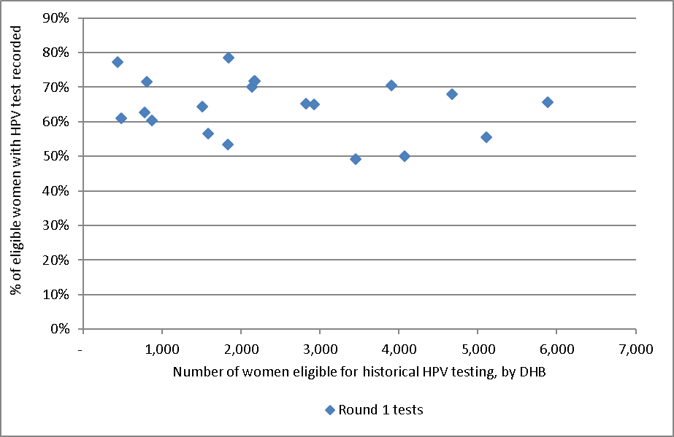
Each dot represents a DHB.
This chart does not suggest that there is any relationship between number of women eligible for testing and percent of women who have being tested, therefore this does not seem a likely explanation for the variation in women tested in different DHBs.

Figure 116 - Relationship between women screened in the previous five years and proportion of women with historical tests recorded, by DHB
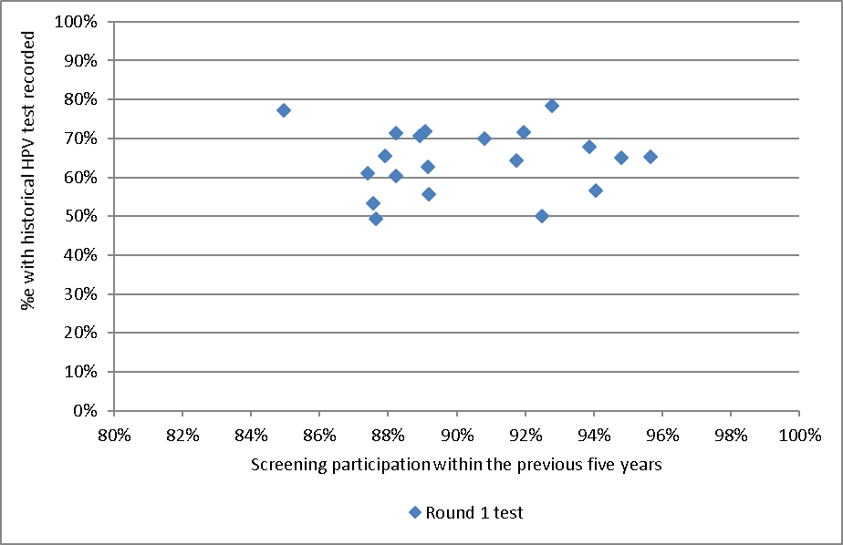
Each dot represents a DHB. See also Table 84.

Figure 117 - Relationship between women screened in the previous five years and proportion of women with historical tests recorded, by ethnicity
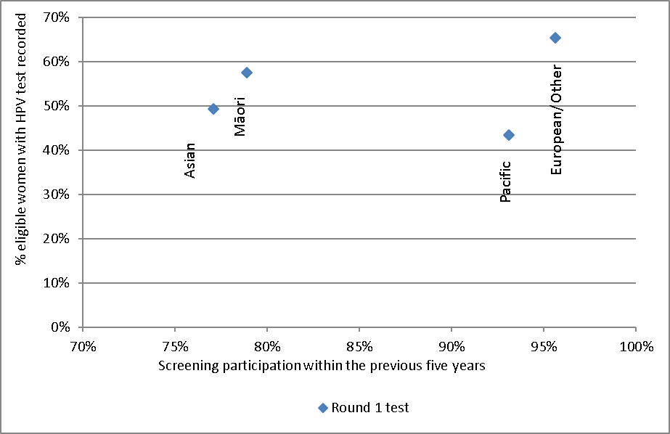
Each dot represents an ethnicity

Table 84 - Women screened in the previous five years and proportion of women with historical round 1 and 2 tests recorded, by DHB
DHB | Women screened in the last 5 years | Round 1 test recorded | Round 2 test recorded
 | % | % | %
Auckland | 92.5% | 50.0% | 32.1%
Bay of Plenty | 94.8% | 65.0% | 46.3%
Canterbury | 87.9% | 65.6% | 56.5%
Capital & Coast | 95.6% | 65.2% | 55.8%
Counties Manukau | 87.6% | 49.3% | 31.6%
Hawke's Bay | 90.8% | 70.0% | 56.9%
Hutt Valley | 91.7% | 64.3% | 53.7%
Lakes | 94.0% | 56.6% | 40.3%
Mid Central | 89.1% | 71.8% | 59.3%
Nelson Marlborough | 92.8% | 78.4% | 69.5%
Northland | 87.6% | 53.4% | 39.2%
South Canterbury | 88.2% | 71.5% | 60.0%
Southern | 93.9% | 67.9% | 56.6%
Tairawhiti | 88.2% | 60.3% | 44.6%
Taranaki | 91.9% | 71.7% | 61.7%
Waikato | 88.9% | 70.6% | 57.1%
Wairarapa | 87.4% | 61.0% | 49.8%
Waitemata | 89.2% | 55.6% | 34.5%
West Coast | 85.0% | 77.3% | 65.6%
Whanganui | 89.2% | 62.7% | 44.0%

Appendix B – Bethesda 2001 New Zealand Modified
TBS code | Descriptor

Specimen type
CPS | Conventional pap smear
LBC | Liquid based cytology
COM | Combined (conventional and liquid based)

Specimen site
T | Vault
R | Cervical
V | Vaginal

Adequacy
S1 | The specimen is satisfactory for evaluation (optional free text)
S2 | The specimen is satisfactory for evaluation (optional free text). No endocervical/ transformation zone component present
UA | The specimen is unsatisfactory for evaluation because of insufficient squamous cells
UB | The specimen is unsatisfactory for evaluation because of poor fixation/preservation
UC | The specimen is unsatisfactory for evaluation because foreign material obscures the cells
UD | The specimen is unsatisfactory for evaluation because inflammation obscures the cells
UE | The specimen is unsatisfactory for evaluation because blood obscures the cells
UF | The specimen is unsatisfactory for evaluation because of cytolysis/autolysis
UG | The specimen is unsatisfactory for evaluation because … (free text)

General
G1 | Negative for intraepithelial lesion or malignancy
G2 | Epithelial cell abnormality: See interpretation/result
G3 | Other: See interpretation/result

Interpretation
O1 | There are organisms consistent with Trichomonas species
O2 | There are fungal organisms morphologically consistent with Candida species
O3 | There is a shift in microbiological flora that may represent bacterial vaginosis
O4 | There are bacteria morphologically consistent with Actinomyces species
O5 | There are cellular changes consistent with Herpes simplex virus
OT1 | There are reactive cellular changes present (optional free text)
OT2 | There are endometrial cells present in a woman over the age of 40 years
OT3 | There are atrophic cellular changes present
ASL | There are atypical squamous cells of undetermined significance (ASC-US) present
ASH | There are atypical squamous cells present. A high grade squamous intraepithelial lesion cannot be excluded (ASC-H)
LS | There are abnormal squamous cells consistent with a low grade squamous intraepithelial lesion (LSIL; CIN1/HPV)
HS1 | There are abnormal squamous cells consistent with a high grade squamous intraepithelial lesion (HSIL). The features are consistent with CINII or CINIII
HS2 | There are abnormal squamous cells consistent with a high grade squamous intraepithelial lesion (HSIL) with features suspicious for invasion
SC | There are abnormal squamous cells showing changes consistent with squamous cell carcinoma
AG1 | There are atypical endocervical cells present
AG2 | There are atypical endometrial cells present
AG3 | There are atypical glandular cells present
AG4 | There are atypical endocervical cells favouring a neoplastic process
AG5 | There are atypical glandular cells favouring a neoplastic process
AIS | There are abnormal endocervical cells consistent with adenocarcinoma in-situ (AIS)
AC1 | There are abnormal glandular cells consistent with endocervical adenocarcinoma
AC2 | There are abnormal glandular cells consistent with endometrial adenocarcinoma
AC3 | There are abnormal glandular cells consistent with extrauterine adenocarcinoma
AC4 | There are abnormal glandular cells consistent with adenocarcinoma
AC5 | There are abnormal cells consistent with a malignant neoplasm

Recommendation
R1 | The next smear should be taken in three years, based on the information held on the NCSP Register
R2 | Please repeat the smear within three months
R3 | Please repeat the smear within three months of the end of pregnancy
R4 | Please repeat the smear in three months
R5 | Please repeat the smear in six months
R6 | Please repeat the smear in 12 months
R7 | Because a previous smear showed atypical squamous cells or low grade changes, please repeat the smear in 12 months
R8 | Annual smears are indicated because of previous high grade abnormality
R9 | Referral for specialist assessment is indicated
R10 | Urgent referral for specialist assessment is indicated
R11 | [not in use]
R12 | Please repeat the smear shortly after a course of oestrogen treatment
R13 | Under specialist care
R14 | In view of the abnormal clinical history provided, urgent referral for assessment is recommended regardless of cytological findings

Appendix C – SNOMED categories for histological samples
Adequacy of specimen |  | 1986 Code | 1993 Code
Insufficient or unsatisfactory material for diagnosis |  | M09000 | M09010
There is no code for satisfactory materials.
Site (topography) of specimen |  | 1986 Code | 1993 Code
Vagina |  | T81 | T82000
Cervix (includes endocervix and exocervix) |  | T83 | T83200
Summary diagnosis | Code stored on register | 1986 Code | 1993 Code | Diagnostic category | Rank*
There will be a maximum of four M codes transmitted to the register.
Negative result - normal tissue |  | M00100 | M60000 | Negative/benign | 1
Inflammation |  | M40000 | M40000 | Negative/benign | 2
Microglandular hyperplasia |  | M72480 | M72480 | Negative/benign | 3
Squamous Metaplasia |  | M73000 | M73000 | Negative/benign | 4
Polyp |  | M76800 | M76800 | Negative/benign | 5
Other (Morphologic abnormality, not dysplastic or malignant) |  | M01000 | M01000 | Negative/benign | 6
Atypia |  | M69700 | M67000 | CIN 1 | 7
Benign glandular atypia |  | M81400 | M67030 | Negative/benign | 8
HPV, koilocytosis, condyloma (NOS)  Condyloma acuminatum | M76700 | M76700  M76720 | M76700  M76720 | HPV | 9
CIN I (LSIL)  (VAIN I when used with T81/ T82000) |  | M74006 | M67016 | CIN 1 | 10
Dysplasia / CIN NOS |  | M74000 | M67015 | CIN 1 | 11
Glandular dysplasia |  | M81401 | M67031 | Glandular dysplasia | 12
CIN II (HSIL)  (VAIN II when used with T81/ T82000) |  | M74007 |  | CIN 2 | 13
HSIL NOS |  | M67017 | M67017 | HSIL | 14
CIN III (HSIL) |  | M74008 |  | CIN 3 | 17
(VAIN III when used with T81/ T82000)  Carcinoma in situ |  | M80102  M80702 | M80102  M80702 |  | 15  16
Adenocarcinoma in situ |  | M81402 | M81402 | Adenocarc. in situ | 18
Microinvasive squamous cell carcinoma |  | M80765 | M80763 | Micro-invasive | 19
Invasive squamous cell carcinoma |  | M80703 | M80703 | Invasive SCC | 20
Invasive adenocarcinoma (endocervical type) |  | M83843 | M83843 | Invasive adenocarcinoma (endocervical type) | 21
Adenosquamous carcinoma |  | M85603 | M85603 | Adenosquamous carcinoma | 22
Invasive adenocarcinoma (not endocervical type) |  | M81403 | M81403 | Invasive adenocarcinoma  (not endocervical type) | 23
Metastatic tumour |  | M80006 | M80006 | Other cancer | 29
Undifferentiated carcinoma |  | M80203 | M80203 | Other cancer | 24
Sarcoma |  | M88003 | M88003 | Other cancer | 25
Other codes accepted | Code stored on register | 1986 Code | 1993 Code | Diagnostic category | Rank
Carcinosarcoma | M88003 | M89803 | M89803 | Other cancer | 26
Choriocarcinoma | M80003 | M91003 | M91003 | Other cancer | 27
Miscellaneous primary tumour | M80003 | M80003 | M80003 | Other cancer | 28
Small cell carcinoma | M80003 | M80413 | M80413 | Other cancer | 30
Malignant tumour, Small cell type | M80003 | M80023 | M80023 | Other cancer | 31
Melanoma | M80003 | M87203 | M87203 | Other cancer | 32
Other primary epithelial malignancy | M80003 | M80103 | M80103 | Other cancer | 33

Appendix D – Indicator Definitions Targets and Reporting Details

Positive predictive value calculations

Table 85 - Definition used for positive predictive value calculations
Histology Diagnosis | G1 | Squamous (G2) |  |  |  |  | Glandular (G2) |  |  | Other (G3) | Total
 | G1 | ASL | LS | ASH | HS1/2 | SC | AG1-5 | AIS | AC1-4 | AC5
Negative |  |  |  | q | y | y | a | a | a
Squam-Atypia NOS |  |  |  | q | y | y | a | a | a
Squam-Low Grade/CIN1/HPV |  |  |  | q | y | y | a | a | a
Squam-High Grade/CIN2-3 |  |  |  | p | x | x | b | b | b
Squam MI SCC |  |  |  | p | x | x | b | b | b
Squam-Invasive SCC |  |  |  | p | x | x | b | b | b
Gland-Benign Atypia |  |  |  | q | y | y | a | a | a
Gland-Dyplasia |  |  |  | p | x | x | b | b | b
Gland-AIS |  |  |  | p | x | x | b | b | b
Gland-Invasive Adeno |  |  |  | p | x | x | b | b | b
Other Malignant Neoplasm |  |  |  | p | x | x | b | b | b
PPV% (ASC-H)= sum(p) / (sum(p)+sum(q))
PPV% (HSIL)= sum(x) / (sum(x)+sum(y))
PPV% (ASC-H+HSIL+SC)= (sum(p) + sum(x))/ (sum(p)+sum(q) +sum(x) + sum(y)

Appendix E – DHB assignment for colposcopy clinics
Where results in Indicator 7 (colposcopy indicators) are provided by DHB, the clinics included in each DHB are as listed below. Assignment of individual facilities to specific DHBs was provided by the NCSP. All other colposcopy clinics were grouped together as “Private practice”.

DHB | Colposcopy clinics included*
Auckland | Ward 97 - Gynae Inpatient Auckland City Hospital  General Surgery – Auckland City Hospital  Colposcopy Clinic - Greenlane Clinical Centre  Gynae Outpatient Clinic – Greenlane Clinical Centre  Short Stay Surgical Unit – Greenlane Clinical Centre  Emergency Medicine – North Shore Hospital
Bay of Plenty | Whakatane Hospital (G)  Opotiki Hospital Outpatients’ Department  Tauranga Hospital (G)
Canterbury | Ashburton Hospital  Christchurch Hospital  Christchurch Sexual Health Centre  Christchurch Women's Hospital - Colposcopy  Christchurch Women's Hospital - Gynaecology
Capital & Coast | Colposcopy Clinic – Wellington Women’s Hospital Outpatients Department  Kenepuru Women's Outpatients’ Department  Women's Clinic – Wellington Regional Hospital
Counties Manukau | Manukau Super Clinic  Gynaecology Clinic – [Middlemore Hospital]  Colposcopy Clinic – Manukau Super Clinic
Hawke's Bay | Chatham Islands Health Centre  Outpatients Dept – Napier Health Centre  Villa 4, Gynaecology, Hawke’s Bay Hospital  Hawkes Bay Regional Hospital  Wairoa Cervical Screening  Wairoa Hospital
Hutt Valley | Women's Health Clinic – Hutt Hospital  Gynaecology Clinic - Hutt Hospital
Lakes | Rotorua Hospital (Gynae Dept)  Taupo Hospital
Mid Central | Colposcopy Clinic – Palmerston North Hospital  Gynaecology Clinic - Palmerston North Hospital  Gynaecology Clinic Horowhenua Hospital
Nelson Marlborough | Marlborough Maternity & Gynae  Nelson Outpatients Department
Northland | Colposcopy Clinic Whangarei Hospital  Kaitaia Hospital Colp Outpatients’ Department  Bay Of Islands Hospital Outpatients’ Department  Gynaecology Clinic Whangarei Hospital
South Canterbury | Timaru Hospital - Colp/Gynae
Southern | General Gynae Department – Dunedin Hospital  Dunedin Public Hospital  Dunedin Colposcopy Clinic  Southland Hospital Gynaecology
Tairawhiti | Gisborne Hospital
Taranaki | Taranaki Health Base Hospital - Outpatients Department  Hawera Outpatients
Waikato | Te Kuiti Hospital  Womens Outpatient Services – Waikato Hospital  Tokoroa Hospital - Bev Thorn
Wairarapa | Gynaecology Clinic – Wairarapa Hospital
Waitemata | Colposcopy Clinic- Waitakere Hospital  Gynaecology Clinic –North Shore Hospital  Colposcopy Clinic- North Shore Hospital  Peri-Operative Department - North Shore Hospital
West Coast | Greymouth Hospital  Gynaecology Clinic Greymouth
Whanganui | Wanganui Hospital  Gynaecology Clinic – Good Health Wanganui
* Assignment of specific facilities to a DHB was provided by the NCSP, in order to distinguish between DHB clinics and private practice, because the NCSP Register records geographic DHB and does not record public vs private clinic.

Appendix F – Glossary
Term | Definition
AGC | Atypical glandular cells
AIS | Adenocarcinoma in situ. High-grade changes to the glandular (endocervical) cells of the cervix
ASC-H | Atypical squamous cells of undetermined significance, cannot exclude high grade
ASC-US | Atypical squamous cells of undetermined significance
ASR | Age standardised rate
CI | Confidence interval
CIN | Cervical intra-epithelial neoplasia; CINI: low grade; CIN2 or 3: high grade
CIS | Carcinoma in situ. An older classification of CIN3. Abnormal cells that are confined to the surface epithelium of the cervix.
CPS | Conventional Pap (Papanicolaou) Smear
DHB | District Health Board
European/ Other | European women and women from non-Māori and non-Pacific ethnic groups
HPV | Human papillomavirus
HPV test | Testing for a high risk (oncogenic) subtype of human papillomavirus
hrHPV | A high risk (oncogenic) subtype of human papillomavirus
HSIL | High grade squamous intra-epithelial lesion
ISC | Invasive squamous carcinoma
LBC | Liquid based cytology
LSIL | Low grade squamous intra-epithelial lesion
NCSP | National Cervical Screening Programme
NHI | National Health Index
NILM | Negative for intraepithelial lesion or malignancy (a negative cytology report)
NSU | National Screening Unit of the Ministry of Health
NPV | Negative predictive value. The proportion of the screened population with negative test results who do not have the disease being tested for.
OR | Odds ratio
PCR | Polymerase chain reaction. A technique in molecular genetics used in many types of HPV testing
PPV | Positive predictive value. The proportion of the screened population with positive test results who have the disease being tested for.
RR | Relative risk
SC | Squamous cell carcinoma (TBS 2001)
SCC | Squamous cell carcinoma
SNOMED | Systematised Nomenclature of Medicine. A systematically organised collection of medical terminology including histopathological diagnoses.
TBS 2001 (New Zealand Modified) | The Bethesda System 2001 NZ Modified. A management system based on categorising the cytological interpretation of cellular abnormality as negative, low-grade or high-grade.
TZ | Transformation zone. The region of the cervix where the glandular precursor cells change to squamous cells

References
1. Gray A. Methodology for estimating hysterectomy prevalence in women 20-69. Wellington, New Zealand; 2011.
2. Ministry of Health. Ethnicity Data Protocols for the Health and Disability Sector. 2004 [cited; Available from: http://www.health.govt.nz/publication/ethnicity-data-protocols-health-and-disability-sector
3. Ministry of Health. Asian Health Chart Book. 2006 [cited; Available from: http://www.health.govt.nz/publication/asian-health-chart-book-2006
4. Simonella L, Lewis H, Smith M, Neal H, Bromhead C, Canfell K. The prevalence of type-specific oncogenic human papillomavirus infection in high grade cervical disease in New Zealand. BMC Infect Dis. 2013; 13(114).
5. Smith JS, Lindsay L, Hoots B, Keys J, Franceschi S, Winer R, et al. Human papillomavirus type distribution in invasive cervical cancer and high-grade cervical lesions: a meta-analysis update. Int J Cancer. 2007; 121(3): 621-32.
6. Stevens MP, Garland SM, Tan JH, Quinn MA, Petersen RW, Tabrizi SN. HPV genotype prevalence in women with abnormal pap smears in Melbourne, Australia. J Med Virol. 2009; 81(7): 1283-91.
7. Brestovac B, Harnett GB, Smith DW, Shellam GR, Frost FA. Human papillomavirus genotypes and their association with cervical neoplasia in a cohort of Western Australian women. J Med Virol. 2005; 76(1): 106-10.
8. Porras C, Rodriguez AC, Hildesheim A, Herrero R, Gonzalez P, Wacholder S, et al. Human papillomavirus types by age in cervical cancer precursors: predominance of human papillomavirus 16 in young women. Cancer Epidemiol Biomarkers Prev. 2009; 18(3): 863-5.
9. Baandrup L, Munk C, Andersen KK, Junge J, Iftner T, Kjaer SK. HPV16 is associated with younger age in women with cervical intraepithelial neoplasia grade 2 and 3. Gynecol Oncol. 2012; 124(2): 281-5.
10. Miyamoto J, Berkowitz Z, Unger E, Lyu C, Copeland G, Lynch C, et al. Vaccine-type HPV distribution in CIN3/AIS: 3 U.S. cancer registries, 1994-2005. International Papillomavirus Conference and Clinical Workshop; 2011 17-22/9/2011; Berlin, Germany; 2011.
11. National Cervical Screening Programme. NCSP Operational Policy and Quality Standards, Section 5.
12. Ministry of Health. Report of the Parliamentary Review Committee regarding the New Zealand Cervical Screening Programme Wellington: Ministry of Health; 2011.
13. Parliamentary Review Committee. Report of the Parliamentary Review Committee regarding the New Zealand Cervical Screening Programme, June 2015. Wellington; 2015.
14. National Screening Unit. Guidelines for Cervical Screening in New Zealand: Incorporating the management of women with abnormal cervical smears. Wellington: National Screening Unit, Ministry of Health; 2008.
15. Smith M, Walker R, Canfell K. National Cervical Screening Programme Monitoring Report Number 33. Wellington; 2012.
16. Smith M, Walker R, Canfell K. National Cervical Screening Programme Monitoring Report Number 34. Wellington; 2012.

