Impact of change of NCSP ethnicity and domicile data source
NCSP December 2015 Coverage

18 March 2016

Contents
Introduction 1
Key findings 2
Technical notes 3
1 National Coverage 4
1.1 National coverage by ethnicity 4
1.2 National coverage by DHB 5
2 Coverage by DHB 7
2.1 DHB coverage – Māori 7
2.2 DHB coverage – Pacific 9
2.3 DHB coverage – Asian 11

List of tables
Table 1: NCSP national screening volumes, population denominators, and coverage rates by ethnicity for women aged 25-69 years for the three year period ending 31 December 2015 using the old and new methods for obtaining screening volumes 4
Table 2: NCSP national screening volumes, population denominators, and coverage rates by district health board for women aged 25-69 years for the three year period ending 31 December 2015 using the old and new methods for obtaining screening volumes 5
Table 3: NCSP Māori screening volumes, population denominators, and coverage rates by district health board for women aged 25-69 years for the three year period ending 31 December 2015 using the old and new methods for obtaining screening volumes 7
Table 4: NCSP Pacific screening volumes, population denominators, and coverage rates by district health board for women aged 25-69 years for the three year period ending 31 December 2015 using the old and new methods for obtaining screening volumes 9
Table 5: NCSP Asian screening volumes, population denominators, and coverage rates by district health board for women aged 25-69 years for the three year period ending 31 December 2015 using the old and new methods for obtaining screening volumes 11

List of figures
Figure 1: Comparison of NCSP national coverage rates by ethnicity for women aged 25-69 years for the three year period ending 31 December 2015 using the old and new methods for obtaining screening volumes 4
Figure 2: Comparison of NCSP national coverage rates by district health board for women aged 25-69 years for the three year period ending 31 December 2015 using the old and new methods for obtaining screening volumes 6
Figure 3: Comparison of NCSP Māori coverage rates by district health board for women aged 25-69 years for the three year period ending 31 December 2015 using the old and new methods for obtaining screening volumes 8
Figure 4: Comparison of NCSP Pacific coverage rates by district health board for women aged 25-69 years for the three year period ending 31 December 2015 using the old and new methods for obtaining screening volumes 10
Figure 5: Comparison of NCSP Asian coverage rates by district health board for women aged 25-69 years for the three year period ending 31 December 2015 using the old and new methods for obtaining screening volumes 12

Introduction
Starting February 2016, the National Screening Unit (NSU) is to begin reporting coverage for the National Cervical Screening Programme (NCSP) using ethnicity and domicile (address code) recorded on the Ministry of Health’s National Health Index (NHI) instead of ethnicity and domicile information from the National Cervical Screening Register (the Register).

The NSU’s new data warehouse holds demographic information from the Register. However, it uses the NHI ethnicity and domicile for reporting purposes. The new data warehouse provided the opportunity to standardise NCSP reporting of ethnicity and domicile with other Ministry of Health reporting via the NHI, though limitations of this data source are still acknowledged. The quality of NHI data is likely to improve over the next few years as the National Enrolment Service is rolled out. This service allows primary care to help keep health identity information accurate and up-to-date.

Changing the source of ethnicity and domicile information impacts on how the count of women screened is distributed across population groups. As coverage is calculated as the proportion of the eligible population who have been screened, a change in the distribution of women screened leads to changes in coverage.

The purpose of this report is to provide a comparison of the coverage calculated using the new method for obtaining coverage numerators (counts of women screened) with what was calculated using the old method.

Key findings
Changing to the NHI ethnicity means more women who participated in cervical screening are counted as Māori, Pacific and Asian. Nationally there is a 1.7%, 1.2%, and 0.7% increase in coverage respectively for Māori, Pacific and Asian women aged 25-69 years, from respectively 63.7% to 65.5%, 74.5% to 75.7%, and 64.0% to 64.8%. The coverage target is 80%. Meanwhile, fewer women are counted as European/Other. Nationally there is a 0.5% decrease in coverage for European/Other women aged 25-69 years, from 82.2% to 81.7%.

Differences in district health board (DHB) coverage reflect inconsistencies in women’s domiciles between the Register and the NHI e.g. due to women who have moved between DHBs since they were screened. West Coast DHB shows the largest increase in coverage by 2.8% while Auckland DHB shows the largest decrease in coverage by 2.4%.

For Māori women, the majority of DHBs show an increase in coverage using the new method. Among those with a decrease in Māori coverage, MidCentral and Nelson Marlborough DHBs show the largest decreases (by 5.0% and 3.6% respectively). Similarly for Pacific women, more DHBs show an increase in coverage than not. Of note for Auckland DHB, Pacific coverage shows a decrease of 4.9% and now sits below the target at 76.9%. However, when data for all three Auckland region DHBs are combined, Pacific coverage shows a 0.7% increase from 77.1% to 77.8%. For Asian women, coverage increases for 12 DHBs. All three DHBs in the Auckland region show increases in Asian coverage (in the range 0.5-1.9%). Among the DHBs with larger Asian populations, the biggest decrease in coverage occurs for Canterbury DHB which drops by 2.9% from 59.4% to 56.5%.

Technical notes
In this report, ‘old’ refers to the old method for obtaining coverage numerators based on the ethnicity and domicile recorded in the Register. ‘New’ refers to the new method for obtaining coverage numerators based on the ethnicity and domicile recorded on the Ministry of Health’s NHI.

The number of women screened for the three year period ending 31 December 2015 was extracted from the data warehouse using the new method on 4 February 2016. This is compared with the number of women screened for the same three year period extracted from the Register on 15 January 2016. Different extract dates and improvements in data processing via the data warehouse mean that the overall number of women screened differs slightly between the two methods.

Screened women – the numerator – are included in the coverage calculations based on their age at the end of the monitoring period. This means that coverage for women aged 25-69 years includes women who were aged 22, 23 or 24 at the start of the monitoring period.

For both numerator and denominator (eligible population), women have been prioritised to a single ethnicity using the following priority order: Māori, Pacific, Asian, European/Other. This means that if a woman chooses more than one category, and one of these is Māori, she is counted as Māori. For ease of reporting, screened women with unknown ethnicity have been classified as European/Other in the new method.
The population denominators used for calculating coverage is Statistics New Zealand’s 2014 update of DHB population projections (2013 Census base) at the end of the monitoring period adjusted for the prevalence of hysterectomy.

To avoid sudden shifts in coverage, the NSU produces population projections for the end of every month using a ‘prospective smoothing’ method. Annual population data is smoothed over a twelve month period starting in July for each year. For example, the 31 December 2015 population comprises 6/12 of the projected population for the year ending 30 June 2015, plus 6/12 of the projected population for the year ending 30 June 2016.

Additional detail on the methodology can be obtained via a request made to screening@moh.govt.nz.

1 National Coverage

1.1 National coverage by ethnicity
Table 1: NCSP national screening volumes, population denominators, and coverage rates by ethnicity for women aged 25-69 years for the three year period ending 31 December 2015 using the oldª and new^{b} methods for obtaining screening volumes
Ethnicity | Women screened in last 3 years |  | Hysterectomy adjusted population | 3-year coverage
 | Oldª | New^{b} |  | Oldª | New^{b} | Difference
Māori | 99,697 | 102,368 | 156,406 | 63.7% | 65.5% | 1.7%
Pacific | 49,244 | 50,025 | 66,090 | 74.5% | 75.7% | 1.2%
Asian | 109,818 | 111,093 | 171,535 | 64.0% | 64.8% | 0.7%
European/Other | 649,590 | 645,274 | 790,098 | 82.2% | 81.7% | -0.5%
Total* | 908,395 | 908,760 | 1,184,129 | 76.7% | 76.7% | 0.0%
Key: a – Register ethnicity; b – NHI ethnicity
*Total screening volumes using the old and new methods are different due to different extract dates and improvements to the way the data is processed in the new data warehouse.
 | ≥80% |  | 70-79.9% |  | <70%

Figure 1: Comparison of NCSP national coverage rates by ethnicity for women aged 25-69 years for the three year period ending 31 December 2015 using the oldª and new^{b} methods for obtaining screening volumes
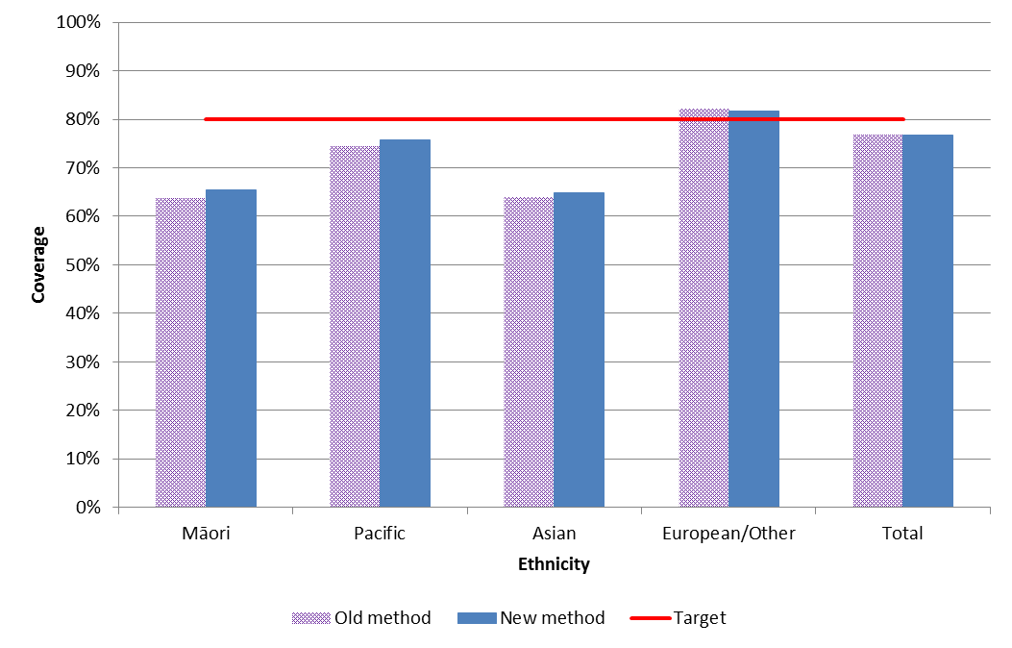
Key: a – Register ethnicity; b – NHI ethnicity

1.2 National coverage by DHB
Table 2: NCSP national screening volumes, population denominators, and coverage rates by district health board (DHB) for women aged 25-69 years for the three year period ending 31 December 2015 using the oldª and new^{b} methods for obtaining screening volumes
DHB | Women screened in last 3 years |  | Hysterectomy adjusted population | 3-year coverage
 | Oldª | New^{b} |  | Oldª | New^{b} | Difference
Northland | 29,948 | 30,864 | 41,711 | 71.8% | 74.0% | 2.2%
Waitemata | 117,564 | 117,307 | 153,682 | 76.5% | 76.3% | -0.2%
Auckland | 105,537 | 102,330 | 132,812 | 79.5% | 77.1% | -2.4%
Counties Manukau | 97,180 | 98,462 | 132,735 | 73.2% | 74.2% | 1.0%
Waikato | 73,079 | 73,731 | 97,340 | 75.1% | 75.8% | 0.7%
Lakes | 20,582 | 20,315 | 26,333 | 78.2% | 77.2% | -1.0%
Bay of Plenty | 44,636 | 44,253 | 55,800 | 80.0% | 79.3% | -0.7%
Tairawhiti | 8,582 | 8,697 | 11,764 | 73.0% | 73.9% | 1.0%
Taranaki | 23,701 | 23,776 | 29,980 | 79.1% | 79.3% | 0.3%
Hawkes Bay | 30,512 | 30,645 | 40,251 | 75.8% | 76.1% | 0.3%
Whanganui | 11,536 | 11,870 | 15,189 | 75.9% | 78.2% | 2.2%
MidCentral | 31,911 | 32,230 | 42,212 | 75.6% | 76.4% | 0.8%
Hutt Valley | 29,542 | 29,096 | 37,991 | 77.8% | 76.6% | -1.2%
Capital and Coast | 64,349 | 63,567 | 80,033 | 80.4% | 79.4% | -1.0%
Wairarapa | 8,232 | 8,289 | 11,047 | 74.5% | 75.0% | 0.5%
Nelson Marlborough | 30,774 | 30,644 | 38,055 | 80.9% | 80.5% | -0.3%
West Coast | 6,256 | 6,502 | 8,706 | 71.9% | 74.7% | 2.8%
Canterbury | 101,119 | 100,959 | 135,673 | 74.5% | 74.4% | -0.1%
South Canterbury | 11,273 | 11,300 | 14,818 | 76.1% | 76.3% | 0.2%
Southern | 62,036 | 62,096 | 77,997 | 79.5% | 79.6% | 0.1%
Total* | 908,395 | 908,760 | 1,184,129 | 76.7% | 76.7% | 0.0%
Key: a – Register domicile; b – NHI domicile
*Total includes women of unknown domicile, and therefore is greater than the sum of DHB counts. Total screening volumes using the old and new methods are different due to different extract dates and improvements to the way the data is processed in the new data warehouse.
 | ≥80% |  | 70-79.9% |  | <70%

Figure 2: Comparison of NCSP national coverage rates by district health board (DHB) for women aged 25-69 years for the three year period ending 31 December 2015 using the oldª and new^{b} methods for obtaining screening volumes
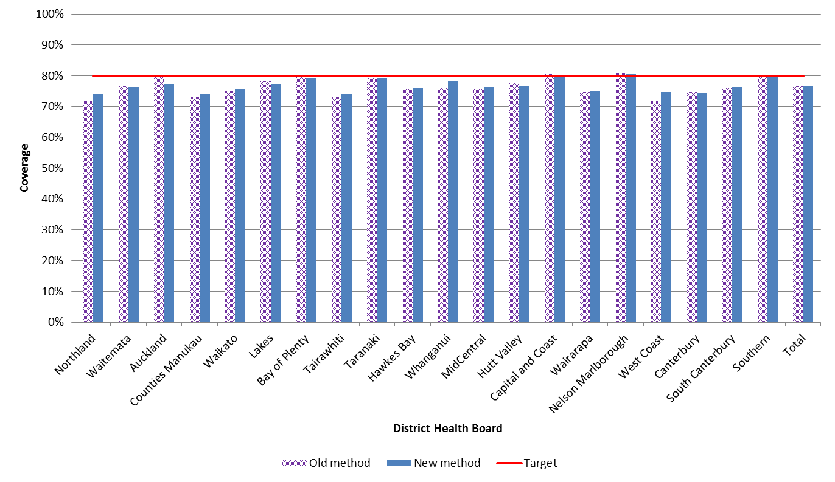
Key: a – Register domicile; b – NHI domicile

2 Coverage by DHB

2.1 DHB coverage – Māori
Table 3: NCSP Māori screening volumes, population denominators, and coverage rates by district health board (DHB) for women aged 25-69 years for the three year period ending 31 December 2015 using the oldª and new^{b} methods for obtaining screening volumes
DHB | Women screened in last 3 years |  | Hysterectomy adjusted population | 3-year coverage
 | Oldª | New^{b} |  | Oldª | New^{b} | Difference
Northland | 7,961 | 8,272 | 12,599 | 63.2% | 65.7% | 2.5%
Waitemata | 7,155 | 7,328 | 12,496 | 57.3% | 58.6% | 1.4%
Auckland | 5,602 | 5,609 | 9,583 | 58.5% | 58.5% | 0.1%
Counties Manukau | 11,411 | 11,925 | 18,017 | 63.3% | 66.2% | 2.9%
Waikato | 11,855 | 12,446 | 19,064 | 62.2% | 65.3% | 3.1%
Lakes | 5,773 | 5,928 | 8,115 | 71.1% | 73.0% | 1.9%
Bay of Plenty | 7,949 | 8,514 | 12,180 | 65.3% | 69.9% | 4.6%
Tairawhiti | 3,610 | 3,688 | 5,322 | 67.8% | 69.3% | 1.5%
Taranaki | 2,880 | 2,914 | 4,421 | 65.1% | 65.9% | 0.8%
Hawkes Bay | 6,584 | 6,448 | 8,879 | 74.2% | 72.6% | -1.5%
Whanganui | 2,456 | 2,503 | 3,501 | 70.2% | 71.5% | 1.3%
MidCentral | 4,679 | 4,333 | 6,925 | 67.6% | 62.6% | -5.0%
Hutt Valley | 3,781 | 3,769 | 5,426 | 69.7% | 69.5% | -0.2%
Capital and Coast | 4,881 | 4,862 | 7,733 | 63.1% | 62.9% | -0.2%
Wairarapa | 1,093 | 1,087 | 1,567 | 69.8% | 69.4% | -0.4%
Nelson Marlborough | 2,227 | 2,111 | 3,182 | 70.0% | 66.3% | -3.6%
West Coast | 523 | 560 | 847 | 61.7% | 66.1% | 4.4%
Canterbury | 5,037 | 5,474 | 9,340 | 53.9% | 58.6% | 4.7%
South Canterbury | 504 | 608 | 972 | 51.9% | 62.6% | 10.7%
Southern | 3,736 | 3,790 | 6,237 | 59.9% | 60.8% | 0.9%
Total* | 99,697 | 102,368 | 156,406 | 63.7% | 65.5% | 1.7%
Key: a – Register ethnicity and domicile; b – NHI ethnicity and domicile
*Total includes women of unknown domicile, and therefore is greater than the sum of DHB counts.
 | ≥80% |  | 70-79.9% |  | <70%

Figure 3: Comparison of NCSP Māori coverage rates by district health board (DHB) for women aged 25-69 years for the three year period ending 31 December 2015 using the oldª and new^{b} methods for obtaining screening volumes
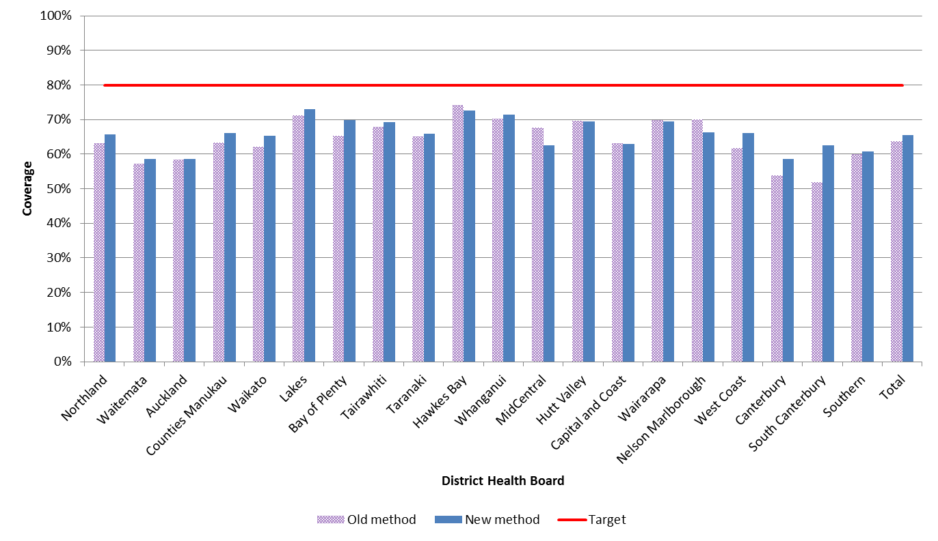
Key: a – Register ethnicity and domicile; b – NHI ethnicity and domicile

2.2 DHB coverage – Pacific
Table 4: NCSP Pacific screening volumes, population denominators, and coverage rates by district health board (DHB) for women aged 25-69 years for the three year period ending 31 December 2015 using the oldª and new^{b} methods for obtaining screening volumes
DHB | Women screened in last 3 years |  | Hysterectomy adjusted population | 3-year coverage
 | Oldª | New^{b} |  | Oldª | New^{b} | Difference
Northland | 348 | 402 | 684 | 50.9% | 58.8% | 7.9%
Waitemata | 6,745 | 7,003 | 9,221 | 73.1% | 75.9% | 2.8%
Auckland | 10,053 | 9,447 | 12,280 | 81.9% | 76.9% | -4.9%
Counties Manukau | 19,013 | 19,671 | 24,918 | 76.3% | 78.9% | 2.6%
Waikato | 1,589 | 1,803 | 2,382 | 66.7% | 75.7% | 9.0%
Lakes | 380 | 423 | 545 | 69.7% | 77.6% | 7.9%
Bay of Plenty | 502 | 549 | 800 | 62.8% | 68.6% | 5.9%
Tairawhiti | 160 | 161 | 252 | 63.5% | 63.9% | 0.4%
Taranaki | 165 | 204 | 275 | 60.0% | 74.2% | 14.2%
Hawkes Bay | 824 | 808 | 1,157 | 71.2% | 69.8% | -1.4%
Whanganui | 171 | 185 | 318 | 53.8% | 58.2% | 4.4%
MidCentral | 692 | 657 | 976 | 70.9% | 67.3% | -3.6%
Hutt Valley | 1,852 | 1,856 | 2,608 | 71.0% | 71.2% | 0.2%
Capital and Coast | 3,339 | 3,444 | 5,096 | 65.5% | 67.6% | 2.1%
Wairarapa | 134 | 120 | 169 | 79.3% | 71.0% | -8.3%
Nelson Marlborough | 320 | 293 | 453 | 70.6% | 64.7% | -6.0%
West Coast | 45 | 59 | 77 | 58.4% | 76.6% | 18.2%
Canterbury | 1,942 | 1,900 | 2,656 | 73.1% | 71.5% | -1.6%
South Canterbury | 97 | 87 | 104 | 93.3% | 83.7% | -9.6%
Southern | 873 | 872 | 1,119 | 78.0% | 77.9% | -0.1%
Total* | 49,244 | 50,025 | 66,090 | 74.5% | 75.7% | 1.2%
Key: a – Register ethnicity and domicile; b – NHI ethnicity and domicile
*Total includes women of unknown domicile, and therefore is greater than the sum of DHB counts.
 | ≥80% |  | 70-79.9% |  | <70%

Figure 4: Comparison of NCSP Pacific coverage rates by district health board (DHB) for women aged 25-69 years for the three year period ending 31 December 2015 using the oldª and new^{b} methods for obtaining screening volumes
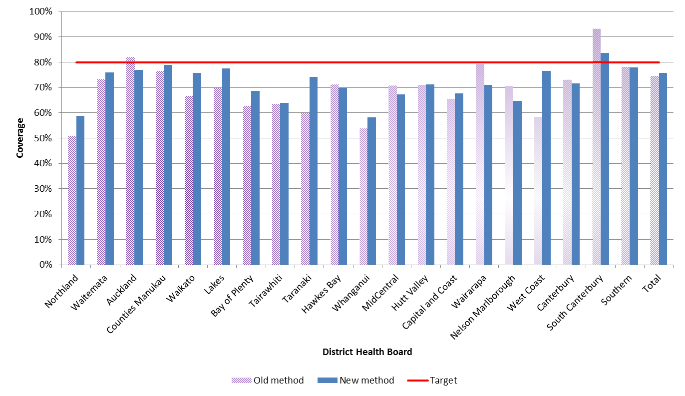
Key: a – Register ethnicity and domicile; b – NHI ethnicity and domicile

2.3 DHB coverage – Asian
Table 5: NCSP Asian screening volumes, population denominators, and coverage rates by district health board (DHB) for women aged 25-69 years for the three year period ending 31 December 2015 using the oldª and new^{b} methods for obtaining screening volumes
DHB | Women screened in last 3 years |  | Hysterectomy adjusted population | 3-year coverage
 | Oldª | New^{b} |  | Oldª | New^{b} | Difference
Northland | 971 | 1,007 | 1,677 | 57.9% | 60.0% | 2.1%
Waitemata | 22,293 | 22,964 | 34,643 | 64.4% | 66.3% | 1.9%
Auckland | 27,327 | 27,516 | 41,675 | 65.6% | 66.0% | 0.5%
Counties Manukau | 23,123 | 23,481 | 35,712 | 64.7% | 65.8% | 1.0%
Waikato | 5,512 | 5,574 | 8,789 | 62.7% | 63.4% | 0.7%
Lakes | 1,165 | 1,097 | 1,992 | 58.5% | 55.1% | -3.4%
Bay of Plenty | 2,154 | 2,107 | 3,523 | 61.1% | 59.8% | -1.3%
Tairawhiti | 197 | 207 | 347 | 56.8% | 59.7% | 2.9%
Taranaki | 795 | 859 | 1,370 | 58.0% | 62.7% | 4.7%
Hawkes Bay | 1,166 | 1,176 | 1,800 | 64.8% | 65.3% | 0.6%
Whanganui | 320 | 347 | 469 | 68.2% | 74.0% | 5.8%
MidCentral | 1,925 | 1,989 | 3,134 | 61.4% | 63.5% | 2.0%
Hutt Valley | 3,333 | 3,318 | 4,397 | 75.8% | 75.5% | -0.3%
Capital and Coast | 7,421 | 7,504 | 11,425 | 65.0% | 65.7% | 0.7%
Wairarapa | 207 | 202 | 331 | 62.5% | 61.0% | -1.5%
Nelson Marlborough | 1,077 | 1,056 | 1,698 | 63.4% | 62.2% | -1.2%
West Coast | 182 | 168 | 343 | 53.1% | 49.0% | -4.1%
Canterbury | 7,867 | 7,479 | 13,242 | 59.4% | 56.5% | -2.9%
South Canterbury | 350 | 305 | 564 | 62.1% | 54.1% | -8.0%
Southern | 2,433 | 2,628 | 4,404 | 55.2% | 59.7% | 4.4%
Total* | 109,818 | 111,093 | 171,535 | 64.0% | 64.8% | 0.7%
Key: a – Register ethnicity and domicile; b – NHI ethnicity and domicile
*Total includes women of unknown domicile, and therefore is greater than the sum of DHB counts.
 | ≥80% |  | 70-79.9% |  | <70%

Figure 5: Comparison of NCSP Asian coverage rates by district health board (DHB) for women aged 25-69 years for the three year period ending 31 December 2015 using the oldª and new^{b} methods for obtaining screening volumes
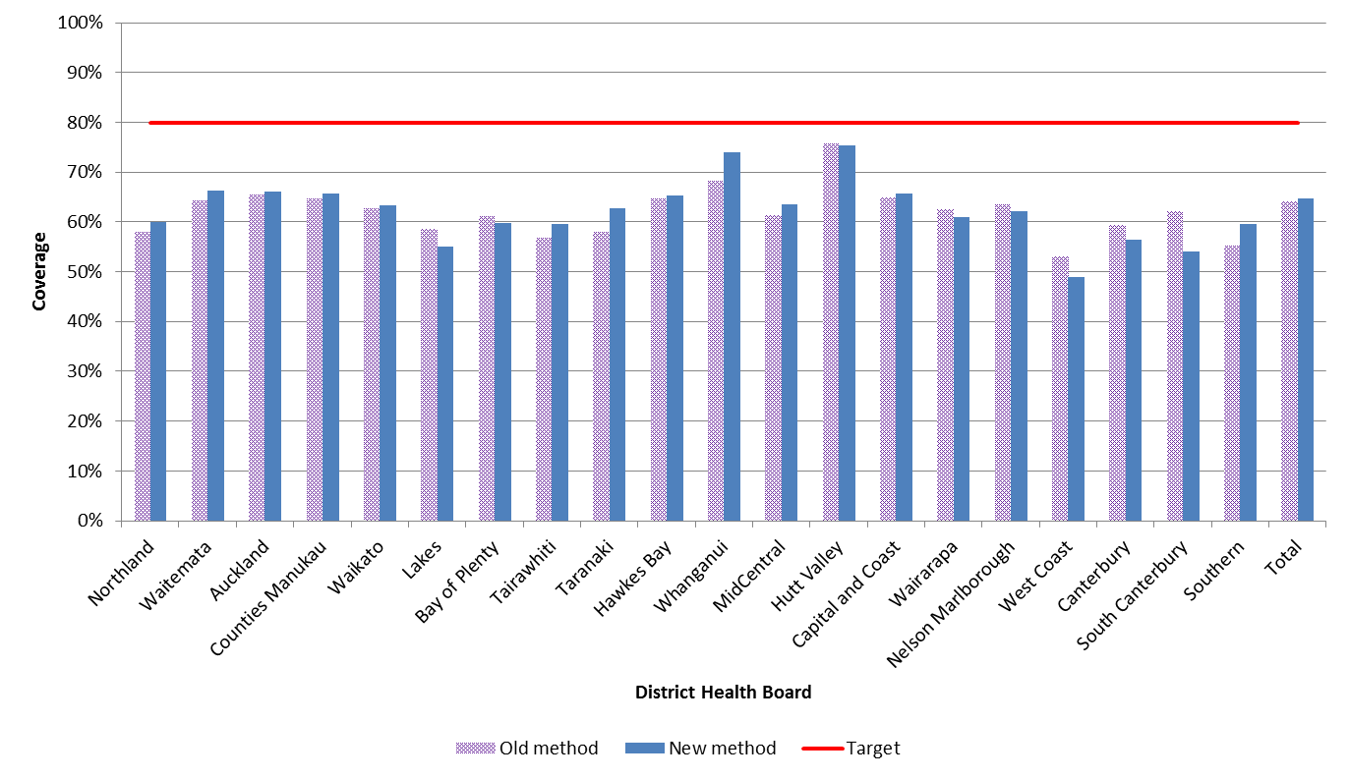 Key: a – Register ethnicity and domicile; b – NHI ethnicity and domicile

