Antenatal Screening for Down Syndrome and Other Conditions
Monitoring Report January 2011 to December 2015

Citation: Ministry of Health. 2017. Antenatal Screening for Down Syndrome and Other Conditions: Monitoring Report January 2011 to December 2015.
Wellington: Ministry of Health.
Published in May 2017
by the Ministry of Health
PO Box 5013, Wellington 6140, New Zealand
ISBN 978-1-98-850257-1 (online)
HP 6618
This document is available at health.govt.nz
This work is licensed under the Creative Commons Attribution 4.0 International licence. In essence, you are free to: share ie, copy and redistribute the material in any medium or format; adapt ie, remix, transform and build upon the material. You must give appropriate credit, provide a link to the licence and indicate if changes were made.

Contents
Executive summary ix
Introduction 1
Background to screening for Down syndrome and other conditions in pregnancy in New Zealand 1
Programme monitoring and data collection 2
Information included in this report 3
Definitions 3
Inclusion criteria 4
Data calculations 4
Data limitations 5
Indicator 1: Screens commenced 7
Total screens commenced by trimester 7
Screens commenced by DHB 8
Screens commenced by age, ethnicity and deprivation 10
Indicator 2: Screens completed 14
Total screens completed by trimester 14
Screens completed by DHB 15
Screens completed by age, ethnicity and deprivation 17
Indicator 3: Screening pathway variance 21
Screening pathway variance by year 21
Screening pathway variance by DHB 22
Screening pathway variance by age, ethnicity and deprivation 23
Indicator 4: Incomplete screens 24
Total incomplete screens 24
Incomplete T1 screens by reason incomplete 24
Incomplete T1 screens by reason and DHB 25
Incomplete T1 screens by age, ethnicity and deprivation 26
Incomplete T2 screens 27
Incomplete T2 screens by DHB 27
Incomplete T2 screens by age, ethnicity and deprivation 28
Indicator 5: Increased risk screening results for trisomy 21, trisomy 18 and trisomy 13 29
Total increased risk screening results for trisomy 21, 18 or 13 29
Increased risk screening results for trisomy 21, 18 or 13 by age, ethnicity and deprivation 29
Increased risk screening results for trisomy 21, 18 or 13 by trimester of screen 30
Increased risk screening results stratified by risk level 32
Indicator 6: Diagnostic testing volumes for women with increased risk screens 33
Diagnostic testing volumes for women with increased risk screens by trimester of screen 33
Diagnostic testing volumes for women with increased risk screens by DHB 34
Diagnostic testing volumes for women with increased risk screens by age, ethnicity and deprivation 35
Diagnostic testing volumes for women with increased risk screening results stratified by risk level 36
Indicator 7: Diagnostic testing volumes for women who receive a low risk screening result 37
Diagnostic testing volumes for women with low risk screens by trimester of screen 37
Diagnostic testing volumes for women with low risk screens by DHB 38
Diagnostic testing volumes for women with low risk screening results by age, ethnicity and deprivation 38
Diagnostic testing volumes for women with low risk screening results stratified by risk 40
Indicator 8: Diagnostic testing for unscreened women 41
Diagnostic volumes for unscreened women 41
Diagnostic results for unscreened women 42
Indicator 9: Diagnostic testing outcomes for women with increased risk screening results 43
Positive predictive value of screening 43
Positive predictive value of screening for trisomy 21 stratified by risk level 45
Positive predictive value of screening for trisomy 21 by age, ethnicity and deprivation 45
Indicator 10: False positive rate 47
False positive rate for screening 47
False positive rate for screening for trisomy 21 by age, ethnicity and deprivation 48
Indicator 11: Detection rate 50
Detection rate for screening 50
Detection rate for screening for trisomy 21 by age, ethnicity and deprivation 51
Indicators 12, 13 & 14: Radiology monitoring Nuchal Translucency (NT) ultrasound volumes by NT operator 53
Indicator 12: Nuchal Translucency (NT) ultrasound volumes by NT operator 54
Indicator 13: Distribution of bias by NT operator 54
Indicator 14: Overall distribution of bias 56
Appendix 1: Indicator definitions 58
Appendix 2: Birth denominator data 60
Appendix 3: Summary of diagnostic testing uptake and results for women that had an increased risk screen 62
Appendix 4: Measuring screening performance 64
Appendix 5: False negative screens by risk level 66
Appendix 6: ROC curve 67
Appendix 7: Radiology indicator summary measures 68
Appendix 8: Example NT Operator Report 69
Appendix 9: Glossary 70

List of tables
Table 2: Total screens commenced by trimester, January 2011 to December 2015 7
Table 3: Screens commenced by trimester and DHB, January 2015 to December 2015 9
Table 4: Screens commenced per 100 births by DHB, January 2011 to December 2015 10
Table 5: Screens commenced by age of mother, ethnicity and NZ deprivation quintile, January 2011 to December 2015 11
Table 6: Total screens completed by trimester, January 2011 to December 2015 14
Table 7: Screening completion by trimester and DHB, January 2015 to December 2015 16
Table 8: Screening completion by DHB, January 2011 to December 2015 17
Table 9: Screens completed by age of mother, ethnicity and NZ deprivation quintile, January 2011 to December 2015 18
Table 10: Screening pathway variance by type, January 2011 to December 2015 21
Table 11: Screening pathway variance by DHB, January 2015 to December 2015 22
Table 12: Screening pathway variance by age, ethnicity and NZ deprivation quintile, January 2015 to December 2015 23
Table 13: Incomplete screens by trimester, January 2011 to December 2015 24
Table 14: Incomplete T1 screens by reason incomplete, January 2011 to December 2015 25
Table 15: Incomplete T1 screens by reason and DHB, January 2015 to December 2015 25
Table 16: Incomplete T1 screens by age, ethnicity and NZ deprivation quintile, January 2015 to December 2015 26
Table 17: Incomplete T2 screens, January 2011 to December 2015 27
Table 18: IncompleteT2 screens by DHB, January 2015 to December 2015 27
Table 19: Incomplete T2 screens by age, ethnicity and NZ deprivation quintile, January 2015 to December 2015 28
Table 20: Number and rate per 100 screens of increased risk screening results for trisomy 21, 18 or 13, January 2011 to December 2015 29
Table 21: Increased risk screening results for trisomy 21, 18 or 13 by age, ethnicity and deprivation, January 2015 to December 2015 30
Table 22: Increased risk screening results for trisomy 21, 18 and 13 by trimester of screen, January 2011 to December 2015 31
Table 23: Increased risk screening results for trisomy 21, 18 and 13 by risk level, January 2015 to December 2015 32
Table 24: Diagnostic testing volumes for women with increased risk screens by trimester of screen, January 2011 to December 2015 33
Table 25: Diagnostic testing volumes for women with increased risk screens by DHB, January 2011 to December 2015 34
Table 26: Diagnostic testing volumes for women with increased risk screening results by age at screen, ethnicity and deprivation, January 2011 to December 2015 35
Table 27: Diagnostic testing volumes for women with increased risk screens by risk level, January 2015 to December 2015 36
Table 28: Diagnostic testing volumes for women with low risk screens by trimester of screen, January 2011 to December 2015 37
Table 29: Total diagnostic testing volumes for women with low risk screens by DHB January 2011 to December 2015 38
Table 30: Diagnostic tests per 100 low risk screens by age, ethnicity and NZ deprivation quintile, January 2011 to December 2015 39
Table 31: Diagnostic tests per 100 low risk screens stratified by risk level, January 2011–December 2015 aggregated 40
Table 32: Diagnostic testing volumes for unscreened women by DHB, January 2012 to December 2015 41
Table 33: Total diagnostic testing volumes for unscreened women by age, ethnicity and deprivation quintile, January 2012 to December 2015 42
Table 34: Total diagnostic testing results for unscreened women, January 2015 to December 2015 42
Table 35: Positive predictive value of screening for trisomy 21, 18 or 13, January 2011 to December 2015 44
Table 36: Positive predictive of screening for trisomy 21, January 2011 to December 2015 44
Table 37: Positive predictive of screening for trisomy 13 or 18, January 2011 to December 2015 44
Table 38: Positive predictive of screening for trisomy 21 stratified by risk level, aggregated 2011 – 2015 45
Table 39: Positive predictive of screening for trisomy 21 by age, aggregated 2011 – 2015 45
Table 40: Positive predictive of screening for trisomy 21 by ethnicity, aggregated 2011 – 2015 46
Table 41: Positive predictive of screening for trisomy 21 by NZ deprivation quintile, aggregated 2011 – 2015 46
Table 42: False positive rate for trisomy 21, 18 or 13, January 2011 to December 2015 47
Table 43: False positive rate for trisomy 21, 18 or 13 by trimester of screen, January to December 2015 47
Table 44: False positive rate for trisomy 21, January 2011 to December 2015 48
Table 45: False positive rate for trisomy 18 and 13, January 2011 to December 2015 48
Table 46: False positive rate for trisomy 21 by age, aggregated January 2011 to December 2015 48
Table 47: False positive rate for trisomy 21 by ethnicity, January 2011 to December 2015 49
Table 48: False positive rate for trisomy 21 by NZ deprivation quintile, January 2011 to December 2015 49
Table 49: Detection rate for trisomy 21, 18 or 13, January 2011 to December 2015 50
Table 50: Detection rate for trisomy 21, January 2011 to December 2015 51
Table 51: Detection rate for trisomy 13 or 18, January 2011 to December 2015 51
Table 52: Detection rate for trisomy 21 by age, aggregated 2011 – 2015 51
Table 53: Detection rate for trisomy 21 by ethnicity, aggregated 2011 – 2015 52
Table 54: Detection rate for trisomy 21 by NZ deprivation quintile, aggregated 2011 – 2015 52
Table 55: Ultrasound scan data received for radiology monitoring, January 2014 to December 2015 54
Table 56: NT volumes by operator, January 2014 to December 2015 54
Table 57: Impact of measurement bias on screening risk result 55
Table 58: Flag status definitions 55
Table 59: Distribution of bias by NT operator, January 2014 to December 2015 55
Table 60: Distribution of bias as a proportion of total scans reported, January 2014 to December 2015 56
Table 61: Definitions used for monitoring indicators 58
Table 62: Live births and still births by district health board 2011–2015 60
Table 63: Live births and still births by age group, 2011–2015 61
Table 64: Live births and still births by 2013 NZ deprivation quintile, 2011–2015 61
Table 65: Live births and still births by ethnicity, 2011-2015 61
Table 66: Diagnostic results for women that accessed a prenatal diagnostic test following an increased risk screen for trisomy 21, 18 or 13 during the 2015 year 62
Table 67: Pregnancy outcomes (where known) for women that did not have a prenatal diagnostic test following an increased risk screen for trisomy 21, 18 or 13 during the 2015 year 63
Table 68: False negative screens for trisomy 21, 18 and 13 by risk level, January 2011 to December 2015 66

List of figures
Figure 1: Data collection process 2
Figure 2: Count and rate of screens commenced, January 2011 to December 2015 7
Figure 3: Screens commenced by DHB, January 2015 to December 2015 8
Figure 4: Screens commenced by age of mother at screen, January 2015 to December 2015 12
Figure 5: Screens commenced by ethnicity of mother, January 2015 to December 2015 12
Figure 6: Screens commenced by NZ deprivation quintile, January 2015 to December 2015 13
Figure 7: Count and rate of screens completed, January 2011 to December 2015 14
Figure 8: Screens completed by DHB, January 2015 to December 2015 15
Figure 9: Screens completed by age of mother at screen, January 2015 to December 2015 19
Figure 10: Screens completed by ethnicity of mother, January 2015 to December 2015 19
Figure 11: Screens completed by NZ deprivation quintile of mother, January 2015 to December 2015 20
Figure 12: Distribution of bias by NT operator, January 2014 to December 2015 56
Figure 13: Distribution of bias as a proportion of total NT scans reported, January 2014 to December 2015 57
Figure 14: Categorisation of screening results 64
Figure 15: Categorisation of trisomy 21 screening results 2015 65
Figure 16: ROC curve for trisomy 21, 18 and 13 screening 2015 67
Figure 17: Example NT operator report 69

Executive summary
This report presents data on antenatal screening for Down syndrome and other conditions for the five calendar years from 1 January 2011 to 31 December 2015, and is based on screens that commenced during that time. For the first time a complete data set, with all cytogenetic testing data, has been used.

Antenatal screening for Down syndrome and other conditions
Antenatal screening for Down syndrome and other conditions provides a risk estimate for Down syndrome (trisomy 21), trisomy 18 (Edwards syndrome), trisomy 13 (Patau syndrome) and some other rare genetic disorders. This screening is optional for pregnant women. Women who are less than 20 weeks pregnant are advised about the availability of screening and provided with up-to-date information to support the screening discussion, to enable women to make an informed decision about whether to participate.

First trimester combined screening should be completed between 9 weeks and 13 weeks 6 days gestation. The recommended timing for the blood test is 9 to 10 weeks and the Nuchal Translucency scan should be done at 12 weeks. Second trimester maternal serum screening should be completed between 14 weeks and 20 weeks gestation. The recommended timing for this test is 14 to 18 weeks.

Key points for 2015
- Screening was commenced for 80% of pregnancies [indicator 1].
- Screening uptake by Māori and Pacific women was half or less the rate of Other women in 2015. Pacific rates have increased each year since 2011, but the rate for Māori reduced slightly for 2015 after increases in previous years [indicators 1 and 2].
- The national screening completion rate has increased each year with 72% of births being screened in 2015. Trimester one screens made up 87% of all completed screens in 2015 [indicator 2].
- Most DHBs showed a trend of increasing rates of screening commencement and completion [indicators 1 and 2].
- Just over half of all completed trimester 2 screens were commenced in trimester 1 [indicator 3].
- Eleven percent of screens commenced in 2015 were not completed and nearly all related to screens commenced in the first trimester. The rate of incomplete screens was higher for younger women, for Māori and Pacific women, and for women from areas of higher deprivation [indicator 4].
- The positive test rate (number of increased risk results per 100 screens) for trisomy 21, 18 and 13 was 2.8 in 2015, consistent with 2014. The positive test rate was higher for second trimester screens (4 per 100 screens) than for first trimester screens (2.6 per 100 screens) for 2015, but the difference in rates was smaller than in 2014 due to a lower T2 positive test rate [indicator 5].
- The false positive rate for trisomy 21, 18 and 13 was 2% in 2015, consistent with previous years. The rate was higher for second trimester screens (4%) than for first trimester screens (2%) [indicator 10].
- The overall detection rate for trisomy 21, 18 and 13 increased to 87% in 2015, up from 81% in 2014 [indicator 11].
- The radiology quality improvement project has produced positive results with a higher proportion of ultrasound operators completing sufficient scans to enable valid statistical monitoring and feedback. There has also been improvement in the proportion of ultrasound operators whose nuchal translucency measurements are within accepted levels of variance relative to the Fetal Medicine Foundation reference curve [indicators 12, 13 and 14].

Introduction

Background to screening for Down syndrome and other conditions in pregnancy in New Zealand
Antenatal screening for Down syndrome and other conditions has been available to pregnant women in New Zealand since 1968. In October 2007, the government agreed to implement quality improvements to ensure consistency with international best practice. The improvements were introduced in February 2010 and included incorporating maternal serum screening with ultrasound, providing practitioner guidelines and consumer resources.

Health practitioners providing maternity care are required to provide women with information about antenatal screening services for Down syndrome and other conditions. There are two screening options:
- first trimester combined screening, which includes a blood test that measures two maternal serum markers, pregnancy-associated protein A (PAPP-A) and free beta- human chorionic gonadotropin (ßhCG). The blood sample is collected between 9 weeks and 13 weeks and 6 days gestation and combined with an ultrasound scan to determine nuchal translucency (NT) and crown rump length (CRL) measurements (and nasal bone assessment if provided) between 11 weeks and 2 days and 13 weeks and 6 days, or
- second trimester screening, which is a blood test that measures four maternal serum markers free beta-human chorionic gonadotropin (ßhCG), alpha-fetoprotein (AFP), unconjugated oestriol (uE3) and inhibin A taken between 14 and 20 weeks gestation.

The results of the ultrasound scan and/or serum are combined with other demographic and maternal factors to provide a risk result. For consistency, all screening risk results are produced by the screening laboratories. The screening laboratories are LabPLUS at Auckland District Health Board (for samples from Taupo north) and Canterbury Health Laboratories at Canterbury District Health Board (for samples south of Taupo). A shared data repository (PerkinElmer LifeCycle) contains data on all screens. Ultrasound scanning is performed by private and public radiology practices around New Zealand and the ultrasound report is sent to the screening laboratories to include in the risk calculation algorithm.

The conditions covered by screening include:
- trisomy 21 (Down Syndrome)
- trisomy 18 (Edwards syndrome)
- trisomy 13 (Patau syndrome)
- triploidy
- Turner syndrome
- neural tube defects

Antenatal screening involves many health professionals including radiology staff, Lead Maternity Carers (LMCs), general practitioners (GPs) and laboratory personnel. The quality of the information provided by health professionals to the laboratories regarding the pregnancy details (such as gestation, maternal age, weight, ethnicity and the ultrasound finding) is critical because these details have a significant impact on the risk calculation and report that is issued.

Programme monitoring and data collection
This report presents monitoring results for antenatal screening for Down syndrome and other conditions for the period 1 January 2011 to 31 December 2015. The definitions for the 14 indicators in this report are contained in Appendix 1. Figure 1 outlines the data collection process the National Screening Unit used to produce indicators 1 to 11. Indicators 12 to 14 relate to separate, independent analysis of NT measurements from ultrasound scans that was completed for 2014 and 2015 screens.

Figure 1: Data collection process
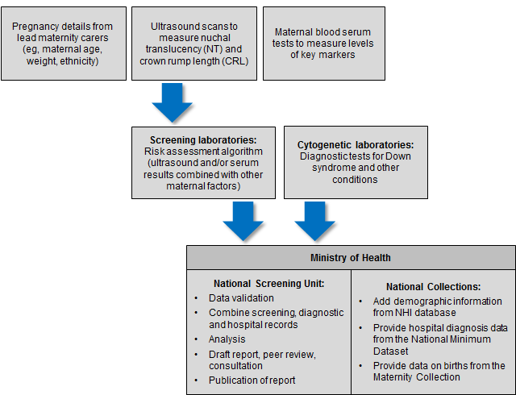

The indicators contained within this monitoring report form one part of the evaluation and audit of the quality improvements to antenatal screening for Down syndrome and other conditions. Other activities include:
- yearly screening laboratory audits by IANZ
- two-yearly peer review of screening laboratories
- contract monitoring and reporting on a monthly and quarterly basis
- occasional studies and qualitative information.

Information included in this report
The screening data in this report was sourced from LabPLUS and covers all of New Zealand. For the first time diagnostic testing data was received from all cytogenetic laboratories (LabPLUS, Waikato, Capital and Coast, and Canterbury Health Laboratories). This has enabled complete results to be calculated for all indicators for the full period. This has led to adjustment in historical results for indicators 6 to 11, which in previous reports excluded women screened from Canterbury, West Coast and South Canterbury DHBs.

The screening and cytogenetic data was combined with hospital discharge data, sourced from the National Minimum Data Set (NMDS), held by the Ministry of Health. This matching between data from screening laboratories, cytogenetic laboratories, and the NMDS was undertaken to identify the outcome for all screened women.

This report also includes radiology monitoring indicators (indicators 12 – 14) for the first time. The ultrasound scan data used for these indicators was sourced from LabPlus. These data were forwarded to an independent analytical service in the United Kingdom (Statistical Solutions Limited (SSL)) where it was analysed, and returned, presented in graphical format which was sent to each radiology practice, radiologist and ultrasound operator as part of the Feedback to Radiology project, an initiative to improve the quality of NT and CRL measurements when assessed against the Fetal Medicine Foundation (FMF) reference curve. The same data have been used as a basis for indicators 12 to 14 in this monitoring report.

Definitions

Commenced screening
At least one of the required components of the screening test was completed.

Completed screening
All the required components of each screening test were complete and a risk result was calculated.

Required components of each screening test
First trimester screening comprises analysis of two serum analytes (βhCG, PAPP-A) and a NT measurement. Second trimester screening comprises analysis of four serum analytes (βhCG, AFP, uE3 and Inhibin A).

Low risk result
A low risk result is defined as a risk lower than 1:300. So a risk of 1:310 is a low risk.

Increased risk result
An increased risk result is defined as a risk higher than or equal to 1:300. For some indicators increased risk screening results are further stratified into:
- 1:5 to 1:20
- 1:25 to 1:50
- 1:55 to 1:300.

Inclusion criteria
Women’s screens were included in this analysis if the following criteria were met:
- screening commencement date between 1 January 2011 and 31 December 2015 (ie, date of the first test the woman had as part of the screening pathway)
- valid National Health Index identifier (NHI)
- known District Health Board (DHB) of domicile
- age at screen from 12 years to 49 years (calculated using the NHI database date of birth)
- single screening result per pregnancy.

Data calculations

DHB of domicile
Each woman was allocated to a DHB based on the residential address recorded in the National Health Index (NHI). Where the NHI database did not have a DHB recorded for an NHI, information from the LabPLUS database was used to assign the DHB.

Ethnicity
Ethnicity data in this report is grouped according to a prioritised system, which is commonly applied across the New Zealand health sector. Prioritisation involves allocating each person to a single ethnic group, based on the ethnicities that person has identified, in the prioritised order of Māori, Pacific, Asian and Other ethnicity. For example, if someone identifies as being New Zealand European and Māori, under the prioritised ethnicity method, they are classified as Māori for the purpose of the analysis. Under this method, the Other ethnicity group effectively refers to non-Māori, non-Pacific, non-Asian people. In this report, women identifying as New Zealand European/Pākehā made up approximately 79% of the Other ethnicity group. Less than 1% of records related to women with unknown/not stated ethnicity. These were grouped with Other for this report.

NZ Deprivation
The New Zealand deprivation index (NZ Dep) is the average level of deprivation of people living in an area at a particular point in time, relative to the whole of New Zealand. Deprivation refers to areas (based on New Zealand Census mesh blocks) rather than individuals. All reporting by NZ Dep is based on the 2013 New Zealand deprivation index decile associated with the residential address held in the NHI database for each woman at the time of data extraction.

This report presents results by 2013 NZ Dep quintiles. Each quintile groups two deciles together and contains about 20% of small areas in New Zealand. The two quintiles at opposite ends of the scale are quintile 1 (deciles 1 and 2), which represents children living in the least deprived 20% of small areas (‘the least deprived areas’), and quintile 5 (deciles 9 and 10), which represents children living in the most deprived 20% of small areas (‘the most deprived areas’). This is opposite to some other systems of classification, such as that used by education, where level 10 is the least disadvantaged and level 1 the most disadvantaged.

Births
Data on the number of live and still births was obtained from the national Maternity Collection for each calendar year. Appendix 2 contains tables for the denominators used in this report.

Small numbers
Small numbers can affect the reliability of results. Where an indicator calculation involves small counts (denominator less than 10) then those results have been suppressed as they are considered too unstable.

Prenatal cytogenetic test
The focus of indicators 6, 7, and 8 is on tests that women choose to have as part of managing their pregnancy. For these indicators prenatal tests are a karyotype or array by chorionic villus sampling (CVS) or amniocentesis procedures (tests on products of conception are not included). For indicators 9, 10 and 11 cytogenetic tests on products of conception are used in addition to CVS, amniocentesis and infant diagnoses to determine the outcome of the pregnancy.

Repeat screens
A repeat screen was defined as a second screen for the same woman within 112 days. Where this occurred, the first completed screen was retained for the analysis. The figure of 112 days was based on the timing of the screening test and considering how soon a woman may become pregnant again following a miscarriage.

Linking rules
When matching screening and diagnosis data the following rules were followed:
- for a birth to link to a commenced screen the screen date must be earlier than the birth date and the date difference must not be greater than 230 days (approximately 33 weeks)
- for a prenatal cytogenetic test to link to a screen the cytogenetic sample date must be later than the screen date, but not more than 105 days (15 weeks) later.

These were based on the possible timing of the different screening and diagnostic tests.

Data limitations

Denominator underestimation
Screening completion rates derived using total births may overestimate the proportion of women participating in antenatal screening for Down syndrome and other conditions. This is because the true denominator (ie, all pregnant women that reach 9 weeks gestation) is likely to be larger than the denominator used (ie, all births reaching at least 20 weeks gestation or at least 400 g birth weight).

Missing data
Missing or incorrect data for any screened woman will affect indicator calculations. Known data issues in this report relate to the following.
- 93 did not have DHB of domicile information recorded in either the NHI database or in the laboratory information system. These records were excluded from the analysis.

Inconsistent data
In some instances there was variation between the demographic information held in the NHI database and that held by LabPLUS. The NHI database was used as the definitive source which led to instances where the age at screen calculated using the NHI date of birth was outside the range of 12 to 49 years (2 records less than 12 years, 3 records 50 years old or greater). These records were excluded from the analysis.

Indicator 1:
Screens commenced
This indicator reports the number of screens commenced by trimester of screening (first or second), by DHB, age, ethnicity, and NZ deprivation quintile.

Total screens commenced by trimester
During 2015, a total of 47,064 screens were commenced, a rate of 80 per 100 births. Table 2 shows the total number of screens commenced by year and trimester of screen. Throughout the report T1 is used to refer to first trimester and T2 to second trimester. The vast majority of screens were T1 screens. The number of screens commenced per 100 births has increased over time from 71 in 2011 to 80 in 2015 (see Table 2 and Figure 2).

Table 2: Total screens commenced by trimester, January 2011 to December 2015
Trimester of screen | Number and rate of screens commenced
 | 2011 | 2012 | 2013 | 2014 | 2015
T1 screen | 39,087 | 39,526 | 38,803 | 40,172 | 41,332
T2 screen | 4,690 | 5,230 | 5,487 | 5,613 | 5,732
Total screens | 43,777 | 44,756 | 44,290 | 45,785 | 47,064
Screens per 100 births | 70.8 | 72.3 | 75.3 | 78.0 | 80.3

Figure 2: Count and rate of screens commenced, January 2011 to December 2015
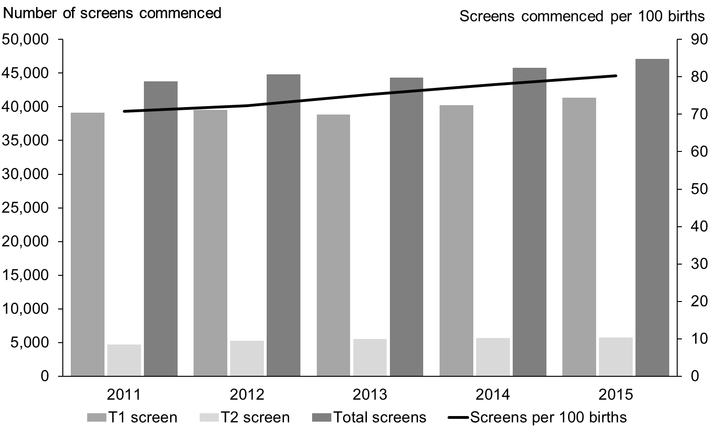

Screens commenced by DHB
Figure 3 shows the screening commencement rates by DHB for 2015. There was a large variation in rates from 60 per 100 births in Northland to 96 per 100 births in Nelson Marlborough (see Figure 3). Half of all DHBs had rates of above 80 per 100 births. Table 3 gives a full breakdown by the trimester of the screen.

Figure 3: Screens commenced by DHB, January 2015 to December 2015
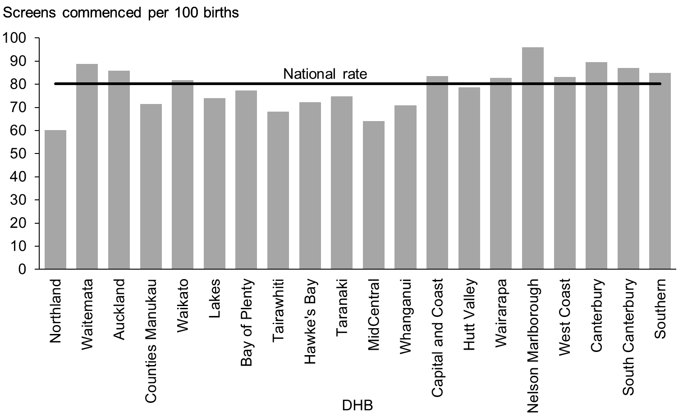

Table 3: Screens commenced by trimester and DHB, January 2015 to December 2015
DHB | Number of screens commenced |  |  | Screens commenced (per 100 births)
 | First trimester | Second trimester | Total | First trimester | Second trimester | Total
Northland | 1,120 | 164 | 1,284 | 52.5 | 7.7 | 60.1
Waitemata | 5,960 | 737 | 6,697 | 78.9 | 9.8 | 88.7
Auckland | 4,452 | 615 | 5,067 | 75.4 | 10.4 | 85.9
Counties Manukau | 4,677 | 1,178 | 5,855 | 57.0 | 14.4 | 71.4
Waikato | 3,855 | 459 | 4,314 | 72.9 | 8.7 | 81.6
Lakes | 1,002 | 113 | 1,115 | 66.4 | 7.5 | 73.9
Bay of Plenty | 1,985 | 176 | 2,161 | 70.9 | 6.3 | 77.2
Tairawhiti | 435 | 70 | 505 | 58.6 | 9.4 | 68.1
Hawke’s Bay | 1,292 | 153 | 1,445 | 64.5 | 7.6 | 72.2
Taranaki | 942 | 189 | 1,131 | 62.2 | 12.5 | 74.7
MidCentral | 1,201 | 149 | 1,350 | 56.9 | 7.1 | 63.9
Whanganui | 492 | 85 | 577 | 60.3 | 10.4 | 70.7
Capital and Coast | 2,658 | 291 | 2,949 | 75.2 | 8.2 | 83.4
Hutt Valley | 1,348 | 197 | 1,545 | 68.5 | 10.0 | 78.5
Wairarapa | 339 | 44 | 383 | 73.2 | 9.5 | 82.7
Nelson Marlborough | 1,248 | 111 | 1,359 | 88.1 | 7.8 | 95.9
West Coast | 260 | 36 | 296 | 73.0 | 10.1 | 83.1
Canterbury | 4,953 | 609 | 5,562 | 79.8 | 9.8 | 89.6
South Canterbury | 485 | 88 | 573 | 73.6 | 13.4 | 86.9
Southern | 2,628 | 268 | 2,896 | 77.0 | 7.9 | 84.8
Total | 41,332 | 5,732 | 47,064 | 70.5 | 9.8 | 80.3

Most DHBs showed an increase in their rate of screens commenced between 2014 and 2015, or had fairly stable rates. Exceptions to this were Lakes, Nelson Marlborough and West Coast where rates decreased between 1.5 and 5% between 2014 and 2015 (see Table 4).

Table 4: Screens commenced per 100 births by DHB, January 2011 to December 2015
DHB | Screens commenced (per 100 births)
 | 2011 | 2012 | 2013 | 2014 | 2015
Northland | 46.5 | 49.7 | 52.8 | 55.6 | 60.1
Waitemata | 83.9 | 82.9 | 86.3 | 86.2 | 88.7
Auckland | 75.0 | 74.4 | 82.4 | 84.0 | 85.9
Counties Manukau | 60.9 | 63.4 | 64.9 | 68.8 | 71.4
Waikato | 72.8 | 72.1 | 76.2 | 80.4 | 81.6
Lakes | 60.5 | 67.8 | 70.2 | 77.3 | 73.9
Bay of Plenty | 65.3 | 68.6 | 69.6 | 72.5 | 77.2
Tairawhiti | 44.2 | 49.1 | 52.7 | 58.5 | 68.1
Hawke’s Bay | 55.8 | 61.8 | 64.3 | 66.1 | 72.2
Taranaki | 62.6 | 60.2 | 61.3 | 68.2 | 74.7
MidCentral | 51.0 | 54.4 | 58.3 | 59.2 | 63.9
Whanganui | 45.1 | 44.9 | 48.1 | 61.1 | 70.7
Capital and Coast | 76.4 | 79.3 | 78.2 | 80.3 | 83.4
Hutt Valley | 70.9 | 70.7 | 72.6 | 78.6 | 78.5
Wairarapa | 72.8 | 69.2 | 76.6 | 81.6 | 82.7
Nelson Marlborough | 87.9 | 90.8 | 87.2 | 97.6 | 95.9
West Coast | 68.9 | 76.5 | 81.3 | 88.0 | 83.1
Canterbury | 85.4 | 86.8 | 90.3 | 89.4 | 89.6
South Canterbury | 92.1 | 85.5 | 88.1 | 78.7 | 86.9
Southern | 75.3 | 80.0 | 81.4 | 83.3 | 84.8
Total | 70.8 | 72.3 | 75.3 | 78.0 | 80.3

Screens commenced by age, ethnicity and deprivation
Table 5 provides an overall view of screens commenced by age, ethnicity and NZ deprivation quintile for January 2011 to December 2015. The 30–34 and 25-29 year age groups had the highest rate of screens commenced for 2015 with 84 women starting screening per 100 births. This was closely followed by the 35-39 year age group with 82 per 100 births. Rates dropped sharply for other age groups to 72% or below (see Figure 4). Rates appear to be increasing for all age groups, except for 40-44 years and 45 years plus, which do not show a clear trend.

Differences in screening commencement rates by ethnicity remained consistent for 2015. Women of Other ethnicity had the highest rate (100%) followed by Asian women (95%). The rate slightly above 100% for Other women is due to the current denominator limitations as discussed under the Data Limitations section. The rate of commenced screens for Pacific and Māori women was lower at 52 per 100 births and 43 per 100 births respectively (see Figure 5). All groups have shown increasing rates over the five years, except for Māori which decreased 1% in 2015 (see Table 5).

A trend of higher screening commencement rates for women in less deprived areas was evident, with 96 women per 100 per births starting screening for quintile 1 in 2015 compared with 64 per 100 births for quintile 5 (see Figure 6). All quintiles showed a rate increase between 2014 and 2015 (see Table 5).

Table 5: Screens commenced by age of mother, ethnicity and NZ deprivation quintile, January 2011 to December 2015
 | Number of screens commenced |  |  |  |  | Screens commenced (per 100 births)#
 | 2011 | 2012 | 2013 | 2014 | 2015 | 2011 | 2012 | 2013 | 2014 | 2015
Age at screen
Under 20 years | 2,282 | 2,128 | 1,947 | 1,990 | 1,928 | 56.3 | 54.5 | 58.6 | 66.4 | 69.2
20–24 years | 6,817 | 6,966 | 6,932 | 7,055 | 7,129 | 58.2 | 60.8 | 64.2 | 68.6 | 71.6
25–29 years | 11,509 | 12,078 | 12,022 | 12,800 | 13,206 | 74.0 | 75.8 | 78.7 | 81.5 | 83.9
30–34 years | 13,433 | 13,751 | 13,914 | 14,623 | 15,124 | 78.0 | 78.8 | 83.0 | 83.2 | 84.4
35–39 years | 8,027 | 8,040 | 7,628 | 7,610 | 8,004 | 74.8 | 77.3 | 76.0 | 78.6 | 82.0
40–44 years | 1,636 | 1,716 | 1,767 | 1,626 | 1,595 | 68.0 | 66.6 | 72.5 | 69.4 | 69.3
45 years and over | 73 | 77 | 80 | 81 | 78 | 57.9 | 64.2 | 55.9 | 61.4 | 56.1
Ethnicity
Māori | 5,540 | 5,881 | 5,805 | 6,284 | 6,269 | 35.0 | 37.5 | 39.9 | 44.2 | 43.1
Pacific | 3,055 | 3,102 | 2,999 | 3,005 | 3,130 | 43.2 | 45.1 | 47.3 | 48.8 | 51.7
Asian | 6,484 | 7,405 | 7,474 | 8,438 | 8,714 | 90.9 | 87.6 | 91.6 | 91.7 | 94.6
Other | 28,698 | 28,368 | 28,012 | 28,058 | 28,951 | 90.3 | 91.9 | 94.2 | 96.3 | 100.6
NZ Deprivation Quintile
Quintile 1 | 8,130 | 8,073 | 7,654 | 7,732 | 7,896 | 95.5 | 93.0 | 93.6 | 91.3 | 95.8
Quintile 2 | 8,174 | 8,395 | 8,231 | 8,413 | 8,660 | 86.0 | 87.4 | 89.0 | 91.8 | 92.7
Quintile 3 | 8,529 | 8,685 | 8,730 | 8,878 | 9,135 | 76.5 | 77.7 | 82.1 | 84.1 | 86.2
Quintile 4 | 9,526 | 9,822 | 9,882 | 10,353 | 10,482 | 69.0 | 71.9 | 73.6 | 77.9 | 79.1
Quintile 5 | 9,409 | 9,777 | 9,789 | 10,408 | 10,885 | 50.0 | 52.1 | 56.6 | 60.4 | 63.8
Unknown | 9 | 4 | 4 | 1 | 6 | - | - | - | - | -
Total | 43,777 | 44,756 | 44,290 | 45,785 | 47,064 | 63.4 | 65.7 | 69.3 | 71.1 | 72.0
# Rate suppressed if the number of screens was <10.

Figure 4: Screens commenced by age of mother at screen, January 2015 to December 2015
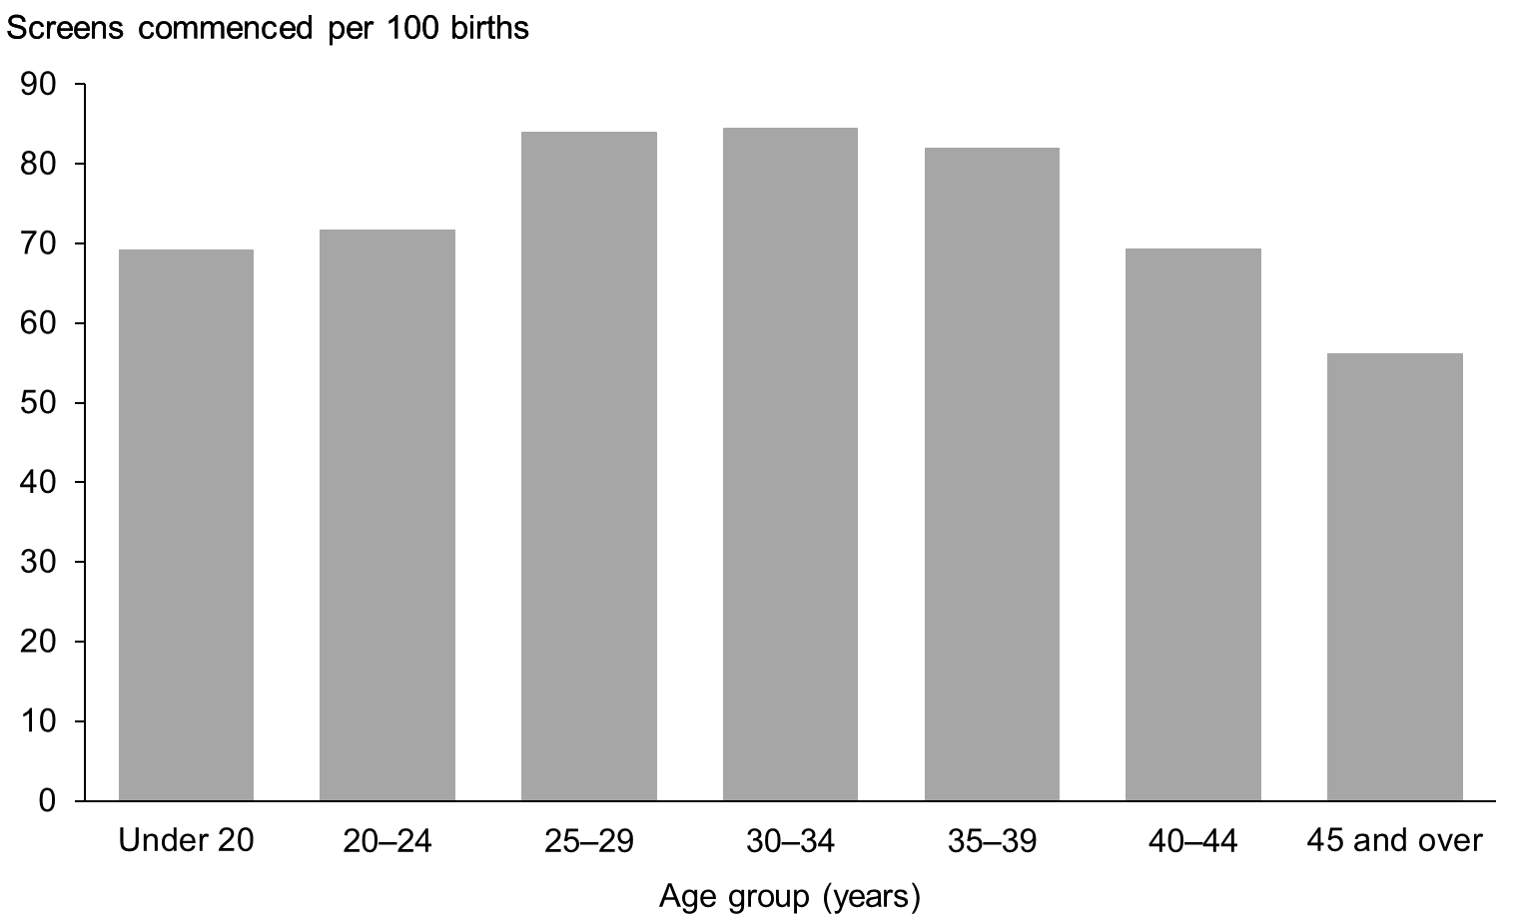

Figure 5: Screens commenced by ethnicity of mother, January 2015 to December 2015
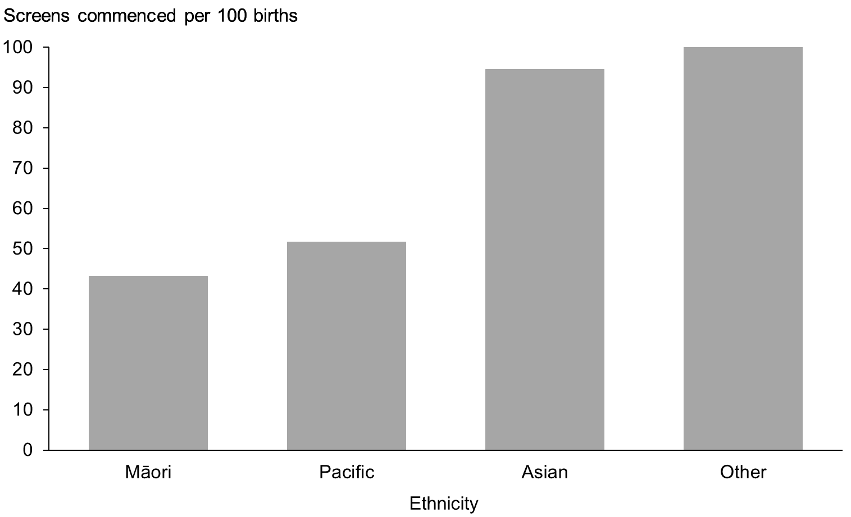

Figure 6: Screens commenced by NZ deprivation quintile, January 2015 to December 2015
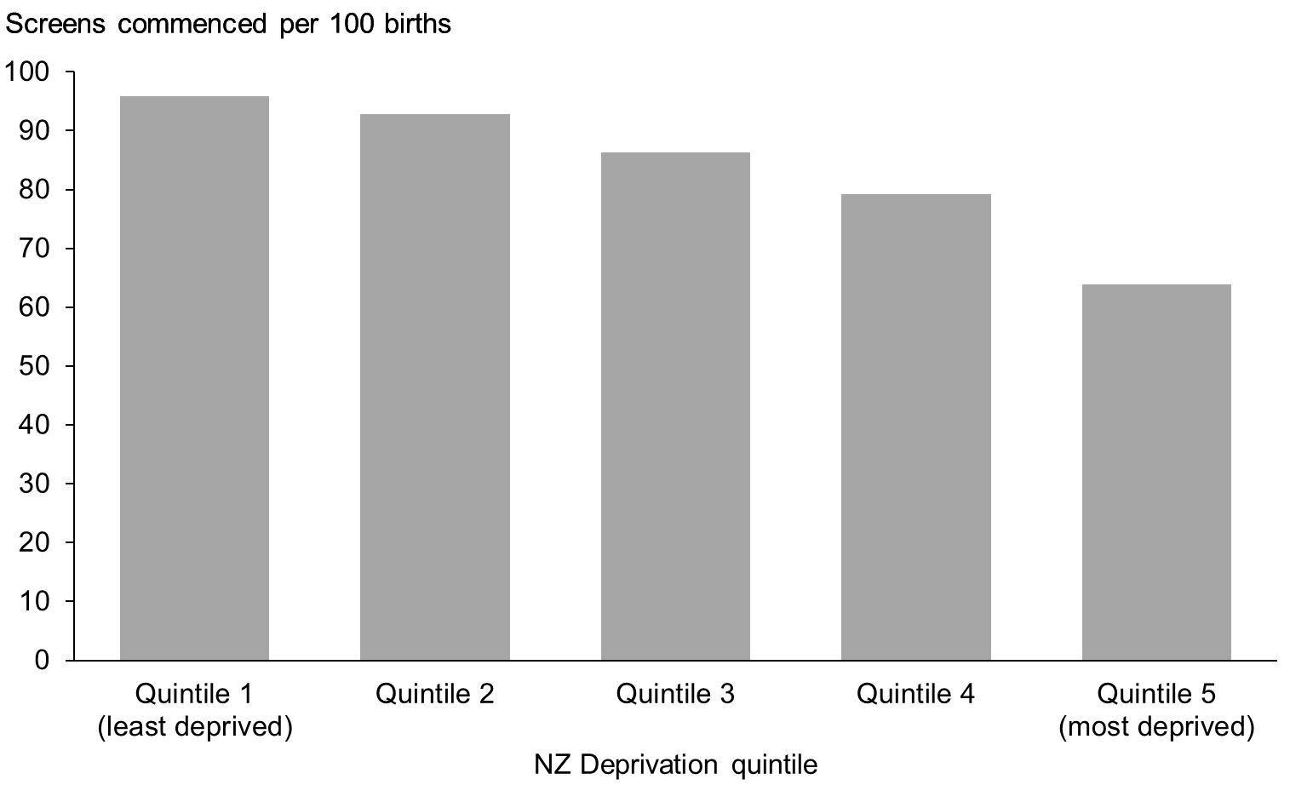

Indicator 2:
Screens completed
This indicator reports the number of screens completed by trimester of screening, DHB, age, ethnicity, and NZ deprivation quintile.

Total screens completed by trimester
During 2015, a total of 42,212 screens were completed, a rate of 72 per 100 births. Table 6 and Figure 7 show the total number of screens completed per year and trimester of screen. Across all years the majority of screens were completed in the first trimester. The total number and rate of completed screens has increased annually since 2011.

Table 6: Total screens completed by trimester, January 2011 to December 2015
Trimester of screen | Number and rate of screens completed
 | 2011 | 2012 | 2013 | 2014 | 2015
T1 screen | 34,735 | 35,691 | 35,464 | 36,280 | 36,704
T2 screen | 4,446 | 4,957 | 5,269 | 5,456 | 5,508
Total screens | 39,181 | 40,648 | 40,733 | 41,736 | 42,212
Screens per 100 births | 63.4 | 65.7 | 69.3 | 71.1 | 72.0

Figure 7: Count and rate of screens completed, January 2011 to December 2015
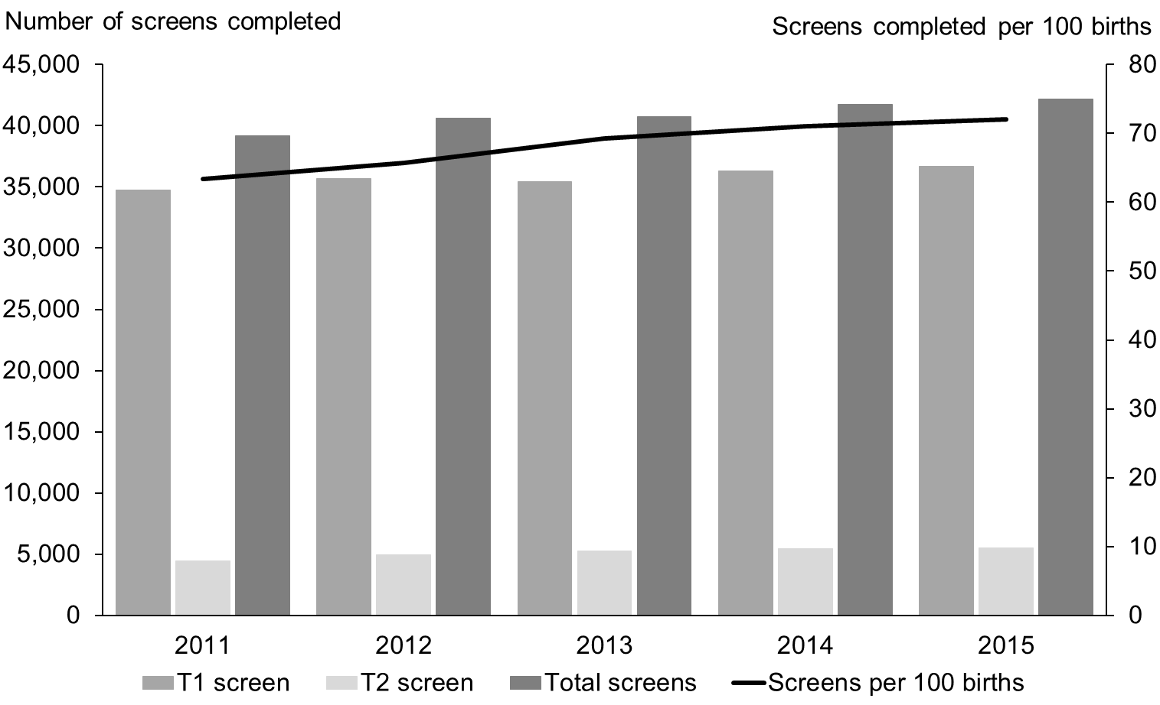

Screens completed by DHB
Screening completion rates for 2015 varied across DHBs from 51 per 100 births in Northland to 84 per 100 births in Nelson Marlborough (see Figure 8). Table 7 gives a full breakdown by the trimester of the screen.

Figure 8: Screens completed by DHB, January 2015 to December 2015
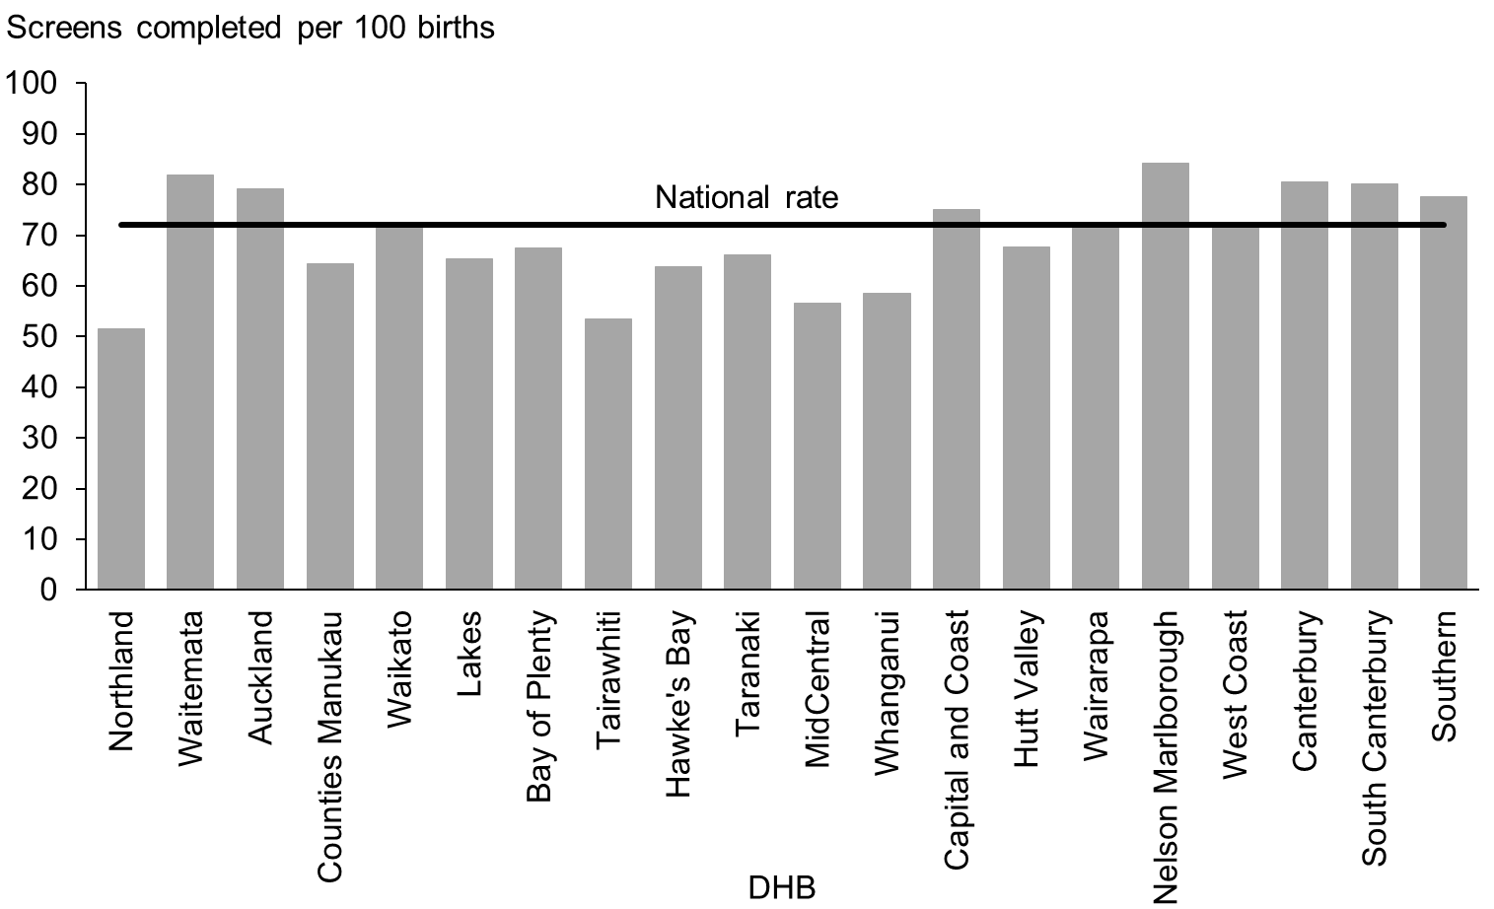

Table 7: Screening completion by trimester and DHB, January 2015 to December 2015
DHB | Number of screens completed |  |  | Screens completed (per 100 births)
 | First trimester | Second trimester | Total | First trimester | Second trimester | Total
Northland | 941 | 159 | 1,100 | 44.1 | 7.4 | 51.5
Waitemata | 5,473 | 710 | 6,183 | 72.5 | 9.4 | 81.9
Auckland | 4,081 | 587 | 4,668 | 69.1 | 9.9 | 79.1
Counties Manukau | 4,153 | 1,132 | 5,285 | 50.6 | 13.8 | 64.4
Waikato | 3,369 | 440 | 3,809 | 63.7 | 8.3 | 72.0
Lakes | 875 | 111 | 986 | 58.0 | 7.4 | 65.3
Bay of Plenty | 1,718 | 169 | 1,887 | 61.4 | 6.0 | 67.4
Tairawhiti | 329 | 68 | 397 | 44.3 | 9.2 | 53.5
Hawke’s Bay | 1,133 | 144 | 1,277 | 56.6 | 7.2 | 63.8
Taranaki | 819 | 182 | 1,001 | 54.1 | 12.0 | 66.1
MidCentral | 1,053 | 144 | 1,197 | 49.9 | 6.8 | 56.7
Whanganui | 396 | 82 | 478 | 48.5 | 10.0 | 58.6
Capital and Coast | 2,373 | 277 | 2,650 | 67.1 | 7.8 | 75.0
Hutt Valley | 1,140 | 190 | 1,330 | 58.0 | 9.7 | 67.6
Wairarapa | 291 | 41 | 332 | 62.9 | 8.9 | 71.7
Nelson Marlborough | 1,087 | 106 | 1,193 | 76.7 | 7.5 | 84.2
West Coast | 224 | 34 | 258 | 62.9 | 9.6 | 72.5
Canterbury | 4,421 | 583 | 5,004 | 71.2 | 9.4 | 80.6
South Canterbury | 440 | 88 | 528 | 66.8 | 13.4 | 80.1
Southern | 2,388 | 261 | 2,649 | 69.9 | 7.6 | 77.6
Total | 36,704 | 5,508 | 42,212 | 62.6 | 9.4 | 72.0

Similar to screens commenced, most DHBs showed a trend of increasing rates of screening completion over the five years covered in this report. West Coast was an exception to this with a decrease in completion rates 2015. South Canterbury’s rate showed an increase in 2015 after a decrease in 2014 (see Table 8).

Table 8: Screening completion by DHB, January 2011 to December 2015
DHB | Screens completed (per 100 births)
 | 2011 | 2012 | 2013 | 2014 | 2015
Northland | 41.1 | 44.4 | 47.0 | 48.0 | 51.5
Waitemata | 78.0 | 77.9 | 82.1 | 81.0 | 81.9
Auckland | 70.4 | 69.4 | 77.6 | 78.9 | 79.1
Counties Manukau | 53.8 | 57.3 | 59.7 | 63.3 | 64.4
Waikato | 65.1 | 64.2 | 69.0 | 72.5 | 72.0
Lakes | 53.1 | 59.1 | 62.7 | 69.8 | 65.3
Bay of Plenty | 58.3 | 61.7 | 62.1 | 64.5 | 67.4
Tairawhiti | 39.4 | 44.3 | 46.7 | 50.7 | 53.5
Hawke’s Bay | 50.2 | 55.9 | 59.7 | 59.5 | 63.8
Taranaki | 58.2 | 55.5 | 55.0 | 61.3 | 66.1
MidCentral | 45.2 | 49.5 | 53.8 | 53.9 | 56.7
Whanganui | 40.3 | 41.8 | 45.2 | 53.1 | 58.6
Capital and Coast | 67.8 | 71.9 | 70.9 | 72.6 | 75.0
Hutt Valley | 59.0 | 62.6 | 64.6 | 68.9 | 67.6
Wairarapa | 62.8 | 59.6 | 66.7 | 70.6 | 71.7
Nelson Marlborough | 78.7 | 81.4 | 78.0 | 87.6 | 84.2
West Coast | 55.6 | 68.6 | 72.5 | 78.6 | 72.5
Canterbury | 72.3 | 75.8 | 81.9 | 81.1 | 80.6
South Canterbury | 87.0 | 82.6 | 85.6 | 75.2 | 80.1
Southern | 67.3 | 73.6 | 75.6 | 74.9 | 77.6
Total | 63.4 | 65.7 | 69.3 | 71.1 | 72.0

Screens completed by age, ethnicity and deprivation
Table 9 provides an overall view of screens completed by age, ethnicity and NZ deprivation quintile for January 2011 to December 2015, with similar trends shown as for screening commencement. Screening completion rates were highest in the 30–34 year age group with 78 women completing screening per 100 births in 2015. This was followed by the 35–39 years and 25-29 years age groups with 76 per 100 births and 75 per 100 births respectively (see Figure 9).

Screening completion rates were highest among women of Other ethnicity at 92 per 100 births for 2015. This was followed closely by Asian women at 88 per 100 births. The rate of completed screens for Pacific and Māori women remains lower at 43 per 100 births and 34 per 100 births respectively (see Figure 10). The rate for Māori is a decrease on the previous year (see Table 9).

Screening completion rates were highest among women in less deprived areas with a rate of 89 per 100 per births for quintile 1 in 2015 compared with 54 per 100 births for quintile 5 (see Figure 11).

Table 9: Screens completed by age of mother, ethnicity and NZ deprivation quintile, January 2011 to December 2015
 | Number of screens completed |  |  |  |  | Screens completed (per 100 births)#
 | 2011 | 2012 | 2013 | 2014 | 2015 | 2011 | 2012 | 2013 | 2014 | 2015
Age at screen
Under 20 years | 1,808 | 1,699 | 1,610 | 1,604 | 1,507 | 44.6 | 43.5 | 48.4 | 53.5 | 54.1
20–24 years | 5,754 | 5,890 | 6,010 | 6,070 | 5,988 | 49.2 | 51.4 | 55.6 | 59.1 | 60.2
25–29 years | 10,276 | 10,997 | 11,097 | 11,685 | 11,811 | 66.1 | 69.0 | 72.6 | 74.4 | 75.1
30–34 years | 12,353 | 12,859 | 13,089 | 13,675 | 14,018 | 71.7 | 73.6 | 78.1 | 77.8 | 78.3
35–39 years | 7,453 | 7,543 | 7,214 | 7,144 | 7,418 | 69.5 | 72.5 | 71.9 | 73.8 | 76.0
40–44 years | 1,474 | 1,588 | 1,643 | 1,486 | 1,406 | 61.3 | 61.6 | 67.4 | 63.4 | 61.1
45 years and over | 63 | 72 | 70 | 72 | 64 | 50.0 | 60.0 | 49.0 | 54.5 | 46.0
Ethnicity
Māori | 4,561 | 4,880 | 4,893 | 5,178 | 4,902 | 28.8 | 31.1 | 33.6 | 36.4 | 33.7
Pacific | 2,479 | 2,591 | 2,606 | 2,598 | 2,623 | 35.1 | 37.7 | 41.1 | 42.2 | 43.3
Asian | 6,024 | 6,990 | 7,091 | 8,034 | 8,114 | 84.4 | 82.7 | 87.0 | 87.3 | 88.1
Other | 26,117 | 26,187 | 26,143 | 25,926 | 26,573 | 82.2 | 84.8 | 87.9 | 89.0 | 92.3
NZ Deprivation Quintile
Quintile 1 | 7,519 | 7,520 | 7,255 | 7,242 | 7,329 | 88.4 | 86.6 | 88.7 | 85.5 | 88.9
Quintile 2 | 7,480 | 7,805 | 7,749 | 7,867 | 8,025 | 78.7 | 81.3 | 83.8 | 85.9 | 85.9
Quintile 3 | 7,748 | 8,028 | 8,102 | 8,195 | 8,318 | 69.5 | 71.9 | 76.2 | 77.6 | 78.5
Quintile 4 | 8,401 | 8,851 | 9,001 | 9,325 | 9,293 | 60.8 | 64.8 | 67.1 | 70.2 | 70.2
Quintile 5 | 8,027 | 8,441 | 8,622 | 9,106 | 9,241 | 42.7 | 45.0 | 49.8 | 52.9 | 54.2
Unknown | 6 | 3 | 4 | 1 | 6
Total | 39,181 | 40,648 | 40,733 | 41,736 | 42,212 | 63.4 | 65.7 | 69.3 | 71.1 | 72.0
# Rate suppressed if the number of screens was <10.

Figure 9: Screens completed by age of mother at screen, January 2015 to December 2015
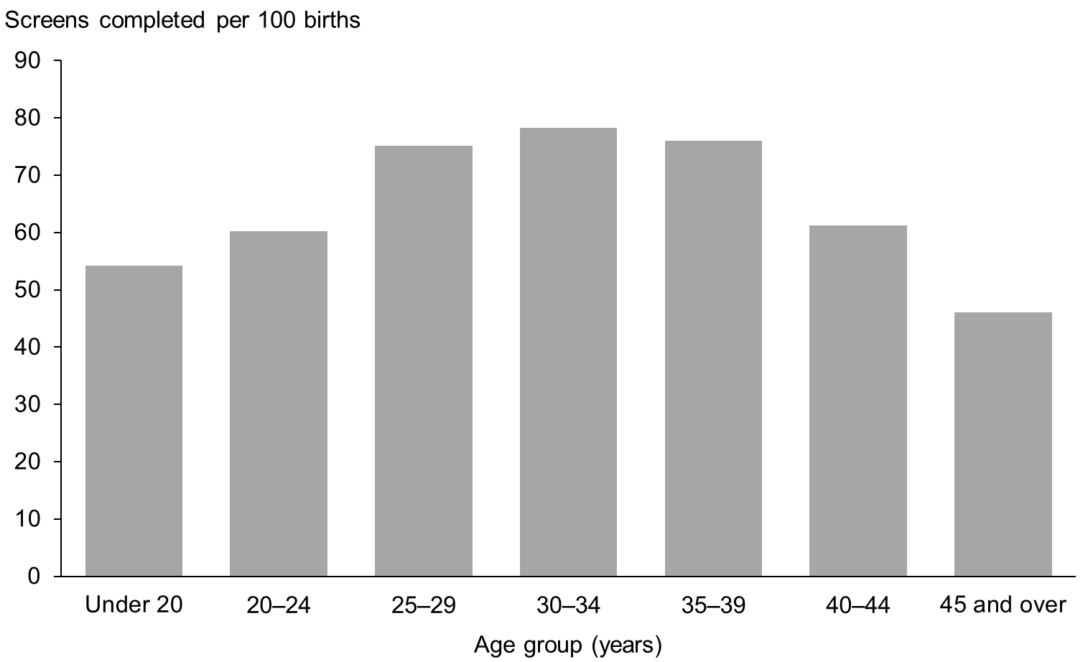

Figure 10: Screens completed by ethnicity of mother, January 2015 to December 2015
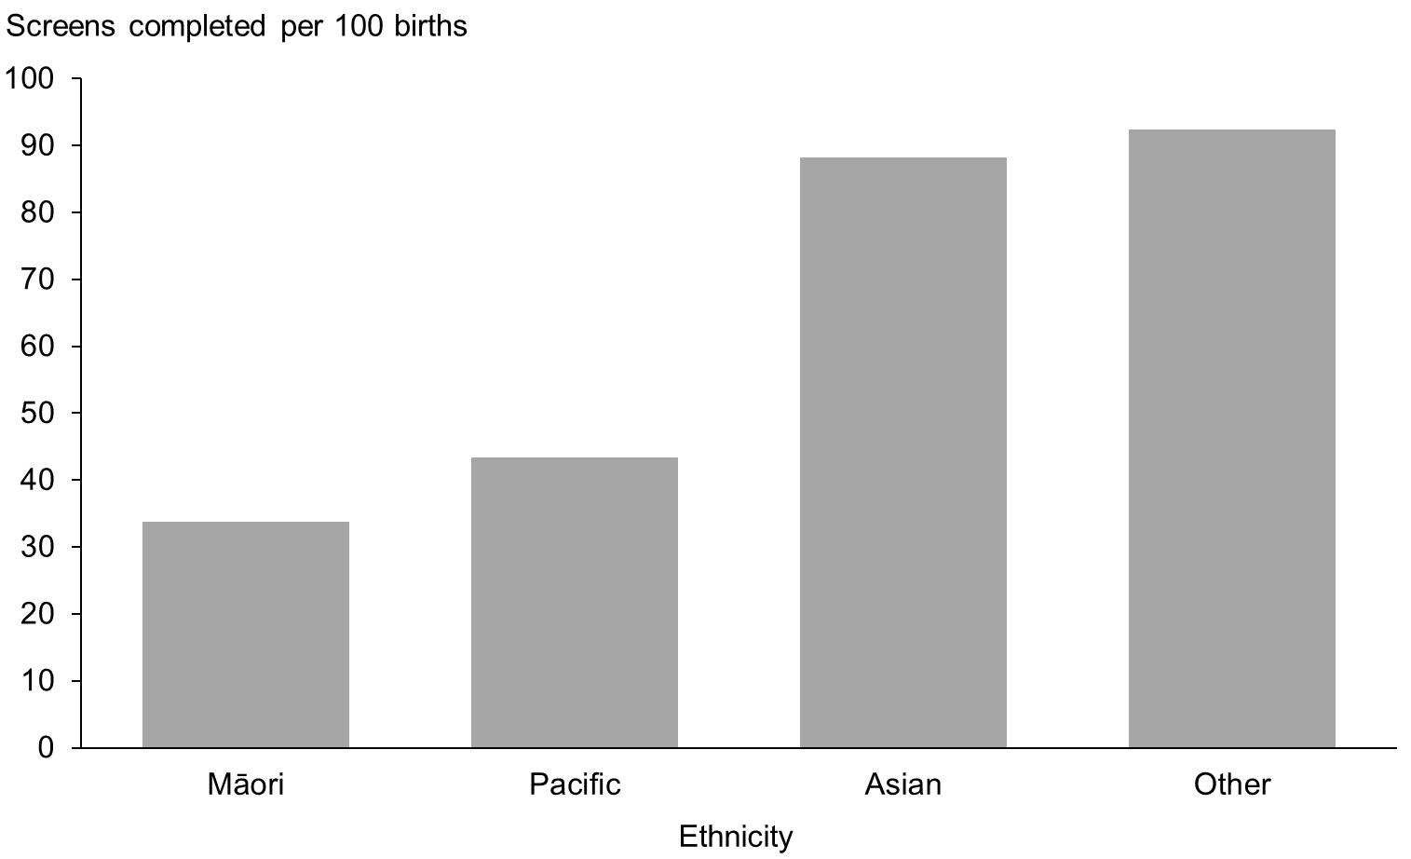

Figure 11: Screens completed by NZ deprivation quintile of mother, January 2015 to December 2015
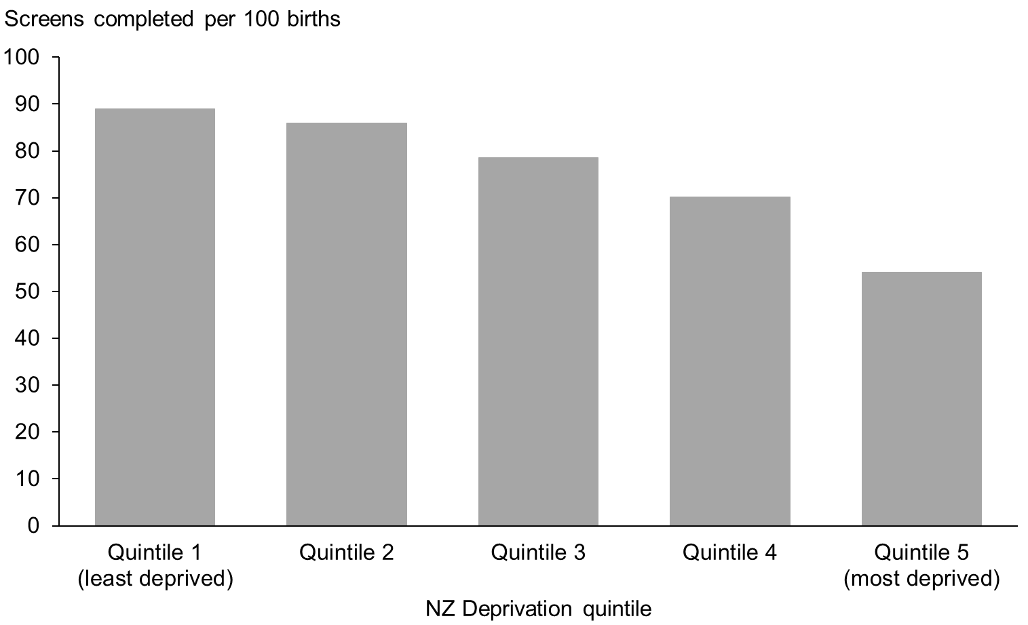

Indicator 3:
Screening pathway variance
This section reports on the number of screens completed in the second trimester which included first trimester screening components. First trimester combined screening requires a blood sample (PAPP-A and ßhCG) and ultrasound scan measurements of NT and CRL. Without both items a risk is not calculated and a second trimester blood sample is recommended. Any information available from the first trimester (NT or PAPP-A) will be included in the second trimester risk assessment.

Second trimester results with an NT measurement indicate that the screening laboratory did not receive a suitable first trimester blood sample. Second trimester results with PAPP-A indicate that the screening laboratory did not receive an NT scan report, or that the scan was performed outside the accepted timeframe for first trimester screening.

Screening pathway variance by year
Table 10 shows the number and proportion of second trimester screening results that included first trimester inputs over the period from 2011 to 2015. This has been broken down by the type of pathway variance.

The proportion of trimester 2 screens with an NT measurement has increased over the four year period from 41% to 45%. The proportion with PAPP-A increased slightly from 6% to 7% between 2012 and 2013 before returning to 6% for 2015.

Table 10: Screening pathway variance by type, January 2011 to December 2015
Year | Second trimester screening results
 | Total T2 screens |  | with NT |  | with PAPP-A | with NT | with PAPP-A
 | Number |  |  |  |  | Percentage
2011 | 4,446 | 1,811 |  | 264 |  | 40.7 | 5.9
2012 | 4,957 | 2,048 |  | 291 |  | 41.3 | 5.9
2013 | 5,269 | 2,219 |  | 361 |  | 42.1 | 6.9
2014 | 5,456 | 2,379 |  | 376 |  | 43.6 | 6.9
2015 | 5,508 | 2,466 |  | 343 |  | 44.8 | 6.2

Screening pathway variance by DHB
Table 11 shows a breakdown of screening pathway variance by DHB and type of variance for the 2015 year. Care should be taken with interpretation given the low number of T2 screens for many DHBs. In general, the national result is reflected at DHB level with a far higher number of women having an NT scan and a T2 screen than those having a T2 screen with PAPP-A.
The crown rump length (CRL) measured by ultrasound is used by the screening laboratory to calculate gestation (may be different from the clinically gestation) leading to women being assessed in a different trimester.
Table 11: Screening pathway variance by DHB, January 2015 to December 2015
DHB | Second trimester screening results
 | Total T2 screens | with NT | with PAPP-A | with NT | with PAPP-A
 | Number |  |  | Percentage
Northland | 159 | 66 | 18 | 41.5 | 11.3
Waitemata | 710 | 355 | 35 | 50.0 | 4.9
Auckland | 587 | 221 | 33 | 37.6 | 5.6
Counties Manukau | 1,132 | 397 | 54 | 35.1 | 4.8
Waikato | 440 | 195 | 18 | 44.3 | 4.1
Lakes | 111 | 56 | 7 | 50.5 | 6.3
Bay of Plenty | 169 | 84 | 9 | 49.7 | 5.3
Tairawhiti | 68 | 32 | 9 | 47.1 | 13.2
Hawke’s Bay | 144 | 55 | 8 | 38.2 | 5.6
Taranaki | 182 | 62 | 22 | 34.1 | 12.1
MidCentral | 144 | 55 | 12 | 38.2 | 8.3
Whanganui | 82 | 51 | 2 | 62.2 | 2.4
Capital and Coast | 277 | 121 | 30 | 43.7 | 10.8
Hutt Valley | 190 | 98 | 18 | 51.6 | 9.5
Wairarapa | 41 | 23 | 3 | 56.1 | 7.3
Nelson Marlborough | 106 | 76 | 3 | 71.7 | 2.8
West Coast | 34 | 19 | 3 | 55.9 | 8.8
Canterbury | 583 | 294 | 45 | 50.4 | 7.7
South Canterbury | 88 | 56 | 2 | 63.6 | 2.3
Southern | 261 | 150 | 12 | 57.5 | 4.6
Total | 5,508 | 2,466 | 343 | 44.8 | 6.2

Screening pathway variance by age, ethnicity and deprivation
Table 12 shows a breakdown of screening pathway variance by age, ethnicity and NZ deprivation quintile for the 2015 year. The results show higher proportions for pathway variance for older age groups, for women of Other ethnicity, and women in areas of lower deprivation.

Table 12: Screening pathway variance by age, ethnicity and NZ deprivation quintile, January 2015 to December 2015
 | Second trimester screening results
 | Total T2 screens |  | with NT |  | with PAPP-A | with NT | with PAPP-A
 | Number |  |  |  |  | Percentage
Age at screen
Under 20 years | 420 |  | 164 |  | 19 | 39.0 | 4.5
20–24 years | 1,328 |  | 566 |  | 67 | 42.6 | 5.0
25–29 years | 1,549 |  | 702 |  | 102 | 45.3 | 6.6
30–34 years | 1,359 |  | 659 |  | 91 | 48.5 | 6.7
35–39 years | 711 |  | 316 |  | 50 | 44.4 | 7.0
40–44 years | 135 |  | 57 |  | 14 | 42.2 | 10.4
45 years and over | 6 |  | 2 |  | 0 | - | -
Ethnicity
Māori | 1,262 |  | 491 |  | 78 | 38.9 | 6.2
Pacific | 1,024 |  | 301 |  | 50 | 29.4 | 4.9
Asian | 980 |  | 410 |  | 69 | 41.8 | 7.0
Other | 2,242 |  | 1,264 |  | 146 | 56.4 | 6.5
NZ Deprivation Quintile
Quintile 1 | 564 |  | 321 |  | 33 | 56.9 | 5.9
Quintile 2 | 695 |  | 385 |  | 44 | 55.4 | 6.3
Quintile 3 | 933 |  | 450 |  | 65 | 48.2 | 7.0
Quintile 4 | 1,304 |  | 589 |  | 89 | 45.2 | 6.8
Quintile 5 | 2,011 |  | 721 |  | 112 | 35.9 | 5.6
Unknown | 1 |  | 0 |  | 0 | - | -
Total | 5,508 |  | 2,466 |  | 343 | 44.8 | 6.2

Indicator 4:
Incomplete screens
This section reports on the number of women who commenced screening but were not issued with a risk result. Women that start screening in trimester 1 but complete screening in trimester 2 are not included in this indicator and are instead covered under indicator 3, pathway variances.

Total incomplete screens
Table 13 shows total number of incomplete screens by calendar year and trimester of screen. Nearly all incomplete screens related to the first trimester, which reflects the different components required to complete screening depending on trimester. First trimester screening requires a blood sample and an NT scan, whereas second trimester screening involves only a blood sample. The total number of incomplete screens for 2015 was 4,852, which equates to 10% of screens commenced that year.

Table 13: Incomplete screens by trimester, January 2011 to December 2015
Trimester of screen | Number of incomplete screens
 | 2011 | 2012 | 2013 | 2014 | 2015
T1 screen | 4,352 | 3,835 | 3,339 | 3,892 | 4,628
T2 screen | 244 | 273 | 218 | 157 | 224
Total screens | 4,596 | 4,108 | 3,557 | 4,049 | 4,852

Incomplete T1 screens by reason incomplete
Table 14 shows provides a breakdown of incomplete T1 screens according to which component of the screen was missing. Results have been reported as a percentage of all commenced screens, and then as a percentage of all incomplete screens.

The proportion of incomplete T1 screens out of all commenced T1 screens in 2015 was 11%, up slightly from 2014. This was the result of increases in both screens without blood samples and screens without NT scans. The split between the percentage of incompletes due to no blood or no NT scan has changed over the 5 years covered in this report (see far right columns of Table 14), with an increasing proportion of incompletes being due to no NT scan (36% in 2015 compared with 24% in 2011).

During 2015 there was one further incomplete T1 screen that had both an NT scan and a blood sample but no weight was provided. In situations of missing maternal weight the screening laboratory follows up but in this case no weight was supplied. This means that the sum of the ‘Reason Incomplete’ columns of tables 14, 15, and 16 is one short of the total number of incomplete T1 screens given in table 13. Inclusion of actual weight in the risk algorithm, as opposed to entering a default weight, leads to a far more accurate risk result.

Table 14: Incomplete T1 screens by reason incomplete, January 2011 to December 2015
Year | Commenced first trimester |  | Reason incomplete |  | Incomplete as percentage of commenced |  |  | Type as percentage of all T1 incomplete
 | Total commenced | Incomplete | No blood | No NT scan | T1 no blood | T1 no NT scan | Total T1 incompletes | T1 no blood | T1 no NT scan
2011 | 39,087 | 4,352 | 3,294 | 1,058 | 8.4 | 2.7 | 11.1 | 75.7 | 24.3
2012 | 39,526 | 3,835 | 2,844 | 991 | 7.2 | 2.5 | 9.7 | 74.2 | 25.8
2013 | 38,803 | 3,339 | 2,318 | 1,021 | 6.0 | 2.6 | 8.6 | 69.4 | 30.6
2014 | 40,172 | 3,892 | 2,630 | 1,262 | 6.5 | 3.1 | 9.7 | 67.6 | 32.4
2015 | 41,332 | 4,628 | 2,974 | 1,653 | 7.2 | 4.0 | 11.2 | 64.3 | 35.7

Incomplete T1 screens by reason and DHB
Table 15 provides the same breakdown by DHB. The lower numbers involved limit DHB comparisons. The range in the percentage of screens incomplete due to no blood sample was from 48 % (at Taranaki) to 84% (at South Canterbury). For screens incomplete due to no NT scan the range was from 16% (at South Canterbury) to 52% (at Taranaki). As these range values indicate, Taranaki DHB had the most even split for reason incomplete, while other DHBs had a higher proportion with no blood sample.

Table 15: Incomplete T1 screens by reason and DHB, January 2015 to December 2015
DHB | Commenced first trimester |  | Reason incomplete |  | Incomplete as percentage of commenced |  |  | Type as percentage of all T1 incomplete
 | Total commenced | Incomplete | No blood | No NT scan | T1 no blood | T1 no NT scan | Total T1 incomplete | T1 no blood | T1 no NT scan
Northland | 1,120 | 179 | 117 | 62 | 10.4 | 5.5 | 16.0 | 65.4 | 34.6
Waitemata | 5,960 | 487 | 294 | 193 | 4.9 | 3.2 | 8.2 | 60.4 | 39.6
Auckland | 4,452 | 371 | 214 | 157 | 4.8 | 3.5 | 8.3 | 57.7 | 42.3
Counties Manukau | 4,677 | 524 | 315 | 209 | 6.7 | 4.5 | 11.2 | 60.1 | 39.9
Waikato | 3,855 | 486 | 326 | 160 | 8.5 | 4.2 | 12.6 | 67.1 | 32.9
Lakes | 1,002 | 127 | 90 | 37 | 9.0 | 3.7 | 12.7 | 70.9 | 29.1
Bay of Plenty | 1,985 | 267 | 178 | 89 | 9.0 | 4.5 | 13.5 | 66.7 | 33.3
Tairawhiti | 435 | 106 | 80 | 26 | 18.4 | 6.0 | 24.4 | 75.5 | 24.5
Hawke’s Bay | 1,292 | 159 | 111 | 48 | 8.6 | 3.7 | 12.3 | 69.8 | 30.2
Taranaki | 942 | 123 | 59 | 64 | 6.3 | 6.8 | 13.1 | 48.0 | 52.0
MidCentral | 1,201 | 148 | 82 | 66 | 6.8 | 5.5 | 12.3 | 55.4 | 44.6
Whanganui | 492 | 96 | 76 | 20 | 15.4 | 4.1 | 19.5 | 79.2 | 20.8
Capital and Coast | 2,658 | 285 | 180 | 105 | 6.8 | 4.0 | 10.7 | 63.2 | 36.8
Hutt Valley | 1,348 | 208 | 145 | 63 | 10.8 | 4.7 | 15.4 | 69.7 | 30.3
Wairarapa | 339 | 48 | 33 | 15 | 9.7 | 4.4 | 14.2 | 68.8 | 31.3
Nelson Marlborough | 1,248 | 161 | 113 | 47 | 9.1 | 3.8 | 12.9 | 70.2 | 29.2
West Coast | 260 | 36 | 27 | 9 | 10.4 | 3.5 | 13.8 | 75.0 | 25.0
Canterbury | 4,953 | 532 | 346 | 186 | 7.0 | 3.8 | 10.7 | 65.0 | 35.0
South Canterbury | 485 | 45 | 38 | 7 | 7.8 | 1.4 | 9.3 | 84.4 | 15.6
Southern | 2,628 | 240 | 150 | 90 | 5.7 | 3.4 | 9.1 | 62.5 | 37.5
Total | 41,332 | 4,628 | 2,974 | 1,653 | 7.2 | 4.0 | 11.2 | 64.3 | 35.7

Incomplete T1 screens by age, ethnicity and deprivation
Table 16 shows a breakdown of incomplete screens with reason incomplete, by age, ethnicity, and NZ deprivation quintile for the 2015 year. This shows higher rates of incomplete T1 screens for younger women (73-74% for women up to 24 years of age). There were higher rates of incomplete screens for Māori (26%) and Pacific (22%) women when compared with Asian (7%) and Other (9%). The rate of incomplete screens also increased with increasing deprivation (18% for quintile 5 compared with 8% for quintile 1).

Table 16: Incomplete T1 screens by age, ethnicity and NZ deprivation quintile, January 2015 to December 2015
 | Commenced T1 screens |  | Reason incomplete |  | Incomplete as percentage of commenced |  |  | Type as percentage of all T1 incomplete
 | Total commenced | Incomplete | No blood | No NT scan | No blood | No NT scan | Total T1 incomplete | No blood | No NT scan
Age at screen
Under 20 years | 1,492 | 405 | 299 | 106 | 20.0 | 7.1 | 27.1 | 73.8 | 26.2
20 – 24 years | 5,754 | 1,094 | 797 | 296 | 13.9 | 5.1 | 19.0 | 72.9 | 27.1
25 – 29 years | 11,597 | 1,335 | 891 | 444 | 7.7 | 3.8 | 11.5 | 66.7 | 33.3
30 – 34 years | 13,710 | 1,051 | 625 | 426 | 4.6 | 3.1 | 7.7 | 59.5 | 40.5
35 – 39 years | 7,257 | 550 | 281 | 269 | 3.9 | 3.7 | 7.6 | 51.1 | 48.9
40 – 44 years | 1,451 | 180 | 77 | 103 | 5.3 | 7.1 | 12.4 | 42.8 | 57.2
45 years and over | 71 | 13 | 4 | 9 | 5.6 | 12.7 | 18.3 | 30.8 | 69.2
Ethnicity
Māori | 4,947 | 1,307 | 935 | 372 | 18.9 | 7.5 | 26.4 | 71.5 | 28.5
Pacific | 2,058 | 459 | 287 | 172 | 13.9 | 8.4 | 22.3 | 62.5 | 37.5
Asian | 7,683 | 549 | 260 | 288 | 3.4 | 3.7 | 7.1 | 47.4 | 52.5
Other | 26,644 | 2,313 | 1,492 | 821 | 5.6 | 3.1 | 8.7 | 64.5 | 35.5
NZ Deprivation Quintile
Quintile 1 | 7,316 | 551 | 332 | 219 | 4.5 | 3.0 | 7.5 | 60.3 | 39.7
Quintile 2 | 7,941 | 611 | 370 | 241 | 4.7 | 3.0 | 7.7 | 60.6 | 39.4
Quintile 3 | 8,165 | 780 | 490 | 290 | 6.0 | 3.6 | 9.6 | 62.8 | 37.2
Quintile 4 | 9,121 | 1,132 | 748 | 383 | 8.2 | 4.2 | 12.4 | 66.1 | 33.8
Quintile 5 | 8,784 | 1,554 | 1,034 | 520 | 11.8 | 5.9 | 17.7 | 66.5 | 33.5
Total | 46,839 | 4,628 | 2,974 | 1,653 | 6.3 | 3.5 | 9.9 | 64.3 | 35.7

Incomplete T2 screens
T2 screens do not require an NT scan, just a blood sample, but may be incomplete if missing dating information or weight, if the sample is taken later than 20 weeks of pregnancy, or if the sample is damaged and not repeated. For 2015, 4% of T2 commenced screens were incomplete, compared with 10% of T1 commenced screens. As Table 17 shows, the percentage of incomplete T2 screens decreased from 5% in 2011 to 3% in 2014, before increasing to 4% in 2015.

Table 17: Incomplete T2 screens, January 2011 to December 2015
Year | Commenced second trimester | No result issued | Percentage incomplete
2011 | 4,690 | 244 | 5.2
2012 | 5,230 | 273 | 5.5
2013 | 5,487 | 218 | 4.1
2014 | 5,613 | 157 | 2.9
2015 | 5,732 | 224 | 4.1

Incomplete T2 screens by DHB
Table 18 shows a breakdown of incomplete T2 screens by DHB for the 2015 year. The very low numbers involved limit meaningful DHB comparisons.

Table 18: IncompleteT2 screens by DHB, January 2015 to December 2015
DHB | Commenced second trimester | No result issued | Percentage incomplete
Northland | 164 | 5 | 3.0
Waitemata | 737 | 27 | 3.7
Auckland | 615 | 28 | 4.6
Counties Manukau | 1,178 | 46 | 3.9
Waikato | 459 | 19 | 4.1
Lakes | 113 | 2 | 1.8
Bay of Plenty | 176 | 7 | 4.0
Tairawhiti | 70 | 2 | 2.9
Hawke’s Bay | 153 | 9 | 5.9
Taranaki | 189 | 7 | 3.7
MidCentral | 149 | 5 | 3.4
Whanganui | 85 | 3 | 3.5
Capital and Coast | 291 | 14 | 4.8
Hutt Valley | 197 | 7 | 3.6
Wairarapa | 44 | 3 | 6.8
Nelson Marlborough | 111 | 5 | 4.5
West Coast | 36 | 2 | 5.6
Canterbury | 609 | 26 | 4.3
South Canterbury | 88 | - | 0.0
Southern | 268 | 7 | 2.6
Total | 5,732 | 224 | 3.9

Incomplete T2 screens by age, ethnicity and deprivation
Table 19 shows a breakdown of incomplete T2 screens by age, ethnicity and NZ deprivation quintile for 2015. The percentage incomplete was higher for older age groups, lower for women of Other ethnicity, and lower for women in the least deprived quintile.

Table 19: Incomplete T2 screens by age, ethnicity and NZ deprivation quintile, January 2015 to December 2015
 | Commenced second trimester | No result issued | Percentage incomplete
Age at screen
Under 20 years | 436 | 16 | 3.7
20–24 years | 1,375 | 47 | 3.4
25–29 years | 1,609 | 60 | 3.7
30–34 years | 1,414 | 55 | 3.9
35–39 years | 747 | 36 | 4.8
40–44 years | 144 | 9 | 6.3
45 years and over | 7 | 1 | 14.3
Ethnicity
Māori | 1,322 | 60 | 4.5
Pacific | 1,072 | 48 | 4.5
Asian | 1,031 | 51 | 4.9
Other | 2,307 | 65 | 2.8
NZ Deprivation Quintile
Quintile 1 | 580 | 16 | 2.8
Quintile 2 | 719 | 24 | 3.3
Quintile 3 | 970 | 37 | 3.8
Quintile 4 | 1,361 | 57 | 4.2
Quintile 5 | 2,101 | 90 | 4.3
Unknown | 1 | - | -
Total | 5,732 | 224 | 3.9
# Suppressed if the number of incomplete screens was <10.

Indicator 5:
Increased risk screening results for trisomy 21, trisomy 18 and trisomy 13
This indicator reports on the screening risk results issued for trisomy 21, trisomy 18 and trisomy 13. Women who complete screening receive a risk result, either low risk or increased risk, for each trisomy. This means that an individual woman may be at increased risk for more than one trisomy.

Total increased risk screening results for trisomy 21, 18 or 13
Table 20 shows total number of screening risk results that were classified as increased risk for one or more of trisomy 21, 18 or 13 by calendar year, together with the number of increased risk results per 100 screens (positive test rate). For the 2015 year, 2.8 increased risk results were issued for every 100 screens completed. This was consistent with the rates for previous years.

Table 20: Number and rate per 100 screens of increased risk screening results for trisomy 21, 18 or 13, January 2011 to December 2015
 | Number and rate of increased risk screens
 | 2011 | 2012 | 2013 | 2014 | 2015
Total increased risk results | 1,099 | 1,156 | 1,103 | 1,157 | 1,163
Positive test rate per 100 screens | 2.8 | 2.8 | 2.7 | 2.8 | 2.8

Increased risk screening results for trisomy 21, 18 or 13 by age, ethnicity and deprivation
Table 21 shows the number and proportion of screening risk results that were classified as increased risk for any one or more of trisomy 21, 18, or 13 by age at screen, ethnicity and deprivation for the 2015 year.

Positive test rate increased markedly with increasing age and was also higher for Pacific and Asian women compared with other ethnicities. Older women are more likely to have a positive test and are also more likely to have a higher detection rate. This is in keeping with the inclusion of prior risk (age) as part of the risk calculation. Different levels of deprivation do not appear to have a relationship with the positive test rate.

Table 21: Increased risk screening results for trisomy 21, 18 or 13 by age, ethnicity and deprivation, January 2015 to December 2015
 | Number of increased risks for trisomy 21, 18 or 13 | Total number of completed screens | Positive test rate per 100 screens
Age at screen
Under 20 years | 13 | 1,507 | 0.9
20–24 years | 60 | 5,988 | 1.0
25–29 years | 129 | 11,811 | 1.1
30–34 years | 282 | 14,018 | 2.0
35–39 years | 378 | 7,418 | 5.1
40–44 years | 284 | 1,406 | 20.2
45 years and over | 17 | 64 | 26.6
Ethnicity
Māori | 132 | 4,902 | 2.7
Pacific | 103 | 2,623 | 3.9
Asian | 278 | 8,114 | 3.4
Other | 650 | 26,573 | 2.4
NZ Deprivation Quintile
Quintile 1 | 211 | 7,329 | 2.9
Quintile 2 | 248 | 8,025 | 3.1
Quintile 3 | 202 | 8,318 | 2.4
Quintile 4 | 253 | 9,293 | 2.7
Quintile 5 | 249 | 9,241 | 2.7
Unknown | 0 | 6 | 0.0

Increased risk screening results for trisomy 21, 18 or 13 by trimester of screen
Table 22 shows the positive test rate for each of trisomy 21, 18 and 13 individually as well as the positive test rate for the three trisomies together by trimester of screen and calendar year. The sum of the individual values for trisomy 21, 18 and 13 is greater than the value for the fourth grouping (any of the three trisomies) because a result can be at increased risk for more than one trisomy.

Trisomy 18 and 13 each showed low positive test rates (0.3 and 0.4 per 100 screens respectively) while the positive test rate for trisomy 21 was just below 3 per 100 screens for all years. The second trimester positive test rate for trisomy 21 was higher than the first trimester positive test rate but the difference was not as large for 2015 as it was in previous years. This difference in rates may be due to variability in nuchal translucency, nasal bone and crown rump length assessments. The positive test rate for any one or more of trisomy 21, 18 or 13 was similar to that of trisomy 21 alone. This reflects the far higher number of trisomy 21 increased risks compared with trisomy 18 and 13.

Table 22: Increased risk screening results for trisomy 21, 18 and 13 by trimester of screen, January 2011 to December 2015
Year | Total increased risks for specified trisomy | Positive test rate per 100 screens | T1 results with increased risk for specified trisomy | Positive test rate per 100 T1 screens | T2 results with increased risk for specified trisomy | Positive test rate per 100 T2 screens
Trisomy 21
2011 | 1,081 | 2.8 | 868 | 2.5 | 213 | 4.8
2012 | 1,144 | 2.8 | 871 | 2.4 | 273 | 5.5
2013 | 1,081 | 2.7 | 840 | 2.4 | 241 | 4.6
2014 | 1,131 | 2.7 | 870 | 2.4 | 261 | 4.8
2015 | 1,140 | 2.7 | 937 | 2.6 | 203 | 3.7
Trisomy 18
2011 | 134 | 0.3 | 123 | 0.4 | 11 | 0.2
2012 | 161 | 0.4 | 149 | 0.4 | 12 | 0.2
2013 | 145 | 0.4 | 125 | 0.4 | 20 | 0.4
2014 | 136 | 0.3 | 120 | 0.3 | 16 | 0.3
2015 | 145 | 0.3 | 127 | 0.3 | 18 | 0.3
Trisomy 13
2011 | 143 | 0.4 | 140 | 0.4 | 3 | 0.1
2012 | 169 | 0.4 | 161 | 0.5 | 8 | 0.2
2013 | 158 | 0.4 | 144 | 0.4 | 14 | 0.3
2014 | 149 | 0.4 | 135 | 0.4 | 14 | 0.3
2015 | 159 | 0.4 | 147 | 0.4 | 12 | 0.2
Any one or more of trisomy 21, 18 or 13
2011 | 1,099 | 2.8 | 878 | 2.5 | 221 | 5.0
2012 | 1,156 | 2.8 | 874 | 2.4 | 282 | 5.7
2013 | 1,103 | 2.7 | 847 | 2.4 | 256 | 4.9
2014 | 1,157 | 2.8 | 883 | 2.4 | 274 | 5.0
2015 | 1,163 | 2.8 | 942 | 2.6 | 221 | 4.0

Increased risk screening results stratified by risk level
Table 23 shows the number of increased risk results stratified by risk level for each of trisomy 21, 18 and 13 for the 2015 year. A woman’s screen result may indicate an increased risk for more than one of trisomy 21, 18 and 13 so the sum of the values in Table 23 will be greater than the total number of increased risk results for 2015.

Table 23: Increased risk screening results for trisomy 21, 18 and 13 by risk level, January 2015 to December 2015
Risk level | Trisomy 21 | Trisomy 18 | Trisomy 13
1:5 – 1:20 | 257 | 57 | 69
1:25 to 1:50 | 168 | 26 | 20
1:55 to 1:300 | 715 | 62 | 70

Indicator 6:
Diagnostic testing volumes for women with increased risk screens
This indicator reports information on the number and proportion of women who complete prenatal diagnostic testing (CVS or amniocentesis) following an increased risk screening result for trisomy 21, trisomy 18 or trisomy 13. Following an increased risk result, women may choose to have diagnostic testing (either amniocentesis or CVS) to determine the absence or the presence of the condition. Results for this indicator, and all remaining indicators, include screened women from Canterbury, South Canterbury and West Coast DHBs for the first time. Screening and outcome data was completely re-matched for all years from 2011 to 2015 for this report.

Diagnostic testing volumes for women with increased risk screens by trimester of screen
Table 24 shows the diagnostic testing rate from 2011 to 2015 by trimester of screen. In 2015, for every 100 women that received an increased risk result after a first trimester screen, 56 women had a diagnostic test. This is lower than previous years. The diagnostic testing rate was lower for women who received an increased risk after a second trimester screen (45 women per 100 increased risk screens) compared with first trimester screens (59 per 100 increased risk screens). See Appendix 3 for a summary of diagnostic test results for women who had increased risk screen in 2015, as well as pregnancy outcomes (where known) for women who did not have a prenatal diagnostic test.

Table 24: Diagnostic testing volumes for women with increased risk screens by trimester of screen, January 2011 to December 2015
Trimester of screen | Diagnostic tests per 100 increased risk screens
 | 2011 | 2012 | 2013 | 2014 | 2015
T1 screen | 65.0 | 66.1 | 66.2 | 62.3 | 59.0
T2 screen | 43.4 | 42.6 | 46.5 | 47.4 | 44.8
Total screens | 60.7 | 60.4 | 61.7 | 58.8 | 56.3

Diagnostic testing volumes for women with increased risk screens by DHB
The number of diagnostic tests and rate per 100 increased risk screens by DHB is given in Table 25. Many DHBs have low numbers and care should be taken with comparisons. The rate of diagnostic testing for women with increased risk screens in 2015 varied across DHBs from 44 per 100 increased risk results in Taranaki, to 75 per 100 increased risk results in South Canterbury.

Table 25: Diagnostic testing volumes for women with increased risk screens by DHB, January 2011 to December 2015
DHB | Number of diagnostic tests |  |  |  |  | Tests per 100 increased risk screens
 | 2011 | 2012 | 2013 | 2014 | 2015 | 2011 | 2012 | 2013 | 2014 | 2015
Northland | 24 | 13 | 28 | 26 | 21 | 49.0 | 38.2 | 56.0 | 59.1 | 48.8
Waitemata | 137 | 138 | 140 | 116 | 107 | 67.5 | 67.6 | 72.9 | 61.7 | 57.5
Auckland | 117 | 118 | 89 | 89 | 76 | 72.2 | 69.0 | 67.4 | 55.3 | 54.3
Counties Manukau | 67 | 76 | 73 | 76 | 86 | 54.5 | 51.4 | 47.1 | 50.3 | 53.8
Waikato | 15 | 26 | 40 | 41 | 42 | 20.5 | 38.2 | 57.1 | 64.1 | 60.0
Lakes | 15 | 23 | 21 | 21 | 28 | 55.6 | 69.7 | 67.7 | 53.8 | 71.8
Bay of Plenty | 11 | 22 | 21 | 21 | 20 | 36.7 | 68.8 | 55.3 | 63.6 | 66.7
Tairawhiti | 5 | 5 | 2 | 2 | 4 | 83.3 | 50.0 | 28.6 | 33.3 | 57.1
Hawke’s Bay | 22 | 18 | 21 | 20 | 15 | 62.9 | 50.0 | 53.8 | 58.8 | 51.7
Taranaki | 14 | 18 | 18 | 12 | 10 | 63.6 | 75.0 | 66.7 | 48.0 | 43.5
MidCentral | 20 | 20 | 10 | 11 | 8 | 54.1 | 62.5 | 38.5 | 57.9 | 44.4
Whanganui | 4 | 4 | 6 | 3 | 4 | 33.3 | 33.3 | 46.2 | 60.0 | 66.7
Capital and Coast | 52 | 61 | 55 | 45 | 66 | 72.2 | 69.3 | 75.3 | 60.0 | 61.7
Hutt Valley | 14 | 24 | 18 | 15 | 18 | 56.0 | 63.2 | 58.1 | 53.6 | 66.7
Wairarapa | 5 | 7 | 9 | 1 | 2 | 71.4 | 100.0 | 81.8 | 25.0 | 40.0
Nelson Marlborough | 23 | 11 | 17 | 18 | 15 | 67.6 | 47.8 | 89.5 | 78.3 | 57.7
West Coast | 3 | 2 | 2 | 8 | 3 | 50.0 | 50.0 | 40.0 | 42.1 | 50.0
Canterbury | 76 | 66 | 73 | 119 | 82 | 66.1 | 60.6 | 59.8 | 64.7 | 50.3
South Canterbury | 6 | 4 | 4 | 3 | 9 | 54.5 | 40.0 | 40.0 | 50.0 | 75.0
Southern | 37 | 42 | 33 | 33 | 39 | 74.0 | 57.5 | 63.5 | 67.3 | 59.1
Total | 667 | 698 | 680 | 680 | 655 | 60.7 | 60.4 | 61.7 | 58.8 | 56.3

Diagnostic testing volumes for women with increased risk screens by age, ethnicity and deprivation
Table 26 shows the diagnostic testing rate for women with increased risk screens by age, ethnicity and NZ deprivation quintile for 2011 to 2015. The diagnostic testing rate ranged from 52 per 100 increased risk screens for women aged 20 to 24 years, to 62 per 100 for women aged 30–34 years, with no clear trend with increasing age.

Diagnostic testing rates were highest for women of Asian ethnicity (63 per 100 increased risks), followed by Other (59 per 100 increased risks), with much lower rates for Māori (45 per 100 increased risks) and Pacific (37 per 100 increased risks). Diagnostic testing rates by deprivation have fluctuated over time but there appears to be a consistent difference in rates between least deprived (Quintile 1) and most deprived (Quintile 5) areas, with women in the most deprived areas less likely to have a diagnostic test.

Table 26: Diagnostic testing volumes for women with increased risk screening results by age at screen, ethnicity and deprivation, January 2011 to December 2015
 | Diagnostic tests per 100 increased risk screens
 | 2011 | 2012 | 2013 | 2014 | 2015
Age at screen
Under 20 years | 50.0 | 35.7 | 28.6 | 50.0 | 53.8
20–24 years | 60.0 | 56.4 | 64.5 | 53.9 | 51.7
25–29 years | 65.4 | 60.7 | 60.5 | 61.7 | 58.1
30–34 years | 65.3 | 69.6 | 68.4 | 65.4 | 61.7
35–39 years | 64.6 | 60.3 | 62.4 | 56.7 | 56.6
40–44 years | 50.2 | 55.7 | 57.3 | 58.1 | 51.8
45 years and over | 43.5 | 40.0 | 44.4 | 33.3 | 41.2
Ethnicity
Māori | 42.2 | 43.9 | 52.5 | 38.7 | 44.7
Pacific | 35.5 | 36.4 | 38.2 | 39.2 | 36.9
Asian | 70.7 | 71.0 | 69.6 | 67.0 | 63.3
Other | 64.9 | 64.4 | 65.2 | 62.4 | 58.8
NZ Deprivation Quintile
Quintile 1 | 70.2 | 66.7 | 71.4 | 65.8 | 62.1
Quintile 2 | 71.2 | 69.5 | 65.3 | 63.9 | 62.9
Quintile 3 | 60.7 | 65.2 | 62.6 | 57.6 | 58.4
Quintile 4 | 54.2 | 52.3 | 58.5 | 59.7 | 57.7
Quintile 5 | 48.0 | 48.8 | 53.2 | 48.8 | 41.8

Diagnostic testing volumes for women with increased risk screening results stratified by risk level
Each screening result includes a separate risk for each of trisomy 21, 18 and 13. For the analysis in this report women were assigned a combined trisomy risk level based on the highest risk score they received across the three trisomies. Table 27 shows the number of diagnostic tests for women that received an increased risk result during 2015 for one or more of trisomy 21, 18 or 13, stratified by risk level. As this shows, uptake of diagnostic testing was higher at higher risk levels. While 7% of women with a risk between 1:55 and 1:300 had a prenatal diagnostic test, this increased to 76% for women with risks of 1:20 or above.

Table 27: Diagnostic testing volumes for women with increased risk screens by risk level, January 2015 to December 2015
Risk level | Number of diagnostic tests | Number of increased risk screens | Tests per 100 increased risk screens
1:5 to 1:20 | 201 | 265 | 75.8
1:25 to 1:50 | 112 | 169 | 66.3
1:55 to 1:300 | 342 | 729 | 46.9

Indicator 7:
Diagnostic testing volumes for women who receive a low risk screening result
This section reports information on the number and proportion of women who complete prenatal diagnostic testing (CVS or amniocentesis procedures) following a low risk screening result. Following a low risk screen, women may still choose to have diagnostic testing to determine the absence or the presence of a condition.

This indicator intends to capture only those that had a low risk in isolation so for this calculation a woman was only counted as having a low risk screen if there was no increased risk for any of the other conditions covered by the screening test in addition to trisomy 21, 18 and 13. So for example, if the result was low risk for each of trisomy 21, 18 and 13 but increased risk for neural tube defects then the woman was categorised as at increased risk for the purposes of this indicator.

Some women with low risk screening results may have other indications for diagnostic testing, eg, family history of another condition that diagnostic testing can identify or an abnormal ultrasound finding. Information on the indication for diagnostic testing is not reliably provided on laboratory forms so the calculations for this indicator cannot exclude these women.

Diagnostic testing volumes for women with low risk screens by trimester of screen
The national rate of diagnostic testing for women that received low risk screening results was 0.69 per 100 low risk screens in 2015. The rate has been consistently below 1 across all years.

Table 28: Diagnostic testing volumes for women with low risk screens by trimester of screen, January 2011 to December 2015
Trimester of screen | Diagnostic tests per 100 low risk screens
 | 2011 | 2012 | 2013 | 2014 | 2015
T1 screen | 0.89 | 0.92 | 0.77 | 0.68 | 0.74
T2 screen | 0.81 | 0.67 | 0.48 | 0.56 | 0.34
Total screens | 0.88 | 0.89 | 0.74 | 0.67 | 0.69

Diagnostic testing volumes for women with low risk screens by DHB
The rate of diagnostic testing for women with low risk screens has varied each year from 2011 to 2015, as shown in Table 29. Given the low numbers involved, caution should be taken in making comparisons, however rates appear to have decreased over time for Waitemata, Auckland and Counties Manukau DHBs.

Table 29: Total diagnostic testing volumes for women with low risk screens by DHB January 2011 to December 2015
DHB | Number of diagnostic tests |  |  |  |  | Tests per 100 low risk screens
 | 2011 | 2012 | 2013 | 2014 | 2015 | 2011 | 2012 | 2013 | 2014 | 2015
Northland | 5 | 2 | 7 | - | 7 | 0.56 | 0.20 | 0.74 | - | 0.66
Waitemata | 64 | 61 | 55 | 34 | 33 | 1.08 | 1.02 | 0.90 | 0.55 | 0.55
Auckland | 71 | 73 | 54 | 38 | 36 | 1.60 | 1.63 | 1.15 | 0.79 | 0.80
Counties Manukau | 39 | 25 | 27 | 18 | 22 | 0.85 | 0.51 | 0.57 | 0.35 | 0.43
Waikato | 6 | 18 | 19 | 30 | 21 | 0.17 | 0.52 | 0.54 | 0.80 | 0.56
Lakes | 3 | 3 | 3 | 5 | 7 | 0.37 | 0.34 | 0.35 | 0.54 | 0.74
Bay of Plenty | 5 | 10 | 9 | 14 | 7 | 0.31 | 0.56 | 0.54 | 0.80 | 0.38
Tairawhiti | - | 3 | - | 1 | - | - | 0.95 | - | 0.29 | 0.00
Hawke’s Bay | 11 | 8 | 6 | 7 | 8 | 1.00 | 0.65 | 0.48 | 0.59 | 0.64
Taranaki | 6 | 11 | 9 | 3 | 1 | 0.67 | 1.31 | 1.11 | 0.33 | 0.10
MidCentral | 7 | 4 | 9 | 8 | 11 | 0.70 | 0.39 | 0.81 | 0.72 | 0.93
Whanganui | 4 | 4 | 2 | 2 | 2 | 1.24 | 1.14 | 0.56 | 0.47 | 0.42
Capital and Coast | 23 | 18 | 21 | 16 | 22 | 0.90 | 0.67 | 0.84 | 0.64 | 0.87
Hutt Valley | 12 | 10 | 8 | 11 | 9 | 1.01 | 0.82 | 0.66 | 0.88 | 0.69
Wairarapa | 1 | - | - | - | 1 | 0.31 | - | - | - | 0.31
Nelson Marlborough | 9 | 14 | 12 | 6 | 9 | 0.71 | 1.15 | 1.01 | 0.49 | 0.77
West Coast | - | - | 1 | 1 | 2 | - | - | 0.37 | 0.39 | 0.79
Canterbury | 40 | 46 | 31 | 45 | 52 | 0.94 | 1.04 | 0.67 | 0.96 | 1.07
South Canterbury | 2 | 3 | 1 | - | 2 | 0.41 | 0.57 | 0.19 | - | 0.39
Southern | 26 | 37 | 18 | 32 | 30 | 1.07 | 1.44 | 0.71 | 1.33 | 1.16
Total | 334 | 350 | 292 | 271 | 282 | 0.88 | 0.89 | 0.74 | 0.67 | 0.69

Diagnostic testing volumes for women with low risk screening results by age, ethnicity and deprivation
Table 30 shows the rate of diagnostic testing for women with low risk screening results by age, ethnicity and NZ deprivation quintile. The rate of diagnostic testing was higher for older age groups, and for women of Asian or Other ethnicity. Women in the most deprived Quintile appear to have a lower rate of diagnostic testing compared to less deprived areas, but the trend across quintiles is not clear.

Table 30: Diagnostic tests per 100 low risk screens by age, ethnicity and NZ deprivation quintile, January 2011 to December 2015
 | Diagnostic tests per 100 low risk screens
 | 2011 | 2012 | 2013 | 2014 | 2015
Age at screen
Under 20 years | 0.39 | 0.71 | 0.38 | 0.44 | 0.33
20–24 years | 0.37 | 0.34 | 0.32 | 0.37 | 0.35
25–29 years | 0.38 | 0.45 | 0.37 | 0.49 | 0.51
30–34 years | 0.57 | 0.64 | 0.53 | 0.53 | 0.60
35–39 years | 1.83 | 1.54 | 1.21 | 0.98 | 1.12
40–44 years | 5.40 | 5.59 | 5.30 | 3.92 | 2.94
45 years and over | 7.50 | 10.64 | 6.98 | 2.08 | 2.13
Ethnicity
Māori | 0.45 | 0.70 | 0.57 | 0.46 | 0.46
Pacific | 0.51 | 0.33 | 0.28 | 0.28 | 0.48
Asian | 0.89 | 0.87 | 0.65 | 0.58 | 0.80
Other | 0.98 | 0.98 | 0.84 | 0.78 | 0.71
NZ Deprivation Quintile
Quintile 1 | 1.45 | 1.66 | 1.11 | 0.91 | 0.77
Quintile 2 | 1.10 | 1.03 | 0.77 | 0.73 | 0.93
Quintile 3 | 0.81 | 0.60 | 0.73 | 0.65 | 0.63
Quintile 4 | 0.70 | 0.80 | 0.63 | 0.62 | 0.72
Quintile 5 | 0.39 | 0.43 | 0.52 | 0.49 | 0.43

Diagnostic testing volumes for women with low risk screening results stratified by risk
Table 31 shows the rate of diagnostic testing for women with low risk screening results, stratified by risk level. Given the low numbers involved for some risk categories, numbers have been aggregated for all years. The aggregated rate of diagnostic testing is more than 15 times higher for the highest category compared with the lowest category and the rate drops away rapidly as risk decreases below 1:1000.

Table 31: Diagnostic tests per 100 low risk screens stratified by risk level, January 2011–December 2015 aggregated
Risk level | Number of diagnostic tests | Number of low risk screens | Tests per 100 low risk screens
1:310 to 1:500 | 185 | 3,094 | 5.98
1:510 to 1:1000 | 253 | 8,081 | 3.13
1:1100 to 1:2000 | 221 | 14,044 | 1.57
1:2100 to 1:3000 | 149 | 12,156 | 1.23
1:3100 to 1:4000 | 79 | 11,146 | 0.71
1:4100 to 1:5000 | 77 | 9,999 | 0.77
1:5100 to 1:10,000 | 222 | 40,382 | 0.55
1:11,000 to 1:100,000 | 351 | 99,767 | 0.35

Indicator 8: Diagnostic testing for unscreened women
This section reports information on the number of women who completed prenatal diagnostic testing but were not screened in the 105 days prior to the diagnostic test. The indication for diagnostic testing is not reliably reported on laboratory request forms but it is likely that many of these women will have had an increased prior risk (eg, family history, previous child with Down syndrome, late maternal age) or a diagnostic test done for another reason and the karyotype reported or an abnormal ultrasound finding.

Diagnostic volumes for unscreened women
During the 2015 year, 252 diagnostic tests were completed for unscreened women. This is similar to the number undertaken in previous years. Table 32 shows the number of tests by DHB and Table 33 shows the breakdown by age, ethnicity and NZ deprivation quintile.

Table 32: Diagnostic testing volumes for unscreened women by DHB, January 2012 to December 2015
DHB | Number of diagnostic tests
 | 2012 | 2013 | 2014 | 2015
Northland | 10 | 6 | 7 | 8
Waitemata | 37 | 24 | 22 | 22
Auckland | 31 | 23 | 25 | 18
Counties Manukau | 19 | 27 | 21 | 18
Waikato | 16 | 24 | 14 | 15
Lakes | 2 | 5 | 6 | 8
Bay of Plenty | 10 | 18 | 12 | 14
Tairawhiti | 5 | - | 1 | 3
Hawke’s Bay | 11 | 6 | 7 | 7
Taranaki | 13 | 11 | 5 | 11
MidCentral | 9 | 11 | 11 | 8
Whanganui | 4 | 2 | 3 | 2
Capital and Coast | 17 | 16 | 30 | 36
Hutt Valley | 9 | 11 | 11 | 22
Wairarapa | 5 | 1 | 1 | 3
Nelson Marlborough | 7 | 1 | 4 | 6
West Coast | - | 1 | 1 | -
Canterbury | 27 | 23 | 37 | 30
South Canterbury | - | 2 | 4 | 2
Southern | 17 | 18 | 13 | 19
Total | 249 | 203 | 235 | 252
Table 33: Total diagnostic testing volumes for unscreened women by age, ethnicity and deprivation quintile, January 2012 to December 2015
 | Number of diagnostic tests
 | 2012 | 2013 | 2014 | 2015
Age
Under 20 years | 15 | 13 | 10 | 16
20–24 years | 32 | 33 | 29 | 19
25–29 years | 43 | 35 | 39 | 53
30–34 years | 62 | 56 | 66 | 70
35–39 years | 55 | 50 | 54 | 54
40–44 years | 41 | 39 | 34 | 35
45 years and over | 1 | 4 | 3 | 5
Ethnicity
Māori | 33 | 49 | 31 | 44
Pacific | 17 | 14 | 20 | 21
Asian | 39 | 31 | 29 | 33
Other | 160 | 136 | 155 | 154
NZ Deprivation Quintile
Quintile 1 | 62 | 36 | 55 | 48
Quintile 2 | 45 | 47 | 39 | 48
Quintile 3 | 40 | 40 | 49 | 51
Quintile 4 | 58 | 59 | 46 | 52
Quintile 5 | 44 | 48 | 46 | 53

Diagnostic results for unscreened women
A breakdown of prenatal diagnostic testing results for unscreened women for the 2015 year is given in Table 34. Of the 252 diagnostic tests in 2015 for unscreened women, 191 (76%) had a normal karyotype. There were thirteen trisomy 21 diagnoses, six trisomy 18 diagnoses and five diagnoses of trisomy 13.

Table 34: Total diagnostic testing results for unscreened women, January 2015 to December 2015
Karyotype result | Number | Percentage
Normal karyotype | 191 | 75.8%
Trisomy 21 | 13 | 5.2%
Trisomy 18 | 6 | 2.4%
Trisomy 13 | 5 | 2.0%
Turner syndrome | 6 | 2.4%
Triploidy | 8 | 3.2%
Other chromosome abnormality | 18 | 7.1%
Failed test | 5 | 2.0%
Total | 252 | 100.0%

Indicator 9: Diagnostic testing outcomes for women with increased risk screening results
This section reports information on the positive predictive value of screening. Positive predictive value (PPV) is calculated by dividing the number of true positives (increased risk screening result and then a positive diagnostic test for trisomy, or a baby born with trisomy) by the number of true positives and false positives (increased risk screening result and then a negative diagnostic test for a trisomy, or a baby born without a trisomy). Appendix 4 contains a summary of how screening measures, such as PPV, are calculated.

Positive predictive value of screening
The combined PPV for trisomy 21, 18 or 13 was calculated by categorising any screening result that included an increased risk for any of trisomy 21, 18 or 13 as a positive screen. If there was a subsequent diagnosis of any of trisomy 21, 18 or 13 then it was classified as a true positive. If there was no diagnosis for any of these three trisomies it was classified as a false positive.

It should be noted that there were a small number of screens where the trisomy with the increased risk screening result was not the trisomy that was ultimately diagnosed. For example, a screening result may have shown an increased risk for trisomy 21 and normal risk for trisomy 13 but the cytogenetic result or infant diagnosis was trisomy 13. For the indicator 9, 10 and 11 calculations that combine the three trisomies together this record was categorised as a true positive. For the calculations looking at trisomy 21 specifically it was a false positive and for the trisomy 13 calculations it was a false negative. Due to this conflict in categorisation, the breakdowns by screening risk level, age, ethnicity, and deprivation have only been reported for trisomy 21 rather than combining trisomy 21, 18 and 13.

The overall PPV for 2015 was 0.11, slightly higher than the 2014 result, but lower than the highest PPV result of 0.13 in 2013 (see Table 35). A value of 0.11 means that if a woman receives an increased risk result for trisomy 21, 18 or 13 there is an 11% probability that she is carrying a fetus with one of these trisomies. When data was aggregated across all years the PPV value for second trimester screens was 0.04 compared with 0.14 for first trimester screens.

Table 35: Positive predictive value of screening for trisomy 21, 18 or 13, January 2011 to December 2015
Year | True positives | False positives | PPV
2011 | 135 | 964 | 0.12
2012 | 141 | 1,015 | 0.12
2013 | 139 | 964 | 0.13
2014 | 121 | 1,036 | 0.10
2015 | 126 | 1,037 | 0.11

The PPV changes when calculated for a specific trisomy. When looking at trisomy 21 the PPV for 2015 was lower than the combined PPV at 0.08 (see Table 36). This means that if a woman receives an increased risk result for trisomy 21 there is an 8% probability that she is carrying a fetus with trisomy 21.

Table 36: Positive predictive of screening for trisomy 21, January 2011 to December 2015
Year | True positives | False positives | PPV
2011 | 88 | 993 | 0.08
2012 | 95 | 1,049 | 0.08
2013 | 109 | 972 | 0.10
2014 | 89 | 1,042 | 0.08
2015 | 95 | 1,045 | 0.08

Trisomies 13 and 18 involve small numbers and have similar risk profiles so combined results for PPV and the remaining indicators have been calculated for these trisomies.

The combined PPV for trisomies 13 or 18 for 2015 was higher than the trisomy 21 PPV at 0.17 (see Table 37). However, the number of positive diagnoses for these two trisomies is low so caution should be taken when interpreting these results.

Table 37: Positive predictive of screening for trisomy 13 or 18, January 2011 to December 2015
Year | True positives | False positives | PPV
2011 | 43 | 127 | 0.25
2012 | 38 | 148 | 0.20
2013 | 28 | 150 | 0.16
2014 | 27 | 144 | 0.16
2015 | 30 | 149 | 0.17

Positive predictive value of screening for trisomy 21 stratified by risk level
Table 38 shows PPV stratified by the risk level indicated in the screening result. Data have been aggregated across the 2011 to 2015 period. Women that received a very increased risk result of 1:5 to 1:20 for trisomy 21 had a 27% probability that they were carrying a fetus with trisomy 21. The PPV was lower for women with increased risks of 1:25 to 1:150, and lower again for women with increased risk results of 1:55 to 1:300.
There is discordance between the PPV and the reported risk estimates, i.e. the reported risk is lower than the observed risk (see ratios added next to the PPV values in table 38). The reason for this will be explored in future reports.

Table 38: Positive predictive of screening for trisomy 21 stratified by risk level, aggregated 2011 – 2015
Risk level | True positives | False positives | PPV | PPV as a ratio
1:5 to 1:20 | 341 | 903 | 0.27 | 1:3.7
1:25 to 1:50 | 65 | 747 | 0.08 | 1:125
1:55 to 1:300 | 70 | 3,451 | 0.02 | 1:200

Positive predictive value of screening for trisomy 21 by age, ethnicity and deprivation
The PPV of screening for trisomy 21 also varied by age group, as shown in Table 39. The aggregated PPV for 2011 to 2015 was highest for the 35-39 and 40–44 years age groups.

Table 39: Positive predictive of screening for trisomy 21 by age, aggregated 2011 – 2015
Age group | True positives | False positives | PPV
Under 20 years | 3 | 57 | 0.05
20 – 24 years | 13 | 294 | 0.04
25 – 29 years | 33 | 565 | 0.06
30 – 34 years | 91 | 1,149 | 0.07
35 – 39 years | 195 | 1,736 | 0.10
40 – 44 years | 135 | 1,192 | 0.10
45 years and over | 6 | 108 | 0.05

The number of true and false positive results by ethnicity is shown in Table 40. Aggregating data across all years gives a PPV of 0.06 (6%) for Māori, 0.03 (3%) for Pacific, 0.05 (5%) for Asian, and 0.11 (11%) for women of Other ethnicity.

Table 40: Positive predictive of screening for trisomy 21 by ethnicity, aggregated 2011 – 2015
Ethnicity | True positives | False positives | PPV
Māori | 34 | 576 | 0.06
Pacific | 15 | 523 | 0.03
Asian | 53 | 1,102 | 0.05
Other | 374 | 2,900 | 0.11

Table 41 shows PPV by NZ deprivation quintile. There appears to be a relationship between PPV and deprivation with higher PPV values for women in areas of lower deprivation.

Table 41: Positive predictive of screening for trisomy 21 by NZ deprivation quintile, aggregated 2011 – 2015
NZ Deprivation Quintile | True positives | False positives | PPV
Quintile 1 | 129 | 965 | 0.12
Quintile 2 | 107 | 957 | 0.10
Quintile 3 | 86 | 975 | 0.08
Quintile 4 | 89 | 1,053 | 0.08
Quintile 5 | 65 | 1,151 | 0.05

Indicator 10:
False positive rate
This section reports information on the false positive rate. The false positive rate is calculated by dividing the number of false positives (increased risk screening result and then a negative diagnostic test for a trisomy, or a baby born without a trisomy) by the number of false positive and true negatives (low risk screening result and then a negative diagnostic test for a trisomy, or a baby born without a trisomy).

False positive rate for screening
The overall false positive rate for trisomy 21, 18 and 13 for 2015 was 0.02 (or 2%). This means that out of all women who had a negative diagnostic or a baby without a trisomy, 2% received an increased risk result for trisomy 21, 18 or 13.

Table 42: False positive rate for trisomy 21, 18 or 13, January 2011 to December 2015
Year | False positives | True negatives | False positive rate
2011 | 964 | 38,045 | 0.02
2012 | 1,015 | 39,452 | 0.03
2013 | 964 | 39,589 | 0.02
2014 | 1,036 | 40,551 | 0.02
2015 | 1,037 | 41,030 | 0.02

The false positive rate was higher for second trimester screens than for first trimester screens, consistent with previous years.

Table 43: False positive rate for trisomy 21, 18 or 13 by trimester of screen, January to December 2015
Trimester | False positives | True negatives | False positive rate
T1 screens | 826 | 35,744 | 0.02
T2 screens | 211 | 5,286 | 0.04
Total screens | 1,037 | 41,030 | 0.02

The false positive rate for trisomy 21 when considered alone was similar to the overall false positive rate (see Table 44). However, the combined false positive rate for trisomy 18 and trisomy 13 is much lower (0.004 for 2015, see Table 45).

Table 44: False positive rate for trisomy 21, January 2011 to December 2015
Year | False positives | True negatives | False positive rate
2011 | 993 | 38,075 | 0.03
2012 | 1,049 | 39,477 | 0.03
2013 | 972 | 39,626 | 0.02
2014 | 1,042 | 40,587 | 0.03
2015 | 1,045 | 41,060 | 0.02

Table 45: False positive rate for trisomy 18 and 13, January 2011 to December 2015
Year | False positives | True negatives | False positive rate
2011 | 127 | 38,995 | 0.003
2012 | 148 | 40,441 | 0.004
2013 | 150 | 40,538 | 0.004
2014 | 144 | 41,550 | 0.003
2015 | 149 | 42,025 | 0.004

False positive rate for screening for trisomy 21 by age, ethnicity and deprivation
False positive rates by age, ethnicity and NZ deprivation quintile are shown in Table 46. The false positive rate for trisomy 21 increases with age. For example, the false positive rate for women under 20 years in 2015 was 0.01 (1%) compared with 0.32 (32%) for women 45 years and older. This difference is due to the inclusion of prior risk (age) in the calculation. Older women are more likely to have a positive test and are also more likely to have a higher detection rate. This difference has been consistent over time.

Table 46: False positive rate for trisomy 21 by age, aggregated January 2011 to December 2015
Age group | 2011 | 2012 | 2013 | 2014 | 2015
Under 20 years | 0.01 | 0.01 | 0.00 | 0.01 | 0.01
20 – 24 years | 0.01 | 0.01 | 0.01 | 0.01 | 0.01
25 – 29 years | 0.01 | 0.01 | 0.01 | 0.01 | 0.01
30 – 34 years | 0.02 | 0.02 | 0.02 | 0.02 | 0.02
35 – 39 years | 0.05 | 0.05 | 0.05 | 0.05 | 0.05
40 – 44 years | 0.16 | 0.16 | 0.15 | 0.15 | 0.18
45 years and over | 0.33 | 0.33 | 0.37 | 0.31 | 0.27

The false positive rate for 2015 varied across ethnic groups from 0.02 (2%) for Māori and Other to 0.04 (4%) for Pacific. These rates are consistent with previous years.

Table 47: False positive rate for trisomy 21 by ethnicity, January 2011 to December 2015
Ethnicity | 2011 | 2012 | 2013 | 2014 | 2015
Māori | 0.02 | 0.02 | 0.02 | 0.02 | 0.02
Pacific | 0.04 | 0.04 | 0.04 | 0.04 | 0.04
Asian | 0.03 | 0.03 | 0.03 | 0.03 | 0.03
Other | 0.02 | 0.02 | 0.02 | 0.02 | 0.02

False positive rate was relatively consistent across deprivation levels with rates between 2% and 3% for 2015 and previous years (see Table 48).

Table 48: False positive rate for trisomy 21 by NZ deprivation quintile, January 2011 to December 2015
NZ Deprivation Quintile | 2011 | 2012 | 2013 | 2014 | 2015
Quintile 1 | 0.03 | 0.03 | 0.03 | 0.03 | 0.02
Quintile 2 | 0.03 | 0.03 | 0.02 | 0.02 | 0.03
Quintile 3 | 0.02 | 0.03 | 0.02 | 0.03 | 0.02
Quintile 4 | 0.02 | 0.02 | 0.02 | 0.02 | 0.02
Quintile 5 | 0.03 | 0.03 | 0.03 | 0.03 | 0.02

Indicator 11:
Detection rate
This section reports information on the detection rate, or sensitivity, of screening. Detection rate is calculated by dividing the number of true positive results (increased risk screening result for a specific trisomy and then a positive diagnostic test or a baby born with that specific trisomy) by the number of true positive and false negative results (low risk screening result for a specific trisomy and then a positive diagnostic test or a baby born with that specific trisomy).

Further information on the number of false negative results stratified by risk is given in Appendix 5, and the receiver operating characteristic (ROC) curve of detection rate against the false positive rate for trisomies 21, 18 and 13 combined is contained in Appendix 6.

Detection rate for screening
The overall detection rate for trisomy 21, 18 and 13 for the 5 years ending 2015 is given in table 49. Rates for trisomy 21 alone, and for trisomies 18 and 13 together are given in tables 50 and 51 respectively. As each of these tables show, detection rates increased between 2014 and 2015. These changes may be related to quality improvements undertaken with radiology practices from 2015, but may also be related to other factors, such as improved completion of screening lab forms (e.g. inclusion of mother’s weight on a greater proportion of forms), or could be partially due to random fluctuation, given the relatively low numbers involved in the calculation of detection rates. The addition of a further data point in next year’s report will give a clearer trend.

The overall detection rate for trisomy 21, 18 and 13 for 2015 was 0.87 (87%). This was higher than all previous years (see Table 49). A detection rate of 0.87 means that there is an 87% probability that a woman carrying a fetus with one of trisomy 21, 18 or 13 will have an increased risk screening result for trisomy 21, 18 or 13.

Table 49: Detection rate for trisomy 21, 18 or 13, January 2011 to December 2015
Year | True positives | False negatives | Detection rate
2011 | 135 | 37 | 0.78
2012 | 141 | 40 | 0.78
2013 | 139 | 41 | 0.77
2014 | 121 | 28 | 0.81
2015 | 126 | 19 | 0.87

The detection rate for trisomy 21 alone is shown in Table 50. The rate for 2015 was slightly higher (0.89) than the overall rate for trisomy 21, 18 and 13. The detection rate for trisomy 13 and 18 was lower at 0.79 for 2015 (see Table 51, over page).

Table 50: Detection rate for trisomy 21, January 2011 to December 2015
Year | True positives | False negatives | Detection rate
2011 | 88 | 25 | 0.78
2012 | 95 | 27 | 0.78
2013 | 109 | 26 | 0.81
2014 | 89 | 18 | 0.83
2015 | 95 | 12 | 0.89

Table 51: Detection rate for trisomy 13 or 18, January 2011 to December 2015
Year | True positives | False negatives | Detection rate
2011 | 43 | 16 | 0.73
2012 | 38 | 21 | 0.64
2013 | 28 | 17 | 0.62
2014 | 27 | 15 | 0.64
2015 | 30 | 8 | 0.79

Detection rate for screening for trisomy 21 by age, ethnicity and deprivation
Due to the low number of true positives and false negative results for some groups the detection rates for trisomy 21 have been calculated in aggregate across the five years in order to present more stable rates. Numbers for the youngest and oldest age groups are still very low after aggregation so care should be taken with interpretation of these. Across the other age groups the detection rate for trisomy 21 appears to increase with age from 0.59 (59%) for women 20–24 years to 0.95 (95%) for women 40-44 years (see Table 52).

Table 52: Detection rate for trisomy 21 by age, aggregated 2011 – 2015
Age | True positives | False negatives | Detection rate#
 | Positive diagnostic test/ infant diagnosis after increased risk screen | Positive diagnostic test/ infant diagnosis after low risk screen
Under 20 years | 3 | 5 | -
20–24 years | 13 | 9 | 0.59
25–29 years | 33 | 15 | 0.69
30–34 years | 91 | 40 | 0.69
35–39 years | 195 | 32 | 0.86
40–44 years | 135 | 7 | 0.95
45 years and over | 6 | 0 | -
# Rate suppressed if the number of positive diagnoses was <10.

The aggregated detection rates by ethnicity ranged from 0.75 (75%) for Pacific to 0.83 (83%) for women of Other ethnicity (see Table 53). Low numbers mean these rates should be interpreted with caution.

Table 53: Detection rate for trisomy 21 by ethnicity, aggregated 2011 – 2015
Ethnicity | True positives | False negatives | Detection rate
 | Positive diagnostic test/ infant diagnosis after increased risk screen | Positive diagnostic test/ infant diagnosis after low risk screen
Māori | 34 | 10 | 0.77
Pacific | 15 | 5 | 0.75
Asian | 53 | 16 | 0.77
Other | 374 | 77 | 0.83

The aggregated detection rates by deprivation quintile ranged from 0.78 to 0.84 (see Table 54). There was no clear trend with increasing deprivation.

Table 54: Detection rate for trisomy 21 by NZ deprivation quintile, aggregated 2011 – 2015
NZ Deprivation Quintile | True positives | False negatives | Detection rate
 | Positive diagnostic test/ infant diagnosis after increased risk screen | Positive diagnostic test/ infant diagnosis after low risk screen
Quintile 1 | 129 | 24 | 0.84
Quintile 2 | 107 | 25 | 0.81
Quintile 3 | 86 | 18 | 0.83
Quintile 4 | 89 | 25 | 0.78
Quintile 5 | 65 | 16 | 0.80

Indicators 12, 13 & 14: Radiology monitoring
Nuchal Translucency (NT) ultrasound volumes by NT operator
In 2015, the NSU introduced a quality improvement initiative for radiology. This included a statistical service to provide radiology practices, reporting radiologists and NT operators with feedback on the quality of their paired NT and CRL measurements provided as part of antenatal screening for DSOC. Individual ultrasound operators, reporting radiologists and practices received reports for 2014 and 2015 on their NT and CRL measurements during the period.

The reports showed the quality of their measurements in terms of bias, spread and trend when compared against the Fetal Medicine Foundation (FMF) reference curve. Results were assigned either a Green Flag (where the results are good), or an Amber or Red Flag (where action is required to improve the quality of their scans). The reports, which will be sent out for every 6 months from January 2016, included a plotted graph of paired NT and CRL measurements against the FMF reference curve as well as summary and explanation of the data.

The data within each graph was assessed to indicate performance in three key areas:

- Bias – The difference between the observed NT measurements and those we would expect from the FMF curve.
- Spread – The way most measurements cluster along the FMF curve.
- Trend – The shape and direction of the curve of observed NT and CRL measurements relative to that of the FMF reference curve.

Further detailed definitions for summary measures of bias, spread and trend are presented in appendix 7.

Table 55 shows the number of ultrasound scans received for radiology monitoring for 2014 and 2015. A large proportion of scans (56%) did not have the individual operator identified which limited the analysis that could be completed. Radiology practices were reminded late in 2015 of the requirement to include the name of the NT operator on ultrasound scan reports and it is expected that the proportion of unknown operators will decrease for future reporting rounds.

Table 55: Ultrasound scan data received for radiology monitoring, January 2014 to December 2015
 | 2014 | 2015
Total NT scan results received | 39,563 | 39,703
Total records by unidentified NT operators | 10,346  (26%) | 10,468  (26%)
Number of radiologists reported | 232 | 248
Number of NT operators reported | 346 | 407

Indicator 12: Nuchal Translucency (NT) ultrasound volumes by NT operator

This indicator looks at the number of ultrasound scans for nuchal translucency (NT) performed by each ultrasound operator in a period. This is important because a minimum number of scans are required in order for valid statistical analysis to be undertaken to assess the quality of the ultrasound operator’s performance, and because it is assumed that the proficiency is likely to be linked to the volume of scans performed. For 2014 and 2015, the number of scans performed by each operator was assessed over 12 month period, and the threshold used for the analysis was 26 scans. As table 56 shows, 51% of operators met this threshold in 2014, and this increased to 56% for the 2015 year.

Table 56: NT volumes by operator, January 2014 to December 2015
Year | 0-10 scans |  | 11-25 scans |  |  | 26+ scans
2014 | 138 | 38% | 38 | 11% | 183 |  | 51%
2015 | 143 | 35% | 38 | 9% | 226 |  | 56%

Those operators that did not perform 26 or more scans during the calendar year still had their data analysed but were assigned a White Flag to indicate that the results were not deemed statistically significant. For the 2016 year onwards the threshold for coloured flag status will move to 25 or more scans per 6 month period.

Indicator 13: Distribution of bias by NT operator

This indicator reports information on the number of nuchal translucency (NT) ultrasound operators whose measurements were within specific ranges. Quality can be determined by assessing NT measurements by individual operators over time by bias, deviation of multiple of the median (MoM) and spread against the Fetal Medicine Foundation (FMF) reference curve. Over or under measuring of NT impacts the positive test rate and detection rate for women screened as outlined in table 57.

Table 57: Impact of measurement bias on screening risk result
Bias | Description | Effect on risk result
Negative | Points tend to lie below the FMF curve | Risk estimate is lower
Positive | Points tend to lie above the FMF curve | Risk estimate is higher

The most common variance from the FMF reference curve is a tendency to under or over measure the NT. The effect of this on the ultrasound practitioners report is to shift NT measurements downwards or upwards relative to the FMF reference curve. An estimate of the overall bias relative to the FMF reference curve was given in each operator’s report. This was accompanied by a flag categorising the bias as Red, Amber or Green as defined in Table 58 below. An example report is given in Appendix 8.

Table 58: Flag status definitions
Flag type | Flag | Bias
Green flag |  | Assigned when NT Bias relative to FMF reference curve is less than or equal to 0.10mm
Amber flag |  | Assigned when NT Bias relative to FMF reference curve is between 0.1 and 0.30mm
Red flag |  | Assigned when NT Bias relative to FMF reference curve is greater than 0.30mm

Table 59 shows a breakdown of NT bias by operator for 2014 and 2015. A coloured flag bias status was only assigned were sufficient scans were performed. Percentages refer to the proportion of all operators that scans were received for. There was an improvement in the proportion of operators with a green flag for bias from 2014 (21%) to 2015 (26%). This corresponded with a decrease in amber flagged operators, while the proportion with a red flag for bias stayed constant at 7%.

Table 59: Distribution of bias by NT operator, January 2014 to December 2015
Year | Green |  | Amber |  |  | Red
2014 | 75 | 21% | 104 | 29% | 24 |  | 7%
2015 | 104 | 26% | 96 | 24% | 29 |  | 7%

The improvement in the proportion of NT operators performing at an acceptable level of bias (green flag status) can be seen in figure 12, below. It should be noted that both sets of results were largely generated before the first round of feedback was distributed to radiology practices. Further improvement is therefore expected for 2016.

Figure 12: Distribution of bias by NT operator, January 2014 to December 2015
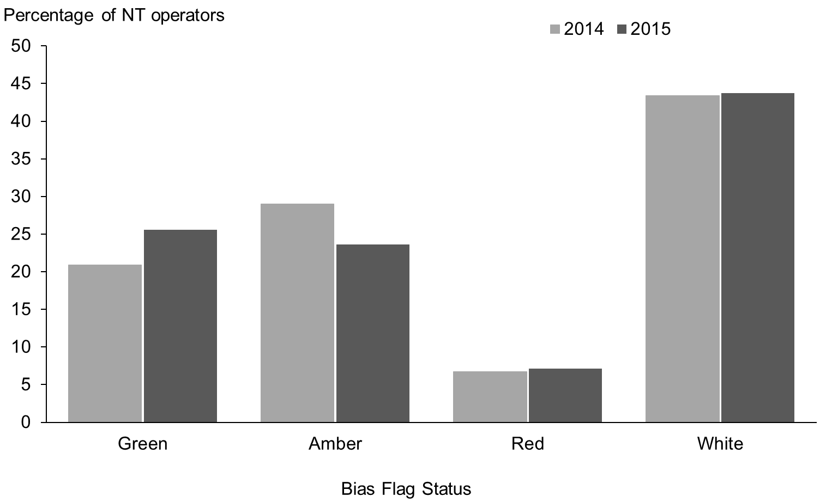

Indicator 14: Overall distribution of bias

The final radiology monitoring indicator reports on the overall distribution of bias in NT scans that were reported as part of antenatal screening. Table 60 gives a breakdown of the proportion of all NT scans undertaken in 2014 and 2015 that were assigned to each bias category. For 2015 57% of women received a scan from a green flagged practitioner, up 3% from 2014.

Table 60: Distribution of bias as a proportion of total scans reported, January 2014 to December 2015
Year | Green |  | Amber |  |  | Red
2014 | 21,207 | 54% | 13,092 | 33% | 4,216 |  | 11%
2015 | 22,594 | 57% | 12,166 | 31% | 3,949 |  | 10%

Figure 13: Distribution of bias as a proportion of total NT scans reported, January 2014 to December 2015
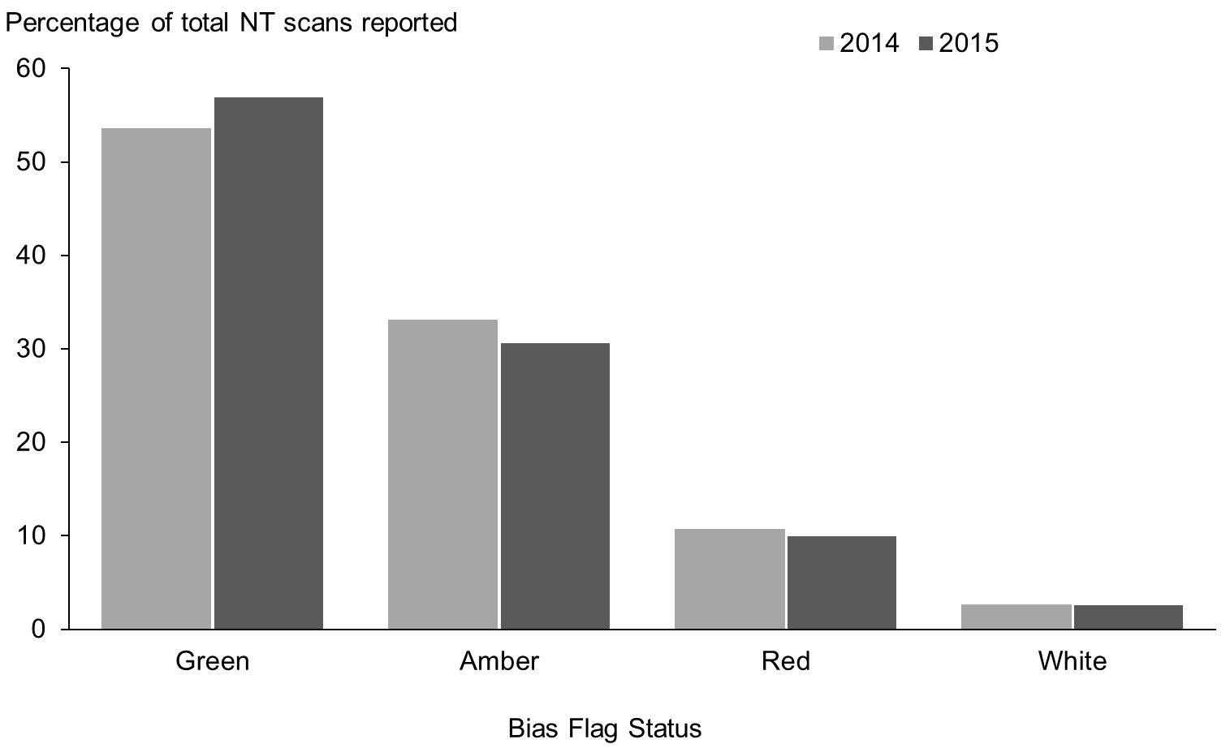

Appendix 1:
Indicator definitions
Table 61: Definitions used for monitoring indicators
Indicator | Methodology
Indicator 1: Screens commenced | Numerator: number of women who start screening  Denominator: number of live births and stillbirths
Indicator 2: Screens completed | Numerator: number of women who have a risk result calculated  Denominator: number of live births and stillbirths
Indicator 3: Pathway variances | Numerator: completed second trimester screens that have an ultrasound or PAPP-A reading recorded against them  Denominator: number of completed second trimester screens
Indicator 4: Incomplete screens | Numerator: number of screens commenced that have no risk result reported against them  Denominator: number of screens commenced
Indicator 5: Increased risk screening results | Numerator: number of women who receive an increased risk result  Denominator: number of women who have a risk result calculated
Indicator 6: Diagnostic testing, increased risk screens | Numerator: number of women with an increased risk result that have a diagnostic test  Denominator: number of women with increased risk results
Indicator 7: Diagnostic testing, low risk screens | Numerator: number of women with a low risk result that have a diagnostic test  Denominator: number of women with low risk results
Indicator 8: Diagnostic testing, unscreened women | Number of women who have diagnostic test that have not participated in screening
Indicator 9: Positive predictive value | Numerator: number of women given an increased risk screen result who have a positive diagnostic test/baby with positive diagnosis  Denominator: number of screened women with an increased risk result
Indicator 10: False positive rate | Numerator: number of women given an increased risk screen result who do not have a positive diagnostic test/baby with positive diagnosis  Denominator: number of screened women who do not have a positive diagnostic test/baby with positive diagnosis
Indicator 11: Detection rate | Numerator: number of women given an increased risk screen result who have a positive diagnostic test/baby with positive diagnosis  Denominator: number of screened women who have a positive diagnostic test/baby with positive diagnosis
Indicator 12: NT volumes by operator | Number of ultrasound scans for nuchal translucency (NT) performed by each NT operator within the period
Indicator 13: Distribution of bias by NT operator | Distribution of NT Bias relative to FMF reference curve by operator. Report presents number and proportion of operators in bias categories of Green (bias relative to FMF reference curve less than or equal to 0.10mm), Amber (bias between 0.10mm and 0.30mm) and Red (bias greater than 0.30mm)
Indicator 14: Overall distribution of bias | Distribution of NT Bias relative to FMF reference curve for each NT scan. Number and proportion of NT scans in bias categories of Green (bias relative to FMF reference curve less than or equal to 0.10mm), Amber (bias between 0.10mm and 0.30mm) and Red (bias greater than 0.30mm)
Calculation rules
- Screen date is the date given as the ‘Collected date’ in the lab system.
- If a woman has more than one screen for the same pregnancy (defined as being within 112 days) then the first completed screen has been retained for the analysis and the others excluded.
- Denominator is live births and still births >20 weeks or >400g.
- Tests on products of conception are excluded from prenatal tests for the purposes of indicators 6, 7 and 8. However, they are included in the outcome set for indicators 9, 10 and 11.
- For a prenatal cytogenetic test to link to a screen the cytogenetic sample date must be later than the screen date, but not more than 105 days (15 weeks) later.
- For an infant diagnosis to link to a commenced screen the screen date must be earlier than the infant’s birth date and the date difference must not be greater than 230 days (approximately 33 weeks).

Appendix 2:
Birth denominator data
Data on the number of live and still births was obtained from the national Maternity Collection for each financial year.

Table 62: Live births and still births by district health board 2011–2015
DHB | 2011 | 2012 | 2013 | 2014 | 2015
Northland | 2,302 | 2,300 | 2,129 | 2,099 | 2,135
Waitemata | 7,881 | 7,969 | 7,653 | 7,850 | 7,554
Auckland | 6,540 | 6,704 | 6,244 | 6,302 | 5,902
Counties Manukau | 8,740 | 8,767 | 8,168 | 8,283 | 8,206
Waikato | 5,390 | 5,483 | 5,227 | 5,252 | 5,287
Lakes | 1,589 | 1,558 | 1,417 | 1,393 | 1,509
Bay of Plenty | 2,859 | 2,968 | 2,752 | 2,782 | 2,798
Tairawhiti | 744 | 738 | 711 | 698 | 742
Hawkes Bay | 2,259 | 2,259 | 2,161 | 2,068 | 2,002
Taranaki | 1,566 | 1,559 | 1,524 | 1,518 | 1,514
MidCentral | 2,300 | 2,152 | 2,120 | 2,094 | 2,112
Whanganui | 829 | 874 | 826 | 817 | 816
Capital and Coast | 3,860 | 3,869 | 3,627 | 3,528 | 3,534
Hutt Valley | 2,056 | 2,006 | 1,914 | 1,853 | 1,967
Wairarapa | 530 | 510 | 501 | 473 | 463
Nelson Marlborough | 1,650 | 1,529 | 1,549 | 1,419 | 1,417
West Coast | 405 | 408 | 375 | 351 | 356
Canterbury | 6,064 | 5,987 | 5,825 | 6,004 | 6,210
South Canterbury | 571 | 648 | 639 | 653 | 659
Southern | 3,673 | 3,597 | 3,446 | 3,285 | 3,414
Total | 61,808 | 61,885 | 58,808 | 58,722 | 58,597

Table 63: Live births and still births by age group, 2011–2015
Age group | 2011 | 2012 | 2013 | 2014 | 2015
Under 20 | 4,055 | 3,908 | 3,324 | 2,997 | 2,786
20–24 | 11,704 | 11,465 | 10,801 | 10,279 | 9,952
25–29 | 15,548 | 15,936 | 15,282 | 15,700 | 15,732
30–34 | 17,223 | 17,460 | 16,768 | 17,574 | 17,913
35–39 | 10,728 | 10,406 | 10,040 | 9,683 | 9,762
40–44 | 2,405 | 2,578 | 2,436 | 2,344 | 2,300
45 and over | 126 | 120 | 143 | 132 | 139
Unknown | 19 | 12 | 14 | 13 | 13
Total | 61,808 | 61,885 | 58,808 | 58,722 | 58,597

Table 64: Live births and still births by 2013 NZ deprivation quintile, 2011–2015
NZ Deprivation Quintile | 2011 | 2012 | 2013 | 2014 | 2015
Quintile 1 | 8,510 | 8,680 | 8,177 | 8,471 | 8,241
Quintile 2 | 9,505 | 9,606 | 9,248 | 9,160 | 9,342
Quintile 3 | 11,147 | 11,173 | 10,627 | 10,557 | 10,592
Quintile 4 | 13,809 | 13,658 | 13,423 | 13,285 | 13,244
Quintile 5 | 18,813 | 18,750 | 17,301 | 17,224 | 17,063
Unknown | 24 | 18 | 32 | 25 | 115
Total | 61,808 | 61,885 | 58,808 | 58,722 | 58,597

Table 65: Live births and still births by ethnicity, 2011-2015
Ethnicity | 2011 | 2012 | 2013 | 2014 | 2015
Māori | 15,829 | 15,694 | 14,560 | 14,232 | 14,543
Pacific | 7,067 | 6,872 | 6,342 | 6,154 | 6,056
Asian | 7,134 | 8,450 | 8,155 | 9,199 | 9,210
Other | 31,778 | 30,869 | 29,751 | 29,137 | 28,788
Total | 61,808 | 61,885 | 58,808 | 58,722 | 58,597

Appendix 3:
Summary of diagnostic testing uptake and results for women that had an increased risk screen

Summary of prenatal diagnostic testing uptake for women with increased risks for trisomy 21, 18 or 13
Of the 1,163 screens that had an increased risk for trisomy 21, 18 or 13 during 2015, 655 (56%) had a prenatal diagnostic test (CVS or Amniocentesis) and 508 (44%) did not. Table 66 shows the diagnostic testing results for the 655 prenatal tests, of which 164 had an abnormal karyotype, including 89 confirmed with Down syndrome. Table 67 shows a breakdown of pregnancy outcomes for the 508 women that had an increased risk screen but did not have a prenatal diagnostic test.

Table 66: Diagnostic results for women that accessed a prenatal diagnostic test following an increased risk screen for trisomy 21, 18 or 13 during the 2015 year
Karyotype result | Number | Percentage
Normal karyotype | 491 | 75.0%
Confirmed Down syndrome | 89 | 13.6%
Other result* | 75 | 11.5%
Total | 655 | 100.0%

* The 75 ‘Other’ results were made up of the following:
Result | Number
Trisomy 18 | 19
Trisomy 13 | 5
Turner syndrome | 10
Triploidy | 4
Sex chromosome aneuploidy (other than non-mosaic 45, X) | 3
Partial aneuploidy (autosome) (including mosaic) | 7
Uniparental disomy | 1
Structural abnormality | 2
Apparently balanced chromosome rearrangement | 24
Total | 75

Table 67: Pregnancy outcomes (where known) for women that did not have a prenatal diagnostic test following an increased risk screen for trisomy 21, 18 or 13 during the 2015 year
Result | Number
No abnormality detected on postnatal diagnostic test | 13
Trisomy 21 | 6
Trisomy 18 | 5
Trisomy 13 | 2
Turner syndrome | 1
Triploidy | 2
Sex chromosome aneuploidy (other than non-mosaic 45, X) | 1
Autosomal trisomy (other than 13, 18, 21) (including mosaic) | 1
Uniparental disomy | 8
No link to a diagnosis | 469
Total | 508

Appendix 4:
Measuring screening performance
Figure 12 shows the categorisation of screening results used to calculate screening performance measures such as positive predictive value, false positive rate and detection rate. The examples given in this appendix focus on trisomy 21.

Figure 14: Categorisation of screening results
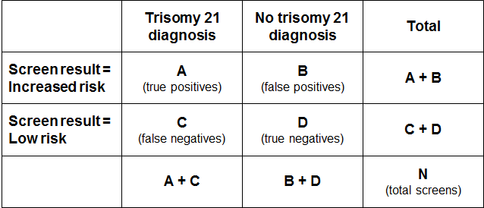

Positive predictive value and positive test rate
The positive test rate is the number of increased risk screens per 100 screens.
Positive test rate = ((A+B)/N)*100

Positive Predictive Value is the probability of having the condition given screen result was increased risk.
PPV = P (Disease | Screen Positive) = A/(A+B)

In order for PPV to increase, ‘A’ needs to be higher (more true positives) and/or ‘B’ needs to be lower (less false positives). However, an increase in positive test rate can come about when ‘A’ and/or ‘B’ increase. If the positive test rate increases due to higher true positives (A), then PPV will also increase. If instead the number of false positives increases, then the positive test rate will increase but PPV will decrease.

False positive rate
False positive rate is the number of false positives divided by false positives plus true negatives. It gives the proportion of women that did not have a baby or fetus with trisomy 21 that received an increased risk screening result.
FPR = B/(B+D)

Detection rate
Detection rate is the number of true positives divided by true positives plus false negatives. It gives the probability that a woman carrying a fetus with trisomy 21 will receive an increased risk screening result for trisomy 21.
Detection rate = A/(A+C)

Data for women screened during 2015
Figure 15 shows the data break down in relation to trisomy 21 for women screened during 2015.
Figure 15: Categorisation of trisomy 21 screening results 2015
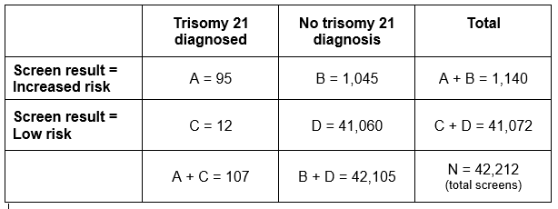

Positive predictive value (indicator 9)
PPV = A/(A+B)
= 95 / 1,140
= 0.08 (or 8%)

If a woman receives an increased risk screening result for trisomy 21, there is an 8% probability that she is carrying a fetus with trisomy 21.

False positive rate (indicator 10)
FPR = B/(B+D)
= 1,045 / 42,105
= 0.02 (or 2%)

Out of all women that ultimately have a negative diagnostic test or a baby without trisomy 21, 2% will have received an increased risk screening result.

Detection rate (indicator 11)
Detection rate = A/(A+C)
= 95 / 107
= 0.89 (or 89%)

There is an 89% probability that a woman carrying a fetus with trisomy 21 will have received an increased risk screening result for trisomy 21.

Appendix 5:
False negative screens by risk level
There were 165 false negative screens in total across the 5 year period covered by this report. A false negative means that the screen result was low risk for each of trisomy 21, 18 and 13 but there was then a positive diagnostic test or infant diagnosis for one of trisomy 21, 18 or 13.

Table 68 shows the number of false negatives for each of the five calendar years broken down by the screening risk result in the first group of columns. The next group of columns gives the number of false negatives as a percentage of all negative (low risk) screens. Overall, false negative screens made up less than 0.1% of all negative screens for each of the years from 2011 to 2015.

Table 68: False negative screens for trisomy 21, 18 and 13 by risk level, January 2011 to December 2015
Risk level | False negatives |  |  |  |  | % of negative screens that are false negatives
 | 2011 | 2012 | 2013 | 2014 | 2015 | 2011 | 2012 | 2013 | 2014 | 2015
1:301 to 1:500 | 10 | 7 | 8 | 7 | 4 | 1.83 | 1.13 | 1.26 | 1.07 | 0.62
1:510 to 1:1,000 | 7 | 6 | 7 | 6 | 4 | 0.44 | 0.38 | 0.45 | 0.37 | 0.23
1:1100 to 1:2000 | 7 | 8 | 7 | 5 | 2 | 0.26 | 0.29 | 0.25 | 0.17 | 0.07
1:2100 to 1:3000 | 3 | 4 | 4 | 3 | 3 | 0.13 | 0.16 | 0.17 | 0.12 | 0.12
1:3100 to 1:4000 | 0 | 3 | 4 | 0 | 1 | - | 0.14 | 0.18 | - | 0.04
1:4100 to 1:5000 | 4 | 2 | 0 | 2 | 1 | 0.20 | 0.10 | - | 0.10 | 0.05
1:5100 to 1:10,000 | 4 | 5 | 6 | 1 | 2 | 0.05 | 0.06 | 0.08 | 0.01 | 0.02
Less than 1:10,000 | 2 | 5 | 5 | 4 | 2 | 0.01 | 0.03 | 0.02 | 0.02 | 0.01
Total | 37 | 40 | 41 | 28 | 19 | 0.10 | 0.10 | 0.10 | 0.07 | 0.05

Appendix 6:
ROC curve
Figure 16 shows the false positive rate plotted against the detection rate in what is known as a ‘receiver operating characteristic’ (ROC) curve. This plots the false positive rate on the horizontal x axis against detection rate on the vertical y axis for different possible cut off points of the screening test. The aim for a screening test is to maximise detection rate while minimising false positive rate.

In New Zealand the cut off used for screening is 1:300. With this cut off the overall detection rate for trisomy 21, trisomy 18 and trisomy 13 in 2015 was 87%, and the false positive rate was 2.4%. To create the graph the detection rate and false positive rate were calculated for a range of other cut off points in order to plot the curve. What the curve shows is that if the cut off was lowered to increase the detection rate to 89.6%, the false positive rate would increase from 2.4% to 4.7%. This occurs at a risk cut off of 1:600.

Figure 16: ROC curve for trisomy 21, 18 and 13 screening 2015
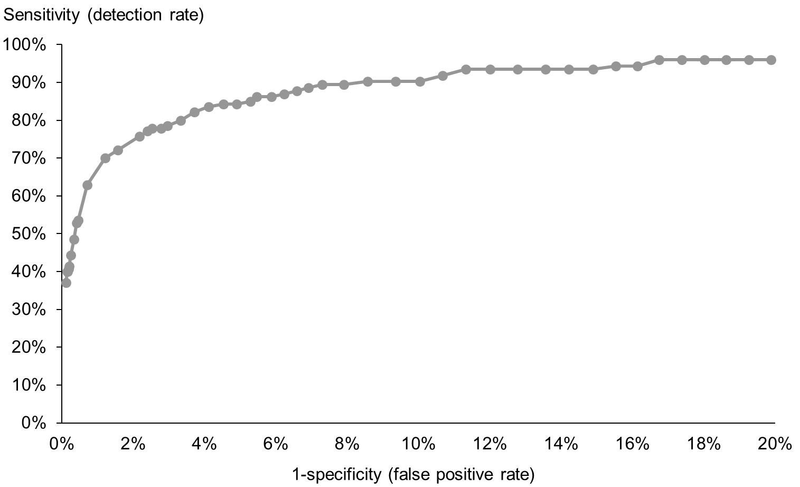

Appendix 7:
Radiology indicator summary measures
Bias – the bias is the difference between observed NT measurements and those we would expect from the FMF curve. For example, the expected NT measurement for a CRL of 60mm is 1.65mm. If a fetus with a CRL measurement of 60mm has an NT measurement of 2mm, the difference is 0.35mm

2mm – 1.65mm = 0.35mm

Or if the measured NT is 1mm, the difference is -0.65mm

1mm – 1.65mm = ‐0.65mm

The figures shown in the distribution plot are the number and percentage of measurements above and below the FMF curve.

Spread – the spread of NT measurements is the way most measurements will cluster along the FMF curve. The number shown is the factor by which the spread is increased (the measurements vary more greatly than would be expected given the CRL) or decreased (the measurements cluster very tightly around the curve, without the expected normal variance).

Trend – the curve of observed NT /CRL values should mimic the FMF curve in shape and direction. The value displayed shows the degree of discrepancy between the expected trend and the observed measurements.

Appendix 8:
Example NT Operator Report
Figure 17 shows an example NT operator report with identifying codes removed. The report states the time period it relates to (6 January 2014 to 31 December 2014) and the number of NT reports completed by the operator (n = 249). The graph is a scatter plot of nuchal translucency measurement versus crown rump length measurement. The blue line in the graph is the Fetal Medicine Foundation reference curve and the black dots plot where each of the operator’s ultrasounds sit in relation to the curve. Each operator is assessed on the amount of bias, spread, and trend. In this example, the operator has a red flag for bias (with a bias value of negative 0.43mm), a green flag for spread, and a green flag for trend. The comment below the graph provides interpretation of these results.

Figure 17: Example NT operator report
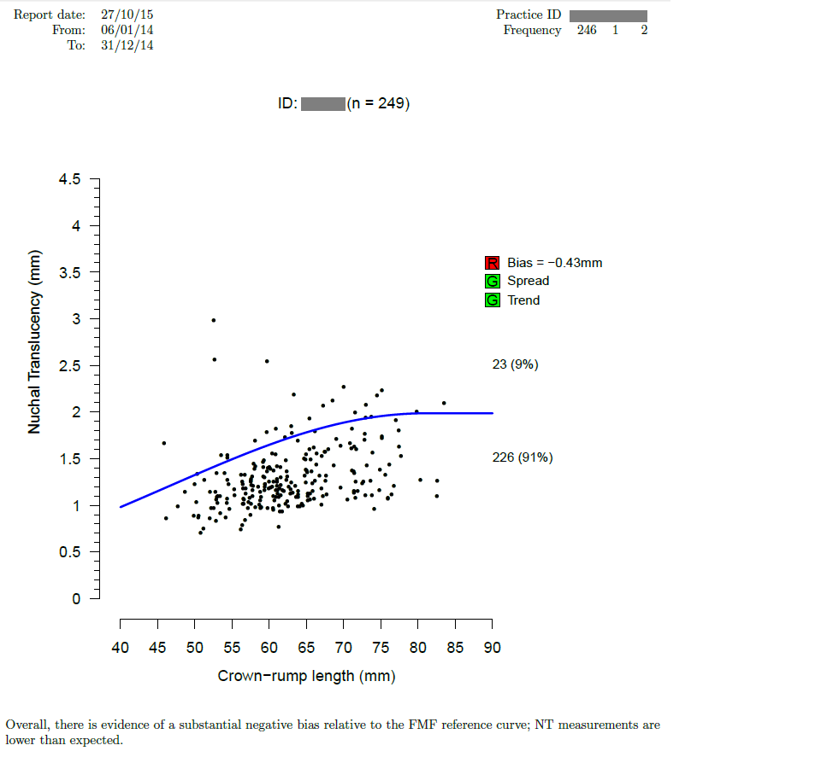

Appendix 9:
Glossary
Alpha-fetoprotein (AFP) – a protein that is normally produced by the fetus. Maternal serum AFP levels can be used as a biochemical marker in the detection of certain fetal abnormalities including neural tube defects (NTDs) after 15 weeks of pregnancy.

Amniocentesis – a procedure involving the withdrawal of a small amount of amniotic fluid by needle and syringe through the abdomen guided by ultrasound performed at the same time. The tests performed on fetal cells in this sample can detect a range of chromosomal and genetic disorders.

Analyte – a substance that is undergoing analysis or being measured. Analytes measured in antenatal screening include: pregnancy associated plasma protein-A, beta human chorionic gonadotropin, unconjugated oestriol, alpha fetoprotein and inhibin A.

Beta-human chorionic gonadotropin (ßhCG) – a hormone produced during pregnancy and present in maternal blood and urine. It is used as a biochemical marker for Down syndrome and other conditions in first trimester combined and second trimester maternal serum screening.

Chorionic villus sampling (CVS) – a procedure involving the withdrawal of a small amount of placental tissue by needle and syringe through the abdomen guided by ultrasound performed at the same time. Tests performed on placental cells can detect a range of chromosomal and genetic disorders.

Crown rump length (CRL) – the measurement from the fetal crown to the prominence of the buttocks or breech. This is used for dating in the first trimester.

Detection rate – the ability of screening to identify individuals with the condition screened for. A test with a high detection rate will have few false negative results. Also referred to as sensitivity.

False negative result – when a woman receives a low risk screening result but the baby does have the condition screened for.

False positive result – when a woman receives an increased risk screening result but the baby does not have the condition screened for.

False positive rate – the false positive rate is the number of false positives divided by the number of false positives and true negatives. A low false positive rate corresponds with a high level of specificity, which refers to the ability of screening to identify individuals who do not have the condition screened for.

Fetal Medicine Foundation (FMF) –a Registered Charity that aims to improve the health of pregnant women and their babies through research and training in fetal medicine. Further information can be found at: https://fetalmedicine.org

Inhibin A – a hormone secreted by the ovary that is used as a biochemical marker in second trimester maternal serum screening for Down syndrome and other conditions.

Multiple of the median (MoM) – a measure of how far an individual result deviates from the median. MoM is commonly used to report the results of medical screening tests, particularly where the results of the individual tests are highly variable.

Nasal bone (NB)- an assessment of nasal bone will be included in the risk calculation if it is reported at the same time as the NT measurement.

Neural tube defect (NTD) – a congenital anomaly involving the brain and spinal cord caused by failure of the neural tube to close properly during embryonic development. Open NTDs occur when the brain and/or spinal cord are exposed at birth through a defect in the skull or vertebrae. Examples of open NTDs are spina bifida (myelomeningocele), anencephaly, and encephalocele.

Nuchal translucency (NT) – sonographic appearance of the collection of fluid under the skin at the back of the fetal neck. NT is a marker for chromosomal and other anomalies and can be measured in the first trimester of pregnancy.

Pregnancy-associated plasma protein A (PAPP-A) – a protein originating from the placenta used as a biochemical marker in first trimester combined screening for Down syndrome and other conditions.

Risk calculation algorithm – an explicit protocol (in this case computer-based) that combines a number of factors in determining overall risk of a particular outcome or condition.

Screening – a way of identifying a group of people who are more likely than others to have a particular condition. The screening process involves testing people for the presence of the condition, and predicting the likelihood that they have the condition. Antenatal screening for Down syndrome and other conditions predicts the likelihood of the conditions being present in the fetus.

Triploidy – an extremely rare chromosomal disorder in which a baby has three of every chromosome making a total of 69 rather than the normal 46 chromosomes.

Trisomy – a group of chromosomal disorders in which there are three copies, instead of the normal two, of a particular chromosome present in the cell nuclei. The most common trisomies in newborns are trisomy 21 (Down syndrome), trisomy 18 (Edwards syndrome) and trisomy 13 (Patau syndrome).

Unconjugated oestriol (uE3) – a hormone produced by the placenta and used as a biochemical marker in second trimester maternal serum screening for Down syndrome and other conditions.

Further terms can be found at www.nsu.govt.nz

Risk ratio values increase in increments of 5 between 1:10 and 1:100, increments of 100 between 1:100 and 1:10,000, and then increments of 1000 to 1:100,000.
Births reaching at least 20 weeks gestation or ≥400 g birth weight.
More information about the FMF can be found at: https://fetalmedicine.org/
Births reaching at least 20 weeks gestation or ≥400 g birth weight.

