Antenatal Screening for Down Syndrome and Other Conditions
2016 Monitoring Report

Citation: Ministry of Health. 2018. Antenatal Screening for Down Syndrome and Other Conditions: 2016 Monitoring Report. Wellington: Ministry of Health.
Published in September 2018
by the Ministry of Health
PO Box 5013, Wellington 6140, New Zealand
ISBN 978-1-98-853982-9 (online)
HP 6912
This document is available at health.govt.nz
This work is licensed under the Creative Commons Attribution 4.0 International licence. In essence, you are free to: share ie, copy and redistribute the material in any medium or format; adapt ie, remix, transform and build upon the material. You must give appropriate credit, provide a link to the licence and indicate if changes were made.

Contents
Executive summary ix
Antenatal screening for Down syndrome and other conditions ix
Key points for 2016 ix
Introduction 1
Background to screening for Down syndrome and other conditions in pregnancy in New Zealand 1
Programme monitoring and data collection 2
Information included in this report 3
Definitions 3
Inclusion criteria 4
Data calculations 4
Data limitations 5
Indicator 1: Screens commenced 7
Total screens commenced by trimester 7
Screens commenced by DHB 8
Screens commenced by age, ethnicity and deprivation 11
Indicator 2: Screens completed 14
Total screens completed by trimester 14
Screens completed by DHB 15
Screens completed by age, ethnicity and deprivation 17
Indicator 3: Screening pathway variance 21
Screening pathway variance by year 21
Screening pathway variance by DHB 22
Screening pathway variance by age, ethnicity and deprivation 23
Indicator 4: Incomplete screens 24
Total incomplete screens 24
Incomplete T1 screens by reason incomplete 25
Incomplete T1 screens by reason and DHB 26
Incomplete T1 screens by age, ethnicity and deprivation 27
Incomplete T2 screens 28
Incomplete T2 screens by DHB 29
Incomplete T2 screens by age, ethnicity and deprivation 30
Indicator 5: Increased risk screening results for trisomy 21, trisomy 18 and trisomy 13 31
Total increased risk screening results for trisomy 21, 18 or 13 31
Increased risk screening results for trisomy 21, 18 or 13 by age, ethnicity and deprivation 32
Increased risk screening results for trisomy 21, 18 or 13 by trimester of screen 33
Increased risk screening results stratified by risk level 34
Indicator 6: Diagnostic testing volumes for women with increased risk screens 35
Diagnostic testing volumes for women with increased risk screens by trimester of screen 35
Diagnostic testing volumes for women with increased risk screens by DHB 36
Diagnostic testing volumes for women with increased risk screens by age, ethnicity and deprivation 37
Diagnostic testing volumes for women with increased risk screening results stratified by risk level 38
Indicator 7: Diagnostic testing volumes for women who receive a low risk screening result 39
Diagnostic testing volumes for women with low risk screens by trimester of screen 39
Diagnostic testing volumes for women with low risk screens by DHB 40
Diagnostic testing volumes for women with low risk screening results by age, ethnicity and deprivation 41
Diagnostic testing volumes for women with low risk screening results stratified by risk 42
Indicator 8: Diagnostic testing for unscreened women 43
Diagnostic volumes for unscreened women 43
Diagnostic results for unscreened women 44
Indicator 9: Diagnostic testing outcomes for women with increased risk screening results 45
Positive predictive value of screening 45
Positive predictive value of screening for trisomy 21 stratified by risk level 47
Positive predictive value of screening for trisomy 21 by age, ethnicity and deprivation 47
Indicator 10: False positive rate 49
False positive rate for screening 49
False positive rate for screening for trisomy 21 by age, ethnicity and deprivation 50
Indicator 11: Detection rate 52
Detection rate for screening 52
Appendices
Appendix 1: Indicator definitions 55
Appendix 2: Birth denominator data 56
Appendix 3: Summary of diagnostic testing uptake and results for women that had an increased risk screen 58
Appendix 4: Measuring screening performance 60
Appendix 5: False negative screens by risk level 62
Appendix 6: ROC curve 63
Appendix 7: Glossary 64

List of Tables
Table 1: Total screens commenced by trimester, January 2011 to December 2016 7
Table 2: Screens commenced by trimester and DHB, January 2016 to December 2016 9
Table 3: Screens commenced per 100 births by DHB, January 2011 to December 2016 10
Table 4: Screens commenced by age of mother, ethnicity and NZ deprivation quintile, January 2011 to December 2016 11
Table 5: Total screens completed by trimester, January 2011 to December 2016 14
Table 6: Screening completion by trimester and DHB, January 2016 to December 2016 16
Table 7: Screening completion by DHB, January 2011 to December 2016 17
Table 8: Screens completed by age of mother, ethnicity and NZ deprivation quintile, January 2011 to December 2016 18
Table 9: Screening pathway variance by type, January 2011 to December 2016 21
Table 10: Screening pathway variance by DHB, January 2016 to December 2016 22
Table 11: Screening pathway variance by age, ethnicity and NZ deprivation quintile, January 2016 to December 2016 23
Table 12: Incomplete screens by trimester, January 2011 to December 2016 24
Table 13: Incomplete T1 screens by reason incomplete, January 2011 to December 2016 25
Table 14: Incomplete T1 screens by reason and DHB, January 2016 to December 2016 26
Table 15: Incomplete T1 screens by age, ethnicity and NZ deprivation quintile, January 2016 to December 2016 27
Table 16: Incomplete T2 screens, January 2011 to December 2016 28
Table 17: IncompleteT2 screens by DHB, January 2016 to December 2016 29
Table 18: Incomplete T2 screens by age, ethnicity and NZ deprivation quintile, January 2016 to December 2016 30
Table 19: Number and rate per 100 screens of increased risk screening results for trisomy 21, 18 or 13, January 2011 to December 2016 31
Table 20: Increased risk screening results for trisomy 21, 18 or 13 by age, ethnicity and deprivation, January 2016 to December 2016 32
Table 21: Increased risk screening results for trisomy 21, 18 and 13 by trimester of screen, January 2011 to December 2016 33
Table 22: Increased risk screening results for trisomy 21, 18 and 13 by risk level, January 2016 to December 2016 34
Table 23: Diagnostic testing volumes for women with increased risk screens by trimester of screen, January 2011 to December 2016 35
Table 24: Diagnostic testing volumes for women with increased risk screens by DHB, January 2011 to December 2016 36
Table 25: Diagnostic testing volumes for women with increased risk screening results by age at screen, ethnicity and deprivation, January 2011 to December 2016 37
Table 26: Diagnostic testing volumes for women with increased risk screens by risk level, January 2016 to December 2016 38
Table 27: Diagnostic testing volumes for women with low risk screens by trimester of screen, January 2011 to December 2016 39
Table 28: Total diagnostic testing volumes for women with low risk screens by DHB January 2011 to December 2016 40
Table 29: Diagnostic tests per 100 low risk screens by age, ethnicity and NZ deprivation quintile, January 2011 to December 2016 41
Table 30: Diagnostic tests per 100 low risk screens stratified by risk level, January 2011–December 2016 aggregated 42
Table 31: Diagnostic testing volumes for unscreened women by DHB, January 2012 to December 2016 43
Table 32: Total diagnostic testing volumes for unscreened women by age, ethnicity and deprivation quintile, January 2012 to December 2016 44
Table 33: Total diagnostic testing results for unscreened women, January 2016 to December 2016 44
Table 34: Positive predictive value of screening for trisomy 21, 18 or 13, January 2011 to December 2016 46
Table 35: Positive predictive of screening for trisomy 21, January 2011 to December 2016 46
Table 36: Positive predictive of screening for trisomy 13 or 18, January 2011 to December 2016 46
Table 37: Positive predictive of screening for trisomy 21 stratified by risk level, aggregated 2011–2016 47
Table 38: Positive predictive of screening for trisomy 21 by age, aggregated 2011–2016 47
Table 39: Positive predictive of screening for trisomy 21 by ethnicity, aggregated 2011–2016 48
Table 40: Positive predictive of screening for trisomy 21 by NZ deprivation quintile, aggregated 2011–2016 48
Table 41: False positive rate for trisomy 21, 18 or 13, January 2011 to December 2016 49
Table 42: False positive rate for trisomy 21, 18 or 13 by trimester of screen, January to December 2016 49
Table 43: False positive rate for trisomy 21, January 2011 to December 2016 50
Table 44: False positive rate for trisomy 18 and 13, January 2011 to December 2016 50
Table 45: False positive rate for trisomy 21 by age, aggregated January 2011 to December 2016 50
Table 46: False positive rate for trisomy 21 by ethnicity, January 2011 to December 2016 51
Table 47: False positive rate for trisomy 21 by NZ deprivation quintile, January 2011 to December 2016 51
Table 48: Detection rate for trisomy 21, 18 or 13, January 2011 to December 2016 52
Table 49: Detection rate for trisomy 21, January 2011 to December 2016 52
Table 50: Detection rate for trisomy 13 or 18, January 2011 to December 2016 53
Table 51: Detection rate for trisomy 21 by age, aggregated 2011–2016 53
Table 52: Detection rate for trisomy 21 by ethnicity, aggregated 2011–2016 53
Table 53: Detection rate for trisomy 21 by NZ deprivation quintile, aggregated
2011–2016 54
Table 54: Definitions used for monitoring indicators 55
Table 55: Live births and still births by district health board 2011–2016 56
Table 56: Live births and still births by age group, 2011–2016 57
Table 57: Live births and still births by 2013 NZ deprivation quintile, 2011–2016 57
Table 58: Live births and still births by ethnicity, 2011-2016 57
Table 59: Diagnostic results for women that accessed a prenatal diagnostic test following an increased risk screen for trisomy 21, 18 or 13 during the 2016 year 58
Table 60: Pregnancy outcomes (where known) for women that did not have a prenatal diagnostic test following an increased risk screen for trisomy 21, 18 or 13 during the 2016 year 59
Table 61: False negative screens for trisomy 21, 18 and 13 by risk level, January 2011 to December 2016 62

List of Figures
Figure 1: Data collection process 2
Figure 2: Count and rate of screens commenced, January 2011 to December 2016 7
Figure 3: Screens commenced by DHB, January 2016 to December 2016 8
Figure 4: Screens commenced by age of mother at screen, January 2016 to December 2016 12
Figure 5: Screens commenced by ethnicity of mother, January 2016 to December 2016 12
Figure 6: Screens commenced by NZ deprivation quintile, January 2016 to December 2016 13
Figure 7: Count and rate of screens completed, January 2011 to December 2016 14
Figure 8: Screens completed by DHB, January 2016 to December 2016 15
Figure 9: Screens completed by age of mother at screen, January 2016 to December 2016 19
Figure 10: Screens completed by ethnicity of mother, January 2016 to December 2016 19
Figure 11: Screens completed by NZ deprivation quintile of mother, January 2016 to December 2016 20
Figure 12: Categorisation of screening results 60
Figure 13: ROC curve for trisomy 21, 18 and 13 screening 2016 63

Executive summary
This report presents data on antenatal screening for Down syndrome and other conditions for the six calendar years from 1 January 2011 to 31 December 2016, and is based on screens that commenced during that time. This is the second year a complete data set, with all cytogenetic testing data, has been used.

Antenatal screening for Down syndrome and other conditions
Antenatal screening for Down syndrome and other conditions provides a risk estimate for Down syndrome (trisomy 21), trisomy 18 (Edwards syndrome), trisomy 13 (Patau syndrome) and some other rare genetic disorders. This screening is optional for pregnant women. Women who are less than 20 weeks pregnant are advised about the availability of screening and provided with up-to-date information to support the screening discussion, to enable women to make an informed decision about whether to participate.

First trimester combined screening should be completed between 9 weeks and 13 weeks 6 days gestation. The recommended timing for the blood test is 9 to 10 weeks and the Nuchal Translucency scan should be done at between 12–13 weeks. Second trimester maternal serum screening should be completed between 14 weeks and 20 weeks gestation. The recommended timing for this test is 14 to 18 weeks.

Key points for 2016
- Screening was commenced for 81% of pregnancies [indicator 1].
- Screening uptake by Māori and Pacific women was half or less the rate of Other women in 2016. Pacific and Māori rates have increased each year since 2011 [indicators 1 and 2].
- The national screening completion rate has increased each year with 73% of births being screened in 2016. First trimester screens made up 86% of all completed screens in 2016 [indicator 2].
- Most DHBs showed a trend of increasing rates of screening commencement and completion [indicators 1 and 2].
- Just over half of all completed trimester 2 screens were commenced in trimester 1 [indicator 3].
- Nine percent of screens commenced in 2016 were not completed and nearly all related to screens commenced in the first trimester. The rate of incomplete screens was higher for Māori and Pacific women, and for women from areas of higher deprivation [indicator 4].
- The overall positive test rate (number of increased risk results per 100 screens) for trisomy 21, 18 and 13 was 2.7 in 2016, similar to 2015 (2.8). The positive test rate was higher for second trimester screens (3.7 per 100 screens) than for first trimester screens (2.6 per 100 screens) for 2016 [indicator 5].
- The overall false positive rate for trisomy 21, 18 and 13 was 2.0% in 2016, consistent with previous years. The rate was higher for second trimester screens (4.0%) than for first trimester screens (2%) [indicator 10].
- The overall detection rate for trisomy 21, 18 and 13 was 79% in 2016, compared to 84% in 2015 [indicator 11].

Introduction

Background to screening for Down syndrome and other conditions in pregnancy in New Zealand
Antenatal screening for Down syndrome and other conditions has been available to pregnant women in New Zealand since 1968. In October 2007, the government agreed to implement quality improvements to ensure consistency with international best practice. The improvements were introduced in February 2010 and included incorporating maternal serum screening with ultrasound, providing practitioner guidelines and consumer resources.

Health practitioners providing maternity care are required to provide women with information about antenatal screening services for Down syndrome and other conditions. There are two screening options:
- first trimester combined screening, which includes a blood test that measures two maternal serum markers, pregnancy-associated protein A (PAPP-A) and free beta- human chorionic gonadotropin (ßhCG). The blood sample is collected between 9 weeks and 13 weeks and 6 days gestation and combined with an ultrasound scan to determine nuchal translucency (NT) and crown rump length (CRL) measurements (and nasal bone assessment if provided) between 11 weeks and 2 days and 13 weeks and 6 days, or
- second trimester screening, which is a blood test that measures four maternal serum markers free beta-human chorionic gonadotropin (ßhCG), alpha-fetoprotein (AFP), unconjugated oestriol (uE3) and inhibin A taken between 14 and 20 weeks gestation.

The results of the ultrasound scan and/or serum are combined with other demographic and maternal factors to provide a risk result. For consistency, all screening risk results are produced by the screening laboratories. The screening laboratories are LabPLUS at Auckland District Health Board (for samples from north of Taupo) and Canterbury Health Laboratories at Canterbury District Health Board (for samples from south of Taupo). A shared data repository (PerkinElmer LifeCycle) contains data on all screens. Ultrasound scanning is performed by private and public radiology practices around New Zealand and the ultrasound report is sent to the screening laboratories to include in the risk calculation algorithm.

The conditions covered by screening include:
- trisomy 21 (Down Syndrome)
- trisomy 18 (Edwards syndrome)
- trisomy 13 (Patau syndrome)
- triploidy
- Turner syndrome
- neural tube defects.

Antenatal screening involves many health professionals including radiology staff, Lead Maternity Carers (LMCs), general practitioners (GPs) and laboratory personnel. The quality of the information provided by health professionals to the laboratories regarding the pregnancy details (such as gestation, maternal age, weight, ethnicity and the ultrasound finding) is critical because these details have a significant impact on the risk calculation and report that is issued.

Programme monitoring and data collection
This report presents monitoring results for antenatal screening for Down syndrome and other conditions for the period 1 January 2011 to 31 December 2016. The definitions for the 11 indicators in this report are contained in Appendix 1. Figure 1 outlines the data collection process the National Screening Unit used to produce indicators 1 to 11. Indicators 12 to 14 are not available in 2016.

Figure 1: Data collection process
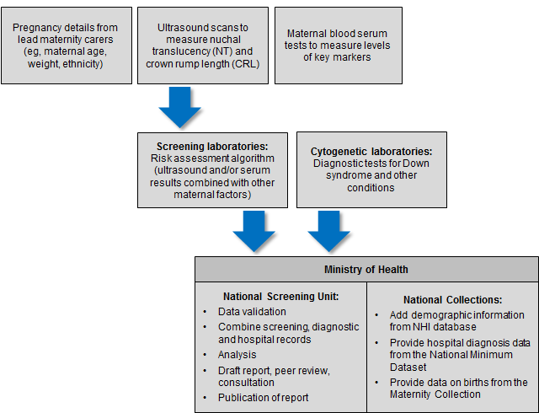

The indicators contained within this monitoring report form one part of the evaluation and audit of the quality improvements to antenatal screening for Down syndrome and other conditions. Other activities include:
- yearly screening laboratory audits by IANZ
- four-yearly peer review of screening laboratories
- contract monitoring and reporting on a six-monthly basis
- occasional studies and qualitative information.

Information included in this report
The screening data in this report was sourced from LabPLUS and covers all of New Zealand. As in 2015, diagnostic testing data was received from all cytogenetic laboratories (LabPLUS, Waikato, Capital and Coast, and Canterbury Health Laboratories).

The screening and cytogenetic data was combined with hospital discharge data, sourced from the National Minimum Data Set (NMDS), held by the Ministry of Health. This matching between data from screening laboratories, cytogenetic laboratories, and the NMDS was undertaken to identify the outcome for all screened women.

Definitions

Commenced screening
At least one of the required components of the screening test was completed.

Completed screening
All the required components of each screening test were complete and a risk result was calculated.

Required components of each screening test
First trimester screening comprises analysis of two serum analytes (βhCG, PAPP-A) and a NT measurement. Second trimester screening comprises analysis of four serum analytes (βhCG, AFP, uE3 and Inhibin A).

Low risk result
A low risk result is defined as a risk lower than 1:300. So a risk of 1:310 is a low risk.

Increased risk result
An increased risk result is defined as a risk higher than or equal to 1:300. For some indicators increased risk screening results are further stratified into:
- 1:5 to 1:20
- 1:20 to 1:50
- 1:50 to 1:300.

Inclusion criteria
Women’s screens were included in this analysis if the following criteria were met:
- screening commencement date between 1 January 2011 and 31 December 2016 (ie, date of the first test the woman had as part of the screening pathway)
- valid National Health Index (NHI) identifier
- known District Health Board (DHB) of domicile
- age at screen from 12 years to 49 years (calculated using the NHI database date of birth)
- single screening result per pregnancy.

Data calculations

DHB of domicile
Each woman was allocated to a DHB based on the residential address recorded in the National Health Index (NHI). Where the NHI database did not have a DHB recorded for an NHI, information from the LabPLUS database was used to assign the DHB.

Ethnicity
Ethnicity data in this report is grouped according to a prioritised system, which is commonly applied across the New Zealand health sector. Prioritisation involves allocating each person to a single ethnic group, based on the ethnicities that person has identified, in the prioritised order of Māori, Pacific, Asian and Other ethnicity. For example, if someone identifies as being New Zealand European and Māori, under the prioritised ethnicity method, they are classified as Māori for the purpose of the analysis. Under this method, the Other ethnicity group effectively refers to non-Māori, non-Pacific, non-Asian people.

NZ Deprivation
The New Zealand deprivation index (NZ Dep) is the average level of deprivation of people living in an area at a particular point in time, relative to the whole of New Zealand. Deprivation refers to areas (based on New Zealand Census mesh blocks) rather than individuals. All reporting by NZ Dep is based on the 2013 New Zealand deprivation index decile associated with the residential address held in the NHI database for each woman at the time of data extraction.

This report presents results by 2013 NZ Dep quintiles. Each quintile groups two deciles together and contains about 20% of small areas in New Zealand. The two quintiles at opposite ends of the scale are quintile 1 (deciles 1 and 2), which represents women living in the least deprived 20% of small areas (‘the least deprived areas’), and quintile 5 (deciles 9 and 10), which represents women living in the most deprived 20% of small areas (‘the most deprived areas’). This is opposite to some other systems of classification, such as that used by education, where level 10 is the least disadvantaged and level 1 the most disadvantaged.

Births
Data on the number of live and still births was obtained from the national Maternity Collection for each calendar year. Appendix 2 contains tables for the denominators used in this report.

Small numbers
Small numbers can affect the reliability of results. Where an indicator calculation involves small counts (denominator less than 10) then those results have been suppressed as they are considered too unstable.

Prenatal cytogenetic test
The focus of indicators 6, 7, and 8 is on tests that women choose to have as part of managing their pregnancy. For these indicators prenatal tests are a karyotype or array by chorionic villus sampling (CVS) or amniocentesis procedures (tests on products of conception are not included). For indicators 9, 10 and 11 cytogenetic tests on products of conception are used in addition to CVS, amniocentesis and infant diagnoses to determine the outcome of the pregnancy.

Repeat screens
A repeat screen was defined as a second screen for the same woman within 112 days. Where this occurred, the first completed screen was retained for the analysis. The figure of 112 days was based on the timing of the screening test and considering how soon a woman may become pregnant again following a miscarriage.

Linking rules
When matching screening and diagnosis data the following rules were followed:
- for a birth to link to a commenced screen the screen date must be earlier than the birth date and the date difference must not be greater than 230 days (approximately 33 weeks)
- for a prenatal cytogenetic test to link to a screen the cytogenetic sample date must be later than the screen date, but not more than 105 days (15 weeks) later.

These were based on the possible timing of the different screening and diagnostic tests.

Data limitations

Denominator underestimation
Screening completion rates derived using total births may overestimate the proportion of women participating in antenatal screening for Down syndrome and other conditions. This is because the true denominator (ie, all pregnant women that reach 9 weeks gestation) is likely to be larger than the denominator used (ie, all births reaching at least 20 weeks gestation or at least 400 g birth weight).

Missing data
Missing or incorrect data for any screened woman will affect indicator calculations. Known data issues in this report relate to the following:
- women with no DHB of domicile information recorded in either the NHI database or in the laboratory information system were excluded from the analysis
- three babies identified with a positive diagnostic test could not be matched to a mother in the National Maternity Collection (MAT). This could be for a number of reasons including that the mothers of these babies may not have accessed publicly funded maternity care, their data may have been delayed, incorrectly entered or the babies may have been stillborn. While mothers with a delivery outcome of stillbirth are recorded in MAT (provided the gestation period was 20+ weeks or the birth weight was 400+ grams), details for the baby are usually not available. These babies may have been either a true positive, a false negative or have an unscreened mother. Due to this indicator 9 (Positive predictive value) and indicator 11 (Detection rate) should be interpreted with caution.

Inconsistent data
In some instances there was variation between the demographic information held in the NHI database and that held by LabPLUS. The NHI database was used as the definitive source which led to instances where the age at screen calculated using the NHI date of birth was outside the range of 12 to 49 years (2 records less than 12 years, 3 records 50 years old or greater). These records were excluded from the analysis.

Indicator 1:
Screens commenced
This indicator reports the number of screens commenced by trimester of screening (first or second), by DHB, age, ethnicity, and NZ deprivation quintile.

Total screens commenced by trimester
During 2016, a total of 47,968 screens were commenced, a rate of 81 per 100 births. Table 1 shows the total number of screens commenced by year and trimester of screen. Throughout the report T1 is used to refer to first trimester and T2 to second trimester. The vast majority of screens were T1 screens. The number of screens commenced per 100 births has increased over time from 71 in 2011 to 81 in 2016 (see Table 1 and Figure 2).

Table 1: Total screens commenced by trimester, January 2011 to December 2016
Trimester of screen | Number and rate of screens commenced
 | 2011 | 2012 | 2013 | 2014 | 2015 | 2016
T1 screen | 39,087 | 39,526 | 38,803 | 40,172 | 41,283 | 41,816
T2 screen | 4,690 | 5,230 | 5,487 | 5,613 | 5,742 | 6,152
Total screens | 43,777 | 44,756 | 44,290 | 45,785 | 47,025 | 47,968
Screens per 100 births | 70.9 | 72.3 | 75.3 | 78.0 | 80.3 | 80.9

Figure 2: Count and rate of screens commenced, January 2011 to December 2016
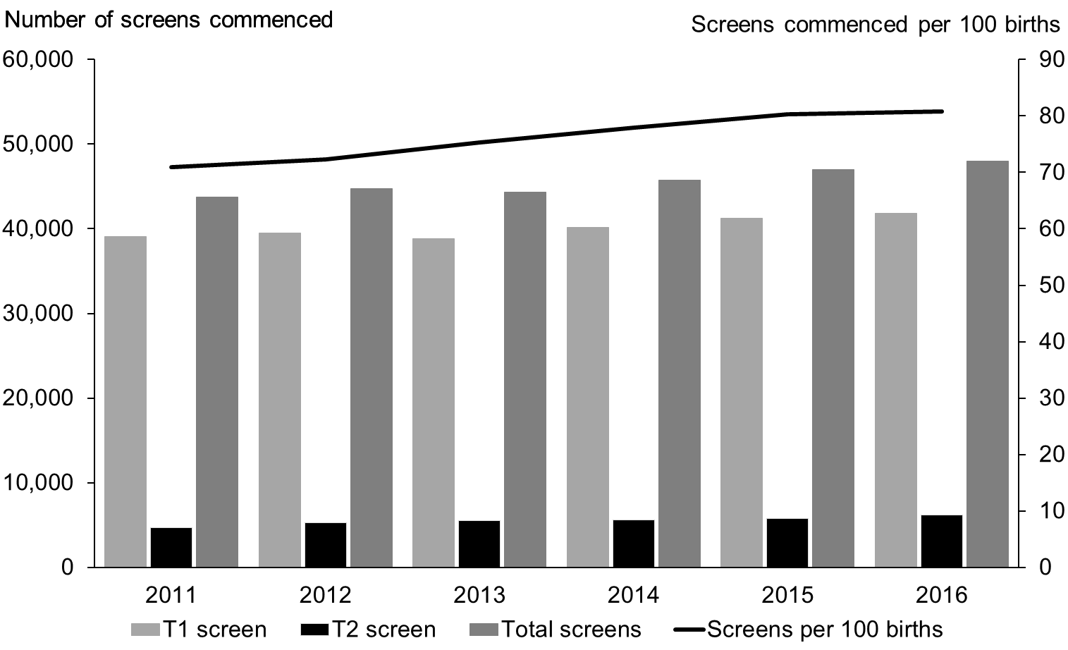

Screens commenced by DHB
Figure 3 shows the screening commencement rates by DHB for 2016. There was a large variation in rates from 59 per 100 births in Northland to 92 per 100 births in Canterbury (see Figure 3). Over half of all DHBs had rates of above 80 per 100 births. Table 2 gives a full breakdown by the trimester of the screen.

Figure 3: Screens commenced by DHB, January 2016 to December 2016
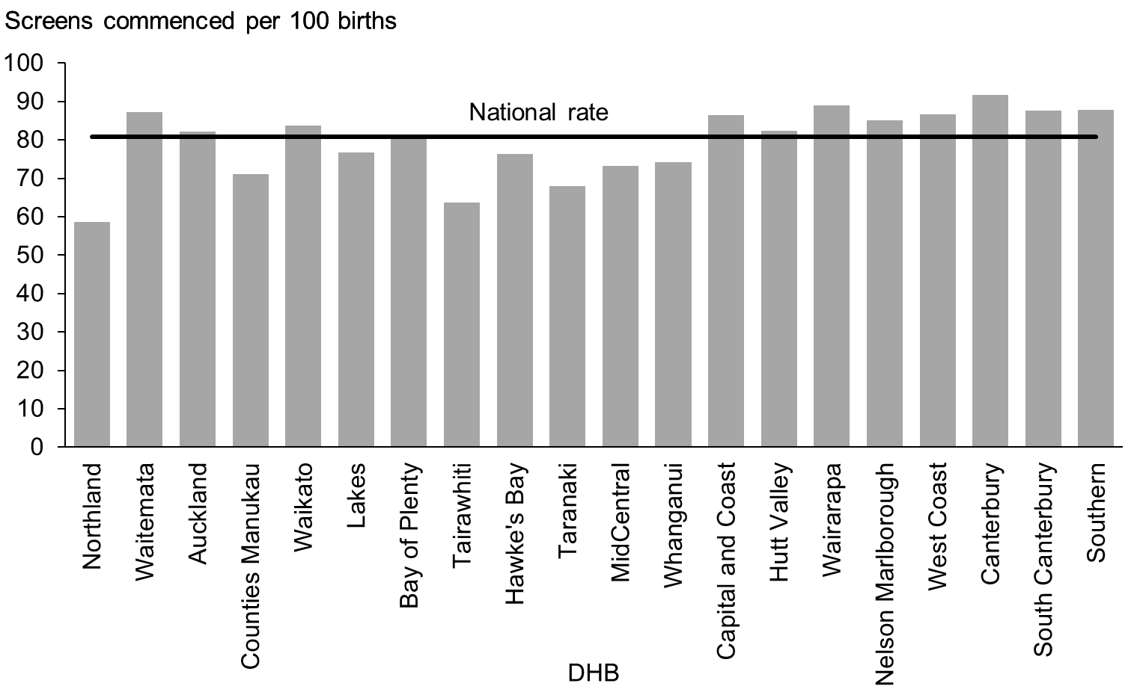

Table 2: Screens commenced by trimester and DHB, January 2016 to December 2016
DHB | Number of screens commenced |  |  | Screens commenced (per 100 births)
 | First trimester | Second trimester | Total | First trimester | Second trimester | Total
Northland | 1,113 | 214 | 1,327 | 49.1 | 9.4 | 58.6
Waitemata | 6,152 | 759 | 6,911 | 77.5 | 9.6 | 87.1
Auckland | 4,264 | 578 | 4,842 | 72.2 | 9.8 | 82.0
Counties Manukau | 4,600 | 1,255 | 5,855 | 55.8 | 15.2 | 71.0
Waikato | 4,023 | 464 | 4,487 | 75.1 | 8.7 | 83.7
Lakes | 1,054 | 131 | 1,185 | 68.2 | 8.5 | 76.7
Bay of Plenty | 2,151 | 200 | 2,351 | 74.2 | 6.9 | 81.1
Tairawhiti | 428 | 65 | 493 | 55.2 | 8.4 | 63.6
Hawke’s Bay | 1,369 | 200 | 1,569 | 66.5 | 9.7 | 76.2
Taranaki | 805 | 167 | 972 | 56.1 | 11.6 | 67.8
MidCentral | 1,355 | 167 | 1,522 | 65.1 | 8.0 | 73.1
Whanganui | 505 | 88 | 593 | 63.1 | 11.0 | 74.1
Capital and Coast | 2,680 | 303 | 2,983 | 77.5 | 8.8 | 86.3
Hutt Valley | 1,370 | 247 | 1,617 | 69.7 | 12.6 | 82.2
Wairarapa | 351 | 60 | 411 | 76.0 | 13.0 | 89.0
Nelson Marlborough | 1,184 | 133 | 1,317 | 76.5 | 8.6 | 85.1
West Coast | 238 | 37 | 275 | 74.8 | 11.6 | 86.5
Canterbury | 5,089 | 685 | 5,774 | 80.7 | 10.9 | 91.5
South Canterbury | 470 | 99 | 569 | 72.3 | 15.2 | 87.5
Southern | 2,615 | 300 | 2,915 | 78.8 | 9.0 | 87.8
Total | 41,816 | 6,152 | 47,968 | Av.70.5 | 10.4 | 80.9

Most DHBs showed an increase in their rate of screens commenced between 2011 and 2016, or had fairly stable rates (see Table 3).

Table 3: Screens commenced per 100 births by DHB, January 2011 to December 2016
DHB | Screens commenced (per 100 births)
 | 2011 | 2012 | 2013 | 2014 | 2015 | 2016
Northland | 46.5 | 49.7 | 52.9 | 55.6 | 60.1 | 58.6
Waitemata | 84.0 | 82.9 | 86.3 | 86.3 | 88.4 | 87.1
Auckland | 75.1 | 74.5 | 82.4 | 84.0 | 85.7 | 82.0
Counties Manukau | 60.9 | 63.4 | 64.8 | 68.7 | 71.1 | 71.0
Waikato | 73.1 | 72.1 | 76.4 | 80.4 | 81.8 | 83.7
Lakes | 60.5 | 67.8 | 70.1 | 77.4 | 74.3 | 76.7
Bay of Plenty | 65.3 | 68.5 | 69.6 | 72.4 | 77.6 | 81.1
Tairawhiti | 44.5 | 49.2 | 53.2 | 59.3 | 68.3 | 63.6
Hawke’s Bay | 55.8 | 61.9 | 64.6 | 66.0 | 72.6 | 76.2
Taranaki | 62.6 | 60.2 | 61.4 | 68.2 | 74.9 | 67.8
MidCentral | 51.1 | 54.4 | 58.3 | 59.3 | 63.9 | 73.1
Whanganui | 45.0 | 44.9 | 47.9 | 61.0 | 70.5 | 74.1
Capital and Coast | 76.4 | 79.4 | 78.1 | 80.3 | 83.4 | 86.3
Hutt Valley | 71.0 | 70.7 | 72.7 | 78.6 | 78.7 | 82.2
Wairarapa | 72.8 | 69.1 | 76.6 | 81.6 | 83.8 | 89.0
Nelson Marlborough | 87.8 | 90.8 | 87.4 | 97.6 | 96.0 | 85.1
West Coast | 68.9 | 76.3 | 81.1 | 88.3 | 82.4 | 86.5
Canterbury | 85.4 | 86.8 | 90.3 | 89.5 | 89.4 | 91.5
South Canterbury | 92.3 | 85.5 | 88.1 | 78.8 | 86.4 | 87.5
Southern | 75.3 | 80.0 | 81.4 | 83.3 | 85.1 | 87.8
National average | 70.9 | 72.3 | 75.3 | 78.0 | 80.3 | 80.9

Screens commenced by age, ethnicity and deprivation
Table 4 provides an overall view of screens commenced by age, ethnicity and NZ deprivation quintile for January 2011 to December 2016. During this reporting period the overall rate of screens commenced has increased and though variation between age, ethnicity and deprivation is still evident these differences have become less marked.

Table 4: Screens commenced by age of mother, ethnicity and NZ deprivation quintile, January 2011 to December 2016
 | Number of screens commenced |  |  |  |  |  | Screens commenced (per 100 births)
 | 2011 | 2012 | 2013 | 2014 | 2015 | 2016 | 2011 | 2012 | 2013 | 2014 | 2015 | 2016
Age at screen
Under 20 years | 2,282 | 2,128 | 1,947 | 1,990 | 1,925 | 1,829 | 56.4 | 54.5 | 58.5 | 66.6 | 69.1 | 74.9
20–24 years | 6,817 | 6,966 | 6,932 | 7,055 | 7,109 | 7,000 | 58.3 | 60.8 | 64.2 | 68.7 | 71.5 | 73.0
25–29 years | 11,509 | 12,078 | 12,022 | 12,800 | 13,189 | 13,943 | 74.1 | 75.8 | 78.8 | 81.5 | 84.0 | 84.3
30–34 years | 13,433 | 13,751 | 13,914 | 14,623 | 15,124 | 15,732 | 78.0 | 78.8 | 83.0 | 83.2 | 84.5 | 85.6
35–39 years | 8,027 | 8,040 | 7,628 | 7,610 | 8,007 | 7,781 | 74.9 | 77.2 | 76.0 | 78.6 | 82.0 | 78.1
40–44 years | 1,636 | 1,716 | 1,767 | 1,626 | 1,593 | 1,574 | 68.1 | 66.5 | 72.6 | 69.3 | 69.3 | 69.2
45 years and over | 73 | 77 | 80 | 81 | 78 | 109 | 57.9 | 64.2 | 55.9 | 61.4 | 56.1 | 86.5
Ethnicity
Māori | 5,540 | 5,881 | 5,805 | 6,284 | 6,256 | 7,176 | 34.9 | 37.3 | 39.6 | 43.9 | 42.9 | 48.7
Pacific | 3,055 | 3,102 | 2,999 | 3,005 | 3,120 | 3,089 | 43.2 | 45.1 | 47.2 | 48.7 | 51.5 | 52.9
Asian | 6,484 | 7,405 | 7,474 | 8,438 | 8,695 | 9,851 | 91.0 | 87.7 | 91.7 | 91.8 | 94.4 | 93.6
Other | 28,698 | 28,368 | 28,012 | 28,058 | 28,954 | 27,852 | 90.6 | 92.2 | 94.5 | 96.6 | 100.9 | 98.7
NZ deprivation quintile
Quintile 1 | 8,130 | 8,073 | 7,654 | 7,732 | 7,898 | 8,509 | 95.6 | 93.1 | 93.6 | 91.3 | 95.8 | 98.2
Quintile 2 | 8,174 | 8,395 | 8,231 | 8,413 | 8,652 | 8,780 | 86.0 | 87.3 | 89.0 | 91.7 | 92.7 | 90.7
Quintile 3 | 8,529 | 8,685 | 8,730 | 8,878 | 9,130 | 9,278 | 76.5 | 77.8 | 82.2 | 84.1 | 86.3 | 86.6
Quintile 4 | 9,526 | 9,822 | 9,882 | 10,353 | 10,475 | 10,584 | 69.1 | 71.9 | 73.7 | 78.0 | 79.1 | 79.6
Quintile 5 | 9,409 | 9,777 | 9,789 | 10,408 | 10,864 | 10,805 | 50.0 | 52.1 | 56.6 | 60.5 | 63.8 | 63.7
Unknown | 9 | 4 | 4 | 1 | 6 | 12
National | 43,777 | 44,756 | 44,290 | 45,785 | 47,025 | 47,968 | 70.9 | 72.3 | 75.3 | 78.0 | 80.3 | 80.9
# Rate suppressed if the number of screens was <10.

Figure 4: Screens commenced by age of mother at screen, January 2016 to December 2016
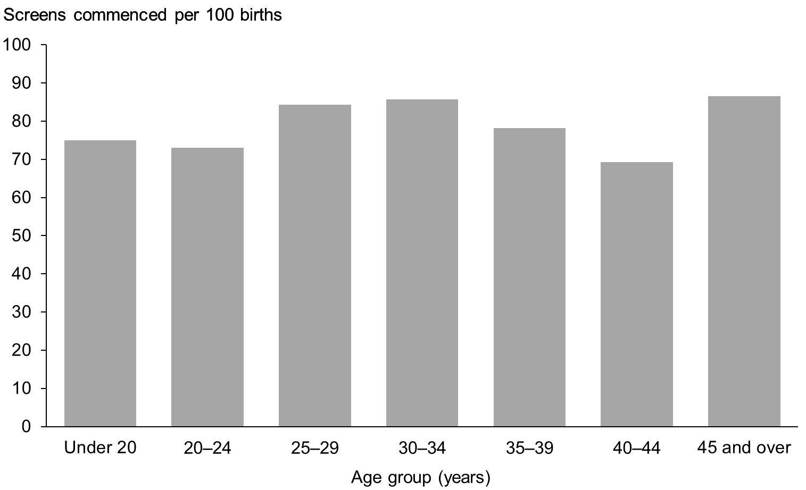

Figure 5: Screens commenced by ethnicity of mother, January 2016 to December 2016
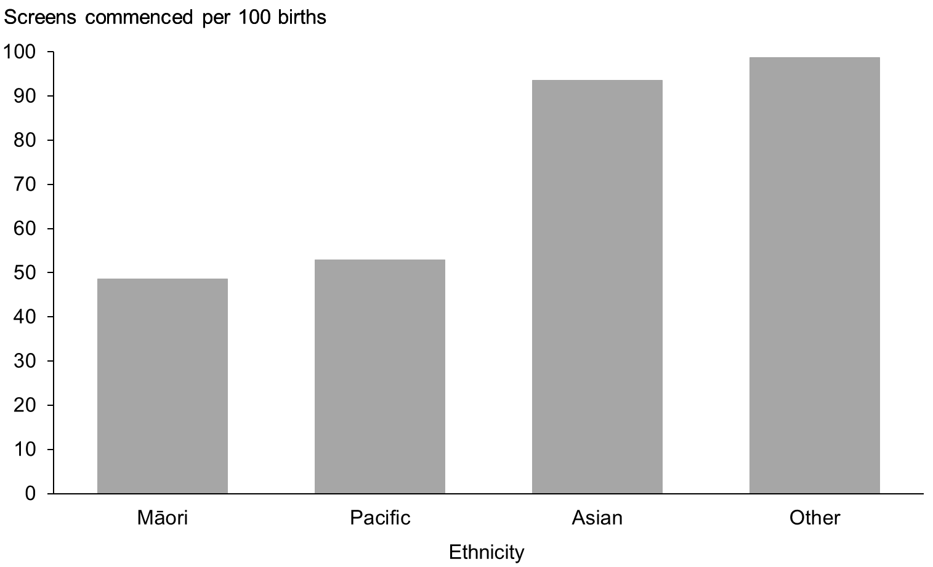

Differences in screening commencement rates by ethnicity remained consistent for 2016. Women of Other ethnicity had the highest rate (99 of 100 births) followed by Asian women (94 of 100 births). The rate of commenced screens for Pacific and Māori women was lower at 53 per 100 births and 49 per 100 births respectively (see Figure 5). All groups have shown increasing rates over the five years, particularly for Māori with an absolute increase of almost 14 percentage points from 35% in 2011 to 49% in 2016 (see Table 4). This rate is however well below the national average.

Figure 6: Screens commenced by NZ deprivation quintile, January 2016 to December 2016
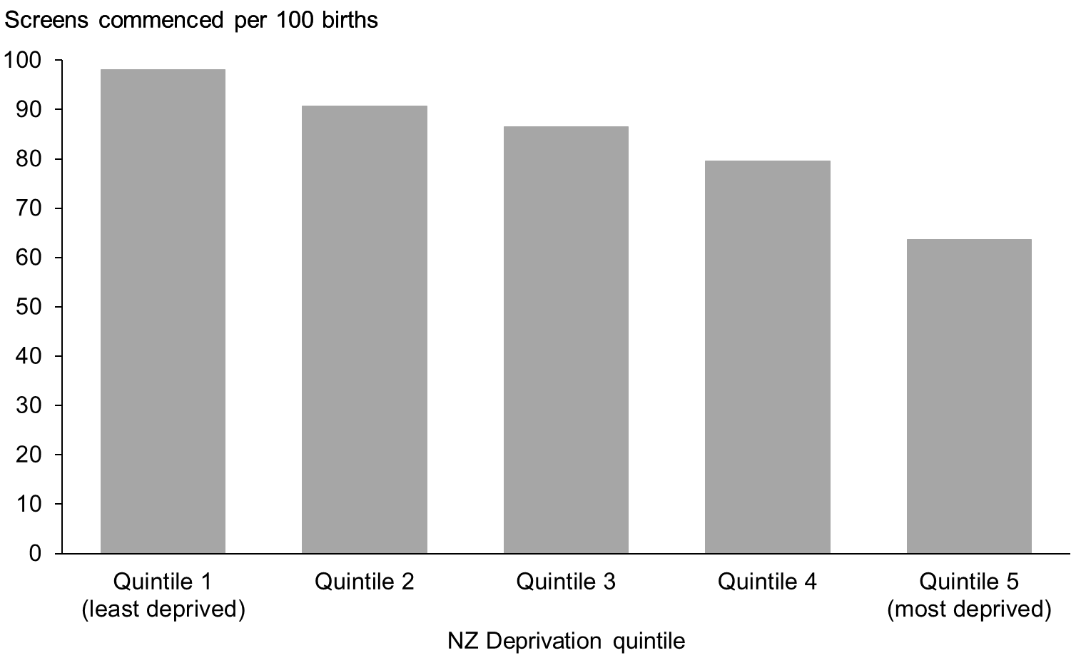

A trend of higher screening commencement rates for women in less deprived areas was evident, with 98 women per 100 per births starting screening for quintile 1 women in 2016 compared with 64 per 100 births for quintile 5 (see Figure 6). All quintiles showed a rate increase between 2011 and 2016, particularly women in more deprived regions (see Table 4).

Indicator 2:
Screens completed
This indicator reports the number of screens completed by trimester of screening, DHB, age, ethnicity, and NZ deprivation quintile.

Total screens completed by trimester
During 2016, a total of 43,519 screens were completed, a rate of 73 per 100 births. Table 5 and Figure 7 show the total number of screens completed per year and trimester of screen. Across all years the majority of screens were completed in the first trimester. The total number and rate of completed screens has increased annually since 2011 (from 63% to 73% in 2016).

Table 5: Total screens completed by trimester, January 2011 to December 2016
Trimester of screen | Number and rate of screens completed
 | 2011 | 2012 | 2013 | 2014 | 2015 | 2016
T1 screen | 34,735 | 35,691 | 35,464 | 36,280 | 36,739 | 37,511
T2 screen | 4,446 | 4,957 | 5,269 | 5,456 | 5,517 | 6,008
Total screens | 39,181 | 40,648 | 40,733 | 41,736 | 42,256 | 43,519
Screens per 100 births | 63.4 | 65.7 | 69.3 | 71.1 | 72.2 | 73.4

Figure 7: Count and rate of screens completed, January 2011 to December 2016
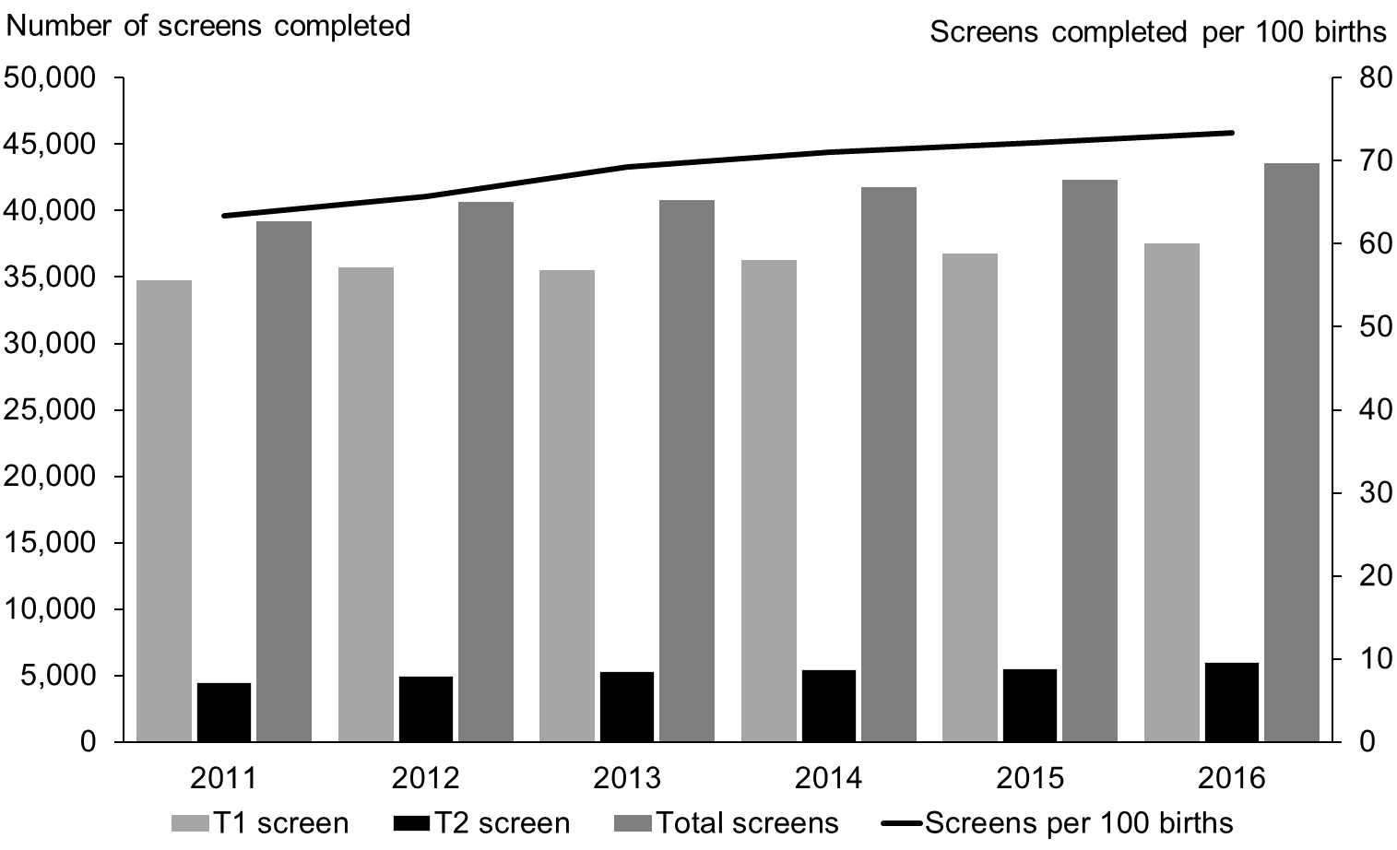

Screens completed by DHB
Screening completion rates for 2016 varied across DHBs from 51 per 100 births in Northland to 82 per 100 births in Canterbury (see Figure 8). Table 7 gives a full breakdown by the trimester of the screen.

Figure 8: Screens completed by DHB, January 2016 to December 2016
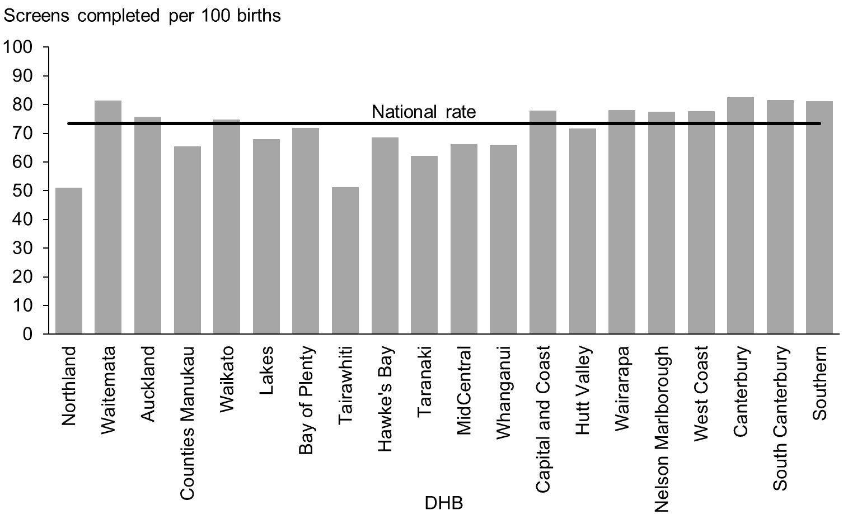

Table 6: Screening completion by trimester and DHB, January 2016 to December 2016
DHB | Number of screens completed |  |  | Screens completed (per 100 births)
 | First trimester | Second trimester | Total | First trimester | Second trimester | Total
Northland | 941 | 212 | 1,153 | 41.5 | 9.4 | 50.9
Waitemata | 5,715 | 741 | 6,456 | 72.0 | 9.3 | 81.4
Auckland | 3,899 | 565 | 4,464 | 66.0 | 9.6 | 75.6
Counties Manukau | 4,173 | 1,221 | 5,394 | 50.6 | 14.8 | 65.4
Waikato | 3,556 | 445 | 4,001 | 66.4 | 8.3 | 74.7
Lakes | 922 | 126 | 1,048 | 59.7 | 8.2 | 67.8
Bay of Plenty | 1,887 | 192 | 2,079 | 65.1 | 6.6 | 71.7
Tairawhiti | 333 | 63 | 396 | 43.0 | 8.1 | 51.1
Hawke’s Bay | 1,216 | 196 | 1,412 | 59.0 | 9.5 | 68.5
Taranaki | 725 | 165 | 890 | 50.6 | 11.5 | 62.1
MidCentral | 1,212 | 165 | 1,377 | 58.2 | 7.9 | 66.1
Whanganui | 441 | 85 | 526 | 55.1 | 10.6 | 65.8
Capital and Coast | 2,393 | 296 | 2,689 | 69.2 | 8.6 | 77.8
Hutt Valley | 1,167 | 240 | 1,407 | 59.4 | 12.2 | 71.6
Wairarapa | 301 | 59 | 360 | 65.2 | 12.8 | 77.9
Nelson Marlborough | 1,065 | 133 | 1,198 | 68.8 | 8.6 | 77.4
West Coast | 210 | 37 | 247 | 66.0 | 11.6 | 77.7
Canterbury | 4,525 | 674 | 5,199 | 71.7 | 10.7 | 82.4
South Canterbury | 433 | 97 | 530 | 66.6 | 14.9 | 81.5
Southern | 2,397 | 296 | 2,693 | 72.2 | 8.9 | 81.1
Total | 37,511 | 6,008 | 43,519 | Av. 63.2 | 10.1 | 73.4

Similar to screens commenced, most DHBs showed a trend of increasing rates of screening completion over the six years covered in this report.

Table 7: Screening completion by DHB, January 2011 to December 2016
DHB | Screens completed (per 100 births)
 | 2011 | 2012 | 2013 | 2014 | 2015 | 2016
Northland | 41.1 | 44.4 | 47.1 | 48.0 | 51.6 | 50.9
Waitemata | 78.0 | 77.9 | 82.1 | 81.0 | 81.7 | 81.4
Auckland | 70.5 | 69.5 | 77.7 | 78.8 | 79.1 | 75.6
Counties Manukau | 53.9 | 57.3 | 59.6 | 63.2 | 64.4 | 65.4
Waikato | 65.3 | 64.2 | 69.2 | 72.5 | 72.4 | 74.7
Lakes | 53.1 | 59.1 | 62.6 | 69.9 | 65.7 | 67.8
Bay of Plenty | 58.3 | 61.7 | 62.0 | 64.5 | 67.8 | 71.7
Tairawhiti | 39.6 | 44.4 | 47.1 | 51.5 | 53.8 | 51.1
Hawke’s Bay | 50.2 | 55.9 | 59.9 | 59.4 | 64.2 | 68.5
Taranaki | 58.2 | 55.6 | 55.1 | 61.2 | 66.3 | 62.1
MidCentral | 45.3 | 49.5 | 53.8 | 54.0 | 56.9 | 66.1
Whanganui | 40.2 | 41.8 | 45.0 | 53.1 | 58.5 | 65.8
Capital and Coast | 67.9 | 71.9 | 70.9 | 72.6 | 75.1 | 77.8
Hutt Valley | 59.1 | 62.5 | 64.7 | 68.9 | 68.0 | 71.6
Wairarapa | 62.8 | 59.5 | 66.7 | 70.6 | 72.8 | 77.9
Nelson Marlborough | 78.6 | 81.3 | 78.1 | 87.6 | 84.7 | 77.4
West Coast | 55.6 | 68.5 | 72.3 | 78.9 | 72.3 | 77.7
Canterbury | 72.4 | 75.8 | 81.9 | 81.2 | 80.6 | 82.4
South Canterbury | 87.2 | 82.6 | 85.6 | 75.3 | 79.8 | 81.5
Southern | 67.3 | 73.7 | 75.5 | 74.8 | 77.9 | 81.1
National average | 63.4 | 65.7 | 69.3 | 71.1 | 72.2 | 73.4

Screens completed by age, ethnicity and deprivation
Table 8 provides an overall view of screens completed by age, ethnicity and NZ deprivation quintile for January 2011 to December 2016, with similar trends to screening commencement. In the six years of reporting, screening completion rates were highest in the 30–34 year age group with 80 women completing screening per 100 births in 2016.

Screening completion rates were highest among women of Other ethnicity at 91 per 100 births for 2016. This was followed closely by Asian women at 88 per 100 births. The rate of completed screens for Pacific and Māori women remains lower at 46 per 100 births and 40 per 100 births respectively (see Figure 10). Completion rates improved in all ethnic groups with the greatest improvement seen in Māori and Pacific women (see Table 8).

Screening completion rates were highest among women in less deprived areas with a rate of 91 per 100 per births for quintile 1 in 2016 compared with 56 per 100 births for quintile 5 (see Figure 11).

Table 8: Screens completed by age of mother, ethnicity and NZ deprivation quintile, January 2011 to December 2016
 | Number of screens completed |  |  |  |  |  | Screens completed  (per 100 births)
 | 2011 | 2012 | 2013 | 2014 | 2015 | 2016 | 2011 | 2012 | 2013 | 2014 | 2015 | 2016
Age at screen
Under 20 years | 1,808 | 1,699 | 1,610 | 1,604 | 1,510 | 1,474 | 44.7 | 43.5 | 48.4 | 53.6 | 54.2 | 60.3
20–24 years | 5,754 | 5,890 | 6,010 | 6,070 | 5,992 | 6,079 | 49.2 | 51.4 | 55.6 | 59.1 | 60.3 | 63.4
25–29 years | 10,276 | 10,997 | 11,097 | 11,685 | 11,824 | 12,675 | 66.1 | 69.0 | 72.7 | 74.4 | 75.3 | 76.6
30–34 years | 12,353 | 12,859 | 13,089 | 13,675 | 14,030 | 14,709 | 71.7 | 73.7 | 78.0 | 77.8 | 78.3 | 80.1
35–39 years | 7,453 | 7,543 | 7,214 | 7,144 | 7,430 | 7,137 | 69.6 | 72.5 | 71.9 | 73.8 | 76.1 | 71.6
40–44 years | 1,474 | 1,588 | 1,643 | 1,486 | 1,406 | 1,366 | 61.3 | 61.6 | 67.5 | 63.3 | 61.2 | 60.0
45 years and over | 63 | 72 | 70 | 72 | 64 | 79 | 50.0 | 60.0 | 49.0 | 54.5 | 46.0 | 62.7
Ethnicity
Māori | 4,561 | 4,880 | 4,893 | 5,178 | 4,911 | 5,924 | 28.7 | 30.9 | 33.4 | 36.2 | 33.7 | 40.2
Pacific | 2,479 | 2,591 | 2,606 | 2,598 | 2,626 | 2,673 | 35.1 | 37.7 | 41.0 | 42.1 | 43.3 | 45.8
Asian | 6,024 | 6,990 | 7,091 | 8,034 | 8,114 | 9,304 | 84.5 | 82.7 | 87.0 | 87.4 | 88.1 | 88.4
Other | 26,117 | 26,187 | 26,143 | 25,926 | 26,605 | 25,618 | 82.4 | 85.1 | 88.2 | 89.2 | 92.7 | 90.8
NZ deprivation quintile
Quintile 1 | 7,519 | 7,520 | 7,255 | 7,242 | 7,335 | 7,847 | 88.5 | 86.7 | 88.7 | 85.5 | 89.0 | 90.5
Quintile 2 | 7,480 | 7,805 | 7,749 | 7,867 | 8,028 | 8,126 | 78.7 | 81.2 | 83.8 | 85.8 | 86.0 | 84.0
Quintile 3 | 7,748 | 8,028 | 8,102 | 8,195 | 8,323 | 8,541 | 69.5 | 71.9 | 76.3 | 77.6 | 78.6 | 79.7
Quintile 4 | 8,401 | 8,851 | 9,001 | 9,325 | 9,307 | 9,554 | 60.9 | 64.8 | 67.1 | 70.3 | 70.3 | 71.9
Quintile 5 | 8,027 | 8,441 | 8,622 | 9,106 | 9,257 | 9,440 | 42.7 | 45.0 | 49.8 | 52.9 | 54.3 | 55.6
Unknown | 6 | 3 | 4 | 1 | 6 | 11
National | 39,181 | 40,648 | 40,733 | 41,736 | 42,256 | 43,519 | 63.4 | 65.7 | 69.3 | 71.1 | 72.2 | 73.4

Figure 9: Screens completed by age of mother at screen, January 2016 to December 2016
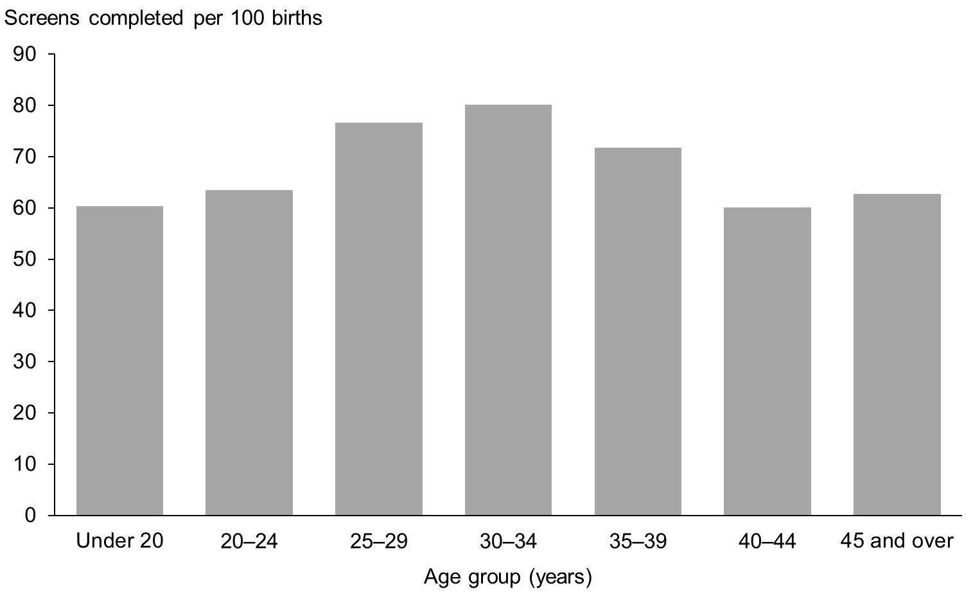

Figure 10: Screens completed by ethnicity of mother, January 2016 to December 2016
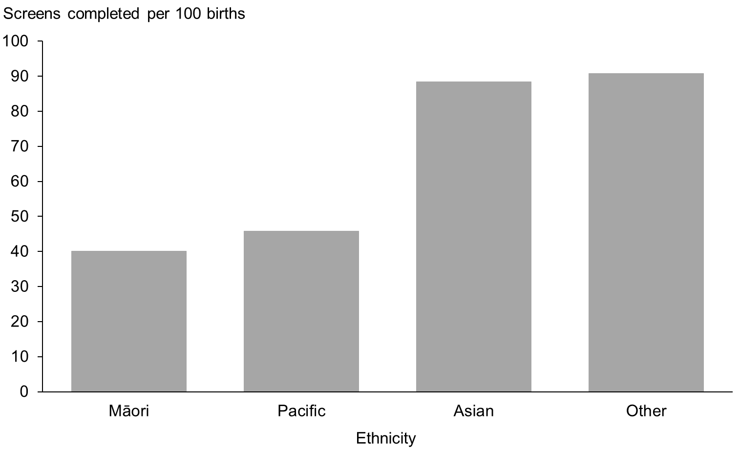

Figure 11: Screens completed by NZ deprivation quintile of mother, January 2016 to December 2016
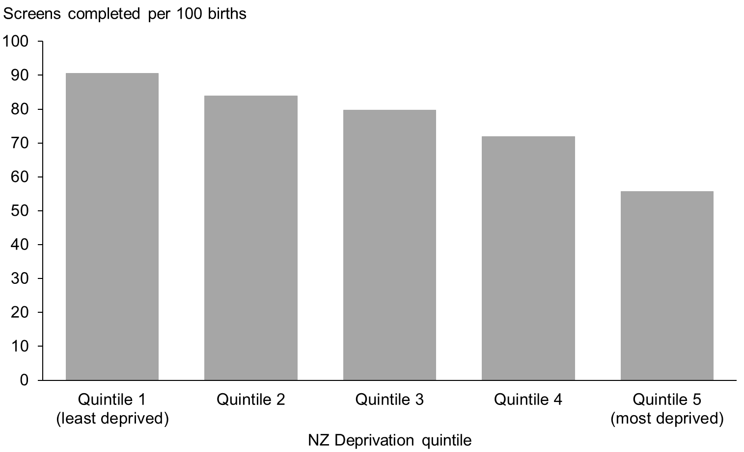

Indicator 3:
Screening pathway variance
This section reports on the number of screens completed in the second trimester which included first trimester screening components. First trimester combined screening requires a blood sample (PAPP-A and ßhCG) and ultrasound scan measurements of NT and CRL. Without both items a risk is not calculated and a second trimester blood sample is recommended. Any information available from the first trimester (NT or PAPP-A) will be included in the second trimester risk assessment.

Second trimester results with an NT measurement indicate that the screening laboratory did not receive a suitable first trimester blood sample. Second trimester results with PAPP-A indicate that the screening laboratory did not receive an NT scan report, or that the scan was performed outside the accepted timeframe for first trimester screening.

Screening pathway variance by year
Table 9 shows the number and proportion of second trimester screening results that included first trimester inputs over the period from 2011 to 2016. This has been broken down by the type of pathway variance.

The largest pathway variance was due to second trimester screens with an NT measurement (44% in 2016). PAPP-A was included in 8% of second trimester screens in 2016, higher than previous years.

Table 9: Screening pathway variance by type, January 2011 to December 2016
Year | Second trimester screening results
 | Number |  |  | Percentage
 | Total T2 screens | with NT | with PAPP-A | with NT | with PAPP-A
2011 | 4,446 | 1,811 | 264 | 40.7 | 5.9
2012 | 4,957 | 2,048 | 291 | 41.3 | 5.9
2013 | 5,269 | 2,219 | 361 | 42.1 | 6.9
2014 | 5,456 | 2,379 | 376 | 43.6 | 6.9
2015 | 5,517 | 2,466 | 344 | 44.7 | 6.2
2016 | 6,008 | 2,670 | 500 | 44.4 | 8.3

Screening pathway variance by DHB
Table 10 shows a breakdown of screening pathway variance by DHB and type of variance for the 2016 year. Care should be taken with interpretation given the low number of T2 screens for many DHBs. In general, the national result is reflected at DHB level with a far higher number of women having an NT scan and a T2 screen than those having a T2 screen with PAPP-A.

The crown rump length (CRL) measured by ultrasound is used by the screening laboratory to calculate gestation (may be different from the clinical gestation) leading to women being assessed in a different trimester.

Table 10: Screening pathway variance by DHB, January 2016 to December 2016
DHB | Second trimester screening results
 | Number |  |  | Percentage
 | Total T2 screens | with NT | with PAPP-A | with NT | with PAPP-A
Northland | 212 | 74 | 19 | 34.9 | 9.0
Waitemata | 741 | 343 | 61 | 46.3 | 8.2
Auckland | 565 | 216 | 53 | 38.2 | 9.4
Counties Manukau | 1,221 | 377 | 113 | 30.9 | 9.3
Waikato | 445 | 223 | 31 | 50.1 | 7.0
Lakes | 126 | 55 | 10 | 43.7 | 7.9
Bay of Plenty | 192 | 105 | 9 | 54.7 | 4.7
Tairawhiti | 63 | 25 | 12 | 39.7 | 19.0
Hawke’s Bay | 196 | 74 | 9 | 37.8 | 4.6
Taranaki | 165 | 55 | 19 | 33.3 | 11.5
MidCentral | 165 | 77 | 11 | 46.7 | 6.7
Whanganui | 85 | 44 | 4 | 51.8 | 4.7
Capital and Coast | 296 | 166 | 22 | 56.1 | 7.4
Hutt Valley | 240 | 116 | 21 | 48.3 | 8.8
Wairarapa | 59 | 33 | 5 | 55.9 | 8.5
Nelson Marlborough | 133 | 75 | 5 | 56.4 | 3.8
West Coast | 37 | 18 | 6 | 48.6 | 16.2
Canterbury | 674 | 357 | 69 | 53.0 | 10.2
South Canterbury | 97 | 59 | 13 | 60.8 | 13.4
Southern | 296 | 178 | 8 | 60.1 | 2.7
Total | 6,008 | 2,670 | 500 | Av. 44.4 | 8.3

Screening pathway variance by age, ethnicity and deprivation
Table 11 shows a breakdown of screening pathway variance by age, ethnicity and NZ deprivation quintile for the 2016 year. The results show higher proportions for pathway variance for women of Other ethnicity, and women in areas of lower deprivation.

Table 11: Screening pathway variance by age, ethnicity and NZ deprivation quintile, January 2016 to December 2016
 | Second trimester screening results
 | Number |  |  | Percentage
 | Total T2 screens | with NT | with PAPP-A | with NT | with PAPP-A
Age at screen
Under 20 years | 423 | 149 | 19 | 35.2 | 4.5
20–24 years | 1,270 | 560 | 80 | 44.1 | 6.3
25–29 years | 1,808 | 833 | 152 | 46.1 | 8.4
30–34 years | 1,551 | 718 | 145 | 46.3 | 9.3
35–39 years | 766 | 332 | 89 | 43.3 | 11.6
40–44 years | 178 | 71 | 14 | 39.9 | 7.9
45 years and over | 12 | 7 | 1 | 58.3 | 8.3
Ethnicity
Māori | 1,552 | 632 | 87 | 40.7 | 5.6
Pacific | 982 | 276 | 76 | 28.1 | 7.7
Asian | 1,224 | 500 | 116 | 40.8 | 9.5
Other | 2,250 | 1,262 | 221 | 56.1 | 9.8
NZ deprivation quintile
Quintile 1 | 657 | 367 | 51 | 55.9 | 7.8
Quintile 2 | 822 | 428 | 82 | 52.1 | 10.0
Quintile 3 | 915 | 470 | 79 | 51.4 | 8.6
Quintile 4 | 1,420 | 633 | 123 | 44.6 | 8.7
Quintile 5 | 2,189 | 770 | 165 | 35.2 | 7.5
Unknown | 5 | 2 | 0 | 40.0 | 0.0
Total | 6,008 | 2,670 | 500 | Av 44.4 | 8.3

Indicator 4:
Incomplete screens
This section reports on the number of women who commenced screening but were not issued with a risk result. Women that start screening in trimester 1 but complete screening in trimester 2 are not included in this indicator and are instead covered under indicator 3, pathway variances.

Total incomplete screens
Table 12 shows the total number of incomplete screens by calendar year and trimester of screen. Nearly all incomplete screens related to the first trimester, which reflects the different components required to complete screening depending on trimester. First trimester screening requires a blood sample and an NT scan, whereas second trimester screening involves only a blood sample. The total number of incomplete screens for 2016 was 4,449, which equates to 9% of screens commenced that year and demonstrates an improvement from 2015.

Table 12: Incomplete screens by trimester, January 2011 to December 2016
Trimester of screen | Number of incomplete screens
 | 2011 | 2012 | 2013 | 2014 | 2015 | 2016
T1 screen | 4,352 | 3,835 | 3,339 | 3,892 | 4,544 | 4,305
T2 screen | 244 | 273 | 218 | 157 | 225 | 144
Total screens | 4,596 | 4,108 | 3,557 | 4,049 | 4,769 | 4,449

Incomplete T1 screens by reason incomplete
Table 13 provides a breakdown of incomplete T1 screens according to which component of the screen was missing. Results have been reported as a percentage of all commenced screens, and then as a percentage of all incomplete screens.

The proportion of incomplete T1 screens out of all commenced T1 screens in 2016 was 10%. This was the result of both screens without blood samples and screens without NT scans. The majority of incomplete screens in T1 were due to a missing blood sample.

Table 13: Incomplete T1 screens by reason incomplete, January 2011 to December 2016
Year | Commenced first trimester |  |  | Reason incomplete |  |  | Incomplete as percentage of commenced |  |  | Type as percentage of all incomplete trimester 1 screens
 | No result issued | Result issued | Total | No blood | No NT scan | No weight | T1 no blood | T1 no NT scan | Total T1 incompletes | T1 no blood | T1 no NT scan
2011 | 4,352 | 34,735 | 39,087 | 3,294 | 1,058 | – | 8.4 | 2.7 | 11.1 | 75.7 | 24.3
2012 | 3,835 | 35,691 | 39,526 | 2,844 | 991 | – | 7.2 | 2.5 | 9.7 | 74.2 | 25.8
2013 | 3,339 | 35,464 | 38,803 | 2,318 | 1,021 | – | 6.0 | 2.6 | 8.6 | 69.4 | 30.6
2014 | 3,892 | 36,280 | 40,172 | 2,630 | 1,262 | – | 6.5 | 3.1 | 9.7 | 67.6 | 32.4
2015 | 4,544 | 36,739 | 41,283 | 2,925 | 1,619 | – | 7.1 | 3.9 | 11.0 | 64.4 | 35.6
2016 | 4,305 | 37,511 | 41,816 | 2,946 | 1,335 | 24 | 7.0 | 3.2 | 10.3 | 68.4 | 31.0

Incomplete T1 screens by reason and DHB
Table 14 provides the same breakdown by DHB. The lower numbers involved limit DHB comparisons. The range in the percentage of screens incomplete due to no blood sample was from 45% (at Taranaki) to 80% (at Whanganui).

Table 14: Incomplete T1 screens by reason and DHB, January 2016 to December 2016
DHB | Commenced first trimester |  |  | Reason incomplete |  |  | Incomplete as percentage of commenced |  |  | Type as percentage of all incomplete
 | No result issued | Result issued | Total | No blood | No NT scan | No weight | T1 no blood | T1 no NT scan | Total T1 | T1 no blood | T1 no NT scan
Northland | 172 | 941 | 1,113 | 118 | 54 | 0 | 10.6 | 4.9 | 15.5 | 68.6 | 31.4
Waitemata | 437 | 5,715 | 6,152 | 275 | 162 | 0 | 4.5 | 2.6 | 7.1 | 62.9 | 37.1
Auckland | 365 | 3,899 | 4,264 | 254 | 111 | 0 | 6.0 | 2.6 | 8.6 | 69.6 | 30.4
Counties Manukau | 427 | 4,173 | 4,600 | 252 | 175 | 0 | 5.5 | 3.8 | 9.3 | 59.0 | 41.0
Waikato | 467 | 3,556 | 4,023 | 346 | 121 | 0 | 8.6 | 3.0 | 11.6 | 74.1 | 25.9
Lakes | 132 | 922 | 1,054 | 100 | 32 | 0 | 9.5 | 3.0 | 12.5 | 75.8 | 24.2
Bay of Plenty | 264 | 1,887 | 2,151 | 188 | 76 | 0 | 8.7 | 3.5 | 12.3 | 71.2 | 28.8
Tairawhiti | 95 | 333 | 428 | 59 | 34 | 2 | 13.8 | 7.9 | 22.2 | 62.1 | 35.8
Hawke’s Bay | 153 | 1,216 | 1,369 | 112 | 39 | 2 | 8.2 | 2.8 | 11.2 | 73.2 | 25.5
Taranaki | 80 | 725 | 805 | 36 | 44 | 0 | 4.5 | 5.5 | 9.9 | 45.0 | 55.0
MidCentral | 143 | 1,212 | 1,355 | 107 | 35 | 1 | 7.9 | 2.6 | 10.6 | 74.8 | 24.5
Whanganui | 64 | 441 | 505 | 51 | 10 | 3 | 10.1 | 2.0 | 12.7 | 79.7 | 15.6
Capital and Coast | 287 | 2,393 | 2,680 | 203 | 83 | 1 | 7.6 | 3.1 | 10.7 | 70.7 | 28.9
Hutt Valley | 203 | 1,167 | 1,370 | 159 | 44 | 0 | 11.6 | 3.2 | 14.8 | 78.3 | 21.7
Wairarapa | 50 | 301 | 351 | 37 | 12 | 1 | 10.5 | 3.4 | 14.2 | 74.0 | 24.0
Nelson Marlborough | 119 | 1,065 | 1,184 | 85 | 34 | 0 | 7.2 | 2.9 | 10.1 | 71.4 | 28.6
West Coast | 28 | 210 | 238 | 21 | 7 | 0 | 8.8 | 2.9 | 11.8 | 75.0 | 25.0
Canterbury | 564 | 4,525 | 5,089 | 382 | 175 | 7 | 7.5 | 3.4 | 11.1 | 67.7 | 31.0
South Canterbury | 37 | 433 | 470 | 28 | 9 | 0 | 6.0 | 1.9 | 7.9 | 75.7 | 24.3
Southern | 218 | 2,397 | 2,615 | 133 | 78 | 7 | 5.1 | 3.0 | 8.3 | 61.0 | 35.8
National | 4,305 | 37,511 | 41,816 | 2,946 | 1,335 | 24 | 7.0 | 3.2 | 10.3 | 68.4 | 31.0

Incomplete T1 screens by age, ethnicity and deprivation
Table 15 shows a breakdown of incomplete screens with reason incomplete, by age, ethnicity, and NZ deprivation quintile for the 2016 year. There were higher rates of incomplete screens for Māori (22%) and Pacific (18%) women when compared with Asian (6%) and Other (9%). The rate of incomplete screens also increased with increasing deprivation (15% for quintile 5 compared with 8% for quintile 1).

Table 15: Incomplete T1 screens by age, ethnicity and NZ deprivation quintile, January 2016 to December 2016
 | Commenced first trimester |  |  | Reason incomplete |  |  | Incomplete as percentage of commenced |  |  | Type as percentage of all incomplete
 | No result issued | Result issued | Total commenced | No blood | No NT scan | No weight | T1 no blood | T1 no NT scan | All T1 incomplete | T1 no blood | T1 no NT scan
Age at screen
Under 20 years | 344 | 1,051 | 1,395 | 257 | 85 | 2 | 18.4 | 6.1 | 24.7 | 74.7 | 24.7
20–24 years | 886 | 4,809 | 5,695 | 653 | 229 | 4 | 11.5 | 4.0 | 15.6 | 73.7 | 25.8
25–29 years | 1,230 | 10,867 | 12,097 | 869 | 349 | 12 | 7.2 | 2.9 | 10.2 | 70.7 | 28.4
30–34 years | 989 | 13,158 | 14,147 | 630 | 356 | 3 | 4.5 | 2.5 | 7.0 | 63.7 | 36.0
35–39 years | 626 | 6,371 | 6,997 | 387 | 237 | 2 | 5.5 | 3.4 | 8.9 | 61.8 | 37.9
40–44 years | 201 | 1,188 | 1,389 | 128 | 73 | – | 9.2 | 5.3 | 14.5 | 63.7 | 36.3
45 years and over | 29 | 67 | 96 | 22 | 6 | 1 | 22.9 | 6.3 | 30.2 | 75.9 | 20.7
Ethnicity
Māori | 1,199 | 4,372 | 5,571 | 907 | 287 | 5 | 16.3 | 5.2 | 21.5 | 75.6 | 23.9
Pacific | 376 | 1,691 | 2,067 | 232 | 143 | 1 | 11.2 | 6.9 | 18.2 | 61.7 | 38.0
Asian | 531 | 8,080 | 8,611 | 298 | 230 | 3 | 3.5 | 2.7 | 6.2 | 56.1 | 43.3
Other | 2,199 | 23,368 | 25,567 | 1,509 | 675 | 15 | 5.9 | 2.6 | 8.6 | 68.6 | 30.7
NZ deprivation quintile
Quintile 1 | 648 | 7,190 | 7,838 | 459 | 186 | 3 | 5.9 | 2.4 | 8.27 | 70.8 | 28.7
Quintile 2 | 643 | 7,304 | 7,947 | 438 | 200 | 5 | 5.5 | 2.5 | 8.1 | 68.1 | 31.1
Quintile 3 | 720 | 7,626 | 8,346 | 486 | 231 | 3 | 5.8 | 2.8 | 8.6 | 67.5 | 32.1
Quintile 4 | 992 | 8,134 | 9,126 | 677 | 309 | 6 | 7.4 | 3.4 | 10.9 | 68.2 | 31.1
Quintile 5 | 1,301 | 7,251 | 8,552 | 885 | 409 | 7 | 10.3 | 4.8 | 15.2 | 68.0 | 31.4
Unknown | 1 | 6 |  | 1 | – | –
National | 4,305 | 37,511 | 41,816 | 2,946 | 1,335 | 24 | 7.0 | 3.2 | 10.3 | 68.4 | 31.0

Incomplete T2 screens
T2 screens do not require an NT scan, just a blood sample, but may be incomplete if missing dating information or no weight, if the sample is taken later than 20 weeks of pregnancy, or if the sample is damaged and not repeated. For 2016, 2% of T2 commenced screens were incomplete, compared with 10% of T1 commenced screens. As Table 16 shows, the percentage of incomplete T2 screens decreased from 5% in 2011 to 2% in 2016.

Table 16: Incomplete T2 screens, January 2011 to December 2016
Year | Commenced second trimester | No result issued | Percentage incomplete
2011 | 4,690 | 244 | 5.2
2012 | 5,230 | 273 | 5.2
2013 | 5,487 | 218 | 4.0
2014 | 5,613 | 157 | 2.8
2015 | 5,742 | 225 | 3.9
2016 | 6,152 | 144 | 2.3
Total | 32,914 | 1,261 | Av of last six years: 3.8

Incomplete T2 screens by DHB
Table 17 shows a breakdown of incomplete T2 screens by DHB for the 2016 year. The very low numbers involved limit meaningful DHB comparisons.

Table 17: Incomplete T2 screens by DHB, January 2016 to December 2016
DHB | Commenced second trimester | No result issued | Percentage incomplete
Northland | 214 | 2 | 0.9
Waitemata | 759 | 18 | 2.4
Auckland | 578 | 13 | 2.2
Counties Manukau | 1,255 | 34 | 2.7
Waikato | 464 | 19 | 4.1
Lakes | 131 | 5 | 3.8
Bay of Plenty | 200 | 8 | 4.0
Tairawhiti | 65 | 2 | 3.1
Hawke’s Bay | 200 | 4 | 2.0
Taranaki | 167 | 2 | 1.2
MidCentral | 167 | 2 | 1.2
Whanganui | 88 | 3 | 3.4
Capital and Coast | 303 | 7 | 2.3
Hutt Valley | 247 | 7 | 2.8
Wairarapa | 60 | 1 | 1.7
Nelson Marlborough | 133 | 0 | 0.0
West Coast | 37 | 0 | 0.0
Canterbury | 685 | 11 | 1.6
South Canterbury | 99 | 2 | 2.0
Southern | 300 | 4 | 1.3
Total | 6,152 | 144 | Av.2.3

Incomplete T2 screens by age, ethnicity and deprivation
Table 18 shows a breakdown of incomplete T2 screens by age, ethnicity and NZ deprivation quintile for 2016. The percentage incomplete was higher for Māori and Pacific women with no clear trends by age and deprivation.

Table 18: Incomplete T2 screens by age, ethnicity and NZ deprivation quintile, January 2016 to December 2016
 | Commenced second trimester | No result issued | Percentage incomplete
Age at screen
Under 20 years | 434 | 11 | 2.5
20–24 years | 1,305 | 35 | 2.7
25–29 years | 1,846 | 38 | 2.1
30–34 years | 1,585 | 34 | 2.1
35–39 years | 784 | 18 | 2.3
40–44 years | 185 | 7 | 3.8
45 years and over | 13 | 1 | 7.7
Ethnicity
Māori | 1,605 | 53 | 3.3
Pacific | 1,022 | 40 | 3.9
Asian | 1,240 | 16 | 1.3
Other | 2,285 | 35 | 1.5
NZ deprivation quintile
Quintile 1 | 671 | 14 | 2.1
Quintile 2 | 833 | 11 | 1.3
Quintile 3 | 932 | 17 | 1.8
Quintile 4 | 1,458 | 38 | 2.6
Quintile 5 | 2,253 | 64 | 2.8
Unknown | 5
National | 6,152 | 144 | 2.3
# Suppressed if the number of incomplete screens was <10.

Indicator 5:
Increased risk screening results for trisomy 21, trisomy 18 and trisomy 13
This indicator reports on the screening risk results issued for trisomy 21, trisomy 18 and trisomy 13. Women who complete screening receive a risk result, either low risk or increased risk, for each trisomy. This means that an individual woman may be at increased risk for more than one trisomy.

Total increased risk screening results for trisomy 21, 18 or 13
Table 19 shows total number of screening risk results that were classified as increased risk for one or more of trisomy 21, 18 or 13 by calendar year, together with the number of increased risk results per 100 screens (positive test rate). For the 2016 year, 2.7 increased risk results were issued for every 100 screens completed. This was consistent with the rates for previous years.

Table 19: Number and rate per 100 screens of increased risk screening results for trisomy 21, 18 or 13, January 2011 to December 2016
 | Number and rate of increased risk screens
 | 2011 | 2012 | 2013 | 2014 | 2015 | 2016
Total increased risk results | 1,104 | 1,160 | 1,111 | 1,162 | 1,168 | 1,189
Positive test rate per 100 completed screens | 2.8 | 2.9 | 2.7 | 2.8 | 2.8 | 2.7

Increased risk screening results for trisomy 21, 18 or 13 by age, ethnicity and deprivation
Table 20 shows the number and proportion of screening risk results that were classified as increased risk for any one or more of trisomy 21, 18, or 13 by age at screen, ethnicity and deprivation for the 2016 year.

Positive test rate was higher for Pacific and Asian women compared with other ethnicities. Older women are more likely to have a positive test and are also more likely to have a higher detection rate. This is because of the inclusion of prior risk (age) as part of the risk calculation. Different levels of deprivation do not appear to have a relationship with the positive test rate.

Table 20: Increased risk screening results for trisomy 21, 18 or 13 by age, ethnicity and deprivation, January 2016 to December 2016
 | Number of screens that include an increased risk for trisomy 21, 18 or 13 | Total number of completed screens | Positive test rate per 100 screens
Age at screen
Under 20 years | 22 | 1,474 | 1.5
20–24 years | 63 | 6,079 | 1.0
25–29 years | 164 | 12,675 | 1.3
30–34 years | 323 | 14,709 | 2.2
35–39 years | 363 | 7,137 | 5.1
40–44 years | 236 | 1,366 | 17.3
45 years and over | 18 | 79 | 22.8
Ethnicity
Māori | 135 | 5,924 | 2.3
Pacific | 102 | 2,673 | 3.8
Asian | 311 | 9,304 | 3.3
Other | 641 | 25,618 | 2.5
NZ deprivation quintile
Quintile 1 | 218 | 7,847 | 2.8
Quintile 2 | 230 | 8,126 | 2.8
Quintile 3 | 244 | 8,541 | 2.9
Quintile 4 | 231 | 9,554 | 2.4
Quintile 5 | 266 | 9,440 | 2.8
Unknown |  | 11 | 0.0

Increased risk screening results for trisomy 21, 18 or 13 by trimester of screen
Table 21 shows the positive test rate for each of trisomy 21, 18 and 13 individually as well as the positive test rate for the three trisomies together by trimester of screen and calendar year. The sum of the individual values for trisomy 21, 18 and 13 is greater than the value for the fourth grouping (any of the three trisomies) because a result can be at increased risk for more than one trisomy.

In 2016, trisomy 18 and 13 each had low positivity rates (0.4 per 100 screens) while the positive test rate for trisomy 21 was just below 3 per 100 screens for all years. The second trimester positive test rate for trisomy 21 was slightly higher than the first trimester positive test rate (3.3 and 2.5 respectively). This difference was more marked in previous years (4.8 and 2.5 in 2011). The difference in rates may be due to variability in nuchal translucency, nasal bone and crown rump length assessments. The positive test rate for any one or more of trisomy 21, 18 or 13 was similar to that of trisomy 21 alone in 2016. This reflects the far higher number of trisomy 21 increased risks compared with trisomy 18 and 13.

Table 21: Increased risk screening results for trisomy 21, 18 and 13 by trimester of screen, January 2011 to December 2016
Year | Total results that include an increased risk for specified trisomy | Positive test rate per 100 screens | T1 results that include an increased risk for specified trisomy | Positive test rate per 100 T1 screens | T2 results that include an increased risk for specified trisomy | Positive test rate per 100 T2 screens
Trisomy 21
2011 | 1,086 | 2.8 | 873 | 2.5 | 213 | 4.8
2012 | 1,148 | 2.8 | 874 | 2.4 | 274 | 5.5
2013 | 1,089 | 2.7 | 848 | 2.4 | 241 | 4.6
2014 | 1,136 | 2.7 | 875 | 2.4 | 261 | 4.8
2015 | 1,145 | 2.7 | 942 | 2.6 | 203 | 3.7
2016 | 1,146 | 2.6 | 950 | 2.5 | 196 | 3.3
Trisomy 18
2011 | 136 | 0.3 | 125 | 0.4 | 11 | 0.2
2012 | 162 | 0.4 | 150 | 0.4 | 12 | 0.2
2013 | 150 | 0.4 | 130 | 0.4 | 20 | 0.4
2014 | 139 | 0.3 | 123 | 0.3 | 16 | 0.3
2015 | 147 | 0.3 | 129 | 0.4 | 18 | 0.3
2016 | 171 | 0.4 | 142 | 0.4 | 29 | 0.5
Trisomy 13
2011 | 145 | 0.4 | 142 | 0.4 | 3 | 0.1
2012 | 170 | 0.4 | 162 | 0.5 | 8 | 0.2
2013 | 162 | 0.4 | 148 | 0.4 | 14 | 0.3
2014 | 152 | 0.4 | 138 | 0.4 | 14 | 0.3
2015 | 161 | 0.4 | 149 | 0.4 | 12 | 0.2
2016 | 174 | 0.4 | 161 | 0.4 | 13 | 0.2
Any one or more of trisomy 21, 18 or 13
2011 | 1,104 | 2.8 | 883 | 2.5 | 221 | 5.0
2012 | 1,160 | 2.9 | 877 | 2.5 | 283 | 5.7
2013 | 1,111 | 2.7 | 855 | 2.4 | 256 | 4.9
2014 | 1,162 | 2.8 | 888 | 2.4 | 274 | 5.0
2015 | 1,168 | 2.8 | 947 | 2.6 | 221 | 4.0
2016 | 1,189 | 2.7 | 969 | 2.6 | 220 | 3.7

Increased risk screening results stratified by risk level
Table 22 shows the number of increased risk results stratified by risk level for each of trisomy 21, 18 and 13 for the 2016 year. A woman’s screen result may indicate an increased risk for more than one of trisomy 21, 18 and 13 so the sum of the values in Table 22 will be greater than the total number of increased risk results for 2016.

Table 22: Increased risk screening results for trisomy 21, 18 and 13 by risk level, January 2016 to December 2016
Risk level | Trisomy 21 | Trisomy 18 | Trisomy 13
1:5 to 1:20 | 286 | 61 | 61
>1:20 to 1:50 | 184 | 22 | 33
>1:50 to 1:300 | 676 | 88 | 80

Indicator 6: Diagnostic testing volumes for women with increased risk screens
This indicator reports information on the number and proportion of women who complete prenatal diagnostic testing (CVS or amniocentesis) following an increased risk screening result for trisomy 21, trisomy 18 or trisomy 13. Following an increased risk result, women may choose to have diagnostic testing (either amniocentesis or CVS) to determine the absence or the presence of the condition.

Diagnostic testing volumes for women with increased risk screens by trimester of screen
Table 23 shows the diagnostic testing rate from 2011 to 2016 by trimester of screen. In 2016, for every 100 women that received an increased risk result after a first or second trimester screen, 46 women had a diagnostic test. This is lower than previous years and there has been a downward trend since 2013. The diagnostic testing rate was lower for women who received an increased risk after a second trimester screen (41 women per 100 increased risk screens) compared with first trimester screens (47 per 100 increased risk screens). See Appendix 3 for a summary of diagnostic test results for women who had increased risk screen in 2016, as well as pregnancy outcomes (where known) for women who did not have a prenatal diagnostic test.

Table 23: Diagnostic testing volumes for women with increased risk screens by trimester of screen, January 2011 to December 2016
Trimester of screen | Diagnostic tests per 100 increased risk screens
 | 2011 | 2012 | 2013 | 2014 | 2015 | 2016
T1 screen | 65.2 | 66.2 | 66.0 | 62.5 | 59.0 | 46.9
T2 screen | 43.4 | 42.8 | 46.9 | 47.4 | 44.3 | 40.5
Total screens | 60.9 | 60.5 | 61.6 | 59.0 | 56.3 | 45.7

Diagnostic testing volumes for women with increased risk screens by DHB
The number of diagnostic tests and rate per 100 increased risk screens by DHB is given in Table 24. Many DHBs have low numbers and care should be taken with comparisons.

Table 24: Diagnostic testing volumes for women with increased risk screens by DHB, January 2011 to December 2016
DHB | Number of diagnostic tests |  |  |  |  |  | Tests per 100 increased risk screens
 | 2011 | 2012 | 2013 | 2014 | 2015 | 2016 | 2011 | 2012 | 2013 | 2014 | 2015 | 2016
Northland | 24 | 13 | 28 | 26 | 21 | 12 | 49.0 | 38.2 | 56.0 | 59.1 | 48.8 | 40.0
Waitemata | 140 | 138 | 141 | 116 | 107 | 82 | 68.0 | 67.6 | 72.7 | 61.7 | 57.5 | 44.6
Auckland | 117 | 119 | 89 | 89 | 76 | 72 | 71.3 | 69.2 | 67.4 | 55.3 | 53.5 | 45.0
Counties Manukau | 67 | 77 | 73 | 76 | 86 | 78 | 54.5 | 51.7 | 47.1 | 50.3 | 53.8 | 54.9
Waikato | 15 | 26 | 41 | 41 | 42 | 45 | 20.5 | 38.2 | 57.7 | 64.1 | 60.0 | 52.9
Lakes | 15 | 23 | 21 | 21 | 28 | 16 | 55.6 | 69.7 | 67.7 | 53.8 | 71.8 | 59.3
Bay of Plenty | 11 | 22 | 21 | 21 | 20 | 17 | 36.7 | 68.8 | 53.8 | 63.6 | 66.7 | 44.7
Tairawhiti | 5 | 5 | 2 | 2 | 4 | 1 | 83.3 | 50.0 | 25.0 | 33.3 | 57.1 | 14.3
Hawke’s Bay | 22 | 18 | 21 | 20 | 15 | 8 | 62.9 | 50.0 | 53.8 | 58.8 | 51.7 | 28.6
Taranaki | 14 | 18 | 18 | 12 | 10 | 8 | 63.6 | 75.0 | 66.7 | 48.0 | 43.5 | 36.4
MidCentral | 20 | 20 | 10 | 11 | 8 | 15 | 54.1 | 62.5 | 38.5 | 57.9 | 44.4 | 46.9
Whanganui | 4 | 4 | 6 | 3 | 4 | 6 | 33.3 | 33.3 | 46.2 | 60.0 | 66.7 | 66.7
Capital and Coast | 53 | 61 | 55 | 46 | 65 | 41 | 73.6 | 69.3 | 74.3 | 59.7 | 60.7 | 60.3
Hutt Valley | 14 | 24 | 18 | 15 | 18 | 15 | 56.0 | 63.2 | 58.1 | 53.6 | 64.3 | 45.5
Wairarapa | 5 | 7 | 9 | 1 | 3 | 3 | 71.4 | 100.0 | 81.8 | 25.0 | 50.0 | 60.0
Nelson Marlborough | 23 | 11 | 17 | 19 | 15 | 14 | 67.6 | 47.8 | 89.5 | 79.2 | 57.7 | 51.9
West Coast | 3 | 2 | 2 | 8 | 3 | 6 | 50.0 | 50.0 | 40.0 | 42.1 | 50.0 | 85.7
Canterbury | 77 | 67 | 74 | 122 | 83 | 80 | 67.0 | 60.4 | 60.2 | 65.6 | 50.6 | 36.7
South Canterbury | 6 | 4 | 4 | 3 | 9 | 4 | 54.5 | 40.0 | 40.0 | 50.0 | 75.0 | 30.8
Southern | 37 | 43 | 34 | 33 | 40 | 20 | 74.0 | 58.9 | 64.2 | 67.3 | 60.6 | 37.0
Total | 672 | 702 | 684 | 685 | 657 | 543 | Av.  60.9 | 60.5 | 61.6 | 59.0 | 56.3 | 45.7

Diagnostic testing volumes for women with increased risk screens by age, ethnicity and deprivation
Table 25 shows the diagnostic testing rate for women with increased risk screens by age, ethnicity and NZ deprivation quintile for 2011 to 2016.

In 2016, diagnostic testing rates were highest for women of Asian ethnicity (56 per 100 increased risks), followed by Māori (47 per 100 increased risks), with much lower rates for Pacific women (34 per 100 increased risks).

Table 25: Diagnostic testing volumes for women with increased risk screening results by age at screen, ethnicity and deprivation, January 2011 to December 2016
 | Diagnostic tests per 100 increased risk screens
 | 2011 |  | 2012 |  | 2013 |  | 2014 |  | 2015 |  | 2016
Age at screen
Under 20 years | 50.0 |  | 35.7 |  | 28.6 |  | 50.0 |  | 53.8 |  | 45.5
20–24 years | 60.0 |  | 55.4 |  | 62.5 |  | 53.9 |  | 51.7 |  | 55.6
25–29 years | 65.7 |  | 60.2 |  | 60.5 |  | 62.7 |  | 58.1 |  | 49.4
30–34 years | 65.8 |  | 70.5 |  | 68.1 |  | 64.9 |  | 61.8 |  | 47.4
35–39 years | 64.5 |  | 60.1 |  | 62.6 |  | 57.1 |  | 57.0 |  | 46.0
40–44 years | 50.6 |  | 56.1 |  | 57.4 |  | 58.1 |  | 50.9 |  | 39.0
45 years and over | 43.5 |  | 40.0 |  | 44.4 |  | 36.0 |  | 41.2 |  | 27.8
Ethnicity
Māori | 42.7 |  | 43.9 |  | 52.5 |  | 38.4 |  | 45.1 |  | 46.7
Pacific | 35.5 |  | 36.4 |  | 38.2 |  | 39.2 |  | 36.2 |  | 34.3
Asian | 70.7 |  | 70.7 |  | 69.2 |  | 67.0 |  | 63.3 |  | 56.3
Other | 65.1 |  | 64.7 |  | 65.2 |  | 62.8 |  | 58.7 |  | 42.1
NZ deprivation quintile
Quintile 1 | 70.5 |  | 68.0 |  | 71.4 |  | 65.8 |  | 62.1 |  | 43.1
Quintile 2 | 71.0 |  | 69.3 |  | 64.8 |  | 64.2 |  | 63.1 |  | 49.1
Quintile 3 | 60.4 |  | 65.0 |  | 62.4 |  | 57.6 |  | 58.6 |  | 43.4
Quintile 4 | 55.1 |  | 52.1 |  | 58.6 |  | 60.0 |  | 57.3 |  | 47.2
Quintile 5 | 48.0 |  | 48.8 |  | 53.2 |  | 49.0 |  | 41.6 |  | 45.5

Diagnostic testing volumes for women with increased risk screening results stratified by risk level
Each screening result includes a separate risk for each of trisomy 21, 18 and 13. For the analysis in this report, women were assigned a combined trisomy risk level based on the highest risk score they received across the three trisomies. Table 26 shows the number of diagnostic tests for women that received an increased risk result during 2016 for one or more of trisomy 21, 18 or 13, stratified by risk level. As expected the number of women having a diagnostic test increased with increasing risk level, increasing from 40 to 60 tests per 100 women with an increased risk.

Table 26: Diagnostic testing volumes for women with increased risk screens by risk level, January 2016 to December 2016
Risk level | Number of diagnostic tests |  | Number of increased risk screens |  | Tests per 100 increased risk screens
1:5 to 1:20 | 180 | 300 |  | 60.0
>1:20 to 1:50 | 88 | 188 |  | 46.8
>1:50 to 1:300 | 275 | 701 |  | 39.2

Indicator 7: Diagnostic testing volumes for women who receive a low risk screening result
This section reports information on the number and proportion of women who complete prenatal diagnostic testing (CVS or amniocentesis procedures) following a low risk screening result. Following a low risk screen, women may still choose to have diagnostic testing to determine the absence or the presence of a condition.

This indicator intends to capture only those that had a low risk in isolation so for this calculation a woman was only counted as having a low risk screen if there was no increased risk for any of the other conditions covered by the screening test in addition to trisomy 21, 18 and 13. For example, if the result was low risk for each of trisomy 21, 18 and 13 but increased risk for neural tube defects then the woman was categorised as at increased risk for the purposes of this indicator.

Some women with low risk screening results may have other indications for diagnostic testing, eg, family history of another condition that diagnostic testing can identify or an abnormal ultrasound finding. Information on the indication for diagnostic testing is not reliably provided on laboratory forms so the calculations for this indicator cannot exclude these women.

Diagnostic testing volumes for women with low risk screens by trimester of screen
The national rate of diagnostic testing for women that received low risk screening results was 0.55 per 100 low risk screens in 2016. This rate has decreased over the reporting period.

Table 27: Diagnostic testing volumes for women with low risk screens by trimester of screen, January 2011 to December 2016
Trimester of screen | Diagnostic tests per 100 low risk screens
 | 2011 | 2012 | 2013 | 2014 | 2015 | 2016
T1 screen | 0.89 | 0.92 | 0.77 | 0.68 | 0.74 | 0.53
T2 screen | 0.83 | 0.67 | 0.48 | 0.56 | 0.36 | 0.69
Total screens | 0.89 | 0.89 | 0.73 | 0.67 | 0.69 | 0.55

Diagnostic testing volumes for women with low risk screens by DHB
The rate of diagnostic testing by DHB for women with low risk screens has varied each year from 2011 to 2016, as shown in Table 28. Given the low numbers involved, caution should be taken in making comparisons, some numbers have been withheld where denominators are lower than 10.

Table 28: Total diagnostic testing volumes for women with low risk screens by DHB January 2011 to December 2016
DHB | Number of diagnostic tests |  |  |  |  |  | Tests per 100 low risk screens
 | 2011 | 2012 | 2013 | 2014 | 2015 | 2016 | 2011 | 2012 | 2013 | 2014 | 2015 | 2016
Northland | 5 | 2 | 7 | 0 | 7 | 5 | 0.56 | 0.20 | 0.74 | 0.00 | 0.66 | 0.45
Waitemata | 62 | 61 | 54 | 35 | 33 | 37 | 1.04 | 1.02 | 0.89 | 0.57 | 0.55 | 0.59
Auckland | 72 | 73 | 55 | 38 | 36 | 20 | 1.62 | 1.63 | 1.17 | 0.79 | 0.80 | 0.46
Counties Manukau | 40 | 25 | 27 | 18 | 23 | 28 | 0.87 | 0.51 | 0.57 | 0.35 | 0.45 | 0.53
Waikato | 6 | 18 | 18 | 30 | 21 | 16 | 0.17 | 0.52 | 0.51 | 0.80 | 0.56 | 0.41
Lakes | 3 | 3 | 3 | 5 | 8 | 0 | 0.37 | 0.34 | 0.35 | 0.54 | 0.84 | 0.00
Bay of Plenty | 5 | 10 | 9 | 14 | 7 | 12 | 0.31 | 0.56 | 0.54 | 0.80 | 0.38 | 0.59
Tairawhiti | 0 | 3 | 0 | 1 | 0 | 0 | 0.00 | 0.95 | 0.00 | 0.29 | 0.00 | 0.00
Hawke’s Bay | 11 | 8 | 6 | 7 | 8 | 4 | 1.00 | 0.65 | 0.48 | 0.59 | 0.64 | 0.29
Taranaki | 6 | 11 | 9 | 3 | 1 | 1 | 0.67 | 1.31 | 1.11 | 0.33 | 0.10 | 0.12
MidCentral | 7 | 4 | 9 | 8 | 11 | 4 | 0.70 | 0.39 | 0.81 | 0.72 | 0.93 | 0.30
Whanganui | 4 | 4 | 2 | 2 | 2 | 2 | 1.24 | 1.14 | 0.56 | 0.47 | 0.42 | 0.39
Capital and Coast | 24 | 18 | 21 | 15 | 22 | 19 | 0.94 | 0.67 | 0.84 | 0.60 | 0.86 | 0.72
Hutt Valley | 12 | 10 | 8 | 11 | 9 | 6 | 1.01 | 0.82 | 0.66 | 0.88 | 0.69 | 0.44
Wairarapa | 1 | 0 | 0 | 0 | 1 | 1 | 0.31 | 0.00 | 0.00 | 0.00 | 0.30 | 0.28
Nelson Marlborough | 9 | 14 | 12 | 5 | 9 | 9 | 0.71 | 1.15 | 1.01 | 0.41 | 0.77 | 0.77
West Coast | 0 | 0 | 1 | 1 | 2 | 2 | 0.00 | 0.00 | 0.37 | 0.39 | 0.79 | 0.83
Canterbury | 41 | 46 | 31 | 45 | 52 | 37 | 0.96 | 1.04 | 0.67 | 0.96 | 1.08 | 0.74
South Canterbury | 2 | 3 | 1 | 0 | 2 | 7 | 0.41 | 0.57 | 0.19 | 0.00 | 0.39 | 1.35
Southern | 27 | 38 | 17 | 33 | 29 | 23 | 1.11 | 1.48 | 0.67 | 1.37 | 1.12 | 0.87
Total | 337 | 351 | 290 | 271 | 283 | 233 | Av.  0.89 | 0.89 | 0.73 | 0.67 | 0.69 | 0.55

Diagnostic testing volumes for women with low risk screening results by age, ethnicity and deprivation
Table 29 shows the rate of diagnostic testing for women with low risk screening results by age, ethnicity and NZ deprivation quintile. In 2016, the rate of diagnostic testing was higher for women in the older age groups and women in less deprived regions. Pacific women were the least likely to have a diagnostic test after a low risk screen.

Table 29: Diagnostic tests per 100 low risk screens by age, ethnicity and NZ deprivation quintile, January 2011 to December 2016
 | Diagnostic tests per 100 low risk screens
 | 2011 | 2012 | 2013 | 2014 | 2015 | 2016
Age at screen
Under 20 years | 0.39 | 0.71 | 0.38 | 0.44 | 0.33 | 0.34
20–24 years | 0.37 | 0.34 | 0.32 | 0.37 | 0.35 | 0.43
25–29 years | 0.39 | 0.45 | 0.37 | 0.49 | 0.52 | 0.50
30–34 years | 0.57 | 0.64 | 0.53 | 0.53 | 0.60 | 0.54
35–39 years | 1.88 | 1.56 | 1.19 | 0.98 | 1.11 | 0.66
40–44 years | 5.32 | 5.59 | 5.30 | 3.92 | 3.04 | 1.33
45 years and over | 7.50 | 10.64 | 6.98 | 0.00 | 2.13 | 3.28
Ethnicity
Māori | 0.45 | 0.70 | 0.57 | 0.46 | 0.46 | 0.50
Pacific | 0.51 | 0.33 | 0.28 | 0.28 | 0.48 | 0.35
Asian | 0.89 | 0.87 | 0.65 | 0.58 | 0.80 | 0.54
Other | 1.00 | 0.98 | 0.83 | 0.78 | 0.72 | 0.58
NZ deprivation quintile
Quintile 1 | 1.45 | 1.66 | 1.12 | 0.91 | 0.80 | 0.76
Quintile 2 | 1.14 | 1.03 | 0.76 | 0.70 | 0.91 | 0.60
Quintile 3 | 0.81 | 0.62 | 0.72 | 0.68 | 0.63 | 0.57
Quintile 4 | 0.70 | 0.80 | 0.62 | 0.62 | 0.72 | 0.54
Quintile 5 | 0.39 | 0.43 | 0.52 | 0.49 | 0.43 | 0.33

Diagnostic testing volumes for women with low risk screening results stratified by risk
Table 30 shows the rate of diagnostic testing for women with low risk screening results, stratified by risk level. Given the low numbers involved for some risk categories, numbers have been aggregated for all years (2011–2016). The aggregated rate of diagnostic testing is more than 14 times higher for the highest category compared with the lowest category and the rate drops away rapidly as risk decreases below 1:1000.

Table 30: Diagnostic tests per 100 low risk screens stratified by risk level, January 2011–December 2016 aggregated
Risk level | Number of diagnostic tests | Number of low risk screens | Tests per 100 low risk screens
1:301 to 1:500 | 194 | 3,702 | 5.24
1:501 to 1:1000 | 271 | 9,514 | 2.85
1:1001 to 1:2000 | 252 | 16,604 | 1.52
1:2001 to 1:3000 | 165 | 14,442 | 1.14
1:3001 to 1:4000 | 90 | 13,178 | 0.68
1:4001 to 1:5000 | 87 | 11,930 | 0.73
1:5001 to 1:10,000 | 251 | 48,309 | 0.52
1:10,001 to 1:100,000 | 455 | 123,339 | 0.37

Indicator 8: Diagnostic testing for unscreened women
This section reports information on the number of women who completed prenatal diagnostic testing but were not screened in the 105 days prior to the diagnostic test. The indication for diagnostic testing is not reliably reported on laboratory request forms but it is likely that many of these women will have had an increased prior risk (eg, family history, previous child with Down syndrome, late maternal age) or a diagnostic test done for another reason and the karyotype reported or an abnormal ultrasound finding.

Diagnostic volumes for unscreened women
During the 2016 year, 212 diagnostic tests were completed for unscreened women. This is lower than the number undertaken in previous years. Table 31 shows the number of tests by DHB and Table 32 shows the breakdown by age, ethnicity and NZ deprivation quintile.

Table 31: Diagnostic testing volumes for unscreened women by DHB, January 2012 to December 2016
DHB | Number of diagnostic tests
 | 2012 | 2013 | 2014 | 2015 | 2016
Northland | 10 | 6 | 7 | 8 | 6
Waitemata | 37 | 24 | 22 | 22 | 19
Auckland | 31 | 23 | 25 | 18 | 23
Counties Manukau | 19 | 27 | 21 | 18 | 21
Waikato | 16 | 24 | 14 | 15 | 16
Lakes | 2 | 5 | 6 | 8 | 3
Bay of Plenty | 10 | 18 | 12 | 14 | 10
Tairawhiti | 5 | 0 | 1 | 3 | 2
Hawke’s Bay | 11 | 6 | 7 | 7 | 8
Taranaki | 13 | 11 | 5 | 11 | 4
MidCentral | 9 | 11 | 11 | 8 | 9
Whanganui | 4 | 2 | 3 | 2 | 2
Capital and Coast | 17 | 16 | 30 | 36 | 25
Hutt Valley | 9 | 11 | 11 | 22 | 10
Wairarapa | 5 | 1 | 1 | 3 | 3
Nelson Marlborough | 7 | 1 | 4 | 6 | 5
West Coast | 0 | 1 | 1 | 0 | 0
Canterbury | 27 | 23 | 37 | 30 | 30
South Canterbury | 0 | 2 | 4 | 2 | 2
Southern | 17 | 18 | 13 | 19 | 14
Total | 249 | 230 | 235 | 252 | 212
Table 32: Total diagnostic testing volumes for unscreened women by age, ethnicity and deprivation quintile, January 2012 to December 2016
 | 2012 | 2013 | 2014 | 2015 | 2016
Age
Under 20 years | 15 | 13 | 10 | 16 | 12
20–24 years | 32 | 33 | 29 | 19 | 17
25–29 years | 43 | 35 | 39 | 53 | 36
30–34 years | 62 | 56 | 66 | 70 | 60
35–39 years | 55 | 50 | 54 | 54 | 56
40–44 years | 41 | 39 | 34 | 35 | 28
45 years and over | 1 | 4 | 3 | 5 | 3
Ethnicity
Māori | 33 | 49 | 31 | 44 | 32
Pacific | 17 | 14 | 20 | 21 | 11
Asian | 39 | 31 | 29 | 33 | 36
Other | 160 | 136 | 155 | 154 | 133
NZ deprivation quintile
Quintile 1 | 62 | 36 | 55 | 48 | 45
Quintile 2 | 45 | 47 | 39 | 48 | 46
Quintile 3 | 40 | 40 | 49 | 51 | 45
Quintile 4 | 58 | 59 | 46 | 52 | 42
Quintile 5 | 44 | 48 | 46 | 53 | 33
Unknown |  |  |  |  | 1

Diagnostic results for unscreened women
A breakdown of prenatal diagnostic testing results for unscreened women for the 2016 year is given in Table 33. Of the 212 diagnostic tests in 2016 for unscreened women, 57 (74%) had a normal karyotype.

Table 33: Total diagnostic testing results for unscreened women, January 2016 to December 2016
Karyotype result | Number | Percentage
Normal karyotype | 157 | 74.1%
Trisomy 21 | 17 | 8.0%
Trisomy 18 | 6 | 2.8%
Trisomy 13 | 4 | 1.9%
Turner syndrome | 5 | 2.4%
Triploidy | 2 | 0.9%
Other chromosome abnormality | 21 | 9.9%
Total | 212 | 100.0%

Indicator 9: Diagnostic testing outcomes for women with increased risk screening results
This section reports information on the positive predictive value of screening. Positive predictive value (PPV) is calculated by dividing the number of true positives (increased risk screening result and then a positive diagnostic test for trisomy, or a baby born with trisomy) by the number of true positives and false positives (increased risk screening result and then a negative diagnostic test for a trisomy, or a baby born without a trisomy). Appendix 4 contains a summary of how screening measures, such as PPV, are calculated.

Positive predictive value of screening
The combined PPV for trisomy 21, 18 or 13 was calculated by categorising any screening result that included an increased risk for any of trisomy 21, 18 or 13 as a positive screen. If there was a subsequent diagnosis of any of trisomy 21, 18 or 13 then it was classified as a true positive. If there was no diagnosis for any of these three trisomies it was classified as a false positive.

It should be noted that there were a small number of screens where the trisomy with the increased risk screening result was not the trisomy that was ultimately diagnosed. For example, a screening result may have shown an increased risk for trisomy 21 and normal risk for trisomy 13 but the cytogenetic result or infant diagnosis was trisomy 13. For the indicator 9, 10 and 11 calculations that combine the three trisomies together this record was categorised as a true positive. For the calculations looking at trisomy 21 specifically it was a false positive and for the trisomy 13 calculations it was a false negative. Due to this conflict in categorisation, the breakdowns by screening risk level, age, ethnicity, and deprivation have only been reported for trisomy 21 rather than combining trisomy 21, 18 and 13.

Also in 2016, 3 babies with a positive test for one of the trisomies could not be matched to a maternal screen. These babies may have been either a true positive, a false negative or have an unscreened mother.

The overall PPV for 2016 was 0.09, slightly lower than previous years (see Table 35). A value of 0.09 means that if a woman receives an increased risk result for trisomy 21, 18 or 13 there is a 9% probability that she is carrying a fetus with one of these trisomies. When data was aggregated across all years the PPV value for second trimester screens was 0.04 compared with 0.13 for first trimester screens.

Table 34: Positive predictive value of screening for trisomy 21, 18 or 13, January 2011 to December 2016
Year | True positives | False positives | PPV | 95% confidence interval
2011 | 136 | 968 | 0.123 | (0.105, 0.144)
2012 | 144 | 1,016 | 0.124 | (0.106, 0.144)
2013 | 142 | 969 | 0.128 | (0.109, 0.149)
2014 | 122 | 1,040 | 0.105 | (0.089, 0.124)
2015 | 133 | 1,035 | 0.114 | (0.097, 0.133)
2016 | 110 | 1,079 | 0.093 | (0.077, 0.110)

The PPV changes when calculated for a specific trisomy. When looking at trisomy 21 the PPV for 2016 was lower than previous years at 0.06 (see Table 35). This means that if a woman receives an increased risk result for trisomy 21 there is a 6% probability that she is carrying a fetus with trisomy 21.

Table 35: Positive predictive of screening for trisomy 21, January 2011 to December 2016
Year | True positives | False positives | PPV | 95% confidence interval
2011 | 88 | 998 | 0.08 | (0.066, 0.099)
2012 | 97 | 1,051 | 0.08 | (0.07, 0.102)
2013 | 109 | 980 | 0.10 | (0.084, 0.119)
2014 | 90 | 1,046 | 0.08 | (0.065, 0.096)
2015 | 99 | 1,046 | 0.09 | (0.072, 0.104)
2016 | 74 | 1,072 | 0.06 | (0.052, 0.08)

Trisomies 13 and 18 involve small numbers and have similar risk profiles so combined results for PPV and the remaining indicators have been calculated for these trisomies.

The combined PPV for trisomies 13 or 18 for 2016 was higher than the PPV for trisomy 21 at 0.15 and 0.06 respectively (see Table 36). However, the number of positive diagnoses for these two trisomies is low so caution should be taken when interpreting these results.

Table 36: Positive predictive of screening for trisomy 13 or 18, January 2011 to December 2016
Year | True positives | False positives | PPV | 95% confidence interval
2011 | 44 | 128 | 0.26 | (0.196, 0.326)
2012 | 39 | 148 | 0.21 | (0.156, 0.272)
2013 | 30 | 153 | 0.16 | (0.117, 0.224)
2014 | 27 | 147 | 0.16 | (0.109, 0.216)
2015 | 33 | 148 | 0.18 | (0.133, 0.245)
2016 | 32 | 181 | 0.15 | (0.108, 0.204)

Positive predictive value of screening for trisomy 21 stratified by risk level
Table 37 shows PPV stratified by the risk level indicated in the screening result. Data have been aggregated across the 2011 to 2016 period. Women that received an increased risk result of 1:5 to 1:20 for trisomy 21 had a 26% probability that they were carrying a fetus with trisomy 21. As expected the PPV was lower for women with increased risks of 1:21 to 1:50, and lower again for women with increased risk results of 1:51 to 1:300.

Table 37: Positive predictive of screening for trisomy 21 stratified by risk level, aggregated 2011–2016
Risk level | True positives | False positives | PPV
1:5 to 1:20 | 406 | 1,135 | 0.26
1:21 to 1:50 | 70 | 932 | 0.07
1:51 to 1:300 | 81 | 4,126 | 0.02
Total | 557 | 6,193 | 0.08

Positive predictive value of screening for trisomy 21 by age, ethnicity and deprivation
The following tables show true positives, false positives and PPV aggregated for 2011–2016 by age, ethnicity and deprivation. The PPV of screening for trisomy 21 also varied by age group, as shown in Table 38. The aggregated PPV for 2011 to 2016 was highest for women 30 years and over (0.09) compared to women under 30 (0.05).

Table 38: Positive predictive of screening for trisomy 21 by age, aggregated 2011–2016
Age | True positives | False positives | PPV
Under 20 years | 5 | 75 | 0.06
20–24 years | 17 | 353 | 0.05
25–29 years | 40 | 718 | 0.05
30–34 years | 108 | 1,447 | 0.07
35–39 years | 222 | 2,073 | 0.10
40–44 years | 158 | 1,402 | 0.10
45 years and over | 7 | 125 | 0.05

Table 39 shows aggregated PPV data across all years by ethnicity. Pacific women had the lowest PPV (0.03 or 3%) and women in the Other ethnicity had the highest at (0.11 or 11%).

Table 39: Positive predictive of screening for trisomy 21 by ethnicity, aggregated 2011–2016
Ethnicity | True positives | False positives | PPV
Māori | 39 | 702 | 0.05
Pacific | 17 | 623 | 0.03
Asian | 70 | 1,385 | 0.05
Other | 431 | 3,483 | 0.11

Table 40 shows PPV by NZ deprivation quintile. There appears to be a relationship between PPV and deprivation with higher PPV values for women in areas of lower deprivation.

Table 40: Positive predictive of screening for trisomy 21 by NZ deprivation quintile, aggregated 2011–2016
NZ dep quintile | True positives | False positives | PPV
Quintile 1 | 148 | 1,161 | 0.11
Quintile 2 | 123 | 1,175 | 0.09
Quintile 3 | 107 | 1,193 | 0.08
Quintile 4 | 106 | 1,268 | 0.08
Quintile 5 | 73 | 1,396 | 0.05

Indicator 10: False positive rate
This section reports information on the false positive rate. The false positive rate is calculated by dividing the number of false positives (increased risk screening result and then a negative diagnostic test for a trisomy, or a baby born without a trisomy) by the number of false positives and true negatives (low risk screening result and then a negative diagnostic test for a trisomy, or a baby born without a trisomy).

False positive rate for screening
The overall false positive rate for trisomy 21, 18 and 13 for 2016 was 0.02 (or 2%) similar to previous years. This means that out of all women who had a negative diagnostic test or a baby without a trisomy, 2% had received an increased risk result for trisomy 21, 18 or 13.

Table 41: False positive rate for trisomy 21, 18 or 13, January 2011 to December 2016
Year | False positives | True negatives | False positive rate | 95% confidence interval
2011 | 968 | 38,039 | 0.02 | (0.02, 0.03)
2012 | 1,016 | 39,451 | 0.03 | (0.02, 0.03)
2013 | 969 | 39,584 | 0.02 | (0.02, 0.03)
2014 | 1,040 | 40,547 | 0.03 | (0.02, 0.03)
2015 | 1,035 | 41,063 | 0.02 | (0.02, 0.03)
2016 | 1,079 | 42,300 | 0.02 | (0.02, 0.03)

The false positive rate was higher for second trimester screens than for first trimester screens, consistent with previous years.

Table 42: False positive rate for trisomy 21, 18 or 13 by trimester of screen, January to December 2016
Trimester | False positives | True negatives | False positive rate
T1 screens | 865 | 36,519 | 0.023
T2 screens | 214 | 5,781 | 0.036
Total screens | 1,079 | 42,300 | 0.025

The false positive rate for trisomy 21 when considered alone was similar to the overall false positive rate (see Table 43). However, the combined false positive rate for trisomy 18 and trisomy 13 is much lower (0.004 for 2016, see Table 44).

Table 43: False positive rate for trisomy 21, January 2011 to December 2016
Year | False positives | True negatives | False positive rate | 95% confidence interval
2011 | 998 | 38,069 | 0.03 | (0.02, 0.03)
2012 | 1,051 | 39,475 | 0.03 | (0.02, 0.03)
2013 | 980 | 39,618 | 0.02 | (0.02, 0.03)
2014 | 1,046 | 40,583 | 0.03 | (0.02, 0.03)
2015 | 1,046 | 41,093 | 0.02 | (0.02, 0.03)
2016 | 1,072 | 42,352 | 0.02 | (0.02, 0.03)

Table 44: False positive rate for trisomy 18 and 13, January 2011 to December 2016
Year | False positives | True negatives | False positive rate | 95% confidence interval
2011 | 128 | 38,993 | 0.003 | (0.003, 0.004)
2012 | 148 | 40,441 | 0.004 | (0.003, 0.004)
2013 | 153 | 40,535 | 0.004 | (0.003, 0.004)
2014 | 147 | 41,547 | 0.004 | (0.003, 0.004)
2015 | 148 | 42,067 | 0.004 | (0.003, 0.004)
2016 | 181 | 43,293 | 0.004 | (0.004, 0.005)

False positive rate for screening for trisomy 21 by age, ethnicity and deprivation
The false positive rate for trisomy 21 increases with age (see Table 45). For example, the false positive rate for women under 20 years in 2016 was 0.01 (1%) compared with 0.21 (21%) for women 45 years and older. This difference is due to the inclusion of prior risk (age) in the calculation. Older women are more likely to have a positive test and are also more likely to have a higher detection rate. This difference has been consistent over time.

Table 45: False positive rate for trisomy 21 by age, aggregated January 2011 to December 2016
Age | 2011 | 2012 | 2013 | 2014 | 2015 | 2016
Under 20 years | 0.01 | 0.01 | 0.00 | 0.01 | 0.01 | 0.01
20–24 years | 0.01 | 0.01 | 0.01 | 0.01 | 0.01 | 0.01
25–29 years | 0.01 | 0.01 | 0.01 | 0.01 | 0.01 | 0.01
30–34 years | 0.02 | 0.02 | 0.02 | 0.02 | 0.02 | 0.02
35–39 years | 0.05 | 0.05 | 0.05 | 0.05 | 0.05 | 0.05
40–44 years | 0.16 | 0.16 | 0.15 | 0.15 | 0.19 | 0.15
45 years and over | 0.33 | 0.33 | 0.37 | 0.32 | 0.27 | 0.21

The false positive rate for 2016 varied across ethnic groups from 0.02 (2%) for Māori and Other to 0.04 (4%) for Pacific. These rates are consistent with previous years (see Table 46).

Table 46: False positive rate for trisomy 21 by ethnicity, January 2011 to December 2016
Ethnicity | 2011 | 2012 | 2013 | 2014 | 2015 | 2016
Māori | 0.02 | 0.02 | 0.02 | 0.03 | 0.02 | 0.02
Pacific | 0.04 | 0.04 | 0.04 | 0.04 | 0.04 | 0.04
Asian | 0.03 | 0.03 | 0.03 | 0.03 | 0.03 | 0.03
Other | 0.02 | 0.02 | 0.02 | 0.02 | 0.02 | 0.02

False positive rate was relatively consistent across deprivation levels with rates between 2% and 3% for 2016 and previous years (see Table 47).

Table 47: False positive rate for trisomy 21 by NZ deprivation quintile, January 2011 to December 2016
NZ dep quintile | 2011 | 2012 | 2013 | 2014 | 2015 | 2016
Quintile 1 | 0.03 | 0.03 | 0.03 | 0.03 | 0.02 | 0.03
Quintile 2 | 0.03 | 0.03 | 0.02 | 0.02 | 0.03 | 0.03
Quintile 3 | 0.02 | 0.03 | 0.02 | 0.03 | 0.02 | 0.03
Quintile 4 | 0.02 | 0.02 | 0.02 | 0.02 | 0.02 | 0.02
Quintile 5 | 0.03 | 0.03 | 0.03 | 0.03 | 0.02 | 0.03

Indicator 11: Detection rate
This section reports information on the detection rate, or sensitivity, of screening. Detection rate is calculated by dividing the number of true positive results (increased risk screening result for a specific trisomy and then a positive diagnostic test or a baby born with that specific trisomy) by the number of true positive and false negative results (low risk screening result for a specific trisomy and then a positive diagnostic test or a baby born with that specific trisomy).

Further information on the number of false negative results stratified by risk is given in Appendix 5.

Detection rate for screening
The overall detection rate for trisomy 21, 18 and 13 for the six years ending 2016 is given in Table 48. Rates for trisomy 21 alone, and for trisomies 18 and 13 together are given in Tables 49 and 50 respectively. As each of these tables show, detection rates fluctuated over this period.

The overall detection rate for trisomy 21, 18 and 13 for 2016 was 0.79 (79%) (see Table 48). A detection rate of 0.79 means that there is a 79% probability that a woman carrying a fetus with one of trisomy 21, 18 or 13 will have an increased risk screening result for trisomy 21, 18 or 13.

Table 48: Detection rate for trisomy 21, 18 or 13, January 2011 to December 2016
Year | True positives | False negatives | Detection rate | 95% confidence interval
2011 | 136 | 38 | 0.78 | (0.71, 0.84)
2012 | 143 | 37 | 0.79 | (0.73, 0.85)
2013 | 142 | 38 | 0.79 | (0.72, 0.84)
2014 | 122 | 27 | 0.82 | (0.75, 0.87)
2015 | 132 | 25 | 0.84 | (0.78, 0.89)
2016 | 110 | 30 | 0.79 | (0.71, 0.85)

The detection rate for trisomy 21 alone is shown in Table 49. The rate for 2016 was similar (0.78) to the overall rate for trisomy 21, 18 and 13. The detection rate for trisomy 13 and 18 was lower at 0.71.

Table 49: Detection rate for trisomy 21, January 2011 to December 2016
Year | True positives | False negatives | Detection rate | 95% confidence interval
2011 | 88 | 26 | 0.77 | (0.69, 0.84)
2012 | 97 | 25 | 0.80 | (0.71, 0.86)
2013 | 109 | 26 | 0.81 | (0.73, 0.87)
2014 | 90 | 17 | 0.84 | (0.76, 0.9)
2015 | 99 | 18 | 0.85 | (0.77, 0.9)
2016 | 74 | 21 | 0.78 | (0.69, 0.85)

Table 50: Detection rate for trisomy 13 or 18, January 2011 to December 2016
Year | True positives | False negatives | Detection rate | 95% confidence interval
2011 | 44 | 16 | 0.73 | (0.61, 0.83)
2012 | 39 | 20 | 0.66 | (0.53, 0.77)
2013 | 30 | 15 | 0.67 | (0.52, 0.79)
2014 | 27 | 15 | 0.64 | (0.49, 0.77)
2015 | 33 | 8 | 0.80 | (0.66, 0.9)
2016 | 32 | 13 | 0.71 | (0.57, 0.82)

Detection rate for screening for trisomy 21 by age, ethnicity and deprivation
Due to the low number of true positives and false negative results for some groups the detection rates for trisomy 21 have been calculated in aggregate across the six years in order to present more stable rates. Numbers for the youngest and oldest age groups are still very low after aggregation so care should be taken with interpretation of these. Across the other age groups the detection rate for trisomy 21 appears to increase with age from 0.61 (61%) for women 20–24 years to 0.93 (93%) for women 40–44 years (see Table 51).

Table 51: Detection rate for trisomy 21 by age, aggregated 2011–2016
Age | True positives | False negatives | Detection rate#
 | Positive diagnostic test/ infant diagnosis after increased risk screen | Positive diagnostic test/ infant diagnosis after low risk screen
Under 20 years | 5 | 5 | 0.50
20–24 years | 17 | 11 | 0.61
25–29 years | 40 | 17 | 0.70
30–34 years | 108 | 48 | 0.69
35–39 years | 222 | 40 | 0.85
40–44 years | 158 | 12 | 0.93
45 years and over | 7 | 0
# Rate suppressed if the number of positive diagnoses was <10.

The aggregated detection rates by ethnicity ranged from 0.71 (71%) for Pacific to 0.82 (82%) for women of Other ethnicity (see Table 52). Low numbers mean these rates should be interpreted with caution.

Table 52: Detection rate for trisomy 21 by ethnicity, aggregated 2011–2016
Ethnicity | True positives | False negatives | Detection rate
 | Positive diagnostic test/ infant diagnosis after increased risk screen | Positive diagnostic test/ infant diagnosis after low risk screen
Māori | 39 | 11 | 0.78
Pacific | 17 | 7 | 0.71
Asian | 70 | 22 | 0.76
Other | 431 | 93 | 0.82

The aggregated detection rates by deprivation quintile ranged from 0.78 to 0.83 (see Table 53). There was no clear trend with increasing deprivation.

Table 53: Detection rate for trisomy 21 by NZ deprivation quintile, aggregated 2011–2016
NZ deprivation quintile | True positives | False negatives | Detection rate
 | Positive diagnostic test/ infant diagnosis after increased risk screen | Positive diagnostic test/ infant diagnosis after low risk screen
Quintile 1 | 148 | 30 | 0.83
Quintile 2 | 123 | 32 | 0.79
Quintile 3 | 107 | 25 | 0.81
Quintile 4 | 106 | 26 | 0.80
Quintile 5 | 73 | 20 | 0.78

Appendix 1:
Indicator definitions
Table 54: Definitions used for monitoring indicators
Indicator | Methodology
Indicator 1: Screens commenced | Numerator: number of women who start screening  Denominator: number of live births and stillbirths
Indicator 2: Screens completed | Numerator: number of women who have a risk result calculated  Denominator: number of live births and stillbirths
Indicator 3: Pathway variances | Numerator: completed second trimester screens that have an ultrasound or PAPP-A reading recorded against them  Denominator: number of completed second trimester screens
Indicator 4: Incomplete screens | Numerator: number of screens commenced that have no risk result reported against them  Denominator: number of screens commenced
Indicator 5: Increased risk screening results | Numerator: number of women who receive an increased risk result  Denominator: number of women who have a risk result calculated
Indicator 6: Diagnostic testing, increased risk screens | Numerator: number of women with an increased risk result that have a diagnostic test  Denominator: number of women with increased risk results
Indicator 7: Diagnostic testing, low risk screens | Numerator: number of women with a low risk result that have a diagnostic test  Denominator: number of women with low risk results
Indicator 8: Diagnostic testing, unscreened women | Number of women who have diagnostic test that have not participated in screening
Indicator 9: Positive predictive value | Numerator: number of women given an increased risk screen result who have a positive diagnostic test/baby with positive diagnosis  Denominator: number of screened women with an increased risk result
Indicator 10: False positive rate | Numerator: number of women given an increased risk screen result who do not have a positive diagnostic test/baby with positive diagnosis  Denominator: number of screened women who do not have a positive diagnostic test/baby with positive diagnosis
Indicator 11: Detection rate | Numerator: number of women given an increased risk screen result who have a positive diagnostic test/baby with positive diagnosis  Denominator: number of screened women who have a positive diagnostic test/baby with positive diagnosis
Calculation rules
- Screen date is the date given as the ‘Collected date’ in the lab system.
- If a woman has more than one screen for the same pregnancy (defined as being within 112 days) then the first completed screen has been retained for the analysis and the others excluded.
- Denominator is live births and still births >20 weeks or >400g.
- Tests on products of conception are excluded from prenatal tests for the purposes of indicators 6, 7 and 8. However, they are included in the outcome set for indicators 9, 10 and 11.
- For a prenatal cytogenetic test to link to a screen the cytogenetic sample date must be later than the screen date, but not more than 105 days (15 weeks) later.
- For an infant diagnosis to link to a commenced screen the screen date must be earlier than the infant’s birth date and the date difference must not be greater than 230 days (approximately 33 weeks).

Appendix 2:
Birth denominator data
Data on the number of live and still births was obtained from the national Maternity Collection for each year.

Table 55: Live births and still births by district health board 2011–2016
DHB | 2011 | 2012 | 2013 | 2014 | 2015 | 2016
Northland | 2,302 | 2,300 | 2,124 | 2,099 | 2,135 | 2,265
Waitemata | 7,878 | 7,970 | 7,654 | 7,845 | 7,555 | 7,934
Auckland | 6,535 | 6,697 | 6,242 | 6,305 | 5,900 | 5,905
Counties Manukau | 8,732 | 8,768 | 8,181 | 8,291 | 8,197 | 8,242
Waikato | 5,372 | 5,485 | 5,216 | 5,250 | 5,274 | 5,359
Lakes | 1,590 | 1,558 | 1,420 | 1,392 | 1,509 | 1,545
Bay of Plenty | 2,859 | 2,969 | 2,753 | 2,784 | 2,791 | 2,898
Tairawhiti | 739 | 736 | 705 | 688 | 738 | 775
Hawke’s Bay | 2,259 | 2,256 | 2,153 | 2,072 | 1,994 | 2,060
Taranaki | 1,566 | 1,558 | 1,521 | 1,519 | 1,515 | 1,434
MidCentral | 2,298 | 2,151 | 2,120 | 2,090 | 2,111 | 2,082
Whanganui | 831 | 874 | 828 | 818 | 816 | 800
Capital and Coast | 3,858 | 3,866 | 3,631 | 3,528 | 3,537 | 3,456
Hutt Valley | 2,053 | 2,008 | 1,911 | 1,854 | 1,967 | 1,966
Wairarapa | 530 | 511 | 501 | 473 | 463 | 462
Nelson Marlborough | 1,652 | 1,530 | 1,546 | 1,419 | 1,417 | 1,548
West Coast | 405 | 409 | 376 | 350 | 357 | 318
Canterbury | 6,062 | 5,985 | 5,825 | 5,997 | 6,205 | 6,308
South Canterbury | 570 | 648 | 639 | 652 | 660 | 650
Southern | 3,675 | 3,594 | 3,448 | 3,287 | 3,411 | 3,320
Total | 61,766 | 61,873 | 58,794 | 58,713 | 58,552 | 59,327

Table 56: Live births and still births by age group, 2011–2016
Age group | 2011 | 2012 | 2013 | 2014 | 2015 | 2016
Under 20 | 4,049 | 3,906 | 3,327 | 2,990 | 2,784 | 2,443
20–24 | 11,690 | 11,461 | 10,803 | 10,275 | 9,941 | 9,584
25–29 | 15,542 | 15,933 | 15,262 | 15,697 | 15,708 | 16,546
30–34 | 17,222 | 17,451 | 16,771 | 17,578 | 17,908 | 18,374
35–39 | 10,716 | 10,409 | 10,039 | 9,681 | 9,761 | 9,964
40–44 | 2,403 | 2,580 | 2,435 | 2,347 | 2,298 | 2,276
45 and over | 126 | 120 | 143 | 132 | 139 | 126
Unknown | 18 | 13 | 14 | 13 | 13 | 14
Total | 61,766 | 61,873 | 58,794 | 58,713 | 58,552 | 59,327

Table 57: Live births and still births by 2013 NZ deprivation quintile, 2011–2016
NZ deprivation quintile | 2011 | 2012 | 2013 | 2014 | 2015 | 2016
Quintile 1 | 8,500 | 8,672 | 8,175 | 8,468 | 8,242 | 8,669
Quintile 2 | 9,502 | 9,614 | 9,244 | 9,171 | 9,332 | 9,675
Quintile 3 | 11,151 | 11,163 | 10,623 | 10,562 | 10,584 | 10,716
Quintile 4 | 13,789 | 13,657 | 13,417 | 13,273 | 13,243 | 13,289
Quintile 5 | 18,800 | 18,749 | 17,303 | 17,214 | 17,036 | 16,965
Unknown | 24 | 18 | 32 | 25 | 115 | 13
Total | 61,766 | 61,873 | 58,794 | 58,713 | 58,552 | 59,327

Table 58: Live births and still births by ethnicity, 2011-2016
Ethnicity | 2011 | 2012 | 2013 | 2014 | 2015 | 2016
Māori | 15,892 | 15,783 | 14,649 | 14,299 | 14,579 | 14,749
Pacific | 7,064 | 6,880 | 6,355 | 6,166 | 6,063 | 5,838
Asian | 7,127 | 8,448 | 8,147 | 9,188 | 9,212 | 10,523
Other | 31,683 | 30,762 | 29,643 | 29,060 | 28,698 | 28,217
Total | 61,766 | 61,873 | 58,794 | 58,713 | 58,552 | 59,327

Appendix 3: Summary of diagnostic testing uptake and results for women that had an increased risk screen

Summary of prenatal diagnostic testing uptake for women with increased risks for trisomy 21, 18 or 13
Of the 1,189 screens that had an increased risk for trisomy 21, 18 or 13 during 2016, 543 (46%) had a prenatal diagnostic test (CVS or Amniocentesis) and 646 (54%) did not. Table 59 shows the diagnostic testing results for the 543 prenatal tests, of which 108 had an abnormal karyotype, including 57 confirmed with Down syndrome. Table 60 shows a breakdown of pregnancy outcomes for the 646 women that had an increased risk screen but did not have a prenatal diagnostic test.

Table 59: Diagnostic results for women that accessed a prenatal diagnostic test following an increased risk screen for trisomy 21, 18 or 13 during the 2016 year
Karyotype result | Number | Percentage
Normal karyotype | 435 | 80.1%
Confirmed Down syndrome | 57 | 10.5%
Other result* | 51 | 9.4%
Total | 543 | 100.0%

Table 60: Pregnancy outcomes (where known) for women that did not have a prenatal diagnostic test following an increased risk screen for trisomy 21, 18 or 13 during the 2016 year
Result | Number
No abnormality detected on postnatal diagnostic test | 7
Trisomy 21 | 17
Trisomy 18 | 8
Trisomy 13 | 1
Turner syndrome | 4
Triploidy | 1
Sex chromosome aneuploidy (other than non-mosaic 45, X) | 1
Autosomal trisomy (other than 13, 18, 21) (including mosaic) | 1
Other | 24
No link to a diagnosis | 582
Total | 646

Appendix 4: Measuring screening performance
Figure 12 shows the categorisation of screening results used to calculate screening performance measures such as positive predictive value, false positive rate and detection rate. The examples given in this appendix focus on trisomy 21.

Figure 12: Categorisation of screening results
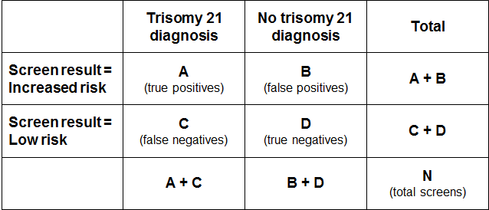

Positive predictive value and positive test rate
The positive test rate is the number of increased risk screens per 100 screens.
Positive test rate = ((A+B)/N)*100

Positive Predictive Value is the probability of having the condition given screen result was increased risk.
PPV = P (Disease | Screen Positive) = A/(A+B)

In order for PPV to increase, ‘A’ needs to be higher (more true positives) and/or ‘B’ needs to be lower (less false positives). However, an increase in positive test rate can come about when ‘A’ and/or ‘B’ increase. If the positive test rate increases due to higher true positives (A), then PPV will also increase. If instead the number of false positives increases, then the positive test rate will increase but PPV will decrease.

False positive rate
False positive rate is the number of false positives divided by false positives plus true negatives. It gives the proportion of women that did not have a baby or fetus with trisomy 21 that received an increased risk screening result.
FPR = B/(B+D)

Detection rate
Detection rate is the number of true positives divided by true positives plus false negatives. It gives the probability that a woman carrying a fetus with trisomy 21 will receive an increased risk screening result for trisomy 21.
Detection rate = A/(A+C)

Appendix 5: False negative screens by risk level
There were 195 false negative screens in total across the six-year period covered by this report. A false negative means that the screen result was low risk for each of trisomy 21, 18 and 13 but there was then a positive diagnostic test or infant diagnosis for one of trisomy 21, 18 or 13.

Table 61 shows the number of false negatives for each of the six calendar years broken down by the screening risk result in the first group of columns. The next group of columns gives the number of false negatives as a percentage of all negative (low risk) screens. Overall, false negative screens made up less than 0.1% of all negative screens for each of the years from 2011 to 2016.

Table 61: False negative screens for trisomy 21, 18 and 13 by risk level, January 2011 to December 2016
Risk level | False negatives |  |  |  |  |  | % of negative screens that are false negatives
 | 2011 | 2012 | 2013 | 2014 | 2015 | 2016 | 2011 | 2012 | 2013 | 2014 | 2015 | 2016
1:301 to 1:500 | 9 | 5 | 7 | 6 | 4 | 8 | 1.69 | 0.83 | 1.14 | 0.94 | 0.63 | 1.25
1:510 to 1:1,000 | 9 | 4 | 8 | 5 | 10 | 7 | 0.58 | 0.26 | 0.52 | 0.31 | 0.58 | 0.46
1:1,100 to 1:2,000 | 8 | 6 | 6 | 4 | 4 | 3 | 0.30 | 0.22 | 0.21 | 0.14 | 0.14 | 0.11
1:2,100 to 1:3,000 | 2 | 5 | 2 | 5 | 2 | 6 | 0.09 | 0.21 | 0.09 | 0.20 | 0.08 | 0.25
1:3,100 to 1:4,000 | 0 | 3 | 3 | 0 | 1 | 0 | – | 0.14 | 0.13 | – | 0.04 | –
1:4,100 to 1:5,000 | 3 | 3 | 1 | 2 | 0 | 0 | 0.16 | 0.15 | 0.05 | 0.10 | – | –
1:5,100 to 1:10,000 | 5 | 6 | 5 | 2 | 3 | 2 | 0.06 | 0.08 | 0.06 | 0.02 | 0.03 | 0.02
Less than 1:10,000 | 2 | 5 | 6 | 3 | 1 | 4 | 0.01 | 0.02 | 0.03 | 0.01 | 0.00 | 0.02
Total | 38 | 37 | 38 | 27 | 25 | 30 | 0.10 | 0.09 | 0.10 | 0.07 | 0.06 | 0.07

Appendix 6: ROC curve
Figure 13 shows the false positive rate plotted against the detection rate in what is known as a ‘receiver operating characteristic’ (ROC) curve. This plots the false positive rate on the horizontal x axis against detection rate on the vertical y axis for different possible cut off points of the screening test. The aim for a screening test is to maximise detection rate while minimising false positive rate.

In New Zealand the cut off used for screening is 1:300. With this cut off the overall detection rate for trisomy 21, trisomy 18 and trisomy 13 in 2016 was 79%, and the false positive rate was 2.5%. To create the graph the detection rate and false positive rate were calculated for a range of other cut off points in order to plot the curve. What the curve shows is that if the cut off was lowered to increase the detection rate to 85%, the false positive rate would increase from 2.5% to 4.6%. This occurs at a risk cut off of 1:600.

Figure 13: ROC curve for trisomy 21, 18 and 13 screening 2016
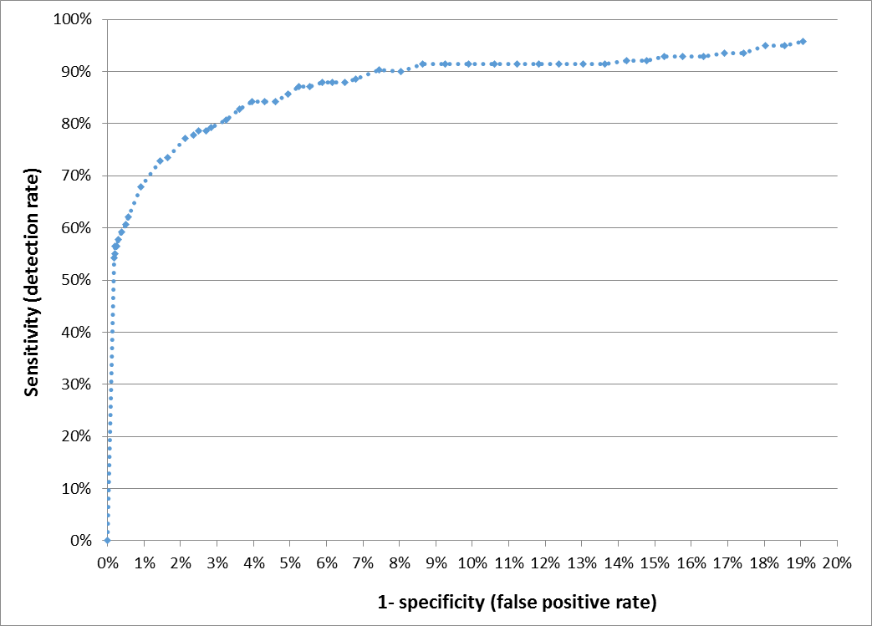

Appendix 7: Glossary
Alpha-fetoprotein (AFP) – a protein that is normally produced by the fetus. Maternal serum AFP levels can be used as a biochemical marker in the detection of certain fetal abnormalities including neural tube defects (NTDs) after 15 weeks of pregnancy.

Amniocentesis – a procedure involving the withdrawal of a small amount of amniotic fluid by needle and syringe through the abdomen guided by ultrasound performed at the same time. The tests performed on fetal cells in this sample can detect a range of chromosomal and genetic disorders.

Analyte – a substance that is undergoing analysis or being measured. Analytes measured in antenatal screening include: pregnancy associated plasma protein-A, beta human chorionic gonadotropin, unconjugated oestriol, alpha fetoprotein and inhibin A.

Beta-human chorionic gonadotropin (ßhCG) – a hormone produced during pregnancy and present in maternal blood and urine. It is used as a biochemical marker for Down syndrome and other conditions in first trimester combined and second trimester maternal serum screening.

Chorionic villus sampling (CVS) – a procedure involving the withdrawal of a small amount of placental tissue by needle and syringe through the abdomen guided by ultrasound performed at the same time. Tests performed on placental cells can detect a range of chromosomal and genetic disorders.

Crown rump length (CRL) – the measurement from the fetal crown to the prominence of the buttocks or breech. This is used for dating in the first trimester.

Detection rate – the ability of screening to identify individuals with the condition screened for. A test with a high detection rate will have few false negative results. Also referred to as sensitivity.

False negative result – when a woman receives a low risk screening result but the baby does have the condition screened for.

False positive result – when a woman receives an increased risk screening result but the baby does not have the condition screened for.

False positive rate – the false positive rate is the number of false positives divided by the number of false positives and true negatives. A low false positive rate corresponds with a high level of specificity, which refers to the ability of screening to identify individuals who do not have the condition screened for.

Fetal Medicine Foundation (FMF) –a Registered Charity that aims to improve the health of pregnant women and their babies through research and training in fetal medicine. Further information can be found at: https://fetalmedicine.org

Inhibin A – a hormone secreted by the ovary that is used as a biochemical marker in second trimester maternal serum screening for Down syndrome and other conditions.

Multiple of the median (MoM) – a measure of how far an individual result deviates from the median. MoM is commonly used to report the results of medical screening tests, particularly where the results of the individual tests are highly variable.

Nasal bone (NB)- an assessment of nasal bone will be included in the risk calculation if it is reported at the same time as the NT measurement.

Neural tube defect (NTD) – a congenital anomaly involving the brain and spinal cord caused by failure of the neural tube to close properly during embryonic development. Open NTDs occur when the brain and/or spinal cord are exposed at birth through a defect in the skull or vertebrae. Examples of open NTDs are spina bifida (myelomeningocele), anencephaly, and encephalocele.

Nuchal translucency (NT) – sonographic appearance of the collection of fluid under the skin at the back of the fetal neck. NT is a marker for chromosomal and other anomalies and can be measured in the first trimester of pregnancy.

Pregnancy-associated plasma protein A (PAPP-A) – a protein originating from the placenta used as a biochemical marker in first trimester combined screening for Down syndrome and other conditions.

Risk calculation algorithm – an explicit protocol (in this case computer-based) that combines a number of factors in determining overall risk of a particular outcome or condition.

Screening – a way of identifying a group of people who are more likely than others to have a particular condition. The screening process involves testing people for the presence of the condition, and predicting the likelihood that they have the condition. Antenatal screening for Down syndrome and other conditions predicts the likelihood of the conditions being present in the fetus.

Triploidy – an extremely rare chromosomal disorder in which a baby has three of every chromosome making a total of 69 rather than the normal 46 chromosomes.

Trisomy – a group of chromosomal disorders in which there are three copies, instead of the normal two, of a particular chromosome present in the cell nuclei. The most common trisomies in newborns are trisomy 21 (Down syndrome), trisomy 18 (Edwards syndrome) and trisomy 13 (Patau syndrome).

True positive – when a woman receives an increased risk screening result and the baby does have the condition screened for.

Unconjugated oestriol (uE3) – a hormone produced by the placenta and used as a biochemical marker in second trimester maternal serum screening for Down syndrome and other conditions.

Further terms can be found at www.nsu.govt.nz

Risk ratio values increase in increments of 5 between 1:10 and 1:100, increments of 100 between 1:100 and 1:10,000, and then increments of 1000 to 1:100,000.
Births reaching at least 20 weeks gestation or ≥400 g birth weight.
Births reaching at least 20 weeks gestation or ≥400 g birth weight.

