National Bowel Screening Programme Primary Care Guide

May 2023

Process

The National Bowel Screening Programme (NBSP) is free for people aged 60 to 74 who are eligible for publicly funded health care in New Zealand. The age at which Māori and Pacific people can have free bowel screening is being lowered to start at 50. This will happen across the country as districts become ready.

The screening programme uses a faecal immunochemical (FIT) blood test, which is specifically for human blood and requires no dietary exclusions.

The invitation strategy during the implementation of the NBSP was linked to birthdays, with invitations for even birth dates (eg, 16 May) one year and odd dates (eg, 17 June) the next year. Repeat screening invitations are usually sent within three months of the birthday of an eligible person.

People new to the programme are offered a test as they turn 60 (this age is being extended to 50 for Māori and Pacific people).

General practice

Primary care has an important part to play in the success of the NBSP. General practitioners, nurse practitioners and practice nurses will discuss and manage positive test results with their patients. They also have a key role in encouraging participation, helping achieve equity, and raising awareness of bowel cancer symptoms and family history. This can be through an opportunistic conversation, kit requests via Dashboard, BPAC or Indici tool (or by emailing info@bowelscreening.health.nz) or encouraging the patient to call the National Coordination Centre (NCC) on 0800 924 432, where multiple languages are spoken. In priority populations, fear and anxiety have been identified as key factors in not completing a kit.

Who should not do the test?

Patients should not do the test if they:
- have symptoms of bowel cancer
- have had a colonoscopy within the last five years
- are on a bowel polyp or bowel cancer surveillance programme
- have had, or are currently being treated for, bowel cancer
- have had their large bowel removed
- have ulcerative colitis or Crohn’s disease that is currently active
- are being investigated for bowel problems.

Advising positive results and referral

- Day one is when the result is first sent from the testing laboratory and appears in the practice inbox.
- Patients need to be contacted within 10 working days and an appointment arranged to explain the positive FIT and the referral process. The consultation could be in-person or virtual. Patients are not to be advised of the result by letter, text or other electronic communication.
- Physical examination is not required unless there are symptoms.
- It is up to the practice to determine its most appropriate workflow process by forwarding FIT results to the clinician or nurse designated to deal with these. Note that results may be sent to a generic practice inbox, so it is important this is checked regularly.

What if the patient has not had a creatinine test in the last three months?

A creatinine test within the last three months is helpful but should not preclude referral. Laboratory requirements vary by region; check with your local health pathway.

Where to refer patients?

To reduce unnecessary anxiety for screening participants and facilitate timely investigation of positive (abnormal) FIT results in line with international recommendations, there is a programme standard to offer a colonoscopy or CTC within 45 working days of positive (abnormal) FIT result and to complete a colonoscopy or CTC within 60 working days of abnormal FIT result. These timeliness indicators are closely monitored, along with key quality performance indicators and unplanned admissions. For these reasons colonoscopy referral through the programme is strongly encouraged.

If a patient chooses to go privately after a positive FIT test, is a referral to the Te Whatu Ora endoscopy unit still required?

Yes, this is an information-only referral. Use the NBSP referral form for your region to indicate the participant has opted to go privately. The fee for the management of a positive result is still available.
The bowel screening programme will assume that a participant who chooses to exit the programme for a private colonoscopy has undertaken the procedure. If they are still eligible, the participant will receive a further invite in five years.

Will health insurance companies fund colonoscopies with FIT positive results?

A positive FIT may be eligible for a private colonoscopy as this indicates the presence of rectal bleeding. The Bowel Screening Register (BSR) is not routinely updated with results from a private colonoscopy, unless sent copies by the private provider.

If information about a patient is unknown, eg, a family history of bowel cancer, can that be left out of the referral?

A family history of bowel cancer is important information to include, however referrals can be submitted without, if this information is not available.

What about those who have a positive test but are not up to the bowel preparation for a colonoscopy?

Where a patient is unsuitable for colonoscopy, please notify the endoscopy unit via your regional referral system. They will be reviewed by the clinical lead to determine the most appropriate follow-up.

What should be done with results?

File the screening FIT with comment “Screening FIT positive or negative”, note “Colonoscopy normal “or “Colonoscopy abnormal” on the classification/problem list.

What should be done if you receive results where the patient is not known at the practice?

Contact NCC on 0800 924 432 if the patient is not known to your practice. The endoscopy unit will follow up if the participant’s GP is unknown.

Is there funding to advise patients of a positive result?

The fee for the management of a positive result is $60 + GST and can be claimed through your payment portal. There is no charge to the patient. The fee is for a referral to the district or an information referral. The fee can be claimed for patients who decline the referral for further investigation, who do not meet the referral criteria or who are referred privately. Referrals need to be undertaken within 10 days of a positive FIT result.

What is the cost to the medical practice to order a FIT kit?

There is no cost to the practice when ordering kits though the PMS (eg, patient dashboard or best practice tool, or by contacting NCC (0800 924 432). Kits can be ordered at any time for the programme’s priority populations of Māori, Pacific people and NZDep quintile 5 following an opportunistic discussion, or for other patients if they have been sent a kit previously and are now overdue for screening. The kit will be delivered to the patient’s address.

Patient testing

What percentage of participants have a positive result?

The positivity rate is approximately 8 percent for the first screening round; however this will vary from district to district depending on demographics and when bowel screening started in the district.

If a person is invited for screening and does not respond, what happens?

In this situation, a reminder letter is sent. For priority groups (Māori, Pacific and people from NZDep quintile 5 areas) the NCC also attempts to contact the participant by phone, including after-hours. If people still can’t be contacted, their details are passed on to districts to follow up. Each district has chosen a particular system of outreach which suits its community.

Will primary care be informed of patients who decline the test or do not participate?

No, this information is not specifically reported, however the patient will be identified on the Practice Management System (PMS) reminder as having not participated. Alternatively, a practice query can be run to provide a list of non-participants. See the practice audit tool later in this guide.

Is primary care notified when invitations are sent out to participants?

Primary care is not notified by the NBSP when invitations are sent out, but is notified of the FIT results, unless the patient withdraws consent.

Is it possible to record patients who are inappropriate for screening? This would reduce resource use.

Patients may be inappropriate for screening, for example due to co-existing serious illness. Information on patients who are inappropriate for screening can be provided to the programme using the reporting tool, where available on the PMS (eg, patient dashboard or best practice tool), or by phoning the NCC 0800 924 432. It is important this is discussed with your patient so they are aware they will not receive an invitation.

If someone is within the eligible age range, but not in a priority group, what is the age at which they are offered a FIT test?

- Age | - When will they get their invitation?
- 59 | - Around their 60th birthday, regardless of their birth date.
- 60 to 74 | - Around their birthday. If they have an even birthdate (eg, 2nd, 14th, 26th of the month) they will receive an invitation two-yearly from the year of implementation of NBSP for the district.  - If they have an odd birthdate (eg, 3rd, 15th, 27th of the month) they will receive an invitation two-yearly from the year after implementation of NBSP for the district.

Where does the Bowel Screening Register (BSR) data come from?

BSR information is pulled from the NHI and the National Enrolment Service (NES). Anyone who has accessed the health service within the last three years will have their information in BSR. This is why it is vitally important to have a person’s correct ethnicity stated in the PMS. This will help the programme achieve equitable participation.

Is FIT available to use on patients who have symptoms?

No, the FIT test is only for NBSP. Any patients with symptoms need to be referred as per current health pathway. Refer to the ‘Referral Criteria for Direct Access Outpatient Colonoscopy or Computed Tomography Colonography’ (https://www.health.govt.nz/publication/referral-criteria-direct-access-outpatient-colonoscopy-or-computed-tomography-colonography)

Managing possible false negatives: Do patients with a negative FIT, who have concerning symptoms, proceed as per current symptomatic pathway?

Yes, refer symptomatic patients using referral criteria for direct access outpatient colonoscopy or computed tomography colonography. These criteria are included in health pathways.

Ineligible participants

What advice should primary care give to people who are outside the age range, but who would like to participate?

People outside the age range are not eligible for the NBSP but they should be assessed for the presence of factors associated with an increased risk of developing bowel cancer. These include a family history of bowel cancer or a personal history of inflammatory bowel disease (IBD) and previous bowel polyps or cancer. More information is available here: ‘National Referral Criteria for Direct Access Outpatient Colonoscopy or CT Colonography’ (Word, 103 KB), https://www.health.govt.nz/publication/referral-criteria-direct-access-outpatient-colonoscopy-or-computed-tomography-colonography

Note: If the person is experiencing symptoms consistent with bowel cancer, they should be referred to the local endoscopy unit for specialist assessment or for colonoscopy as per the symptomatic health pathway.

What happens to ‘spoiled’ samples?

If the kit is spoiled, the NCC will automatically send a replacement kit. In the event of multiple spoilt kits being returned by a participant, the NCC will contact them and provide advice.

Spoilt kits are caused by: not putting the bar code on the kits; failing to include the consent form with the kit; and delay in postage. If the participant has lost the kit they can contact the NCC to be sent another one.

PMS reminder systems

Are the patient dashboard or BPAC prompt add-on automatic?

These prompts will require the primary health organisation (PHO) or district to add them to the PMS system. The Indici reminder is built into the PMS.

See screenshots below.

- Medtech

Patient dashboard NBSP status and priority test kit requesting

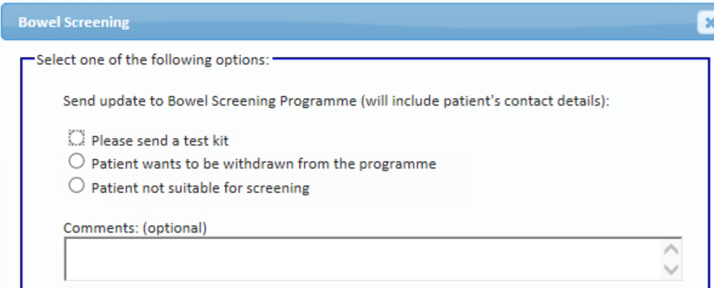
- Mōhio
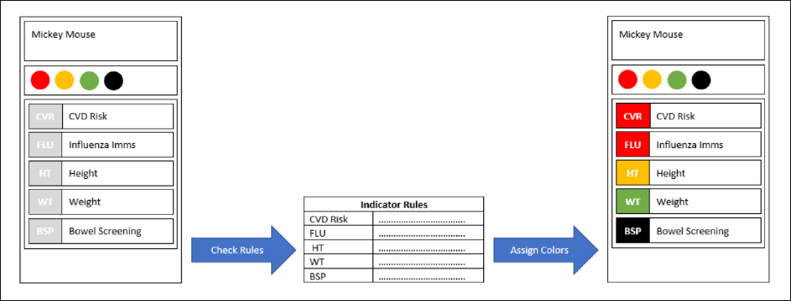
Colour | Description
Red | It’s due and should be completed now
Orange | It’s not due yet, but will be due soon
Green | It’s done and won’t be due for sometime
Black | Is not applicable for this patient

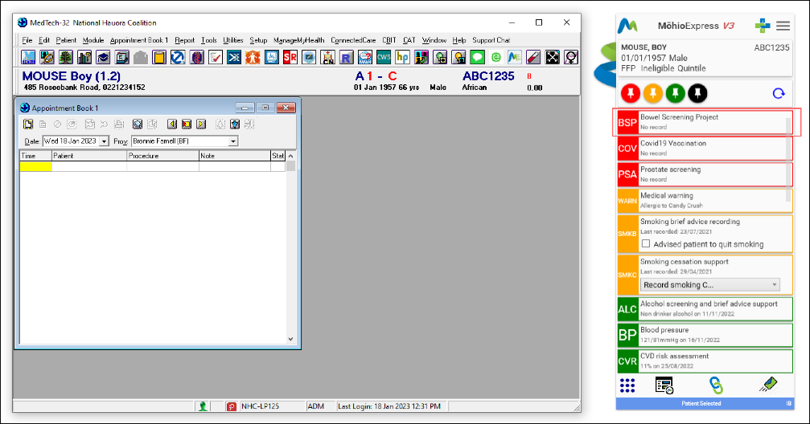
- Indici
- 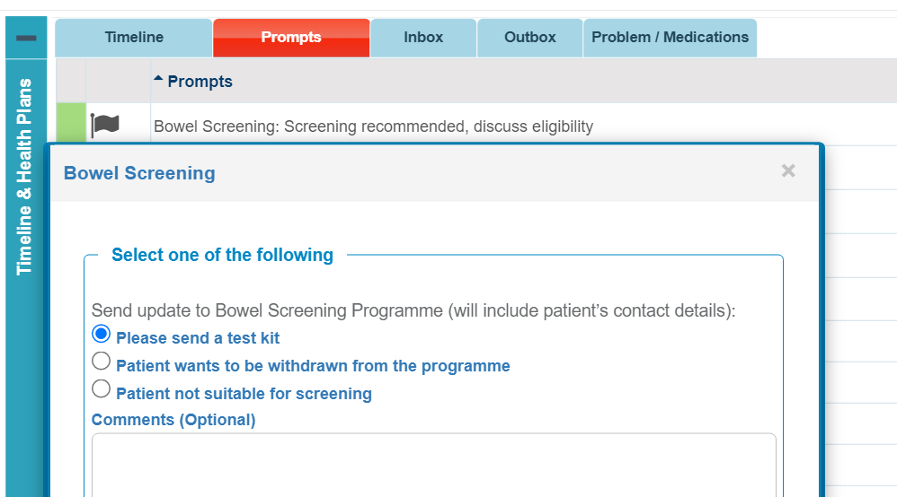

- No bowel screening history present – Screening recommended, discuss eligibility:
- Color: Green
- Caption: Bowel Screening: Screening recommended, discuss eligibility.

- Bowel screening result was negative two years ago – Screened more than two years ago, discuss with the patient:
  - Color: Red
  - Caption: Bowel Screening: Screened more than two years ago, discuss with the patient.

- Bowel Screening patient declined two years ago – Declined two years ago, discuss with the patient:
      - Color: Red
      - Caption: Bowel Screening: Declined two years ago, discuss with a patient.

- Bowel Screening patient result was positive – Screened with a positive result, review history:
      - Color: Yellow
      - Caption: Bowel Screening: Screened with a positive result, review history.

Practice audit tool

It is possible to audit patients to see if they have completed a kit.

  - Medtech
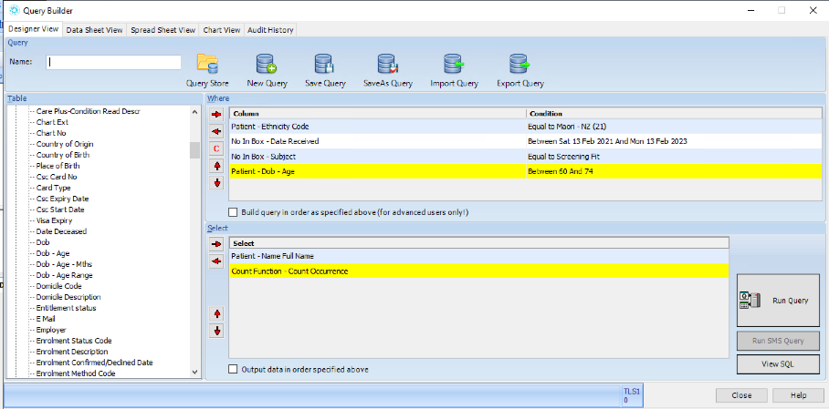
- Indici
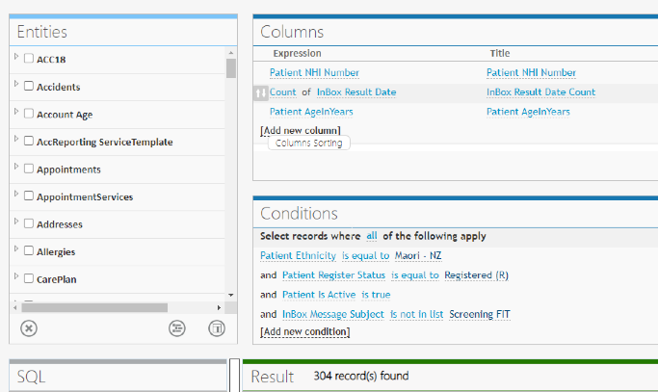

Will NBSP become an auto recall on our PMS?

No, it is not necessary for practices to recall patients for bowel screening, as this is carried out by the programme. While it is useful for you have a recall process within your practice, the interval between kits will vary depending on the outcome:

- Negative FIT tests – two years.
- Normal colonoscopy – five years.
- Post surveillance (following discharge from surveillance) – five years (if still within age range). Currently, the fact that a person is no longer undergoing surveillance colonoscopy and is therefore once again eligible for the NBSP is not notified automatically to the NBSP. Therefore, the fact they are once again eligible for the NBSP needs to be notified to NCC by their GP or by the patient calling the 0800 number.

What are the options for practices who do not have access to electronic kit requests?

NBSP kits can be ordered by phoning NCC directly on 0800 924 432 or emailing info@bowelscreening.health.nz

Appointment scanners

Some PMS systems allow the day’s appointment book to be scanned for overdue prompts and allow screening interventions before, during or after appointment.

See examples from Indici and Medtech.

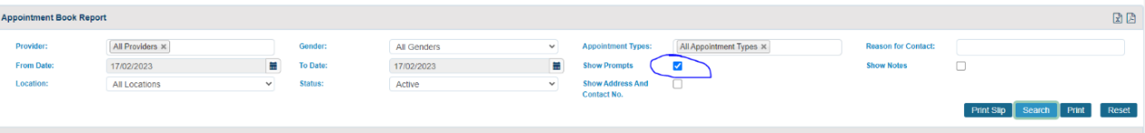
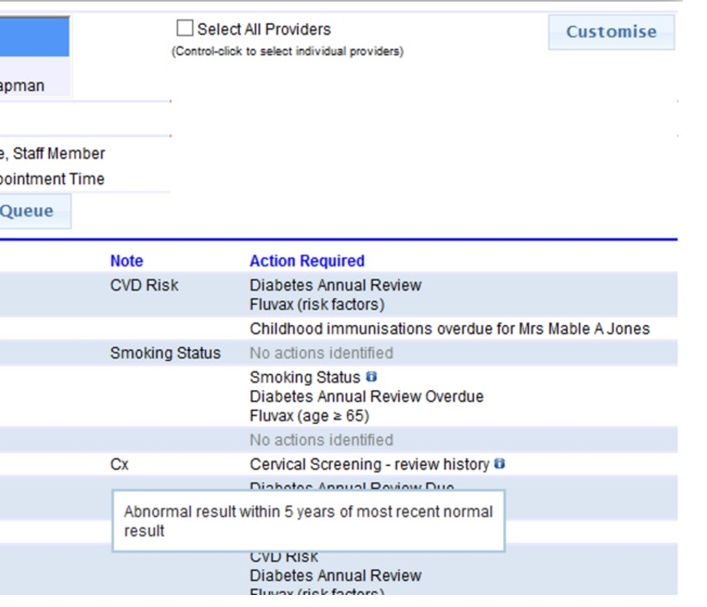

Priority populations

Is the invitation in different languages?

The invitation pack includes information in various languages and instructions on how to do the test. Participants are also invited to contact the NCC who have staff able to talk through doing the kit in a range of languages or via interpreter services.

NBSP information brochures and posters are available in multiple languages and can be ordered through HealthEd: www.healthed.govt.nz/

What is the advice If patients want to request a test kit?

Kits can only be ordered in advance for priority populations (Māori, Pacific peoples, NZDep quintile 5) following a discussion with primary care/health promoters. You can arrange a kit to be sent using either:

- the direct request tool on your PMS
- phoning 0800 924 432 or emailing info@bowelscreening.health.nz.

Kits can also be ordered for participants who have lost or damaged their kit or if the kit has expired. All other patients will need to wait for their routine invitation.

Can a person pay for a FIT privately?

In New Zealand the use of a FIT in asymptomatic individuals is not recommended or encouraged, outside the NBSP. The FIT used in the NBSP is not available for purchase outside the programme.

If a person undertakes a privately obtained FIT, they are ineligible to go through the NBSP process. They will not be offered a public colonoscopy unless they meet the symptomatic criteria. If the patient has symptoms, they should be managed as per Health Pathways: ‘Colorectal symptoms’ https://www.nsu.govt.nz/health-professionals/national-bowel-screening-programme/use-self-purchased-fobt-kits

Diagnostic findings pathway

Where will colonoscopies be performed for FIT positive patients?

All colonoscopies will be performed at the district Te Whatu Ora endoscopy unit, by specifically credentialled endoscopists.

If patient has positive FIT test, then low grade polyp on colonoscopy, what is the process?

They have a repeat FIT test in five years.

Will a positive patient with polyps return to NBSP or the polyp surveillance list?

The National Bowel Cancer Working Group has written a recent ‘Update on surveillance post polypectomy’, see link below.
https://www.health.govt.nz/publication/update-polyp-surveillance-guidelines-2020

Follow up will be based on this and includes either colonoscopy surveillance via the district Te Whatu Ora service or a return to the NBSP. Check your local health pathway.

Is the FIT test subsequently offered every two years or five years in patients receiving a colonoscopy through NBSP?

The interval between kits will vary dependant on the outcome (assuming they are still within the age range):

- Negative FIT: sent a FIT in two years.
- Normal colonoscopy: sent a FIT in five years.
- Polypectomy: refer to new polypectomy guidelines (see link below) https://www.health.govt.nz/publication/update-polyp-surveillance-guidelines-2020

Resources

Where can I get resources?

Posters/brochures can be ordered from either: Community and Public Health, or via HealthEd.

General information

What is NZDep quintile 5?

This refers to people living in our most deprived areas. They are included in the priority population for the programme along with Māori and Pacific people.

If 7 of 10 positive tests will be due to polyps, what proportion of negative test would have polyps? Ie, how many patients with polyps are missed?

It is expected that a small proportion of participants with negative FIT tests will have cancer and polyps. This is why regular screening is important. Participants with a negative FIT should be re-screened every two years while they are eligible and referred via the symptomatic pathway if they have symptoms.

